Vietnamese Stage 1
Giờ dự tiệc (Party time!)
Contents
Unit overview 5
Stage 1 outcomes and content to be addressed 6
Learning map 9
Assessment 12
Assessment opportunities 13
Teaching and learning activities 14
Week 1 – Kim’s birthday party 14
Vocabulary 1 – numbers 15
Activity 1 – learning map 16
Activity 2 – Kim’s Birthday Party PowerPoint book 16
Activity 3 – number review 17
Activity 4 – I have... who has… 17
Activity 5 – How old are you? 18
Week 2 – When is my party? 19
Vocabulary 2 – days of the week 20
Vocabulary 3 – time of day 21
Activity 1 – days of the week 21
Activity 2 – snap game, days of the week 22
Activity 3 – time of day 22
Activity 4 – days of the week tag 23
Activity 5 – When is my party? 24
Week 3 – Where is my party? 26
Vocabulary 4 – party places 26
Activity 1 – role play, my party is on … 27
Activity 2 – memory game 28
Activity 3 – jumbled sentences 29
Activity 4 – question builder 30
Week 4 – writing an invitation 31
Vocabulary 5 – invitation vocabulary 31
Activity 1 – puppet role play – invitation 32
Activity 2 – Kim’s invitation 33
Activity 3 – writing an invitation 34
Week 5 – assessment criteria and practice task 37
Activity 1 – warm up – ‘Buzz off’ 37
Activity 2 – introduce assessment task 38
Activity 3 – success criteria 38
Activity 4 – practice task – puppet talk 39
Week 6 – communicative task – invite a friend to your party 41
Activity 1 – pass the message 41
Activity 2 – task set-up 42
Activity 3 – communicative task – inviting a friend to your party 42
Activity 4 – peer assessment 44
Week 7 – feedback and goal setting 45
Activity 1 – beat the teacher 45
Activity 2 – self-assessment 46
Activity 3 – set learning goals 46
Week 8 – language review 48
Activity 1 – student questions 49
Activity 2 – grammar review 49
Student resources 51
Resource 1 – Who has? number cards 52
Resource 2 – days of the week poster 55
Resource 3 – days of the week SNAP! cards 56
Resource 4 – time of day flashcards 59
Resource 5 – sentence builder 60
Resource 6 – memory game cards 61
Resource 7 – jumbled sentences 63
Resource 8 – question maker 67
Resource 9 – puppet printout 68
Resource 10 – student rubric – Party time! 69
Resource 11 – peer feedback strategy – Two stars and a wish 70
Support and alignment 71
References 74

Unit overview
Stage: 1
Title: Giờ dự tiệc (Party time!)
Description: In this unit, students create a party invitation for their friends in Vietnamese, specifying details such as the day, time and location of the party. They then use simple formulaic language and expressions to invite friends to a party.
Duration: This lesson sequence is designed to be completed over approximately 8 weeks.
Student proficiency levels: It is assumed that most Stage 1 students have been learning Vietnamese since Kindergarten and their proficiency level will still be Beginner. The assessment tasks in this scope and sequence are aimed at Beginner students. Every classroom will be different and teachers will need to adapt to their context. Many classes may include a combination of Beginner, Intermediate and Advanced students with varying skills and abilities within these proficiency levels. Assessment tasks and opportunities in this unit can be differentiated using the ‘Too hard?’ and ‘Too easy?’ suggestions.

Stage 1 outcomes and content to be addressed
The table below outlines the focus area, outcomes and content points for Stage 1 students.
Focus area and outcome | Content points
Interacting  A student:  - exchanges meaning by selecting culturally appropriate modelled language ML1-INT-01 | Exchanging meaning in oral interactions in the target language  - Exchange greetings, farewells, and simple information to describe people or objects  - Interact in classroom routines using familiar language  - Interact by selecting modelled language in games or scenarios using imagination  Reproducing oral language to interact in the target language  - Recognise and reproduce modelled sounds, including pronunciation and intonation patterns to interact  - Reproduce familiar vocabulary and short formulaic phrases to interact  Applying knowledge of the target language culture(s) to interact  - Use familiar verbal and nonverbal communication that is appropriate to cultural practices
Understanding texts  A student:  - recognises and responds to information in simple texts to demonstrate understanding ML1-UND-01 | Understanding and responding to target language texts  - Follow instructions  - Listen to, read and/or view simple texts such as stories, songs, charts, rhymes or lists on familiar themes  - Associate vocabulary on familiar themes with known actions, people, places, objects, and ideas  - Recognise information in simple texts and respond to simple questions in the target language and/or English to show understanding of texts  - Demonstrate understanding when responding to texts using actions, drawing, singing or simple exchanges in the target language and/or English  Applying knowledge of language systems to understand and respond to target language texts  - Recognise and use sounds of modelled vocabulary and phrases to understand and respond to texts  - Recognise sound–symbol correspondences in modelled words and phrases to understand and respond to texts  - Recognise and use knowledge of modelled vocabulary, high-frequency words and formulaic phrases on familiar themes to understand and respond to texts  - Use simple grammar patterns to understand and respond to texts  - Recognise that the target language has features that may be similar to or different from English  - Recognise and reproduce symbols or modelled vocabulary and phrases of the writing system to understand and respond to texts
Creating texts  A student:  - creates simple texts by selecting culturally appropriate modelled language ML1-CRT-01 | Creating spoken, written and multimodal texts in the target language  - Create texts using familiar vocabulary, phrases and visuals to express meaning  - Create a simple sentence about themselves and their personal world to express ideas and/or give descriptive information  Applying knowledge of language systems to create texts in the target language  - Use simple modelled sentence structures to create texts  - Reproduce modelled features of the target language writing system to create written texts
Modern Languages K–10 Syllabus © NSW Education Standards Authority (NESA) for and on behalf of the Crown in right of the State of New South Wales, 2022.

Learning map
The creation of maps for learning is a planning process that incorporates Aboriginal intellectual tradition. Learning maps are a visual pathway of what students will learn.
Share the learning map with your students, briefly explaining the learning that will happen in each lesson. Provide students with a copy of the learning map or display the learning map in the classroom. This learning map can be adapted to Vietnamese by accessing a copy of Learning map – Giờ dự tiệc (Party time!) (Stage 1).
Figure 1 – Party time! learning map
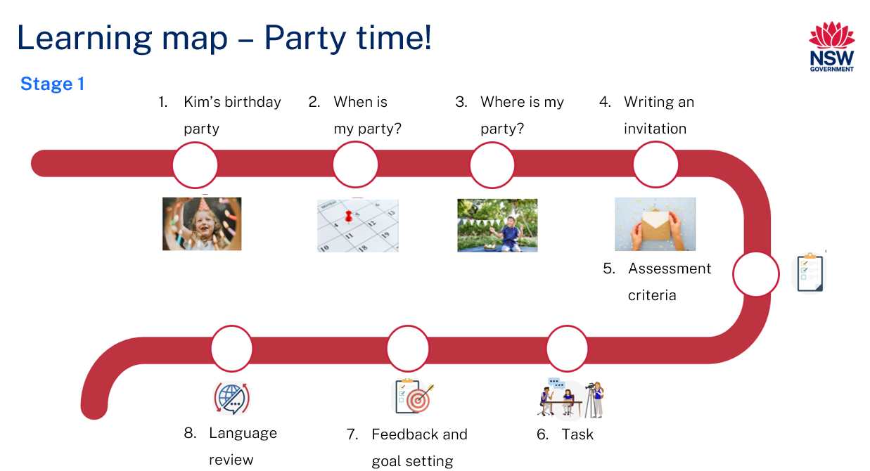
Figure 2 – Giờ dự tiệc (Party time!) learning map
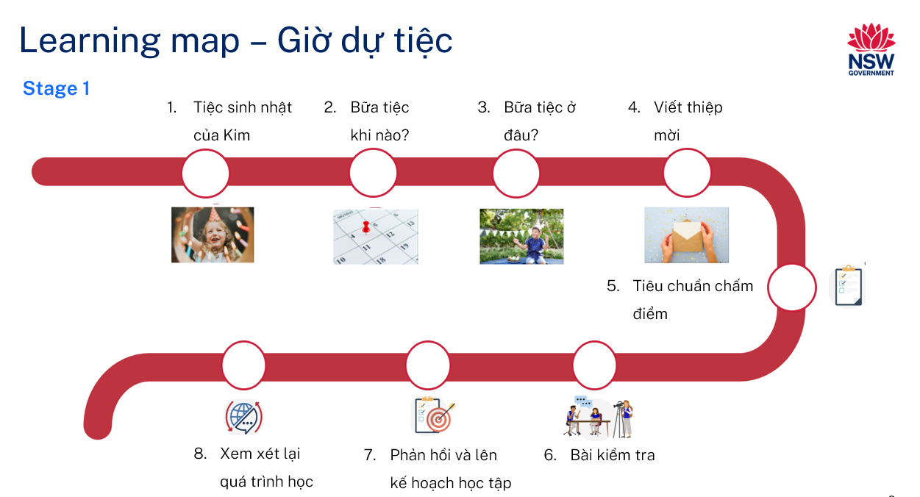

Assessment
Stage 1 communicative task: You would like to invite your friend to your birthday party during the next school holidays by giving them an invitation that you have created. Ask them if they would like to come to your party and tell them the details of your party in Vietnamese, including the day, time and location of the party.
Too hard?
Ask your friend if they would like to come to your birthday party.
Too easy?
Ask your friend if they would like to come to your birthday party. Include details about the day, time and location. Also include information about activities that will take place.
Context: your party will be soon
Audience: your friend
Purpose: to invite your friend to your party

Assessment opportunities
The table below details assessment opportunities and differentiation ideas.
Assessment opportunities | Too hard? | Too easy?
Week 2 – When is my party?  Students create a sentence using Resource 5 – sentence builder, about when they would like to have their party and read it to their peers. | When is my party?  Teacher or peers help the student create their sentence to include which day their birthday party is on. | When is my party?  Students can add why they want their birthday party to be on a certain day and time.
Week 3 – jumbled sentences  Students are given sentences from Resource 7 – jumbled sentences where the words are out of order and they need to cut the words out and put them in the correct order to form sentences. | Jumbled sentences  Students are given an additional copy of the sentences already in the correct order to use as a guide. | Jumbled sentences  Students create their own jumbled sentence which they can give to their partner to put in the correct order to create a sentence.
Week 4 – writing an invitation  Students create a party invitation that includes how old they are turning, who is having the party, where and when the party is occurring. | Writing an invitation  Students use the book ‘Kim’s Birthday Party page?’ As a scaffold to complete their invitation. | Writing an invitation  Students create a party invitation that includes an opening sentence, how old they are turning, who is having the party, where and when.

Teaching and learning activities

Week 1 – Kim’s birthday party
The table below outlines the learning intentions and success criteria of the lesson, and materials that the teacher and students will need to complete the teaching and learning activities.
Learning intentions and success criteria | Materials
Students will:  - listen to and answer questions about Tiệc Sinh Nhật của Kim (Kim’s Birthday Party)  - revise numbers from 1 to 10.  Students can:  - answer questions about the story Tiệc Sinh Nhật của Kim (Kim’s Birthday Party), in Vietnamese  - count from 1 to 10 in Vietnamese. | - Kim’s Birthday Party PowerPoint book (English)  - Tiệc Sinh Nhật của Kim PowerPoint book (Vietnamese)  - ‘Em tập hát và đếm?’ I practise counting song (English)  - ‘Em tập hát và đếm?’ I practise counting song (Vietnamese)  - Resource 1 – Who has? number cards

Vocabulary 1 – numbers
The table below outlines the suggested vocabulary used throughout this learning sequence. It includes the Vietnamese words and phrases and their corresponding English translations.
English | Vietnamese
one | một
two | hai
three | ba
four | bốn
five | năm
six | sáu
seven | bảy
eight | tám
nine | chín
ten | mười

Activity 1 – learning map
Explain and display the Learning map to give students a more detailed breakdown of lessons during the unit. Point out that the Learning map is a plan that may need to change.

Activity 2 – Kim’s Birthday Party PowerPoint book
Have students sit on the floor and read the Tiệc Sinh Nhật của Kim (Kim’s Birthday Party) PowerPoint book. Ask the following questions in English or Vietnamese to assess their prior knowledge and understanding of the story. Students can respond in English or Vietnamese.
- Câu chuyện này nói về cái gì? (What is this story about?)
- Các em có biết từ nào không? (Do you know any of the words?)
- Từ nào các em thấy khó? (What words do you find difficult?)
- Sử dụng tiếng Việt, các em có thể cho cô/thầy biết ai đang tổ chức tiệc sinh nhật không? (In Vietnamese, can you tell me who is having a birthday party?)
- Sử dụng tiếng Việt, có thể cho cô/thầy biết khi nào bữa tiệc xảy ra không? (In Vietnamese, can you tell me when the party is happening?)
- Sử dụng tiếng Việt, có thể cho cô/thầy biết bữa tiệc diễn ra ở đâu không? (In Vietnamese, can you tell me where the party is being held?)
Go to page 3 and show students the invitation, asking them if they know what it is. Ask what the Vietnamese word for ‘invitation’ is (Thiệp mời).

Activity 3 – number review
Sing the song ‘Em tập đếm (I practise counting)’.
Have students sit on the floor to sing the song using the given lyrics.
Note: this song is to the tune of Incy Wincy spider.

Activity 4 – I have... who has…
- Choose 3 students to demonstrate the activity. Give each student a card with a number on it from 1 to 3 Resource 1 – Who has? number cards.
- The student with the number 1 card starts by saying ‘Em có số một, ai có số hai?’ (‘I have 1, who has 2?’)
- The student with the number 2 card replies, ‘Em có số hai, ai có số ba?’ (‘I have 2, who has 3?’)
- The activity continues, as the student with the number 3 says, ‘Em có số ba, ai có số bốn?’ (‘I have 3, who has 4?’)
- Students then get into groups of 10 and each student is given a card with a number on it from 1 to 10.
- As in the demonstration, the student with the number 1 cards starts the activity. This continues until the cards get to number 10.
- One student from each group can collect the cards, shuffle them and redistribute them so that each student gets a different card.
- Repeat the process for as long as time permits.

Activity 5 – How old are you?
- Ask the question Bạn bao nhiêu tuổi? Or Bạn mấy tuổi? (‘How old are you?’) in Vietnamese. If a student can answer in Vietnamese, ask the class what their answer was. Then ask what the question was.
- If nobody can answer, ask students the question in English.
- Model the pronunciation of the question and answer. Ask students to repeat after you.
- In pairs, students take it in turns to ask and answer the question ‘How old are you?’, ‘Bạn bao nhiêu tuổi?’, ‘I am … years old.’, ‘Mình … tuổi’.
Note: use Intentional observation checklist for communicative activities to make notes about student understanding of the target language, their pronunciation and use of gesture, facial expression and tone to support communication.

Week 2 – When is my party?
The table below outlines the learning intention and success criteria of the lesson, and materials that the teacher and students will need to complete the teaching and learning activities.
Learning intention and success criteria | Materials
Students will use vocabulary related to days of the week and the time of the day.  Students can:  - say time-of-day vocabulary in Vietnamese  - choose the best day and time to have a party  - give reasons for choosing the day and time to have a party in Vietnamese  - create sentences giving the time and day of their party in Vietnamese. | - Resource 2 – days of the week poster  - Resource 3 – days of the week SNAP! cards  - Resource 4 – time of day flashcards  - Resource 5 – sentence builder  - Coloured markers  - Large piece of paper/whiteboard

Vocabulary 2 – days of the week
The table below outlines the suggested vocabulary used throughout this learning sequence. It includes the Language words and phrases and their corresponding English translations.
English | Vietnamese
Monday | Thứ Hai
Tuesday | Thứ Ba
Wednesday | Thứ Tư
Thursday | Thứ Năm
Friday | Thứ Sáu
Saturday | Thứ Bảy
Sunday | Chủ Nhật

Vocabulary 3 – time of day
The table below outlines the suggested vocabulary used throughout this learning sequence. It includes the Language words and phrases and their corresponding English translations.
English | Vietnamese
morning | buổi sáng
lunchtime | buổi trưa
afternoon | buổi chiều

Activity 1 – days of the week
- To pre-assess vocabulary, ask students to turn to a partner and name any of the days of the week they know in Vietnamese. Pairs share their knowledge with the class.
- Display the Vietnamese words in Resource 2 – days of the week poster. Read each day of the week aloud and ask students to repeat.
- Take the poster away and write the days of the week in Vietnamese in random order on the board. Select students to say or write the English word for each day of the week next to the Vietnamese word. Ask the rest of the class if the matched words are correct by giving a thumbs up or thumbs down.
- Model and drill Vocabulary 2 – days of the week in Vietnamese to ensure students have the correct pronunciation.
- Point out that all the English words end in -day. Discuss any similar patterns. In Vietnamese all days except for Sunday start with Thứ.

Activity 2 – snap game, days of the week
- In groups of 4, students are given a set of Resource 3 – days of the week SNAP! cards showing the days of the week in Vietnamese and in English. Each group will need 4 copies of this resource.
- Shuffle the cards and pass them to each of the students until all the cards are handed out. Cards are to be kept face down.
- Students decide who will go first and the order they will play the game in.
- The first student puts a card in the pile face up. This is followed by the other students one by one until there is a match.
- Once there is a matching pair the first student to gently SNAP the card with the palm of their hand and say ‘SNAP’, gets to take the pile of cards and puts it aside.
- When all the cards are finished the person with the most cards is the winner.

Activity 3 – time of day
- Display the images in Resource 4 – time of day flashcards.
- To pre-assess vocabulary, ask students to turn to a partner and tell them any of the words they know on the chart. Pairs share their knowledge with the class. Add the Vietnamese words to the images when students give the correct word.
- Display any additional words with the images.
- Read the Vietnamese time of day words out aloud and have students repeat each word a number of times to ensure correct pronunciation.
- Ask students to look for any similarities between the words for the time of day in English and in Vietnamese.
- If students have a language background other than Vietnamese or English, ask if they can see any similarities in their background language as well.

Activity 4 – days of the week tag
- Display Resource 2 – days of the week poster, and have students read aloud the days of the week in Vietnamese.
- Play a class game of ‘tag’ by pinning the days of the week onto the whiteboard in the correct order.
- Divide students into teams of 7 if possible. Give each team a cut up copy of Resource 2 – days of the week poster.
- The teams make lines in front of the class whiteboard or alternatively pin up a big piece of paper.
- The first students in line go to the whiteboard or paper and stick Thứ Hai (Monday). Once they finish, they then tag the next person in their team to stick Thứ Ba (Tuesday).
- The game continues until everyone in the team has had a turn. The first team with all their players to finish sticking all the days of the week correctly on the whiteboard wins.
- Once all the days of the week have been stuck to the whiteboard they can be taken down for another round.

Activity 5 – When is my party?
Note: as students practise language throughout this activity use the Intentional observation checklist for communicative activities to record your observations of students’ pronunciation and their use of vocabulary.
- Ask students when a good time would be to have a party. Have them Think-Pair-Share what day of the week and time of the day would be the best.
- Students share their thoughts in English with the class including reasons as to why they would want to have their party on a certain day and time. Suggested answers may include:
- Saturday lunchtime because it’s the weekend and you can have a sleep in.
- Sunday morning because it’s the weekend and you can play with your presents in the afternoon.
- Any afternoon after school because you’re already with your friends.
- Display Resource 5 – sentence builder.
- Once students have decided when they would like to have their party, they create their sentence and read it to their peers.
Note: the words buổi can be omitted from the time-of-day words so that you use sáng, chiều (morning, afternoon)
Example:
In the morning is buổi sáng, but Sunday morning is Sáng Chủ Nhật.
At lunchtime is buổi trưa, but Monday lunch is Trưa Thứ Hai.
Evaluation: students can correctly respond to and write a sentence about when their birthday party is.

Week 3 – Where is my party?
The table below outlines the learning intention and success criteria of the lesson, and materials that the teacher and students will need to complete the teaching and learning activities.
Learning intention and success criteria | Materials
Students will use words of places where parties are held in simple sentences.  Students can:  - say the names of different venues and locations where parties are held in Vietnamese  - create a sentence using the sentence builder. | - Resource 6 – memory game cards  - Resource 7 – jumbled sentences  - Resource 8 – question maker

Vocabulary 4 – party places
The table below outlines the suggested vocabulary used throughout this learning sequence. It includes the Language words and phrases and their corresponding English translations.
English | Vietnamese
house | nhà
park | công viên
pool | hồ bơi
restaurant | nhà hàng
indoor playground | khu vui chơi
beach | biển
at | tại

Activity 1 – role play, my party is on …
- Tell students that they will learn to ask if their friend can come to their birthday party in Vietnamese. Model and drill Bạn đi dự sinh nhật của tôi được không? (Can you come to my birthday party?) in chunks, then as a whole phrase.
- Then, ask students to use the sentences they constructed in Week 2 – When is my party? Add it to the following conversation and role-play with a peer. For example:
- Bạn đi dự sinh nhật của tôi được không? (Can you come to my birthday party?)
- Tiệc sinh nhật của bạn là khi nào? (When is your birthday party?)
- Buổi tiệc sinh nhật của vào bữa trưa Thứ bảy. (My birthday party is on Saturday at lunchtime).
- Students swap roles and practise a few times before they present this exchange to the class.

Activity 2 – memory game
- Ask students where they think would be a good place to have a birthday party. Student answers may include:
- nhà (house)
- công viên (park)
- hồ bơi (swimming pool)
- nhà hàng (restaurant)
- khu vui chơi trong nhà (indoor playground)
- biển (beach).
- Display Vocabulary 4 – party places. To pre-assess students’ vocabulary call out each word on the chart, ask students to turn to a partner and tell them any of the words they know on the chart. Pairs share their knowledge with the class. Display Resource 6 – memory game cards. Call out each word, and have students repeat each word. Ensure students use correct Vietnamese pronunciation and tone.
- In pairs or small groups, students are given a set of English and Vietnamese Resource 6 – memory game cards. Students mix the cards and put them face down on the desk or floor. Students take turns to turn 2 cards face up and read the word aloud. When students have a matching pair, they keep the pair. At the end of the game the student with the most pairs of matching cards wins.

Activity 3 – jumbled sentences
Note: when asking a question in Vietnamese, question words will often appear at the end of a sentence. However, in English, words such as who, when, where, what or can will be found at the start of a sentence.
- Display Resource 7 – jumbled sentences. Read the 6 sentences aloud. Show students that each sentence is a different colour.
- Cut out each word of the yellow sentence Sinh nhật của mình là ở bãi biển (My birthday is at the beach) and stick each word onto the board making sure they are not in the correct order.
- Select individual students to put the words in order and construct the sentence correctly. Use prompts to assist students. What will the first word have if it is at the start of a sentence? (Student will say capital letter). What will go at the end of a sentence? (Full stop).
- Construct the sentence correctly on the board. Sentences should look like the examples below:
- Sinh nhật ở nhà tôi. (My birthday is at my house.)
- Sinh nhật ở khu vui chơi trong nhà. (My birthday is at the indoor playground.)
- Give each student a copy of Resource 7 – jumbled sentences and, in pairs, students unjumble the words to create sentences.
- Students read the sentences they have created to their partner and then stick these in their workbooks.
Note: prior to the lesson, cut out the 6 sentences that you will be modelling from Resource 7 – jumbled sentences.

Activity 4 – question builder
Note: as students practise language throughout this activity use the Intentional observation checklist for communicative activities to record your observations of students’ pronunciation and their use of vocabulary.
Have students build questions from Resource 8 – question maker. Students record sentences into their workbook.
For example:
- Can you come to my birthday party at the pool? Bạn đến dự tiệc sinh nhật của mình ở hồ bơi được không?
- Can you come to my birthday party at the park? Bạn đến dự tiệc sinh nhật của mình ở công viên được không?
- Can you come to my birthday party at my house? Bạn đến dự tiệc sinh nhật của mình ở nhà được không?

Week 4 – writing an invitation
The table below outlines the learning intention and success criteria of the lesson, and materials that the teacher and students will need to complete the teaching and learning activities.
Learning intention and success criteria | Materials
Students will write simple phrases and use appropriate sentence structure when writing a birthday invitation.  Students can:  - write simple phrases or sentences in Vietnamese using a word bank  - include correct tone marks  - use a template to write a party invitation. | - Tiệc Sinh Nhật của Kim PowerPoint book (Vietnamese)  - Resource 9 – puppet printout  - Craft sticks  - Glue

Vocabulary 5 – invitation vocabulary
The table below outlines the suggested vocabulary used throughout this learning sequence. It includes the Language words and phrases and their corresponding English translations.
English | Vietnamese
you | bạn
birthday party | sinh nhật
years old | tuổi
invited | mời
to | đến
my | của mình

Activity 1 – puppet role play – invitation
Use 2 readymade puppets or use Resource 9 – puppet printout to make 2 stick puppets using glue and craft sticks.
Have the puppets say the following greeting conversation out aloud in Vietnamese:
- Bình: Chào bạn, bạn khỏe không? (Hi Tinh, how are you?)
- Tính: Chào Bình, mình rất khỏe. (Hello Binh, I’m very well.)
- Bình: Bạn đến sinh nhật mình được không? (Tinh, I’m having a birthday party, can you come?)
- Tính: Ừa, mình đi được. Khi nào vậy? (When is it it?)
- Bình: Vào buổi sáng Thứ Bảy. (It is on Saturday morning.)
- Tính: Tiệc tổ chức ở đâu? (Where are you having the party?)
- Bình: Ở công viên. (At the park.)
- Tính: Vâng, tôi có thể đến. Cảm ơn lời mời. (Yes, I can come. Thank you for the invitation.)
- Bình: Không có chi.Hẹn gặp bạn vào Thứ Bảy. (You’re welcome. See you on Saturday.)
Evaluation: use the Intentional observation checklist for communicative activities to make notes about student understanding of the target language, their pronunciation and use of gesture, facial expression and tone to support communication.

Activity 2 – Kim’s invitation
Turn to page 3 in the PowerPoint book Tiệc Sinh Nhật của Kim (Kim’s Birthday Party) with Kim’s invitation. As a whole class, model how to fill out an invitation with students’ help using the story. Tell students to write neatly so others can read their writing. Have students help you fill out the template by asking the following questions in English or in Vietnamese:
- Ai tổ chức bữa tiệc này? (Who is having this party?)
- Khi nào Kim tổ chức tiệc? (When is Kim having the party?)
- Tiệc của Kim ở đâu? (Where is Kim having the party?)
- Bạn ấy bao nhiêu tuổi? (How old is she turning?)

Activity 3 – writing an invitation
Ask students the following questions in English:
- Have you written a birthday invitation before?
- Why do we write birthday invitations? Explain that a birthday invitation is to tell your friends about what you are celebrating and to give important information about the party.
- What important information do we need to include? For example, who, when, where and the age the person is turning.
- What else is included on the invitation? For example, pictures or photographs (see Figure 3).
Figure 3 – Kim's party invitation
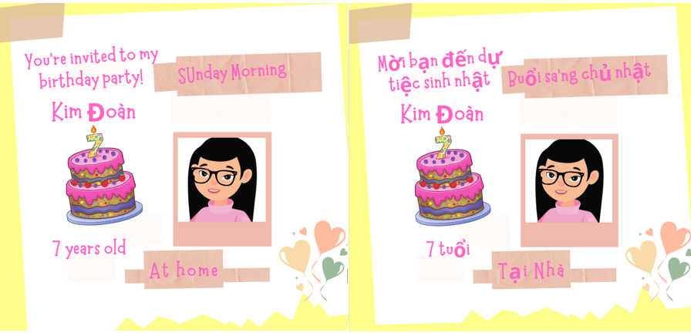
Students create an individual birthday invitation. In their invitation, they must include the following in Vietnamese:
- ‘You’re invited to my birthday party’
- Name of person having the party (Kim Doàn)
- Age of person having the party (7)
- Where the party is being held (at home)
- The day and time of day (Sunday morning) Ngày và giờ.
Note: depending on their language confidence students choose which resource writing template to use. Students that are proficient in Vietnamese can write the sentence Mời bạn đến dự sinh nhật của mình! (You’re invited to my birthday party!) And add how old they are turning.
Evaluation: check that students’ invitations include the following details in Vietnamese – age, the day, time of day and location of the party.

Week 5 – assessment criteria and practice task
The table below outlines the learning intention and success criteria of the lesson, and materials that the teacher and students will need to complete the teaching and learning activities.
Learning intention and success criteria | Materials
Students will develop an understanding of the requirements of the assessment task.  Students can:  - say what they need to do to be successful in the task  - ask questions if they don’t understand the requirement of the assessment task. | - Learning map  - Resource 10 – student rubric – Party time!  - Puppets (from previous lesson)

Activity 1 – warm up – ‘Buzz off’
- As a warm-up have students sit in a circle to play ‘Buzz off’ using the days of the week in Vietnamese.
- Pick a student to start with Monday. Students continue saying all the days of the week individually until they get to Sunday.
- Students sit down if they are unable to correctly say their day of the week.
- The next student then says ‘Buzz’, the next says ‘off’, then the next person says ‘hairy’, and the next says ‘legs’. The person who says ‘legs’ is out and sits down. Continue the game until you have a winner.
- Repeat the game with numbers from 1 to 10 in Vietnamese.

Activity 2 – introduce assessment task
- To prepare students for the final task, review the Learning map and discuss the language that has been taught each week. Point out that, according to the learning map, the final task will be completed in Week 6.
- Tell students that their communicative task is: You would like to invite your friend to your party by giving them an invitation that you have created. Greet your friend and ask them if they would like to come to your party. Tell them the details of your party in Vietnamese. Point out that:
- the context of the task is that you are having a party
- the audience of the communication will be your friend
- the communicative purpose or reason is to invite your friend to your party.

Activity 3 – success criteria
After looking at the assessment task, students Think-Pair-Share and suggest appropriate success criteria, such as:
I will be successful if I can:
- invite my friend to my party
- tell them where the party is
- tell them when the party is
- speak loudly and clearly
- say words in the correct order.
Explain Resource 10 – student rubric – Party time! and adjust if necessary.

Activity 4 – practice task – puppet talk
- Organise students into pairs and give them a few minutes to ensure everybody knows the order in which they will perform each role.
- Explain to students that the puppet is going to have a birthday party and would like to invite them.
- Demonstrate the interaction first, students repeat after each puppet speaks. Discuss what each sentence means.
- In pairs students hold a puppet each and practise the following exchange:
- Student 1: Chào bạn, bạn khỏe không? (Hi, [insert student name], how are you?)
- Student 2: Chào bạn, mình rất khỏe. (Hello, [insert student name], I’m very well.)
- Student 1: Bạn đến tiệc sinh nhật của mình được không? (Can you come to my birthday party?)
- Student 2: Ừa, mình đi được. Khi nào vậy? (Yes, I can come. When is it?)
- Student 1: Vào buổi sáng Chủ Nhật. (It is on Sunday morning.)
- Student 2: Tiệc ở đâu? (Where is the party?)
- Student 1: Ở công viên. (At the park.)
- Student 2: Cảm ơn bạn đã mời mình. (Thank you for the invitation.)
- Student 1: Không có chi. Hẹn gặp lại Chủ Nhật. (You’re welcome! See you on Sunday.)
Note: as students are completing the practice task, use the Intentional observation checklist for communicative activities to record your observations of students’ pronunciation and their use of grammar and vocabulary.

Week 6 – communicative task – invite a friend to your party
The table below outlines the learning intention and success criteria of the lesson, and materials that the teacher and students will need to complete the teaching and learning activities.
Learning intention and success criteria | Materials
Students will ask a friend to come their birthday party in Vietnamese.  Students can:  - invite a friend to their birthday party and include information such as when and where  - speak clearly and with expression  - use the appropriate volume and pace  - look at the audience  - use appropriate Vietnamese tone. | - Resource 11 – peer feedback strategy – Two stars and a wish  - Recording device  - Tripod and microphones (if possible)

Activity 1 – pass the message
- Students sit in a circle on the floor.
- Pick a student to start with a sentence that they have been learning in class. An example includes ‘Can you come to my party on Saturday?’. This student whispers it in the ear of the student next to them.
- The second student repeats the message to the third player, and so on.
- When the message reaches the last student, they announce the message they just heard, to the entire class. The first person then compares the original message with the final version.

Activity 2 – task set-up
Students get into groups of 3. Groups are given a few minutes to ensure everybody knows the order in which they will perform each role. ‘You’ is the student who will be completing the assessed communicative task.
Suggested rotations
- Role-play/Presentation 1: Student 1 – ‘You’, Student 2 – Peer assessor/Camera operator, Student 3 – Friend
- Role-play/Presentation 2: Student 1 – Friend, Student 2 – ‘You’, Student 3 – Peer assessor/Camera operator
- Role-play/Presentation 3: Student 1 – Peer assessor/Camera operator, Student 2 – Friend, Student 3 – ‘You’.

Activity 3 – communicative task – inviting a friend to your party
Note: make sure to space students apart when filming. Demonstrate how to film using a recording device. Use microphones, if possible, to maximise sound quality. Highlight the importance of holding the recording device still by using a tripod or resting it on a table.
All students will tell their friend about their birthday party. Remember to include greetings, day of the week, time of day and the location of your party.
Example interaction
- You: Chào _____, bạn khỏe không? (Hi _____, how are you?)
- Friend: Chào ______, mình rất khỏe. (Hello _____, I’m very well.)
- You: Bạn đến tiệc sinh nhật của mình được không? (Can you come to my birthday party?)
- Friend: Ừa, mình đi được. Khi nào vậy? (Yes, I can come. When is it?)
- You: Vào trưa chủ nhật. (It is on Sunday at lunchtime.)
- Friend: Tiệc ở đâu? (Where is the party?)
- You: Ở khu vui chơi. (At the park.)
- Friend: Cảm ơn bạn đã mời mình. (Thank you for the invitation.)
- You: Không có chi. Hẹn gặp lại chủ nhật. (You’re welcome. See you on Sunday.)
Note: students will insert their friend’s name in the blank space indicated.
Before recording interactions, check if any students do not have permission to be filmed. Alternatives to video recording include audio recording or the teacher watching the interactions while taking notes and marking the rubric.

Activity 4 – peer assessment
Note: this may be the first time students have engaged in peer assessment. As a result, you may need to provide further explanations about why this is important and what students should and shouldn’t do while giving and receiving peer assessment. Remind students that they need to be respectful to each other when giving and receiving feedback. Co-construct ground rules for peer feedback. Providing sentence starters, for example, ‘I like the way …’, ‘You did an excellent job of …’, ‘My favourite part was …’, ‘I didn’t understand …’ may be helpful to prompt them. Emphasise that the peer feedback should only be related to the visual rubric provided in this task.
Each student will provide and receive feedback to the student who was ‘you’ when they had the role of peer assessor/camera operator. Peer feedback is provided verbally and may be followed up with a completed peer feedback slip. See Resource 11 – peer feedback strategy – Two stars and a wish.

Week 7 – feedback and goal setting
Note: if there is insufficient time to mark the videos before Week 8, Weeks 7 and 8 can be swapped.
The table below outlines the learning intention and success criteria of the lesson, and materials that the teacher and students will need to complete the teaching and learning activities.
Learning intention and success criteria | Materials
Students will reflect on feedback to set suitable learning goals.  Students can:  - reflect on the feedback provided to establish a new learning goal. | - Resource 10 – student rubric – Party time! – teacher marked rubric (one per student)  - Language exercise books  - Recording of each student’s performance
Note: prior to this lesson, the teacher views each video and marks each student according to the criteria on the Resource 10 – student rubric – Party time!.

Activity 1 – beat the teacher
- Using images from Resource 6 – memory game cards, hold a card up to the class and call out what is on that card in Vietnamese.
- You may choose to read out what is written on the game card or you can try and trick the class by saying something different. If the party location matches what is written on the card, the class must all repeat it immediately. If this happens, students get a point.
- If the party location that is called out is different to what is on the flashcard the students must remain silent. If any student repeats the wrong word, then the teacher gets a point. If all students stay silent, they get a point.

Activity 2 – self-assessment
Students watch the video of themselves completing the task and mark themselves using the Resource 10 – student rubric – Party time! Students then compare both the teacher completed rubric and the one they completed.

Activity 3 – set learning goals
- Students reflect on the teacher, peer- and self-evaluation to set learning goals for the next phase of learning. Example learning goals could be: ‘I will not be worried about making a mistake when speaking Vietnamese’. Learning goals are written in language notebooks.
Note: this may be the first time students will be setting learning goals. Students will choose a suggested learning goal from the list below by raising their hand.
- To foster student ownership of their learning, facilitate a class discussion to help students reflect on their marked rubric, peer- and self-assessment and set their own personalised learning goals for the next phase. Use simplified language to ensure that the students can understand and engage with the discussion effectively.
- Teacher suggested learning goals include:
- I will be confident when saying words in Vietnamese.
- I will try to say Vietnamese words in the correct order.
- I will practise saying tricky sounds in Vietnamese.
- Encourage students to raise their hands when they hear a goal that resonates with them. Students record their learning goals.
Evaluation: students set appropriate learning goals based on previous learning goals and/or teacher, peer- and self-assessment.

Week 8 – language review
Note: if there is insufficient time to mark the videos before Week 8, Weeks 7 and 8 can be swapped.
The table below outlines the learning intention and success criteria of the lesson, and materials that the teacher and students will need to complete the teaching and learning activities.
Learning intention and success criteria | Materials
Students will reflect on and ask questions about the language taught in this unit.  Students can:  - ask questions about vocabulary, grammar or pronunciation they have used in this unit  - use the Vietnamese they have learned to communicate with classmates. | - Individual whiteboards (class set)  - Hand puppets from previous lessons  - Vocabulary tables 1 to 4 (class set)
Note: over the course of the unit, gaps in student knowledge, misconceptions and misuse of language will have been identified. These observations are addressed using engaging and interactive activities and strategies. The activities below are examples and will need to be supplemented with activities to address your observations.

Activity 1 – student questions
Remind students of the activities and tasks they have completed over the course of the unit. Give students time to Think-Pair-Share any questions they may have about any aspect of the language taught.

Activity 2 – grammar review
This station will focus on grammar taught during the unit.
Suggested activities
- Hand puppets: In pairs, students use their hand puppets to invite each other to their party. Each student has a turn at being the student that is invited and being the student inviting. The conversation must include where and when the party is taking place.
- Ask me a question: In pairs students ask each other questions about the other student’s party. For example:
- Student 1: Bạn đến tiệc sinh nhật của mình được không? (Can you come to my birthday party?)
- Student 2: Vâng. Mình đến được. (Yes. I can come.)
- Student 1: Tiệc của bạn khi nào? (When is your party?)
- Student 2: Là thứ bảy. (It is this Saturday.)
- Student 1: Tiệc ở đâu vậy? (Where is your party?)
- Student 2: Tiệc ở công viên. (My party is in a park.)
Students swap roles and then start a new conversation with another partner.
Note: as students practise language throughout each station, use the Intentional observation checklist for communicative activities to record your observations of students’ pronunciation and their use of vocabulary.

Student resources

Resource 1 – Who has? number cards
Em có số một, ai có số hai? |  | Em có số hai, ai có số ba? |  | Em có số ba, ai có số bốn? |  | Em có số bốn, ai có số năm?
I have 1, who has 2? |  | I have 2, who has 3? |  | I have 3, who has 4? |  | I have 4, who has 5?
Em có số năm, ai có số sáu? |  | Em có số sáu, ai có số bảy?  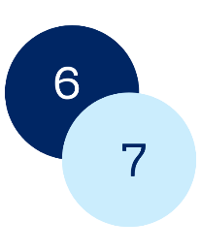 |  | Em có số bảy, ai có số tám?  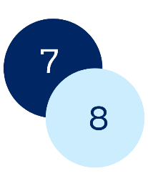 |  | Em có số tám, ai có số chín?
I have 5, who has 6? |  | I have 6, who has 7? |  | I have 7, who has 8? |  | I have 8, who has 9?
Em có số chín, ai có số mười?  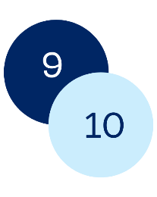 |  | Em có số mười, ai có số mười một?  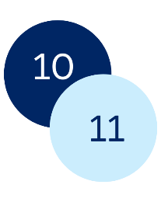 |  | Em có số mười một, ai có số mười hai?  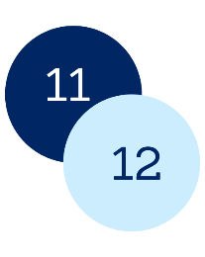 |  | Em có số mười hai, ai có số mười ba?  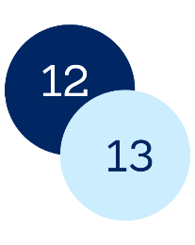
I have 9, who has 10? |  | I have 10, who has 11? |  | I have 11, who has 12? |  | I have 12, who has 13?
Em có số mười ba, ai có số mười bốn?  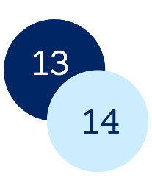 |  | Em có số mười bốn, ai có số mười năm?  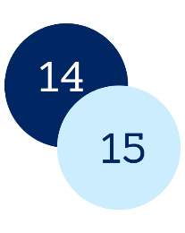 |  | Em có số mười năm, ai có số mười sáu?  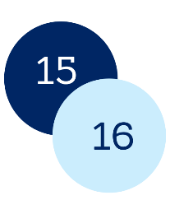 |  | Em có số mười sáu, ai có số mười bảy?  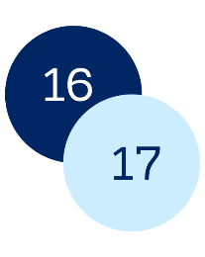
I have 13, who has 14? |  | I have 14, who has 15? |  | I have 15, who has 16? |  | I have 16, who has 17?
Em có số mười bảy, ai có số mười tám?  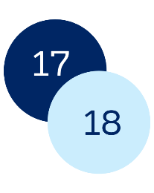 |  | Em có số mười tám, ai có số mười chin?  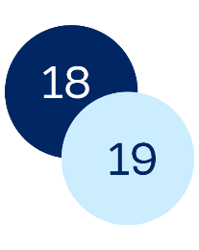 |  | Em có số mười chin, ai có số hai mười?  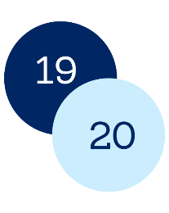 |  | Em có số hai mười.  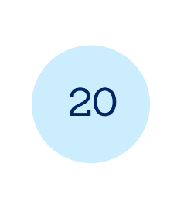
I have 17, who has 18? |  | I have 18, who has 19? |  | I have 19, who has 20? |  | I have 20
This resource can be adapted by replacing the text to suit your language.

Resource 2 – days of the week poster
Thứ Hai |  | Monday
Thứ Ba |  | Tuesday
Thứ Tư |  | Wednesday
Thứ Năm |  | Thursday
Thứ Sáu |  | Friday
Thứ Bảy |  | Saturday
Chủ Nhật |  | Sunday
This resource can be adapted by replacing the text to suit your language.

Resource 3 – days of the week SNAP! cards
Thứ Hai |  | Thứ Ba |  | Thứ Tư |  | Thứ Năm
 |  |  |  |  |  | 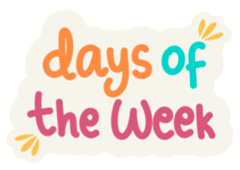
Thứ Sáu |  | Thứ Bảy |  | Chủ Nhật |  | Các ngày trong tuần
This resource can be adapted by replacing the text to suit your language.
This resource can be adapted by replacing the text to suit your language.
Thứ Hai |  | Thứ Ba |  | Thứ Tư |  | Thứ Năm
Thứ Sáu |  | Thứ Bảy |  | Chủ Nhật |  | Các ngày trong tuần

Resource 4 – time of day flashcards
morning |  | lunchtime |  | afternoon
buổi sáng |  | buổi trưa |  | buổi trưa
This resource can be adapted by replacing the text to suit your language.

Resource 5 – sentence builder
My birthday party is on | Day | Preposition | Time
Mình muốn tổ chức tiệc sinh nhật của mình vào  (My birthday party is on …) | Thứ Bảy (Saturday)  Chủ Nhật (Sunday)  Thứ Hai (Monday)  Thứ Ba (Tuesday)  Thứ Tư (Wednesday)  Thứ Năm (Thursday)  Thứ Sáu (Friday) | lúc (in the)  ở (at) | buổi sáng. (morning.)  buổi trưa. (lunchtime.)  buổi chiều. (afternoon.)

Resource 6 – memory game cards
This resource can be adapted by replacing the text to suit your language.
biển |  | biển |  | công viên |  | công viên |  | nhà hàng |  | nhà hàng
nhà |  | nhà |  | hồ bơi |  | hồ bơi |  | khu vui chơi |  | khu vui chơi

beach |  | beach |  | park |  | park |  | restaurant |  | restaurant
home |  | home |  | swimming pool |  | swimming pool |  | playground |  | playground

Resource 7 – jumbled sentences
Sinh nhật | của mình
ở | nhà | .

Sinh nhật | của mình
ở | Khu vui chơi trong nhà | .

Sinh nhật | của mình
ở | hồ bơi | .

Sinh nhật | của mình
ở | công viên | .

Sinh nhật | của mình
ở | nhà hàng | .

Sinh nhật | của mình
ở | biển | .

birthday | My | is
at | house. | my

birthday | My | is
at | indoor playground | the

birthday | My | is
at | pool | the

birthday | My | is
at | park | the

birthday | My | is
at | restaurant | a

birthday | My | is
at | beach | the

Resource 8 – question maker
Question | Venue
Can you come to my birthday party at ... | - the park?  - the pool?  - my house?  - the indoor playground?  - the restaurant?

Câu Hỏi | Nơi
- Bạn đến dự tiệc sinh nhật của mình ở …  - được không? | - công viên?  - hồ bơi?  - nhà?  - khu vui chơi?  - nhà hàng?  - biển?

Resource 9 – puppet printout
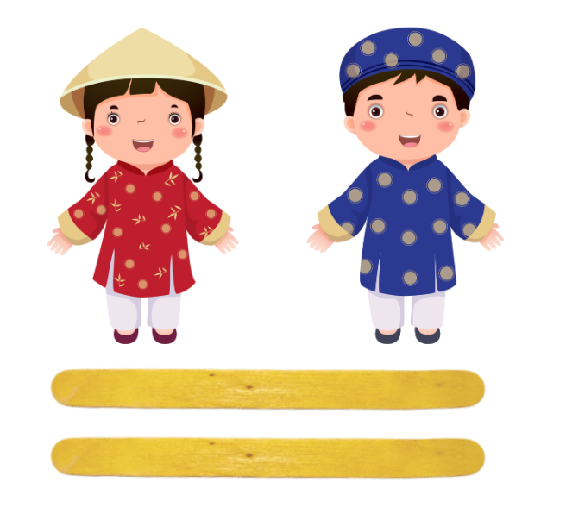

Resource 10 – student rubric – Party time!
I can invite my friend to my party.
I can tell them where the party is.
I can tell them when the party is.
I can speak loudly and clearly.
I can say words in the right order.

Resource 11 – peer feedback strategy – Two stars and a wish
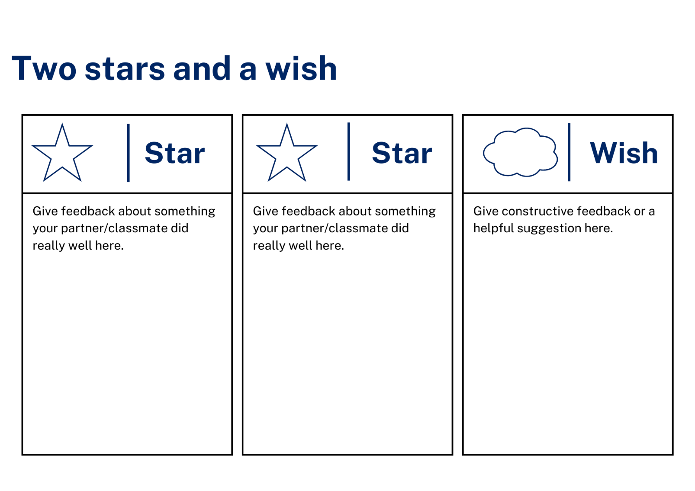

Support and alignment
Resource evaluation and support: all curriculum resources are prepared through a rigorous process. Resources are periodically reviewed as part of our ongoing evaluation plan to ensure currency, relevance, and effectiveness. For additional support or advice, contact the Primary Languages team by emailing primlang@det.nsw.edu.au.
Alignment to system priorities and/or needs: School Excellence Policy
Alignment to the School Excellence Framework: this resource supports the School Excellence Framework elements of curriculum (curriculum provision, teaching and learning programs) and effective classroom practice (lesson planning).
Alignment to Australian Professional Teaching Standards: this resource supports teachers to address Australian Professional Teaching Standards 2.2.2, 3.2.2.
Consulted with: Curriculum, Secondary Learners, school-based staff and NESA subject matter experts. Advice from Aboriginal Outcomes and Partnerships, EAL/D, HPGE and Inclusive Education for Modern Languages Stage 3 Italian Mangiare in Ristorante has been considered in preparing this document.
NSW syllabus: Modern Languages K–10 Syllabus
Syllabus outcomes: ML1-INT-01, ML1-UND-01, ML1-CRT-01
Author: Primary Curriculum
Publisher: State of NSW, Department of Education
Resource: unit
Related resources: further resources to support Stage 1 Modern Languages can be found on the Languages K–6 curriculum page.
Professional learning: relevant professional learning is available through Primary Languages Statewide Staffroom on Teams (staff only).
Universal Design for Learning: support the diverse learning needs of students using inclusive teaching and learning strategies. Some students may require more specific adjustments to allow them to participate on the same basis as their peers. For further advice see Inclusive practice resources for primary school.
Differentiation: when using these resources in the classroom, it is important for teachers to consider the needs of all students in their class, including:
- Aboriginal and Torres Strait Islander students. Targeted strategies can be used to achieve outcomes for Aboriginal students in K-12 and increase knowledge and understanding of Aboriginal histories and cultures. Teachers should use students’ Personalised Learning Pathways to support individual student needs and goals.
- EAL/D learners. EAL/D learners may require scaffolding to support them to gain content knowledge, while providing extra time and assistance to master the English language required to engage with texts or complete classroom tasks. View some samples of differentiating through scaffolding.
- Students with additional learning needs. Learning adjustments enable students with disability and additional learning and support needs to access syllabus outcomes and content on the same basis as their peers. Teachers can use a range of adjustments to ensure a personalised approach to student learning.
- High potential and gifted learners. Assessing and identifying high potential and gifted learners will help teachers decide which students may benefit from extension and additional challenge. In addition, the Differentiation Adjustment Tool can be used to support the specific learning needs of high potential and gifted students.
Creation date: 28 February 2024
Rights: © State of New South Wales, Department of Education

References
This resource contains NSW Curriculum and syllabus content. The NSW Curriculum is developed by the NSW Education Standards Authority. This content is prepared by NESA for and on behalf of the Crown in right of the State of New South Wales. The material is protected by Crown copyright.
Please refer to the NESA Copyright Disclaimer for more information https://educationstandards.nsw.edu.au/wps/portal/nesa/mini-footer/copyright.
NESA holds the only official and up-to-date versions of the NSW Curriculum and syllabus documents. Please visit the NSW Education Standards Authority (NESA) website https://educationstandards.nsw.edu.au/ and the NSW Curriculum website https://curriculum.nsw.edu.au.
Modern Languages K–10 Syllabus © NSW Education Standards Authority (NESA) for and on behalf of the Crown in right of the State of New South Wales, 2022.
8 Ways (n.d.) 8 Aboriginal Ways of Learning [website], accessed 13 December 2022.
AITSL (Australian Institute for Teaching and School Leadership Limited) (2017) Feedback Factsheet, AITSL, accessed 28 February 2024.
Brookhart SM (2011) How to Assess Higher-Order Thinking Skills in Your Classroom, Hawker Brownlow Education, Victoria.
CESE (Centre for Education Statistics and Evaluation) (2020a) What works best: 2020 update, NSW Department of Education, accessed 28 February 2024.
CESE (2020b) What works best in practice, NSW Department of Education, accessed 28 February 2024.
Conti G (28 September 2015) 16 tips for effective grammar teaching in the foreign language classroom, The Language Gym website, accessed 28 February 2024.
Conti G (28 May 2017) From Target Language to Model Language – the mind shift that has transformed my teaching, The Language Gym website, accessed 28 February 2024.
Henshaw FG and Hawkins MD (2022) Common Ground: Second Language Acquisition Theory Goes to the Classroom, Focus, Hackett Publishing Company, Indianapolis.
Jones J and Wiliam D (2014) Modern Foreign Languages Inside the Black Box: Assessment for Learning in the Modern Foreign Languages Classroom GL Assessment, United Kingdom.
NESA (NSW Education Standards Authority) (2020) NSW Curriculum Review – final report, NESA website, accessed 28 February 2024.
Rosenshine B (2012) ‘Principles of Instruction: Research-Based Strategies That All Teachers Should Know’, American Educator, 36(1):12–19, ISSN-0148-432X, accessed 28 February 2024.
Smith S (2022) Becoming an Outstanding Languages Teacher, 2nd edn, Routledge, United Kingdom.
Wisniewski B, Zierer K and Hattie J (2020) ‘The Power of Feedback Revisited: A Meta-Analysis of Educational Feedback Research’, Frontiers In Psychology, 10(3087), doi:10.3389/fpsyg.2019.03087, accessed 28 February 2024.
Wiliam D (2013) ‘Assessment: The Bridge between Teaching and Learning’, Voices from the Middle, 21(2):15–20, DOI:10.58680/vm201324461, accessed 28 February 2024.
Wiliam D and Leahy S (2015) Embedding Formative Assessment: Practical Techniques for K–12 Classrooms, Learning Sciences International, United States.

© State of New South Wales (Department of Education), 2024
The copyright material published in this resource is subject to the Copyright Act 1968 (Cth) and is owned by the NSW Department of Education or, where indicated, by a party other than the NSW Department of Education (third-party material).
Copyright material available in this resource and owned by the NSW Department of Education is licensed under a Creative Commons Attribution 4.0 International (CC BY 4.0) license.
This license allows you to share and adapt the material for any purpose, even commercially. Attribution should be given to © State of New South Wales (Department of Education), 2024.
Material in this resource not available under a Creative Commons license:
- the NSW Department of Education logo, other logos and trademark-protected material
- material owned by a third party that has been reproduced with permission. You will need to obtain permission from the third party to reuse its material.
Links to third-party material and websites
Please note that the provided (reading/viewing material/list/links/texts) are a suggestion only and implies no endorsement, by the New South Wales Department of Education, of any author, publisher, or book title. School principals and teachers are best placed to assess the suitability of resources that would complement the curriculum and reflect the needs and interests of their students.
If you use the links provided in this document to access a third-party's website, you acknowledge that the terms of use, including licence terms set out on the third-party's website apply to the use which may be made of the materials on that third-party website or where permitted by the Copyright Act 1968 (Cth). The department accepts no responsibility for content on third-party websites.

