Chinese Early Stage 1
说说我的玩具 (Show and tell)
Contents
Unit overview 5
Early Stage 1 outcomes and content to be addressed 6
Learning map 9
Assessment 12
Assessment opportunities 13
Teaching and learning activities 14
Week 1 – toys 14
Vocabulary 1 – toys 14
Activity 1 – learning map 15
Activity 2 – toys 16
Activity 3 – Chinese whispers 17
Activity 4 – ‘Duck, duck, goose’ 17
Week 2 – ‘This is my …’ 18
Activity 1 – my toy 18
Activity 2 – ‘This is my ...’ 19
Activity 3 – guess the toy 19
Activity 4 – draw and label ‘This is my ...’ 20
Week 3 – size and colour 21
Vocabulary 2 – colour and size 21
Activity 1 – vocabulary 22
Activity 2 – cross the river 23
Activity 3 – colourful toys 23
Activity 4 – listen and colour 24
Activity 5 – big and small 25
Activity 6 – put it all together 26
Week 4 – I like my toy 27
Activity 1 – reading 27
Activity 2 – Bingo 28
Activity 2 – I like my … 28
Activity 3 – pass the parcel 29
Activity 4 – toy charades 29
Week 5 – assessment criteria and practice task 31
Activity 1 – find opposite friends 31
Activity 2 – discuss the assessment task 32
Activity 3 – success criteria 33
Activity 4 – discuss the rubric 33
Activity 5 – peer assessment 34
Activity 6 – practice task 35
Week 6 – communicative task – introduce your toy 36
Activity 1 – sentence race 36
Activity 2 – set up 37
Activity 3 – communicative task – introduce your toy 38
Activity 4 – peer assessment 39
Week 7 – feedback and goal setting 40
Activity 1 – Bingo 41
Activity 2 – self-assessment 41
Activity 3 – learning goals 41
Week 8 – language review 43
Activity 1 – student questions 44
Activity 2 – fly swat 44
Activity 3 – Hot seat 44
Activity 4 – create your own toy 45
Student resources 46
Resource 1 – toy flashcards 46
Resource 2 – colours and size flashcards 48
Resource 3 – listen and colour 50
Resource 4 – Bingo cards 51
Resource 5 – student rubric 56
Resource 6 – flashcard mat 57
Resource 7 – peer feedback strategy – Two stars and a wish 58
Support and alignment 59
References 62

Unit overview
Stage: Early Stage 1
Title: 说说我的玩具 (Show and tell)
Description: In this unit, students introduce their favourite toy to the class in Chinese. They use basic adjectives to describe the size and colour of their toy.
Duration: This lesson sequence is designed to be completed over approximately 8 weeks.
Student proficiency levels:
Early Stage 1: It is assumed that most Early Stage 1 students are Beginner learners of Chinese. Some Early Stage 1 students may be Intermediate or Advanced users of Chinese if it is the background language of their family or it is their mother tongue. The assessment tasks in this scope and sequence are aimed at Beginner students. Every classroom will be different and teachers will need to adapt to their context. Many classes may include a combination of Beginner, Intermediate and Advanced students with varying skills and abilities within these proficiency levels. Assessment tasks and opportunities in this unit can be differentiated using the ‘Too hard?’ and ‘Too easy?’ suggestions.

Early Stage 1 outcomes and content to be addressed
The table below outlines the focus area, outcomes and content points for Early Stage 1 students.
Focus area and outcome | Content points
Interacting  A student:  - exchanges meaning through play and actions by reproducing culturally appropriate modelled language MLE-INT-01 | Exchanging meaning in oral interactions in the target language  - Interact in classroom routines reproducing modelled language with actions and gestures  - Interact in games and imaginative play  Reproducing oral language to interact in the target language  - Reproduce modelled vocabulary and formulaic phrases on familiar themes to interact  - Recognise and reproduce modelled sounds to interact  Reproducing how target language speakers communicate in interactions  - Reproduce verbal and nonverbal communication that is appropriate to cultural practices
Understanding texts  A student:  - responds to information in simple texts in a variety of ways to demonstrate understanding MLE-UND-01 | Understanding and responding to target language texts  - Listen to, read and/or view simple texts such as stories or songs by participating in shared activities  - Use auditory cues, gestures, visuals and other forms of nonverbal communication to understand texts  - Associate vocabulary on familiar themes with known actions, people, places and objects  - Respond to simple texts using actions, drawing and singing in the target language and/or English  - Reproduce vocabulary seen or heard in texts to demonstrate understanding  Developing knowledge of language systems to understand and respond to target language texts  - Recognise the meaning of modelled vocabulary on familiar themes to understand and respond to texts  - Recognise and reproduce sounds to understand and respond to texts  - Connect symbols in the target language with familiar sounds to understand and respond to texts  - Notice and reproduce symbols of the writing system to understand and respond to texts  Developing intercultural understanding through target language texts  - Understand that there are many languages and cultural practices that are used by peers, family and community
Creating texts  A student:  - creates simple texts by reproducing culturally appropriate modelled vocabulary MLE-CRT-01 | Creating multimodal texts in the target language  - Create texts reproducing modelled vocabulary with visuals and other forms of nonverbal communication to express meaning  - Label objects and caption images  Reproducing vocabulary to create texts  - Reproduce modelled vocabulary and formulaic phrases on familiar themes to create texts  - Use modelled sound–symbol correspondences to create written texts  - Reproduce modelled features of the target language writing system to create simple written texts  Reproducing how target language speakers communicate to create texts  - Reproduce language appropriate to cultural practices to create texts
Modern Languages K–10 Syllabus © NSW Education Standards Authority (NESA) for and on behalf of the Crown in right of the State of New South Wales, 2022.

Learning map
The creation of maps for learning is a planning process that incorporates Aboriginal intellectual tradition. Learning maps are a visual pathway of what students will learn.
Share the learning map with your students, briefly explaining the learning that will happen in each lesson. Provide students with a copy of the learning map or display the learning map in the classroom. This learning map can be adapted to Chinese by accessing a copy of Learning map – 说说我的玩具 (Show and tell) (Early Stage 1).

Figure 1 – Show and tell learning map
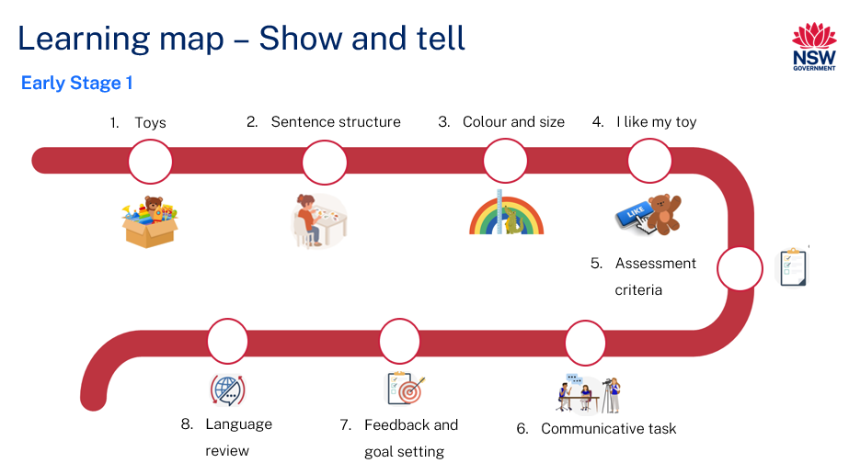
Figure 2 – 说说我的玩具learning map
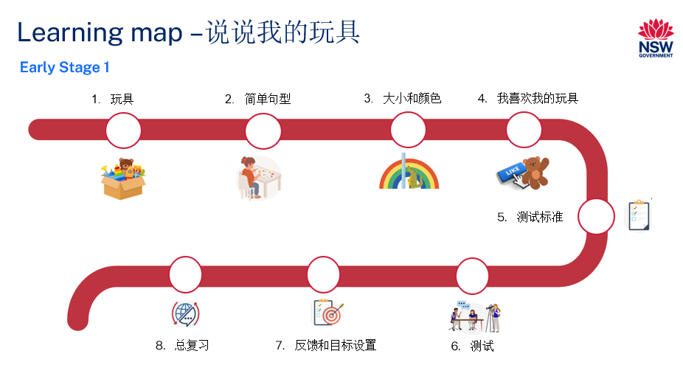

Assessment
Early Stage 1 communicative task: For your news day, introduce your favourite toy to your classmates. Bring a toy from home and describe it.
Too hard?
Students say what their favourite type of toy is.
Too easy?
Students introduce their favourite toy and say why they like it.
Context: it’s your news day. Introduce your toy to the class.
Audience: classmates
Purpose: to tell your class about your favourite toy

Assessment opportunities
The table below details assessment opportunities and differentiation ideas.
Assessment opportunities | Too hard? | Too easy?
Week 1 – toys  Pre-assessment of vocabulary knowledge. | Toys  If most of the students know only a few of the words, reduce the number of words taught. | Toys  If most of the students know all of the words, include additional vocabulary, such as, 球 (ball), 火车 (train), 拼图 (puzzles).
Week 2 – this is my …  Students practise sentence structure, 这是我的 (‘This is my …’) by saying the word for the toy on the flashcards they pick up. | This is my ...  Students name the toy on the flashcard by saying ‘My (toy)’. | This is my ...  Guess 2 toy flashcards and say the sentence to include 2 toys. For example: 这是我的车和泰迪熊. (‘This is my car and teddy bear.’)
Week 3 – put it all together  In pairs, use flashcards to describe a toy’s colour and size. For example, 我的娃娃是红色的. (‘My doll is red.’) 我的娃娃小. (‘My doll is small.’) | Put it all together  Students use adjectives to describe the toy by saying 红色的 (‘red’) or 娃娃小 ('small doll’). | Put it all together  Students describe a toy using 2 or more adjectives.

Teaching and learning activities

Week 1 – toys
The table below outlines the learning intention and success criteria of the lesson, and materials that the teacher and students will need to complete the teaching and learning activities.
Learning intention and success criteria | Materials
Students will use vocabulary related to toys in Chinese.  Students can:  - say the name of common toys in Chinese. | - Resource 1 – toy flashcards  - wǒdē wánjù PowerPoint book (Chinese)  - My toy PowerPoint book (English)  - Learning map  - Real toys of similar colours and size if available

Vocabulary 1 – toys
The table below outlines the suggested vocabulary for Activity 2, Activity 3 and Activity 4. It includes the original Chinese characters, a Romanised version of the Chinese characters (Pinyin) and the corresponding English translations.
English | Romanised Chinese (Pinyin) | Chinese characters
toy | wán jù | 玩具
car | qìchē | 汽车
teddy bear | tài dí xióng | 泰迪熊
doll | wáwa | 娃娃
dinosaur | kǒng lóng | 恐龙
shuttlecock | jiàn zi | 毽子
ball | qiú | 球

Activity 1 – learning map
Explain and display the Learning map to give students a more detailed breakdown of lessons during the unit. Point out that the Learning map is a plan that may need to change.

Activity 2 – toys
- Have students sit on the floor and read the PowerPoint book My toy. To pre-assess students’ prior knowledge, ask the following questions and have students respond with an answer or a ‘thumbs up’.
- Do you know the names of all the toys in Chinese?
- Do you know most of them?
- Do you know any of them?
- In pairs, students Think-Pair-Share the words they know.
- Display toys in the book or Resource 1 – toy flashcards on the board. Call out each word on the flashcard in Chinese and ask students to tell their partners the words they know by saying them in English.
- As a whole class, say the names of the toys aloud in Chinese one at a time, and have students repeat each word after you. Model and drill the correct pronunciation of names of toys in Chinese.
- Point to the picture of a shuttlecock. Tell students that a 毽子 (shuttlecock) is a traditional Chinese toy. Kicking a shuttlecock is a traditional Chinese sport. Shuttlecock kicking originated about 2000 years ago. The goal is to kick the shuttlecock to make it remain in the air. You compete to kick as many times as possible or do tricks while kicking.
Note: you may bring some shuttlecocks and demonstrate kicking it in front of the students to show them how to play if possible. Allow them time to play with the shuttlecock if time permits. Teachers of other languages can replace the shuttlecock with a culturally relevant toy.

Activity 3 – Chinese whispers
Divide the class into small groups of 6 and ask them to sit in a straight line. Tell the first student of each line the name of a toy in Chinese. The first student whispers the word to the next student until the last student has heard the name. The last student then calls out the name of the toy they have heard and picks up the correct flashcard (from Resource 1) or toy (if available).

Activity 4 – ‘Duck, duck, goose’
- Play a game of ‘Duck, duck, goose’ in English if students are not familiar with the game.
- Tell students that they will be playing an adapted version of the game, ‘Duck, duck, goose’.
- Pick any 3 words from Vocabulary 1 – toys to be used to replace ‘Duck, duck, goose’. For example, 泰迪熊 (teddy bear), 玩具汽车 (car), 娃娃 (doll).
- Ask students to sit in a circle. Put the flashcards from Resource 1 – toy flashcards in the centre of the circle. Choose 娃娃 (doll) as the ‘goose’ word. Ask one student to stand behind the seated students.
- As the student walks around, they gently tap the players’ shoulders and say whether they are a 泰迪熊 (teddy bear), 玩具汽车 (a toy car) or a 娃娃 (doll). Once someone is the ‘goose’ 娃娃 (doll), they get up and try to chase the student around the circle. The goal is for the ‘goose’ 娃娃 (doll) to catch the student before they sit or stand in the ‘goose’s’ spot.
Evaluation: students can identify and say the names of the toys in Chinese.

Week 2 – ‘This is my …’
The table below outlines the learning intention and success criteria of the lesson, and materials that the teacher and students will need to complete the teaching and learning activities.
Learning intention and success criteria | Materials
Students will introduce a toy in Chinese.  Students can:  - say the phrase ‘This is my …’ correctly in Chinese. | - Resource 1 – toy flashcards for display and sets for small groups  - Lead pencils and coloured pencils  - Toys  - White A4 paper

Activity 1 – my toy
- Split the class into small groups and hand out Resource 1 – toy flashcards to each group. Spread the flashcards out on the ground. One student from each group calls out a word from the flashcards. The other students listen to the called-out word and the first one to pick the correct flashcard wins the round. That student will now call out a different word. Repeat the activity, ensuring all students get a turn at calling out a word.
- Demonstrate saying 我的… (my...) in Chinese using Resource 1 – toy flashcards and point to yourself, for example: 我的汽车 (my car), 我的泰迪熊 (my teddy bear) and so on.
- Have students repeat the phrase 我的... (my…) using the flashcards and pointing to themselves and then the toy on the flashcard. Ask students to complete this activity in groups of 3. They take turns picking up a flashcard and saying 我的... (my…) followed by the name of the toy.

Activity 2 – ‘This is my ...’
- Display the words 这/是/我的 (This/is/my) separately on the board along with the Pinyin. Model saying the phrase 这是我的... (‘This is my …’). Add a toy card from Resource 1 – toy flashcards to the end of the phrase to make the sentence 这是我的...[玩具.]’ (‘This is my ... [name of a toy].’) Ask students to repeat the sentences using different toys. Ask students to clap hands as they say each group of words.
- For example, point to the phrase 这/是/我的 (‘This/is/my’) on the board and say it aloud. Say the chunk of words 这是/我的 (‘This/is/my’) while clapping your hands to show syllables.
- Add the teddy bear card to the end of the phrase on the board.
- Say 这是/我的/泰迪熊 (‘This/is/my /teddy bear.’) Have students repeat after you while clapping their hands.
- Keep the phrase 这/是/我的... (‘This/is/my …’) on the board and replace the teddy bear with a different toy from Resource 1 – toy flashcards. Say the sentence with students while your clapping hands.
- Split the class into small groups of 3 and have them repeat the activity in their groups.

Activity 3 – guess the toy
- Tell students that they will be playing a guessing game. Keep the phrase 这/是/我的... (‘This/is/my ...’) on whiteboard. Have a pile of Resource 1 – toy flashcards at the front. Ask one student to come to the front and guess what toy card they will pick up using a full sentence. The student says 这是我的... (‘This is my ...’) followed by the word on the flashcard. They then say the word on the flashcard they turn over, before using this word in a sentence. For example:
- student guesses: 这是我的娃娃. (‘This is my doll.’)
- student picks up a flashcard: 汽车 (‘car’).
- new sentence: 这是我的汽车. (‘This is my car.’)
- Ask students to repeat the activity in pairs. They take turns to guess and say their toy. Whoever says the toy correctly can keep the card. The winner is the one with the most toy cards.

Activity 4 – draw and label ‘This is my ...’
Model how to draw and label a favourite toy by copying the Pinyin of the toy. Ask students to draw their favourite toy on paper. Then label the picture by copying the Pinyin next to the word. Have students verbally introduce their drawing by saying 这是我的... (‘This is my ...’) in Chinese to a partner.
Note: write Chinese characters on the paper for students with Intermediate or Advanced proficiency and ask them to trace the characters using different colours.
Evaluation: students introduce their favourite toy in Chinese correctly.

Week 3 – size and colour
The table below outlines the learning intention and success criteria of the lesson, and materials that the teacher and students will need to complete the teaching and learning activities.
Learning intention and success criteria | Materials
Students will use words and phrases related to colours and sizes of toys in Chinese.  Students can:  - identify and say words to indicate size in Chinese  - identify and say colours in Chinese  - say a sentence to describe their toy in Chinese. | - Resource 1 – toy flashcards  - Resource 2 – colours and size flashcards  - Resource 3 – listen and colour  - wǒ dē wánjù PowerPoint book (Chinese)  - Coloured pencils  - Toys of various sizes (for example, a big car and a small toy car)

Vocabulary 2 – colour and size
The table below outlines the suggested vocabulary for Activity 1, Activity 2, Activity 3 and Activity 4. It includes the original Chinese characters, a Romanised version of the Chinese characters (Pinyin) and the corresponding English translations.
English | Romanised Chinese (Pinyin) | Chinese
brown | zōng sè de | 棕色的
red | hóng sè de | 红色的
blue | lán sè de | 蓝色的
green | lǜ sè de | 绿色的
big | dà | 大
small | xiǎo | 小

Activity 1 – vocabulary
- To pre-assess students’ vocabulary before teaching new words, ask students to turn to a partner and tell them any colours they know in Chinese using the Think-Pair-Share strategy.
- Display colours flashcards from Resource 2 – colours and size flashcards on the board. Call out each word on the board and ask students to show a ‘thumbs up’ at their chest when they are familiar with a colour. Read aloud the colours in Chinese using Resource 2 – colours and size flashcards and have students repeat each word after you call them out. Model and drill the correct pronunciation of colours in Chinese.
- Read aloud Vocabulary 2 – colour and size using the colour flashcards and have students repeat each word after you. Model and drill the correct pronunciation of colours and sizes of toys.
Note: if needed, introduce more colours based on the toys that you use in your classroom.

Activity 2 – cross the river
- Split the class in half and have them stand in 2 lines.
- Scatter multiple sets of Resource 2 – colours and size flashcards on the floor, forming 3 rows like rocks in the river. Ensure that each row has all the colours.
- Call out the name of one colour from Vocabulary 2 – colour and size. Students from each team stand on the flashcard of the colour they hear in the first row. If they stand on the incorrect flashcard, they step back to where they were.
- The first student to cross all the 3 rows and ‘cross the river’ wins the first round for their team.

Activity 3 – colourful toys
- Display Resource 1 – toy flashcards. Display one flashcard at a time and ask students to say the sentence with the name of toy displayed at the end using 这是我的... (‘This is my ...’) phrase. For example, display the picture of a teddy bear. Students say 这是我的泰迪熊. (‘This is my teddy bear.’)
- Ask students what colour the teddy bear is. Students say 棕色的 (brown). Demonstrate and model saying 我的泰迪熊是... (‘My teddy bear is …’) Tell students that they will add the colour of the teddy bear to make a complete sentence. For example: 我的泰迪熊是棕色的. (‘My teddy bear is brown.’) Sample interaction:
- Teacher displays the teddy bear flashcard.
- Students say 这是我的泰迪熊. (‘This is my teddy bear.’)
- Teacher points at the body of teddy bear.
- Students say 我的泰迪熊是棕色的. (‘My teddy bear is brown.’)
- Repeat the activity with different toy flashcards. After a few repetitions, have students practise saying the sentences with different toys as a class and then in small groups.

Activity 4 – listen and colour
- Hand out Resource 3 – listen and colour to students. Say a sentence about each picture to describe its colour and ask the students to colour in the pictures accordingly. For example: The teacher says ‘My teddy bear is brown.’ Students colour in the picture of a teddy bear, brown.
- Have the students talk about their pictures and colours with different partners using learned sentence structure.
- Sample answers: The student may say: 这是我的泰迪熊. (‘This is my teddy bear.’) 我的泰迪熊是棕色的. (‘My teddy bear is brown.’)

Activity 5 – big and small
Note: print 2 versions of Resource 1 – toys flashcards. Enlarge or reduce the flashcards to indicate the size of the toys. Tell students that one set is of big toys and the other one is of small toys. Use these sets for any activities related to size in the unit.
- Read the wǒ dē wánjù PowerPoint book and ask students to identify ‘big’ and ‘small’ toys on the page.
- Display real toys or Resource 1 – toys flashcards. Show students 2 toy cars or flashcards, one big and one small. Compare and model how to say 大 (big) and 小 (small) in Chinese. Use actions to assist. Stretch their arms for 大 (big), and put their thumb and index finger together, pinching, with a small space between the fingers, for 小 (small). Say the sentence loudly if the toy is big and softly if the toy is small. Have students repeat as a class with actions and volume of voice.
- Display flashcards one at time and move your arms to indicate size. Model saying 我的汽车大/小. (‘My car is big/small.’) while showing the picture of a car and changing the position of your arms. Repeat the activity with other flashcards. Ask the students to say the sentence while doing actions.
- Have students sit in a circle. Give each student a flashcard of a different sized toy from Resource 1 – toys flashcards. Choose a toy and say 我的...大. (‘My … is big.’) Ask students who have a big toy called out to stand up quickly, stretch their arms and call out 我的 [name of a toy] 大. (‘My [name of a toy] is big.’) Continue calling out toys and alternating between big and small. Ensure all students have an opportunity to participate.

Activity 6 – put it all together
- Make 2 piles of big and small toys using Resource 1 – toy flashcards. Pick a flashcard from any of the piles one at a time. As a whole class, demonstrate saying sentences to describe the toy using colours and size.
- Students will then create sentences describing the size and colour of each toy. Ask students to repeat the sentences after you. Display the ‘car’ flashcard from small toys pile. Sample sentences include:
- 这是我的汽车.(‘This is my car.’)
- 我的汽车是红色的. (‘My car is red.’)
- 我的汽车小. (‘My car is small.’)
- In pairs, students take turns to pick a flashcard from the big and small toys pile. Describe the toy using colour and size.
Evaluation: students correctly say the colour and size of their toys in Chinese.

Week 4 – I like my toy
The table below outlines the learning intention and success criteria of the lesson, and materials that the teacher and students will need to complete the teaching and learning activities.
Learning intention and success criteria | Materials
Students will say that they like their toy.  Students can:  - say ‘I like …’ in Chinese. | - Resource 1 – toy flashcards  - Resource 2 – colours and size flashcards  - Resource 4 –Bingo cards  - wǒ dē wánjù PowerPoint book  - Counters  - Music  - Soft ball  - Various toys

Activity 1 – reading
Read the wǒ dē wánjù PowerPoint book with the class. Ask questions such as the following:
- How do you say ‘toys’ in Chinese?
- Can you name some small toys in the book?
- Can you name some big toys in the book?
- What colour is the car?

Activity 2 – Bingo
- Revise toy names, colours and size by playing a game of Bingo. Hand out Resource 4 –Bingo cards and some counters. Use Resource 1 – toy flashcards as call cards.
- Call out a word or phrase and ask students to cover the image with a counter if it is on their card. For example, if 棕色的泰迪熊 (brown teddy bear) is called out, then students need to cover the picture of ‘brown teddy bear’. They can cover 2 boxes at a time. Students may cover brown and teddy bear if they have both on their card.
- Go through all the words on Resource 1 – toy flashcards. If students can connect pictures in a row, they call ‘Bingo!’ and win.

Activity 2 – I like my …
- Model saying 我 (I), 喜欢 (like) and 我的 (my) as separate words and then model it as a chunk, 我/喜欢/我的... (‘I/like/my ...’) Ask students to repeat a few times using actions. Suggested actions include: pointing to yourself to indicate ‘I’, putting a ‘thumbs up’ to indicate ‘like’ and folding arms in front of chest to indicate ‘my’. Model and drill the correct pronunciation of the phrase, 我喜欢我的… (‘I like my …’).
- Show students different toys or pictures of toys from Resource 1 – toy flashcards. Ask them to use different tones or volumes of voice to say 我 喜欢我的... (‘I like my …’). For example:
- Show a card with a dinosaur and tell students: ‘Use a scary tone to say, 我喜欢我的恐龙. (‘I like my dinosaur’.)
- Students loudly say: 我喜欢我的恐龙. (‘I like my dinosaur.’) using a scary tone.
- Show a card of a doll and tell students to use a soft voice and say, ‘I like my doll.’
- Students gently say: 我喜欢我的娃娃. (‘I like my doll.’)
- Display different toys or flashcards, one at a time, and students say 我喜欢... (‘I like my doll.’) in Chinese if they like a certain toy.

Activity 3 – pass the parcel
- Have students sit in a circle and place toys or flashcards from Resource 1 – toy flashcards in the middle of the circle.
- Give a soft ball to a student. Start the music and students begin passing the ball around the circle. Let them know that they should only pass the ball to the person sitting next to them. Show them the direction they should pass it around the circle.
- When the music stops, the student holding the ball should pick up a toy or picture and say 我喜欢我的... (‘I like my ...’) in Chinese to the class. Then put the card back and pass the ball to the next student. Keep playing until each student has a turn.

Activity 4 – toy charades
- Place a pile of Resource 1 – toy flashcards and Resource 2 – colours and size flashcards face down in front of the class.
- Ask 2 students to come to the front and demonstrate the activity. One student acts or mimes and the other student guesses the toy, colour or size and says a sentence using the guessed toy, colour or size.
Sample activity:
- Student A picks up a ‘car’ toy card and pretends to drive.
- Student B guesses the toy and says 这是我的汽车. (‘This is my car.’)
- Student A picks up the blue-coloured card from Resource 2 – colours and size flashcards and points to something blue.
- Student B says 我的汽车是蓝色的。 (‘My car is blue.’)
- Student A stretches their arm to show ‘big’
- Student B 我的汽车大. (‘My car is big.’)
- Student A smiles.
- Student B ends by saying 我喜欢我的汽车. (‘I like my car.’)
- In pairs, students take turns at pretending to be a toy. Partners guess the toy, its size and colour.
Evaluation: students can say ‘I like my …’ correctly in Chinese.

Week 5 – assessment criteria and practice task
The table below outlines the learning intention and success criteria of the lesson, and materials that the teacher and students will need to complete the teaching and learning activities.
Learning intention and success criteria | Materials
Students will develop an understanding of the requirements of the assessment task.  Students can:  - say what they need to do to be successful in the task  - ask questions if they don't understand the requirements of the assessment task. | - Learning map  - Resource 1 – toy flashcards  - Resource 2 – colours and size flashcards  - Resource 5 – student rubric  - Resource 6 – flashcard mat

Activity 1 – find opposite friends
Note: print 2 versions of Resource 1 – toys flashcards. Enlarge or reduce the flashcards to indicate the size of the toys. Tell students that one set is of big toys and the other one is of small toys. Use these sets for any activities related to size in the unit.
- Hand out one flashcard to each student from Resource 1 – toy flashcards either as a small or big toy.
- Get students to walk around and find a ‘friend’ who has the same toy but with the opposite size.
- Ask students to tell their friend 我的...大. (‘My ... is big.’) or 我的...小. (‘My ... is small.’)
- When all students find their friends, redistribute the cards and ask them to play another round. Have a few pairs share back to the class to talk about their ‘big’ or ‘small’ toy.

Activity 2 – discuss the assessment task
- To prepare students for the final task, review the Learning map and discuss the language that has been taught each week. Point out that, according to the learning map, the final task will be completed in Week 6.
- Explain the communicative task: For your news day, introduce your favourite toy to your classmates. Bring a toy from home and describe it in Chinese.
- Point out that:
- the context or setting of the task is that it is your news day
- the audience of the communication, or person you are talking to, will be your classmates
- the communicative purpose or reason is to tell your classmates about your favourite toy.
Note: some students with Advanced proficiency may be from a Chinese-speaking country. These students can complete the ‘Too easy’ adjustment of the task and include why they like their toy.

Activity 3 – success criteria
After looking at the assessment task, students Think-Pair-Share and suggest appropriate success criteria, such as:
I will be successful if I can:
- name my favourite toy
- say the colour of my toy
- say the size of my toy
- say ‘I like my toy’
- say a sentence in Chinese with words in the right order.

Activity 4 – discuss the rubric
- To help students understand the rubric for the final task, show them Resource 5 – student rubric. It is important to note that this rubric can be adapted if the class has decided on different success criteria.
- Explain that the rubric has been written using ‘I can’ statements to help students understand each component of the task. Introduce the concept of a thumb signal for each level of achievement. A ‘thumbs up’ signal means students have achieved the task completion objectives, while a ‘thumbs sideways’ signal means they still need to work on it.
- Go through each component of the rubric and explain what is expected at each level of achievement.

Activity 5 – peer assessment
Note: this may be the first time that students are engaging in peer assessment. As a result, teachers may need to provide further explanations on why this is important and what students should and should not do while giving and receiving peer assessment.
Explain that, as part of the task, peer feedback will be incorporated. To help with this, use the ‘thumbs up or thumbs sideways’ strategy as the scale of understanding. Explain that students will use this strategy to provide feedback to the student introducing themselves. A ‘thumbs up’ signal means ‘You did it!’, while a 'thumbs sideways’ signal means ‘Tell me more!’
Note: display Figure 3 below and explain this strategy verbally to the students.
Figure 3 – ‘thumbs up and thumbs sideways’ strategy

Activity 6 – practice task
- Split the class into groups of 3. Hand out Resource 1 – toy flashcards, Resource 2 – colours and size flashcards and Resource 6 – flashcards mat.
- Have students spread the flashcards under each section of the Resource 6 – flashcards mat. Students take turns to pick a toy card, matching the colour and any size flashcard. They take turns to say a sentence each.
Sample activity:
- Student A picks up a ‘doll’ toy card and says 这是我的娃娃. (‘This is my doll.’)
- Student B picks up a matching ‘colour’ card from Resource 2 – colours and size flashcards and says 我的娃娃是橙色的. (‘My doll is orange.’)
- Student C picks up a ‘size’ card from Resource 2 – colours and size flashcards and says 我的娃娃小. (‘My doll is small.’)
- Students A, B and C say 我喜欢我的娃娃. (‘I like my doll.’)
Evaluation: use the Intentional observation checklist for communicative activities to record observations of students’ performance in group work. Students can understand and describe their toy using the correct pronunciation.

Week 6 – communicative task – introduce your toy
The table below outlines the learning intention and success criteria of the lesson, and materials that the teacher and students will need to complete the teaching and learning activities.
Learning intention and success criteria | Materials
Students will present their toy as their news item to their classmates  Students can:  - name their favourite toy  - say the colour of their toy  - say the size of their toy  - say ‘I like my toy’  - say a sentence in Chinese with words in the right order. | - Resource 1 – toy flashcards  - Resource 2 – colours and size flashcards  - Resource 7 – peer feedback strategy – Two stars and a wish  - Recording devices and microphones (if possible)

Activity 1 – sentence race
- Divide the class into 2 teams. Place Resource 1 – toy flashcards and Resource 2 – colours and size flashcards face down in 3 separate piles (toys, colours and sizes) at the front of the class.
- Students from each team come forward one at a time. The first students pick up a flashcard from each of the toy piles. They must correctly say the name of the toy on the flashcard in Chinese and use the phrase 这是我的 (‘This is my …’) in a sentence. For example, if the flashcard shows a picture of a ‘car’, they say, 这是我的汽车. (‘This is my car.’) The student that correctly says the sentence first wins a point for their team.
- Then, the next person in the team picks a card from the colours pile and says a sentence about the colour of the toy. For example, the second student picks up a ‘blue’ flashcard. The student says, ‘blue’ and then the sentence我的汽车是蓝色的. (‘My car is blue.’) The first student to correctly say the sentence wins a point for their team.
- Then the third student from the team picks one of the size flashcards from the third pile and says a sentence about the size of the toy. For example, the third student picks a ‘big’ flashcard. The student says 大 (big) and then the sentence 我的汽车大. (‘My car is big.’) The first student to correctly name the size and say the sentence wins a point for their team.
- Continue playing to ensure all students turn over a flashcard and say a sentence.

Activity 2 – set up
Students get into groups of 3. Give groups a few minutes to ensure everybody knows the order in which they will be performing each role. Students then take turns to introduce their favourite toy to their peers.
Suggested rotations
- Role-play 1: Student 1 – ‘You’, Student 2 – Peer assessor, Student 3 – Camera operator
- Role-play 2: Student 1 – Camera operator, Student 2 – ‘You’, Student 3 – Peer assessor
- Role-play 3: Student 1 – Peer assessor, Student 2 – Camera operator, Student 3 – ‘You’

Activity 3 – communicative task – introduce your toy
Note: make sure to space students apart when filming. Demonstrate how to film using a recording device. Use microphones, if possible, to maximise sound quality. Highlight the importance of holding the recording device still by using a tripod or resting it on a table.
For this task, students will present their toy as their news item to their classmates.
Example responses:
- This is my car.
- My car is red.
- My car is small.
- I like my car.
Note: before recording presentations, check if any students do not have permission to be filmed. Alternatives to video recording include audio recording or the teacher watching the interactions while taking notes and marking the rubric.

Activity 4 – peer assessment
Note: this may be the first time students have engaged in peer assessment. As a result, teachers may need to provide further explanations on why this is important and what students should and should not do while giving and receiving peer feedback.
Explain that it is important that students check not only their own work but also provide feedback to their classmates regarding their work. Remind students that they need to be respectful to each other when giving and receiving feedback.
Co-construct ‘ground rules’ for peer feedback. It may be helpful to provide sentence starters for students to prompt them. For example, ‘I like the way …’, ‘You did an excellent job of …’, ‘My favourite part was …’, ‘I didn’t understand …’. Emphasise that the peer feedback should be related to the visual rubric provided in this task.
Students will pair up and give each other feedback on their presentation using the ‘thumbs up, thumbs sideways’ strategy or Resource 7 – peer feedback strategy – Two stars and a wish.

Week 7 – feedback and goal setting
Note: if there is insufficient time to mark the videos before Week 8, Weeks 7 and 8 can be swapped.
The table below outlines the learning intention and success criteria of the lesson, and materials that the teacher and students will need to complete the teaching and learning activities.
Learning intention and success criteria | Materials
Students will reflect on feedback to set suitable learning goals.  Students can:  - self-assess their completion of the task  - set appropriate learning goals based on previous learning goals and teacher, peer and self-assessment. | - Resource 1 – toy flashcards  - Resource 4 – Bingo cards  - Resource 5 – student rubric  - Counters  - Recorded student videos
Note: prior to this lesson, view each video and mark each student according to the criteria on the rubric for communicative language tasks.

Activity 1 – Bingo
- This activity is to revise colours and sentences, for example, 我的娃娃是红色的. (‘My doll is red’.)
- Provide each student with some counters and Resource 4 – Bingo cards. Use Resource 1 – toy flashcards as call cards. Students take turns to be a caller.
- Ask students to cover the word they hear with a counter. For example, if 棕色的泰迪熊 (brown teddy bear) is called, then students need to cover the picture of the brown teddy bear. The first student to cover all words is the winner.
- Play again, but this time say a sentence with a colour adjective in it. For example, say 我的泰迪熊 是 棕色的. (‘My teddy bear is brown.’) and ask students to cover the picture of ‘brown colour’ and ‘teddy bear’, if they have both on their card.

Activity 2 – self-assessment
Students watch the video of themselves completing the task and use Resource 5 – student rubric to self-assess. Students compare their self-assessment rubric with the teacher’s completed rubric.

Activity 3 – learning goals
To foster student ownership of their learning, facilitate a class discussion to help students reflect on their marked rubrics and teacher feedback to set their own personalised learning goals for the next phase of learning. Use simplified language to ensure that students can understand and engage with the discussion effectively.
Provide sentence starters and example prompts, such as the following, to guide students’ thinking:
- I now feel confident when saying a sentence with ‘This is my …’ in Chinese.
- I always/sometimes feel confused when choosing the correct word for colours in Chinese.
- A next step for me is to write words related to colours in Chinese.
Present suggestions like these, appropriate to the context of your class. Encourage students to raise their hands when they hear a goal that resonates with them. By doing so, students will understand their options and select a learning goal that is relevant and suitable for their needs. Student learning goals are recorded in their student workbooks.
Evaluation: students set appropriate learning goals based on previous learning goals and/or teacher, peer and self-assessment.

Week 8 – language review
Note: if there is insufficient time to mark the videos before Week 8, Weeks 7 and 8 can be swapped.
The table below outlines the learning intention and success criteria of the lesson, and materials that the teacher and students will need to complete the teaching and learning activities.
Learning intention and success criteria | Materials
Students will review the language learned during this unit to be able to talk about their favourite toys.  Students can:  - ask questions about the vocabulary, grammar or pronunciation they have used in this unit  - listen and say the vocabulary and sentences they have learned in this unit  - tell others their favourite toy, its size and colour and that they like their toy in Chinese. | - Resource 1 – toy flashcards  - Resource 2 – colours and size flashcards  - 2–4 swatters  - Paper and coloured pencils  - Toys
Note: over the course of the unit, gaps in student knowledge, misconceptions and misuse of language will have been identified. These observations are addressed using engaging and interactive activities and strategies.

Activity 1 – student questions
Remind students of the activities and tasks they have completed over the course of the unit. Give students time to Think-Pair-Share any questions they may have about any aspect of the language taught.

Activity 2 – fly swat
Place toys or Resource 1 – toys flashcards face up on the floor. Ask students to take turns to say a word or sentence to the group. The rest of the group listen and quickly swat the toy or flashcards. For example, if the talking student says 汽车 (car) or 这是我的汽车. (‘This is my car.’) The rest of the group will need to swat the toy car or the car flashcard.

Activity 3 – Hot seat
- Play a communicative language learning game, Hot seat with the whole class to practise the vocabulary of toys, colours and size.
- Divide the class into 2 teams. Select one player from each team to sit with their back to the board.
- Write a word from Vocabulary 1 – toys, Vocabulary 2 – colours and size in Chinese on the board.
- Students from each team will take turns giving clues in English to their teammate in the hot seat. Students can’t use the Chinese word written on the board when giving clues. The first student in the hot seat to correctly say the word earns a point for their team.

Activity 4 – create your own toy
- Explain and demonstrate to students how to draw their new favourite toy. Tell them they can draw it big or small and they can colour it in using more than one colour.
- They then talk about the toy using learned vocabulary and sentences to a partner. Ask a few students to share with the class. For example, draw a big dinosaur and colour it red, blue and green. Talk about it like this: 这是我的恐龙.我的恐龙大.我的恐龙是红色的、蓝色的和绿色的.我喜欢我的恐龙. (‘This is my dinosaur. My dinosaur is big. My dinosaur is red, blue and green. I like my dinosaur.’)
- Students label their drawing by copying the word, in Pinyin or Chinese characters, for their toy on the page.
Evaluation: students can talk about their favourite toy using learned vocabulary and full sentences.

Student resources

Resource 1 – toy flashcards
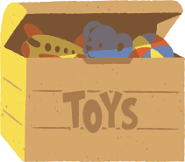 |  | 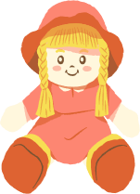
玩具 |  | 娃 娃 |  | 汽 |  | 恐
毽 |  | 泰 |  | 球

toy |  | doll |  | car |  | dinosaur
shuttlecock |  | teddy bear |  | ball
This resource can be adapted by replacing the text to suit your language.

Resource 2 – colours and size flashcards
红 |  | 绿 |  | 蓝
棕 |  | 大 |  | 小

red |  | green |  | blue
brown |  | big |  | small
This resource can be adapted by replacing the text to suit your language.

Resource 3 – listen and colour
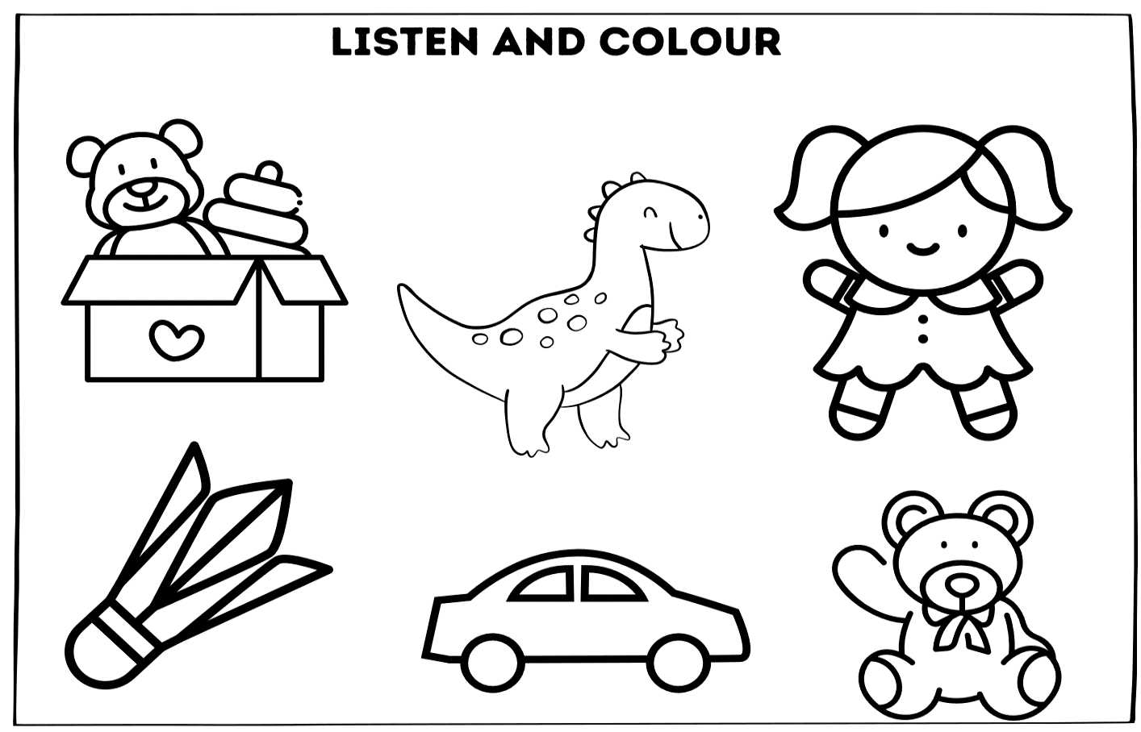

Resource 4 – Bingo cards
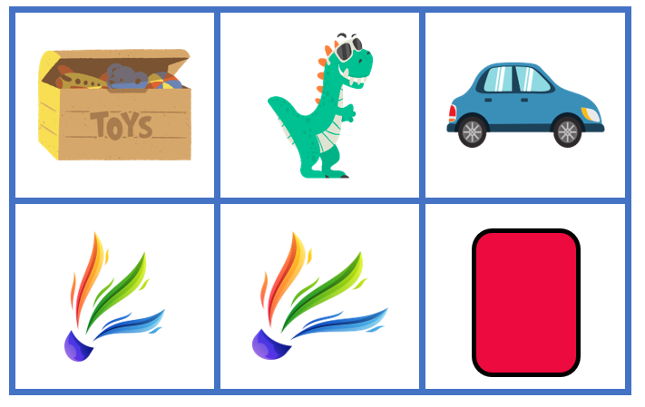
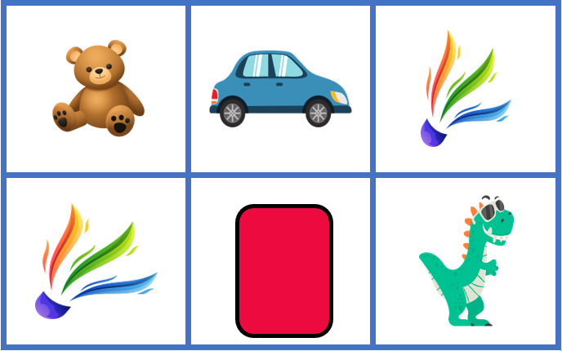
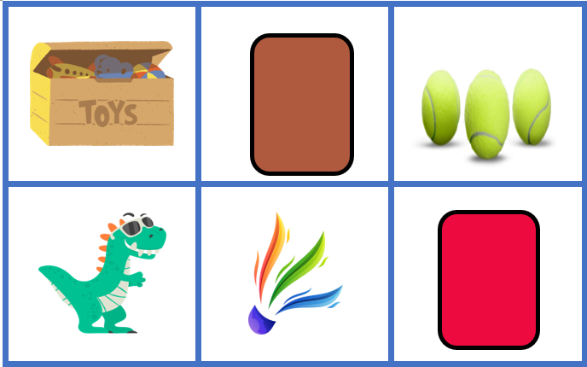
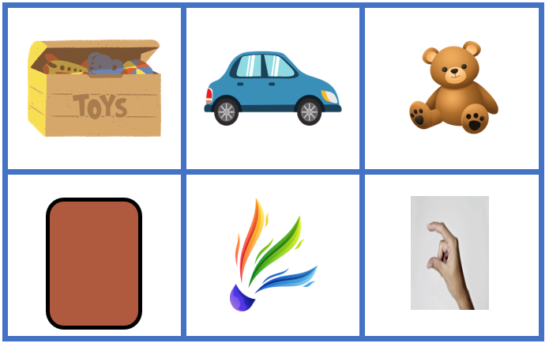
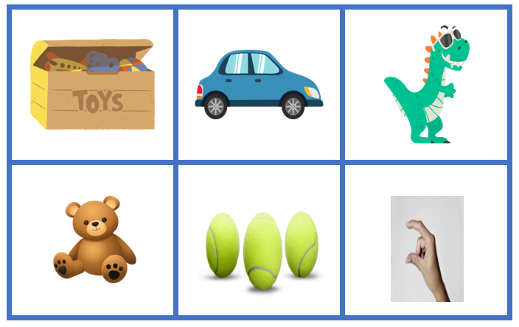

Resource 5 – student rubric
I can name my favourite toy.
I can say the colour of my toy. 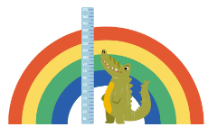
I can say the size of my toy.
I can say ‘I like my toy’. 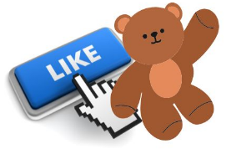
I can say a sentence in Chinese with words in the right order.

Resource 6 – flashcard mat
Toy | Colour | Size

Resource 7 – peer feedback strategy – Two stars and a wish
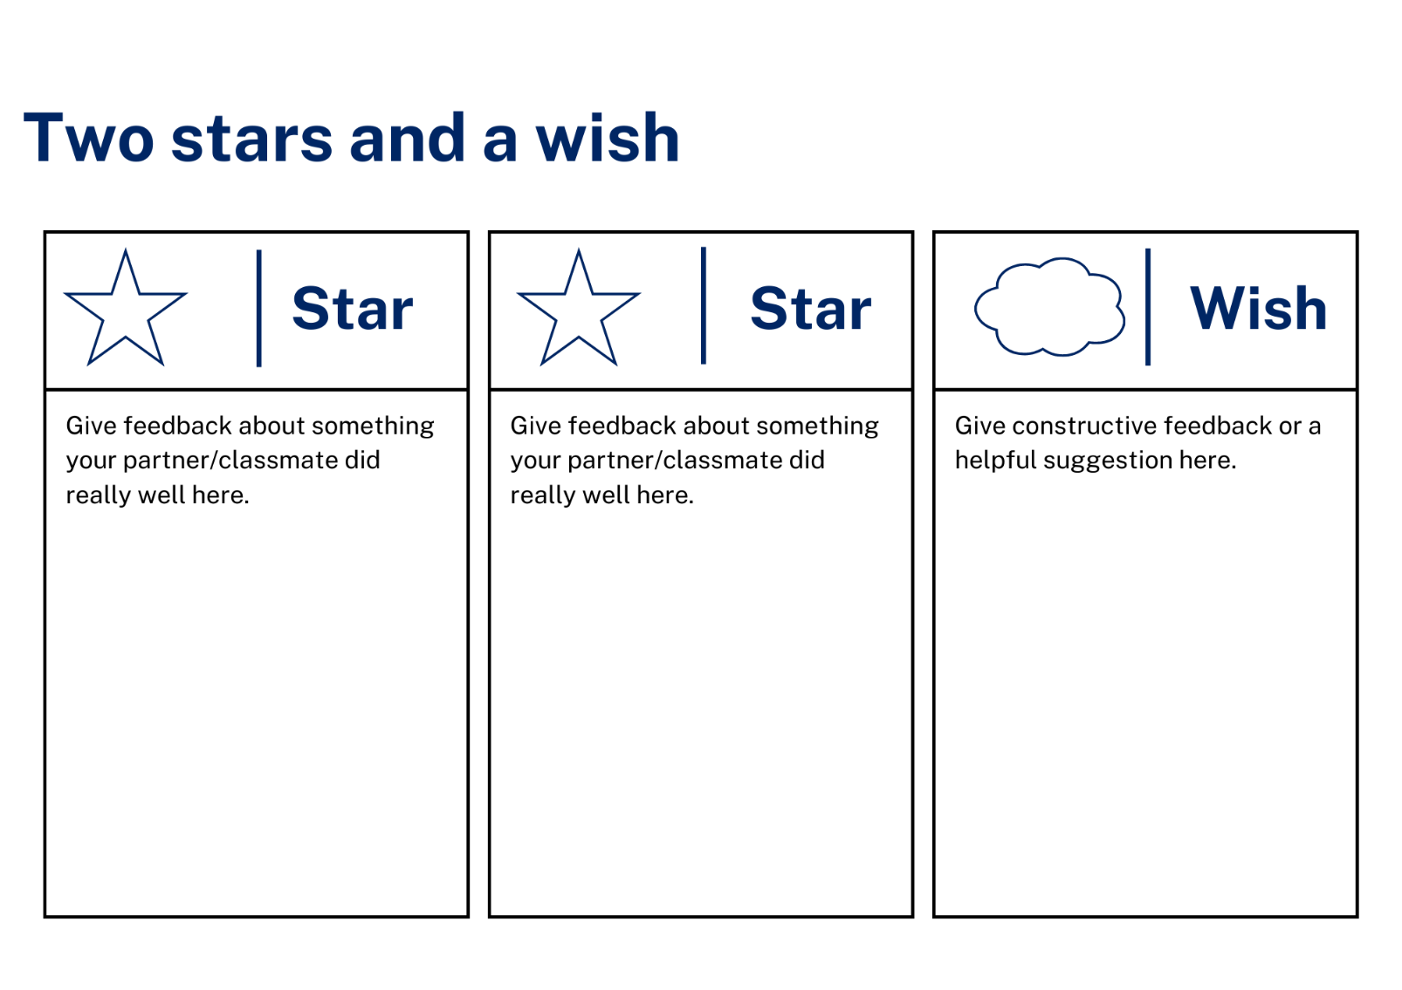

Support and alignment
Resource evaluation and support: all curriculum resources are prepared through a rigorous process. Resources are periodically reviewed as part of our ongoing evaluation plan to ensure currency, relevance, and effectiveness. For additional support or advice, contact the Primary Languages team by emailing primlang@det.nsw.edu.au.
Alignment to system priorities and/or needs: School Excellence Policy
Alignment to the School Excellence Framework: this resource supports the School Excellence Framework elements of curriculum (curriculum provision, teaching and learning programs) and effective classroom practice (lesson planning).
Alignment to Australian Professional Teaching Standards: this resource supports teachers to address Australian Professional Teaching Standards 2.2.2, 3.2.2.
Consulted with: Curriculum, Secondary Learners, school-based staff and NESA subject matter experts. Advice from Aboriginal Outcomes and Partnerships, EAL/D, HPGE and Inclusive Education for Modern Languages Stage 3 Italian Mangiare in Ristorante has been considered in preparing this document.
NSW syllabus: Modern Languages K–10 Syllabus
Syllabus outcomes: MLE-INT-01, MLE-UND-01, MLE-CRT-01
Author: Primary Curriculum
Publisher: State of NSW, Department of Education
Resource: unit
Related resources: further resources to support Early Stage 1 Modern Languages can be found on the Languages K–6 curriculum page.
Professional learning: relevant professional learning is available through Primary Languages Statewide Staffroom on Teams (staff only).
Universal Design for Learning: support the diverse learning needs of students using inclusive teaching and learning strategies. Some students may require more specific adjustments to allow them to participate on the same basis as their peers. For further advice see Inclusive practice resources for primary school.
Differentiation: when using these resources in the classroom, it is important for teachers to consider the needs of all students in their class, including:
- Aboriginal and Torres Strait Islander students. Targeted strategies can be used to achieve outcomes for Aboriginal students in K-12 and increase knowledge and understanding of Aboriginal histories and cultures. Teachers should use students’ Personalised Learning Pathways to support individual student needs and goals.
- EAL/D learners. EAL/D learners may require scaffolding to support them to gain content knowledge, while providing extra time and assistance to master the English language required to engage with texts or complete classroom tasks. View some samples of differentiating through scaffolding.
- Students with additional learning needs. Learning adjustments enable students with disability and additional learning and support needs to access syllabus outcomes and content on the same basis as their peers. Teachers can use a range of adjustments to ensure a personalised approach to student learning.
- High potential and gifted learners. Assessing and identifying high potential and gifted learners will help teachers decide which students may benefit from extension and additional challenge. In addition, the Differentiation Adjustment Tool can be used to support the specific learning needs of high potential and gifted students.
Creation date: 29 February 2024
Rights: © State of New South Wales, Department of Education

References
This resource contains NSW Curriculum and syllabus content. The NSW Curriculum is developed by the NSW Education Standards Authority. This content is prepared by NESA for and on behalf of the Crown in right of the State of New South Wales. The material is protected by Crown copyright.
Please refer to the NESA Copyright Disclaimer for more information https://educationstandards.nsw.edu.au/wps/portal/nesa/mini-footer/copyright.
NESA holds the only official and up-to-date versions of the NSW Curriculum and syllabus documents. Please visit the NSW Education Standards Authority (NESA) website https://educationstandards.nsw.edu.au/wps/portal/nesa/home and the NSW Curriculum website https://curriculum.nsw.edu.au.
Modern Languages K–10 Syllabus © NSW Education Standards Authority (NESA) for and on behalf of the Crown in right of the State of New South Wales, 2022.
8 Ways (n.d.) 8 Aboriginal Ways of Learning [website], accessed 13 December 2022.
AITSL (Australian Institute for Teaching and School Leadership (2017) ‘Feedback Factsheet’, AITSL, accessed 5 February 2024.
Brookhart SM (2011) How to Assess Higher-Order Thinking Skills in Your Classroom, Hawker Brownlow Education, Victoria.
CESE (Centre for Education Statistics and Evaluation) (2020a) What works best: 2020 update, NSW Department of Education, accessed 16 November 2023.
CESE (Centre for Education Statistics and Evaluation) (2020b) What works best in practice, NSW Department of Education, accessed 17 February 2024.
Conti G (28 September 2015) ‘16 tips for effective grammar teaching in the foreign language classroom’, The Language Gym, accessed Day Month Year.
Conti G (28 May 2017) ‘From Target Language to Model Language – the mind shift that has transformed my teaching’, The Language Gym, accessed 29 February 2024
Henshaw FG and Hawkins MD (2022) Common Ground: Second Language Acquisition Theory Goes to the Classroom, Focus, Indianapolis.
Jones J and Wiliam D (2014) Modern Foreign Languages Inside the Black Box: Assessment for Learning in the Modern Foreign Languages Classroom (Black P, Harrison C, Marshall B and Wiliam D eds), Learning Sciences International, United States.
NESA (NSW Education Standards Authority) (2020) NSW Curriculum Review – final report, NESA, accessed 16 November 2023.
NESA (NSW Education Standards Authority) (2024) ‘Proficient Teacher: Standard descriptors’, Achieve Proficient Teacher accreditation, NESA website, accessed 2 May 2024.
Rosenshine B (2012) Principles of Instruction: Research-Based Strategies That All Teachers Should Know’, American Educator, 36(1):12–19, 39, accessed 30 January 2024.
Smith S (2022) Becoming an Outstanding Languages Teacher, 2nd edn, Routledge, United Kingdom.
Wisniewski B, Zierer K and Hattie J (2020) ‘The Power of Feedback Revisited: A Meta-Analysis of Educational Feedback Research’, Frontiers In Psychology, 10(3087), doi:10.3389/fpsyg.2019.03087, accessed 14 February 2024.
Wiliam D (2013) ‘Assessment: The bridge between teaching and learning’, Voices from the Middle, 21(2):15–20, accessed 6 November 2023.
Wiliam D and Leahy S (2015) Embedding Formative Assessment: Practical Techniques for K–12 Classrooms, Learning Sciences International, United States.

© State of New South Wales (Department of Education), 2024
The copyright material published in this resource is subject to the Copyright Act 1968 (Cth) and is owned by the NSW Department of Education or, where indicated, by a party other than the NSW Department of Education (third-party material).
Copyright material available in this resource and owned by the NSW Department of Education is licensed under a Creative Commons Attribution 4.0 International (CC BY 4.0) license.
This license allows you to share and adapt the material for any purpose, even commercially.
Attribution should be given to © State of New South Wales (Department of Education), 2024.
Material in this resource not available under a Creative Commons license:
- the NSW Department of Education logo, other logos and trademark-protected material
- material owned by a third party that has been reproduced with permission. You will need to obtain permission from the third party to reuse its material.
Links to third-party material and websites
Please note that the provided (reading/viewing material/list/links/texts) are a suggestion only and implies no endorsement, by the New South Wales Department of Education, of any author, publisher, or book title. School principals and teachers are best placed to assess the suitability of resources that would complement the curriculum and reflect the needs and interests of their students.
If you use the links provided in this document to access a third-party's website, you acknowledge that the terms of use, including licence terms set out on the third-party's website apply to the use which may be made of the materials on that third-party website or where permitted by the Copyright Act 1968 (Cth). The department accepts no responsibility for content on third-party websites.

