# Story cubes

This resource is for the teacher. It provides the content and instructions you need to share with students.

Use the story cubes provided, or create your own using the template in this document or the [editable version on Canva](https://www.canva.com/design/DAGNH-k7iRg/9HBTlsONBXXVihQKu3si1w/view?utm_content=DAGNH-k7iRg&utm_campaign=designshare&utm_medium=link&utm_source=publishsharelink&mode=preview).

Story cubes are used in the activities below to assist students to practise their use of direct object pronouns in scaffolded interactions.

## Activity 1

In this activity, students use story cube 1 (household chores) and story cube 2 (frequency words).

To play, Student A rolls story cube 1 (household chores). Using the image the cube lands on as a prompt, they form a question in Italian which they ask Student B. Student B then rolls story cube 2 (frequency words). Using the term the cube lands on as a prompt, Student B responds to the question asked by Student A, using a direct object pronoun in their response, for example:

Student A rolls story cube 1 (household chores)  and asks *Fai la spesa?*

Student B rolls story cube 2 (frequency words)  and responds *No,* *non la faccio mai!*

After several turns, students swap roles with Student B asking the questions and Student A responding.

## Activity 2

In this activity, students use story cube 1 (household chores) and story cube 3 (likes and dislikes phrases).

To play, Student A rolls story cube 1 (household chores). Using the image they land on as a prompt, they form a question in Italian which they ask Student B. Student B then rolls story cube 2 (likes and dislikes phrases). Using the term the cube lands on as a prompt, Student B responds to the question asked by Student A, using a direct object pronoun in their response, for example:

Student A rolls the story cube 1 (household chores)  and asks *Ti piace portare a passeggio il cane?*

Student B rolls story cube 3 (likes and dislikes phrases) 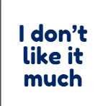 and responds *No, non mi piace molto farlo.*

After several turns, students swap roles with Student B asking the questions and Student A responding.

 **Differentiation examples**

**The following strategies provide a starting point for how you can differentiate this activity for a range of learners. Adapt or design alternatives, to meet the needs of students in your class.**

**Students with advanced proficiency and high potential and gifted students** – encourage students to extend the interaction, with Student B asking Student A a question back after giving their response. Allow students to use any frequency word, or likes and dislikes phrase, in their response. For example, *Fai la spesa?*, *No,* *non la faccio mai!*, would then continue with Student B asking, *E tu?* and Student A responding using any frequency word of choice *La faccio raramente*.

**Students requiring additional support – include the Italian vocabulary on the story cube and allow students to use their anchor charts for support.**

## Story cubes

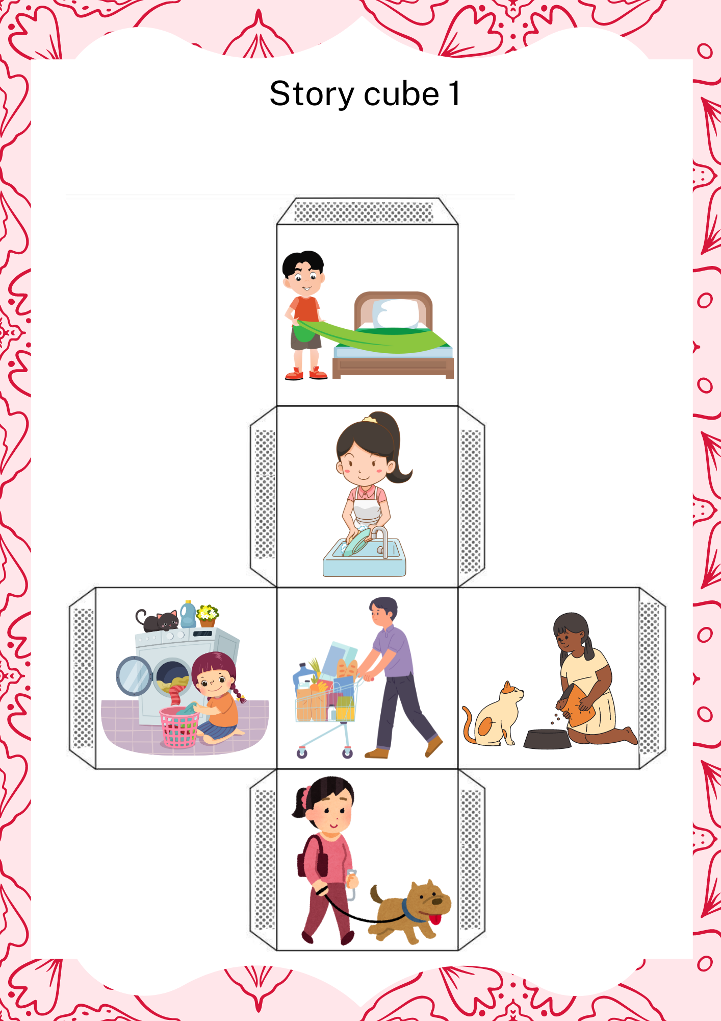

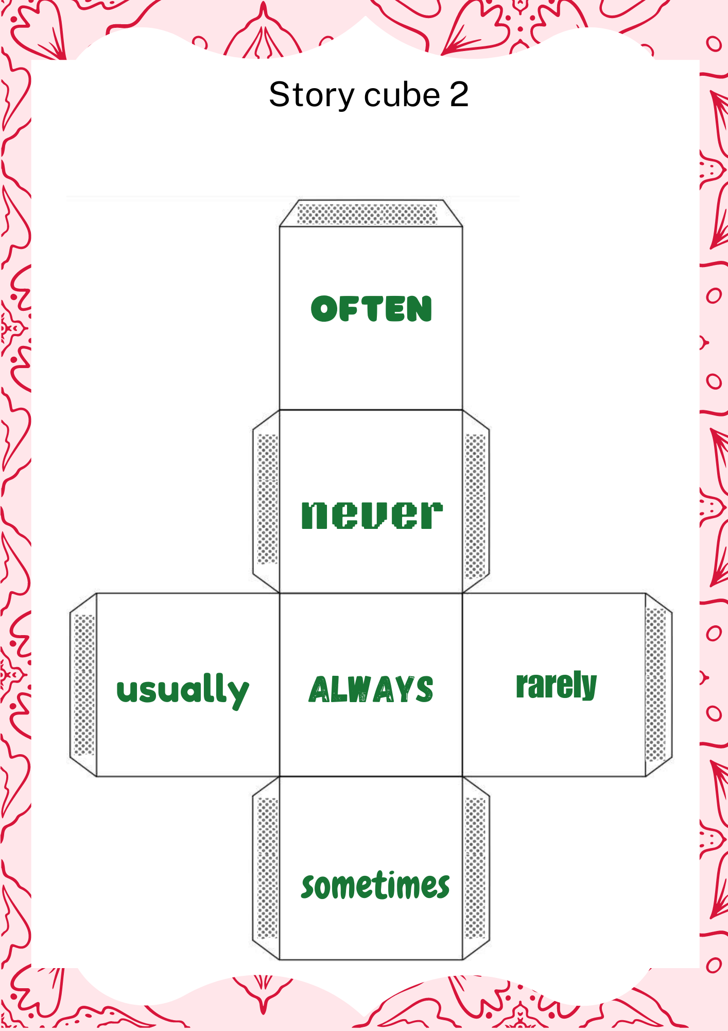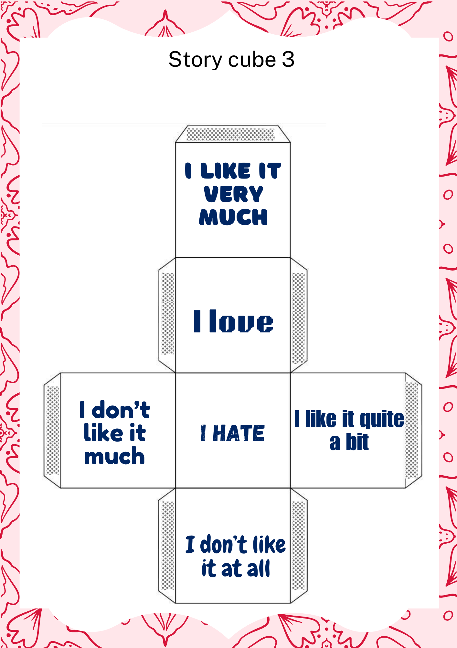

## Blank story cube template

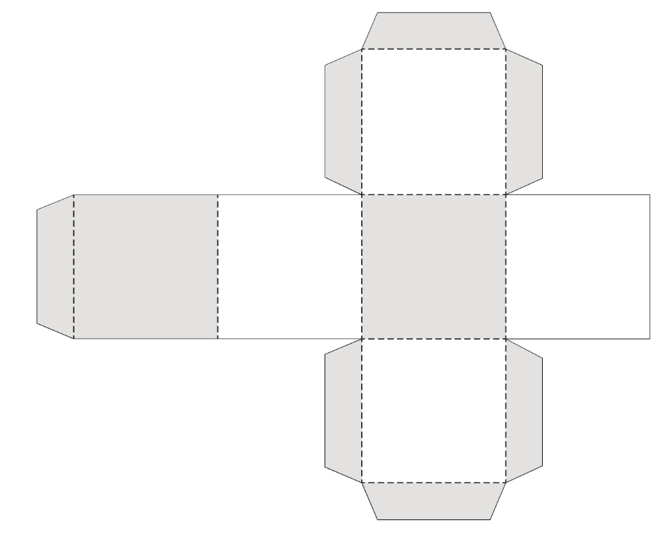

**© State of New South Wales (Department of Education), 2024**

The copyright material published in this resource is subject to the Copyright Act 1968 (Cth) and is owned by the NSW Department of Education or, where indicated, by a party other than the NSW Department of Education (third-party material).

Copyright material available in this resource and owned by the NSW Department of Education is licensed under a [Creative Commons Attribution 4.0 International (CC BY 4.0) license](https://creativecommons.org/licenses/by/4.0/).

[](https://creativecommons.org/licenses/by/4.0/)

This license allows you to share and adapt the material for any purpose, even commercially.

Attribution should be given to © State of New South Wales (Department of Education), 2024.

Material in this resource not available under a Creative Commons license:

* the NSW Department of Education logo, other logos and trademark-protected material
* material owned by a third party that has been reproduced with permission. You will need to obtain permission from the third party to reuse its material.

**Links to third-party material and websites**

Please note that the provided (reading/viewing material/list/links/texts) are a suggestion only and implies no endorsement, by the New South Wales Department of Education, of any author, publisher, or book title. School principals and teachers are best placed to assess the suitability of resources that would complement the curriculum and reflect the needs and interests of their students.

If you use the links provided in this document to access a third-party's website, you acknowledge that the terms of use, including licence terms set out on the third-party's website apply to the use which may be made of the materials on that third-party website or where permitted by the Copyright Act 1968 (Cth). The department accepts no responsibility for content on third-party websites.