# Reading and responding – email

## Activity 1

Read the email below and answer the questions in English on the next page.

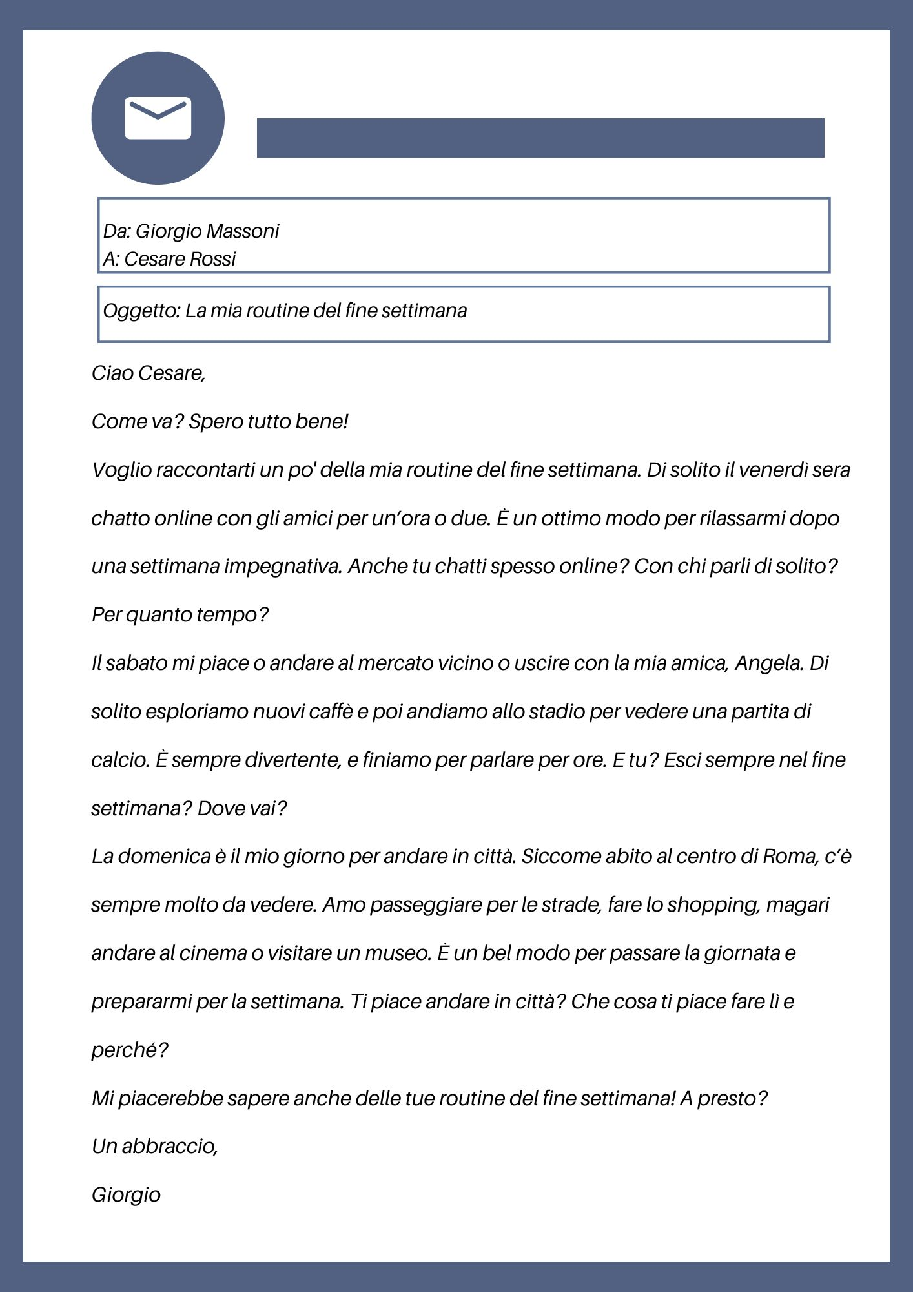

1. What does Giorgio usually do on Friday evenings?

|  |
| --- |
|  |

1. Why does he do this?

|  |
| --- |
|  |

1. Who does Giorgio usually hang out with on Saturdays, and what activities do they typically enjoy?

|  |
| --- |
|  |
|  |

1. Describe a typical Sunday for Giorgio.

|  |
| --- |
|  |
|  |
|  |

1. Giorgio likes spending time with friends and exploring the city. Why do you think this is?

|  |
| --- |
|  |
|  |
|  |

## Activity 2

Complete the table below with phrases from the email in Activity 1 that match each element of an email listed in the first column. The first one has been provided for you.

|  |  |  |
| --- | --- | --- |
| Elements of an email | Phrases | Additional sample phrases |
| Opening greeting | Ciao Cesare |  |
| Introduction including reason for writing |  |  |
| Body of the text with elaboration of key ideas |  |  |
| Closing salutation |  |  |

Below are some more examples of phrases for each element in the table above. Place these in the third column according to which structure they match.

*Caro Giorgio, come stai?*

*Come va a …?*

*Grazie per il tuo email.*

*Scrivimi presto!*

*Prima di tutto, …*

*Un bacio, Mario/a*

*Per rispondere alla tua domanda*, *…*

*Spero di sentirti presto, Mario/a*

*Con affetto, Mario/a*

## Activity 3

Using the sample phrases from Activity 2, write a response to Giorgio’s email in Activity 1, in the space provided below.

Remember to include:

* an opening greeting
* an introduction and reason for writing
* the body of the text with elaboration of key ideas including answers to the questions Giorgio has asked and anything else you would like to comment on
* appropriate structures to sequence your ideas and information
* a range of vocabulary
* a closing salutation.

|  |
| --- |
|  |
|  |
|  |
|  |
|  |
|  |
|  |
|  |
|  |
|  |
|  |

## For the teacher

Remove this section before sharing this resource with students.

Use the sample text provided or use the [editable version on Canva](https://www.canva.com/design/DAGMjlV37Ak/Hx4-YOlLKgWsYlKWuUOcYA/view?utm_content=DAGMjlV37Ak&utm_campaign=designshare&utm_medium=link&utm_source=publishsharelink&mode=preview) to edit the content to suit your context. An accessible version of the text is provided below.

## Activity 1

### Accessible version of text

***Da: Giorgio Massoni***

***A: Cesare Rossi***

***Oggetto: La mia routine del fine settimana***

*Ciao Cesare,*

*Come va? Spero tutto bene!*

*Voglio raccontarti un po’ della mia routine del fine settimana. Di solito il venerdì sera chatto online con gli amici per un’ora o due. È un ottimo modo per rilassarmi dopo una settimana impegnativa. Anche tu chatti spesso online? Con chi parli di solito? Per quanto tempo?*

*Il sabato mi piace o andare al mercato vicino o uscire con la mia amica, Angela. Di solito esploriamo nuovi caffè e poi andiamo allo stadio per vedere una partita di calcio. È sempre divertente, e finiamo per parlare per ore. E tu? Esci sempre il fine settimana? Dove vai?*

*La domenica è il mio giorno per andare in città. Siccome abito al centro di Roma, c’è sempre molto da vedere. Amo passeggiare per le strade, fare lo shopping, magari andare al cinema o visitare un museo. È un bel modo per passare la giornata e prepararmi per la settimana. Ti piace andare in città? Che cosa ti piace fare lì e perché?*

*Mi piacerebbe sapere anche delle tue routine del fine settimana! A presto?*

*Un abbraccio,*

*Giorgio*

### Answers

1. **Friday evenings Giorgio chats online with friends for an hour or 2.**
2. **It’s a great way to relax after a busy week.**
3. **He hangs out with his friend Angela. Usually they explore new cafes or stop in a park and listen to music. They have fun and talk for hours**.
4. **He goes to the city to walk the streets. Because he lives in the centre of Rome, there’s always a lot to see. He loves walking the streets, going shopping, to the movies or even a museum.**
5. **Because he has a busy week and he likes to relax and unwind. Exploring the city is a change of scenery for him and prepares him for his week.**

## Activity 2

|  |  |  |
| --- | --- | --- |
| Structure | Sample phrases | Additional sample phrases |
| Opening greetings | Ciao Cesare | ***Caro Giorgio, come stai?***  ***Come va a …?*** |
| Introduction including initial reason for writing | ***Come va? Spero tutto bene!***  ***Voglio raccontarti un po' della mia routine del fine settimana.*** | ***Grazie per il tuo email.*** |
| Body of the text with elaboration of key ideas | ***Di solito...***  ***Il sabato mi piace...***  ***La domenica è il mio giorno per...***  ***C’è sempre molto da...***  ***È un bel modo per...*** | ***Prima di tutto,…***  ***Per rispondere alla tua domanda*,** |
| Closing salutation | ***Mi piacerebbe sapere anche...***  ***A presto?***  ***Un abbraccio*** | ***Scrivimi presto!***  ***Un bacio, Mario/a***  ***Spero di sentirti presto, Mario/a***  ***Con affetto, Mario/a*** |

**© State of New South Wales (Department of Education), 2024**

The copyright material published in this resource is subject to the *Copyright Act 1968* (Cth) and is owned by the NSW Department of Education or, where indicated, by a party other than the NSW Department of Education (third-party material).

Copyright material available in this resource and owned by the NSW Department of Education is licensed under a [Creative Commons Attribution 4.0 International (CC BY 4.0) license](https://creativecommons.org/licenses/by/4.0/).

**[](https://creativecommons.org/licenses/by/4.0/)**

This licence allows you to share and adapt the material for any purpose, even commercially. Attribution should be given to © State of New South Wales (Department of Education), 2024.

Material in this resource not available under a Creative Commons licence:

* the NSW Department of Education logo, other logos and trademark-protected material
* material owned by a third party that has been reproduced with permission. You will need to obtain permission from the third party to reuse its material.

**Links to third-party material and websites**

Please note that the provided (reading/viewing material/list/links/texts) are a suggestion only and implies no endorsement, by the New South Wales Department of Education, of any author, publisher, or book title. School principals and teachers are best placed to assess the suitability of resources that would complement the curriculum and reflect the needs and interests of their students.

If you use the links provided in this document to access a third-party's website, you acknowledge that the terms of use, including licence terms set out on the third-party's website apply to the use which may be made of the materials on that third-party website or where permitted by the *Copyright Act 1968* (Cth). The department accepts no responsibility for content on third-party websites.