# Text message

## Activity 1 – text message

Read the text message exchange between Ginevra and Marco.

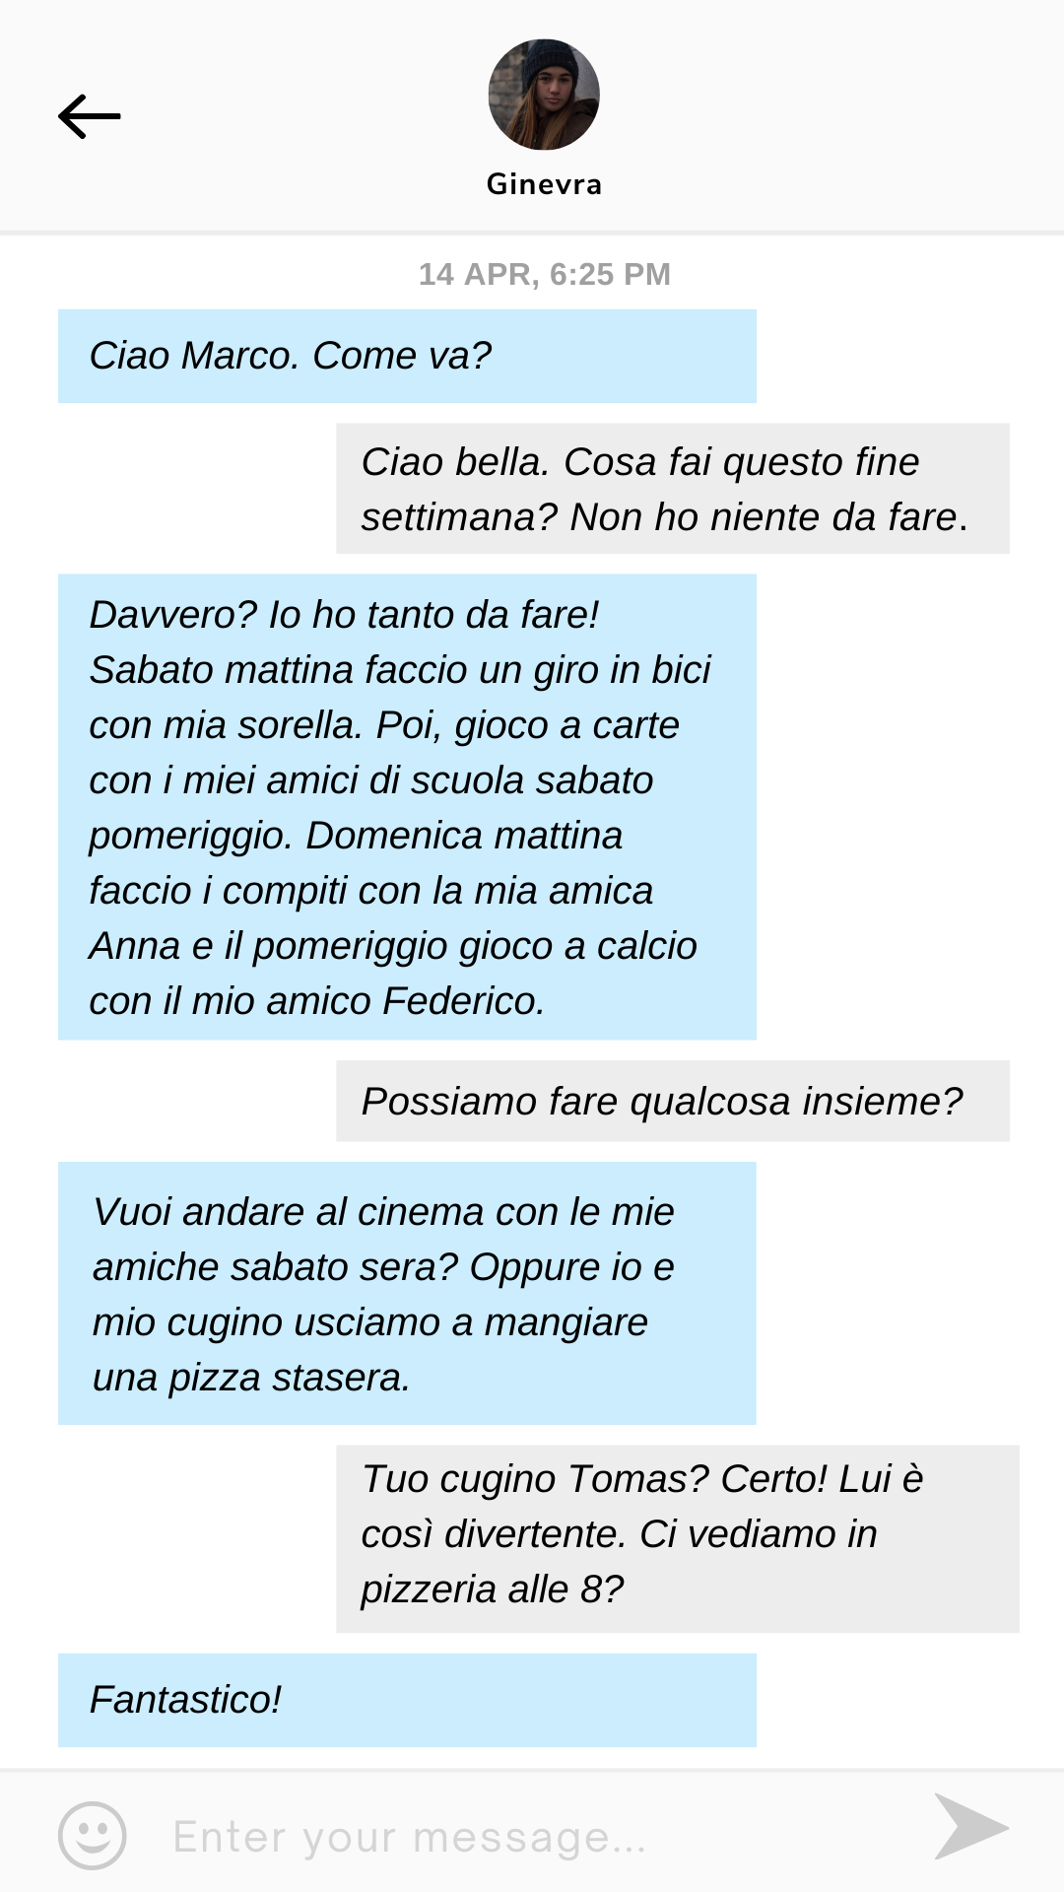

From the text message exchange, identify the phrases in the table below.

|  |  |
| --- | --- |
| English | Italian |
| with my sister |  |
| with my friends from school |  |
| with my friend Anna |  |
| with my friend Federico |  |
| with my (female) friends |  |
| with my cousin |  |

What do you notice about the difference between ‘my sister’ and ‘my (female) friend’?

|  |
| --- |
|  |

What do you notice about the difference between ‘my cousin’ and ‘my (male) friend’?

|  |
| --- |
|  |

The Italian language does not use definite articles with possessive adjectives in front of singular nouns of family members. For example, *mio padre*.

However, they are used before family members when:

* in the plural form, for example, *le mie sorelle*
* diminutives are used, such as *la mia mamma* or *il mio fratellino*
* the possessive adjective is *loro* (their), even for close family members.

## Activity 2 – possessive adjectives

Complete the first row of the table below with the ‘my’ forms of the possessive adjective in Italian you identified in the text. Follow the patterns for forming possessive adjectives to fill in the spaces in the table.

|  |  |  |  |  |
| --- | --- | --- | --- | --- |
| English | masculine singular | feminine singular | masculine plural | feminine plural |
| my |  |  |  |  |
| your (singular) | *il tuo* | *la tua* | *i tuoi* | *le tue* |
| his/her | *il suo* |  |  | *le sue* |
| our |  | *la nostra* | *i nostri* |  |
| your (plural) | *il vostro* | *la vostra* |  |  |
| their | *il loro* |  |  | *le loro* |

## Activity 3 – story cubes

Take turns rolling the story cubes provided by your teacher. Use the prompts on the cubes to create different possessive adjectives. Roll both dice 5 times each. Write your own answers in the space provided below. An example has been provided for you.

 + 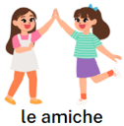 = *le nostre amiche*

|  |
| --- |
|  |

## Activity 4 – rewrite the text message

Rewrite the second text message from Ginevra in Activity 1, from ‘*Io ho tanto da fare!’* to ‘*Federico*’, changing the subject of the sentence each time using the subject pronouns in the first column. Make sure you make appropriate changes to verbs, pronouns and possessive adjectives. An example has been provided in the table below.

|  |  |
| --- | --- |
| Subject pronoun | Amended text |
| *tu* | ***Hai*** *tanto da fare ogni settimana. Sabato mattina* ***fai*** *un giro…* |
| *lei* |  |
| *noi* |  |
| *voi* |  |
| *loro* |  |

## Activity 5 – write a response to the text message

Use a [text message generator](https://ifaketextmessage.com/), or a text message template on [Canva](https://www.canva.com/design/DAGL0QTIm9Q/lfLpbcVxKUEhDuvUjSEZbw/view?utm_content=DAGL0QTIm9Q&utm_campaign=designshare&utm_medium=link&utm_source=publishsharelink&mode=preview), to create a response to Marco’s question *Cosa fai questo fine settimana?* Include at least 4 activities, when you’re doing them and with whom.

## For the teacher

Remove this section before sharing this resource with students.

### Activity 1 – text message

Use the sample text message provided or use the [editable version on Canva](https://www.canva.com/design/DAGL0QTIm9Q/lfLpbcVxKUEhDuvUjSEZbw/view?utm_content=DAGL0QTIm9Q&utm_campaign=designshare&utm_medium=link&utm_source=publishsharelink&mode=preview) to edit the content to suit your context.

#### Accessible version of text

**Ginevra:** *Ciao Marco. Come va?*

**Marco:** *Ciao bella. Cosa fai questo fine settimana? Non ho niente da fare.*

**Ginevra:** *Davvero? Io ho tanto da fare! Sabato mattina faccio un giro in bici con mia sorella. Poi, gioco a carte con i miei amici di scuola sabato pomeriggio. Domenica mattina faccio i compiti con la mia amica Anna e il pomeriggio gioco a calcio con il mio amico Federico.*

**Marco:** *Possiamo fare qualcosa insieme?*

**Ginevra:** *Vuoi andare al cinema con le mie amiche sabato sera? Oppure io e mio cugino usciamo a mangiare una pizza stasera.*

**Marco:** *Tuo cugino Tomas? Certo! Lui è così divertente. Ci vediamo in pizzeria alle 8?*

**Ginevra:** *Fantastico!*

 **Differentiation examples**

For **students requiring additional support**, read through Ginevra’s text message together, in which she outlines her planned weekend activities and who she is doing them with. Ask questions to check for understanding. Identify the phrases for saying ‘my’ which appear in the text, for example, *il mio amico*, *la mia amica*, *i miei amici*, *le mie amiche*. Remind them that the definite article is not used for immediate family members in the singular form, for example, *mio* *fratello*.

#### Answers

Read the text message exchange between Ginevra and Marco and identify the following phrases in the table below.

|  |  |
| --- | --- |
| English | Italian |
| with my sister | ***con mia sorella*** |
| with my friends from school | ***con i miei amici di scuola*** |
| with my friend Anna | ***con la mia amica Anna*** |
| with my friend Federico | ***con il mio amico Federico*** |
| with my (female) friends | ***con le mie amiche*** |
| with my cousin | ***con mio cugino*** |

What do you notice about the difference between ‘my sister’ and ‘my (female) friend’?

**My sister is *mia sorella* and my (female) friend is *la mia amica* – friend has the definite article, sister doesn’t.**

What do you notice about the difference between ‘my cousin’ and ‘my (male) friend’?

**My cousin is *mio cugino* and my (male) friend is *il mio amico* – friend has the definite article, cousin doesn’t.**

### Activity 2 – possessive adjectives

Direct students to add new structures and vocabulary to their anchor charts, books or devices.

|  |  |  |  |  |
| --- | --- | --- | --- | --- |
| English | masculine singular | feminine singular | masculine plural | feminine plural |
| my | ***il mio*** | ***la mia*** | ***i miei*** | ***le mie*** |
| your (singular) | *il tuo* | *la tua* | *i tuoi* | *le tue* |
| his/her | *il suo* | ***la sua*** | ***i suoi*** | *le sue* |
| our | ***il nostro*** | *la nostra* | *i nostri* | ***le*** *nostre* |
| your (plural) | *il vostro* | *la vostra* | ***i vostri*** | ***le vostre*** |
| their | *il loro* | ***la loro*** | ***i loro*** | *le loro* |

### Activity 3 – story cubes

Provide each pair of students with a set of story cubes. Demonstrate how to form possessive adjectives using the cues on the cubes as prompts.

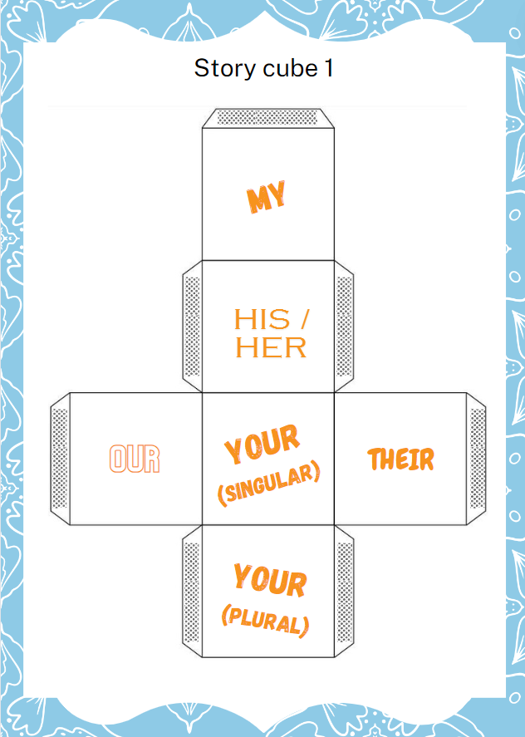

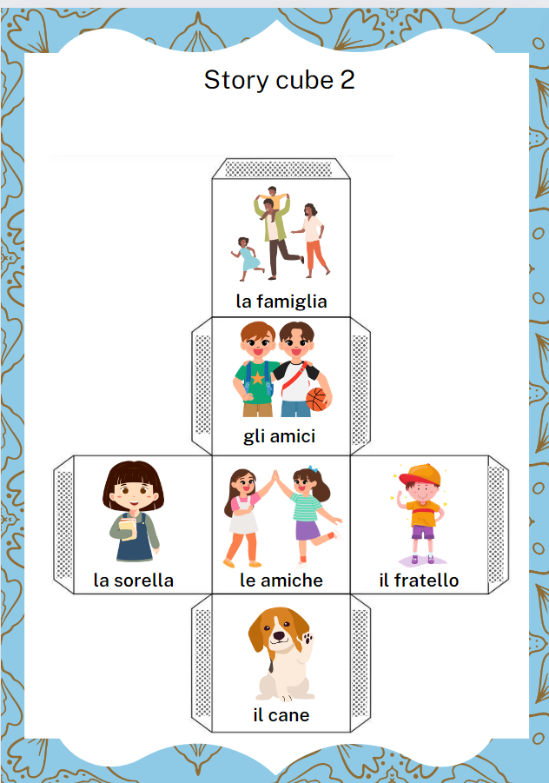

### Activity 4 – rewrite the text message

|  |  |
| --- | --- |
| Subject pronoun | Amended text |
| *tu* | ***Hai*** *tanto da fare! Sabato mattina* ***fai*** *un giro in bici con* ***tua*** *sorella. Poi,* ***giochi*** *a carte con* ***i tuoi*** *amici di scuola sabato pomeriggio. Domenica mattina* ***fai*** *i compiti con* ***la tua*** *amica Anna e il pomeriggio* ***giochi*** *a calcio con* ***il tuo*** *amico Federico.* |
| *lei* | ***Ha*** *tanto da fare! Sabato mattina* ***fa*** *un giro in bici con* ***sua*** *sorella. Poi,* ***gioca*** *a carte con* ***i suoi*** *amici di scuola sabato pomeriggio. Domenica mattina* ***fa*** *i compiti con* ***la sua*** *amica Anna e il pomeriggio* ***gioca*** *a calcio con* ***il suo*** *amico Federico.* |
| *noi* | ***Abbiamo*** *tanto da fare! Sabato mattina* ***facciamo*** *un giro in bici con* ***nostra*** *sorella. Poi,* ***giochiamo*** *a carte con* ***i nostri*** *amici di scuola sabato pomeriggio. Domenica mattina* ***facciamo*** *i compiti con* ***la nostra*** *amica Anna e il pomeriggio* ***giochiamo*** *a calcio con* ***il nostro*** *amico Federico.* |
| *voi* | ***Avete*** *tanto da fare! Sabato mattina* ***fate*** *un giro in bici con* ***vostra*** *sorella. Poi,* ***giocate*** *a carte con* ***i vostri*** *amici di scuola sabato pomeriggio. Domenica mattina* ***fate*** *i compiti con* ***la vostra*** *amica Anna e il pomeriggio* ***giocate*** *a calcio con* ***il vostro*** *amico Federico.* |
| *loro* | ***Hanno*** *tanto da fare! Sabato mattina* ***fanno*** *un giro in bici con* ***la loro*** *sorella. Poi,* ***giocano*** *a carte con* ***i loro*** *amici di scuola sabato pomeriggio. Domenica mattina* ***fanno*** *i compiti con* ***la loro*** *amica Anna e il pomeriggio* ***giocano*** *a calcio con* ***il loro*** *amico Federico.* |

### Activity 5 – write a response to the text message

Student responses will vary. Responses can be used as a formative assessment opportunity.

**© State of New South Wales (Department of Education), 2024**

The copyright material published in this resource is subject to the Copyright Act 1968 (Cth) and is owned by the NSW Department of Education or, where indicated, by a party other than the NSW Department of Education (third-party material).

Copyright material available in this resource and owned by the NSW Department of Education is licensed under a [Creative Commons Attribution 4.0 International (CC BY 4.0) license](https://creativecommons.org/licenses/by/4.0/).

[](https://creativecommons.org/licenses/by/4.0/)

This license allows you to share and adapt the material for any purpose, even commercially.

Attribution should be given to © State of New South Wales (Department of Education), 2024.

Material in this resource not available under a Creative Commons license:

* the NSW Department of Education logo, other logos and trademark-protected material
* material owned by a third party that has been reproduced with permission. You will need to obtain permission from the third party to reuse its material.

**Links to third-party material and websites**

Please note that the provided (reading/viewing material/list/links/texts) are a suggestion only and implies no endorsement, by the New South Wales Department of Education, of any author, publisher, or book title. School principals and teachers are best placed to assess the suitability of resources that would complement the curriculum and reflect the needs and interests of their students.

If you use the links provided in this document to access a third-party's website, you acknowledge that the terms of use, including licence terms set out on the third-party's website apply to the use which may be made of the materials on that third-party website or where permitted by the Copyright Act 1968 (Cth). The department accepts no responsibility for content on third-party websites.