# Memory and speaking game

This resource is for the teacher. It provides the content and instructions you need to share with students.

Use the playing cards provided below or use the [editable version on Canva](https://www.canva.com/design/DAGL0VbSs0c/nWAomSYYbuUqntUpF7WMGg/view?utm_content=DAGL0VbSs0c&utm_campaign=designshare&utm_medium=link&utm_source=publishsharelink&mode=preview) to modify the content to suit your own context.

Separate students into groups of 4 to 5, using the [Team Picker tool](https://pickerwheel.com/).

Print and cut out the playing cards, ensuring there is enough for each group to have their own copy. Students place all the cards face down.

To play, students take turns turning 2 cards over at a time, attempting to find a matching pair. When a student finds a pair, they provide a sentence based on the image and the subject pronoun on the card. They must include an additional detail, such as a time or expression of frequency, for example:

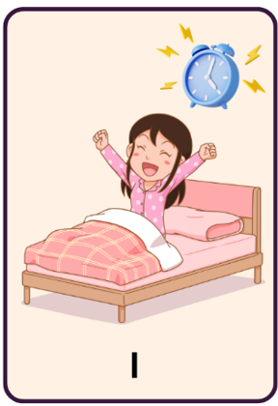 *Mi sveglio alle sette.*

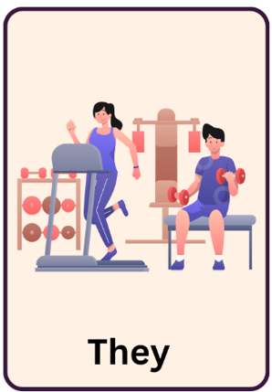 *Vanno in palestra ogni giorno*.

If their sentence is grammatically correct, they keep the pair of cards. If a classmate identifies a mistake in their sentence, the student must return the cards to the middle. The student with the most pairs at the end, wins. The teacher adjudicates any uncertainties.

 **Differentiation examples**

**Students with advanced proficiency** and **high potential and gifted students** – encourage students to expand their sentence by providing an additional detail such as a time phrase.

**Students requiring additional support** – reduce the number of playing cards and encourage students to look at their anchor chart to assist them in accessing the vocabulary required to form sentences.

## Memory playing cards

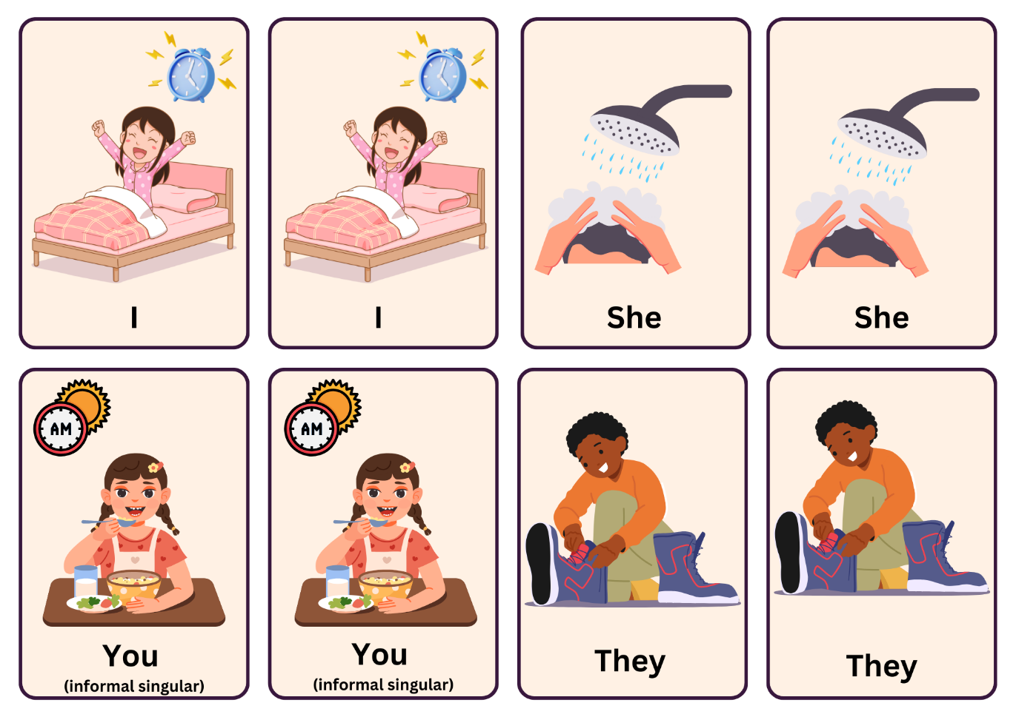

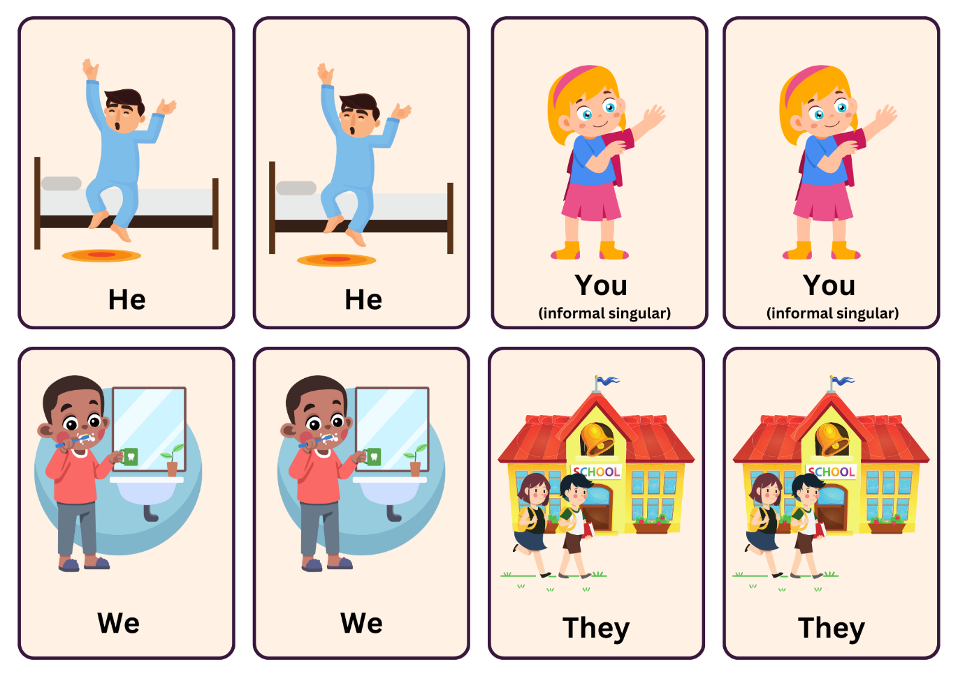

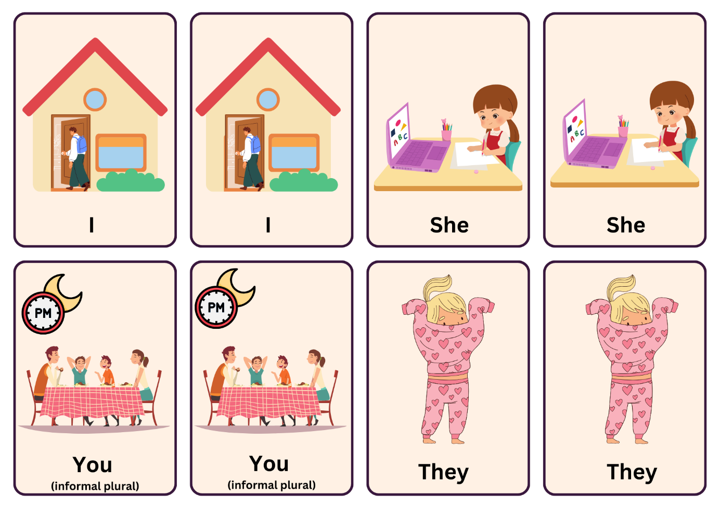

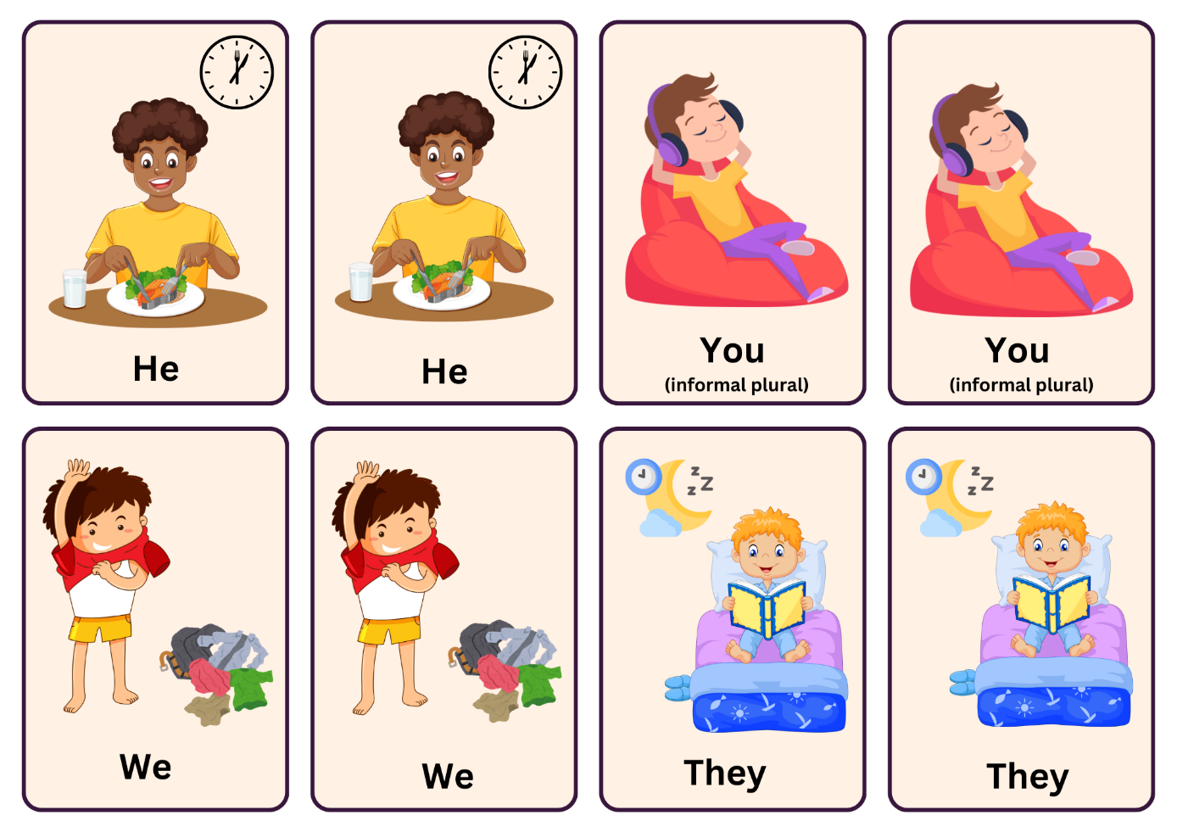

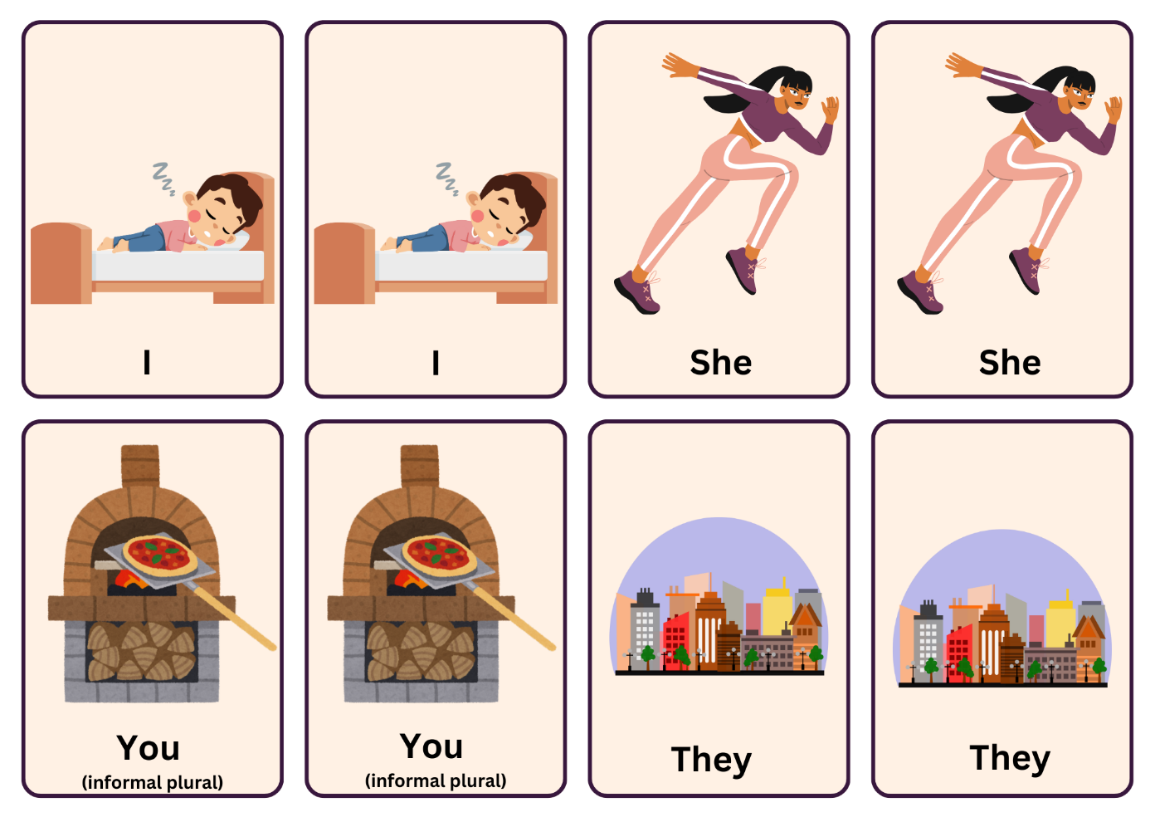

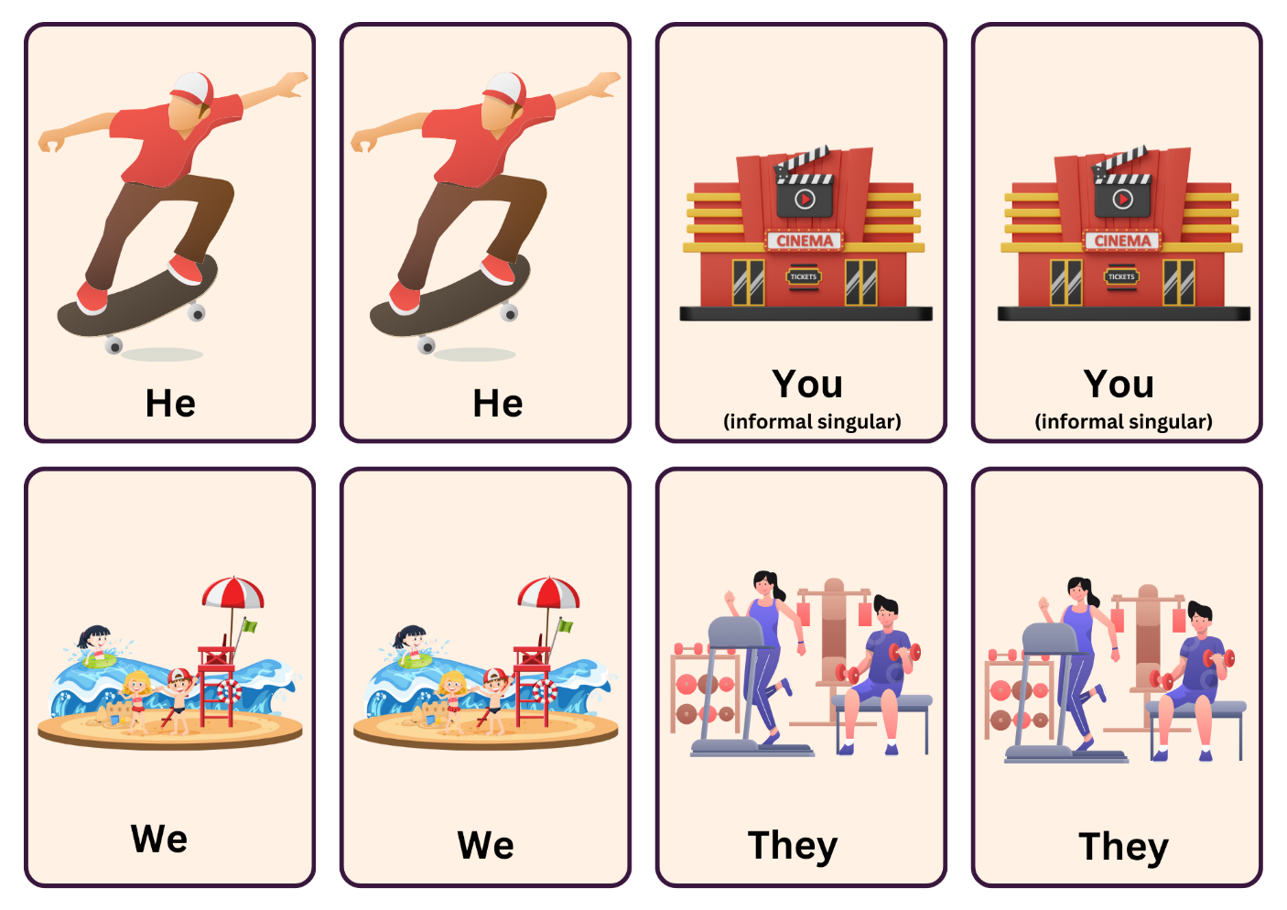

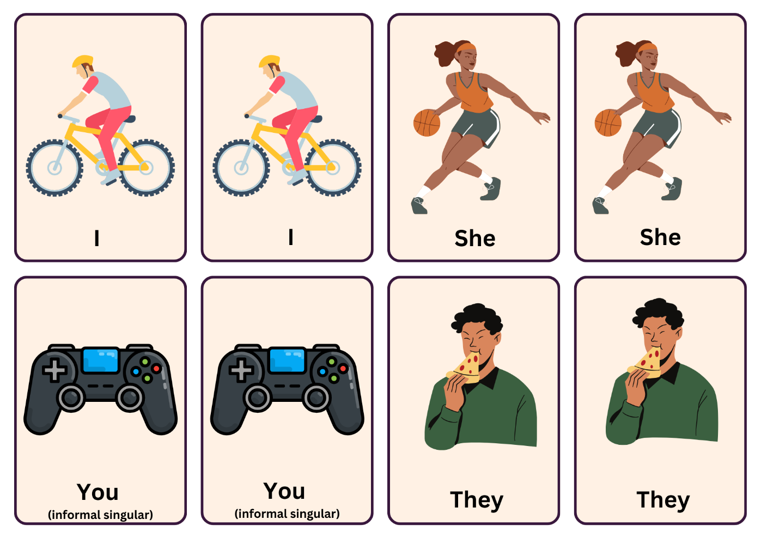

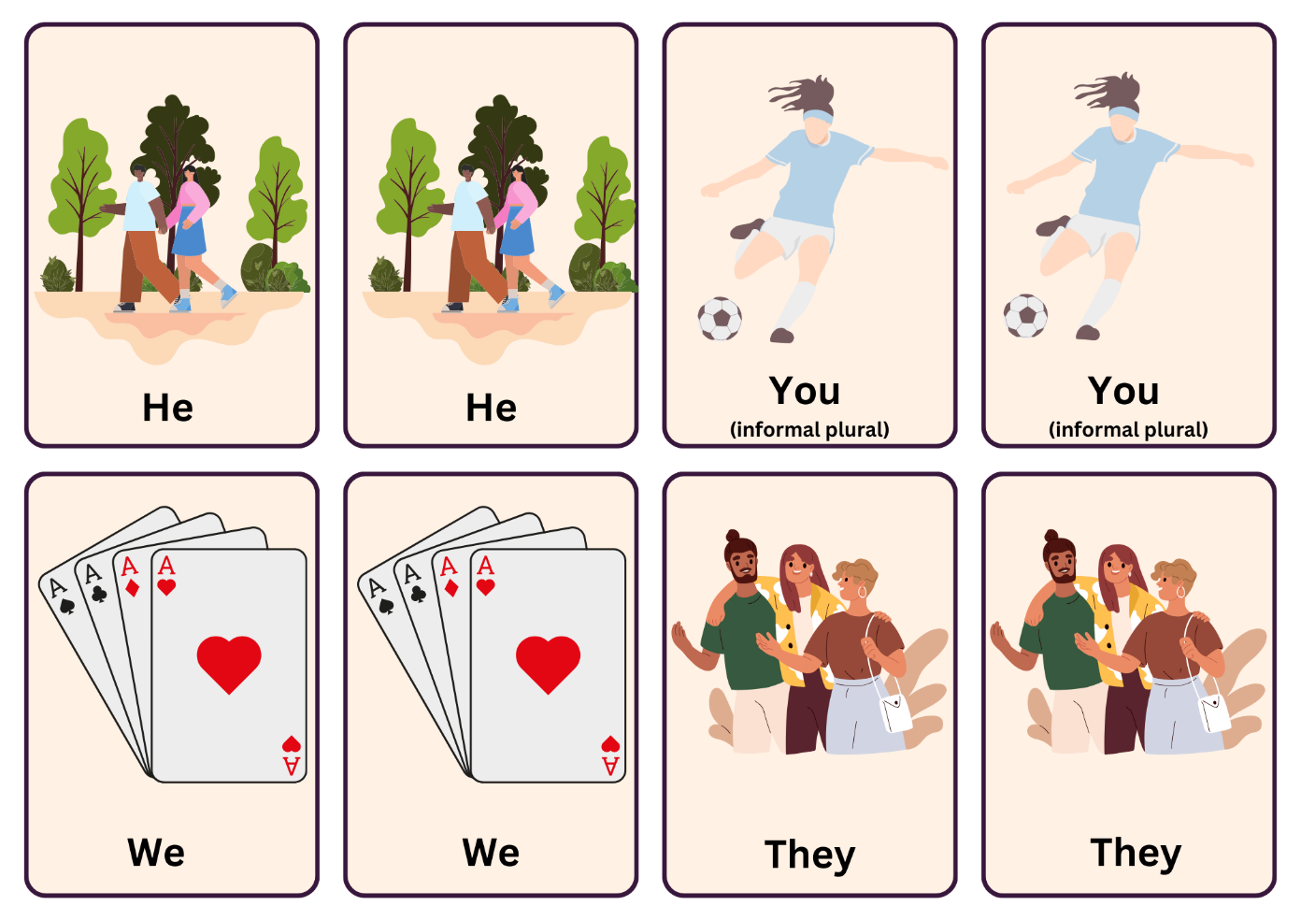

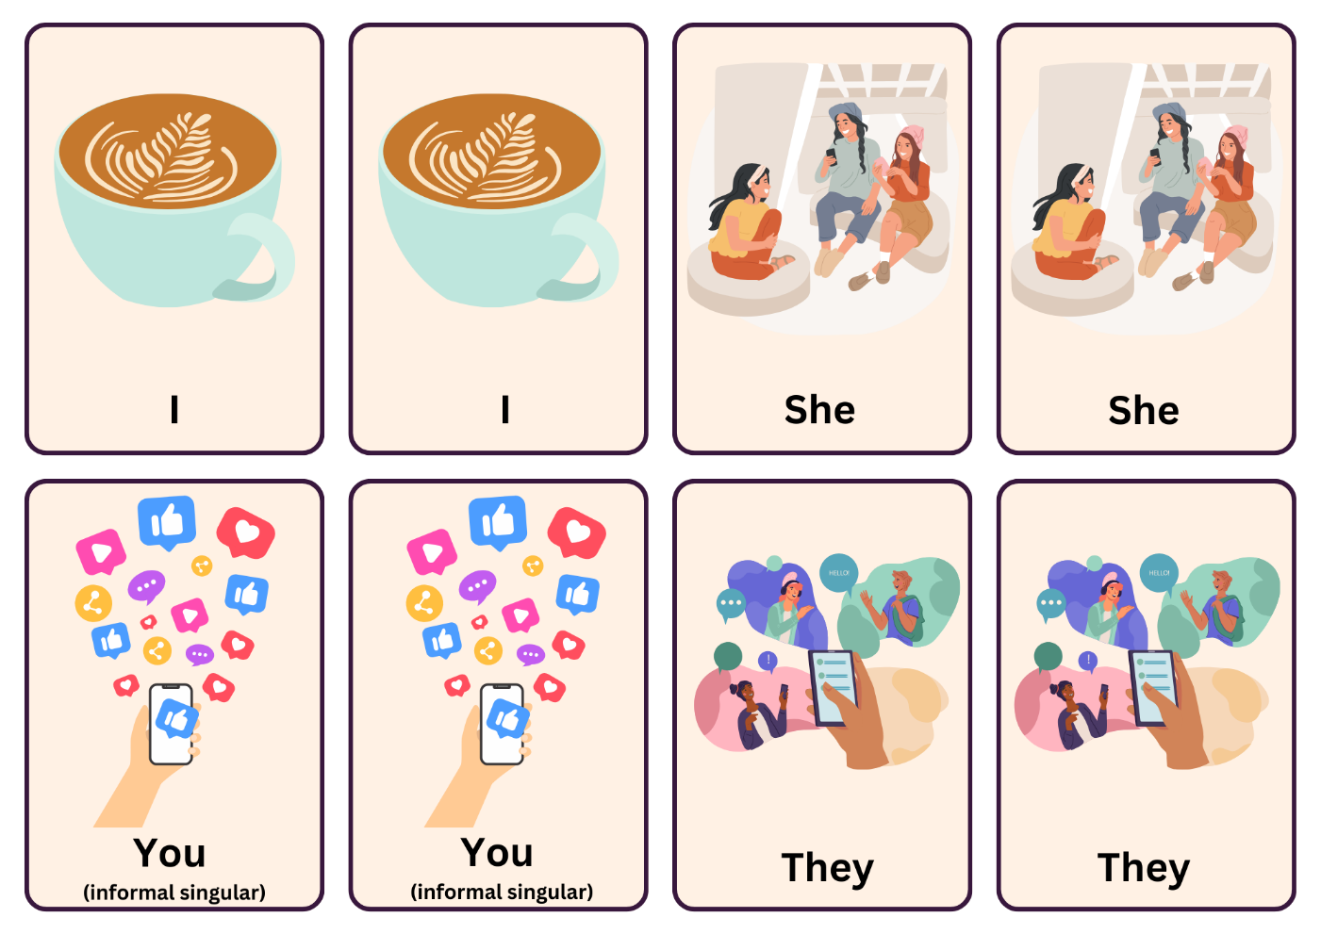

**© State of New South Wales (Department of Education), 2024**

The copyright material published in this resource is subject to the Copyright Act 1968 (Cth) and is owned by the NSW Department of Education or, where indicated, by a party other than the NSW Department of Education (third-party material).

Copyright material available in this resource and owned by the NSW Department of Education is licensed under a [Creative Commons Attribution 4.0 International (CC BY 4.0) license](https://creativecommons.org/licenses/by/4.0/).

[](https://creativecommons.org/licenses/by/4.0/)

This license allows you to share and adapt the material for any purpose, even commercially.

Attribution should be given to © State of New South Wales (Department of Education), 2024.

Material in this resource not available under a Creative Commons license:

* the NSW Department of Education logo, other logos and trademark-protected material
* material owned by a third party that has been reproduced with permission. You will need to obtain permission from the third party to reuse its material.

**Links to third-party material and websites**

Please note that the provided (reading/viewing material/list/links/texts) are a suggestion only and implies no endorsement, by the New South Wales Department of Education, of any author, publisher, or book title. School principals and teachers are best placed to assess the suitability of resources that would complement the curriculum and reflect the needs and interests of their students.

If you use the links provided in this document to access a third-party's website, you acknowledge that the terms of use, including licence terms set out on the third-party's website apply to the use which may be made of the materials on that third-party website or where permitted by the Copyright Act 1968 (Cth). The department accepts no responsibility for content on third-party websites.