# Daily routine timeline listening activity

This resource is for the teacher. It provides the content and instructions you need to share with students.

Students form pairs. Distribute the first set of sentence slips in this resource or use the [editable version on Canva](https://www.canva.com/design/DAGLAsrQATk/1vZpdpqMYlhuyEBQOVT6IA/view?utm_content=DAGLAsrQATk&utm_campaign=designshare&utm_medium=link&utm_source=publishsharelink&mode=preview), so that each pair has one sentence from Text 1.

Where there are more sentence slips than students, some students can work individually rather than with a partner.

Read the first text aloud. Students listen carefully and attempt to line themselves up in the same order as the sentences are read to recreate the text. Students are not allowed to talk or gesture to each other as they line up. They can only look at their peers’ sentences slip, to determine if they are before or after that sentence as they listen to the text being read aloud. Read the text twice.

Then, display the text on the board. Students rearrange if they find themselves in the incorrect order. Read the text as a class and ask questions to ensure understanding.

Repeat for the second text after handing out the second set of sentence slips.

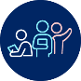 **Differentiation examples**

**Students with advanced proficiency** and **high potential and gifted students** – students read the sentence on their sentence slip, and then put their sentence slip away and complete the task from memory. Once they have lined up in the correct order, students work together to recreate the text, aiming to recall the text in its entirety without hearing it again.

**Students requiring additional support** – provide students with a cloze passage of the text, with some keywords missing. Students use this resource to assist them to determine where they should line up, according to their sentence slip.

## Transcripts

### Text 1

*Antonio abita a Venezia. Questa settimana ha molto da fare. Lunedì mattina si alza alle sette e mezza per andare dal medico. Si veste e fa colazione alle otto meno dieci. Prima di partire si lava i denti alle otto e un quarto. Arriva alla fermata del traghetto alle nove meno dieci. Il traghetto parte alle nove in punto. Arriva dal medico alle dieci meno venti. Dopo va subito al lavoro. Arriva in ufficio alle dieci e mezza. Lavora fino alle quattordici meno un quarto e va a pranzare. Dopo pranzo torna in ufficio. Finisce il lavoro alle diciotto. Prende il traghetto delle diciotto e venticinque per tornare a casa. Cena con la sua famiglia verso le venti e poi guarda la TV per due ore.*

### Text 2

*Maria è studentessa all’università e studia molto. Martedì mattina alle undici ha un esame di matematica. Si sveglia alle sei meno dieci. Fa la doccia e si veste. Fa colazione alle sei e mezza. Alle sette meno un quarto va alla fermata dell’autobus e l’autobus arriva alle sette in punto. All’università Maria va in biblioteca. Studia dalle otto alle dieci e quaranta. Poi, comincia l’esame alle undici. Dopo l’esame, alle tredici, Maria torna a casa perché non ha lezioni oggi. A casa, pranza con suo papà e si riposa davanti alla TV per un’ora. Il pomeriggio, verso le quindici e mezza, Maria va in centro per incontrare le sue amiche a un caffè. Prendono qualcosa da bere insieme e parlano per due ore. Alle diciotto, torna a casa per studiare un po’. Cena con sua mamma e suo papà alle diciannove e mezza.*

## Sentence slips – set 1Sentence slips Set 1 aSentence slips set 1 b

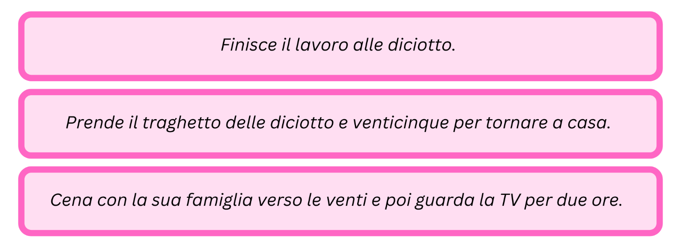

## Sentence slips – set 2

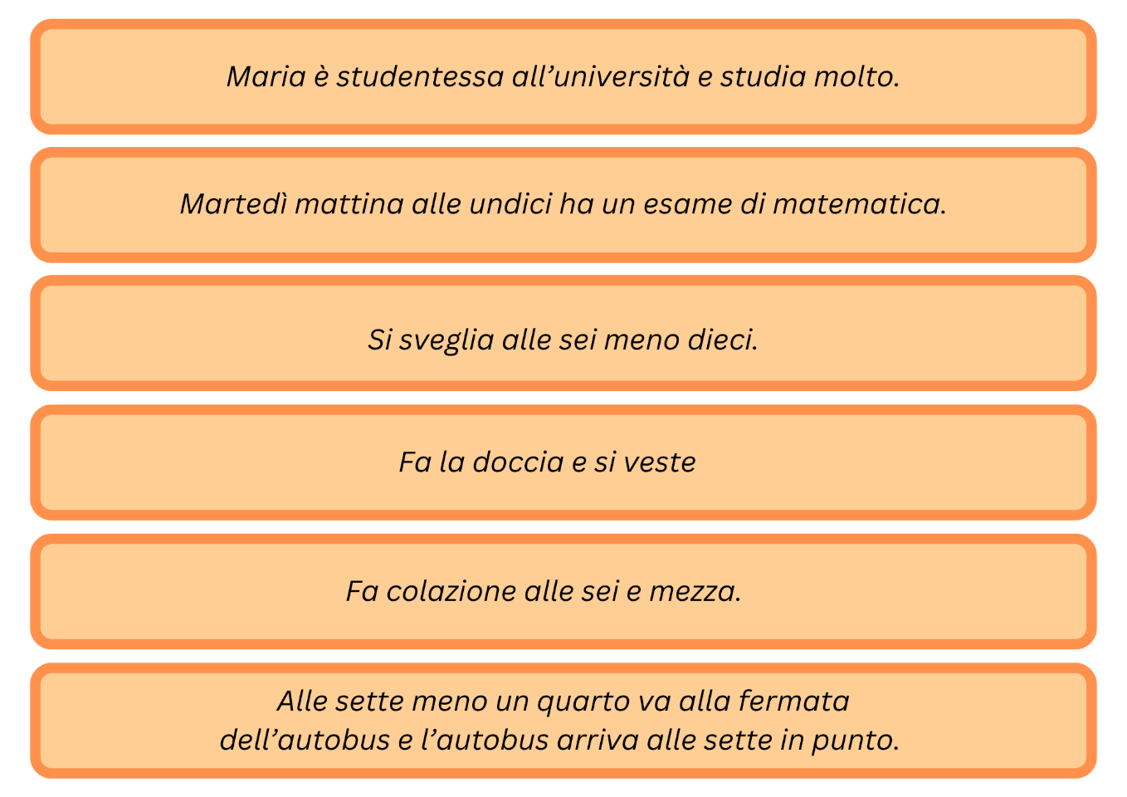

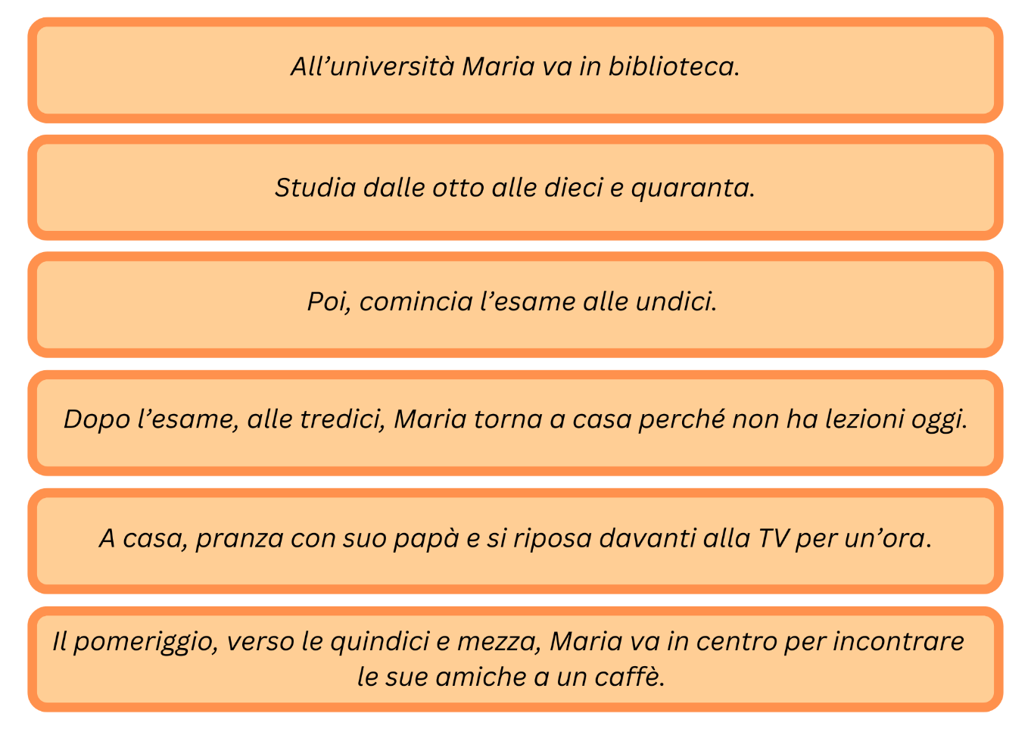

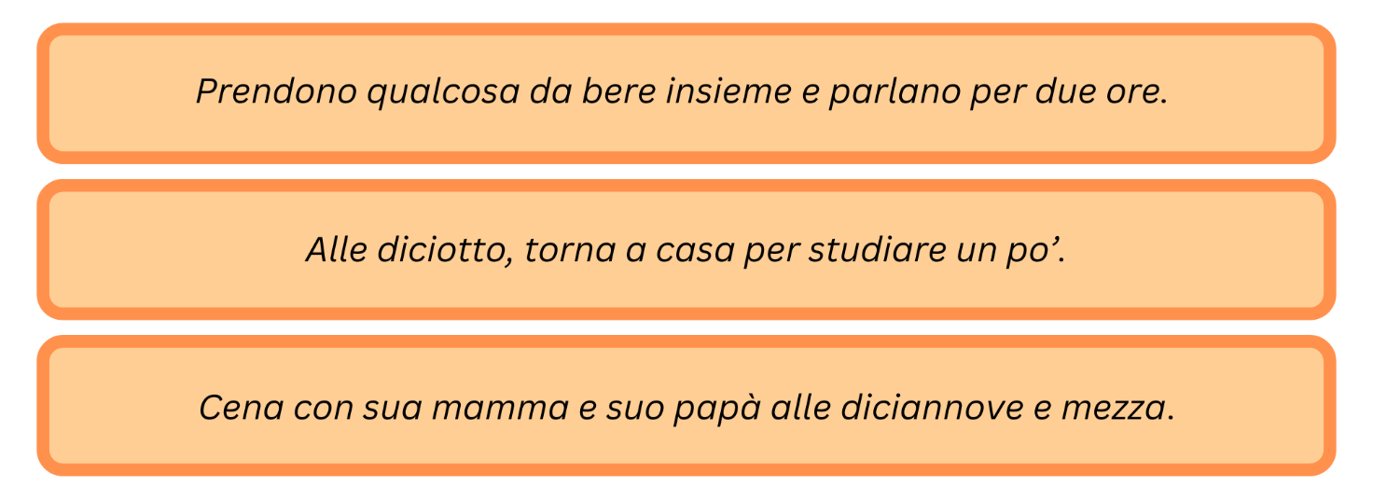

**© State of New South Wales (Department of Education), 2024**

The copyright material published in this resource is subject to the *Copyright Act 1968* (Cth) and is owned by the NSW Department of Education or, where indicated, by a party other than the NSW Department of Education (third-party material).

Copyright material available in this resource and owned by the NSW Department of Education is licensed under a [Creative Commons Attribution 4.0 International (CC BY 4.0) license](https://creativecommons.org/licenses/by/4.0/).

**[](https://creativecommons.org/licenses/by/4.0/)**

This license allows you to share and adapt the material for any purpose, even commercially. Attribution should be given to © State of New South Wales (Department of Education), 2024.

Material in this resource not available under a Creative Commons license:

* the NSW Department of Education logo, other logos and trademark-protected material
* material owned by a third party that has been reproduced with permission. You will need to obtain permission from the third party to reuse its material.

**Links to third-party material and websites**

Please note that the provided (reading/viewing material/list/links/texts) are a suggestion only and implies no endorsement, by the New South Wales Department of Education, of any author, publisher, or book title. School principals and teachers are best placed to assess the suitability of resources that would complement the curriculum and reflect the needs and interests of their students.

If you use the links provided in this document to access a third-party's website, you acknowledge that the terms of use, including licence terms set out on the third-party's website apply to the use which may be made of the materials on that third-party website or where permitted by the *Copyright Act 1968* (Cth). The department accepts no responsibility for content on third-party websites.