# My day

## Activity 1

Using the cue cards provided, work in pairs with the cards face down in front of you. Take it in turns to pick up a card and ask your partner the question *A che ora…?* based on the image you see on the card. Your partner responds to the question. For example, if you pick up the card for svegliarsi, you ask the question A che ora ti svegli? and your partner responds using the structure Mi sveglio alle *[*time*]*.

## Activity 2

In the table below write 5 questions in Italian to ask your partner using the daily routine verbs you have just practised, for example, A che ora fai colazione? Take it in turns to ask your partner your questions and write down the response given in the space provided on the sheet. The first row has been done for your as an example.

|  |  |
| --- | --- |
| Question | Response |
| *A che ora fai colazione?* | **7:00 or *alle* sette** |
|  |  |
|  |  |
|  |  |
|  |  |
|  |  |

When you have completed the table above, write a descriptive paragraph about your partner’s routine using the times given and appropriate sequencing words on the lines provided. A sample sentence has been provided for you below:

***Tommaso si sveglia alle sette. Poi fa colazione alle otto.***

|  |
| --- |
|  |
|  |
|  |
|  |
|  |

## For the teacher

Remove this section before sharing this resource with students.

These activities are designed to suit a range of abilities and contexts. Adjust the level of difficulty of the activities to suit your students.

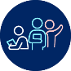 **Differentiation examples**

**Students with advanced proficiency** – students practise using more specific questions, such as, *A che ora ti svegli il sabato?* and more detailed responses, for example, *Il sabato* *mi sveglio alle otto perché vado allo stadio*.Students can take notes during the conversation and thenreport back to the teacher, for example, *Tommaso si sveglia alle sei il sabato e subito fa la doccia*.

**High potential and gifted students** – give students cue cards with the images only, omitting the Italian reflexive verb. Encourage students to ask follow-up questions using reflexive verbs, for example, *A che ora ti svegli e cosa fai dopo?*

**Students requiring additional support** – for Activity 1, give students cards with the Italian infinitive as well as the time cards provided in this resource. Provide the questions on the card and/or a prompt sheet with answer stems, for example *Mi sveglio alle…* Give students time to write down their responses before interacting. For Activity 2, provide students with sentence starters to help write the text.

## Cue cards

|  |  |  |
| --- | --- | --- |
| a person waking up | a person getting up | a person having a shower |
| ***svegliarsi*** | ***alzarsi*** | ***fare la doccia*** |
| a person getting dressed. | a person having breakfast. | a person brushing teeth |
| ***vestirsi*** | ***fare colazione*** | ***lavarsi i denti*** |
| a person getting ready | a person going to school | a person returning home |
| ***prepararsi*** | ***andare a scuola*** | ***tornare a casa*** |
| a person having lunch | a person doing homework | a person resting |
| ***pranzare*** | ***fare i compiti*** | ***riposarsi*** |
| a person having dinner | a person getting undressed | a person putting on PJs |
| ***cenare*** | ***spogliarsi*** | ***mettersi il pigiama*** |
| a person going to bed | a person going to sleep |  |
| ***andare a letto*** | ***addormentarsi*** |  |

## Time cards

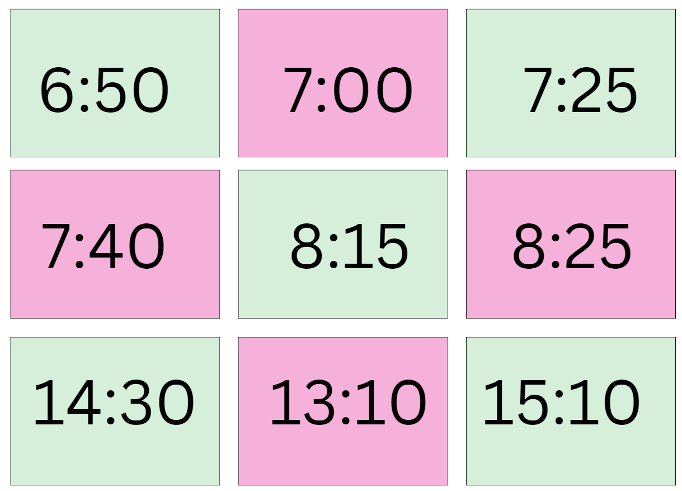

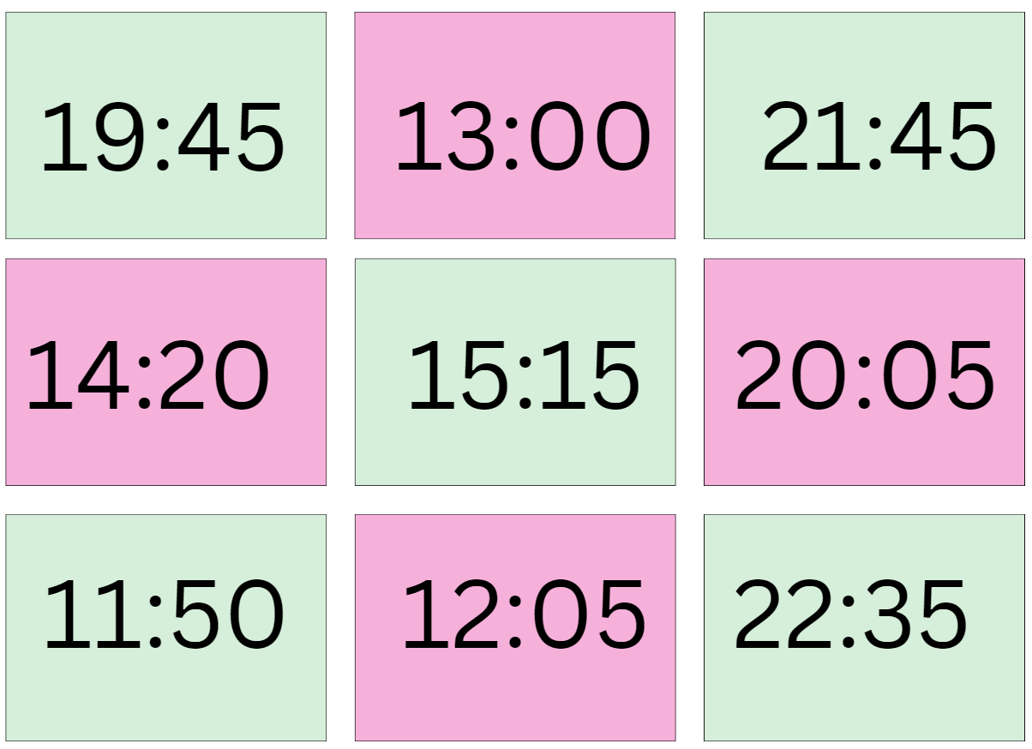

**© State of New South Wales (Department of Education), 2024**

The copyright material published in this resource is subject to the *Copyright Act 1968* (Cth) and is owned by the NSW Department of Education or, where indicated, by a party other than the NSW Department of Education (third-party material).

Copyright material available in this resource and owned by the NSW Department of Education is licensed under a [Creative Commons Attribution 4.0 International (CC BY 4.0) license](https://creativecommons.org/licenses/by/4.0/).

**[](https://creativecommons.org/licenses/by/4.0/)**

This licence allows you to share and adapt the material for any purpose, even commercially. Attribution should be given to © State of New South Wales (Department of Education), 2024.

Material in this resource not available under a Creative Commons licence:

* the NSW Department of Education logo, other logos and trademark-protected material
* material owned by a third party that has been reproduced with permission. You will need to obtain permission from the third party to reuse its material.

**Links to third-party material and websites**

Please note that the provided (reading/viewing material/list/links/texts) are a suggestion only and implies no endorsement, by the New South Wales Department of Education, of any author, publisher, or book title. School principals and teachers are best placed to assess the suitability of resources that would complement the curriculum and reflect the needs and interests of their students.

If you use the links provided in this document to access a third-party's website, you acknowledge that the terms of use, including licence terms set out on the third-party's website apply to the use which may be made of the materials on that third-party website or where permitted by the *Copyright Act 1968* (Cth). The department accepts no responsibility for content on third-party websites.