# Each day activity

This resource is for the teacher. It provides the content and instructions you need to share with students.

Use the playing cards provided or use the [editable version on Canva](https://www.canva.com/design/DAGLAjc_9TQ/9CbdwchsJB0XvxuKUvL_Hg/view?utm_content=DAGLAjc_9TQ&utm_campaign=designshare&utm_medium=link&utm_source=publishsharelink&mode=preview).

Print and cut up the playing cards below, ensuring there are enough for each group to receive their own set. To save time, ask students to cut out the playing cards for their group.

Give each student a colour card in Italian from resource **16. Colour cards (Word)** and direct them to form groups with other students who have a matching colour card.

Ask students to recall how to say ‘each day’ from prior learning. Revise the structure *ogni giorno*.

Instruct students to place the cards face down in the middle of the group. Tell the students the aim of the activity is to create a long sentence by remembering what was said by each student before them and then adding their own activity to the sentence, using conjunctions where appropriate. Demonstrate how to use the cards by modelling a sequence using the cards as prompts:

1. Direct a volunteer student to pick up the first card (for example, I have breakfast) and make a sentence with the phrase *ogni giorno* and the prompt on the card (*faccio colazione)*. Direct the student to place the card face down in front of them.
2. Direct a different volunteer student to pick up a second card (for example, I get dressed) and first repeat the sentence from the previous student, before adding to the sentence using a conjunction (***e***)and theprompt on their card (*mi vesto).* Direct the student to place the card face down in front of them.
3. Pick up a third card (for example, I go to school) and say *Ogni giorno mi vesto* ***poi*** *vado a scuola.*
4. Ask students if anything was missed in the sequence (*faccio colazione*).
5. Point out to students that because a phrase was missed, the cards are put back in the pile and the activity recommences from the beginning.
6. Check for student understanding of the activity before students complete the activity in their groups.

Explain to students that the sentence produced does not need to make sense, as the cards will be drawn at random. The eldest student in each group begins by drawing a card to commence the activity. Students with cards who have already had their turn will need to listen attentively and let their team know if the activity on their own card was forgotten in the sentence sequence. If a student makes a mistake or an activity is left out of the sentence sequence, all cards are returned to the middle and shuffled, and the game starts again.

The group to get through all playing cards first, wins.

 **Differentiation examples**

**High potential and gifted students** and **students with advanced proficiency** – students complete multiple rounds, each time constructing the text using a different subject pronoun, for example, he, she, you, we or they.

**Students requiring additional support** – add the infinitive of the verb, or where required, the verb in the first person on the playing cards, to assist students with recalling vocabulary. A list of conjunctions could also be provided.

## Each day playing cards

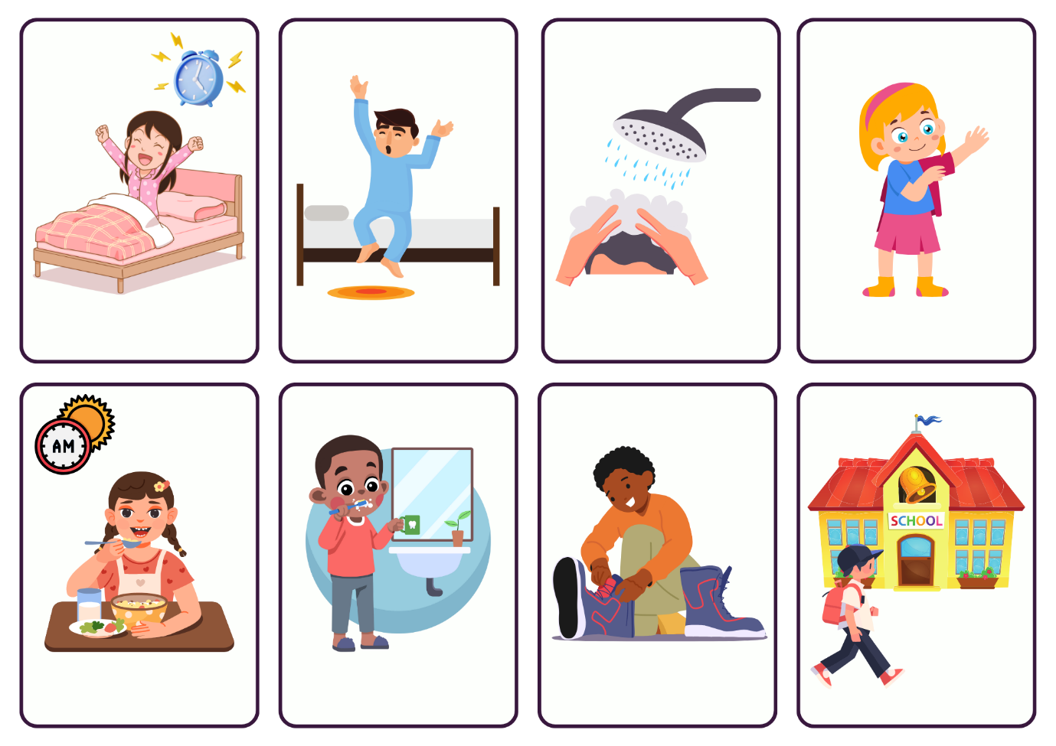

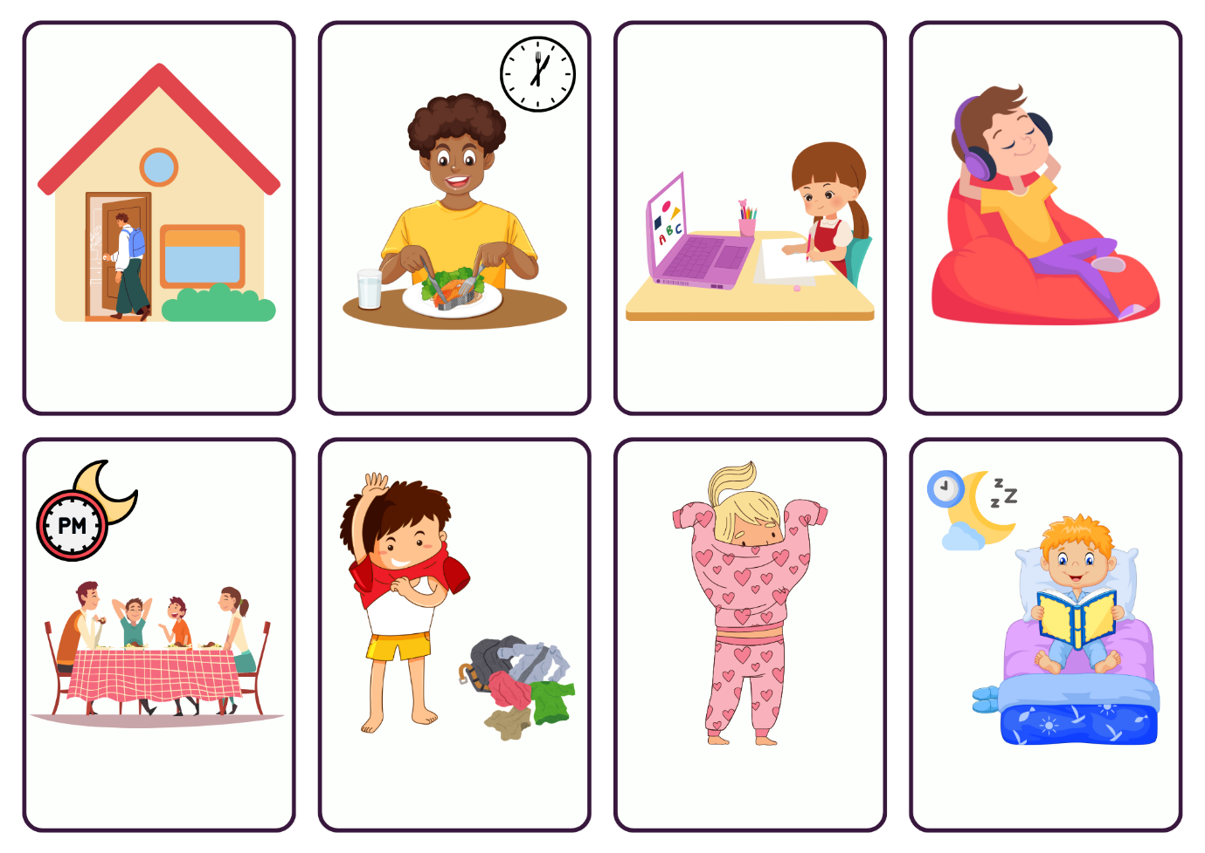

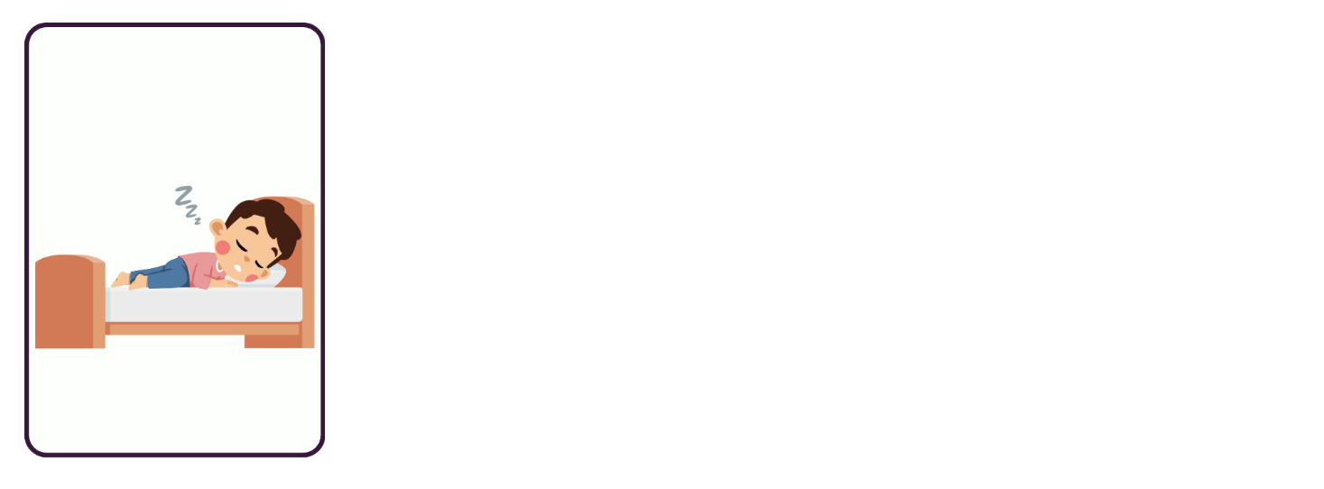

**© State of New South Wales (Department of Education), 2024**

The copyright material published in this resource is subject to the *Copyright Act 1968* (Cth) and is owned by the NSW Department of Education or, where indicated, by a party other than the NSW Department of Education (third-party material).

Copyright material available in this resource and owned by the NSW Department of Education is licensed under a [Creative Commons Attribution 4.0 International (CC BY 4.0) license](https://creativecommons.org/licenses/by/4.0/).

[](https://creativecommons.org/licenses/by/4.0/)

This license allows you to share and adapt the material for any purpose, even commercially.

Attribution should be given to © State of New South Wales (Department of Education), 2024.

Material in this resource not available under a Creative Commons license:

* the NSW Department of Education logo, other logos and trademark-protected material
* material owned by a third party that has been reproduced with permission. You will need to obtain permission from the third party to reuse its material.

**Links to third-party material and websites**

Please note that the provided (reading/viewing material/list/links/texts) are a suggestion only and implies no endorsement, by the New South Wales Department of Education, of any author, publisher, or book title. School principals and teachers are best placed to assess the suitability of resources that would complement the curriculum and reflect the needs and interests of their students.

If you use the links provided in this document to access a third-party's website, you acknowledge that the terms of use, including licence terms set out on the third-party's website apply to the use which may be made of the materials on that third-party website or where permitted by the Copyright Act 1968 (Cth). The department accepts no responsibility for content on third-party websites.