# Word snatch

This resource is for the teacher. It provides the content and instructions you need to share with students.

Students work in pairs or small groups. Use the playing cards provided or use the [editable version on Canva](https://www.canva.com/design/DAGKIvVsHiQ/ODS38sKDEBeMO3bcyHeXpg/view?utm_content=DAGKIvVsHiQ&utm_campaign=designshare&utm_medium=link&utm_source=publishsharelink&mode=preview) to amend the content. Print and give each pair or group a copy of the playing cards below. To save time, ask students to cut out their own playing cards.

Using the script provided in the resource, read aloud the 10 sample verb conjugations. Students race to be the first to snatch the card with the correct conjugation they hear, avoiding cards included as ‘distractors’. Point out to students that the playing cards do not have the pronoun, as these are not commonly used in Italian, so students will need to listen carefully for the correct verb ending. Students receive one point for every correct card snatched but lose 2 points for each incorrect card snatched. The winner is the student with the most points. Read the correct answers carefully at the end of the game to allow students to tally their points. At the end of the round students return all playing cards to the middle.

For the second round, using the script provided, read aloud the 2 texts. Students must listen carefully and snatch the cards which match the verb conjugations as they hear them. At the conclusion of the game, read each paragraph again slowly to allow students to tally their points. The same point system applies.

 **Differentiation examples**

**High potential and gifted students** and **students with advanced proficiency** – students of similar ability play together, with one student reading out the scripts.

**Students requiring additional support** – reduce the pace and the number of verb conjugations for the first round. Say sentences, rather than a paragraph, for the second round. Consider creating cards with subject pronouns and direct students to create pairs by matching them with the correct conjugations of the verb.

## Word snatch playing cards

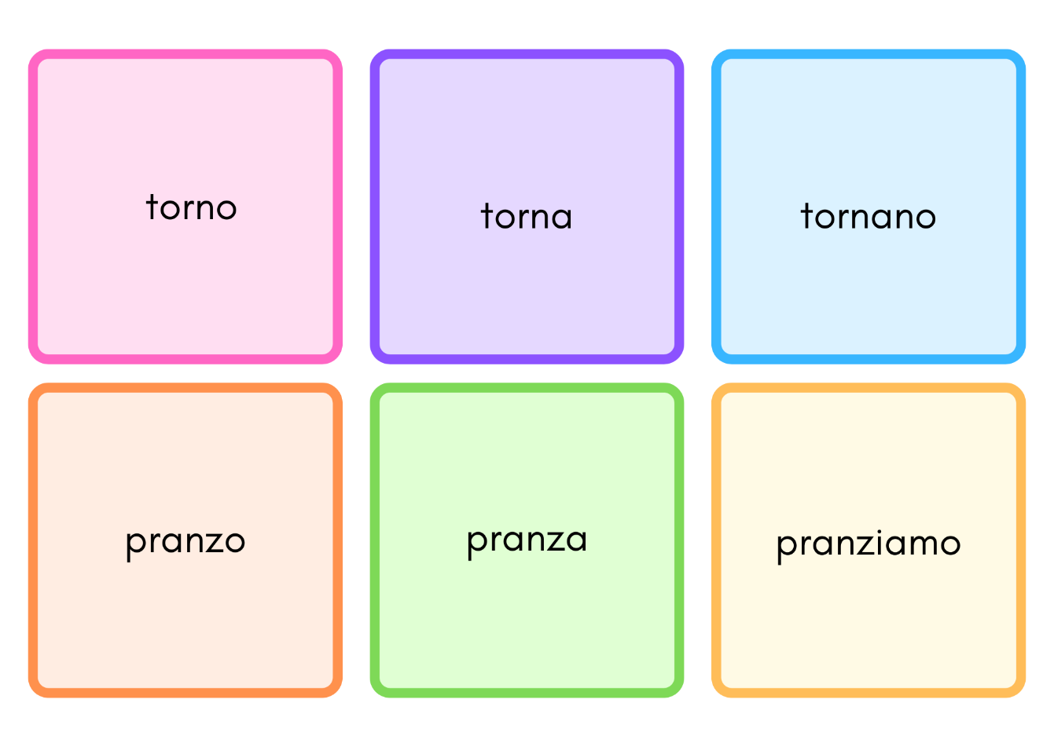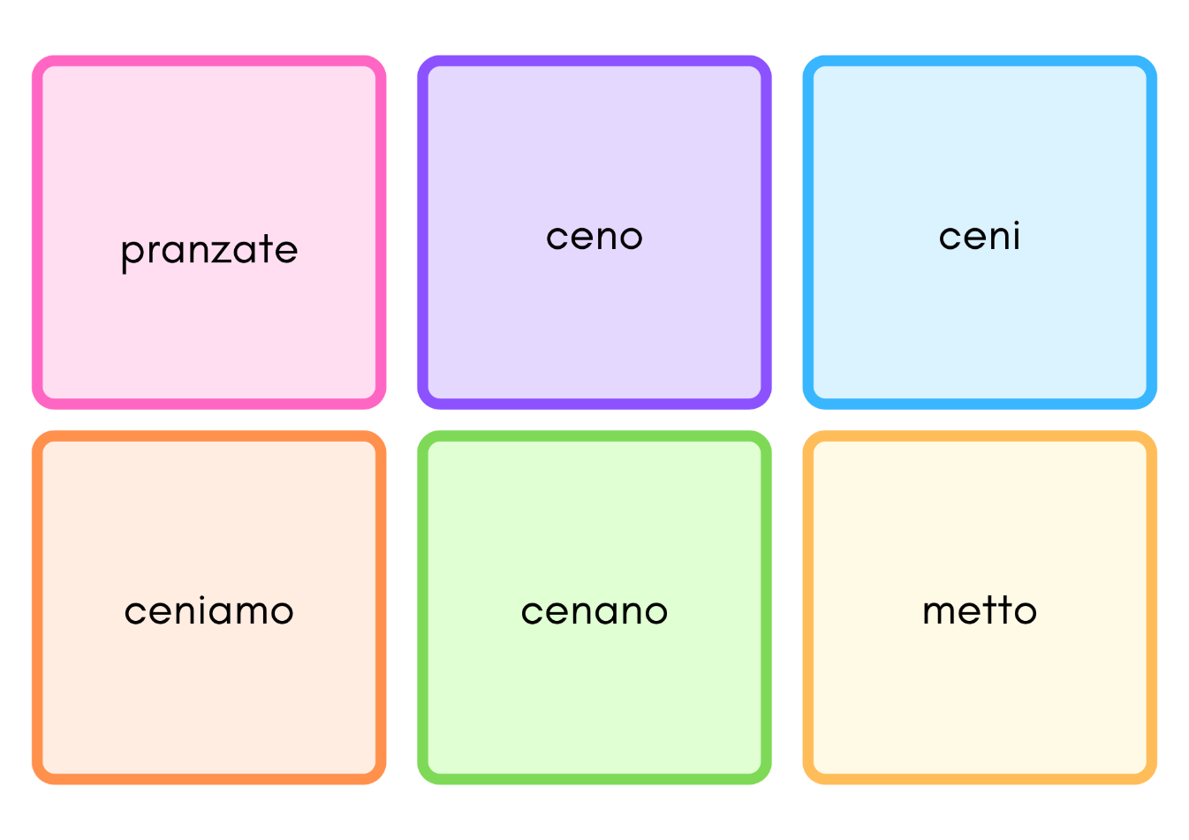

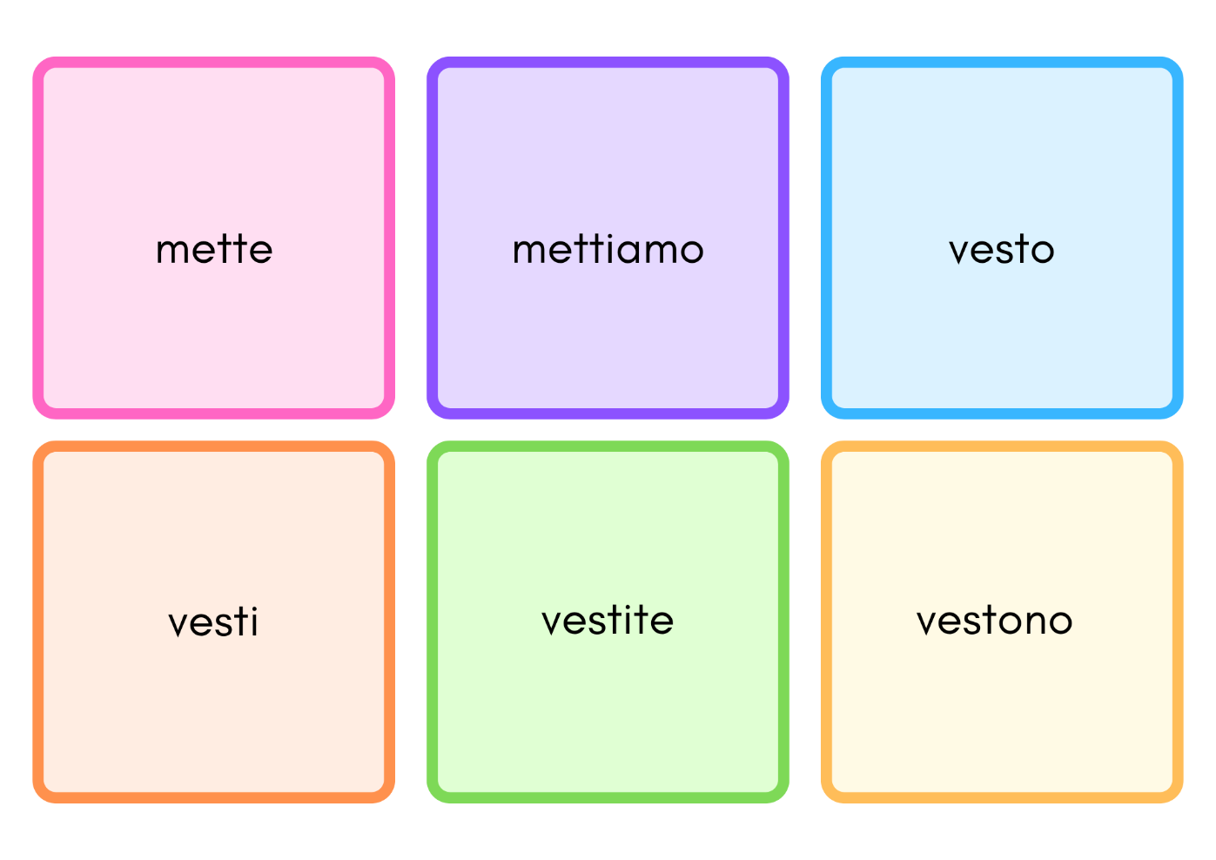

## Scripts

### Script 1

1. *io metto*
2. *tu ceni*
3. *loro vestono*
4. *lui torna*
5. *voi pranzate*
6. *io torno*
7. *lei mette*
8. *loro cenano*
9. *lei pranza*
10. *noi mettiamo*

### Script 2

1. *Bianca e Lorenzo preparano il pranzo quando io torno a casa. Mentre noi pranziamo insieme, mettiamo la musica che Bianca preferisce e Lorenzo mette la bottiglia d’acqua sulla tavola. Dopo, Lorenzo e Bianca tornano al lavoro.*
2. *Voi vi vestite elegantemente ogni volta che pranzate al ristorante in centro. lo non mi vesto mai alla moda e non pranzo mai al ristorante.*

**© State of New South Wales (Department of Education), 2024**

The copyright material published in this resource is subject to the *Copyright Act 1968* (Cth) and is owned by the NSW Department of Education or, where indicated, by a party other than the NSW Department of Education (third-party material).

Copyright material available in this resource and owned by the NSW Department of Education is licensed under a [Creative Commons Attribution 4.0 International (CC BY 4.0) license](https://creativecommons.org/licenses/by/4.0/).

**[](https://creativecommons.org/licenses/by/4.0/)**

This license allows you to share and adapt the material for any purpose, even commercially. Attribution should be given to © State of New South Wales (Department of Education), 2024.

Material in this resource not available under a Creative Commons license:

* the NSW Department of Education logo, other logos and trademark-protected material
* material owned by a third party that has been reproduced with permission. You will need to obtain permission from the third party to reuse its material.

**Links to third-party material and websites**

Please note that the provided (reading/viewing material/list/links/texts) are a suggestion only and implies no endorsement, by the New South Wales Department of Education, of any author, publisher, or book title. School principals and teachers are best placed to assess the suitability of resources that would complement the curriculum and reflect the needs and interests of their students.

If you use the links provided in this document to access a third-party's website, you acknowledge that the terms of use, including licence terms set out on the third-party's website apply to the use which may be made of the materials on that third-party website or where permitted by the *Copyright Act 1968* (Cth). The department accepts no responsibility for content on third-party websites.