# Daily routine flashcards

This resource is for the teacher. It provides the content and instructions for you to share with students.

Use the daily routine flashcards provided or use the [editable version on Canva](https://www.canva.com/design/DAGKTqBZRNM/L6ddoV_5evhFiwVwRE-V0w/view?utm_content=DAGKTqBZRNM&utm_campaign=designshare&utm_medium=link&utm_source=publishsharelink&mode=preview) to amend the content.

Print and cut out the daily routine flashcards. The cards can be used throughout the unit in the following ways:

* Play a game of ‘Beat the teacher’. Hold up one of the flashcards and, in Italian, say a daily routine term in the first person. If the term matches the image on the flashcard, the students repeat it. If it does not match, they remain silent. If one student makes an error and breaks the silence, you win the point. If all students remain silent, the class wins the point. The first to 7 points is the winner.
* Revise the pronunciation of daily routine vocabulary, using the cards as flashcards.
* Display the flashcards in the classroom.

Laminate the cards for ongoing use throughout the unit.

### Daily routine flashcards

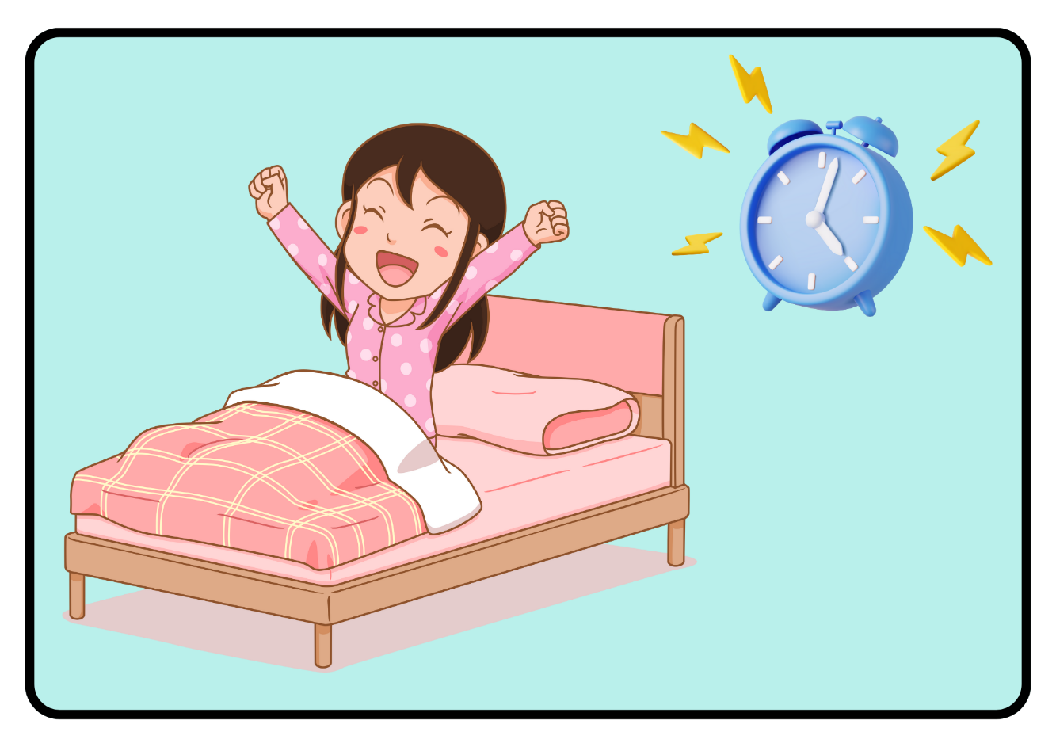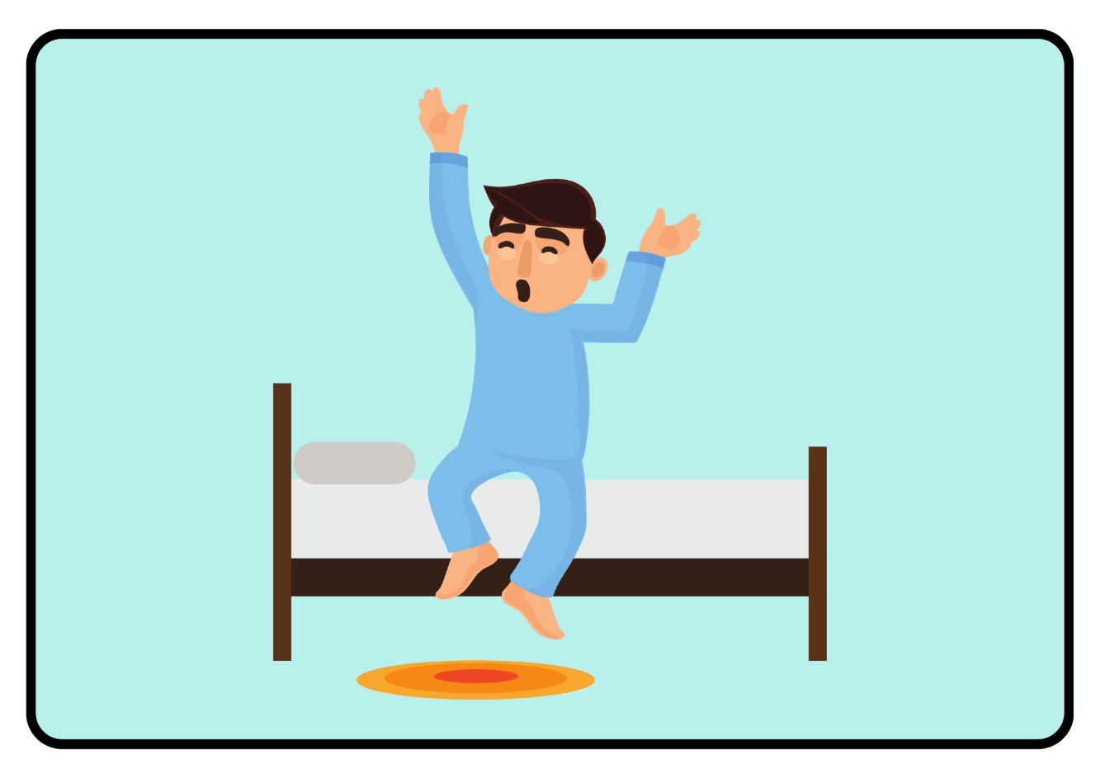

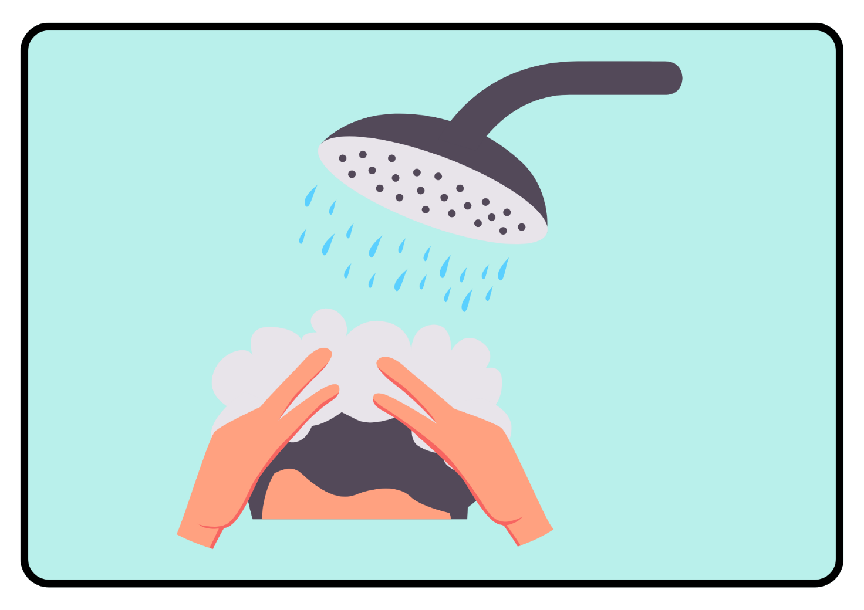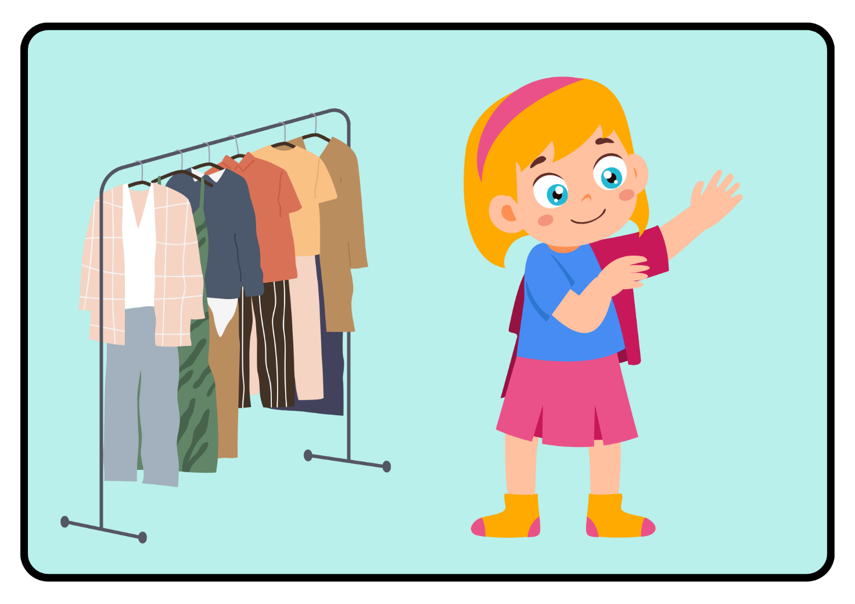

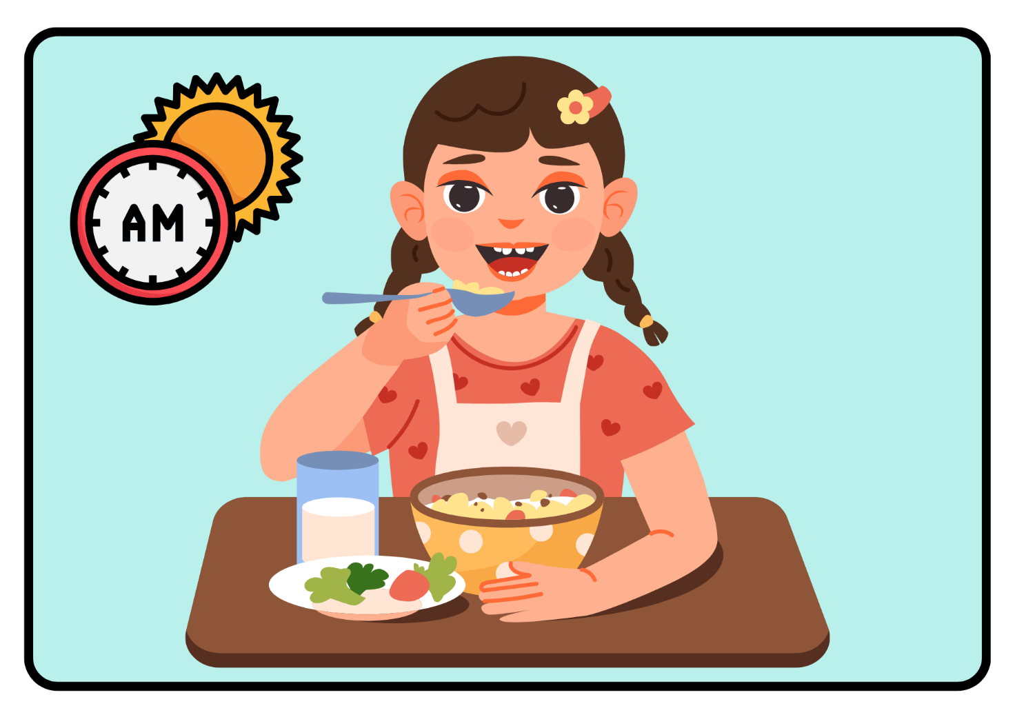

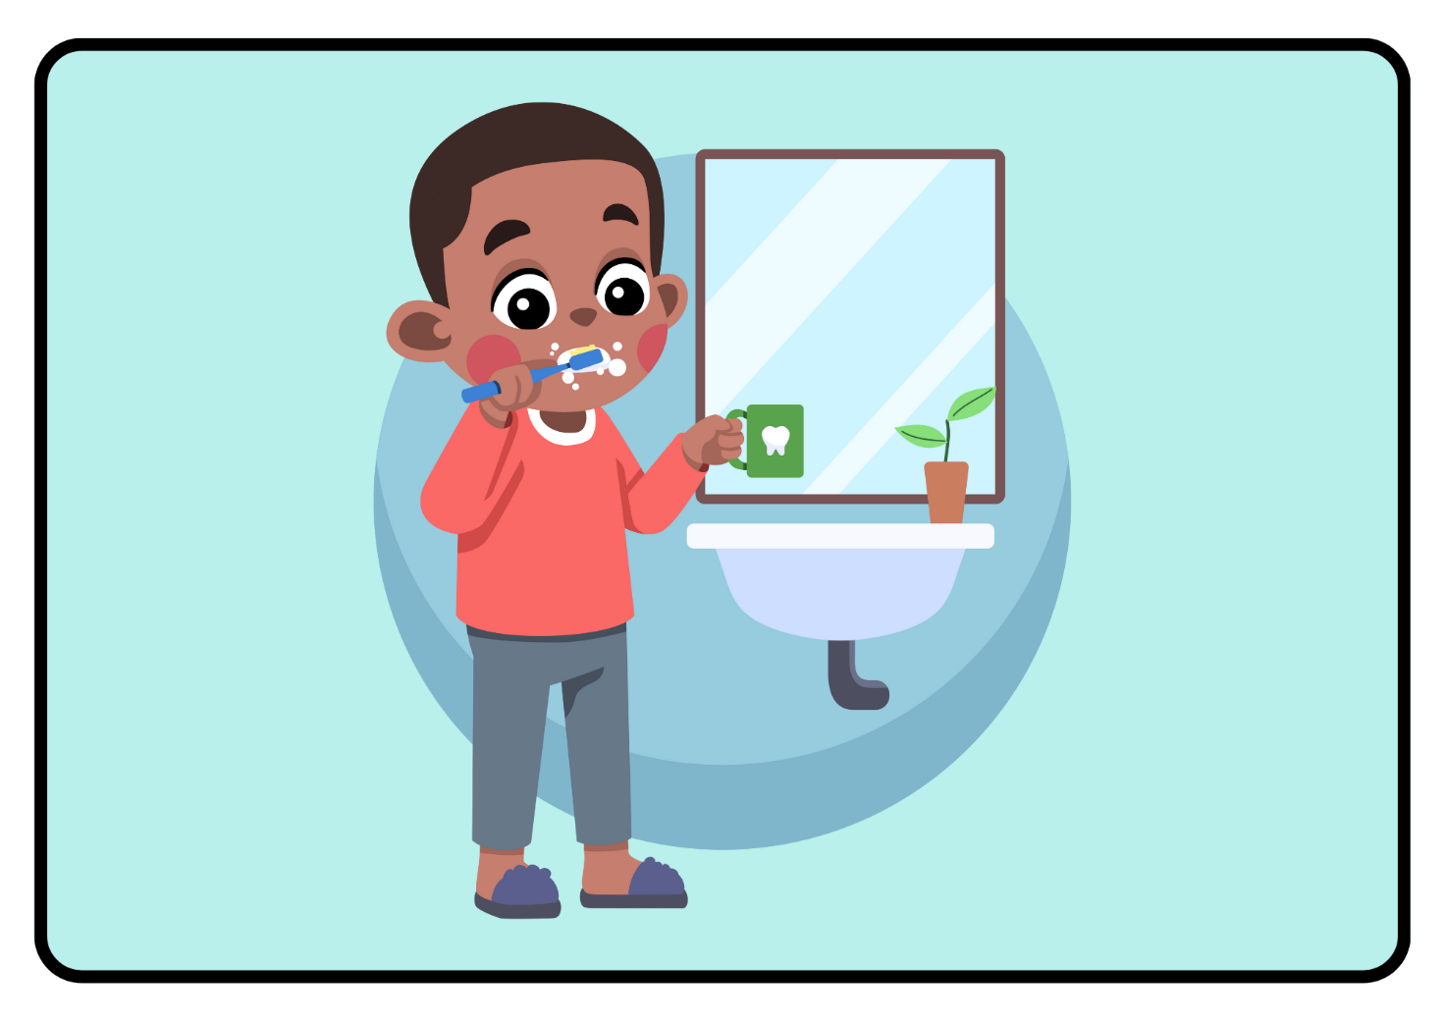

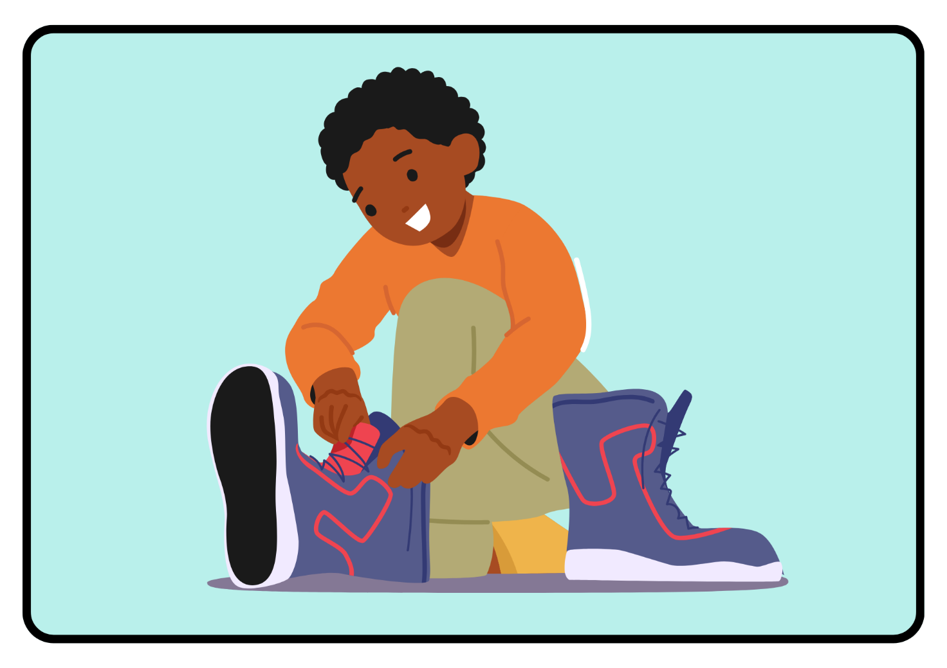

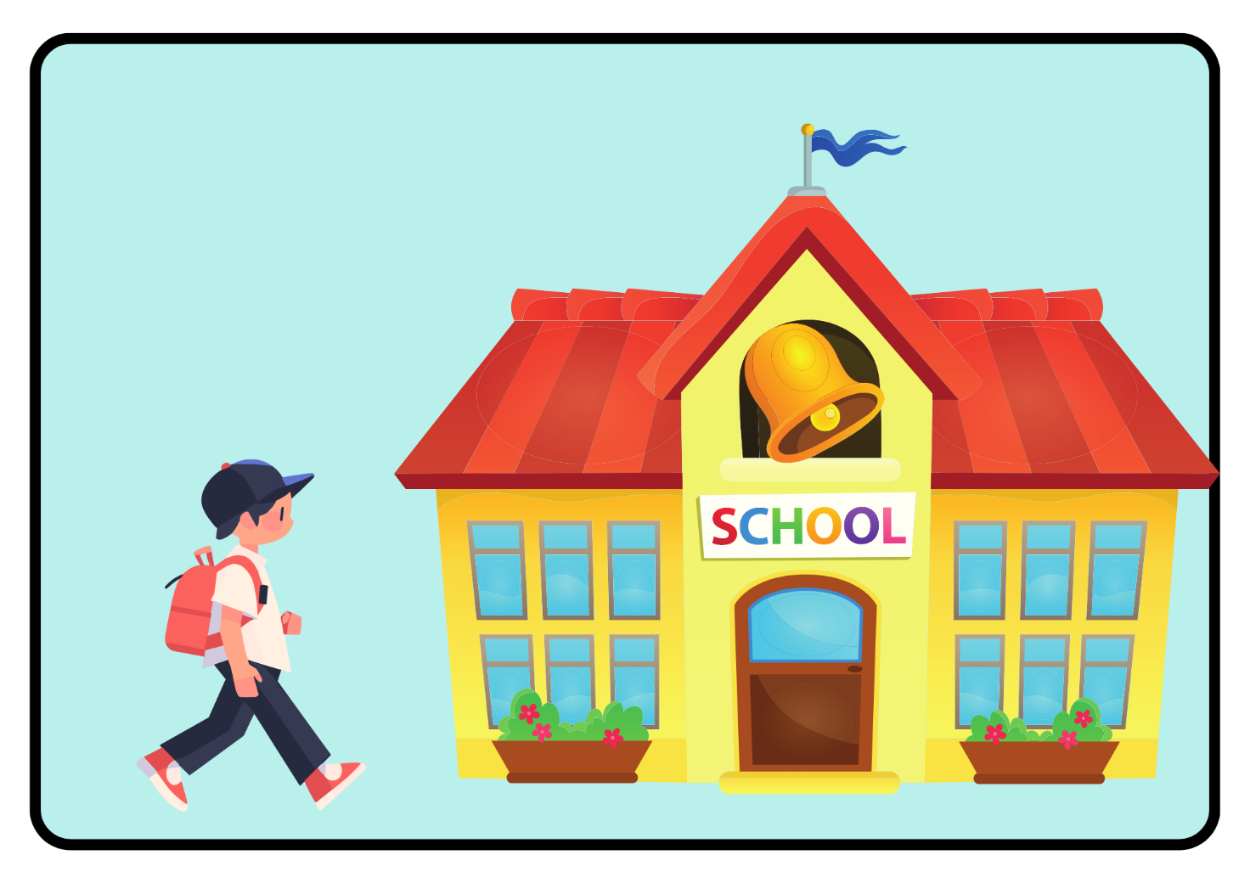

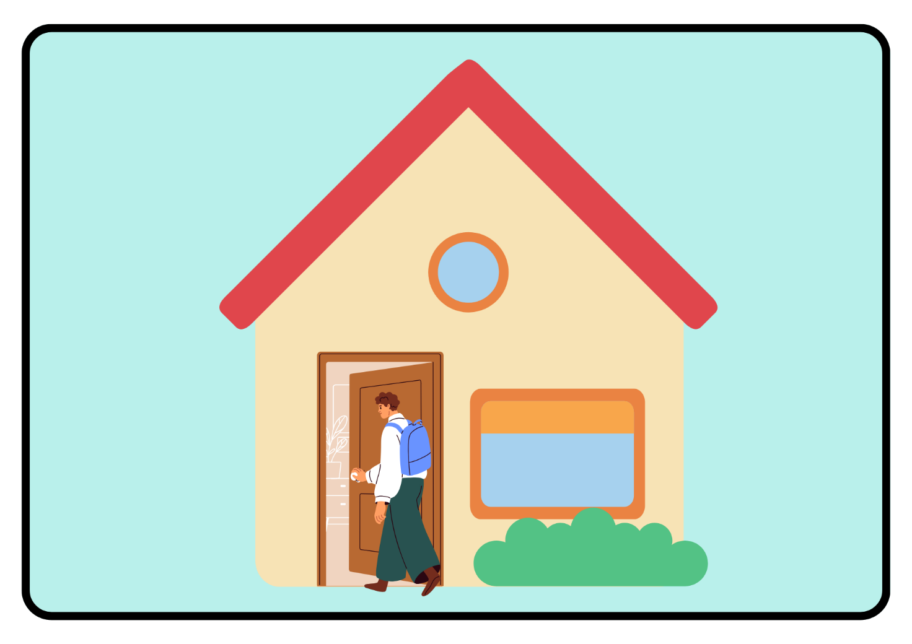

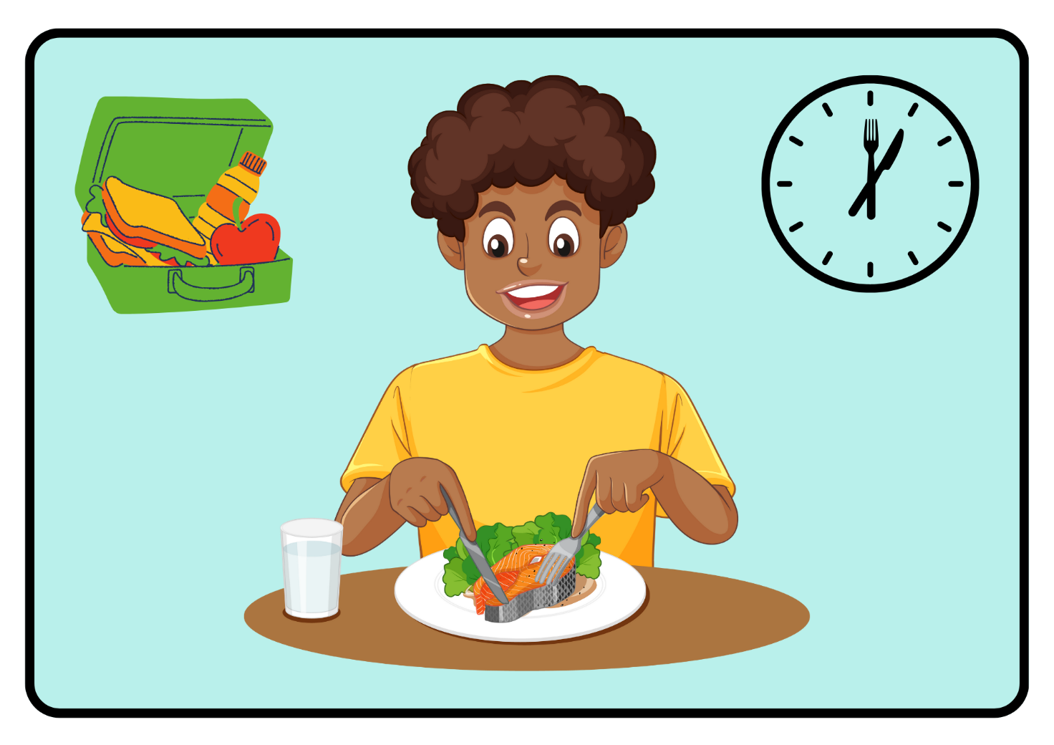

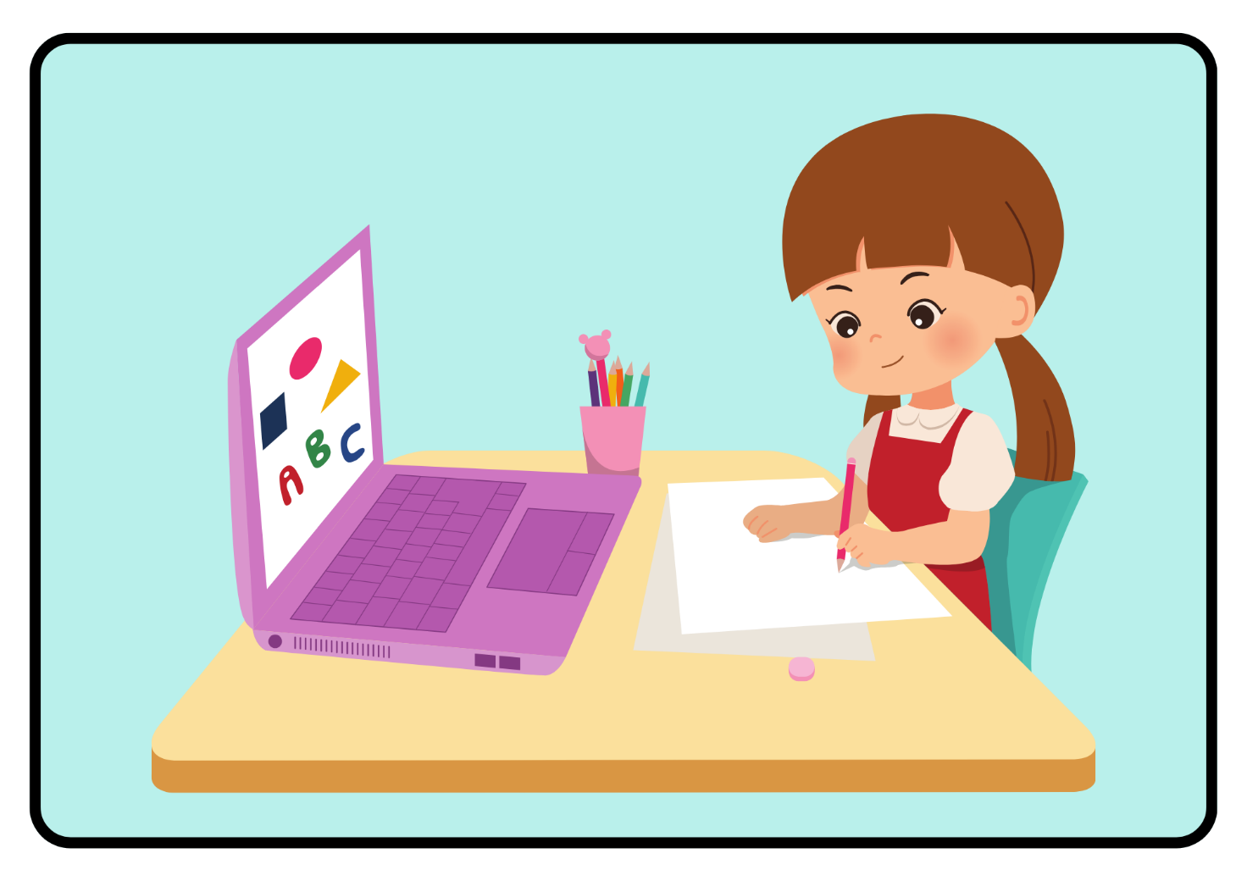

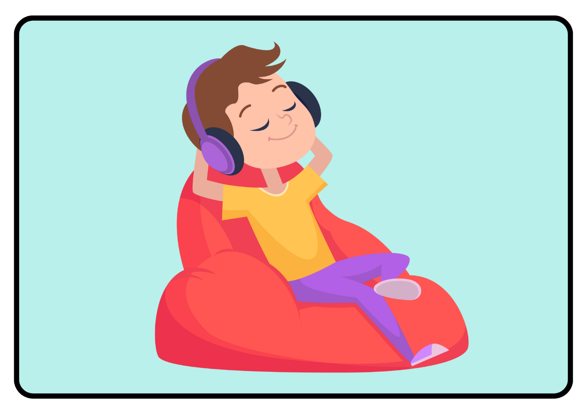

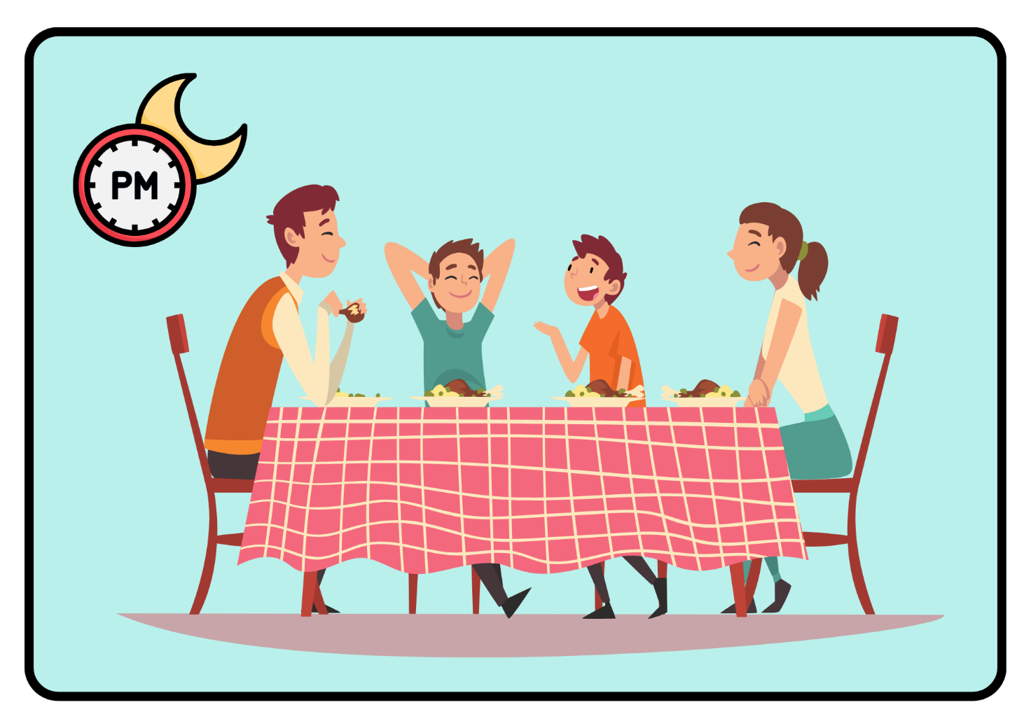

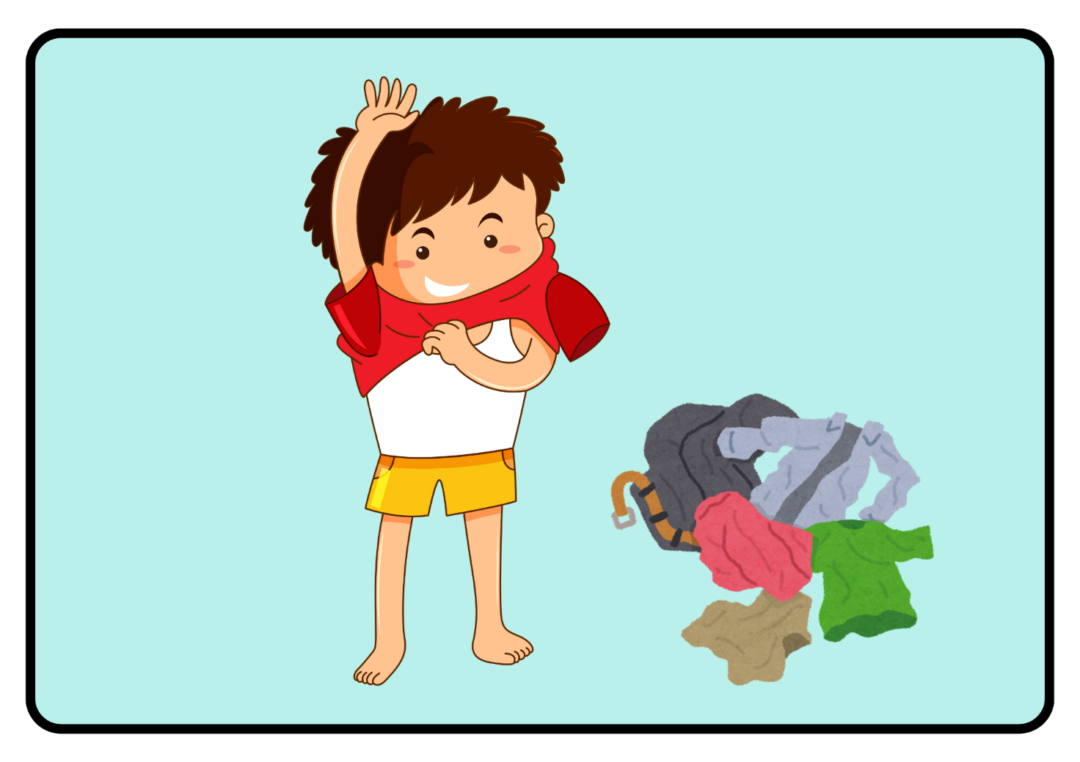

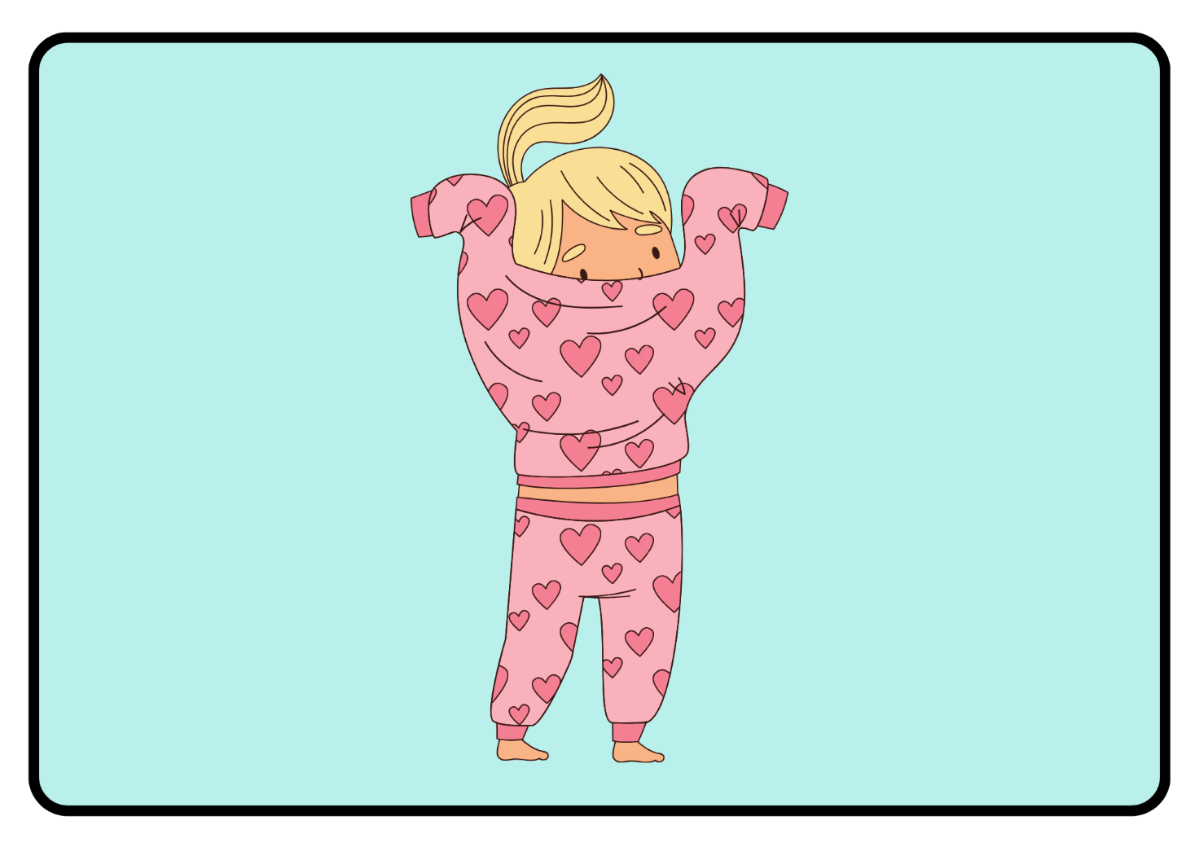

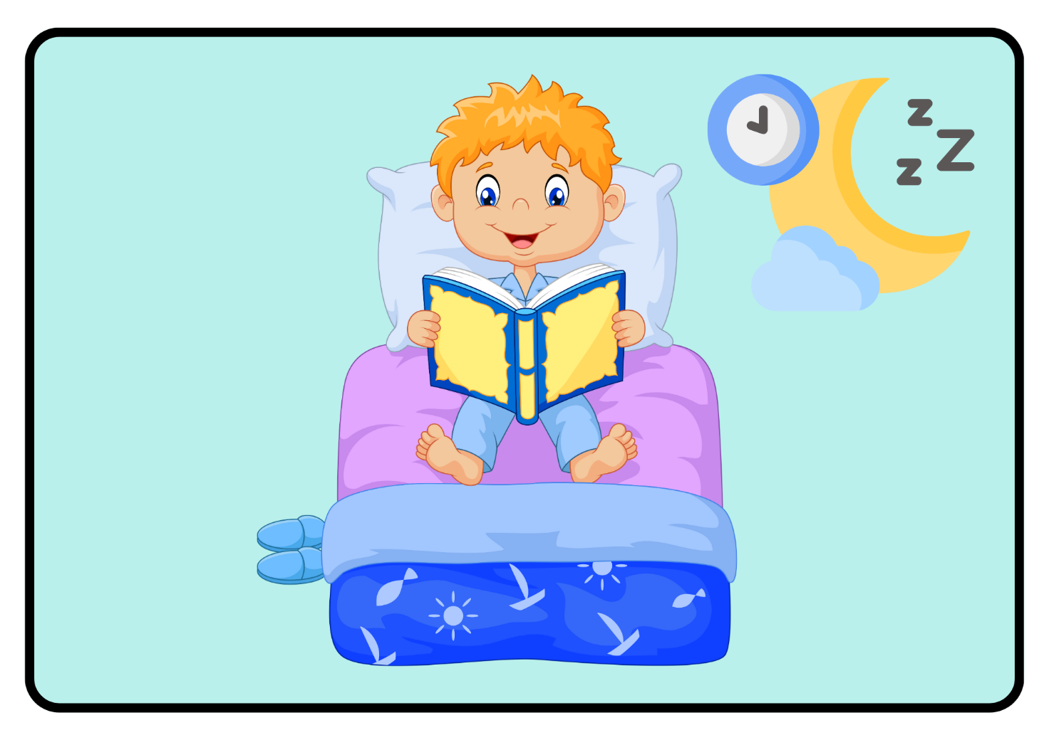

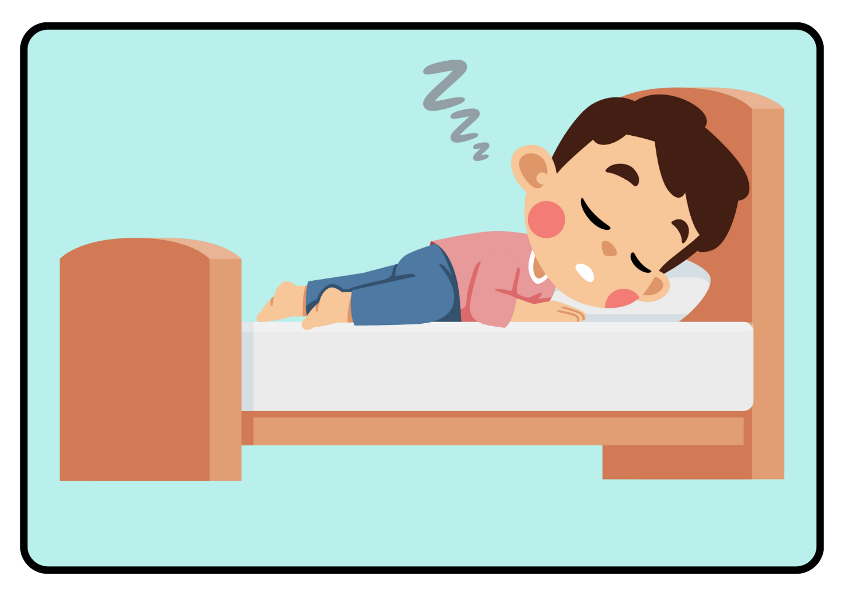

**© State of New South Wales (Department of Education), 2024**

The copyright material published in this resource is subject to the *Copyright Act 1968* (Cth) and is owned by the NSW Department of Education or, where indicated, by a party other than the NSW Department of Education (third-party material).

Copyright material available in this resource and owned by the NSW Department of Education is licensed under a [Creative Commons Attribution 4.0 International (CC BY 4.0) license](https://creativecommons.org/licenses/by/4.0/).

[](https://creativecommons.org/licenses/by/4.0/)

This license allows you to share and adapt the material for any purpose, even commercially.

Attribution should be given to © State of New South Wales (Department of Education), 2024.

Material in this resource not available under a Creative Commons license:

* the NSW Department of Education logo, other logos and trademark-protected material
* material owned by a third party that has been reproduced with permission. You will need to obtain permission from the third party to reuse its material.

**Links to third-party material and websites**

Please note that the provided (reading/viewing material/list/links/texts) are a suggestion only and implies no endorsement, by the New South Wales Department of Education, of any author, publisher, or book title. School principals and teachers are best placed to assess the suitability of resources that would complement the curriculum and reflect the needs and interests of their students.

If you use the links provided in this document to access a third-party's website, you acknowledge that the terms of use, including licence terms set out on the third-party's website apply to the use which may be made of the materials on that third-party website or where permitted by the Copyright Act 1968 (Cth). The department accepts no responsibility for content on third-party websites.