Modern Greek Stage 4 – sample unit
Do you like school? – Σου αρέσει το σχολείο;

Contents
Unit description and duration 4
Student prior learning 5
Syllabus outcomes and content 6
Accessing the resources 6
Summative assessment task – end of unit 7
Learning sequence 8
Introduction 8
Weeks 1–3 – times and days 10
Numbers 11
What time and which day? 13
Mini task 1 – progress checkpoint 17
Weeks 4–5 – transport 19
Getting to and from school 20
Mini task 2 – progress checkpoint 24
Weeks 6–7 – What do I study at school? 26
Discussing subjects and expressing favourites 28
How much do you like …? 29
Mini task 3 – progress checkpoint 32
Weeks 8–10 – subject descriptions and assessment task 35
Describing subjects 36
Evaluation and variation 42
Registration 42
Appendix A – sample summative assessment task 43
Outcomes and content 43
Task 43
Marking guidelines 44
Sample response 47
Appendix B – unit infographic for students 52
About this resource 53
How to use this resource 53
Supporting students with disability 53
Additional support for EAL/D students 55
Evidence base 55
Further information 56
Support and alignment 57
Evidence base 59

Unit description and duration
This 10-week (25-hour) unit introduces students to sharing information about their school day and allows opportunities to compare school routines in Australia and Greece. Students will develop the language skills and intercultural capability to describe their subjects and to express preferences with reasons. Students will also discuss the times and days of the week that schooling occurs.
In this unit, students are provided with opportunities to:
- identify days and times, including when school and breaks start and finish
- ask and answer questions about how they travel to and from school
- identify and describe school subjects, using adjectives
- discuss subject preferences, with reasoning.

Student prior learning
This is the Term 4 Modern Greek unit of the Stage 4 scope and sequence for the mandatory 100 hours.
Before engaging in these teaching and learning activities, students may have had prior experience with the vocabulary and structures below, if they have been following the Modern Greek Stage 4 scope and sequence available on the Support for Modern Greek Stage 4 webpage:
- greetings and introducing themselves and others
- exchanging information about themselves, their family and friends, including physical attributes and personality
- sharing information about their pet or ideal pet
- numbers and expressing age
- expressing where they live and their nationality
- expressing likes and dislikes with reasons, for example, Μου αρέσει η σαλάτα γιατί είναι υγιεινή
- ordering items from a menu.

Syllabus outcomes and content
This unit addresses the following outcomes.
- ML4-INT-01 exchanges information and opinions in a range of familiar contexts by using culturally appropriate language
- ML4-UND-01 interprets and responds to information, opinions and ideas in texts to demonstrate understanding
- ML4-CRT-01 creates a range of texts for familiar communicative purposes by using culturally appropriate language
The relevant syllabus content points are included after each teaching and learning activity. These are suggested only and may vary according to how you use and/or adapt each activity for your context.
Modern Languages K–10 Syllabus © NSW Education Standards Authority (NESA) for and on behalf of the Crown in right of the State of New South Wales, 2022.

Accessing the resources
This unit includes a range of student-facing and teacher resources, in Word, PowerPoint and PDF format.
All resources can be accessed individually from the Support for Modern Greek Stage 4 webpage. For teachers in NSW public schools, all resources can be downloaded as a zipped file from the Languages statewide staffroom. If you’re not a member, please join via our short entry survey.
Within the unit, resources have been numbered and shown in bold.

Summative assessment task – end of unit
This is an overview only. Further details, including related content dot points and marking guidelines, can be found at Appendix A.
- ML4-CRT-01 creates a range of texts for familiar communicative purposes by using culturally appropriate language
Create an audio-visual presentation, using PowerPoint or similar, to introduce yourself and your school to a potential exchange student from Greece. In your presentation, include a range of relevant images and information about:
- when school starts and finishes
- how you get to and from school
- what time you arrive at school, your break times and when you go home
- your opinion on at least 3 subjects you do at school, including one you don’t like, with different reasons
- your favourite subject, why you like it and when you have it.

Learning sequence

Introduction
This unit embeds explicit teaching strategies. Explicit teaching works for students of all ages and all backgrounds. It aligns with how students process, store and retrieve information.
Learning is a cumulative and systematic process. Organising the content, teaching strategies and activities into learning sequences chunks the learning, acknowledging that the use of working memory is optimised when new content is broken into manageable steps and consolidated with practice. The learning sequences in this unit allow students to develop their skills gradually, reinforcing and building vocabulary and structures over time. By providing opportunities to revisit and build upon what they have learned, students can use their language skills to participate in increasingly complex situations.
Adjust the learning sequences to suit your context. This includes adjusting the timeframes, formative and summative assessment tasks, teaching and learning activities and reflection and feedback opportunities, based on the specific strengths and needs of your students.
Teaching strategies included in the learning sequences include:
- Student engagement strategies to encourage student participation and engagement. Learning is regularly linked to students’ personal worlds, encouraging them to make connections and appreciate the relevance of the learning in a meaningful way. Colour cards are used as a tool to form groups. The random student generator is used when formatively assessing students – calling on students at random to participate in activities promotes student engagement as students must remain on task and be prepared to respond at any time. The inclusion of games also facilitates enjoyment in learning. Many of these games can be played regularly, gradually becoming routines (PDF 536 KB). The unit also includes activities which can be completed outside and/or which involve physical movement.
- Brain breaks allow students to replenish focus and attention.
- Differentiation examples to adjust the learning for students with advanced proficiency in the target language, for high potential and gifted students, and for students requiring additional support. Adjust or add to these strategies to suit your students.
- Anchor charts to provide a visual summary of learning. Anchor charts can be created collaboratively as a class or individually for a personalised summary of useful vocabulary and structures for the unit. Anchor charts can be handwritten or digital, using tools such as Bubbl.us, set out with various categories such as food items, souvenirs, bargaining phrases and so on.
- Visible thinking routines to promote deeper understanding, student reflection and feedback opportunities. A wide range of visible thinking routines for the languages classroom, feedback guides for teachers and students, the ‘Learning journals – a guide for students’ and an online sample self-reflection guide for students can be found at the Teaching tools section of the Languages curriculum web section. Practising routines with students, so they become automatic, can reduce cognitive load.
- Templates and conversation scaffolds to support students with modelled and guided learning.
- Online flashcards and games using ICT tools such as Quizizz and Kahoot to provide students with opportunities to create flashcards and play games to practise new vocabulary and structures. Allowing students ongoing opportunities to revisit and memorise vocabulary and structures at intervals throughout the unit (spreading out study over time) supports memory retrieval practices.
- Mini whiteboard activities to check for every student’s understanding. If you do not have access to mini whiteboards, you can use A4 paper in plastic sleeves, with whiteboard markers and paper towel.
- Exit tickets to encourage student reflection, check for understanding and provide informal feedback.

Weeks 1–3 – times and days
The table below contains suggested learning intentions and success criteria. These are best co-constructed with students.
Table 1 – learning intentions and success criteria for Weeks 1–3
Learning intentions | Success criteria
Students are learning:  - that the school system is structured differently in Greece, compared to Australia | Students can:  - identify some of the differences between the school systems in Greece and Australia
- to tell the time in Greek | - tell the time on and past the hour
- that there are different structures to use when saying when something happens, according to the time and the day. | - express at what time and on what day something happens, using correct language structures, for example, when school finishes (Το σχολείο τελειώνει στις τρεις).
Suggested vocabulary and grammatical structures
Numbers up to 100: revise zero to 20, introduce 21 to 100
Asking and telling the time: Τι ώρα είναι;, Είναι μία η ώρα, Είναι τρεις και μισή, Είναι δύο και πέντε, Είναι μεσημέρι, Είναι μεσάνυχτα
Days of the week: Δευτέρα, Τρίτη, Τετάρτη, Πέμπτη, Παρασκευή, Σάββατο, Κυριακή
Expressing on what days of the week and at what time events start and finish: Το σχολείο αρχίζει/τελειώνει στις... [time];, Φτάνω στο σχολείο στις εννιά/εννέα, Τη Δευτέρα φτάνω στο σπίτι στις τέσσερις.

Numbers
- Introduce the final summative assessment task which students will do at the end of term. Discuss the task and marking guidelines to ensure students understand expectations and learning goals. Explain that all activities completed this term will build students’ skills to help them complete the task. Encourage students to ask questions.
- To build the field, students watch the video What is the public school system like in Greece? (18:10). Then, using resource 1. Schooling in Greece (PowerPoint), discuss schooling in Greece, including typical subjects taught in the different year levels. Discuss the differences and similarities between the NSW school system and the Greek school system. Encourage EAL/D students in the class to contribute to the discussion with information about their home culture. Students complete the ‘See, Think, Wonder’ activity on the final slide of the PowerPoint. Students may record their responses in their notebooks or devices, or using an online tool such as Mentimeter. Give students an opportunity to share and discuss their responses. Students then complete a Plus, Minus, Interesting (PMI) chart to generate discussion around the positives, negatives and interesting ideas associated with schooling in Greece.
- Review numbers by watching the YouTube clip How to count from 1–20 in Greek (2:19). Encourage students to repeat the numbers at each interval. Use resource 2. Numbers 0–100 (PowerPoint) (slides 1 to 26) with choral repetition to practise pronunciation of numbers between zero and 20. Use slide 27 to introduce and explain how to form larger numbers. Write 5 to 6 larger numbers on the board, for example, 36, 42, 55, 68, 27, 46. In Greek, model each number on the board, eliciting answers from the class. Play a game of ‘Beat the teacher’ by writing a number on the board and saying it aloud as you point to it. Students repeat after you if you have used the word that identifies the number correctly. If the word is different from the number on the board, they remain silent to win a point. If the word does not match the number and anyone in the class makes a sound, you take the point. The first to 7 points is the winner. Use knowledge of features of the sound system to understand texts (ML4-UND-01)
- Support students to start an anchor chart for the unit in their books or devices by modelling on the board. Remind students of the unit’s final summative task and brainstorm categories to include in the chart, for example, numbers and ordinal numbers, times, school subjects, likes and dislikes, transport. Then, ask students to transfer the numbers vocabulary into their own anchor chart. Use sound–symbol correspondences to create written texts (ML4-CRT-01)
- Revise saying age – Πόσων χρονών είσαι;, Είμαι [age] χρονών. Practise with a range of students in the class. Revise or introduce how to ask and express how old someone else is, using Πόσων χρονών είσαι;, Είναι… χρονών. Write a series of names and ages on the board, for example, Chloe – 32, Alexander – 60, Elena – 19, Ahmed – 24. Elicit responses from students until they feel confident. Provide students with resource 3. Ages and numbers (Word) to consolidate their understanding. Use relevant and familiar vocabulary from a range of themes to create texts (ML4-CRT-01)
- Play the game κόκκινο ψάρι (‘Red fish’). Students form a circle and count around the circle from one to 20 in Greek. Once they are confident with the numbers, increase the range to one to 50 and introduce replacing numbers with a multiple of 5 with the word ψάρι (for 5, 10, 15, 20, 25, 30). After a lap around the circle, add that they need to say κόκκινο for a multiple of 7. If a student gets to the number 35 (a multiple of 5 and 7) they must say κόκκινο ψάρι. If a student makes a mistake while counting, they are out and the number count starts again from one. The game can be varied with different multiples each round. Use features of the sound system to create spoken texts (ML4-CRT-01)
 Differentiation examples
Provide students requiring additional support with a list of the numbers in Greek, with the multiples of 5 and 7 highlighted.
- For consolidation of numbers, students play a game of φίδια και σκάλες (‘Snakes and ladders’) – this is an editable template on Canva which you can adapt for your context. Students play in small groups – provide each group with one die or 2 dice. Students use items from their pencil case as tokens. Before beginning, introduce the phrases required for interactive play, for example, Η σειρά σου, Τέλεια, Ευτυχώς!, Να τα ζάρια. As each student rolls, they count in Greek as they move their token. When a student lands at the bottom of a ladder, they draw a question card from the pile. To move up the ladder, they must answer the question correctly. If they do not answer correctly, they continue play without climbing the ladder. Students who land at the top of a snake must slide down the snake. The first player to 100 wins. Socialise with peers; Understand and reciprocate information about their own and others’ personal worlds; Use features of the sound system in spoken interactions (ML4-INT-01)
- Exit ticket – students must identify the number you write on the whiteboard, in Greek or in English, depending on student ability.

What time and which day?
- Introduce the time in Greek by writing the question Τι ώρα είναι; on the board. Using an interactive digital clock, announce the time on the hour using the phrase Είναι [number]. Write the structure on the board to model the response. Provide several examples, changing the time on the clockface and announcing the time, before asking students to respond independently to the question in Greek, using the modelled structures. Introduce the phrases Είναι μεσημέρι and Είναι μεσάνυχτα. Explain that Τι ώρα είναι; (‘What hour is it?’) is used to ask the time in Greek. Direct students to take turns, with a partner, asking and answering the question Τι ώρα είναι; as you change the time on the interactive clock. Ask students to add the new structures to their anchor charts. Use features of the sound system to create spoken texts (ML4-CRT-01)
- Students play a version of Λύκε, Τι ώρα είναι; (‘What’s the time Mr Wolf?’), with times on the hour. Consider playing the game outside. The λύκος is positioned at the front of the classroom with their back to the class. The class asks Λύκε, Τι ώρα είναι;. The λύκος calls out a time in Greek. The class listens to the time called out and counts aloud the corresponding number of steps as they move towards the λύκος. At some point chosen by the λύκος, instead of providing a time, they call out (Είναι) ώρα για φαγητό, turn and try to tag a class member to be the next λύκος. A new round begins with a new λύκος. If a new λύκος wasn’t ‘caught’, nominate a new λύκος or call for a volunteer. Use knowledge of features of the sound system to understand texts (ML4-UND-01)
- To introduce telling times past the hour and to practise identifying features of the sound system, students complete ‘Activity 1 – break the flow’ in resource 4. What time is it? (Word), where they are given sentences that contain different times, without the spaces between words. Students listen as you read aloud the different times at natural speed (or you can use the audio file in the teacher section of the resource, pausing where appropriate). Students draw lines in the sentences to show where they think the spaces should be, based on their knowledge of numbers and time. Do not correct this activity with students yet – it will be corrected as part of the next activity. Use knowledge and features of the sound system to understand texts (ML4-UND-01)
- Using resource 5. What time is it? (PowerPoint), revise time on the hour and introduce the phrases for expressing past the hour: και [number of minutes], και τέταρτο and και μισή. Direct students to add the new structures to their anchor charts. Students then check their answers for the ‘Activity 1 – break the flow’ in resource 4. What time is it? (Word), to see if they added spaces in the appropriate places in each sentence, making corrections where necessary. Students consolidate new learning by completing Activities 2 and 3 in resource 4. What time is it? (Word). Use knowledge of appropriate and familiar vocabulary from a range of themes to understand and respond to texts (ML4-UND-01); Use relevant and familiar vocabulary from a range of themes to create texts (ML4-CRT-01)
- Students participate in a game in pairs, with one student facing the board and the second student facing the rear of the classroom with a mini whiteboard and marker. Write a time on the board (using numerals, for example, 7:05) and say Έτοιμο (‘Ready!’) to begin. The student facing the rear must ask their partner Τι ώρα είναι; and the student facing the front must state the time from the board in Greek. Their partner writes the time (using numerals) on their mini whiteboard, holds it up and says Τελείωσα (Finished!). The first pair to show the correct time wins the point. Direct students to exchange places after 5 rounds or a number to be determined by you. This activity can be done with a group of 3 students, rotating the roles after a number of rounds. Use knowledge of features of the sound system to understand texts (ML4-UND-01); Use features of the sound system to create spoken texts (ML4-CRT-01)
- Provide students with resource 6. Time activities (Word) to complete a number of consolidation activities to practise the time in Greek. Use knowledge of appropriate and familiar vocabulary from a range of themes to understand and respond to texts; Use knowledge of features of the sound system to understand texts (ML4-UND-01)
- Brain break – play ‘Time ballet’. Ask students to find a place to stand in the room. Using music of your choice, display a range of times on the board using digital time, for example 1:00, 8:15, 6:30. As each new time appears on the board, they ‘make’ the time using their body. This activity should take 3 to 4 minutes.
Differentiation examples
The following strategies provide a starting point for how you can differentiate telling the time for a range of learners. Adapt or design alternatives to meet the needs of students in your class.
High potential and gifted students – introduce additional vocabulary το πρωί, το απόγευμα, το βράδυ and τη νύχτα by asking students how they distinguish between 8 at night and 8 in the morning in English. Introduce the phrases that are used in Greek to make the distinction between am or pm, using slide 18 of resource 5. What time is it? (PowerPoint). Students add these new phrases in their books or devices. Encourage students to investigate how to express 24-hour time in Greek. An activity to accompany this vocabulary can be found in the ‘For the teacher’ section of resource 4. What time is it? (Word)
Students requiring additional support – write 5 to 6 times on the board, in Greek, or provide on a piece of paper. In pairs, students order the times from earliest to latest.
- Write the questions Τι ώρα αρχίζει το σχολείο; and Τι ώρα τελειώνει το σχολείο; on the board to model how to ask what time school starts and finishes. Using slides 2 and 3 from resource 7. School starts … (PowerPoint), show the images of schools with different starting and finishing times and model a response on the board for both slides to express what time school starts, Το σχολείο αρχίζει στις εννέα (slide 2) and finishes, Το σχολείο τελειώνει στις έξι η ώρα (slide 3), asking for input from the class. Using the images in slides 4 to 6 as prompts, co-create sentences on the board using the structures Το σχολείο αρχίζει στις [time] and Το σχολείο τελειώνει στις [time]. Ask students to independently create the sentences for the starting and finishing times for the schools for the remaining 4 slides. Students write the responses in their books or devices. Students then create 2 sentences with the start and finish time for their own school and add these structures to their anchor charts. Use relevant and familiar vocabulary from a range of themes to create texts (ML4-CRT-01)
- Students complete resource 8. School starts … (Word) to practise the new structures. Use knowledge of features of the sound system to understand texts; Use knowledge of appropriate and familiar vocabulary from a range of themes to understand and respond to texts (ML4-UND-01); Use structures and features of the grammatical system to create texts (ML4-CRT-01)
- Using resource 9. School card game (Word) students play a card game in 2 groups to exchange information about school starting and finishing times. Before beginning the game, read the instructions as a class and practise with a volunteer student to model the interaction. Use structures and features of the grammatical system to interact; Ask questions and describe actions (ML4-INT-01)
- Introduce days of the week with the Days of the week song in Greek (4:03) or Greek song for the days of the week (0:51). Replay the songs as necessary and encourage students to sing along. Ask students to add the new vocabulary to their anchor charts. Students use the Quizizz flashcards set on Modern Greek time and days of the week to consolidate learning of new vocabulary. Students then create sentences in their books or devices to state what time school starts and finishes for them on the different days of the week using the structure Το σχολείο αρχίζει/τελειώνει στις [time] την [day of the week]. Point out the use of the word την to mean ‘every [weekday]’. This concept will be explained in greater detail later in the learning sequence. Move around the room as students complete the sentences, asking them to respond to the question in Greek, correcting pronunciation and sentence structures where appropriate. Use knowledge of appropriate and familiar vocabulary from a range of themes to understand and respond to texts (ML4-UND-01); Use structures and features of the grammatical system to create texts (ML4-CRT-01)
- Exit ticket – write a time on a mini whiteboard and students respond to either Τι ώρα αρχίζει το σχολείο; or Τι ώρα τελειώνει το σχολείο; using the time on the whiteboard.

Mini task 1 – progress checkpoint
Table 2 – mini task – progress checkpoint 1
Mini task – audio message and email
 As a formative assessment task, to ensure students are on track to succeed in the final summative assessment task, students listen to an audio message they have received from a student at their Greek sister school, welcoming them and describing the structure of the day at the Greek school. Students then provide a translation of the recording for their family so they will know when to contact them while they are away and create a written message reply in Greek, describing the structure of their day.
Task – using resource 10. Mini task – progress checkpoint 1 (Word), listen to the audio message. Demonstrate your understanding by providing a translation of the recording for your family. In your translation, ensure you include:
- when the student’s school day starts on different days
- when the school day finishes on different days.
Create a message reply in Greek, describing the structure of your school week to show how it is different to theirs. For example, ‘On Mondays, Wednesdays, Thursdays and Fridays, school begins at 9 and finishes at 3:15. On Tuesdays school begins at 9:15 and finishes at 2.’
Respond appropriately in the target language and/or English to main ideas and supporting details in texts by interpreting information, opinions and ideas (ML4-UND-01); Create informative texts to describe and share information about themselves and their personal world (ML4-CRT-01)
Students should consult the marking guidelines for the final assessment of learning task to check for understanding of language and expectations and apply these to the mini task, as well as set future learning goals.
 Feedback – as students are working on their translations, provide verbal feedback and, where required, orally repeat key phrases that students might have misunderstood. At the conclusion of the task, co-create a model email and discuss as a class. Discuss errors you noticed while providing students with feedback and check for understanding.
 Student reflection – students complete a learning reflection journal entry, digitally or on paper (see sample, or students could use their own format), reflecting on their learning progress and setting new learning goals.
Reflection questions:
- How could this learning be applied to the final summative assessment task? Write specific examples in Greek that can be used in the task.
- What did I do well? Write specific details and how they can be applied to future language use or learning.
- What am I still unsure about? Write specific details and an action plan of how to get help and by when.
 Teacher reflection and evaluation – reflect on the unit of work to this point, along with student data such as formative assessment and feedback through exit tickets. Use this space to add any adjustments made to the unit or that will be made to the next stage of the learning sequence.

Weeks 4–5 – transport
The table below contains suggested learning intentions and success criteria. These are best co-constructed with students.
Table 3 – learning intentions and success criteria for Weeks 4–5
Learning intentions | Success criteria
Students are learning:  - to express when they do things relating to the school day | Students can:  - use correct present tense verb conjugations of verbs to express events relating to the school day
- to express how they travel to school. | - describe how they travel to and from school using correct verb forms, prepositions and modes of transport.
Suggested vocabulary and grammatical structures
Modes of transport: με το λεωφορείο, με το αυτοκίνητο, με το τρένο, με τα πόδια
Asking and responding to questions about your day: Τι ώρα πας στο σχολείο;, Φτάνω στο σχολείο στις [time], Τι ώρα τρως;, Τρώω στις [time], Τι ώρα φτάνεις στο σπίτι;, Πάω σπίτι στις [time]

Getting to and from school
- On the board, write the sentences Φτάνω στο σχολείο στις οχτώ την Πέμπτη, Φτάνω στο/Πάω σπίτι στις τέσσερις την Δευτέρα. Provide students with the cards from resource 11. Translation cue cards (Word). Students complete the activity to consolidate learning of times and days of the week, taking turns drawing cards and translating the text on the card into Greek. Further instructions and differentiation examples are included in the resource. Use structures and features of the target language writing system to create written texts (ML4-CRT-01)
- Discuss with the class what a blog is, including possible language features (such as informal register and visual supports). Provide students with resource 12. My school day (Word) in which they use a range of comprehension strategies to explore a series of blog posts where students in Greece discuss their school day. Ask students to locate the phrases Πάω στο σχολείο στις, Πάω σπίτι στις, Τρώω στις [time] and predict their meaning in the context of each blog. Confirm the meaning of the phrases and ask students to add the new vocabulary to their anchor charts. Students complete Activity 1 using the information they have identified in the posts. Additional activities in the resource will be completed later in the learning sequence. Develop and use comprehension strategies to interpret information, opinions and ideas in texts (ML4-UND-01)
- Provide students with resource 13. At what time …? (Word) to practise the new sentence structures through a listening activity, writing activity and an interacting game. Before completing the interacting game, review the questions students have been asked about the structure of their school day, for example, Τι ώρα πας στο σχολείο;, Τι ώρα πας σπίτι; and Τι ώρα τρως;. Write the questions on the board and point out the different verb conjugations when asking the questions (in the εσύ form), instead of answering them (using the εγώ form). Using the cards in the resource and the questions on the board, model an interaction with a volunteer student. Repeat the interaction until students are confident to interact independently. Use knowledge of appropriate and familiar vocabulary from a range of themes to understand and respond to texts (ML4-UND-01); Use structures and features of the grammatical system to create texts (ML4-CRT-01); Ask questions and describe actions (ML4-INT-01)
- Refer back to resource 12. My school day (Word) and ask students to complete Activity 2 to identify the modes of transport in each post. Identify with the class other ways they might get to school. Review the transport vocabulary identified in the activity, using resource 14. Modes of transport (PowerPoint) and practising choral repetition to model correct pronunciation and intonation. Ask students to add the new vocabulary to their anchor charts. Listen to, read and view information, opinions and ideas in a range of predictable texts on familiar themes; Use knowledge of features of the sound system to understand texts (ML4-UND-01)
- Brain break – complete a game of individual ‘Draw this’ with students. Say a mode of transport in Greek. Students draw a picture of the transport on a mini whiteboard or on a piece of paper. Once the transport is drawn, students stand up. The teacher may introduce a prize system (for example, stickers or bookmarks) where the student with the most accurate drawing is awarded a point. This may not necessarily be the first student to stand up. Play for 4 to 5 minutes. The student with the most points at the end of the game wins. Use knowledge of features of the sound system to understand texts (ML4-UND-01)
- Students complete Activities 3 and 4 of 12. My school day (Word), listening to people describing their day, including arrival at school and eating times, transport and what time they get home and complete a translation activity. Listen to, read and view information, opinions and ideas in a range of predictable texts on familiar themes (ML4-UND-01)
- Students complete Activity 5 of 12. My school day (Word), creating their own blog about a school day. Students use the blog posts as a guide to structure their own text. See resource for differentiation strategies for this activity. Use familiar text features; Create informative texts to describe and share information about themselves and their personal world (ML4-CRT-01)
- Using resource 15. Bingo cards (Word), students play a game of bingo which includes days of the week, times and modes of transport. Use knowledge of features of the sound system to understand texts (ML4-UND-01)
Differentiation examples
High potential and gifted students and students with advanced proficiency – students play games of bingo in small groups with students taking turns to be the caller.
Students requiring additional support – include vocabulary on the bingo card.
- Exit ticket – draw 3 images on the board to represent school, home and eating. As students leave the room, point to one of the images and ask when students do that activity, for example, Τι ώρα πας σπίτι; or Τι ώρα τρως;
- Write the phrases Το έχω (‘I have it’) and δεν το έχω (‘I don’t have it’) on the board. Ask students to identify the meaning of either phrase from prior knowledge or learning. Explain that they will need these phrases for the next activity. Students participate in a ‘walk and talk’ activity using resource 15. Bingo cards (Word) from the previous activity as prompts for an interaction with each other. Each student has one bingo card with 16 images. When directed, students move around the room until they are told to stop. Identify which person asks the question in the interaction each time (the one closest to the windows, the ones facing the front of the room and so on). Students greet each other appropriately and, without showing the other person, choose an image from their bingo card and say the phrase that matches that image, for example, με τα πόδια, στις πέντε και τέταρτο or Δευτέρα. If the phrase matches any of the images on their partner’s card, the partner says το έχω and they can both cross the image off. If they don’t have the matching image, the partner says δεν το έχω. Students continue to say phrases from their cards, taking turns to say the phrases that are represented by the images on their bingo card, until the teacher directs them to ‘walk’. Students must farewell each other in Greek before they move on. They then repeat the process with new partners. The first student to have crossed off all the images in any one row is the winner. Use knowledge of features of the sound system to understand texts (ML4-UND-01)
- Using resource 16. At what time …? – profile cards (Word), students answer questions based on the profile card they have and then participate in a ‘find someone who’ activity to identify someone who matches their profile for each question. Use relevant and familiar vocabulary from a range of themes to interact; Use structures and features of the grammatical system to interact; Socialise with peers (ML4-INT-01)
- Using slide 2 of resource 17. Sentence builders (PowerPoint), play a game of ‘Mind reader’. Using the structures from the sentence builder, write a sentence on a mini whiteboard or somewhere else concealed from students about arriving at school or going home, the mode of transport and the time. Call on one student to construct a meaningful sentence from the sentence builder and say it aloud. Repeat the sentence back to the student to reinforce correct pronunciation if necessary. Tell the class whether the guess for each column of the sentence builder is correct or not by providing a grid on the board to represent each column of the sentence builder and ticking and crossing the appropriate columns. For example, if your sentence is Πάω σπίτι στις τέσσερις και μισή and the student guesses Πάω στο σχολείο στις οκτώ και δέκα, you would place a cross in the first, second, fourth and fifth columns and a tick in the third column. Continue to ask students to create sentences until they have guessed all parts of the sentence correctly. Use features of the sound system to create spoken texts (ML4-CRT0-01)
- Exit ticket – ask students Πώς πας στο σχολείο; Students answer with a full sentence, for example, Πάω στο σχολείο με το αυτοκίνητο.

Mini task 2 – progress checkpoint
Table 4 – mini task – progress checkpoint 2
Mini task – big book
As a formative assessment task, to ensure students are on track to succeed in the final summative assessment task, students work together to create a ‘big book’, a teaching and learning resource for younger students at a feeder primary school in their local area where they have been learning Greek. In pairs (or individually, if preferred), students use Canva or similar to create one page of the big book. All pages will be collated and sent to the feeder school. Each page should include details about:
- the person’s name
- nationality
- when they go to school
- how they get to school
- when school starts
- when they eat
- when school finishes
- when they go home
- how they go home.
Show students the Yiannis sample from resource 18. Mini task – progress checkpoint 2 (PDF) and discuss ‘What a good one looks like’ (WAGOLL). You can modify the sample using the editable link. The sample includes a template for students to consider using, as well as a scaffold for students needing additional support. Adapt the sample to suit your context.
Create informative texts to describe and share information about themselves and their personal world (ML4-CRT-01)
Students should consult the marking guidelines for the final assessment of learning task to check for understanding of language and expectations and apply these to the mini task, as well as set future learning goals.
Peer feedback – students use the peer checklist in resource 18. Mini task – progress checkpoint 2 (PDF) to provide feedback on another student’s work.
Differentiation examples
The following strategies provide a starting point for how you can differentiate this task for a range of learners. Adapt or design alternatives to meet the needs of students in your class.
High potential and gifted students – students might work without the template and include more detail in their responses, for example, where the student lives.
Students requiring additional support – provide students with the scaffold, as well as slide 2 from 17. Sentence builders (PowerPoint).
Advanced proficiency – students create an audio-visual resource, adding recorded audio to their cartoon.
Student reflection – students complete a learning reflection journal entry, digitally or on paper (see sample, or students could use their own format), reflecting on their learning progress and setting new learning goals.
Reflection questions:
- What elements of this task can be included in the final summative assessment task?
- How can I build my confidence to create text without any support?
- Do I need to revise any vocabulary or structures from prior learning? If yes, what should I focus on?
Teacher reflection and evaluation – reflect on the unit of work to this point, along with student data such as formative assessment and feedback through exit tickets. Use this space to add any adjustments made to the unit or that will be made to the next stage of the learning sequence.

Weeks 6–7 – What do I study at school?
The table below contains suggested learning intentions and success criteria. These are best co-constructed with students.
Table 5 – learning intentions and success criteria for Weeks 6–7
Learning intentions | Success criteria
Students are learning:  - that high school students study a range of typical subjects, which often differ between Greece and Australia | Students can:  - state when they have subjects, based on their timetable
- to share information related to school subjects, such as likes or dislikes (singular and plural) and favourites. | - express likes in both singular and plural, for example, Μου αρέσει/αρέσουν πολύ τα αγγλικά, δε μου αρέσει η επιστήμη  - express their favourite subject.
Suggested vocabulary and grammatical structures
Identifying school subjects: η επιστήμη, τα μαθηματικά, τα ελληνικά, τα αγγλικά, το θέατρο, η τέχνη, η γεωγραφία, η ιστορία, η μουσική, η φυσική αγωγή, η πληροφορική, το σπορ
Discussing timetables: Τι ώρα έχεις [subject]; Έχω [subject] στις [time]
Additional expressions of preference and favourites: Μου αρέσει/αρέσουν πολύ, Δεν μου αρέσει/αρέσουν, Μου αρέσει/αρέσουν λίγο, Δεν μου αρέσει/αρέσουν καθόλου, Προτιμώ, Σου αρέσει/αρέσουν [subject]; Ποιο είναι το αγαπημένο σου μάθημα;

Discussing subjects and expressing favourites
- Use slides 2 to 13 of resource 19. School subjects (PowerPoint) to introduce school subjects. Print the slides for use throughout the unit, if preferred. Use choral repetition to practise correct pronunciation and intonation. Revise the question-and-answer structures Σου αρέσει/αρέσουν…;, Μου αρέσει/αρέσουν (prior learning), asking students to give their opinion of the subjects in Greek as you go through the slides. At this point, remind students that αγγλικά, μαθηματικά, ελληνικά are plural so the verb form of αρέσει changes to the plural, Μου αρέσουν τα μαθηματικά. Use knowledge of features of the sound system to understand texts (ML4-UND-01); Use relevant and familiar vocabulary from a range of themes to create texts (ML4-CRT-01)
- Write the question on the board Ποιο είναι το αγαπημένο σου μάθημα;. Model a response on the board so that students can see how the sentence Το αγαπημένο μου μάθημα είναι [subject] is structured. Keep a tally of responses on the board as you ask students the question Ποιο είναι το αγαπημένο σου μάθημα; to see which subjects are the most popular. If it is a large class, poll students by asking them to raise their hand for their favourite subject and ask a number of individual volunteers to respond to the question for each subject, correcting pronunciation if necessary. Ask students to add the new vocabulary to their anchor charts. Express and explain emotions, opinions and personal preferences (ML4-INT-01)
- Refer to the timetable on slide 14 of resource 19. School subjects (PowerPoint) and write the question Τι ώρα έχεις [subject without article]; on the board. Model an interaction, asking students Τι ώρα έχεις [subject];. Write a sample response on the board using the information from the timetable. For example, Έχω [subject] στις [time]. Point out to students that the article (η, τα, το) is not used when asking about what time a subject appears in the timetable, but it must be used when asking and speaking about preferences. Repeat the interaction a number of times with input from students until they are confident to interact independently using the information in the timetable on the slide. Direct students to form 5 groups (ideally of even numbers) to represent each day of the school week. Allocate a day of the week to each group. When directed, the first student in the group asks the next student to their left Τι ώρα έχεις [subject]; Students refer to the timetable to formulate a response, for example, Team Δευτέρα would respond: Έχω μαθηματικά στις εννέα η ώρα. This student then asks the next student what time they study the next subject on the same day in the timetable. Teams can time themselves or race another group to be the first to complete the day’s timetable by asking about every class scheduled for that day. Some students might need to have more than one turn, depending on the class and group size. Use features of the sound system to create spoken texts (ML4-CRT-01)
- Using resource 20. Information gap activity (Word), students interact in pairs to fill in the blank spaces on their timetable and consolidate their understanding of days, times and subject names. An example of differentiation for this activity is included in the resource. Understand and reciprocate information about their own and others’ personal worlds; Use features of the sound system in spoken interactions (ML4-INT-01)

How much do you like …?
- Introduce additional phrases to express preferences Δεν μου αρέσει/αρέσουν καθόλου, Μου αρέσει/αρέσουν πολύ and Μου αρέσει/αρέσουν λίγο to allow students to talk more specifically about their preferences. Include the plural form Μου αρέσουν to remind students to use this form of the verb when talking about τα μαθηματικά, τα αγγλικά and τα ελληνικά. Model examples of each phrase in a sentence using facial expressions and gestures to elicit their meaning from the students. Use slides 15 to 17 of resource 19. School subjects (PowerPoint) to demonstrate an interaction. Ask a volunteer student the questions on the slide and direct them to read the responses, sharing their preference for the subject by choosing from Μου αρέσει/αρέσουν, Δε μου αρέσει/αρέσουν, Δε μου αρέσει/αρέσουν καθόλου, Μου αρέσει/αρέσουν πολύ or Μου αρέσει/αρέσουν λίγο on the slide. As you progress through slides 18 to 22, direct students to work in pairs to ask and respond to the questions, filling in the missing phrases to complete the interactions. In slides 23 to 25, students interact independently without the support of the written text. To consolidate their understanding of the new structures, direct students to write a sentence to express their opinion of each subject, for example, Μου αρέσει πολύ η τέχνη, Μου αρέσουν τα ελληνικά, Μου αρέσουν λίγο τα μαθηματικά and so on. Ask students to add the new vocabulary to their anchor charts. Express and explain emotions, opinions and personal preferences (ML4-INT-01); Use relevant and familiar vocabulary from a range of themes to create texts (ML4-CRT-01)
- Students write a word cline for their school subjects. Students choose at least 6 of their school subjects and write them in order from the one they like the least, to their favourite – see Figure 1 below, as a sample. Create informative texts to describe and share information about themselves and their personal worlds (ML4-CRT-01)
Figure 1 – example word cline
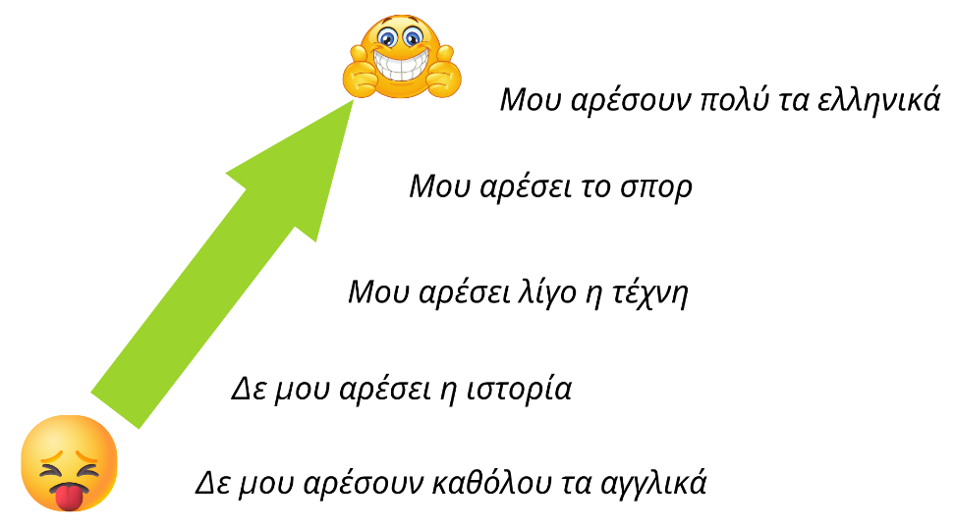
- Students form a physical word cline, based on their subject preferences. Say a subject aloud, then ask students to line up based on how they feel about the subject. For example, students who really like the subject stand nearest the front of the classroom and students who really dislike the subject stand at the back of the room. Students discuss with the students around them how they feel about the subject to ensure they are in the right order. When ready, or after a certain time (for example 3 mins), students then say how they feel about the subject, starting with the student at the front of the line and finishing with the student at the back of the line. Express and explain emotions, opinions and personal preferences (ML4-INT-01)
- Provide students with resource 21. Do you like …? (Word) to consolidate their understanding of the new structures. Understand and reciprocate information about their own and others’ personal worlds (ML4-INT-01); Use knowledge of features of the sound system to understand texts (ML4-UND-01); Create informative texts to describe and share information about themselves and their personal world (ML4-CRT-01)
- Using resource 22. Conversation – my school day (Word), explore a range of strategies to support comprehension – these are included in the ‘For the teacher’ section of the resource. Students then read and answer questions on the text in the resource – a predictable text with some unfamiliar vocabulary. Develop and use comprehension strategies to interpret information, opinions and ideas in texts; Respond appropriately in the target language and/or in English to main ideas and supporting details in texts by interpreting information, ideas and opinions (ML4-UND-01)
- Refer to resource 22. Conversation – my school day (Word) to identify phrases where people express their favourite subject. Identify the question and answer Ποιο είναι το αγαπημένο σου μάθημα; Το αγαπημένο μου μάθημα είναι [subject] with students, write them on the board and model correct pronunciation. Ask students Ποιο είναι το αγαπημένο σου μάθημα; (What is your favourite subject?). Students respond using the modelled answer on the board, adding their own favourite subject. Ask students to add the new vocabulary to their anchor charts. Use knowledge of features of the sound system to understand texts (ML4-UND-01)
- Using the story cubes ‘subjects’ and ‘likes and dislikes’ from resource 23. Do you like …? – story cubes (Word), students work in groups of 3 to 5 to identify and express how they feel about different subjects. Examples of how to differentiate this activity are included in the resource. Use relevant and familiar vocabulary from a range of themes to interact (ML4-INT-01); Use relevant and familiar vocabulary from a range of themes to create texts (ML4-CRT-01)
- Using resource 24. Find someone who … (Word), students indicate the subjects they like or dislike. Students then move around the room, interacting with their peers to find students who have the same responses. Socialise with peers; Use structures and features of the grammatical system to interact (ML4-INT-01)
- Exit ticket – at the end of the lesson, hold up flashcard images of school subjects and ask the question Σου αρέσει/αρέσουν [subject]; Each student responds, indicating how much they like or dislike the subject. For students requiring additional support, they can simply respond with Ναι and Όχι.

Mini task 3 – progress checkpoint
Table 6 – mini task – progress checkpoint 3
Mini task – ‘speed friending’
As a formative assessment task, to ensure students are on track to succeed in the final summative assessment task, students practise for the arrival of a group of exchange students from their Greek sister school. They participate in a ‘speed friending’-style interaction to practise new structures, discover new friends and learn about subject preferences.
Divide students into 2 groups – the ‘visiting’ students from Greece and the ‘host’ students from Australia. To support classroom management, consider asking all ‘visiting’ students to sit on one side of the room and all ‘host’ students to sit on the other side.
Using resource 25. Mini task – progress checkpoint 3 (Word), students complete a table with information of their choosing from the vocabulary they have learned so far (Activity 1).
Once they have completed the table, students formulate questions they will need to ask to elicit the correct information from the other person, for example, Πώς σε λένε; Πόσων χρονών είσαι; Που μένεις; Ποιο φαγητό σου αρέσει; Σου αρέσει η ιστορία; (Activity 2). When ready, students begin the interactions (Activity 3). The ‘host’ students remain seated and the ‘visiting’ students move around. The ‘visiting’ students find a seated ‘host’ student and ask them as many questions as they can, completing the answer sheet with that student’s information. The seated students answer each question until you call time and/or sound a buzzer. The ‘visiting’ students then move to a different partner and start a new interaction. Once most students have met each other, students swap over – the ‘host’ students who were seated now move around the room, asking the questions and completing the answer sheet.
Consider giving students instructions about how best to move around the class, for example, in a clockwise direction or front to back, depending on how your classroom is arranged.
At the conclusion of the activity, students then identify their ‘best match’ and provide reasons (Activity 4).
Use relevant and familiar vocabulary from a range of themes to interact; Use a range of communication strategies to facilitate interactions in familiar contexts (ML4-INT-01)
Teacher feedback – as students engage in their conversations, listen and provide verbal feedback. At the conclusion of the task, write up common errors and discuss as a class. Comment on pronunciation, the variety of questions asked, and the appropriateness and content of responses, including the range of vocabulary and structures. Ask 3 or 4 students who they matched with, with reasons why.
Differentiation examples
The following strategies provide a starting point for how you can differentiate this task for a range of learners. Adapt or design alternatives to meet the needs of students in your class.
Students with advanced proficiency – group students with similar abilities to enable them to exchange additional information from their profiles using prior learning.
High potential and gifted students – encourage students to use conversation fillers and make comments on what information their partner is sharing from the phrases they have learned throughout the unit.
Students requiring additional support – provide students with the scaffold included in the resource.
Student reflection – students complete a learning reflection journal entry, digitally or on paper (see sample, or students could use their own format), reflecting on their learning progress and setting new learning goals.
Reflection questions:
- What elements of this task can be included in the final summative assessment task?
- Do I need to revise any vocabulary or structures? If yes, what should I focus on?
Teacher reflection and evaluation – reflect on the unit to this point, along with student data such as formative assessment and feedback through exit tickets. Use this space to add any adjustments made to the unit or that will be made to the next stage of the learning sequence.

Weeks 8–10 – subject descriptions and assessment task
The table below contains suggested learning intentions and success criteria. These are best co-constructed with students.
Table 7 – learning intentions and success criteria for Weeks 8–10
Learning intentions | Success criteria
Students are learning:  - to agree subjects and adjectives when justifying an opinion about subjects | Students can:  - express their subject preferences, using adjectives to provide a reason, for example, Το αγαπημένο μου μάθημα είναι τα ελληνικά γιατί είναι χρήσιμο μάθημα
- that qualifiers and conjunctions add depth and meaning to sentence structures | - create more complex sentences, using qualifiers and conjunctions, for example, Το αγαπημένο μου μάθημα είναι τα ελληνικά γιατί είναι πολύ χρήσιμο μάθημα
- to express agreement, disagreement and interest, using specific phrases to maintain a conversation. | - use Κι εμένα, Ούτε κι εμένα and Αλήθεια; in spoken conversations.
Suggested vocabulary and grammatical structures
Describing subjects: Είναι δύσκολο/καλό/βαρετό/διασκεδαστικό/χρήσιμο/κουραστικό μάθημα
Using conjunctions: γιατί, αλλά, και
Qualifiers: αρκετά, πολύ, λίγο
Expressing agreement and disagreement with someone else’s opinion: Κι εμένα, Ούτε κι εμένα, Αλήθεια;

Describing subjects
- For this learning sequence, arrange students into teams. Teams choose different Greek islands for team names. Let students know that any time there is a point-scoring activity, either as an individual or as a group, the points will go towards their team’s overall tally. Adapt the scoring system to suit your context.
- Write 3 sentences on the board about school subjects, for example, Μου αρέσουν τα μαθηματικά γιατί είναι χρήσιμο μάθημα, Δε μου αρέσει η επιστήμη γιατί είναι βαρετό μάθημα and Το αγαπημένο μου μάθημα είναι η μουσική γιατί είναι διασκεδαστικό μάθημα, and ask students to guess or predict the meaning of the sentences. Brainstorm with students the adjectives in English they can recall from resource 22. Conversation – my school day (Word), in English or Greek. Using slides 2 to 7 from resource 26. Adjectives – school subjects (PowerPoint), model the pronunciation of the adjectives, using choral repetition. Ask students Σου αρέσει/αρέσουν [subject]; (using the printed flashcards, if preferred) from resource 19. School subjects (PowerPoint) and refer to the examples on the board to model a response to the question Γιατί; For example, Γιατί είναι χρήσιμο μάθημα, Γιατί είναι κουραστικό μάθημα, Γιατί είναι δύσκολο μάθημα. Ask students to add the new vocabulary to their anchor charts. Use features of the sound system to create spoken texts (ML4-CRT-01)
- Using resource 27. Adjectives – school subjects (Word), students complete a range of activities to consolidate new and prior learning. Students revisit the conversation from earlier in the unit and identify the adjectives. They then identify grammatical and/or pronunciation errors made when the conversation is read aloud. They rewrite the conversation, changing key information and seeking peer feedback. Finally, they write how they feel about 5 of their school subjects. Use knowledge of appropriate and familiar vocabulary from a range of themes to understand and respond to texts; Use familiar metalanguage to compare target language structures and features with English (ML4-UND-01); Use structures and features of the grammatical system to create texts (ML4-CRT-01)
- Using story cubes 1a, 1b, 2 and 3 from resource 23. Do you like …? – story cubes (Word), students work in groups of 3 to 5 to interact to identify the subjects, express how they feel about the subject and provide a reason. Use relevant and familiar vocabulary from a range of themes to interact (ML4-INT-01); Use relevant and familiar vocabulary from a range of themes to create texts (ML4-CRT-01)
- Write the following sentences, from the table below, on the board:
Μου αρέσει η μουσική γιατί είναι διασκεδαστικό μάθημα. | Δε μου αρέσει η μουσική αλλά είναι καλό μάθημα.
Μου αρέσει η επιστήμη γιατί είναι χρήσιμο μάθημα. | Δε μου αρέσει η επιστήμη αλλά είναι χρήσιμο μάθημα.
Το αγαπημένο μου μάθημα είναι η φυσική αγωγή γιατί είναι καλό (μάθημα). | Το αγαπημένο μου μάθημα είναι η φυσική αγωγή αλλά είναι κουραστικό μάθημα.
Ask students to work out the meaning of each sentence and then see if they can work out the meaning of αλλά (‘but’). In a dictation-style activity, create 5 sentences using adjectives and an appropriate conjunction (αλλά, και or γιατί) to describe the subjects, for example, Δε μου αρέσουν καθόλου τα μαθηματικά αλλά είναι χρήσιμο μάθημα. Students write the sentences in their books or devices in Greek as they hear them being read aloud. Students to compare their responses with a partner for peer feedback and then review as a class to check for accuracy. Use knowledge of sound–symbol correspondences to understand and respond to texts (ML4-UND-01)
- Refer to the range of preferences used in slide 15 of resource 19. School subjects (PowerPoint) and ask students to identify the qualifiers ‘a lot’ and ‘a bit’. Discuss with students how qualifiers can provide a more descriptive response to questions and add more depth to their language. Write examples of qualifiers on the board, Είναι λίγο βαρετό, Είναι αρκετά διασκεδαστικό and Είναι πολύ δύσκολο. Ask students to add the qualifiers to their anchor charts. Play a game of ‘Mind reader’ using slide 4 of resource 17. Sentence builders (PowerPoint). Write a sentence on a mini whiteboard or somewhere else concealed from students. Call on one student to construct a meaningful sentence from the sentence builder and say it aloud. Repeat the sentence back to the student to reinforce correct pronunciation if necessary. Tell the class whether the guess for each column of the sentence builder is correct or not by providing a grid on the board to represent each column of the sentence builder and ticking and crossing the appropriate columns. For example, if your sentence is Δε μου αρέσουν καθόλου τα μαθηματικά γιατί είναι πολύ δύσκολο μάθημα and the student guesses Δε μου αρέσουν καθόλου τα ελληνικά γιατί είναι λίγο δύσκολο μάθημα, you would place a tick in the first, third and fifth columns and a cross in the second and fourth columns. Continue to ask students to construct sentences until they have guessed each section of the entire sentence correctly. Play this game as a class, with students in their teams, with each team taking a turn to guess. Play several times, awarding 2 points to the winning team each round. Then direct students to play the same game in small groups, providing each group with a mini whiteboard and marker, with one student leading the group each round. Use relevant and familiar vocabulary from a range of themes to create texts (ML4-CRT-01)
- Using resource 28. One pen, one dice (Word), students play a game of ‘One pen, one dice’ in pairs or small groups, racing each other to translate sentences from English into Greek. The first pair to correctly finish (as judged by the teacher) wins 3 points for their team. Use relevant and familiar vocabulary from a range of themes to create texts (ML4-CRT-01); Socialise with peers (ML4-INT-01)
- Building on the word cline activity completed earlier in the lesson sequence, students now add more details to each sentence, using conjunctions, qualifiers and adjectives– see Figure 2 below, as a sample. Create informative texts to describe and share information about themselves and their personal worlds (ML4-CRT-01).
Figure 2 – example word cline
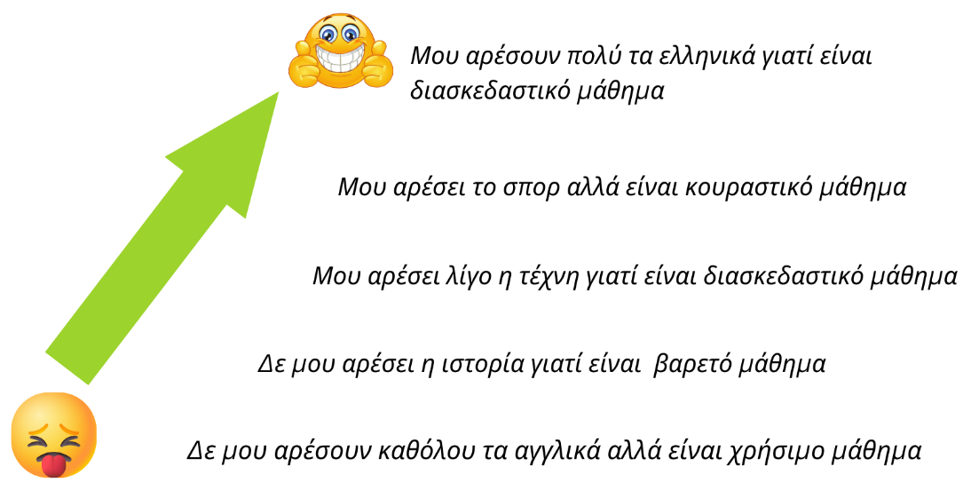
- Provide students with 3 strips of paper and direct them to write a sentence on each one about their favourite subject, a subject they like, and a subject they dislike using qualifiers and adjectives to justify their opinions. Students participate in a ‘walk and talk’ to find someone with the same sentences as them and collect their initials. Direct students to walk around the room. After a few moments, direct them to stop and ‘talk’ with the nearest person. Indicate which person in the pair (closest to the board, closest to the window and so on) must ask the questions – Ποιο είναι το αγαπημένο σου μάθημα;, Ποιο μάθημα σου αρέσει; and Ποιο μάθημα δε σου αρέσει;. If the student they are interacting with has the same subject, qualifier or adjective in their sentence, they write this person’s initials above that section of the sentence on their own slip of paper. (They might match with more than one section of the sentence.) Once they have had time to ask all 3 questions, direct them to begin moving around the room again until they are directed to stop for the next interaction with a different student. When you determine that enough time has passed, direct students to return to their seats and add up how many initials students in each team have collected. Add this tally to their team’s point score. Express and explain emotions, opinions and personal preferences; Socialise with peers (ML4-INT-01)
- Students from groups of 3 or 4, based on their teams. Depending on the size of each team, there may be 2 groups for each team. Provide each group with a mini whiteboard and marker. Using all the story cubes from resource 23. Do you like …? – story cubes (Word), students must form sentences from the cubes that they roll to include a preference, a subject, a reason that also includes a qualifier for the adjective (in its correct form) and the appropriate conjunction, depending on the results on the dice. For example, Δε μου αρέσει η ιστορία αλλά είναι αρκετά καλό μάθημα. Ensure you roll the cubes in a place all groups can see, for example, in the centre of the classroom with groups surrounding you. The first group to hold up their board with an accurate sentence that makes sense wins points for their team. For a variation, and to make this activity more accessible for all skill levels, award each group up to 5 points for each sentence for each round, awarding less points for sentences that make sense but contain errors. The maximum 5 points can be awarded if the sentence makes sense and contains no errors. Add group points to the team tallies. Use relevant and familiar vocabulary from a range of themes to create texts; Use structures and features of the grammatical system to create texts (ML4-CRT-01)
- Write Σου αρέσει/αρέσουν...; on the board, with a sample response, for example, Μου αρέσει η ιστορία. Brainstorm, with students, possible ways to respond to the sample sentence to signal agreement or disagreement, make a comment or ask a follow-up question, for example, Κι εμένα, Ούτε κι εμένα, Αλήθεια; Γιατί;, Γιατί όχι;. Guide interaction with volunteer students for the rest of the class to listen to. Continue to model the interactions with different students until students are confident to interact independently. A sample has been provided in the table below.
Interaction sample 1  • Teacher: Σου αρέσουν τα μαθηματικά;  • Student: Ναι, μου αρέσουν πολύ.  • Teacher: Κι εμένα. Γιατί;  • Student: Γιατί είναι διασκεδαστικό μάθημα. | Interaction sample 2  • Teacher: Σου αρέσει η τέχνη;  • Student: Όχι. Δε μου αρέσει καθόλου.  • Teacher: Αλήθεια; Ούτε κι εμένα. Γιατί όχι;  • Student: Γιατί είναι βαρετό μάθημα.
When students are ready, begin the game by asking a student Σου αρέσει/αρέσουν [subject];. Once the student has replied to the question, the rest of the class tries to be the first to put up their hand, flag or press the buzzer to offer a good follow-up question or comment to win a point for their team. Award points based on the complexity of the response, for example, one point for a follow-up comment or question or 2 points if they respond with both a follow-up comment and question. Ask students to add the new vocabulary to their anchor charts. Use relevant and familiar vocabulary from a range of themes to create texts (ML4-CRT-01); Express and explain emotions, opinions and personal preferences (ML4-INT-01)
- Exit ticket – ask a student to express their opinion about a school subject. A second student must make a contribution to the conversation using the responses practised in the previous learning sequence: Κι εμένα, Ούτε κι εμένα or Αλήθεια;

Evaluation and variation
Record any variations you implemented, including extensions and adjustments implemented to support student learning. for students with special education needs. The evaluation can include feedback from students.

Registration
Teacher name:
Teacher signature:
Date:

Appendix A – sample summative assessment task

Outcomes and content
ML4-CRT-01 creates a range of texts for familiar communicative purposes by using culturally appropriate language
- Create informative texts to describe and share information about themselves and their personal world
- Use relevant and familiar vocabulary from a range of themes to create texts

Task
Create an audio-visual presentation, using PowerPoint or similar, to introduce yourself and your school to a potential exchange student from Greece. In your presentation, include a range of relevant images and information about:
- when school starts and finishes
- how you get to and from school
- what time you arrive at school, your break times and when you go home
- your opinion on at least 3 subjects you do at school, including one you don’t like, with different reasons
- your favourite subject, why you like it and when you have it.
Differentiation examples
The following strategies provide a starting point for how you can differentiate this task for a range of learners. Adapt or design alternatives to meet the needs of students in your class.
High potential and gifted students – identify a Greek-speaking student in your community and record yourself interviewing them about their school. Add any additional questions you would like to ask.
Students with advanced proficiency – students might include additional details about themselves and the people they have chosen to describe using third person structures. Students might also opt to make an audio-visual recording of their presentation.
Students requiring additional support – students might be provided with a scaffold and/or blank template. Students might also work with all or part(s) of resource 17. Sentence builders (PowerPoint).

Marking guidelines
Table 8 – marking guidelines for summative assessment task
Outcome and content | A – extensive | B – thorough | C – sound | D – basic | E – elementary
Creating texts (ML4-CRT-01)  - Create informative texts to describe and share information about themselves and their personal world  - Use relevant and familiar vocabulary from a range of themes to create texts | Creates a detailed text, with a high level of accuracy, that includes:  - when school starts and finishes  - what time they arrive at school, a break time and when they go home  - mode(s) of transport to and from school  - their opinion on 3 subjects, including one they don’t like, with a range of reasons  - their favourite subject, why they like it and when they have it. | Creates a detailed text, with minor errors, that includes:  - when school starts and finishes  - what time they arrive at school, a break time and when they go home  - mode(s) of transport to and from school  - their opinion on 3 subjects, including one they don’t like, with a range of reasons  - their favourite subject, why they like it and when they have it. | Creates a text, with errors that do not impact communication, that includes:  - when school starts and finishes  - what time they arrive at school, a break time and when they go home  - mode(s) of transport to and from school  - their opinion on 3 subjects, including one they don’t like, with reasons  - their favourite subject, why they like it and when they have it. | Creates a text, with errors that might impact communication, that includes some of the following:  - when school starts and finishes  - what time they arrive at school, a break time and when they go home  - mode(s) of transport to and from school  - their opinion on 3 subjects, including one they don’t like, with a range of reasons  - their favourite subject, why they like it and when they have it. | Creates a text with isolated words and/ or phrases.
Creating texts (ML4-CRT-01)  - Use structures and features of the grammatical system to create texts | Uses a variety of structures and features of the grammatical system, with a high level of accuracy, including:  - time structures  - verb conjugations  - a range of ways to express preferences  - adjectives with agreement  - compound sentences with conjunctions  - qualifiers, such as πολύ and λίγο. | Uses a variety of structures and features of the grammatical system, with minor errors, including:  - time structures  - verb conjugations  - a range of ways to express preferences  - adjectives with agreement  - compound sentences with conjunctions  - qualifiers, such as πολύ and λίγο. | Uses structures and features of the grammatical system with some errors, including:  - time structures  - verb conjugations  - expressing likes and dislikes  - adjectives with agreement  - compound sentences with conjunctions  - qualifiers, such as πολύ and λίγο. | Uses structures and features of the grammatical system, with errors that might hinder comprehension, including any of the following:  - time structures  - verb conjugations  - expressing likes and dislikes  - adjectives with agreement  - compound sentences with conjunctions  - qualifiers, such as πολύ and λίγο. | Attempts to apply structures and features of the grammatical system.
Creating texts (ML4-CRT-01)  - Use features of the sound system to create spoken texts | Communicates effectively and authentically, using accurate intonation and pronunciation. | Communicates effectively and authentically, with minor errors, using clear intonation and pronunciation. | Communicates with mostly clear intonation and pronunciation, with some errors. | Communicates with errors in intonation and pronunciation that may hinder comprehension. | Attempts to replicate the sound system.

Sample response
This sample is provided as a guide to demonstrate the intentions of the task aligned to the unit and the marking guidelines. Responses will vary – adjust the task, marking guidelines and sample response to suit your context.
As this is an audio-visual task, students present orally in class or add a recording to each slide. Students hand in their scripts and their presentations.
This is an example of a Grade A response (text only). An editable version of this sample can be modified for your context. A sample scaffold is also provided for you to adapt for students requiring additional support.

Slide 1
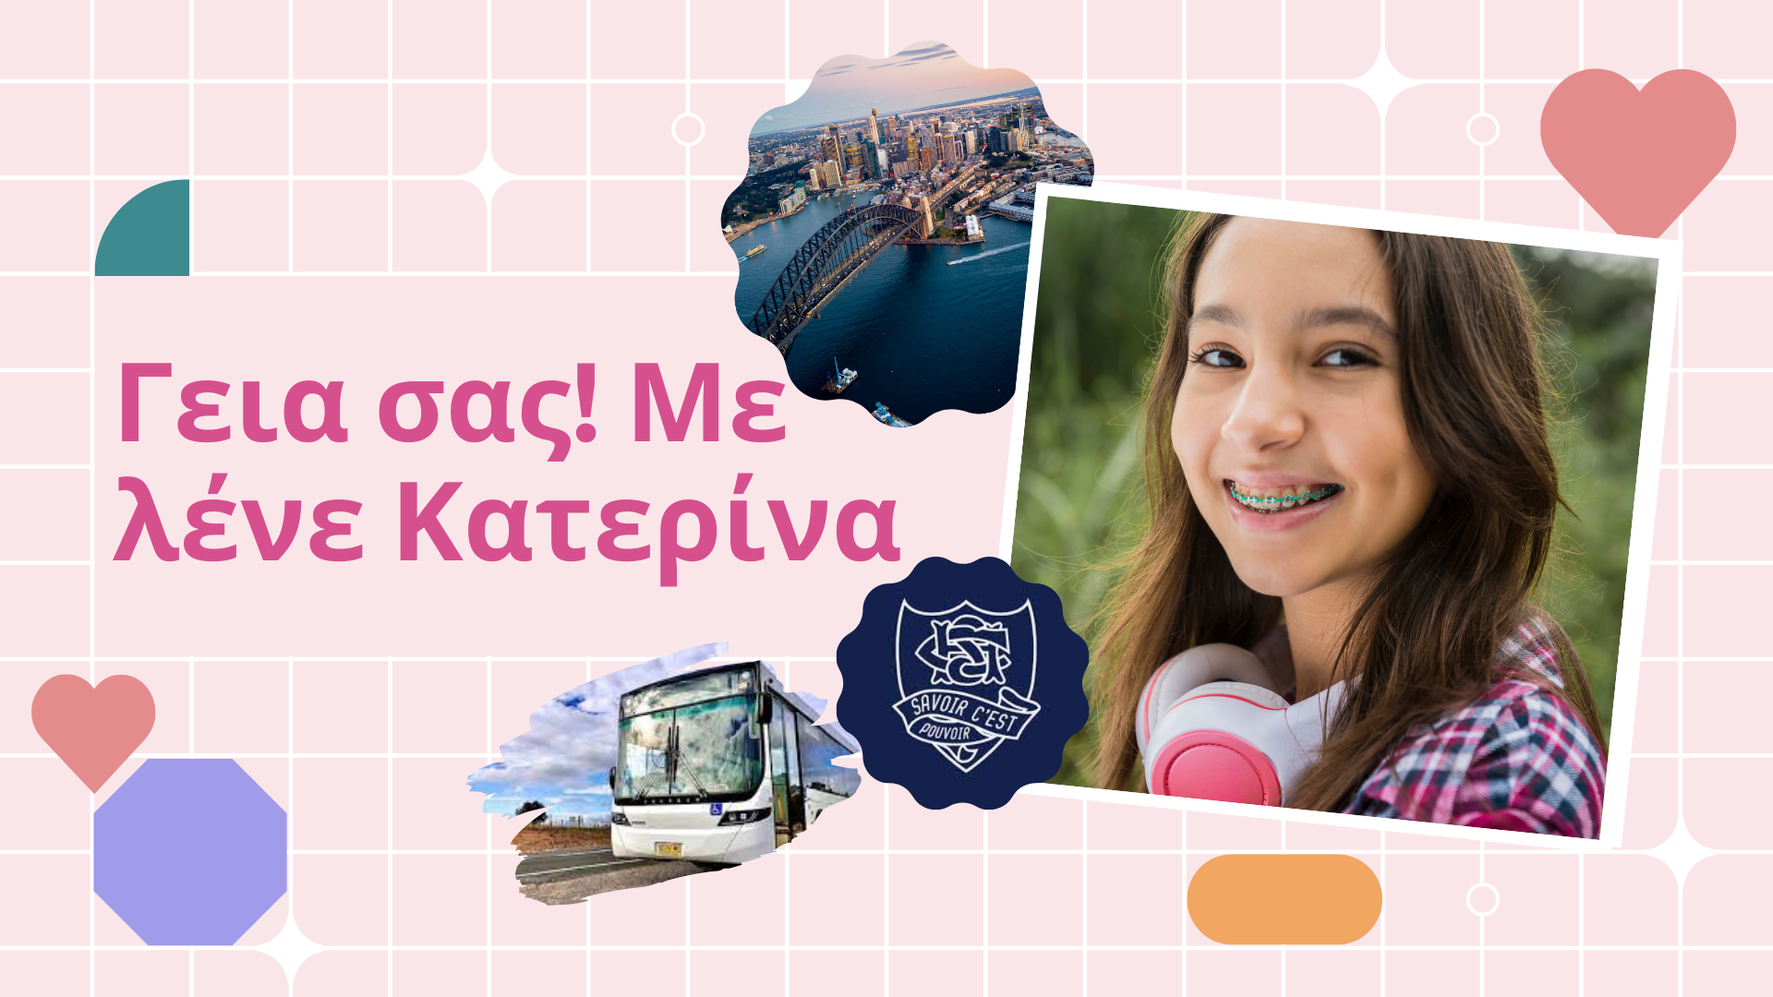
Script: Γεια σας! Με λένε Κατερίνα. Είμαι δώδεκα χρονών και μένω στο Σίδνεϋ, στην Αυστραλία. Πάω στο γυμνάσιο του Blakehurst και είμαι στην πρώτη γυμνασίου. Το σχολείο αρχίζει στις εννιά παρά δέκα και τελειώνει στις τρεις η ώρα. Πάω στο σχολείο με το λεωφορείο στις οχτώ και τέταρτο.

Slide 2
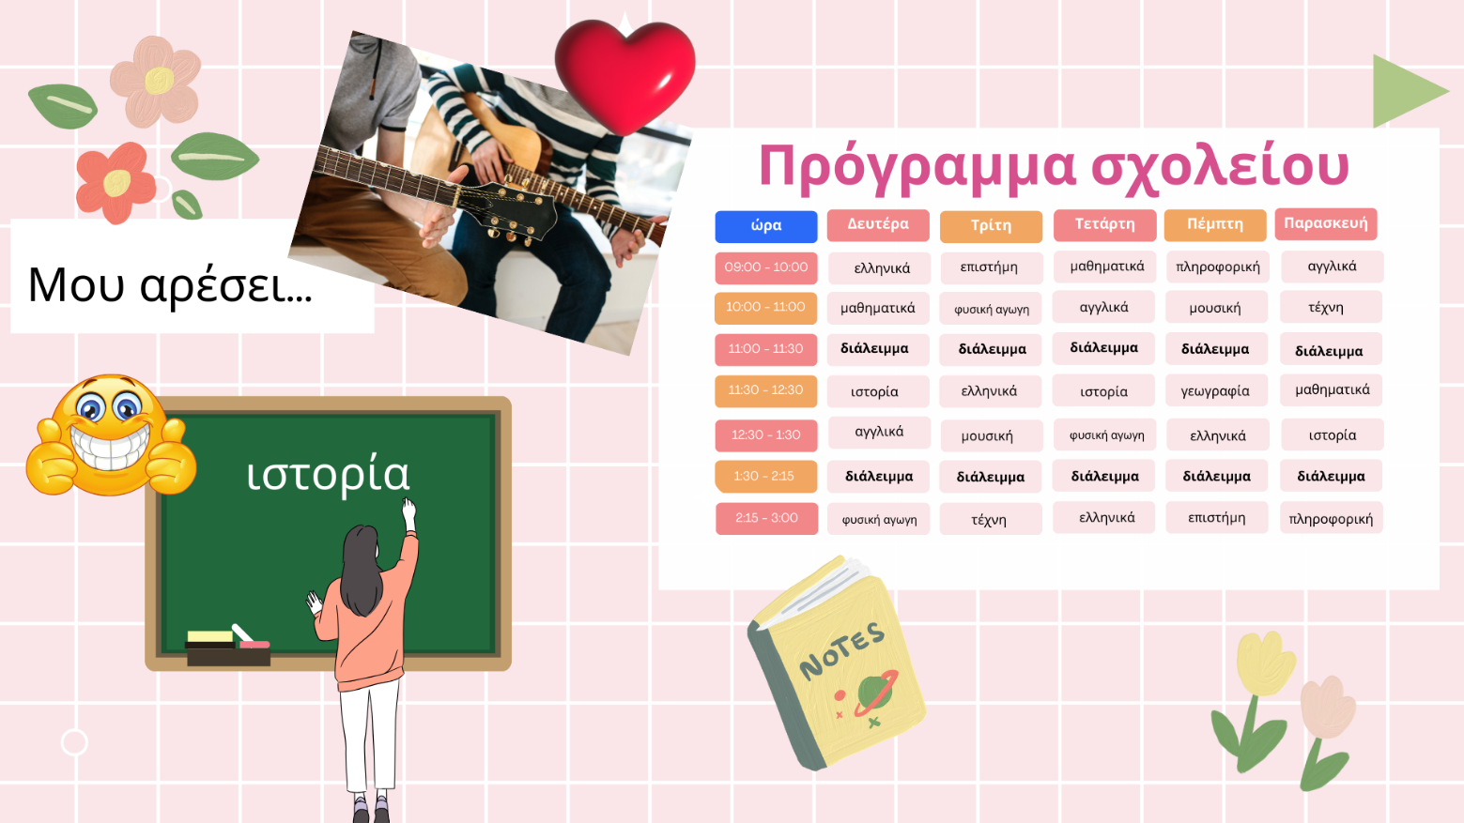
Script: Τρώω στο σχολείο στη μία και μισή. Πάω σπίτι στις τρεις και δέκα. Μου αρέσει η μουσική. Είναι διασκεδαστικό μάθημα, αλλά λίγο δύσκολο. Μου αρέσει η ιστορία γιατί είναι καλό μάθημα αλλά δεν είναι χρήσιμο.

Slide 3

Script: Δεν μου αρέσει η επιστήμη. Είναι βαρετό μάθημα και πολύ κουραστικό.

Slide 4

Script: Το αγαπημένο μου μάθημα είναι η φυσική αγωγή γιατί είναι διασκεδαστικό μάθημα. Έχω φυσική αγωγή τη Δευτέρα στις εννέα η ώρα, την Τετάρτη στις έντεκα και τέταρτο και την Παρασκευή στις δώδεκα και μισή.

Appendix B – unit infographic for students
To support student engagement in the unit, the student-facing infographic gives students a visual guide of the unit’s learning pathway. It is available on the Support for Modern Greek Stage 4 webpage. You can also access an editable version, to amend for your own context. Using visual learning journeys also supports Embedding Aboriginal pedagogies in language teaching through Learning Maps – explicitly mapping or visualising processes.
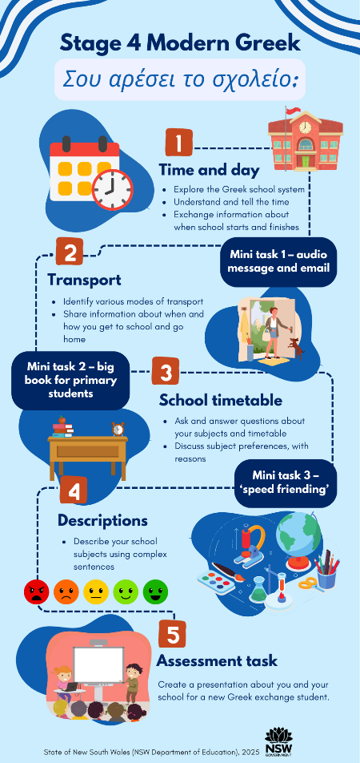

About this resource
- The target audience for this resource is teachers of Modern Greek Stage 4.
- Email questions and feedback about this resource to languagesnsw@det.nsw.edu.au using the subject line ‘Modern Greek Stage 4’.
- This resource will be reviewed in 12 months’ time as part of ongoing internal evaluation.
- Created/last updated: 28 March 2025.

How to use this resource
This 10-week unit can be modified to suit the needs of your learners, including adding your own resources, modifying content or duration, and differentiating for learning needs and learner groups. Assessing and identifying high potential and gifted learners will help teachers decide which students may benefit from extension and additional challenge. To learn more about how to support the specific learning needs for high potential and gifted learners, you can access the department’s Differentiation Adjustment Tool. Accessing the microlearning series Curriculum planning for every student in every classroom will support you to plan for the diversity of student need. The learning, teaching and assessment strategies and assessment task are suggestions only.

Supporting students with disability
When using this unit, the assessment task and embedded scaffolds, planners and teaching and learning activities consider the needs of students with disability to ensure inclusivity for student access, engagement and expression in lessons.
Considerations may include:
- providing scaffolds as an option for all students to use when needed to guide their response
- providing a visual list of key vocabulary and phrases
- providing options for student expression using their preferred mode of communication
- using closed captions (with English translation setting where appropriate) and/or provide transcripts for deaf or hard of hearing students
- providing documents digitally and/or orally, as well as on paper so that they may be accessed by means such as screen readers
- advising students of accessibility options for websites used in the unit, such as large font and voice over options.
Adjustments are recommended to cater to your class’s learning needs. This could include how students will present their work and communicate their understanding.
Appropriate adjustments may include:
- use of explicit instructions and defining key terms/concepts
- simplified or modified practical activities
- use of pictures and diagrams, clearly labelled to support students to access the tasks
- speech-to-text or augmentative communication devices.
Tailoring the mini task – progress checkpoints should provide an equitable opportunity for all students to demonstrate their understanding and receive quality feedback to improve learning outcomes.
Further examples of differentiated and personalised adjustments are provided on the Inclusive Practice hub.

Additional support for EAL/D students
When using this resource, it is important to consider the needs of EAL/D students’ backgrounds when adapting teaching and learning activities. Considerations may include:
- building background knowledge (cultural and linguistic) for what may be considered ‘common’ terms as students may not have a conceptual understanding of some terms
- understanding that topics that address ‘home life’ can be a sensitive topic for many students, particularly those from refugee backgrounds. Teachers’ knowledge of their students’ family backgrounds is essential to adapt the task appropriately
- including comparisons between Modern Greek-speaking countries and Australia. Comparisons with their home countries will help students make connections and use their experiences as a resource
- questions in English posed using language that is accessible for EAL/D students as students will have varying levels of proficiency in English and will need to process and make meaning across 2 languages different from their own
- EAL/D learners may require scaffolding to support them to gain content knowledge, while providing extra time and assistance to master the English language required to engage with texts or complete classroom tasks. EAL/D students could require background knowledge and explicit teaching of particular text types (audience, purpose, structure, register, language). EAL/D students may be unfamiliar with a blog. They should have multiple authentic examples/models to read and opportunities to practise writing blog responses prior to the task.

Evidence base
This unit supports the following themes from ‘What works best’ 2020 update:
- high expectations
- explicit teaching
- effective feedback
- use of data to inform practice
- assessment.

Further information
- Aligned to system priorities and/or needs: Our Plan for NSW Public Education
- Aligned to School Excellence Framework: Learning domains – curriculum; assessment; Teaching domain – effective classroom practice
- Consultation: EAL/D and Inclusive Education

Support and alignment
Resource evaluation and support: All curriculum resources are prepared through a rigorous process. Resources are periodically reviewed as part of our ongoing evaluation plan to ensure currency, relevance and effectiveness. For additional support or advice, contact the Languages and Culture team by emailing languagesnsw@det.nsw.edu.au.
Differentiation: Further advice to support Aboriginal and Torres Strait Islander students, EAL/D students, students with a disability and/or additional needs, and high potential and gifted students can be found on the Planning, programming and assessing 7–12 webpage. This includes the Inclusion and differentiation advice 7–10 webpage.
Assessment: Further advice to support formative assessment is available on the Planning, programming and assessing 7–12 webpage. This includes the Classroom assessment advice 7–10. For summative assessment tasks, the Assessment task advice 7–10 webpage is available.
Explicit teaching: Further advice to support explicit teaching is available on the Explicit teaching webpage. This includes the CESE Explicit teaching – Driving learning and engagement webpage.
Consulted with: Curriculum, Inclusive Education and subject matter experts.
Alignment to system priorities and/or needs: School Excellence Policy, Our Plan for NSW Public Education.
Alignment to the School Excellence Framework: This resource supports the School Excellence Framework elements of curriculum (curriculum provision) and effective classroom practice (lesson planning, explicit teaching).
Alignment to Australian Professional Standards for Teachers: This resource supports teachers to address Proficient Teacher Standard Descriptors[3.2.2, 3.3.2].
NSW syllabus: Modern Languages K–10 Syllabus
Syllabus outcomes: ML4-INT-01, ML4-UND-01, ML4-CRT-01
Author: Languages and Culture
Publisher: State of NSW, Department of Education
Resource: Unit guidelines and template
Related resources: Further resources to support Modern Languages can be found on the Languages curriculum page.
Professional learning: relevant professional learning is available through the Languages statewide staffroom (entry survey link for staff only).
Creation date: March 2025
Rights: © State of New South Wales, Department of Education

Evidence base
This resource contains NSW Curriculum and syllabus content. The NSW Curriculum is developed by the NSW Education Standards Authority. This content is prepared by NESA for and on behalf of the Crown in right of the State of New South Wales. The material is protected by Crown copyright.
Please refer to the NESA Copyright Disclaimer for more information https://educationstandards.nsw.edu.au/wps/portal/nesa/mini-footer/copyright.
NESA holds the only official and up-to-date versions of the NSW Curriculum and syllabus documents. Please visit the NSW Education Standards Authority (NESA) website https://educationstandards.nsw.edu.au and the NSW Curriculum website https://curriculum.nsw.edu.au.
Modern Languages K–10 Syllabus © NSW Education Standards Authority (NESA) for and on behalf of the Crown in right of the State of New South Wales, 2022.
CESE (Centre for Education Statistics and Evaluation) (2020) What works best: 2020 update, NSW Department of Education, accessed 25 August 2023.
NESA (NSW Education Standards Authority) (2022a) ‘Advice on units’, Programming, NESA website, accessed 25 August 2023.
NESA (2022b) ‘Assessment Principles’, Assessment, NESA website, accessed 25 August 2023.

© State of New South Wales (Department of Education), 2025
The copyright material published in this resource is subject to the Copyright Act 1968 (Cth) and is owned by the NSW Department of Education or, where indicated, by a party other than the NSW Department of Education (third-party material).
Copyright material available in this resource and owned by the NSW Department of Education is licensed under a Creative Commons Attribution 4.0 International (CC BY 4.0) license.

This license allows you to share and adapt the material for any purpose, even commercially.
Attribution should be given to © State of New South Wales (Department of Education), 2025.
Material in this resource not available under a Creative Commons license:
- the NSW Department of Education logo, other logos and trademark-protected material
- material owned by a third party that has been reproduced with permission. You will need to obtain permission from the third party to reuse its material.
Links to third-party material and websites
Please note that the provided (reading/viewing material/list/links/texts) are a suggestion only and implies no endorsement, by the New South Wales Department of Education, of any author, publisher, or book title. School principals and teachers are best placed to assess the suitability of resources that would complement the curriculum and reflect the needs and interests of their students.
If you use the links provided in this document to access a third-party's website, you acknowledge that the terms of use, including licence terms set out on the third-party's website apply to the use which may be made of the materials on that third-party website or where permitted by the Copyright Act 1968 (Cth). The department accepts no responsibility for content on third-party websites.

Teachers should be mindful that some students will have had significant disruption to their schooling while transitioning to school in Australia.
Consider learning the Greek Sign Language (Ελληνική νοηματική γλώσσα) vocabulary for this and similar activities (some Greek Sign Language vocabulary [4:24]) or allowing students to use a digital communication device as a means of communication.
This website provides the time in digital and analog form.
Depending on your context, the λύκος may write the time on a mini whiteboard, in place of or in addition to saying the time aloud.

