# At the market – story cubes

This resource is for the teacher. It provides the content and instructions you need to share with students.

## Instructions

Use the story cubes provided, or create your own using the template in this document or with the [editable version on Canva](https://www.canva.com/design/DAGD22wyN4A/rInlaWJdiOTi6hPOFIRU4Q/view?utm_content=DAGD22wyN4A&utm_campaign=designshare&utm_medium=link&utm_source=publishsharelink&mode=preview).

Organise students into groups of 3 to 4, providing each group with a set of cubes. There are cubes for food or drinks, cubes for prices and quantities and a cube with ticks and crosses to indicate whether you have the item or not. Direct the students to alternate using cubes for variety.

Model the activity with students by rolling the cubes and working with them to create questions they could ask or statements they could make using each cube. For example:

무엇을 드릴까요?

뭐예요?

*[*Food or drink*]* 에요/이에요

*[*Food or drink*]* 주세요

*[*Food or drink*]* 있어요?

*[*Item*]* 몇 개?

*[*Food or drink*]* 은/는 얼마예요?

### Sample conversation

Student A: 무엇을 드릴까요?

Student B: (rolls a banana ) 바나나 주세요. 바나나 있어요?

Student A: (rolls a cross ❌) 아니요, 바나나 없어요.

Student B: (rolls an apple 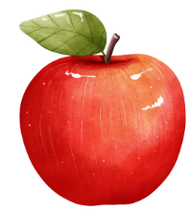) 사과 주세요. 사과 있어요?

Student A: (rolls a tick ✔️) 네, 사과 있어요. 사과 몇 개?

Student B: (rolls a 7) 사과 일곱 개 주세요. 사과는 얼마예요?

Student A: (rolls 500₩) 사과는 오백 원이에요.

 **Differentiation examples**

**The following strategies provide a starting point for how you can differentiate this activity for a range of learners. Adapt or design alternatives, to meet the needs of students in your class.**

**Students requiring additional support – consider including the *Hangeul* and romanised Korean vocabulary on the cube. Limit the number of food cubes and quantity cubes used in the activity to shorten the interaction, or** provide the following scaffold:

Food/drink cube:

[Food] 주세요 ([Food] juseyo). [Food] 있어요? ([food] isseoyo?).

❌/✔️ cube:

(rolls a ❌) 아니요, ~없어요 (aninyo, eopseoyo).

or (rolls a ✔️) 네, 사 과 있어요 (*ne*, *[*food*] isseoyo*). 몇 개? (*myeot gae?).*

Quantities cube:

*[*food*][*number*]* 개 주세요 *([*food*] [*number*] gae juseyo*). *[*food*]*은/는 얼마예요? *([*food*] eun*/*neun eol-ma-e-yo?).*

Prices cube: *[*item*]*은/는 *[*price*]* 원이에요 *([*item*]eun/neun* *[*price*] won-i-e-yo*).

**High potential and gifted students** – allow students to make more complex sentences with the prompts on the story cube, for example, using adjectives.

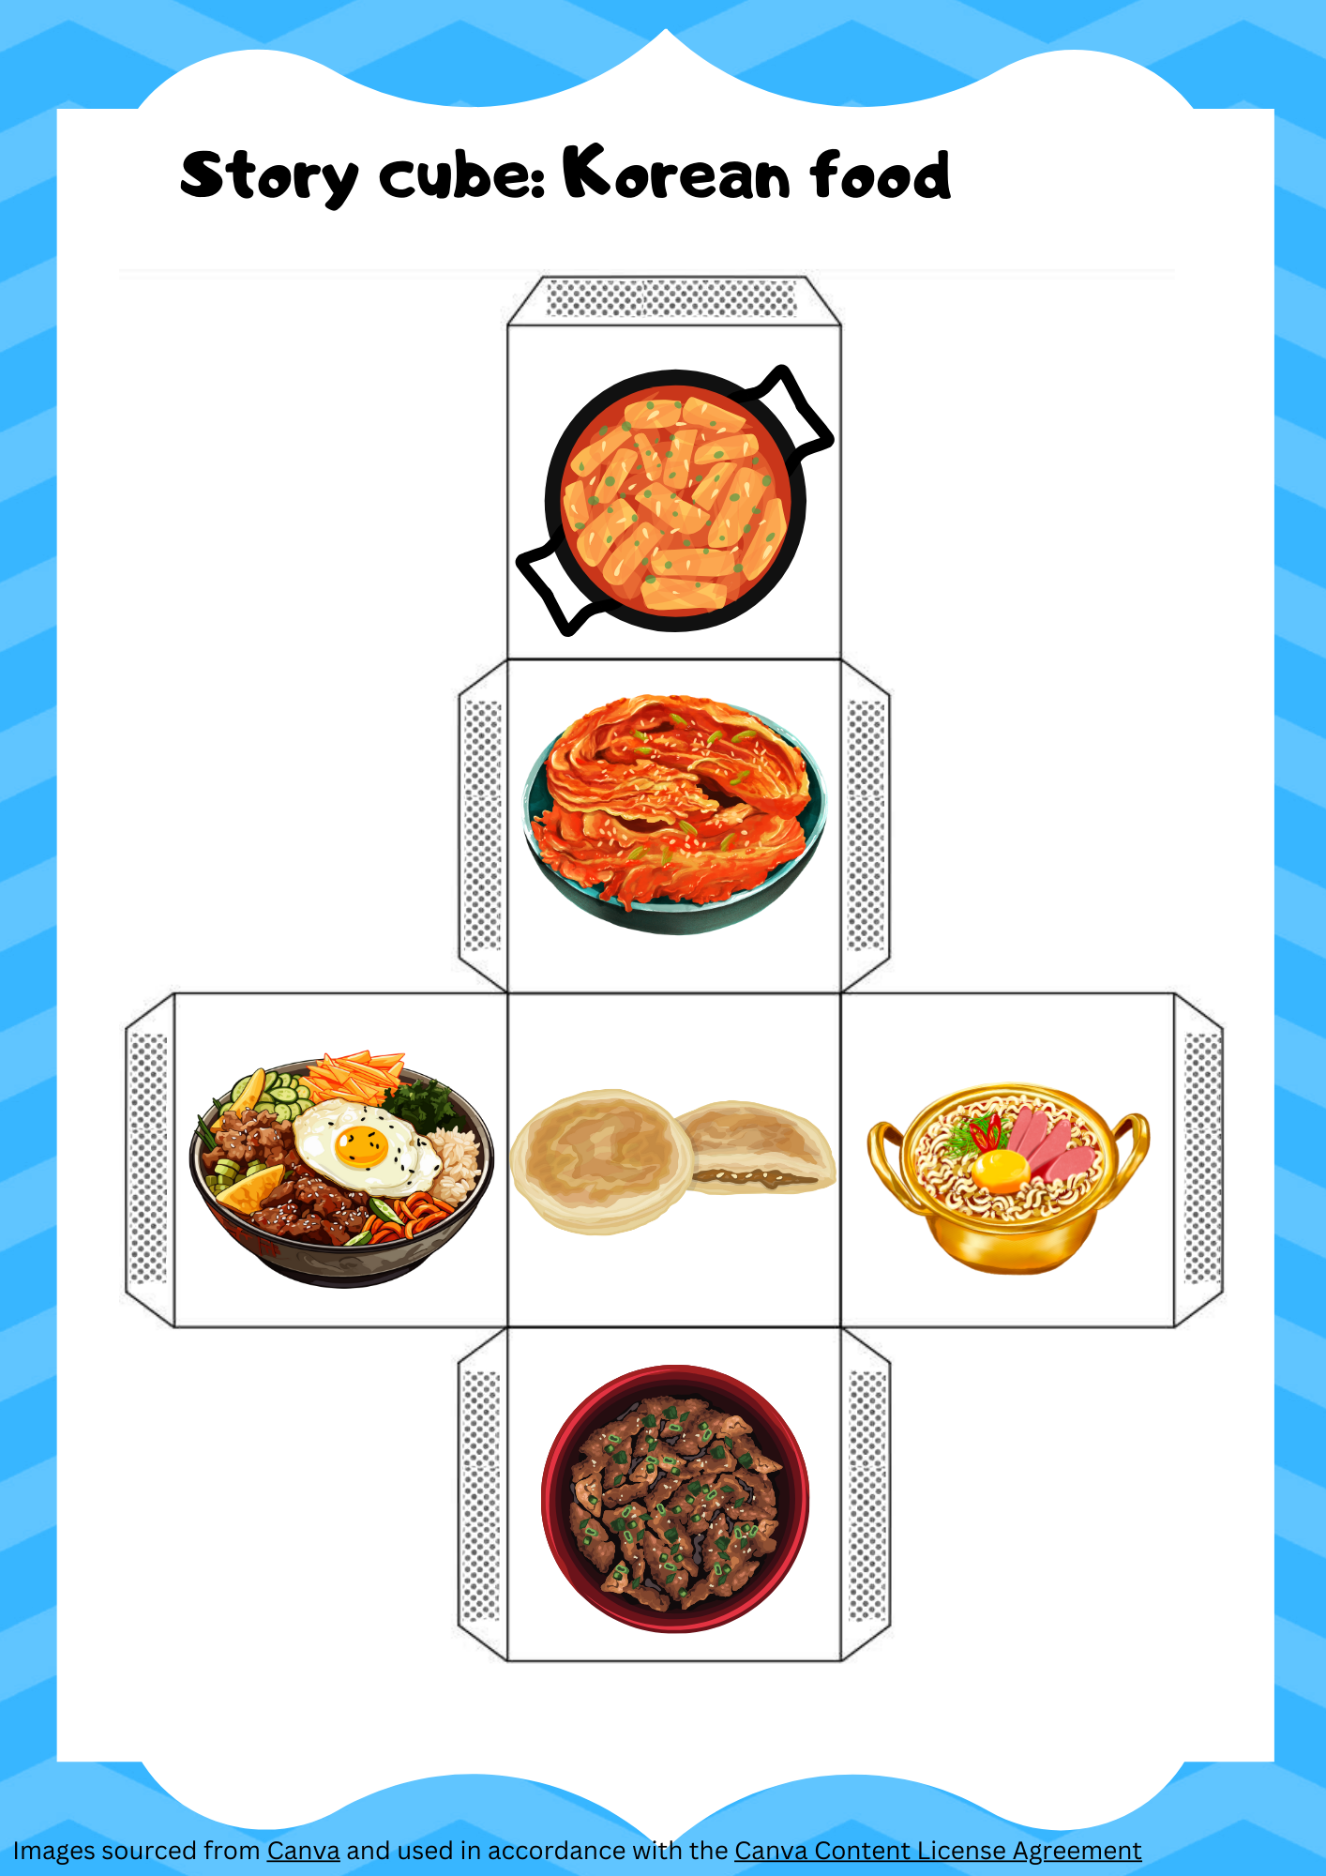

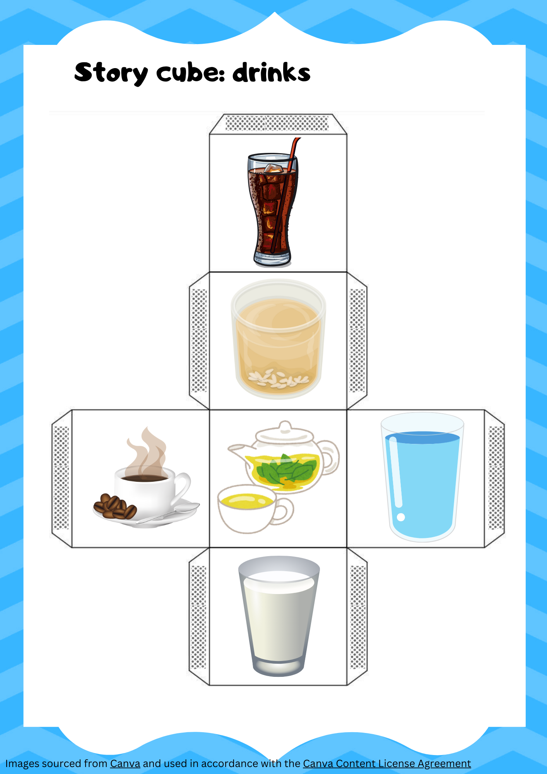

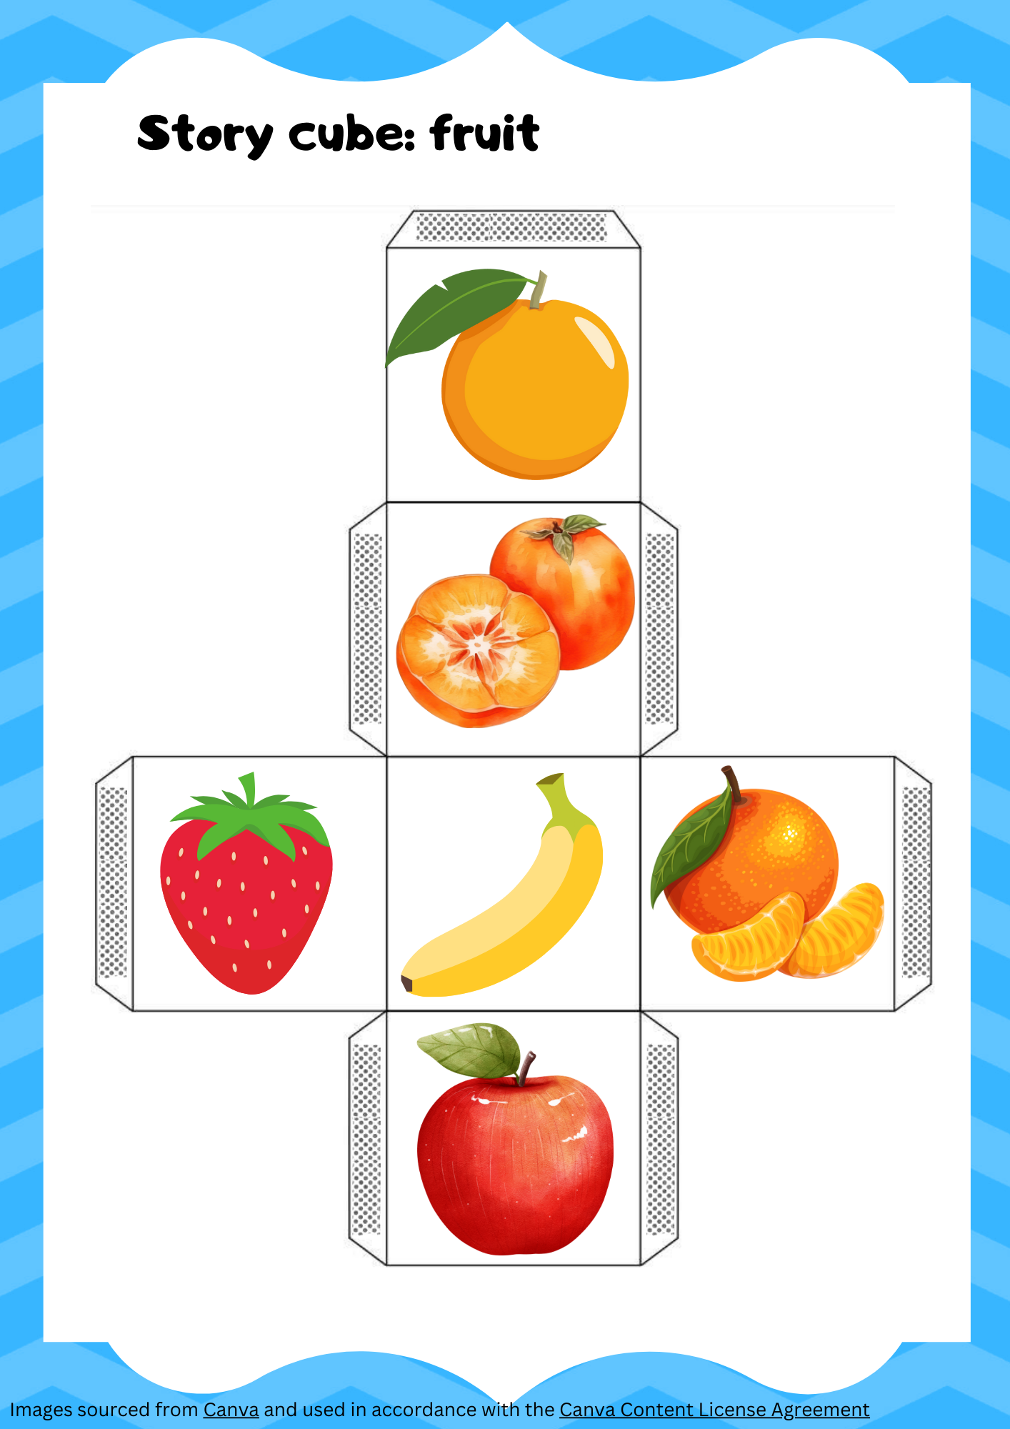

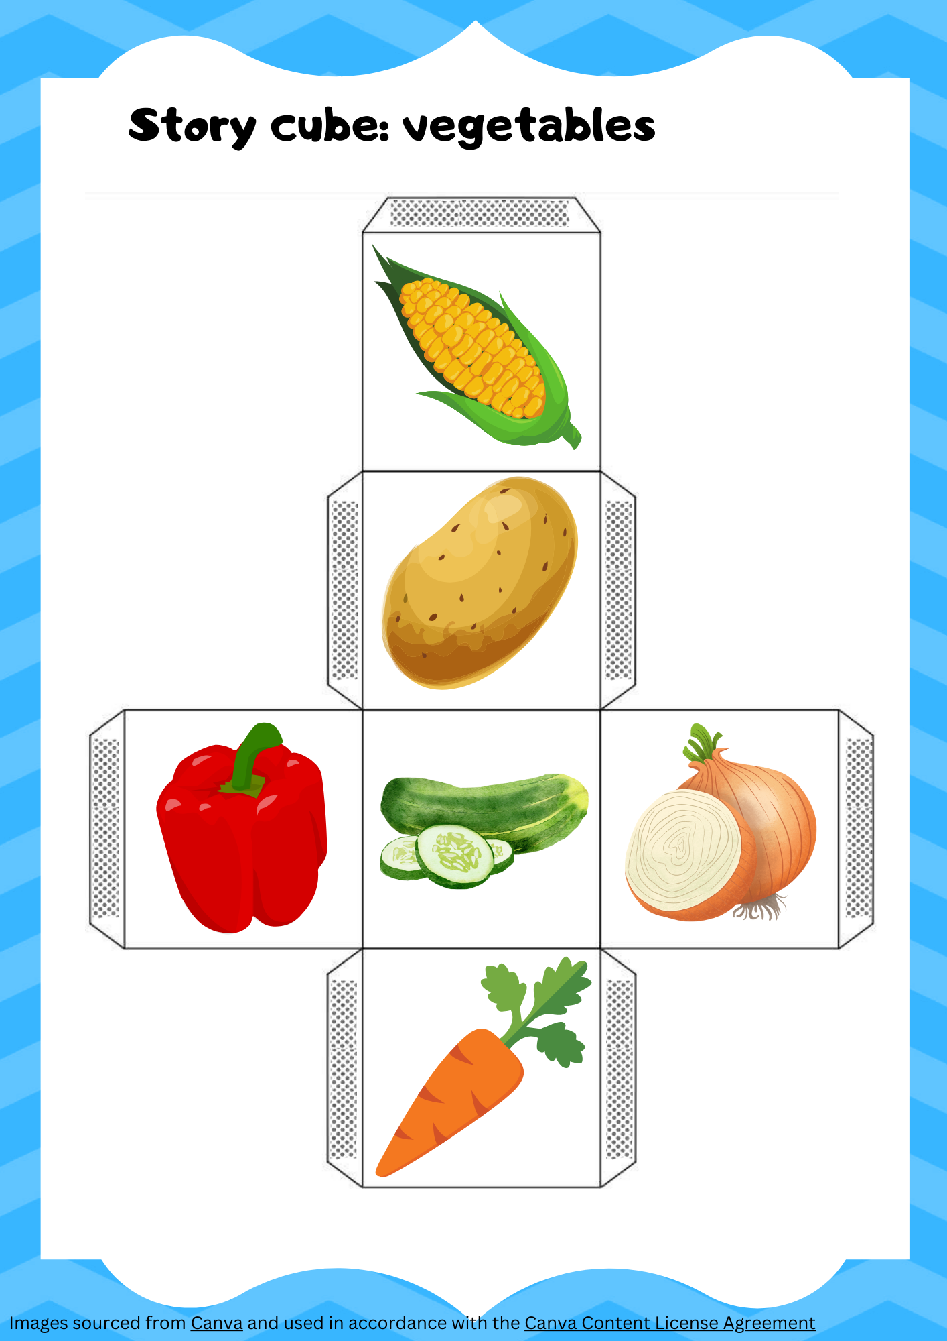

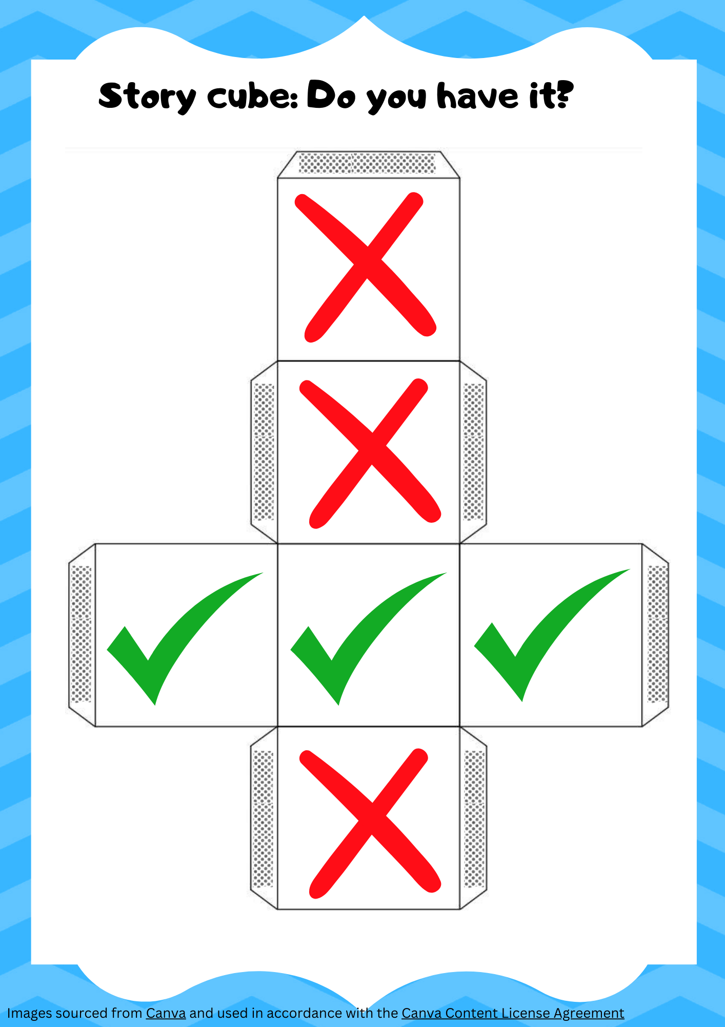

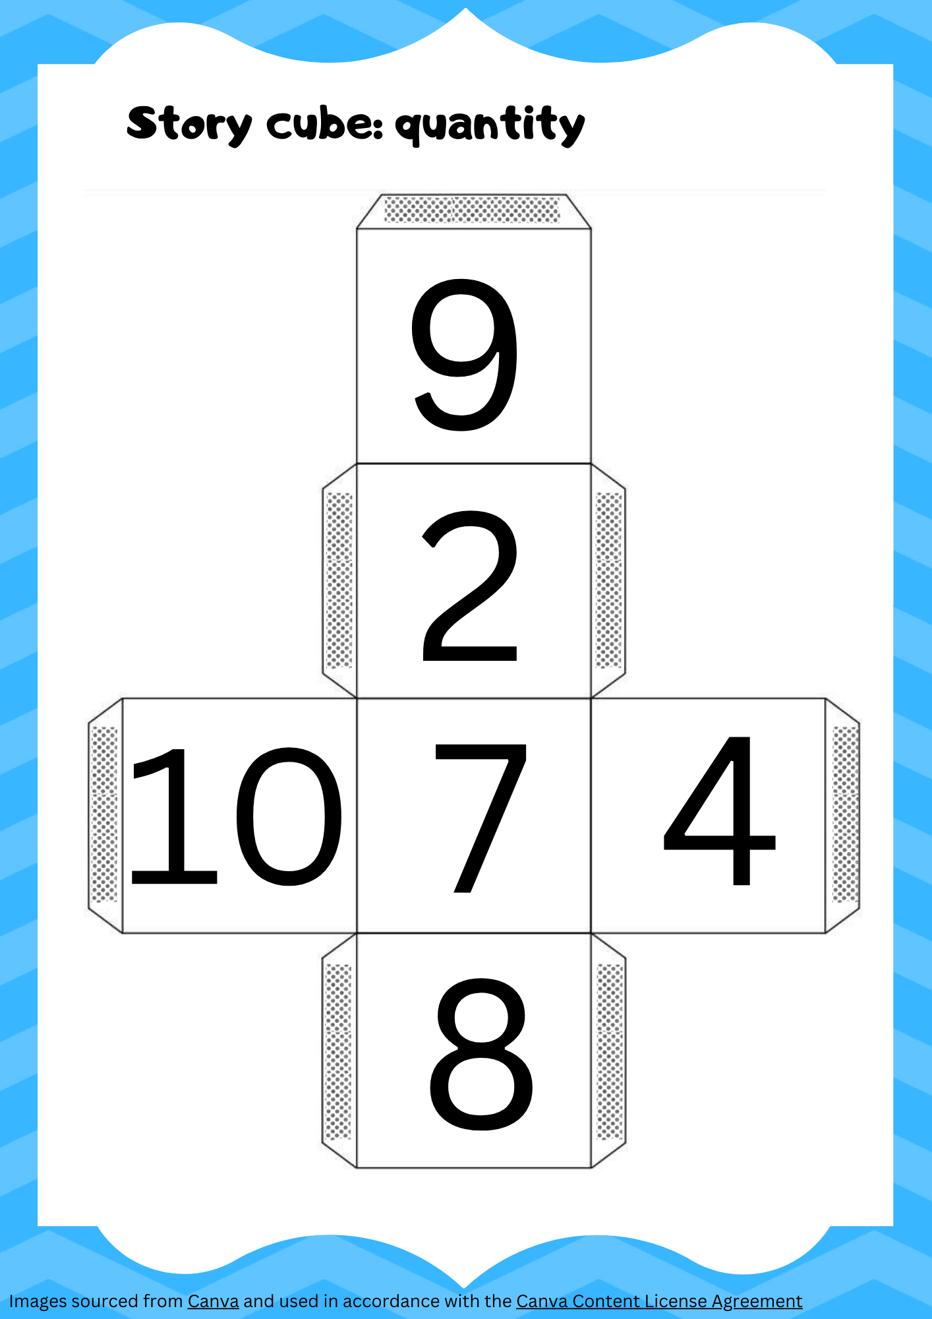

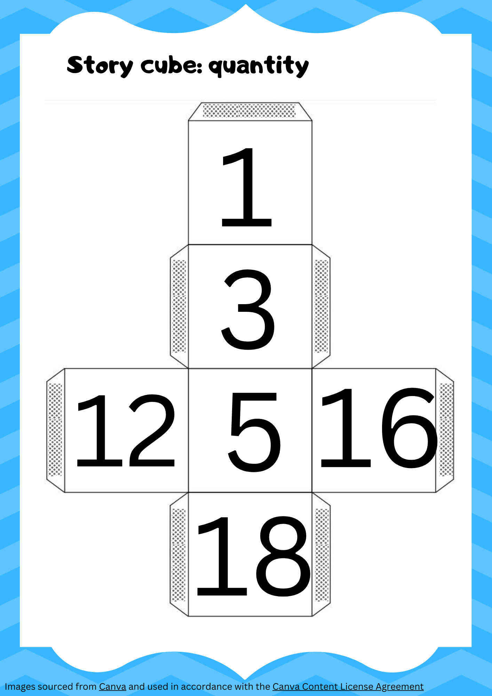

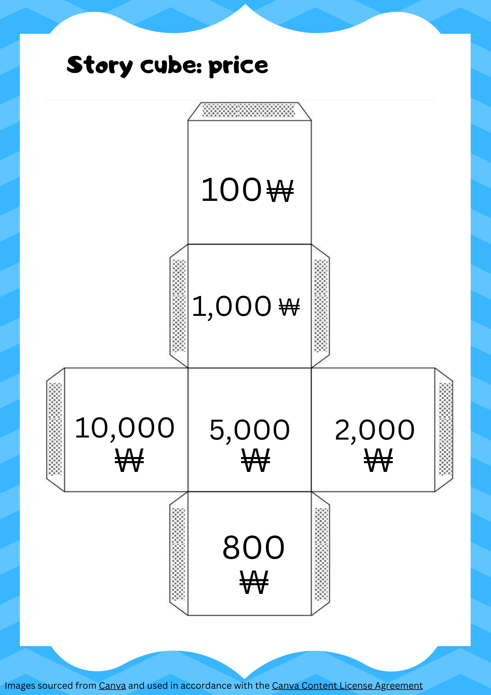

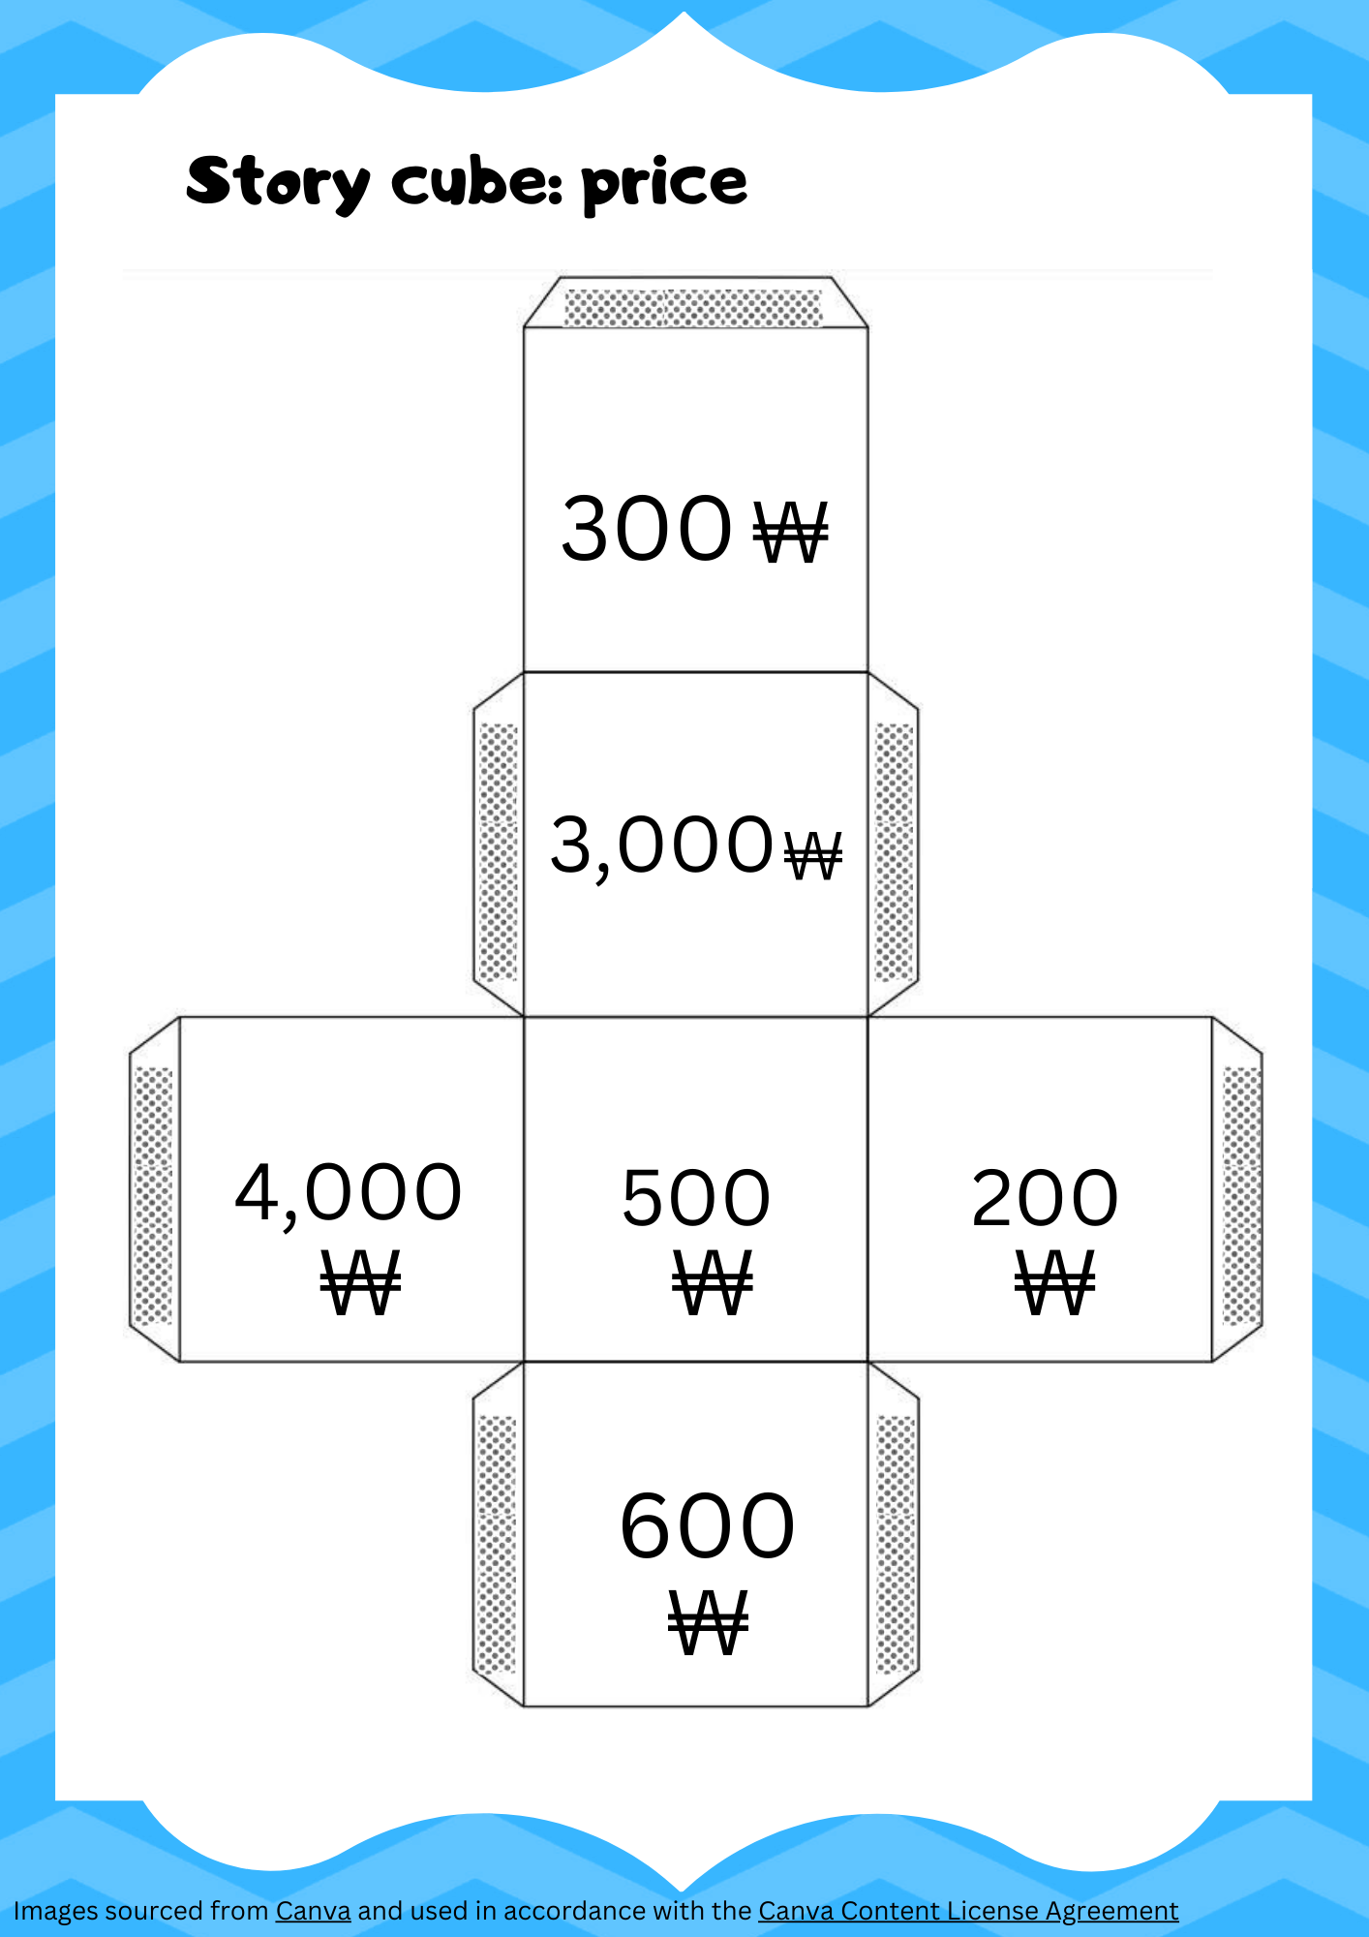

## Blank template

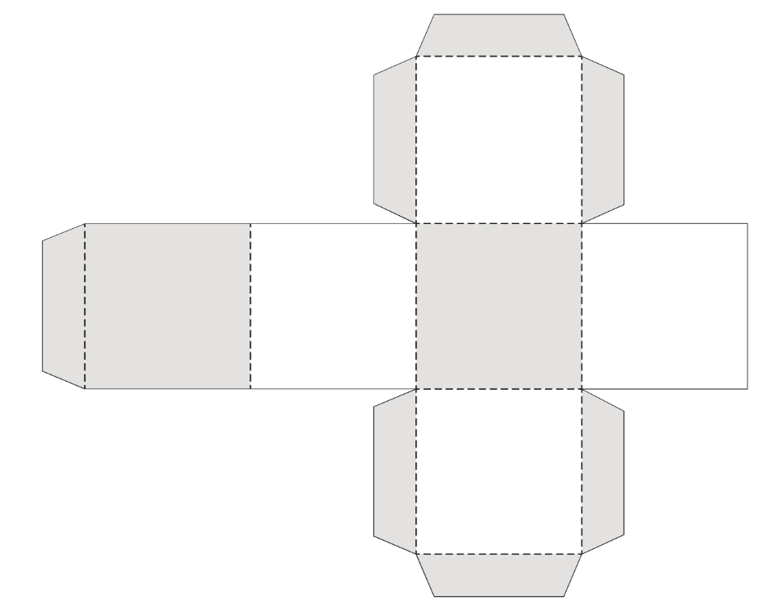

**© State of New South Wales (Department of Education), 2024**

The copyright material published in this resource is subject to the Copyright Act 1968 (Cth) and is owned by the NSW Department of Education or, where indicated, by a party other than the NSW Department of Education (third-party material).

Copyright material available in this resource and owned by the NSW Department of Education is licensed under a [Creative Commons Attribution 4.0 International (CC BY 4.0) license](https://creativecommons.org/licenses/by/4.0/).

[](https://creativecommons.org/licenses/by/4.0/)

This license allows you to share and adapt the material for any purpose, even commercially.

Attribution should be given to © State of New South Wales (Department of Education), 2024.

Material in this resource not available under a Creative Commons license:

* the NSW Department of Education logo, other logos and trademark-protected material
* material owned by a third party that has been reproduced with permission. You will need to obtain permission from the third party to reuse its material.

**Links to third-party material and websites**

Please note that the provided (reading/viewing material/list/links/texts) are a suggestion only and implies no endorsement, by the New South Wales Department of Education, of any author, publisher, or book title. School principals and teachers are best placed to assess the suitability of resources that would complement the curriculum and reflect the needs and interests of their students.

If you use the links provided in this document to access a third-party's website, you acknowledge that the terms of use, including licence terms set out on the third-party's website apply to the use which may be made of the materials on that third-party website or where permitted by the Copyright Act 1968 (Cth). The department accepts no responsibility for content on third-party websites