# *Yōkai* booklet – みんなのようかい

## ようかいはなんですか

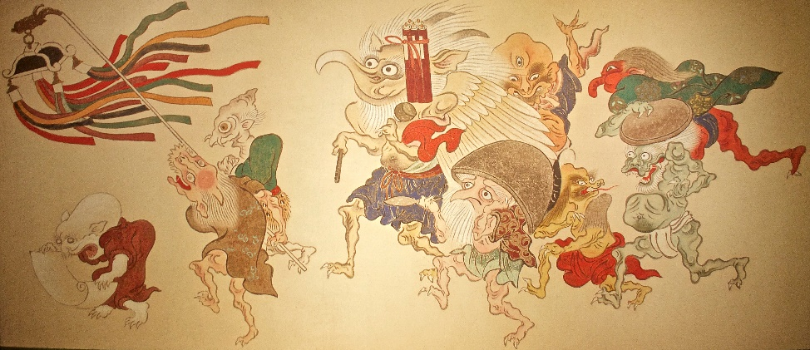

‘[Yōkai: Ghosts & Demons Of Japan](https://www.flickr.com/photos/29261037@N02/52381093675)’ by [pecooper98362](https://www.flickr.com/photos/29261037@N02) is licensed under [CC BY-NC-SA 2.0](https://creativecommons.org/licenses/by-nc-sa/2.0/?ref=openverse).

*Yōkai* is a term from Japanese folklore that refers to supernatural or paranormal entities, often translated as ‘ghosts’, ‘monsters’ or ‘spirits’. *Yōkai* can take on a wide range of forms, from shape-shifting animals and mythical creatures to ghosts and supernatural beings with unique abilities or characteristics. Sometimes *yōkai* are also known as *obake* or *bakemono*.

*Yōkai* have played an important role in Japanese culture and have been depicted in various art forms, such as woodblock prints, paintings and literature. They are often seen as mischievous or malevolent creatures, but some *yōkai* are considered benevolent or even protective.

*Yōkai* continue to have a significant influence on modern Japanese culture. *Yōkai* have become a popular subject in Japanese pop culture, appearing in *manga*, *anime*, video games and movies. *Pikachu* from *Pokemon*, which has become a global icon, is based on a *yōkai*. Other *anime* that include *yōkai* themes include *Demon Slayer*, *One Piece*, *Yu-yu Hakusho*, *Inuyashiya* and Studio Ghibli *anime* such as *Spirited Away* and *Princess Mononoke*.

Many Japanese festivals celebrate *yōkai*, such as the Obon festival in August, which honors the spirits of ancestors and features dancing performed in *yōkai* costumes. *Yōkai* have had a significant role in traditional Japanese culture and continue to do so in modern Japan.

## Activity 1 – parts of the body

Let’s learn to name parts of the body for people and creatures. In pairs, take turns to read the body parts, then the parts of the face. からだ means body and かお means face.

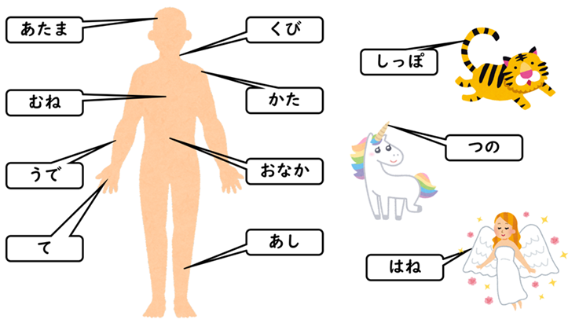

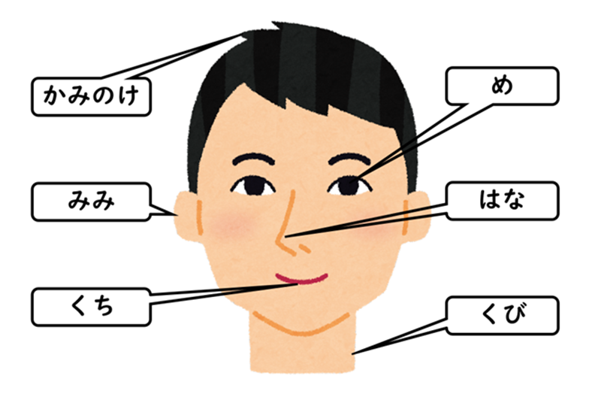

## Activity 2 – memory challenge

Listen to your teacher or a partner read the words and see if you can label the parts of the body and face correctly.

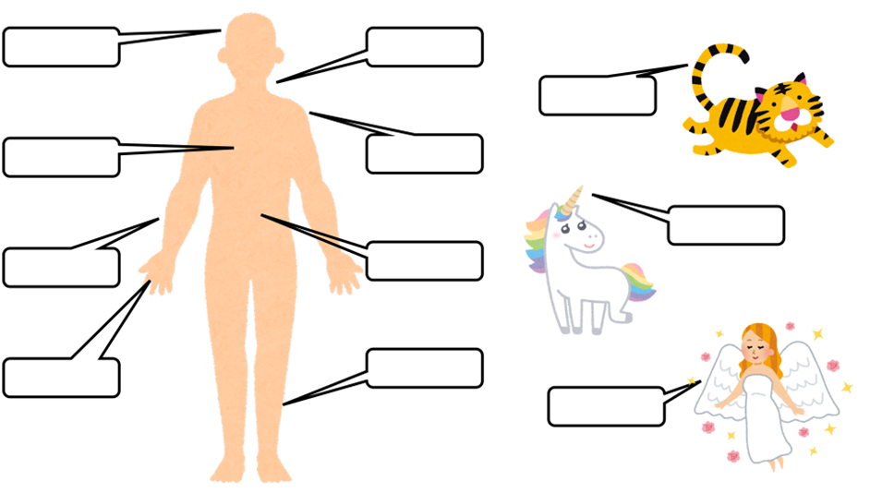

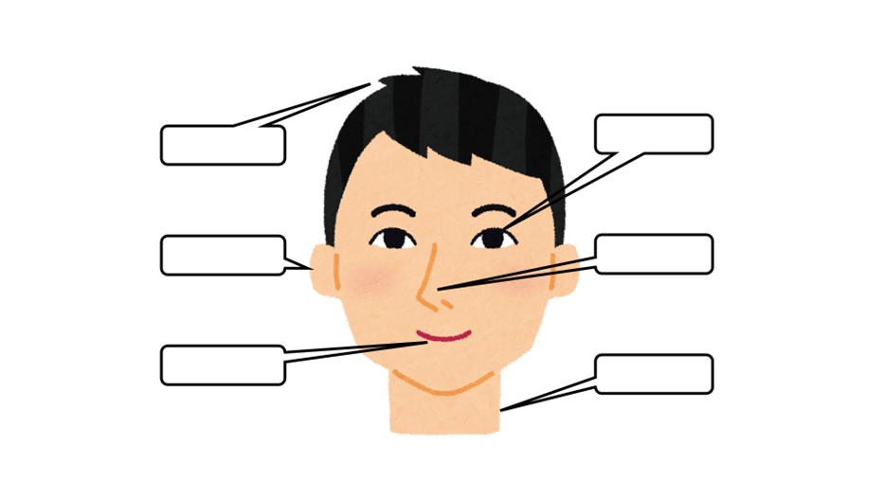

## Activity 3 – adjectives

In pairs or as a class, create a bilingual adjective list that you could use to describe *yōkai* using your own knowledge and/or print or online dictionaries.

|  |  |
| --- | --- |
| English | Japanese |
|  |  |
|  |  |
|  |  |
|  |  |
|  |  |
|  |  |
|  |  |
|  |  |
|  |  |
|  |  |
|  |  |
|  |  |
|  |  |
|  |  |

## Activity 4 – making descriptive sentences

How can you describe *yōkai*? The first sentence has been done for you. Look at the word order then try describing the hair, face and nose.

|  |
| --- |
| おにはつのがきいろいです。 |
|  |
|  |

A cartoon of a blue face with horns on it



Have a look at this *chōchin-obake* and see if you can write 3 sentences to describe it in Japanese.

|  |
| --- |
|  |
|  |
|  |

A cartoon of a lantern with one eye and a tongue



## Activity 5 – using あります and ありません

Hang on! What if the creature has no nose? You can use あります and ありません to say that something exists or doesn’t exist. Look at the 2 examples in the table below.

|  |  |
| --- | --- |
| English | Japanese |
| He has a nose. | はながあります。 |
| He doesn’t have a nose. | はながありません。 |

If a creature has no ears, what would you say?

If a creature has a tail, what would you say?

## Activity 6 – listening activity

1. Listen to the audio [Activity 6 – listening activity – sample 1.mp3 (0:21)](https://players.brightcove.net/6197335233001/RYyTOryUkW_default/index.html?videoId=6358118733112) describing a creature and draw what you hear in the box.

|  |
| --- |
|  |

1. Listen to [Activity 6 – listening activity – sample 2.mp3 (0:27)](https://players.brightcove.net/6197335233001/default_default/index.html?videoId=6358120707112) describing a creature and draw what you hear in the box.

|  |
| --- |
|  |

## Activity 7 – learning about famous yōkai

Read the descriptions of the *yōkai* in the table below and answer the questions that follow. The vocabulary column has been added to help you.

|  |  |  |
| --- | --- | --- |
| Name and picture | Description | Vocabulary |
| かっぱ  A cartoon of a green character holding a cucumber | ぼくはかっぱです。  かわにすんでいます。  からだはみどりです。  きゅうりがすきです。  かっぱはおもしろいです。 | かわ river  みどり green  きゅうり cucumber  おもしろい funny |
| ろくろっくび  A cartoon of a person with a long neck | わたしはろくろっくびです。  まちにすんでいます。  おんなです。  くびがながいです。 | まち town  おんな female  くび neck  ながい long |
| ぬえ  A cartoon of a monkey with a snake tail | ぼくはぬえです。  やまにすんでいます。  しっぽがへびです。  かおがさるです。 | やま mountain  へび snake  かお face  さる monkey |
| ぬらりひょん  A cartoon of an old person with an elongated head | ぼくはぬらりひょんです。  ようかいのリーダーです。  おじいさんです。  あたまがいいです。 | ーー leader  おじいさん old man  あたまがいい clever |
| のっぺらぼう  A cartoon of a person with no face | ぼくはのっぺらぼうです。  おとこです。  まちにすんでいます。  かおがありません。  ふくがしろいです。 | おとこ male  ありません don’t have  ふく clothes  しろい white |
| ざしきわらし  A cartoon of a child with a ball | わたしはざしきわらしです。  ふるいいえにすんでいます。  いえをまもります。  こどもです。 | ふるい old  いえ house  まもります protect  こども child |
| てんぐ  A cartoon of a person holding a leaf | わたしはてんぐです。  やまにすんでいます。  はながたかいです。（はながながいです。）  からだがあかいです。  しろいはねがあります。 | やま mountain  はね feather |
| うみぼうず  A cartoon of a monster in the water | ぼくはうみぼうずです。  うみにすんでいます。  からだがくろいです。  とてもおおきいです。 | おおきい big  くろい black |
| ゆきおんな  A cartoon of a person with blue hair in the snow | わたしはゆきおんなです。  やまにすんでいます。  とてもきれいです。  ふゆがすきです。 | きれい beautiful  ふゆ winter  すき like  おんな female  ゆき snow |
| からかさ  A cartoon umbrella with one eye and its tongue sticking out | ぼくはからかさです。  おはかにすんでいます。  あめがすきです。 | おはか cemetery  あめ rain  かさ umbrella |

Using the information in the table, answer the following questions.

1. Which *yōkai* has a green body?
2. Where does *tengu* live?
3. Which *yōkai* is clever?
4. Which *yōkai* has the monkey face?
5. Which *yōkai* likes winter?
6. What do you learn about *umibōzu*?
7. Which *y**ōkai* protects the house?
8. List 3 *yōkai* that live in the mountains.
9. Which *yōkai* has a long neck?
10. What does *karakasa* like?

Using the information in the table, write a suitable word in the blank space to form a correct sentence.

1. おには＿＿＿＿＿＿＿＿＿です。
2. のっぺらぼうは＿＿＿＿＿＿＿＿＿＿です。
3. ざしきわらしは＿＿＿＿＿＿＿＿＿＿です。
4. かっぱはきゅうりが＿＿＿＿＿＿＿＿＿＿＿です。
5. ろくろっくびは＿＿＿＿＿＿＿＿＿＿にすんでいます。
6. ぬえは＿＿＿＿＿＿＿＿＿＿がへびです。
7. からかさはおはかに＿＿＿＿＿＿＿＿＿＿＿＿＿＿＿＿。
8. うみぼうずはとても＿＿＿＿＿＿＿＿＿＿＿です。
9. ゆきおんなは＿＿＿＿＿＿＿＿＿＿＿＿がすきです。
10. てんぐははねが＿＿＿＿＿＿＿＿＿＿＿＿です。

## Activity 8 – *yōkai* design

Now it’s your turn to be creative and design a *yōkai*. Use the descriptions in Activity 7 to help you with describing your *yōkai*. Write 4 sentences about your *yōkai*. Be creative and don’t forget to give it a name and include any additional vocabulary you use in the last column.

|  |  |  |
| --- | --- | --- |
| Name and picture | Description | Vocabulary |
|  |  |  |

## Activity 9 – *yōkai* research

Choose any one of the *yōkai* below to research, and complete 5 facts about them in English or Japanese using full sentences.

|  |  |  |
| --- | --- | --- |
| A cartoon of a wall  ぬりかべ | A cartoon of a mermaid | A cartoon of a tree  こだま |

|  |  |
| --- | --- |
| Name of *yōkai* | Facts |
|  |  |
|  |  |
|  |  |
|  |  |
|  |  |

## Activity 10 – reading about *yōkai*

Read more details about some of the *yōkai* found in Japanese folklore and answer the questions that follow.

*Rokurokubi* are typically depicted as humans who can stretch or detach their heads from their bodies and are sometimes referred to as a ‘long necked *yōkai*’. They are said to have long necks that can grow to incredible lengths and stretch their necks to spy on humans or to attack them.

*Nue* is typically described as a composite of various animals, including a monkey, a raccoon dog, a snake and a tiger. The *nue* is often portrayed as a malicious, shape-shifting monster that can cause diseases, including the plague, and can even disrupt the weather and bring about natural disasters. Despite its ominous reputation, the *nue* is also sometimes depicted as a comical figure and is sometimes said to bring good luck to those who can capture it.

*Oni* is a type of demon or ogre that is often depicted as having horns, sharp claws and a fearsome appearance. *Oni* are often portrayed as evil and malevolent beings who torment and harm humans, but there are also tales that show them as more complex characters who can be both cruel and kind, good and bad. They are a common subject in Japanese art, literature and popular culture, and they have become an integral part of the country’s cultural heritage.

The *noppera-bō*, or faceless ghost, is a Japanese *yōkai* that looks like a human but has no face. *Noppera-bō* is known primarily for frightening humans but is usually otherwise harmless. It appears at first as an ordinary human being, sometimes impersonating someone familiar to the victim, before their features disappear, leaving a blank, smooth sheet of skin where its face should be.

*Tengu* is a type of supernatural creature. It is typically depicted as having both human and bird-like characteristics, often with a long nose and wings. It is considered to be a powerful and mischievous being and is sometimes associated with martial arts and the protection of the mountains.

*Yukionna* is a mythical creature, often depicted as a beautiful and mysterious woman with long black hair, pale skin and the ability to control snow and ice. She is often associated with winter and is said to lure travellers into the mountains, where she can freeze them to death.

*Kappa* is a mythical creature, often depicted as a water spirit or demon that dwells in rivers, lakes and other bodies of water. It is typically depicted as having the body of a tortoise and the head of a monkey, with scaly skin and webbed hands and feet. *Kappa* is often portrayed as mischievous or malevolent, but also as having a mischievous or playful side, and is sometimes said to be able to grant wishes or perform other helpful acts. In Japanese folklore, it is said that one should bow to a *kappa* to show respect, as they are said to be polite creatures that will return the gesture and may then spare a person from harm. Learn more about the *kappa* by watching [Ancient Aliens: The Legendary Japanese Kappa (2:30)](https://www.youtube.com/watch?v=mjOWPD7hJhw).

*Umibōzu* is a mythical sea monster, often depicted as a giant, ghostly figure with a bald head and a large body that resembles that of a Buddhist priest. It is said to dwell in the ocean and is associated with storms and rough seas. In some legends, *umibōzu* is said to be a spirit of the sea that demands a toll from sailors for safe passage, while in others it is depicted as a malevolent monster that capsizes ships and drags sailors down to their deaths.

*Zashikiwarashi* is a supernatural spirit or monster in Japanese folklore. It is typically depicted as a small child with wild, unkempt hair, who lives in old, traditional houses and brings good fortune to the household.

*Nurarihyon* is a type of supernatural creature. It is often depicted as an old man with a large forehead and an elongated, wrinkled face, who is the leader of a group of *yōkai*. In some stories, *nurarihyon* is depicted as a cunning and deceitful figure who uses his wit and powers to manipulate humans and other *yōkai* to his advantage. In other stories he is portrayed as a benevolent figure who brings good luck and prosperity to households.

*Karakasa* is a type of supernatural creature. It is typically depicted as a ghostly figure with a large, umbrella-like head that is said to haunt graveyards, abandoned temples and other lonely places. In some legends, it is said to appear on rainy nights and to try to scare or attack people who cross its path. Despite its frightening appearance, the *karakasa* is also sometimes depicted as a comical figure and is sometimes even said to bring good luck to those who are able to outwit it.

1. Which is your favourite *yōkai* and why? Please answer in English, giving details.
2. Complete the table below by filling in the meanings of the English words from the passage. You may use a print or [online dictionary](https://www.macquariedictionary.com.au/) to assist you.

|  |  |
| --- | --- |
| Word | Meaning (in English) |
| composite |  |
| malicious |  |
| plague |  |
| ominious |  |
| malevolent |  |
| literature |  |
| impersonate |  |
| mischievous |  |
| lure |  |
| unkempt |  |
| wit |  |
| elongated |  |
| deceitful |  |
| manipulate |  |
| outwit |  |

## Activity 11 – *kanji* activity

Complete the table below following these steps:

1. Read the word in *hiragana* and write its meaning in English in the first column.
2. The third column displays the stroke number for the *kanji* as well as a link to see the stroke order. View the stroke order carefully. Use the practice spaces to copy the *kanji*, using the correct stroke order.

|  |  |  |  |  |  |  |  |  |
| --- | --- | --- | --- | --- | --- | --- | --- | --- |
| English | *Hiragana* | Strokes | *Kanji* | Practice spaces | | | | |
|  | まち | [7](https://tangorin.com/kanji/machi) | 町 |  |  |  |  |  |
|  | やま | [3](https://tangorin.com/kanji?search=yama) | 山 |  |  |  |  |  |
|  | かわ | [3](https://tangorin.com/kanji?search=kawa) | 川 |  |  |  |  |  |
|  | うみ | [9](https://tangorin.com/kanji?search=umi) | 海 |  |  |  |  |  |
|  | おんな | [3](https://tangorin.com/kanji?search=onna) | 女 |  |  |  |  |  |
|  | おとこ | [7](https://tangorin.com/kanji?search=otoko) | 男 |  |  |  |  |  |
|  | あめ | [8](https://tangorin.com/kanji?search=ame) | 雨 |  |  |  |  |  |
|  | あかい | [7](https://tangorin.com/kanji?search=aka) | 赤い |  |  |  |  |  |
|  | しろい | [5](https://tangorin.com/kanji?search=shiro) | 白い |  |  |  |  |  |
|  | おおきい | [3](https://tangorin.com/kanji?search=big) | 大きい |  |  |  |  |  |

## Activity 12 – song のきたろう

Watch the video [ゲゲゲのきたろう(1:14)](https://www.youtube.com/watch?v=vWTKaoi6UBE) and answer the following questions.

1. What do you think ゲゲゲ means?
2. Can you name any of the characters in the video?
3. How does this song make you feel?

## Activity 13 – singalong

Listen to the video[ゲゲゲのきたろう(1:14)](https://www.youtube.com/watch?v=vWTKaoi6UBE) again and sing along or follow the words.

ゲッゲッ　ゲゲゲのゲー

あさはねどこで　グーグーグー

たのしいな　たのしいな

おばけにゃがっこうも

しけんもなんにもない

ゲッゲッ　ゲゲゲのゲー

みんなでうたおう　ゲゲゲのゲ

ゲッゲッ　ゲゲゲのゲー

よるははかばで　うんどうかい

たのしいな　たのしいな

おばけはしなない

びょうきもなんにもない

ゲッゲッ　ゲゲゲのゲー

みんなでうたおう　ゲゲゲのゲ

みんなでうたおう　ゲゲゲのゲ

みんなでうたおう　ゲゲゲのゲ

## Activity 14 – *y**ōkai* in*Tōkyō*

Look at the pictures taken in Tokyo. Which *yōkai* is pictured?

|  |  |  |  |
| --- | --- | --- | --- |
| A sign displaying a green character holding a cucumber | Two stuffed green animals on a table | A black statue | A green statue with a hat |
| Two wooden statues | A sticker of two creatures holding hands | A tile in the pavement with a character in water | A stone statue in the garden |

## References

HISTORY (8 September 2015) [‘Ancient Aliens: The Legendary Japanese Kappa (S8, E7)](https://www.youtube.com/watch?v=mjOWPD7hJhw)’, HISTORY, YouTube, accessed 13 June 2024.

Toho Animation Koshiki (1 April 2018) ‘[オープニング主題歌「ゲゲゲの鬼太郎」(歌:氷川きよし)](https://www.youtube.com/watch?v=lOCq2OG2y5c)’, YouTube, accessed 13 June 2024.

**© State of New South Wales (Department of Education), 2024**

The copyright material published in this resource is subject to the *Copyright Act 1968* (Cth) and is owned by the NSW Department of Education or, where indicated, by a party other than the NSW Department of Education (third-party material).

Copyright material available in this resource and owned by the NSW Department of Education is licensed under a [Creative Commons Attribution 4.0 International (CC BY 4.0) license](https://creativecommons.org/licenses/by/4.0/).

[](https://creativecommons.org/licenses/by/4.0/)

This license allows you to share and adapt the material for any purpose, even commercially.

Attribution should be given to © State of New South Wales (Department of Education), 2024.

Material in this resource not available under a Creative Commons license:

* the NSW Department of Education logo, other logos and trademark-protected material
* material owned by a third party that has been reproduced with permission. You will need to obtain permission from the third party to reuse its material.

**Links to third-party material and websites**

Please note that the provided (reading/viewing material/list/links/texts) are a suggestion only and implies no endorsement, by the New South Wales Department of Education, of any author, publisher, or book title. School principals and teachers are best placed to assess the suitability of resources that would complement the curriculum and reflect the needs and interests of their students.

If you use the links provided in this document to access a third-party's website, you acknowledge that the terms of use, including licence terms set out on the third-party's website apply to the use which may be made of the materials on that third-party website or where permitted by the *Copyright Act 1968* (Cth). The department accepts no responsibility for content on third-party websites.