Programming guidelines for the Classical Languages K–10 Syllabus

Contents

Introduction 2

Programming 2

Elements of a program 3

Scope and sequence 3

Units 6

Assessment 11

Formative assessment 11

Summative assessment 12

Reporting considerations 13

Register 14

Appendix A – scope and sequence checklist 15

Appendix B – unit checklist 16

Appendix C – summative assessment task and notification checklist 18

Support and alignment 20

Evidence base 21

# Introduction

This document supports teachers of classical languages 7–10, their supervisors and the educational teams who provide universal support to schools.

# Programming

**Programming** is the process through which teachers select and sequence teaching, learning and assessment experiences which cater for the diversity of learners in a particular year or stage.

A **program** is all of the documents involved in the overall planning for each language and year or stage.

Effective programs enable teachers to:

* plan for the delivery of syllabus outcomes and content
* improve student learning outcomes
* respond to student learning needs, school context, self-reflection and evaluation
* record planned learning experiences of how syllabus requirements are met.

Programs are evidence of compliance in [NESA’s registration process for schools](https://educationstandards.nsw.edu.au/wps/portal/nesa/regulation/government-schooling/registration-process-government-schooling).

The department also sets additional requirements, outlined in the ‘Curriculum Planning and Programming, Assessing and Reporting to Parents K–12 Policy’ available in the [policy library](https://education.nsw.gov.au/policy-library).

A program also allows for continuity of quality learning for students, by allowing other teachers to continue teaching students if required, for example during periods of absence.

The [Classical Languages K–10 Syllabus](https://curriculum.nsw.edu.au/learning-areas/languages/classical-languages-k-10-2022/overview) (2022) states that ‘The aim of Classical Languages K–10 is to empower students with the knowledge, understanding and skills required to access and appreciate a range of Classical texts’. As such, all the teaching, learning and assessment activities you design for your program should focus on developing students’ linguistic competence, interest and enjoyment of language learning through selected texts.

This document guides you through the elements of a program, and links each element to the Classical Languages K–10 Syllabus within the context of language teaching in Years 7–10.

# Elements of a program

For each language and year or stage, you need to have a program that includes the elements listed below.

Figure 1 – elements of a program

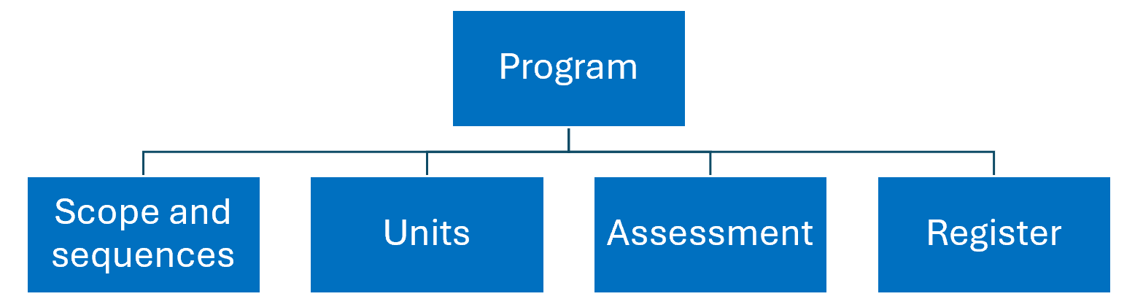

In this document, you can find more information about each element, as well as checklists to help you program, including NESA requirements and other considerations.

## Scope and sequence

A scope and sequence summarises what is to be taught and the sequence in which it will be taught within a year or stage. For example, you may have one unit for each term of learning, which looks at a particular theme or topic.

NESA requires that a scope and sequence includes the title of each unit, the sequence of each unit for the year or stage, the duration of each unit and syllabus outcomes included in each unit (as outcomes codes).

While not required by NESA for school registration, the department recommends including the following in your scope and sequence, for each unit:

* the skills students will develop
* a short description of the summative assessment task.

These inclusions support a backward mapping approach and provide a succinct reminder of what skills are important for students to successfully demonstrate achievement of the outcomes and content in the context of the unit.

Take a look at the example below.

Table 1 – sample scope and sequence

|  |  |  |  |  |
| --- | --- | --- | --- | --- |
| Term/ duration | Learning overview | Outcomes | Skills | Assessment |
| Term 3  5 weeks | **Introduction to epic poetry**  Students learn about the nature and features of epic poetry in the target language.  Students study and learn to read aloud an extract of epic poetry in the target language. | **CL5-UND-01**  analyses and responds to information to demonstrate understanding of a range of moderately complex texts  **CL5-ICU-01**  analyses the relationship between contemporary and target languages, culture(s) and identity | * Understand the performative nature of epic poetry and its cultural role in the ancient civilisation. * Describe the narrative context of an extract of an epic poem. * Describe the narrative and cultural content of the epic poem. * Identify usages of grammatical concepts in the extract that correspond with prior learning. * Understand how the writer has used literary features to achieve effects appropriate to the context. * Read the extract using appropriate pronunciation, intonation and phrasing. | **Part A: Understanding texts (CL5-UND-01)**  Read aloud an extract of authentic epic poetry in the target language that has been previously studied in class.  Observe:   * accurate pronunciation of phonemes, word accent, and poetic conventions, for example, elision * appropriate intonation and phrasing that conveys the extract’s purpose and meaning.   **Part B: Understanding texts, Intercultural understanding (CL5-UND-01, CL5-ICU-01)**  Students select sections of the extract studied in class and, with reference to the text, explain in English:   * the narrative context of the extract * the meaning of 2 culturally specific words * how the extract reflects the attitudes, values and/or beliefs of the culture.   Extension: Students explain 2 ways in which the writer has used language for a specific literary purpose. |

Understanding the target language and culture through textsis the central goal of classical language learning in the syllabus. It requires students to undertake close study of texts in the target language. This central goal needs to be clear when describing the summative assessment task for each unit in your scope and sequence.

With only 3 outcomes per stage in Years 7–10, all units in your scope and sequence should address all outcomes. While the same syllabus outcomes and content may be targeted in each unit’s summative assessment task, the texts assessed should become increasingly complex. By assessing all outcomes (and a range of their related content) across a year or stage, you are allowing opportunities for students to demonstrate their achievement more broadly.

When designing your scope and sequence, embed the spiral approach to learning. The acquisition of a language is a cumulative process, therefore a continuous and sequenced approach is essential when developing your units. This allows students to develop their skills gradually, reinforcing and building vocabulary and structures over time. By providing students with opportunities to revisit and build upon what they have learned, they can use their language skills to understand and respond to texts of increasing complexity. This also supports the shift of new content into students’ long-term memory, lightening cognitive load. Students’ knowledge is deepened and broadened, and they experience a feeling of success by building on prior learning.

Finally, the department recommends providing a ‘student-friendly’ copy of the scope and sequence to students at the start of the year, written and presented in a way that is appropriate to them. This gives students a sense of what they may be able to achieve by the end of each year or stage, which can be motivating. Students will also be able to see how all their learning links and builds, enhancing engagement and supporting students to reflect and focus on areas for growth.

When planning your scope and sequence, use the checklist provided in Appendix A.

## Units

Units summarise the teaching and learning strategies, resources and assessment (both formative and summative) for a particular set of outcomes and content in the syllabus. They also include adjustments to meet the learning needs of students, where required, and a section for reflection and evaluation.

NESA requires that a unit includes:

* a unit description
* syllabus outcomes
* duration
* year or stage
* integrated teaching and learning activities
* differentiation catering to the range of student abilities and interests
* opportunities to collect evidence of student achievement
* subject-specific requirements (where relevant)
* resources
* reflection and evaluation
* adjustments for students with disability, where appropriate.

While not required by NESA for school registration, the department recommends the following:

* designing your summative assessment task first, and then backward mapping your unit, including your teaching and learning activities and formative assessment opportunities for students. It is important that students receive ongoing feedback and time for reflection as the unit progresses, so they are engaged with and involved in their learning journey and can identify their individual learning goals (learn more in the Assessment section below)
* organising your unit into sequences of learning which break down aspects of the final summative task, with clear learning intentions and success criteria for each sequence. By ‘chunking’ the learning in this way, with each sequence of learning building towards a particular aspect of the final task, students are supported to develop the necessary skills to succeed at the summative task.

The backward mapping process for Stages 4 and 5 should be undertaken with an understanding of the requirements for Stage 6 to facilitate students’ transition to original texts in the target language. **Note:** the table below is a condensed example only, to provide a snapshot of the process.

Table 2 – sample sequence of learning

|  |  |  |  |
| --- | --- | --- | --- |
| Sequence of learning focus | Learning intentions | Success criteria | Mini task – progress checkpoint |
| Conventional word order in the target language | **Students are learning:**   * conventional word order in the target language, for example, subject, direct object, transitive verb or subject, linking verb, complement * parsing each word as they read for its grammatical features and usage. | **Students can:**   * identify conventional word order in sentences * verbalise their reading process. | **Understanding texts (CL4-UND-01)**  Students are provided with a series of 3–4 short sentences, with a mixture of conventional and non-conventional word order, that are revealed to them one word at a time.  For each word, students note its grammatical features and possible usage in the sentence.  Students identify whether the word order of the sentence is conventional or non-conventional. |
| Development of reading comprehension by dividing sentences into smaller sense units | **Students are learning:**   * to divide compound and complex sentences into smaller sense units * to translate these sentences into fluent English. | **Students can:**   * use their knowledge of conventional word order to predict the structure of sentences * divide sentences into phrases and clauses using verbal markers such as conjunctions and prepositions * translate sentences they have divided into smaller sense units. | **Part A: Understanding texts** **(CL4-UND-01)**  Students are given 2–3 new sentences of varying length and complexity, one word at a time.  Students note each word’s grammatical features and possible usage, including whether it is a marker for a smaller sense unit.  Students predict whether the sentence follows conventional word order, then mark up a copy of these sentences with their sentence divisions.  **Part B: Understanding texts** **(CL4-UND-02)**  Students translate the sentences. |

In the [Classical Languages K–10 Syllabus](https://curriculum.nsw.edu.au/learning-areas/languages/classical-languages-k-10-2022/overview) (2022), understanding the target language and culture through texts is the central goal. Students show their understanding across 2 focus areas:

* **Understanding texts**
* Understanding and responding
* Applying knowledge of language systems
* Translating
* **Intercultural understanding**
* Understanding the world of the target language
* Reflecting on language, culture and identity

Language systems include the sounds, vocabulary, grammar and script/alphabet of the language, and knowledge of language systems is applied to understand, respond to and translate texts. Translation is a core skill in the study of a classical language. Intercultural understanding involves gaining knowledge of the classical world, making connections and comparisons and reflecting on identity.

Each focus area in Years 7–10 has 3 stage-based outcomes – 2 relating to **Understanding texts** and one relating to **Intercultural** **understanding**.

**Stage 4**

* **CL4-UND-01** interprets and responds to information to demonstrate understanding of a range of predictable texts
* **CL4-UND-02** translates a range of predictable texts into English
* **CL4-ICU-01** describes the relationship between contemporary and target languages, culture(s) and identity

**Stage 5**

* **CL5-UND-01** analyses and responds to information to demonstrate understanding of a range of moderately complex texts
* **CL5-UND-02** translates a range of moderately complex texts into English
* **CL5-ICU-01** analyses the relationship between contemporary and target languages, culture(s) and identity

The content in the syllabus is represented through content groups and dot points, as seen in the figure below.

Figure 2 – syllabus content groups and content

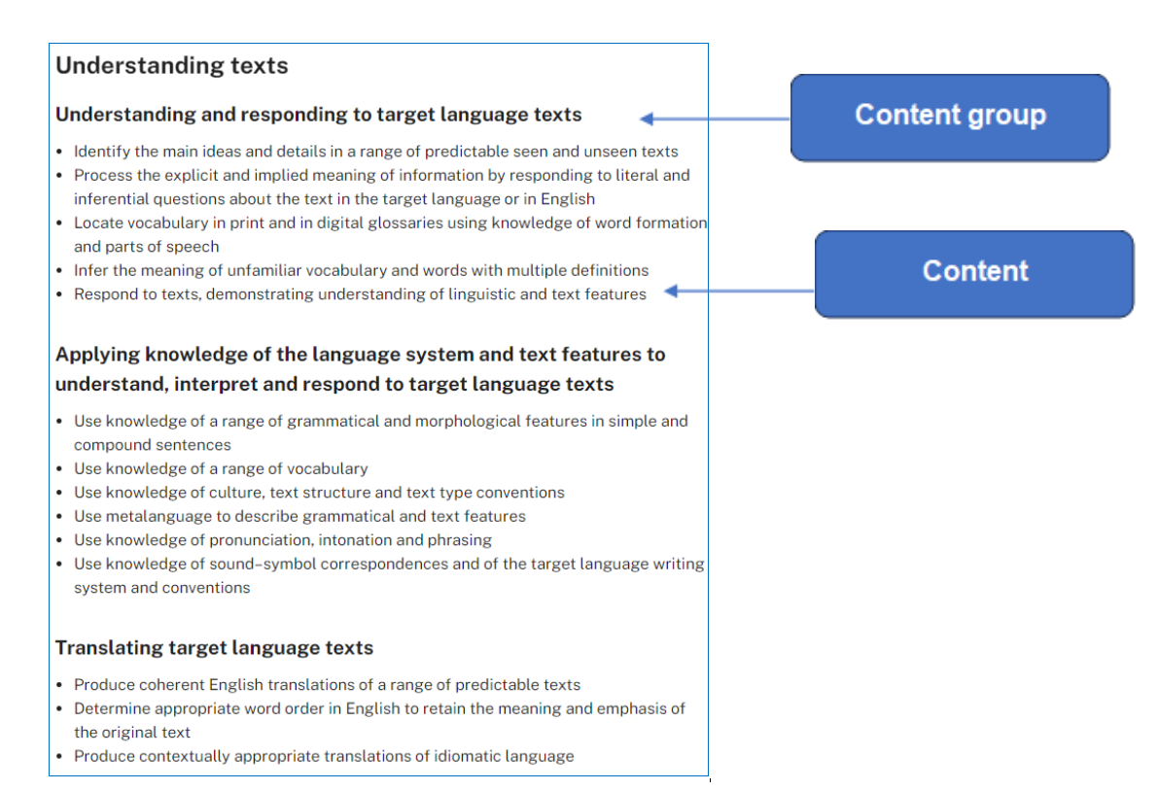

Image modified from [Classical Languages K–10 Syllabus](https://curriculum.nsw.edu.au/learning-areas/languages/modern-languages-k-10-2022) © 2022 NSW Education Standards Authority (NESA) for and on behalf of the Crown in right of the State of New South Wales.

All of the content is considered ‘essential learning’ in order for students to demonstrate achievement of the outcome. The content groups are not intended to be hierarchical or indicative of time spent. For this reason, when designing units, program for all the content, adjusting the time required, depending on student ability and proficiency. While each unit should address all outcomes, it does not need to cover all the content dot points for each outcome. These can be covered across a year or stage of learning.

The examples in the digital curriculum and the teaching advice provide guidance on how the outcomes and content are to be interpreted and applied. They also provide examples of themes you could include in your units. By ascertaining students’ existing prior knowledge, including their existing target language skills and their interests, you can design learning which is more engaging.

When planning your unit, use the checklist provided in Appendix B.

## Assessment

Assessment provides opportunities for teachers to gather evidence about student achievement in relation to syllabus outcomes, including a range of student work samples.

NESA states:

‘The primary role of assessment is to establish where students are in their learning so that teaching can be differentiated and further learning progress can be monitored over time. It provides information that assists teachers to target their teaching at the point of student need. Assessment is most effective when it is an integral part of teaching and learning programs.

Assessment involves:

* establishing where students are in their learning
* ongoing monitoring
* formative and summative tasks
* providing feedback about student progress.’

[Classical Languages K–10 Syllabus](https://curriculum.nsw.edu.au/learning-areas/languages/modern-languages-k-10-2022) © 2022 NSW Education Standards Authority (NESA) for and on behalf of the Crown in right of the State of New South Wales.

### Formative assessment

Formative assessment aims to close the gap between where a student is now and where they need to be, in order to successfully demonstrate their achievement of the outcomes. Teachers use evidence of students' knowledge, understanding and skills to inform their teaching and to provide feedback to students about their learning and how to improve.

It is important to plan opportunities which allow students to discover where they are now and enable them to plan how to move to the next stage of their learning.

For example:

* pre-testing for prior knowledge prior to starting a unit (Are you aware of what students already know and can do? Does your unit ‘tap into’ areas of student interest and acknowledge their cultural and background knowledge?)
* activities and quizzes to monitor learning
* mini tasks which allow opportunities for students to practise new vocabulary and skills, and receive feedback, to support their success in the summative assessment task (progress checkpoints)
* effective feedback, including peer feedback and self-reflection opportunities.

### Summative assessment

Summative assessment allows teachers to gather evidence of achievement of learning intentions and outcomes against standards, thus measuring student success **at a point in time**. Like all assessment, it is an opportunity to provide feedback to students on their progress.

Provide your students with the assessment task notification, including a clear task description, marking criteria and marking guidelines, at the start of the unit to help them plan and link their learning. Allow time to discuss the task, and then revisit the task at various points throughout your teaching of the unit, so students are reminded of why each sequence of learning is relevant.

Since understanding the target language and culture through texts is the central goal of language learning in the syllabus, summative assessment takes the form of text-based tasks. These allow students to demonstrate their mastery of the language system, their knowledge of the culture as it is expressed in texts, and their ability to understand and respond to the texts, including through translation.

For example, a summative assessment might include: the comprehension of an unfamiliar story, the grammatical analysis and translation of a familiar play or identifying mythological allusions in a text.

By designing your summative assessment first, then backward mapping your teaching, learning and formative assessment opportunities, you are supporting your students to develop the skills required to understand and respond to the texts.

Assessment opportunities are required to be inclusive of and accessible for all students. It is important to consider how you will support the needs of all students, for example by:

* providing a scaffold
* allowing the use of assistive technology
* negotiating a plan to prepare students for a summative assessment task.

When planning your summative assessment task, use the checklist provided in Appendix C.

### Reporting considerations

The parents and/or carers of all students are to be provided with a formal report on their child’s learning twice a year. Each student’s achievement is reported in relation to syllabus standards, for example outcomes and content.

The 2 focus areas – **Understanding texts** and **Intercultural understanding** – and their related outcomes and content should form the basis of your reports. Per stage, there are 2 outcomes for **Understanding texts** and one outcome for **Intercultural understanding**. With only 3 outcomes per stage, the department recommends reporting on each outcome across a stage. This allows opportunities for students to demonstrate their achievement more broadly. It is not necessary, however, to report on all outcomes in every reporting period. Schools and teachers decide what to report on to determine a grade for each subject.

Outcome content dot points are considered essential to students being able to demonstrate achievement of the outcome. As such, all content dot points must be addressed over a stage, but they do not all need to be formally assessed.

When creating assessment tasks that will be used for reporting, the department recommends teachers identify the content dot points within the outcome that the task addresses and then use these to inform wording in marking guidelines and reporting.

For example, a Grade B comment for a Stage 4 Latin student could be:

Emmanuel has actively participated in class activities and discussions this semester, demonstrating a consistent approach to class activities. He effectively used his understanding of the Latin language system and text features to interpret and respond to predictable seen and unseen texts. Emmanuel demonstrated a strong grasp of grammatical and morphological elements, applying them well in both simple and compound sentences. His vocabulary was both appropriate and varied, reflecting a good understanding of cultural references, text structure and conventions. In translation tasks, Emmanuel produced clear and coherent English translations of various predictable Latin texts. He adeptly determined the appropriate word order in English to preserve the meaning and emphasis of most of the original Latin. To further enhance his skills, I encourage Emmanuel to continue analysing more complex texts, and focus on the translating of idiomatic expressions.

### Register

A register is a document which tracks the progress of each unit, including any variations made, and allows for evaluation of the strategies and activities used. Teachers and schools may approach this differently. For example, some teachers may annotate units of work, indicating when activities and tasks were completed by each class and noting any adjustments which were required, including a self-reflection. Other teachers may have their register as a separate document. It will depend on the requirements of your faculty and/or school.

# Appendix A – scope and sequence checklist

My scope and sequence includes:

☐ the NESA requirements

☐ title of each unit

☐ sequence of each unit for the year or stage

☐ duration of each unit

☐ syllabus outcomes included in each unit (as outcomes codes)

☐ understanding the target language and culture through texts, as the central goal

☐ the skills and understanding students will develop in each unit

☐ a short description of the summative assessment task for each unit, which focuses on responding to text(s) in the target language

☐ assessing all outcomes and content across the year or stage

☐ opportunities for students to revisit language from previous units, building on existing knowledge and skills, in new contexts.

I have:

☐ shared my scope and sequence with students, using student-friendly language.

# Appendix B – unit checklist

My unit includes:

☐ the NESA requirements

☐ unit description

☐ syllabus outcomes

☐ duration

☐ year or stage

☐ integrated teaching and learning activities

☐ differentiation catering to the range of student abilities and interests

☐ opportunities to collect evidence of student achievement (through formative and summative assessment)

☐ resources

☐ reflection and evaluation

☐ adjustments for students with disability, where appropriate

☐ opportunities to ascertain students’ prior knowledge

☐ understanding the target language and culture through texts, as the central goal

☐ opportunities for students to develop knowledge of language systems (including sounds, vocabulary, grammar and, where required, script)

☐ opportunities to develop intercultural understanding

☐ learning intentions and success criteria for each sequence of learning within the unit, supporting student engagement and success

☐ opportunities for feedback and student reflection for deeper understanding and identification of individual learning goals.

# Appendix C – summative assessment task and notification checklist

My summative assessment task includes:

☐ the NESA requirements

☐ based on syllabus outcomes

☐ valid (assesses what it is designed to assess)

☐ criteria which clarifies for students what aspects of learning are being assessed

☐ reliable, measuring what the task intends to assess, and providing accurate information on each student's achievement

☐ free from bias and providing evidence that accurately represents a student's knowledge, understanding and skills

☐ enable students and teachers to use feedback effectively and reflect on the learning process

☐ inclusive of and accessible for all students

☐ part of an ongoing process where progress is monitored over time through a range of tasks

☐ understanding the target language and culture through texts, as the central goal

☐ relevant support for all students to succeed.

I have:

☐ explained the requirements of the assessment task with students at the start of the unit, supporting them to see the relevance of the upcoming learning

☐ planned opportunities for students to revisit the requirements of the assessment task throughout the unit, so they can see if they are on track and plan their next steps.

My assessment task notification includes:

☐ outcomes to be assessed

☐ a clear description of what the task involves

☐ marking criteria (‘You will be assessed on your ability to …’)

☐ success criteria (descriptions of how students can show their achievement)

☐ how feedback will be provided.

# Support and alignment

**Resource evaluation and support:** All curriculum resources are prepared through a rigorous process. Resources are periodically reviewed as part of our ongoing evaluation plan to ensure currency, relevance, and effectiveness. For additional support or advice, contact the Languages and Culture team by emailing [languagesnsw@det.nsw.edu.au](mailto:languagesnsw@det.nsw.edu.au).

**Alignment to system priorities and/or needs:** [Curriculum Planning and Programming, Assessing and Reporting to Parents K–12 Policy](https://education.nsw.gov.au/policy-library/policies/pd-2005-0290)

**Alignment to the School Excellence Framework:** This resource supports the [School Excellence Framework](https://schoolsequella.det.nsw.edu.au/file/b214a08b-5c9d-4ca2-9eb7-caaf7e6e53a0/1/School_Excellence_Framework.pdf) elements of curriculum (teaching and learning programs).

**Alignment to Australian Professional Teaching Standards:** This resource supports teachers to address [Australian Professional Teaching Standards](https://educationstandards.nsw.edu.au/wps/portal/nesa/teacher-accreditation/meeting-requirements/the-standards/proficient-teacher) 2.2.2, 2.3.2, 3.2.2.

**Consulted with:** Curriculum and Reform and subject matter experts, Inclusive Education

**NSW syllabus:** Classical Languages K–10 Syllabus (2022)

**Author:** Languages and Culture

**Publisher:** State of NSW, Department of Education

**Resource:** Programming guidelines for the Classical Languages K–10 Syllabus

**Related resources:** Further resources to support classical languages can be found on the [Languages curriculum page](https://education.nsw.gov.au/teaching-and-learning/curriculum/languages).

**Professional learning:** Relevant professional learning is available through the [Languages statewide staffroom](https://forms.office.com/Pages/ResponsePage.aspx?id=muagBYpBwUecJZOHJhv5kSNaKRC4ClVDiPgZI5jjt3lUQ1pMWVRSU0kzWExaMEIyVFg5VlJPVkRVRyQlQCN0PWcu&wdLOR=cEA84311A-3447-4AD2-B1BB-FA5CACDA69B7) (entry survey link for staff only).

**Creation date:** November 2024

**Rights:** © State of New South Wales, Department of Education

# Evidence base

[Classical Languages K–10 Syllabus](https://curriculum.nsw.edu.au/learning-areas/languages/classical-languages-k-10-2022/overview) © 2022 NSW Education Standards Authority (NESA) for and on behalf of the Crown in right of the State of New South Wales.

NESA (NSW Education Standards Authority) (2022) ‘[Advice on scope and sequences](https://educationstandards.nsw.edu.au/wps/portal/nesa/k-10/understanding-the-curriculum/programming/advice-on-scope-and-sequences)’, *Programming*, NESA website, accessed 14 March 2022.

NESA (NSW Education Standards Authority) (2022) ‘[Advice on units](https://educationstandards.nsw.edu.au/wps/portal/nesa/k-10/understanding-the-curriculum/programming/advice-on-units)’, *Programming*, NESA website, accessed 14 March 2022.

NESA (NSW Education Standards Authority) (2022) ‘[Proficient Teacher: Standard descriptors](https://educationstandards.nsw.edu.au/wps/portal/nesa/teacher-accreditation/meeting-requirements/the-standards/proficient-teacher)’, *The Standards*, NESA website, accessed 21 December 2022.

**© State of New South Wales (Department of Education), 2024**

The copyright material published in this resource is subject to the *Copyright Act 1968* (Cth) and is owned by the NSW Department of Education or, where indicated, by a party other than the NSW Department of Education (third-party material).

Copyright material available in this resource and owned by the NSW Department of Education is licensed under a [Creative Commons Attribution 4.0 International (CC BY 4.0) license](https://creativecommons.org/licenses/by/4.0/).

[](https://creativecommons.org/licenses/by/4.0/)

This license allows you to share and adapt the material for any purpose, even commercially.

Attribution should be given to © State of New South Wales (Department of Education), 2024.

Material in this resource not available under a Creative Commons license:

* the NSW Department of Education logo, other logos and trademark-protected material
* material owned by a third party that has been reproduced with permission. You will need to obtain permission from the third party to reuse its material.

**Links to third-party material and websites**

Please note that the provided (reading/viewing material/list/links/texts) are a suggestion only and implies no endorsement, by the New South Wales Department of Education, of any author, publisher, or book title. School principals and teachers are best placed to assess the suitability of resources that would complement the curriculum and reflect the needs and interests of their students.

If you use the links provided in this document to access a third-party's website, you acknowledge that the terms of use, including licence terms set out on the third-party's website apply to the use which may be made of the materials on that third-party website or where permitted by the *Copyright Act 1968* (Cth). The department accepts no responsibility for content on third-party websites.