# Geography Year 12 fieldwork – Ecosystems and global biodiversity – subtropical rainforests of the Illawarra–Shoalhaven

**Note:** a comprehensive health and safety risk assessment is required for all school/work excursions and travel. Please visit [Excursions and travel](https://education.nsw.gov.au/inside-the-department/health-and-safety/risk-management/excursions-and-travel-health) for further guidance.

Controversial issues may be questions, subjects, topics or problems which create a difference of opinion, causing contention and debate within the school or the community. Controversial issues will differ across schools and communities.

This resource includes topics that may be considered controversial or sensitive. Teachers are to respect the diverse views and experiences of all students, and approach discussions in a manner that is impartial, free from harassment and discrimination, supportive of students’ wellbeing needs, and aligned with the department’s [Code of Conduct policy](https://education.nsw.gov.au/policy-library/policies/pd-2004-0020-01), [Anti-racism policy](https://education.nsw.gov.au/policy-library/policies/pd-2005-0235) , [Controversial issues in schools policy and procedures](https://education.nsw.gov.au/policy-library/policies/pd-2002-0045) and [Values in NSW public schools](https://education.nsw.gov.au/policy-library/policies/pd-2005-0131).

Teachers should facilitate rational discourse and objective study while tailoring the content to meet the unique needs of their students. Where possible, teachers should consult with the school’s wellbeing team before using contexts that may be sensitive for some students. Controversial issues may be questions, subjects, topics or problems which create a difference of opinion, causing contention and debate within the school or the community. Controversial issues will differ across schools and communities.

## Syllabus focus area

This fieldwork resource is on the following **syllabus focus area** – **Ecosystems and global biodiversity**

### Outcomes

* **GE-12-02** analyses geographical processes and influences, at a range of scales, that form and transform places and environments
* **GE-12-07** selects and applies geographical inquiry skills and tools, including spatial technologies, fieldwork, and ethical practices, to investigate places and environments
* **GE-12-08** applies mathematical ideas and techniques to analyse complex geographical data

[Geography 11–12 Syllabus](https://curriculum.nsw.edu.au/learning-areas/hsie/geography-11-12-2022/overview) © NSW Education Standards Authority (NESA) for and on behalf of the Crown in right of the State of New South Wales, 2022.

### Syllabus content

**Investigation of ecosystems**

Students investigate TWO different types of ecosystems. They undertake a study to illustrate each type of ecosystem selected. At least ONE study is to be selected from outside Australia.

For each study, students investigate:

* The characteristics of the ecosystem, including its spatial pattern and the nature of its biodiversity
* The dynamics of ecosystem functioning, including vulnerability, resilience and ecological disturbance
* Human-induced modifications to the ecosystem
* Responses and strategies, including for maintaining ecosystem functioning and actions for sustainability

## Background to location

### Geographical setting

The Illawarra–Shoalhaven subtropical rainforest occurs south of Sydney in NSW, near the coast in the Sydney Basin Bioregion. Its range extends from the Royal National Park (north of Wollongong) to the Milton-Ulladulla district in the south.

* The majority of this rainforest is located on the Illawarra Escarpment. This region is characterised by steep cliffs, rocky outcrops and deep gullies which form a natural barrier that captures moisture from the Tasman Sea when it rains. This creates a humid and temperate climate ideal for rainforest growth.
* The topography of the Illawarra Escarpment features elevations ranging from sea level to over 500 meters, with steep slopes and sheer cliffs. These areas are often densely vegetated with a mix of tall trees like the Giant Red Cedar and understory plants such as ferns, vines and epiphytes that have adapted to living in this challenging environment.
* The rainforest canopy on the escarpment is multilayered, with towering emergent trees such as the Moreton Bay Fig (Ficus macrophylla) and the Red Cedar (Toona ciliata). Beneath these giants, a mid-layer of smaller trees and shrubs, along with a rich understory of ferns, vines and epiphytes, creates a dense and diverse vegetative structure.
* Numerous creeks and rivers originate from the escarpment, cascading down its slopes to the coastal plain. Waterfalls, such as Minnamurra Falls and Macquarie Pass Falls, are scattered throughout the landscape, creating scenic and ecological highlights. These bodies of water provide critical habitats for both aquatic and terrestrial species and contribute to the overall moisture levels within the rainforest.

### Cultural and historical context

For thousands of years, the Dharawal, Jerringa and Yuin people, the Aboriginal peoples of the region, have relied on the rainforests for sustenance and cultural practices. These forests provided food, medicine and materials for shelter and tools. Many sites within the rainforest hold spiritual significance, with rock art and ceremonial sites scattered throughout the escarpment.

* The arrival of European settlers in the early 19th century marked the beginning of significant changes to the rainforests of the Illawarra–Shoalhaven. The forests were first exploited for timber, particularly Red Cedar. The rich soil of the land supported farming and dairy operations, leading to substantial deforestation.
* The discovery of coal in the Illawarra region further accelerated the deforestation and degradation of the rainforests. Mining operations and the associated infrastructure, including railways and roads, fragmented the forest and led to habitat loss.
* The environmental impact of these activities was profound, altering the landscape and affecting the region’s biodiversity. Today, only around 25% of the original rainforest remains. Fortunately, the steep terrain of the Illawarra Escarpment has acted as a natural boundary, helping preserve significant portions of the escarpment’s natural environment from urban sprawl. The remaining forest is now listed as an endangered ecological community under the NSW Office of Environment and Heritage (OEH).

Figure 1 – understory plants showing ferns, vines and epiphytes

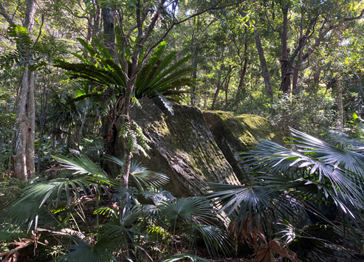

Photograph by Illawarra Environmental Education Centre is licensed under a [Creative Commons Attribution 4.0 International (CC BY 4.0) licence](http://creativecommons.org/licenses/by/4.0/).

Figure 2 – Giant Red Cedar tree (*Toona ciliata*)

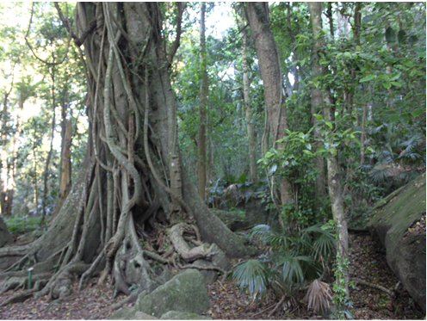

Photograph by Illawarra Environmental Education Centre is licensed under a [Creative Commons Attribution 4.0 International (CC BY 4.0) licence](http://creativecommons.org/licenses/by/4.0/).

Figure 3 – multilayered forest canopy with towering emergent trees such as the Moreton Bay Fig and Red Cedar

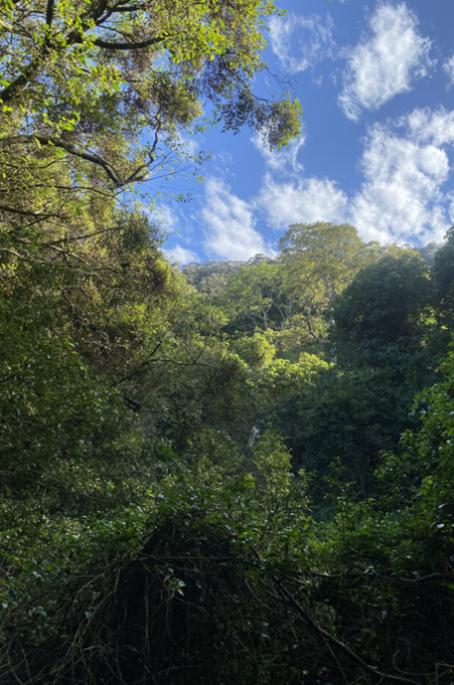

Photograph by Illawarra Environmental Education Centre is licensed under a [Creative Commons Attribution 4.0 International (CC BY 4.0) licence](http://creativecommons.org/licenses/by/4.0/).

## Geographical investigation and/or questions

* Investigate the geographical characteristics that influence the vulnerability, resilience and impact of disturbances on the ecosystem functioning of the subtropical rainforests of the Illawarra.
* How do human-induced modifications alter these characteristics and affect the overall integrity of the ecosystem?

## Pre-fieldwork tasks

**Note:** to access [Google Earth Pro](https://www.google.com/earth/about/versions/) students mustdownload the app and sign in to complete the task.

### Research the area

* Create a research [mind-map](https://app.pre.education.nsw.gov.au/learning-tools-selector/LearningActivity/Card/577?clearCache=50a9bfa4-7bad-9b4a-9ee0-e790ae41bcc5) or an [infographic](https://www.canva.com/create/infographics/) to record notable information on the subtropical rainforests of the Illawarra–Shoalhaven, such as the location, aspect, extent, composition, fauna, flora, Aboriginal history, human-induced modifications following European settlement, threats, conservation status. Provided are links for research.
* NSW NPWS (National Parks and Wildlife Service) [‘Mount Keira Ring track – Illawarra Escarpment State Conservation Area’](https://www.nationalparks.nsw.gov.au/things-to-do/walking-tracks/mount-keira-ring-track/learn-more#46160A3B46C24E47A6F74AE88E23D80D)
* NSW NPWS [‘Minnamurra Falls walk – Budderoo National Park’](https://www.nationalparks.nsw.gov.au/things-to-do/walking-tracks/minnamurra-falls-walk)
* OEH (Office of Environment & Heritage) Endangered Ecological Community listing for [Illawarra Subtropical Rainforest in the Sydney Basin Bioregion](https://threatenedspecies.bionet.nsw.gov.au/profile?id=10427)
* View historical images and read articles related to the human-induced modifications, such as [Red Cedar logging](https://library.kiama.nsw.gov.au/History/Photographs-stories-oral-histories-and-more/Local-history-stories/Cedar-Getters), [dairy farming](https://library.kiama.nsw.gov.au/History/Walking-tours-monuments-and-heritage-plaques/Heritage-plaques/Clearing-the-coast) and [coal mining](https://www.illawarra-heritage-trail.com.au/the-miners-life/), in the Illawarra post-European settlement. Include notes in the research mind-map or infographic.

### Maps and satellite images

Access the [satellite imagery of the Illawarra–Shoalhaven area on Google Earth](https://earth.google.com/web/@-34.46890175,150.7181799,558.49472195a,273306.92890976d,35y,0h,0t,0r/data=OgMKATA) to observe and comment on the location, range, extent and proximity to urban areas.

Table 1 – observations of Illawarra–Shoalhaven subtropical rainforest

|  |  |
| --- | --- |
| Satellite image | Observations |
| Location |  |
| Range |  |
| Extent |  |
| Proximity to urban areas |  |

* Use [Google Earth Pro](https://www.google.com/earth/about/versions/) to create a profile of the escarpment leading onto the coastal plain, use the following link to [calculate relief and slope](https://support.google.com/earth/answer/148134?hl=en).

**Note:** explain the concepts and check for understanding of relief and slope, providing clear definitions and examples using diagrams or photos of escarpments. Demonstrate step-by-step how to open [Google Earth Pro](https://www.google.com/earth/about/versions/) locate the area of the escarpment and create the terrain profile, including, using the Path tool to mark a line across the escarpment and coastal plain. Show how to generate the elevation profile and identify the highest and lowest points to calculate the relief. Guide students in using the elevation data to calculate the slope using the formula: $Slope = \frac{vertical rise}{horizontal run} × 100$. Model a sample calculation of relief and slope using real data from Google Earth Pro. Walk through the process with students, having them follow along on their devices. Check for understanding by asking questions and ensuring students can locate and use the tools in Google Earth Pro. Provide a worksheet where students calculate relief and slope for practise using a different section of the escarpment, with support as needed. Students use the formula and cross-check their results.

* Use the following topographic maps to investigate the elevation of the escarpment at [Minnamurra Rainforest](https://en-au.topographic-map.com/map-dqqbtf/Minnamurra-Rainforest/?center=-34.67559%2C150.70097&zoom=12) and [Illawarra Escarpment State Conservation Area](https://en-au.topographic-map.com/map-t61pdn/Illawarra-Escarpment-State-Conservation-Area/).

Follow the steps below to investigate elevation using topographic maps.

1. Begin by locating Minnamurra Rainforest and the Illawarra Escarpment State Conservation Area on the provided topographic maps. Use the map’s contour lines to identify changes in elevation.
2. Focus on identifying the elevation at various points along the escarpment. Pay attention to how the contour lines indicate steepness or gradual slope.
3. Record the highest and lowest points of elevation at both Minnamurra Rainforest and the Illawarra Escarpment. Discuss in pairs how these variations in elevation might impact the rainforest and its surrounding environment.

Check for understanding throughout the activity and/or teacher to model use of topographic map.

* Use the choropleth/topographic map on [NSW SEED](https://geo.seed.nsw.gov.au/vertigisstudio/web/?app=cabd04d595ec43c1aaf4298e80e83ec2) (The Central Resource for Sharing and Enabling Environmental Data in NSW) to:
* use scale to calculate approximate area of subtropical rainforest
* observe the presence of subtropical rainforest predominantly east of the escarpment and on southeast-facing gullies
* observe the extent of habitat fragmentation throughout its range.

Follow the steps below using [NSW SEED](https://geo.seed.nsw.gov.au/vertigisstudio/web/?app=cabd04d595ec43c1aaf4298e80e83ec2):

1. Select **NSW Topo Map** from the **Basemap** options. This will provide a detailed view of the area.
2. Select **Add layers from catalogue**, then choose **Vegetation** and **Vegetation classes of NSW (Version 3.03 - 200m Raster)**. Close the catalogue window to view the map.
3. Switch the view from **Layers** to **Legend** to understand what each colour and symbol on the map represents. Take a moment to familiarise yourself with the subtropical rainforest classification.
4. Scale calculation – use the scale at the bottom of the map to calculate the approximate area covered by subtropical rainforest. For example, select a portion of the rainforest, measure its dimensions using the scale, and then multiply the length by the width to estimate its area. Discuss your findings with a partner or group.
5. Identifying the location of rainforest – focus on the subtropical rainforest areas east of the escarpment and in southeast-facing gullies. Use the legend to verify these areas. Describe the importance of these locations for rainforest growth.
6. Observing habitat fragmentation – examine the map for evidence of habitat fragmentation. Notice breaks in the continuous range of the rainforest. Discuss in your group how human activities or natural barriers might contribute to this fragmentation and its potential effects on biodiversity.

Figure 4 – NSW Government, SEED Map

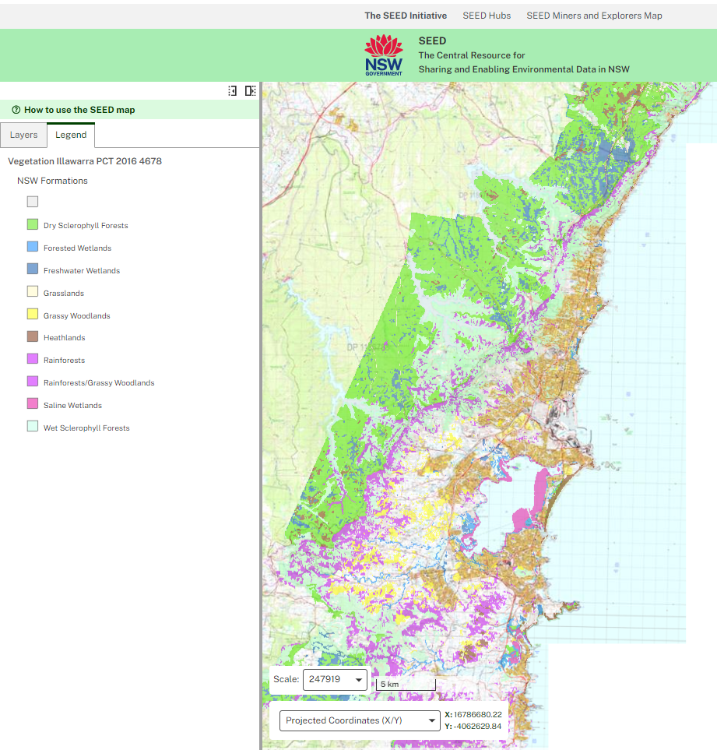

Map data © OpenStreetMap contributors, Microsoft, Facebook, Inc. and its affiliates, Esri Community Maps contributors, Map layer by Esri.

## Fieldwork tasks

These activities are designed to be completed on site.

### Fieldwork task 1 – ecosystem vulnerability

#### Background information

Vulnerability refers to how susceptible an ecosystem is to disturbance. In contrast, resilience refers to how quickly an ecosystem can restore normal functioning after a disturbance. The vulnerability of an ecosystem is determined by its characteristics, such as location, extent, biodiversity and the number of linkages within its food web.

* [Rainforests of the Illawarra by J. Bywater](https://ro.uow.edu.au/wollgeo/3/) (1979) describes 3 types of rainforests in the Illawarra–Shoalhaven region, simple, mixed or complex (page 5). The type of rainforest is related to the duration and degree of disturbance or modification. Bywater also provides a profile diagram and a species key method to classify the 3 types of rainforests, which can be used as a classification tool during fieldwork.

#### Geographical question

How do the characteristics of the subtropical rainforest reflect its vulnerability?

#### Activities – characteristics of Illawarra–Shoalhaven subtropical rainforest

##### Part A – rainforest classification

* Conduct a qualitative plant diversity survey of the rainforest vegetation at 5 metre intervals along a 30 metre transect in a section of the rainforest.

**Note:** have a class discussion about the following:

* Define what plant diversity is and why it’s important in ecosystems, particularly in rainforests.
* Describe what a qualitative survey is, focusing on observing and describing species without counting specific numbers or focusing on precise measurements.
* Introduce the transect method, emphasising its purpose in sampling plant diversity across a specific distance.

Demonstrate how to set up a 30-meter transect in the field or through a classroom simulation: use a rope or measuring tape to mark a straight 30-meter line. Show how to measure 5-meter intervals and mark these points for data collection. At each 5-meter point, observe and record the types of plants, their characteristics and any notable features such as height, leaf shape or texture. Use descriptive terms rather than numbers (for example, ‘broad leaves’, ‘dense canopy’, ‘shrubs with thorns’). Guide students in setting up their own transects in small groups using photos or modelling the activity.

* Construct a profile sketch using the transect data. Include a heading, tree height estimates and a key for the listed plant species.

**Note:** explain what a profile sketch is and how it visually represents data along a transect line. Introduce the components of the profile sketch.

* + Heading – a clear title such as ‘Rainforest Vegetation Profile – [Location Name]’.
  + Tree height estimates – these should be added to the sketch based on qualitative observations from the transect (for example, if the average tree height was observed to be approximately 15 meters at a certain interval).
  + Key – include symbols for each plant species recorded along the transect (for example, small trees, large shrubs, ferns) and create a legend or key to represent them in the sketch.

Model the process of constructing a profile sketch using the steps below.

1. Start by drawing a horizontal line to represent the 30-meter transect.
2. Mark each 5-meter interval on this line to reflect the data collection points.
3. For each 5-meter point, sketch the observed plant species, estimating their heights and positioning them vertically on the profile (for example, larger trees reaching higher, shrubs lower down).
4. Use consistent symbols or colours for each plant species and label them in the key.

Provide a grid sheet for students to plot the 30-meter transect and draw the vertical profiles for plant species. Guide students in transferring their data from their field notes into the profile sketch, helping them estimate tree heights and place plant species correctly. Encourage accuracy by asking guiding questions such as: ‘How can you represent the differences in tree heights accurately on the sketch?’ and ‘What symbols will you use to represent different plant species in your key?’.

* Use the information gathered in the transect survey and profile sketch to classify the rainforest as either simple, mixed or complex, according to Bywater’s classification method. Categorise your rainforest section as simple, mixed or complex by asking guiding questions, such as:
* How many different species did you observe at each interval?
* Does your profile sketch show multiple canopy layers, or is it more uniform?
* Is there significant variation in the heights of trees and other plants?

##### Part B – animal diversity

* Survey a 30 m × 30 m area of the rainforest, recording direct and indirect evidence of animals using binoculars and animal ID guides (see [Fieldwork Student Booklet (PDF 32.6 MB)](https://docs.google.com/document/d/1fXjmLENk4XHXg6dtklXNOKwXPIcIEWzoCjmRJWc5xCs/edit?tab=t.0)). Use soil sieves to search through leaf litter and white groundsheets when employing the tree-shake method.

**Note:** explain to students that they will survey a section of the rainforest to record both direct and indirect evidence of animals. Outline the methods they will use, including binoculars, animal ID guides, soil sieves and the tree-shake method. Introduce the key methods used to survey animal evidence.

* + Direct evidence – observing animals in the rainforest using binoculars (for example, birds, mammals, reptiles).
  + Indirect evidence – finding traces of animals like footprints, nests, droppings or food remnants.
  + Tree-shake method – using a white groundsheet to catch small animals or insects by shaking tree branches gently.
  + Soil sieving – using a sieve to search through leaf litter for small creatures, such as insects or spiders, that might not be easily visible.

Clarify that this activity will help students develop skills in fieldwork techniques for studying animal presence and behavior in rainforest ecosystems. Demonstrate how to create a fieldwork sheet to record the types of evidence found, specifying whether it is direct (for example, seeing a bird) or indirect (for example, finding bird droppings). Help students divide the area into manageable sections for systematic surveying. Assist students in using binoculars to observe animals and identify using ID guides. Provide support as students sift through leaf litter using soil sieves, ensuring students are thorough but careful. Oversee the tree-shake method, helping students place the groundsheet correctly and interpret their findings.

* Combine data with known animal recordings to assess the diversity of animal species in the rainforest.
* Evaluate the impact of observed feral animals on the diversity and abundance of native species in the rainforest (see Fieldwork Student Booklet, page 7)

**Equipment required**

* Fieldwork Student Booklet page 5
* 30 m retractable tape measures
* Bywater’s rainforest classification diagrams (included in the Fieldwork Student Booklet, page 3)
* White drop sheets, soil sieves, garden gloves, magnifiers and binoculars

### Fieldwork task 2 – ecosystem resilience

#### Background information

A rainforest with a mosaic of different successional stages is more resilient, as the diversity of habitats supports recovery from disturbances. However, introduced weeds can disrupt this balance, negatively impacting biodiversity and overall resilience.

#### Geographical question

How does the presence of a mosaic of successional stages in Illawarra’s subtropical rainforests indicate a resilient ecosystem, particularly in the context of the abundance of introduced weed species?

#### Activities – resilience of Illawarra-Shoalhaven subtropical rainforests

##### Part A – succession assessment

* Collect biotic and abiotic measurements at 3 selected areas within the rainforest, comparing sites showing a range from recent to historical disturbance by events such as land clearing, tree felling, flood, fire, landslide or lightning strike.

**Note:** check student understanding of concepts of biotic and abiotic factors:

* + Biotic factors – include all living things like plants, animals, fungi and bacteria.
  + Abiotic factors – include environmental conditions like temperature, humidity, soil moisture, light intensity and wind speed.

Explain the significance of disturbances:

* + Describe how disturbances such as fire, flood or tree falls create changes in both biotic and abiotic conditions within the rainforest.
  + Discuss how these disturbances impact biodiversity, species recovery and soil health.

Model the tools and methods for collecting data:

* + For biotic factors, show how to record observations of plant and animal species, including tree height, plant density and species diversity.
  + For abiotic factors, demonstrate the use of instruments, such as a thermometer (to measure temperature), soil moisture meter (to check soil moisture content), light meter (to measure the intensity of sunlight reaching the forest floor), anemometer (to measure wind speed). For example, measure temperature at a site that experienced a recent fire and compare it to an historically undisturbed area.

Guide students in selecting and setting up 3 different sites within the rainforest that show a range of disturbance levels (for example, one recently affected by tree fall, one with historical disturbance and one relatively undisturbed). Ask guiding questions to help students interpret what they observe: ‘What differences do you notice in plant species and density between the disturbed and undisturbed sites?’, ‘How do the abiotic conditions, like soil moisture or temperature, vary between these sites?’

* Measure physical factors such as light, wind speed, pH, soil moisture, canopy height, leaf litter depth, leaf litter cover, humidity and soil surface temperature, as well as the percentage cover of plant species in each 10 m2 area.

**Note:** demonstrate how to use fieldwork instruments to measure each factor:

* + Light meter – to measure light intensity at different points in the 10 m² plot.
  + Anemometer – to measure wind speed.
  + pH meter or pH strips – for testing soil acidity.
  + Soil moisture meter – to assess moisture levels at the soil surface.
  + Inclinometer and tape measure – to measure canopy height.
  + Leaf litter collection – demonstrate how to measure leaf litter depth and cover using a ruler and estimate percentage cover visually.
  + Thermometer – for measuring soil surface temperature.

Guide students in setting up their 10 m² plots and measuring each physical factor, including helping students choose representative spots for measuring light, wind speed and other factors within the plot. Provide support as students take measurements, ensuring accuracy and correct use of instruments. Assist students in calculating percentage cover of plant species by visually estimating how much ground each species covers within the plot. Provide a guideline or chart to help with percentage cover estimation (for example, 0%, 25%, 50%, 75%, 100%). Ask guiding questions, such as:

* How does the light intensity vary across the plot, and how might that affect plant growth?
* What is the relationship between soil moisture and the types of plants you’re seeing?

After collecting all the data, have students reflect on how the physical factors they measured influence the ecosystem. Ask guiding questions, such as:

* What physical factor had the greatest impact on plant species cover in your area?
* Did areas with higher soil moisture show more plant cover or diversity?
* Assess students on their ability to measure and record data accurately and their analysis of the relationship between physical factors and plant species distribution.
* Compare data with end-stage succession parameters and assess each site to the stage of its succession (new, mid or advanced).
* Use the data collected on the mosaic structure to make a preliminary assessment on the resilience of the rainforest.

##### Part B – the impact of human-induced modifications: invasive weeds

* At each location selected in Part A, perform a qualitative assessment of weed presence, determining whether they are abundant, frequent, common, rare or absent. Complete the table below.

Table 2 – qualitative assessment of weed presence

|  |  |
| --- | --- |
| Weed presence | Comments |
| Abundant |  |
| Frequent |  |
| Common |  |
| Rare |  |
| Absent |  |

* Record evidence of detrimental human activities at each site if applicable.
* Integrate this new data to re-evaluate initial assessment of the ecosystem’s resilience.

**Equipment required**

* [Fieldwork Student Booklet (PDF 32.6 MB)](https://docs.google.com/document/d/1fXjmLENk4XHXg6dtklXNOKwXPIcIEWzoCjmRJWc5xCs/edit?tab=t.0)
* Soil moisture probe
* Light meter
* Hydrometer
* Anemometer
* Inclinometer
* 30 m laser measurer
* Densitometer (mobile phone app)

### Fieldwork task 3A – human-induced modifications

#### Background to Red Cedar in the Illawarra–Shoalhaven

The Illawarra and Shoalhaven regions were once abundant in Red Cedar (Toona ciliata), a highly prized timber species that played a crucial role in early European settlement and the economic development of the area. Historically one of the most dominant species, with an estimated density of over 100 trees per hectare, Red Cedar populations suffered a dramatic decline due to intensive logging throughout the 19th century, leaving only scattered remnants in the region’s rainforests.

Despite its current protection and ability to grow prolifically, Red Cedar’s growth is hindered by the Cedar Tip moth (Hypsipyla robusta). This native insect lays its eggs on the tree’s main growing shoot, and when the larvae hatch, they bore into the shoot, causing dieback and forcing the tree to develop multiple stems and branches, ultimately limiting its ability to grow tall and thrive. These stunted trees were overlooked by Cedar loggers, who favoured tall, straight trunks. Without the survival of these remaining trees, the recovery of the species in the Illawarra–Shoalhaven region may not have been possible.

#### Geographical questions

* How has the historical decimation of the once-dominant Red Cedar in Illawarra’s rainforests impacted its current population?
* How has the Cedar Tip moth affected the Red Cedar’s ability to regain its previous status in the ecosystem?

#### Activities – investigate the impact of historical logging on the abundance of Red Cedar in the Illawarra–Shoalhaven

##### Part A – tree abundance survey

* Haphazardly place a 10 × 10 m quadrat within the rainforest. Use [Fieldwork Student Booklet (PDF 32.6 MB)](https://docs.google.com/document/d/1fXjmLENk4XHXg6dtklXNOKwXPIcIEWzoCjmRJWc5xCs/edit?tab=t.0) page 5 to identify and record the number of tree species present within each quadrat.

Note: check understanding of the concept of a quadrat survey:

* + Explain that a quadrat is a square plot used in ecological studies to isolate a standard unit for data collection.
  + Haphazard placement means the quadrat should be placed randomly, but within practical considerations to avoid bias.

Demonstrate how to navigate the guide to identify trees based on leaf shape, bark texture, fruit or other distinguishing features. Show students how to compare tree characteristics in the field with the descriptions and illustrations in the guide. Model the process of placing and measuring a quadrat:

1. Use a tape measure to mark out a 10 × 10 m area within the rainforest.
2. Ensure the quadrat is placed in a way that avoids specific selection bias, but is safe and accessible for the survey.
3. Walk students through identifying and counting the number of distinct tree species within the quadrat using the ID guide.
4. Record the species identified and the number of individuals of each species.

Guide students in selecting a location to place their quadrat. Ensure students understand the concept of haphazard placement to avoid over-selecting one type of area (for example, only areas with dense vegetation). Assist students in measuring the 10 × 10 m quadrat and marking the boundaries using tape measures and stakes. Support students as they use the tree ID guide, help students correctly identify tree species using key features from the guide. Provide tips on how to differentiate similar species and use the guide effectively. Ask guiding questions to prompt student thinking, such as:

* What key features are you using to identify this tree?
* How many different species can you identify in this quadrat?

Facilitate a discussion comparing the results across different quadrats. Discussion starters may include:

* How did the species diversity vary between different quadrats?
* What might explain the differences in species distribution across the rainforest?
* If time permits repeat the procedure in 2 more haphazard locations, at least 20 m apart.
* Calculate the average abundance for each tree species and use the parameters provided in the table below to categorise each species based on its population density.

Table 3 – density parameters for estimating rainforest tree populations

|  |  |
| --- | --- |
| Density parameters | Estimating rainforest tree populations |
| Dense population | 20 to 100 trees per hectare (0.002 to 0.01 trees/m2) |
| Medium population | 10 to 20 trees per hectare (0.001 to 0.002 trees/m2) |
| Sparse population | Less than 10 trees per hectare (less than 0.001 trees/m2) |

* Specifically compare the current abundance estimate of Red Cedars with an estimated historical abundance of 100 trees per hectare, (total current area 3400 h).

**Equipment Required**

* Fieldwork Student Booklet
* 10 × 10 m quadrats (use 30 m tape measures, removable pegs and line)

##### Part B – Cedar Tip moth impact on Red Cedar recovery

* Conduct a sight inspection on various Red Cedar trees, looking for indications of the Cedar Tip moth. Indications of infestation include curled leaves, yellow mess on growing tips of the tree and multiple shoots replacing a dominant growing stem tip, twisted growing stems.

Note: guide students in identifying Red Cedar trees in the inspection area. Provide support as students conduct their inspections, helping students identify and interpret signs of Cedar Tip moth infestation. Assist in distinguishing between healthy growth and signs of infestation. Encourage students to document their observations by taking notes and recording specific signs. Ask guiding questions to prompt deeper thinking, such as:

* What might cause these leaves to curl in this way?
* How would multiple shoots growing from one tip affect the tree’s overall health?

Have students work independently or in small groups to inspect several Red Cedar trees in the area for signs of infestation. Encourage students to take clear notes and, if possible, photograph areas of the tree showing signs of Cedar Tip moth damage. Provide students with a fieldwork sheet to record the symptoms they observe for each tree (for example, presence of curled leaves, yellow mess, twisted stems).

* Conduct an investigation to determine whether the only old growth Cedars in the area (pre 1900s) have evidence of past Cedar Tip moth damage.
* Based on your observations and calculations from both Part A and Part B, complete a consequence chart to predict the impacts this human induced modification has had on the rainforest.

Figure 5 – consequence chart for predicting impacts of Red Cedar decimation to the rainforest

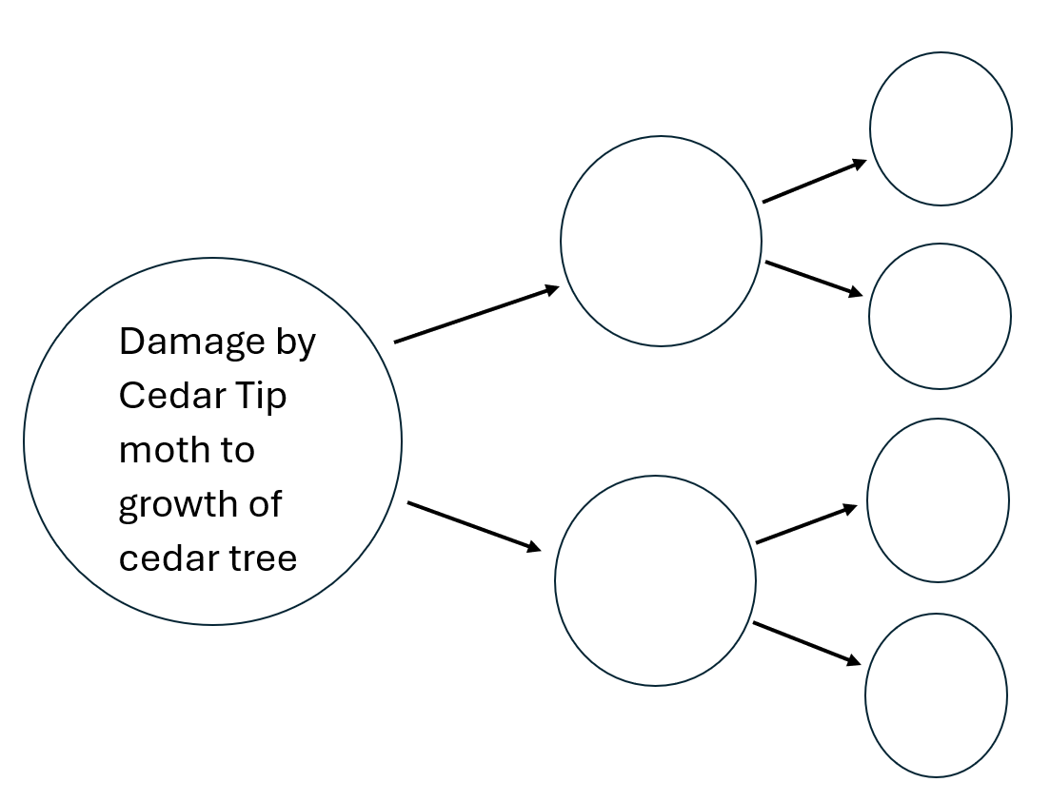

### Fieldwork task 3B – introduced weed invasion

#### Background information

The rainforests of the Illawarra have undergone significant modifications since European settlers arrived in the early 19th century. Initially, Red Cedar was extensively logged, and large areas were cleared for dairy farming. The discovery of coal in the escarpment further contributed to deforestation and habitat degradation due to mining activities. It is estimated that only 25% of the original rainforests remain, and these remnants are highly fragmented. Introduced species, including invasive weeds and feral animals, now inhabit the ecosystem, reducing its biodiversity and severely impacting the rainforest’s resilience.

#### Geographical questions

* To what extent are the Illawarra’s rainforests impacted by weeds?
* How have human-made structures such as roads and clearings impacted the prevalence of weeds in the forest?

#### Activities – investigate the impact of invasive weeds on the rainforest

* Walk along a 30 m belt transect, starting from the edge of a rainforest clearing or human-made structure and moving into the interior of a rainforest patch. At 5 m intervals, record the percentage cover of weeds in each 1 × 1 m quadrat. Include cover at all levels within the quadrat, not just ground cover (canopy).

**Note:** explain to students that they will walk along a 30 m belt transect starting from the edge of a rainforest clearing or human-made structure and moving into the interior of the rainforest. Percentage cover is an estimate of how much of the quadrat area is occupied by plants, in this case, weeds. It includes cover from all levels, such as ground cover, shrubs and canopy. For example, if half of the quadrat is covered by weeds, students would record a 50% cover.

Outline the task recording the percentage cover of weeds at 5 m intervals within 1 × 1 m quadrats, taking into account all vegetation layers (ground, understory and canopy). Clarify that this activity will help students develop skills in ecological surveying, data collection on plant cover, and analysing patterns of weed distribution in relation to disturbance areas.

Model how to set up and record data in the quadrat, using the following steps.

1. Walk 5 meters along the transect and place a 1 × 1 m quadrat on the ground.
2. Visually estimate the percentage of the quadrat area covered by weeds at the ground level, in the understory and within the canopy.
3. Record the percentage cover for each level separately or as a combined total if cover exists across multiple levels (for example, 30% ground, 20% understory and 10% canopy).
4. Repeat at 5-meter intervals along the 30-meter transect.

Provide a sample data recording sheet for students to use as they collect data. Guide students in setting up their belt transect, ensuring they measure 30 meters from the edge of the clearing or structure into the rainforest interior. Assist students as they place their quadrats at 5 m intervals and estimate weed cover, help students break down the quadrat into sections to more accurately estimate percentage cover. Support students’ estimation by providing examples of how to assess different layers of vegetation (ground, understory, canopy).

Encourage students to make detailed notes and observations, such as:

* What differences in weed cover do you notice as you move away from the edge?
* Are there more weeds in the ground cover or higher up in the canopy?

Encourage accuracy by prompting students to carefully observe the weeds at all levels within the quadrat, not just the ground.

* Based on your findings, draw conclusions about the impact of fragmentation on weed proliferation in the rainforest.

**Equipment** **required**

* [Fieldwork Student Booklet (PDF 32.6 MB)](https://docs.google.com/document/d/1fXjmLENk4XHXg6dtklXNOKwXPIcIEWzoCjmRJWc5xCs/edit?tab=t.0)
* 1 × 1 m quadrats
* 30 m retractable tape measure
* NSW Weeds ID guide

## Post-fieldwork task

**Fieldwork report objective:** Using research conducted before and after the fieldwork, the data and observations collected on the fieldwork day, and subsequent analysis, write a comprehensive fieldwork report. The report should address the inquiry question: Do the subtropical rainforests of the Illawarra–Shoalhaven have ecosystem integrity?

### Fieldwork report task instructions

#### Introduction

* Briefly describe the subtropical rainforests of the Illawarra–Shoalhaven, highlighting their significance and unique features.
* Clearly state the inquiry question and the purpose of the report.

#### Research and data collection

* Summarise the key research findings gathered prior to the fieldwork. This should include information on the historical and current conditions of the ecosystem.
* Describe the observations and data collected during the fieldwork day, detailing specific activities that investigated characteristics, resilience and the impact of human-induced modifications.

#### Analysis

* Assess the ecosystem’s vulnerability and resilience in relation to human-induced modifications. Consider the following factors
* The decimation of Red Cedar (Toona ciliata).
* Land clearing for dairy farming and mining.
* Weed invasion and the impact of feral animals.
* Habitat fragmentation due to urban development and other human activities.
* The influence of climate change, particularly increasing temperatures, given the ecosystem’s location at its southernmost range.
* Include visual representations such as charts, maps and other data collected during your fieldwork. For example, use a stacked bar chart to represent weed distribution along the 30 m transect.

#### Ecosystem integrity

* Evaluate the overall integrity of the subtropical rainforests based on your analysis.
* Discuss how the identified factors impact the health and functionality of the ecosystem.

#### Management strategies

* Explore management strategies in place for the subtropical rainforests in at least one of the following areas. For example, [Illawarra Escarpment State Conservation Area](https://www.nationalparks.nsw.gov.au/visit-a-park/parks/illawarra-escarpment-state-conservation-area), [Budderoo National Park](https://www.nationalparks.nsw.gov.au/visit-a-park/parks/budderoo-national-park) and [Milton-Ulladulla Subtropical Rainforests](https://threatenedspecies.bionet.nsw.gov.au/profile?id=10532). Use the following site to assist your analysis, [Saving our Species program](https://www.environment.nsw.gov.au/topics/animals-and-plants/threatened-species/saving-our-species-program).
* What is the effectiveness of these strategies in addressing the issues that have been identified and in enhancing the ecosystem’s integrity?

#### Conclusion

* Summarise findings and provide a final statement on the integrity of the subtropical rainforests of the Illawarra–Shoalhaven.
* Offer recommendations for further research or management actions based on your analysis.

## Resources

Equipment may vary depending on methodology and access. Check with your school’s Science department and/or local Environmental and Zoo Education Centre about equipment that is available.

**Geographical tools and equipment**

* [Google Earth Pro](https://www.google.com/earth/about/versions/)
* [NSW Government SEED Map](https://geo.seed.nsw.gov.au/vertigisstudio/web/?app=cabd04d595ec43c1aaf4298e80e83ec2)
* [Topographic maps](https://en-au.topographic-map.com/)
* Clipboards, pencils and data sheets
* 30 m retractable tape measures
* 1 × 1 m quadrat squares
* Illawarra Rainforest plant ID guide
* Bywater’s rainforest classification diagrams (in [Fieldwork Student Booklet (PDF 32.6 MB)](https://docs.google.com/document/d/1fXjmLENk4XHXg6dtklXNOKwXPIcIEWzoCjmRJWc5xCs/edit?tab=t.0))
* White drop sheets
* Soil sieves
* Magnifying lenses
* Australian vertebrate/invertebrate ID guides
* Binoculars
* Soil moisture probe
* Light meter
* Hygrometer
* Anemometer
* Inclinometer
* 30 m laser measurer
* Densitometer (app) – [Canopy Cover](https://play.google.com/store/apps/details?id=com.heaslon.canopycover&hl=en_AU&pli=1) (android) or [Canopeo](https://apps.apple.com/us/app/canopeo/id929640529)
* Tracks, scats and other traces field guide

**Safety equipment**

* Hat
* Sunscreen
* Sturdy footwear
* Water bottle
* First aid kit
* Gardening gloves
* Mobile phone reception
* Emergency evacuation meeting point plan

**Research materials**

* [Investigation of the Subtropical Rainforests of the Illawarra-Shoalhaven](https://threatenedspecies.bionet.nsw.gov.au/profile?id=10427)
* A comprehensive list of relevant information and research is provided in the References section below

**Further information**

Contact the [Illawarra Environmental Education Centre](https://illawarra-e.schools.nsw.gov.au/) to host a field trip to the rainforests listed below.

**Travel to Mt Keira Rainforest**

* Mt Keira Scout camp (currently closed, 2024)
* Time from Sydney approx. 1 hr or from Nowra approx. 1.5 hrs
* Bookings required/small fee charged per student
* No public transport access available
* Note – access is difficult for very large buses
* Mt Keira Byarong Park
* Time from Sydney approx. 1 hr or from Nowra approx. 1.5 hrs
* No bookings required
* No public transport access available

Figure 6 – Google Earth image of Illawarra–Shoalhaven including Mt Keira area

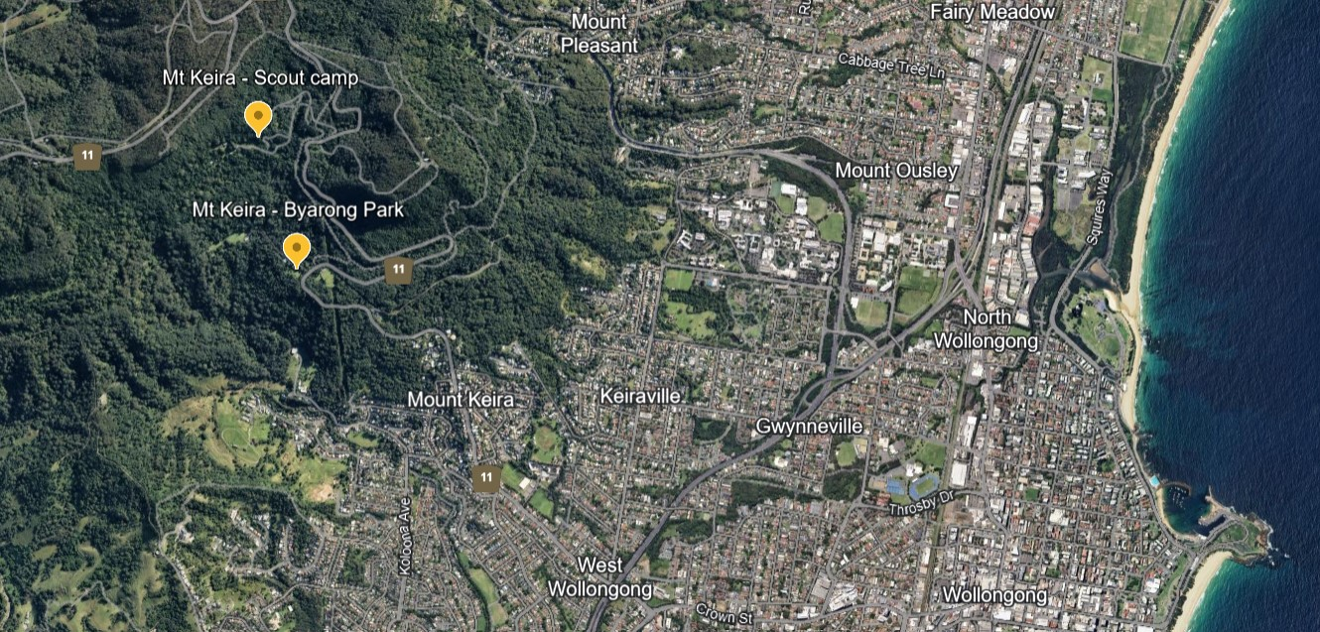

**Travel to Minnamurra Rainforest**

* Minnamurra Rainforest Centre
* Bookings required, managed by NPWS
* Car park entry fee for busses
* No public transport access available
* Approximate times from Sydney, 1.5 hrs and from Wollongong and Nowra 1 hr

Figure 7 – Google Earth image of Illawarra–Shoalhaven including Minnamurra rainforest area

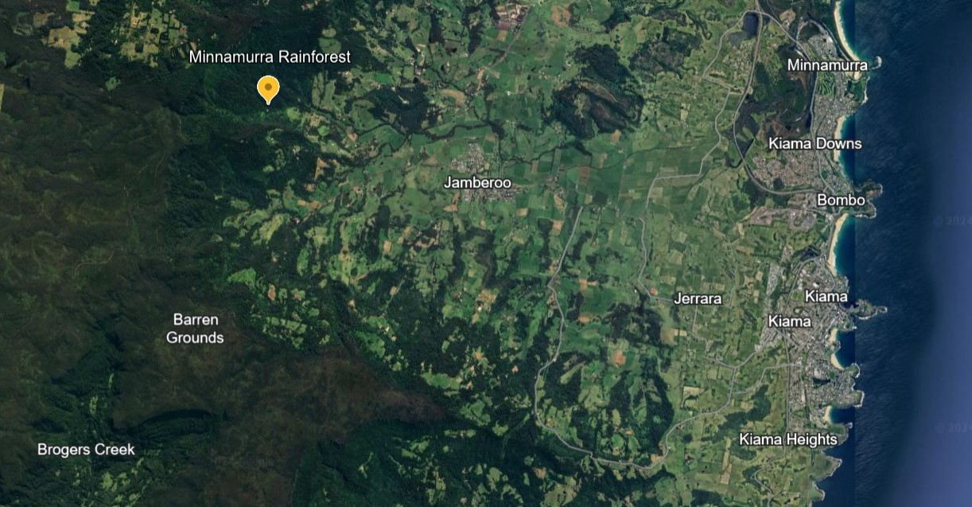

**Travel to Milton-Ulladulla Rainforest**

* Milton rainforest reserve
* Small reserve
* No bookings required
* Toilets located on main street, Milton
* Public transport (bus) accessible
* Approximate time from Ulladulla is 15 min, Nowra is 1 hr and Wollongong 1 hr 45 min

Figure 8 – Google Earth image of Illawarra–Shoalhaven including Milton rainforest area

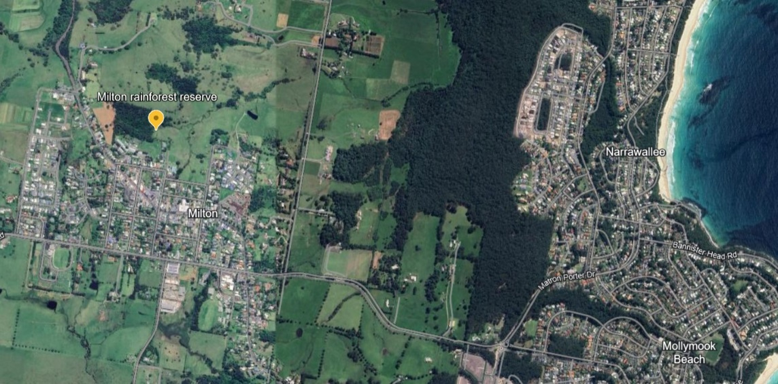

## References

This resource contains NSW Curriculum and syllabus content. The NSW Curriculum is developed by the NSW Education Standards Authority. This content is prepared by NESA for and on behalf of the Crown in right of the State of New South Wales. The material is protected by Crown copyright.

Please refer to the NESA Copyright Disclaimer for more information <https://educationstandards.nsw.edu.au/wps/portal/nesa/mini-footer/copyright>.

NESA holds the only official and up-to-date versions of the NSW Curriculum and syllabus documents. Please visit the NSW Education Standards Authority (NESA) website <https://educationstandards.nsw.edu.au> and the NSW Curriculum website <https://curriculum.nsw.edu.au>.

[Geography 11–12 Syllabus](https://curriculum.nsw.edu.au/learning-areas/hsie/geography-11-12-2022/overview) © NSW Education Standards Authority (NESA) for and on behalf of the Crown in right of the State of New South Wales, 2022.

Bywater J (1979) ‘[Rainforests of the Illawarra](https://ro.uow.edu.au/wollgeo/3/)’ *Wollongong Studies in Geography*, 3, accessed 5 September 2024.

Google Earth Help (n.d.) [*Measure distance & elevation*](https://support.google.com/earth/answer/148134?hl=en), Google Earth Help website, accessed 9 September 2024.

Growing Illawarra Natives (n.d.) [*Plant Finder*](https://finder.growingillawarranatives.org/plants/finder), Growing Illawarra Natives website, accessed 9 September 2024.

Illawarra Environmental Education Centre (n.d.) [*Year 12 Geography – Fieldwork Student Booklet – Ecosystems and Global Biodiversity [PDF 32.6 MB]*](https://docs.google.com/document/d/1fXjmLENk4XHXg6dtklXNOKwXPIcIEWzoCjmRJWc5xCs/edit?tab=t.0), Illawarra Environment Education Centre, accessed 9 September 2024.

Illawarra Heritage Trail (n.d.) [*The Miner’s Life*](https://www.illawarra-heritage-trail.com.au/the-miners-life/), Illawarra Heritage Trail website, accessed 9 September 2024.

Kiama Municipal Council (n.d.) [*Cedar Getters*](https://library.kiama.nsw.gov.au/History/Photographs-stories-oral-histories-and-more/Local-history-stories/Cedar-Getters), Kiama Library website, accessed 9 September 2024.

Kiama Municipal Council (n.d.) [*Clearing The Coast*](https://library.kiama.nsw.gov.au/History/Walking-tours-monuments-and-heritage-plaques/Heritage-plaques/Clearing-the-coast), Kiama Library website, accessed 9 September 2024.

Kiama Municipal Council (n.d.) [*Reclaiming The Coast*](https://library.kiama.nsw.gov.au/History/Walking-tours-monuments-and-heritage-plaques/Heritage-plaques/Reclaiming-the-coast), Kiama Library website, accessed 9 September 2024.

NSW Department of Environment and Heritage (2021) [*Illawarra subtropical rainforest in the Sydney Basin Bioregion – endangered ecological community listing*](https://www.environment.nsw.gov.au/topics/animals-and-plants/threatened-species/nsw-threatened-species-scientific-committee/determinations/final-determinations/2000-2003/illawarra-subtropical-rainforest-sydney-basin-bioregion-endangered-ecological-community-listing), NSW Environment and Heritage website, accessed 5 September 2024.

NSW Department of Environment and Heritage (2023) [*Milton Ulladulla subtropical rainforest revival*](https://www2.environment.nsw.gov.au/news/milton-ulladulla-subtropical-rainforest-revival), Department of Environment and Heritage website, accessed 5 September 2024.

NSW Department of Planning and Environment (n.d.) *Saving our Species* [website], accessed 5 September 2024.

NSW National Parks and Wildlife Service (NSW NPWS) (n.d.) [*Budderoo National Park*](https://www.nationalparks.nsw.gov.au/visit-a-park/parks/budderoo-national-park#:~:text=Budderoo%20National%20Park%20is%20always,in%20the%20Minnamurra%20Rainforest%20area.), NSW NPWS website, accessed 5 September 2024.

NSW NPWS (n.d.) [*Mount Keira Ring track*](https://www.nationalparks.nsw.gov.au/things-to-do/walking-tracks/mount-keira-ring-track/learn-more#46160A3B46C24E47A6F74AE88E23D80D), NSW NPWS website, accessed 5 September 2024.

NSW Office of Environment & Heritage (2022) [*Illawarra Subtropical Rainforest in the Sydney Basin Bioregion – profile*](https://threatenedspecies.bionet.nsw.gov.au/profile?id=10427), NSW Office of Environment & Heritage website, accessed 5 September 2024.

NSW Office of Environment & Heritage (n.d.) [*Threatened biodiversity profile search*](https://threatenedspecies.bionet.nsw.gov.au/), NSW Office of Environment & Heritage website, accessed 5 September 2024.

Plant Health Australia (2024) [*Fact sheet – Shoot-borer*](https://www.planthealthaustralia.com.au/?s=shoot+borer&resource_type=&resource_industry=&resource_pests_disease=) Plant Health Australia website, accessed 31 October 2024.

Smith AD (20 November 2020) ‘[Milton farmers help conserve rare subtropical rainforest on New South Wales south coast](https://www.abc.net.au/news/2020-11-20/efforts-underway-to-conserve-rare-rainforest-milton-nsw/12900126)’, *ABC News website*, accessed 5 September 2024.

State of New South Wales (Department of Education) (n.d.) [*Controversial issues in schools*](https://education.nsw.gov.au/policy-library/policies/pd-2002-0045), NSW Department of Education website, accessed 16 October 2024.

State of New South Wales (Department of Education) (n.d.) [*Digital Learning Selector*](https://app.education.nsw.gov.au/digital-learning-selector/LearningActivity/Browser?cache_id=4cf93), NSW Department of Education website, accessed 24 August 2023.

State of New South Wales (Department of Education) (2023) [NSW Department of Education Code of Conduct](https://education.nsw.gov.au/rights-and-accountability/department-of-education-code-of-conduct), NSW Department of Education website, accessed 16 October 2024.

State of New South Wales (Department of Education) (2024) [*Excursions and travel*](https://education.nsw.gov.au/inside-the-department/health-and-safety/risk-management/excursions-and-travel-health), NSW Department of Education website, accessed 16 October 2024.

topographic-map.com (n.d.) [*Illawarra Escarpment State Conservation Area topographic map*](https://en-au.topographic-map.com/map-t61pdn/Illawarra-Escarpment-State-Conservation-Area/), topographic-map.com, , accessed 5 September 2024.

topographic-map.com (n.d.) [*Minnamurra Rainforest topographic map*](https://en-au.topographic-map.com/map-dqqbtf/Minnamurra-Rainforest/?center=-34.62752%2C150.72293&zoom=15), topographic-map.com, accessed 5 September 2024.

Triggs B (2004) *Tracks, scats and other traces: A field guide to Australian mammals*, Oxford University Press, ANZ.

**© State of New South Wales (Department of Education), 2024**

The copyright material published in this resource is subject to the *Copyright Act 1968* (Cth) and is owned by the NSW Department of Education or, where indicated, by a party other than the NSW Department of Education (third-party material).

Copyright material available in this resource and owned by the NSW Department of Education is licensed under a [Creative Commons Attribution 4.0 International (CC BY 4.0) license](https://creativecommons.org/licenses/by/4.0/).

[](https://creativecommons.org/licenses/by/4.0/)

This license allows you to share and adapt the material for any purpose, even commercially.

Attribution should be given to © State of New South Wales (Department of Education), 2024.

Material in this resource not available under a Creative Commons license:

* the NSW Department of Education logo, other logos and trademark-protected material
* material owned by a third party that has been reproduced with permission. You will need to obtain permission from the third party to reuse its material.

**Links to third-party material and websites**

Please note that the provided (reading/viewing material/list/links/texts) are a suggestion only and implies no endorsement, by the New South Wales Department of Education, of any author, publisher, or book title. School principals and teachers are best placed to assess the suitability of resources that would complement the curriculum and reflect the needs and interests of their students.

If you use the links provided in this document to access a third-party's website, you acknowledge that the terms of use, including licence terms set out on the third-party's website apply to the use which may be made of the materials on that third-party website or where permitted by the *Copyright Act 1968* (Cth). The department accepts no responsibility for content on third-party websites.