History Stage 5
Depth Study 2a – Making a Nation
Site study – Lambing Flat riots, 1861

Contents
Overview 4
Outcomes 4
Historical concepts and skills 5
Site and source context for teachers 6
Historical background 6
Key events 6
Why did conflict develop between the European and Chinese miners? 8
Government response 8
Learning sequence 1 – site and sources 9
Syllabus content 9
Background to the Lambing Flat riots (Lesson 1) 10
Learning intentions and success criteria 10
Introduction 10
Background of the Lambing Flat riots 11
Timeline of the Lambing Flat riots 11
Archaeological evidence of riots part 1 (Lesson 2) 13
Learning intentions and success criteria 13
Introduction 13
Initial analysis of sources 14
Archaeological evidence of riots part 2 (Lesson 3) 16
Learning intentions and success criteria 16
Video explainer of sources 16
Archaeological evidence of riots part 3 (Lesson 4) 19
Learning intentions and success criteria 19
Initial assessment of the ‘Roll Up’ banner 19
Additional context for the ‘Roll Up’ banner 20
Visual and written evidence of riots (Lesson 5) 22
Learning intentions and success criteria 22
Introduction 22
Analysing visual evidence 23
Analysing written evidence 24
Learning sequence 2 – site interpretation 25
Syllabus content 25
Interpreting the Lambing Flat riots (Lesson 6) 26
Learning intentions and success criteria 26
Introduction 26
Interpreting the past 27
Why does the site of the Lambing Flat riots matter today? 28
Remembering the Lambing Flat riots (Lesson 7) 30
Learning intentions and success criteria 30
Introduction 30
Examples of memorialisation of the Lambing Flat riots 31
Memorialising the Lambing Flat riots 32
Appendix 1 – map of Lambing Flat 34
Appendix 2 – timeline scaffold 35
Appendix 3 – site introduction video 36
Appendix 4 – virtual walkthrough of site 37
Appendix 5 – 3D models of sources 38
Appendix 6 – video explainers of sources 39
Appendix 7 – source analysis scaffold 40
Appendix 8 – ‘Roll Up’ banner 42
Appendix 9 – painting of Lambing Flat 44
Appendix 10 – written evidence of riots 45
Appendix 11 – newspaper article 47
Appendix 12 – scene 3 from memorial scroll 48
Appendix 13 – panel discussion 49
Additional information 50
Support and alignment 50
References 52

This resource has been developed to assist teachers in NSW Department of Education schools to create learning that is contextualised to their classroom. It can be used as a basis for the teacher’s own program, assessment, or scope and sequence. The resource has suggested timeframes that may need to be adjusted by the teacher to meet the needs of their students.

Overview
Description: this program of learning addresses the experiences of non-Europeans in Australia prior to the 1900s at Lambing Flat, NSW. It constitutes a site and source study in Depth Study 2a – Making a Nation. The lessons and sequences in this site study are designed to allow students to build an understanding of this topic through a range of sources while also developing their understanding of historical concepts such as cause and effect and perspectives.
Duration: this program of learning is designed to be completed in approximately 5 hours.

Outcomes
A student:
- HT5-1 explains and assesses the historical forces and factors that shaped the modern world and Australia
- HT5-3 explains and analyses the motives and actions of past individuals and groups in the historical contexts that shaped the modern world and Australia
- HT5-5 identifies and evaluates the usefulness of sources in the historical inquiry process
- HT5-6 uses relevant evidence from sources to support historical narratives, explanations and analyses of the modern world and Australia
- HT5-8 selects and analyses a range of historical sources to locate information relevant to an historical inquiry
- HT5-9 applies a range of relevant historical terms and concepts when communicating an understanding of the past
History K–10 Syllabus © NSW Education Standards Authority (NESA) for and on behalf of the Crown in right of the State of New South Wales, 2012.

Historical concepts and skills

Historical concepts
Cause and effect: intended and unintended causes and consequences of a particular historical event or development.
Perspectives: the reasons for different perspectives in a particular historical context.
Empathetic understanding: the actions, values, attitudes and motives of people in the context of the past.

Historical skills
Comprehension, chronology, terms and concepts: read and understand historical texts; sequence historical events; use historical terms and concepts in appropriate contexts.
Analysis and use of sources: identify different types of sources; identify the origin, content, context and purpose of primary and secondary sources; process and synthesise information from a range of sources as evidence; evaluate the reliability and usefulness of primary and secondary sources for a specific historical inquiry.
Perspectives and interpretations: identify and analyse the reasons for different perspectives in a particular historical context.
Empathetic understanding: interpret history through the actions, values, attitudes and motives of people in the context of the past.
Research: identify, locate, select and organise information from a variety of sources.
Explanation and communication: develop historical texts, particularly explanations and historical arguments that use evidence from a range of sources.

Site and source context for teachers
Note: the following site and source study leads students through an historical investigation focusing on the Lambing Flat riots, NSW, 1860–61, using a variety of evidence. A site study should be integrated within each of Stages 4 and 5 as a means by which students acquire knowledge, skills, values and attitudes from experience in the field or by analysing a virtual site using ICT. Site studies enable students to understand their historical environment and participate actively in historical inquiry. They can offer a means of interpreting the past and recognising how human occupation and use of the site has changed over time. Such an approach can lead to an understanding of the historical context in which changes over time occurred.
Beginning with an overview of a selection of artefacts excavated from the site, the investigation examines other sources of evidence, such as the ‘Roll Up’ banner, a painting, newspaper articles and government sources from the time. By examining all types of evidence, students come to an overall understanding of events and will gain a further understanding of the limitations and challenges of different types of sources relating to an historical event and site.

Historical background
The first news of gold in the Lambing Flat district in NSW came in August 1856. Chinese miners were among the earliest miners there. The Lambing Flat anti-Chinese riots and confrontations occurred from November 1860 to July 1861. It was the worst violence against Chinese migrants in NSW history. It was the most serious clash between miners and police following the Eureka Stockade in Ballarat, Victoria in 1854 and was the first on the NSW goldfields.
There was scattered archaeological evidence left at the actual site. Altogether archaeologists recovered 27,452 archaeological shards and fragments from the time. An introduction to several of these artefacts from the site provides opportunities for students to question such finds and attempt to draw evidence from them.

Key events
Chinese migration began with the arrival of the first Chinese labourers in NSW in 1848. Gold rushes in 1851 increased demand for labour. Between 1851 and 1854, the number of Chinese indentured labourers in NSW rose to 3,000. By 1855, some began to arrive on the NSW goldfields. By 1860, 2,000 people lived at Lambing Flat, mostly searching for gold, including 500 Chinese people.
Conflicts between European and Chinese miners flared up from November 1860 to 1861. On 27 January 1861, 1,500 European miners gathered at Lambing Flat to hear anti-Chinese speeches. The Riot Act was read out by Commissioner Dickson, but it failed to prevent the burning of Chinese tents and the expulsion of Chinese miners.
On 17 February 1861, a mob drove out 200 Chinese miners from nearby Blackguard Gully. Fourteen men were arrested and locked up for the night. A police telegraph reported 5,000 to 6,000 diggers assembling at Lambing Flat. There were many arrests and reinforcements were requested. On 11 March 1861 reinforcements arrived: 130 men of the 12th Regiment, 43 artillerymen and 23 mounted policemen.
The NSW Census of 1861 of the local area showed 8,996 men, 2,530 females, 496 Chinese men and no Chinese women.
In April 1861, Lambing Flat was renamed Young. On 17 May 1861, further riots occurred, with Chinese stores destroyed. The military withdrew on 24 May with only a few soldiers left at the site. On 18 June, 25 Europeans behind the ‘Roll Up’ banner drove about 40 Chinese miners from the goldfields of nearby Wombat. On 30 June, Chinese miners were driven off other nearby goldfields by miners armed with bludgeons and pick handles and Chinese tents were burnt. Eyewitness reports were published in the Sydney Morning Herald.
On 14 July, 3 men were arrested and, that evening, around 1,000 miners met with the police captain and demanded they be released. He refused and different versions of the following events exist, including the miners’ claim the police fired first. A riot ensued at the police camp. Shots were fired and miner William Lupton was killed. Two police were wounded, 2 horses were shot. Buildings including the police barracks were damaged. The mob was eventually driven off. Police reinforcements finally arrived on 31 July and several miners were arrested.
The following court trial, at Goulburn in September 1861, saw miners charged, as well as a publican, storekeeper, store-hand, boxer, cook and 2 bandsmen. All were acquitted except for a watchmaker.

Why did conflict develop between the European and Chinese miners?
Few miners found enough gold to earn a living. The Chinese generally worked long hours as a team, and had simple quarters and food. They were often more successful than many European miners. Many European miners complained that the Chinese miners muddied waterholes, worked on Sundays, were thieves, had unsanitary habits and accepted lower wages as labourers. They were easy targets. Previously in Victoria, there had been attempts to keep them out of the goldfields. There had also been previous outbreaks of violence against them.

Government response
In Sydney in the NSW Legislative Assembly throughout the second half of 1861, there were debates to restrict Chinese immigration. Several Chinese miners petitioned the NSW Government for compensation. Petitions were also received from European miners wanting to exclude Chinese miners from the goldfields. These were not granted, though The Gold Fields Act and Regulations of 1861 imposed penalties on aliens not authorised on goldfields, prohibited Chinese from new goldfields and restricted them to certain areas of established goldfields. On the same day, 22 November 1861, the Act to Regulate and Restrict the Immigration of Chinese restricted the number of Chinese migrants entering New South Wales and added £10 entry tax on new Chinese arrivals.
In November 1863, prominent businesspeople of Young requested that restrictions on Chinese on the goldfields be lifted. This was refused. On 27 September 1866, The Gold Fields Act was altered to remove restrictions on Chinese mining. On 8 October 1867, the Act to Regulate and Restrict the Immigration of Chinese was repealed.

Learning sequence 1 – site and sources
This sequence is designed to take approximately 3.5 hours. Students will draw on knowledge from previous content in Stage 5 History and source analysis skills. An understanding of key terms such as riot, artefact, archaeology, physical evidence, porcelain and percussion cap is needed. This learning sequence is designed to support source analysis skills. This sequence should be taught with awareness of the Controversial issues in schools policy.
Consider the following when adapting this learning sequence to your school context:
- The appropriateness of individual sources and content given the age and maturity level of your students
- The presence of students with close links to the events discussed in the learning sequence
- The literacy and numeracy needs of students, especially in relation to reading and understanding primary sources
- The opportunities to further differentiate the content to improve accessibility for your students.

Syllabus content
The experiences of non-Europeans in Australia prior to the 1900s (such as the Japanese, Chinese, South Sea Islanders, Afghans) (ACDSEH089)
Students:
- explain why ONE of the non-European groups came to Australia
- describe how the chosen group lived and worked in Australia

Background to the Lambing Flat riots (Lesson 1)

Learning intentions and success criteria
Note: these learning intentions and success criteria are general and should be contextualised to suit your school and students’ needs. Success criteria can be differentiated, depending on the starting point of diverse students. For more information on this explicit teaching strategy, see Sharing success criteria.
Learning intention – students:
- understand the experiences of Chinese peoples in Australia prior to the 1900s.
Success criteria – students can:
- work with a peer to create questions about the experiences of Chinese migrants to Australia
- create a timeline of the events leading up to anti-Chinese riots at Lambing Flat.
Note: the following activities support students to acquire knowledge, develop historical skills and understand values and attitudes through an analysis of the site of the Lambing Flat riots of 1861. The site study enables students to understand a specific historical environment and participate actively in an historical inquiry. Students will examine a range of sources, from archaeological, visual and written evidence. As the different types of evidence are examined, the history of events will gradually unfold. The sequence will begin with archaeological evidence found at the site, followed by other physical evidence and conclude with a selection of written sources.

Introduction
- Develop a concept map of the terms that come to mind when you think about the reasons that people migrated to Australia in the nineteenth century.
- Compare answers in terms of Anglo-Celtic migrants and non-European migrants such as Japanese, Chinese, South Sea Islanders and Afghans.
- Create a list of questions that you have about the experiences of Chinese migrants to Australia during the nineteenth century. Share these questions with a peer and then contribute them to a class discussion.

Background of the Lambing Flat riots
- Use an online mapping site such as Google Maps to locate the town of Young, NSW.
- Take notes based on teacher explanation of the historical background of the Lambing Flat riots while viewing an historical map of Young (Appendix 1).
- Create a town profile of Young, NSW using the ‘Young’ section of the Hilltops region tourism website and answer the following questions:
- Who are the traditional custodians of the lands around Young, NSW?
- When did Europeans arrive in Young, NSW?
- Why did migration to Young by Europeans and non-Europeans increase rapidly in the 1860s?

Timeline of the Lambing Flat riots
Note: you will need to prepare one timeline activity sheet (Appendix 2) per student in advance of the lesson and distribute to each student. This activity presents the opportunity to explain to students the importance of scale, labelling, headings and key when developing timelines. Teachers should be aware of the need to explicitly teach the skill of timeline construction. The Center for Teaching at Vanderbilt University provides a helpful teacher guide for teaching students about timelines and using timelines in assessment. Begin the activity by narrating the history of the Lambing Flat riots using the ‘Key events’ component of the Site and source context section
- As your teacher narrates the history of the Lambing Flat riots, complete your timeline scaffold (Appendix 2), documenting significant moments in the history of the riots.
- Colour code your timeline using highlighters to identify key decision points and trace causal sequences. For example, the ‘Roll Up’ banner provided a catalyst for further anti-Chinese violence throughout 1861.
Additional resources are available at:
Museums of History NSW: The Lambing Flat Riots (overview)
National Museum of Australia: Violence on the Goldfields (anti-Chinese violence)
This Week in History: Lambing Flat Riots (podcast).
Differentiation:
HPGE focus (Mapping and context) – access a contemporary map of Young, NSW via Google Maps. Work in pairs to carefully examine the names of streets, rivers or streams and other geographical features of the town. Discuss which names reference the town’s Indigenous heritage, European heritage, non-European heritage and mining. Consider the numerical and geographical distribution of references in your discussion.
HPGE focus (Timelines) – examine the timeline that you have created. How linear are the events leading to the riots at Lambing Flat in terms of cause and effect?

Archaeological evidence of riots part 1 (Lesson 2)

Learning intentions and success criteria
Note: these learning intentions and success criteria are general and should be contextualised to suit your school and students’ needs. Success criteria can be differentiated, depending on the starting point of diverse students. For more information on this explicit teaching strategy, see Sharing success criteria.
Learning intention – students:
- recognise sources of evidence for the experiences of Chinese peoples in Australia prior to the 1900s.
Success criteria – students can:
- complete a scaffolded analysis of sources produced during the Lambing Flat riots.
Note: the following activities support students to develop their knowledge of the Lambing Flat riots, their understanding of archaeology and their source analysis skills. Commence the lesson with the site introduction video (Appendix 3). This video provides an overview of the current uses of the Lambing Flat site and the context in which the archaeological evidence of the riots is housed.

Introduction
- Watch the site introduction video (Appendix 3).
- Watch the site introduction video a second time and this time add to the timeline of the Lambing Flat riots that was produced in Lesson 1 as the video plays.
- Complete a virtual walkthrough of the site (Appendix 4) and continue adding to your timeline.
- Discuss the following questions with a peer and then generate answers together. Record the answers.
- What structures are currently located on the site of the Lambing Flat riots?
- How new do the structures appear to be and why?
- Did you notice any references to the Lambing Flat riots in the virtual walkthrough (Appendix 4)? If so, what kind of references were made? Why do you think that the references are there?
Additional resources providing information about the site are available at:
Young Historical Museum (general history of the Young area)
School Infrastructure NSW (overview of the development of the site).

Initial analysis of sources
Note: direct students to use the links in Appendix 5 to access online 3D models of sources found at the Lambing Flat site. These sources are from the time of the Lambing Flat riots and students should be encouraged to explore them before viewing any of the video explainers of the sources in Appendix 6 (Lesson 3). Each student will need access to 3 electronic or printed copies of the source analysis scaffold in Appendix 7. Regularly ask students ‘What have we discovered so far?’ throughout the lesson to highlight the ongoing nature of the process of historical inquiry.
- Access the source analysis scaffold (Appendix 7).
- Access the online 3D models of sources found at Lambing Flat (Appendix 5).
- Carefully observe your teacher as they model how to examine one of the provided sources in the 3D environment, noting down their initial observations on the source analysis scaffold. Copy your teacher’s observations onto one of your source analysis scaffold sheets.
- Work with a peer and your teacher to select another one of the provided sources and note down your initial observations on the source analysis scaffold. Consider which elements of the scaffold you can complete and which elements you cannot complete at this stage.
- Work individually to select the final provided source and note down your initial observations on the source analysis scaffold. Consider which elements of the scaffold you can complete and which elements you cannot complete at this stage.
- Discuss what you may be able to conclude about the Lambing Flat riots based on the 3D models of sources alone. Consider whether you can confidently connect any of the sources to events on the timeline developed in Lesson 1.

Archaeological evidence of riots part 2 (Lesson 3)

Learning intentions and success criteria
Note: these learning intentions and success criteria are general and should be contextualised to suit your school and students’ needs. Success criteria can be differentiated, depending on the starting point of diverse students. For more information on this explicit teaching strategy, see Sharing success criteria.
Learning intention – students:
- interpret simple sources of evidence for the experiences of Chinese peoples in Australia prior to the 1900s.
Success criteria – students can:
- work in groups to record conclusions about life at the site of the Lambing Flat riots, using sources.
Note: introduce the videos by highlighting how these sources represent only a small selection of the artefacts found at the site. Students should be encouraged to be attentive to how the sources may provide clues to the actual events occurring on the site in 1861 and use the videos to test their initial interpretation of the sources, developed when engaging with the 3D models. Students will need to continue to refer to the source analysis scaffold (Appendix 7) that was used in part 1 of this lesson. Regularly ask students ‘What have we discovered so far?’ throughout the lesson to highlight the ongoing nature of the process of historical inquiry.

Video explainer of sources
- Access the video explainer of sources (Appendix 6) as a class.
- Have 3 copies of your source analysis scaffold (Appendix 7) readily available to you.
- Watch each of the videos as a class, adding to your source analysis scaffold as appropriate. There are 8 videos. You should be actively adding to your source analysis scaffold during 3 of the 8 videos. The 8 videos address:
- a collection of sewing pins
- a military button
- a glass bottle
- a belt buckle
- a percussion cap from a rifle
- the heel of a man’s boot
- an ointment jar
- a porcelain ginger jar.
- Break into small groups and select one of the 8 sources to discuss. Use your knowledge of the source and notes on your source analysis scaffold to discuss the following questions. Record your answers as you discuss.
- Describe your chosen source. What is it?
- What do you think was its purpose or function?
- What does the source tell you about the site or life at the site?
- What does the source tell you about:
    - armaments, law and order on the goldfields
    - domestic life including clothing, food and drink
    - movement of goods or people around NSW
    - the presence or absence of non-European peoples
    - women and/or children.
Note: not every source will address each of the points above.
- Do you think that the source is a significant find? Does it change the way that you think about the Lambing Flat riots?
Note: the following teacher-led activities are designed to support class discussion and debate. The school context may mean that it is necessary to integrate additional scaffolding into the activity to ensure that all students are able to fully engage in the discussion.
- As a class, answer the following question for each source:
- Do you think the source was preserved by choice or by chance? Why?
- As a class, conduct a brainstorm and create a list of sources that might not have survived but would be likely to make a significant contribution to our understanding of the site and the Lambing Flat riots.
- As a class, discuss any conclusions that we can draw about the Lambing Flat riots so far and the limitations of only using archaeological sources.

Archaeological evidence of riots part 3 (Lesson 4)

Learning intentions and success criteria
Note: these learning intentions and success criteria are general and should be contextualised to suit your school and students’ needs. Success criteria can be differentiated, depending on the starting point of diverse students. For more information on this explicit teaching strategy, see Sharing success criteria.
Learning intention – students:
- interpret complex sources of evidence for the experiences of Chinese peoples in Australia prior to the 1900s.
Success criteria – students can:
- work in groups to record conclusions about the role of racism in the Lambing Flat riots, using sources.
Note: the next piece of evidence for students to consider is a banner produced in 1861 and paraded during the riots (Appendix 8). Written on the banner are the words ‘Roll Up, No Chinese’. It is made from canvas and painted on it are the stars of the Southern Cross and the St Andrews Cross on a blue background. The ‘Roll Up’ banner contains historical material that discriminates or promotes discriminatory behaviour and should only be used for study purposes that are relevant to the delivery of the curriculum. This source should be used with awareness of the Controversial issues in schools policy.
Teachers should distribute an additional copy of the source analysis scaffold (Appendix 7) and ‘Roll Up’ banner (Appendix 8) to each student at the beginning of the lesson. Students will also need to access the timeline that they created in Lesson 1. Teachers are encouraged to ask ‘What have we discovered so far?’ at the end of the activity to highlight the ongoing nature of the process of historical inquiry.

Initial assessment of the ‘Roll Up’ banner
- Carefully observe the ‘Roll Up’ banner (Appendix 8) and read the associated information.
- Add the dates that the ‘Roll Up’ banner was paraded to the timeline that you created in Lesson 1. Consider whether the banner was created as a way of instigating (starting) the riots or whether it was a response to pre-existing tensions.
- Conduct a source analysis of the banner using the information provided in Appendix 8 and the source analysis scaffold (Appendix 7).
- Break into small groups and discuss how the banner changes our understanding of the purpose and target of the riots. Consider the relationship between racism and the presence of non-European peoples in worsening disputes on the goldfields.
- Individually compose a paragraph-length answer to the following question: ‘To what extent does the banner clarify our understanding of the sources that were examined in Lessons 2 and 3?’
Note: teachers should support students to develop ordered and logical paragraphs. Writing scaffolds support students to plan and effectively structure their writing and, when implemented digitally, allow for increased accessibility, with voice recording, drawing and video options.
- Compare your answer to that of a peer using a Think-Pair-Share routine. Consider the level to which you agree. If you agree, identify why you agree. If you disagree, discuss the reasons for your disagreement with reference to the evidence provided by the banner itself and information in Appendix 8.

Additional context for the ‘Roll Up’ banner
Note: after completing an analysis of the ‘Roll Up’ banner (Appendix 8) and developing preliminary conclusions regarding its significance, students should then view the associated video explainer of the source (Appendix 8). View the video prior to watching it with students to determine which components of the video are most suitable for your students. Given the inflammatory content of the banner and issues discussed in the video, familiarise yourself with the Controversial Issues in Schools policy prior to the lesson. It is suggested you ask ‘What have we discovered so far?’ at the end of the activity to highlight the ongoing nature of the process of historical inquiry.
- Access the video explainer of the ‘Roll Up’ banner (Appendix 8) as a class.
- Have the source analysis scaffold (Appendix 7) that you used to examine the ‘Roll Up’ banner ready to write on.
- Watch the video as a class, adding to your source analysis scaffold as appropriate.
- Discuss in small groups:
- Whose perspective is represented in the ‘Roll Up’ banner?
- What does the ‘Roll Up’ banner tell you about:
    - armaments, law and order on the goldfields
    - domestic life including clothing, food and drink
    - movement of goods or people around NSW
    - the presence or absence of non-European peoples
    - women and/or children.
- Does the ‘Roll Up’ banner change the way that we think about the Lambing Flat riots?
Differentiation:
HPGE focus – Do you think that the ‘Roll Up’ banner is a significant find? How does it compare in terms of significance to the artefacts that were discovered on the Lambing Flat site? Discuss as a class the kind of criteria that might need to be applied to sources to consistently assess their significance.

Visual and written evidence of riots (Lesson 5)

Learning intentions and success criteria
Note: these learning intentions and success criteria are general and should be contextualised to suit your school and students’ needs. Success criteria can be differentiated, depending on the starting point of diverse students. For more information on this explicit teaching strategy, see Sharing success criteria.
Learning intention – students:
- interpret visual and written sources of evidence for the experiences of Chinese peoples in Australia prior to the 1900s.
Success criteria – students can:
- identify ways that an image can add to our understanding about events at Lambing Flat
- work individually to analyse how one petition arising from the Lambing Flat riots adds to our understanding of the event.
Note: you may use this lesson as an opportunity to integrate a wider range of literacy-focused source analysis skills. You should familiarise yourself with the sources provided in Appendix 9 (painting of Camp Hill (Lambing Flat) immediately before the riot, Young, NSW, 1860–61, inscribed 'by Mrs C. Moley Clark' and held by the State Library of New South Wales) and Appendix 10 (petitions made to the NSW Legislature in response to the riots at Lambing Flat). You may wish to print Appendix 9 and Appendix 10 for students. Tell students that we are now building on our analysis of artefacts found at the site by examining other physical evidence associated with the riots and held in museum and art gallery collections. This is an opportunity to explicitly teach the concept of corroboration to students.

Introduction
- Take notes as your teacher explains the importance of pairing historical artefacts discovered at the site of the Lambing Flat riots with other physical evidence produced immediately before, and in the aftermath, of the riots.
- Write 3 sentences answering the following question: Why do historians and archaeologists need to corroborate the evidence provided by artefacts found during archaeological excavations?
Note: teachers should support students to develop ordered and logical sentences. Types of Sentences supports teachers to understand and explicitly teach sentence structure.
- Discuss your reasons with a peer via a Think-Pair-Share routine. Do you agree? If not, consider why you might disagree about the purposes of corroboration.

Analysing visual evidence
- Carefully examine the painting in Appendix 9 and read the bibliographic information associated with the painting.
- Create a concept map describing the scene in the painting in Appendix 9. Consider the inclusion and organisation of both the human and natural environment.
- Ask a peer what the significance of tents might be given that they are present in the image alongside permanent dwellings. Refer to the timeline generated in Lesson 1 if you require additional context for your discussion.
- Answer the following questions in writing. Write 3 to 4 sentences in response to each question:
- What appears to be happening?
- What can we now add to our understanding about events at Lambing Flat?
- What further evidence would be required to understand events of the time?
Differentiation:
Literacy focus – you may wish to consider integrating elements of visual literacy and the associated metalanguage into this section of the site and source study. Visual literacy skills enable students to explain how meaning is made within visual sources and describe the choices that may have been made by the author of the source while creating it.

Analysing written evidence
Note: a selection of written reports of the riots in Appendix 10 (from petitions to the NSW Parliament) provide further evidence of events to make our investigation more complete. Throughout the second half of 1861, the NSW Legislative Assembly received petitions from Chinese people for compensation. This evidence is accessible in Appendix 10. Petitions were also received from European miners to exclude Chinese people from the goldfields. You may wish to provide a segue from the previous activity by referencing the question that students responded to: ‘What further evidence would be required to understand events of the time?’
- You will be divided into either 4 or 8 groups (one to 2 groups per petition in Appendix 10).
- One student in each group should read the petition out loud to the remaining group members who are encouraged to follow along on their own copy of Appendix 10.
- Older documents, particularly legal or government documents such as petitions, often include language that may be difficult to understand. Work as a group to rewrite the petition in simpler, everyday language. This may involve dividing the petition into sections with one student taking responsibility for rewriting each section.
- Work as a group to highlight elements of your rewritten petition that provide additional evidence about the riots at Lambing Flat. Students could compare the content of the petition to the timeline that they began to develop in Lesson 1 to determine what content constitutes additional evidence.
- Work individually to answer the following questions in writing. Write 3 to 4 sentences in response to each question:
- Who is the petitioner?
- What is the petitioner asking for and why?
- What can we now add to our understanding about events at Lambing Flat?
- What further evidence would be required to understand events of the time?
Note: teachers should support students to develop ordered and logical sentences. Types of Sentences supports teachers to understand and explicitly teach sentence structure.

Learning sequence 2 – site interpretation
Note: this sequence is designed to take 90 minutes. Students will draw on knowledge from previous content in learning sequence 1 and source analysis skills. An understanding of key terms such as riot, artefact, archaeology, physical evidence, porcelain and percussion cap is needed. This learning sequence is designed to support source analysis skills. This sequence should be taught with awareness of the Controversial issues in schools policy.
Consider the following when adapting this learning sequence to your school context:
- The appropriateness of individual sources and content given the age and maturity level of your students
- The presence of students with close links to the events discussed in the learning sequence
- The literacy and numeracy needs of students, especially in relation to reading and understanding primary sources
- The opportunities to further differentiate the content to improve accessibility for your students.

Syllabus content
The experiences of non-Europeans in Australia prior to the 1900s (such as the Japanese, Chinese, South Sea Islanders, Afghans) (ACDSEH089)
Students:
- describe the contribution of non-European workers to Australia's development to 1900

Interpreting the Lambing Flat riots (Lesson 6)

Learning intentions and success criteria
Note: these learning intentions and success criteria are general and should be contextualised to suit your school and students’ needs. Success criteria can be differentiated, depending on the starting point of diverse students. For more information on this explicit teaching strategy, see Sharing success criteria.
Learning intention – students:
- examine how the experiences of Chinese peoples in Australia prior to the 1900s have been interpreted at the site of the Lambing Flat riots.
Success criteria – students can:
- write 3 sentences explaining why students should study the site of the Lambing Flat riots with reference to the experience of Chinese peoples in Australia.
Note: the following activities support students to develop their knowledge of the Lambing Flat riots and their historical skills. Students are encouraged to consider the intended and unintended causes and consequences of the Lambing Flat riots. Students develop empathetic understanding of the actions, values, attitudes and motives of people in the context of the past. Students engage with the concept of perspective and consider its implications for the use of historical sources to develop interpretations of the past.

Introduction
- Listen and take notes while your teacher explains the importance of perspective and interpretation in efforts to understand the past.
- Access the document B32 Heritage interpretation strategy (pp 32–38) and break into 3 groups (or ensure that the total number of groups are equal to a multiple of 3) to complete a jigsaw activity. Each group should read and summarise information from one of the 3 key themes that informed heritage interpretation on the Lambing Flat site:
- Deep Time, Enduring Presence
- A Rich and Prosperous Land
- ‘Roll Up No Chinese’.
- After generating a summary, form new groups each comprising of 3 students where each student has developed expertise on a different theme.
- Students should take 3 minutes each to share what they have learnt about their focus theme while their peers take notes.

Interpreting the past
- Generate a one-paragraph summary in response to the question: What happened during the Lambing Flat riots of 1861 and how do we know that it happened?
Note: teachers should support students to develop ordered and logical paragraphs. Writing scaffolds support students to plan and effectively structure their writing and, when implemented digitally, allow for increased accessibility, with voice recording, drawing and video options.
- Compare your response to that of 3 other class members, noting the similarities and differences.
- As a class, discuss why different students came to differing conclusions about what happened during the riots or evidenced their conclusions in different ways. Consider how different types of evidence may lead to different conclusions. What sources that may not have survived would contribute to our understanding of the site?
- Break into groups again with each group answering one of the following questions:
- Based only on the archaeological evidence, what could be written about the site and its history? Which sources survived by chance or by human intervention?
- Based only on the written evidence, what could be written about the site and its history? Which sources survived by chance or by human intervention?
- Based only on visual evidence, what could be written about the site and its history? Which sources survived by chance or by human intervention?
- As a class, discuss why different types of evidence led to differing conclusions about what happened during the riot. Consider what might be the limitations of using only one type of evidence to understand an historical event.
- Use archaeological, written and visual evidence to write a one-page report of events that took place in Young from 1860 to 1862.
Note: teachers should support students to develop ordered and logical extended responses. Teachers may wish to consult an overview of strategies for writing extended responses or provide students with a checklist to support them as they refine their work.

Why does the site of the Lambing Flat riots matter today?
- Write 3-sentence answers to the following questions individually:
- What excites you about the Lambing Flat site?
- Why should students make it a priority to look at Lambing Flat as a site study?
Note: teachers should support students to develop ordered and logical sentences. Types of Sentences supports teachers to understand and explicitly teach sentence structure.
- Watch the following 2 excerpts from the panel discussion between Dr Bec Parkes, Dr Jennifer Lawless and Dr Simon Graham (Appendix 13):
  - What excites you about the Lambing Flat site? (6:37)
  - What do you want us to take from the site study? (4:05)
- With a peer, compare the answers of Dr Parkes and Dr Lawless with your answers to question 1. To what extent are the answers that you wrote down similar or different to those of Dr. Parkes and Dr. Lawless?
- As a class, complete a Think-Pair-Share routine to explore how different perspectives can lead people to approach and value historical sources and sites differently.
Differentiation:
HPGE focus – watch the remainder of the panel discussion (Appendix 13) between:
- Dr Bec Parkes, lead archaeologist during the excavation of the Lambing Flat site and director of Lantern Heritage
- Dr Jennifer Lawless, consultant historian and educational lead for the Lambing Flat riots site and source study
- Dr Simon Graham, HSIE curriculum advisor and project lead for the Lambing Flat riots site and source study.
Compare and contrast the answers that Dr Parkes and Dr Lawless provided to the following questions:
      - How did you approach the Lambing Flat site as an historian and an archaeologist, respectively? What kind of priorities did you approach the site with? What would you start with and why?
      - Were you challenged by any of the limitations of the site and artefacts? How have you negotiated gaps or absences in the historical record?
      - How might historians’ interpretations of the site differ based on their approach, perspective or background?
Discuss how the different methodologies and priorities of archaeologists and historians may lead to differing conclusions about the key features of an historical site.

Remembering the Lambing Flat riots (Lesson 7)

Learning intentions and success criteria
Note: these learning intentions and success criteria are general and should be contextualised to suit your school and students’ needs. Success criteria can be differentiated, depending on the starting point of diverse students. For more information on this explicit teaching strategy, see Sharing success criteria.
Learning intention – students:
- examine how the experiences of Chinese peoples in Australia prior to the 1900s have been memorialised since the Lambing Flat riots.
Success criteria – students can:
- create a Frayer diagram that compares the different ways that individuals and groups have memorialised the Lambing Flat riots between 1861 and the present day.
Note: the following activities support students to develop their knowledge of the Lambing Flat riots and their historical skills. Students are encouraged to consider how the Lambing Flat riots have been remembered by different groups of people and in different contexts. Students develop empathetic understanding of the actions, values, attitudes and motives of people in the context of the past. Students engage with the concept of perspective and consider its implications for the memorialisation of historical events.

Introduction
- Take notes based on teacher explanation of the role of perspective and memorialisation in efforts to understand the past.
- Access the NSW War Memorials Register.
- Scroll down the landing page to use the ‘search memorials by suburb or postcode’ function to identify a memorial in your local area or near your school.
- Write one paragraph describing the memorial while answering the following questions:
- What kind of memorial is it? Is it a statue, a plaque or a roll of honour?
- Who or what does the memorial commemorate?
- What is the main perspective that the memorial communicates?
- Are there any stories that are missing in the memorial?
Note: teachers should support students to develop ordered and logical paragraphs. Writing scaffolds support students to plan and effectively structure their writing and, when implemented digitally, allow for increased accessibility, with voice recording, drawing and video options.

Examples of memorialisation of the Lambing Flat riots
- Examine the newspaper article (Appendix 11). Note the year when the newspaper article was published and write 3 sentences describing how the Lambing Flat riots are memorialised in the article.
- Examine the memorial scroll (Appendix 12). Write 3 sentences describing how the Lambing Flat riots are memorialised in the scroll.
- Review the examples of historical memorialisation of the events that occurred at Lambing Flat in the virtual walkthrough of the Lambing Flat riots site (Appendix 4). Explore the virtual walkthrough to find the following examples of memorialisation:
- sign commemorating the reading of the Riot Act in Young on 14 July 1861
- engravings on the footpath telling the story of the riots
- information panels commemorating aspects of the riots.
- Create a Frayer diagram that compares the different ways that individuals and groups have memorialised the Lambing Flat riots between 1861 and the present day.
- Individually create a pamphlet that provides an historical overview for visitors to the site, highlighting key examples of memorialisation. Include a section that explains the significance of at least one of the archaeological artefacts that you have studied.
- Throughout the activity, pause every 10 minutes for a brief class discussion of how the interpretive choices that you make while you create the pamphlet contributes to writing the history of the site for visitors.
- Consider how your priorities may influence representations of the site.
- Ask whose stories you are telling in your pamphlet and whose stories might be being omitted? How intentional are these choices?

Memorialising the Lambing Flat riots
Note: students will need access to a range of craft supplies to complete the activity below including A3 paper or cardboard, pencils and a collaborative workspace.
- Break into groups of 3 to 4.
- Access one piece of A3 paper or cardboard per group, pencils and associated craft supplies.
- Use the craft supplies to create a memorial that recognises the Lambing Flat riots of 1861. This could take the form of a 2D poster or be a 3D structure. As you create the memorial consider:
- What are your group’s priorities as you design your memorial?
- Who are you choosing to memorialise? Are you omitting anyone from the memorial?
- How are you choosing to memorialise particular people, groups and events? Are these choices consistent with the way that these people and groups understand their relationship to the Lambing Flat riots?
- Does your memorial incorporate different perspectives of the history of the Lambing Flat riots, or does it only tell one story?
- Present your memorial to the class via a 3-minute explanation of the creative choices that your group made. Justify these choices based on the historical evidence examined as you completed the site and source study.
- Display the memorials to the Lambing Flat riots around your classroom.
- Conduct a gallery walk of the memorials, followed by a teacher-led discussion of the different ways that students chose to memorialise the Lambing Flat riots.

Appendix 1 – map of Lambing Flat
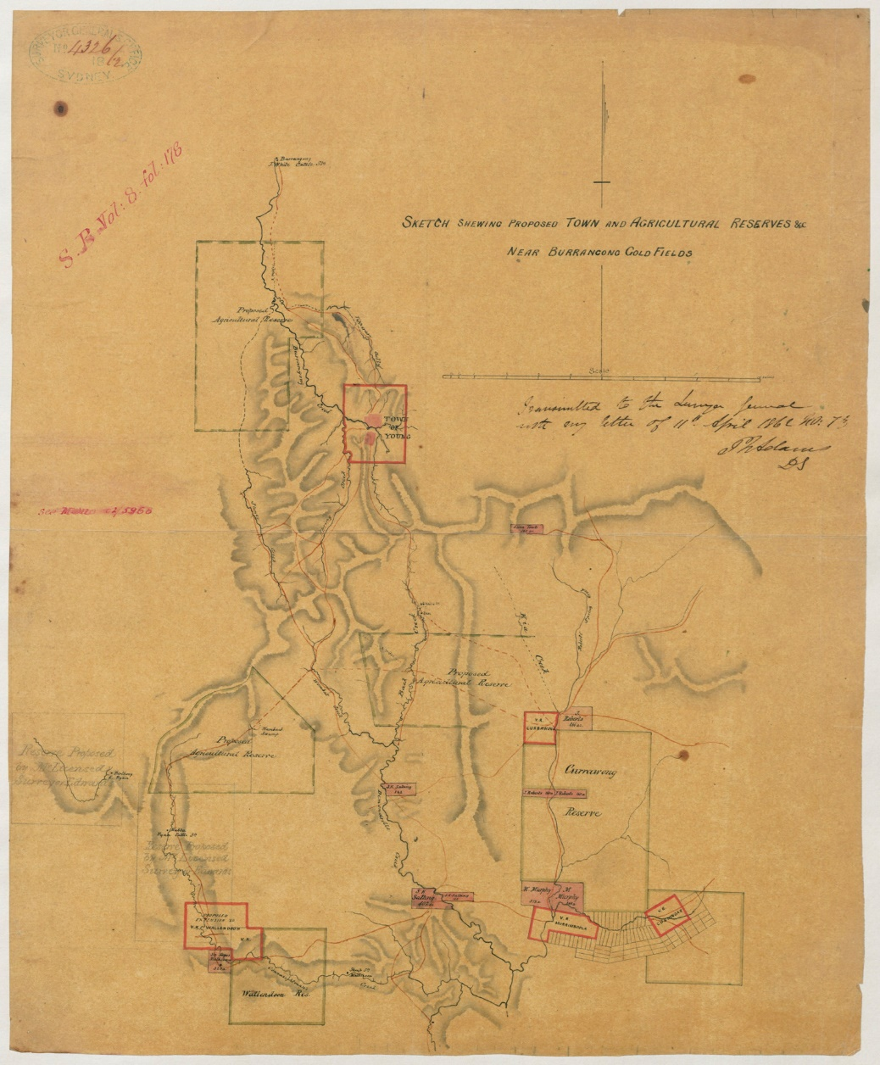
‘Sketch showing proposed town and agricultural reserves near Burrangong gold fields’. Sketch book 8 folio 178 © State of New South Wales through Museums of History NSW, public domain.

Appendix 2 – timeline scaffold
Heading: ________________________________________________________________
- Place the timeline start date here >
- Place the timeline end date here >
- Measure the timeline: the timeline is ___________ centimetres long.
- Subtract the timeline start date from the end date. The resulting number is __________ . This is the number of sections that the timeline should be divided into.
- Divide the number produced in step 3 by the number produced in step 4. The resulting number is __________ . This is the length of each section of the timeline and represents one year.
- Add relevant events onto the timeline as instructed by your teacher.
- Create a key for any symbols used in the timeline.

Appendix 3 – site introduction video
Figure 1 – screenshot of the site introduction and walkthrough video
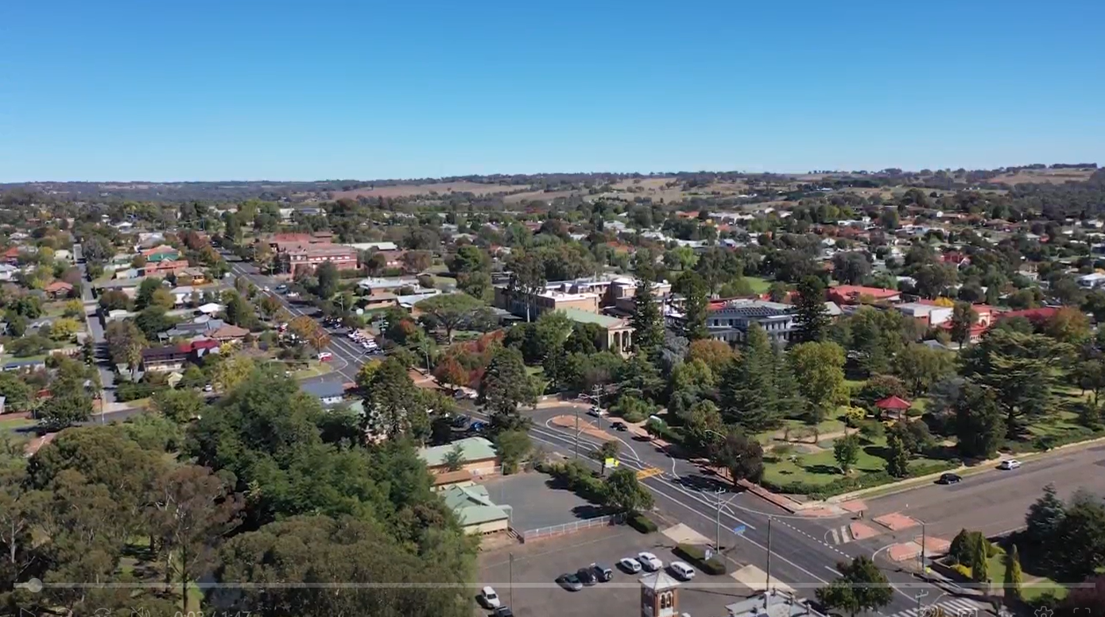
Note: the site introduction video (1:47) provides students with an overview of the history of the site of the Lambing Flat riots and context for understanding the current uses of the site.
Navigation: students can watch the video by clicking on the link above. Students can pause the video and adjust the video speed using the control ribbon at the bottom of the video interface.

Appendix 4 – virtual walkthrough of site
Figure 2 – screenshot from the virtual walkthrough of Hilltops Young High School Library
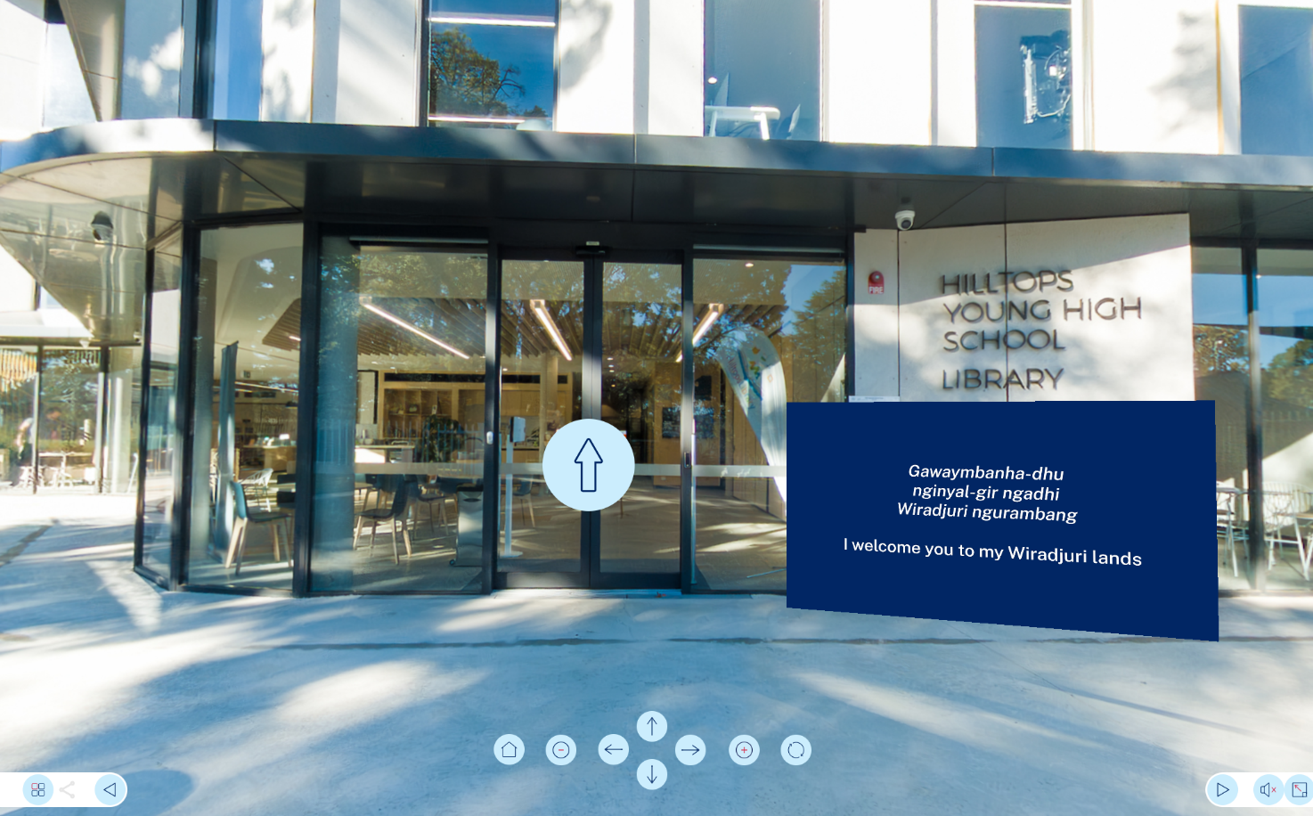
Note: the virtual walkthrough of Hilltops Young High School Library and the surrounding environment enables students to explore the contemporary physical environment on the site of the Lambing Flat riots. In the virtual environment students can:
- explore the ground floor of Hilltops Young High School Library, including the space in which the artefacts referred to throughout this site and source study are displayed
- access the video explainers of sources (separate links also provided in Appendix 6)
- explore the physical environment immediately adjacent to Hilltops Young High School Library, including the Young Heritage Walk in Carrington Park
- explore the heritage information boards located along the Young Heritage Walk
- explore Young Historical Museum and the immediate context of the ‘Roll Up’ banner.
Navigation: students can move between locations by clicking on the circle containing 4 squares on the bottom left of the screen.

Appendix 5 – 3D models of sources
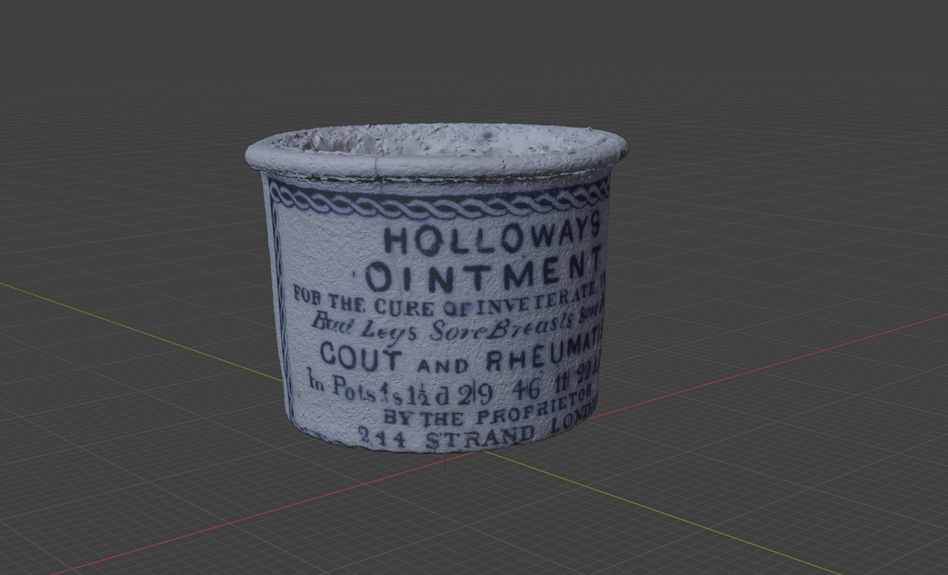
Note: 3-dimensional (3D) models of 3 key artefacts found on the site of the Lambing Flat riots are accessible via the links below:
- A belt buckle
- An ointment jar
- A porcelain ginger jar.
Navigation: students can access each 3D model by clicking on the link above. Students can use the cursor to rotate the 3D model.

Appendix 6 – video explainers of sources
Figure 3 – screenshot from video explanation of artefact
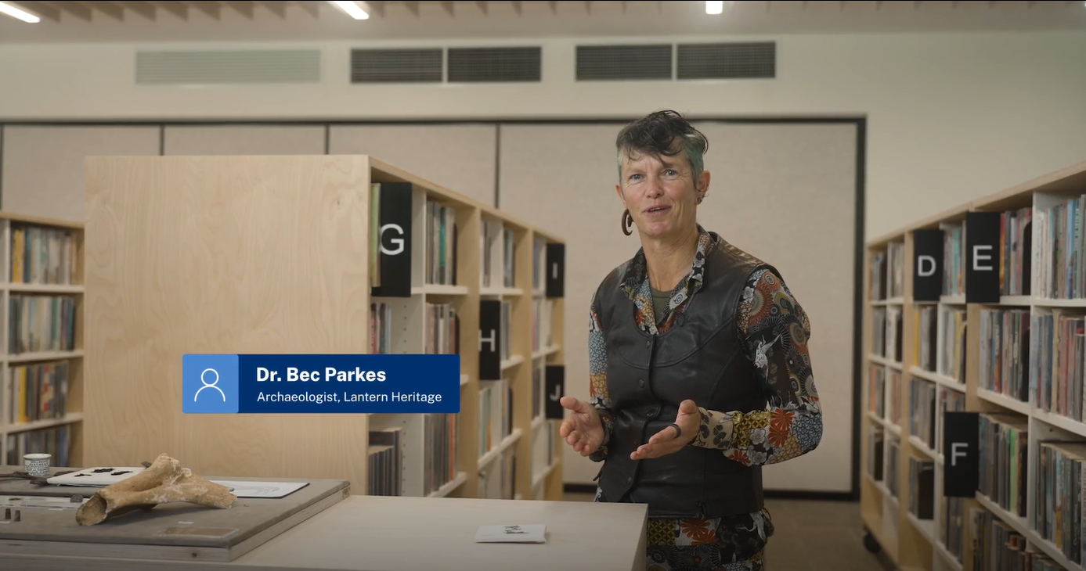
Note: video explainers of 8 key artefacts found on the site of the Lambing Flat riots are accessible via the links below:
- A collection of sewing pins (2:32)
- A military button (3:26)
- A glass bottle (1:12)
- A belt buckle (2:24)
- A percussion cap from a rifle (3:30)
- The heel of a man’s boot (1:34)
- An ointment jar (1:18)
- A porcelain ginger jar (2:38)
Navigation: students can watch each video by clicking on the link above. Students can pause the video, and adjust the video speed using the control ribbon at the bottom of the video interface.

Appendix 7 – source analysis scaffold
Source name:
Where does the source come from?
 | Date
 | Title
Origin and provenance | Author
 | Source type
 | Audience
What is the source about?
 | Summary
 | Perspective
Content, motive and perspective | Argument
 | Techniques
 | Significance
How might the source be used?
 | Questions
 | Value
Use, constraints and corroboration | Limitations
 | Link to other sources
 | Still need to know …
Note: a more detailed explanation of the kinds of content that might be included in each section is included for teachers below:
- Where does the source come from? This could include comment on:
- the bibliographic details of the source (date of production, authorship, digital collection and/or fonds, accession, box and file numbers and title)
- the type of source (newspaper, government document, memorandum, photograph, propaganda poster and so on)
- any unique physical characteristics of the source (for example a 'classified' stamp or marginalia) and an explanation of their significance
- the initial audience of the source (and subsequent audiences as applicable).
- What is the source about? Analyse the contents of the source with a view to understanding it as a cohesive text. This could include:
- a one-sentence summary of the content of the source
- identification of the author's perspective based on evidence in the source
- analysis of any argument being advanced in the source including comment on whether the author is responding to another position
- analysis of the language (or techniques of composition) used or not used by the author to persuade their audience of their argument
- analysis of the significance (or insignificance) of the source in the context of production.
- How might the source be used? Analyse the utility of the source in the context of the study of the Lambing Flat riots. This could include:
- identification of any research questions that the source clearly raises (Is the source typical or atypical?)
- description of the key historical arguments that the source is evidence for
- analysis of the limitations of the source as historical evidence (Is there limited corroboration, questionable provenance and so on?)
- evaluation of the additional evidence needed to better understand and/or make use of the source.

Appendix 8 – ‘Roll Up’ banner
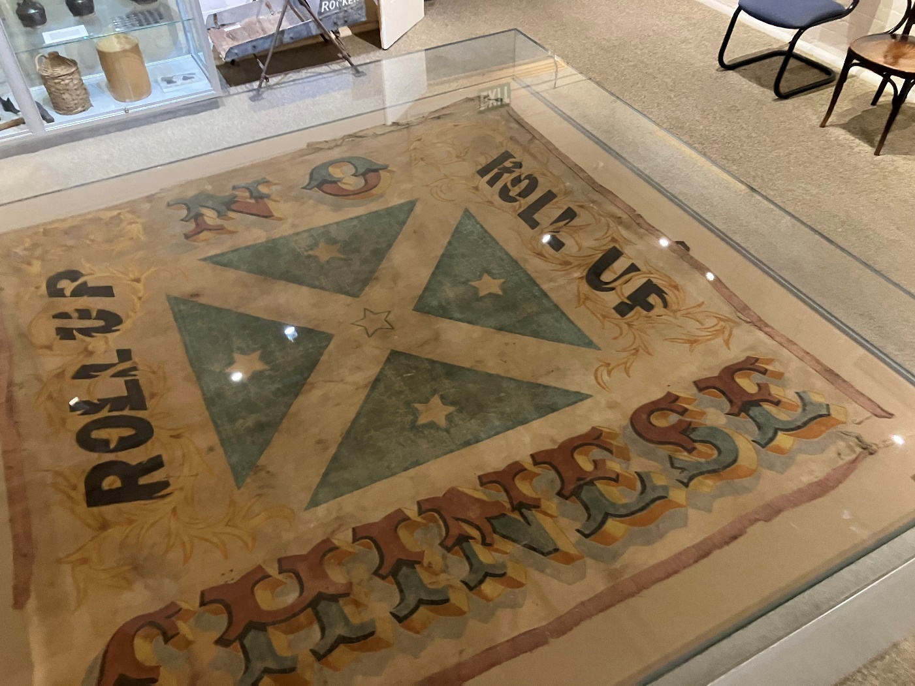
Note: the banner above was made in 1861 and is now located in the Young Historical Museum. Written on the banner are the words ‘Roll Up, No Chinese’. The banner is made from canvas and painted on it are the stars of the Southern Cross and the St Andrews Cross on a blue background. The banner was paraded by miners 3 times during the period of the Lambing Flat riots:
- 18 June 1861: 25 Europeans marched behind the banner to drive out around 40 Chinese from the goldfield at Wombat, a settlement to the south of Lambing Flat
- 30 June 1861: miners marched behind the banner to drive out around 2,000 Chinese miners from the Burrangong goldfield adjacent to Lambing Flat
- 16 July 1861: the banner was paraded at the public funeral of a miner William Lupton at Spring Creek, another settlement near Lambing Flat.
The banner was initially owned by the miner Timothy McCarthy, a leader of the Miners’ Protective League. The banner was bought by the Young Historical Museum in 1964.
The ‘Roll Up’ banner contains historical material that discriminates or promotes discriminatory behaviour and should only be used for study purposes that are relevant to the delivery of the curriculum. This source should be used with awareness of the Controversial issues in schools policy.
Figure 4 – screenshot from video explanation of ‘Roll Up’ banner
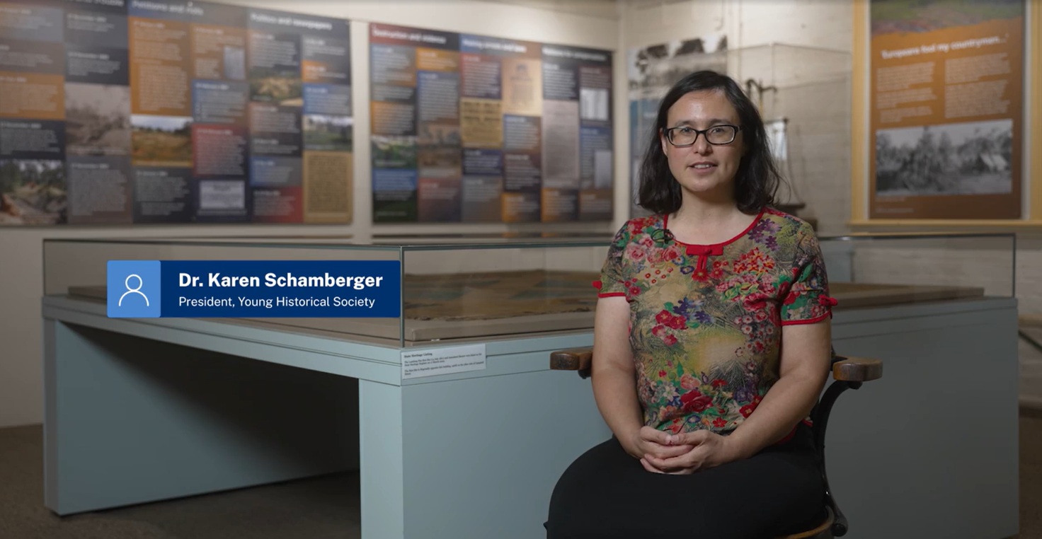
The video explainer of the ‘Roll Up’ banner used during the riots and held by the Young Historical Museum is available via the link below:
- ‘Roll Up’ banner (7:31)
Navigation: students can watch the video by clicking on the link above. Students can pause the video, and adjust the video speed using the control ribbon at the bottom of the video interface.

Appendix 9 – painting of Lambing Flat
Camp Hill (Lambing Flat) immediately before the riot, Young, NSW, 1860-61, inscribed 'by Mrs C. Moley Clark', State Library of New South Wales, DG SV1B/3, public domain.
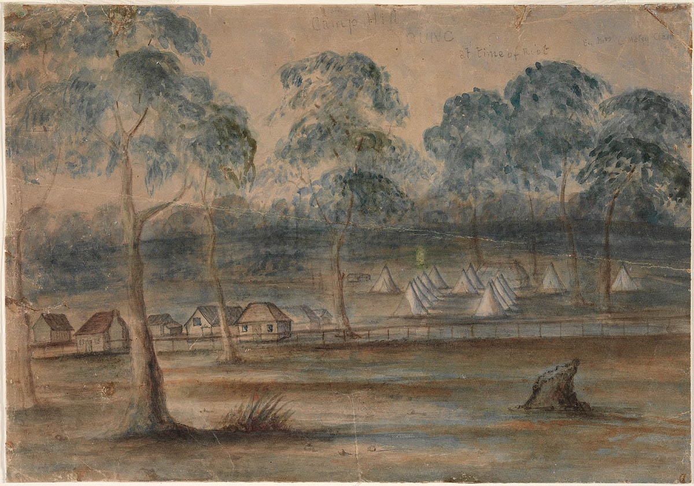
‘Camp Hill Young at time of Riot’ by P Nuyts (attributed) is available in the public domain. Dixson Galleries, State Library of New South Wales.

Appendix 10 – written evidence of riots
Petition 1: Su San Ling Doh to the NSW Legislative Assembly, 12 March, 1861.
“… On the 22nd day of December 1860, I went on to Lambing Flat; I went to the Commissioner and asked him if Chinamen would be allowed to dig on these diggings, and he said “Yes”. I had a Miners Right from the Snowy River. I accordingly commenced work on 25th January. The Europeans posted notices on the diggings, stating that, on the 27th, if the Chinese would not clear out by that date, they would drive them away. I asked the Europeans for three days to remove my goods, bought at Walker’s Store in Braidwood, and partly not paid for, which they would not grant me. I then asked for one day and was refused. On the 27th I was drove off with the rest of my countrymen. I asked policemen to look after my goods. Early on the 28th I went on to the diggings again; I found about 20 or 30 Europeans and one woman by my tent, my goods all gone, and my tent burning; my goods amounted in value to £300”.
Petition 2: Kew Loong Pow (storekeeper) to the NSW Legislative Assembly, April 1861.
“… about December 1860, … Kew Loong Pow, was a licensed Storekeeper at the Lambing Flat Diggings, and I was peaceably and quietly prosecuting my business there as a storekeeper till the 27th of that month, when I was driven from the said diggings with the rest of my countrymen; my property, consisting of general provisions was destroyed, amounting in value to about (£850) … I am, in consequence, left destitute, and without the means of providing a living either for myself or infant son”.
Petition 3: Mun Gaim to the NSW Legislative Assembly, 9 April 1861.
“That your Petitioner was born at Hong Kong, in China, is unacquainted with the English language, and came over from San Francisco to this colony in the ship Europa in the year 1858, with the intention of working at the gold fields.
That year, by great exertion and unwearied industry, saved a small sum of money, with which he purchased and forwarded goods to the diggings at Lambing Flat – erected his tent and established a store on the diggings.
That, only five days after the establishment of the store, the European diggers at Lambing Flat, illegally, and by force, drove your Petitioner and other Chinese from the said diggings to a distance of five miles and burnt the tent of your Petitioner, together with the goods therein, consisting of Chinese silk and crepe, and other Chinese and European products – your Petitioner not being able to save anything. That the property of your Petitioner, to the value of £500, was so burnt and destroyed by the said diggers. That your Petitioner, since his arrival here, has conducted himself peaceably, and has not committed any offence against the laws of the colony”.
Petition 4: Simon Sanling (interpreter) to the NSW Legislative Assembly, 5 September 1861.
“That your Petitioner resided for five months at Lambing Flat… where he acted as an interpreter between his countrymen and Europeans … That your Petitioner is a Catholic, married to a European wife of the same faith, and has a family of three young children, natives of the Colony.
That on the 30th June, your Petitioner was in occupation of a tent at a place called Back Creek, six or seven miles from Lambing Flat … a multitude of about 1300 or 1400 persons, strangers to your Petitioner, assembled near your Petitioner’s tent, in a riotous and disorderly manner, with firearms and other weapons, some being on horseback, but the most on foot, and with evident purposes of violence and hostility towards your Petitioner and other natives of China.
That, without provocation on your Petitioner’s part, some of the aforesaid persons so assembled, drove your Petitioner, his wife, and family, with violence from their tent, and destroyed the same and other property of your Petitioner with fire.
That in trying to escape, your Petitioner was pursued by two of the persons on horseback, and by several of the persons on foot, by whom, or some of whom, your Petitioner was beaten with sticks, knocked down, and wounded …”.
Simon was robbed of £7, two gold nuggets and a pocketknife. He hid in the bush for several hours and eventually returned to find his tent burnt, most of his property destroyed and his wife and children with only the clothes they wore. He stated that police made no attempt to find the attackers”.

Appendix 11 – newspaper article
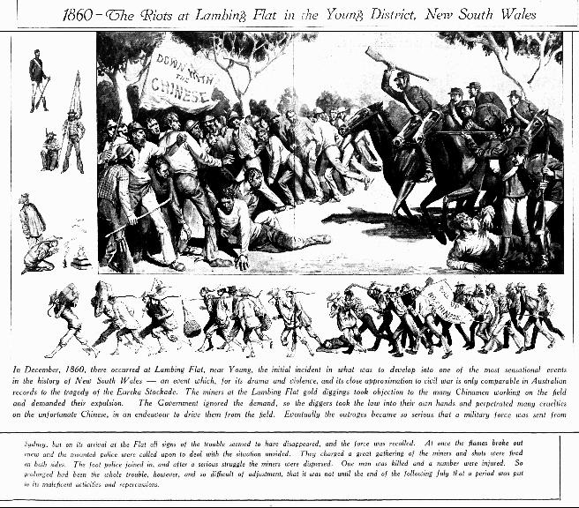
‘1860 – The Riots at Lambing Flat in the Young District, New South Wales’ by Sydney Mail is available in the public domain.
Note: Image and text from p 26 of the Sydney Mail [newspaper], Wednesday 10 July 1935.
Excerpt from the text reads: ‘In December, 1860, there occurred at Lambing Flat, near Young, the initial incident in what was to develop into one of the most sensational events in the history of New South Wales – an event which, for its drama and violence, and its close approximation to civil war is only comparable in Australian records to the tragedy of the Eureka Stockade. The miners at the Lambing Flat gold diggings took objection to the many Chinamen [sic] working on the field and demanded their expulsion. The Government ignored the demand, so the diggers took the law into their own hands and perpetrated many cruelties on the unfortunate Chinese in an endeavour to drive them from the field …’

Appendix 12 – scene 3 from memorial scroll
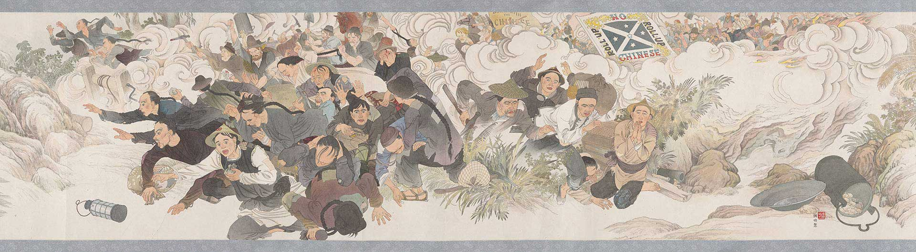
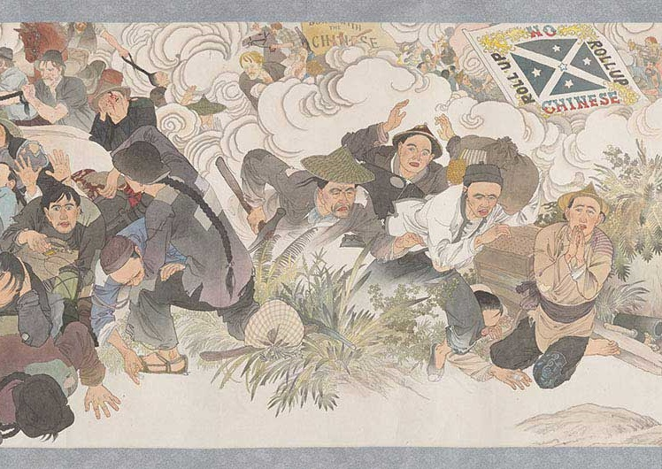
‘Harvest of Endurance: A History of the Chinese in Australia 1788–1988’ by Mo Xiangyi © Australia-China Friendship Society. National Museum of Australia.
Note: Harvest of Endurance scroll: A History of the Chinese in Australia, 1788-1988. Artist: Mo Xiangyi, assisted by Wang Jingwen, researcher: Mo Yimei. Ink on paper, mounted on silk and paper. © Australia-China Friendship Society. Courtesy of National Museum of Australia.

Appendix 13 – panel discussion
Note: this resource is a video recording of a discussion that occurred on MS Teams in the context of a HSIE Statewide Staffroom event to explain and promote the Lambing Flat riots site and source study. The discussion included the following participants:
- Dr Bec Parkes, lead archaeologist during the excavation of the Lambing Flat site and director of Lantern Heritage
- Dr Jennifer Lawless, consultant historian and educational lead for the Lambing Flat riots site and source study
- Dr Simon Graham, HSIE curriculum advisor and project lead for the Lambing Flat riots site and source study.
The participants responded to 5 questions over the course of the discussion. Click on the links below to access the video associated with each question.
- How did you approach the Lambing Flat site? (6:04)
- What excites you about the Lambing Flat site? (6:37)
- Were you challenged by limitations of the site? (5:16)
- How might historians interpret the site? (3:58)
- What do you want us to take from the site study? (4:05)
Navigation: students can watch the video by clicking on the links above. Students can pause the video, toggle closed captions and adjust the video speed using the control ribbon at the bottom of the video interface.

Additional information
The information below can be used to support teachers when using this teaching resource for Stage 5 history.

Support and alignment
Resource evaluation and support: all curriculum resources are prepared through a rigorous process. Resources are periodically reviewed as part of our ongoing evaluation plan to ensure currency, relevance and effectiveness. For additional support or advice contact the HSIE curriculum team by emailing hsie@det.nsw.edu.au.
Explicit teaching: further advice to support explicit teaching is available on the Explicit teaching webpage. This includes the CESE Explicit teaching – Driving learning and engagement webpage.
Alignment to system priorities and/or needs: School Excellence Policy, Our Plan for NSW Public Education
Alignment to the School Excellence Framework: this resource supports the School Excellence Framework element of assessment (formative assessment, summative assessment, student engagement).
Alignment to Australian Professional Standards for Teachers: this resource supports teachers to address Australian Professional Standards for Teachers 5.1.2, 5.4.2.
Consulted with: Explicit Teaching, Curriculum and Reform
NSW Syllabus: History 7–10 Syllabus © NSW Education Standards Authority (NESA) for and on behalf of the Crown in right of the State of New South Wales, 2012.
Syllabus outcomes: HT5-1, HT5-3, HT5-5, HT5-6, HT5-8, HT5-9
Author: HSIE Curriculum Team
Publisher: State of NSW, Department of Education
Resource: site and source study
Related resources: further resources to support Stage 5 History can be found on the HSIE K–12 curriculum page
Professional learning: relevant professional learning is available through the HSIE Statewide staffroom.
Universal Design for Learning: Universal Design for Learning planning tool. Support the diverse learning needs of students using inclusive teaching and learning strategies.
Creation date: 8 October 2024
Rights: © State of New South Wales, Department of Education

References
This resource contains NSW Curriculum and syllabus content. The NSW Curriculum is developed by the NSW Education Standards Authority. This content is prepared by NESA for and on behalf of the Crown in right of the State of New South Wales. The material is protected by Crown copyright.
Please refer to the NESA Copyright Disclaimer for more information https://educationstandards.nsw.edu.au/wps/portal/nesa/mini-footer/copyright.
NESA holds the only official and up-to-date versions of the NSW Curriculum and syllabus documents. Please visit the NSW Education Standards Authority (NESA) website https://educationstandards.nsw.edu.au/ and the NSW Curriculum website https://curriculum.nsw.edu.au/home.
History K–10 Syllabus © NSW Education Standards Authority (NESA) for and on behalf of the Crown in right of the State of New South Wales, 2012.
1861 'THE LAMBING FLAT RIOTS' (27 February 1861, p 2) Freeman's Journal (Sydney, NSW: 1850–1932), http://nla.gov.au/nla.news-article115760707, accessed 2 Jul 2024.
1861 'LAMBING FLAT RIOTS' (10 July 1861, p 6) The Argus (Melbourne, Vic.: 1848–1957), http://nla.gov.au/nla.news-article5701829, accessed 2 Jul 2024.
1861 'THE RIOTS AT LAMBING FLAT' (22 July 1861, p 5) The Herald (Melbourne, Vic.: 1861– 1954), accessed 2 Jul 2024, http://nla.gov.au/nla.news-article244247371.
1898 'The Lambing Flat Riots' (6 April 1898, p 4) The Burrangong Argus (NSW: 1865–1913), accessed 2 Jul 2024, http://nla.gov.au/nla.news-article247690285.
1934 'Lambing Flat Riots', (9 February 1934, p 3) The Forbes Advocate (NSW: 1911–1954), http://nla.gov.au/nla.news-article218396459, accessed 2 Jul 2024.
ABC Listen (2020) This Week in History: The Lambing Flat Riots, https://www.abc.net.au/listen/programs/nightlife/this-week-in-history-the-riots-at-lambing-flat/12539800, accessed 6 March 2024.
Allender T, Clark A and Parkes R (2020) Historical Thinking for History Teachers: A new approach to engaging students and developing historical consciousness, 1st edn, Routledge.
Anon, Sketch showing proposed town and agricultural reserves near Burrangong gold fields. Sketch book 8 folio 178 © State of New South Wales through Museums of History NSW, public domain.
Archer AL and Hughes CA (2011) Explicit instruction: effective and efficient teaching, Guilford Press.
Auerbach S (2013) ‘Margaret Tart, Lao She, and the Opium-Master’s Wife: Race and Class among Chinese Commercial Immigrants in London and Australia, 1866–1929’, Comparative Studies in Society and History, 55(1), 35–64.
Bagnall K (2006) Golden shadows on a white land: An exploration of the lives of white women who partnered Chinese men and their children in southern Australia, 1855-1915, The University of Sydney.
—— (2011) ‘Rewriting the History of Chinese Families in Nineteenth-Century Australia’, Australian Historical Studies, 42(1): 62–77.
Byrne D (2016) ‘The need for a transnational approach to the material heritage of migration: The China–Australia corridor’, Journal of Social Archaeology, 16(3): 261–285.
CESE (Centre for Education Statistics and Evaluation) (2020a) ‘What works best: 2020 update’, CESE, NSW Department of Education, accessed 9 February 2024.
—— (2020b) ‘What works best in practice’, CESE, NSW Department of Education, accessed 9 February 2024.
Cherry‐Smith B (2021) ‘Immigration, the “Chinese Question”, and Ontological Insecurity in Colonial Australia’, The Australian Journal of Politics and History, 67(2): 208–225.
Clark A (2006) Teaching the nation: politics and pedagogy in Australian history, Melbourne University Press.
Clark A (2008) History’s children: history wars in the classroom, 1st edn, University of New South Wales Press.
Clark A (ed) (2019) The knowledge solution: Australian history, Melbourne University Publishing.
Clark A (2022) Making Australian history, Vintage Books Australia.
Clark A, Rees A and Simmonds A (eds) (2017) Transnationalism, Nationalism and Australian History, 1st edn, Springer, Singapore.
Connolly CN (1978) ‘MINERS’ RIGHTS: Explaining the “Lambing Flat” Riots of 1860-61’, Labour History (Canberra), (35):35–47.
Cook A, Reeves A and McCalman I (2001) Gold: Forgotten Histories and Lost Objects of Australia, Cambridge University Press, UK.
Couchman S and Bagnall K (eds) (2015) Chinese Australians: politics, engagement and resistance, Koninklijke Brill, Leiden, The Netherlands.
Couchman S and Bagnall K (2023) ‘Identification Photography and the Surveillance of Chinese Mobility in Colonial Australasia’, Australian Historical Studies, 54(2): 299–329.
Crawford R (2022) ‘Action Research as Evidence-based Practice: Enhancing Explicit Teaching and Learning Through Critical Reflection and Collegial Peer Observation’, The Australian Journal of Teacher Education, 47(12), 53–75.
Fitzgerald J and Kuo M (2017) ‘Diaspora Charity and Welfare Sovereignty in the Chinese Republic: Shanghai Charity Innovator William Yinson Lee (Li Yuanxin, 1884–1965)’, Twentieth-Century China, 42(1): 72–96.
Fitzpatrick MP and Monteath P (2019) Colonialism, China and the Chinese, Routledge.
Gao M (2017) ‘Early Chinese Migrants to Australia: A Critique of the Sojourner Narrative on Nineteenth-century Chinese Migration to British Colonies’, Asian Studies Review, 41(3): 389–404.
Gassin G and Schamberger K (2021) ‘Roundtable – Translation and transformation: exploring histories of Chinese diaspora in Aotearoa New Zealand’, New Zealand Journal of History, 55(2): 51–52.
Indelicato ME (2023) ‘Neither Black Nor White: Colonial Myths, Irish Women, and Chinese Men’s Quest for Respectability’, Interventions (London, England), 25(4):448–467.
Kwok J (2022) ‘The Lambing Flat riots and the Chinese quest for compensation’, Journal of Australasian Mining History, 20:86–107.
Ledman K (2015) ‘Navigating historical thinking in a vocational setting: Teachers interpreting a history curriculum for students in vocational secondary education’, Journal of Curriculum Studies, 47(1):77–93.
Lee KJ (2015) ‘“Quo vadis, Terra Australis?”: Don’o Kim’s The Chinaman’, Journal of Australian Studies, 39(4):461–476.
Loy-Wilson S (2012) ‘White Cargo: Australian Residents, Trade and Colonialism in Shanghai Between the Wars’, History Australia, 9(3):154–177.
—— (2017) Australians in Shanghai: race, rights and nation in treaty port China, Routledge.
Martínez, J, Lowrie C, Benton G, Fong N, Gibson P, Kuo M, Surany N, Wong DTK, Zhang R and Loy-Wilson S (2024) Chinese Colonial Entanglements: Commodities and Traders in the Southern Asia Pacific, 1880-1950, University of Hawaii Press.
McGowan B (2004) ‘Reconsidering race: The Chinese experience on the goldfields of southern New South Wales’, Australian Historical Studies, 36(124):312–331.
Museums of History NSW (2022) Chinese on the Goldfields, https://mhnsw.au/stories/general/chinese-goldfields/, accessed 9 March 2024.
National Museum of Australia (2023) Violence on the Goldfields, https://www.nma.gov.au/explore/features/harvest-of-endurance/scroll/violence-on-goldfields, accessed 8 March 2024.
NESA (NSW Education Standards Authority) (2022) ‘Proficient Teacher: Standard descriptors’, The Standards, NESA website, accessed 9 February 2024.
Ngai MM (2021) The Chinese question: the gold rushes and global politics, 1st edn, WW Norton & Company Inc, New York.
O’Connell D (2016) ‘Contesting White Australia: Black Jazz Musicians in a White Man’s Country’, Australian Historical Studies, 47(2):241–258.
Rodwell G (2017) ‘A national history curriculum, racism, a moral panic and risk society theory’, Issues in Educational Research, 27(2):365–380.
Rooney M (2007) ‘Cosmopolitan Bohemians and Bachelors: Chinese Enclaves in Late 19th-Century Australia and the United States’, Antipodes (Brooklyn, New York, N.Y.), 21(2):141–146.
Rosenshine B (2012) ‘Principles of Instruction: Research-Based Strategies That All Teachers Should Know’, American Educator, 36(1):12-19.
Sandwell RW and Von Heyking, AJ (2014) Becoming a history teacher: sustaining practices in historical thinking and knowing, University of Toronto Press.
Schamberger K (2011) ‘“Still Children of the Dragon”? A review of three Chinese Australian heritage museums in Victoria’, Australian Historical Studies, 42(1):140–147.
—— (2017) ‘An invitation to explore the Central West of NSW’, History Australia, 14(2):291–292.
—— (2017) ‘Difficult History in a Local Museum: The Lambing Flat Riots at Young, New South Wales’, Australian Historical Studies, 48(3):436–441.
—— (2021) ‘Objects Mediating Identity, Belonging and Cultural Difference in Australian Museums’, in Dellios A and Henrich E (eds) Migrant, Multicultural and Diasporic Heritage,1st edn, pp 52–67, Routledge.
—— (2021) ‘Whose Stories Are We Telling? Chinese Australian History in New South Wales and Victorian Museums’, Australian Historical Studies, 52(4):567–590.
Sharp H (2022) Teaching secondary history, Cambridge University Press.
Slocomb M (2014) Among Australia’s pioneers: Chinese indentured pastoral workers on the Northern Frontier 1848 to c.1880, Balboa Press, Bloomington, IN.
State of New South Wales (Department of Education) (2024) ‘Controversial Issues in Schools’, Policy library, accessed 2 February 2024.
State of New South Wales (School Infrastructure NSW) (2024) Young High School upgrade and new joint use library and community facility completed project, NSW Department of Education – School Infrastructure website, accessed 9 February 2024.
State of Victoria (Department of Education) (2023) Visual literacy https://www.education.vic.gov.au/school/teachers/teachingresources/discipline/english/literacy/readingviewing/Pages/litfocusvisual.aspx, accessed 8 June 2024.
Stoel GL, van Drie JP and van Boxtel CAM (2017) ‘The Effects of Explicit Teaching of Strategies, Second-Order Concepts, and Epistemological Underpinnings on Students’ Ability to Reason Causally in History’, Journal of Educational Psychology, 109(3):321–337.
Wineburg SS (2001) Historical thinking and other unnatural acts: charting the future of teaching the past, Temple University Press.
Wisniewski B, Zierer K and Hattie J (2020) ‘The Power of Feedback Revisited: A Meta-Analysis of Educational Feedback Research’, Frontiers In Psychology, 10:3087, doi:10.3389/fpsyg.2019.03087.
Wong YT (2015) Penang Chinese Commerce in the 19th Century: The Rise and Fall of the Big Five, ISEAS, Singapore.
Yen MG, Yen S, Horsburgh R and Loy-Wilson S (2022) South Flows the Pearl: Chinese Australian Voices, Sydney University Press.
Young Historical Museum (2024) Young Historical Museum [website], accessed 7 February 2024.
Young NSW (2023) Young, Hilltops Region, https://www.visithilltopsregion.com.au/towns-villages/young/.

© State of New South Wales (Department of Education), 2024
The copyright material published in this resource is subject to the Copyright Act 1968 (Cth) and is owned by the NSW Department of Education or, where indicated, by a party other than the NSW Department of Education (third-party material).
Copyright material available in this resource and owned by the NSW Department of Education is licensed under a Creative Commons Attribution 4.0 International (CC BY 4.0) license.

This license allows you to share and adapt the material for any purpose, even commercially.
Attribution should be given to © State of New South Wales (Department of Education), 2024.
Material in this resource not available under a Creative Commons license:
- the NSW Department of Education logo, other logos and trademark-protected material
- material owned by a third party that has been reproduced with permission. You will need to obtain permission from the third party to reuse its material.
Links to third-party material and websites
Please note that the provided (reading/viewing material/list/links/texts) are a suggestion only and implies no endorsement, by the New South Wales Department of Education, of any author, publisher, or book title. School principals and teachers are best placed to assess the suitability of resources that would complement the curriculum and reflect the needs and interests of their students.
If you use the links provided in this document to access a third-party's website, you acknowledge that the terms of use, including licence terms set out on the third-party's website apply to the use which may be made of the materials on that third-party website or where permitted by the Copyright Act 1968 (Cth). The department accepts no responsibility for content on third-party websites.

