History elective Years 7–10

Topic 1: History, Heritage and Archaeology – underwater archaeology

Contents

Overview 3

Outcomes 3

Learning sequence 1 – history, archaeology and historical inquiry 4

Syllabus content 4

Learning intentions and success criteria 4

Features of history, heritage and archaeology 5

Methods of historical and archaeological investigations 7

Develop inquiry question 8

Locate and select sources 9

Analyse sources 14

Select and organise evidence 19

Communicate findings 20

Sources used in underwater archaeology 21

Learning sequence 2 – continuity, change and historical meaning 23

Syllabus content 23

Learning intentions and success criteria 23

Features of continuity and change 24

Varying constructions of historical meaning 28

Learning sequence 3 – issues related to the study of the past 33

Syllabus content 33

Learning intentions and success criteria 33

Collecting sources, displaying the past and reconstructing the past 34

Who owns the past? 37

Preservation and conservation issues 39

Appendix 1 – field matching activity 42

Appendix 2 – artefact groups for sorting activity 46

Set 1 46

Set 2 47

Set 3 48

Set 4 49

Appendix 3 – school archives card 50

Appendix 4 – *Titanic* survivor testimony extracts 51

Appendix 5 – Options Diamond scaffold 54

Appendix 6 – Frayer model scaffold 55

Further reading 56

Support and alignment 57

References 58

This resource has been developed to assist teachers in NSW Department of Education schools to create learning that is contextualised to their classroom. It can be used as a basis for the teacher’s own program, assessment, or scope and sequence, or be used as an example of how the new curriculum could be implemented. The resource has suggested timeframes that may need to be adjusted by the teacher to meet the needs of their students.

# Overview

**Description:** this program of learning addresses Topic 1: History, Heritage and Archaeology. It covers the Archaeological sites option with a focus on underwater archaeology. The sequences in this program of learning allow students to develop an understanding of the nature of history and the ways in which different perspectives and interpretations of the past are reflected in a variety of historical constructions. The learning activities are centred on the inquiry question: How does underwater archaeology contribute to our understanding of the nature of history and the ways in which historical meanings can be constructed?

**Duration:** this program of learning is designed to be completed in approximately 25 hours.

**Note**: Aboriginal and/or Torres Strait Islander peoples should be aware that links in this resource may contain images, voices and names of deceased persons.

## Outcomes

A student:

* **HTE5-1** applies an understanding of history, heritage, archaeology and the methods of historical inquiry
* **HTE5-2** examines the ways in which historical meanings can be constructed through a range of media
* **HTE5-6** identifies and evaluates the usefulness of historical sources in an historical inquiry process
* **HTE5-7** explains different contexts, perspectives and interpretations of the past
* **HTE5-8** selects and analyses a range of historical sources to locate information relevant to an historical inquiry

[History Elective Years 7–10 Syllabus](https://educationstandards.nsw.edu.au/wps/portal/nesa/k-10/learning-areas/hsie/history-elective-7-10-2019) © NSW Education Standards Authority (NESA) for and on behalf of the Crown in right of the State of New South Wales, 2019.

# Learning sequence 1 – history, archaeology and historical inquiry

This learning sequence provides an overview of history and archaeology and introduces concepts relevant to underwater archaeology. Activities in this sequence are designed to be adaptable to other options in Topic 1: History, Heritage and Archaeology.This sequence addresses the historical concepts of comprehension: chronology, terms and concepts; and historical skills of analysis and use of sources.

**Duration:** this learning sequence is designed to be completed in approximately 12 hours.

## Syllabus content

Students:

* explain the features of history, heritage and archaeology
* identify and assess the range of sources used in investigating history, heritage or archaeology
* examine the varying methods of historical and archaeological investigations.

## Learning intentions and success criteria

**Note:** these learning intentions and success criteria are general and should be contextualised to suit your school and students’ needs.

Students learn about:

* features of history, heritage and archaeology
* methods of historical and archaeological investigations
* the range of sources used in underwater archaeology.

Students will be able to:

* explain the similarities and differences between history, heritage and archaeology
* discuss the methods involved in historical and archaeological investigations
* analyse a range of sources.

## Features of history, heritage and archaeology

**Note**: [Rapid-fire writing](https://education.nsw.gov.au/teaching-and-learning/learning-remotely/teaching-at-home/expectations/contemporary-learning-and-teaching-from-home/learning-from-home--teaching-strategies#/asset7) is a structured and fast-paced independent writing activity. It uses timed phases of writing and self-reflection to scaffold students’ understanding of the main ideas in a topic. Outline the protocol for learners before engaging in the activity. It can be useful to display the phases of the activity and associated times on the board, along with a timer for each phase.

Separating the class into 8 to 10 groups is recommended for the [Fist to Five voting](https://www.cps.edu/sites/equity/tools/dimensions/fist-to-five-voting-and-consensus/) activity. Teachers need to pre-select 3 unique quotes for each group. [Alpha History: History quotes](https://alphahistory.com/history-quotes/) is a useful source for quotes. A balanced range of quotes should be used to support a rounded discussion of issues and perspectives.

Print and cut up cards in Appendix 1 – field matching activity prior to the [silent card shuffle (3:55)](https://youtu.be/RMjpEsNvPB8) activity. Shuffle cards and give one set to each pair of students.

Construct definitions of ‘history’, ‘heritage’ and ‘archaeology’ based on your existing knowledge. Share as a class and compare with definitions from [Cambridge Dictionary](https://dictionary.cambridge.org/).

On a blank piece of paper, draw an image of a historian on the left and an archaeologist on the right. Share your drawing with a partner. Discuss similarities and differences between your drawings and justify the features you included to distinguish between a historian and an archaeologist.

Create a [concept map](https://app.education.nsw.gov.au/digital-learning-selector/LearningActivity/Card/577?clearCache=1a8c9e98-fc4e-ee2-f584-47a92b214530) of the ways you engage with history. Consider:

* your education
* hobbies and interests
* places you have visited
* popular culture you engage with.

Use [rapid fire writing](https://education.nsw.gov.au/teaching-and-learning/learning-remotely/teaching-at-home/expectations/contemporary-learning-and-teaching-from-home/learning-from-home--teaching-strategies#/asset7) with the stimulus ‘Everyone is a historian. Everyone is his own historian.’ ([Teodoro A. Agoncillo](https://www.goodreads.com/quotes/491108-everyone-is-a-historian-everyone-is-his-own-historian)).

1. Spend one minute independently reflecting on the stimulus. You can refer to your concept map to support your thinking.
2. Write continuously about the stimulus for 3 minutes.
3. Re-read your work for one minute and circle your 3 main ideas (words or phrases).
4. Write continuously about the stimulus again for 2 minutes – don’t stop writing!
5. Re-read your work again for 30 seconds and place a square around the main idea of your work (single word or phrase).
6. Write continuously about this main idea for one minute without stopping.
7. Share your final idea with the class and reflect on how you reached this opinion.

Working in groups of 2 to 3 students, read and discuss the 3 quotes about history provided by your teacher. Select the quote you think best reflects the key features of history and share with your class. As a class:

* conduct a [Fist to Five vote](https://www.cps.edu/sites/equity/tools/dimensions/fist-to-five-voting-and-consensus/) to rate how effectively each quote presented conveys the features of history. Calculate a score for each quote by counting the number of fingers put up across the room
* discuss the strengths of the 3 highest and limitations of the 3 lowest scoring quotes
* develop a quote that defines the class viewpoint of history.

Use the [Cornell Notes (0:59)](https://youtu.be/HEsBd_Rgzfs) structure to take notes about [An Introduction to Archaeology: What is Archaeology and Why is it Important? (12:51)](https://youtu.be/3tkTxALrVvg). Compare notes with a partner before completing the summary section.

Complete a [silent card shuffle (3:55)](https://youtu.be/RMjpEsNvPB8) in pairs to match the archaeological field and definition cards from Appendix 1 – field matching activity.

Consider the definition of heritage and engage with [What is Heritage? (2:50)](https://youtu.be/nf8DyjCz8UE). Conduct a [card cluster](https://gdhr.wa.gov.au/learning/teaching-strategies/tuning-in/card-clusters) on the question: Why is heritage important?

1. Your teacher will allocate you to a small group and provide a few slips of paper.
2. Individually respond to the stimulus question. Only one idea should be represented on each slip of paper. Place your responses in the middle of the group.
3. Discuss the responses and put them in groups by identifying similarities. A heading or title can be given to each pile of slips.
4. Share your group’s thinking with the class.
5. Record the thinking of the whole class by creating a [concept map](https://app.education.nsw.gov.au/digital-learning-selector/LearningActivity/Card/577) or using each idea as a new sentence.

**Differentiation**: subtitles should be used to support hearing impaired and EAL/D students. [Auto Translate YouTube Video into your Language (3:24)](https://youtu.be/LZz03myFuWA?si=H-KQG0D8M3wHf5MM) shows how to use subtitles in any language to support learners.

Quick-Draw Paper or assistive technologies such as [starryai](http://www.starryai.com) should be provided for students with visual impairments when completing the drawing activity.

## Methods of historical and archaeological investigations

While the methods used in historical and archaeological investigations may differ, they follow the same overall inquiry process shown in Figure 1.

Figure 1 – inquiry process

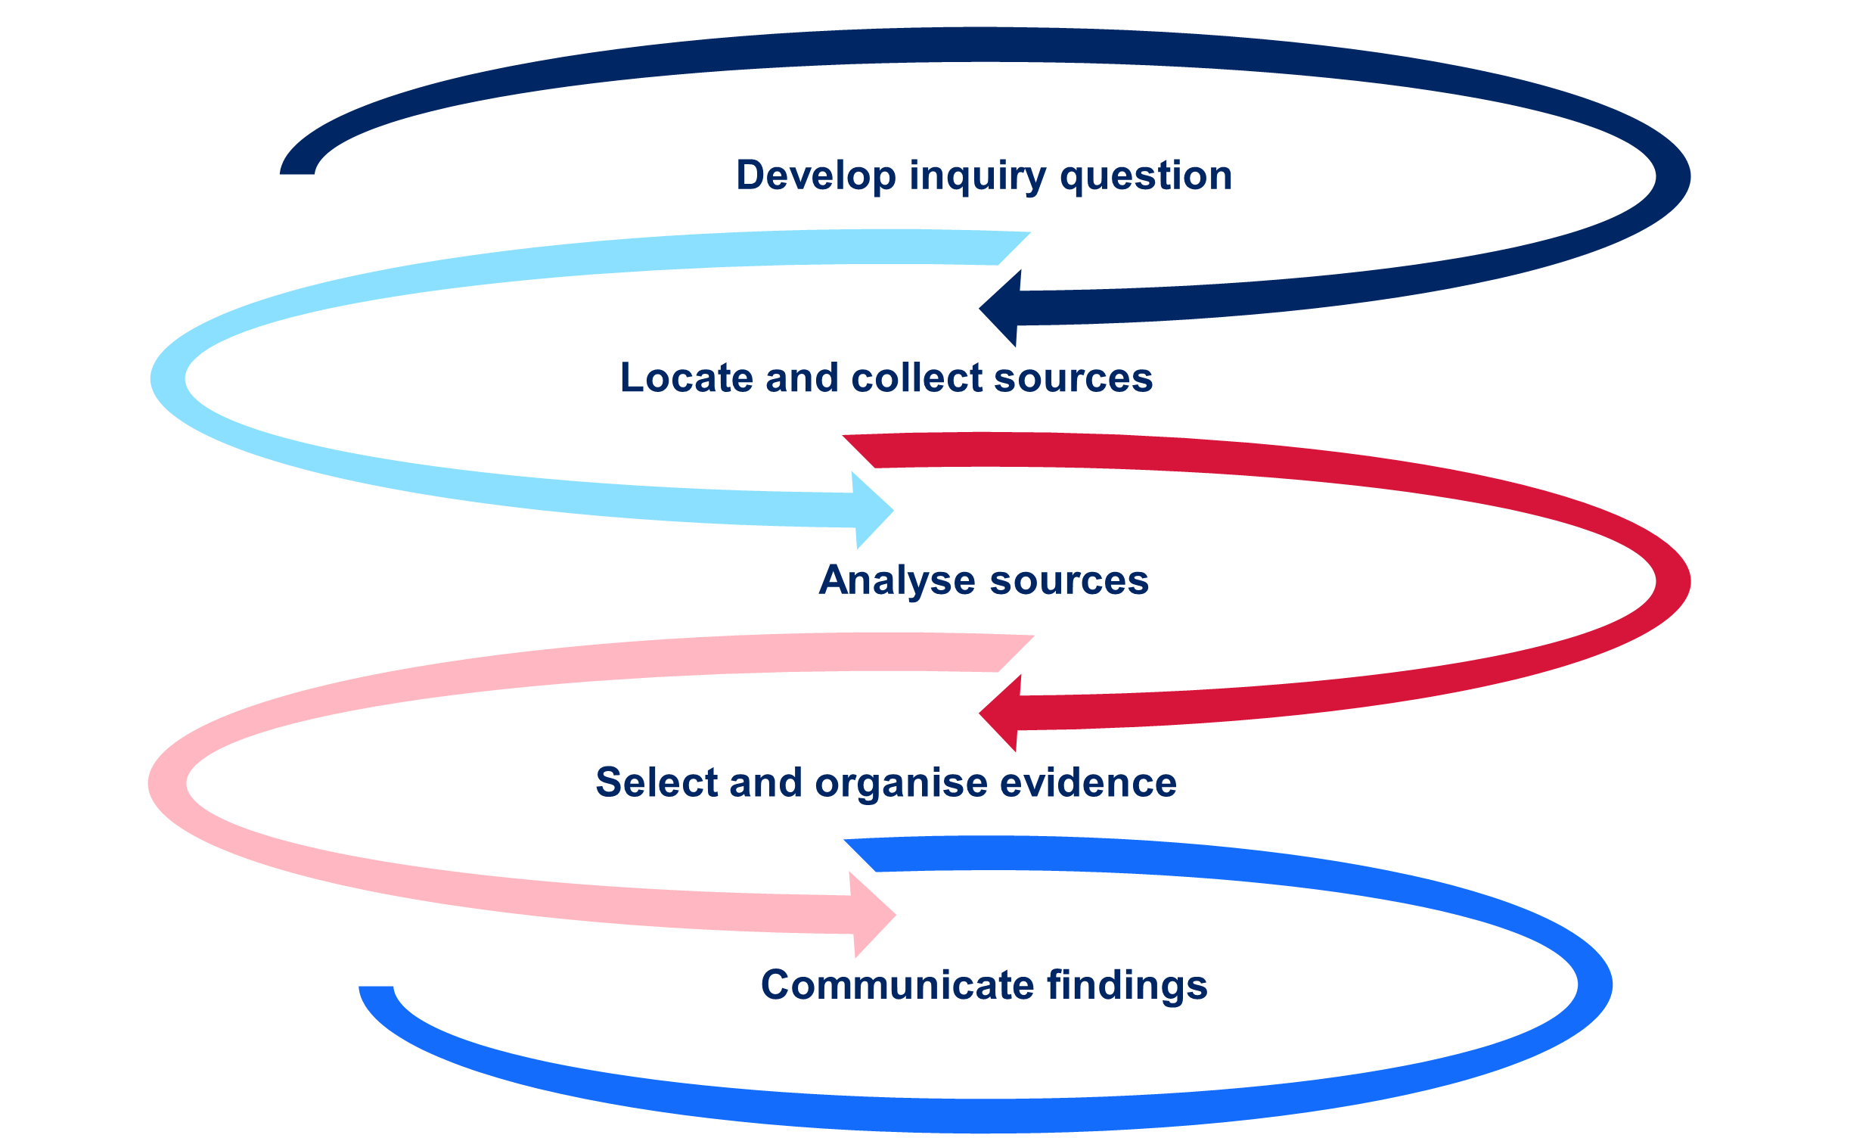

### Develop inquiry question

**Note**: the research for this activity should not be extensive; only a brief understanding of the topic is required. Alternatively, teacher-identified resources can be provided.

Working in a small group, use [How to Create Key Inquiry Questions (3:56)](https://youtu.be/hTzI14M38Qc) as stimulus to develop a checklist for a good inquiry question. Compare your checklist with 2 other groups and make any adjustments needed to ensure your checklist:

* covers the core rules for a key inquiry question
* is clear and easy to use
* provides short suggestions and/or examples where appropriate.

Your group will be allocated one of the following inquiry topics. Each topic has a focus underwater archaeological site.

* Trade in ancient Egypt – Thonis-Heracleion.
* The Franklin expedition – *HMS Erebus.*
* The role of science in underwater archaeology – ‘Lost city’ off the coast of Zakynthos.
* African slave experiences during transport – São José shipwreck.
* Tuskegee Airmen training during World War II – Tuskegee plane wrecks in the Great Lakes.
* Trade during the Ming Dynasty – Ming Dynasty shipwrecks in the South China Sea.

Conduct brief research into the topic and archaeological site. Prepare and deliver a 2-minute class presentation covering:

* a brief overview of the topic and the archaeological site
* the inquiry question you would investigate for this topic as an underwater archaeologist, including a demonstration of how the question meets the criteria on your checklist
* the 3 to 5 sub-questions you would use to address the inquiry question.

**Differentiation**: [Differentiating learning – flexible student grouping options](https://education.nsw.gov.au/teaching-and-learning/professional-learning/teacher-quality-and-accreditation/strong-start-great-teachers/refining-practice/differentiating-learning#:~:text=Flexible%20student%20grouping%20options) provides useful grouping strategies that promote student social support.

### Locate and select sources

**Note**: the grid square activity is designed to be completed in a large outdoor space. Each group requires a minimum 15 metres of string and tent pegs are ideal to use as ground spikes. Timing for the activity can be adjusted to suit the needs of students. It can also be adapted for the classroom by reducing the measurement to 40 centimetres by 30 centimetres and using sticks with mounting tack. The activity targets understanding geometric properties numeracy indicator UGP7. Refer to [National Numeracy Learning Progression (Version 3)](https://www.australiancurriculum.edu.au/resources/national-literacy-and-numeracy-learning-progressions/version-3-of-national-literacy-and-numeracy-learning-progressions/). Groups for the grid square activity can be mixed ability based on numeracy skill level to allow for social support.

Sticky notes in 3 different colours are required for the comparison activity. Alternatively, a digital platform such as [Microsoft Whiteboard](https://whiteboard.office.com/) may be used.

Using Table 1, identify the methods for locating sources in land-based and underwater archaeology shown in the following videos:

* [How Do Archaeologists Know Where to Dig? (4:53)](https://youtu.be/O2zQSnrJ7ik)
* [Robert Ballard: Restore the Titanic from 5:16–9:13 (duration 3:57)](https://youtu.be/l25QT9YFQFM?si=MNLXBwBn2Npv-LlH&t=316) and [13:50–17:00 (duration 3:10)](https://youtu.be/l25QT9YFQFM?si=FqtVgIiEwBWHPJ8s&t=830).

Table 1 – methods for locating sources in archaeology

|  |  |
| --- | --- |
| Archaeological type | Methods for locating sources |
| Land-based archaeology |  |
| Underwater archaeology |  |

Engage with [Underwater Archaeology | SciTech Now (6:27)](https://youtu.be/BITmXuNkYgU) and use the guiding questions below to take notes:

* What are some advantages of underwater archaeology?
* What technologies were used to locate archaeological sites at Lake Huron?
* What were the benefits of using these technologies?

Use Table 2 to guide online research into technologies used to locate archaeological sites. For each technology, determine if it is used in land-based or underwater archaeology, or both. The following websites are a starting point for your research:

* [Remote Sensing in Archaeology](https://archaeology.ncdcr.gov/blog/2021-04-16/remote-sensing)
* [Six tools that are revolutionising archaeology by helping us find sites without digging](https://theconversation.com/six-tools-that-are-revolutionising-archaeology-by-helping-us-find-sites-without-digging-51826)
* [AI Is Dramatically Changing Archaeology, Discovering New Sites And Artifacts](https://www.unite.ai/ai-is-dramatically-changing-archaeology-discovering-new-sites-and-artifacts/)

Table 2 – technology used to locate archaeological sites

|  |  |  |
| --- | --- | --- |
| Technology | Notes from research | Used in land-based and/or underwater archaeology |
| Aerial photography |  |  |
| Artificial intelligence (AI) |  |  |
| Drones |  |  |
| Ground penetrating radar (GPR) |  |  |
| LiDAR |  |  |
| Magnetometers |  |  |
| Portable x-ray fluorescence analysers (pXRF) |  |  |
| Remote operating vehicles (ROVs) and autonomous underwater vehicles (AUVs) |  |  |
| Satellite imagery |  |  |
| Sonar |  |  |

Once a site has been located, archaeologists set up a string grid to support excavation. A typical grid square is a 4 metre by 3 metre rectangle. In small groups, attempt to accurately set up a 4 metre by 3 metre grid square in under 5 minutes using the following tools:

* string
* 2 tape measures
* 6 ground spikes
* mallet.

Reflect on this activity in class discussion using the following questions:

* What strategy did you use to create your grid square?
* Why do you think a 4 metre by 3 metre grid square is typically used?

Engage with [Archaeology Skills: stringing up an excavation unit (6:53)](https://youtu.be/xSC3LACE5kQ) then continue the class reflection discussion:

* How does the strategy in the video compare to the one you used?
* Do you think a string grid can be used in underwater archaeology?
* What tools could make setting up a string grid easier?

Create a list of tools used in archaeology using the following videos and websites:

* [The Excavation Process: How We Excavate (3:05)](https://youtu.be/PcT1vGyJzyg)
* [#8 How do you excavate underwater (Discovering underwater archaeology) (2:28)](https://youtu.be/7Gohv_AzQUk)
* [What Tools Do Archaeologists Use: Exploring The Essential Toolkit](https://www.spatialpost.com/what-tools-do-archaeologists-use/)
* [Tools for Foreshore and Underwater Archaeology](https://www.3hconsulting.com/techniques/TechEquipment.html).

Compare land-based and underwater archaeological methods and tools for locating and excavating sources based on your work so far. Write your comparison on 3 different coloured sticky notes:

* colour 1: methods and/or tools used only by underwater archaeologists
* colour 2: methods and/or tools used only by land-based archaeologists
* colour 3: methods and/or tools used by both.

Share your sticky notes with a partner and brainstorm additional similarities and differences. Write these on sticky notes. Share your sticky notes in a class discussion.

### Analyse sources

**Note**: a free National Geographic account is required to access [How archaeologists determine the date of ancient sites and artefacts](https://www.nationalgeographic.com/culture/article/archaeologist-methods-date-sites-artifacts).

Appendix 2 – artefact groups for sorting activity can either be printed or provided digitally for the activity.

Classroom furniture may need to be moved to allow free movement during the star discussion activity. Alternatively, an open space outside the classroom could be used.

Consider the following when analysing a source:

* Type:
* is the source written, archaeological or both?
* what is the source made from?
* Origin:
* when was the source made?
* is it a primary or secondary source?
* who made the source?
* Reason:
* why was the source made?
* what was the purpose of the source?
* Content:
* what do we learn about the past from the source?
* what specific evidence does it provide?
* Honesty:
* how reliable is the source?
* can the evidence be trusted?
* do other sources support the evidence?

Use these points to analyse Figure 2.

Figure 2 – ’All that was left of the greatest ship in the world’ photograph of *Titanic* lifeboats.

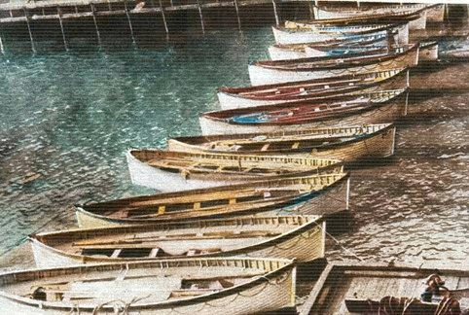

‘[*Titanic* life boats recovered](https://commons.wikimedia.org/wiki/File:Titanic_life_boats_recovered.jpg)’ originally published in *The Pageant of the Century* (1912) is available in the [public domain](https://commons.wikimedia.org/wiki/Commons:Licensing#Material_in_the_public_domain) and has been modified through digital colourisation using Palette in 2023.

**Note**: suggested answers:

Type: archaeological source; digitally altered photograph.

Origin: 1912; it is a secondary source as it is a reproduction; a photographer who colourised it with an AI website.

Reason: to show how many lifeboats were recovered from the *Titanic*; Photo taken for a publication.

Content: the source indicates 13 wooden lifeboats were recovered from the *Titanic* sinking.

Honesty: lack of photographer name makes it difficult to assess reliability; There’s no clear indication in the image the boats were from the *Titanic*. Colourisation of the image may not be accurate. Photograph was taken for commercial reasons rather than for historical record; There were 20 lifeboats on the *Titanic*: 2 wooden cutters, 14 standard wooden lifeboats and 4 collapsible canvas lifeboats.

When the date of an archaeological source is unknown, we can use dating methods to determine its origin. Working in small groups, sort one set of artefacts from Appendix 2 in what you think is the correct chronological order (oldest to newest). Share your ordered artefacts with a pair who sorted a different set of artefacts in a tuning protocol:

1. Pair 1 presents their sorted artefacts and justifies the order.
2. Pair 2 asks clarifying questions then offers feedback and suggestions.
3. Pair 1 can choose to change the order of their artefacts.
4. Repeat this process with roles reversed.

Complete Table 3 on archaeological dating methods using information from the following sources:

* [How archaeologists determine the date of ancient sites and artifacts](https://www.nationalgeographic.com/culture/article/archaeologist-methods-date-sites-artifacts)
* [The incredible ways we can tell how old ancient artefacts are](https://www.historyskills.com/classroom/ancient-history/anc-absolute-dating-reading/).

Table 3 – dating methods

|  |  |  |
| --- | --- | --- |
| Dating method | Description and use | Limitations |
| Stratigraphy |  |  |
| Seriation |  |  |
| Carbon-14 dating  (radiocarbon dating) |  |  |
| Dendrochronology |  |  |
| Thermoluminescence |  |  |

Participate in a [Think-Pair-Share](https://app.education.nsw.gov.au/digital-learning-selector/LearningActivity/Card/645?clearCache=5e1b194-d54a-909e-7aec-26a89d2b81eb) routine to consider:

* other limitations that can be added to the table
* which dating method best matches your process in the artefact sorting activity.

Participate in a star discussion activity on the following scenario:

You are an underwater archaeologist who discovered an ancient timber ship. The ship is filled with amphorae (ancient pottery jars) and jewellery with precious stones. Some amphorae appear to contain organic material. Your budget only allows you to use one dating method in your study. Which method would you choose and why?

1. Using Figure 3 as a guide, stand in a position in the classroom to show your choice.

Figure 3 – star discussion layout

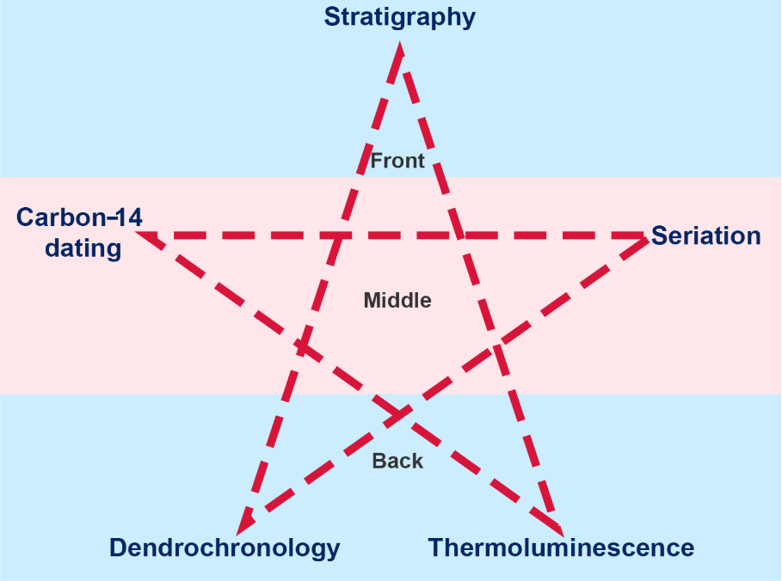

1. Develop a 30-second pitch as a group for why your dating method is the ‘star’.
2. Deliver the pitch to the class.
3. Move to the dating method you think is the most appropriate after the final pitch. You can remain in your original position.
4. The dating method with the most students is selected as the ‘star’ dating method.

Engage with the following sources:

* [How AI is helping historians better understand our past](https://www.technologyreview.com/2023/04/11/1071104/ai-helping-historians-analyze-past/)
* [The AI historian: A new tool to decipher ancient texts (6:53)](https://youtu.be/rq0Ex_qCKeQ).

Conduct a [Socratic seminar](https://www.facinghistory.org/resource-library/socratic-seminar) on the topic: What impacts could AI have on source analysis?

### Select and organise evidence

**Differentiation**: the [higher order thinking](https://education.nsw.gov.au/teaching-and-learning/high-potential-and-gifted-education/supporting-educators/implement/differentiation-adjustment-strategies#:~:text=thinking%20(DLS%20applications)-,Adjustment%3A%20Higher%20order%20thinking,-Strategies) of this activity can be adjusted to suit HPGE students. Students could develop their own historical inquiry question after examining the webpage and challenge other students to select 3 sites to suit their historical inquiry question.

Select 3 sites from [Historical Context – Ancient History](https://bth.humanrights.gov.au/significance/historical-context-ancient-history) that provide the best evidence for the inquiry question: How did tools used by Aboriginal peoples in ancient Australia develop over time?

* Rank the sites in order of relevance to the historical inquiry.
* Compare your sites with a partner and select one site that would be the most useful for the historical inquiry.
* Working with your partner, co-produce an annotation (maximum 150 words) about the site you selected as the most useful explaining:
* how this source would be useful for the inquiry
* what could make it more useful to the inquiry
* any historiographical issues that could affect the reliability of the source.
* Swap annotations with another pair and provide feedback on their annotation.

### Communicate findings

**Note**: [Dive & Dig Podcast Series](https://honorfrostfoundation.org/podcast/) contains all episodes of the podcast.

A transcript should be provided for hearing impaired and EAL/D students. [Dive & Dig II – Builders of the Pyramids, Wadi el Jarf, Egypt (28:02)](https://audioboom.com/posts/8174676-d-d-ii-builders-of-the-pyramids-wadi-el-jarf-egypt) is available for free download. A [transcript](https://support.microsoft.com/en-us/office/transcribe-your-recordings-7fc2efec-245e-45f0-b053-2a97531ecf57) can be created from the downloaded audio file.

Conduct a class brainstorm of ways research findings can be communicated. Rank ideas from the brainstorming session from most to least effective communication methods. Justify your rankings.

Listen to [Dive & Dig II – Builders of the Pyramids, Wadi el Jarf, Egypt (28:02)](https://audioboom.com/posts/8174676-d-d-ii-builders-of-the-pyramids-wadi-el-jarf-egypt) podcast.

* Construct a summary of what you remember at the end of the podcast.
* Working in small groups, complete a [cost-benefit analysis](https://app.education.nsw.gov.au/digital-learning-selector/LearningActivity/Card/659?clearCache=436b81a5-aa3e-e3f5-160e-865d48b84a50) about using podcasts to communicate findings. Share your analysis with the class.
* Discuss as a class why podcasts have become a popular communication medium for historical and archaeological findings.

Compare the 2 paragraphs on [Why is referencing important?](https://www.student.unsw.edu.au/why-referencing-important#:~:text=writing%20more%20persuasive.-,Exercise%3A%20Look%20at%20the%20two%20paragraphs%20below%3A%20which%20one%20seems,allow%20a%20song%20to%20be%20made%20to%20speak%20to%20political%20issues.,-The%20paragraphs%20are) Which appears to be the most authoritative? Justify your response. Participate in a class discussion about why we reference when communicating findings of an historical inquiry.

Look back at your drawing of a historian and an archaeologist. Would you change anything about your drawings based on your learning so far?

## Sources used in underwater archaeology

**Note**: explicit teaching of vocabulary is required to support students with literacy needs to access the readings in this learning sequence. [Vocabulary](https://education.nsw.gov.au/teaching-and-learning/curriculum/literacy-and-numeracy/teaching-and-learning-resources/literacy/effective-reading-in-the-early-years-of-school/vocabulary) provides guidance on vocabulary instruction. Estimated article reading time for the Jigsaw activity is 15 minutes. One group is given 2 articles for equity in content and reading time.

Conduct a class [Jigsaw](https://app.education.nsw.gov.au/digital-learning-selector/LearningActivity/Card/546?clearCache=f63dfe61-fcd6-277b-edcc-efcfcb44a401) on underwater archaeology.

1. Examine one set of articles from the list below in your expert group.

* [Ancient Cities Lost Under the Aegean Sea in Greece](https://greekreporter.com/2022/04/17/ancient-cities-lost-under-aegean-sea-greece/) and [A Submerged 7,000-Year-Old Discovery Shows the Great Potential of Underwater Archaeology](https://www.smithsonianmag.com/science-nature/archaeology-underwater-australia-180975235/)
* [Clues to the Lives of North America’s First Inhabitants Are Hidden Underwater](https://www.smithsonianmag.com/history/biggest-clues-lives-early-americans-hidden-underwater-submerged-prehistory-180981891/)
* Lost cities #6: [how Thonis-Heracleion resurfaced after 1,000 years under water](https://www.theguardian.com/cities/2016/aug/15/lost-cities-6-thonis-heracleion-egypt-sunken-sea)
* [Relics of the Kamikaze](https://archive.archaeology.org/0301/etc/kamikaze.html)
* [Underwater archaeology: Hunt for the ancient mariner](https://www.nature.com/articles/481426a)

1. Highlight key words in the article and write them in the appropriate section of Table 4. Using the key words, write a summary of what you learned from the article for each key question.

Table 4 – article summary scaffold

|  |  |  |
| --- | --- | --- |
| Question | Key words | Summary |
| What artefacts have been found by this underwater archaeology project? |  |  |
| What have we learned about the past from this project? |  |  |
| What technology was used in this project? |  |  |
| What future research could be conducted? |  |  |

1. Move to your home group and share the article summaries.
2. As a group, create a statement about the role underwater archaeology plays in shaping our understanding of the past. Share your group statement with the class.

# Learning sequence 2 – continuity, change and historical meaning

This learning sequence builds understanding of continuity and change. It uses a *Titanic* case study to explore varying constructions of historical meaning over time. This sequence addresses the historical concepts of continuity and change, perspectives and contestability. It incorporates historical skills of comprehension, analysis and use of sources, and perspectives and interpretations.

**Duration:** this learning sequence is designed to be completed in approximately 6 hours.

## Syllabus content

Students:

* explain the significance of features of continuity and change
* examine the varying constructions of historical meaning through a range of examples.

## Learning intentions and success criteria

**Note:** these learning intentions and success criteria are general and should be contextualised to suit your school and students’ needs.

Students learn about:

* the features of continuity and change
* how historical constructions vary over time using a range of underwater archaeological sites.

Students will be able to:

* identify features of continuity and change
* explain the significance of continuity and change
* examine varying constructions of historical meaning at multiple underwater archaeological sites.

## Features of continuity and change

**Note**: visually impaired students will require support to complete the spot the difference activity. The [3D City Planning Set](https://www.thingiverse.com/thing:6091482) could be used as an alternative for this task with the teacher constructing a cityscape then changing some elements.

The 4-quadrant diagram can be conducted digitally using [Microsoft Whiteboard](https://whiteboard.office.com/) with students adding examples as sticky notes.

Inspect Figure 4 and Figure 5. Circle the differences you spot in Figure 5.

Figure 4 – aerial view of construction of Sydney Harbour Bridge Jan 1930

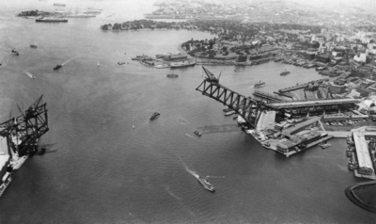

[Image](https://digitalcollections.qut.edu.au/7015/) by Isabel Edith Doris is available in the public domain.

Figure 5 – Harbour View 2006

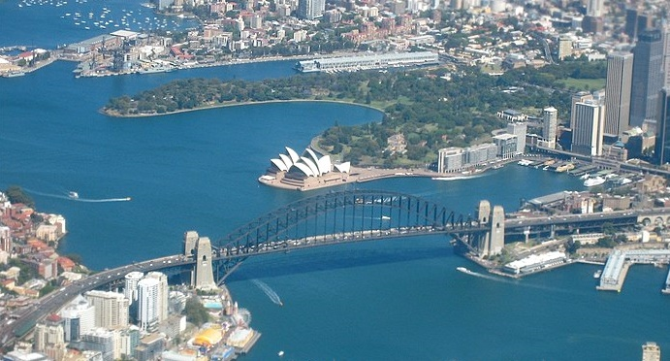

‘[Harbour View](https://www.flickr.com/photos/cogdog/1800517728/)’ by Alan Levine is available in the [public domain](https://creativecommons.org/publicdomain/zero/1.0/).

Things you circled are examples of change over time. The features you did not circle are examples of continuity. Continuity and change are core concepts in the study of history.

When constructing an understanding of the past, historians and archaeologists consider what factors were continuous and what changed over time. PESTLE is a useful tool for analysing continuity and change by considering the following categories:

* Political: government, power, peace and conflict
* Economic: currency, earning and spending
* Social: everyday lives and roles of people
* Technological: inventions, innovations, machinery and weapons
* Legal: laws, regulations and judicial systems
* Environmental: nature, climate and human impacts.

Conduct a PESTLE analysis using Table 5 on continuity and change in the world during your lifetime. Include at least 2 points for each category.

Table 5 – PESTLE analysis

|  |  |  |
| --- | --- | --- |
| Feature | Continuity | Change |
| Political |  |  |
| Economic |  |  |
| Social |  |  |
| Technological |  |  |
| Legal |  |  |
| Environmental |  |  |

Select 3 examples of continuity and 3 examples of change. Share your examples on a 4–quadrant diagram as shown in Figure 6.

Figure 6 – continuity and change 4-quadrant diagram

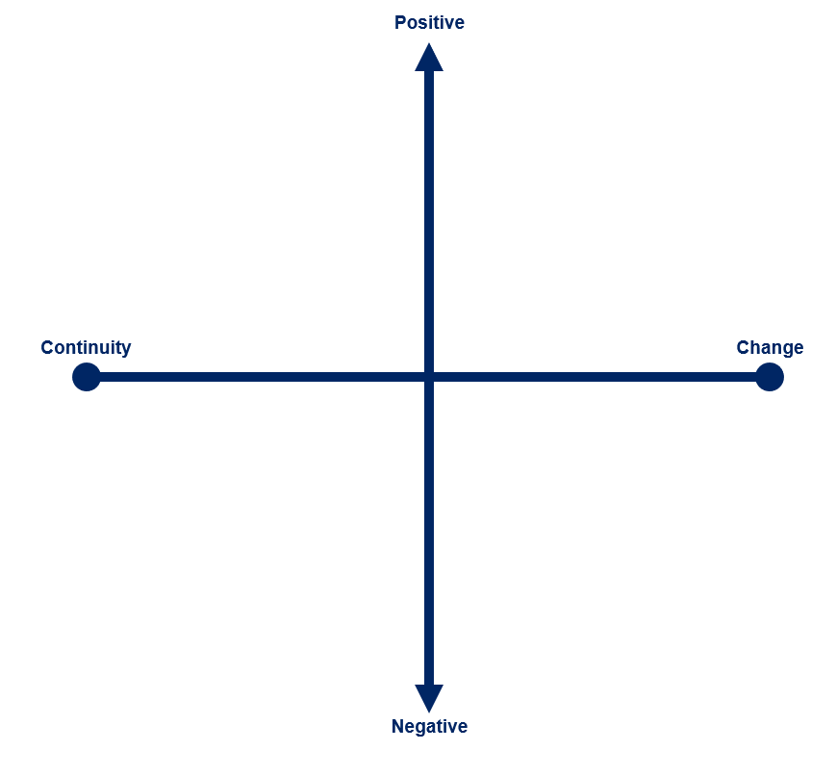

## Varying constructions of historical meaning

**Note**: students require numeracy skills in percentages (PrT2) and interpreting charts (IRD3) for these tasks. [What is Percent? | Simple (2:56)](https://youtu.be/EUfCmluK94o) and [Common graphs (2:58)](https://education.nsw.gov.au/teaching-and-learning/curriculum/hsie/hsie-curriculum-resources-k-12/hsie-7-10-curriculum-resources/common-graphs) can be used to explicitly teach these skills to students with below stage numeracy skills. Refer to [National Numeracy Learning Progression (Version 3)](https://www.australiancurriculum.edu.au/resources/national-literacy-and-numeracy-learning-progressions/version-3-of-national-literacy-and-numeracy-learning-progressions/) for progression indicators.

Some videos do not need to be played in full for the activities. Timing guidance is provided after the hyperlink for these videos. [What did Titanic's Break Up REALLY Look Like? (15:06)](https://youtu.be/9FLsr-t1mSY?si=UBExipQ4f8Df1xxz) provides an analysis of film depictions of the *Titanic* sinking in the first 9 minutes. This is not required for the activity but could be used for a ‘Film as history’ option study.

[Enhanced teaching and learning activities for EAL/D learners](https://sites.google.com/view/hsc-minimum-standard/writing/text-structure#h.p_vARW9qOlrvCJ) provides strategies and graphic organisers that can be used to support EAL/D and students with additional literacy needs with the essay activity.

Engage with [Archives have the power to boost marginalised voices (8:23)](https://youtu.be/XsNPlBBi1IE) and complete a [Connect, Extend, Challenge](https://pz.harvard.edu/resources/connect-extend-challenge) thinking routine. Share your responses with a partner, then discuss how you would like your year group to be remembered by the school community in 20 years. Create a card for the school archives using Appendix 3. Share your card with the class, then conduct a class discussion assessing how archives can influence the construction of historical meaning.

When using sources, historians and archaeologists need to consider potential historiographical issues. Some key historiographical issues are:

* **Fact or opinion**: most sources are made by everyday people, not historians. As such, these sources require close attention to separate historical facts from opinions. Comparing sources to other evidence can be useful to identify facts and opinions.
* **Bias**: this is when the source is influenced by the creator’s attitudes about factors such as gender, race and politics. It is important to know the background of the source’s creator, including attitudes of their society and time, to assess potential bias.
* **One-sided accounts**: sometimes the available evidence only shows viewpoints from one side of an issue or event. It is important to look for additional viewpoints. If none are available, cautiously consider what other viewpoints there may have been.

Inspect [G.Bron's chart of "The Loss of the 'Titanic'", from The Sphere, 4 May 1912](https://www.researchgate.net/figure/GBrons-chart-of-The-Loss-of-the-Titanic-from-The-Sphere-4-May-1912-Each-subgroup_fig1_330916468). Calculate the percentage of survivors who were:

* passengers
* crew
* men
* women
* children.

In 1912, 91 survivors testified at either the US or British *Titanic* inquiries, with some providing witness statements at both. Using Figure 7 and Figure 8, compare the breakdown of official survivor testimony to the survivor percentages you calculated. Based on this comparison and the key historiographical issues outlined on the previous page, write a paragraph about the issues involved when using witness statements from the inquiries in an historical inquiry on the sinking of the *Titanic*.

Figure 7 – survivor testimony by role

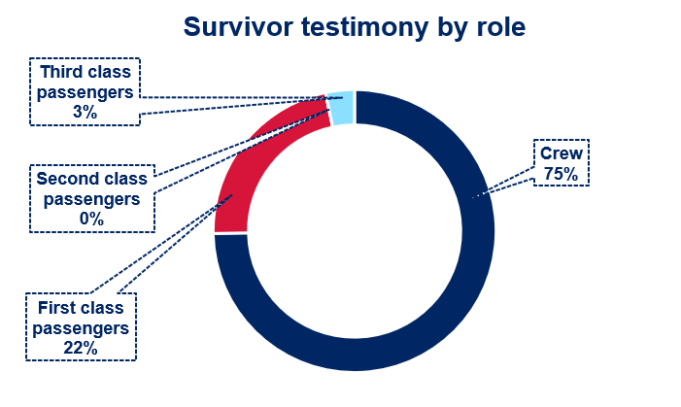

Figure 8 – survivor testimony by gender

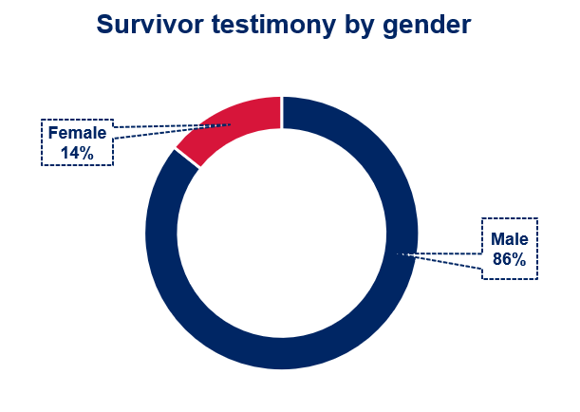

Read the findings about the final stages of the *Titanic* sinking in the [United States Senate Inquiry Report](https://www.titanicinquiry.org/USInq/USReport/AmInqRep07.php#a7:~:text=SHIP%20SINKING.,she%20was%20sinking.) and [British Wreck Commissioner’s Inquiry Report](https://www.titanicinquiry.org/BOTInq/BOTReport/botRepFinEff.php). Write a short summary of how the *Titanic* sank based on the final reports.

Use Appendix 4 – *Titanic* survivor testimony extracts to answer these questions:

* Which witness statement matches the findings in the final reports for the inquiries?
* Why do you think this witness was considered more reliable? Justify your response with evidence from the testimony extracts.
* Which version of events do you find the most credible? Justify your response with evidence from the testimony extracts.

Conduct content analysis on [The Titanic Break-Up](https://www.encyclopedia-titanica.org/the-titanic-break-up.html) using the scaffold in Table 6 to categorise the types of survivors who stated the *Titanic* broke in 2 while sinking. Survivor details to support categorisation are available through [Titanic survivors](https://www.encyclopedia-titanica.org/titanic-survivors/).

Table 6 – content analysis scaffold

|  |  |  |
| --- | --- | --- |
| Category | Tally | Total |
| Males |  |  |
| Females |  |  |
| Passengers |  |  |
| Crew |  |  |

Engage with [What did Titanic's Break Up REALLY Look Like? (15:06)](https://youtu.be/9FLsr-t1mSY?si=zjfr8vF42Jtkc8n9&t=553) – watch 9:13–15:06. Consider how the conditions at the time of the sinking may have impacted on survivor testimony.

Participate in a [snowball discussion](https://education.nsw.gov.au/teaching-and-learning/learning-remotely/teaching-at-home/expectations/contemporary-learning-and-teaching-from-home/learning-from-home--teaching-strategies#/asset8) about why the *Titanic* breaking in half was dismissed by authorities despite the number of survivors stating they witnessed the ship break. Consider historiographical issues using evidence from the activities completed so far.

Engage with sections of the following clips then write a short reflection on how the discovery of the *Titanic* in 1985 impacted interpretations of the sinking.

* [From the archives: Titanic shipwreck's discovery in 1985; survivors react (7:43)](https://youtu.be/F0qasc6RHPI) – relevant section 0:00–2:53.
* [From the archives: Footage of Titanic shared by Robert Ballard in 1985 (49:41)](https://youtu.be/Fe54buLGWS8?si=BH3eqmBV5qWI3x7K&t=2685) – relevant section 44:45–48:21.

Your teacher will assign you a theory for the sinking of the *Titanic*.

* Complete a [dictagloss](https://app.education.nsw.gov.au/digital-learning-selector/LearningActivity/Card/661?clearCache=d59f5eb-449e-4833-6f1d-b7b7fa4d7cfb) for the theory as it is presented in [Structural Integrity Failure: Titanic Modern Break Ups (18:56)](https://youtu.be/5Pf47oV5UCQ?si=OLH9CtE5nZU8CSvE):
* Richard Woytowich and Roy Mengot Theory: [05:42–10:09](https://www.youtube.com/watch?v=5Pf47oV5UCQ&t=342s) (duration 4:27)
* George Behe, Tad Fitch, J. Kent Layton, and Bill Wormstedt: [10:10–13:27](https://www.youtube.com/watch?v=5Pf47oV5UCQ&t=610s) (duration 3:17)
* Samuel Halpern: [13:28–18:01](https://www.youtube.com/watch?v=5Pf47oV5UCQ&t=808s) (duration 4:33).
* Compare your recreated text with a partner who watched the same theory. Edit your text recreation to include any key details you missed in your first write.
* Form a group of 3 with students who watched the other theories. Share your text recreations then decide on the best theory, or develop your own, as a group. Share with the class, justifying your decision with evidence.

Read [Titanic Sank Quickly](https://maritime-executive.com/article/2005-12-09titanic-sank-quickly) and answer:

* What was discovered?
* How did this discovery change our understanding of the *Titanic* sinking?
* Why wasn’t this evidence discovered sooner?

Write an essay response for the question: Examine the role of evidence in changing theories about the sinking of the *Titanic* over time.

# Learning sequence 3 – issues related to the study of the past

This learning sequence builds understanding of continuity and change. It uses a *Titanic* case study to explore varying constructions of historical meaning over time. This sequence addresses the historical concepts of cause and effect, perspectives and significance. It incorporates historical skills of comprehension, perspectives and interpretations, and explanation and communication.

**Duration:** this learning sequence is designed to be completed in approximately 7 hours.

## Syllabus content

Students:

* identify and examine the various means of collecting sources, displaying the past and reconstructing the past
* identify and assess the ethical issues arising from ownership of the past
* analyse the significance of preservation and conservation issues.

## Learning intentions and success criteria

**Note:** these learning intentions and success criteria are general and should be contextualised to suit your school and students’ needs.

Students learn about:

* how underwater sources are collected, displayed and used to reconstruct the past
* the difference between legal and ethical issues arising from ownership of the past
* about preservation and conservation issues for underwater archaeological sites.

Students will be able to:

* discuss methods for collecting and displaying sources from underwater sites
* examine how sources from the *Titanic* are used to reconstruct the past
* identify and assess ethical issues arising from ownership of the *Titanic*
* analyse the significance of preservation and conservation issues.

## Collecting sources, displaying the past and reconstructing the past

**Note**: previous exposure to a museum could be useful to support student learning. The [Chau Chak Wing Museum virtual excursion](https://app.situ360.com/30a92f/9467/61633/public) can be explored as a class to give students a visual of a traditional museum.

A free SBS On Demand account is required to view [The First Inventors: Season 1 Episode 2 –Science of Story (46:24)](https://www.sbs.com.au/ondemand/tv-series/the-first-inventors/season-1/the-first-inventors-s1-ep2/2219829827888).

Classroom furniture may need to be moved to support creation of 5 stations and free student movement in the [Conver-stations](https://portal.emints.org/store/p177/Conver-stations.html#:~:text=Conver%2Dstations%20is%20a%20small,for%20conversations%20on%20related%20topics.) activity.

Complete the first 2 columns of a [KWLH chart](https://app.education.nsw.gov.au/digital-learning-selector/LearningActivity/Card/562?clearCache=d6d67b2d-c2b8-38a8-4889-ed062758ecec) on the topic of underwater archaeology.

Engage with [Difficulties and Advantages of Underwater Archaeology along with the Demonstration of Invisible Wonders](https://www.walshmedicalmedia.com/open-access/difficulties-and-advantages-of-underwater-archaeology-along-with-the-demonstration-of-invisible-wonders-120432.html), [#8 How do you excavate underwater (Discovering underwater archaeology) (2:28)](https://youtu.be/7Gohv_AzQUk?si=CgOdSpTGqa5RfQy9), [#9 Do you bring everything back to the surface (Discovering underwater archaeology) (1:51)](https://youtu.be/pcUlrENXYFw?si=6pOj-9cjbrSgBWny) and [#11 How do you bring objects to the surface (Discovering underwater archaeology) (2:29)](https://youtu.be/ICaDxCglV7A?si=dPHL5TKBXFOd6fr6). Take notes on:

* the challenges when studying underwater sites
* the importance of underwater archaeology to our understanding of the past
* ways sources can be excavated from underwater archaeological sites.

Use [The First Inventors: Season 1 Episode 2 –Science of Story (46:24)](https://www.sbs.com.au/ondemand/tv-series/the-first-inventors/season-1/the-first-inventors-s1-ep2/2219829827888) from 3:35–15:25 and [Ancient Aboriginal underwater site in Flying Foam Passage thought to be deepest in Australia](https://www.abc.net.au/news/2023-06-28/underwater-ancient-aboriginal-discovery-pilbara-wa/102529502) to answer the following:

* What sources have been found underwater at Murujuga?
* How were these sources found?
* What role did the local Aboriginal community play in the discovery and analysis of these sources?
* What can archaeologists learn from the sources?
* How could this research impact the reconstruction of Australia’s past?

Engage with [You can now explore a 2,500-year-old shipwreck (0:49)](https://edition.cnn.com/videos/travel/2020/08/03/greece-underwater-museum-shipwreck-orig-mss.cnn) and [Ocean explorer and adventurer Victor Vescovo on Titan submersible tragedy (3:46)](https://youtu.be/EDdehXmaS4o). Form small groups and complete a [PMI chart](https://app.education.nsw.gov.au/digital-learning-selector/LearningActivity/Card/551?clearCache=27cce83e-2fe6-81c7-2cd4-b00ad12b5e82) on using underwater sites for tourism.

Conduct a [Conver-stations](https://portal.emints.org/store/p177/Conver-stations.html#:~:text=Conver%2Dstations%20is%20a%20small,for%20conversations%20on%20related%20topics.) on the following starters:

* Why do museums and other institutions display sources?
* Who benefits from sources being displayed?
* Should sources from underwater sites be excavated and put on display, or left in-situ (where they were found)?
* Should underwater archaeological sites be used as tourist attractions?
* Are there any historical sources that should not be on public display?

Engage with the following clips then complete a comparison of *Titanic* imagery using Table 7.

* [Titanic Real Footage: Leaving Belfast for Disaster (6:46)](https://youtu.be/05o7sOAjtXE?si=RwGIEcObfTtrHWLo) – from 0:00–1:06
* [When Alvin visited the wreck of the Titanic (1:21:55)](https://youtu.be/kmfjjsRbKCY?si=E5zC641L_-Ac54NI&t=320) – from 5:20–9:20
* [Scan of Titanic reveals wreck as never seen before – BBC News (10:13)](https://youtu.be/R2XtefrMNhg) – from 0:00–4:09.

Table 7 – *Titanic* imagery comparison

|  |  |  |  |  |
| --- | --- | --- | --- | --- |
| Comparison | 1912 footage | 1986 footage | 4K footage | 3D reconstruction |
| Visibility |  |  |  |  |
| Detail |  |  |  |  |

Use [Titanic shipwreck visualised on the seabed for first time in 3D scan](https://www.abc.net.au/news/2023-05-18/titanic-3d-visualisation-scan-deep-sea-mapping/102360630) and [3D scan of Titanic reveals wreck as never seen before – BBC News (10:13)](https://youtu.be/R2XtefrMNhg?si=atY5rIDcS5tXDhpL&t=249) from 4:09–10:13 to answer the following:

* How was the 3D reconstruction made?
* In what ways is the 3D reconstruction changing interpretations about the *Titanic*?
* How are other technologies being used to reconstruct the stories of the *Titanic’s* passengers and final moments?

*Titanic: Honor and Glory* is a video game currently under development that is based on a virtual reconstruction of the *Titanic* before it sank. Players can ‘walk in the shoes’ of a person on *Titanic’s* maiden voyage. The game includes ‘sinking mode’, a real-time recreation of the sinking. Engage with [Titanic Demo 401 – Official Update Trailer (1:59)](https://youtu.be/SIcLmLUgR4Q?si=6jOm8d4dKldpZMPN) and [Log entries – Part Three (6:47)](https://youtu.be/wPJjvC2w73k?si=1uuqSKNVkB6QJOOP) from 0:00–4:05 and then discuss:

* the reliability of the game as an historical source
* the role this game plays in shaping public understanding of the *Titanic*.

In small groups, complete a [See Think Wonder](https://app.education.nsw.gov.au/digital-learning-selector/LearningActivity/Card/662?clearCache=a360db58-71ae-b056-6977-98a4c807d4f9) on one of the *Titanic*: Honor and Glory videos below. Share your See Think Wonder with the class.

* [Titanic Demo 401 – First Class Trailer (2:42)](https://youtu.be/ZwlE_fkqUck?si=bu_0Y-noue6bn88P)
* [Titanic Demo 401 – Second Class Trailer (2:17)](https://youtu.be/AkOreUh1Lm8?si=Bm-0buj2Uh8Jo8-T)
* [Titanic Demo 401 – 3rd Class Trailer (2:55)](https://youtu.be/jkeY1HWba6E?si=KWOLEew2QbLNzMj1)
* [Titanic Demo 401 – Crew Trailer (4:08)](https://youtu.be/PaORR3EiuCc?si=z9TVfrWs5lz2zRE0)
* [Titanic Demo 401 – Exterior Trailer (2:49)](https://youtu.be/Imb4G_Ht0cI?si=mV4Gp4-TD4FbPXnt)
* [Titanic: Honor and Glory – Demo401 V2.0 Reciprocating Engine Room (2:12)](https://youtu.be/7O0pLaxS8oA?si=1X1OgVV3YejV6RgR)

**Differentiation**: [Adjustments](https://educationstandards.nsw.edu.au/wps/portal/nesa/k-10/diversity-in-learning/special-education/adjustments) provides suggestions for reading, listening, and viewing adjustments that may be useful for these activities to support access for students with disability. Blind and visually impaired students can be partnered with another student to describe the visuals in the *Titanic* imagery comparison and See Think Wonder activities.

## Who owns the past?

**Note**: proposed timing for the class trial:

* 15 minutes preparation time
* 3 minutes presentation time per group
* 5 minutes deliberation time for judging panel before handing down their decision.

[Reflective writing: the 3D format](https://www.scootle.edu.au/ec/viewing/S7033/index.html) provides teaching advice to support the student reflection activity.

Legal ownership of the *Titanic* and its artefacts is still debated today. The wreck site is in international waters, which adds to the complexity. Figure 9 shows the location of the *Titanic* site. Light blue represents territorial waters and dark blue represents international waters.

Figure 9 – map of *Titanic* wreck site

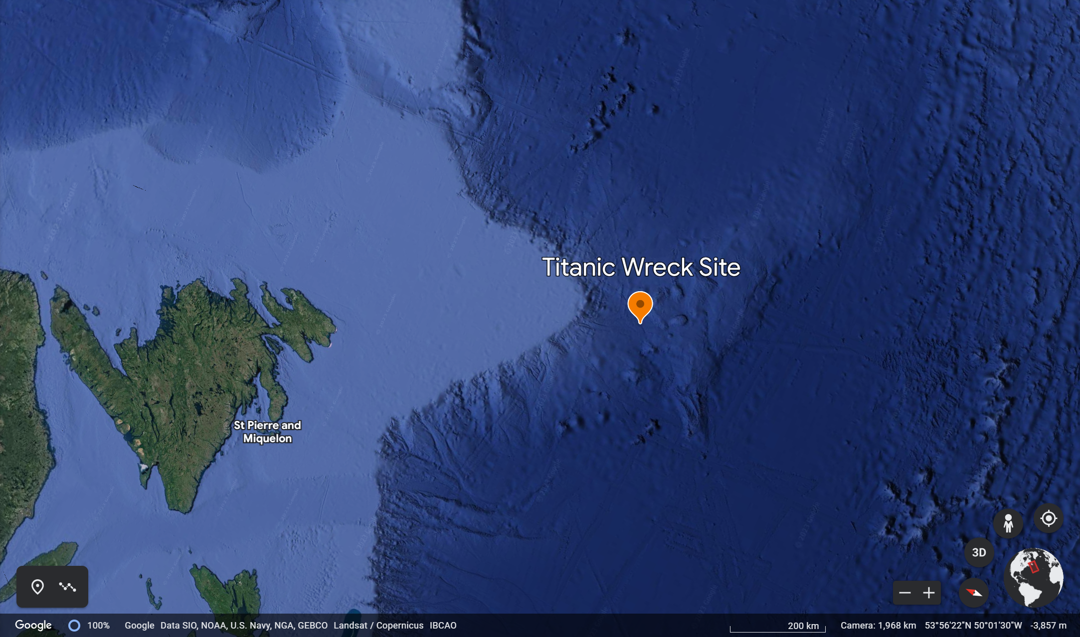

Map data by Google and SIO, NOAA, U.S. Navy, NGA, GEBCO, Landsat / Copernicus IBCAO.

Hold a class trial to determine who legally owns the *Titanic* and its related artefacts. Form 7 groups:

* Group 1 is the judging panel. They determine the order for cases to be presented and make final judgement on legal ownership. They read and discuss the following in preparation for the trial:
* [Are Finders Keepers Under the Sea? What You Need to Know About Finding Shipwrecked Treasures](https://www.lawinfo.com/resources/admiralty-maritime/are-finders-keepers-under-the-sea-what-you-ne.html)
* [UNESCO Convention](https://www.aima-underwater.org.au/unesco-convention.html) – this convention only applies to countries that ratify it (write it into laws in their country).
* Groups 2–7 are the claimants. They conduct a [Claim Support Question](https://app.education.nsw.gov.au/digital-learning-selector/LearningActivity/Card/664?clearCache=6900cb86-4b0d-210b-5bb0-37ddbf9aa016) to develop their argument for legal ownership and present their case during the trial. Each group represents one of the following perspectives:
* Carnival Corporation (modern owner of White Star Line) – shipping company that owned the *Titanic* in 1912
* Robert Ballard – finder of the *Titanic* site
* *Titanic* victim family members represented by Nancy Clark – great-granddaughter of *Titanic* victim Englehart C. Ostby
* RMS *Titanic* Inc. (RMST) formerly known as Titanic Ventures Limited Partnership (TVLP) – first company to salvage (bring to the surface) artefacts from the *Titanic*
* United Nations Educational, Scientific and Cultural Organization (UNESCO) – the international body responsible for the preservation of world heritage.

After the judging panel makes their decision, examine the highlighted text on [R.M.S Titanic – Frequently Asked Questions: Salvage](https://www.noaa.gov/gc-international-section/rms-titanic-frequently-asked-questions#:~:text=Titanic%20was%20a%20British%2Dregistered%20ship%20in,Covenants%20and%20Conditions%20carried%20over%20to%20PAHL.) and [Who owns the Titanic, and who can dive at the wreck?](https://www.thejournal.ie/who-owns-the-titanic-and-who-can-dive-at-the-wreck-404369-Apr2012/#:~:text=So%20who%20owns,be%5D%20no%20problem.%E2%80%9D) Construct a reflection comparing the decision of the class judging panel to the actual decision on ownership of the *Titanic*.

Use [Titanic salvage: recovering the ship’s radio could signal a disaster for underwater cultural heritage](https://theconversation.com/titanic-salvage-recovering-the-ships-radio-could-signal-a-disaster-for-underwater-cultural-heritage-139795) to answer the following questions:

* Is RMS *Titanic* Inc. legally allowed to remove the Marconi radio?
* Why is removing the Marconi radio considered unethical?
* Assess the reliability of this article as a source when studying preservation of the *Titanic*.

Examine [What have explorers recovered and sold?](https://www.cbsnews.com/news/robert-ballard-titanic-wreckage-1985-discovery-artifacts/#:~:text=What%20have%20explorers%20recovered%20and%20sold%3F) In small groups, conduct a [currency conversion](https://g.co/kgs/syXnqZ) to Australian dollars (AUD) for the artefact sale values then discuss:

* How are the value of artefacts determined?
* Apart from monetary value, what other value do these artefacts have?
* How appropriate are the prices for these artefacts?
* The estimated minimum cost of a *Titanic* expedition to recover artefacts is $8,000,000 (AUD). RMS *Titanic* have conducted 8 expeditions so far. How does the appraised value of their artefact collection compare to the cost involved in salvaging the artefacts?
* Should Premier Exhibitions and Henry Aldridge & Son be allowed to sell *Titanic* artefacts to private buyers? Justify your opinion.

Complete an [Options Diamond](https://pz.harvard.edu/resources/options-diamond) using Appendix 5 on the issue of ownership of historical artefacts.

**Differentiation**: [Differentiating learning – flexible student grouping options](https://education.nsw.gov.au/teaching-and-learning/professional-learning/teacher-quality-and-accreditation/strong-start-great-teachers/refining-practice/differentiating-learning#:~:text=Flexible%20student%20grouping%20options) provides useful grouping strategies that promote student social support.

Include time for ‘what if?’ questions after each group presentation in the class trial to adjust the [complexity](https://education.nsw.gov.au/teaching-and-learning/high-potential-and-gifted-education/supporting-educators/implement/differentiation-adjustment-strategies#:~:text=Learning%20Selector%20(DLS).-,Adjustment%3A%20Complexity,-Strategies) for HPGE students.

## Preservation and conservation issues

**Note**: paper and sticky notes are recommended for the [decision tree](http://www.classtools.net/blog/using-decision-trees-to-categorise-compare-and-contrast-key-factors/) activity. Alternatively, digital tools such as [Microsoft Whiteboard](https://whiteboard.office.com/) can be used.

[Writing scaffolds – persuasive writing](https://app.education.nsw.gov.au/digital-learning-selector/LearningActivity/Card/625?clearCache=c488c8d-4da1-4664-aec0-cbd2187669) provides scaffolds that can be used to support student writing in the exposition activity.

A rope and sticky notes are required for the tug of war activity. ‘What if?’ questions that can be used to promote discussion during the tug of war activity include:

* What if all artefacts were left in-situ?
* What if technology improved and could guarantee safe extraction of fragile artefacts?
* What if ocean temperatures continue rising due to climate change?
* What if all underwater sites were turned into underwater museums?

Use [Why is this 2,500 year old shipwreck so well-preserved? (4:46)](https://youtu.be/mHMfzDq1F08?si=uDiTgiK4C7eSK6PU) to answer the following:

* Why has the Black Sea preserved so many ancient artefacts?
* What happens to the artefacts when they are removed from the Black Sea?
* In what ways is the preservation of artefacts in the Black Sea different to other underwater sites?

Create a bullet point summary of the issues of in-situ preservation identified in the highlighted sections of [Extraction of underwater fragile artifacts: research status and prospect](https://heritagesciencejournal.springeropen.com/articles/10.1186/s40494-022-00645-1#:~:text=The%20analysis%20of,problem%20%5B51%5D.).

Working in small groups, create a [decision tree](http://www.classtools.net/blog/using-decision-trees-to-categorise-compare-and-contrast-key-factors/) for whether underwater artefacts should be left in-situ or extracted.

Conduct a class brainstorm in response to the question: What laws, if any, are needed to conserve underwater archaeological sites?

The UNESCO Convention on the Protection of the Underwater Cultural Heritage (2001) is an international agreement to protect and conserve underwater archaeological sites.

* Complete the Frayer diagram in Appendix 6 using [Article 1.1](https://www.unesco.org/en/legal-affairs/convention-protection-underwater-cultural-heritage#:~:text=Article%201%20%E2%80%93%20Definitions) and [Rules 1–8, 17, and 35](https://www.unesco.org/en/legal-affairs/convention-protection-underwater-cultural-heritage#:~:text=Annex-,Rules%20concerning%20activities%20directed%20at%20underwater%20cultural%20heritage,-I.%20General%20principles) of the [Convention on the Protection of the Underwater Cultural Heritage](https://www.unesco.org/en/legal-affairs/convention-protection-underwater-cultural-heritage).
* Engage with [What does Australia’s National Underwater Cultural Heritage Act (2018) Protect?](https://deephistoryofseacountry.com/2020/09/21/what-does-australias-underwater-cultural-heritage-act-2018-automatically-protect/) Discuss the following as a class:
* Does the *Underwater Cultural Heritage Act 2018* adequately reflect the Convention on the Protection of the Underwater Cultural Heritage (2001)?
* What is automatically protected under the Act?
* Should anything else be included for automatic protection under the Act? If yes, why?

Engage with [Robert Ballard: Restore the Titanic (9:13–13:50)](https://youtu.be/l25QT9YFQFM?t=553) (duration 4:37) and complete a [3–2–1 reflect](https://gdhr.wa.gov.au/learning/teaching-strategies/reflecting/3-2-1-reflect).

Examine [The 'Titanic' Wreckage Could Entirely Disintegrate in Approximately 30 Years, Experts Say](https://people.com/experts-say-titanic-wreckage-entirely-disintegrate-7551172) and [Plans to extract historic treasure from Titanic shipwreck](https://www.9news.com.au/national/titanic-wreck-plans-to-extract-artefact-from-inside-the-vessel-revealed-us/1516711b-b56b-4b05-9027-55f408312a55). Construct an exposition about whether RMS *Titanic* Inc. should extract artefacts from inside the *Titanic*. Consider how the rules of the Convention on the Protection of the Underwater Cultural Heritage (2001) apply to the proposed expedition as well as the issues of ownership and ethics you have considered previously.

Participate in a [tug of war activity](https://pz.harvard.edu/resources/tug-of-war) on the topic: Are human interactions with underwater archaeological sites destroying the past for future generations?

Complete the last 2 columns of your [KWLH chart](https://app.education.nsw.gov.au/digital-learning-selector/LearningActivity/Card/562?clearCache=d6d67b2d-c2b8-38a8-4889-ed062758ecec) on underwater archaeology. Discuss your responses with a partner.

**Differentiation**: having students swap sides in the tug of war activity can adjust the [challenge](https://education.nsw.gov.au/teaching-and-learning/high-potential-and-gifted-education/supporting-educators/implement/differentiation-adjustment-strategies#:~:text=Complexity%20(DLS%20applications)-,Adjustment%3A%20Challenge,-Strategies) of this activity for HPGE students by encouraging them to present an argument from an opposing viewpoint to their own.

# Appendix 1 – field matching activity

This table is designed to be printed, cut up and distributed to students for the silent card shuffle activity. Fields have been matched with the correct definitions in this appendix.

|  |  |
| --- | --- |
| **Bioarchaeology** | The study of biological remains at archaeological sites. This includes human, animal and plant remains. |
| **Digital archaeology** | Studying archaeological evidence through the application of information technology and digital media. |
| **Environmental archaeology** | Also known as human paleoecology, this is the study of environmental conditions that influenced people in the past. |
| **Ethnoarchaeology** | The study of how people use and organise objects today in order to understand how people may have used tools in the past. |
| **Experimental archaeology** | Studying the past by replicating the processes and techniques humans used to create and use objects. This includes recreating workshops and homes to better understand the practicalities of life in the past. |
| **Field archaeology** | Study involving locating, removing and analysing human material culture through survey and excavations. |
| **Forensic archaeology** | The excavation and study of remains and artefacts surrounding areas containing graves, or sites where murder or genocide occurred. DNA evidence is an important source in this field. |
| **Geoarchaeology** | The use of earth science methodologies in the study of archaeology. |
| **Historic archaeology** | The study of people, culture, and civilisations that developed writing. Written records are incorporated into the archaeological research. |
| **Indigenous archaeology** | The study of indigenous heritage that includes engaging with the indigenous community. This field aims to correct inequalities and past bias in archaeology. |
| **Industrial archaeology** | The study of sites and artefacts that were created or used after the Industrial Revolution (1700s and 1800s). |
| **Paleopathology** | The study of disease in ancient cultures. This includes investigating the occurrence of specific diseases, geographical spread of diseases, and how different communities reacted to disease. |
| **Prehistoric archaeology** | The study of civilisations that did not develop writing. |
| **Underwater archaeology** | The investigation of sites and artefacts submerged in water such as lakes, rivers and oceans. |
| **Zooarchaeology** | The study of animal remains recovered from archaeological sites. The focus of the study is to understand past human interactions with different animal species. |

# Appendix 2 – artefact groups for sorting activity

## Set 1

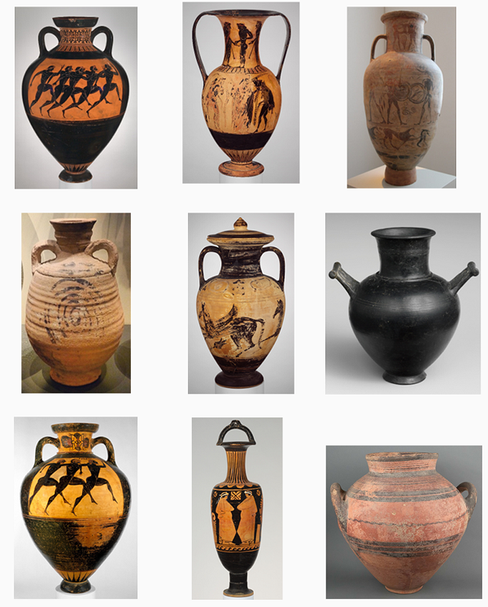

## Set 2

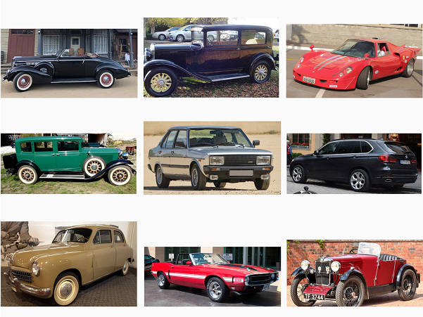

## Set 3

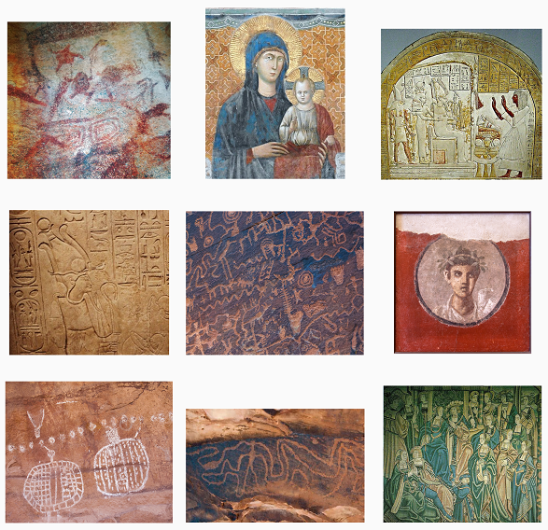

## Set 4

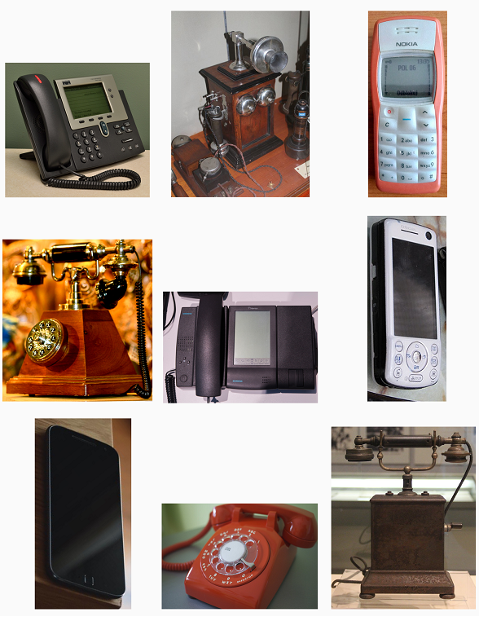

# Appendix 3 – school archives card

|  |  |
| --- | --- |
| Date: | Created by: |
| Year 12 graduation year: | Year advisor: |
| Overview of year group: |  |
| Summary of one key event: |  |

# Appendix 4 – *Titanic* survivor testimony extracts

Testimony extracts from [British Wreck Commissioner’s Inquiry (PDF 9.45MB)](https://www.titanicinquiry.org/downloads/BritishInquiry.pdf) – Charles H. Lightoller, Second Officer *SS Titanic* (most senior surviving officer) sourced from [Titanic Inquiry Project](https://www.titanicinquiry.org)

Solicitor-General (14074): I do not know whether you can help us at all in describing what happened to the ship. You were engaged and had other things to think about; but what did happen to the ship? Can you tell us at all?

Lightoller: Are you referring to the reports of the ship breaking in two?

Solicitor-General (14075): Yes?

Lightoller: It is utterly untrue. The ship did not and could not have broken in two.

…

Solicitor-General (14092): Did you continue watching the afterpart sufficiently to be able to tell us whether the afterpart settled on the water at all?

Lightoller: It did not settle on the water.

Solicitor-General (14093): You are confident it did not?

Lightoller: Perfectly certain.

…

Solicitor-General (14096): Now just carry it on, did you continue watching her until she disappeared?

Lightoller: I did.

Solicitor-General (14097): Just tell us what happened, as you saw it?

Lightoller: After she reached an angle of 50 or 60 degrees, or something about that, there was this rumbling sound, which I attributed to the boilers leaving their beds and crushing down on or through the bulkheads. The ship at that time was becoming more perpendicular, until finally she attained the absolute perpendicular – somewhere about that position, and then went slowly down. She went down very slowly until the end, and then, after she got so far, the afterpart of the second cabin deck, she, of course, went down much quicker.

Solicitor-General (14098): You have spoken of these rumblings which you heard, which you attributed to the boilers losing their places. Did you hear anything which you would call an explosion?

Lightoller: No. The only thing that I should attribute to explosions – which might have been attributed to explosions – was when I was, in the first place, sucked to the blower, and, in the second place, just, shortly before the forward funnel falling, there was an up-rush of certainly warm water, but whether it was caused by an explosion or what, I could not say.

Solicitor-General (14099): Of course, if you were under water at that time you were not in a very good position to hear it?

Lightoller: No.

Testimony extracts from [British Wreck Commissioner’s Inquiry (PDF 9.45MB)](https://www.titanicinquiry.org/downloads/BritishInquiry.pdf) – Frederick Scott, Greaser sourced from [Titanic Inquiry Project](https://www.titanicinquiry.org)

Attorney-General (5674): You got away?

Scott: Yes; we had just got at the stern of her when she started breaking up.

Attorney-General (5675): You say she started breaking up?

Scott: Yes; she broke off at the after-funnel, and when she broke off her stern end came up in the air and came down on a level keel and disappeared.

Attorney-General (5676): It went up in the air and came back on a level keel?

Scott: Yes.

Attorney-General (5677): Then did she go up again before she disappeared?

Scott: No.

Attorney-General (5678): Simply sank?

Scott: She simply sank.

…

Attorney-General (5681): Do you mean the break was aft of her last funnel?

Scott: Yes, just aft of the last funnel.

The Commissioner (5682): Aft of the ventilating funnel?

Scott: Yes, that is right.

The Commissioner: Does this agree with the other evidence?

Attorney-General: No.

The Commissioner: I thought the other Witness made it more forward.

Attorney-General: Yes, between the forward and the second funnels; and one of the Witnesses said she came back and righted on her keel and then up-ended again, with her stern in the air, and then plunged into the water. There is, not unnaturally, some discrepancy about it. There is some evidence from one of the Witnesses, who said the last funnel seemed to come towards him, then to go aft. Your Lordship will remember that.

The Commissioner: Yes.

Attorney-General (5683): That will correspond, at any rate. It is the best description a man can give of what he saw on a dark night. You were behind her stern?

Scott: Yes.

Attorney-General (5684): You could not see how far forward she parted?

Scott: No.

Affidavit extract from [United States Senate Inquiry (PDF 4.4MB)](https://www.titanicinquiry.org/downloads/USInq.pdf) – Emily Ryerson, First class passenger sourced from [Titanic Inquiry Project](https://www.titanicinquiry.org)

Then suddenly, when we still seemed very near, we saw the ship was sinking rapidly. I was in the bow of the boat with my daughter and turned to see the great ship take a plunge toward the bow, the two forward funnels seemed to lean and then she seemed to break in half as if cut with a knife, and as the bow went under the lights went out; the stern stood up for several minutes, black against the stars, and then that, too, plunged down, and there was no sound for what seemed like hours, and then began the cries for help of people drowning all around us, which seemed to go on forever.

# Appendix 5 – Options Diamond scaffold

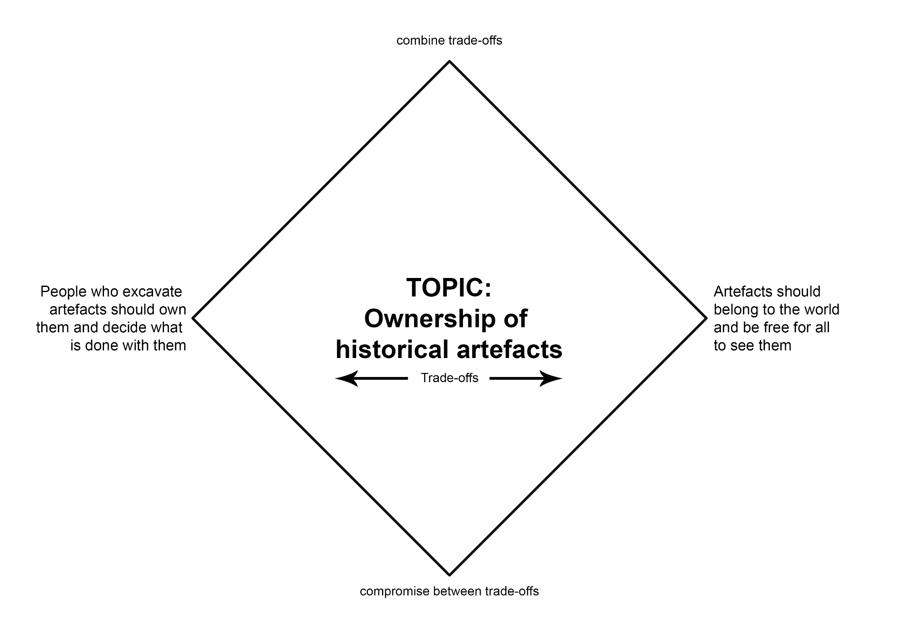

# Appendix 6 – Frayer model scaffold

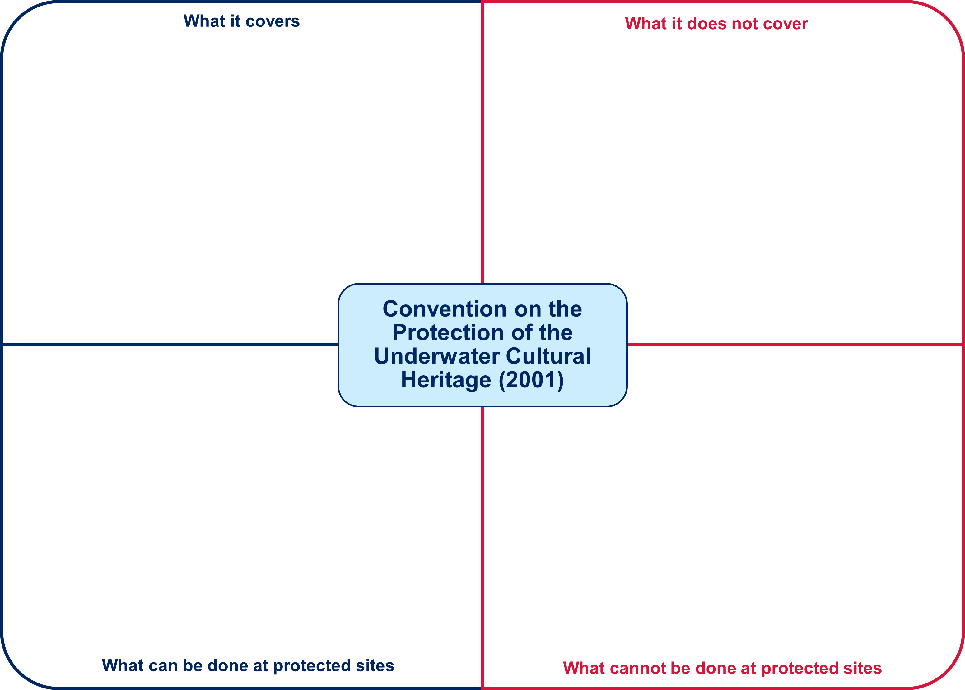

# Further reading

AITSL (Australian Institute for Teaching and School Leadership Limited) (n.d.) [Learning intentions and success criteria [PDF 251 KB]](https://www.aitsl.edu.au/docs/default-source/feedback/aitsl-learning-intentions-and-success-criteria-strategy.pdf?sfvrsn=382dec3c_2#:~:text=Learning%20Intentions%20are%20descriptions%20of,providing%20feedback%20and%20assessing%20achievement.), AITSL, accessed 3 July 2024.

AITSL (2017) ‘[Feedback Factsheet](https://www.aitsl.edu.au/teach/improve-practice/feedback#:~:text=FEEDBACK-,Factsheet,-A%20quick%20guide)’, AITSL, accessed 3 July 2024.

Brookhart S (2011) *How to Assess Higher-Order Thinking Skills in Your Classroom*, Hawker Brownlow Education, Victoria.

CESE (Centre for Education Statistics and Evaluation) (2020a) [*What works best: 2020 update*](https://education.nsw.gov.au/about-us/education-data-and-research/cese/publications/research-reports/what-works-best-2020-update), NSW Department of Education, accessed 3 July 2024.

CESE (2020b) [*What works best in practice*](https://education.nsw.gov.au/about-us/education-data-and-research/cese/publications/practical-guides-for-educators-/what-works-best-in-practice), NSW Department of Education, accessed 3 July 2024.

NESA (NSW Education Standards Authority) (2022) ‘[Advice on units](https://educationstandards.nsw.edu.au/wps/portal/nesa/k-10/understanding-the-curriculum/programming/advice-on-units)’, *Programming*, NESA website, accessed 3 July 2024.

NESA (NSW Education Standards Authority) (2022) ‘[Proficient Teacher: Standard descriptors](https://educationstandards.nsw.edu.au/wps/portal/nesa/teacher-accreditation/meeting-requirements/the-standards/proficient-teacher)’, *The Standards*, NESA website, accessed 3 July 2024.

NESA (NSW Education Standards Authority) (2022) ‘[Programming](https://educationstandards.nsw.edu.au/wps/portal/nesa/k-10/understanding-the-curriculum/programming)’, *Understanding the curriculum*, NESA website, accessed 3 July 2024.

Rosenshine B (2012) ‘[Principles of Instruction: Research-Based Strategies That All Teachers Should Know](https://eric.ed.gov/?id=EJ971753)’, *American Educator*, 36(1):12–19 accessed 3 July 2024.

Wiliam D (2013) ‘[Assessment: The bridge between teaching and learning](https://www.researchgate.net/publication/258423377_Assessment_The_bridge_between_teaching_and_learning)’, *Voices from the Middle*, 21(2):15–20, accessed 3 July 2024.

Wiliam D (2017) *Embedded Formative Assessment*, 2nd edn, Solution Tree Press, Bloomington, IN.

Wisniewski B, Zierer K and Hattie J (2020) ‘[The Power of Feedback Revisited: A Meta-Analysis of Educational Feedback Research](https://doi.org/10.3389/fpsyg.2019.03087)’, *Frontiers In Psychology*, 10:3087, doi:10.3389/fpsyg.2019.03087, accessed 3 July 2024.

Support and alignment

**Resource evaluation and support:** all curriculum resources are prepared through a rigorous process. Resources are periodically reviewed as part of our ongoing evaluation plan to ensure currency, relevance and effectiveness. For additional support or advice, or to provide feedback, contact the HSIE Curriculum team by emailing hsie@det.nsw.edu.au.

**Differentiation:** further advice to support Aboriginal and Torres Strait Islander students, EALD students, students with a disability and/or additional needs and High Potential and gifted students can be found on the [Planning programming and assessing 7–12](https://education.nsw.gov.au/teaching-and-learning/curriculum/planning-programming-and-assessing-k-12/planning-programming-and-assessing-7-12) webpage. This includes the [Inclusion and differentiation 7–10 advice](https://education.nsw.gov.au/teaching-and-learning/curriculum/planning-programming-and-assessing-k-12/planning-programming-and-assessing-7-12/inclusion-and-differentiation-advice-7-10) webpage.

**Assessment:** further advice to support formative assessment is available on the [Planning programming and assessing 7–12](https://education.nsw.gov.au/teaching-and-learning/curriculum/planning-programming-and-assessing-k-12/planning-programming-and-assessing-7-12) webpage. This includes the [Classroom assessment advice 7–10](https://education.nsw.gov.au/teaching-and-learning/curriculum/planning-programming-and-assessing-k-12/planning-programming-and-assessing-7-12/classroom-assessment-advice-7-10-). For summative assessment tasks, the [assessment task advice 7–10](https://education.nsw.gov.au/teaching-and-learning/curriculum/planning-programming-and-assessing-k-12/planning-programming-and-assessing-7-12/assessment-task-advice-7-10) webpage is available.

**Explicit teaching:** further advice to support explicit teaching is available on the [Explicit teaching](https://education.nsw.gov.au/teaching-and-learning/curriculum/explicit-teaching) webpage. This includes the CESE [Explicit teaching – Driving learning and engagement](https://education.nsw.gov.au/about-us/education-data-and-research/cese/publications/research-reports/what-works-best-2020-update/explicit-teaching-driving-learning-and-engagement) webpage.

**Consulted with:** Curriculum and Reform and subject matter experts.

**Alignment to system priorities and/or needs:** [School Excellence Policy](https://education.nsw.gov.au/policy-library/policies/pd-2016-0468), [Our Plan for NSW Public Education](https://education.nsw.gov.au/about-us/strategies-and-reports/plan-for-nsw-public-education).

**Alignment to the School Excellence Framework:** this resource supports the [School Excellence Framework](https://education.nsw.gov.au/inside-the-department/directory-a-z/strategic-school-improvement/school-excellence-framework) elements of curriculum (curriculum provision) and effective classroom practice (lesson planning, explicit teaching).

**Alignment to Australian Professional Standards for Teachers:** this resource supports teachers to address [Proficient Teacher Standard Descriptors](https://educationstandards.nsw.edu.au/wps/portal/nesa/teacher-accreditation/meeting-requirements/the-standards/proficient-teacher) 3.2.2, 3.3.2.

**Creation date:** July 2024

# References

This resource contains NSW Curriculum and syllabus content. The NSW Curriculum is developed by the NSW Education Standards Authority. This content is prepared by NESA for and on behalf of the Crown in right of the State of New South Wales. The material is protected by Crown copyright.

Please refer to the NESA Copyright Disclaimer for more information <https://educationstandards.nsw.edu.au/wps/portal/nesa/mini-footer/copyright>.

NESA holds the only official and up-to-date versions of the NSW Curriculum and syllabus documents. Please visit the NSW Education Standards Authority (NESA) website <https://educationstandards.nsw.edu.au> and the NSW Curriculum website <https://curriculum.nsw.edu.au>.

[History Elective Years 7–10 Syllabus](https://educationstandards.nsw.edu.au/wps/portal/nesa/k-10/learning-areas/hsie/history-elective-7-10-2019) © NSW Education Standards Authority (NESA) for and on behalf of the Crown in right of the State of New South Wales, 2019.

2 Minute Classroom (13 October 2016) [‘What is percent? | simple’ [video]](https://www.youtube.com/watch?v=EUfCmluK94o), *2 Minute Classroom*, YouTube, accessed 4 July 2023.

3H Consulting (16 October 2016)‘Tools for foreshore and underwater archaeology’, [*Equipment*](https://www.3hconsulting.com/techniques/TechEquipment.html), 3H Consulting Ltd website, accessed 24 July 2023.

Agoncillo TA (2024) ‘[Teodoro A. Agoncillo](https://www.goodreads.com/quotes/491108-everyone-is-a-historian-everyone-is-his-own-historian)’, *Quotes*, Goodreads website, accessed 3 June 2024.

Alpha History (2023) [*History quotes*](https://alphahistory.com/history-quotes/), Alpha History, accessed 3 July 2023.

Australasian Institute for Maritime Archaeology (AIMA) (2020) [*UNESCO convention*](https://www.aima-underwater.org.au/unesco-convention.html), AIMA website, accessed 1 September 2023.

Australian Curriculum Assessment and Reporting Authority (ACARA) (n.d.) [*Version 3 of National Literacy and Numeracy Learning Progressions*](https://www.australiancurriculum.edu.au/resources/national-literacy-and-numeracy-learning-progressions/version-3-of-national-literacy-and-numeracy-learning-progressions/), Australian Curriculum website, accessed 18 July 2023.

Barcella L (21 June 2023) [*The 'Titanic' wreckage could entirely disintegrate in approximately 30 years, experts say*](https://people.com/experts-say-titanic-wreckage-entirely-disintegrate-7551172), People, accessed 7 September 2023.

BBC News (17 May 2023) [‘Scan of Titanic reveals wreck as never seen before’ [video]](https://www.youtube.com/watch?v=R2XtefrMNhg), *BBC News*, YouTube, accessed 30 August 2023.

Behrendt L (director) (2023) [‘The First Inventors: Season 1 Episode 2 Science Of Story’ [video]](https://www.sbs.com.au/ondemand/tv-series/the-first-inventors/season-1/the-first-inventors-s1-ep2/2219829827888), SBS On Demand, SBS website, accessed 31 August 2023.

Blakemore E (28 June 2019) ‘[How archaeologists determine the date of ancient sites and artifacts](https://www.nationalgeographic.com/culture/article/archaeologist-methods-date-sites-artifacts?loggedin=true&rnd=1694390242513)’, *Culture*, National Geographic website, accessed 11 September 2023.

British Pathé (14 April 2014) [‘Titanic real footage: leaving Belfast for disaster (1911–1912)’ [video]](https://www.youtube.com/watch?v=05o7sOAjtXE), *British Pathé*, YouTube, accessed 30 August 2023.

Bron G (4 May 1912) ‘*The loss of the 'Titanic’* [infographic], [The Sphere](https://www.researchgate.net/figure/GBrons-chart-of-The-Loss-of-the-Titanic-from-The-Sphere-4-May-1912-Each-subgroup_fig1_330916468), accessed 26 June 2023.

Cawthorne R (n.d.) [*Historical context – ancient history*](https://bth.humanrights.gov.au/significance/historical-context-ancient-history), Bringing Them Home | Australian Human Rights Commission, accessed 28 August 2023.

CBS News (24 June 2023a) [‘From the archives: Titanic shipwreck's discovery in 1985; survivors react’ [video]](https://www.youtube.com/watch?v=F0qasc6RHPI), *CBS News*, YouTube, accessed 30 August 2023.

CBS News (24 June 2023b) [‘Ocean explorer and adventurer Victor Vescovo on Titan submersible tragedy’ [video]](https://www.youtube.com/watch?v=EDdehXmaS4o), *CBS News*, YouTube, accessed 8 September 2023.

CBS News (27 June 2023c) [‘From the archives: footage of Titanic shared by Robert Ballard in 1985’ [video]](https://www.youtube.com/watch?v=Fe54buLGWS8), *CBS News*, YouTube, accessed 30 August 2023.

CESE (Centre for Education Statistics and Evaluation) (2020a) [*What works best: 2020 update*](https://education.nsw.gov.au/about-us/educational-data/cese/publications/research-reports/what-works-best-2020-update), NSW Department of Education, accessed 12 September 2023.

CESE (2020b) [*What works best in practice*](https://education.nsw.gov.au/about-us/educational-data/cese/publications/practical-guides-for-educators-/what-works-best-in-practice), NSW Department of Education, accessed 12 September 2023.

Chen X-Q, Xia K, Hu W, Cao M, Deng K and Fang S (15 January 2022) [‘Extraction of underwater fragile artifacts: research status and prospect’](https://heritagesciencejournal.springeropen.com/articles/10.1186/s40494-022-00645-1), *Heritage Science*, 10(1), accessed 12 September 2023.

Cheong J (28 June 2023) [*Ancient Aboriginal underwater site in Flying Foam Passage thought to be deepest in Australia*](https://www.abc.net.au/news/2023-06-28/underwater-ancient-aboriginal-discovery-pilbara-wa/102529502), ABC (Australian Broadcasting Corporation), accessed 31 August 2023.

Chicago Public Schools (2022) [*Fist to five voting and consensus*](https://www.cps.edu/sites/equity/tools/dimensions/fist-to-five-voting-and-consensus/), Chicago Public Schools website, accessed 3 July 2023.

CNN (n.d.) [*You can now explore a 2,500-year-old shipwreck*](https://edition.cnn.com/videos/travel/2020/08/03/greece-underwater-museum-shipwreck-orig-mss.cnn), CNN Travel, accessed 31 August 2023.

Cooper's Ferry Site (4 July 2012) [‘The excavation process: how we excavate’ [video]](https://www.youtube.com/watch?v=PcT1vGyJzyg), *Cooper's Ferry Site*, YouTube, accessed 24 July 2023.

Cranford D (16 April 2021) [*Remote sensing in archaeology*](https://archaeology.ncdcr.gov/blog/2021-04-16/remote-sensing), North Carolina Office of State Archaeology website, accessed 24 July 2023.

Deep History of Sea Country: Climate Sea Level and Culture (21 September 2020) [*What does Australia’s national Underwater Cultural Heritage Act (2018) protect?*](https://deephistoryofseacountry.com/2020/09/21/what-does-australias-underwater-cultural-heritage-act-2018-automatically-protect/), Deep History of Sea Country website, accessed 1 September 2023.

Derek Verveer (21 August 2022) [‘Titanic: Honor and Glory – Demo401 v2.0 reciprocating engine room’ [video]](https://www.youtube.com/watch?v=7O0pLaxS8oA), *Derek Verveer*, YouTube, accessed 1 September 2023.

Donovan M (11 April 2023) [How AI is helping historians better understand our past](https://www.technologyreview.com/2023/04/11/1071104/ai-helping-historians-analyze-past/), MIT Technology Review, accessed 2 July 2024.

Encyclopedia Titanica (2022) [*The Titanic Break-Up*](https://www.encyclopedia-titanica.org/the-titanic-break-up.htm), Encyclopedia Titanica website, accessed 26 June 2023.

Encyclopedia Titanica (2023) [*Titanic survivors – names of all passengers and crew that survived*](https://www.encyclopedia-titanica.org/titanic-survivors/), Encyclopedia Titanica website, accessed 30 June 2023.

Farr H and Sturt F (9 June 2020) ‘[Titanic salvage: recovering the ship's radio could signal a disaster for underwater cultural heritage](https://theconversation.com/titanic-salvage-recovering-the-ships-radio-could-signal-a-disaster-for-underwater-cultural-heritage-139795)’, *The Conversation*, accessed 7 September 2023.

Flipped Classroom Tutorials (18 October 2021) [‘Auto translate YouTube video into your language’ [video]](https://www.youtube.com/watch?v=LZz03myFuWA), *Flipped Classroom Tutorials*, YouTube, accessed 23 August 2023.

Francis IE (January 1930) *Aerial view of construction of Sydney Harbour Bridge Jan 1930* [photograph], [A series of photographs taken of the construction of the Sydney Harbour Bridge in January 1930 and 1931](https://digitalcollections.qut.edu.au/7015/), accessed 23 June 2023.

Franck Goddio (3 March 2021) [‘#8 How do you excavate underwater (discovering underwater archaeology)’ [video]](https://www.youtube.com/watch?v=7Gohv_AzQUk), *Franck Goddio*, YouTube, accessed 24 July 2023.

——(15 March 2021b) [‘#9 Do you bring everything back to the surface (Discovering underwater archaeology)’](https://www.youtube.com/watch?v=pcUlrENXYFw) [video], YouTube, accessed 30 August 2024.

——(29 March 2021c) [‘#11 How do you bring objects to the surface (Discovering underwater archaeology)’](https://www.youtube.com/watch?v=ICaDxCglV7A) [video], YouTube, accessed 30 August 2024.

Gannon M (1 July 2020) ‘[A submerged 7,000-year-old discovery shows the great potential of underwater archaeology](https://www.smithsonianmag.com/science-nature/archaeology-underwater-australia-180975235/)’, *Smithsonian Magazine*, accessed 4 July 2023.

Government of Western Australia (Department of Health) (n.d. a) [*Card clusters*](https://gdhr.wa.gov.au/learning/teaching-strategies/tuning-in/card-clusters), Growing and developing healthy relationships website, accessed 3 July 2023.

Government of Western Australia (Department of Health) (n.d. b) [*3–2–1 reflect*](https://gdhr.wa.gov.au/learning/teaching-strategies/reflecting/3-2-1-reflect), Growing and developing healthy relationships website, accessed 3 July 2023.

Harvard Graduate School of Education (2015a) [*Options diamond*](https://pz.harvard.edu/resources/options-diamond), Project Zero website, accessed 1 September 2023.

Harvard Graduate School of Education (2015b) [*Tug of war*](https://pz.harvard.edu/resources/tug-of-war), Project Zero website, accessed 7 September 2023.

History Inside A Nutshell (21 April 2023) [‘Structural integrity failure: Titanic modern break ups’ [video]](https://www.youtube.com/watch?v=5Pf47oV5UCQ), *History Inside A Nutshell*, YouTube, accessed 30 August 2023.

History Nebraska (6 February 2019) [‘How do archeologists know where to dig?’ [video]](https://www.youtube.com/watch?v=O2zQSnrJ7ik), *History Nebraska*, YouTube, accessed 11 July 2023.

History Skills (n.d.) [*The incredible ways we can tell how old ancient artefacts are*](https://www.historyskills.com/classroom/ancient-history/anc-absolute-dating-reading/), History Skills, accessed 26 July 2023.

History Skills (11 July 2019) [‘How to create key inquiry questions (history research process – step 1)’ [video]](https://www.youtube.com/watch?v=hTzI14M38Qc), *History Skills,* YouTube, accessed 10 July 2023.

Horton M and Heyd V (8 December 2015) ['Six tools that are revolutionising archaeology by helping us find sites without digging'](https://theconversation.com/six-tools-that-are-revolutionising-archaeology-by-helping-us-find-sites-without-digging-51826), *The Conversation*, accessed 24 July 2023.

Hughes B and Blue L (2022) [*Dive & dig podcast*](https://honorfrostfoundation.org/podcast/), Honor Frost Foundation, accessed 28 August 2023.

ITCPublications (20 August 2012) [‘Silent card shuffle’ [video]](https://www.youtube.com/watch?v=RMjpEsNvPB8), *ITCPublications*, YouTube, accessed 3 July 2023.

Kalafatis J (17 April 2022) [*Ancient cities lost under the Aegean Sea in Greece*](https://greekreporter.com/2022/04/17/ancient-cities-lost-under-aegean-sea-greece/), GreekReporter.com, accessed 4 July 2023.

Kingsley S (29 March 2023) ‘[Clues to the lives of North America's first inhabitants are hidden underwater](https://www.smithsonianmag.com/history/biggest-clues-lives-early-americans-hidden-underwater-submerged-prehistory-180981891/)’, *Smithsonian Magazine*, accessed 4 July 2023.

Kroum Batchvarov - Underwater Ship Archaeologist (17 September 2023) [‘Methods of underwater archaeology’](https://www.youtube.com/watch?v=BQIplzQhgro) [video], YouTube, accessed 4 July 2024.

Lathouris O (21 January 2020) ‘[Plans to extract historic treasure from Titanic shipwreck revealed](https://www.9news.com.au/national/titanic-wreck-plans-to-extract-artefact-from-inside-the-vessel-revealed-us/1516711b-b56b-4b05-9027-55f408312a55)’, *9News*, accessed 28 August 2023.

LawInfo (n.d.) ‘[Are finders keepers under the sea? What you need to know about finding shipwrecked treasures](https://www.lawinfo.com/resources/admiralty-maritime/are-finders-keepers-under-the-sea-what-you-ne.html)*’*, *Maritime Law*, LawInfo website, accessed 1 September 2023.

Learning Strategies Center Cornell (11 December 2019) [‘What are Cornell notes?’ [video]](https://www.youtube.com/watch?v=HEsBd_Rgzfs), *Learning Strategies Center Cornell*, YouTube, accessed 3 July 2023.

Levine A (28 October 2006) Harbour view [photograph], [flickr](https://flic.kr/p/3K78c7), accessed 23 June 2023.

Marchant J (January 2012) [‘Underwater archaeology: hunt for the ancient mariner’](https://www.nature.com/articles/481426a), *Nature*, 481:426–428, accessed 4 July 2023.

Martin AK (18 July 2022) ‘[Submerged secrets: the hunt for Japan’s underwater ruins](https://www.japantimes.co.jp/life/2022/07/18/environment/underwater-archaeology/)’, *The Japan Times*, accessed 4 July 2023.

Microsoft (n.d. a) [*Microsoft Whiteboard*](https://whiteboard.office.com/), Microsoft Whiteboard, accessed 11 September 2023.

Microsoft (n.d. b) [*Transcribe your recordings – Microsoft Support*](https://support.microsoft.com/en-us/office/transcribe-your-recordings-7fc2efec-245e-45f0-b053-2a97531ecf57), Microsoft Support, accessed 28 August 2023.

National Geographic (21 May 2012) [‘Robert Ballard: restore the Titanic’ [video]](https://www.youtube.com/watch?v=l25QT9YFQFM), *National Geographic*, YouTube, accessed 20 July 2023.

Nature video (9 March 2022) [‘The AI historian: a new tool to decipher ancient texts’ [video]](https://www.youtube.com/watch?v=rq0Ex_qCKeQ), *Nature video*, YouTube, accessed 17 July 2023.

Nelson D (9 December 2022) [*AI is dramatically changing archaeology, discovering new sites and artifacts*](https://www.unite.ai/ai-is-dramatically-changing-archaeology-discovering-new-sites-and-artifacts/), Unite.AI, accessed 24 July 2023.

NESA (NSW Education Standards Authority) (n.d.) ‘[Adjustments](https://educationstandards.nsw.edu.au/wps/portal/nesa/k-10/diversity-in-learning/special-education/adjustments)’, *Diversity in learning*, NESA website, accessed 21 August 2023.

NESA (NSW Education Standards Authority) (2022) ‘[Proficient Teacher Standard descriptors](https://educationstandards.nsw.edu.au/wps/portal/nesa/teacher-accreditation/meeting-requirements/the-standards/proficient-teacher)’, The Standards, NESA website, accessed 12 September 2023.

Nigel Chang (26 February 2021) [‘Archaeology skills: stringing up an excavation unit’ [video]](https://www.youtube.com/watch?v=xSC3LACE5kQ), *Nigel Chang*, YouTube, accessed 24 July 2023.

Ocampo A (1995) [*A quote from Talking History*](https://www.goodreads.com/quotes/491108-everyone-is-a-historian-everyone-is-his-own-historian), Goodreads, accessed 4 July 2023.

Oceanliner Designs (4 July 2022) [‘What did Titanic's break up really look like? (How the movies got it wrong.)’ [video]](https://www.youtube.com/watch?v=9FLsr-t1mSY), *Oceanliner Designs*, YouTube, accessed 30 August 2023.

Reuters/AFP (17 May 2023) ['Titanic shipwreck visualised on the seabed for first time in 3D scan'](https://www.abc.net.au/news/2023-05-18/titanic-3d-visualisation-scan-deep-sea-mapping/102360630), *ABC News*, accessed 30 August 2023.

Rueb E (9 May 2023) [*Difficulties and advantages of underwater archaeology along with the demonstration of invisible wonders*](https://www.walshmedicalmedia.com/open-access/difficulties-and-advantages-of-underwater-archaeology-along-with-the-demonstration-of-invisible-wonders-120432.html), Journal of Coastal Zone Management, accessed 30 August 2024.

Ryan S (14 April 2012) ['Who owns the Titanic, and who can dive at the wreck?'](https://www.thejournal.ie/who-owns-the-titanic-and-who-can-dive-at-the-wreck-404369-Apr2012/#:~:text=So%20who%20owns,be%5D%20no%20problem.%E2%80%9D), *TheJournal*, accessed 1 September 2023.

SciTech Now (15 December 2015) [‘Underwater archaeology’ [video]](https://www.youtube.com/watch?v=BITmXuNkYgU), *SciTech Now*, YouTube, accessed 17 July 2023.

Shenker J (15 August 2016) ['Lost cities #6: how Thonis-Heracleion resurfaced after 1,000 years under water'](https://www.theguardian.com/cities/2016/aug/15/lost-cities-6-thonis-heracleion-egypt-sunken-sea), *The Guardian*, accessed 4 July 2023.

Spatial Post (25 June 2023) ['What tools do archaeologists use: exploring the essential toolkit (21+ tools)'](https://www.spatialpost.com/what-tools-do-archaeologists-use/), *Spatial Post*, accessed 24 July 2023.

State of New South Wales (Department of Education) (n.d.) ['Text structure'](https://sites.google.com/view/hsc-minimum-standard/writing/text-structure), *HSC minimum standard*, NSW Department of Education, accessed 27 July 2023.

State of New South Wales (Department of Education) (2021a) [*Rapid fire writing*](https://education.nsw.gov.au/teaching-and-learning/learning-remotely/teaching-at-home/expectations/contemporary-learning-and-teaching-from-home/learning-from-home--teaching-strategies#/asset7), NSW Department of Education, accessed 4 July 2023.

State of New South Wales (Department of Education) (2021b) [*Snowball*](https://education.nsw.gov.au/teaching-and-learning/learning-remotely/teaching-at-home/expectations/contemporary-learning-and-teaching-from-home/learning-from-home--teaching-strategies#/asset8), NSW Department of Education, accessed 4 July 2023.

State of New South Wales (Department of Education) (2022) [*Differentiating learning*](https://education.nsw.gov.au/teaching-and-learning/professional-learning/teacher-quality-and-accreditation/strong-start-great-teachers/refining-practice/differentiating-learning), NSW Department of Education, accessed 19 July 2023.

State of New South Wales (Department of Education) (2023a) [*City planning set*](https://www.thingiverse.com/thing:6091482), Thingiverse – Digital Designs for Physical Objects, accessed 6 September 2023.

State of New South Wales (Department of Education) (2023b) [*Common graphs*](https://education.nsw.gov.au/teaching-and-learning/curriculum/hsie/hsie-curriculum-resources-k-12/hsie-7-10-curriculum-resources/common-graphs), NSW Department of Education, accessed 4 July 2023.

State of New South Wales (Department of Education) (2023c) [*Differentiation adjustment tool*](https://education.nsw.gov.au/teaching-and-learning/high-potential-and-gifted-education/supporting-educators/implement/differentiation-adjustment-strategies#:~:text=thinking%20(DLS%20applications)-,Adjustment%3A%20Higher%20order%20thinking,-Strategies), NSW Department of Education, accessed 11 September 2023.

State of New South Wales (Department of Education) (2023d) [*Digital Learning Selector*](https://app.education.nsw.gov.au/digital-learning-selector), NSW Department of Education, accessed 11 September 2023.

State of New South Wales (Department of Education) (2023e) [*Vocabulary*](https://education.nsw.gov.au/teaching-and-learning/curriculum/literacy-and-numeracy/teaching-and-learning-resources/literacy/effective-reading-in-the-early-years-of-school/vocabulary), NSW Department of Education, accessed 11 September 2023.

Tabachnick C (21 June 2023) ['Robert Ballard found the Titanic wreckage in 1985. Here's how he discovered it and what has happened to its artifacts since'](https://www.cbsnews.com/news/robert-ballard-titanic-wreckage-1985-discovery-artifacts/#:~:text=What%20have%20explorers%20recovered%20and%20sold%3F), *CBS News*, accessed 4 September 2023.

Tarr R (n.d.) [*Using Decision Trees to categorise, compare and contrast key factors*](http://www.classtools.net/blog/using-decision-trees-to-categorise-compare-and-contrast-key-factors/), Tarr's Toolbox website, accessed 1 September 2023.

TEDx Talks (30 June 2018) [‘Archives have the power to boost marginalized voices | dominique luster | tedxpittsburgh’ [video]](https://www.youtube.com/watch?v=XsNPlBBi1IE), *TEDx Talks*, YouTube, accessed 30 June 2023.

TED-Ed (22 October 2021) [‘Why is this 2,500 year old shipwreck so well-preserved? – Helen Farr and Jon Adams’ [video]](https://www.youtube.com/watch?v=mHMfzDq1F08), *TED-Ed*, YouTube, accessed 8 September 2023.

The Archaeologist (28 April 2023) [*The challenges and triumphs of digging the deep blue in underwater archeology*](https://www.thearchaeologist.org/blog/the-challenges-and-triumphs-of-digging-the-deep-blue-in-underwater-archeology), The Archaeologist, accessed 4 July 2024.

The Heritage Council (13 March 2019) [‘What is heritage?’ [video]](https://www.youtube.com/watch?v=nf8DyjCz8UE), *The Heritage Council*, YouTube, accessed 6 July 2023.

The Maritime Executive (9 December 2005) [*Titanic sank quickly*](https://maritime-executive.com/article/2005-12-09titanic-sank-quickly), The Maritime Executive website, accessed 30 August 2023.

The University of Sydney (2023) [*Chau Chak Wing Museum*](https://app.situ360.com/30a92f/9467/61633/public), Situ, accessed 8 September 2023.

Titanic: Honor and Glory (31 May 2021) [‘Log entries – part three’ [video]](https://www.youtube.com/watch?v=wPJjvC2w73k), *Titanic: Honor and Glory*, YouTube, accessed 1 September 2023.

Titanic: Honor and Glory (4 February 2023) [‘Titanic Demo 401 – official update trailer’ [video]](https://www.youtube.com/watch?v=SIcLmLUgR4Q), *Titanic: Honor and Glory*, YouTube, accessed 1 September 2023.

Titanic: Honor and Glory (11 February 2023) [‘Titanic Demo 401 – first class trailer’ [video]](https://www.youtube.com/watch?v=ZwlE_fkqUck), *Titanic: Honor and Glory*, YouTube, accessed 1 September 2023.

Titanic: Honor and Glory (15 February 2023) [‘Titanic Demo 401 – second class trailer’ [video]](https://www.youtube.com/watch?v=AkOreUh1Lm8), *Titanic: Honor and Glory*, YouTube, accessed 1 September 2023.

Titanic: Honor and Glory (18 February 2023) [‘Titanic Demo 401 – 3rd class trailer’ [video]](https://www.youtube.com/watch?v=jkeY1HWba6E), *Titanic: Honor and Glory*, YouTube, accessed 1 September 2023.

Titanic: Honor and Glory (22 February 2023) [‘Titanic Demo 401 – crew trailer’ [video]](https://www.youtube.com/watch?v=PaORR3EiuCc), *Titanic: Honor and Glory*, YouTube, accessed 1 September 2023.

Titanic: Honor and Glory (25 February 2023) [‘Titanic Demo 401 – exterior trailer’ [video]](https://www.youtube.com/watch?v=Imb4G_Ht0cI), *Titanic: Honor and Glory*, YouTube, accessed 1 September 2023.

Titanic Inquiry Project (n.d. a) [*British wreck commissioner's inquiry report: description of the damage to the ship and its gradual final effect – final effect of the damage*](https://www.titanicinquiry.org/BOTInq/BOTReport/botRepFinEff.php), Titanic Inquiry Project website, accessed 24 July 2023.

Titanic Inquiry Project (n.d. b) [*United States Senate inquiry report: abandoning ship*](https://www.titanicinquiry.org/USInq/USReport/AmInqRep07.php), Titanic Inquiry Project website, accessed 24 July 2023.

United Nations Educational Scientific and Cultural Organization (UNESCO) (n.d.) [*Convention on the Protection of the Underwater Cultural Heritage*](https://www.unesco.org/en/legal-affairs/convention-protection-underwater-cultural-heritage), UNESCO website, accessed 1 September 2023.

United States government (U.S. Department of Commerce) (2022) [*R.M.S Titanic – frequently asked questions*](https://www.noaa.gov/gc-international-section/rms-titanic-frequently-asked-questions), National Oceanic and Atmospheric Administration website, accessed 1 September 2023.

UNSW Sydney (21 June 2023) [*Why is referencing important?*](https://www.student.unsw.edu.au/why-referencing-important), UNSW Current Students, accessed 21 December 2023.

Woods Hole Oceanographic Institution (16 February 2023) [‘When Alvin visited the wreck of the Titanic’ [video]](https://www.youtube.com/watch?v=kmfjjsRbKCY), *Woods Hole Oceanographic Institution*, YouTube, accessed 30 August 2023.

World History Encyclopedia (22 March 2022) [‘An introduction to archaeology: what is archaeology and why is it important?’ [video]](https://www.youtube.com/watch?v=3tkTxALrVvg), *World History Encyclopedia*, YouTube, accessed 10 July 2023.

**© State of New South Wales (Department of Education), 2024**

The copyright material published in this resource is subject to the Copyright Act 1968 (Cth) and is owned by the NSW Department of Education or, where indicated, by a party other than the NSW Department of Education (third-party material).

Copyright material available in this resource and owned by the NSW Department of Education is licensed under a [Creative Commons Attribution 4.0 International (CC BY 4.0) license](https://creativecommons.org/licenses/by/4.0/).

[](https://creativecommons.org/licenses/by/4.0/)

This license allows you to share and adapt the material for any purpose, even commercially.

Attribution should be given to © State of New South Wales (Department of Education), 2024.

Material in this resource not available under a Creative Commons license:

* the NSW Department of Education logo, other logos and trademark-protected material
* material owned by a third party that has been reproduced with permission. You will need to obtain permission from the third party to reuse its material.

**Links to third-party material and websites**

Please note that the provided (reading/viewing material/list/links/texts) are a suggestion only and implies no endorsement, by the New South Wales Department of Education, of any author, publisher, or book title. School principals and teachers are best placed to assess the suitability of resources that would complement the curriculum and reflect the needs and interests of their students.

If you use the links provided in this document to access a third-party's website, you acknowledge that the terms of use, including licence terms set out on the third-party's website apply to the use which may be made of the materials on that third-party website or where permitted by the Copyright Act 1968 (Cth). The department accepts no responsibility for content on third-party websites.