Geography 7–10 – guide  
to teaching mapping – distance and area

Contents

Overview 2

Outcomes 2

Learning sequence 1 – topographic maps – area and distance 3

Syllabus content 3

Learning intentions and success criteria 3

Learning intentions 3

Success criteria 4

Working with maps 5

Topographic maps 5

Measuring distance 6

Measuring area 11

Area game 12

Measuring area for non-standard shapes 14

Appendix 1 – mapping tools 17

Appendix 2 – Area game resources 19

References 22

This resource has been developed to assist teachers in NSW Department of Education schools to create learning that is contextualised to their classroom. It can be used as a basis for the teacher’s own program, assessment, scope and sequence, or be used as an example of how the new curriculum could be implemented. The resource has suggested timeframes that may need to be adjusted by the teacher to meet the needs of their students.

# Overview

**Description:** this teaching support resource addresses the K–10 geographical tools continuum, providing examples of how students can engage with the the geographical tool of maps. The lessons and sequences in this program of learning are designed to allow students to build understanding of this geographical tool through a range of working geographically with geographical skills across geography 7–10.

**Duration:** this learning sequence is designed to be completed in approximately 2 hours.

## Outcomes

A student:

* **GE4-7** acquires and processes geographical information by selecting and using geographical tools for inquiry

[Geography K–10 Syllabus](https://www.educationstandards.nsw.edu.au/wps/portal/nesa/k-10/learning-areas/hsie/geography-k-10) © NSW Education Standards Authority (NESA) for and on behalf of the Crown in right of the State of New South Wales, 2015.

# Learning sequence 1 – topographic maps – area and distance

**Note:** this Guide to teaching mapping – area and distance resource is designed to be used as a support resource for teachers addressing the tools continuum. This resource is not guiding teaching and learning of a specific topic content in geography 7–10; rather, it provides resources and strategies that can be applied at any point across the stages in the context of the content they are teaching.

## Syllabus content

Maps take many forms and include digital and non-digital mediums. Examples include, but are not limited to, pictorial maps, large-scale and small-scale maps, relief maps, choropleth maps, flowline maps, cadastral maps, isoline maps, land use maps, physical maps, political maps, precis maps, cultural mapping, road maps, thematic maps, tactile maps, topographic maps and special-purpose maps.

Maps are used to locate, visualise, represent, display and record spatial data.

## Learning intentions and success criteria

**Note:** these learning intentions and success criteria are general and should be contextualised to suit your school and students’ needs.

### Learning intentions

Students learn about:

* key features of area and distance
* the different ways to measure distance on topographic maps.

### Success criteria

Students will be able to:

* interpret topographic maps to calculate area
* use different methods to measure distance on topographic maps.

## Working with maps

**Note:** teachers who are not familiar with topographic maps may find the video [Area and distance (3:22)](https://education.nsw.gov.au/teaching-and-learning/curriculum/hsie/hsie-curriculum-resources-k-12/hsie-7-10-curriculum-resources/area-and-distance) useful in explaining the geographical tool. Use this video as a stimulus in lessons if required.

Provide students with topographic maps for learning activities in this sequence. [Geoscience Australia](https://www.ga.gov.au/scientific-topics/national-location-information/topographic-maps-data/topographic-maps) provides a variety of topographic maps useful for this activity. Teachers need to be aware of the ratio scale on the Geoscience maps. The recommended print sizes are A1 for Geoscience 1:50000 maps. [NSW Spatial Services topographic maps](https://www.spatial.nsw.gov.au/products_and_services/topographic_maps) are more complicated but include linear scale and can be printed on A3 paper.

### Topographic maps

The topography of an area is the physical features such as rivers, hills and valleys in the landscape. Topographic maps show us the physical features of the land. They show us geographical position and elevations for natural and built features. Topographic maps show relief, the shape of the land, the mountains, valleys and plains. They also show vegetation and hydrology – the rivers, streams, lakes, and dams. Figure 1 is an annotated example of a topographic map.

**Note**: Figure 1 is a fictional location used for illustrative purposes. The map is not to scale in this document.

Figure 1 – annotated topographic map

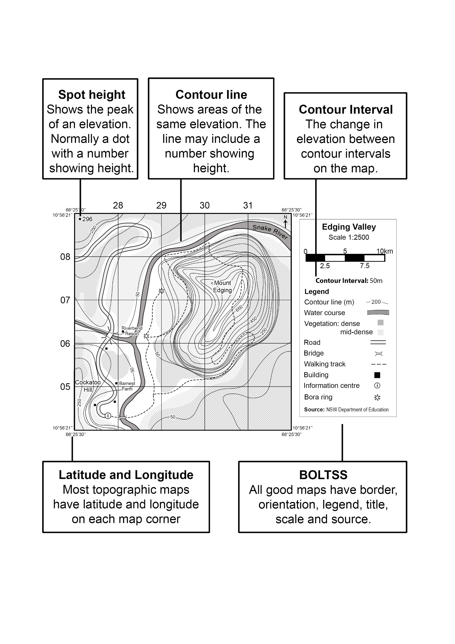

## Measuring distance

**Note:** topographic maps use scale to help us find how far it is from one place to another on the ground. We use many different types of scale in geography but the most common one used to find distance on a map is the linear scale. The [BOLTSS and scale (4:06)](https://education.nsw.gov.au/teaching-and-learning/curriculum/hsie/hsie-curriculum-resources-k-12/hsie-7-10-curriculum-resources/boltss-and-scale) video may be helpful when revisiting this geographic tool in a lesson.

Students require a ruler and string of at least 30 cm in length to complete the activities in this sequence. The activities are aligned with PrT4, PrT6 and PoL5 of the [National Numeracy Learning Progressions Version 3](https://www.australiancurriculum.edu.au/resources/national-literacy-and-numeracy-learning-progressions/version-3-of-national-literacy-and-numeracy-learning-progressions/).

We use linear scale on a topographic map to find out how far it is between 2 places in real life. To do this we must:

1. Find out how far it is on the map.
2. Calculate what the distance represents on the linear scale.

Use the map in Figure 2 to:

* measure the straight-line distance in centimetres (cm) between the information centre and the bora ring
* use the scale on the map to calculate the real-life distance between the information centre and the bora ring.

Figure 2 – Paceworth map

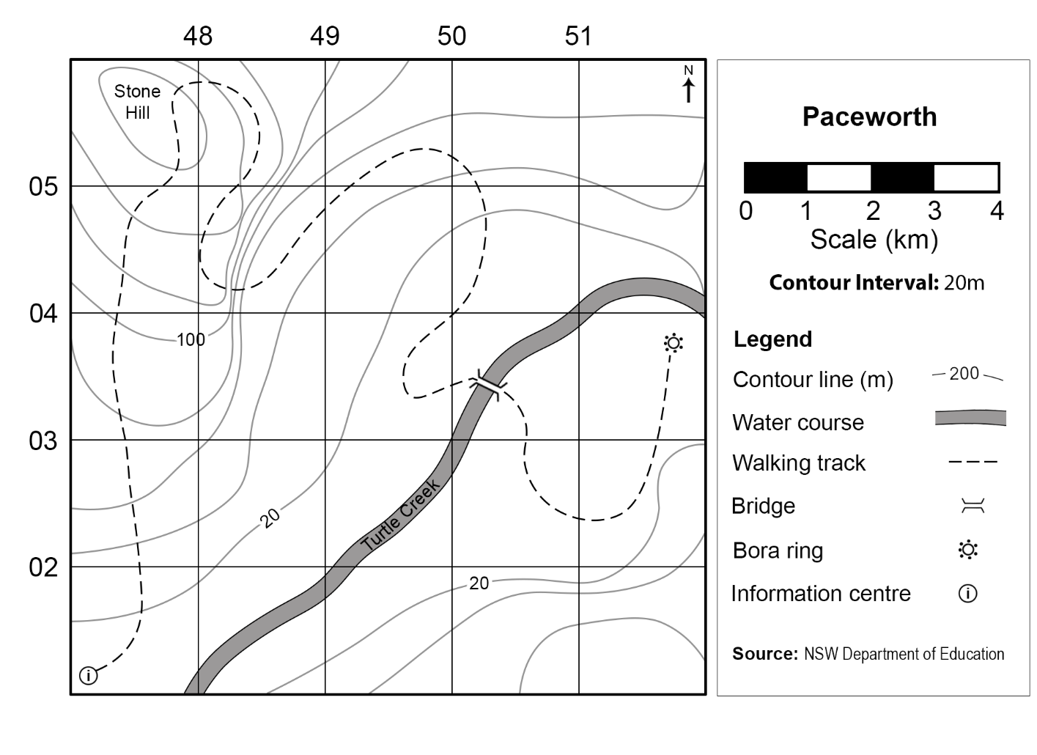

**Answers:**

* 9.6 cm
* 9.6 km.

1. Use Figure 3 to measure and calculate the straight-line distances from:
2. Point A to Point D
3. Point C to Point E
4. Point B to Point D
5. Point B to Point E
6. Point D to Point E.
7. Calculate the distance for each of the above questions if the map scale was:
8. 1:200000
9. 1:500000
10. 1:350000.

Figure 3 – Dreamouth Siding map

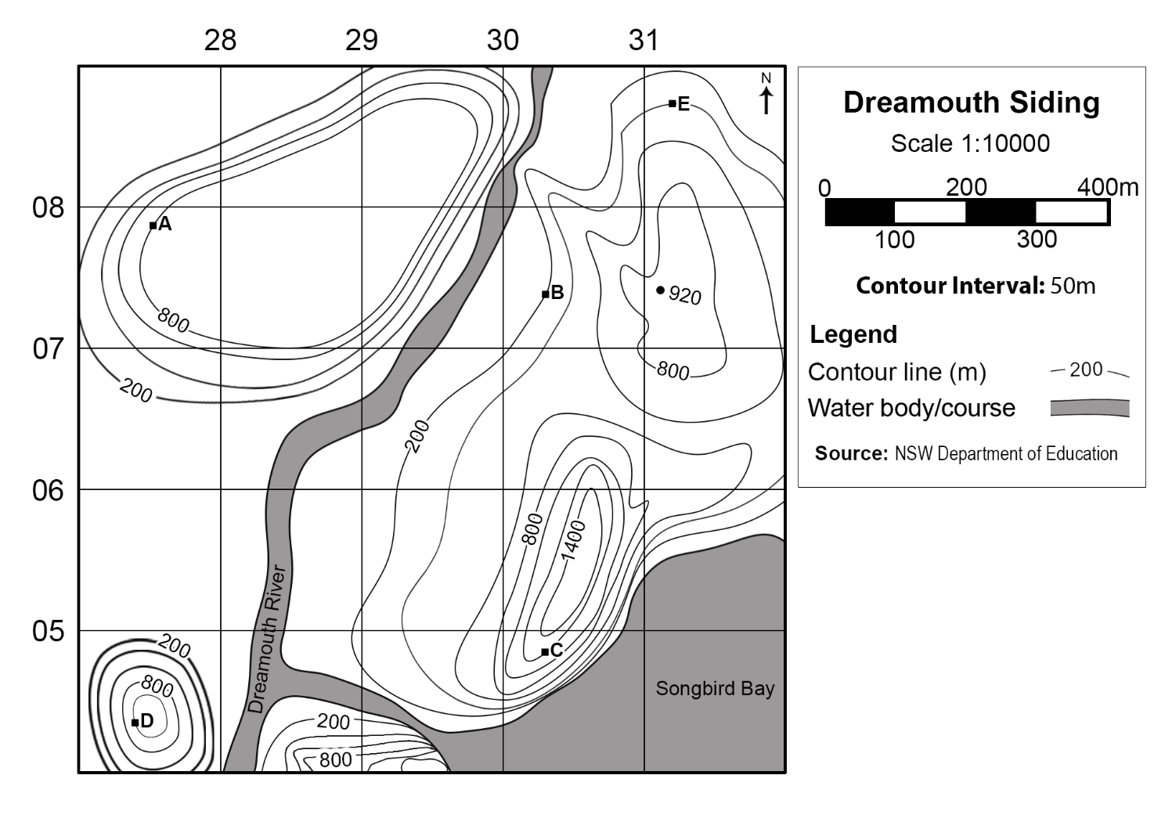

**Answers:**

1. Original scale (1 cm represents 100 m):
2. 700 m
3. 800 m
4. 840 m
5. 320 m
6. 1.16 km.
7. 1:200000 (1 cm represents 2 km): 14 km, 16 km, 16.8 km, 6.4 km, 23.2 km
8. 1:500000 (1 cm represents 5 km): 35 km, 40 km, 42 km, 16 km, 58 km
9. 1:350000 (1 cm represents 3.5 km): 24.5 km, 28 km, 29.4 km, 11.2 km, 40.6 km.

Use [Measuring Distances on Map Using String Method (2:09)](https://youtu.be/dTriKKOsqyI?si=IPDpWeqIv6oAfJtB), string and Figure 2 to:

* measure the distance in centimetres (cm) of the walking track
* use the scale to convert this measurement to real-life distance
* calculate the difference between the real-life walking track distance and the straight-line distance.

**Answers:**

* 29.5 cm
* 29.5 km
* 19.9 km.

Allow approximately 0.2 centimetres or kilometres difference with student answers to accommodate slight differences in string measurements.

**Differentiation:** to extend high potential and gifted education (HPGE) students, ask them to calculate how much longer it takes to travel via the walking track instead of the straight-line distance if walking at a speed of 8 kilometres (km) per hour (**Answer:** 2 hours 29 minutes 15 seconds).

Calculate the real-life measurements for the following using Figure 4:

* distance of the road shown on the map
* distance between the 2 bridges if travelling via boat
* difference in distance from the information centre to the second bora ring of the direct walking track and the track over Mount Edging.

Figure 4 – Mount Edging map

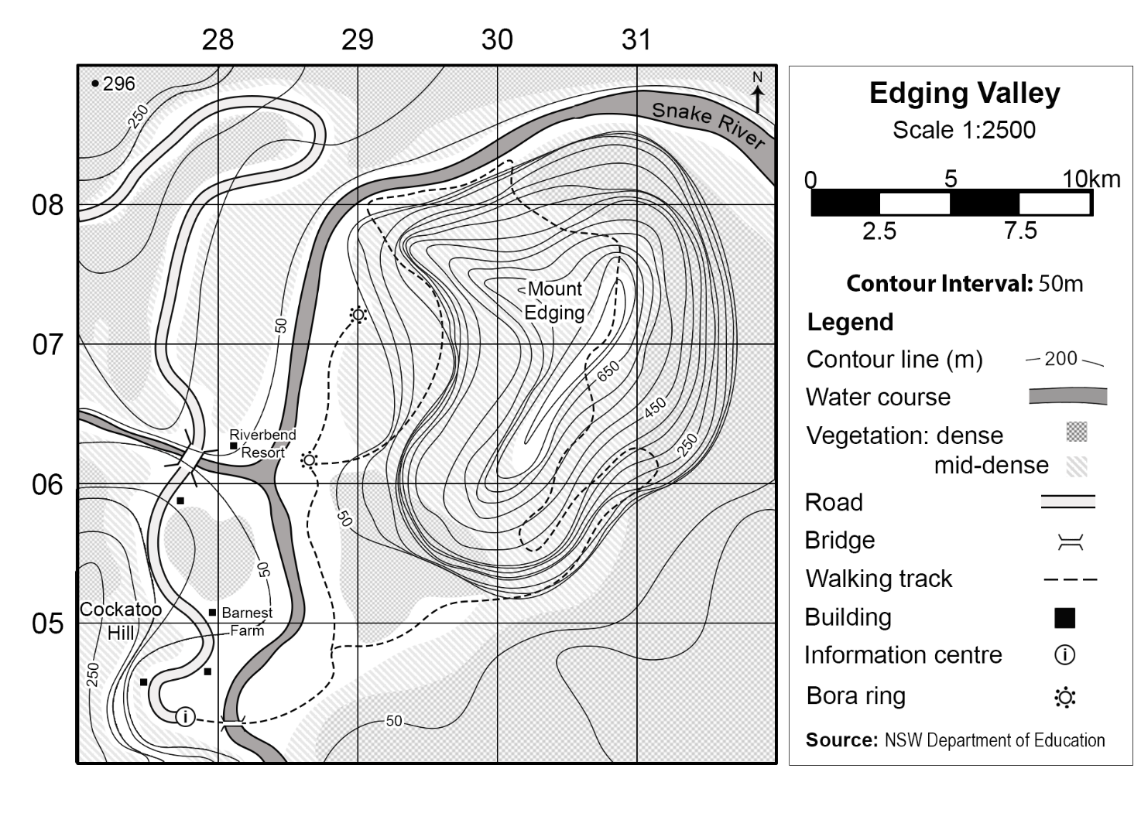

**Answers:**

* 362.5 m
* 125 m
* 480 m (662.5 m–182.5 m).

Allow approximately 5 metres difference with student answers to accommodate slight differences in string measurements.

## Measuring area

Geographers use the following steps to calculate area for a standard shaped feature on a topographic map:

1. Measure the dimensions.
2. Convert the dimensions to real life distance using the scale.
3. Calculate the area using the formula for the shape.
4. Convert to an appropriate unit of measurement as needed.

Area formulas for standard shapes:

* Square: $A = s2$ (s = side)
* Rectangle: $A = lb$ (length × breadth [width])
* Triangle: $A = ½bh$ (½ × base length × height)
* Circle: $A = πr2$ (π × radius × radius)

Area unit of measurement conversions:

* 1 hectare (1 ha) = 10000 square metres (10000 m2)
* 1 square kilometre (1 km2) = 100 hectares (100 ha).

### Area game

**Note:** students play this game in groups of 2 to 4 students and require the following:

* copy of Appendix 2 – Area game resources, either printed or on a digital device (multiple copies recommended)
* two dice (electronic dice can be used)
* different coloured pencil for each player (if using print version).

This game is designed to support student numeracy development in multiplicative strategies, targeting MuS6 and UuM8 of the [National Numeracy Learning Progressions Version 3](https://www.australiancurriculum.edu.au/resources/national-literacy-and-numeracy-learning-progressions/version-3-of-national-literacy-and-numeracy-learning-progressions/).

**Differentiation:** group students with similar numeracy ability. Provide students who require numeracy support with a simple scale, such as 1:100000 with students calculating their score in square kilometres (km2). For HPGE students, use a more complex scale such as 1:15000 with students calculating their score in hectares. Additional complexity could be added by increasing the value of land area compared to water and having students calculate the final percentage of total land and water they conquered.

Use the map provided to play the ‘Area game’. The rules for the game are below.

* The youngest player has the first turn. Play then moves in a clockwise direction.
* Your teacher will give you a ratio scale for the game map. Write this in the legend.
* On your turn:

1. Roll both dice.
2. Draw and colour in a rectangle on the map with grid square dimensions matching your roll. The rectangle edges must be on the grid lines. Figure 5 demonstrates the 2 ways a rectangle could be drawn for a dice roll of 2 and 4.

Figure 5 – examples for Area game

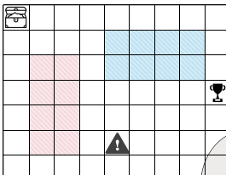

1. Convert the dimensions for the rectangle to real life distances using the map scale.
2. Calculate the area.
3. Write the area in your first column on the score sheet. Keep a running total of the area in the second column, as shown in Figure 6.

Figure 6 – score sheet example

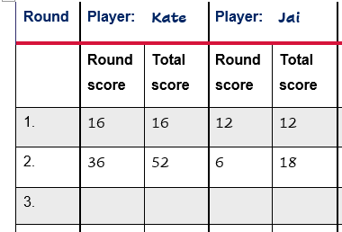

* When a map icon is in the rectangle you draw, check the legend and follow the instructions. Only one icon can be used each turn. If there is more than one icon in your rectangle, select one to be used.
* Only unused grid squares can be included in a rectangle. If you cannot fit a rectangle for your roll, your turn is over and your score for the round is zero.
* The game ends when all grid squares are used or time runs out.
* The winner is the player with the highest area score.

### Measuring area for non-standard shapes

Geographers use the following steps to calculate area for non-standard shaped features on maps such as a dam, orchard or wetland.

1. Use the scale to determine the area of one grid square.
2. Calculate the number of completely-filled grid squares.
3. Calculate the number of incomplete grid squares:
4. combine half (½) and quarter (¼) grid squares to total one grid square, where possible
5. record leftover estimates
6. combine these calculations to get the total grid squares
7. convert to an appropriate unit of measurement as needed.

**Note:** teachers may wish to introduce density at this stage to HPGE students who are demonstrating understanding of area on topographic maps.

Extend students understanding of area further by providing them with more complicated topographic maps and location examples.

Figure 7 is a fictional location used for illustrative purposes.

Use Figure 7 to determine the area of:

* each grid square on the map
* Equist City
* Oveala Plateau
* Trigtown
* the forest
* Cherish Lake
* wetlands.

Figure 7 – Cherish Lake map

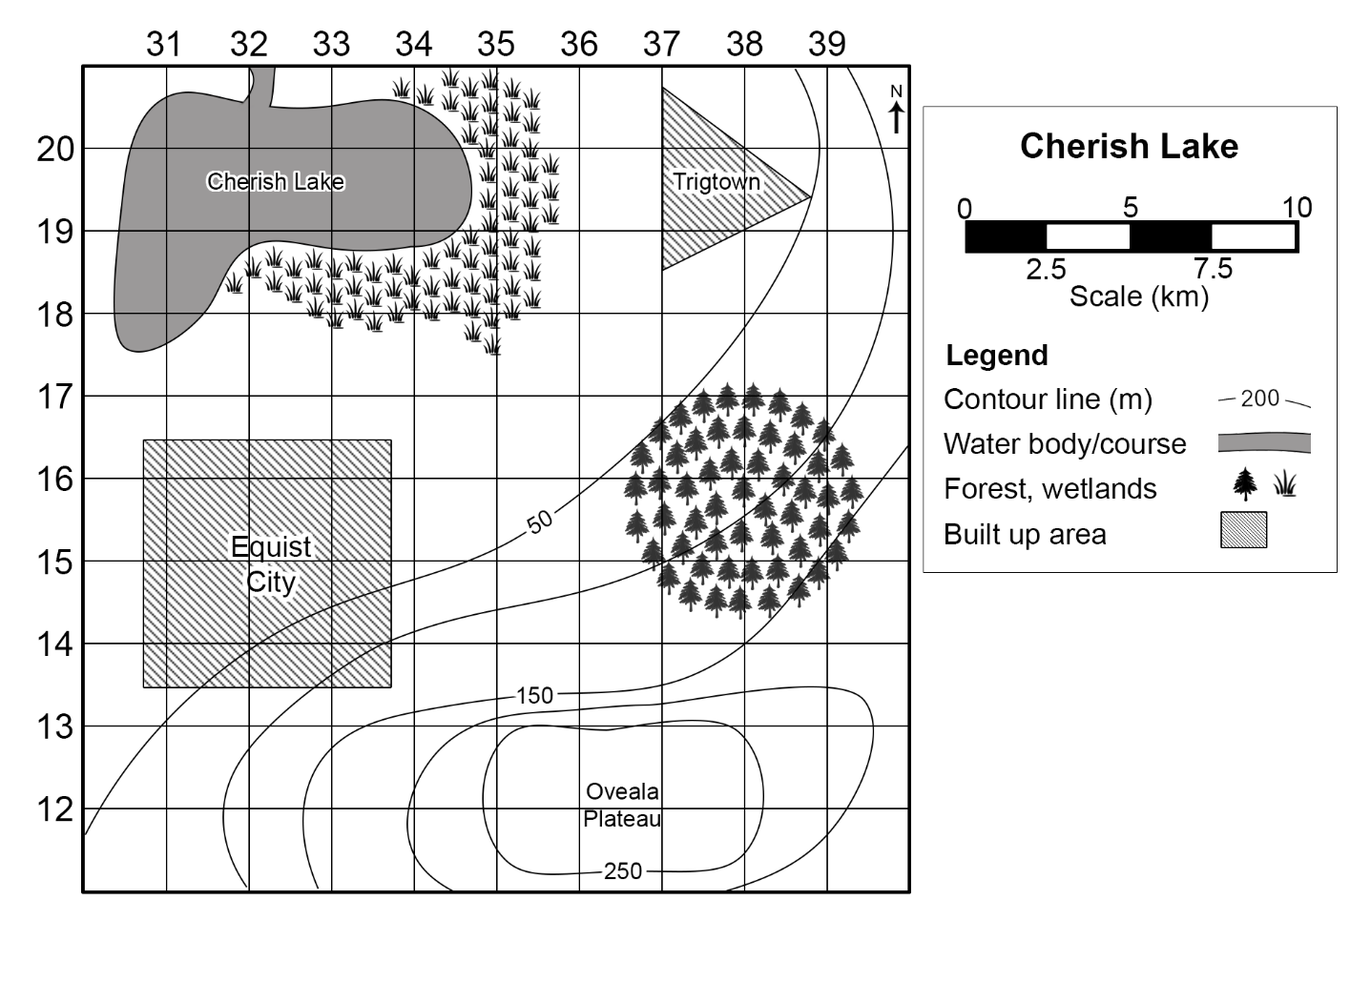

**Answers:**

* $2.5 km × 2.5 km = 6.25 km2$ (area of a square formula)
* $(3 × 2.5 km)2 = 56.25 km2$ (area of a square formula)
* $6 × 6.25 km2 = 37.5 km2$ (grid square approximation)
* $½ × (2 × 2.5 km) × (2 × 2.5 km) = 12.5 km2$ (area of a triangle formula)
* $π × (1.4 × 2.5 km)2 = 39.27 km2$ (area of a circle formula)
* $8 × 6.25 km2 = 50 km2$ (grid square approximation)
* $6 × 6.25 km2 = 37.5 km2$ (grid square approximation).

# Appendix 1 – mapping tools

The following page contains images of a ruler, protractor, compass and 1 cm × 1 cm grid to support students when completing paper-based mapping skills tasks. It should be printed on A4 transparency sheets. Do not scale the page when printing.

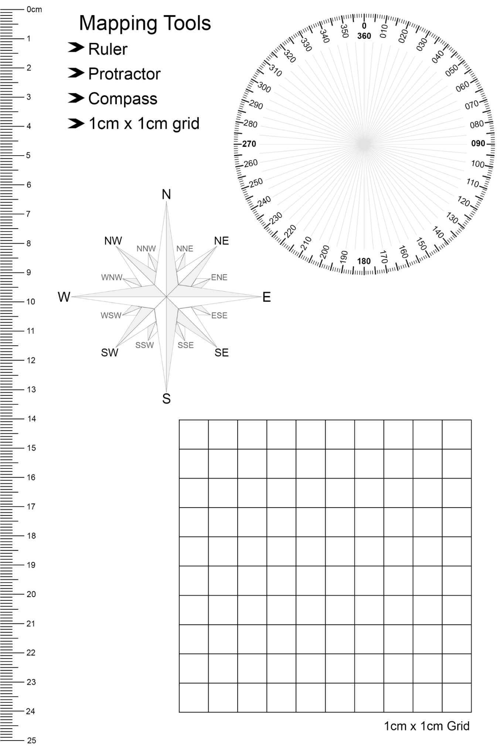

# Appendix 2 – Area game resources

Table 1 – Area game score sheet

|  |  |  |  |  |  |  |  |  |
| --- | --- | --- | --- | --- | --- | --- | --- | --- |
| Round | Player: |  | Player: |  | Player: |  | Player: |  |
|  | Round score | Total score | Round score | Total score | Round score | Total score | Round score | Total score |
|  |  |  |  |  |  |  |  |  |
|  |  |  |  |  |  |  |  |  |
|  |  |  |  |  |  |  |  |  |
|  |  |  |  |  |  |  |  |  |
|  |  |  |  |  |  |  |  |  |
|  |  |  |  |  |  |  |  |  |
|  |  |  |  |  |  |  |  |  |
|  |  |  |  |  |  |  |  |  |
|  |  |  |  |  |  |  |  |  |
|  |  |  |  |  |  |  |  |  |
|  |  |  |  |  |  |  |  |  |
|  |  |  |  |  |  |  |  |  |
|  |  |  |  |  |  |  |  |  |
|  |  |  |  |  |  |  |  |  |
|  |  |  |  |  |  |  |  |  |
|  |  |  |  |  |  |  |  |  |
|  |  |  |  |  |  |  |  |  |
|  |  |  |  |  |  |  |  |  |

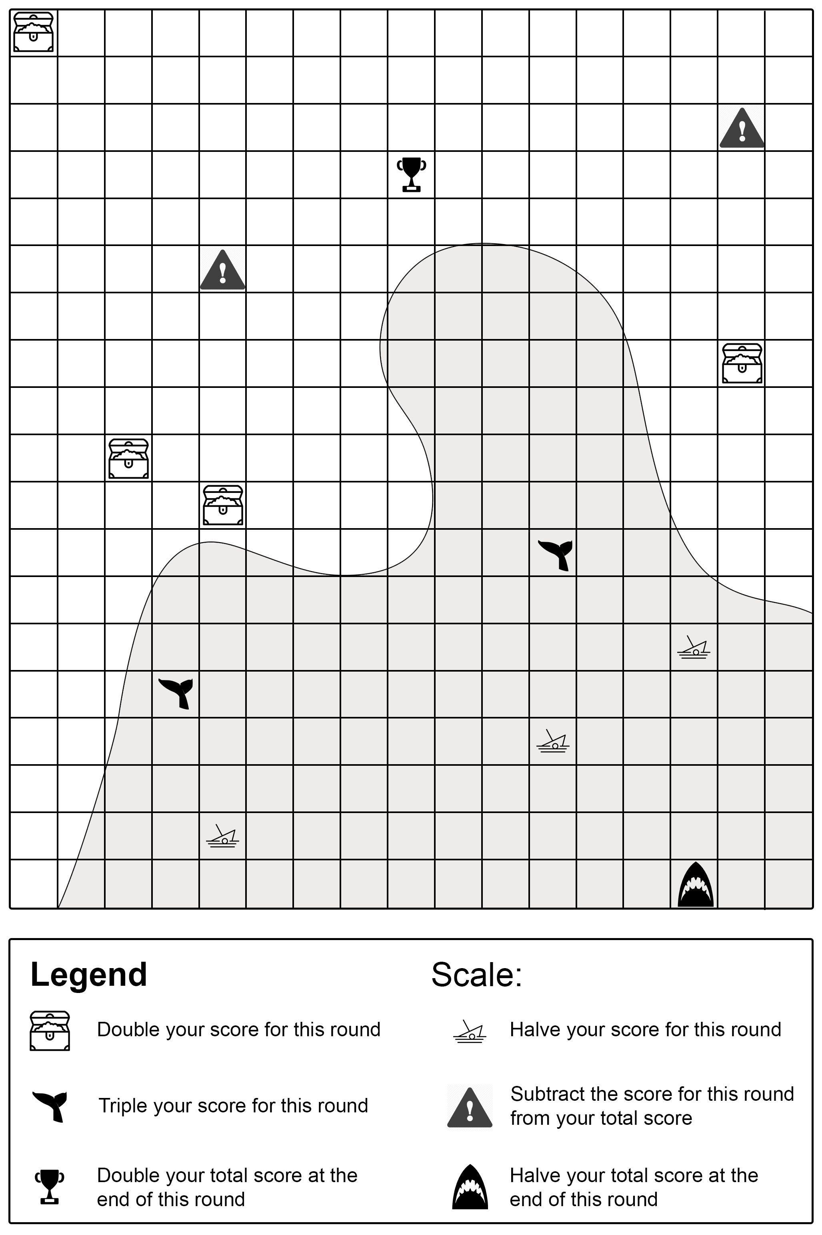

# References

This resource contains NSW Curriculum and syllabus content. The NSW Curriculum is developed by the NSW Education Standards Authority. This content is prepared by NESA for and on behalf of the Crown in right of the State of New South Wales. The material is protected by Crown copyright.

Please refer to the NESA Copyright Disclaimer for more information <https://educationstandards.nsw.edu.au/wps/portal/nesa/mini-footer/copyright>.

NESA holds the only official and up-to-date versions of the NSW Curriculum and syllabus documents. Please visit the NSW Education Standards Authority (NESA) website <https://educationstandards.nsw.edu.au> and the NSW Curriculum website <https://curriculum.nsw.edu.au>.

[Geography K–10 Syllabus](https://www.educationstandards.nsw.edu.au/wps/portal/nesa/k-10/learning-areas/hsie/geography-k-10) © NSW Education Standards Authority (NESA) for and on behalf of the Crown in right of the State of New South Wales, 2015.

[National Numeracy Learning Progression](https://www.australiancurriculum.edu.au/resources/national-literacy-and-numeracy-learning-progressions/version-3-of-national-literacy-and-numeracy-learning-progressions/) © Australian Curriculum, Assessment and Reporting Authority (ACARA) 2010 to present, unless otherwise indicated. This material was downloaded from the [Australian Curriculum](http://www.australiancurriculum.edu.au/) website (National Numeracy Learning Progression) (accessed 11 December 2023) and was not modified. This material is licensed under [CC BY 4.0](https://creativecommons.org/licenses/by/4.0/).

Aboriginal Education Consultative Group (2023) [*AECG Languages App*](https://www.aecg.nsw.edu.au/download-aecg-languages-app/), Aboriginal Education Consultative Group website, accessed 21 August 2023.

AIATSIS (The Australian Institute of Aboriginal and Torres Strait Islander Studies) (n.d.) [*Map of Indigenous Australia*](https://aiatsis.gov.au/explore/map-indigenous-australia), AITSIS website, accessed 24 August 2023.

Australian Government Geoscience Australia (2023) [*Topographic Maps*](https://www.ga.gov.au/scientific-topics/national-location-information/topographic-maps-data/topographic-maps), Geoscience Australia website, accessed 21 August 2023.

NESA (NSW Education Standards Authority) (2022) ‘[Proficient Teacher: Standard descriptors’](https://www.nsw.gov.au/education-and-training/nesa/teacher-accreditation/proficient-teacher/standard-descriptors), *The Standards*, NESA website, accessed 20 July 2023.

NSW Government Spatial Services (2023) [*Topographic Maps*](https://www.spatial.nsw.gov.au/products_and_services/topographic_maps), Spatial Services website, accessed 21 August 2023.

**© State of New South Wales (Department of Education), 2024**

The copyright material published in this resource is subject to the Copyright Act 1968 (Cth) and is owned by the NSW Department of Education or, where indicated, by a party other than the NSW Department of Education (third-party material).

Copyright material available in this resource and owned by the NSW Department of Education is licensed under a [Creative Commons Attribution 4.0 International (CC BY 4.0) license](https://creativecommons.org/licenses/by/4.0/).

[](https://creativecommons.org/licenses/by/4.0/)

This license allows you to share and adapt the material for any purpose, even commercially.

Attribution should be given to © State of New South Wales (Department of Education), 2024.

Material in this resource not available under a Creative Commons license:

* the NSW Department of Education logo, other logos and trademark-protected material
* material owned by a third party that has been reproduced with permission. You will need to obtain permission from the third party to reuse its material.

**Links to third-party material and websites**

Please note that the provided (reading/viewing material/list/links/texts) are a suggestion only and implies no endorsement, by the New South Wales Department of Education, of any author, publisher, or book title. School principals and teachers are best placed to assess the suitability of resources that would complement the curriculum and reflect the needs and interests of their students.

If you use the links provided in this document to access a third-party's website, you acknowledge that the terms of use, including licence terms set out on the third-party's website apply to the use which may be made of the materials on that third-party website or where permitted by the Copyright Act 1968 (Cth). The department accepts no responsibility for content on third-party websites.