Geography 7–10 – guide  
to teaching field sketches

Contents

Overview 2

Outcomes 2

Learning sequence 1 – field sketches 3

Syllabus content 3

Learning intentions and success criteria 3

Learning intentions 3

Success criteria 4

Field sketches 5

Working in the field 8

Appendix 1 – viewing frame template 10

Appendix 2 – field sketch template 11

References 12

This resource has been developed to assist teachers in NSW Department of Education schools to create learning that is contextualised to their classroom. It can be used as a basis for the teacher’s own program, assessment, or scope and sequence, or be used as an example of how the new curriculum could be implemented. The resource has suggested timeframes that may need to be adjusted by the teacher to meet the needs of their students.

# Overview

**Description:** this teaching support resource addresses the K–10 geographical tools continuum providing examples of how students can engage with the the geographical inquiry skills continuum. The lessons and sequences in this program of learning are designed to allow students to build understanding of geographical inquiry skills.

**Duration:** this sequence is designed to be completed in approximately 1 hour.

# Outcomes

A student:

* **GE4-7** acquires and processes geographical information by selecting and using geographical tools for inquiry.

[Geography K–10 Syllabus](https://www.educationstandards.nsw.edu.au/wps/portal/nesa/k-10/learning-areas/hsie/geography-k-10) © NSW Education Standards Authority (NESA) for and on behalf of the Crown in right of the State of New South Wales, 2015.

# Learning sequence 1 – field sketches

**Note:** the guide to teaching field sketches is designed to be used as a support resource for teachers addressing the geographical skills continuum. This resource is not guiding teaching and learning of a specific topic content in geography 7–10; rather, it provides resources and strategies that can be applied at any point across the stages in the context of the content they are teaching.

## Syllabus content

Visual representations take many forms and include digital and non-digital mediums. Examples include, but are not limited to, diagrams, images, photographs, paintings, illustrations, symbols, models, posters, collages, cartoons, multimedia, infographics and mind maps. Visual representations are used to display, visualise, analyse and communicate geographical data and information.

Fieldwork is an integral part of geography. Students must undertake and participate in fieldwork in each stage of learning. There are many opportunities for fieldwork in Stages 4 and 5, such as investigating the characteristics of a local place or observing aspects of human-induced environmental change.

## Learning intentions and success criteria

**Note:** these learning intentions and success criteria are general and should be contextualised to suit your school and students’ needs.

### Learning intentions

Students learn about:

* key features of field sketches
* the purpose of conducting a field sketch.

### Success criteria

Students will be able to:

* construct a field sketch
* explain how a field sketch assists in investigating characteristics of a local place.

## Field sketches

Field sketches are drawings made while in the field. Field sketches have many uses, to:

* ensure careful observation
* assist in keeping an accurate record of what is observed in the field
* assist in describing places to other people.

Figure 2 provides an example of a field sketch based on the location shown in Figure 1.

Figure 1 – photograph of Shelly Beach in East Ballina

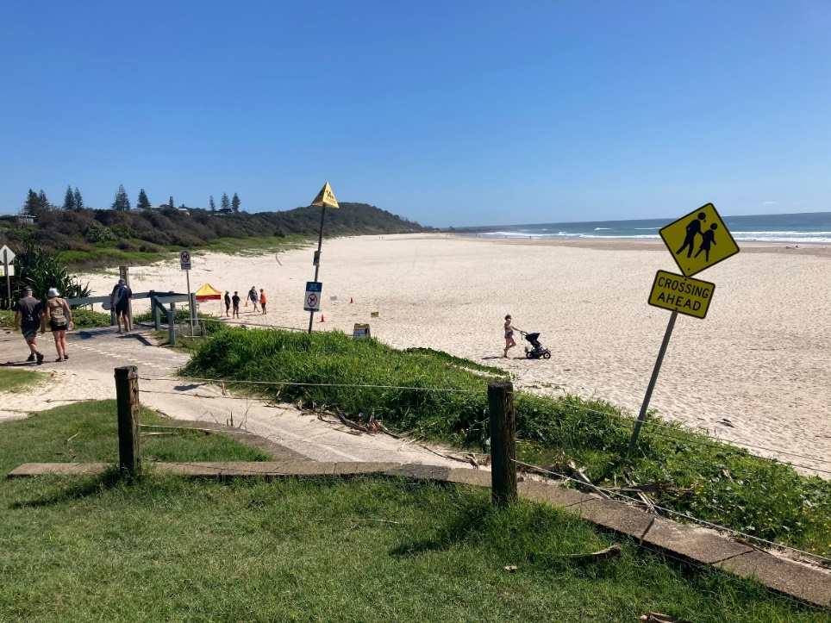

As shown in Figure 2, a field sketch is divided into 3 sections.

* Foreground: the area nearest to you. Objects are larger and more detailed.
* Middle ground: the area slightly further in the distance. Objects become smaller and less detailed.
* Background: the area furthest away, including the horizon. Objects are smaller and drawn in less detail.

Notes and annotations are important features of field sketches. Labelling important objects and noting observations assists when using the field sketch throughout the geographical inquiry.

Figure 2 – field sketch of Shelly Beach Ballina

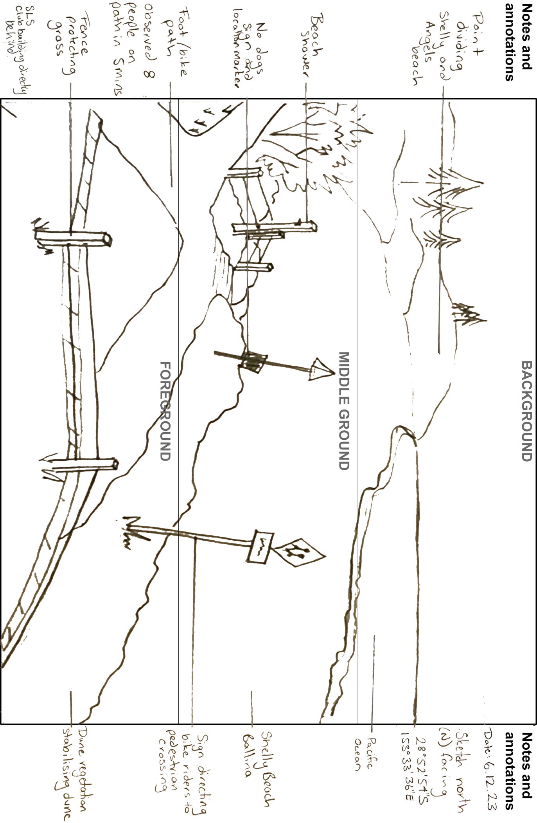

Complete a [See, Think, Wonder](https://pz.harvard.edu/resources/see-think-wonder) routine using Figure 2.

* What do you see in the field sketch?
* What stands out?
* What features do you notice?
* How does it compare to Figure 1?
* What do you think about the field sketch?
* What could be the purpose of the field sketch?
* What do you learn from it?
* What geographical inquiry questions could this be used for?
* How do you think it could be used in a geographical inquiry?
* What do you wonder about the field sketch?
* Are there any questions you have about the field sketch?

**Note**: probing questions to support the [See, Think, Wonder](https://app.education.nsw.gov.au/digital-learning-selector/LearningActivity/Card/638) activity include:

* How is a field sketch different to a photograph?
* What can you learn about the characteristics of the beach in the Figure 2 that you couldn’t from the photograph in Figure 1?
* What advantages are possible for drawing a field sketch as opposed to drawing a line drawing from a photograph?
* How might the time difference between taking a photograph and creating a line drawing impact on your study of a place?
* Why might you use a hand drawn field sketch instead of using digital tools?
* How might field sketches assist in making predictions about the future of a field study site?

## Working in the field

**Note:** for this task, identify an appropriate location to conduct a field sketch. It is easier to draw a field sketch of a location with obvious distinguishing features such as a cliff, significant landform or building. The video [Conducting a field sketch (4:50)](https://education.nsw.gov.au/teaching-and-learning/curriculum/hsie/hsie-curriculum-resources-k-12/hsie-7-10-curriculum-resources/conducting-a-field-sketch) may prove helpful in explaining how to teach drawing a field sketch or be used in the context of a lesson.

Conduct all fieldwork undertaken off school site in accordance with the [NSW Department of Education Excursions policy](https://education.nsw.gov.au/policy-library/policies/pd-2004-0010).

Provide students with cardboard, scissors, a clipboard, paper, pencil and a ruler for the activity. Teachers can pre-prepare step 1. A template has been provided in Appendix 1 – viewing frame template that matches the proportions for the field sketch template in Appendix 2 – field sketch template. Print Appendix 1 in an enlarged format on A3 paper.

Teachers may choose to skip step 1 and have students use their hands to identify their frame of reference for the field sketch.

Use the following steps to construct a field sketch.

1. Cut a hole in a piece of cardboard the same shape as you want your sketch to be. Usually this is a rectangle, approximately 30 cm by 25 cm. Appendix 1 can be used as a guide.
2. Hold the frame at arm’s length.
3. Draw the main features of the land as seen through the frame using Appendix 2.
4. Observe the scene again and add in any other smaller details.
5. Complete your sketch by adding labels, annotations of key observations, the name of the location, [Latitude and longitude (4:24)](https://education.nsw.gov.au/teaching-and-learning/curriculum/hsie/hsie-curriculum-resources-k-12/hsie-7-10-curriculum-resources/latitude-and-longitude) of the site and date you made the sketch.

Review your field sketch and compose 3 [Geographical inquiry (2:59)](https://education.nsw.gov.au/teaching-and-learning/curriculum/hsie/hsie-curriculum-resources-k-12/hsie-7-10-curriculum-resources/geographical-inquiry) questions that could be applied to the site you were observing.

**Note:** when using assessment as learning in the classroom, peer and self-assessment is an effective approach to enhance the learning of students. Explicitly teaching students how to assess their own work, and the work of their peers, has many benefits. It promotes student understanding of their learning and provides opportunities for critical analysis of their own efforts encouraging them to become more autonomous learners. [See three before me (C3B4Me)](https://app.education.nsw.gov.au/digital-learning-selector/LearningActivity/Card/549) peer assessment requires students to share their work with 3 peers before submitting to the teacher.

Exchange your field sketch and 3 geographical inquiry questions with 3 of your peers in the class. Provide feedback for your peers on their field sketch and inquiry questions. Some ideas you might like to consider in your feedback are listed below.

* How effective is the field sketch in illustrating the field location?
* How well presented is the field sketch? Is it easy to read?
* How well labelled is the field sketch?
* Is there enough relevant information provided with the field sketch, for example, latitude and longitude, and the date the sketch was drawn?
* How effective inquiry questions are in providing scope for further geographical investigation?
* Is there a better way to word any of the inquiry questions?

Before submitting your field sketch and inquiry questions to your teacher use your peer feedback to amend and improve your work.

# Appendix 1 – viewing frame template

The following page contains a viewing frame template that can be printed and used for suggested learning activities.



# Appendix 2 – field sketch template

The following page contains a field sketch template that can be printed and used for suggested learning activities.

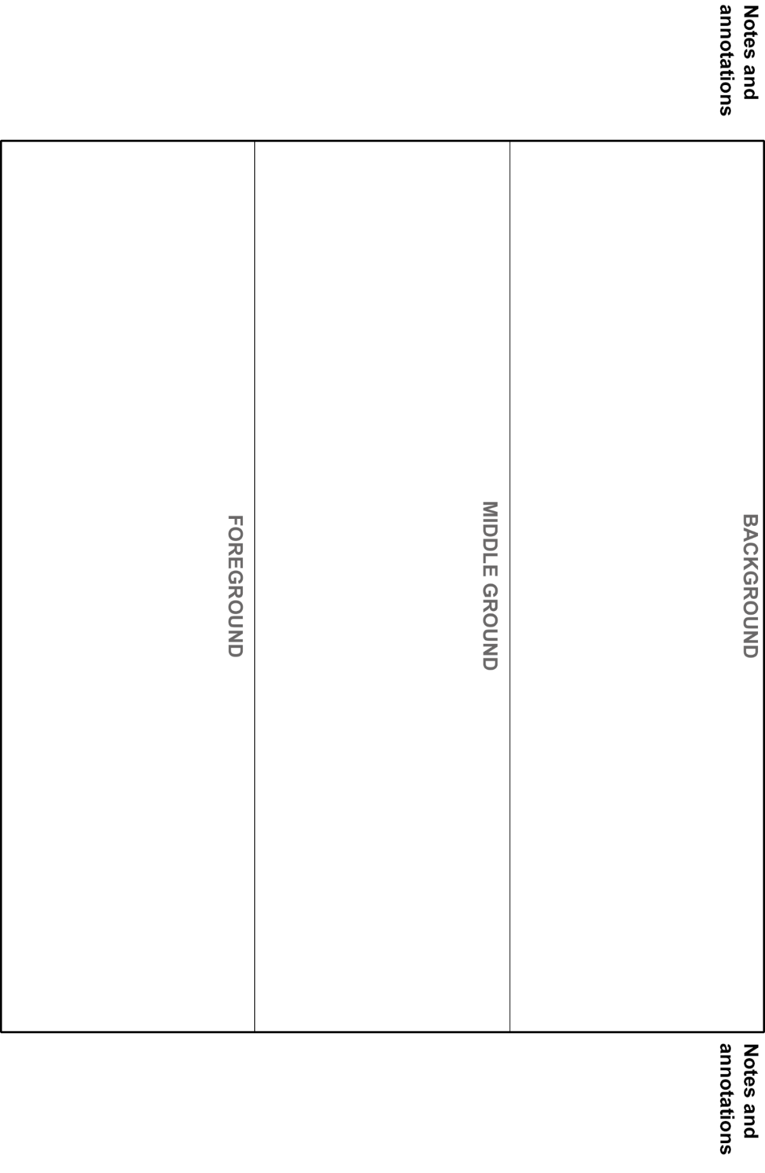

# References

This resource contains NSW Curriculum and syllabus content. The NSW Curriculum is developed by the NSW Education Standards Authority. This content is prepared by NESA for and on behalf of the Crown in right of the State of New South Wales. The material is protected by Crown copyright.

Please refer to the NESA Copyright Disclaimer for more information <https://educationstandards.nsw.edu.au/wps/portal/nesa/mini-footer/copyright>.

NESA holds the only official and up-to-date versions of the NSW Curriculum and syllabus documents. Please visit the NSW Education Standards Authority (NESA) website <https://educationstandards.nsw.edu.au> and the NSW Curriculum website <https://curriculum.nsw.edu.au>.

[Geography K–10 Syllabus](https://www.educationstandards.nsw.edu.au/wps/portal/nesa/k-10/learning-areas/hsie/geography-k-10) © NSW Education Standards Authority (NESA) for and on behalf of the Crown in right of the State of New South Wales, 2015.

Aboriginal Education Consultative Group (2023) [*AECG Languages App*](https://www.aecg.nsw.edu.au/download-aecg-languages-app/), Aboriginal Education Consultative Group website, accessed 21 August 2023.

AIATSIS (The Australian Institute of Aboriginal and Torres Strait Islander Studies) (n.d.) [*Map of Indigenous Australia*](https://aiatsis.gov.au/explore/map-indigenous-australia), AITSIS website, accessed 24 August 2023.

Australian Government Geoscience Australia (2023) [*Topographic Maps*](https://www.ga.gov.au/scientific-topics/national-location-information/topographic-maps-data/topographic-maps), Geoscience Australia website, accessed 21 August 2023.

NESA (NSW Education Standards Authority) (2022) ‘[Proficient Teacher: Standard descriptors’](https://www.nsw.gov.au/education-and-training/nesa/teacher-accreditation/proficient-teacher/standard-descriptors), *The Standards*, NESA website, accessed 20 July 2023.

NSW Government Spatial Services (2023) [*Topographic Maps*](https://www.spatial.nsw.gov.au/products_and_services/topographic_maps), Spatial Services website, accessed 21 August 2023.

**© State of New South Wales (Department of Education), 2024**

The copyright material published in this resource is subject to the Copyright Act 1968 (Cth) and is owned by the NSW Department of Education or, where indicated, by a party other than the NSW Department of Education (third-party material).

Copyright material available in this resource and owned by the NSW Department of Education is licensed under a [Creative Commons Attribution 4.0 International (CC BY 4.0) license](https://creativecommons.org/licenses/by/4.0/).

[](https://creativecommons.org/licenses/by/4.0/)

This license allows you to share and adapt the material for any purpose, even commercially.

Attribution should be given to © State of New South Wales (Department of Education), 2024.

Material in this resource not available under a Creative Commons license:

* the NSW Department of Education logo, other logos and trademark-protected material
* material owned by a third party that has been reproduced with permission. You will need to obtain permission from the third party to reuse its material.

**Links to third-party material and websites**

Please note that the provided (reading/viewing material/list/links/texts) are a suggestion only and implies no endorsement, by the New South Wales Department of Education, of any author, publisher, or book title. School principals and teachers are best placed to assess the suitability of resources that would complement the curriculum and reflect the needs and interests of their students.

If you use the links provided in this document to access a third-party's website, you acknowledge that the terms of use, including licence terms set out on the third-party's website apply to the use which may be made of the materials on that third-party website or where permitted by the Copyright Act 1968 (Cth). The department accepts no responsibility for content on third-party websites.