Geography 7–10 – direction and bearings

Contents

Overview 2

Outcomes 2

Learning sequence 1 – direction and bearings 3

Syllabus content 3

Learning intentions and success criteria 3

Learning intentions 3

Success criteria 3

Working with maps 5

Orientating a map 7

Using bearings to explain direction 10

Appendix 1 – mapping tools 16

References 18

This resource has been developed to assist teachers in NSW Department of Education schools to create learning that is contextualised to their classroom. It can be used as a basis for the teacher’s own program, assessment or scope and sequence. It can also be used as an example of how curriculum reform can be implemented in geography classrooms. The resource has suggested timeframes that may need to be adjusted by the teacher to meet the needs of their students.

# Overview

**Description:** this teaching support resource addresses Thinking and working geographically, providing examples of how students can engage with the the geographical tool of maps. The lessons in this resource are designed to allow students to build understanding of this geographical tool through a range of learning activities and can be applied where appropriate across Geography 7–10.

**Duration:** this learning sequence is designed to be completed in approximately 3 hours.

## Outcomes

A student:

* **GE4-TAP-01** selects and uses geographical tools to acquire and process geographical information
* **GE5-TAP-01** applies and evaluates a range of geographical tools to acquire and process geographical information

[Geography 7–10 Syllabus](https://curriculum.nsw.edu.au/learning-areas/hsie/geography-7-10-2024/overview) © NSW Education Standards Authority (NESA) for and on behalf of the Crown in right of the State of New South Wales, 2024.

# Learning sequence 1 – direction and bearings

**Note:** the guide to teaching direction and bearings is designed to be used as a support resource for teachers addressing Thinking and working geographically. This resource provides resources and strategies that can be applied at any point across Geography 7–10 where relevant to syllabus content.

## Syllabus content

Maps are to be integrated into Stage 4 and Stage 5 as appropriate: large-scale maps and small-scale maps, relief maps, special-purpose maps, physical maps, political maps, sketch maps, précis maps, topographic maps, land use maps and thematic maps, such as choropleth maps, isoline maps, cartogram maps, dot maps, flowline maps, weather maps or synoptic charts, graduated or proportional symbol maps.

## Learning intentions and success criteria

**Note:** these learning intentions and success criteria are general and should be contextualised to suit your school and students’ needs.

### Learning intentions

Students learn about:

* BOLTSS and orientation of maps on the ground
* locating places using direction and bearings on maps.

### Success criteria

Students will be able to:

* align a map on the ground with north using a compass or watch
* locate and describe features on topographic maps using direction and bearings.

## Working with maps

**Note:** teachers will need to provide students with a topographic map for learning activities in this sequence. [Geoscience Australia](https://www.ga.gov.au/scientific-topics/national-location-information/topographic-maps-data/topographic-maps) and [NSW Spatial Services](https://www.spatial.nsw.gov.au/products_and_services/topographic_maps) provide a variety of topographic maps useful for this activity. Teachers need to be aware of the representative fraction scale on the Geoscience maps and the recommended print sizes are A1 for Geoscience 1:50000 maps. NSW Spatial Services maps include linear scale and can be printed on A3 paper.

Students will need a ruler, protractor and pencil to complete the activities in this learning sequence. Appendix 1 – mapping tools provides printable mapping tools. These need to be printed on transparency sheets.

This sequence includes terminology which may be unfamiliar to students, such as orientation and cardinal points. Literacy strategies such as [Frayer diagrams](https://app.education.nsw.gov.au/digital-learning-selector/LearningActivity/Card/553) may be useful for pre-teaching this vocabulary.

Teachers who are not familiar with directions and bearings may find the video [Directions and bearings (3:45)](https://education.nsw.gov.au/teaching-and-learning/curriculum/hsie/hsie-curriculum-resources-k-12/hsie-7-10-curriculum-resources/directions-and-bearings) useful in explaining the geographical skills and tools. The video may be used as a stimulus in lessons if required.

Maps are used in geography to communicate information about places. Geographers use many different types of maps. They are used as a tool to find places, understand the patterns of natural and human features and discover relationships between features. The easiest way of explaining the direction of one place from another, either on a map or on the ground, is to use the points of the compass shown in Figure 1.

Figure 1 – 16-point compass

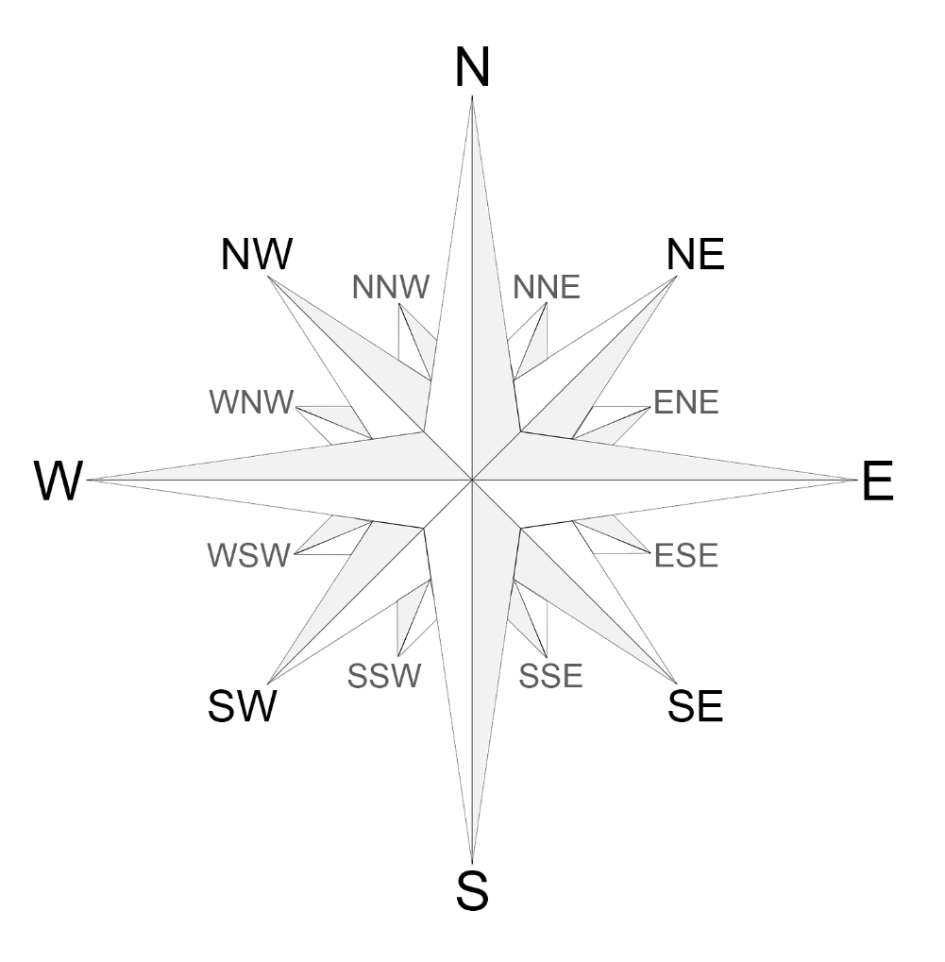

North (N), south (S), east (E) and west (W) are the 4 main points of a compass. They are called the cardinal points. North-east (NE), south-east (SE), south-west (SW) and north-west (NW) are in between each of the cardinal points. They are called intermediate points.

When drawing and using maps it is useful to understand the acronym BOLTSS: border, orientation, legend, title, scale and source. Orientation refers to direction on a map. All good maps will have a north point clearly marked on it. The north point shows which way north is on your map.

Use the compass in Figure 1 to answer the following questions:

* What compass point lies in the opposite direction to north?
* What direction is opposite of east?
* What direction is halfway between north and east?
* What direction is opposite of north-west?

**Answers:**

* south (S)
* west (W)
* north-east (NE)
* south-east (SE).

Use the [Map of Indigenous Australia](https://aiatsis.gov.au/explore/map-indigenous-australia) to locate your local language, social or nation group. With the class, identify direction between key places. For example, Kamilaroi: What is the direction of Inverell from Gunnedah?

### Orientating a map

A map is said to be orientated when it has been turned around so that north on the map is in line with the true direction of north on the ground, as illustrated in Figure 2.

Figure 2 – orientating a map with ground features

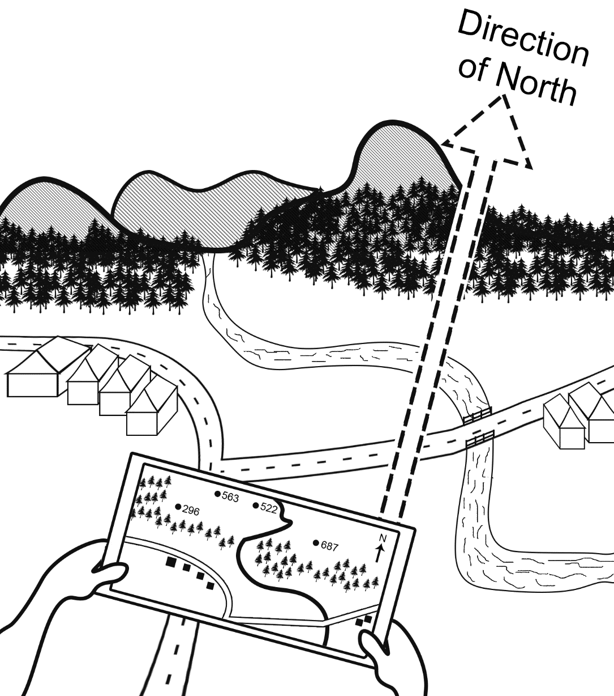

There are several ways geographers orientate maps.

1. With a magnetic compass: a magnetic compass can be used to orientate the map if there is a magnetic north pointer on the map. The map is turned around so that magnetic north, both on the map and on the compass, are in line.
2. Using features on the ground: a map can also be orientated by identifying features on the ground and then turning the map until those same features are in their correct position on the map.
3. Using the sun and an analogue watch: the sun and your analogue watch face can be used to find north during the day. Turn your watch so that the 12 points to the sun. Halfway between 12 and the hour hand will be the direction of north.

**Note:** students will need a map of the school, a clip board, compass, pencil and a watch with an analogue face to complete the following activity.

Ensure student safety by advising they wear sunglasses when looking towards the sky and remind students to never look directly at the sun, but to look towards it.

Teachers may like to display [Google Earth](https://app.education.nsw.gov.au/digital-learning-selector/LearningTool/Card/620) in the classroom with pins identifying the places students are seeking direction for. This can help students check answers or used to present the map in a different view (orientation) if students are unsure of some locations.

Without using a compass or your watch, write down the direction of the following places from where you are right now:

* your house
* a friend or family member’s house
* the nearest post office
* the nearest police station
* the nearest sporting venue.

Use the fieldwork equipment provided by your teacher to work with a partner to find north. Then check the answers you recorded in the previous activity. Circle which best applies to your accuracy:

* we were completely accurate
* we were mostly accurate
* we had a few mistakes.

Use the fieldwork equipment provided by your teacher to work with a partner to respond to the following prompts.

* Move to the flagpole in the playground at your school. Orientate yourself and the map of your school to face north (N). Write down the direction of the following places:
* the principal’s office
* the canteen
* your HSIE classroom
* the school library.

**Note:** when using formative assessment in the classroom, peer and self-assessment is an effective approach to enhance the learning of students. Explicitly teaching students how to assess their own work, and the work of their peers, has many benefits. It promotes student understanding of their learning and provides opportunities for critical analysis of their own efforts, encouraging them to become more autonomous learners. The following learning activities provide an example of self-assessment. More information on this aspect of formative assessment is available at [Peer and self-assessment for students](https://education.nsw.gov.au/teaching-and-learning/professional-learning/teacher-quality-and-accreditation/strong-start-great-teachers/refining-practice/peer-and-self-assessment-for-students).

Table 1 – self-assessment

|  |  |  |  |
| --- | --- | --- | --- |
| Statement | Confident | Somewhat confident | Need more help |
| How confident are you in finding north using a compass? |  |  |  |
| How confident are you in finding north using a watch? |  |  |  |
| How confident are you in orientating a map to face north and locate places? |  |  |  |

### Using bearings to explain direction

Bearings are used when giving the exact direction of one place from another. A bearing is another name for an angle. Angles are measured in degrees. A circle has 360 degrees. The direction of one place from another is described as so many degrees from north which is 0 degrees. Figure 3 shows how each point on the compass can be turned into a bearing. True bearings use 3 digits, so we include 0 at the start of any bearings under 100 degrees.

Figure 3 – compass with 360-degree bearings

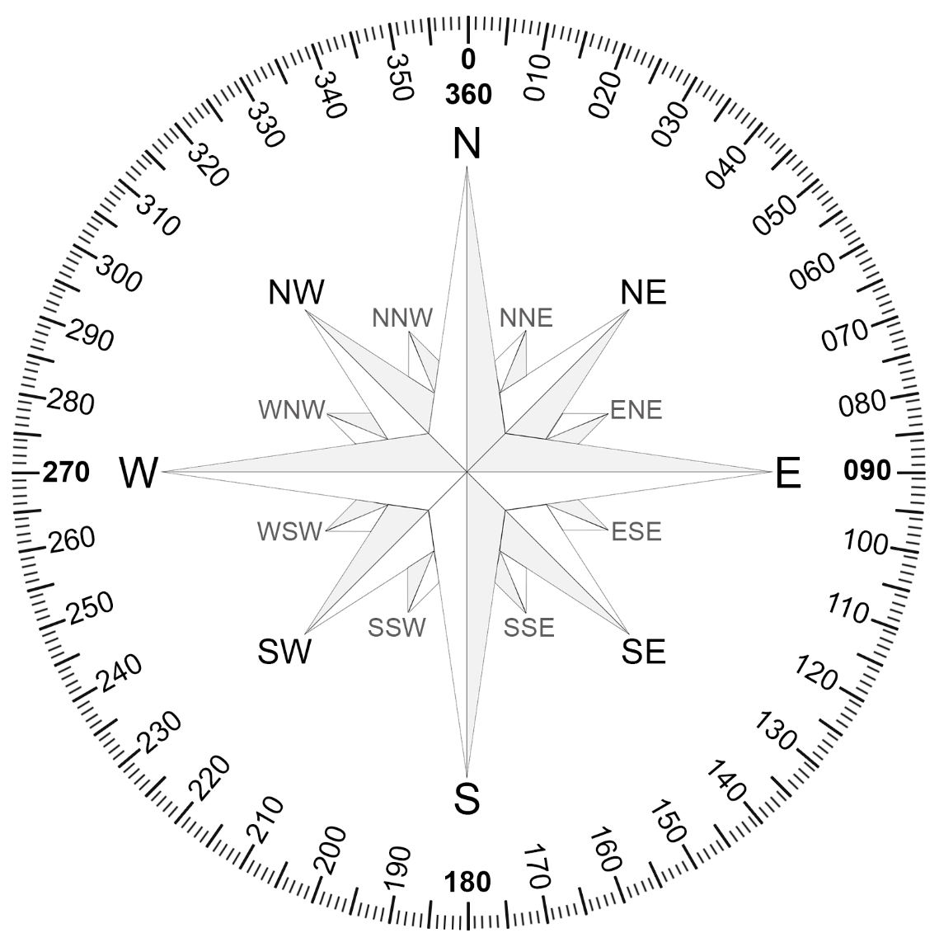

**Note:** teachers who are not familiar with directions and bearings may find the video [Directions and bearings (3:45)](https://education.nsw.gov.au/teaching-and-learning/curriculum/hsie/hsie-curriculum-resources-k-12/hsie-7-10-curriculum-resources/directions-and-bearings) useful in explaining the geographical skills and tools. The video may be used as a stimulus in lessons if required.

In geography we use a protractor to measure the angle and identify bearings on maps. Figure 4 shows that the bearing of Mount Pleasant from the information centre is 240.

Figure 4 – map with protractor illustrating bearings

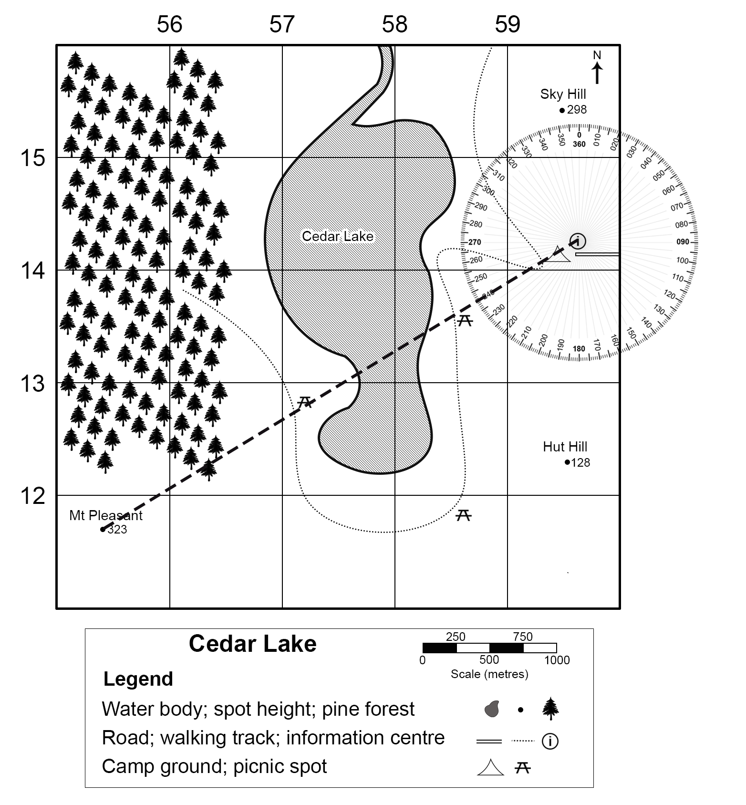

Figure 4 is used as an example here. In geography we use the following steps to find bearings on a map.

1. Locate the 2 points on the map you are finding the bearing for. In this case Mount Pleasant and the information centre.
2. Place your protractor so the centre point of the protractor is on the point from which you must give the bearing (the information centre). Make 0° on the protractor point north (N). Always check the orientation of the map at this step.
3. Look carefully at the point where the line from the information centre to Mount Pleasant crosses the outside edge of the protractor. Read the angle of the bearing. In this example, the angle bearing is 240.

**Note:** students will need to be provided with Figure 5 to answer the following learning activities. Gamilaraay language is used in Figure 5. Gamilaraay Nation is located in north-eastern NSW and south-western Queensland.

The [NSW AECG Languages app](https://wellmob.org.au/key-resources/resources/43997/?title=NSW+AECG+languages+app&contenttypeid=1&contentid=43997_1) contains all words used. Permission to use the traditional language of Gamilaraay was sought and approved by the NSW Aboriginal Education Consultative Group (AECG). Figure 5 is a fictional location used for illustrative purposes.

Students unfamiliar with area and grid reference may need to revisit the geographical skill. The video [Area and grid reference (3:32)](https://education.nsw.gov.au/teaching-and-learning/curriculum/hsie/hsie-curriculum-resources-k-12/hsie-11-12-curriculum-resources/area-and-grid-reference) may be useful for revision or addressing this skill.

Use Figure 5 – Bandaar Walaay map to answer the following questions:

1. What is the bearing of Giidjaa Dhuyul (AR3215) from Wii Dhuyul (AR3319)?
2. What is the bearing of Wii Dhuyul (AR3319) from the bridge (AR3418)?
3. What facility is located at a bearing of 125 from the hospital?
4. What is located at a bearing of 280 from the helipad?
5. What is the bearing of the helipad from the SES?
6. What is the bearing of the helipad from the information centre?
7. What built feature is located at 111 from GR316195 (homestead)?
8. What facility is located at 115 from GR316179 (windmill)?

**Answers**:

1. 190
2. 315
3. fire station
4. SES
5. 100
6. 301
7. bridge
8. drive-in theatre.

Standard differentiation for vision impaired students is allowing answers to the nearest 5 to be correct.

Figure 5 – Bandaar Walaay map

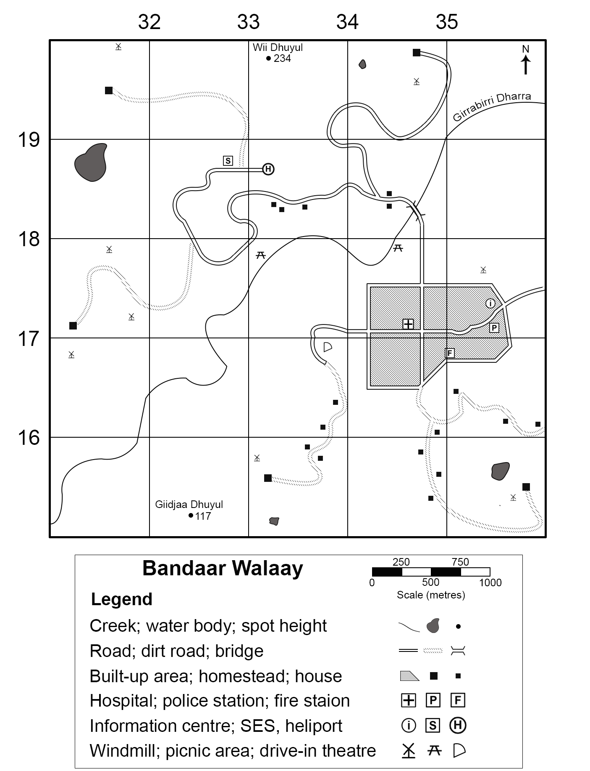

Gamilaraay language used with permission of NSW AECG.

**Note:** divide students into pairs for the following learning activity. Provide each pair with a [NSW Spatial Services Topographic map](https://www.spatial.nsw.gov.au/products_and_services/topographic_maps) and have them work together to choose 3 locations each. Write each location on a craft stick then randomly choose 2 at a time. The first location each time is the location the pair are coming from.

Students will need the following resources to complete this learning activity: Topographic map, craft sticks, protractor, ruler, pencil and markers.

High potential and gifted education (HPGE) students or higher stage students may appreciate adding to the complexity of this activity by including the latitude and longitude of places on their craft stick.

Your teacher will allocate you to work with a partner. Working with your partner, use the following steps to calculate bearings on a map:

1. Locate 3 places on the map provided by your teacher.
2. Each pair writes the name of each place identified on a craft stick (6 in total).
3. Randomly draw 2 craft sticks and take turns to calculate the bearing between the 2 locations.
4. Repeat until you have exhausted all bearing combinations.
5. Reflect on your understanding of finding bearings on topographic maps.

* How confident are you in finding bearings using a protractor and topographic map?
* confident
* somewhat confident
* need more help.

# Appendix 1 – mapping tools

The following page contains images of a ruler, protractor, compass and a 1 cm × 1 cm grid to support students when completing paper-based mapping skills tasks. It should be printed on A4 transparency sheets. Do not scale the page when printing.

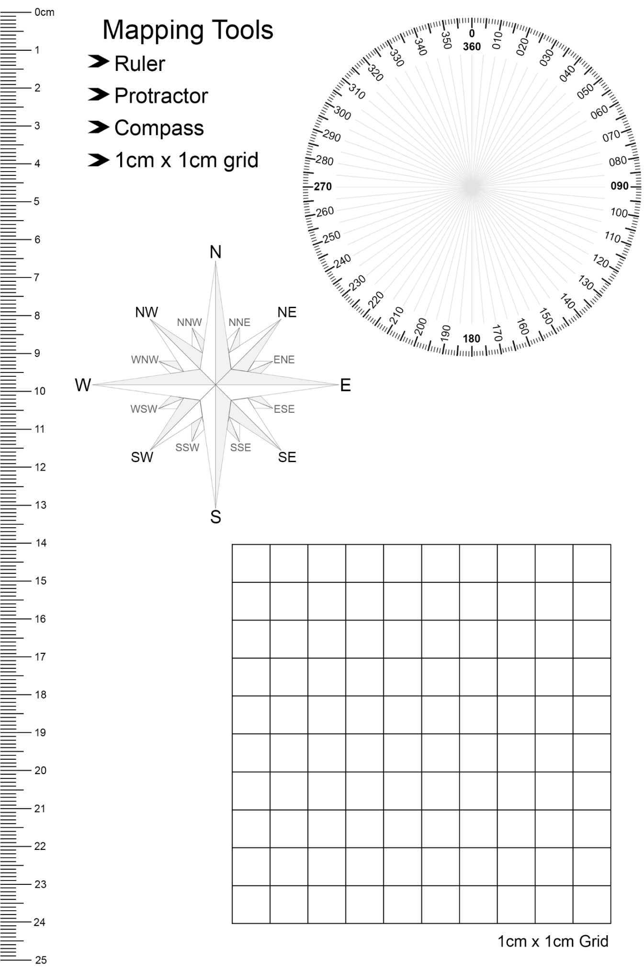

# References

This resource contains NSW Curriculum and syllabus content. The NSW Curriculum is developed by the NSW Education Standards Authority. This content is prepared by NESA for and on behalf of the Crown in right of the State of New South Wales. The material is protected by Crown copyright.

Please refer to the NESA Copyright Disclaimer for more information <https://educationstandards.nsw.edu.au/wps/portal/nesa/mini-footer/copyright>.

NESA holds the only official and up-to-date versions of the NSW Curriculum and syllabus documents. Please visit the NSW Education Standards Authority (NESA) website <https://educationstandards.nsw.edu.au> and the NSW Curriculum website <https://curriculum.nsw.edu.au>.

[Geography 7–10 Syllabus](https://curriculum.nsw.edu.au/learning-areas/hsie/geography-7-10-2024/overview) © NSW Education Standards Authority (NESA) for and on behalf of the Crown in right of the State of New South Wales, 2024.

AIATSIS (The Australian Institute of Aboriginal and Torres Strait Islander Studies) (n.d.) [*Map of Indigenous Australia*](https://aiatsis.gov.au/explore/map-indigenous-australia), AITSIS website, accessed 24 August 2023.

Australian Government Geoscience Australia (2023) [*Topographic Maps*](https://www.ga.gov.au/scientific-topics/national-location-information/topographic-maps-data/topographic-maps), Geoscience Australia website, accessed 21 August 2023.

NESA (NSW Education Standards Authority) (2022) ‘[Proficient Teacher Standard Descriptors’](https://www.nsw.gov.au/education-and-training/nesa/teacher-accreditation/proficient-teacher/standard-descriptors), *The Standards*, NESA website, accessed 20 July 2023.

NSW Aboriginal Education Consultative Group (2023) [*NSW AECG Languages App*](https://wellmob.org.au/key-resources/resources/43997/?title=NSW+AECG+languages+app&contenttypeid=1&contentid=43997_1), WellMob website, accessed 21 August 2023.

NSW Government Spatial Services (2023) [*Topographic Maps*](https://www.spatial.nsw.gov.au/products_and_services/topographic_maps), Spatial Services website, accessed 21 August 2023.

**© State of New South Wales (Department of Education), 2024**

The copyright material published in this resource is subject to the Copyright Act 1968 (Cth) and is owned by the NSW Department of Education or, where indicated, by a party other than the NSW Department of Education (third-party material).

Copyright material available in this resource and owned by the NSW Department of Education is licensed under a [Creative Commons Attribution 4.0 International (CC BY 4.0) license](https://creativecommons.org/licenses/by/4.0/).

[](https://creativecommons.org/licenses/by/4.0/)

This license allows you to share and adapt the material for any purpose, even commercially.

Attribution should be given to © State of New South Wales (Department of Education), 2024.

Material in this resource not available under a Creative Commons license:

* the NSW Department of Education logo, other logos and trademark-protected material
* material owned by a third party that has been reproduced with permission. You will need to obtain permission from the third party to reuse its material.

**Links to third-party material and websites**

Please note that the provided (reading/viewing material/list/links/texts) are a suggestion only and implies no endorsement, by the New South Wales Department of Education, of any author, publisher, or book title. School principals and teachers are best placed to assess the suitability of resources that would complement the curriculum and reflect the needs and interests of their students.

If you use the links provided in this document to access a third-party's website, you acknowledge that the terms of use, including licence terms set out on the third-party's website apply to the use which may be made of the materials on that third-party website or where permitted by the Copyright Act 1968 (Cth). The department accepts no responsibility for content on third-party websites.