Workshop 1 – What is explicit teaching?

Facilitator guide
It is recommended facilitators review the ‘Explicit teaching in NSW public schools’ statement and the Explicit teaching webpages prior to leading the workshop. Facilitators should consider the most suitable approach to engage the whole school to develop a shared understanding of explicit teaching.

Purpose
This purpose of this workshop is to:
- start a discussion in your school about explicit teaching
- develop a shared understanding of the ‘Explicit teaching in NSW public schools’ statement
- provide an opportunity to explore the Explicit teaching webpages.

Outcomes
By the end of the workshop, participants will:
- form an understanding of what explicit teaching is
- develop an awareness of the evidence-base for explicit teaching
- begin to reflect on current practices and find links to explicit teaching.

Timing
The workshop is designed for a 45-minute session. This timing is suggested and the facilitator should make decisions about timing based on the school context.

Facilitating the workshop

Suggested structure
- Present the Workshop 1 – What is explicit teaching? Powerpoint presentation and use the speaking notes and facilitator prompts to guide discussion [25 minutes].
The PowerPoint contains 2 pauses to allow for reflection on current practice – one at the beginning and one at the end of the presentation. The discussion questions are included in this guide.
- Continue the discussion using the extended discussion questions in this guide [20 minutes].
The facilitator may choose which questions are most appropriate for their context and the time available for discussion. This workshop can be completed across more than one session.

Discussion questions
The discussion questions in this guide include reflection questions embedded in the Workshop 1 – What is explicit teaching? PowerPoint presentation and questions for extended discussion.

Reflection questions
- Reflecting on current practice (slide 3), consider the following:
- What practices are we already doing that deliver success in learning?
- How do we know these practices are successful?
- Circling back (slide 20), think back to our examples of success:
- What connections can you make between your example and explicit teaching?
- What are you curious to know more about?

Extended discussion questions
- The ‘Explicit teaching in NSW public schools’ statement defines explicit teaching as a range of dynamic and responsive teaching strategies. Discuss common myths and misconceptions about explicit teaching.
- How could teachers address common misconceptions with members of the school community?
- Based on the ‘Explicit teaching in NSW Public Schools’ statement, share and discuss examples and non-examples of explicit teaching.
- After exploring the Explicit teaching webpages, consider the following:
- How does it connect to what you already know about how students learn?
- How does it extend what you know about how students learn?
- What challenges might explicit teaching pose for you in your context?
- How can our school ensure there is a shared understanding of explicit teaching?
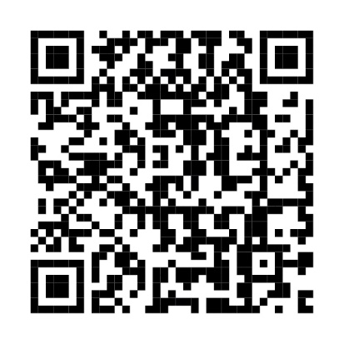
Explicit teaching webpages.
If you have questions about the guide, please email ContactCurriculumReform@det.nsw.edu.au.

© State of New South Wales (Department of Education), 2024
The copyright material published in this resource is subject to the Copyright Act 1968 (Cth) and is owned by the NSW Department of Education or, where indicated, by a party other than the NSW Department of Education (third-party material).
Copyright material available in this resource and owned by the NSW Department of Education is licensed under a Creative Commons Attribution 4.0 International (CC BY 4.0) license.
This license allows you to share and adapt the material for any purpose, even commercially.
Attribution should be given to © State of New South Wales (Department of Education), 2024.
Material in this resource not available under a Creative Commons license:
- the NSW Department of Education logo, other logos and trademark-protected material
- material owned by a third party that has been reproduced with permission. You will need to obtain permission from the third party to reuse its material.
Links to third-party material and websites
Please note that the provided (reading/viewing material/list/links/texts) are a suggestion only and implies no endorsement, by the New South Wales Department of Education, of any author, publisher, or book title. School principals and teachers are best placed to assess the suitability of resources that would complement the curriculum and reflect the needs and interests of their students.
If you use the links provided in this document to access a third-party's website, you acknowledge that the terms of use, including licence terms set out on the third-party's website apply to the use which may be made of the materials on that third-party website or where permitted by the Copyright Act 1968 (Cth). The department accepts no responsibility for content on third-party websites.

