English Stage 5 (Year 9) – resources and activities
9.1 – ‘Representation of life experiences’
This document contains the teacher-facing resources and activities that accompany the teaching and learning program, ‘Representation of life experiences’ – Year 9, Term 1.

Contents
About this resource 4
Purpose of resource 4
Target audience 4
When and how to use 4
Core texts and text requirements 5
Pre-reading – approach to conceptual programming 5
Phase 1 – engaging with the unit and strengthening the learning community 8
Phase 1, resource 1 – What matters to young people? 9
Phase 1, activity 1 – exploring the effectiveness of texts 11
Phase 1, activity 2 – personal voice 14
Phase 2 – unpacking and engaging with the conceptual focus 16
Phase 2, activity 1 – hybrid texts 17
Phase 2, activity 2 – exploring an imaginative hybrid text 19
Phase 2, resource 1 – hybridity in the text 20
Core formative task 1 – imaginative writing 22
Phase 2, activity 3 – narrative structure of a text 23
Phase 2, activity 4 – personal response to a core text 24
Phase 2, activity 5 – writing about a textual concept 26
Phase 2, resource 2 – summary of core texts for personal responses 27
Phase 3 – discovering and engaging analytically with the core texts 29
Phase 3, resource 1 – revisiting texts 30
Phase 3, activity 1 – identifying ideas and values in texts 31
Phase 3, resource 2 – vocabulary used in the text 33
Phase 3, resource 3 – the art of annotation 36
Phase 3, resource 4 – language features in ‘Monsters and Mice’ 38
Phase 3, activity 2 – What’s the message? 40
Phase 3, activity 3 – preparing to write 41
Core formative task 2 – adaptation of ideas and attitudes for a new audience 43
Phase 3, activity 4 – reflecting on writing 44
Phase 4 – deepening connections between texts and concepts 46
Phase 4, activity 1 – pre-reading and making connections 47
Phase 4, activity 2 – language features 48
Phase 4, activity 3 – exploring the term ‘anaphora’ 50
Phase 4, activity 4 – exploring the term ‘allusion’ 51
Phase 4, resource 1 – recursive writing 52
Phase 4, activity 5 – semantic vocabulary mapping 53
Phase 4, activity 6 – reading the text 54
Phase 4, resource 2 – effect on the reader 55
Phase 4, resource 3 – discussion activities 56
Phase 4, resource 4 – language forms and features in ‘The Masala of My Soul’ 57
Phase 5 – engaging critically and creatively with model texts 60
Phase 5, activity 1 – annotating ‘Nomad’ 61
Core formative task 3 – experimenting with language features 62
Phase 5, resource 1 – the language of reflection 63
Core formative task 4 – writing a draft reflection 66
Phase 5, activity 2 – reflective writing support 71
Phase 6 – preparing the assessment task 73
Phase 6, activity 1 – word cline template 74
Phase 6, resource 1 – A-grade sample response 75
Part A – imaginative response 75
Part B – reflection 76
Phase 6, resource 2 – annotated A-grade sample response 78
Phase 6, activity 2 – check your draft 87
Phase 6, activity 3 – peer feedback 90
Phase 6, activity 4 – actioning feedback to refine your writing 92
Phase 6, activity 5 – student-teacher conference 93
References 95

Updating the table of contents
Want to update the table? Have you added content to the document and noticed the page numbers have changed? As you add content to this report, you can update the table of contents to accurately reflect the page numbers within the resource. To update the table:
- Right click on the table and select ‘Update table of contents’ (in the browser version) or ‘Update field’ (in the desktop app). In the browser version, it will automatically update the entire table.
- In the desktop app, you will then need to select ‘Update entire table’. Your table numbers should then update to reflect your changes.

About this resource
This resource booklet aligns with a sample teaching and learning program. It has been developed to assist teachers in NSW Department of Education schools to create learning experiences that are contextualised to their students’ needs, interests and abilities for the English K–10 Syllabus (NESA 2022).

Purpose of resource
This resources and activities booklet is not a standalone resource and aligns with the following support materials for the program ‘Representation of life experiences’:
- Assessment resources: Assessment – 9.1; Core formative tasks – 9.1
- Programming resources: Program – 9.1
- Resources and activities support in Word: Core texts – 9.1
- Resources and activities in PowerPoint: Phase 2 – exploring the textual concepts – 9.1; Phase 3 – fables and fairytales – 9.1; Phase 3 – text annotations – Fries – 9.1; Phase 4 – text annotations – Smith – 9.1; Phase 4 – text annotations – Tahsin – 9.1; Phase 5 – text annotations – Swan – 9.1
- Scope and sequence: Year 9.
All documents associated with this resource can be found on the Planning, programming and assessing English 7–10 webpage.

Target audience
This resource booklet is intended to support teachers and curriculum leaders as they develop contextually appropriate teaching and learning resources for the English K–10 Syllabus (NESA 2022). Teacher-facing material has been included as a ‘resource’, while student-facing material has been labelled ‘activity’ in this booklet.

When and how to use
These resources have been designed for Term 1 of Year 9. This resource booklet provides opportunities for the teacher to build a class rapport, while encouraging students to explore and understand new texts and concepts, and experience new ways of learning.The program and associated materials can be used as a basis for the teacher’s own program, assessment or scope and sequence, or be used as an example of how the English K–10 Syllabus (NESA 2022) can be implemented.
The program and associated resources are not intended to be taught exactly as is presented in their current format. Teachers using this program and the associated materials should adapt these to suit their students’ needs, interests, abilities and the texts selected. The resources should be used with timeframes that are created by the teacher to meet the overall assessment schedules.
Some of the information is collated from relevant NESA and department documentation. It is important that all users re-read and cross-reference the relevant syllabus, assessment and reporting information hyperlinked throughout. This ensures the content is an accurate reflection of the most up-to-date syllabus content.
Teacher note: the blue feature boxes include instructions for the classroom teacher engaging with the activities and resources. They provide suggestions for how content could be delivered and links to additional resources. These notes should be removed before distributing activities and resources to students.
Student note: the pink feature boxes include information for students to develop and clarify their understanding about why they are engaging with specific activities. These notes could be edited or modified to suit the needs of students within your context.

Core texts and text requirements
The core texts and their alignment to the text requirements are provided in their entirety or as the licenced extracts in the Core texts booklet. The name and details of each text, the syllabus requirement being addressed, points of note and a succinct overview of the texts and the reasons for their use in the teaching and learning program is provided.

Pre-reading – approach to conceptual programming
Below is a graphic demonstrating the lead and supporting concepts at the heart of the ‘Representations of life experiences’ sample materials.
Figure 1 – conceptual programming outline Representation of life experiences
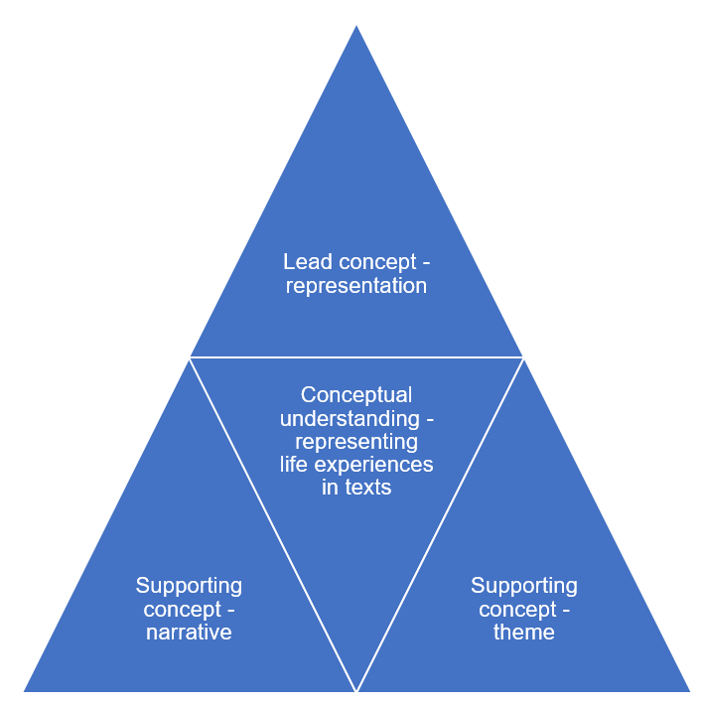
The conceptual programming diagram has been included for teacher reference to showcase one approach to conceptual programming. There is a lead concept, representation, and 2 supporting concepts, narrative and theme. The conceptual understanding is at the heart of the program and guides the teaching and learning experiences and formative and formal assessment. In this program students are supported to represent personal experiences in texts. The choice of concepts here does not mean the program, resources and activities do not connect to other concepts. It means these are your driving force from which the teacher will build towards conceptual understanding and deep knowledge. The guiding questions and conceptual programming questions align with the concepts and represent the ideas that matter to subject English. This structure helps teachers move away from topic- and text-based programs and towards conceptual, transferrable learning.
Conceptual understanding and Phases approach to learning
The diagram below is an adaptation of an approach signalled in Stern et al. (2017) for ‘uncovering’ (as opposed to ‘covering’) conceptual understanding so that students can transfer their learning to new situations. The learning sequences start with a conceptual question then guide students to deepen their interest and understanding by exploring an illustrative text or extract. In each subsequent sequence the conceptual question is deepened then explored through a new text or extract. Finally, students are supported to apply their learning to new situations.
Figure 2 – uncovering conceptual understanding (adapted from Stern et al. 2017)
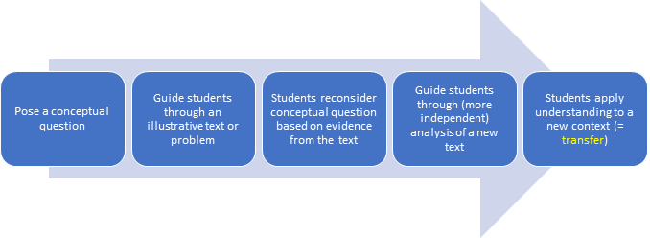

Phase 1 – engaging with the unit and strengthening the learning community
In the ‘engaging with the unit and strengthening the learning community’ phase, students explore the issues that matter to them. They discuss how their voices can be heard and discuss the importance of having a ‘voice’. This phase contains the opening few lessons and is designed to pique interest in the program. To encourage a meaningful connection, activities in this phase focus on the learning process of engaging personally.

Phase 1, resource 1 – What matters to young people?
Teacher note: this resource provides examples to support the teaching of Phase 1, sequence 1 – What matters to young people? Use professional judgement to determine how this resource can be used to support students in your context.
Examples of issues that matter to young people:
- mental health concerns, such as anxiety, depression and the need for additional support for young people’s mental health
- climate change
- access to quality education
- social justice issues, such as racism, gender equality, LGBTQIA+ rights
- body image and self-esteem
- technology and privacy. This could include the use of artificial intelligence, cyberbullying, social media or misinformation online.
Sample responses for tiered quick write questions
Tier 1: In your opinion, what issues matter most to you? Why does this issue matter?
The issue that matters the most to me is cyberbullying. Young people seem to be online on their phones all the time and this can be a problem when people are mean and bully others online. This issue matters to me because I know people who have been the victim of cyberbullying and it was not good. They got really upset and felt really bad.
Tier 2: In your opinion, what issue matters most to young people? Support your response with examples from your group or class discussion.
After talking to the various members in my group today, I believe that cyber safety is an issue that matters a great deal to young people. Too many of the people in my group spoke of instances when they, or people they knew, experienced cyberbullying. This makes me realise the importance of providing more support for young people to be safe online and promote respectful cyber relationships.
Tier 3: When reflecting on your class discussion, discuss what matters most to young people. Support your response with your opinion of why this issue is important to young people.
After reflecting on the class discussion and brainstorm from today’s lesson, I determine that one of the issues that matters most to young people is cyber safety. Ten of the 30 people in my class listed cyberbullying as an issue they had personal or indirect experience with. Supporting young people to form respectful online relationships and communicate kindly and with care for the wellbeing of others online is necessary. Combatting cyberbullying will, in my opinion, result in improved mental health and wellbeing for teenagers. One way we can combat cyberbullying is to share the negative impact it can have on victims, so we can build empathy and understanding.

Phase 1, activity 1 – exploring the effectiveness of texts
Teacher note: students should be split into small groups or pairs to complete this activity. Assign each group with one of the 5 stories from the YouTube clip Young voices from regional Australia | Heywire | ABC Australia (11:28). They will need computer access to complete this activity and instructions on how to access the transcript for their particular story. You may also like to provide printed copies of the transcripts depending on your students’ computer skills.
- View your assigned ‘story’ carefully. As you watch, make notes about how the story appeals to you as a ‘reader’.
Table 1 – text exploration
Language form, feature or structure | Personal response | Effect
Who is telling the story?
What is the story about?
Visual features that help tell the story – images, camera and film conventions
Audio features that help tell the story – music, sound effects, pause, pace
Initial personal response to the text – how does it make you feel?
- Read the transcript for your assigned clip.
- Identify language features that are used to construct the composer’s argument about rural experiences. What is the effect of using the particular language feature?
Table 2 – language features in the text
Language feature | Evidence | Effect
Figurative language – alliteration, hyperbole, imagery, simile
Persuasive language – analogy, rhetorical questions, repetition, rule of 3, high modality
Narrative features – allegory, allusion, connotation, irony, flashback, cliché
Other language features
- Consider the composer’s perspective on the topic they are speaking about. In a 200-word paragraph, respond to the following prompts in your English book
- Does the clip express the composer’s personal voice?
- Has a sense of personal voice been communicated? Has the composer expressed their point of view on the topic?
- Has the composer’s personal values and experiences been communicated about living in rural Australia?
- Have you, as the responder, been emotionally impacted or affected by the information expressed in the clip?
- Has the composer been effective in the creation of the text to engage with the audience?

Phase 1, activity 2 – personal voice
Teacher note: for this activity write the prompt questions (or question letter) on the board for students to place their sticky notes. Categorise the responses into similar responses for each question. Discuss the common responses, then ask students to expand on any outlying responses.
Tone – describes the way the ‘voice’ is delivered. For example, the tone of a voice or the tone in a passage of writing could be friendly or angry or persuasive (ACARA 2024).
Voice – the way in which language is used and/or interpreted to represent particular thoughts, opinions or perspectives. This includes the authorial voice or the voice of a narrator, character or persona within a text (NESA 2024Glossary).
Voice can be created through word choice, tone and sentence structure.
Dissecting voice
- Read the extract from Core text 2 – ‘Monsters and Mice’ by Emily Fries.
For as long as Helen could remember, the Monster had been a nameless fear, lurking in the hills. Every villager had different ideas. Some hung rosemary above beds to ward off a dragon. Some poured salt under windows against a lion.
And that, was why Helen was fetching grain to scatter under the beds, her mother’s method of keeping the Monster at bay. Helen’s lone footsteps padded on the road. No one went outside, not if they could help it. Not with the Monster about. She stumbled, breaking into a jog. Enough of this. She would get the grain and hurry home.
- Work with a partner to answer the questions below on sticky notes.
- What is the topic of this text?
- What words or phrases does the writer use to express their ideas on the topic?
- What tone does the writer use? How can you tell?
- Put your sticky notes on the board under the letter for each question to prepare for a class discussion.
Personal voice
Personal voice is the natural reflection of an individual’s way of expressing themselves. It is the words they use, their tone and the way they express their personal opinions.
Emotive language
Emotive language is a term used to describe language that evokes an emotional response from the responder. Emotive words can either be positive or negative. That is, they can evoke either a positive or a negative emotion. An example has been provided for you below.
- Baseline story: I walked down the street holding something. I called my friend and told them something important.
- Positive emotive story: The stars glistened in the sky as I gleefully skipped along clasping the bunch of roses to my chest. My heart flitted as I excitedly dialled my closest friend and rattled off the story of my dreamy first date with my secret admirer.
- Negative emotive story: The darkness of the sky enveloped me as I stumbled hurriedly towards the streetlight. I clutched my purse to my chest as I warily glanced around me. My fingers trembled uncontrollably as I dialled my best friend. I could hardly breathe as I pushed out the words, ‘Help me’.
- Consider the bolded words and how they have been used to evoke different emotions for a similar storyline. Now try adding positive and negative emotive language to the baseline story below. Do this in your English book.
The girl sat in the playground. She read a book to the other children. The bell rang.
- In your English book, write a personal response about your favourite place. Try exaggerating your own personality in your writing and using emotive language to convey your personal feelings. It should be about a half a page to one page long. Consider
- whether ‘your place’ has changed over time
- whether particular factors have changed it
- how you feel about these changes.
Consolidating ideas
- Write a one sentence response to the question: ‘Why is personal voice important in writing?’

Phase 2 – unpacking and engaging with the conceptual focus
In the ‘unpacking and engaging with the conceptual focus’ phase, students engage with the textual concepts of representation, theme and narrative and how they are communicated. They explore a core text focusing on identifying and developing an understanding of their effect on the responder. The teaching and learning activities guide the focus on specific textual and language features. Students will practise writing short evaluative responses about the use of language features. This will allow the teacher to assess the students’ evaluative writing skills. This is important for the reflection component of the assessment task. The teacher recognises students’ prior understanding of elements of imaginative writing, and students reflect upon their own skills, to unpack the requirements of the formal assessment task and begin to draft their own imaginative writing.

Phase 2, activity 1 – hybrid texts
Narratives
Narrative – an account of events or experiences, which are real or imagined. In English literary theory, narrative includes a story (what is narrated) and a discourse (how it is narrated). Narrative can present as an explicit sequencing of events (type of text) or it can be an implied or inferred component in a text (NESA 2024).
Narratives have a purpose and present a perspective – they tell a story. This is often delivered through a thematic concern and may be considered the argument the author is presenting. The thematic concern is the message the composer wants the responder to take away from the story. This is also referred to as the moral purpose in narratives such as fairy tales or fables.
Hybrid texts
Hybrid text – composite texts resulting from combining elements from different genres, styles and modes (NESA 2024).
Applied to a narrative, any text that blends or combines 2 or more forms of writing can be referred to as hybrid.
Therefore, a hybrid narrative or hybrid imaginative response is a creative response that incorporates elements of other forms (the way texts are structured) or genres (the content category of a text). The core texts explored in this program are constructed using a blend of narrative forms and genres.
A hybrid text allows composers to draw on structures, features, stylistic devices of other types of texts to achieve their purpose.
- Add the following examples into either the form or genre column.
Table 3 – list of examples
Examples
Historical fiction, prose, poetry, romance, news article, horror, true crime, narrative, autobiography, letter, lyrics, extended response, fantasy, comedy
Table 4 – form or genre table
Form | Genre
- Complete a Venn diagram in your English book comparing the features of imaginative, informative and persuasive texts based on your prior understanding of these text forms. Add common features to the middle section of the diagram.
- In your English book, explain how narratives can be hybrid texts.

Phase 2, activity 2 – exploring an imaginative hybrid text
Teacher note: students will need a copy of Core text 1 – ‘To Draw a Home’ by Sindy Zhang. They can complete this activity in pairs to build confidence.
- Read Core text 1 – ‘To Draw a Home’ by Sindy Zhang.
- Work with a peer to answer the following questions in your English books
- What is the narrative about?
- What is the theme, main idea or message of this story?
- How does the title represent the story’s content?
- How is this text structured?
- What language features can you identify in the text? For example, figurative, descriptive, persuasive, informative, reflective language? Create a list of examples for each category you find.
- What combination of forms do you think it uses?
- Individually, use your notes to reflect on how effective this text is in representing the composer’s ideas.

Phase 2, resource 1 – hybridity in the text
Core text 1 – ‘To Draw a Home’ by Sindy Zhang can be considered a hybrid text because it combines multiple text types, tones and modes of expression to convey its themes and ideas.
Reflective and personal narrative
The text shares the author’s personal experiences and reflections, particularly regarding migration, adaptation and identity. This gives it a narrative quality, as it recounts a series of life events (moving homes, cultural adjustments and emotional growth).
The use of first-person perspective and emotive language (‘I was overcome by a sense of emptiness, a notion of loss ...’) adds a reflective, memoir-like tone to the narrative.
Descriptive and poetic elements
The text incorporates poetic structure, as seen in the line length in:
‘A triangle at the top.
A square in the middle.
A rectangle at the bottom.
Done. A house.
This is combined with vivid imagery in passages of prose such as, ‘This air of unfamiliarity persisted throughout my brief stay here, sweeping through the modest rooms and making itself more at home than I was’, create a lyrical quality. The rhythm of the prose, vivid sensory imagery and personification evoke a strong imaginative response in the reader.
Expository and analytical
The text delves into abstract ideas about ‘home’, exploring its transient and dynamic nature. This analytical layer encourages readers to think critically about what defines a home – moving beyond physical structures to emotional and cultural connections.
Symbolism and universal themes
The text uses symbols, such as the ‘triangle, square, and rectangle’ of a kindergarten drawing, to represent universal perceptions of home, before challenging these simplistic notions. This gives the text a broader philosophical or symbolic layer.
Hybrid in audience and purpose
The text changes between being deeply personal (aimed at evoking empathy or connection) and broader in its appeal (inviting readers to reflect on their own definitions of home). This blend of personal and universal ideas makes it appeal to different contexts.

Core formative task 1 – imaginative writing
Teacher note: this task has been created to help you differentiate the teaching and learning of the program for individual student needs. Review student responses to see where their strengths and areas of improvement lie. If students have a clear understanding of narrative conventions, you can adjust the program content to reflect student needs.
- Use the image below to write an imaginative story. Your story should
- be approximately 200 to 400 words in length
- use an appropriate narrative structure
- use a range of narrative language features
- use a range of appropriate punctuation.
Figure 3 – stimulus image

Image licensed under Unsplash License.
- Submit your story to your teacher.

Phase 2, activity 3 – narrative structure of a text
- Return to Core text 1 – ‘To Draw a Home’ by Sindy Zhang and map it on the plot diagram below.
- In your English book, write an observation about how the story meets the narrative plot components.
Figure 4 – plot diagram
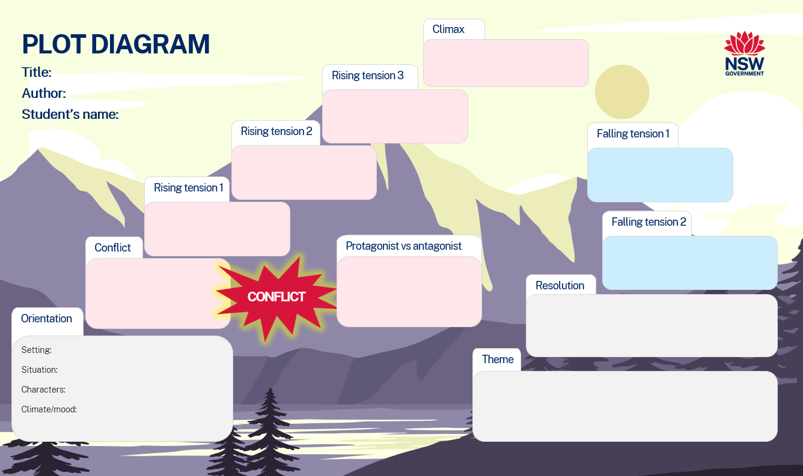

Phase 2, activity 4 – personal response to a core text
Teacher note: for this activity, individual students should be issued with a printed copy of different core texts other than Core text 1 – ‘To Draw a Home’ by Sindy Zhang. This will allow students to examine one new text in detail and be introduced to the other texts for future familiarity.
Your teacher has issued you with one of the core texts to examine.
- Use the prompts below to gather information about the text you have been issued.
- Write a personal reflection in your English book about what the concept of ‘home’ means to you, both physically and emotionally.
Table 5 – personal reflection
Prompts | Notes
Title of the text and author
How does the title engage the target audience?
What is the main theme or message of the text?
What patterns in language features do you notice? Are there words or types of words that are repeated for effect?
What other texts have you read that are like this text?
What do you like about the text?
What connections do you make to your own life?

Phase 2, activity 5 – writing about a textual concept
Teacher note: it may be necessary to spend some time explicitly teaching elaborated noun groups and cohesive devices. Students should select one of the lead or supporting concepts (representation, theme, narrative) to complete this activity.
- Read the information below to review your knowledge of elaborated noun groups and cohesive devices.
Elaborated noun groups
Elaborated noun groups include adjectives that provide more information about the topic. They can be included before the noun, after the noun or as an appositive. For example: Sindy Zhang’s cleverly constructed narrative, ‘To Draw a Home’, explores the theme that home is not a place, but a feeling connected to people and values.
Cohesive devices
Cohesive devices are words and expressions that show relationships between parts of text and ideas, such as cause and effect, time, addition, or comparison and contrast. Cohesion can be created by:
- using linking words or phrases – use a range of text connectives such as: additionally, unless, in comparison, similarly, however, for example, that is, although, generally, secondly
- referring backwards – use similes or pronouns instead of repeating the same word
- looking forward – use words such as: as follows, below, next, subsequently
- connecting paragraphs – use sentences that link back to the ideas from the previous paragraph (University of Melbourne n.d.).
- Using the core text used for Phase 2, activity 4 – personal response to a core text, write a paragraph about the theme of the text.
- Use elaborated noun groups and text connectives to expand your ideas.

Phase 2, resource 2 – summary of core texts for personal responses
Teacher note: this resource has been provided to support teachers in checking student personal responses in the previous activities.
- Sindy Zhang, ‘To Draw a Home’
- The form (prose, memoir) is accessible and allows readers into the world of a young migrant child.
- The title is clever and allows the reader to think more deeply about the importance of reflecting on childhood experiences to identify how our current perceptions were formed.
- The message about the importance of changing our perceptions as we engage with more life experiences is clear and impactful.
- Emily Fries, ‘Monsters and Mice’
- The form (allegorical, fairy tale, fable) lifts the quality of writing and extends the reach to readers of all age groups.
- The title is clever and allows the reader to draw on prior knowledge.
- There is a contrast that is built on in the narrative and it is used to challenge perceptions of prejudice.
- The message about being careful not to believe everything you hear or are told if you haven’t seen it yourself is clear and impactful.
- Freya Smith, ‘Stories Matter’
- The form (prose, poetry) is accessible and creates a rhythm and this makes the message easier to access.
- The double meaning in the title is clever and allows the reader to think more deeply about why all stories matter.
- The message about all stories, big or small (canonical, classic, modern, and so on) having relevance is clear and impactful.
- Tanisha Tahsin, ‘The Masala of My Soul’
- The form (prose, memoir) is accessible and effectively creates the emotional experience into which readers are invited.
- The title is clever and allows the reader to think more deeply about the importance of making connections with culture and traditions.
- The message about the importance of letting go of the need to fit all society’s expectations and embracing your true self is clear and impactful.
- Eleanor Swan, ‘Nomad’
- The form (prose, monologue) is accessible and allows readers to connect with the narrator.
- The title is clever and allows the reader to think more deeply about the metaphor of being a nomadic reader.
- The message about the importance of writing being unrestricted so that creativity continues to thrive is clear and impactful.

Phase 3 – discovering and engaging analytically with the core texts
In the ‘discovering and engaging analytically with the core texts’ phase, students will move through a process of reading and responding to develop a deep understanding of one core text. Students will explore the hybrid narrative ‘Monsters and Mice’, in which Emily Fries blends the fable and folklore forms and genres to create a fabulist narrative. They revisit fables or fairy tales to engage in structured reading that activates prior knowledge about narrative and helps to refine reading and comprehension skills. Students will deepen their conceptual understanding of representation, code and convention and theme by analysing language forms and features in a core text and their own compositions. They will focus specifically on the use of allegory and anthropomorphism, which are distinguishing characteristics of the core text. This will help students analyse how composers represent thematic concerns. Students engage in compositional activities to strengthen their imaginative and reflective writing skills. They will also be introduced to self and peer feedback strategies to edit, refine and revise their work.

Phase 3, resource 1 – revisiting texts
Our understanding of the themes, ideas and attitudes represented in the narratives we read can be linked back to the reading we did as children. This is usually reading of fairy tales and fables.
Fairy tales
A fairy tale is a prose story that belongs to the folklore genre (stories are typically set in a magical realm). Fairy tales often include human characters as well as unearthly or otherworldly beings such as ghosts, spirits, witches, wizards, gods or superheroes. Our earliest fairy tales explored dark and ominous ideas and attitudes and were not suitable for younger audiences. Some examples of fairy tales include ‘Cinderella’, ‘Beauty and the Beast’ and ‘Jack and the Beanstalk’. These provide lessons for readers and provide lessons that are intended to shape the way we respond to situations we may encounter. The characters represented in these narratives are usually representative of different social groups and their attitudes.
Fables
A prose or poetic piece that is a short tale written with the driving purpose of teaching a moral lesson. Traditional fables across many cultures have anthropomorphised animals as characters, as well as a story being told by a talking plant or a force of nature. Aesop’s fables are the most well-known text of this type. All of Aesop’s fables represent ideas that affirm or challenge cultural attitudes and values, which is an expression of the thematic concern.
Fabulist narratives
Longer pieces of imaginative writing that have the same purpose as a fable (to teach a specific lesson or to introduce a moral to show readers how our lives could be better) are referred to as fabulist. The story ‘Monsters and Mice’ by Emily Fries is an example. Often, these narratives are also referred to as allegorical.

Phase 3, activity 1 – identifying ideas and values in texts
Teacher note: copies of the stories for this activity can be located on the links: Little Red Riding Hood, Rumpelstiltskin and Hansel and Gretel. You may need to provide printed copies of the stories to your students. Use different fairy tales if required for your cohort.
All fairy tales and fables represent themes, ideas and values.
- Choose one of the following fairy tales
- Little Red Riding Hood
- Rumpelstiltskin
- Hansel and Gretel
- Write an outline of the narrative in the first column. Only include key events that shape the narrative and represent the ideas and attitudes represented.
- Based on this recollection, summarise the ideas and values represented in column 2.
An example is provided in the first row, for ‘Jack and the beanstalk’.
Table 6 – thematic concerns in fairy tales and fables
Fairy tale and summary | Ideas and values represented
Jack and the beanstalk  Jack is a poor boy sent by his mother to the local markets to sell their last cow.  Jack makes the bad decision to trust a stranger and trades the cow for magic beans.  In her fury and frustration, Jack’s mother hurls these out the window and sends Jack to bed hungry and sad.  The next morning, the magic beans have sprouted a gigantic beanstalk that stretches into the clouds, which Jack climbs hoping to escape the misery of his mother.  In the clouds, Jack discovers a grand castle filled with luxury. He fills his pocket with golden coins and hurries back to his mother.  While these coins could have ensured Jack and his mother lived comfortably ever after, Jack becomes a little greedy and keeps climbing the beanstalk.  On his third visit, Jack disturbs the giant who owns the coins Jack has been stealing. The giant cuts down the beanstalk as Jack is tumbling down to earth and while he almost dies, he learns a valuable lesson about being content with what one acquires. | Poor people deserve empathy.  People must be careful with who they trust – this includes placing trust in your child to do the right thing and placing trust in a stranger.  Sometimes the poor need to take drastic action, such as stealing, to survive.  People who enjoy a more comfortable lifestyle think they are above others.  People with excess wealth should consider the less fortunate otherwise they could become victims of their own greed, and other people’s crimes.  Despite hardship, a good person (Jack’s mum) will eventually be rewarded with better days.

Phase 3, resource 2 – vocabulary used in the text
Teacher note: this word bank should be used in conjunction with the PowerPoint Phase 3 – text annotations – Fries – 9.1. Students should use a different coloured highlighter to identify different examples of parts of speech on their copy of the text and add other words they are not familiar with. They should add additional rows to the tables if required. You may also like to explore the webpage How to use the English core texts.
Differentiation note: this word bank only draws on the first 3 paragraphs of the narrative. If you know that your students will need extensive support, add to this word bank. Encourage students to add additional rows and list any other unfamiliar words they experience in the text. Support students to identify where it has been used in the text and create definitions.
Student note: some of the vocabulary in ‘Monsters and Mice’ might be unfamiliar to you. To support your engagement with the text, words or phrases from the first 3 paragraphs have been defined in the context of how they have been used in this narrative. Add additional rows for other unfamiliar words and seek assistance to create definitions and check your answers.
‘Monsters and Mice’ word bank
The tables below identify the varying word choices made within the text.
- Verbs – words that describe an action
Table 7 – verbs in 'Monsters and Mice'
Verb | Used in context | Definition or alternate use
lurking | For as long as Helen could remember, the Monster had been a nameless fear, lurking in the hills. | Hiding in the hills
ward off | Some hung rosemary above beds to ward off a dragon. | Prevent the dragon from hurting anyone
fetching | And that, was why Helen was fetching grain to scatter under the beds. | Moving around to collect something
glanced | She glanced back. | Look back, quickly
- Nouns – words that name a person, place, object, feeling and so on
Table 8 – nouns in 'Monsters and Mice'
Noun | Used in context | Definition or alternate use
village/villager | Every villager had different ideas. | A village is a community of houses that is smaller than a town – a villager is a person who lives in a village.
grain | She would get the grain and hurry home. | The small seed from wheat.
set of buildings (noun phrase) | A set of dull buildings rested against the valley’s lush slopes. | Buildings that are close to each other.
- Adjectives – words that add description, usually to a noun or a pronoun
Table 9 – adjectives in 'Monsters and Mice'
Adjective | Used in context | Definition or alternate use
dull | A set of dull buildings rested against the valley’s lush slopes. | Buildings that don’t have any colour
padded | Helen’s lone footsteps padded on the road. | Footsteps making a soft sound
twisting maze | Despite her best efforts, the streets were a twisting maze to her. | Description of the street having lots of bends and turns
- Prepositions – words that describe where something is within a space or when in time something occurs
Table 10 – prepositions in 'Monsters and Mice'
Preposition | Used in context | Definition or alternate use
rested against | A set of dull buildings rested against the valley’s lush slopes. | These buildings appear to be in the background, just before the changing landscape
- Idioms or phrases – a phrase or saying that is commonly used and has an associated meaning
Table 11 – idioms and phrases in 'Monsters and Mice'
Idiom or phrase | Used in context | Definition of alternate use
at bay | And that, was why Helen was fetching grain to scatter under the beds, her mother’s method of keeping the Monster at bay. | Holding the monster back
pour salt | Some poured salt under windows against a lion. | A traditional method used to keep away negative or scary things (like a lion).
hung rosemary | Some hung rosemary above beds to ward off a dragon. | Rosemary is a herb that was traditionally believed to reduce fear or stress.

Phase 3, resource 3 – the art of annotation
What is annotation?
Annotation is a reading strategy that allows you to track how meaning is crafted in a text. When you annotate a narrative, you might make a note about a whole sentence or just a single word. At other times, your note could be about the entire paragraph.
Definitions
An annotation (noun) is a note that provides an explanation or comment about a part of the text.
Annotate (verb) means to point out a specific feature in a text and to add notes in the form of short explanations or creating a drawing or diagram in relation to a text. In this process, the reader provides an opinion, gives an explanation or a comment.
Annotating (the present participle of the verb annotate) is the act of adding notes to a text or diagram and giving explanation or comment.
How to annotate
The process usually involves highlighting or underlining key pieces of text and making notes in the margins of the text. If a lot of annotations are added to the text, drawing lines or arrows from the notation to the word, phrase or sentence that the annotation is about is helpful.
- If you have a printed copy of the text, use sticky notes and various colours of pens, pencils and highlighters.
- If you are using a digital copy of the text, use the highlighter tab and type annotations in the ‘comment box’ feature.
Why annotate?
Annotating a text helps to ensure that you understand a text and its meaning. This occurs because you deliberately interact with a text following a series of steps and these enhance your understanding of, recall of, and engagement with the text. In English we often refer to this as ‘close reading’, as this means you are examining a text at word, sentence, paragraph or stanza and whole text level.
Purposeful annotation
Annotating everything you can identify in a text can lead to lots of great observations and notes but this won’t necessarily be beneficial when you need to use these annotations if you are using the annotated text for an assessment task. To annotate skilfully, consider using one of the following approaches.
- Focus on identifying how the text is crafted – use different colours to organise your annotations into groups or to focus on particular features of texts. For example, if you are annotating to identify how meaning is shaped
- use a blue highlighter and pen to identify word-level language use (such as diction, connotation or effective use of verbs)
- use a green highlighter and pen to annotate sentence-level language (such as simile, metaphor or personification)
- use a purple highlighter and pen to annotate paragraph-level features (such as repetition, contrast or tropes).
- Focus on tracking the narrative convention(s) – when you annotate a text with a specific focus (such as the fabulist form in ‘Monsters and Mice’ or the use of metanarrative in ‘Nomad’) you could re-read and only annotate the examples which build this form. This allows you to annotate the text with a narrow but deep purpose. At the end of the annotations, you will have a clear summary of how the composer shapes the narrative.
- Focus on tracking the narrative purpose or thematic concern – to annotate the text with this focus, you will need to have already developed a clear understanding of the purpose or theme. On re-reading the text, you would identify the quotes which build or add to the thematic concern and make a note about what the composer is doing at this point in the narrative.
In summary
Annotating a text is like having a conversation with that text. It means you are adding notes, which provide a commentary or explanation of the text and observations you are making as you uncover the layers of meaning.

Phase 3, resource 4 – language features in ‘Monsters and Mice’
Teacher note: some definitions have been provided from the 2012 English K–10 Syllabus glossary as the English K–10 Syllabus (NESA 2022) does not currently provide a definition.
Student note: even though a fable is a short narrative, the way it is written can be complex. You need to know and understand some of the common features used in fables to create meaning. To support your engagement with the core text, the common language forms and features used in fables are defined in this resource and these definitions are supported with quotes from ‘Monsters and Mice’.
Anthropomorphism
Many children’s stories rely on anthropomorphism. This is a feature of writing which can be used briefly in one section of a text or extended for the whole text. Put simply, when a writer uses an animal or inanimate object as a character, this is known as anthropomorphism. This feature of writing extends on what you may know as personification. So, while personification is created using the same concept, anthropomorphism takes the personification and extends it by sustaining the animal or inanimate object as a character for the duration of the narrative. Often, animals are used to represent the ideas and attitudes of people, to make the message appropriate to children.
In ‘Monsters and Mice’, the anthropomorphism is established through direct dialogue which extends for the duration of the narrative. Even though Fries gives the mouse speaking ability, other human characteristics such as movement remains limited. The mouse is described as rising to its back feet, hopping forward and scuttling. This blend of human and animal characteristics is important because it allows the reader to recognise the difference between the animal and human characters.
When anthropomorphism is used in a narrative, the animal characters are often wiser than the human characters. This is the case in ‘Monsters and Mice’ because it allows Fries to develop her message about the village folk being prejudiced.
Allegory is defined as ‘A story in prose fiction, poetry, drama or visual language that has more than one level of meaning. The characters, events and situations can represent other characters, events and situations’ (NESA 2012).
Fables are a common example of this narrative, such as ‘Monsters and Mice’. In this narrative, Emily Fries’ ideas and attitudes are represented in a layered way and built up with comparison. Consider these statements about how the text uses comparison to build the allegory.
This comparison is of the perception the young narrator and the reality she discovers at the end. The narrator and her community represent society who judge others before they know the truth. They are the ‘real’ monsters in the text. The ‘Mouse’, who is misjudged by the community represents the victim of prejudice.
Contextual references
Narratives from different cultures or time periods (such as a fable) often refer to traditions or superstition that is relevant to the time in which the narrative was composed. There are several contextual references in ‘Monsters and Mice’, some of which use idioms to represent a past tradition or superstition. Examples include:
- ‘some hung rosemary above beds to ward off a dragon’
- ‘some poured salt under windows against a lion’
- ‘fetching grain to scatter under the beds’.

Phase 3, activity 2 – What’s the message?
Teacher note: students’ capacity to infer meaning when reading is an important aspect of reading comprehension that relies heavily on background knowledge. Support students to recognise ‘clues’ throughout narratives, which they can then piece together to gain an overall understanding of the text. Refer to the department’s Stage 5 reading – Inference page for additional resources to support.
Make explicit to students the difference between explain and analyse using the English K–10 Syllabus Glossary. Students should be moving from explaining cause and effect; making the relationships between things evident; providing why and/or how, to instead analysing components and the relationship between them; drawing out and relating implications to communicate how the reader is positioned to interpret the composer’s meaning or message in the text by developing this skill.
- In your English book, explain how Emily Fries shapes readers’ understanding and engagement in her moral purpose through her use of form and language features. In your answer, make explicit reference to
- the intended audience
- what Emily Fries wants her audience to understand (name the moral purpose of the narrative)
- at least 2 quotes which support the message Fries wants her audience to understand (textual evidence)
- the language forms and features used in these examples and how these position the reader (textual evidence)
- how Fries wants the reader to think, feel or react (ensure this is in relation to the moral purpose).

Phase 3, activity 3 – preparing to write
- Read the model story – ‘Jack the thief!’
Jack the thief!
Once upon a time, in a readership whose values were distorted by over-emotional reactions for those who are poor, there was a pathetic child, Jack, who used his social status as an excuse to steal. And the antagonist in this story wasn’t him! It was me! My name’s Thunder. I’m a giant who (unfortunately) lives in the clouds directly above Jack’s pathetic cottage. The last day Jack stole from me (an entire pot of gold and my harp), I cut the beanstalk he’d been using for his break and enter shenanigans. I chopped it in half and Jack tumbled to earth, crashing through the straw roof of his home and breaking both his legs.
Serves him right. Right?
You’d think so, BUT guess who ended up in Cloud Prison for reckless behaviour resulting in intentional bodily harm? Not Jack!
I’ve served the 5-year sentence and tomorrow I will be released.
Fe, fi, fo, fum ... I smell the blood of an English Man!
- Complete the table below, identifying the features of the text.
Table 12 – features of the text
Feature of the text | Information (or evidence) of this feature
Title of original text
New context
New purpose
New audience
Authorial decision used to change the context or purpose
Example of authorial decision

Core formative task 2 – adaptation of ideas and attitudes for a new audience
Student note: before you complete the writing task, consider how a refocus on justice for all in ‘Jack and the beanstalk’ would change the narrative. Read the example and discuss the new ideas and attitudes represented.
- Choose one of the fairy tales or fables explored in Phase 3, activity 1 – identifying ideas and values in texts.
- Select a thematic concern to be represented in your adaptation.
- Re-write the opening of this narrative, adapting it for a new context and purpose. You could do this by
- reinterpreting the attitude, ideas or themes represented in the original text
- changing the point of view
- changing the setting
- making changes to the characters (age, gender, attributes)
- change the form or blend different forms or genres to make the text a hybrid text.
- In your English book, use Phase 3, activity 4 – reflecting on writing to explain one authorial decision you made to repurpose the fairy tale or fable.
- Use the checklist in Phase 6, activity 2 – check your draft to edit your own work.

Phase 3, activity 4 – reflecting on writing
Teacher note: reflective writing has been taught explicitly in Stage 4. It may be useful to review Phase 5 of Powerful youth voices – Year 7, Term 1 and the use of modality, evaluative language, text connectives and the use of first person to support students with reflective writing.
Student note: in Stage 4, you developed your reflective writing skills. Apply this understanding to this activity.
- Read the sample reflection below and the identified language features.
Table 13 – approaches for reflective writing
Sample reflection | Approach to using the language feature
Revenge tragedy is an underrated genre that I have used as the basis of my adaptation of ‘Jack and the beanstalk’. Too often, the ‘bad guy’ in children’s tales is so exaggerated that the bad moral actions of the ‘good guy’ characters may go unnoticed. A perfect example of this is Jack, the thief. Plain and simple, there is no other way to put it. And, frankly, being poor does not justify stealing, not in the 21st century. For this reason, I have taken that folk story and appropriated it by effectively flipping the narrative point of view to be that of the giant. Doing this means my narrative effectively validates the thematic statement that ‘an eye for an eye is justice served’. The use of these features in my composition creates a highly effective narrative that engages the audience with the theme. | Begin with a statement about your topic.  Identify the appropriated or core text within the first couple of sentences.  Clearly state the theme by the end of the first paragraph.  - Use first person.  - Write in past tense.  - Use evaluative language.  Refer to specific quotes from your writing.  Use the language of self-evaluation.
- In your English book, use the approaches identified in the table above to reflect on your own composition. You should
- write 100 to 150 words
- begin with a statement about your topic
- identify the original text
- explain why you have adapted the original text and the theme you are addressing
- provide an example of what you have done
- evaluate the effectiveness of your composition.

Phase 4 – deepening connections between texts and concepts
In the ‘deepening connections between texts and concepts’ phase, students conduct a close study of the core text ‘Stories Matter’ by Freya Smith and ‘The Masala of My Soul’ by Tanisha Tahsin. Students develop a deep understanding of how the language features of these texts have been used to shape representations of theme through the hybrid nature of the texts. They deepen their understanding of how language forms and features develop a personal and informed narrative voice and invite a response from the reader. Building on their analysis of the authors’ intentional use of code and conventions, students experiment with the use of language features in their own writing.

Phase 4, activity 1 – pre-reading and making connections
The rare freedom of a story.
Whether it begins with Once Upon a Time,
And has pages that smell like a comforting kind of old,
- Read the opening 3 lines of Core text 3 – ‘Stories Matter’ by Freya Smith and record your responses to the questions below in your English book.
- What do you think this text is about?
- What is the most important word or phrase in this text?
- Are there any words or phrases that remind you of something else?
- What do you notice about the punctuation?
- Can you make any personal connections to the text? Explain.
- Explain how this text makes you feel.

Phase 4, activity 2 – language features
Teacher note: depending on your class, it may be necessary to spend some time reviewing the language features identified in this activity prior to students completing it.
Composers use language features in their writing to evoke particular responses from their audience. Work with a peer to draw on your prior knowledge of language features to complete this activity.
- Read the definitions of each language feature and annotate notes next to them if you need to clarify their meaning.
- Look at the provided examples for each language feature and its effect.
- Find your own example of each language feature used in Core text 3 – ‘Stories Matter’ by Freya Smith.
Table 14 – language features used in the text
Language feature | Example | Your example | Effect
Anaphora – repetition of a phrase for emphasis and rhythm | ‘These stories matter’ |  | Builds a rhythmic structure and reinforces the significance of stories.
Imagery – descriptive language that appeals to the senses | ‘And has pages that smell like a comforting kind of old.’ |  | Evokes vivid sensory experiences, helping readers imagine what is being talked about.
Rhetorical questions – questions posed for reflection, not to be answered directly | ‘But which is more real?’ |  | Engages the reader in reflection.
Metaphor – comparison without using like or as | ‘Stories that have been the very foundation for the world we live in.’ |  | Makes a clear connection to the influence of stories.
Inclusive language – directly addresses the reader to create connection | ‘We learn from their mistakes’ |  | Makes the reader feel personally involved.
Alliteration – repetition of consonant sounds | ‘Shiny swords’ |  | Creates a pleasing rhythm.
Juxtaposition – contrast of different ideas or concepts | ‘All, or maybe none’ |  | Provokes thought about the subjective nature of storytelling.
Tone – creates a feeling linked to the text | ‘This is my story, of what matters to me.’ |  | Encourages self-reflection on own stories and how they shape identity and understanding.
Allusion – reference to something or someone famous | ‘Whether it begins with Once Upon a Time... ‘ (refers to the traditional opening of fairy tales). |  | Invites readers to connect with the text through prior knowledge.

Phase 4, activity 3 – exploring the term ‘anaphora’
- Use the Online Etymology Dictionary to look up the definition and the origins of the word. Write a definition below for ‘anaphora’.
- Create a symbolic representation to help you remember the meaning of the word. To do this, draw a picture of the word that represents its meaning. It cannot be a picture of the word. Write one or 2 sentences that explains how your picture represents the term. Bold or highlight the term in your explanation. Think of your image when you come across the word in the future.

Phase 4, activity 4 – exploring the term ‘allusion’
- Use the Online Etymology Dictionary to look up the definition and the origins of the word. Write a definition below for ‘allusion’.
- Create a symbolic representation to help you remember the meaning of the word. To do this, draw a picture of the word that represents its meaning. It cannot be a picture of the word. Write one or 2 sentences that explains how your picture represents the term. Bold or highlight the term in your explanation. Think of your image when you come across the word in the future.

Phase 4, resource 1 – recursive writing
Teacher note: students should be supported through the recursive writing process. It should be explored by the class and any misunderstandings clarified by the teacher. As students become more familiar with the process, their independence in writing effectively will develop.
Recursive writing – comes from the Latin ‘recurs’, meaning returned. Therefore, recursive writing means ‘coming back to the writing.’ To do this, we follow a 5-step process of writing:
- Read the task, identify requirements, think and plan.
- Draft the piece of writing.
- Seek and think about feedback.
- Edit and refine writing.
- Publish (or submit) the final product.
Recursive writing is a flexible process that may require revisiting steps several times. This writing process approach means we focus on working in ways that expert practitioners do. For example, real writers – such as real scientists, mechanics or musicians – brainstorm, try it out, get feedback, do it again, collaborate, hone and draft again as part of a recursive process that leads to more effective practices and end products.

Phase 4, activity 5 – semantic vocabulary mapping
Teacher note: Shanahan outlines how to use semantic maps in the slide show 7 Paths to Improved Reading Comprehension (slides 30 to 31). Semantic maps support students to make connections based on word association and on the use of specific vocabulary (Shanahan 2023). Alternatively, more capable and/or independent students may prefer a blank scaffold, or no scaffold, to allow for more flexible charting of ideas.
Semantic mapping is a strategy for graphically representing concepts. Semantic maps support you to make connections based on word association with other related words or phrases similar in meaning to the new word.
- Look at the semantic vocabulary map below. The text title is in the centre of the map and 5 key words have been identified.
- For each of the key words, find synonyms to help you understand the meaning of the word.
Figure 5 – semantic vocabulary map
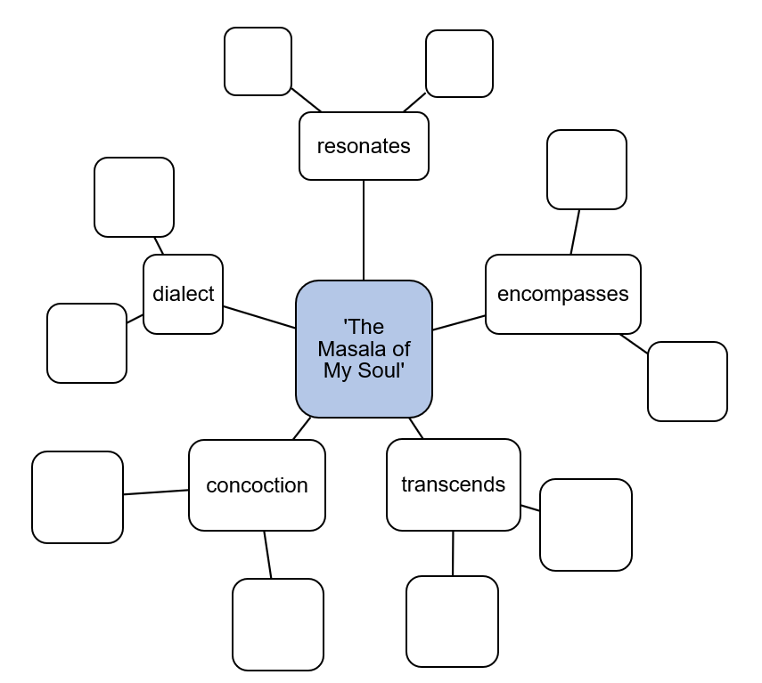

Phase 4, activity 6 – reading the text
Teacher note: this activity is a comprehension strategy as a starting point from which to build deeper understanding. Allow time at the end of this activity for students to share their responses and to have any questions clarified.
- Re-read Core text 4 – ‘The Masala of My Soul’ by Tanisha Tahsin.
- Complete the table below.
Table 15 – who, what, when, where and how chart
Narrative component | Information from the text
Who – who the characters are and what information we learn about them.
What – what the focus or main idea of the text is.
When – the temporal (time) setting of the text.
Where – the spatial (physical) setting of this text.
How – the language features you identify in this read through the text.

Phase 4, resource 2 – effect on the reader
- Issue students with one effect card.
- Instruct students that they will be given 5 minutes to consider how the particular emotion may be evoked by the text.
- Ask students to share their responses in a class discussion.
Table 16 – effect on the responder
Effects
Anger | Memories | Warmth | Hatred
Isolation | Racism | Happiness | Comfort
Shame | Fear | Belonging | Love
Familiarity | Understanding | Admiration | Sadness

Phase 4, resource 3 – discussion activities
Class discussion
Use the following prompts to guide the class discussion:
- What is this text saying about culture?
- What is the persona’s perspective on their culture and identity? Does this change throughout the text?
- How does the reference to the masala curry represent the author’s perspective on culture and identity?
Responding to the discussion
Students should complete the following I used to think ... now I think ... in their English book:
- I used to think that the purpose of imaginative writing was to …
- Now I think that imaginative writing can also …
- I thought this text was about …
- Now I appreciate [insert what is appreciated] in the text.

Phase 4, resource 4 – language forms and features in ‘The Masala of My Soul’
Teacher note: this resource is designed to build on student understanding of extended metaphor and imagery. You may need to spend extra time examining these language features if students are unfamiliar with the terms.
Etymology of metaphor
The word metaphor comes from the Greek ‘metapherein’ or ‘metaphora’ which translates to – a transfer, to carry over; change, alter; to use a word in a strange sense. ‘Meta’ means ‘change’ or ‘alteration’ and ‘pherein’ (phora) means to carry or bear.
Literary metaphor
The English K–10 Syllabus glossary defines metaphor as ‘an object, entity or situation that can be regarded as representing something else’ (NESA 2024). A metaphor is a figurative device which seeks to draw comparison between 2 ideas, objects or images. The comparison is usually between 2 things which are not similar in nature. In the metaphor ‘you are my sunshine’, the persona draws a comparison between someone who is very important to them, with ‘sunshine’. The implication of this metaphor is that the sun or sunshine is integral to all life on earth, therefore, the person that is being referenced here is very significant to the persona. Using figurative language in this way helps authors to communicate complex emotions in creative ways.
Extended metaphor
An extended metaphor refers to the use of metaphor throughout a paragraph, a stanza of poetry or throughout the entirety of the text. The metaphor may be expressed as an image that builds in complexity and reveals more information. In ‘The Masala of My Soul’, the metaphor of masala curry is used to represent a deep connection with family and culture. There are signposts for the reader as the author intends to make the meaning of the metaphor clear to the reader in the quotes:
- ‘Where I’m from we call that spice’
- ‘It’s a way of life’
- ‘My beautiful memory takes me back to darker, masala-less days’.
Therefore, by extending this metaphor of the masala curry, the author reinforces the significance of culture, identity and food in the story, which is also informed by their personal perspective and experience.
Imagery
The English K–10 Syllabus glossary defines imagery as the ‘Use of figurative language to represent objects, characters, actions or ideas in such a way that they appeal to the senses of the reader or viewer’ (NESA 2024). Imagery is an umbrella term which describes the many ways that an author can craft a better picture for the audience so that they can be immersed in the world of the narrative. Immersing a reader involves the senses: sight, smell, touch, taste and sound. It can include more complex images which capture emotion or movement. Imagery can be achieved through a range of language features and figurative devices such as descriptive language, active verbs, hyperbole, metonymy, synecdoche, personification, emotive language and sensory language.
Dialogue (sight)
The author has used visual imagery to describe an exciting and frenetic moment of fun and joy in ‘In my head it repaints memories of hot summer days splashing in the riverbank, flying through rice fields, drowning in confectionary from my village’s local sweet shop’. The author has used hyperbole to emphasise the excitement of this moment. Through these exaggerations, achieved using active verbs ‘flying’ and ‘drowning’, a sense of excitement and an insatiable appetite for living this experience, and being present in the moment is achieved.
Gustatory imagery (taste)
In ‘The Masala of My Soul’, the author has used imagery to communicate taste to the audience. The technical term for this is gustatory imagery. An example of gustatory imagery from the story is ‘Every tickle of turmeric, every zinging of ginger and the torching of my tongue reminded my soul of being home’. Notice that when you read this sentence from the story you can imagine the delicious flavours as the sensation of eating is described to the reader.
Sample annotations
See below for a close annotation of language features which have been used to achieve gustatory imagery in the story.
‘Every tickle of turmeric ...’ – the author has used alliteration with the ‘t’ sound combined with the personification of the turmeric in ‘tickling’ to evoke the physical sensation of the eating experience. This use of personification animates the metaphor (curry). This serves to express the significance of culture and food and how food can transport the author to consider their culture more deeply.
‘... every zinging of ginger’ – the gerund ‘zinging’ is a creative way to describe what the flavour of ginger is doing, coupled with the other verbs in this passage such as ‘tickle, zinging and torching’ the author uses verbs in an inventive way to explain the sensation of eating.
‘... torching of my tongue’ – the alliteration of the ‘t’ combined with the hyperbolic personification of the ginger and its impact emphasises the powerful experience of eating the spicy curry.
‘... reminded my soul of being home’ – the use of personal and possessive pronoun ‘my’ emphasises the author’s connection to culture as expressed through the metaphor of the curry. The use of ‘soul’, which is a non-literal and figurative entity, is used in this context to elicit an emotive response and then reinforced further in the connotation of ‘home’. This evokes positive connotations of family and culture.

Phase 5 – engaging critically and creatively with model texts
In the ‘engaging critically and creatively with model texts’ phase, students explore, respond to and experiment with models for the textual and language features necessary to complete the formal assessment task. Students engage critically with the core text ‘Nomad’ by Eleanor Swan to engage deeply with the text. They respond critically and creatively to the text to build confidence to complete the formal assessment. This will help students understand how language forms and features can be used to represent a thematic concern within hybrid imaginative texts.
Students will experiment with incorporating the language forms and features in their own imaginative writing. They are provided with the opportunity to reflect on and edit their work. They will also begin evaluating the effectiveness of their authorial choices.

Phase 5, activity 1 – annotating ‘Nomad’
Teacher note: this activity has been provided as an opportunity to model annotations of imaginative language features to students. It should be completed prior to completing the text annotations sections of the PowerPoint Phase 5 – text annotations – Swan – 9.1. Examples of imaginative language features for this activity include:
- alliteration – the repetition of the consonant at the beginning of words
- personification – when a human quality is given to an inanimate object.
- Your teacher has modelled how to annotate the examples of imaginative language features as provided below.
- Identify and annotate other examples of alliteration and personification on your copy of Core text 5 – ‘Nomad’ by Eleanor Swan.
Table 17 – annotating the code and conventions in a text
Narrative | Annotations of language features
I sit at a desk, pen to paper. Mind sluggishly attempting to write something. I stare once again at the instructions: | Alliteration is used at the beginning of the words ‘pen’ and ‘paper’ to suggest ‘action’ and that the composer is about to write something.  The personification of the ‘mind sluggishly attempting …’, creates the ‘mood’ that the student is disengaged with the task and that the ‘mind’ is almost on autopilot doing its own thing.

Core formative task 3 – experimenting with language features
Teacher note: Core formative task 3 – experimenting with language features can be found in Phase 5. Relevant activities and resources can be found below.
Student note: for this task, you will use the opening lines from Core text 5 – ‘Nomad’ by Eleanor Swan to prompt your response. This is a good opportunity to use the recursive writing process to refine your work.
- Re-read the opening lines of Core text 5 – ‘Nomad’ by Eleanor Swan. Focus on the second paragraph.
‘Write a persuasive essay on what political issue matters to you.’
- Write your own response to the prompt using a selection of persuasive language features used in the core text. Aim for approximately 500 words.
- Self-review your draft and make any required refinements.
- Use Phase 6, activity 3 – peer feedback to give and seek feedback from peer(s).
- Use Phase 6, activity 4 – actioning feedback to refine your writing to revise your work.

Phase 5, resource 1 – the language of reflection
Reflective writing is ‘the thought process by which students develop an understanding and appreciation of their own learning. This process draws on both cognitive and affective experience’ (NESA 2024).
Reflective writing is usually about:
- the process of doing something
- the effectiveness of doing something.
Figure 6 – reflective writing
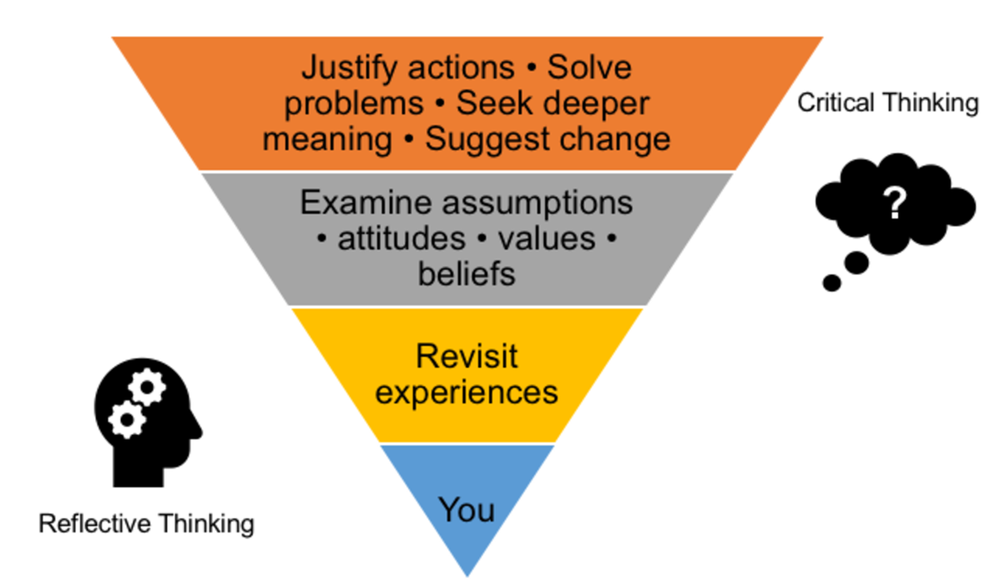
The process of reflection
The table below outlines the process of reflection. It has been adapted from Pappas P (2010) ‘Taxonomy of reflection’.
Table 18 – the process of reflection
The process of reflection
Remembering – think about the purpose of your piece of writing. What were your main ideas?
Understanding – what was important about your ideas? What theme or message did you intend to convey?
Analysing – were there particular codes and conventions of different genres that you used in your writing? Did you use particular language forms and features?
Evaluating – how did these genre conventions and language features help you convey the purpose of your piece of writing?
Applying and creating – overall, would this process of writing be something you might use again in future tasks?
The language of reflection
You can use the following language features in reflective writing:
- first person – you can include yourself (I, me, we) in your writing when you are expressing personal experiences, observations or opinions
- third person – when you are referring to theory or other writers
- actions (verbs) – when discussing how you feel and think about something (considered, wondered, learned
- low modal words – if your opinion is not very strong about a topic (may, perhaps or might)
- past tense – the purpose of a reflection statement is to look back and reflect upon the language choices that you have made
- evaluative language – words that convey a judgement or an appraisal of your own work
- comparative language – words that show connection between the core text and your own writing (for example, similarly, I also used, I therefore decided).
Table 19 – evaluative language
Evaluative language that expresses constructive criticism | Evaluative language that expresses negative criticism
Balanced  Convincing  Detailed, clear  Impressive, important, interesting  Timely, thorough  Useful | One of the limitations …  A problem with this …  There is inconsistency in …  One major drawback …  … fails to …  … is problematic …

Core formative task 4 – writing a draft reflection
Teacher note: this core formative task provides students with the opportunity to draft a reflection about their formal assessment composition.
- Use your imaginative response for this task and Phase 5, activity 2 – reflective writing support.
- You will need to reflect on how
- your imaginative hybrid composition represents a specific thematic concern
- the core text(s) influenced your compositional choices, using specific examples from both your own work and the core text(s).
- The reflection should
- use language appropriate to reflective writing to evaluate your compositional choices
- be 400 to 500 words in length.
- Refine your reflection through
- self-editing using Phase 6, activity 2 – check your draft and the student-facing rubric from the Representation of life experiences – imaginative response and reflection assessment notification
- seeking peer feedback using Phase 6, activity 3 – peer feedback
- applying peer feedback using Phase 6, activity 4 – actioning feedback to refine your writing
- seeking teacher feedback using Phase 6, activity 5 – student-teacher conference.
Remember, in Part B of your formal assessment task, you are required to:
- Write a 400 to 500-word reflection about your hybrid imaginative response. It should
- reflect on why you have chosen to represent a specific thematic concern in your writing
- evaluate how the core text(s) influenced your compositional choices, using specific examples from both your own work and the core text(s)
- use language appropriate to reflective writing to evaluate your compositional choices.
The scaffold below has been provided as a guide to support you in constructing your reflection and there is no requirement to use this structure.
Table 20 – writing scaffold for reflective writing
Structure | Suggested sentence starters
Orient the reader  This should be one paragraph in length, 3 to 5 sentences at most.  Identify and introduce your thematic concern in the opening paragraph of your reflection. Follow this with a sentence which highlights how the core text has inspired your ideas for writing or your use of particular language features. | My writing explores [insert thematic concern].  In class, we read [insert name of text here] and I was inspired by how the author used [insert language feature] to achieve [insert analysis] in their writing.  The text challenged me to consider [insert use of language feature] how I could [insert comment about how you have been inspired to use this language feature].  Tips on language use:  - use first person ‘my writing ...’  - write in the past tense ‘... we read’  - use adjectives to represent your process of composition ‘I used a range of sensory imagery to …’  - use precise verbs to explain your engagement with the core text ‘... challenged me to …’.
Provide specific details  This should be one paragraph in length, 2 to 5 sentences at most.  Provide some more detail about your thematic concern and explain how this message reflects your perspective and context. | As a young person who has suffered discrimination [or other information regarding your context], I believe [insert comment about the impact of this information to your perspective on a particular issue or topic].  I am alarmed about [insert comment about a social issue or other issue].  My thematic concern is [insert thematic concern].  My purpose in writing this piece is to [insert purpose].  Tips on language use:  - use personal and possessive pronouns ‘my writing’, ‘my purpose …’  - use emotive language to communicate your perspective on an issue or to develop a relationship with the reader ‘... suffered discrimination’  - use high modal language to express your perspective ‘... alarmed ...’  - integrate appropriate metalanguage of the task and terms you have unpacked in this unit (thematic concern, purpose, audience, context, perspective).
Elaborate on your ideas and provide evidence  In a series of short body paragraphs (2 to 4) explain how you have adapted and experimented with features from the core text to convey your thematic concern to your audience.  Clearly explain how an aspect of the core text (language forms and features) has influenced your experimentation.  Provide a direct quote from the core text and a short explanation of how this feature is used to position the reader.  Identify and explain why and how you experimented with this feature in your own writing to communicate your thematic concern to your chosen audience. Evaluate your success in doing so.  Conclude each paragraph or start a new paragraph with a sentence which leads into the next or the one before. Your ideas should be connected to one another through the organisation of the paragraphs. | - Zhang’s/Tahsin’s use of [insert analysis of language feature] inspired me to experiment with [insert use of language feature in your writing and what you hope to achieve].  - The use of [insert language feature] can be seen in this example [insert direct example from core text] which positions the reader to consider [insert explanation].  - I was inspired by the use of [insert language feature] and I used it to enhance/extend my description of [insert information as relevant to your writing].  - I used [insert language feature] to develop my thematic concern [insert thematic concern] ensuring [insert explanation how this feature positions the audience].  - My use of [insert language feature] in [insert direct example from your writing] achieves [insert impact and effectiveness of authorial choice] in my writing.  - Similar to Zhang’s/Tahsin’s use of [insert language feature and explanation], I have [insert your use of a language feature and evaluate the effectiveness of your choice].  - I felt I could have used [insert language feature] more effectively by [insert feedback you have been offered or your own observation].  - Through his process, I have learnt that [insert personal reflective statement].  - An area for further development in my writing is [insert relevant information. This could be based on the student-facing criteria using self-assessment and teacher feed-forward processes].  - A strength of my writing is [insert relevant information. This could be based on the student-facing criteria using self-assessment and teacher feed-forward processes].  - My use of [insert language feature] allowed me to successfully [insert evaluation of your authorial choices].  - Additionally, I used [insert language feature or editing strategy].  - My writing continued to develop when [insert personal reflection on writing process].  - I went back to the core text to refine [provide specific detail about writing and editing].  Tips on language use:  - use reflective language  - use thinking and sensing verbs  - use evaluative language such as positive, negative or neutral words that convey your judgement on how well you achieved your purpose  - use comparative or contrasting language ‘similarly, unlike, just as, in contrast to’  - use causal language to connect your ideas ‘as a result of, due to, therefore’.
Conclude  This should be one paragraph in length, 2 to 4 sentences at most.  Provide a summary and evaluation of how well you appealed to your audience and achieved your purpose. | Suggested sentence starters  - My writing has achieved [insert relevant information about writing purpose] in appealing to [insert relevant information about audience and how your writing appeals to them].  - I have used [insert language features] in an attempt to successfully position the audience to [insert impact on audience].  - My personal voice is [insert adjective to describe writing style and personal perspective] which presents my perspective on [state issue or idea].

Phase 5, activity 2 – reflective writing support
- Reflect on your process of writing, using the prompts in the first column of the table. Answer all of the questions. Too many ‘no’ responses suggest you have not applied careful consideration of the features of writing you have been learning about. If you haven’t used a feature, consider if you could have used it and revise your work.
Table 21 – recursive writing student self-reflection
Reflection prompts | Example from your response | How can I improve my work?
Thematic concern
Did you carefully plan your topic and does this develop into a purposeful thematic statement?
Is your thematic statement threaded throughout your response?
Narrative form
Have you used conventions of narrative to craft an engaging response?
Core texts
Did you draw on the core text as inspiration for your own writing?
Is the way this text inspired you clear in your composition (ideas, form or use of language features)?
Own reflection points
- Use the observations you have made to re-write your response. Apply your observations to improve the original response.

Phase 6 – preparing the assessment task
In the ‘preparing the assessment task’ phase, students are supported to complete a task that best represents their learning and effort. A series of planning, reading, writing and reviewing activities are structured into the teaching and learning program at intervals. These core formative tasks are designed to encourage student understanding of, engagement with, and ownership of the response they create during the assessment task design process. The following strategies are designed to support both the experimentation within formative tasks and the preparation for the formal summative task. They are not meant to be completed consecutively, nor are they a checklist. They should be introduced when required, running concurrently within the other phases. Some may take a few minutes in a once-off lesson, others will need to be repeated. Some may require an entire lesson. All will need to be adapted to the class context.
The teacher recognises students’ prior understanding of assessment practices but should use this phase as an opportunity to reinforce the importance of using drafting strategies and feedback processes to improve clarity, meaning and intended effect in texts. This is particularly so for student understanding of Stage 5 style marking criteria and school expectations for submission.

Phase 6, activity 1 – word cline template
Teacher note: provide students with a copy of this word cline organiser for each marking criteria. Split students into groups and allocate a marking criteria to each group. Students should share their findings with the class, so students can annotate ideas onto their assessment notification for the other marking criterion.
- Read your allocated marking criteria carefully.
- Sort the phrases in the student facing rubric from most successful to needs improvement.
- Think about what you need to do to have success in your allocated criterion.
- Share your findings with the class.
- Copy the main ideas for the other criterion onto your assessment notification.
Figure 7 – word cline organiser template
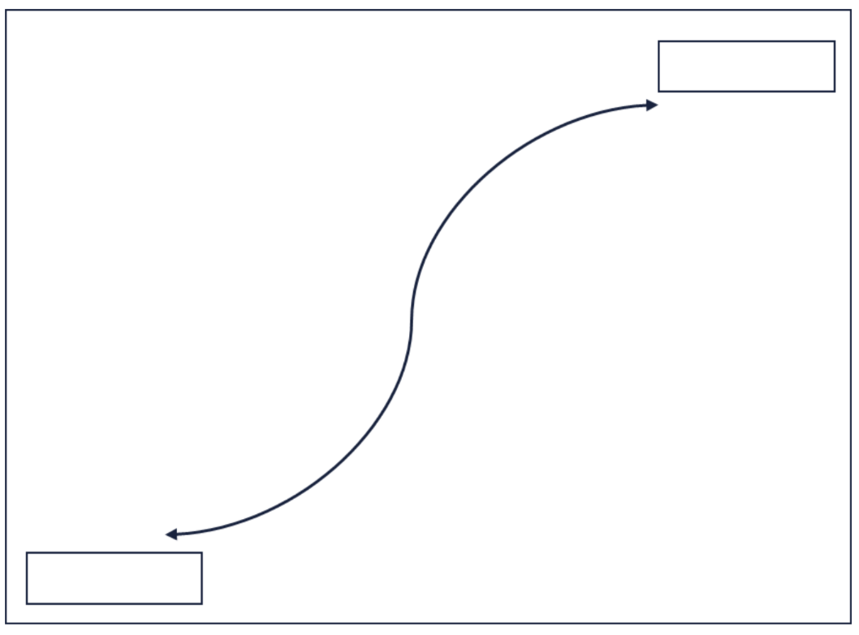

Phase 6, resource 1 – A-grade sample response
Teacher note: this student work sample is an exemplar of an A-grade student response.

Part A – imaginative response
What a woman can do, a man can too!
I lay in bed listening to Mum quietly walking around the kitchen. I hear the gentle clatter of plates being laid out. I could picture her putting the plates on the table – each one set down in an over exaggerated way to not make too much noise. Mum was always careful not to wake us up. When breakfast was ready, she would come upstairs and get us one by one. ‘Time to get up, honey, ‘ she’d say. When we got downstairs Mum was always dressed for work. She made sure that we were all fed and dressed and had our school bags packed, and that we were out of the door to get the bus on time. It was only then that she would leave the house and head off to work. She always put our needs first.
Mum was usually home when we got off the school bus. After-noon tea was always fun, a healthy snack, encouraging us to tell her about our day. After dinner Mum would clean up (even though she also cooked dinner), while Dad watched the news, or one of his boring YouTube videos about motor bikes. She would make sure that us kids were settled down – books out, doing our homework.
That was Mum. She was quiet, gentle, considerate and caring.
As I tried to do my homework with the annoying noise of the show dad was watching on YouTube distracting me, I watched Mum. I watched her pop a beer down next to Dad. He didn’t even look up. He grabbed his beer and took a sip before putting it down again, without thanking Mum. She looked up and our eyes met. She looked disappointed and I thought that she was going to cry because her face looked ready to crumble. But instead, when she saw me watching, she stood up, smiled, and asked if I was okay.
I looked down at my schoolbook. The set reading was called ‘Not for me, thank you!’. The woman writing the article was talking about the historical roles of men and women in a household. As I’d read the sections on the role of men, I kept looking at my Dad! When I’d read about the changing roles of women, I thought, just like the author, that having to do everything was not what I’d enjoy!
I thought about Mum. Was she happy? If I tried really hard I could see the moment her face would clear when she looked at us, a warm welcoming smile and hug ready. Before that look after dinner, before our eyes met, I would have thought what I usually think – it’s just Mum. Why did it take me so long to notice?
‘Mum, do we have some A4 card?’ ‘Yes, Charlotte, it’s in the craft drawer.’
I set to work and drew a table. When I finished, I looked at the chores and the names I wrote next to them. I rubbed some out – writing another name instead. I wondered if David was too small to unload a dishwasher? Scoffing to myself, I wrote his name next to that chore. I really had to think about who would make dinner! Mum did all the cooking. A tiny part of me, wondered whether it was Mum’s fault that she did everything. I looked back at the article again … ‘Gender roles are social constructs developed over time and not based on natural human behaviour.’ Hmm, maybe not!
The next morning I placed my chore list in the middle of the breakfast table. David cried. Dad just stared at me as if I’d grown two heads. Mum almost cried and beamed a smile that warmed my heart.
[616 words]

Part B – reflection
My reflection
My short story focuses on gender issues. We looked at a range of short stories in this unit which focus on life experience. I especially liked The Masala of My Soul. In the story the main character struggled trying to fit in. In the end, the character found a way to feel accepted.
As a fourteen-year-old girl I am becoming more aware of the expectations for women. I wanted to write a story for girls my age to let them know that being born female does not have to come with a set of rules that they must follow.
I tried to copy the styles used in the stories that I have read in this unit. In Masala the main character steals “whitening creams”. Whitening creams are used to bleach the skin white. This is a metaphor, as the main character wants to look like everyone else. This is reinforced by her hope that it will help her to ‘fit in’. I used the metaphor of the “chore list” to represent gender equality. I tried to make this point more obvious by getting my main character to look down at the article about whether boys and girls are treated differently.
The author uses single sentence paragraphs for emphasis. ‘Every tickle of turmeric … reminded my soul of being home’ draws attention to the fact that the protagonist has come to terms with his culture and is proud of his family’s cultural values. I used a single sentence paragraph to show what is expected of women ‘Quiet … Gentle … Considerate … Caring.’ I spent some time editing my draft so that I did not overuse the single sentence paragraphing technique. I also wanted to highlight that the father just drinks beer and watches videos. I also used a range of adjectives to describe the mother as sad and disappointed. I wanted to show that the mother is struggling to cope with being expected to do everything – the quote from the article about ‘social constructs’, supports this idea.
I think that it is up to my generation to make sure that these kinds of gender expectations are challenged, which is why it is the young girl that creates the chores list and puts it on the breakfast table.
I am quite happy with my story. I rewrote a couple of sections to make them more clear. I think that I could have experimented with language techniques a bit but I ran out of time. I also need to start drafting earlier so that I don’t run out of time.
[428 words]

Phase 6, resource 2 – annotated A-grade sample response
- Read through each paragraph of the exemplar response and the corresponding annotations.
Part A – annotated student work sample
Table 22 – annotated student work sample – Part A
Student work sample | Annotations in relation to the marking criteria | Suggestions for feed-forward and skill development
I lay in bed listening to Mum quietly walking around the kitchen. I hear the gentle clatter of plates being laid out. I could picture her putting the plates on the table – each one set down in an over exaggerated way to not make too much noise. Mum was always careful not to wake us up. When breakfast was ready, she would come upstairs and get us one by one. ‘Time to get up, honey, ‘ she’d say. When we got downstairs Mum was always dressed for work. She made sure that we were all fed and dressed and had our school bags packed, and that we were out of the door to get the bus on time. It was only then that she would leave the house and head off to work. She always put our needs first. | A solid orientation which establishes the domesticity of the scene.  Use of first person begins to establish connection with the reader and a sense of authenticity and relatability regarding the personal anecdote employed.  Language features used:  - onomatopoeia ‘clatter’  - alliteration ‘putting … plates’  - short sentences for effect ‘She always put our needs first.’ | Consider ways of including an extended metaphor into the text that links to Mum working hard and the thematic concern.  Expand the use of words instead of ‘said’ or ‘say’.
Mum was usually home when we got off the school bus. After-noon tea was always fun, a healthy snack, encouraging us to tell her about our day. After dinner Mum would clean up (even though she also cooked dinner), while Dad watched the news, or one of his boring YouTube videos about motor bikes. She would make sure that us kids were settled down – books out, doing our homework. | Again, a clear depiction of domesticity. The student effectively highlights the caring and domestic role of the mother, while the father watches videos about motorbikes. The choice of motorbikes establishes a traditional male stereotype. This helps to engage the audience in the main thematic concern of the response. | At this point the relevance of the mother meeting the children getting off the bus seems unnecessary.  This section is almost a recount of the afternoon chores – consider other ways of building Mum’s responsibilities.  Use audio-visual imagery in relation to the YouTube videos of motorbikes to create emphasis or tone.
That was Mum. She was quiet, gentle, considerate and caring. | A truncated sentence draws attention to the typical characteristics of a mother.  The intentional brevity of this paragraph demonstrates an effective control of structure appropriate to form. | Experiment with punctuation to change the tone of this text.
As I tried to do my homework with the annoying noise of the show dad was watching on YouTube distracting me, I watched Mum. I watched her pop a beer down next to Dad. He didn’t even look up. He grabbed his beer and took a sip before putting it down again, without thanking Mum. She looked up and our eyes met. She looked disappointed and I thought that she was going to cry because her face looked ready to crumble. But instead, when she saw me watching, she stood up, smiled, and asked if I was okay. | This paragraph reflects stereotypical male behaviour, drinking beer and being waited on, juxtaposing the female characteristics above.  Structurally this section signifies a change in tone. The daughter has recognised that her mother may not be happy.  The use of punctuation structures the sentences to further juxtapose the father’s world with that of Mum’s. | Include a greater range of language features to develop the story further.
I looked down at my schoolbook. The set reading was called ‘Not for me, thank you!’. The woman writing the article was talking about the historical roles of men and women in a household. As I’d read the sections on the role of men, I kept looking at my Dad! When I’d read about the changing roles of women, I thought, just like the author, that having to do everything was not what I’d enjoy! | This section continues to build upon the main thematic concern of the response.  The statement ‘… having to do everything was not what I’d enjoy!’ creates a clear link between mother and daughter.  The line ‘As I’d read the sections on the role of men, I kept looking at my Dad!’ reinforces the main idea of the student’s response, continues to create the personal voice of the author and conveys the contextual change and world of the student. | Some vocabulary used here is not cohesive to the text – consider expanding vocabulary choices.
‘Mum, do we have some A4 card?’ ‘Yes, Charlotte, it’s in the craft drawer.’ | Use of direct speech to add personal voice to the text. | Apply dialogue layout conventions – start a new speaker on a new line.
I set to work and drew a table. When I finished, I looked at the chores and the names I wrote next to them. I rubbed some out – writing another name instead. I wondered if David was too small to unload a dishwasher? Scoffing to myself, I wrote his name next to that chore. I really had to think about who would make dinner! Mum did all the cooking. A tiny part of me, wondered whether it was Mum’s fault that she did everything. I looked back at the article again … ‘Gender roles are social constructs developed over time and not based on natural human behaviour.’ Hmm, maybe not! | The visual imagery in this paragraph solidly establishes the daughter’s reflections as she ‘rubbed out’ names and scoffed to herself. The student references the article that has led to her realisation that there is an issue with gender equality within the household. | The statement, ‘I looked back at the article again ...’ implies that the article has been previously noted in the text due to the temporal connective ‘again’. It has not. As the article becomes a significant (although all too convenient and clunky) reference, the lack of cohesion and constructed significance is problematic and makes the conclusion overly simplistic compared to the rest of the text.
The next morning I placed my chore list in the middle of the breakfast table. David cried. Dad just stared at me as if I’d grown two heads. Mum almost cried and beamed a smile that warmed my heart. | The modality of ‘my chore list’ indicates a shift in persona for the daughter. It indicates a clear use of authority. The use of the positional adjective serves to frame the importance of the chore list.  The conscious use of the interplay of simple, compound and complex sentences to achieve purpose increases in complexity based on the daughters’ perceived ideas of the characteristics of the family members.  The lexical cohesion of ‘beamed’ and ‘warmed’ effectively signifies the dawning of a new day for the mother. | Some minor punctuation issues. A comma required after ‘morning’.  The hyperbole is a little dramatic and detracts from the authenticity of the response.
Part B – annotated student work sample
Table 23 – annotated student work sample – Part B
Student work sample | Annotations in relation to the marking criteria | Suggestions for feed-forward and skill development
My short story focuses on gender issues. We looked at a range of short stories in this unit which focus on life experience. I especially liked The Masala of My Soul. In the story the main character struggled trying to fit in. In the end, the character found a way to feel accepted. | The student identifies the conceptual focus of her story in the first line. She then identifies the core text which appealed to her including a brief explanation of the concepts that were addressed.  A number of connectives are used in the opening paragraph to establish cohesion. | A clearer explanation to the thematic concerns (intercultural assimilation) of the core texts would have led to a stronger response.  Inverted commas to indicate the text titles are missing.  The use of evaluative language in ‘I especially liked’ establishes a thesis, but this could have been refined to give further clarity to the whole text.
As a fourteen-year-old girl I am becoming more aware of the expectations for women. I wanted to write a story for girls my age to let them know that being born female does not have to come with a set of rules that they must follow. | This paragraph competently establishes the concept on which the student has chosen to focus. An explanation is provided to outline the purpose of the writing.  Effective variety of syntax in the initial dependent clause ‘as a fourteen-year-old girl’ purposefully justifies the argument. | High modality refines the student’s perspective, though this is inconsistent next to the weaker emotive language of ‘let them know’ and ‘does not have to’.
I tried to copy the styles used in the stories that I have read in this unit. In Masala the main character steals “whitening creams”. Whitening creams are used to bleach the skin white. This is a metaphor, as the main character wants to look like everyone else. This is reinforced by her hope that it will help her to ‘fit in’. I used the metaphor of the “chore list” to represent gender equality. I tried to make this point more obvious by getting my main character to look down at the article about whether boys and girls are treated differently. | A specific language feature is identified from the core l text ‘The Masala of My Soul’. This gives an example of the way the student has attempted to emulate the author’s style.  The first person is used soundly to introduce specific compositional decisions and intentions. This suits the reflective nature of the response.  Connectives of cause and effect are used but needs further development. | There is an unnecessary abbreviation of the title of the core text.  The student needs to explain their use of the metaphor ‘chore list’ in more detail.  The reference to the article is unclear. Greater foreshadowing of this article earlier in the response would help to make this reference clearer.  The response uses the word ‘styles’ incorrectly in the opening sentence when identifying what was adapted from the core texts.  Exploring ‘motif’ in this paragraph rather than ‘metaphor’ would have extended this response.
The author uses single sentence paragraphs for emphasis. ‘Every tickle of turmeric … reminded my soul of being home’ draws attention to the fact that the protagonist has come to terms with his culture and is proud of his family’s cultural values. I used a single sentence paragraph to show what is expected of women ‘Quiet … Gentle … Considerate … Caring’. I spent some time editing my draft so that I did not overuse the single sentence paragraphing technique. I also wanted to highlight that the father just drinks beer and watches videos. I also used a range of adjectives to describe the mother as sad and disappointed. I wanted to show that the mother is struggling to cope with being expected to do everything – the quote from the article about ‘social constructs’, supports this idea. | The student describes the way they have attempted to emulate the author’s use of single sentence paragraphing to highlight specific ideas.  The student briefly mentions the use of male and female stereotypical attributes to reinforce domestic ideals.  Connectives of cause and effect indicate rationale, while adverbial clauses add detail.  First person explanation soundly used to indicate progress and some reflection. | Using a variety of language to introduce the processes, would have strengthened the analysis. For example, instead of using ‘I used … I wanted … I spent …’ use different sentence starters that support your thought processes and actions. For example – ‘By using a single sentence paragraph, I …’ or ‘Spending time editing my work, allowed me to …’.  Use correct pronouns – the composer is female and should have the personal pronoun of ‘she’.
I think that it is up to my generation to make sure that these kinds of gender expectations are challenged, which is why it is the young girl that creates the chores list and puts it on the breakfast table. | The student clearly outlines her purpose, but more detail is needed.  Sound evaluative language (‘I think’) and effective emotive language (‘challenged’) indicate the purpose. | The student could have made specific reference to the significance of the placement of the chore list.
I am quite happy with my story. I rewrote a couple of sections to make them more clear. I think that I cold have experimented with language techniques a bit but I ran out of time. I also need to start drafting earlier so that I don’t run out of time. | Informal language (‘quite happy’, ‘a couple’ and ‘a bit’) are used to create a sound summative evaluation.  This part of the response makes reference to the recursive writing process. | The connective ‘also’ indicates sound addition but also reveals the limitations of evaluation in this section.  The spelling errors here suggest that this final part of the task was quite rushed and not proofread before submission.

Phase 6, activity 2 – check your draft
Writing is a recursive process. This means you plan, draft, seek feedback, revise and refine. At this stage of learning, you have planned, researched and drafted your work. What is next? Self-editing!
Use this resource to edit your own draft response. Before you pass on your work to a peer or the teacher for feedback, you should edit and refine your own writing. This will avoid receiving feedback about things you could have fixed yourself. To guide the self-editing process, use the following tables. You could also add annotations to your draft as you work with the checklist in the table.
Table 24 – self-editing checklist
Checkpoints | Identified issues – What can you improve? | Plans for refinement – How can you improve it?
Spelling
Consider homonyms, contractions, double syllables and any other ‘issues’ you may normally experience.
Vocabulary
Consider word choices, difficulty level, variation, suitability, and so on.
Punctuation
Consider variation, accuracy, purposefulness, and so on. Double check use of speech marks, apostrophes and run-on sentences.
Grammar or parts of speech
Consider tense, agreement, syntax, verb choices, noun choices, use of adverbs (avoid too many), use of adjectives, and so on.
Sentence types
Consider if you have used a variety of sentence types (question, exclamation, truncated, and so on). Also check if you could use more or less complex and compound sentences.
Paragraphing
Consider if your ideas are organised into chunks that develop your purpose. Think about where you could experiment with paragraphing in a purposeful way.
Genre
Are you writing in a particular genre and have you applied the ‘recognised features’ (or subverted these) for effect?
Structure of a narrative
Consider if the parts of a narrative are used (or omitted) to achieve your purpose. Assess your use of (where relevant) title, orientation or opening, rising tension or plot development, characterisation, coda, and so on.
Thematic concern
Is this established and developed throughout your piece in a clear and purposeful way?
Consider if you have used things like metaphor, motif or imagery to thread the theme throughout your piece.
Argument
Consider if your intended message is clear and developed using features of persuasive language.
Personal voice
Consider if you have made deliberate compositional choices to shape your message.

Phase 6, activity 3 – peer feedback
Teacher note: use the steps of this activity dependent on student abilities. Some students may be able to begin with steps later in the process.
Collaboration with your peers can be a very effective way to learn. You will gain feedback and also see another person’s view of your composition. In this resource, you are going to ask your peer to be an editor to check for your use of the writing mechanics and to make suggestions about your use of features of language that enhance your imaginative writing. As such, your peer will complete 2 to 3 tables.
- Give your draft and this resource to your peer to complete.
Table 25 – peer feedback on the mechanics of writing
Reflection prompts | Advice – What could be done to improve the writing?
Vocabulary
Experimentation – does your peer use vocabulary in an interesting way to engage the reader and/or convey meaning?
Spelling
Accuracy – are all words consistently spelt accurately?
Punctuation
Experimentation – is punctuation used in an interesting way to engage the reader and/or convey meaning?
Sentence types
Experimentation – are sentence structures used in an interesting way to engage the reader and/or convey meaning?
Paragraphing
Experimentation – are paragraphs used in an interesting way to engage the reader and/or convey meaning?
Tense
Consistency – is tense used consistently throughout the writing? If there are shifts in the tense, are these purposeful and appropriate in the writing?
Use of figurative language
Experimentation – has your peer experimented with language to reinforce ideas purposefully?
Additional observations – are there additional areas of your peer’s writing that you have noticed and would like to comment on?

Phase 6, activity 4 – actioning feedback to refine your writing
Part of the recursive writing process requires you to carefully consider all the feedback you have received and begin the process of revising, refining and re-writing your response.
What you need
- Your response
- Green highlighter and green sticky notes for your ‘do’ annotations
- Orange highlighter and orange sticky notes for your ‘fix’ annotations
- Red or pink highlighter and red or pink sticky notes for your ‘ask’ annotations
Fine tuning your writing
The ‘Traffic Lights’ method will help you to reflect, revise and re-write. Use this strategy to engage with written feedback you have received about your response. This will enhance your understanding of your own composition and position you to act on the feedback you have received.
- Read and highlight in green the sections of your response where you have done well. On a green sticky note, outline how you can carry the content or approach you applied forward.
- Read and highlight in orange the sections of your work that were identified as needing improvement, which you know how to improve. On an orange sticky note, explain how you will refine your writing to implement the feedback provided.
- Read and highlight in red the sections of your work that were identified as needing improvement, which you don’t know how to improve. That is, you will need to ask clarifying questions about what you can do to act on the feedback. On a red sticky note labelled ‘ask’, write questions to ask your teacher and a peer marker.

Phase 6, activity 5 – student-teacher conference
Student note: use this process when seeking teacher feedback about your work. It will help you and your teacher identify the strengths of your writing and those areas that need further attention. A one-on-one conference allows your teacher to focus on your writing and suggest strategies and revision activities that can help you develop a plan to refine these aspects of your writing. To get the most out of your conference, there are some tasks you need to complete.
Step 1 – before the conference
- Revisit the feedback you received for your draft from your peer or your teacher.
- Complete the ‘Traffic Lights’ strategy to reflect on your writing. Aim to improve your draft using observations made from the feedback and self-evaluation.
- Complete the following questions about your work in your English book
- This writing piece was inspired by the core text ____________________________.
- The theme of my writing is ______________________________________________.
- The purpose of this writing is ____________________________________________.
- I have used the language features of ______________________________________.
- The use of these features makes the (effect of their use) _______________________.
- After reviewing this piece, I felt I have done these things well: ___________________.
- Some questions I need to ask are: _________________________________________.
Step 2 – conference
- Take notes for the following points in your English book.
- The strengths of my response
- Areas for improvement
- My plan moving forward
- The strategies I am going to use to reach this goal
Step 3 – revise and refine
- Use the feedback from your teacher conference to refine your work.
- You may like to use the refinement plan below to guide your work.
Table 26 – refinement plan
Your draft response | Feedback received | Plan for improvement | Refined writing

References
This resource contains NSW Curriculum and syllabus content. The NSW Curriculum is developed by the NSW Education Standards Authority. This content is prepared by NESA for and on behalf of the Crown in right of the State of New South Wales. The material is protected by Crown copyright.
Please refer to the NESA Copyright Disclaimer for more information https://educationstandards.nsw.edu.au/wps/portal/nesa/mini-footer/copyright.
NESA holds the only official and up-to-date versions of the NSW Curriculum and syllabus documents. Please visit the NSW Education Standards Authority (NESA) website https://educationstandards.nsw.edu.au/ and the NSW Curriculum website https://curriculum.nsw.edu.au.
English K–10 Syllabus © NSW Education Standards Authority (NESA) for and on behalf of the Crown in right of the State of New South Wales, 2022.
National Literacy Learning Progression © Australian Curriculum, Assessment and Reporting Authority (ACARA) 2010 to present, unless otherwise indicated. This material was downloaded from the Australian Curriculum website (National Literacy Learning Progression) (accessed 16 September 2024) and was not modified.
ACARA (Australian Curriculum, Assessment and Reporting Authority) (2024) Glossary, ACARA website, accessed 12 December 2024.
Centre for Education Statistics and Evaluation (CESE) (2020) What works best: 2020 update, NSW Department of Education website, accessed 12 December 2024.
Eleanor Swan (2020) ‘Nomad’, Frensham School (shortlist, year 11/12 finalist, 2020). Reproduced and made available for copying and communication by NSW Department of Education for its educational purposes with the permission of Eleanor Swan, Frensham School. Accessed 12 December 2024.
Emily Fries (2021) ‘Monsters and Mice’, James Ruse Agricultural High School (Shortlist, Year 9/10 category, 2021). Reproduced and made available for copying and communication by NSW Department of Education for its educational purposes with the permission of Emily Fries, James Ruse Agricultural High School. Accessed 12 December 2024.
Etymonline (2024) Online Etymology Dictionary, Etymonline website, accessed 12 December 2024.
Freya Smith (2022) ‘Stories Matter’, Hobart City High School (Year 9/10 category winner, 2022). Reproduced and made available for copying and communication by NSW Department of Education for its educational purposes with the permission of Freya Smith, Hobart City High School. Accessed 12 December 2024.
Grimm J and Grimm W (2021) Grimms’ Fairy Tales – Hansel and Gretel, The Project Gutenberg website, accessed 16 January 2025. This work is in the public domain.
——(2021) Grimms’ Fairy Tales – Little Red-Cap (Little Red Riding Hood), The Project Gutenberg website, accessed 16 January 2025. This work is in the public domain.
——(2021) Grimms’ Fairy Tales – Rumpelstiltskin, The Project Gutenberg website, accessed 16 January 2025. This work is in the public domain.
Harvard Graduate School of Education (2022) Project Zero’s Thinking Routine Toolbox, Project Zero website, accessed 20 June 2023.
Ishan@seefromthesky (23 August 2018) clear plastic bottle beside beach, Unsplash, accessed 29 November 2024.
Membean (2023) Word Roots [website], accessed 12 December 2024.
NESA (New South Wales Standards Education Authority) (2012) English K–10 Syllabus (2012) – Glossary, NESA website, accessed 28 May 2025.
NESA (2024) Glossary, NESA website, accessed 29 November 2024.
Pappas P (2010) Taxonomy of reflection, Copy/Paste website, accessed 7 January 2025.
Shanahan T (2023) 7 Paths to Improved Reading Comprehension [PowerPoint presentation], Shanahan on Literacy website, accessed 29 November 2024.
Sindy Zhang (2022) ‘To Draw a Home’, Sydney Girls High School (Shortlist, Year 11/12 category, 2022). Reproduced and made available for copying and communication by NSW Department of Education for its educational purposes with the permission of Sindy Zhang, Sydney Girls High School. Accessed 12 December 2024.
State of New South Wales (Department of Education) (2024a) Explicit teaching – Driving learning and engagement, Centre for Education Statistics and Evaluation website, accessed 12 December 2024.
——(2024b) Our Plan for NSW Public Education, NSW Department of Education website, accessed 12 December 2024.
——(2024c) Powerful youth voices – Year 7, Term 1, NSW Department of Education website, accessed 29 November 2024.
——(2024d) Reading, writing and numeracy guides, NSW Department of Education website, accessed 12 December 2024.
——(2024e) Seldon method for writing, NSW Department of Education website, accessed 17 January 2025.
——(2024f) Sentence types, HSC minimum standard website, accessed 29 November 2024.
——(2024g) Transport me to the ‘real’ – Year 8, Term 2, NSW Department of Education website, accessed 29 November 2024.
——(2024h) Writing in Secondary, NSW Department of Education website, accessed 21 January 2025.
Stern J, Ferraro K and Mohnkern J (2017) Tools for Teaching Conceptual Understanding, Secondary, Corwin, SAGE, Thousand Oaks CA.
Tanisha Tahsin (2020) ‘The Masala of My Soul’, Hurlstone Agricultural High School (competition winner and winner Year 9/10 category, 2020). Reproduced and made available for copying and communication by NSW Department of Education for its educational purposes with the permission of Tanisha Tahsin, Hurlstone Agricultural High School. Accessed 12 December 2024.
University of Melbourne (n.d.) Connecting ideas, The University of Melbourne website, accessed 13 January 2025.
Whitlam Institute (2023) What Matters? Writing competition, Whitlam Institute website, accessed 29 November 2024.

© State of New South Wales (Department of Education), 2024
The copyright material published in this resource is subject to the Copyright Act 1968 (Cth) and is owned by the NSW Department of Education or, where indicated, by a party other than the NSW Department of Education (third-party material).
Copyright material available in this resource and owned by the NSW Department of Education is licensed under a Creative Commons Attribution 4.0 International (CC BY 4.0) license.

This license allows you to share and adapt the material for any purpose, even commercially.
Attribution should be given to © State of New South Wales (Department of Education), 2024.
Material in this resource not available under a Creative Commons license:
- the NSW Department of Education logo, other logos and trademark-protected material
- material owned by a third party that has been reproduced with permission. You will need to obtain permission from the third party to reuse its material.
Links to third-party material and websites
Please note that the provided (reading/viewing material/list/links/texts) are a suggestion only and implies no endorsement, by the New South Wales Department of Education, of any author, publisher, or book title. School principals and teachers are best placed to assess the suitability of resources that would complement the curriculum and reflect the needs and interests of their students.
If you use the links provided in this document to access a third-party's website, you acknowledge that the terms of use, including licence terms set out on the third-party's website apply to the use which may be made of the materials on that third-party website or where permitted by the Copyright Act 1968 (Cth). The department accepts no responsibility for content on third-party websites.

