English Stage 4 (Year 8) – core texts booklet

The camera never lies

Contents

About this resource 2

Purpose of this resource 2

Target audience 2

When and how to use 3

Texts and resources 4

Core texts 7

Core text – *Satellite Boy* directed by Catriona McKenzie 7

Core text – *Took the Children Away* by Archie Roach and illustrated by Ruby Hunter 8

Core text – ‘Mankind Is No Island’ directed by Jason van Genderen 13

References 14

**Updating the table of contents**

Want to update the table? Have you added content to the document and noticed the page numbers have changed? As you add content to this report, you can update the table of contents to accurately reflect the page numbers within the resource. To update the table:

* Right click on the table and select ‘Update table of contents’ (in the browser version) or ‘Update field’ (in the desktop app). In the browser version, it will automatically update the entire table.
* In the desktop app, you will then need to select ‘Update entire table’. Your table numbers should then update to reflect your changes.

# About this resource

## Purpose of this resource

This core texts booklet has been developed to assist teachers in NSW Department of Education schools to create and deliver teaching and learning programs and assessment that align with the [English K–10 Syllabus](https://curriculum.nsw.edu.au/learning-areas/english/english-k-10-2022/overview) (NESA 2022).

This core texts booklet is not a standalone resource and aligns with the following support materials:

* Assessment task notification – examination – The camera never lies – Term 4
* Examination – The camera never lies
* Core formative tasks booklet – The camera never lies
* Core formative task 4 – practice examination
* Teaching and learning program – The camera never lies
* Resource booklet – The camera never lies
* Phase 1 – identifying key visual features – PowerPoint
* Phase 3 – understanding filmic devices – PowerPoint
* Phase 3 – check your understanding of theme – PowerPoint
* Phase 4 – features of children’s picture books – PowerPoint
* Year 8 scope and sequence.

All documents associated with this resource can be found on the [Planning, programming and assessing English 7–10](https://education.nsw.gov.au/teaching-and-learning/curriculum/english/planning-programming-and-assessing-english-7-10) webpage.

## Target audience

This core texts booklet is created as a teacher resource. It provides the full version of core texts or the full excerpts that are licenced and explored in the Year 8 ‘The camera never lies**’ program.** It has been designed for use by teachers in connection to the Year 8 resources designed by the English curriculum team for the NSW [English K–10 Syllabus](https://curriculum.nsw.edu.au/learning-areas/english/english-k-10-2022/overview) (NESA 2022). Links contained within this resource were correct as of 18 October 2024.

## When and how to use

The core texts provided can be used as a basis for the teacher’s own programming and, assessment processes. It can also be used as an example of how the [English K–10 Syllabus](https://curriculum.nsw.edu.au/learning-areas/english/english-k-10-2022/overview) (NESA 2022) can be implemented, specifically the text requirements for Stage 4. Additionally, the annotations provided in this resource are aligned with [National Literacy Learning Progression (V3)](https://www.australiancurriculum.edu.au/resources/national-literacy-and-numeracy-learning-progressions/version-3-of-national-literacy-and-numeracy-learning-progressions/). Teachers can use this resource to consider how the texts selected for study challenge and support all learners and meet syllabus requirements.

The following is an outline of some of the ways this program can be used. Teachers can:

* use the core texts booklet as a model and make modifications reflective of contextual needs
* examine the core texts booklet during faculty meetings or planning days to collaborate regarding programming and text choices
* examine the core texts booklet during faculty meetings or planning days and collaboratively plan opportunities for team teaching, collaborative resource development, mentoring, lesson observation and the sharing of student samples
* use the core texts booklet as a model for appropriate text selection using the [National Literacy Learning Progression (V3)](https://curriculum.nsw.edu.au/learning-areas/english/english-k-10-2022/overview) to guide this process.

This resource aligns with the completed Year 8 sample scope and sequence which can be found on the [Planning, programming and assessing English 7–10](https://education.nsw.gov.au/teaching-and-learning/curriculum/english/planning-programming-and-assessing-english-7-10) webpage.

## Texts and resources

A succinct overview of the texts required for the teaching and learning program is outlined in the table below. This brief overview provides the name and details of each text, the syllabus requirement being addressed and points of note.

Table 1 – texts selected and their alignment to the text requirements

|  |  |  |
| --- | --- | --- |
| Text | Text requirement | Annotation and overview |
| McKenzie, C (director) (2012) Satellite Boy [motion picture], Satellite Films, Australia.  No extracts have been included from the film. | The text helps meet the [Text requirements for English 7–10](https://curriculum.nsw.edu.au/learning-areas/english/english-k-10-2022/overview#course-requirements-k-10-english_k_10_2022) as it is an Australian film created by an Aboriginal composer. It explores cultural and social perspectives through the lens of youth culture.  **EN4-RVL-01** requires students to read texts that are complex in their ideas and construction.  This film has elements of a complex text as per the [National Literacy Learning Progression (NLLP) (V3)](https://www.australiancurriculum.edu.au/resources/national-literacy-and-numeracy-learning-progressions/version-3-of-national-literacy-and-numeracy-learning-progressions/) Text Complexity scale. It provides students with opportunities to engage with a text with words from other than English challenging ideas and subtle and implied meanings through visual and audio features. | The film follows the journey of a young boy who tries to save his home in the northern Kimberley in Western Australia from developers. In the process, the boy realises the importance of his cultural heritage and his connection to Country. The film addresses issues faced by Aboriginal youth in a sensitive manner.  A study of this text will allow for students to better understand how film positions the audience emotionally to share cultural experiences and stories.  Aboriginal and Torres Strait Islander viewers are advised that the film contains images of people who have died. |
| Roach A and Hunter R (2020) Took the Children Away, Simon & Schuster Australia. ISBN: 9781760857219  The 4 double-spreads from this text have been reproduced with the permission of Simon & Schuster Australia. We are grateful for their support in the development of this resource. This material is licensed up until 30 May 2027. | The text helps meet the [Text requirements for English 7–10](https://curriculum.nsw.edu.au/learning-areas/english/english-k-10-2022/overview#course-requirements-k-10-english_k_10_2022) as it is a multimodal text created by Aboriginal composers. It explores cultural and social perspectives about diverse experiences.  **EN4-RVL-01** requires students to read texts that are complex in their ideas and construction.  While the picture book format is an element of moderately complex text complexity, it also has elements of a complex text as per the [NLLP (V3)](https://www.australiancurriculum.edu.au/resources/national-literacy-and-numeracy-learning-progressions/version-3-of-national-literacy-and-numeracy-learning-progressions/) Text Complexity scale. Through the lens of visual literacy, it provides students opportunities to engage with a text with challenging ideas and subtle and implied meanings. | This picture book is about the forced removal of Aboriginal children from their families during the historical period known as the Stolen Generations. It is based on the song lyrics by Archie Roach and is accompanied by illustrations by Ruby Hunter. It explores the Stolen Generations through the lyrics and images.  A study of this text gives students the knowledge and understanding of a significant traumatic event in Australia's history and explores this with sensitivity and compassion through images and visual literacy.  Aboriginal and Torres Strait Islander readers are advised that the picture book contains reference to people who have died. |
| Tropfest (30 September 2008) ['Mankind Is No Island | Winner of Tropfest New York 2008' [video]](https://www.youtube.com/watch?v=ZrDxe9gK8Gk), *Tropfest*, YouTube, accessed 10 September 2024.  No extracts have been included from the short film. | The text helps meet the [Text requirements for English 7–10](https://curriculum.nsw.edu.au/learning-areas/english/english-k-10-2022/overview#course-requirements-k-10-english_k_10_2022) as it is a multimodal text created by an Australian composer. It explores intercultural and diverse experiences through the lens of cultural and social perspectives.  **EN4-RVL-01** requires students to read texts that are complex in their ideas and construction.  The structure of this short film uses elements of a complex text as per the [NLLP (V3)](https://www.australiancurriculum.edu.au/resources/national-literacy-and-numeracy-learning-progressions/version-3-of-national-literacy-and-numeracy-learning-progressions/) Text Complexity scale. The unique structural features enhance meaning and impact and include complex reading paths. The content is complex as it explores challenging ideas through multiple perspectives. It also features elements of highly complex texts as its ideas are recontextualised for modern society using contemporary media and cultures featuring several levels of inferred meaning. | Winner of Tropfest New York 2008, Mankind Is No Island is recorded entirely on a mobile phone. This short documentary-style film introduces the idea of a narrative without dialogue. It uses street and shop signage from New York and Sydney to tell the common narrative of the 2 cities. It addresses themes such as the distress of homelessness and having empathy for others.  A study of this text will allow for students to better understand how film positions the audience emotionally to share cultural experiences and tell stories. |

# Core texts

## Core text – Satellite Boy directed by Catriona McKenzie

**Teacher note**: this text is used in Phase 3 of the **Year 8, Term 4 – The camera never lies teaching and learning program.**

The following scenes have been selected from **McKenzie, C (director) (2012) *Satellite Boy* [motion picture], Satellite Films, Australia** for the purposes of analysis and examination preparation. It is advised that students are shown the film in its entirety to reinforce the narrative and context of the film. The YouTube clip links have been provided for explicit practise of analysing film and language devices.

* [SATELLITE BOY - clip: Astronaut (0:58)](https://www.youtube.com/watch?v=xaw8H0p6ESw)I
* [SATELLITE BOY - Clip: Blackfella Style (0:53)](https://www.youtube.com/watch?v=DFlJTEPADDs)
* [SATELLITE BOY - Clip: Mysterious Path (1:07)](https://www.youtube.com/watch?v=FHIMIbXRcNs)
* [SATELLITE BOY - clip: This is your fire (1:41)](https://www.youtube.com/watch?v=ICZzHfh-nrM)
* [SATELLITE BOY - clip: Where are you going? (2:25)](https://www.youtube.com/watch?v=o06o6iy0cMo)
* [SATELLITE BOY - on shooting in Bungle Bungles ranges (2:26)](https://www.youtube.com/watch?v=zgElOPYV5rA)
* [SATELLITE BOY - Trailer (2:16)](https://www.youtube.com/watch?v=iUDx1eCye6k)

## Core text – Took the Children Away by Archie Roach and illustrated by Ruby Hunter

**Teacher note**: this text is used in Phase 1 of the **Year 8, Term 4 – The camera never lies teaching and learning program.**

A selection of pages from the children’s picture book have been used to introduce the idea of diverse narratives for children.

Figure 1 – front cover of the children’s picture book Took the Children Away

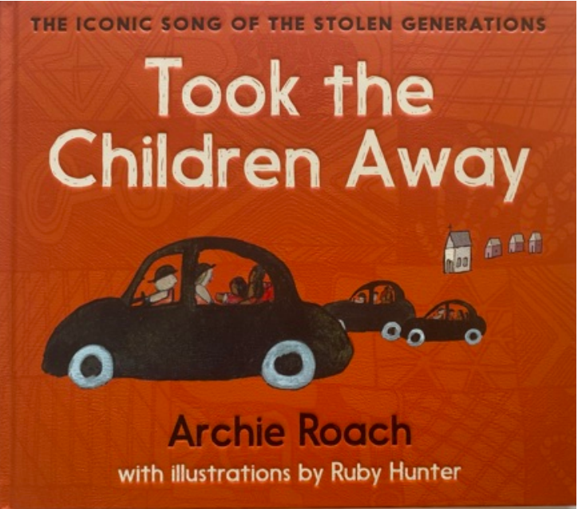

Figure 2 – first page of the narrative of the children’s picture book Took the Children Away

The first page of 'Took the Children Away' by Archie Roach.
Text reads:
This story's right this story's true
I would not tell lies to you
Like the promises they did not keep
And how they fenced us in like sheep.

Figure 3 – second page of the narrative of the children’s picture book Took the Children Away

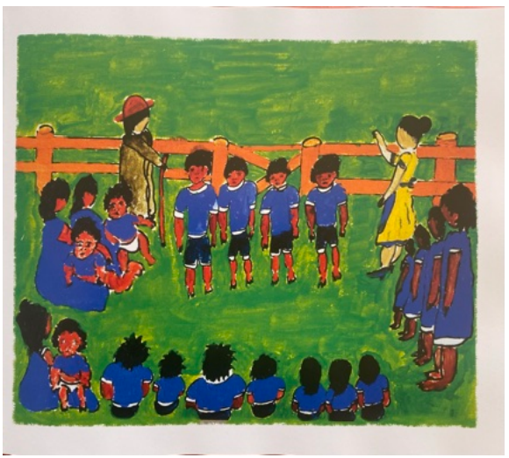

Figure 4 – internal page of the children’s picture book Took the Children Away

An internal page of 'Took the Children Away' by Archie Roach.
Text reads:
Took us away
They took us away
Snatched from our mother's breast
Said this was for the best
Took us away.

Figure 5 – internal page of the children’s picture book Took the Children Away

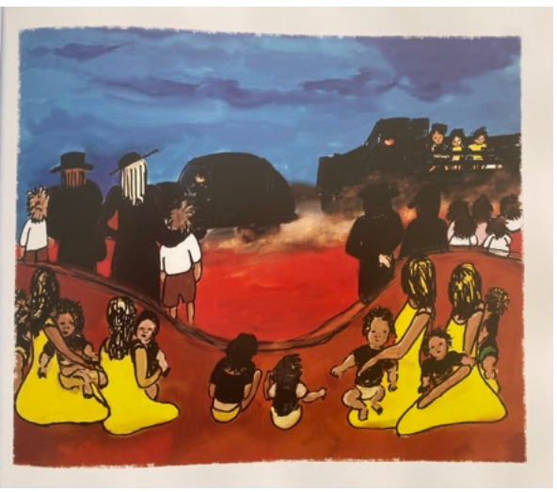

Figure 6 – internal page of the children’s picture book Took the Children Away

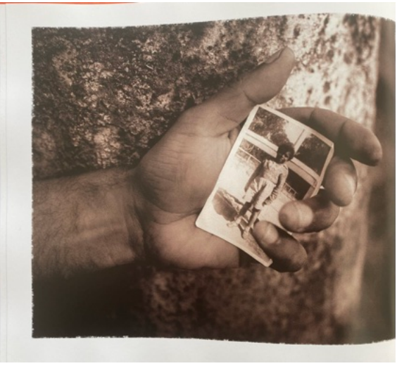

Figure 7 – internal page of the children’s picture book Took the Children Away

An internal page of 'Took the Children Away' by Archie Roach.
Text reads:

One sweet day all the children came back
The children came back
The children came back
Back where their hearts grow strong
Back where they all belong

The children came back
Said the children came back
The children came back
Back where they understand
Back to their mother's land
The children came back.

Figure 8 – back cover of the children’s picture book Took the Children Away

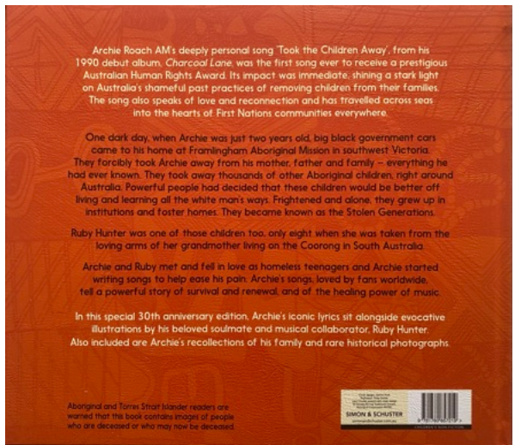

## Core text – ‘Mankind Is No Island’ directed by Jason van Genderen

**Teacher note**: this text is used in Phase 2 of the **Year 8, Term 4 – The camera never lies teaching and learning program.**

Winner of Tropfest New York 2008, ‘Mankind Is No Island’ is recorded entirely on a mobile phone. It uses street and shop signage from New York and Sydney to tell the common narrative of the 2 cities. It addresses themes such as homelessness and having empathy for others in a unique short film. The YouTube clip link has been provided below.

* [Mankind Is No Island | Winner of Tropfest New York 2008 (3:30)](https://www.youtube.com/watch?v=ZrDxe9gK8Gk)

# References

This resource contains NSW Curriculum and syllabus content. The NSW Curriculum is developed by the NSW Education Standards Authority. This content is prepared by NESA for and on behalf of the Crown in right of the State of New South Wales. The material is protected by Crown copyright.

Please refer to the NESA Copyright Disclaimer for more information <https://educationstandards.nsw.edu.au/wps/portal/nesa/mini-footer/copyright>.

NESA holds the only official and up-to-date versions of the NSW Curriculum and syllabus documents. Please visit the [NSW Education Standards Authority (NESA)](https://www.nsw.gov.au/education-and-training/nesa) website and the [NSW Curriculum](https://curriculum.nsw.edu.au/) website.

[English K–10 Syllabus](https://curriculum.nsw.edu.au/learning-areas/english/english-k-10-2022/overview) © NSW Education Standards Authority (NESA) for and on behalf of the Crown in right of the State of New South Wales, 2022.

[National Literacy Learning Progression](https://www.australiancurriculum.edu.au/resources/national-literacy-and-numeracy-learning-progressions/version-3-of-national-literacy-and-numeracy-learning-progressions/) © Australian Curriculum, Assessment and Reporting Authority (ACARA) 2010 to present, unless otherwise indicated. This material was downloaded from the [Australian Curriculum](http://www.australiancurriculum.edu.au/) website (National Literacy Learning Progression) (accessed 4 October 2022) and was not modified.

eOne ANZ (11 June 2013) ['SATELLITE BOY - clip: Astronaut' [video]](https://www.youtube.com/watch?v=xaw8H0p6ESw), *eOne ANZ*, YouTube, accessed 10 September 2024.

—— (20 June 2013) ['SATELLITE BOY - Clip: Blackfella Style' [video]](https://www.youtube.com/watch?v=DFlJTEPADDs), *eOne ANZ*, YouTube, accessed 10 September 2024.

—— 13 June 2013) ['SATELLITE BOY - Clip: Mysterious Path' [video]](https://www.youtube.com/watch?v=FHIMIbXRcNs), *eOne ANZ*, YouTube, accessed 10 September 2024.

—— (22 May 2013) ['SATELLITE BOY - clip: This is your fire' [video]](https://www.youtube.com/watch?v=ICZzHfh-nrM), *eOne ANZ*, YouTube, accessed 10 September 2024.

—— (8 May 2013) ['SATELLITE BOY - clip: Where are you going?' [video]](https://www.youtube.com/watch?v=o06o6iy0cMo), *eOne ANZ*, YouTube, accessed 10 September 2024.

—— (7 May 2013) ['SATELLITE BOY - on shooting in Bungle Bungles ranges' [video]](https://www.youtube.com/watch?v=zgElOPYV5rA), *eOne ANZ*, YouTube, accessed 10 September 2024.

—— (8 January 2013) ['SATELLITE BOY - trailer' [video]](https://www.youtube.com/watch?v=iUDx1eCye6k), *eOne ANZ*, YouTube, accessed 10 September 2024.

McKenzie, C (director) (2012) *Satellite Boy* [motion picture], Satellite Films, Australia.

Roach A (2020) Took the Children Away: The Iconic Song of the Stolen Generations, (Hunter R illus), Simon & Schuster Australia.

Tropfest NY (30 September 2008) ['Mankind Is No Island | Winner of Tropfest New York 2008' [video]](https://www.youtube.com/watch?v=ZrDxe9gK8Gk), directed by Jason van Genderen, *Tropfest*, YouTube, accessed 10 September 2024.

**© State of New South Wales (Department of Education), 2024**

The copyright material published in this resource is subject to the *Copyright Act 1968* (Cth) and is owned by the NSW Department of Education or, where indicated, by a party other than the NSW Department of Education (third-party material).

Copyright material available in this resource and owned by the NSW Department of Education is licensed under a [Creative Commons Attribution 4.0 International (CC BY 4.0) license](https://www.youtube.com/watch).

[](https://www.youtube.com/watch)

This license allows you to share and adapt the material for any purpose, even commercially.

Attribution should be given to © State of New South Wales (Department of Education), 2024.

Material in this resource not available under a Creative Commons license:

* the NSW Department of Education logo, other logos and trademark-protected material
* material owned by a third party that has been reproduced with permission. You will need to obtain permission from the third party to reuse its material.

**Links to third-party material and websites**

Please note that the provided (reading/viewing material/list/links/texts) are a suggestion only and implies no endorsement, by the New South Wales Department of Education, of any author, publisher, or book title. School principals and teachers are best placed to assess the suitability of resources that would complement the curriculum and reflect the needs and interests of their students.

If you use the links provided in this document to access a third-party's website, you acknowledge that the terms of use, including licence terms set out on the third-party's website apply to the use which may be made of the materials on that third-party website or where permitted by the Copyright Act 1968 (Cth). The department accepts no responsibility for content on third-party websites.