English Stage 3 Second year – Unit 13
Argument and authority – Fake news

Contents
Unit overview and instructions for use 5
Teacher notes 7
Outcomes and content 9
Resources 16
Week 1 20
Component A teaching and learning 20
Planning framework 20
Component B teaching and learning 20
Learning intentions and success criteria 20
Learning intention 21
Success criteria 21
Lesson 1 – exploring authorial choices in digital articles 21
Lesson 2 – understanding authority 24
Lesson 3 – exploring perspective in digital articles 27
Lesson 4 – creating an argument using modality 30
Week 2 34
Component A teaching and learning 34
Planning framework 34
Component B teaching and learning 34
Learning intentions and success criteria 34
Learning intention 35
Success criteria 35
Lesson 5 – investigating fake news 35
Lesson 6 – planning a persuasive text 38
Lesson 7 – composing and presenting a persuasive text 42
Lesson 8 – comparing the authority of texts 45
Week 3 49
Component A teaching and learning 49
Planning framework 49
Component B teaching and learning 49
Learning intentions and success criteria 49
Learning intention 50
Success criteria 50
Lesson 9 – researching and summarising topic related ideas 50
Lesson 10 – drafting and composing a factual news article 54
Lesson 11 – drafting and composing a factual news article 58
Lesson 12 – revising and publishing a multimodal news article 60
Week 4 63
Component A teaching and learning 63
Component B teaching and learning 63
Lesson 13 – presenting a real news article 64
Lesson 14 – exploring fake news 66
Lesson 15 – recognising fabricated news 69
Lesson 16 – planning a fabricated news article 72
Week 5 75
Component A teaching and learning 75
Planning framework 75
Component B teaching and learning 75
Learning intentions and success criteria 75
Learning intention 76
Success criteria 76
Lesson 17 – drafting and composing an opening paragraph for a fabricated news article 76
Lesson 18 – drafting and composing body paragraphs in a fabricated news article 79
Lesson 19 – drafting a conclusion and publishing a fabricated news article 81
Lesson 20 – presenting and reflecting 84
Resource 1 – assessing the authority of a text exemplar 87
Resource 2 – article deconstruction 89
Resource 3 – factual news article (Sydney Harbour Bridge) 90
Resource 4 – factual news article analysis 91
Resource 5 – writing process 94
Resource 6 – news flash cards 95
Resource 7 – gorilla escapes from the zoo 96
Resource 8 – fabricated news article (Sydney Harbour Bridge) 97
References 98

Unit overview and instructions for use
In this 5-week unit, students will gain a greater understanding of the textual concepts of ‘argument and authority’ and ‘perspective and context’. Through the study of digital articles, students will recognise the various authorial choices that can impact the authority of a text. Students will analyse texts to establish reliability, validity, authority and perspective. They will also plan, revise and publish factual news articles and manipulate language features to compose a fabricated news article.
Outcomes and content in this unit are organised into Component A and Component B. The components are connected, with learning in Component A complementing learning in Component B.
Note: the duration of this unit can be adapted to suit individual school contexts. For example, learning could occur across 5 days rather than 4.
The table below highlights the focus areas and preparation required for Component A and Component B.
Teaching and learning | Component A | Component B
Suggested duration | 60 minutes × 4 days/week or equivalent | 60 minutes × 4 days/week or equivalent
Explicit teaching focus areas | Component A addresses content from the focus areas:  - Vocabulary  - Reading comprehension  - Creating written texts  - Spelling  - Handwriting and digital transcription  It centres on the development of foundational skills and knowledge through regular, systematic and repeated practice. | Component B addresses content from the focus areas:  - Oral language and communication  - Vocabulary  - Reading comprehension  - Creating written texts  - Understanding and responding to literature  It centres on the conceptual understandings of English and exemplifies the importance of learning about and enjoying literature through the study of quality texts.
Preparing for teaching and learning | - Specific teaching and learning activities need to be developed by the teacher. When planning for these activities, please refer to the Component A outcomes and content, teaching guides and planning frameworks.  - Plan and document how you will sequence teaching and learning in whole-class and targeted-groups across the 5-week cycle as required. This should be based on student needs identified through ongoing assessment data. | - Familiarise yourself with the mentor and supporting texts and textual concepts, and the teaching and learning sequence.  - Determine how you will support students in whole-class and targeted-groups across the 5-week cycle as required. This should be based on student needs identified through ongoing assessment data.
English K–10 Syllabus © NSW Education Standards Authority (NESA) for and on behalf of the Crown in right of the State of New South Wales, 2022.

Teacher notes
- ‘Argument and authority’ is the mentor concept of this unit, explored using a range of digital articles.
- Argument is a stated position about an idea. The way in which various dimensions of a text (such as theme, perspective and style) can be understood to represent a particular position on an issue (NESA 2024).
- Authority of a text refers to how trustworthy, authentic or valid an audience may find the representation of ideas, experiences, perspectives and arguments in a text. Authority over a text refers to the varying degrees to which the meaning of a text is controlled or constructed by its creator(s) and by its audience (NESA 2024).
- Understanding of ‘argument and authority’ can be supported through watching the department’s videos: Understanding argument (3:17) and Understanding authority (2:39).
- While ‘argument and authority’ is the mentor concept for the conceptual component of this unit, the supporting concept of ‘perspective and context’ is explored within the digital articles.
- For information on perspective, subjective language, emotive language, objective language, adverbial clauses, modality, lexical cohesion, declarative, exclamatory, interrogative, imperative sentences and rhetorical questions, Tier 2 and Tier 3 vocabulary refer to the NESA Glossary.
- In addition to the resources listed, students will require access to short passages of the mentor and/or supporting texts. Teachers can copy extracts from texts in reliance on the Statutory Text and Artistic Works Licence. Teachers need to attribute the extracts and include the following notice: ‘This material has been copied [and communicated to you] in accordance with the statutory licence in section 113P of the Copyright Act. Any further reproduction or communication of this material by you may be the subject of copyright protection under the Act. Do not remove this notice’.
- This unit could enhance student learning towards the achievement of science and technology, personal development, health and physical education (PDHPE) and human society and its environment (HSIE) outcomes.
- Reflect on student learning and engagement in activities and record differentiation and adjustments within the unit to inform future teaching and learning. One way of doing this could be to add comments to the digital file.
- In NSW classrooms there is a diverse range of students including Aboriginal and/or Torres Strait Islander students, students learning English as an additional language or dialect, high potential and gifted students and students with disability. Some students may identify with more than one of these groups, or possibly all of them. Refer to Curriculum planning for every student – advice for further information.
- Content points are linked to the National Literacy Learning Progression (version 3).
Levels and indicators sourced from National Literacy Learning Progression © Australian Curriculum, Assessment and Reporting Authority (ACARA), (accessed 9 February 2024) and was not modified. See references for more information.

Outcomes and content
The table below outlines the outcomes and content for this unit. The letters 'A' and 'B' in the header refer to Components A and B. The numbers 1 to 5 refer to weeks. The use of 'x' in these columns indicates where the content points are intended to be addressed and in which week.
Focus area and outcome, content points and National Literacy Learning Progression | A | B | 1 | 2 | 3 | 4 | 5
Oral language and communication
EN3-OLC-01 communicates to wide audiences with social and cultural awareness, by interacting and presenting, and by analysing and evaluating for understanding
- Initiate and contribute to sustained discussions, through questioning, building on and evaluating shared information (InT5) |  | x | x | x | x | x | x
- Identify varying social conventions that influence interactions across wide audiences (InT6) |  | x | x | x | x | x
- Interact in a range of contexts and deliberately adjust language and style (InT6) |  | x | x | x | x | x | x
- Analyse key ideas and perspectives expressed by others through paraphrasing and note-taking (InT5, LiS7) |  | x |  | x | x | x
- Evaluate the effectiveness of rhetorical questions used for intentional effect |  | x |  | x | x | x | x
- Present multimodal arguments that include research and references, topic-specific vocabulary and the selection of persuasive techniques appropriate to audience (SpK6) |  | x |  |  |  | x | x
Vocabulary
EN3-VOCAB-01 extends Tier 2 and Tier 3 vocabulary through interacting, wide reading and writing, morphological analysis and generating precise definitions for specific contexts
- Identify and use words that convey informative and objective meanings in texts | x | x | x | x | x | x
- Identify and use words that convey subjective, emotive and persuasive meanings in texts | x | x | x | x | x | x | x
- Apply knowledge of taught Tier 3 subject-specific morphemes and their meanings (UnT9, CrT8) | x |  | x | x | x | x
Reading comprehension
EN3-RECOM-01 fluently reads and comprehends texts for wide purposes, analysing text structures and language, and by monitoring comprehension
- Adjust reading rate to suit the purpose for reading and the complexity of the text (FlY6) | x |  | x | x | x | x | x
- Efficiently follow signposting features to navigate print and digital texts | x | x | x | x | x
- Select texts from print or digital sources to gather and organise research on a topic |  | x |  |  | x | x
- Use criteria to determine the accuracy and reliability of sourced information |  | x | x | x | x | x | x
- Compare and evaluate print and digital texts for their pertinence to a task, their authority and their level of detail (UnT8) | x | x |  | x | x | x | x
- Use knowledge of text structure to navigate the text to locate specific information (UnT8) | x | x | x | x | x
- Analyse use of multimodal features to enhance meaning within texts | x | x | x | x | x | x | x
- Identify lexical cohesive devices used by the author that support understanding when reading (UnT8) | x | x |  |  | x | x | x
- Analyse how the meanings of key words and phrases in sentences and across a text support local and global inferencing when reading (UnT8) | x |  | x | x | x | x | x
- Compare and evaluate subjective and objective language to identify bias | x | x | x | x | x | x
- Question the assertions made by authors when engaging with print and digital texts |  | x | x | x | x | x
- Check the accuracy of own recorded gist statements made during reading, before summarising information to determine a text’s main themes, ideas or concepts | x | x | x | x |  | x
- Categorise information or ideas and create hierarchies to aid recall and support summarisation |  | x |  |  | x | x
- Generate, monitor and adjust own goals for improving oral reading fluency and silent reading fluency | x |  | x | x | x | x | x
Creating written texts
EN3-CWT-01 plans, creates and revises written texts for multiple purposes and audiences through selection of text features, sentence-level grammar, punctuation and word-level language
- Choose text formats with appropriate text structures, features and language to persuade a target audience (CrT9) |  | x |  | x | x | x | x
- Create objective, impersonal arguments (CrT9) |  | x |  |  | x
- Combine personal and objective arguments for persuasive effect |  | x | x |  | x | x
- Present arguments from one or multiple viewpoints to persuade target audiences |  | x | x | x |  | x | x
- Use rhetorical devices targeted to the audience (CrT9) |  | x |  | x | x | x | x
- Use modality to qualify or strengthen arguments |  | x | x | x |  | x | x
- Acknowledge sources of information to add credibility and authority to arguments and information (CrT8) |  | x | x | x | x | x
- Experiment with the use of non-finite verbs in adverbial clauses | x | x |  |  | x | x | x
- Experiment with the placement of adverbial clauses, to modify the meaning or to add detail to a verb or verb group (GrA6) | x | x |  | x | x | x | x
- Make choices about the use of declarative, exclamatory, interrogative and imperative sentences to suit text purpose, and for meaning and effect (CrT8) | x | x | x | x | x | x | x
- Use a comma to separate a subordinate clause or a phrase from the main clause, or to separate information within a sentence, or to separate items in a list (CrT8, PuN6) | x | x |  | x | x | x | x
- Use parentheses in the first instance when abbreviating names using acronyms, and when acknowledging a source (PuN7) | x | x |  | x | x |  | x
- Use topic-specific Tier 2 and Tier 3 vocabulary intentionally to add credibility and enhance authority (CrT9) | x | x | x | x | x | x
- Control modality related to probability, occurrence, obligation or inclination for precision | x | x | x | x |  |  | x
- Select text formats for combined purposes, creating hybrid texts for target audiences |  | x |  |  |  | x | x
- Research and summarise information from several sources to plan for writing |  | x |  | x | x | x
- Assess the reliability and authority of sources, including digital sources, when researching and acknowledging texts |  | x | x | x | x | x | x
Spelling
EN3-SPELL-01 automatically applies taught phonological, orthographic and morphological generalisations and strategies when spelling in a range of contexts, and justifies spelling strategies used to spell unfamiliar words
- Segment unfamiliar multisyllabic words into syllables and phonemes as a strategy when spelling | x |  | x | x | x | x | x
- Recognise that the same grapheme can represent different phonemes (SpG10) | x |  | x | x | x | x | x
- Explain and use spelling conventions to add derivational suffixes such as -ion, -ian, -ence, -ous to base words or roots (SpG10) | x |  |  |  | x | x | x
- Explain the etymology of taught roots and apply this knowledge when creating written texts (SpG10) | x |  | x | x |  | x | x
Handwriting and digital transcription
EN3-HANDW-01 sustains a legible, fluent and automatic handwriting style
EN3-HANDW-02 selects digital technologies to suit audience and purpose to create texts
- Use handwriting efficiently in formal and informal situations (HwK8) | x |  | x |  | x |  | x
- Adjust handwriting style to suit writing purpose (HwK8) | x |  | x |  | x |  | x
- Reflect on and monitor typing accuracy and rate according to goals and given criteria | x |  | x | x |  | x
- Use taught shortcut functions on digital tools to facilitate text creation (HwK8) | x |  |  |  |  | x
Understanding and responding to literature
EN3-UARL-02 analyses representations of ideas in literature through genre and theme that reflect perspective and context, argument and authority, and adapts these representations when creating texts
- Recognise how an argument is influenced by perspective and create texts that adopt a perspective beyond personal experience |  | x | x | x | x | x | x
- Understand the authority given to objectivity versus subjectivity in arguments |  | x | x | x | x | x | x
- Compare the reliability and validity of texts to make judgements about their authority (UnT7) |  | x | x | x | x | x
- Identify how perspective is made evident through authorial choices (UnT8) |  | x | x | x | x | x | x
English K–10 Syllabus © NSW Education Standards Authority (NESA) for and on behalf of the Crown in right of the State of New South Wales, 2022.

Resources
The resources in the table below are referred to in this unit. Letters 'A' and 'B' in the header refer to Component A and B respectively, and the numbers 1 to 5 indicate weeks. The use of 'x' in these columns indicates whether the resources are required in Component A, B or both, and in which week.
Resource | A | B | 1 | 2 | 3 | 4 | 5
Digital article: Man on the moon |  | x | x
Digital article: Travel to Moon Possible by 1980 |  | x | x
Video (optional): World News 2023 (3:44) |  | x | x
Digital article: The Search For Life | x | x | x
Resource 1 – assessing the authority of a text exemplar |  | x | x
Digital article: A New Test for Life on Other Planets |  | x | x
Digital article: Man walks the moon again |  | x | x
Video: What is fake news and how you can identify it? (1:54) |  | x |  | x
Digital article: Kids urged to get real on fake news | x | x |  | x
Video: Australian Lab-Grown Meat (3:42) |  | x |  | x
Digital article: Is lab-grown meat coming soon to a supermarket near you? (7:00) |  | x |  | x
Digital article: AI resurrects The Beatles with release of new song Now and Then |  | x |  | x
Digital article: How artificial intelligence is helping scientists talk to bats and honeybees |  | x |  | x
Digital article: How AutoGPT is taking AI to the next level and why it has technology experts worried |  | x |  | x
Resource 2 – article deconstruction |  | x |  | x |  | x
Digital article: Aileen Davis attended Sydney Harbour Bridge's opening in her mother's arm, she's back 90 years on |  | x |  |  | x
Resource 3 – factual news article (Sydney Harbour Bridge) | x | x |  |  | x | x
Resource 4 – factual news article analysis |  | x |  |  | x
Resource 5 – writing process |  | x |  |  | x | x
Individual whiteboards |  | x |  |  |  | x
Resource 6 – news flash cards |  | x |  |  |  | x
Video: Fake news fight (3:36) |  | x |  |  |  | x
Digital article: Spotting fake news |  | x |  |  |  | x
Video: How five lions escaped their Taronga zoo enclosure (1:15) |  | x |  |  |  | x
Digital article: Taronga lions made hole in fence before great escape |  | x |  |  |  | x
Resource 7 – gorilla escapes from the zoo | x | x |  |  |  | x
Resource 8 – fabricated news article (Sydney Harbour Bridge) | x | x |  |  |  |  | x
Sticky notes |  | x |  |  |  |  | x

Week 1

Component A teaching and learning
Component A focuses on the development of foundational skills and knowledge through regular, systematic and repeated practice. The mentor and supporting texts used in Component B of this unit can support the effective implementation of Component A teaching and learning.

Planning framework
To plan and document Component A teaching and learning, a planning scaffold (DOCX 228 KB) is provided. To support you in your planning, a link to a detailed example of a one-week teaching and learning cycle is included in the scaffold. Additional resources to support teaching and learning in each focus area can be found at Lesson advice guides.

Component B teaching and learning
The following teaching and learning sequence has been designed to address Component B outcomes and content and develops conceptual understandings of English through the study of quality texts. Adapt the sequence as required to best meet the needs of your students.

Learning intentions and success criteria
Learning intentions and success criteria are best co-constructed with students.

Learning intention
Students are learning to analyse how authorial choices influence the reader and explore the concepts of perspective, argument and authority.

Success criteria
Students can:
- identify how authorial choices impact the reader
- use criteria to determine the authority of a text
- explore how language choices are used to create perspective
- create personal and objective arguments using modality.

Lesson 1 – exploring authorial choices in digital articles
- Discuss the important role of interacting with others as a learning strategy. Develop a shared criteria, or agreed-upon protocols, for successful interactions with a partner, small group and in whole class contexts. Display in the classroom to use throughout the unit.
- Display the Man on the moon article from the Trove website. Students share what they see, know and wonder about the printed newspaper. Ask:
- What type of text is this? Why do you think this?
- Who is the author? For example, journalist or reporter. How do you know?
- What might the purpose of the text be? For example, to inform the public on current events.
- Who might the intended audience be? How do you know?
- How is the text communicated (mode)? For example, printed text and photographs.
- Draw students’ attention to the headline of the article. Ask:
- Does the headline make you want to read the article? Why?
- What questions do you have about the article?
- Explore how authorial choices are deliberately made in news headlines to attract attention and reader curiosity. Highlight that headlines in news articles use concise and attention-grabbing language. They often incorporate specific vocabulary choices, relevant topics, or teasing details to grab a reader's attention and spark their curiosity. The choice of words, style, and emphasis can determine whether the reader is compelled to explore the story.
- As a class, read the Man on the moon article. Discuss the features of the text and why the author has chosen to include them. Record observations. For example:
- simple headline to draw in the reader’s attention and spark curiosity
- photographs to capture the reader’s interest
- short paragraphs to enhance readability and engage the reader
- descriptive language to create a vivid and emotional portrayal of the moon landing. For example, ‘first faltering steps’ ‘constant quest to unlock the secrets of the universe’
- emotive and informative language to create a well-rounded article
- global perspective to emphasise the universal impact of the event. For example, ‘...millions of people around the world...’.
- Provide pairs of students with the Travel to Moon Possible by 1980 article from the Trove website. Students record features they notice about the article and discuss the purpose of the authorial choices. Prompt students to consider their observations from activity 5 as a guide.
Too hard? Scaffold a discussion using sentence stems. For example, I noticed… which was interesting because…
- As a class, students present their findings. Ask students whether they noticed any similarities and differences between Man on the moon and the Travel to Moon Possible by 1980 article.
- Review how the short, sharp headline from the Man on the moon article was effective in engaging the audience about the historical event.
- As a class, brainstorm other monumental world events. For example, COVID-19 Pandemic, Russia invades the Ukraine, the death of Queen Elizabeth the Second. Optional: watch World News 2023 (3:44) or a similar video.
- Discuss the impact these events had on the world and how a well-crafted headline could capture the most important information about the news event.
- Organise the class into small groups and assign each group a different world event. Alternatively, students can choose their own world event.
- Students brainstorm key points about the world event and how they could condense their ideas into short attention-grabbing headlines. Students record and display their headline. Encourage students to experiment with language and consider the tone of their headlines.
- Conduct a gallery walk to view and provide peer feedback on other groups’ headlines.
- As a class, reflect on the importance of authorial choices when creating impactful headlines and interesting news articles. Encourage students to explain how the language choices used influence the reader.

Lesson 2 – understanding authority
- Display the 2 news headlines, ‘NASA discovers evidence of water on Mars’ and ‘Students claim teacher cancels homework forever’. Ask students which headline they think is more trustworthy and why.
- Explain that throughout this unit students will be investigating whether an article is real (factual) or fake (fabricated).
- Introduce the textual concept of ‘argument and authority’ and explain that learning will begin with a focus on ‘authority’. Watch Understanding authority (2:39). While watching, pause the video to draw attention to the questions that may support the evaluation of sources. For example:
- Is it written by an expert?
- Is it written in an appropriate style?
- Is it published by a reputable source?
- Is it a collaborative creation?
- Read The Search For Life article. Ask:
- What is the purpose of the article?
- What features do you notice in this text? For example, headlines, subheadings, quotes.
- Who is providing the information?
- Do you believe this article? Why or why not?
- What evidence has the author used?
- Is it reliable? How do you know?
- As a class, create criteria for assessing the authority of a text. Note: refer to Resource 1 – assessing the authority of a text exemplar as a guide before completing the criteria as a class.
- Analyse The Search For Life article using the class criteria for assessing the authority of the text. For example:
- Purpose: to inform the reader about the investigation of life on other planets.
- Author: science writer Pat Brennan, found on the NASA website. There does not appear to be a specific bias towards a particular perspective in the article. Science enthusiasts, educational institutes, researchers and the funding bodies of the James Webb Space telescope would benefit from this article.
- Currency: while a specific publication date is not provided for the article, the page was last updated on 25 August 2023.
- Authority: the text demonstrates correct spelling and grammar. It contains both subjective and objective language. The layout is well presented, and the sentence structure is correct.
- Accuracy: the article combines facts, such as details about the telescope, with speculative content discussing the possibilities of detecting signs of life, such as oxygen, carbon dioxide, and methane. It also contains speculations that are not backed by evidence but represent possible scenarios.
- Credibility: is believable because the article provides links to other credible resources.
- Provide small groups of students with a variety of news articles. For example, A New Test for Life on Other Planets. Students analyse the articles against the criteria to assess the authority of the text.
Too hard? Use sentence stems to guide their discussion. For example, ‘I believe this article is real/fake because… The evidence that supports my thinking is…’.
- As a class, students share their findings and explain how they used the class criteria for assessing the authority of the text to determine the accuracy and reliability of the article.
- Review gist statements from learning in Component A as succinct thoughts or information that capture the generalisations gleaned from what has been read, heard or viewed (NESA 2024). Explain that students will explore the newspaper article further to identify and record the ‘gist’ or main idea.
- Model the process of ‘getting the gist’ using the Man on the moon article from Lesson 1. For example:
- Step 1: Read the text carefully to understand the main points.
- Step 2: Identify the key information, including the who, what, when, where, and why. See examples below.
- Neil Armstrong and Edwin Aldrin took their first steps on the moon during the Apollo 11 mission.
- The astronauts raised the US flag on the moon in a ceremony observed by millions of people.
- The significance of humans walking on the moon, marking a milestone in space exploration.
- Step 3: Condense the key information to capture the main idea of the text in less than 40 words.
- Millions of people worldwide observed the historic milestone in space exploration, when Neil Armstrong and Edwin Aldrin completed the first moonwalk and raised the US flag.
- Step 4: Check the accuracy of the gist statement to ensure it captures the main ideas.
- Provide groups of students with The Search for Life article from activity 6. Students re-read the article, discuss key points and record gist statements to summarise the main ideas.
- Groups of students share their gist statements with the class. Highlight the importance of checking the accuracy of the gist statements to ensure they are capturing the main ideas and concepts.
- Students reflect on their understanding of authority and the importance of identifying how trustworthy a text is. Explain that students will use the class criteria for assessing the authority of a text to determine the credibility of a source, including news articles throughout the unit.

Lesson 3 – exploring perspective in digital articles
- In pairs, ask students to consider how they would feel if they were invited to travel to the moon. Ask guiding questions such as:
- What emotions would you feel?
- What kind of reactions do you anticipate when sharing the news with your family and friends? How might that influence your emotions?
- What prior experiences would influence the way you feel about travelling to the moon?
- Revise the concept of ‘perspective’ as a lens through which the author perceives the world and creates a text, or the lens through which the reader or viewer perceives the world and understands a text (NESA 2024).
- Display the Man walks the moon again article from the Trove website. Read the article and focus on the emotive language used in article. For example, ‘ghostly white figures’, ‘alien world’. Ask:
- What effect does the language choices have on the reader? For example, the words ‘alien world’ elicits a sense of the unknown.
- Why did the author make these language choices? For example, to engage the reader and create interest.
- Revise objective, subjective and emotive language from Component A and previous learning. Explore how the use of subjective and objective language in an article can significantly impact the authority of the text.
Note: objective language is fact-based, measurable and observable, verifiable and unbiased. It does not include a speaker or writer’s point of view, interpretation or judgement. Subjective language are words used to communicate based on opinion, feelings or personal biases (NESA 2024).
- Display the first 3 paragraphs of the ‘Man walks the moon again’ article. Explore how subjective language is used to highlight the author’s perspective. For example, ‘perfect touchdown’, ‘daring approach’, ‘perfect landing’. Guide students to locate words, phrases and sentences that are highly emotive or subjective and discuss the impact of the language choices on the reader.
- Display an example of the first 3 paragraphs that have been rewritten to eliminate emotive and subjective language, altering the tone to be objective. For example:
Conrad and Alan Bean executed a precise landing on the moon and conducted a comprehensive scientific examination of the lunar surface and collection of samples, as reported by the Associated Press. The first colour television transmission from the moon's surface depicted the two men as figures moving through the sparse environment, adapting to the lunar gravity, which is one-sixth that of Earth. The earthbound perspective of the moonwalk was interrupted as the astronauts attempted to reposition the camera after approximately 45 minutes, resulting in a sudden loss of the transmission. Subsequently, both astronauts and ground experts endeavoured to identify and rectify the issue.
- In pairs, students analyse the effect of language choices on the reader and discuss its impact on the authority of the text. Ask guiding questions such as:
- How has the tone of the article changed?
- What effect do these changes have on the engagement of the reader?
- Is there a clear perspective now that the paragraph is more objective?
- In pairs, students write statements using either subjective or objective language about the moon landing. Optional: assign each pair of students with the focus ‘subjective’ or ‘objective’. For example:
- subjective language: the awe-inspiring moon landing captivated the world, evoking a profound sense of wonder and pride as humanity achieved an extraordinary feat beyond our wildest dreams
- objective language: the moon landing occurred on July 20, 1969, when the Apollo 11 mission, led by astronauts Neil Armstrong and Edwin Aldrin, successfully landed the lunar module on the surface of the moon.
- Students compare their statements with another pair and evaluate the effect the language choices have on the reader.

Lesson 4 – creating an argument using modality
- Label 2 locations in the room as ‘Choice A’ and ‘Choice B’. Provide students with a ‘would you rather’ question and ask students to move to the location that represents their choice. Between each question, ask students from each location to justify their choice. Ask:
- Would you rather be able to (a) fly or (b) run at 100km/h?
- Would you rather have (a) no fingernails or (b) no teeth?
- Would you rather live (a) under the sea or (b) in space?
- Revise the concept of ‘argument’ and explain that an argument is a stated position on an idea (NESA 2024).
- Explain that when students selected choices and justified their decisions in activity 1, they were stating a position on an idea. Highlight that their perspective on the topic influenced their decision and helped form their argument. For example, I would rather live under the sea because there are so many amazing creatures there. This is because I am fascinated with the unexplored nature and possibilities of sea creatures.
- An author’s perspective is made evident through their authorial choices, such as subjective and objective arguments. Explain that subjective arguments stem from personal experiences, values, and beliefs. Objective arguments, in contrast, prioritise information, evidence, and logical reasoning. Discuss that when evaluating the authority of a source it is important to understand if the argument is subjective or objective.
- Explain that a news reporter or journalist is an author who conveys a particular argument. Their perspective on the topic could be influenced by their news organisation, therefore affecting the bias of the article.
- Read the Moon First Stop in 10-20 Years article. Display the quote, ‘Human beings will be able to fly to the moon in the next 10 or 20 years...’. Ask:
- Does this statement have authority? Why or why not?
- What language choices make this convincing?
- Display the quote ‘As the matter now stood, it would probably be much longer’. Ask:
- Do you believe this statement? Why or why not?
- Does this statement have authority? Why or why not?
- Is the language as convincing as the statement from activity 6? Why do you say that?
- Explain that, when an author is writing arguments in a text, the text’s modality can change its effectiveness. Revise types of modal words from Component A and how they are used to indicate degrees of probability, occurrence, obligation and inclination. For example:
- probability: helps convey the level of certainty or possibility associated with a particular statement (certainly, definitely, surely)
- occurrence: indicates the occurrence or non-occurrence of an event (always, never, consistently)
- obligation: expresses a sense of duty or something that is required (must, have to, ought to, should)
- inclination: expresses a personal preference or willingness to do something (want, wish, would like to).
- Discuss how an authors’ use of modality in a text can strengthen arguments and add weight to their point of view.
- As a class, deconstruct the article from activity 6 to identify authorial choices that convey arguments and perspective. For example, modality, subjective and objective language and analyse the effect of these choices.
- Display the headline, ‘Humans prioritise space exploration over solving earthly issues!’. As a class, brainstorm ideas for both sides of the argument (humans should prioritise space exploration or focus on solving issues on Earth). Discuss how personal perspective and values influence opinions.
- Explain that students will write a persuasive paragraph on whether humans should prioritise space exploration or focus on solving issues on Earth. Model writing a persuasive paragraph to show how perspective is made evident through authorial choices. For example:
Without a doubt, our immediate focus must be on addressing the critical challenges here on Earth, rather than diverting resources to space exploration. The undeniable issues of climate change, poverty, and global inequality demand urgent attention. We must channel our collective efforts into resolving these challenges before venturing into the unknown. We are all witnessing the impacts of climate change on communities and ecosystems, emphasising our responsibility to care for our planet. Scientific data supports the critical state of our environment, requiring immediate intervention to mitigate the consequences. Our duty lies in tending to the needs of our home planet first. By prioritising and addressing these earthly issues, we lay the foundation for a more sustainable and equitable future.
- Deconstruct the modelled text and explore the authorial choices. For example:
- objective language: ‘scientific data’, ‘critical state of our environment’ emphasises a factual, evidence-based approach, giving credibility to the argument
- subjective language: ‘Without a doubt’, ‘our duty lies in’ conveys the author’s personal perspective, appealing to the emotions and values of the reader
- modality: ‘must be’, ‘demands urgent attention’ conveys a sense of obligation, necessity and need for immediate action.
- Students independently write their paragraph about whether humans should prioritise space exploration or focus on solving issues on Earth. Encourage students to make deliberate authorial choices to depict their perspective.
Too hard? Provide students with sentence stems and a word bank.
Too easy? Students enhance the authority of their text by including quotes from the article to support their argument.
- Revise that social conventions are like unspoken rules or expectations for how people should behave in different contexts. For example, it is expected you raise your hand to speak in class.
- Explore the appropriate language that is expected when providing peer feedback. For example, speaking in a respectful voice with an appropriate tone and telling them something that they did well before telling them something they could improve.
- In pairs, students share their paragraphs and provide peer feedback. Students check for effective use of modality, subjective, and objective language using guiding questions, for example:
- How is subjective language used to convey your perspective?
- In what way is objective language used and how does it support your argument?
- How is modality used and what impact does it have on the reader?

Week 2

Component A teaching and learning
Component A focuses on the development of foundational skills and knowledge through regular, systematic and repeated practice. The mentor and supporting texts used in Component B of this unit can support the effective implementation of Component A teaching and learning.

Planning framework
To plan and document Component A teaching and learning, a planning scaffold (DOCX 228 KB) is provided. To support you in your planning, a link to a detailed example of a one-week teaching and learning cycle is included in the scaffold. Additional resources to support teaching and learning in each focus area can be found at Lesson advice guides.

Component B teaching and learning
The following teaching and learning sequence has been designed to address Component B outcomes and content and develops conceptual understandings of English through the study of quality texts. Adapt the sequence as required to best meet the needs of your students.

Learning intentions and success criteria
Learning intentions and success criteria are best co-constructed with students.

Learning intention
Students are learning to analyse texts and make deliberate authorial choices to enhance the authority of a text.

Success criteria
Students can:
- analyse how language choices are used to inform a target audience
- plan, create and present a news report making deliberate authorial choices for persuasive effect
- explore and compare the authority of texts.

Lesson 5 – investigating fake news
- Revise the textual concept of ‘argument and authority’. Students turn and talk to reflect on their understanding by identifying 3 things they have learned, 2 questions they have and a reason why it is important to learn about argument and authority.
- Watch What is fake news and how you can identify it? (1:54). Ask:
- Have you ever seen a fake news story?
- Where did you see it?
- How did you know it was fake news?
- What are some ways to spot fake news?
- Display and read the article, Kids urged to get real on fake news. Guide students to read and follow signposting features to navigate the article. Ask the following guiding questions:
- How is the article organised? For example, information, links, questions, other related stories.
- What organisational features help to navigate the text to locate information? For example, headlines, subheadings, quotes, multimodal features.
- Analyse the multimodal features used. For example, photographs with captions, clickable related sources, audio file. In pairs, students brainstorm how these multimodal features enhance the meaning of the text.
- Revise the importance of evaluating sources of information and news articles for credibility to ensure information is true. Analyse the authority of the Kids urged to get real on fake news article using the class criteria for assessing authority created in Lesson 2. Discuss what gave the text authority.
- Revise gist statements from Component A and Lesson 2. Students create gist statements to summarise the article.
- In pairs, students share and compare their gist statements to check for accuracy.
- Review language features that are used to inform a target audience. Provide pairs of students with the Kids urged to get real on fake news article. In pairs, students deconstruct the article to identify language choices that are used to inform the target audience. For example:
- objective and informative language to provide facts and data: ‘As well as tackling fake news, the Alannah & Madeline Foundation’s Media Literacy Lab, which already has had about 150 schools signed up, includes lessons on how information is published online, how algorithms work to put certain information on your screen and how to verify information sources’.
- Tier 3 words to add precision and specificity to the article: ‘navigate’, ‘distorted’, ‘authentic’, ‘credible’.
- As a class, evaluate the effectiveness of the language choices used to inform a target audience.
- Ask students to think of a time that they have read, seen or heard 'fake news' and thought it was true. Students write a reflection about their experience using guiding questions:
- Where did you hear the ‘fake news’? How do you think the ‘fake news’ started?
- How did you work out that the news was untrue?
- Why do you think the author created the fake news? What purpose did it serve?
- Do you think the fake news had a positive or negative impact? Why do you think this?
- Students share their writing with a peer and discuss the importance of accessing the authority of a text to identify ‘fake news’.
- As a class co-construct a definition of fake news. For example:
Fake news refers to false reports or misinformation shared. It is spreading make-believe stories to trick people into thinking something that isn't real. This can happen on the internet, in newspapers, or even when people talk to each other. People often disguise fake news as real news to manipulate people’s opinions. It’s important to be aware and check if the information is true before believing or sharing it with others.

Lesson 6 – planning a persuasive text
- Explain that students will play a game of ‘True or false’. If students think the statement is ‘true’ they will stand. If they believe the statement is ‘false’ they sit down. Between each question, provide students an opportunity to justify their choice. Ask:
- Rebel Wilson made the term ‘fake news’ famous. (False)
- 150 schools have signed up to the Media Literacy Lab. (True)
- NASA Jet Propulsion Laboratory is a credible source. (True)
- Subjective language enhances the authority of a text. (False)
- The author’s bias does not need to be considered when accessing the authority of a text. (False)
- Highlight the importance of assessing the authority of a source, regardless of its mode and medium. Explain that a significant number of people obtain their news online, particularly through videos on social media. In pairs, students reflect on where they personally source their news and in what format.
- Revise that a reporter is an author presenting a specific argument and often aligns with the perspective of their news organisation. Remind students that when evaluating the authority of a source, it is crucial to establish whether the argument is subjective or objective to help identify potential bias.
- Watch Australian Lab-Grown Meat (3:42). Analyse the authority of the text using the class criteria for assessing the authority from Lesson 2. Discuss what gave the text its authority.
- Explain that students can develop strong analytical skills and enhance their understanding of different perspectives through paraphrasing and note-taking. Paraphrasing and note-taking are not just copying information but actively analysing it. Introduce the concept of hierarchical categorisation, where information or ideas are organised into categories to aid recall and summarisation. Explain that these skills develop a deep understanding about the content, the key ideas presented and the skills to think critically about the author’s message.
Note: paraphrase is a rewording of something that has been written or spoken (NESA 2024).
- Brainstorm categories for hierarchical categorisation based on common ideas and themes in the video. For example, ‘What is lab-grown meat?’, ‘How is it made?’ and ‘Why has it been made?’.
- Rewatch the first 14 seconds of Australian Lab-Grown Meat (3:42). Model paraphrasing this part of the article. For example, ‘Many families love eating dumplings in the winter, but these dumplings are special. The meat inside them comes from animal cells grown in a nutrient tank right from the start.’
- Explain that students will rewatch the ‘Australian Lab-Grown Meat’ video from activity 4. While watching, students will use a Note taking strategy. Students will then analyse the key ideas and paraphrase their notes. Note: pause the video regularly to allow the students to take notes and paraphrase.
- Students review their notes and organise them into the hierarchical categories from activity 6.
- In pairs, students share their notes and explain how they categorised the information.
- Read the text under the Australian Lab-Grown Meat video from ‘The US recently approved...’ to ‘...the lab-grown plunge?’. Review how authors use rhetorical questions to make a point, engage the reader and to get the audience thinking.
- Discuss the intentional effect of the rhetorical question, ‘But are Aussies ready to take the lab-grown plunge?’. For example, the question creates suspense and anticipation, encouraging readers to consider their own opinions for the introduction of lab-grown meat in Australia.
- Students turn and talk to generate other rhetorical questions that could be used in the video. For example, ‘Is society ready to try meat that is made in a lab?’. Students explain the effectiveness of rhetorical questions on the audience.
- Review the shared criteria for successful learning interactions from Lesson 1. Display the statement, ‘Lab-grown meat is the meat of the future!’. Students participate in a Socratic Seminar where the inner circle will discuss whether they agree or disagree with this statement and justify their response. The outside circle observes the discussion, then offers constructive feedback that guides and informs a second round of discussion.
- Explain that students will develop a persuasive text that argues for or against the statement ‘Lab-grown meat is the meat of the future!’ Revise the purpose of a persuasive text (which is to convince the audience of the author’s perspective). Ask:
- What type of persuasive texts have you encountered? For example, advertisements, letters, debates, social media posts.
- How do authors use language choices to persuade their audience? For example, emotive language, rhetorical questions, modality.
- What are some common persuasive devices used in written and spoken texts?
- What are the key components of a persuasive text's structure? Are all persuasive texts structured the same way? Why or why not?
- Brainstorm persuasive devices that could be included in students’ writing. For example, modality, rhetorical devices (including a rhetorical questions), subjective and emotive language.
- Review the structure of a persuasive text using a persuasive writing scaffold. For example, the introduction states the position of the writer, sequenced paragraphs containing a reason or argument elaborated with evidence and examples, a conclusion that restates the writer’s position, and summarises the arguments from the sequenced paragraphs.
- Model planning a persuasive text ‘for’ or ‘against’ lab-grown meat using a persuasive writing scaffold. For example:
- Title: Lab-grown meat is clearly the meat of the future.
- Introduction: Lab-grown meat is a unique and sustainable alternative to traditional meat products.
- Paragraph 1: Good for the planet (reason). Reduces land use, water consumption and greenhouse gas emissions (argument).
- Paragraph 2: Reduces animal cruelty by harvesting cells and turning them into stem cells (reason). An alternate for people who don’t want to eat ‘real’ meat’ (argument).
- Paragraph 3: Quality controlled (reason). Approved by US Food and Drug Administration for American customers. Food standards Australia New Zealand is currently considering the application for lab-grown meat (argument).
- Conclusion: Efficient and clean way to grow meat into the future. It is time to act now.
- Students begin planning their text using a persuasive writing scaffold.
Too hard? Students innovate off the teacher model to complete their plan.
- Revise the social conventions for providing feedback. In pairs, students share their plan and provide feedback using the criteria for assessing authority.

Lesson 7 – composing and presenting a persuasive text
- Watch Is lab-grown meat coming soon to a supermarket near you? (7:00). Explore how Nadia Daly, the presenter, delivers the news report and how she uses volume, pace and/or intonation to enhance meaning and engage the audience. Ask:
- Are there any particular words or phrases Nadia Daly emphasises? Why do you think she does this?
- Are there any parts that you feel were particularly engaging? What techniques are used to engage you? For example, multimodal arguments that include research and references, topic-specific vocabulary.
- Explain that students will compose and present a persuasive text about lab-grown meat. Revise the structure of a written persuasive text (introduction, sequenced arguments in paragraphs, conclusion). Demonstrate writing a persuasive text using the teacher modelled plan from Lesson 6. For example:
Lab-grown meat is clearly the way of the future!
In a world where choices truly matter, lab-grown meat emerges as a remarkably cool and eco-friendly alternative to the meat we know. Why settle for the ordinary when we can eat the extraordinary? Let's explore why it’s not just the meat of today but clearly the meat of the future!
Imagine if we could enjoy our favourite burgers and dumplings while also being superheroes for the planet. Lab-grown meat makes this possible! It doesn’t just use less land, less water, and produce fewer polluting gases that harm our environment. It radically transforms how we think about enjoying our meals and protecting our planet.
Lab-grown meat isn’t just a solution, it’s like a superhero cape for animals! Instead of traditional farming, where animals might be sadly harmed, lab-grown meat starts by taking tiny cells from living animals. It’s an absolutely awesome alternative for those who want the taste of meat without the worry of hurting animals. Whether you’re a meat lover or not, there's a delicious option for everyone!
Now, here’s the really exciting part: lab-grown meat isn’t a wild experiment, it’s quality-controlled and approved by the powerhouse agency, the US Food and Drug Administration. They didn’t just approve it. They gave it the green light for American customers, and guess what? Food Standards Australia New Zealand is considering approving it too. This means it’s not just safe and tasty, it’s almost ready for us to enjoy.
Lab-grown meat isn’t just a glimpse into the future, it is something we all need to be a part of. It’s a clean, efficient, and totally tasty way to grow meat without harming our planet or its animals. So, what are we waiting for? Let’s choose lab-grown meat, take a giant leap towards a better future, and show everyone that being a superhero can be as easy as deciding what's for dinner! It’s time to act now for a planet-friendly and absolutely delicious tomorrow!
- Deconstruct the teacher model to identify the use of persuasive devices. For example, topic sentence, supporting evidence, persuasive language, modality, rhetorical questions. Discuss the purpose of each paragraph.
- Students write their persuasive text using the completed persuasive writing scaffold from Lesson 6.
Too hard? Students work in pairs to compose their argument.
Too easy? Students include counterarguments, acknowledging multiple perspectives on the topic.
- Revise the social conventions for providing feedback. In pairs, students share their writing and provide feedback on the use of text structures, features and language to persuade a target audience.
- When interacting and presenting, discuss different situations that may impact what type of language is used. For example, speaking formally when presenting to the class or small group, or casually when talking to a good friend. Highlight how interactions may change depending on the formality of context. For example:
- Formal context: minimal use of contractions may be appropriate when interacting in a formal context (NESA 2024).
- Informal context: deliberate use of colloquialism, slang and jargon may be appropriate when interacting in an informal context (NESA 2024).
- Co-construct success criteria for presenting using Is lab-grown meat coming soon to a supermarket near you? as an exemplar. For example:
- present with a clear voice
- adjust volume to add meaning to the text and engage the audience
- maintain a steady pace
- use intonation for emphasis and to engage the audience
- use gesture to support meaning.
- In small groups, students take turns presenting their persuasive text. Optional: students use a green screen and a digital recording device to record their news reports.
- After each presentation, students provide peer feedback using guiding questions. For example:
- Was the speaker able to establish a clear argument?
- How did the speaker use emotive, subjective or objective language? Could you identify any bias?
- Was the speaker's perspective obvious? Did this impact their authority?
- Did the speaker use topic-specific vocabulary? What was the impact?
- As a class, students reflect on how the author’s perspective influenced their text. Encourage students to provide examples from their peers’ presentations.
Assessment task 1 – observations from this lesson allow students to demonstrate achievement towards the following syllabus outcomes and content points:
EN3-OLC-01 – communicates to wide audiences with social and cultural awareness, by interacting and presenting, and by analysing and evaluating for understanding
- interact in a range of contexts and deliberately adjust language and style.
EN3-VOCAB-01 – extends Tier 2 and Tier 3 vocabulary through interacting, wide reading and writing, morphological analysis and generating precise definitions for specific contexts
- identify and use words that convey subjective, emotive and persuasive meanings in text.

Lesson 8 – comparing the authority of texts
- Display and read the AI resurrects The Beatles with release of new song Now and Then article. Students turn and talk to discuss the perspective presented in the article. In pairs, students assess the authority of the article using the class criteria for assessing the authority of a text from Lesson 2.
- As a class, analyse the language features that the author used to support the text’s purpose (to inform). For example, modality, subjective and objective language, Tier 2 and Tier 3 vocabulary.
- Revise types of sentences from Component A, including interrogative, exclamatory and declarative sentences. Identify and analyse how the author has relied on declarative sentences throughout the article.
- Explore how the article could include a variety of sentence types to engage the audience.
- Display the declarative sentence, ‘The new song, titled Now and Then, is unique because it combined the singing of McCartney and Starr with Lennon, who passed away in 1980, and the guitar skills of Harrison, who passed away in 2001.’
- Model using the information to compose an interrogative sentence and exclamatory sentence. For example:
- Interrogative sentence: How did AI reunite all living and passed Beatles members to release the new chart-topping song ‘Now and Then’?
- Exclamatory sentence: What a remarkable achievement! Artificial intelligence brings back The Beatles!
- In pairs, students experiment using declarative sentences from the article to compose interrogative and exclamatory sentences. Share student responses with the class.
- Provide pairs of students with either the How artificial intelligence is helping scientists talk to bats and honeybees or How AutoGPT is taking AI to the next level and why it has technology experts worried article. Students deconstruct the article and identify the text structures and language features that impact the authority of the text using Resource 2 – article deconstruction.
- Students compare their findings with another pair that has a different article. Encourage students to identify similarities and differences between the articles, focusing on language features and sentence structure. Share student responses with the class.
- Revise that active listening strategies are applied during discussions when questioning, building on and evaluating shared information. Emphasise that students will apply their active listening skills to engage respectfully in a sustained discussion about the articles from activity 8. Ask guiding questions, for example:
- Which article did you find more engaging?
- What impact did the language used have on your opinion of the text?
- What impact did the authorial choices and perspective of the author have on your engagement with the article?
- Which text do you think has more authority? What makes you say that?
Too hard? Scaffold a discussion using sentence stems. For example, ‘Can you explain more about …’, ‘I agree with... because…’
- Revise the placement of adverbial clauses from Component A using the article from activity 1. For example, ‘Since its release last week, the song was on track to be named number one on the UK’s official singles charts.’ Explain that placing the adverbial clause at the beginning of the sentences shows the order of events.
- Students review the How AutoGPT is taking AI to the next level and why it has technology experts worried article and experiment with the placement of the adverbial clause(s) to modify the meaning or add detail.
Too hard? Students work in a teacher guided group.
- Students share responses with the class.
- Reflect on how authorial choices including the placement of an adverbial clause demonstrates that the author has control over their writing.

Week 3

Component A teaching and learning
Component A focuses on the development of foundational skills and knowledge through regular, systematic and repeated practice. The mentor and supporting texts used in Component B of this unit can support the effective implementation of Component A teaching and learning.

Planning framework
To plan and document Component A teaching and learning, a planning scaffold (DOCX 228 KB) is provided. To support you in your planning, a link to a detailed example of a one-week teaching and learning cycle is included in the scaffold. Additional resources to support teaching and learning in each focus area can be found at Lesson advice guides.

Component B teaching and learning
The following teaching and learning sequence has been designed to address Component B outcomes and content and develops conceptual understandings of English through the study of quality texts. Adapt the sequence as required to best meet the needs of your students.

Learning intentions and success criteria
Learning intentions and success criteria are best co-constructed with students.

Learning intention
Students are learning to use research and multimodal features to enhance authority, understanding and reader engagement when composing informative texts.

Success criteria
Students can:
- use research to support the authority of a text
- apply structural and language features to draft and compose a news article
- revise and edit their work to enhance the authority of a text
- analyse how multimodal features enhance meaning within texts.

Lesson 9 – researching and summarising topic related ideas
- Label 4 areas around the classrooms with ‘A’, ‘B’, ‘C’ and ‘D’. Explain that students will move and stand at the letter matching the headline they find most engaging and the article they would most like to read. Display and read the following headlines:
- School days are 6 hours long.
- School days are too long, they are exhausting!
- School days must be shortened.
- Is the length of the school day merely a tradition?
- Students move to their chosen area and discuss the authorial choices that made the headline engaging. For example, the use of modality or rhetorical devices.
- Repeat activity with the following headlines:
- Sport is played in schools all over Australia.
- It is an atrocious waste of time for students to play sport in schools!
- Should we prioritise sport in schools?
- Sport should be banned in schools!
- Explain that students will create a factual news article over the next few lessons and use research to support the authority of their text.
- Discuss the importance of assessing the reliability and authority of sources, including digital sources, when researching and acknowledging texts. Ask:
- When researching, why is it important to use different types of sources to gather information?
- How do you determine if a digital research source is reliable?
- When reading new information, what will you need to consider? For example, if the information is presented objectively, if the author has shared their personal opinions.
- What are the benefits of viewing multiple sources when researching? For example, ensuring the accuracy of information presented.
- View the article, Aileen Davis attended Sydney Harbour Bridge's opening in her mother's arm, she's back 90 years on to research information and take notes about the Sydney Harbour Bridge. Note: these notes will be used for modelled writing in Lesson 10 and Lesson 11.
- As a class, summarise the information.
- Explore other features of the text. Ask guiding questions, for example:
- What is the author’s perspective? How is this evident in the text?
- What structural features are used? How do they support the purpose of the text? For example, headings, subheadings, bold text, pictures, diagrams, additional videos.
- What language choices are used? How do they support the purpose of the text? For example, Tier 2 and 3 vocabulary, declarative, exclamatory, interrogative sentences.
- How does the use of multimodal features enhance the meaning of this article? For example, it incorporates videos and images from the time of the construction.
- How can you categorise or sort the information presented? For example, ‘construction’, ‘personal stories’, ‘historical context’, ‘evolution and significance’.
- What authority does the text have? Encourage students to refer to the class criteria for assessing authority from Lesson 2.
- Revise parentheses from Component A. Model how to use parentheses to acknowledge a source from the research in activity 6. For example, (enter name, date of information source).
- Explain that students will research and summarise information to plan for a factual news article.
- Brainstorm and record 4 ideas for possible news topics such as, historical events, scientific discoveries, animals, climate change. Students choose a topic for their factual news article using one of the 4 brainstormed ideas.
- Provide time for students to explore a variety of sources to research their topic. For example, books, websites, podcasts and videos.
Note: the following websites could be used ABC News, National Geographic, BBC Bitesize.
- Students navigate the text using their knowledge of text structure to locate specific information. Remind students to categorise information to support summarisation and use parentheses to acknowledge a source.
Too hard? Provide students with information about a topic to summarise.
Too easy? Students select a personal interest topic and explore a variety of sources to gather information. Students analyse conflicting viewpoints to add depth to their reporting.
- Students share their notes with a peer that has researched the same topic. Encourage students to stay on topic and build on others’ ideas.
Assessment task 2 – observations and work samples from this lesson allow students to demonstrate achievement towards the following syllabus outcomes and content points:
EN3-RECOM-01 – fluently reads and comprehends texts for wide purposes, analysing text structures and language, and by monitoring comprehension
- efficiently follow signposting features to navigate print and digital texts
- use criteria to determine the accuracy and reliability of sourced information
- compare and evaluate print and digital texts for their pertinence to a task, their authority and their level of detail
- use knowledge of text structure to navigate the text to locate specific information.
EN3-CWT-01 – plans, creates and revises written texts for multiple purposes and audiences through selection of text features, sentence-level grammar, punctuation and word-level language
- research and summarise information from several sources to plan for writing
- assess the reliability and authority of sources, including digital sources, when researching and acknowledging texts.
EN3-UARL-02 – analyses representations of ideas in literature through genre and theme that reflect perspective and context, argument and authority, and adapts these representations when creating texts
- understand the authority given to objectivity versus subjectivity in arguments
- compare the reliability and validity of texts to make judgements about their authority.

Lesson 10 – drafting and composing a factual news article
- Students review their research notes from Lesson 9 and play ‘2 truths and a lie’. In pairs, students present 2 true statements about their topic and a false statement. Students identify which 2 statements are true and which is false.
- Revise the importance of undertaking thorough research to establish authority and credibility when writing a factual news article. Ask:
- Why is it crucial for journalists to be well-informed about their topics?
- What challenges could arise if a news article lacks authority and credibility?
- How does thorough research contribute to the overall quality of a news article?
- Explain that in this lesson students will use their research from Lesson 9 to draft and compose a factual news article. Review the structural features of a news article. For example:
- Headline: summarises the main point of the news article in a concise and attention-grabbing statement.
- Byline: indicates the author of the news report. This helps establish accountability and gives credit to the reporter.
- Opening paragraph (introduction): includes information about who, what, when, where, why, and how. It provides a brief overview of the most important information and grabs the reader’s attention.
- Body: expands the information provided in the opening paragraph (introduction). The most crucial information should come first, followed by supporting details. The body paragraphs are ordered from most important to least important.
- Quotes or expert opinions: integrate direct quotes from relevant sources, such as eyewitnesses, experts, or officials. Attribute the quotes to the appropriate individuals, providing context and credibility to the information.
- Conclusion: concludes the news report with a summarising paragraph that reinforces the main points. A conclusion may also include implications or future considerations and a call to action.
- Display and read Resource 3 – factual news article (Sydney Harbour Bridge).
- Revise lexical cohesive devices as taught in Component A. Explore how the author has chosen vocabulary that is connected to support readers to build an understanding of the topic. Guide students to locate examples of lexical cohesive devices in the article. For example:
- synonyms: ‘boosting’ and ‘increasing’ to avoid repetition and provide variation in the text
- hypernyms: ‘transportation’ is used to generalise information rather than listing specific terms, such as all types of transportation
- word associations: ‘maritime traffic’, ‘trade and commerce’ both describe the functions of the Sydney Harbour Bridge.
- Revise non-finite verbs as taught in Component A. Explain that the author has chosen vocabulary that provides information about the time, place, condition, reason, manner or purpose. Guide students to locate examples of non-finite verbs and explain their impact. For example, ‘stretching’ describes the action of extending over a distance, ‘to connect’ describes the action of joining or linking different parts, ‘serves’ indicates the purpose or function of the bridge.
- In pairs, students deconstruct Resource 3 – factual news article (Sydney Harbour Bridge) by exploring the structure and language features used by the author. Note: refer to Resource 4 – factual news article analysis before completing this activity for support.
- Co-construct success criteria for writing a factual news article and display in the classroom. For example:
- use appropriate text structures, such as headings, subheadings, paragraphs
- include objective and informative language
- employ topic-specific Tier 2 and Tier 3 vocabulary
- control modality
- include rhetorical devices including interrogative sentences and a rhetorical question
- make choices about the use of declarative and exclamatory sentences
- experiment with non-finite verbs in adverbial clauses
- include statistics, facts, quotes to enhance authority
- utilise parentheses to acknowledge a source
- include multimodal features (images or diagrams, sound, written or spoken language).
- Revise Resource 5 – writing process. Explain how good writers move back and forth between the phases to produce quality writing. Clarify that this lesson will focus on beginning the drafting and composing phase.
- Jointly construct an opening paragraph, using the teacher modelled notes from Lesson 9.
- Students draft their opening paragraph using their notes from Lesson 9. Encourage students to re-read and revise their writing throughout the drafting and composing phase.
Too hard? Students innovate from the teacher model to complete their introduction.
- Select a peer feedback protocol for students to use. In pairs, students review their writing and provide peer feedback.

Lesson 11 – drafting and composing a factual news article
- Remind students of the social conventions for interacting in small groups. For example, everyone should be invited to speak, everyone should listen carefully, everyone can agree or disagree. Display the question, ‘Why do you think staying updated with real news is crucial in today’s world?’ Students complete a snowball discussion to analyse the question.
- Review the jointly constructed introduction and co-constructed success criteria from Lesson 10. Explain that students will continue drafting and composing their factual news articles.
- Model drafting sequenced paragraphs and a conclusion using the research notes from Lesson 9 and the modelled introduction from Lesson 10.
- Students compose their article using their notes from Lesson 9 and introduction from Lesson 10.
Too hard? Jointly construct the sequenced paragraphs. Students use speech-to-text technology to draft their text.
- Review Resource 5 – writing process. Prompt students to reflect on revising and editing as essential stages in the writing process, considering their relation to the authority and authorship of a text. Ask:
- What is the purpose of revising and editing? How are they different?
- How does revising contribute to the overall authority and credibility of writing?
- Why is it important for authors to take ownership of their writing, through the revising and editing process?
- How does the quality of writing impact the authority of the author? Encourage students to consider grammar and punctuation.
- Review that the authority of a text is closely tied to its credibility, accuracy, and reliability. Explain that when an author revises and edits their work, it enhances the authority of the text. Emphasise that when readers encounter mistakes in writing, they are less likely to trust the information presented.
- Provide time for students to revise and edit their writing using the co-constructed success criteria.
- Select a peer feedback protocol for students to use. In pairs, students review their writing and provide peer feedback using the co-constructed success criteria. Encourage students to consider the language choices made when giving and receiving feedback. Students ask clarifying questions if necessary. For example:
- What lexical devices and non-finite verbs did you incorporate?
- How did you use objective and informative language to create a factual text?
- What declarative or exclamatory sentences did you use to evoke feelings and connections with the reader?
- Did you experiment with the placement of adverbial clauses to modify the meaning or to add detail to a verb or verb group?
- What Tier 2 and Tier 3 specific vocabulary did you use?
- How did your perspective on the topic show through authorial choices?
- How did you use rhetorical devices? Provide an example.
Assessment task 3 – observations and work samples from this lesson allow students to demonstrate achievement towards the following syllabus outcomes and content points:
EN3-OLC-01 – communicates to wide audiences with social and cultural awareness, by interacting and presenting, and by analysing and evaluating for understanding
- initiate and contribute to sustained discussions, through questioning, building on and evaluating shared information
- identify varying social conventions that influence interactions across wide audiences
- interact in a range of contexts and deliberately adjust language and style
- evaluate the effectiveness of rhetorical questions used for intentional effect.
EN3-CWT-01 – plans, creates and revises written texts for multiple purposes and audiences through selection of text features, sentence-level grammar, punctuation and word-level language
- use rhetorical devices targeted to the audience.

Lesson 12 – revising and publishing a multimodal news article
- Explain that effective news articles combine different modes of communication (multimodal), such as text, images, videos, infographics and interactive elements to convey information in a rich and engaging manner. Review the Aileen Davis attended Sydney Harbour Bridge's opening in her mother's arm, she's back 90 years on article and Resource 3 – factual news article (Sydney Harbour Bridge).
- Explore how both authors have used multimodal features to enhance meaning and support the purpose of the text. For example, the ABC news article includes black and white and coloured videos and photographs to highlight the historical context of the article; the Sydney Harbour Bridge factual news article uses the iconic image of the bridge to immediately capture the reader’s attention and provide a visual context for the information.
- In pairs, students turn and talk to discuss which news article they found more engaging. Encourage students to consider how individual perspectives and experiences may influence their preference.
- As a class, reflect on how the use of multimodal features can impact a reader’s engagement and understanding of the text.
- Review Resource 5 – writing process and explain that this lesson will focus on the publishing phase of the writing process.
- Explore ways of presenting or publishing work as a multimodal text. For example, including 2 modes, such as images or diagrams, sound, written or spoken language.
- In pairs, students explore how they will publish and present their text. Ask:
- What form will you use to publish your text? (poster, digital poster, slideshow)
- How will your text be communicated (mode)? (written language, images, sound, spoken language)
- How will your text be conveyed (medium)? (printed, digitally)
- What text structures will you include for text navigation?
- What impact does the inclusion of multimodal features have on the reader? For example, expand meaning, make engaging.
- Students select how they will publish their multimodal text. For example, a printed newspaper, digital poster using Canva for Education, a slideshow using Microsoft PowerPoint or a video. Provide time for students to publish their factual news article.
Too hard? Provide a scaffold on Microsoft PowerPoint for students to use.
- Students self-assess and reflect on how the multimodal features contribute to the overall effectiveness of their text using the co-constructed success criteria from Lesson 10.
- Explain that students will present their multimodal texts in Lesson 13.
Assessment task 4 – collecting work samples from this lesson allows students to demonstrate achievement towards the following syllabus outcomes and content points:
EN3-VOCAB-01 – extends Tier 2 and Tier 3 vocabulary through interacting, wide reading and writing, morphological analysis and generating precise definitions for specific contexts
- identify and use words that convey informative and objective meanings in texts.
EN3-CWT-01 – plans, creates and revises written texts for multiple purposes and audiences through selection of text features, sentence-level grammar, punctuation and word-level language
- create objective, impersonal arguments
- combine personal and objective arguments for persuasive effect
- acknowledge sources of information to add credibility and authority to arguments and information
- make choices about the use of declarative, exclamatory, interrogative and imperative sentences to suit text purpose, and for meaning and effect
- use parentheses in the first instance when abbreviating names using acronyms, and when acknowledging a source
- use topic-specific Tier 2 and Tier 3 vocabulary intentionally to add credibility and enhance authority.

Week 4

Component A teaching and learning
Component A focuses on the development of foundational skills and knowledge through regular, systematic and repeated practice. The mentor and supporting texts used in Component B of this unit can support the effective implementation of Component A teaching and learning.

Planning framework
To plan and document Component A teaching and learning, a planning scaffold (DOCX 228 KB) is provided. To support you in your planning, a link to a detailed example of a one-week teaching and learning cycle is included in the scaffold. Additional resources to support teaching and learning in each focus area can be found at Lesson advice guides.

Component B teaching and learning
The following teaching and learning sequence has been designed to address Component B outcomes and content and develops conceptual understandings of English through the study of quality texts. Adapt the sequence as required to best meet the needs of your students.

Learning intentions and success criteria
Learning intentions and success criteria are best co-constructed with students.

Learning intention
Students are learning to analyse how the reliability and validity of texts is influenced by authorial choices.

Success criteria
Students can:
- understand how accurate and credible information enhances the authority of texts
- use gist statements to determine a text’s main ideas and key points
- evaluate how text structures and language features can decrease the authority of a text
- plan a fabricated news article using appropriate authorial choices.

Lesson 13 – presenting a real news article
- Divide the class into small groups. Explain that a news headline will be displayed, and each group will have 30 seconds to determine whether the given headline is real or fake. After 30 seconds each group must write real or fake on an individual whiteboard and hold it up. After each round provide one group the opportunity to share their reason for the decision they made. News headlines could include:
- Scientists discover pink Polar Bears. (Fake)
- King’s guard struck by horse at Buckingham Palace. (Fake)
- Hottest night in 7 years for one unlucky state. (True)
- El Nino has officially been declared. But what does that mean? (True)
- ‘They’re everywhere’: Mouse plague spreading chaos in Australia. (True)
- Provide time for students to finish publishing their factual news article from Lesson 12. Students use the co-constructed success criteria from Lesson 10 to review their work and make changes where required.
- Explain that students will be presenting their multimodal news article to a small group. Revise how the language used in spoken texts changes based on the context of the interaction. For example, the use of colloquialism and jargon in an informal context compared to a minimal use of contractions in a formal setting. Develop expectations for active listening during the presentations to ensure a respectful and engaging environment.
- Revise the success criteria for presenting from Lesson 7. In small groups, students take turns presenting their multimodal factual news articles.
- After each presentation, students provide feedback using TAG feedback. Encourage students to consider how their peers used language features, text structure and multimodal elements to demonstrate the authority of their text.
- Provide individual students with one headline from Resource 6 – news flash cards. Instruct students to hide their card from their peers. Explain that students will present an impromptu speech and have a short period of time to prepare their breaking news report.
- Provide time for students to prepare their breaking news report.
- In small groups, students take turns to present their breaking news report. After each news report, students provide constructive feedback. Ask guiding questions, for example:
- What did you like about the report? How could it be improved? (2 stars and a wish)
- How did the presenter use persuasive devices targeted to the audience? What impact did that have on the audience?
- Was the presenter’s perspective obvious in the presentation? If so, what was it?
- Did you believe the news report? Why or why not?
- As a class, reflect on the difference in authority between the well-researched, planned presentation and the breaking news presentation. Highlight the importance of research to deliver accurate and credible information and enhance the authority of the text.

Lesson 14 – exploring fake news
- Review the co-constructed definition of ‘fake news’ from Lesson 5. Discuss what is already known about the concept of fake news and its impact on society.
- Watch Fake news fight (3:36). Ask:
- How are fake news stories spread?
- What makes fake news believable? For example, it is based on real events.
- Have you ever been misled by fake news? If so, provide an example.
- Have you ever shared fake news, only to find out later that it was fake? How did this make you feel?
- What are some different ways people or organisations are trying to stop fake news?
- How can you help combat fake news?
- Revise notetaking and paraphrasing as a way of analysing key ideas and perspectives expressed from Lesson 6. Review the concept of hierarchical categorisation from Lesson 6. Brainstorm categories based on common ideas and themes in the video from activity 2. For example:
- What is fake news?
- What are the dangers of fake news?
- How is fake news spread?
- What is being done to stop the spread of fake news?
- How can you help combat fake news?
- Rewatch Fake news fight (3:36), paying attention to the main ideas and key points presented. Students take notes on the main topics covered in the video and paraphrase information into their own words.
- Students review their notes and organise them into the hierarchical categories from activity 3. In pairs, students explain how they categorised the information.
- Students identify the most important ideas in their notes and record gist statements that summarise the main ideas and key points from the video.
- In pairs, students share and analyse their gist statements to check that they accurately capture the main ideas and key points of the video.
- Display and read Spotting fake news from the National Geographic Kids website. Students independently take notes and paraphrase the article.
- In pairs, students review their notes and organise them into the hierarchical categories.
- Students identify the most important ideas in their notes and record gist statements that summarise the main ideas and key points from the video.
- In pairs, students share and compare their gist statements to check for accuracy.
- As a class, compare the reliability and validity of both texts. Ask guiding questions for a deeper analysis. For example:
- How do the texts resemble or differ from each other?
- Do both articles follow the anticipated structure of a news report?
- How are the reporters’ perspectives similar? For example, both articles are concerned about the impact of fake news; their perspectives are that people need to be aware and action should be taken.
- In pairs, students design a poster to inform the audience about fake news and caution them against its dangers. Encourage students to incorporate topic-specific vocabulary, modality to strengthen the argument and declarative sentences. Optional: students create a digital poster using Canva for Education.
- As a class, students share their posters.
Assessment task 5 – observations and work samples from this lesson allow students to demonstrate achievement towards the following syllabus outcomes and content points:
EN3-OLC-01 – communicates to wide audiences with social and cultural awareness, by interacting and presenting, and by analysing and evaluating for understanding
- analyse key ideas and perspectives expressed by others through paraphrasing and note-taking.
EN3-RECOM-01 – fluently reads and comprehends texts for wide purposes, analysing text structures and language, and by monitoring comprehension
- select texts from print or digital sources to gather and organise research on a topic
- check the accuracy of own recorded gist statements made during reading, before summarising information to determine a text’s main themes, ideas or concepts
- categorise information or ideas and create hierarchies to aid recall and support summarisation.
EN3-CWT-01 plans, creates and revises written texts for multiple purposes and audiences through selection of text features, sentence-level grammar, punctuation and word-level language
- use modality to qualify or strengthen arguments.

Lesson 15 – recognising fabricated news
- Watch How five lions escaped their Taronga Zoo enclosure (1:15). Students share what they see, know and wonder about the video. Ask:
- What type of text is it? What makes you say that?
- Who is the author and how do you know?
- What is the purpose of the text?
- Who might the intended audience be? How do you know?
- What multimodal features are used in the text and what impact do they have?
- Do you believe this news? Why or why not?
- Display and read the Taronga lions made hole in fence before great escape article from the Sydney Morning Herald website. As a class, analyse the article using the class criteria for assessing the authority of a text from Lesson 2.
- Provide pairs of students with Resource 7 – gorilla escapes from the zoo. Students analyse the article using the class criteria for assessing the authority of a text. Share student responses.
- Revise the co-constructed class definition of fake news from Lesson 5. Highlight that this practice involves taking genuine events and adding fictional elements to enhance the narrative. Explain that ‘Taronga lions made hole in fence before great escape’ is a factual news article that occurred in 2022 and Resource 7 – gorilla escapes from the zoo is a fabricated article.
- Revise Resource 2 – article deconstruction. Provide pairs of students with either Resource 7 – gorilla escapes from the zoo or the ‘Taronga lions made hole in fence’ article. Students deconstruct their article and identify the text structures and language features that impact the authority of the text.
- Students share their article deconstruction with a pair of students that explored a different article. Students identify similarities and differences between the types of language features and sentence structures used.
- As a class, explore students’ findings from both articles. Analyse which text effectively used language features to enhance the authority of the text. Ask guiding questions, for example:
- Were you able to differentiate the fabricated news article from the real news article? Why or why not? For example, spelling and grammatical errors (taronga zoo, Lion enclosure, fairy, .con), and conflicting statements from witnesses.
- How do both texts resemble or differ from each other?
- Do they follow the anticipated structure of a news report? (consider the structure of both texts)
- Which argument did you find more believable? Why?
- Do you feel that the authors of these texts have the authority to make these assertions?
- Explain that students will write a fabricated news article, based on the information used in their factual news article presented in Lesson 13. Students will make authorial choices that decrease authority to demonstrate their understanding of fabricated news.
- Review the success criteria for the factual news article from Lesson 10. Discuss the similarities and differences required for the fabricated news article. For example, both texts include similar text structure and multimodal features. A factual news article includes topic specific vocabulary and low modality while a fabricated news article uses emotive or subjective language.
- Co-construct success criteria for writing a fabricated news article and display in the classroom. For example:
- use text structures, such as headings, subheadings, paragraphs
- include subjective and emotive language to create bias
- employ general vocabulary to decrease authority
- control modality
- include rhetorical devices including interrogative sentences for rhetorical effect
- make choices about the use of sentence types, including declarative and exclamatory sentences
- experiment with non-finite verbs in adverbial clauses
- include multimodal features, such as images or diagrams, sound, written or spoken language
- use parentheses for acronyms.
- Explain that students will plan their fabricated news article in Lesson 16.
Assessment task 6 – observations and work samples from this lesson allow students to demonstrate achievement towards the following syllabus outcome and content points:
EN3-RECOM-01 – fluently reads and comprehends texts for wide purposes, analysing text structures and language, and by monitoring comprehension
- analyse use of multimodal features to enhance meaning within texts
- identify lexical cohesive devices used by the author that support understanding when reading
- compare and evaluate subjective and objective language to identify bias
- question the assertions made by authors when engaging with print and digital texts.

Lesson 16 – planning a fabricated news article
- Display a range of sentences about current issues or news events. For example:
- The Australian government has announced that Australia will have a public holiday to celebrate the inauguration of Queen Mary from Denmark.
- In 2022, Anthony Albanese was named the Australian Prime Minister.
- The Australian Education Minister has decided that all Australian schools will move to a 4-day school week.
- The telecommunication company, Optus had a nationwide outage in 2023 where internet services were interrupted.
- Students create an engaging news headline for each sentence using a rhetorical question. For example, ‘Should Australia Honor Queen Mary from Denmark with a Public Holiday?’ Optional: provide students with a 30 second time limit.
- Share student responses and discuss the effectiveness of the rhetorical question used.
- Remind students that they will use the information from their factual news article to create a fabricated news article.
- As a class, re-read Resource 3 – factual news article (Sydney Harbour Bridge) from Lesson 10. Explore the authorial choices that give authority to the text using a variety of highlighters. For example, objective and informative language, modality, varied sentence types, facts and quotes, Tier 2 and Tier 3 vocabulary.
- Remind students that fake news articles present false reports or misinformation to manipulate people’s opinions. Using examples from activity 5, model changing sentences or phrases to decrease the authority of the text. For example:
- specific facts: ‘Construction began in 1924 and was opened to traffic in 1932 (Transport for NSW 2024)’ increases authority
- generalisations: ‘The Sydney Harbour Bridge emerged from ambitious plans in the 1990s’ decreases authority.
- Students highlight the authorial choices that give authority to their factual news article from Lesson 13. In pairs, students explore how they could change the structure and/or language features to decrease the authority of their text. Students use the co-constructed success criteria from Lesson 15 to guide their analysis.
- Revisit Resource 5 – writing process. Revise how good writers move back and forth between the phases to produce quality writing. Clarify that this lesson will focus on the planning phase.
- Remind students of appropriate social interactions when working in pairs. Students turn and talk to plan their fabricated news article, using ideas from their factual news article.
- Students record their ideas to plan their fabricated news article.
Too hard? Use an informative writing scaffold to model and support students writing.
- Remind students of the shared criteria for successful learning interactions. Students share their plan and provide feedback using TAG feedback. Provide time for students to apply feedback.

Week 5

Component A teaching and learning
Component A focuses on the development of foundational skills and knowledge through regular, systematic and repeated practice. The mentor and supporting texts used in Component B of this unit can support the effective implementation of Component A teaching and learning.

Planning framework
To plan and document Component A teaching and learning, a planning scaffold (DOCX 228 KB) is provided. To support you in your planning, a link to a detailed example of a one-week teaching and learning cycle is included in the scaffold. Additional resources to support teaching and learning in each focus area can be found at Lesson advice guides.

Component B teaching and learning
The following teaching and learning sequence has been designed to address Component B outcomes and content and develops conceptual understandings of English through the study of quality texts. Adapt the sequence as required to best meet the needs of your students.

Learning intentions and success criteria
Learning intentions and success criteria are best co-constructed with students.

Learning intention
Students are learning to compose a well-structured text applying a range of language and multimodal features to enhance meaning.

Success criteria
Students can:
- use planned language choices to compose an introduction
- draft sequenced paragraphs and a conclusion using planned ideas
- proofread and edit own and others writing using the criteria for assessing authority
- present arguments and reflect on how multimodal features add to the meaning of the text.

Lesson 17 – drafting and composing an opening paragraph for a fabricated news article
- As a class, reflect on the importance of authorial choices in creating impactful headlines and interesting news articles and how these choices influence the reader.
- Display the headline ‘Sydney Harbour Bridge to be Replaced by Ferries!’. Students turn and talk to discuss the headline using the following guiding questions:
- What authorial choices make this headline engaging?
- What do you think the topic of the news article will be about? How did the headline help you?
- Is the author’s perspective evident? If so, how?
- Would you want to read this article? Why or why not?
- Students review their plan and create an engaging headline for their fabricated news article.
- Explain that students will use their planned ideas from Lesson 16 to draft and compose their fabricated news article. This lesson will focus on drafting and composing an opening paragraph. Revisit Resource 5 – writing process and discuss the importance of the drafting process.
- Review the headline ‘Sydney Harbour Bridge to be Replaced by Ferries!’ and read the subheading ‘Controversial proposal in an effort to combat pollution and cut costs.’ In pairs, students predict what they think the article will be about.
- Review the structural features of a news article’s opening paragraph from Lesson 10. Model drafting an opening paragraph for the fabricated news article. For example:
In a bold and controversial move, government officials have announced plans to dismantle the iconic sydney harbour bridge and replace it with a fleet of ferries. Is this a wise choice? There have been concerns from many people over pollution, maintenance costs, and travel time. The proposal has sparked intense debate among residents and experts. While addressing environmental challenges, it aims to also streamline transportation in Australia’s largest city.
- Deconstruct and analyse the language choices in the modelled opening paragraph. For example:
- adverbial clause to add information: ‘While addressing environmental challenges (dependent), it aims to also streamline transportation in Australia’s largest city (main).’
- subjective and emotive language: ‘In a bold and controversial move...’ (subjective), ‘erasing a cherished piece of the city's history and cultural identity’ (subjective and emotive)
- modality: ‘There have been concerns...’ (occurrence), ‘...would amount to...’ (probability)
- interrogative sentences for rhetorical effect: ‘Is this a wise choice?’
- declarative sentence: ‘There have been concerns from many people over pollution, maintenance costs, and travel time.’
- parentheses to abbreviate a name using an acronym: ‘...New South Wales (NSW)’
- misinformation: ‘...Australia’s largest city...’
- editorial mistake: ‘Sydney Harbour Bridge’ is a proper noun and requires capital letters.
- Students draft an introduction for their fabricated news article using the success criteria and plan from Lesson 16.
Too hard? Provide students with sentence stems to begin their structured paragraphs.
Too easy? Students use digital technologies to draft and enhance the article.
- In pairs, students begin the revising process by choosing 2 success criteria as a focus. Students read their draft to their partner, identifying how they have met the criteria selected. Students provide feedback through questioning, building on and evaluating their work using guiding questions. For example:
- Are you saying that...?
- Have you thought about including...?
- I like the way you have included.... because...
- Students apply feedback to their work.
- Explain that students will continue composing their fabricated news article in Lesson 18 and Lesson 19.

Lesson 18 – drafting and composing body paragraphs in a fabricated news article
- Review the structural features of body paragraphs in a news article from Lesson 10.
- Explain that students will be use their plan from Lesson 16 and opening paragraph from Lesson 17 to draft body paragraphs for their fabricated news article.
- Model drafting body paragraphs using the teacher modelled plan from Lesson 16. For example:
Erected in 1932, the bridge has long served as a vital link between Sydney’s central business district (CBD) and the North Shore. However, its maintenance costs and environmental impact have prompted authorities to explore alternative solutions. Under the new initiative, the traditional bridge structure will be dismantled and make way for a modernised ferry system to transport commuters and vehicles across Sydney Harbour. Experts argue that ferries offer a more sustainable mode of transportation as they emit fewer greenhouse gases and reduce the city’s carbon footprint. Additionally, ferry services are believed to be more cost-effective in the long run compared to maintaining the aging bridge infrastructure.
While the proposal has gathered support from some quarters, it has also sparked outrage and scepticism among many Sydney residents. Critics argue that dismantling the Sydney Harbour Bridge would amount to erasing a cherished piece of the city’s history and cultural identity. Moreover, concerns have been raised regarding the practicality of relying solely on ferries to meet the city’s transportation needs.
- Review adverbial clauses and non-finite verbs from Component A and previous lessons. Jointly deconstruct the modelled text to identify examples of adverbial clauses with non-finite verbs to provide information about the time, place, condition, reason, manner or purpose. For example:
- adverbial clause: ‘While the proposal has gathered support from some quarters...’ (dependent)
- non-finite verb: the verb ‘gathered’ is used to indicate action without providing information about who or when
- comma: the subordinate clause, introduced by ‘While,’ does not make complete sense on its own and relies on the main clause to provide a complete thought. The comma helps clarify the relationship between the 2 clauses and indicates that they are part of a complex sentence structure.
- Experiment with the placement of the adverbial clause to modify the meaning or to add detail to a verb. For example:
- ‘Experts argue that ferries offer a more sustainable mode of transportation as they emit fewer greenhouse gases and reduce the city’s carbon footprint.’ The main idea is placed at the beginning of the sentence while the adverbial clause is placed at the end to provide additional information.
- ‘As they emit fewer greenhouse gases and reduce the city’s carbon footprint, experts argue that ferries offer a more sustainable mode of transportation.’ The adverbial clause at the beginning of the sentence emphasises the reasons (environmental benefits).
- Students draft body paragraphs using their planned ideas from Lesson 16 and introduction from Lesson 17.
Too hard? Students work in a teacher-guided group.
- In pairs, students continue the revising process by choosing 2 different success criteria as a focus. Students read their draft to their partner, identifying how they have met the criteria selected and discussing improvements that could be made. Students apply feedback to their work.
- Explain that students will continue composing their fabricated news article in Lesson 19.

Lesson 19 – drafting a conclusion and publishing a fabricated news article
- Students turn and talk to discuss the structural features of a news article’s conclusion from Lesson 10.
- Explain that students will use their plan from Lesson 16, the introduction from Lesson 17 and sequenced paragraphs from Lesson 18 to draft a conclusion for their fabricated news article.
- Model drafting the conclusion for the fabricated news article using the teacher modelled plan from Lesson 16. For example:
As the debate over the future of the Sydney Harbour Bridge continues to unfold, there are two questions to consider. Does switching to ferries mean a better transportation plan, or does it threaten the history and culture of the Sydney Harbour Bridge? While the initiative promises environmental benefits and cost savings, it also raises fundamental questions about the preservation of cultural landmarks. Ultimately, officials must assess all factors before making their decision.
- Deconstruct and analyse the language choices in the modelled conclusion. For example:
- modality: ‘...must...’ (obligation)
- interrogative sentence for rhetorical effect: ‘Does switching to ferries mean a better transportation plan, or does it threaten the history and culture of the Sydney Harbour Bridge?’
- imperative sentence: ‘Ultimately, Sydney Harbour Bridge officials must assess all factors before making their decision’ gives a command
- generalisations: ‘officials’ does not specify who will need to make the decision.
- Students draft the conclusion using their planned ideas from Lesson 16, the introduction from Lesson 17 and sequenced paragraphs from Lesson 18.
- Encourage students to read their writing aloud to assist with proofreading, revising and editing. Remind students to use the success criteria to add or change details in their writing.
- Select a peer feedback protocol for students to use. In pairs, students review their writing and provide feedback. Encourage students to reflect on the success criteria when giving and receiving feedback. For example:
- What language choices did you use to decrease the authority of the article?
- What persuasive devices did you use to strengthen your argument?
- How did your perspective influence your authorial choices?
- Provide time for students to apply feedback.
- Review Resource 5 – writing process and the importance of publishing by combining words and illustrations in a multimodal text.
- Display Resource 8 – fabricated news article (Sydney Harbour Bridge). Discuss the multimodal features used to enhance the text. For example, the use of colour, placement of images and text, choice of font style and size (bold, italics, underlined). Explore other features that decrease the authority of the text. For example, use of clipart, no byline, no specific year the article was written.
- Students choose how they will publish their multimodal text. For example, a printed newspaper, digital poster using Canva for Education, slideshow using Microsoft PowerPoint or a video.
- Students publish their fabricated news article, adding multimodal features.
Assessment task 7 – observations and work samples from this lesson allow students to demonstrate achievement towards the following syllabus outcome and content points:
EN3-CWT-01 – plans, creates and revises written texts for multiple purposes and audiences through selection of text features, sentence-level grammar, punctuation and word-level language
- choose text formats with appropriate text structures, features and language to persuade a target audience
- present arguments from one or multiple viewpoints to persuade target audiences
- experiment with the use of non-finite verbs in adverbial clauses
- experiment with the placement of adverbial clauses, to modify the meaning or to add detail to a verb or verb group
- use a comma to separate a subordinate clause or a phrase from the main clause, or to separate information within a sentence, or to separate items in a list
- use parentheses in the first instance when abbreviating names using acronyms, and when acknowledging a source
- control modality related to probability, occurrence, obligation or inclination for precision
- select text formats for combined purposes, creating hybrid texts for target audiences.

Lesson 20 – presenting and reflecting
- Explain that each student will present their multimodal fabricated news article. Revise the social conventions and the appropriate language that is expected when giving peer feedback and presenting to a small group.
- Revise the success criteria for presenting from Lesson 7. In small groups, students take turns presenting their fabricated news articles. Students provide peer feedback using the success criteria for presenting.
- After all presentations are complete, students analyse how their peers used multimodal features to enhance meaning within the text. For example, the use of colour, font style and images.
- Reflect on the textual concepts of ‘argument and authority’ and ‘perspective and context’ and learning throughout the unit. Ask guiding questions. For example:
- Considering all the articles explored throughout the unit, which article do you think had the greatest authority? Why?
- How does analysing objectivity and subjectivity in arguments help you understand the authority of a text?
- What strategies do you use to compare the reliability and validity of a text to make judgements about their authority?
- How have you created texts that have adopted a perspective beyond your personal experience? Share an example from your work.
- How do the authorial choices made by an author make their perspective clear? How does recognising these choices enhance your understanding of the text?
- On a sticky note, students record:
- 1 part of the unit they enjoyed the most
- 2 parts of the unit they found interesting
- 3 areas of improvement in their learning.
Assessment task 8 – observations and work samples from this lesson allow students to demonstrate achievement towards the following syllabus outcomes and content points:
EN3-OLC-01 – communicates to wide audiences with social and cultural awareness, by interacting and presenting, and by analysing and evaluating for understanding
- present multimodal arguments that include research and references, topic-specific vocabulary and the selection of persuasive techniques appropriate to audience.
EN3-UARL-02 – analyses representations of ideas in literature through genre and theme that reflect perspective and context, argument and authority, and adapts these representations when creating texts
- recognise how an argument is influenced by perspective and create texts that adopt a perspective beyond personal experience
- understand the authority given to objectivity versus subjectivity in arguments
- identify how perspective is made evident through authorial choices.

Resource 1 – assessing the authority of a text exemplar
Criteria | Guiding questions
Purpose | - Does it inform, persuade and/or entertain?
Author | - Who wrote it?  - Are they an expert?  - Is there bias?  - Who benefits from the text?
Currency | - When was it written?  - When was it last updated?
Authority | - Does it read well? (sentence structure, correct spelling and grammar)  - What language features are used? (modality, subjective or objective language)  - Is the layout well presented?
Accuracy | - Does it have statistics, facts or quotes?  - Is it factual or opinion based?
Credibility | - Is it believable or fake?  - What evidence supports your thinking?

Resource 2 – article deconstruction
Criteria | Response
Purpose
Author
Currency
Authority
Accuracy
Sentence types (interrogative, exclamatory, declarative):
Credibility

Resource 3 – factual news article (Sydney Harbour Bridge)
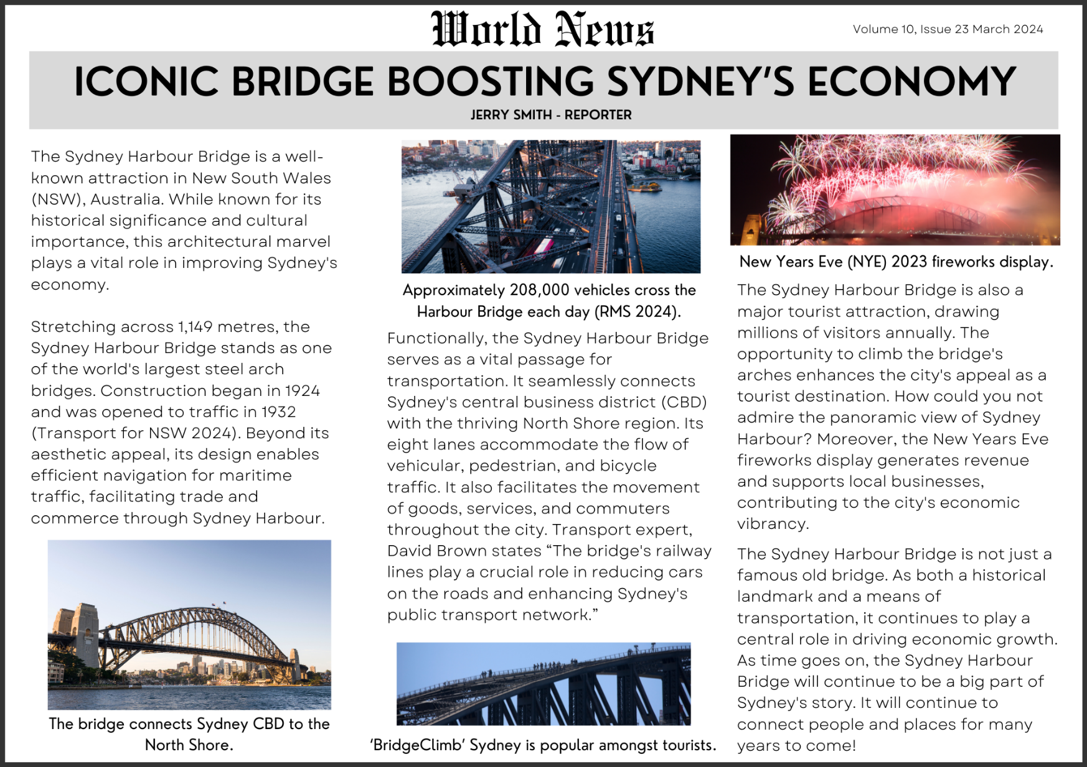

Resource 4 – factual news article analysis
Focus | Examples
Text structure | - Headline: ‘Iconic Bridge Boosting Sydney’s Economy’ summarises the main point of the article  - Byline: ‘Jerry Smith – reporter’ indicates who the author of the article is  - Opening paragraph provides a brief overview of the article  - Body paragraph 1: provides background knowledge (structural information) and its functional importance  - Body paragraph 2: provides information about its uses with a focus on transportation to boost the economy  - Body paragraph 3: provides information about tourism generating revenue for the economy  - Conclusion: summarises the ideas presented and reinforces the main idea of boosting the economy
Language features | Vocabulary  - Topic-specific Tier 2 and Tier 3 vocabulary to add credibility and enhance authority  - ‘maritime’  - ‘commerce’  - ‘revenue’  - Objective and informative language to convey factual information  - ‘Stretching across 1,149 metres, the Sydney Harbour Bridge stands one of the world's largest steel arch bridges’  Sentence-level grammar  - Declarative sentences to provide facts:  - ‘It seamlessly connects Sydney’s central business district (CBD) with the thriving North Shore region.’  - Exclamatory sentences to evoke feelings and connect with the reader  - ‘It will continue to connect people and places for many years to come!’  - Non-finite verbs in adverbial clauses  - ‘Stretching across 1,149 metres (dependent), the Sydney Harbour Bridge stands one of the world's largest steel arch bridges (independent).’  - Rhetorical devices targeted to the audience (interrogative sentence)  - ‘How could you not admire the panoramic view of Sydney Harbour?’  - Control modality  - ‘The Sydney Harbour Bridge is also a major tourist attraction’ presents a fact without room for doubt  - ‘...enhancing Sydney’s public transport network’ implies there is a high probability  - Statistics, facts or quotes  - ‘Approximately 208,000 vehicles cross the Harbour Bridge each day (RMS, 2024)’  - ‘Construction began in 1924 and was opened to traffic in 1932’  - ‘Transport expert, David Brown states “The bridge's railway lines...’  Punctuation  - Parentheses to acknowledge sources of information to add authority and credibility to arguments and information:  - ‘...(Transport for NSW 2024).’

Resource 5 – writing process
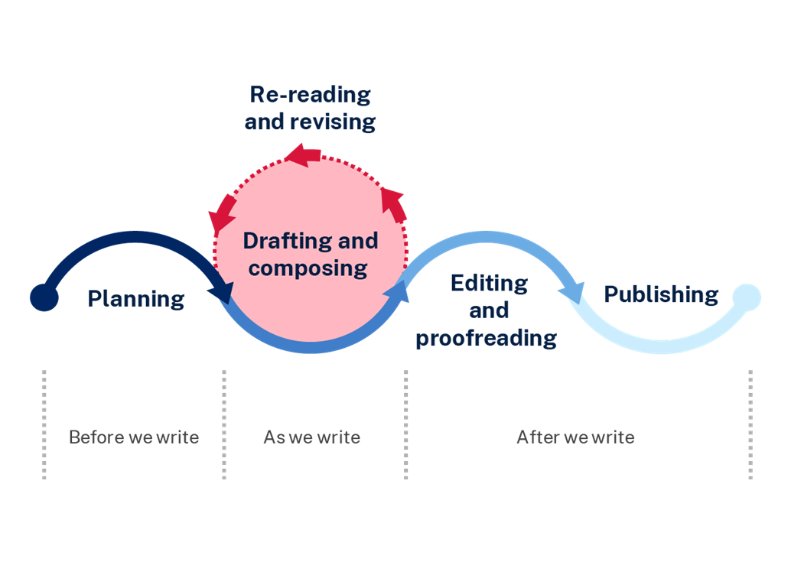

Resource 6 – news flash cards
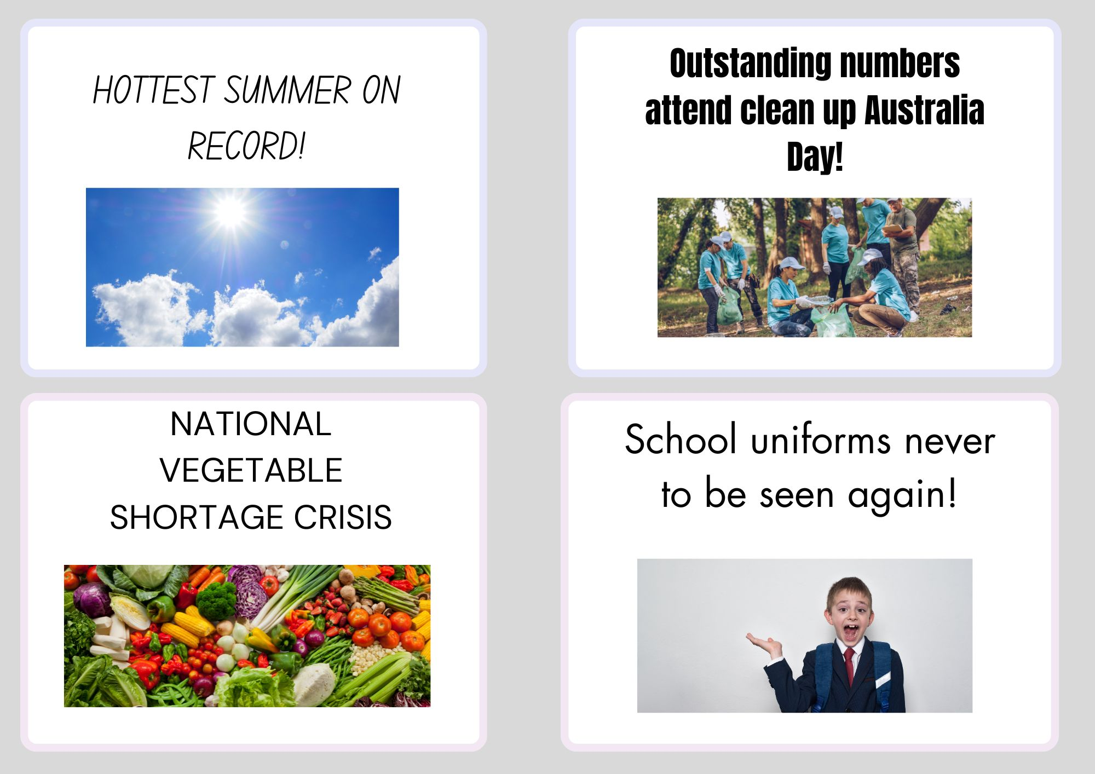

Resource 7 – gorilla escapes from the zoo
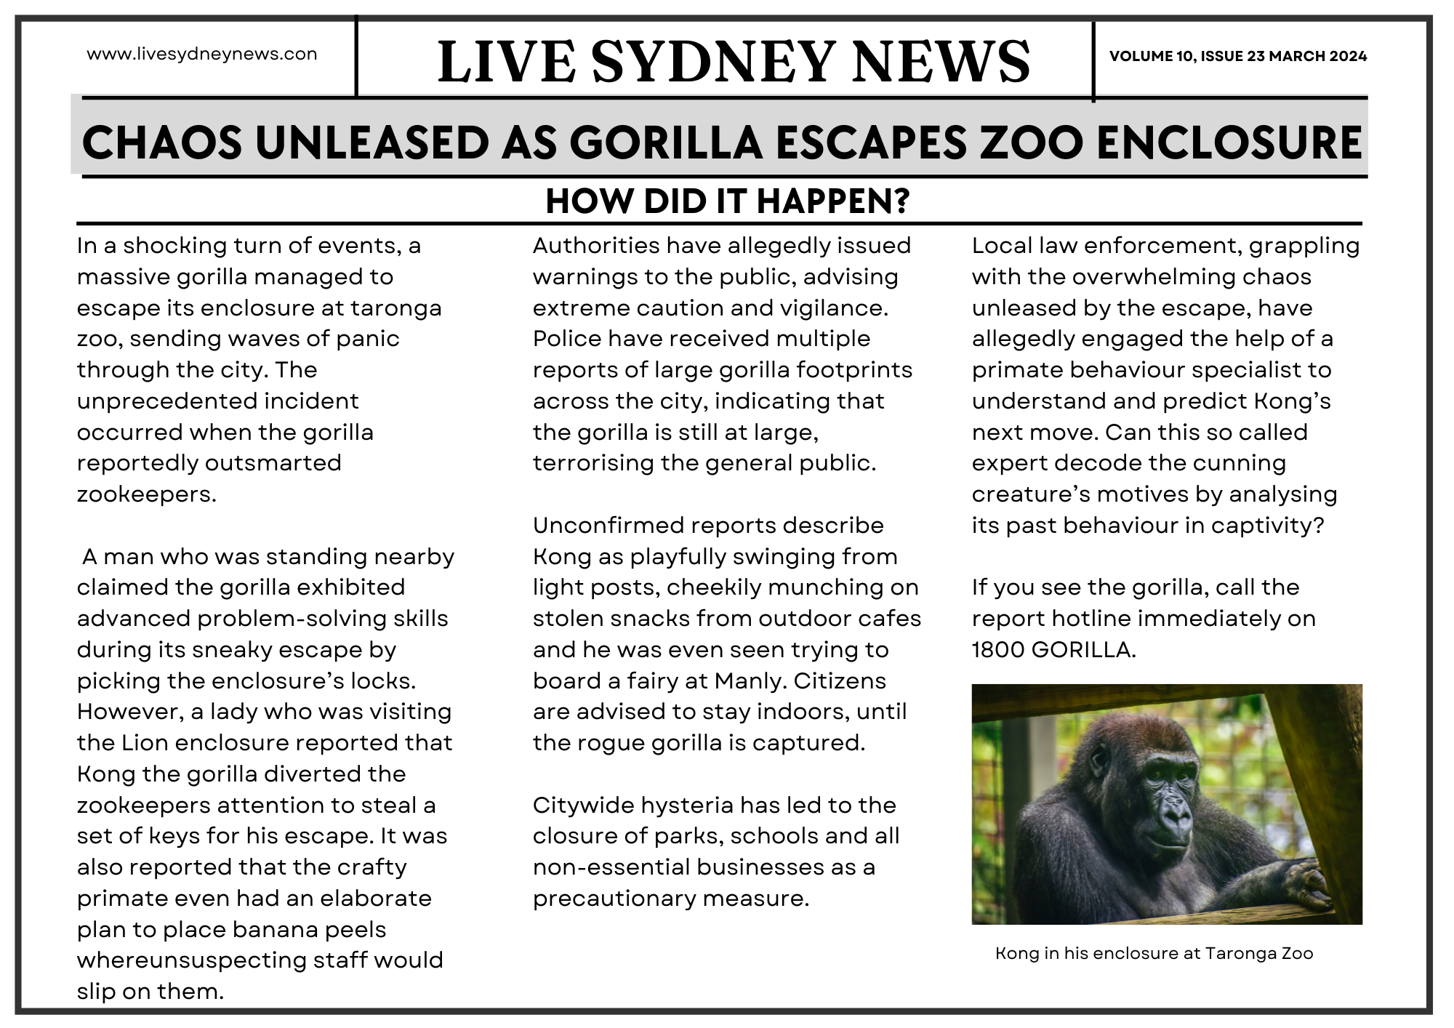

Resource 8 – fabricated news article (Sydney Harbour Bridge)
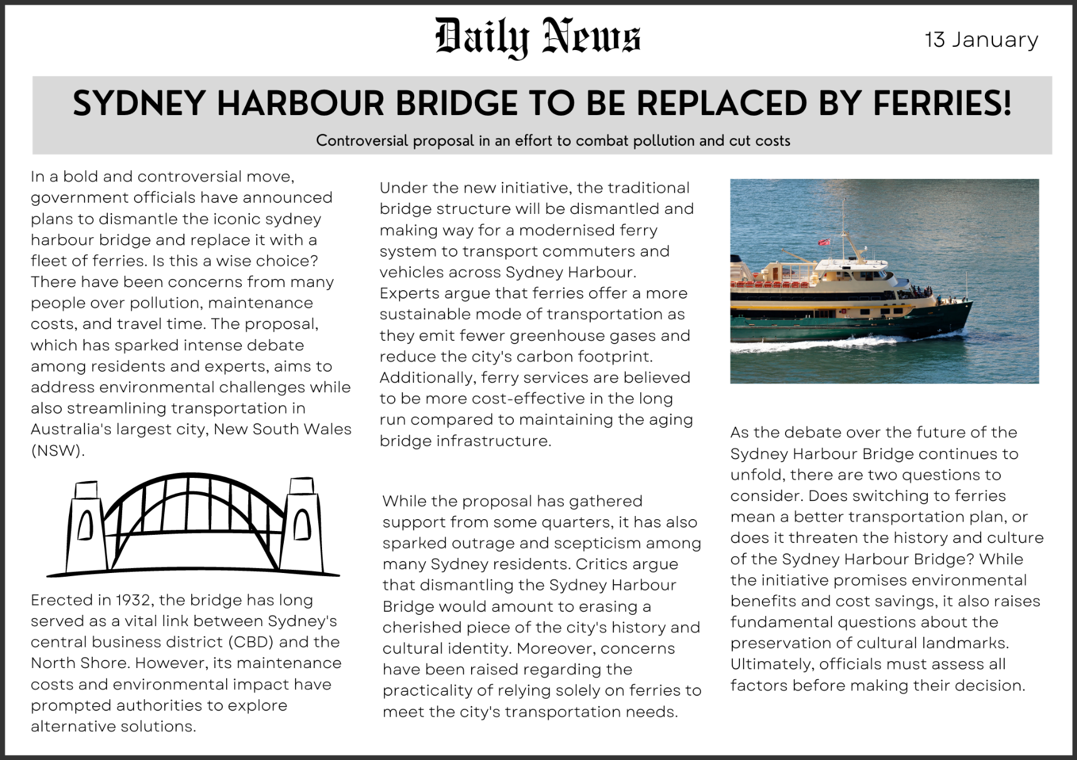

References
This resource contains NSW Curriculum and syllabus content. The NSW Curriculum is developed by the NSW Education Standards Authority. This content is prepared by NESA for and on behalf of the Crown in right of the State of New South Wales. The material is protected by Crown copyright.
Please refer to the NESA Copyright Disclaimer for more information https://educationstandards.nsw.edu.au/wps/portal/nesa/mini-footer/copyright.
NESA holds the only official and up-to-date versions of the NSW Curriculum and syllabus documents. Please visit the NSW Education Standards Authority (NESA) website https://educationstandards.nsw.edu.au and the NSW Curriculum website https://curriculum.nsw.edu.au.
English K–10 Syllabus © NSW Education Standards Authority (NESA) for and on behalf of the Crown in right of the State of New South Wales, 2022.
National Literacy Learning Progression © Australian Curriculum, Assessment and Reporting Authority (ACARA) 2010 to present, unless otherwise indicated. This material was downloaded from the Australian Curriculum website (National Literacy Learning Progression) (accessed 22 February 2024) and was not modified.
ABC (2 March 2021) 'Fake News Fight' [video], ABC, Behind the News, accessed 8 February 2024.
ABC News (25 July 2023) 'Is lab-grown meat coming soon to a supermarket near you?' [video], ABC website, accessed 20 February 2024.
BBC News (12 November 2018) 'What is fake news and how can you identify it?' [video], BBC, News, accessed 8 February 2024.
Cornish R (20 March 2023) ‘Aileen Davis attended Sydney Harbour Bridge’s opening in her mother’s arm, she’s back 90 years on’, ABC, accessed 8 February 2024.
Evans J (5 December 2023) 'World News 2023' [video], ABC, Behind the News, accessed 8 February 2024.
Croll V and AFP (6 November 2023) ’AI resurrects The Beatles with release of new song Now and Then’, Kids News, accessed 8 February 2024.
Burgess M (9 May 2023) ’How AutoGPT is taking AI to the next level and why it has technology experts worried’, Kids News, accessed 8 February 2024.
Cogdon K (16 August 2020) ‘Kids urged to get real on fake news’, Kids News, accessed 8 February 2024.
Khan L (1 August 2023) ’Australian Lab-Grown Meat’ [video], ABC, Behind the News, accessed 8 February 2024.
Lemon J (10 November 2022) Taronga lions made hole in fence before great escape, The Sydney Morning Herald website, accessed 8 February 2024.
NASA (26 January 2017) A New Test for Life on Other Planets, California Institute of Technology website, accessed 8 February 2024.
NASA (25 August 2023) The Search For Life, Exoplanet Exploration website, accessed 8 February 2024.
National Geographic Kids (2015) Spotting fake news, National Geographic website, accessed 8 February 2024.
National Library of Australia (22 July 1969) ‘Man on the moon: The Canberra Times Tuesday July 22nd 1969’, Trove, accessed 8 February 2024.
National Library of Australia (20 November 1969) ‘Man walks on the moon again: The Canberra Times Thursday November 1969’, Trove, accessed 8 February 2024.
National Library of Australia (31 March 1952) ‘Moon First Stop in 10-20 Years: Narandera Argus and Riverina Advertiser Monday 31 March 1952’, Trove, accessed 8 February 2024.
National Library of Australia (2 October 1950) ‘Travel to Moon Possible by 1980: The Age (Melbourne, Vic. :1854-1954 Monday October 2nd’, Trove, accessed 8 February 2024.
NESA (NSW Education Standards Authority) (2024) ‘Glossary’, Resources, NESA website, 22 February 2024.
Taronga Zoo (1 December 2022) 'How five lions escaped their Taronga zoo enclosure' [video], The Guardian, accessed 8 February 2024.

© State of New South Wales (Department of Education), 2024
The copyright material published in this resource is subject to the Copyright Act 1968 (Cth) and is owned by the NSW Department of Education or, where indicated, by a party other than the NSW Department of Education (third-party material).
Copyright material available in this resource and owned by the NSW Department of Education is licensed under a Creative Commons Attribution 4.0 International (CC BY 4.0) license.
This license allows you to share and adapt the material for any purpose, even commercially.
Attribution should be given to © State of New South Wales (Department of Education), 2024.
Material in this resource not available under a Creative Commons license:
- the NSW Department of Education logo, other logos and trademark-protected material
- material owned by a third party that has been reproduced with permission. You will need to obtain permission from the third party to reuse its material.
Links to third-party material and websites
Please note that the provided (reading/viewing material/list/links/texts) are a suggestion only and implies no endorsement, by the New South Wales Department of Education, of any author, publisher, or book title. School principals and teachers are best placed to assess the suitability of resources that would complement the curriculum and reflect the needs and interests of their students.
If you use the links provided in this document to access a third-party's website, you acknowledge that the terms of use, including licence terms set out on the third-party's website apply to the use which may be made of the materials on that third-party website or where permitted by the Copyright Act 1968 (Cth). The department accepts no responsibility for content on third-party websites.

