English Stage 3 First year – Unit 6
Perspective and context – August & Jones

Contents
Unit overview and instructions for use 5
Teacher notes 7
Outcomes and content 9
Resources 16
Week 1 19
Component A teaching and learning 19
Planning framework 19
Component B teaching and learning 19
Learning intentions and success criteria 19
Lesson 1 – introduction to perspective and context 20
Lesson 2 – getting the gist of authorial choices 24
Lesson 3 – understanding the author’s perspective 27
Lesson 4 – understanding how tense variation contributes to perspective 32
Week 2 36
Component A teaching and learning 36
Planning framework 36
Component B teaching and learning 36
Learning intentions and success criteria 36
Lesson 5 – using sentences to engage and connect 37
Lesson 6 – enhancing emotional impact through modal verbs 40
Lesson 7 – navigating themes and messages 44
Lesson 8 – using appositives to enhance writing 47
Week 3 50
Component A teaching and learning 50
Planning framework 50
Component B teaching and learning 50
Learning intentions and success criteria 50
Lesson 9 – experiment with the placement of adverbial clauses 51
Lesson 10 – exploring author perspective through characters 55
Lesson 11 – crafting narratives with personal insights and sentences openers 59
Lesson 12 – writing to reveal perspective 62
Week 4 66
Component A teaching and learning 66
Planning framework 66
Component B teaching and learning 66
Learning intentions and success criteria 66
Lesson 13 – analysing and comparing themes and messages 67
Lesson 14 – expressing ideas using poetic forms 71
Lesson 15 – recalling poetic forms to express ideas 76
Lesson 16 – Creating poetic forms to inclusively express ideas 80
Week 5 84
Component A teaching and learning 84
Planning framework 84
Component B teaching and learning 84
Learning intentions and success criteria 84
Lesson 17 – blog planning 85
Lesson 18 – blog drafting and composing 89
Lesson 19 – blog editing and publishing 91
Lesson 20 – presenting and reflecting 93
Resource 1 – author in a box 96
Resource 2 – author context chart 97
Resource 3 – capturing the heart 98
Resource 4 – character roadmap 99
Resource 5 – ask away exemplar 100
Resource 6 – ask away template 101
Resource 7 – poetry examples 102
Resource 8 – the writing process 103
Resource 9 – blog post plan 104
Resource 10 – blog post exemplar 105
References 106

Unit overview and instructions for use
In this 5-week unit, which serves as the sequel to Unit 5 based on August & Jones by Pip Harry, students will engage with the concepts of ‘perspective and context’ and ‘theme’. They will explore how the author uses different characters’ viewpoints to share perspective and enrich the story. Throughout the unit themes such as friendship, resilience, growth, perseverance and change will be a focus. The unit combines critical analysis with creative writing that reflects the novel's themes and messaging. In the final task, students are asked to research, plan, draft, edit, publish and present a blog post emphasising the themes explored in the text.
Outcomes and content in this unit are organised into Component A and Component B. The components are connected, with learning in Component A complementing learning in Component B.
Note: the duration of this unit can be adapted to suit individual school contexts. For example, learning could occur across 5 days rather than 4.
The table below highlights the focus areas and preparation required for Component A and Component B.
Teaching and learning | Component A | Component B
Suggested duration | 60 minutes × 4 days/week or equivalent | 60 minutes × 4 days/week or equivalent
Explicit teaching focus areas | Component A addresses content from the focus areas:  - Vocabulary  - Reading comprehension  - Creating written texts  - Spelling  - Handwriting and digital transcription  It centres on the development of foundational skills and knowledge through regular, systematic and repeated practice. | Component B addresses content from the focus areas:  - Oral language and communication  - Vocabulary  - Reading comprehension  - Creating written texts  - Understanding and responding to literature  It centres on the conceptual understandings of English and exemplifies the importance of learning about and enjoying literature through the study of quality texts.
Preparing for teaching and learning | - Specific teaching and learning activities need to be developed by the teacher. When planning for these activities, please refer to the Component A outcomes and content, teaching guides and planning frameworks.  - Plan and document how you will sequence teaching and learning in whole-class and targeted-groups across the 5-week cycle as required. This should be based on student needs identified through ongoing assessment data. | - Familiarise yourself with the mentor and supporting texts and textual concepts, and the teaching and learning sequence.  - Determine how you will support students in whole-class and targeted-groups across the 5-week cycle as required. This should be based on student needs identified through ongoing assessment data.
English K–10 Syllabus © NSW Education Standards Authority (NESA) for and on behalf of the Crown in right of the State of New South Wales, 2022.

Teacher notes
- Perspective is a lens through which the author perceives the world and creates a text, or the lens through which the reader or viewer perceives the world and understands a text. Readers may also temporarily adopt the perspectives of others as a way of understanding texts (NESA 2024).
- Context is the range of personal, situational, social, historical and cultural circumstances that shape how texts and their representations are conceived, constructed, understood and interpreted (NESA 2024).
- Understanding perspective can be supported by watching the department’s video: Perspective (3:37).
- Understanding context can be supported by watching the department’s video: Context (5:23).
- While ‘perspective and context’ is the mentor concept for the conceptual component of this unit, the supporting concept of ‘theme’ is explored within the relevant sections of the mentor and supporting texts, August & Jones by Pip Harry and Try Everything by Shakira.
- For information on adverbial clauses and appositives refer to the NESA Glossary.
Note for Lesson 6: address the class with sensitivity and awareness throughout this lesson, emphasising the importance of literature's emotional impact. Acknowledge the potentially challenging nature of Chapter 27, recognising the significance of empathy and mutual respect in students’ approach. Discussions may involve themes of illness, medical decisions and emotional distress. Given that such topics might resonate deeply with some students, offer an understanding and compassionate viewpoint, ensuring that the classroom remains a safe space for all participants. Alternative activities can be created, encouraging students to prioritise their comfort and emotional wellbeing.
- Lesson 8 requires students to create a word cloud, which can be accessed via the Digital Learning Selector’s Mentimeter. All staff can create a free account. To access a word cloud, select Mentimeter, then Mentimeter Overview, followed by Features.
- In addition to the resources listed, students will require access to short passages of the mentor and/or supporting texts. Teachers can copy extracts from texts in reliance on the Statutory Text and Artistic Works Licence. Teachers need to attribute the extracts and include the following notice: ‘This material has been copied [and communicated to you] in accordance with the statutory licence in section 113P of the Copyright Act. Any further reproduction or communication of this material by you may be the subject of copyright protection under the Act. Do not remove this notice’.
- Reflect on student learning and engagement in activities and record differentiation and adjustments within the unit to inform future teaching and learning. One way of doing this could be to add comments to the digital file.
- In NSW classrooms there is a diverse range of students including Aboriginal and/or Torres Strait Islander students, students learning English as an additional language or dialect, high potential and gifted students and students with disability. Some students may identify with more than one of these groups, or possibly all of them. Refer to Curriculum planning for every student – advice for further information.
- Content points are linked to the National Literacy Learning Progression (version 3).
Levels and indicators sourced from National Literacy Learning Progression © Australian Curriculum, Assessment and Reporting Authority (ACARA), (accessed 11 September 2023) and was not modified. See references for more information.

Outcomes and content
The table below outlines the outcomes and content for this unit. The letters 'A' and 'B' in the header refer to Components A and B. The numbers 1 to 5 refer to weeks. The use of 'x' in these columns indicates where the content points are intended to be addressed and in which week.
Focus area and outcome, content points and National Literacy Learning Progression | A | B | 1 | 2 | 3 | 4 | 5
Oral language and communication
EN3-OLC-01 communicates to wide audiences with social and cultural awareness, by interacting and presenting, and by analysing and evaluating for understanding
- Ask and respond to analytical and evaluative questions about literature that contribute to own or others’ enjoyment and understanding (SpK5, UnT7) |  | x |  |  |  | x | x
- Respond to questions with elaboration and detail (InT5) |  | x | x | x |  | x | x
- Deliver presentations suited to purpose and audience (SpK6) |  | x |  |  |  | x | x
Vocabulary
EN3-VOCAB-01 extends Tier 2 and Tier 3 vocabulary through interacting, wide reading and writing, morphological analysis and generating precise definitions for specific contexts
- Identify newly encountered words from interactions and wide reading, and use them in writing, discussions and presentations | x | x | x | x |  | x
- Describe multiple meanings of words, including their metaphorical uses (UnT8) | x | x |  |  |  | x
- Evaluate the effectiveness of modal words used in texts to intensify or soften emotional responses (CrT9) | x | x |  | x |  | x
Reading comprehension
EN3-RECOM-01 fluently reads and comprehends texts for wide purposes, analysing text structures and language, and by monitoring comprehension
- Syllabify, blend grapheme–phoneme correspondences and use morphemic knowledge as strategies for reading words accurately (SpG10, PKW9, FlY6) | x |  | x | x | x | x | x
- Reflect on reading experiences and identify texts and language features that are enjoyable |  | x |  |  |  | x | x
- Use morphology and etymology to work out the meaning of unfamiliar words (UnT8) | x | x |  | x
- Explain how modality can have subtle impacts on the meanings of words and contribute to deeper understanding when reading | x | x |  | x |  | x
- Understand that sentence openers signal what the sentence will be about, and that the rest of the sentence can provide new information | x | x |  |  | x |  | x
- Recognise that a sequence of clauses may use different tenses but remains connected throughout a topic or section of text (GrA5) | x | x | x |  | x |  | x
- Monitor and repair reading when meaning breaks down (UnT9) | x |  | x | x | x | x | x
- Check the accuracy of own recorded gist statements made during reading, before summarising information to determine a text’s main themes, ideas or concepts |  | x | x
Creating written texts
EN3-CWT-01 plans, creates and revises written texts for multiple purposes and audiences through selection of text features, sentence-level grammar, punctuation and word-level language
- Experiment with the development of thematic elements |  | x | x | x |  | x
- Select and use poetic forms to descriptively express ideas |  | x |  |  |  | x
- Control tense across a text according to purpose, shifting between past, present and future tense if required (GrA6, CrT9) | x | x | x |  |  | x | x
- Acknowledge sources of information to add credibility and authority to arguments and information (CrT8) |  | x |  |  | x |  | x
- Experiment with the placement of adverbial clauses, to modify the meaning or to add detail to a verb or verb group (GrA6) | x | x |  |  | x | x | x
- Include appositives to provide details to nouns and to vary sentence structures suited to text purpose | x | x |  | x |  |  | x
- Make choices about the use of declarative, exclamatory, interrogative and imperative sentences to suit text purpose, and for meaning and effect (CrT8) | x | x |  | x | x | x | x
- Use capital letters at the beginning of a sentence, to indicate proper nouns, for headings and subheadings, to indicate the beginning of a poetry line, for emphasis, and when using acronyms (PuN7) | x | x |  |  |  | x | x
- Use a comma to separate a subordinate clause or a phrase from the main clause, or to separate information within a sentence, or to separate items in a list | x | x |  |  | x | x | x
- Select and use a range of synonyms in a longer text, for precision and to create variety for reader engagement | x | x | x | x |  | x | x
- Use print or digital tools to plan, sequence, create, revise, edit and publish texts |  | x |  |  |  | x | x
Spelling
EN3-SPELL-01 automatically applies taught phonological, orthographic and morphological generalisations and strategies when spelling in a range of contexts, and justifies spelling strategies used to spell unfamiliar words
- Segment unfamiliar multisyllabic words into syllables and phonemes as a strategy when spelling | x |  | x | x | x | x | x
- Apply infrequently occurring graphemes and letter patterns when spelling base words in a range of writing contexts (SpG10, SpG11) | x |  | x | x |  | x | x
- Recognise that the same grapheme can represent different phonemes (SpG10) | x |  | x | x | x | x | x
- Proofread written texts to correct misspellings, making use of spelling reference tools where required | x |  | x | x |  |  | x
- Explain and use spelling conventions for assimilated prefixes such as in-, ad-, com- (SpG10) | x |  | x |  | x | x | x
- Explain the etymology of taught roots and apply this knowledge when creating written texts (SpG10) | x |  | x | x | x | x | x
Handwriting and digital transcription
EN3-HANDW-01 sustains a legible, fluent and automatic handwriting style
EN3-HANDW-02 selects digital technologies to suit audience and purpose to create texts
- Sustain writing with a legible, fluent and personal handwriting style across a text (HwK8) | x |  | x |  | x | x | x
- Use handwriting efficiently in formal and informal situations (HwK8) | x |  |  | x |  |  | x
- Reflect on and monitor typing accuracy and rate according to goals and given criteria | x |  |  | x |  | x | x
- Use taught shortcut functions on digital tools to facilitate text creation (HwK8) | x |  | x |  | x | x | x
Understanding and responding to literature
EN3-UARL-01 analyses representations of ideas in literature through narrative, character, imagery, symbol and connotation, and adapts these representations when creating texts
EN3-UARL-02 analyses representations of ideas in literature through genre and theme that reflect perspective and context, argument and authority, and adapts these representations when creating texts
- Identify core social, personal and moral messages within and between texts |  | x | x | x |  | x
- Identify how perspective is made evident through authorial choices (UnT8) |  | x | x | x | x |  | x
- Explore how perspective is influenced by personal, social and cultural contexts |  | x | x | x | x |  | x
English K–10 Syllabus © NSW Education Standards Authority (NESA) for and on behalf of the Crown in right of the State of New South Wales, 2022.

Resources
The resources in the table below are referred to in this unit. Letters 'A' and 'B' in the header refer to Component A and B respectively, and the numbers 1 to 5 indicate weeks. The use of 'x' in these columns indicates whether the resources are required in Component A, B or both, and in which week.
Resource | A | B | 1 | 2 | 3 | 4 | 5
Harry P (2022) August & Jones, Lothian Children’s Books, Melbourne. ISBN13: 9780734420350 | x | x | x | x | x | x | x
Resource 1 – author in a box |  | x | x |  | x | x
Video: CBCA/ATYP Pip Harry Interview (7:51) |  | x | x | x
Resource 2 – author context chart |  | x | x
Website: Sydney Marathon |  | x |  | x
Video: Jessica Darrow – Surface Pressure (From "Encanto") (3:30) |  | x |  | x
Resource 3 – capturing the heart |  | x |  | x
Resource 4 – character road map |  | x |  |  | x
Article: Blind teenager's connection with loyal friend inspires children's book by Pip Harry |  | x |  |  | x
Video: Shakira – Try Everything (Official Video) (3:22) |  | x |  |  |  | x
Try Everything song lyrics (teacher-sourced) |  | x |  |  |  | x
Resource 5 – ask away exemplar |  | x |  |  |  | x
Resource 6 – ask away template |  | x |  |  |  | x
Resource 7 – poetry examples |  | x |  |  |  | x
Thread or wool |  | x |  |  |  | x
Blog: Jessica Watson |  | x |  |  |  |  | x
Resource 8 – the writing process |  | x |  |  |  |  | x
Resource 9 – blog post plan |  | x |  |  |  |  | x
Website: Kosciuszko National Park |  | x |  |  |  |  | x
Strips of paper and a container |  | x |  |  |  |  | x
Resource 10 – blog post exemplar |  | x |  |  |  |  | x

Week 1

Component A teaching and learning
Component A focuses on the development of foundational skills and knowledge through regular, systematic and repeated practice. The mentor and supporting texts used in Component B of this unit can support the effective implementation of Component A teaching and learning.

Planning framework
To plan and document Component A teaching and learning, a planning scaffold (DOCX 228 KB) is provided. To support you in your planning, a link to a detailed example of a one-week teaching and learning cycle is included in the scaffold. Additional resources to support teaching and learning in each focus area can be found at Lesson advice guides.

Component B teaching and learning
The following teaching and learning sequence has been designed to address Component B outcomes and content and develops conceptual understandings of English through the study of quality texts. Adapt the sequence as required to best meet the needs of your students.

Learning intentions and success criteria
Learning intentions and success criteria are best co-constructed with students.

Learning intention
Students are learning that perspective is influenced by personal, social and cultural contexts and is seen through authorial choices.

Success criteria
Students can:
- discuss how personal, social and cultural contexts influence perspectives
- identify how perspective is made evident through authorial choices
- understand how character viewpoints contribute to the author’s themes and messages
- record gist statements made during reading
- use different tenses within clauses to connect a text.

Lesson 1 – introduction to perspective and context
- Set a 30-second timer and direct students to close their eyes and imagine an important item or special event that has happened in their life. Encourage students to engage their senses while remembering this item or event. After 30 seconds, students draw or write about their item or event and how remembering this item or event activated their senses. For example, 'My special event was visiting my Gran’s house and going to the beach together. I can see the crystal-clear water and I can smell the ocean and my Gran’s floral perfume. I remember feeling the sand between my toes and tasting the fish and chips we would eat for lunch.’
- Revise the definitions of perspective and context, identifying their role in storytelling and how they can influence meaning.
Perspective: a lens through which the author perceives the world and creates a text, or the lens through which the reader or viewer perceives the world and understands a text. Readers may also temporarily adopt the perspectives of others as a way of understanding texts (NESA 2024).
Context: the range of personal, situational, social, historical and cultural circumstances that shape how texts and their representations are conceived, constructed, understood and interpreted (NESA 2024).
- Ask students how activity one revealed their perspective and context. For example, ‘I drew about visiting my grandmother's house and talked about the memories I have of spending time there. This house is not just a physical space for me; it holds significant emotional value and cultural context. It's where I learned about my family's history, traditions and values’.
- Display Resource 1 – author in a box. Explain that it contains items that reflect the author's life and influences. In small groups students examine the items, discussing potential connections to the author's personal, social and cultural backgrounds. Based on their discussions, students categorise each item under personal context, social context or cultural context.
- Students share their reasoning for placing each item under specific categories.
- Watch the Pip Harry Interview (7:51) to find out more about the author’s context, stopping at 4:33. Students divide a page in their workbook in half, labelling the first column 'perspective' and the second column 'context.' While listening to the interview, students take notes in each column to identify specific examples of how the author's writing is influenced. For example:
- Perspective: Pip Harry demonstrates her perspective on change by explaining that we can go through challenges and come out the other end stronger. She discusses her own life and surgery and shares her perspective that you can be thrown into difficult situations and survive.
- Context: Pip Harry talks about her own experiences of moving and about how difficult it is to deal with change and challenge.
- After completing activity 6, students review their information recorded in the columns with a partner and identify similarities and differences between each of their notes.
- Discuss how each item that represents Pip Harry in Resource 1 – author in a box becomes clearer after watching the interview and by identifying Pip Harry’s inspiration for writing August & Jones.
- Read Chapters 16 and 17 of August & Jones. Model answering a question about the text with elaboration and detail. For example, ‘How do you think the author’s personal context helped shape her perspective?’ A sample answer may be: ‘In Chapter 16 when August has a panic attack, Pip Harry’s context as a mother is shown when August’s mum (Nicole) comforts her son’.
- Ask students further questions about Chapters 16 and 17 to support an understanding of context. Using prompts such as ‘Keep explaining’, ‘Can you extend on your answer?’, ‘What else can you add?’ to encourage elaboration and detail to answers. Ask:
- How does Pip Harry reveal her cultural context? For example, in Chapter 17, August emails Jones when he discovers that sloths are not in Australia. Pip Harry’s cultural context of being Australian is shown as realistic scenarios.
- How does Pip Harry reveal her social context? For example, in Chapter 17, text messaging occurs between August and Jones. Pip Harry’s social context of being an author in modern times (in the year 2022) is shown with the inclusion of text messaging.
Optional: students create a podcast script about August & Jones explaining why Pip Harry wrote the story and how her experiences, the people she knows, and her culture influenced the story. Students include a brief introduction to Pip Harry and talk about the main characters in the book. In groups, students brainstorm Pip Harry's inspiration for writing the story and practice giving detailed answers. Students will draft and answer questions about Pip Harry's life, her cultural background, and how these are presented in August & Jones.
- Display Resource 2 – author context chart. Explain that these examples help shape Pip Harry’s perspective.
- In pairs, students identify another example where Pip Harry’s personal, social or cultural context influences her lens as an author. Encourage reference to Resource 1 – author in a box as a prompt for ideas before sharing responses.
- Students write a reflection on how the author’s personal, social, and cultural contexts influence her storytelling and how this deepens their understanding of the author’s work. Provide students with the following scaffolded example:
- Introduce the author and her context.
- Discuss one way the author's personal context influences her storytelling.
- Explore how the author's cultural background is reflected in her work.
- Consider the impact of the author's social context on the characters or themes.
- Include examples from the previous activities and discussions that support your ideas.
- Summarise how understanding the author's context deepens appreciation and understanding of her writing.
Too hard? Co-construct sentences on how knowing the author's background can change an interpretation and understanding of August & Jones.
Too easy? Explore how the author's background influences her storytelling and characters. Share observations and examples that link her experiences with the narrative themes.
- Discuss how understanding an author's background helps us better appreciate their stories and shows how they include their views in their writing.

Lesson 2 – getting the gist of authorial choices
- Students draw a picture representing something significant to them, such as a memory, a belief or their place of birth. Share some examples and discuss how these aspects of themselves shape their perspectives. Students then turn and talk to explore how their drawings reflect their personal, social or cultural backgrounds, recognising the stories that make up their identities.
- In small groups, students discuss how their drawings, which represent their personal experiences, might inspire stories another person could write about. Students ask one another:
- How do you think authors’ personal experiences, like the ones we have drawn, might influence the themes and characters in their stories?
- Identify elements in your drawing that might inspire a narrative or character in a book. Explain why you chose that element.
- How does recognising the personal or cultural significance behind a story's theme or setting enrich our reading experience?
- Discuss the influence of Pip Harry's personal experiences on the narrative of August & Jones, comparing these to the student-created drawings reflecting their own backgrounds. Use the drawings as a basis to discuss how individual memories, beliefs or cultural origins shape the themes and characters within a story, recognising connection between an author’s life and their work.
- Review gist statements from learning in Component A as succinct thoughts or information that capture the generalisations gleaned from what has been read, heard or viewed (NESA 2024). Explain that students will read Chapter 18, then identify and record the ‘gist’ or main idea.
- Read Chapter 18, then model the process of ‘getting the gist’. For example:
- Read the text carefully to understand the main events.
- August’s experience during a semi-final game.
- Identify the key information, including the who, what, when, where and why.
- Who: Archer, August (Gus) and Gus' dad (Heath)
- What: August plays for only 11 minutes during his game without touching the ball, but his team wins and now he has a conflict between the final game and zoo tickets with Jones.
- When: the events occur on semi-final day, with activities and reflections happening the same day and thoughts about the next day.
- Where: the location transitions from the semi-final game to August’s dad’s new apartment.
- Why: Gus' dad appears stressed, possibly due to personal issues (hinted at by the mention of his and mum's problems) and reflects this by yelling at the team.
- The visit to Dad's new apartment and the conversation about family issues highlight August’s feelings of displacement and concern about his parents' relationship.
- Condense the key information to capture the main idea of the text in around 40 words.
- August briefly participates in a winning semi-final. He is then faced with a conflict between next week's grand final and zoo plans with Jones. After the game, his dad appears stressed as he suggests afternoon entertainment. Conversations at Dad's new apartment reveal August's concerns about his parent's relationship.
- Check the accuracy of the gist statement to ensure it captures the main ideas and is easily understood.
- Read Chapter 19. Students follow the ‘getting the gist’ process for Chapter 19 and record in their notebook.
- Students analyse their gist statements, considering how the author's personal experiences and intentions might influence the story's key themes or events. This introduces the idea that authors make intentional choices in their storytelling, including decisions about the story's structure, the characters they develop, and the language they use. Encourage students to recognise how these choices are shaped by the author's background and the messages they wish to convey to their audience.
- Re-read from 'Later, I hear my parents arguing...' to '...even though they are both right.' (p 160). Encourage students to think about how the storytelling techniques used here, such as the use of dialogue, help the reader to understand the different viewpoints of Jones's parents.
- Students reflect on August's values by re-reading from 'Good luck, boys' to 'Yes. You have to go.' (p 149). Ask them to consider what this part of the story reveals about what August values most.
- In small groups, students discuss insights into August's character using the Jigsaw strategy. Assign each group one of the following discussion questions:
- How does the author's choice of structure, such as the sequence of events, and use of language, including the use of specific words, contribute to understanding of August's character and perspective? For example, the author places one of the key moments of August’s character development (his decision to quit football) right after the grand final which is a sequence that heightens the emotional impact of his choices. This emphasises August’s inner conflict and growth, displaying his bravery and individuality in contrast to the excitement of the grand final win.
- How does the author use characterisation to reveal August’s perspective? Consider not just his dialogue with other characters but also the descriptions, thoughts, and actions the author chooses to include. How do these choices inform us about August's character? How does the author position the audience to relate to or understand August's character?
- How does the author's style, including the use of first person narrative voice, influence our connection to August and our understanding of his experiences?
- How might August’s character be a reflection of the author’s perspectives or life experiences? Consider how the author's background, as well as the themes she chooses to explore through August's story, might inform this connection.
- Students summarise the gist of their group discussions and select one group member to share with the class.
Too hard? Write a short piece of dialogue between August and Jones that displays an example of their friendship.
- Students write a tweet-length summary (280 characters or less) reflecting on how authorial choices reveal perspective and context. These are then shared in small groups to exchange insights in a concise, innovative way. For example: ‘Using great conversations and the power of friendship, the author shows how August’s wishes clash with his father's hopes, making it hard for him to follow his heart while trying to make his family happy. #StoryChoices #Understanding #AuthorialChoices #Perspective’

Lesson 3 – understanding the author’s perspective
- Provide each student with a sticky note to write down one word describing August’s point of view based on what they have read. Students stick their notes on the board. As a class, discuss the words students have chosen and why they reflect August's perspective.
- Read Chapters 20 and 21. As a whole class, analyse how the plot unfolds through a series of events such as the football grand final and August and Jones's eagerly awaited trip to the zoo. Remind students that these events detail the characters' experiences. Highlight that examining these chapters and the author's decisions in presenting these events enables insights into the author’s perspective, influencing our understanding of the narrative.
- During reading, pause and reflect to discuss what the students consider to be the author’s intent, subject matter and how the author's context and perspective is revealed.
- Clarify that authors make purposeful decisions to depict characters and events. These choices are significant and carefully selected to communicate specific themes, messages or emotions to the reader. In pairs, students discuss August's point of view regarding the footy final. Encourage students to think about the author's intentions by reflecting on why August's experience is portrayed in a particular way. Ask:
- How is August feeling about the footy final? How do you know?
- What was the author's intent for presenting August's point of view on the footy final the way she did?
- What messages or emotions has the author expressed through August's feelings and responses?
- Students write a gist statement about Chapter 20 or 21 on a strip of paper and share with a partner. Students re-read their gist statement, check its accuracy, and ensure that the main idea is captured and is easily understood.
- In small groups, allocate each group member a different character, for example Lexi, Mum, Dad, Rafferty or Archer. Students make notes or record key words to describe the character’s behaviour and motivation throughout Chapter 20.
- Students prepare a role-play as their assigned character demonstrating how the character's context influences their point of view about the footy final. Instruct groups to explain what they believe the author intended to convey through this character by linking the character’s contextual elements to the author's broader thematic goals.
- Each group member begins by analysing their assigned character, focusing on understanding the character’s background, interests, motivations and how these would influence their viewpoint of the footy final.
- Based on their analysis, groups will develop a short role-play that displays their character's reaction to, and views about, the footy final ensuring they highlight how the character’s context informs these views.
- Each group prepares a brief explanation of how their character’s views and context related to the author’s broader messages. This involves discussing the characters' role in the story and what the author might be trying to communicate through their viewpoint.
- Groups will rehearse their role-play, focusing on the accurate portrayal of their character’s viewpoints and emotions.
- Perform the role-play for the class. After the performance, one member from each group will present the explanation of their character’s perspective, how it reflects their context, and how this perspective connects to the broader thematic intentions of the narrative.
- As a class, discuss:
- How does each character help show the author's main ideas or messages? For example, Mum shows a lot of empathy and support in the family. She cares deeply about August's happiness and notices when he's uncomfortable at the footy final, contrasting with the dad's stricter views. This emphasises the author's message about the role of compassion and support in nurturing individual growth within a family.
- In what ways do the different points of view of each character help us understand the author's intent more clearly? For example, August's reluctance to play football contrasts with family expectations, therefore highlighting personal identity struggles.
- Re-read pages 176 to 177 from ‘I don’t want to play footy anymore.’ to ‘...ripping the medal from my neck and dumping it into a rubbish bin.’ Examine the challenges August faces in expressing his reasons for not wanting to participate in football and his subsequent actions.
- Discuss why the author portrays the scene in this way. Students consider what the author is communicating through August's experiences. For example, the description of August feeling torn about the footy final and his choice to leave the team shows that the author wants to highlight the importance of discovering who you are, and the bravery required to pursue what you truly love, even if it is different from what others expect.
- Encourage students to consider how characters such as Mum or Archer might view August's situation with his dad. Discuss how these varied views reveal the author's purpose to include them within the text.
- Model writing from Mum's point of view about the scene where Gus (August) is having a tough conversation with his dad, Heath. Focus on capturing Mum's inner thoughts and feelings as she observes the interaction. Consider how she might interpret Gus and Heath's body language, her concerns for Gus' emotional wellbeing, and her reflections on the role of a parent. Highlight specific word choices and descriptions that convey Mum's perspective on family dynamics, the pressures of parental expectations, and her deep empathy for Gus. For example:
I look over and see how nervous Gus looks. He’s fiddling with his hands as he talks to Heath, but I can see he is trying to stay calm. Heath’s eyebrows are raised, and he doesn’t look happy with what Gus is saying. I wish my boy didn’t have to have these difficult conversations. Parents are supposed to build their kids up, not make kids scared of disappointing them. August’s voice is getting a little louder, but I can’t make out what he is saying. I watch Gus flee and throw his medal in the bin with tears starting to fall down his cheeks. As a mum, it breaks my heart.
- Identify vocabulary that the author uses in Chapters 20 and 21 and the impact it has on reader engagement. For example, the use of ‘shocked’ (p 170), ‘sprint’ (p 171) and ‘disorganised’ (p 173) unlock mental models, evoke emotion and create variety for readers.
- Make links to Component A learning on synonyms. Students explore the modelled example from activity 12 and identify the synonyms used for more common words, for example, 'nervous' for uncomfortable or 'flee' for run. In pairs or small groups, students discuss how these synonyms enhance clarity, engage the reader, and convey ideas more precisely. Share findings with the class.
- Students individually plan and write a reflection on their understanding of the author's choices in presenting various points of view, including examples from the text. Encourage emphasis on the use of synonyms and impactful vocabulary, analysing how these language choices enhance the narrative and contribute to the themes or messages. A suggested planning framework is outlined below:
- Select examples: choose specific points of view from the text and note them down.
- Identify language: identify impactful vocabulary and develop synonyms for these terms.
- Analyse effect: discuss how these language choices enhance the story and connect to themes.
- Write reflection: organise thoughts into an introduction, body paragraphs (each analysing a different point of view), and a conclusion.
- Use and discuss vocabulary: incorporate synonyms and impactful vocabulary in the reflection and consider sharing and discussing findings with peers.
- Student sample plan:
- Select examples: I'll focus on the scene where Lexi whispers to August before the footy final, encouraging him to tell his dad that he has decided to quit the Lane Cove Cats. It is a crucial moment because it shows that this is a big decision.
- Identify language: The story uses words like 'whispers' and 'nod my head,' making the moment seem secretive and serious. The phrase 'for good' makes it feel final and like there's no turning back. The synonyms ‘tell him’ and ‘speak up’ have been used to create variety and engage the reader.
- Analyse effect: The word 'whispers' creates a feeling of closeness and secrecy, adding depth to this scene. It shows August's mixed feelings and bravery about telling his dad that he does not want to play footy anymore.
- Write reflection: I'll start by explaining why this scene is so important. Then, I'll discuss the specific words used and what they tell us about the character's feelings and the story's themes, like choosing one's own path. Finally, I'll reflect on August’s courage.
- Use and discuss vocabulary: In my reflection, I might switch 'whispers' to 'murmurs' to see how it changes things, and instead of 'nod my head,' I could use 'show I agree.' Then, I'll share why I made these changes and talk about how they might change what readers picture in their heads.
- Students share their writing and explore how their interpretations of different viewpoints reveal the author’s intended message.
Assessment task 1 – observations and work samples from this lesson allow students to demonstrate achievement towards the following syllabus outcome and content point:
EN3-RECOM-01 – fluently reads and comprehends texts for wide purposes, analysing text structures and language, and by monitoring comprehension
- check the accuracy of own recorded gist statements made during reading, before summarising information to determine a text’s main themes, ideas or concepts.

Lesson 4 – understanding how tense variation contributes to perspective
- Prompt students to recall a day when they felt nervous as if it is occurring at this moment, capturing the immediate tension. Then, reflect on it as a past event to reveal how perspectives shift over time. This transition from 'is happening' to 'happened' illustrates the power of tense to alter emotional engagement, transforming present anxiety into reflective insight. Explain to students that this lesson will focus on how tense variations can reshape narratives, turning immediate experiences into memories with newfound understanding.
- Revise different tenses and how they are connected, as taught in Component A.
- Engage students with a game focused on tense. For example, divide students into pairs or small groups. Display a present tense word. Select a student from each pair, or small group, to record a sentence with the present tense word. The next student records a sentence with the same idea but with a different tense. Provide time for pairs or groups to discuss ideas. For example:
- Play:
- Present tense: I play soccer almost every day at school and get better every time.
- Future tense: Because I will play so much soccer, I will be nominated as team captain.
- Sing:
- Present tense: He sings in the school choir and is getting ready for a big concert.
- Past tense: He sang his first solo in a concert last year after practicing for weeks.
- Study:
- Present tense: We study a lot for our big test to make sure we know everything.
- Past tense: We studied very hard last time and ended up getting the best grades we've ever received.
Too easy? Use all 3 tenses in a sequence of sentences.
- Read Chapters 22 and 23. Remind students of the author’s use of first-person narrative voice, alternating between the text’s protagonists August and Jones, and revise how first-person narration allows the reader to infer attributes from what the main character says and how others react.
- Identify examples of tense in the chapters. For example, ‘Gus! I’m not getting in a car accident because you want to see a rare monkey baby!’ (p 180). This example is in present tense, the words 'am' (I’m) combined with 'getting,' indicate an action currently happening or ongoing. Ask: What tense is predominantly used in these chapters, and how does it affect your reading experience?
- Display and re-read from ‘A medal...’ to ‘…happy about my decision.’ (p 182). Discuss the verbs used in the passage and how they reflect tense. For example, ‘told’ and ‘had’ are past tense verbs, while ’feel’ is a present tense verb, highlighting that there is a change of tense. Ask: How does the inclusion of past tense add to the depth of character understanding, and how does change in tense impact the reader’s response? For example, while this text is predominantly written in present tense, the dialogue is often written using past tense. Recounting past events offers insights into previous experiences, explaining why the characters behave and feel as they do in the present moment.
- Display the sentence ‘Lately, he’s been so tired...’ to ‘…running with me.’ (p 185). Discuss how the tense changes within the clauses but the ideas are still connected to Jones's dad.
- Explain that students will write a sequence of sentences about an event from the text using past and present tense to link ideas. Reinforce that the purpose of the task is to engage an audience and to grasp the perspective and emotions of the characters and perspective of the author.
- Model writing a sequence of sentences about an event from the text using different tenses to link ideas. Identify the tense used and determine how it is controlled across a text by shifting between past, present and future tense. For example:
Jones is excitedly capturing videos of the monkeys during our long-awaited zoo visit. I was late this afternoon, which must have disappointed her, but her enthusiasm doesn't seem dimmed as we watch the monkeys together. When we spot a baby monkey clinging to its mother's stomach and it looks over at us, any tension from earlier fades away. The way Jones squeezes my arm with her eyes lighting up erases my regrets about being late. Our shared wonder at the monkeys feels like it mends everything. Despite the rocky start to our afternoon, standing here with Jones makes me believe this experience will be one we'll cherish for the rest of our lives.
- Students select an event from the text and write a sequence of sentences using different tense to link ideas. For example, going out for burgers after the zoo closes. Identify the tenses used.
Too hard? Co-construct sentences with past and present tense verbs.
- In pairs, students highlight examples of past and present tense in their partner’s writing and consider if the text remains connected.
- Students discuss and take notes on how switching between tenses enhances the story's progression and depth. Encourage students to recognise how past tense in dialogue or recounted events enriches our understanding of a character's motivations and emotions in the present.

Week 2

Component A teaching and learning
Component A focuses on the development of foundational skills and knowledge through regular, systematic and repeated practice. The mentor and supporting texts used in Component B of this unit can support the effective implementation of Component A teaching and learning.

Planning framework
To plan and document Component A teaching and learning, a planning scaffold (DOCX 228 KB) is provided. To support you in your planning, a link to a detailed example of a one-week teaching and learning cycle is included in the scaffold. Additional resources to support teaching and learning in each focus area can be found at Lesson advice guides.

Component B teaching and learning
The following teaching and learning sequence has been designed to address Component B outcomes and content and develops conceptual understandings of English through the study of quality texts. Adapt the sequence as required to best meet the needs of your students.

Learning intentions and success criteria
Learning intentions and success criteria are best co-constructed with students.

Learning intention
Students are learning to identify how perspective and theme are evident through authorial choices.

Success criteria
Students can:
- use declarative, exclamatory, interrogative and imperative sentences to suit purpose and for meaning and effect
- evaluate the use of modal words to intensify or soften emotional responses
- identify and compare messages and themes across texts
- understand and use appositives to enhance writing.

Lesson 5 – using sentences to engage and connect
- Discuss and summarise the key events and emotional shifts experienced by the characters, emphasising August’s personal growth and Jones’s resilience. Recognise the importance of understanding the characters’ emotional landscape and how their decisions impact their relationships and personal development.
- Read Chapters 24 and 25, encouraging students to identify the emotional shifts and associated experiences as they engage with the text. For example, August taking down the AFL poster signifies a moment of personal choice and liberation from his father's expectations.
- As introduced in Component A, revise how to make choices about the use of declarative, exclamatory, interrogative and imperative sentences to suit text purpose and for meaning and effect.
Declarative sentence: a statement presented as a complete sentence to provide fact, evidence or detail.
Exclamatory sentences: a statement expressing a strong emotion, formed as a complete sentence, and often ending with an exclamation mark.
Interrogative sentence: a sentence that asks a direct or indirect question.
Imperative sentence: a complete sentence conveying a direct command, request, invitation, warning or instruction, typically directed to an implied person (NESA 2024).
- Re-read from ‘Next year, let’s dress up...’ (p 200) to ‘I feel like I could keep going forever’ (p 201) analysing sentence functions.
- Explore how the variety of sentence structures used in the text mirrors the emotions of the characters and the overarching themes.
Theme: an overarching or recurring idea that describes attitudes or values that are perceived in a text. A theme may range from the understood ‘moral’ of a text to philosophical observations that the audience makes about the events, characters and experiences depicted in a text. A text may have more than one theme (NESA 2024).
- In small groups students discuss the following questions and share their responses with the class. Ask:
- Which themes within the text connect with you on a personal level?
- In what ways are the characters' emotional journeys intertwined with these themes?
- What role do the variety of sentence structures play in deepening the story?
- Can you identify how these sentences enhance our understanding of the characters?
- Discuss the bridge run as an event as well as a metaphor for the characters’ journey and challenges.
- Explain the connections between internal struggles and external experiences and how these reflect themes within the text, using examples that show excitement and support during the run, alongside the internal struggles of August and Jones. Students reflect on how these elements relate to each other and to the text's overarching themes, noting specific examples.
- Create a Venn diagram to visually represent the external experiences during the run and August and Jones's internal struggles, identifying where they connect to the text's themes.
- Discuss and share insights on the Venn diagram findings, emphasising the significance of these connections.
- Students use their Venn diagram to write a reflective paragraph that focuses on the themes, August and Jones’ emotional journeys, and the impact of sentence structure on narrative depth. Students could consider the following:
- Theme connection: talk about which parts of the story really speak to you and why. Think about how these parts relate to bigger ideas or your own life. (What is the story really about?)
- Characters' emotional journeys: recognise how August and Jones feel throughout their adventure and how these feelings tie back to the story's big ideas (themes). Find places in the book that show these emotions clearly. (How do they feel?)
- Narrative depth through sentence structure: look at how the author uses different kinds of sentences to make the story more interesting and help the reader get to know the characters better. Show examples from the book that make you feel more connected to what's happening. (Why does how it's written matter?)
- Personal insight and why this matters: share what you have learned by thinking about all these things and how it has changed the way you see the story, its characters and even your own world. Think about why it is good to understand stories deeply, such as how they help us understand others and think more about our own choices and feelings. (What did I learn and why does it matter?)
- Students write an exit ticket summarising how different sentence functions enhance storytelling and connect readers to the characters' emotions, using one example from the lesson.

Lesson 6 – enhancing emotional impact through modal verbs
Note: address the class with sensitivity and awareness throughout this lesson, emphasising the importance of literature's emotional impact. Acknowledge the potentially challenging nature of Chapter 27, recognising the significance of empathy and mutual respect in students’ approach. Discussions may involve themes of illness, medical decisions and emotional distress. Given that such topics might resonate deeply with some students, offer an understanding and compassionate viewpoint, ensuring that the classroom remains a safe space for all participants. Alternative activities can be created, encouraging students to prioritise their comfort and emotional wellbeing.
- Identify that the lesson will focus on the subtleties of modal verbs in literature whilst exploring how these tools can increase or decrease the emotional experiences conveyed through the text.
- Read Chapters 26 and 27. Discuss how the author uses modality to intensify or soften the emotional responses of the reader. By carefully selecting words, setting the tone and using narrative techniques, an author can intensify or soften the reader's emotional experience, creating a more engaging story.
- Ask students to reflect on how the text made them feel, noting their emotional responses in their workbook. Facilitate a voluntary sharing session where students can discuss the emotions they identified and why certain passages evoked these feelings. Ensure a supportive atmosphere, emphasising empathy and understanding.
- Draw on learning from Component A to identify sentences from the text that heighten or soften emotional responses and explore how to alter the modality to make each sentence softer or stronger. For example:
- original sentence with softened modality: “Jones, the IAC chemo isn’t working as well as we’d hoped,” says Dr Habib.
- intensified modality: “Jones, the IAC chemo isn’t proving effective at all,” says Dr Habib.
- Discuss and analyse how the change in modal verbs and language alters the emotional weight of Dr. Habib’s statement, identifying the effect of softening or intensifying language on the reader’s emotional response.
- Students turn and talk in small groups to discuss how their own personal context, such as age, similarity to and knowledge of Jones's challenges, enhances their compassion for her during her difficult decision. Encourage students to respond with elaboration and detail to explore the thoughts and emotions experienced during the decision-making process.
- In small groups, students select another sentence from the text and work together to create a softened and intensified version. Each group then presents their sentences and explains how the changes in modality affect the emotional tone and reader engagement.
- Students select a scenario (related or unrelated to the text) where a difficult decision must be made. Students complete a Plus, Minus, Interesting (PMI) to analyse the positives, negatives and interesting ideas associated with their scenario. For example:
Scenario:
Jones has been battling eye cancer, and despite undergoing chemotherapy, the treatment isn't getting the desired results. Dr. Habib suggests surgery as the next step, which is a daunting decision that involves removing Jones's eye to eliminate the cancer. This scenario involves emotional turmoil for Jones and her family, who must decide between the distressing option of surgery or facing an uncertain future with the ongoing threat of cancer.
PMI chart analysis:
Positives
- Surgery offers a concrete solution to eliminate cancer, potentially saving Jones's life.
- Removing the eye could prevent the cancer from spreading to the brain, reducing further complications.
- The family demonstrates strong unity and their support for Jones can be a source of strength and resilience.
Negatives
- The emotional and psychological impact of losing an eye includes fear, loss of self-esteem and the challenge of adapting to a new way of life.
- Medical expenses and economic hardship already put a financial strain on the family.
- There is uncertainty and fear surrounding the surgery's success and adjusting to life afterward.
Interesting
- The scenario explores themes of resilience, family unity and the complex emotions involved in making life-altering decisions.
- Jones's maturity in facing her illness and making a difficult decision highlights her courage and empathy for her family's feelings.
- Explain how modality can have subtle impacts on meaning and contribute to deeper understanding when reading. This can include modal verbs such as: must, should, have to, ought to, may, might, can, could, will, always, never, typically, would, want, wish, prefer. See example sentences below.
- She might be worried about the upcoming surgery.
- She must be worried about the upcoming surgery.
- Model writing a response based on the PMI analysis from activity 8, that demonstrates the use of modal verbs and synonyms to engage the reader emotionally. For example:
Jones is faced with the daunting decision of surgery, and she knows it could offer a chance to beat the cancer threatening her life. The surgery would not only aim to save her life but also prevent the disease from reaching her brain, offering a sliver of hope amidst the storm. Supported by her family's unwavering love, she finds strength, even as she grapples with the emotional toll of losing an eye. The fear of financial burden on her parents adds to the weight of her decision. Yet, throughout this uncertainty, Jones's resilience shines through, reflecting a maturity and bravery beyond her years. Her choice shows deep sacrifice and a strong family bond, proving the strength of the human spirit in tough times.
- Students return to their PMI analysis from activity 8 to write a paragraph about their chosen decision using synonyms and modality to create an emotional response in the reader.
Too hard? Students strengthen the modality of their PMI sentences from activity 8.
Too easy? Students experiment with changing modal words to alter the impact of the modality.
- Students share their writing with a peer and discuss how modality contributes to an emotional response from the reader.

Lesson 7 – navigating themes and messages
- Explain that the focus of this lesson will be on deepening students’ understanding and analysis of thematic elements and messages in literature to enhance and support their interpretation.
- Watch Jessica Darrow – Surface Pressure (3:30).
- Identify and discuss the themes and messaging of the clip by focusing on the contrast between external strength and internal vulnerability. Ask students how the lyrics and imagery convey this. For example, the lyrics 'strong,' 'pressure,' and 'under the surface' spotlight the character's outward display of toughness. At the same time, the imagery of the character's quiet moments and uncertainty exposes the hidden vulnerability and the heavy burdens she bears by emphasising the theme of contrasting external strength with internal challenges.
- Explore how the depicted experiences of the 2 characters in the clip mirror the themes in August & Jones by emphasising the challenges of managing external perceptions versus internal realities.
- Ask students what the main message about perception and dealing with expectations is. For example, projecting strength externally while battling inner doubts and the pressure of expectations.
- Discuss that themes in different texts can be wide ranging, including love, friendship, change, family, betrayal, trust, bullying, politics and perseverance. It is important to recognise that texts often convey a combination of these themes or messages, which readers may interpret differently based on their personal perspectives and contexts.
- Read Chapters 28 and 29, pausing to discuss any newly encountered words. Unpack the morphology and etymology of words that are important to understanding the chapter’s themes, as taught in Component A. For example, words such as occupational therapy (p 234), conformer and prosthesis (p 240).
- Discuss the significance of these terms in the context of August & Jones by encouraging students to relate them to broader societal issues or personal growth themes. This conversation should highlight how particular words can be windows into the deeper messages of the text.
- Students Think-Pair-Share to discuss the social, personal and moral messages conveyed through Chapter 29, using guiding questions to probe deeper into the text's thematic exploration. Encourage students to draw links between the chapter’s themes and their own lives, building a personal connection to the text. Ask students:
- What social, personal and moral messages is the author trying to convey to readers throughout the text? For example, personal – August and Jones's deep friendship is a source of strength, support and inspiration highlighting the importance of genuine connections with others.
- What themes are being explored in the text? For example: friendship, empathy, resilience, individuality, hope and overcoming challenges.
- What texts can you think of that share a similar theme? For example, Rowan of Rin and The Little Refugee.
- Students reflect on new words from Chapter 29 and complete a quick write to share with the class, drawing links to personal experiences or observations. For example, see the modelled example below.
After reading Chapter 29, I discovered many new words that I found interesting. ‘Occupational therapy’ (p 234) showed me the beauty of helping people reclaim their everyday lives. The word ‘conformer’ (p 240) made me ponder the tough pressures to fit societal norms. ‘Prosthesis,’ also on page 240, revealed the incredible ways technology supports those who've lost limbs. These terms broadened my view, making me deeply appreciate the blend of science and compassion in enhancing human lives.
- Ask if the theme of ‘change’ within the text is a social, personal or moral message. For example, the theme of change is a personal message reflecting the main character’s experience of change, such as transitioning to a new school. Prompt students to consider the author’s context and what influenced her to write about a character changing schools. For example, her daughter started at a new school when they moved back to Australia.
- Students select a theme from August & Jones and complete Resource 3 – capturing the heart, using evidence from the text to support their choices. For example, friendship, family, illness and perseverance.
- Students use their chosen theme from activity 1 to write a paragraph explaining how the theme is depicted in the text. Students should provide specific examples and explain how the theme relates to their experiences or viewpoints. Remind students to refer to their completed Resource 3 – capturing the heart.
- Students complete a 3-2-1 exit ticket to demonstrate 3 themes they found in the text, posing 2 questions they still have, and sharing one insight about how themes can be interpreted differently by readers.
Assessment task 2 – observations and work samples from this lesson allow students to demonstrate achievement towards the following syllabus outcome and content point:
EN3-RECOM-01 – fluently reads and comprehends texts for wide purposes, analysing text structures and language, and by monitoring comprehension
- use morphology and etymology to work out the meaning of unfamiliar words.

Lesson 8 – using appositives to enhance writing
- Create a digital or hard copy word cloud about the textual concept of perspective and context. Ask students to draw on their prior knowledge and record key words or phrases about perspective and context. Students record ideas on a sticky note and attach it to a poster or use an online application such as Mentimeter. Examples of words that might be recorded could include ‘lens’, ‘perceives the world’, ‘understanding’, ‘author’, ‘social’, ‘cultural’ and ‘personal’. After creating the word cloud, start a brief discussion on how specific word choices can shape perspective and context, laying the groundwork for upcoming activities that will explore vocabulary and modality.
- Discuss some of the words on the word cloud to review learning so far. Remind students that an author’s perspective is influenced by their context. Explain that authorial choices allow writers to create the lens they want the reader to see through.
- Brainstorm and give examples of the authorial choices that the author makes in August & Jones for reader engagement. For example:
- the subject matter
- modality
- different sentence functions.
- Revise appositives from Component A. Explain that these are another authorial language choice that the author uses. For example, ‘At least our Persian longhair, Ringo, is coming with us to the city.’ (p 2).

Appositive: a noun or pronoun that is positioned beside another noun or pronoun to explain or identify it. An appositive often includes modifiers or noun groups with modifiers (NESA 2024). Appositives contribute to sentence variety, which keeps writing engaging and prevents monotony. An appositive usually follows the noun it describes and is contained in commas. Appositives generally do not include a verb as this can change the explanation or additional details in a clause.
- Co-construct sentences related to August & Jones that include appositives and highlight how the appositive adds further detail to the noun. For example:
- Meimei, the baby Francois Langur monkey, was clinging to her mother’s stomach.
- Heath, August’s dad, played AFL when he was younger.
- Visiting Dr Wu, the ophthalmologist, makes Jones feel nervous.
- Read Chapters 30 and 31. Record the characters and places that appear in the chapters. For example, Dr Habib, Uncle Pete, paediatric ward, assembly. Consider the following questions to engage with the text:
- How might Jones have felt when she recognised August by his unique scent, and what does this moment tell us about the depth of their friendship? Reflect on the importance of sensory memories in connecting with those we care about.
- Describe the emotions August might have experienced upon receiving Jones's hug, especially considering his concern for her wellbeing. How does this interaction highlight the strength and challenges of caring deeply for someone facing health issues?
- Imagine yourself in Jones's position, losing a key sense but still being able to recognise a close friend through another sense. How would this loss encourage you to appreciate your other senses and develop the resilience to adapt to new and unfamiliar situations?
- Model selecting one character or place and write a sentence with an appositive about that character or place. For example, ‘August, her best friend, receives a heartfelt hug from her, embodying the warmth of their unbreakable friendship.’
- Students select characters or places from Chapters 30 and 31 and write sentences with appositives to enhance descriptions of their chosen character or place. Encourage students to incorporate newly identified vocabulary and concepts of modality. Guide them to choose examples reflecting the core social, personal, and moral messages of the chapters they have read. This could involve creating sentences encapsulating key character development moments or thematic significance.
- Ask questions to guide in-depth reflection, encouraging students to respond with elaboration and detail such as:
- Does using appositives make your sentences more interesting or engaging? Why or why not?
- How do you think using appositives contributes to the clarity of your writing?
- How does considering appositives affect your approach to sentence construction?
- How do appositives help you convey the emotions and experiences of the characters more vividly, and how does this affect your emotional connection to the story?

Week 3

Component A teaching and learning
Component A focuses on the development of foundational skills and knowledge through regular, systematic and repeated practice. The mentor and supporting texts used in Component B of this unit can support the effective implementation of Component A teaching and learning.

Planning framework
To plan and document Component A teaching and learning, a planning scaffold (DOCX 228 KB) is provided. To support you in your planning, a link to a detailed example of a one-week teaching and learning cycle is included in the scaffold. Additional resources to support teaching and learning in each focus area can be found at Lesson advice guides.

Component B teaching and learning
The following teaching and learning sequence has been designed to address Component B outcomes and content and develops conceptual understandings of English through the study of quality texts. Adapt the sequence as required to best meet the needs of your students.

Learning intentions and success criteria
Learning intentions and success criteria are best co-constructed with students.

Learning intention
Students are learning to recognise how author's choices highlight their unique perspective and influence the reader's understanding of the story.

Success criteria
Students can:
- experiment with the placement of adverbial clauses
- explore how author perspective is revealed through the characters
- understand that sentence openers signal what the sentence will be about
- use personal context to plan and write a short text
- experiment with language choices to reveal personal perspective.

Lesson 9 – experiment with the placement of adverbial clauses
- Review and discuss prior chapters of August & Jones focusing on Jones’s recent accomplishments (wins). Students write a short, positive and powerful motto that Jones lives by. For example, ‘Embrace challenges. Achieve growth.’
- Read Chapters 32 and 33 and focus on how the author develops themes of resilience, friendship and change through the character’s experiences. After reading, students reflect on the following in small groups: Consider what the author aims to convey through the events and interactions in these chapters. How do these moments contribute to August & Jones's overall message? For example, the author emphasises resilience and the power of friendship as Jones bravely returns to school and engages in new challenges. This reflects the narrative's core message that support and understanding are crucial in overcoming life's obstacles.
- In small groups, students write a brief reflection to share with the class on the significance of these chapters in the narrative. What insights do they provide into the characters’ growth, and how do they move the story forward?
- Revisit the concept of adverbial clauses as taught in Component A, then display the sentence, ‘We drove to Mount Kosciuszko’.
Adverbial clause: a dependent clause that modifies a verb, adjective or another adverb. It includes words that provide information about the time, place, condition, reason, manner or purpose (NESA 2024).
Note: a comma is used to separate the adverbial clause from the main clause if it comes before the main (independent) clause.
- Explain how adverbial clauses give more details about what is happening in a sentence. Using 'We drove to Mount Kosciuszko,' add extra information about this action by including an adverbial clause. Create an adverbial clause that tells more about when, where, or why. Through examples, show how placing this extra detail at the beginning or end changes the sentence, making it easier to picture the action and understand its significance. For example, 'When the sun rose, we drove to Mount Kosciuszko.' introduces a clause providing additional context about the timing of the action. This adjustment shifts from describing when to explaining the condition under which the action occurred by offering a fuller picture of the event.
- Adverbial clause: late in the afternoon
- Full sentence: Late in the afternoon, Jones committed herself to rigorous rock-climbing training.
- Ask:
- How does the sentence's meaning or focus shift when moving the adverbial clause, 'late in the afternoon,' to a different part of the sentence? For instance, does starting the sentence with this clause immediately emphasis Jones's awareness and determination?
- What do you observe about the comma's placement after the adverbial clause 'Late in the afternoon’?
- How does this punctuation affect how the sentence is read?
- Why is placing the comma after the adverbial clause important for understanding Jones's actions? How does it help in pacing the information and ensuring the sentence flows smoothly, providing clear emphasis on her commitment?
- Explain that experimenting with the placement of adverbial clauses can vary the flow, rhythm and coherence of a piece of writing. An adverbial clause can be placed at the beginning, middle or end of a sentence for intentional effect and purpose. Explore the impact of adverbial clauses in the middle of a sentence using ideas from the text. For example:
- We ate breakfast, before driving to Mount Kosciuszko, to ensure we had energy for the hike.
- Jones stopped and smelt the air, after the arduous and exhilarating climb, to take in the beautiful world around her.
- Revisit examples of adverbial clauses used in Chapters 32 and 33. Ask students to identify the effect of the adverbial clause placement. For example:
- Time (when): ‘After the dishes are cleared, we check out the maps.’ (p 261). The adverbial clause, ‘After the dishes are cleared’ indicates when the action takes place.
- Place (where): 'As we stand at the buffet, Dad helps me load my plate up with chocolate croissants, fruit, apple Danish, hash browns, bacon, and scrambled egg.' (p 265) The adverbial clause, 'As we stand at the buffet,' provides a specific location where the action occurs.
- Reason (why): ‘Because Jones and I are on the School Council, we get to sit on the stage in our new jackets’ (p 259). The adverbial clause, ‘Because Jones and I are on the School Council’ explains why August and Jones get to sit on the stage.
- Co-construct a list of actions and events from Chapters 32 and 33 demonstrating the friendship between August and Jones that students think would be a special memory for the characters. For example, graduating Year 5 or seeing a wombat on the drive to Mount Kosciuszko.
- Brainstorm some ideas of photographs that August and Jones may take of special moments, then model writing sentences to match. Ensure that the placement of the adverbial clause modifies meaning and adds detail to the verb or verb group. Revisit the correct placement of the comma. For example:
- While on our way to Mount Kosciuszko, Jones and I spot a big hairy wombat. His name is Wally. Isn’t he cute?!
- As soon as we graduated, we jumped for joy. Woohoo!
- Students select events from the list created in activity 9 and write sentences to match. When deciding where to place adverbial clauses, students must focus on how these choices can change the emphasis and mood of the sentences. They should consider what they want to highlight about the event: the timing, the reason, or how it happened. This intentional choice will make the writing more engaging.
Too hard? Students select one event and illustrate the photograph from activity 10. Co-construct sentences and support students to highlight the adverbial clause.
Too easy? Students select 2 different photograph ideas and integrate adverbial clauses that connect the 2 events.
- In small groups, students share their sentences. Group members provide feedback on the correct use of a comma in the sentence and if the placement of the adverbial clause is having the desired effect.
- Select student work samples to analyse the adverbial clauses. Ask questions such as:
- What is the main verb or verb group in the sentence, and how is it modified by the adverbial clause?
- What information does the adverbial clause provide in a sentence?
- How do adverbial clauses contribute to the meaning of a sentence?
- Why is it important to understand adverbial clauses when writing sentences?

Lesson 10 – exploring author perspective through characters
- Provide students with one minute to think about a personal challenge they have faced in their lives. Using knowledge about how August and Jones have overcome their challenges, students write a paragraph outlining how they have been inspired by August and Jones and how this influences them to conquer their personal challenges.
- Read Chapters 34 and 35. Revise the concept of sentence openers to signal what a sentence will be about and that the rest of the sentence can provide new information. Display a variety of sentence openers. For example:
- After reading Chapters 34 and 35, I noticed that the author's background and perspective ...
- The author's perspective influenced the narrative in Chapters 34 and 35 by ...
- In Chapters 34 and 35, the author's background and perspective enhanced my understanding of the story by ...
- I found that the author's perspective in Chapters 34 and 35 made me think differently about ...
- After reading Chapters 34 and 35, I realised that the author's background and perspective helped me to see ...
- In pairs, students select 2 of the sentence openers to verbally complete the sentence.
- Engage students in a brainstorming discussion, creating a class summary of how the author’s perspective might impact the unfolding of the narrative. For example:
The final chapters of August & Jones highlight overcoming personal challenges. This reflects the author's deep understanding of courage and support, as seen in August's fears and Jones's resilience through health struggles. This perspective shapes the story, guiding us to appreciate the characters' challenges and their achievements. The author's perspective enriches our connection to August and Jones and invites us to consider how empathy, resilience, and shared experiences can impact our lives and the stories we tell.
- Explain that students will engage in a Socratic seminar to discuss how the author's perspective influences the character growth of Heath (August’s dad). Review the specific protocols for a Socratic seminar as explored in Stage 3 Unit 5 and facilitate a Socratic seminar using guiding questions. For example:
- How do Heath's interactions with other characters reflect the author's perspective on relationships or individuality?
- Do you think the author wants readers to reflect upon Heath’s growth? Why?
- What personal challenges does Heath overcome, and how do these moments highlight his growth?
- How does Heath's development affect his relationships with others, and what does this tell us about his evolving sense of self?
- Display Resource 4 – character roadmap. Explain that a character roadmap uses text and images to describe the transformation of a character throughout a narrative. Discuss the exemplar and how it reflects Heath’s dramatic growth. For example, Heath begins the story focussed on being a footy coach and has some conflict with Nicole (August’s mum). As the narrative develops, he builds his relationships with his children. His story concludes with a shift in focus from footy coach to Dad, which displays the change and growth in his character.
- Compare and discuss Resource 4 – character roadmap with the student responses from activity 5.
- Students reflect on characters within the text who undergo meaningful transformations. Encourage them to share how witnessing these journeys influences their understanding or feelings about the themes of support and resilience. For example, observing the growth of characters like Heath, August & Jones might highlight the value of compassion and companionship when facing life’s hurdles.
- Students select a character to create their own roadmap. Students consider how the author's perspective influences the character's development. Students discuss and include specific text examples to support their display, using print or digital platforms such as Canva for Education.
Too hard? Support students by using sentence openers for students to complete.
- In pairs, students review their character roadmaps, highlighting where they effectively capture the author's perspective. Students should consider how the author's experiences and views have shaped the character's development, providing examples to support their discussion.
- Students think about their favourite character from August & Jones and why. In pairs, students play hot seat, where one partner adopts the persona of their favourite character, and the other partner asks questions to determine who their favourite character is. Students swap roles, and once both partners correctly guess, each student explains why their chosen character is their favourite.
- As a class discuss if their view of their chosen character has changed from the beginning to now. Acknowledge that this reflects how much their understanding has developed throughout the unit.
- Provide students with the following reflective prompt: As we close our 8-week journey through August & Jones, take a moment to reflect on the story's impact on you. Share a memorable moment from the text that has stayed with you.
Too hard? Students select one key moment for their character and discuss how it shows the author's perspective, using one example to help explain their point.
- Optional task: Cinema in the classroom – crafting trailers to celebrate our story.
- Divide students into small groups and ask them to create a short movie trailer or concept that encapsulates the essence of the story. Mention that, based on availability, they can choose between using digital tools or paper and art supplies.
- Encourage groups to brainstorm critical elements of the story, such as themes, characters, and pivotal moments, to be highlighted in their trailer or concept.
- Guide each group in writing a brief script or outline and sketch a storyboard, deciding on scenes, dialogue, and visuals that will convey the story's atmosphere and emotional impact. This can be planned as a digital project or drawn on paper.
- Direct students on the options for creation: They can film and edit their trailers digitally, incorporating music, dramatic readings of text and visuals. Alternatively, if digital tools are not accessible, students can bring their trailers to life through detailed illustrations, crafted materials and creative presentations on paper.
- Organise a mini-film festival or showcase, enabling groups to present their trailers or trailer concepts in class. Celebrate the story's completion and students' hard work by viewing and discussing each group's creative interpretation and emotional connection with the narrative.
- Facilitate a reflection session after the presentations, encouraging students to discuss how this activity helped them connect with the story and express their feelings about its completion. Explore how creating something new from the narrative allowed them to explore the author's perspective further in a unique and engaging way.

Lesson 11 – crafting narratives with personal insights and sentences openers
- Introduce the newspaper article 'Blind teenager's connection with loyal friend inspires children's book by Pip Harry' by reading its title and presenting the first image. Discuss the article's credibility and authority, highlighting its publication by ABC News and the inclusion of insights from the author, Pip Harry.
- Read the newspaper article 'Blind teenager's connection with loyal friend inspires children's book by Pip Harry'. Guide students to evaluate the article's reliability by highlighting how the journalist uses direct quotes, detailed descriptions, and photographic evidence to show credibility. Ask students:
- Why is it important for writers, like journalists, to back up their claims and cite their sources?
- How do direct quotes and specific details in the article contribute to its credibility?
- Why is it important for journalists to include evidence like photographs to back up their stories?
- How does this impact a reader's understanding and trust?
- Discuss the connection between real-life events and narrative writing. Ask students to create a Venn diagram using Canva or paper to draw connections between August & Jones and the newspaper article, recognising shared themes, characters' experiences and any other similarities they can discover.
- Revise that sentence openers signal what a sentence will be about. Display several sentence openers such as the ones listed below. In pairs students take turns at predicting the rest of the sentence and justify their predictions. For example:
- The newspaper article portrays the bond between Jarrah and Mathilde as...
- In the story of August & Jones, the characters' relationship is depicted as...
- One difference I noticed is how the bond is portrayed as...
- Encourage students to reflect on their own experiences and how these could be woven into their writing. Students draw unique aspects of their lives, such as hobbies, family dynamics and interests.
- Guide students to use their drawings as inspiration to write sentences with a range of openers. They should select at least 5 personal aspects and write sentences, observing how different openers alter the feel of their writing.
- In small groups, students share and discuss their sentences by focusing on the impact of personal experiences on their writing and how sentence openers can change the tone.
- Revisit Resource 1 – author in a box from Lesson 1 to explore how personal experiences can influence writing.
- Model creating a personal version of ‘author in a box’.
- Students create their own ‘author in a box’ by recording unique things about themselves as the author. Encourage students to consider their own context, what shapes their perspectives and who they are. Students may choose to add drawings in the same style as the resource.
- Using Resource 1 – author in a box from activity 8, model creating sentence openers to co-construct complete sentences. For example:
Sometimes I feel like nobody knows I am here ...
As the peacemaker between my older and younger siblings, I often find myself ...
Being sandwiched between 2 older sisters and 2 younger brothers gives me the unique perspective of ...
Dealing with everyday things, like arguing over who took whose clothes, helps me learn about ...
- Students refer to their ‘author in a box’ and add sentence openers to the ideas. Explain that students will expand on their writing in Lesson 12.
Too hard? Students use drawings to brainstorm ideas and link connections.
- Students reflect on learning from the lesson and record one thing they are still curious about, a question they may have or something that they would like more support to understand. For example:
- One thing I am still curious about: How do authors decide which real-life experiences to incorporate into their imaginative texts?
- One thing I am still curious about: How can different types of sentence openers affect the tone or mood of a piece of writing?
Assessment task 3 – observations and work samples from this lesson allow students to demonstrate achievement towards the following syllabus outcome and content point:
EN3-RECOM-01 – fluently reads and comprehends texts for wide purposes, analysing text structures and language, and by monitoring comprehension
- understand that sentence openers signal what the sentence will be about, and that the rest of the sentence can provide new information.

Lesson 12 – writing to reveal perspective
- Draw on learning from Component A and Component B to revise language features that might help readers to identify the author's perspective (authorial choices). For example, different sentence functions (declarative, exclamatory, interrogative, imperative), adverbial clauses, appositives, controlling and shifting between tense across a text. Record each item discussed. These will be used to build success criteria.
- Ask students to explain how each language feature can unveil an author's perspective. For example, adverbial clauses can provide additional detail, appositives can clarify or emphasise key information and controlling tense ensures consistency and coherence throughout the text. As learning is recalled, co-construct success criteria for writing. For example:
- use a variety of sentence functions to engage your readers
- incorporate adverbial clauses to modify verbs and add detail to your sentences
- consider how using appositives can enhance your sentence construction.
- Explain that in this lesson students will plan and write a short text to expand on their ideas from their ‘author in a box’. Revise that as authors, students need to consider their perspective as the lens through which they perceive the world to create a text.
- Revisit Resource 1 – author in a box from Lesson 1. Model how to elaborate on ideas and identify the author’s perspective whilst adhering to the success criteria and using the example provided.
In the middle of everything, it often feels like I'm invisible, like a ninja sneaking around in my big family! I'm the go-between for my older sisters and younger brothers and am always trying to keep the peace in our house. With two little brothers who think they rule the world, and two sisters figuring out how to be teenagers, I'm like the superhero of sibling harmony. And let me tell you, things get extra tricky when it comes to who borrowed whose clothes. It's like being in the middle of a fashion war, and I, the peacemaker, must use my secret powers of compromise. Being 11 in a family like mine is an adventure every day!
- Explicitly identify the success criteria within the text. For example:
- Highlight descriptive language: point out phrases like 'invisible, like a ninja' and 'fashion war' as examples of using imagery and metaphors to paint vivid pictures.
- Discuss sentence variety: note the mix of short, impactful sentences and longer, descriptive ones, demonstrating how varied sentence structures keep the narrative engaging.
- Identify personal experience: emphasise how the narrative draws on personal experiences of family dynamics, showing personal experience to enrich writing.
- Point out sensory details: mention the sensory details of feeling invisible and the emotional turmoil of sibling arguments incorporating sensory details.
- Reflect on audience engagement: discuss how the example is relatable to family life and therefore contributes to audience engagement.
- Reflecting on author’s perspective: discuss how the author's voice shapes the narrative, focusing on their personal style, tone, and the way they express their thoughts and feelings. The author views themself as being overlooked and the family's peacemaker. The author's perspective is they have lost the simplicity and carefree nature of their childhood.
- Students then plan and write a short text to expand on their ideas from their ‘author in a box’. Remind students to refer to the success criteria. For example:
- Introduce the initial idea by presenting a simple statement such as: Sometimes I feel like nobody knows I am here, being in the middle ...
- Prompt students to reflect on being 'in the middle' by asking for specific examples and feelings associated with being a middle child.
- Connect students’ reflections to the success criteria, focusing on adding depth through details and varied sentences structures.
- Demonstrate expanding a simple idea into a more detailed piece of writing while explaining the addition of details and emotions.
- Guide students to turn their reflections into a short text incorporating detailed descriptions and personal anecdotes.
- Conclude the lesson by initiating a discussion to deepen students' understanding of writing from different perspectives, focusing on critical elements. Ask:
- What do you think are the most important aspects to consider (tone, vocabulary and structure) when writing from a particular perspective? Why?
- Can you identify and share phrases from your writing where your unique context (personal, social, cultural) is evident to the reader? What authorial choices did you make to communicate that?
- Did you encounter any challenges when attempting to express your personal perspective in your writing? If so, what were they, and how did you navigate them?
Assessment task 4 – observations from this lesson allow students to demonstrate achievement towards the following syllabus outcome and content points:
EN3-UARL-01 – analyses representations of ideas in literature through narrative, character, imagery, symbol and connotation, and adapts these representations when creating texts
- identify how perspective is made evident through authorial choices
- explore how perspective is influenced by personal, social and cultural contexts.

Week 4

Component A teaching and learning
Component A focuses on the development of foundational skills and knowledge through regular, systematic and repeated practice. The mentor and supporting texts used in Component B of this unit can support the effective implementation of Component A teaching and learning.

Planning framework
To plan and document Component A teaching and learning, a planning scaffold (DOCX 228 KB) is provided. To support you in your planning, a link to a detailed example of a one-week teaching and learning cycle is included in the scaffold. Additional resources to support teaching and learning in each focus area can be found at Lesson advice guides.

Component B teaching and learning
The following teaching and learning sequence has been designed to address Component B outcomes and content and develops conceptual understandings of English through the study of quality texts. Adapt the sequence as required to best meet the needs of your students.

Learning intentions and success criteria
Learning intentions and success criteria are best co-constructed with students.

Learning intention
Students are learning to experiment with thematic elements in literary sources to present ideas in a poetic form.

Success criteria
Students can:
- analyse and compare themes and messages between texts
- revisit previous learning on poetic forms and recall different poetic structures
- use evaluative questions to decide on the effectiveness of a poetic form in communicating a theme
- use a poetic form to express ideas about a theme.

Lesson 13 – analysing and comparing themes and messages
- Revise ‘theme’ from Lesson 7. ‘Theme’ is the overarching idea that describes attitudes or values that are perceived in a text. It is the moral or message in a text. Revisit the differences between personal, social and moral messages.
- View Shakira – Try Everything (Official Video) (3:22). Explain that song lyrics can be considered a form of poetry as they often contain poetic devices such as rhythm, rhyme and symbolism to express ideas. Examine the lyrics and ask questions to unpack the song. For example:
- What is the theme conveyed in the lyrics of Try Everything? For example, perseverance and not giving up.
- How does the repetition of certain phrases or lines reinforce the song’s message?
- What emotions or reactions does Try Everything evoke in the audience, and how are these achieved through the combination of music and visuals?
- What personal, social or moral messages can be identified? For example, staying hopeful and facing fears are personal messages.
- How does Shakira portray these messages? For example, the phrase, ‘I want to try even though I could fail’ connects with the audience and sends the message that we should try new things, even though we might not succeed first time.
- Students turn and talk to discuss a time when they had to ‘try everything’ to overcome a challenge.
- Students create a concept map to visually display the connections between the themes in the song Try Everything and August & Jones. Begin with a node that represents the overarching theme of perseverance and hope. From there, branch out to nodes that detail specific themes from the song, such as ‘never giving up’ and ‘every ending is a new beginning.’ Similarly, add nodes for August & Jones, identifying examples such as Jones's continuous positivity despite challenges. Draw lines to connect nodes that share similar themes, illustrating how both the song and August & Jones convey messages about overcoming adversity and maintaining hope.
- Explain that asking and responding to analytical and evaluative questions will contribute to understanding.
Analytical questions: these questions align with 'analyse,' which involves identifying character traits, actions, motivations, relationships, development, and dialogue and their relationships within the text. Asking how characters evolve or change prompts students to examine the parts of the narrative (character development) and understand their significance and relationships within the story's broader context (NESA 2024).
Evaluative questions: evaluative questions align with 'evaluate', requiring students to make judgments based on certain criteria, such as assessing the impact of characters' changes on the text's overall message or theme. This process involves determining the value or significance of these elements within the text and encourages deep reflection and critical assessment (NESA 2024).
- Identify the characteristics of analytical and evaluative questions, using Resource 5 – ask away exemplar.
- Re-watch Shakira – Try Everything (Official Video) (3:22). Model writing examples of analytical and evaluative questions that could deepen understanding of the themes and messages in the song. For example, How did Shakira portray themes in the song? Are there any symbols that enhance the storytelling in the video?
- In pairs, students use the ideas from activity 7 and Resource 6 – ask away template to develop analytical and evaluative questions following the steps below:
- In pairs students revisit the ideas generated in activity 7 combined with Resource 6 – ask away template.
- Pairs use the insights and the template to create analytical and evaluative questions related to the themes and messages of the song.
- Pairs swap their questions with another pair, ensuring each pair has a new set of questions to consider.
- After swapping, each pair works together to answer the questions they received from the other pair.
- Each pair chooses one question from those they have answered that they find especially meaningful or insightful.
- Pairs share their chosen question with the class, explaining why this question deepens the understanding of the song’s themes and messages, justifying their selection.
- Revisit the song lyrics and ask students to identify where commas are used in the lyrics and discuss their purpose. For example, identify commas that separate phrases or clauses that add to the main idea of the lyrics, as taught in Component A.
- Explain that students will write about a time they faced a challenge they have overcome. In small groups students discuss facing and overcoming personal challenges. Ask:
- What is something you have had to do that was difficult and out of your comfort zone?
- How did it make you feel?
- Introduce haiku as a poetic form, explaining its structure and purpose. Refer to the haiku example on Resource 7 – poetry examples and model writing a haiku about overcoming a challenge, focusing on the use of concise language and the traditional haiku structure.
A haiku:
- has 3 lines that do not rhyme
- follows a set structure of syllables in each line (5, 7, 5)
- traditionally used for humour, to raise social awareness or to reminisce
- can use figurative language, such as metaphors and similes.
For example:
Facing the mountain,
Heart pounding and feet slipping
Conquering the peak.
- Students write a haiku about an experience where they tried everything to overcome a challenge. Remind students to focus on the use of concise language and ensure the traditional haiku structure.
Too hard? Students illustrate their challenge then record sentences to describe it, using commas to separate ideas.
Too easy? Students write using modality to intensify or soften sentences and include a variety of sentence functions.
Assessment task 5 – observations and work samples from this lesson allow students to demonstrate achievement towards the following syllabus outcomes and content points:
EN3-UARL-02 – analyses representations of ideas in literature through genre and theme that reflect perspective and context, argument and authority, and adapts these representations when creating texts
- identify core social, personal and moral messages within and between texts.
EN3-OLC-01 – communicates to wide audiences with social and cultural awareness, by interacting and presenting, and by analysing and evaluating for understanding
- ask and respond to analytical and evaluative questions about literature that contribute to own or others’ enjoyment and understanding
- respond to questions with elaboration and detail.

Lesson 14 – expressing ideas using poetic forms
- Revise the themes identified in August & Jones from Lesson 7 and in Shakira – Try Everything (Official Video) (3:22) from Lesson 13. For example, perseverance and not giving up.
- Explore the connection between music and literature through shared themes, using Try Everything and August & Jones as examples. Both song and narrative demonstrate the significance of facing challenges and the valuable lessons learned from failure, recognising their role in personal growth.
Optional: students are provided with 3 threads. The threads will be woven into a braided friendship band to symbolise 3 theme connections that resonate most with the students. For example, change, perseverance and friendship.
- Discuss that songwriters, like authors, use thematic elements to connect with their listener or viewer to communicate their perspective or message. For example, songwriters:
- maximise emotional impact
- use personal experience
- have a clear topic
- use symbols or symbolic language such as metaphor.
- Discuss how Shakira expresses themes and messages in the song Try Everything. Highlight her use of synonyms in the song lyrics to clarify and emphasise the message of perseverance. For example, illustrate how ‘falling down’ and ‘hitting the ground’ both evoke images of encountering and overcoming obstacles.
- Expand the discussion to include how modality impacts the understanding of these themes. Explain that modality forms a continuum from high modality (always, must) to low modality (might, could) (NESA 2024). For example, phrases like 'I could fail' use modality to suggest possibility rather than certainty, making the theme of perseverance more relatable and encouraging.
- Revise synonyms as taught in Component A as a word or phrase that has the same or a similar meaning to another word or phrase. Display how synonyms, combined with modality, add depth to the lyrics. For example:
- Original: 'I won’t give up, no, I won’t give in.'
- Alternative: 'I will persist, I refuse to surrender.'
- In small groups, students are provided with a teacher sourced copy of the song lyrics for Try Everything. Assign each group the task of selecting words or phrases and recording alternatives that adjust the modality for precision and to create variety for the reader or listener.
- Original: 'I lost another fight'
- Alternative: 'I was defeated again.'
- Students share their findings with the class. Encourage discussion about how their chosen alternatives, including synonyms and modality changes, affect the song's emotional tone and the listener's engagement. Discuss which versions might be more effective in conveying the song's theme of perseverance and why.
- Identify the poetic devices in Try Everything and examine the impact. For example, the use of rhyming words such as ‘tonight’ and ‘fight’, which invite the listener into the song with its catchy structure. Verses are usually 4 lines long; this provides a consistent and predictable structure for the audience. Each new line starts with a capital letter, however there are no full stops, influencing pace and flow of the song.
- Remind students of the common themes between the 2 texts identified in activity 2. Explain that students will select one resonating theme to create a poem expressing their ideas. Students may choose to use their friendship bracelet as a visual prompt, with each thread representing a different theme they connected with, helping them focus on the chosen theme for their poem.
- Revisit previous learning from Stage 3 Unit 4 to reflect and record the poetic forms students are familiar with, such as haiku, limerick, sonnet, free verse and slam. Poems follow specific structures, patterns, and elements, each with its own rules and conventions, allowing for a variety of effects and expressions of themes and emotions.
- Introduce the theme of ‘change’ to be used in activity 14 and brainstorm students' experiences and feelings related to change. With a focus on enhancing student vocabulary, discuss synonyms and related terms for 'change,' providing students with alternative expressions and enhancing their understanding of the theme for their poems.
- Explain that free verse poetry uses the natural flow and pauses of language instead of a strict rhyme. Lines may break after a particular clause or phrase, reflecting the natural rhythm of speech. Additionally, capitalisation at the beginning of lines helps to emphasise the start of each new thought or idea.
- Model creating a free verse poem, focusing on expressing the student’s insights on change. Include using poetic devices such as imagery. Demonstrating how they can deepen the poem’s emotional depth and encourage students to use declarative and imperative sentences to add variety and depth. Highlight the role of sentence structure in conveying tone and perspective.
Navigate change
Not like a broken toy's missing piece,
Not life altering storm-like change
Not like a surprise party's sudden arrival,
Change that will bring challenges and growth like a puzzle, rearranging its pieces
Change that must provide new experiences and opportunities to overcome obstacles
Change that is surprising like finding a hidden treasure
CHANGE!
- Co-construct questions that can analyse and evaluate the theme and modality of a poem. For example:
- What is the main message of the poem?
- Does the structure of the poem contribute to enjoyment for the audience? If so, how?
- How does the descriptive language express the theme? (For example, the use of similes and metaphors)
- What would be the impact of including any newly learnt words? (For example, using synonyms to replace frequently used words)
- How effective are the modal words at intensifying or softening emotional responses?
- How do the modal words subtly influence meaning or contribute to a deeper understanding of the theme?
- Students brainstorm thematic ideas to use in Lesson 15 to create their own poem. Students could record ideas by sketches and squiggles, listing key words or using a mind map.
Too hard? Select a theme for students to focus on. For example, friendship or not giving up. Co-construct a plan using one strategy such as a mind map.
Assessment task 6 – observations and work samples from this lesson allow students to demonstrate achievement towards the following syllabus outcome and content point:
EN3-RECOM-01 – fluently reads and comprehends texts for wide purposes, analysing text structures and language, and by monitoring comprehension
- explain how modality can have subtle impacts on the meanings of words and contribute to deeper understanding when reading.

Lesson 15 – recalling poetic forms to express ideas
- Revisit the concepts of change and perseverance as previously explored throughout the unit. Identify the significance of these themes within the context of different poetic forms, including haiku, limerick, sonnet, and slam poetry, without introducing specific poems yet. Ask:
- What emotions or images come to mind when you think about change and perseverance?
- How might different poetic forms convey these themes effectively?
- Listen to Shakira – Try Everything (Official Video) (3:22). Display the line ‘I messed up tonight, I lost another fight’. Ask students to explain how Shakira uses the word ‘messed’. Identify the multiple meanings of the word. For example:
- I messed up tonight by saying things I didn't mean during our argument.
- Someone messed with the settings on my computer, and now it doesn't work correctly.
- The room was messed up after the class party.
- Inform students that over the following 2 lessons they will draft a poem centred around their chosen theme. Detailed instructions for each step will be provided in the subsequent activities:
- Revisit their poem plans from Lesson 14.
- Support students to select a poetic form that best fits their chosen theme.
- Assist in planning their poems, emphasising descriptive language and poetic devices.
- Organise peer-review sessions for constructive feedback.
- Draft poems.
- Support revision and refinement based on peer feedback.
- Publish poems.
- Coordinate a class-wide sharing session for the presentation of final poems.
- Introduce 3 poetic forms: haiku, limerick, and sonnet. Briefly explain the structures and purposes of limerick and poem, and revisit haiku, focusing on its structure and how it can convey themes of change and growth. Refer to Resource 7 – poetry examples for modelled examples illustrating each form.
Limerick
A limerick:
- has 5 lines with the rhyme pattern A-A-B-B-A
- lines 1, 2 and 3 have 7 to 10 syllables and they rhyme
- lines 3 and 4 have 5 to 7 syllables and they rhyme
- is usually humorous.
Sonnet
A sonnet:
- has 14 lines
- is divided into 4 stanzas
- uses the rhyme scheme A-B-A-B (stanza 1) C-D-C-D (stanza 2) E-F-E-F (stanza 3) and G-G (stanza 4)
- uses iambic pentameter (every second syllable is stressed)
- traditionally about love (Shakespearean influence) but can be about any topic.
- Revisit the example free verse poem from Lesson 14. Draw on learning from Components A and B and ask students to identify what language features and punctuation have been used. Highlight the metaphorical use of words like 'puzzle' and 'treasure,' discussing how these metaphors enhance the theme and message of the poem.
Note: students may also choose to write a slam poem as taught in Stage 3 Unit 4. The poetic form chosen will be included in the final writing task in Week 5. (Refer to Resource 10 – blog post exemplar to view the final writing task).
- In small groups, students select and discuss the poetic form they think best fits their chosen theme. Selected students will explain their choices to the class, adding more detail to their reasons when asked analytical and evaluative questions such as, 'Can you explain further?' or 'What more can you tell us to help us understand your choice?’
- Students select a poetic form (haiku, limerick or sonnet) to express the theme from the modelled free verse poem, considering how the structure and style of each form can best communicate their ideas about change.
- Select students to share their planning process and poetic form choice with the class. Encourage peer feedback, focusing on how well the chosen form might convey the intended theme and emotion.
- Guide students through planning their poems. Encourage the use of declarative and imperative sentences to add variety and depth. Emphasise the role of sentence structure in conveying tone and perspective.
- Organise a peer review session where students share their plans and provide constructive feedback, particularly on the effective use of vocabulary, poetic devices and communication of the theme.
- Facilitate a class-wide sharing of their plans, allowing students to present their work.
- Reflecting on the discussion and feedback, students will revisit and refine their poem plans from Lesson 14, considering how modal words might intensify or soften their message and the metaphorical use of their chosen words.
- Inform students that the next lesson will be dedicated to writing their poems based on their plans. Encourage them to consider any additional inspiration or research needed to complete their drafts.
Too hard? Students with similar themes work in small groups to respond to selected questions then share ideas of how their plans could be improved.

Lesson 16 – Creating poetic forms to inclusively express ideas
- Co-construct success criteria by drawing on learning from previous lessons in Component A and B. For example:
- use a poetic form to convey a chosen theme
- use thematic elements, such as personal experience, to convey a clear topic and message
- use descriptive language to express ideas (imagery, metaphors, similes)
- experiment with and control tense – shift between past, present and future if needed
- select and use synonyms for reader engagement
- use modal words to enhance writing and engage a reader
- use a comma to separate ideas or items in a list
- place capital letters at the beginning of a poetry line for emphasis of certain words.
- communicate effectively with diverse audiences.
Too easy? Add additional points to the success criteria that draw upon and connect learning in previous units. For example, include hyperbole, personification, onomatopoeia.
- Discuss the importance of tone, language and delivery in engaging a wide audience, ensuring that students understand how to adapt their presentations as mentioned in Lesson 15. For example, when presenting a poem on diverse family traditions, students should use a respectful tone, inclusive language, and engaging delivery to honour all cultures and foster a sense of community among listeners.
- Guide students in planning how to present their poems, considering their audience's needs and the message they wish to convey. Encourage them to think about how their voice and body language can enhance the communication of their poem's theme and message. For example, when presenting a poem about resilience, the student would plan to speak clearly and with a steady, confident tone and use open gestures, making the poem's message of perseverance more impactful.
- Co-construct a list of skills that need to be demonstrated when presenting to an audience. For example:
- Maintain a clear and expressive voice throughout the presentation.
- Engage the audience by using appropriate gestures.
- Effectively use pauses and tone to convey meaning.
- Establish connection with the audience through consistent eye contact.
- Demonstrate passion and authenticity in delivery.
- Respond to audience questions with elaboration and detail.
Note: this success criteria will be referred to again in Lesson 20.
- Students draft a poem based on their chosen theme using the planning from Lesson 15. Emphasise that students will use the co-constructed success criteria to guide their presentations. Explain that their poetry will be used to enhance a writing task in the final week of the unit.
- In pairs, students share their drafts, offering peer feedback based on the success criteria. They discuss improvements in poetic form, modal word usage, words with multiple meanings and other criteria elements. This feedback session should also include critiquing presentation plans, focusing on readiness to convey the poem's theme with an awareness of cultural and social nuances.
- Using their peer and teacher feedback, students edit and publish their writing. Students could use print or digital tools, such as Google Docs or Canva for Education. Remind students that the published poem will be added to their final writing task in Week 5.
Too hard? Students illustrate their theme and label their drawing using phrases or sentences from their plan.
- Students present their poems to the class or in small groups, creating a supportive space for sharing their work. After the presentations, discuss as a class what everyone learned about making their presentations suitable for people from different backgrounds. Encourage students to talk about how they made their presentations welcoming and engaging for everyone recognising the importance of communicating clearly with people from various cultures and communities.
Assessment task 7– observations and work samples from this lesson allow students to demonstrate achievement towards the following syllabus outcomes and content points:
EN3-VOCAB-01 – extends Tier 2 and Tier 3 vocabulary through interacting, wide reading and writing, morphological analysis and generating precise definitions for specific contexts
- describe multiple meanings of words, including their metaphorical uses
- evaluate the effectiveness of modal words used in texts to intensify or soften emotional responses.
EN3-CWT-01 – plans, creates and revises written texts for multiple purposes and audiences through selection of text features, sentence-level grammar, punctuation and word-level language
- experiment with the development of thematic elements
- select and use poetic forms to descriptively express ideas.

Week 5

Component A teaching and learning
Component A focuses on the development of foundational skills and knowledge through regular, systematic and repeated practice. The mentor and supporting texts used in Component B of this unit can support the effective implementation of Component A teaching and learning.

Planning framework
To plan and document Component A teaching and learning, a planning scaffold (DOCX 228 KB) is provided. To support you in your planning, a link to a detailed example of a one-week teaching and learning cycle is included in the scaffold. Additional resources to support teaching and learning in each focus area can be found at Lesson advice guides.

Component B teaching and learning
The following teaching and learning sequence has been designed to address Component B outcomes and content and develops conceptual understandings of English through the study of quality texts. Adapt the sequence as required to best meet the needs of your students.

Learning intentions and success criteria
Learning intentions and success criteria are best co-constructed with students.

Learning intention
Students are learning to write about experiences influenced by their context, perspective and other credible sources whilst also considering authorial choices.

Success criteria
Students can:
- research and plan for writing a blog
- examine the credibility of sources
- draft a blog using a plan
- use print or digital tools to edit and publish a blog
- deliver presentations suited to purpose and audience.

Lesson 17 – blog planning
- View the Jessica Watson blog, using the ‘About’ tab, to gain an understanding of her background. Discuss some of the information that engages the reader. For example, Jessica Watson aged 16, navigated some of the world’s most remote oceans and spent 210 days alone at sea to become the youngest person to sail solo, nonstop around the world.
- Ask what the purpose of a blog is and how it is organised. For example, a blog is a platform to share opinions or viewpoints on a certain topic or experience. The blog is organised with the writer’s name in the top left corner, date of the blog, and a quote from the writer.
- Read the blog and identify the perspective and personal context of the writer. For example, Jessica Watson’s perspective of herself has changed from seeing herself as a fearful person, to a person who overcame those fears. Her personal context of fearing everything influenced how she perceived herself.
- In small groups, students discuss the similarities between August, Jones and Jessica Watson and how these individuals perceive themselves, focusing on their shared qualities, such as being ordinary people with a dream.
- Explain that students are going to be authors like Pip Harry and Jessica Watson. They will draw on their own contexts to write a blog that describes climbing Mount Kosciuszko with August and Jones. Remind students that their poems, written in Lesson 16, will also be included in the blog. The blog should also make note of the special bond and friendship between August and Jones.
- Brainstorm the structure and language features used in the Jessica Watson blog. For example, first person voice, past tense, placement of commas, sentence openers that signal what the sentence is about and adverbial clauses such as, ‘When I started sailing aged eight’. Reinforce that the adverbial clauses add extra information to the verb and provide information for the reader.
- Display Resource 8 – writing process. Revise the different phases of writing and discuss the planning phase.
- Model identifying and recording some information about Mount Kosciuszko from August & Jones in the text information section on Resource 9 – blog post plan. For example, Pip Harry references:
- wildlife – Alpine Tree Frog
- flora – anemone buttercup
- scenery – glacial water
- landmarks – Lake Cootapatamba lookout
- distances and heights – 2228 metres
- terrain – steep.
- Students record information about Mount Kosciuszko from August & Jones, in the text information section on Resource 9 – blog post plan.
- Explore and read Kosciuszko National Park. Discuss information about Mount Kosciuszko and the credibility of the site. For example, the site is a NSW government site, which gives credibility to the accuracy of the information.
- In pairs, students check the credibility of the information about Mount Kosciuszko used in August & Jones, referring to their information on Resource 9 – blog post plan. For example, Pip Harry references ‘At 2228 metres, Mount Kosciuszko...’ (p 278). NSW National Parks and Wildlife Service states ‘Stand on the very rooftop of Australia at Mount Kosciuszko summit lookout, 2228 m above sea level. This is evidence that Pip Harry used credible information to support her imaginative writing, giving authority to the text.
- Students record additional facts about Mount Kosciuszko in the research section of Resource 9 – blog post plan, referring to the Kosciuszko National Park website. Students acknowledge the sources of their information to add credibility and authority. For example, NSW National Parks and Wildlife Service.
- Introduce a focus on utilising sensory details (sights, sounds, smells, feelings) in blog writing. Explain how sensory descriptions can vividly convey experiences making the blog more engaging for readers. Provide examples and encourage students to think about how they can incorporate sensory details into their blog plans, enhancing readers’ engagement.
- Co-construct success criteria for blog post writing. Draw on learning from Component A to revise and explain each point. For example:
- experiment with varied sentence structures, such as adverbial clause placement and diverse sentence beginnings, to enhance expression and engage the reader.
- employ appositives to enrich sentence structure and effectively use capital letters for emphasis and clarity
- ensure consistent tense throughout the text and purposefully select sentence structures to achieve desired effects
- use a comma to separate a subordinate clause or a phrase from the main clause to separate information within a sentence, or items in a list
- incorporate factual information, citing sources to establish credibility and authority in the writing
- select and use a variety of sentence functions including declarative, exclamatory, interrogative and imperative sentences to suit the purpose and for effect
- integrate sensory details, including sights, sounds, smells, textures, and tastes, to evoke vivid imagery and immerse the reader in the blog's narrative for deeper engagement.
Note: keep the success criteria for the remainder of the unit.
Too hard? Co-construct a plan. Prompt students to draw on any mental model they created whilst reading about August and Jones climbing Mount Kosciuszko.
- Pre-prepare some analytical and evaluative questions on strips of paper and place them in a container. Select students to choose a strip of paper and answer the question. Questions could include:
- How will you use reliable facts to make your blog about the climb trustworthy?
- Think about what you want to achieve with your blog. How will you use that to decide what to write about?

Lesson 18 – blog drafting and composing
- Revise how experiences and contexts influence readers and writers. For example, reading about characters making new friends might relate to personal experiences, encouraging more connection to the story.
- Explain that students will write 2 posts for their blog, one prior to climbing Mount Kosciuszko and one after climbing Mount Kosciuszko. Clarify that the purpose for writing the blog is to draw on their own contexts and highlight their perspective on climbing Mount Kosciuszko with August and Jones.
- Display Resource 8 – writing process. Revise the different phases of writing and discuss the drafting and composing phase.
- Examine Resource 10 – blog post exemplar to identify examples from the success criteria developed in Lesson 17. Remind students about learning in Component A to strengthen understanding. For example:
- Experiment with varied sentence structures, such as adverbial clause placement and diverse sentence beginnings, to enhance expression and engage the reader. For example, the introductory sentence uses a simple sentence structure ‘I can't believe tomorrow is the day we tackle Mount Kosciuszko together’, while the following sentences incorporate complex structures with adverbial clause placement ‘As we stand on the brink of this monumental adventure’ and diverse sentence beginnings ‘With each step closer to the mountain's peak’.
- Use appositives to enrich sentence structure and effectively use capital letters for emphasis and clarity. For example, August, a determined boy, was grappling with his fear of heights, and Jones, an inspirational athlete, always remained positive despite adversity.
- Ensure capitalisation is used correctly throughout the text for proper nouns and emphasis. It is also important to ensure clarity and consistency of tense throughout the text and purposefully select sentence structures to achieve desired effects. For example, predominantly using present tense to describe the anticipation and excitement for the upcoming journey ‘I can't believe tomorrow is the day,’ ‘I am filled with anticipation,’ ‘excitement courses through me’. Past tense is used to recount the events of the journey ‘Today, we embarked,’ ‘Our path was arduous’.
- Incorporate information, citing sources to establish credibility and authority in the writing. For example, ‘The text incorporates information about the destination, Mount Kosciuszko, and the challenges faced during the journey. However, there are no citations provided to establish credibility and authority, which could be included for further enhancement.’
- Integrate sensory details, including sights, sounds, smells, textures, and tastes, to evoke vivid imagery and immerse the reader in the blog's narrative for deeper engagement. For example, sensory details are skilfully integrated throughout the text to evoke vivid imagery and immerse the reader in the narrative. Examples include descriptions of ‘the breathtaking views of the Snowy Mountains’ and ‘the delicate fragrance of billy buttons,’ appealing to the reader's senses of sight and smell.
- Students draft their blog posts using their plans and the success criteria. Display Resource 10 – blog post exemplar for students to refer to.
Too hard? Students write and/or illustrate one post for their blog.
Too easy? Students research and add additional information from other credible sources.
- To reflect on learning, students record, in written or oral form, more than one answer to the question: Why and how can different tense be used across a text? and What is the impact of using different tenses throughout a text? Answers may include:
- Different tenses are useful because they help readers know when things happen in the story, which adds clarity to the timeline and enhances understanding.
- By maintaining a clear sequence of events, readers can follow the storyline more clearly, understanding not just what happens but when.
- Knowing the timing of events helps readers become more engaged in the narrative as they actively piece together the timeline and understand the progression of events and character development over time.
Assessment task 8 – observations and work samples from this lesson allow students to demonstrate achievement towards the following syllabus outcome and content point:
EN3-RECOM-01 – fluently reads and comprehends texts for wide purposes, analysing text structures and language, and by monitoring comprehension
- recognise that a sequence of clauses may use different tenses but remains connected throughout a topic or section of text.

Lesson 19 – blog editing and publishing
- Display Resource 8 – writing process. Revise the different phases of writing and discuss editing and publishing, highlighting why it is important for writers to dedicate time to each phase.
- Display the co-constructed success criteria from Lesson 17. In pairs, students share their draft writing and provide peer feedback, using a pre-flight checklist. For example:
- Does the writing include an adverbial clause?
- What source is acknowledged?
- Is tense controlled throughout the text? Are different tenses used across the text?
- What sentence functions are used?
- What is one thing the writer could improve?
- Students revisit draft writing and apply relevant peer feedback from activity 2.
- Students publish their blog post using blank paper, a template or a digital platform such as Google Slides, Microsoft PowerPoint or Canva for Education. Students should include the poetic form from Lesson 16.
Assessment task 9 – observations and work samples from this lesson allow students to demonstrate achievement towards the following syllabus outcomes and content points:
EN3-VOCAB-01 – extends Tier 2 and Tier 3 vocabulary through interacting, wide reading and writing, morphological analysis and generating precise definitions for specific contexts
- identify newly encountered words from interactions and wide reading, and use them in writing, discussions and presentations.
EN3-CWT-01 – plans, creates and revises written texts for multiple purposes and audiences through selection of text features, sentence-level grammar, punctuation and word-level language
- control tense across a text according to purpose, shifting between past, present and future tense if required
- acknowledge sources of information to add credibility and authority to arguments and information
- experiment with the placement of adverbial clauses, to modify the meaning or to add detail to a verb or verb group
- include appositives to provide details to nouns and to vary sentence structures suited to text purpose
- make choices about the use of declarative, exclamatory, interrogative and imperative sentences to suit text purpose, and for meaning and effect
- use a comma to separate a subordinate clause or a phrase from the main clause, or to separate information within a sentence, or to separate items in a list
- use capital letters at the beginning of a sentence, to indicate proper nouns, for headings and subheadings, to indicate the beginning of a poetry line, for emphasis, and when using acronyms
- select and use a range of synonyms in a longer text, for precision and to create variety for reader engagement
- use print or digital tools to plan, sequence, create, revise, edit and publish texts.

Lesson 20 – presenting and reflecting
- Explain that students will present their published writing about Mount Kosciuszko.
- Refer to the co-constructed list of skills from Lesson 16 that need to be demonstrated when presenting to an audience. For example:
- Maintain a clear and expressive voice throughout the presentation.
- Engage the audience by using appropriate gestures.
- Effectively use pauses and tone to convey meaning.
- Establish connection with the audience through consistent eye contact.
- Demonstrate passion and authenticity in delivery.
- Respond to audience questions with elaboration and detail.
- Select groups to share their ideas and use common points to construct a class success criteria. In small groups, students present their blogs while peers provide feedback that reflects what they enjoyed or found interesting about each blog post, on a sticky note.
- At the conclusion of the presentations, students place their blog posts around the room. Students attach their sticky note feedback to the blog.
Note: if blogs were created using digital platforms, students could post comments using technology.
- Students collate their feedback and write a self-reflection addressing their peer feedback.
- Students reflect on the unit and record:
- which text form they enjoyed the most and why. (This could be a song or story.)
- language features they enjoyed using when writing
- parts of the unit they found interesting or enjoyed.
- Based on reflections from activity 6, students create tailored learning goals for future focus.
Assessment task 10 – observations from this lesson allow students to demonstrate achievement towards the following syllabus outcomes and content points:
EN3-OLC-01 – communicates to wide audiences with social and cultural awareness, by interacting and presenting, and by analysing and evaluating for understanding
- deliver presentations suited to purpose and audience.
EN3-RECOM-01 – fluently reads and comprehends texts for wide purposes, analysing text structures and language, and by monitoring comprehension
- reflect on reading experiences and identify texts and language features that are enjoyable.

Resource 1 – author in a box

Resource 2 – author context chart
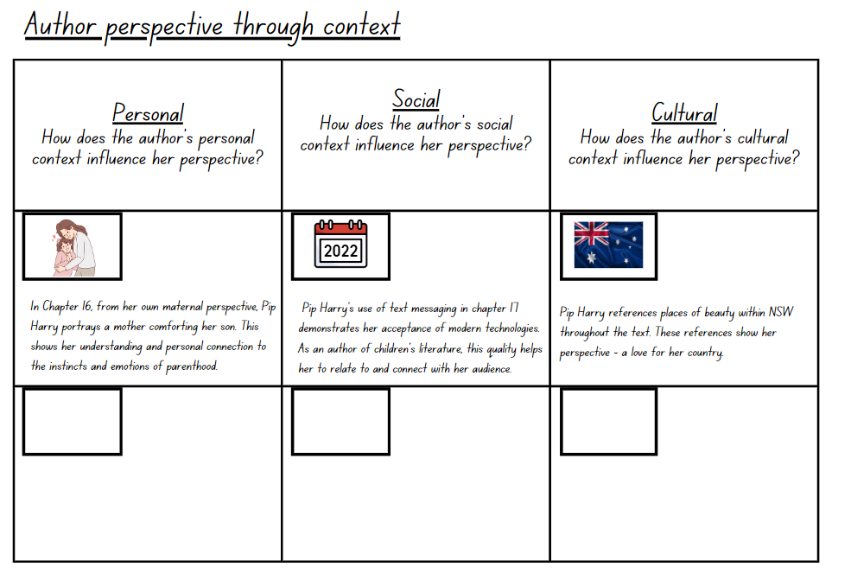

Resource 3 – capturing the heart
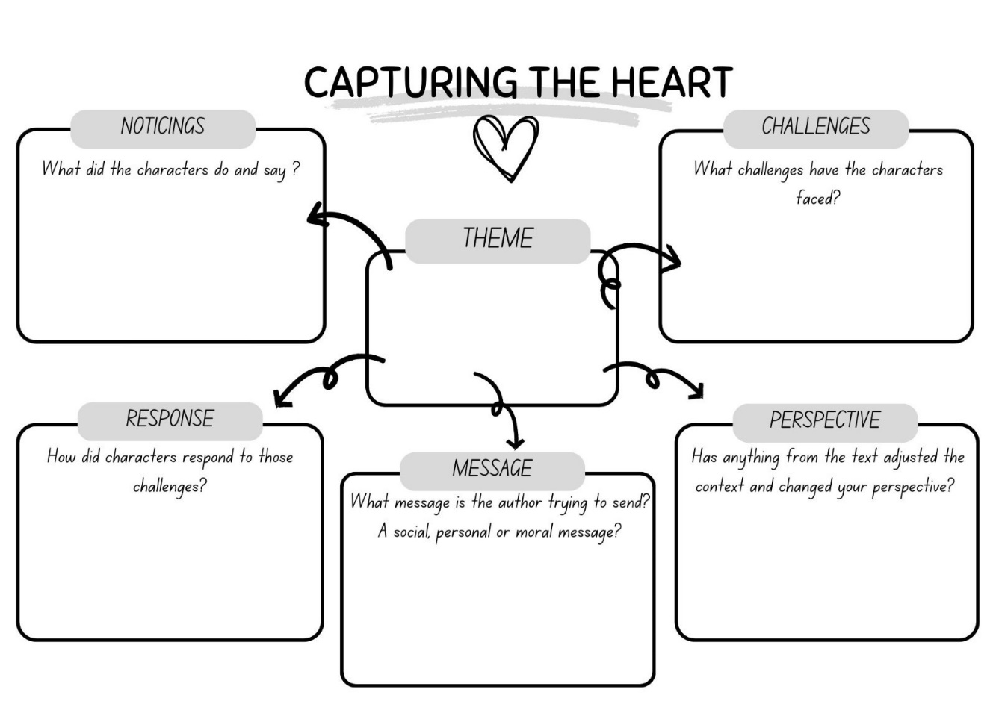

Resource 4 – character roadmap
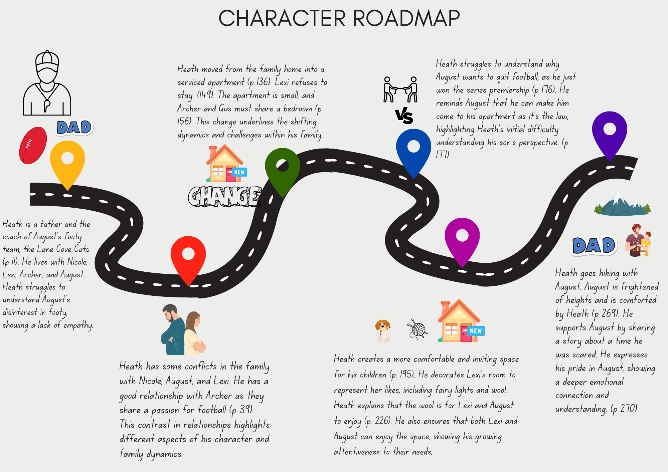

Resource 5 – ask away exemplar
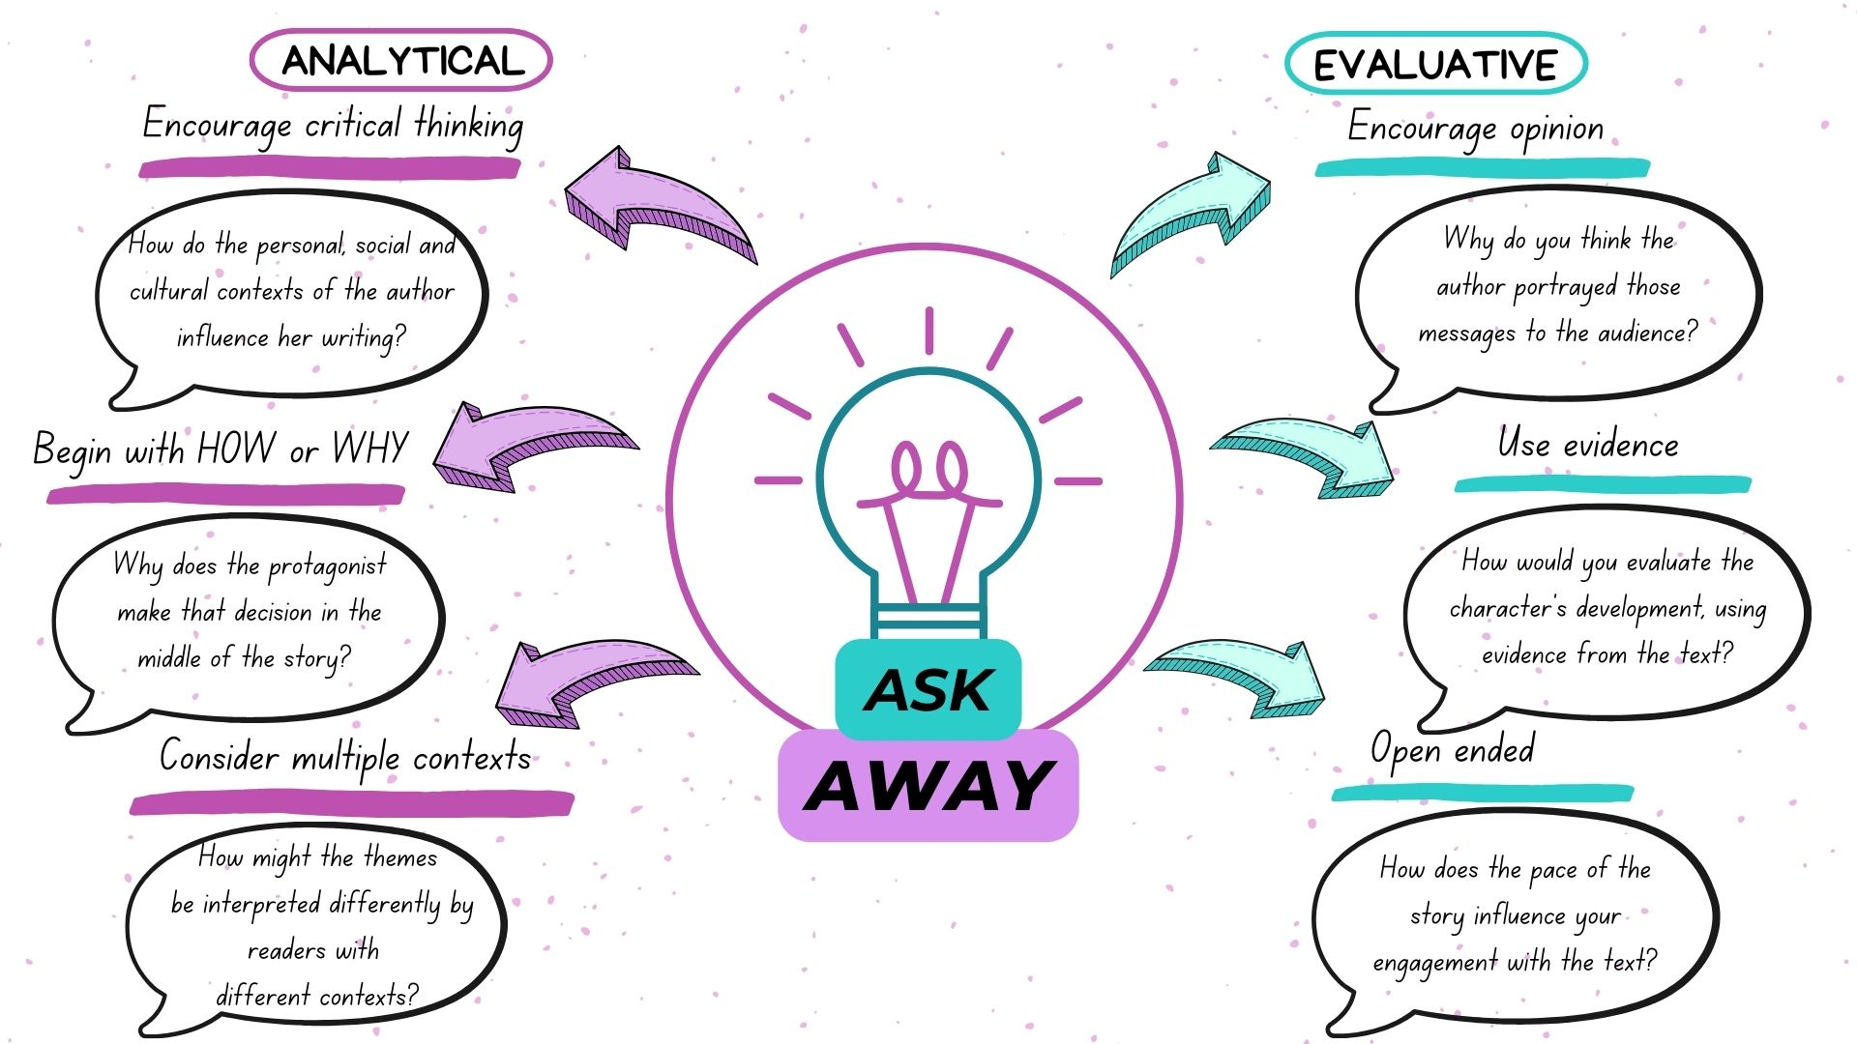

Resource 6 – ask away template
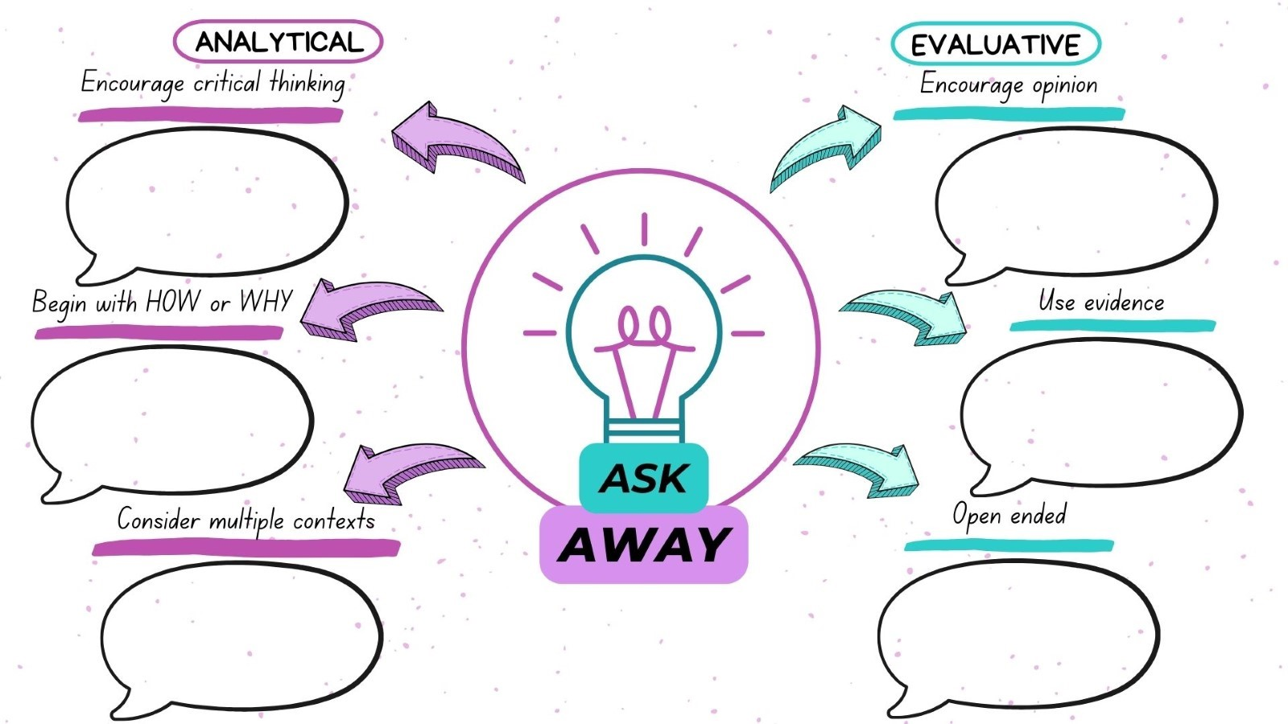

Resource 7 – poetry examples
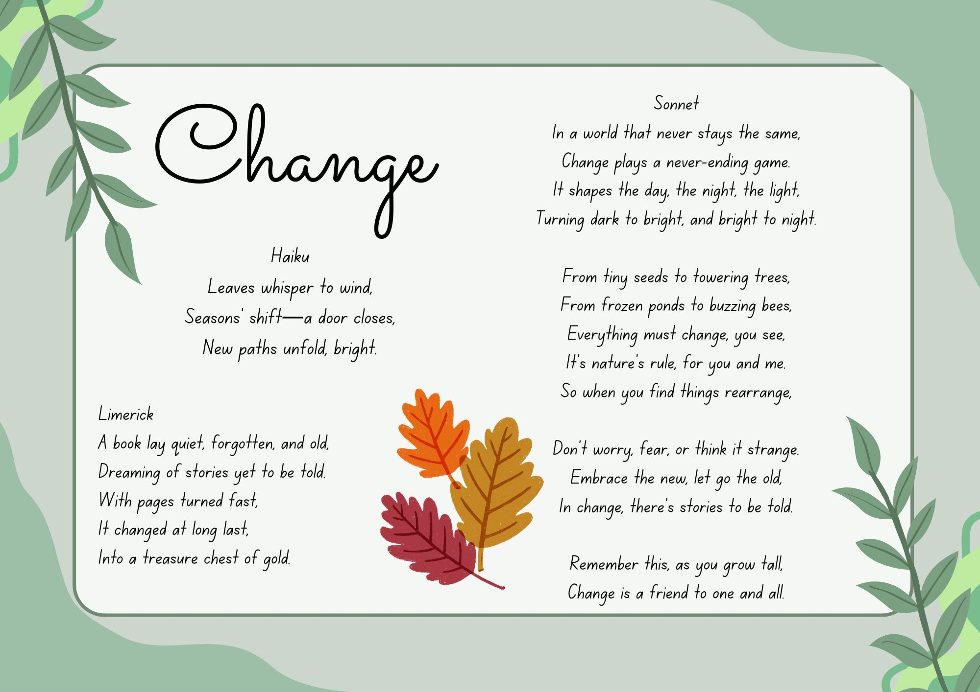

Resource 8 – the writing process
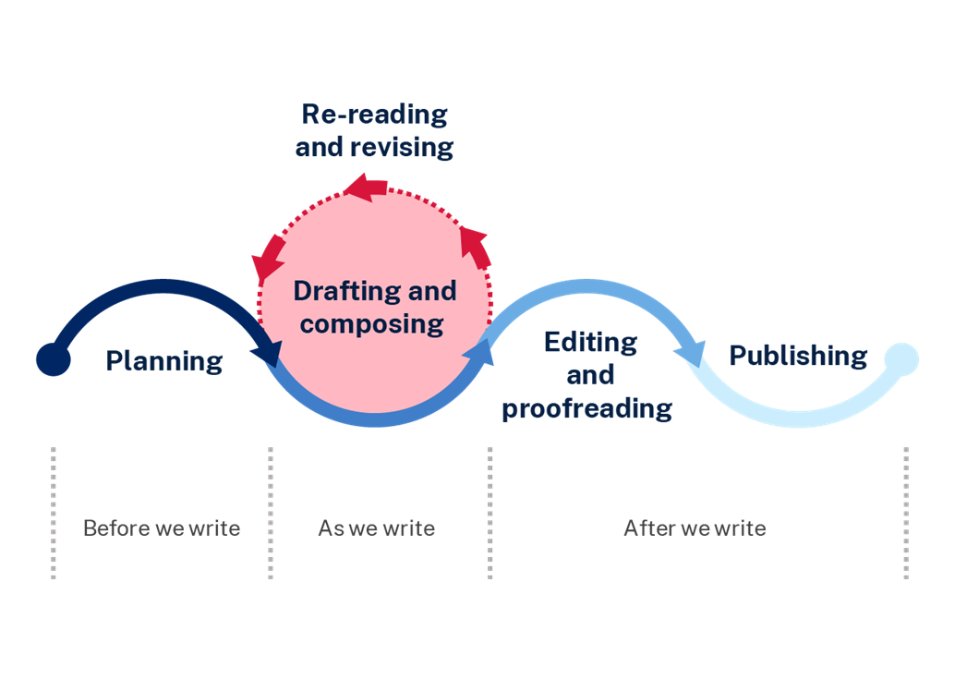

Resource 9 – blog post plan
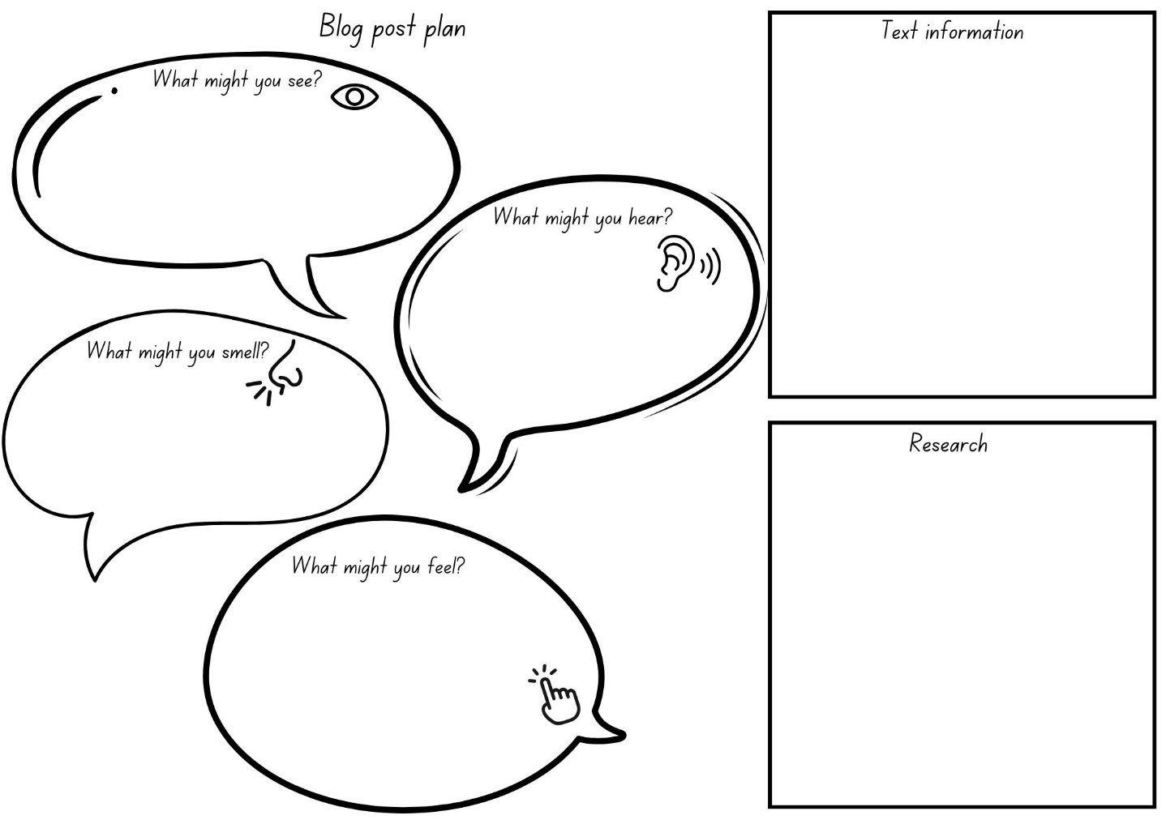

Resource 10 – blog post exemplar
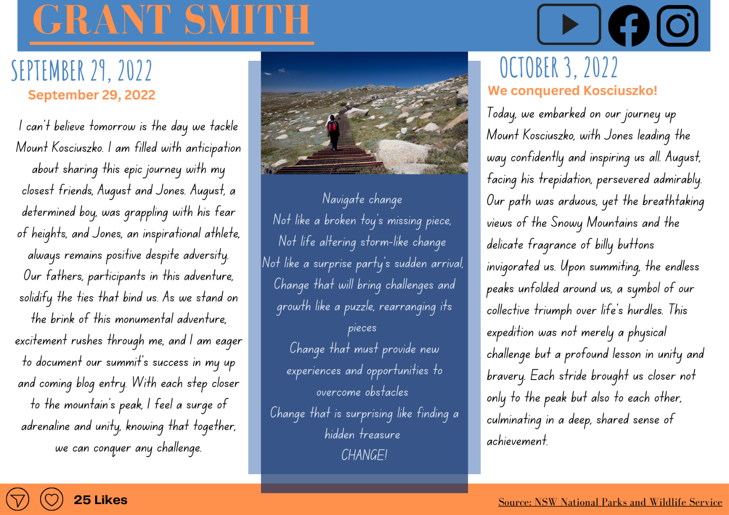

References
This resource contains NSW Curriculum and syllabus content. The NSW Curriculum is developed by the NSW Education Standards Authority. This content is prepared by NESA for and on behalf of the Crown in right of the State of New South Wales. The material is protected by Crown copyright.
Please refer to the NESA Copyright Disclaimer for more information https://educationstandards.nsw.edu.au/wps/portal/nesa/mini-footer/copyright.
NESA holds the only official and up-to-date versions of the NSW Curriculum and syllabus documents. Please visit the NSW Education Standards Authority (NESA) website https://educationstandards.nsw.edu.au/wps/portal/nesa/home and the NSW Curriculum website https://curriculum.nsw.edu.au.
English K–10 Syllabus © NSW Education Standards Authority (NESA) for and on behalf of the Crown in right of the State of New South Wales, 2022.
National Literacy Learning Progression © Australian Curriculum, Assessment and Reporting Authority (ACARA) 2010 to present, unless otherwise indicated. This material was downloaded from the Australian Curriculum website (National Literacy Learning Progression) (accessed 11 September 2023) and was not modified.
Children’s Book Council of Australia & ATYP (21 August 2023) 'CBCA/ATYP Pip Harry Interview' [video], Children’s Book Council of Australia, YouTube, accessed 5 September 2023.
Harry P (2022) August & Jones, Lothian Children’s Books, Melbourne.
Jessica Watson (9 September 2017) ‘Jessica Watson: ‘People assumed I was fearless, that couldn’t be further from the truth’, Jessica Watson (originally on Mamamia), accessed 8 September 2023.
Lawrence S (9 August 2022) ‘Blind teenager's connection with loyal friend inspires children's book by Pip Harry’, ABC Central Victoria, accessed 5 September 2023.
NESA (NSW Education Standards Authority) (2023) ‘Glossary’, Resources, NESA website, accessed 11 September 2023.
NSW National Parks and Wildlife Service (2023) Kosciuszko National Park, NSW National Parks and Wildlife Service website, accessed 8 September 2023.
Pont3 (2023) Sydney Marathon [website], accessed 4 September 2023.
Shakira (4 March 2016) ‘Shakira – Try Everything (Official Video)’ [video], Shakira, YouTube, accessed 5 September 2023.
Walt Disney Records (24 December 2021) ’Jessica Darrow – Surface Pressure (From “Encanto”)’ [video], DisneyMusicVEVO, YouTube, accessed 30 January 2024.

© State of New South Wales (Department of Education), 2024
The copyright material published in this resource is subject to the Copyright Act 1968 (Cth) and is owned by the NSW Department of Education or, where indicated, by a party other than the NSW Department of Education (third-party material).
Copyright material available in this resource and owned by the NSW Department of Education is licensed under a Creative Commons Attribution 4.0 International (CC BY 4.0) license.
This license allows you to share and adapt the material for any purpose, even commercially.
Attribution should be given to © State of New South Wales (Department of Education), 2024.
Material in this resource not available under a Creative Commons license:
- the NSW Department of Education logo, other logos and trademark-protected material
- material owned by a third party that has been reproduced with permission. You will need to obtain permission from the third party to reuse its material.
Links to third-party material and websites
Please note that the provided (reading/viewing material/list/links/texts) are a suggestion only and implies no endorsement, by the New South Wales Department of Education, of any author, publisher, or book title. School principals and teachers are best placed to assess the suitability of resources that would complement the curriculum and reflect the needs and interests of their students.
If you use the links provided in this document to access a third-party's website, you acknowledge that the terms of use, including licence terms set out on the third-party's website apply to the use which may be made of the materials on that third-party website or where permitted by the Copyright Act 1968 (Cth). The department accepts no responsibility for content on third-party websites.

