English Stage 3 First year – Unit 5
Characterisation – August & Jones

Contents
Unit overview and instructions for use 5
Teacher notes 7
Outcomes and content 9
Resources 15
Week 1 17
Component A teaching and learning 17
Planning framework 17
Component B teaching and learning 17
Learning intentions and success criteria 17
Lesson 1 – characterisation of Jones 18
Lesson 2 – characterisation of August 21
Lesson 3 – deepening understanding of characterisation through stereotypes 22
Lesson 4 – applying narrative conventions when creating texts 1 25
Week 2 27
Component A teaching and learning 27
Planning framework 27
Component B teaching and learning 27
Learning intentions and success criteria 27
Lesson 5 – applying narrative conventions when creating texts 2 28
Lesson 6 – developing characterisation through dialogue 30
Lesson 7 – using archetypes to develop characterisation 33
Lesson 8 – analysing characters 35
Week 3 37
Component A teaching and learning 37
Planning framework 37
Component B teaching and learning 37
Learning intentions and success criteria 37
Lesson 9 – characterisation through plot development 1 38
Lesson 10 – characterisation through plot development 2 39
Lesson 11 – use of characterisation when planning a postcard 41
Lesson 12 – use of characterisation when writing a postcard 44
Week 4 47
Component A teaching and learning 47
Planning framework 47
Component B teaching and learning 47
Learning intentions and success criteria 47
Lesson 13 – characterisation through dialogue 48
Lesson 14 – using adverbial clauses to add detail 50
Lesson 15 – research to support final writing task 1 53
Lesson 16 – research to support final writing task 2 56
Week 5 58
Component A teaching and learning 58
Planning framework 58
Component B teaching and learning 58
Learning intentions and success criteria 58
Lesson 17 – final writing task – plan 59
Lesson 18 – final writing task – draft 61
Lesson 19 – final writing task – draft and edit 62
Lesson 20 – final writing task –publish 63
Resource 1 – character grid exemplar 66
Resource 2 – character grid 67
Resource 3 – script 68
Resource 4 – archetypes in August & Jones 69
Resource 5 – character analysis exemplar 70
Resource 6 – character analysis 71
Resource 7 – characterisation through plot development (August) 72
Resource 8 – characterisation through plot development (Jones) 73
Resource 9 – postcard exemplar 74
Resource 10 – research scaffold 75
Resource 11 – exemplar letter 76
Resource 12 – planning scaffold 77
References 78

Unit overview and instructions for use
In this 5-week unit, students will gain a deeper understanding of the textual concepts of characterisation and narrative. Through the text August & Jones, students will explore the development of characters as depicted through their appearance, words, thoughts and actions. They will explore the models of behaviour presented and explore whether characters draw on stereotypes or archetypes. Students will create imaginative texts, drawing on Pip Harry’s characterisation of August & Jones.
Note: August & Jones will also be used as the mentor text in Unit 6.
Outcomes and content in this unit are organised into Component A and Component B. The components are connected, with learning in Component A complementing learning in Component B.
Note: the duration of this unit can be adapted to suit individual school contexts. For example, learning could occur across 5 days rather than 4.
The table below highlights the focus areas and preparation required for Component A and Component B.
Teaching and learning | Component A | Component B
Suggested duration | 60 minutes × 4 days/week or equivalent | 60 minutes × 4 days/week or equivalent
Explicit teaching focus areas | Component A addresses content from the focus areas:  - Vocabulary  - Reading comprehension  - Creating written texts  - Spelling  - Handwriting and digital transcription  It centres on the development of foundational skills and knowledge through regular, systematic and repeated practice. | Component B addresses content from the focus areas:  - Oral language and communication  - Vocabulary  - Reading comprehension  - Creating written texts  - Understanding and responding to literature  It centres on the conceptual understandings of English and exemplifies the importance of learning about and enjoying literature through the study of quality texts.
Preparing for teaching and learning | - Specific teaching and learning activities need to be developed by the teacher. When planning for these activities, please refer to the Component A outcomes and content, teaching guides and planning frameworks.  - Plan and document how you will sequence teaching and learning in whole-class and targeted-groups across the 5-week cycle as required. This should be based on student needs identified through ongoing assessment data. | - Familiarise yourself with the mentor and supporting texts and textual concepts, and the teaching and learning sequence.  - Determine how you will support students in whole-class and targeted-groups across the 5-week cycle as required. This should be based on student needs identified through ongoing assessment data.
English K–10 Syllabus © NSW Education Standards Authority (NESA) for and on behalf of the Crown in right of the State of New South Wales, 2022.

Teacher notes
- Characterisation is the technical construction and representation of any personality or person-like figure in text, including features such as their appearance, actions, words or thoughts (NESA 2024).
- Understanding of characterisation can be supported through watching the department’s video: Character (2:31).
- While ‘characterisation’ is the mentor concept for the conceptual component of this unit, the supporting concept of ‘narrative’ is explored within the relevant sections of the mentor text, August & Jones by Pip Harry. For information on characterisation and narrative, refer to the NESA Glossary.
- When discussing the information about Jones’ experience with cancer as a young child, approach the topic with compassion and awareness. Students might have personal experiences or strong emotions related to cancer. Create a safe and respectful space for discussion, allowing for sharing thoughts and feelings, while providing factual information to clarify understanding. Some students might require access to additional support resources.
- Further support and advice when referring to people living with cancer can be accessed via About cancer | Cancer Institute NSW. When writing or speaking about cancer, supportive language can be accessed via Writing about cancer guidelines | Cancer Institute NSW.
- In addition to the resources listed, students will require access to short passages of the mentor and/or supporting texts. Teachers can copy extracts from texts in reliance on the Statutory Text and Artistic Works Licence. Teachers need to attribute the extracts and include the following notice: ‘This material has been copied [and communicated to you] in accordance with the statutory licence in section 113P of the Copyright Act. Any further reproduction or communication of this material by you may be the subject of copyright protection under the Act. Do not remove this notice’.
- Consider students’ prior knowledge of grammar and literary devices to maintain correct noun-pronoun agreement, subject-verb consistency and use of various connectives for text cohesion. Encourage experimentation with figurative language, including metaphors, hyperboles and oxymorons to enhance writing engagement and effectiveness.
- Reflect on student learning and engagement in activities and record differentiation and adjustments within the unit to inform future teaching and learning. One way of doing this could be to add comments to the digital file.
- In NSW classrooms there is a diverse range of students including Aboriginal and/or Torres Strait Islander students, students learning English as an additional language or dialect, high potential and gifted students and students with disability. Some students may identify with more than one of these groups, or possibly all of them. Refer to Curriculum planning for every student – advice for further information.
- Content points are linked to the National Literacy Learning Progression (version 3).
Levels and indicators sourced from National Literacy Learning Progression © Australian Curriculum, Assessment and Reporting Authority (ACARA), (accessed 11 September 2023) and was not modified. See references for more information.

Outcomes and content
The table below outlines the outcomes and content for this unit. The letters ‘A’ and ‘B’ in the header refer to Components A and B. The numbers 1 to 5 refer to weeks. The use of ‘x’ in these columns indicates where the content points are intended to be addressed and in which week.
Focus area and outcome, content points and National Literacy Learning Progression | A | B | 1 | 2 | 3 | 4 | 5
Oral language and communication
EN3-OLC-01 communicates to wide audiences with social and cultural awareness, by interacting and presenting, and by analysing and evaluating for understanding
- Follow agreed-upon protocols and define individual roles as needed for in-person or online interactions, establishing specific goals, criteria or timeframes (LiS6) |  | x | x | x | x | x | x
- Apply active listening strategies by retelling or repeating what another person has expressed and by building on what has been said (InT5, InT6) |  | x | x |  | x | x | x
- Reflect on and monitor own and peer presentations according to given criteria |  | x |  | x |  |  | x
Vocabulary
EN3-VOCAB-01 extends Tier 2 and Tier 3 vocabulary through interacting, wide reading and writing, morphological analysis and generating precise definitions for specific contexts
- Identify newly encountered words from interactions and wide reading, and use them in writing, discussions and presentations | x | x | x | x | x | x | x
- Use metalanguage when discussing language features encountered in texts (UnT9, CrT9) |  | x | x | x | x
- Describe multiple meanings of words, including their metaphorical uses (UnT8) | x | x | x | x | x
- Analyse morphemic structures of Tier 2 and Tier 3 words to determine their meaning (SpG10, SpG11) | x |  |  |  | x | x | x
Reading comprehension
EN3-RECOM-01 fluently reads and comprehends texts for wide purposes, analysing text structures and language, and by monitoring comprehension
- Adjust reading rate to suit the purpose for reading and the complexity of the text (FlY6) | x |  | x | x | x | x
- Bring subject vocabulary, technical vocabulary, background knowledge and conceptual knowledge to new reading tasks (UnT8) | x | x | x | x | x | x
- Describe how own mental model is adjusted as new words and information deepen understanding during reading |  | x | x | x | x
- Analyse how the meanings of key words and phrases in sentences and across a text support local and global inferencing when reading (UnT8) | x | x | x | x | x | x | x
- Monitor and repair reading when meaning breaks down (UnT9) | x |  | x | x | x | x | x
- Ask questions to clarify thinking, and to provide reasons or evidence (LiS6) |  | x |  |  |  | x | x
Creating written texts
EN3-CWT-01 plans, creates and revises written texts for multiple purposes and audiences through selection of text features, sentence-level grammar, punctuation and word-level language
- Experiment with characterisation (CrT9) |  | x | x | x | x | x | x
- Choose and control narrative voice across a text |  | x | x | x | x | x | x
- Maintain correct noun–pronoun referencing, subject–verb agreement and use temporal, conditional and causal connectives to build cohesive links across a text (GrA5, GrA6, CrT9) |  | x |  | x | x | x | x
- Experiment with figurative language for effect and to engage the reader, including metaphor, hyperbole, oxymoron and allusion (CrT8) |  | x | x | x | x
- Make choices about verbs and verb groups to achieve precision and add detail (GrA6) | x | x | x | x | x | x | x
- Experiment with the placement of adverbial clauses, to modify the meaning or to add detail to a verb or verb group (GrA6) | x | x |  | x | x | x | x
- Use quotation marks consistently across a text to distinguish words that are spoken by characters in dialogue or words authored by others (PuN5, PuN7) | x | x | x | x | x | x | x
- Experiment with dashes and parentheses for humorous or ironic effect |  | x |  |  | x |  | x
- Select and use a range of synonyms in a longer text, for precision and to create variety for reader engagement | x | x | x | x | x
- Re-read, proofread and edit own and other’s writing, and use criteria and goals in response to feedback |  | x | x | x |  |  | x
Spelling
EN3-SPELL-01 automatically applies taught phonological, orthographic and morphological generalisations and strategies when spelling in a range of contexts, and justifies spelling strategies used to spell unfamiliar words
- Segment unfamiliar multisyllabic words into syllables and phonemes as a strategy when spelling | x |  | x | x | x | x | x
- Recognise that the same grapheme can represent different phonemes (SpG10) | x |  | x | x | x | x | x
- Explain the etymology of taught roots and apply this knowledge when creating written texts (SpG10) | x |  |  |  | x | x | x
- Correctly spell taught homophones when creating written texts across a range of writing topics and learning areas (SpG10) | x |  | x | x |  |  | x
Handwriting and digital transcription
EN3-HANDW-01 sustains a legible, fluent and automatic handwriting style
EN3-HANDW-02 selects digital technologies to suit audience and purpose to create texts
- Sustain writing with a legible, fluent and personal handwriting style across a text (HwK8) | x |  |  | x | x | x | x
- Use handwriting efficiently in formal and informal situations (HwK8) | x |  |  | x | x | x | x
- Navigate the keyboard with efficiency and accuracy when typing words, numerals, punctuation and other symbols (HwK8) | x |  |  |  |  | x | x
- Reflect on and monitor typing accuracy and rate according to goals and given criteria | x |  |  |  |  |  | x
Understanding and responding to literature
EN3-UARL-01 analyses representations of ideas in literature through narrative, character, imagery, symbol and connotation, and adapts these representations when creating texts
EN3-UARL-02 analyses representations of ideas in literature through genre and theme that reflect perspective and context, argument and authority, and adapts these representations when creating texts
- Describe how narrative conventions engage the reader through models of behaviour, and apply narrative conventions when creating texts |  | x | x | x | x | x | x
- Recognise how character archetypes and stereotypes are represented in literature |  | x | x | x | x | x | x
- Analyse how engagement with characters within and between texts invites enjoyment of literature |  | x | x | x | x | x
English K–10 Syllabus © NSW Education Standards Authority (NESA) for and on behalf of the Crown in right of the State of New South Wales, 2022.

Resources
The resources in the table below are referred to in this unit. Letters ‘A’ and ‘B’ in the header refer to Component A and B respectively, and the numbers 1 to 5 indicate weeks. The use of ‘x’ in these columns indicates whether the resources are required in Component A, B or both, and in which week.
Resource | A | B | 1 | 2 | 3 | 4 | 5
Harry P (2022) August & Jones, Lothian Children’s Books, Melbourne. ISBN13: 9780734420350 | x | x | x | x | x | x | x
Resource 1 – character grid exemplar |  | x | x
Resource 2 – character grid |  | x | x
Individual whiteboards | x | x | x |  |  | x
Resource 3 – script |  | x |  | x
Resource 4 – archetypes in August & Jones |  | x |  | x
Resource 5 – character analysis exemplar |  | x |  | x
Resource 6 – character analysis |  | x |  | x
Resource 7 – characterisation through plot development (August) |  | x |  |  | x
Resource 8 – characterisation through plot development (Jones) |  | x |  |  | x
Resource 9 – postcard exemplar |  |  |  |  | x
Resource 10 – research scaffold |  |  |  |  |  | x
Resource 11 – exemplar letter |  |  |  |  |  |  | x
Resource 12 – planning scaffold |  |  |  |  |  |  | x

Week 1

Component A teaching and learning
Component A focuses on the development of foundational skills and knowledge through regular, systematic and repeated practice. The mentor and supporting texts used in Component B of this unit can support the effective implementation of Component A teaching and learning.

Planning framework
To plan and document Component A teaching and learning, a planning scaffold (DOCX 228 KB) is provided. To support you in your planning, a link to a detailed example of a one-week teaching and learning cycle is included in the scaffold. Additional resources to support teaching and learning in each focus area can be found at Lesson advice guides.

Component B teaching and learning
The following teaching and learning sequence has been designed to address Component B outcomes and content and develops conceptual understandings of English through the study of quality texts. Adapt the sequence as required to best meet the needs of your students.

Learning intentions and success criteria
Learning intentions and success criteria are best co-constructed with students.

Learning intention
Students are learning to deepen their understanding of characterisation and narrative conventions by analysing characters and exploring settings.

Success criteria
Students can:
- communicate their mental model for August and Jones
- recognise stereotypes represented in literature
- follow discussion protocols and apply active listening strategies
- analyse text and use metalanguage to discuss language features

Lesson 1 – characterisation of Jones
- Display the front cover of the text August & Jones by Pip Harry. Read the blurb on the front cover. Ask:
- What does it mean to be extraordinary?
- How does the author describe the friendship between the characters, August and Jones? What does this tell us about their friendship? For example, the term ‘life-changing’ used by the author communicates that the friendship has significant impact on the character’s lives. Discuss synonyms for the term ‘life-changing’. For example, transformative, profound, important.
- Read aloud the author’s dedication on the inside cover. Highlight the author’s use of the term ‘bucket list’. Ask students what they think they know and understand about its meaning.
- Analyse how the meanings of key words and phrases used, for example, ‘life-changing power of friendship’, ‘extraordinary’ and ‘bucket list’, can support us to make inferences and help the reader to build a mental model of the text. Using these key words and phrases, ask students what they can infer about the characters August and Jones and the narrative plot. Read the blurb on the back cover and prompt students to elaborate on their initial thinking.
- Read aloud Chapter 1 of August & Jones. Draw attention to how the author uses first-person narrative voice and has written the text so that the characters are the narrators of the story. First-person narration allows readers to infer attributes from what the main character says and how others react.
- Re-read and display text excerpt from pages 2 and 3 that starts with ‘I put my palms on the bare walls of my bedroom…’ and ends with ‘...shoved it into the recycling bin’. Provide students with a 3-minute time limit to use the details from the excerpt to visualise and quick-draw the character, Jones. Explain to students that the intention of the drawing is to capture the student’s mental model of Jones at this point of the narrative, rather than the actual drawing.
Note: students will use this drawing in Lesson 8 to reflect on how our engagement with and understanding of characters in narratives develop over time, as authors reveal their appearance, actions, words or thoughts.
- In small groups, students orally share their depiction of the character Jones, explaining key details of their drawing by using evidence from the text. Model how to effectively communicate using active listening strategies such as repeating what another person has expressed and building on what has been said. For example, a student might say ‘I drew cat hair on Jones’ t-shirt due to her owning a Persian longhair cat, Ringo’. Another student might build on this by saying ‘Yes, and she would have held Ringo often. The cat poster on her bedroom wall gives us a clue that she really loves cats.’
- As a class, discuss the characterisation of Jones so far. Consider the significance of the reveal on page 8 about Jones having had cancer. Revise how characters are important because what happens to them and what they do drives the action in a narrative. Explain that our engagement with and understanding of characters in narratives develops over time. In future lessons, students will reflect on their initial impression of Jones.
Characterisation: the technical construction and representation of any personality or person-like figure in text, including features such as their appearance, actions, words or thoughts (NESA 2024).
- Explore expectations students may have of Jones because she has grown up in the country? For example, she is comfortable with animals and the outdoors. She loves wide, open spaces. Ask students to record their expectations around their drawing of Jones from activity 5.
- Guide students to reflect on how Jones’ new life in Sydney may be similar or different to her life in the country and how this might impact her character development. Ask:
- How might daily life be different in the country and the city?
- What things might be the same?
- Can you relate any of your personal experiences to these settings?
- Discuss how our experiences help us to connect with characters. For example, Jones identifies that ‘sometimes the right thing to do is the hardest’. Ask students if they can relate to this statement.
- Reflect on why authors construct characters with qualities that readers believe in and can relate to.

Lesson 2 – characterisation of August
- Ask students to orally summarise the events from Chapter 1 of August & Jones.
- Revise how our engagement with and understanding of characters in narratives develop over time, as authors reveal their appearance, actions, words or thoughts.
- Brainstorm the character attributes of Jones as revealed in Chapter 1.
- Display Resource 1 – character grid exemplar. Review the listed character attributes of Jones and discuss the meaning of each attribute to ensure there is a shared understanding. Review the evidence from the text, as shown on the exemplar, and model gathering and recording further evidence.
- Read Chapter 2, pausing to discuss unfamiliar vocabulary. Vocabulary discussed could be explored further in Component A.
- Re-read and display the excerpt from ‘Like an animal lower down the food chain...’ to ‘...I brace for impact’ (page 14). Ask:
- What does the simile ‘Like an animal lower down the food chain’ mean? What happens to animals lower down the food chain? Why would they try to camouflage themselves?
- How has the phrase ‘brace for impact’ been used metaphorically? What is August ‘bracing’ for?
- Why do authors use figurative language? What impact does it have? For example, it enriches writing by presenting a ‘moment’ in a unique way (McDonald 2023). Figurative language can add to characterisation and enhance the reader’s mental model.
- What does this internal thought reveal about August? For example, he doesn’t want to stand out and doesn’t see himself as popular with his peers. August is accustomed to being targeted by George and Theo.
- Brainstorm the character attributes of August as revealed in Chapter 2.
- In pairs, provide students with a copy of Chapter 2 and Resource 2 – character grid. Students list character attributes for August brainstormed in activity 7, and gather and record supporting evidence from the text.
- Referring to the completed character grids, revise how authors often construct characters with qualities or attributes that readers believe in and can relate to. Explain that this is a feature of realistic fiction. Ask students if they can relate to any of the attributes demonstrated by August or Jones. They might see the attributes within themselves, or within a family member or friend. What actions, thoughts or words demonstrate this attribute?
- Model writing a paragraph to identify attributes(s) of August or Jones that you relate to and include the reasons why. For example:
For an 11-year-old, Jones is very mature. Although she is upset about moving, she recognises that sometimes doing the right thing is hard. Like Jones, I have also demonstrated maturity. My best friend received the school leadership position that I was hoping for. I was upset to miss out on the role but congratulated my friend. Even though it was hard, I tried to be genuinely happy for her because it was the right thing to do.
- Students independently write a paragraph to identify attributes(s) of August or Jones that they relate to and include the reasons why.
- Encourage students to share the connections they’ve made to each character. Reflect on how engaging with a character invites enjoyment of literature.

Lesson 3 – deepening understanding of characterisation through stereotypes
- Explain to students that you will name a familiar person, animal or place. For example, cat, dog, princess, principal, nurse, surf lifesaver, farmer, boy, girl, teenager, Australian, Australia. On mini whiteboards, students record one character attribute, interest or skill that they associate with that name. For example, when the word ‘teenager’ is called out, student responses might include independent, mature, lazy, addicted to social media.
- As students reveal their whiteboards, identify similar responses to explore commonly held beliefs about the person, place or thing. Explain that these commonly held beliefs are known as stereotypes. Stereotypes are a simple representation or generalised belief about a group of people, animal or place. These beliefs centre around specific attributes, interests and skills and are assumed to be true for the entire group. For example, all boys love the colour blue and all girls love pink, every Australian eats Vegemite, all dogs are loyal, friendly and obedient. Although there is usually some truth in a stereotype, the assumption that every individual in the group has the same attribute is incorrect (Stoodt-Hill and Amspaugh-Corson 2009).
- Display the excerpt where August’s dad says ‘Boys need sport. It moulds them into men’ (page 16). Ask:
- What generalised belief does August’s dad hold about boys? For example, they need to play sport, and this makes them men.
- What makes this generalised belief a stereotype? For example, it is a belief assumed to be true for all boys.
- Explain that students will engage in a Socratic seminar to discuss the stereotype presented in the statement from activity 3. Introduce the specific protocols for a Socratic seminar [DOCX 93 KB]. This form of structured discussion requires students to fulfil set roles and effectively communicate through active listening, eye contact and turn-taking. Students need to think critically about the question posed, and about the quality of discussion. Facilitate a Socratic seminar. Questions posed may include:
- What makes it a stereotype? For example, it is a belief assumed to be true for all boys.
- Is this an accurate representation of all boys? Why or why not? For example, this is not an accurate representation of all boys. Not all boys need or like sport. Not all men play sport. You do not need to play sport to be a man. Boys and/or men are a diverse group with diverse interests, skills and attributes. What this group have in common is that they are boys and/or men. It doesn’t mean they all have the same shared interests, skills or attributes. These do not define them as boys or men.
- Why is this stereotype problematic? For example, it ignores the diversity within groups of people. While the stereotype may be true for some people, we can’t assume it is true for all. It can be used to make a judgement about people and may be disrespectful to people for whom this belief isn’t true.
- Why might August’s dad hold this stereotype? For example, this stereotype may have been passed on from his parents, it is a common stereotype seen in books, movies or television shows, sport is important for physical health and the belief that strong men are physically healthy.
Note: Socratic seminars are a student-driven discussion routine, with minimal teacher intervention. However, if this is a new routine for students, explicit modelling of protocols will be needed to enhance the quality of the discussion.
- Guide students to reflect on what they now know and understand about stereotypes. Highlight how stereotypical characters are those whose attributes are simplified. Discuss why authors use stereotypes to create characters. For example, typical stereotypes are a common convention of narratives. Readers immediately recognise their character attributes and their purpose, without needing to provide too much detail or ‘backstory’.
- Ask students to identify other stereotypes presented in the text so far. For example, Theo and George present as the stereotypical bully, Archer presents as the stereotypical popular kid because he is good at sport, August’s dad presents as the intense and highly competitive coach/father who shouts at kids from the sideline.
- Students complete an exit ticket using the routine ‘I used to think... Now I think...’ to reflect on new learning about stereotypes.

Lesson 4 – applying narrative conventions when creating texts 1
- Read Chapter 3 of August & Jones. Draw attention to the author’s use of first-person narrative voice, alternating between the text’s protagonists August and Jones. Revise how first-person narration allows the reader to infer attributes from what the main character says and how others react.
- Explore how authors use narrative conventions, such as setting and descriptive language to engage readers. Display and re-read the text excerpt beginning from ‘On the small balcony...’ to ‘...smelly apartment and noisy trains’ (pp 21–22). Provide time for students to consider what makes this an effective description.
- Guide students to analyse and annotate the text excerpt, using metalanguage to identify the language features and discuss how they contribute to the creation of an effective descriptive setting. For example, Pip Harry uses:
- Sensory details: ‘two butcherbirds...singing to each other’, ‘streaks of lemon yellow, burnt orange and grapefruit pink splashed across the sky’
- Figurative language: ‘dirty undercooked sunset’ (metaphor), ‘the golden fire that lights up the paddock back home’ (metaphor), ‘the streetlights blink on’ (personification)
- Precise vocabulary: ooze (verb), plonk (verb), perch (verb), dips (verb), splashed (verb), sliver (adjective), winter (adjective), golden (adjective), noisy (adjective)
- Contrast: ‘dirty undercooked sunset’ (city) compared to ‘golden fire that lights up the paddocks back home...’ (country).
- Discuss how the rich use of language features evoke the senses and assist in shaping a reader’s mental model.
Mental model: a mental representation of the information in a real or an imaginary world. A student develops a mental model as the text progresses. It may include information derived from inferences and from background knowledge as well as from what is explicitly stated in the text itself (NESA 2024).
- Students will write a paragraph to describe a setting of their choice using descriptive language that evokes the senses. The place should be familiar to students and should elicit an emotional response. For example, theme park or playground, grandparents’ house, national park, veterinary clinic.
- Co-construct a success criteria for a paragraph that describes a setting:
- use and control first-person narrative voice
- include figurative language (metaphor, personification, hyperbole)
- select precise vocabulary for precision and to add detail (verbs, adjectives, adverbs).
- Use the example of Jones’ apartment to model how to use a Y-chart to describe how a setting looks, feels and sounds.
- Provide students with a Y-chart. Students brainstorm and record ideas for describing how their chosen setting looks, feels and sounds. Encourage students to use language features that evoke the senses and assist in building a reader’s mental model.
- In pairs, students share their Y-charts and provide feedback based on the success criteria.
Note: students will use their Y-chart planning to create a descriptive text in Lesson 5.

Week 2

Component A teaching and learning
Component A focuses on the development of foundational skills and knowledge through regular, systematic and repeated practice. The mentor and supporting texts used in Component B of this unit can support the effective implementation of Component A teaching and learning.

Planning framework
To plan and document Component A teaching and learning, a planning scaffold (DOCX 228 KB) is provided. To support you in your planning, a link to a detailed example of a one-week teaching and learning cycle is included in the scaffold. Additional resources to support teaching and learning in each focus area can be found at Lesson advice guides.

Component B teaching and learning
The following teaching and learning sequence has been designed to address Component B outcomes and content and develops conceptual understandings of English through the study of quality texts. Adapt the sequence as required to best meet the needs of your students.

Learning intentions and success criteria
Learning intentions and success criteria are best co-constructed with students.

Learning intention
Students are learning to develop a deeper understanding of narrative conventions including characterisation.

Success criteria
Students can:
- experiment with figurative language and precise vocabulary, including synonyms
- identify and use dialogue as a strategy for developing characterisation
- recognise stereotypes and archetypes in literature
- analyse how the meaning of key words and phrases support inferencing
- describe how our own mental model is adjusted through new words and information.

Lesson 5 – applying narrative conventions when creating texts 2
- Revise how authors use narrative conventions, such as creating descriptive settings which evoke the senses, to engage readers. Review the text excerpt from Lesson 4, highlighting the author’s use of language features such as sensory details, figurative language, precise vocabulary and contrast, and how they contribute to the creation of an effective setting.
- Model using the completed Y-chart and success criteria from Lesson 4 to write a paragraph describing Jones’ apartment. For example:
Unlike the 15-minute walk to the farm’s back paddock, the grand tour of our cramped apartment takes a total of 3 minutes. The smell of fake lavender mixed with disinfectant and boiled vegetables reminds me of Grandma Pat’s room at Green Acre nursing home. I throw open the doors to the small balcony, as the afternoon train screeches past. The building vibrates and I’m worried the windowpanes might break. A wave of homesickness hits me with such force that I plonk down onto the dusty camping chair. I close my eyes and reminisce about my friends and the golden fire that lights up the paddocks back at the farm each evening.
- Use the success criteria to deconstruct the exemplar text. Highlight:
- language used when writing using first-person narrative voice – our, I, me, my
- the intentional use of sensory details to structure the paragraph – identifies place, describes how it smells, how it sounds, and the physical and emotional feelings that the place evokes
- figurative language – ‘a wave of homesickness’, ‘golden fire that lights up the paddocks’
- precise vocabulary – cramped, fake, boiled, screeches, vibrates, reminisce.
- Students use their completed Y-chart to write a paragraph describing their chosen setting. Prompt students to refer to the co-constructed success criteria as they write.
Too hard? Support students in selecting and ordering details from their Y-chart for use in writing.
- Using the exemplar paragraph from activity 2, review the precise vocabulary used. As introduced in Component A, model selecting words where synonyms could be used to add further precision or variety. For example, small, worried. Demonstrate replacing selected words using a thesaurus.
- Students re-read, proofread and edit their writing using the success criteria. Encourage students to identify and replace words where synonyms could be used to add further precision or variety.
- In small groups, students share their descriptive paragraphs. Prompt them to use metalanguage to discuss the language features that contribute to the development of their mental model.
Assessment task 1 – observations from this lesson allow students to demonstrate achievement towards the following syllabus outcome and content point:
EN3-VOCAB-01 – extends Tier 2 and Tier 3 vocabulary through interacting, wide reading and writing, morphological analysis and generating precise definitions for specific contexts
- use metalanguage when discussing language features encountered in texts.

Lesson 6 – developing characterisation through dialogue
- Briefly recall the key details of August & Jones so far. Read Chapter 4.
- Explore how authors use dialogue to develop characterisation. A character’s attributes can be revealed through conversation with another character. Reflect on the conversations in Chapter 4 between August and Lexi, and August and Dad. Ask what is revealed about August, Lexi and Dad through this dialogue.
- Provide students with Resource 3 – script. In groups of 3, students are assigned the role of a character from Chapter 4. Students perform the dialogue and experiment with how voice, gesture and actions support inference and contribute to meaning.
- Students perform the dialogue for another group. Students reflect on how voice, gesture and actions support inference and contribute to meaning. For example, Dad’s tone of voice shows that he is judgemental of boys knitting, Lexi’s gestures reveal her care and encouragement of August.
- As a class, discuss what the dialogue reveals about the family dynamic and the relationship between August’s family members. Use a concept map and model creating a sociogram to visually record these explanations. This sociogram will be revisited in Lesson 7 and updated throughout the unit as the relationships between characters develop. For example, August is worried about Dad knowing he prefers knitting to AFL, and he thinks Dad isn’t proud of him. Dad is frustrated that August doesn’t show an interest in AFL like his brother. Lexi cares for and is protective of August.
- Optional: the sociogram could also be used to develop a classroom display that is added to throughout the unit.
- Display and re-read the text excerpt from ‘Get your boots on...’ to ‘...Dad reminds me of it every single week’ (p 27). Revise the conventions of dialogue within a narrative, including:
- combination of dialogue and narration
- quotation marks to distinguish words that are spoken
- capitalising the first word of the spoken text
- starting a new line every time the speaker changes
- correct use of noun-pronoun referencing
- use of verbs to describe how the text is spoken.
- Discuss how this conversation could have changed if August stood up to Dad and decided to remain knitting with Lexi. Model writing a short excerpt of text which includes dialogue between Dad and August. Use think-alouds to annotate the conventions of dialogue used. For example:
“If you’re so bored, you can come to the park with me and Archer and do kicking drills.”
Lexi nudges me, and I gather the courage to speak.
“Not today, Dad. It’s cold out,” I say, my voice trembling.
“Once you’re running, you will be fine. Come on, mate.”
Dad stares at me. He is waiting for me to drop the knitting and get off the couch.
“No, not today,” I say. “Maybe next time.”
- In pairs, students roleplay an alternate ending to the chapter where August stands up to Dad.
- Students write their alternate ending. Students refer to the conventions of dialogue in activity 6 as their success criteria for writing.
- Read Chapter 5. Discuss new information revealed about Jones. For example, her vision is more blurry than usual (p 30). Prompt students to consider the significance of this reveal and how it might drive the action in the narrative.

Lesson 7 – using archetypes to develop characterisation
- Read up until the section break on page 38 in Chapter 6 of August & Jones.
- Display and re-read the text excerpt that starts with ‘The other thing about Jones is that she’s vision impaired…’ to ‘...Occasionally it might fall out, but that’s fine and it doesn’t hurt Jones’ (pp 35–36).
- Identify newly encountered words and phrases from the excerpt and provide opportunity for students to share knowledge of word meaning. For example, vision impaired, retina, retinoblastoma, detects, tumour and prosthetic. Support students to make local inferences in defining newly encountered words, such as retinoblastoma being ‘cancer that grows in the retina’ (p 36). Provide student friendly definitions of these words.
- Re-read and display the excerpt on page 35, ‘The other thing about Jones is that she’s vision impaired’. Ask students to make inferences about the impact Jones’ vision impairment may have on her experiences at school and consider how these inferences adjust their mental model of Jones. For example, the texts she reads in class may need to be bigger, strategic positioning in the classroom to ensure her right side is closest to the board, she may take time off school to attend medical appointments, her other senses might be more enhanced, her vision impairment has minimal impact on her day-to-day life.
- Read the remainder of Chapter 6. Reflect on how the relationship between characters develops characterisation – what they say to each other and how they act towards each other. Discuss what the dialogue between August’s family members further reveals about the family dynamic and how it deepens our understanding of the relationship between the characters.
- Revisit the sociogram from Lesson 6. Model updating the sociogram to include new information about the relationships between August’s family members from Chapter 6. For example, August likes the affection that Mum gives to him, Dad is annoyed that Mum isn’t carrying out household duties like she did in the past. Discuss how the engagement or relationships between characters invites enjoyment of texts. For example, I don’t like the way that Dad is currently treating August or Mum, but I am intrigued to keep reading to see if this relationship changes over time.
- Revise learning about stereotypes from Lesson 3. Remind students that stereotypical characters are those whose attributes are simplified. Ask:
- What attributes might exist for a stereotypical 11-year-old boy?
- What attributes might exist for a stereotypical 11-year-old girl?
- Is August a stereotypical 11-year-old boy? Why or why not? What evidence is there in the text to support your claim?
- Is Jones a stereotypical 11-year-old girl? Why or why not? What evidence is there in the text to support your claim?
- Discuss how Pip Harry has given August and Jones unique character traits which contrast each other.
- Introduce the word ‘archetype’ to students and explain that an archetype is a character that represents a universal model of behaviour that can be identified in characters across literature, film and storytelling. For example, the hero, the villain, the outcast or the mentor. As a class, brainstorm characters from literature, film and storytelling that fit each of these archetypes, such as Roz from The Wild Robot (hero), Scar from The Lion King (villain), Augie from Wonder (outcast) or Dumbledore from Harry Potter (mentor). Similar to the use of stereotypes, authors might use archetypes so readers can understand the character’s role or purpose in a narrative. However, archetypal characters generally tend to be more complex than stereotypical characters.
Too easy? Introduce a broader range of archetypes to students, such as the sidekick, rebel, underdog, explorer.
- In small groups, students discuss whether any of the characters in August & Jones represent a universal model of behaviour (archetype). On Resource 4 – archetypes in August & Jones, students should record the character’s name, archetype presented, evidence behind this archetype and other known characters who fit this model of behaviour. For example, Lexi is an archetypal caregiver. She shows care and concern for August by encouraging him to stand up for what he wants by quitting AFL. She also provides comfort during challenging times, like when Mum and Dad are fighting. Other characters who fit this model of behaviour include, Auggie’s sister Via and his mother Isabel in Wonder, and Marlin from Finding Nemo.
- Invite students to share their responses with the class.
Note: students may identify stereotypical characters as being archetypal. For example, Theo and George. Remind students that archetypal characters generally tend to be more complex than stereotypical characters, with authors spending more time on their character development.
Assessment task 2 – observations from this lesson allow students to demonstrate achievement towards the following syllabus outcome and content points:
EN3-RECOM-01 – fluently reads and comprehends texts for wide purposes, analysing text structures and language, and by monitoring comprehension
- analyse how the meanings of key words and phrases in sentences and across a text support local and global inferencing when reading
- bring subject vocabulary, technical vocabulary, background knowledge and conceptual knowledge to new reading tasks.

Lesson 8 – analysing characters
- Revise learning about archetypes from Lesson 7 and co-construct a student-friendly definition of an archetype. For example, an archetype is a character that presents a familiar model of behaviour such as the hero, the villain, the outcast or the mentor.
- Review how authors use archetypes to develop characterisation. Archetypes support readers to understand the character’s role or purpose in a narrative. Use Resource 5 – character analysis exemplar to model how characterisation is developed through the character’s actions, thoughts, motivation, dialogue, relationships with other characters, character attributes, conflict.
- Explain that a narrative convention is the inclusion of protagonists (main characters) who drive the plot forward and antagonists who oppose the protagonist. For example, August is a protagonist, and his father is an antagonist.
- Read Chapter 7 of August & Jones.
- Provide students with a copy of Resource 6 – character analysis. Students analyse the character of Jones and her experience of starting at a new school. They use evidence from the text to identify how characterisation has been developed.
- Students refer to their drawing of Jones from Lesson 1. Prompt them to reflect on how their mental model of Jones has developed through the different strategies the author has used to develop characterisation. Students update and elaborate on their drawing to reflect their adjusted mental model.
- As a class or in small groups, students refer to the updated drawing of Jones to discuss how they have adjusted their mental model of her character.

Week 3

Component A teaching and learning
Component A focuses on the development of foundational skills and knowledge through regular, systematic and repeated practice. The mentor and supporting texts used in Component B of this unit can support the effective implementation of Component A teaching and learning.

Planning framework
To plan and document Component A teaching and learning, a planning scaffold (DOCX 228 KB) is provided. To support you in your planning, a link to a detailed example of a one-week teaching and learning cycle is included in the scaffold. Additional resources to support teaching and learning in each focus area can be found at Lesson advice guides.

Component B teaching and learning
The following teaching and learning sequence has been designed to address Component B outcomes and content and develops conceptual understandings of English through the study of quality texts. Adapt the sequence as required to best meet the needs of your students.

Learning intentions and success criteria
Learning intentions and success criteria are best co-constructed with students.

Learning intention
Students are learning to experiment with characterisation when creating written texts to engage readers.

Success criteria
Students can:
- examine how characterisation is enhanced through plot development
- explain how characters’ behaviours follow or challenge archetypes
- identify and describe narrative conventions that engage readers
- use first-person narrative voice, maintaining correct subject–verb agreement and correct noun–pronoun referencing
- experiment with figurative language in writing for effect

Lesson 9 – characterisation through plot development 1
- Ask students to consider a narrative they have read that has been engaging. Students turn and talk to identify the narrative and how the author made it engaging. As a class, students share their thinking by repeating what their partner expressed. For example, relatable characters that students empathise with, characters that inspire and motivate, interesting and unpredictable plot, moral or inspirational lessons learned, figurative language that appeals to the senses and develops imagery.
- Model using metalanguage to discuss the conventions of an engaging narrative. Explain that narrative conventions support authors to craft and structure stories effectively so that readers are engaged. For example, narrative conventions such as setting, plot development, challenges or conflict, characterisation, dialogue and point of view.
- Revise how August & Jones has a parallel plot where 2 stories are told simultaneously to show different characters’ point of view. Explain how the plot develops gradually through a logical sequence of major and minor events. This sequence is driven by the experiences of the characters.
- Read Chapter 8 of the text August & Jones. Explore how the author’s use of first-person narrative voice allows the action and dialogue of the narrative to unfold, while sharing the character’s inner thoughts and feelings.
- Use Resource 7 – characterisation through plot development (August) and evidence from the text to examine the events of Chapter 8 and how the author further develops August’s character. For the sequence of events, model and co-construct identifying the character attributes shown by August and select supporting evidence from the text.
- Display the text excerpt from ‘I speed up and down the dirt bumps...’ to ‘I think about next Friday’s playdate with Jones’ (pp 68–69). Students use information from the excerpt to independently complete the remainder of Resource 7 – characterisation through plot development (August).
- Revise how authors use archetypes to develop characterisation. Archetypes support readers to understand the character’s role or purpose in a narrative. Reflect on the character development of August in this chapter. Use Resource 7 – characterisation through plot development (August) to discuss how August’s thoughts, actions and words conform with or challenge the archetype (universal model of behaviour) of outcast.

Lesson 10 – characterisation through plot development 2
- Review how Pip Harry’s use of first-person narrative voice in August & Jones allows the action and dialogue of the narrative to unfold, while sharing the character’s inner thoughts and feelings.
- Read Chapter 9 of August & Jones. Ask:
- What does Chapter 9 reveal about both August’s mum and Jones’ mum? For example, August’s mum is worn-down by her arguments with August’s dad. She thinks it is easier for August to stop knitting, rather than reasoning with Dad. Jones’ mum is lonely and trying to make friends in a new place.
- What stereotypes does each mother represent? For example, Jones’ mum bakes award-winning scones and is setting up for afternoon tea. August’s mum is ‘too busy’ to stay for a ‘quick cuppa’.
- Why might Pip Harry use these stereotypes? For example, readers immediately recognise their character attributes and their purpose, without needing to provide too much detail or ‘backstory’.
- Consider the sentences: ‘These are the painstaking work of ocularists. Moulded to fit my eye socket precisely. They’re works of art’ (p 76). What can we infer about the meaning of the word ‘ocularist’?
- How might this chapter have changed if it was told in third-person narrative voice? For example, ‘Jones sat at the newly assembled dining table, drawing’ rather than ‘I’m sitting at our newly assembled dining table, drawing.’ Ask if readers would have connected to the characters as strongly or developed the empathy towards them and their experiences if written in third-person narrative voice.
- Provide students with a copy of Resource 8 – characterisation through plot development (Jones) and text excerpt from ‘After we eat two warm scones each...’ to ‘...August’s rainbow scarf is nearly finished’ (pp 75–79). Students use evidence from the text to examine the events of Chapter 9 and how the author further develops Jones’ character.
- As a class, share students’ conclusions. Use Resource 8 – characterisation through plot development (Jones) to discuss how Jones’ thoughts, actions and words develop characterisation and how they conform with or challenge the archetype (universal model of behaviour) of hero.
- Students reflect on their understanding about characterisation through plot development. They complete an exit ticket responding to the question prompt: How do Jones’ thoughts, actions and words conform with or challenge the archetype of hero?

Lesson 11 – use of characterisation when planning a postcard
- Display the excerpt from ‘I choose a bright yellow wool...’ to ‘...We could play a board game or watch a movie?’ (pp 78–79). Re-read and identify the figurative language and vocabulary within this short passage. Discuss how these language features enhance the reader’s mental model. For example:
- Simile: ‘the wool is like strands of slippery spaghetti’ – the comparison between wool and spaghetti shows how difficult the wool is to hold
- Hyperbole: ‘I had a million dropped stitches and big hole’ – the exaggeration emphasises the number of mistakes August initially made when he began knitting
- Precise vocabulary: ‘casts on’ (verb), ‘clumsy’ (adjective), aches’ (verb) – vocabulary selected has a precise meaning which supports reader understanding.
Figurative language: word groups/phrases used differently from the expected or everyday usage to express an idea in a non-literal way for a particular effect (NESA 2024).
Hyperbole: an exaggerated statement not intended to be taken literally; may be used as a rhetorical device or figure of speech (NESA 2024).
- Revise that August & Jones is written in first-person narrative voice using present tense. As a class, locate language from the text excerpt in activity 1 that shows Pip Harry’s use of first-person narrative voice. For example, I, me, our, we. Prompt students to consider how the excerpt would change if it was told using third-person narrative voice.
- Annotate the text excerpt to show how pronouns change from first-person to third-person narrative voice, and that verbs may need to change to agree with the subject. For example, ‘I choose’ becomes ‘Jones chooses’. As introduced in Component A, remind students that a consistent narrative voice is a narrative convention that contributes to text cohesion.
- Display the text excerpt from ‘I pick up the knitting...’ to ‘...August’s rainbow scarf is nearly finished’ (p 79). Students rewrite the passage using third-person narrative voice and adjust verbs as needed to ensure correct subject–verb agreement. For example:
Jones picks up the knitting. This time, August talks her through the stitches and she uses his voice to guide her fingers, instead of her sight.
“Like this?” Jones asks, pulling a loop through cleanly.
“That’s it!” replies August.
After a while, Jones starts to get the hang of it and does a whole row by herself. By the time August’s mum comes to pick him up, Jones has a square of bright yellow knitting and August’s rainbow scarf is nearly finished.
- Guide students to reflect and annotate on their writing from activity 4, highlighting:
- conventions of dialogue used
- correct noun–pronoun referencing. Consider impact of using third-person rather than first-person narrative voice. For example, first-person narrative voice allows the character (acting as narrator) to tell the reader directly what they are thinking and feeling which enhances the connection between the character and reader. With third-person narrative voice, the narrator indirectly reveals the thoughts and feelings of all the characters and explains their significance to the reader
- need to change verbs so they ‘agree’ with the subject. For example, ‘After a while, I start to get the hang of it...’ becomes ‘After a while, Jones starts to get the hang of it...’
- use of temporal connectives to build cohesion. For example, this time, after a while, by the time.
- Explain to students that they will apply their knowledge of the characterisation of Jones to write a postcard. The postcard will be written to her friend Hannah or Taylor, and describe her experiences, thoughts and feelings since the move to Sydney.
- Co-construct a success criteria for writing. For example:
- use first-person narrative voice
- maintain correct subject–verb agreement
- use correct noun–pronoun referencing
- use dashes or parentheses for humorous or ironic effect
- include figurative language and precise vocabulary, including verbs.
- Display Resource 9 – postcard exemplar. Read and deconstruct using the success criteria from activity 7.
- Brainstorm ideas for writing a postcard from Jones to her friend Hannah or Taylor. The postcard will include information about Jones’ experiences, thoughts and feelings since the move to Sydney. This brainstorming will be referred to in Lesson 12.
Too hard? Students continue writing the teacher modelled conversation.

Lesson 12 – use of characterisation when writing a postcard
- Read Chapter 10 of August & Jones. As you read, ask students to listen for examples of figurative language. For example:
- ‘Dad leans into the photographer’s ear and points me out of the line-up like a criminal’ (p 81) (simile)
- ‘This is pole position...I don’t deserve to be front and centre and everyone knows it’ (p 81) (metaphor)
- ‘Parents cradle hot coffees’ (p82) (personification)
- ‘I see him every day, but he feels like a stranger most of the time’ (p87) (simile)
- ‘“Soft as butter,” Dad scoffs’ (p 87) (simile)
- ‘I wonder if I should’ve stayed...even if it meant getting hypothermia’ (pp 87–88) (hyperbole).
- For each example of figurative language identified, explore the meaning and discuss how it enhances the reader’s mental model.
- Display Resource 9 – postcard exemplar and the success criteria from Lesson 11. Review the writing task set, where students will apply their knowledge of the characterisation of Jones to write a postcard. The postcard will be written to Jones’ friend Hannah or Taylor, and describes her experiences, thoughts and feelings since the move to Sydney.
- Students use the success criteria and brainstormed ideas from Lesson 11 to independently write a postcard to Hannah or Taylor from Jones’ point of view.
- Optional: students use a digital tool to create their postcard, such as Canva for Education.
Too hard? Co-construct a simplified postcard from Jones to a friend, providing sentence starters as a scaffold for writing.
Too easy? Students experiment with a broader range of figurative language to engage the reader.
- Using Resource 9 – postcard exemplar, review the precise vocabulary used. Model selecting words where synonyms could be used to add further precision or variety. For example, so bad, fell. Demonstrate replacing selected words using a thesaurus.
- Students re-read, proofread and edit their writing using the success criteria. Encourage students to identify and replace words where synonyms could be used to add further precision or variety.
- In pairs, students share their postcards. They receive feedback based on the success criteria and apply to their writing.
- Reflecting on their postcards, students explain how they used Pip Harry’s characterisation of Jones within their writing.
Assessment task 3 – observations and work samples from this lesson allow students to demonstrate achievement towards the following syllabus outcomes and content points:
EN3-VOCAB-01 – extends Tier 2 and Tier 3 vocabulary through interacting, wide reading and writing, morphological analysis and generating precise definitions for specific contexts
- describe multiple meanings of words, including their metaphorical uses.
EN3-RECOM-01 – fluently reads and comprehends texts for wide purposes, analysing text structures and language, and by monitoring comprehension
- describe how own mental model is adjusted as new words and information deepen understanding during reading.
EN3-CWT-01 – plans, creates and revises written texts for multiple purposes and audiences through selection of text features, sentence-level grammar, punctuation and word-level language
- choose and control narrative voice across a text
- experiment with figurative language for effect and to engage the reader, including metaphor, hyperbole, oxymoron and allusion
- make choices about verbs and verb groups to achieve precision and add detail
- select and use a range of synonyms in a longer text, for precision and to create variety for reader engagement.

Week 4

Component A teaching and learning
Component A focuses on the development of foundational skills and knowledge through regular, systematic and repeated practice. The mentor and supporting texts used in Component B of this unit can support the effective implementation of Component A teaching and learning.

Planning framework
To plan and document Component A teaching and learning, a planning scaffold (DOCX 228 KB) is provided. To support you in your planning, a link to a detailed example of a one-week teaching and learning cycle is included in the scaffold. Additional resources to support teaching and learning in each focus area can be found at Lesson advice guides.

Component B teaching and learning
The following teaching and learning sequence has been designed to address Component B outcomes and content and develops conceptual understandings of English through the study of quality texts. Adapt the sequence as required to best meet the needs of your students.

Learning intentions and success criteria
Learning intentions and success criteria are best co-constructed with students.

Learning intention
Students are learning to recognise and explain how characters’ behaviours follow or challenge archetypes and how these enhance characterisation

Success criteria
Students can:
- use quotation marks consistently across a text to distinguish words that are spoken by characters in dialogue or words authored by others
- maintain correct noun–pronoun referencing and subject–verb agreement across a text
- identify and use adverbial clauses to provide additional detail to writing
- ask questions to clarify thinking, and to provide reasons or evidence.

Lesson 13 – characterisation through dialogue
- Read Chapter 11 of August & Jones.
- Display and re-read the text chat between August and Jones from ‘Responds right away...’ to ‘...Bye!’ (pp 91–93). Analyse and discuss how the language and tone reveal the character attributes of August and Jones and their relationship. For example, Jones shows care and support for August, as she has done in the past. They have a trusting friendship where August feels safe to reveal the feelings and problems that are happening at home.
- Ask students why they think the author includes text messaging and how text messaging is different from face-to-face interactions. For example, the language is more informal (abbreviations), emojis are used to convey meaning, can be easier to express feelings through written communication rather than through face-to-face interactions.
- Students turn and talk to consider how this text excerpt may change if narrative conventions were used. For example, structure, dialogue, narration, precise vocabulary, punctuation.
- Model re-writing a section of the text excerpt from activity 2 using first-person narrative voice. The text is from the point of view of Jones and will include both dialogue and narration. For example:
On Monday morning, I jog over to August on the playground.
“Hi August. Did you win your footy game?” I ask him.
“We won,” August answers miserably.
“You don’t sound very happy about it. Isn’t winning a good thing?” I ask him.
“Now we have to play the Sea Snakes next, and they are scary! The thing is, Jones...” August pauses like he is unsure if he should go on. I give him a nudge and an encouraging smile.
“I don’t like footy. My dad makes me play.”
I’d always assumed that August liked playing footy, although he hardly talks about it.
“I’m really sorry your dad makes you play, even though you don’t want to,” I tell him.
- Deconstruct the exemplar from activity 5 using the narrative conventions of structure, dialogue, narration, precise vocabulary and punctuation. Highlight the correct noun/pronoun referencing, and the additional details included in the re-written text which reveal more about the character’s actions, behaviours, thoughts and feelings.
- Students rewrite another section of the text chat between August and Jones from the text excerpt (pp 92–93) using first-person narrative voice and the narrative conventions of structure, dialogue, narration, precise vocabulary and punctuation.
- Provide time for students to share their writing with a partner and to reflect on the characterisation shown in their re-written text.
Assessment task 4 – observations and work samples from this lesson allow students to demonstrate achievement towards the following syllabus outcome and content points:
EN3-CWT-01 – plans, creates and revises written texts for multiple purposes and audiences through selection of text features, sentence-level grammar, punctuation and word-level language
- use quotation marks consistently across a text to distinguish words that are spoken by characters in dialogue or words authored by others
- maintain correct noun–pronoun referencing, subject–verb agreement and use temporal, conditional and causal connectives to build cohesive links across a text.

Lesson 14 – using adverbial clauses to add detail
- Read Chapter 12 of August & Jones.
- Display and re-read text excerpt from ‘In PE, we warm up...’ to ‘...I guess I’ll find out soon’ (pp 97–98). Students turn and talk to discuss the questions below:
- What is revealed about Jones in this chapter?
- How does Jones’ behaviour follow or challenge the archetype of hero? How?
- Why might the word ‘cancer’ make August feel scared?
- What is ‘Leukaemia’? How did you determine the meaning?
- How does August respond to Jones’ worries?
- Prompt students to build on their partner’s answers.
- As introduced in Component A, revise adverbial clauses. Brainstorm a list of subordinating conjunctions that adverbial clauses often begin with. For example, after, although, as, because, if, since, that, until, when, while, where.
Adverbial clause: a dependent clause that modifies a verb, adjective or another adverb. It includes words that provide information about the time, place, condition, reason, manner or purpose (NESA 2024). Adverbial clauses are in complex sentences.
- As a class, identify the main verb/verb groups and adverbial clauses within the text excerpt from activity 2. For example:
- We warm up for cricket by running laps of the oval.
- I jog next to Jones because we have the same long legs.
- “What do you call a pig that knows karate?” I say, as we finish our first lap.
- The doctors will try to fix it, like they did before.
- Discuss why authors use adverbial clauses. For example, they add precision and detail to verb and verb groups which contributes to reader engagement, they include words that provide information about the time and place, they can show when actions are happening simultaneously, they express relationships between different parts of the sentence.
- Flick through the text pausing at the start of several chapters. Read aloud several sentences that begin each chapter to model how the author has used adverbial clauses to include words that provide information about the time and place at the start of many of the chapters. For example, ‘After school, I pedal past the Kiss ‘n’ Drop’ (p 67), ‘Before our Saturday game…’ (p 81), ‘After dad and I go rock climbing, I lie on the top bunk with my laptop…’ (p 91).
- On individual whiteboards, students experiment with the placement of adverbial clauses in the sentences from activity 4. For example, By running laps of the oval, we warm up for cricket. Discuss the impact on clarity or meaning when the adverbial clause is moved.
- Remind students that August tried to cheer Jones up by telling her a joke (p 98). Brainstorm different ways that August could support Jones at this worrying time. For example, going running with her after school, taking her rock climbing, baking her favourite treat, painting a picture of Ringo and giving it to her as a gift.
- Explain that students will write a paragraph that describes how August plans to support Jones. Students will write using first-person narrative voice and use adverbial phrases to add detail to sentences.
- Model selecting an idea and writing a paragraph from the point of view of August. For example:
Maybe Jones would like to go for a run around Balls Head Reserve? We could bound through the bushland, as fast as the kangaroos living here. We would jump over logs and speed around corners. We would stop when we reached glistening Sydney Harbour. While we catch our breath, Jones and I would admire the sailing boats as they glide across the glassy water. When we run, Jones might forget her worries, even if just for a minute.
- In pairs, students select an idea and write a paragraph that describes how August plans to support Jones. Remind students to write using first-person narrative voice and use adverbial phrases to add detail to sentences.
- Students annotate their paragraphs by identifying the main verb/verb groups and adverbial phrases within each sentence.
- Invite students to share their writing and reflect on the impact of using adverbial clauses.

Lesson 15 – research to support final writing task 1
- Read Chapter 13 of August and Jones until the page break on page 106.
- Identify newly encountered words and phrases from the excerpt and provide opportunity for students to ask questions to clarify thinking and share knowledge of word meaning. For example, microscope, ophthalmoscope, pupil, fundoscopy, radiology, cannula. Highlight how the author’s use of subject-specific terms, particularly medical terminology, adds precision.
- Support students to make local inferences in defining newly encountered words. Use the online Etymology Dictionary to build student knowledge of the words, ‘ophthalmoscope and fundoscopy’.
- Ask students what we can infer from Dr Wu’s sense of urgency to send Jones to radiology.
- Read the remainder of Chapter 13.
- Ask students to reflect on what is revealed about Jones in this chapter. Provide opportunity for students to ask questions to clarify their thinking and understanding about the return of Jones’ cancer. Create a safe and respectful space for discussion, allowing for students to share their thoughts and feelings, while providing factual information to clarify understanding.
- Display the quote inscribed on Jones’ locket, ‘Be Bold, Be Brave, Be Yourself’. Use evidence from the text to discuss how Jones models the attributes outlined in the quote. For example:
- Be Bold – Jones is bold and fearless in her actions and doesn’t let being vision-impaired or the return of cancer stand in the way of her physical pursuits and dreams. For example, Jones wants to be an explorer, she loves rock climbing and plans to fearlessly climb mountains.
- Be Brave – Jones demonstrates bravery throughout the medical procedures. Although she is terrified about the return of her cancer, Jones shows incredible bravery and determination to beat cancer for a second time.
- Be Yourself – in Chapter 7, Jones wears her runners with the fluorescent pink laces with alpacas on them, instead of her regulation school shoes for her first day at her new school.
- Use new information revealed in Chapter 13 to explore how Jones’ behaviour supports the archetype of hero. Re-read the text excerpt that starts with, ‘But how will I climb Kilimanjaro…’ to ‘…this is a family fight and we Kirby’s are tough’ (p 112). Highlight that Jones will be supported by her family as she begins her journey to beat cancer for a second time. Guide students to reflect on how knowing when to ask for help is a great character strength that reflects courage.
- Re-read the text excerpt that starts with, ‘At home, I search up blind adventurers…’ to ‘…Life is either a daring adventure, or nothing’ (pp 111–112).
- Revisit Pip Harry’s quote on the cover of the text and revise her use of the word ‘extraordinary’ to describe August and Jones. Discuss the character attributes that make Jones extraordinary. For example, fearless, brave, adventurous.
- Brainstorm the attributes that Helen Keller would have possessed to accomplish what she did. Ask students to compare these attributes to those modelled by Jones and discuss similarities.
- Revise how Jones doesn’t let being vision-impaired or the return of cancer stand in the way of her physical pursuits and dreams to be an explorer. Explain that there are many examples of ordinary people doing extraordinary things, including those who have experienced adversity who go on to accomplish aspirational goals.
- Explain that students are going to select and research a person with a physical disability who has accomplished extraordinary physical pursuits. For example, Ellie Cole, Erik Weihenmayer, Bethany Hamilton, Darren Edwards, Dylan Alcott, Aaron Fotheringham. This research will inform their writing task in Week 5.
- Display a copy of Resource 10 – research scaffold. As a class, use August & Jones and Helen Keller to research information about Helen Keller’s time and place of birth, personal and physical attributes, what motivates her and how she is extraordinary (her actions). Model succinctly recording the information on Resource 10 – research scaffold. For example:
- Time and place of birth – Helen was born in 1880 in America. She died in 1968 at the age of 88.
- Personal attributes – brave, resilient, determined, fearless.
- Physical attributes and disability – Helen Keller became deaf and blind at 19 months old because of an unknown illness.
- What motivates them? – Learning and equitable access to education for people with disabilities.
- Quote they live by – ‘Life is either a daring adventure, or nothing.’
- What makes them extraordinary? Helen Keller did not let her disability stop her from achieving extraordinary things. She travelled the world, met presidents, prime ministers and government leaders to advocate for education for people with disabilities.
- Individually or in pairs, students use Resource 10 – research scaffold and digital devices to research a person with a physical disability who has accomplished extraordinary physical pursuits. This research will be used to inform students’ final writing tasks in Week 5.
Note: if digital devices are not available, provide students with a selection of texts or articles to support their research.

Lesson 16 – research to support final writing task 2
- Provide time for students to complete their research about a person with a physical disability who has accomplished extraordinary physical pursuits. Students will use this research to inform their planning for their final writing task in Lesson 17.
- Read Chapter 14. Revise how our understanding of the relationship between the characters is enhanced through the author’s use of first-person narrative voice and dialogue, which allows the action of the narrative to unfold while sharing the character’s inner thoughts and feelings.
- Reflect on how the relationship between characters develops characterisation and invites enjoyment of texts. Summarise the key moments in this chapter and discuss what the dialogue between August and his family further reveals about the family dynamic.
- Discuss the characterisation of August and Lexi. Invite students to share their understanding and interpretations of the characters based on their models of behaviour (actions, words, thoughts), as revealed in this chapter.
- Explore the characterisation of Lexi. On individual whiteboards, students brainstorm a list of Lexi’s character attributes. In small groups, students share their list of attributes and use evidence from the text (her actions, words, thoughts) to support their reasoning.
- Prompt students to consider whether they can relate to any of the attributes demonstrated by Lexi. They might see the attributes within themselves, or within a family member or friend. Revise why authors often construct characters with qualities or attributes that readers believe in and can relate to, and how this is a feature of realistic fiction.
- Revisit how authors use archetypes to develop characterisation and how archetypes support readers to understand the character’s role or purpose in a narrative. Students reflect on their understanding about characterisation through universal models of behaviour (archetype). They complete an exit ticket responding to the question prompt: How do Lexi’s thoughts, actions and words conform with or challenge the archetype (universal model of behaviour) of caregiver? Prompt students to use evidence from the text to support their reasoning.
Assessment task 5 – observations and work samples from this lesson allow students to demonstrate achievement towards the following syllabus outcomes and content points:
EN3-UARL-01 – analyses representations of ideas in literature through narrative, character, imagery, symbol and connotation, and adapts these representations when creating texts
EN3-UARL-02 – analyses representations of ideas in literature through genre and theme that reflect perspective and context, argument and authority, and adapts these representations when creating texts
- recognise how character archetypes and stereotypes are represented in literature
- analyse how engagement with characters within and between texts invites enjoyment of literature.

Week 5

Component A teaching and learning
Component A focuses on the development of foundational skills and knowledge through regular, systematic and repeated practice. The mentor and supporting texts used in Component B of this unit can support the effective implementation of Component A teaching and learning.

Planning framework
To plan and document Component A teaching and learning, a planning scaffold (DOCX 228 KB) is provided. To support you in your planning, a link to a detailed example of a one-week teaching and learning cycle is included in the scaffold. Additional resources to support teaching and learning in each focus area can be found at Lesson advice guides.

Component B teaching and learning
The following teaching and learning sequence has been designed to address Component B outcomes and content and develops conceptual understandings of English through the study of quality texts. Adapt the sequence as required to best meet the needs of your students.

Learning intentions and success criteria
Learning intentions and success criteria are best co-constructed with students.

Learning intention
Students are learning to apply characterisation and narrative conventions to construct a text.

Success criteria
Students can:
- use correct subject–verb agreement
- maintain correct noun–pronoun referencing
- use dashes or parentheses for humorous or ironic effect
- use quotation marks for dialogue or for words spoken by others
- re-read, proofread and edit writing using success criteria and feedback.

Lesson 17 – final writing task – plan
- Read Chapter 15 of August and Jones.
- Explore what is meant by the phrase ‘bucket list’. Discuss its purpose and metaphorical significance. Ask students why author, Pip Harry uses a bucket list in the text. For example, it symbolises hope. It draws the 2 characters together as they reflect on what they value and enjoy. The bucket list is a fun distraction, at a time that presents uncertainty for the characters and softens the harsh reality of the complication for the reader.
- Re-read text excerpt from ‘“I have one more,” says August, writing another item on our list...’ to ‘...it covers both the bucket list items, which is very clever’ (pp 131–132). Ask:
- What does this excerpt and chapter reveal about the characterisation of August? For example, the characterisation of August has evolved through plot development. Jones’ courage and determination motivate and inspire August to challenge himself to do hard things. August’s thoughtful gesture of gifting his rainbow knitted scarf and beanie are more representative of the archetype of caregiver.
- What does this chapter reveal about August and Jones’ friendship? For example, the power of friendship to motivate and inspire. Their friendship is based on mutual support. August and Jones inspire the best qualities in each other, such as courage and kindness.
- How does August’s behaviour follow and/or challenge the archetype of outcast? Prompt students to use what is revealed about August’s thoughts, actions and words to support their reasoning. For example, August’s behaviour challenges the archetype of outcast because he is confident and courageous. Although he fears heights, August adds climbing Mount Kosciuszko to their bucket list to support Jones.
- Re-read and display the excerpt, ‘I feel the worry bees start to buzz’ (p 128). Ask students to describe the meaning of the metaphor and discuss how it enhances the reader’s mental model. For example, the metaphor compares worries to persistent, buzzing bees that can be annoying or distracting. Pip Harry has used figurative language to create a vivid image and convey deeper meaning.
- Introduce the final writing task to students. Explain that they are going to write a letter to the extraordinary person they researched in Lesson 15 and Lesson 16 from the point of view of August. The purpose of the letter is to:
- acknowledge their chosen person’s accomplishments and personal attributes
- describe why their personal attributes remind August of Jones
- explain how the person inspired and motivated August and Jones to complete The Bridge Run and climb Mount Kosciusko.
- Co-construct a success criteria for the writing task. For example:
- use first-person narrative voice
- maintain correct subject–verb agreement
- use correct noun–pronoun referencing
- use dashes or parentheses for humorous or ironic effect
- use quotation marks for dialogue or for words spoken by others.
- Discuss why the narrative convention, tone will differ from the post card written in Lesson 12. For example, the tone of the writing will be more formal because different audiences have different expectations.
- Display Resource 11 – exemplar letter. Deconstruct the exemplar text using the success criteria.
- Students use their completed research from Lesson 16 and Resource 12– planning scaffold to plan their writing task.

Lesson 18 – final writing task – draft
- Review the co-constructed success criteria and deconstructed exemplar letter from Lesson 17.
- Students use the success criteria and their writing plan from Lesson 17 to draft a letter to their inspirational person.
Too hard? With the support of the teacher, students work in small groups to jointly construct a letter to the same inspirational person.

Lesson 19 – final writing task – draft and edit
- Students finalise their draft letter from Lesson 18.
- Students present their letter in small groups. Following each presentation, students take turns to ask clarifying questions to support their understanding of the inspirational person, what makes them extraordinary and the personal attributes that they share with the character, Jones.
- Using the success criteria and a feedback protocol such as TAG feedback, each student provides peer feedback.
- Provide time for students to apply peer feedback to edit and refine their writing.
Assessment task 6 – observations and work samples from this lesson allow students to demonstrate achievement towards the following syllabus outcomes and content points:
EN3-OLC-01 – communicates to wide audiences with social and cultural awareness, by interacting and presenting, and by analysing and evaluating for understanding
- reflect on and monitor own and peer presentations according to given criteria
- follow agreed-upon protocols and define individual roles as needed for in-person or online interactions, establishing specific goals, criteria or timeframes
- apply active listening strategies by retelling or repeating what another person has expressed and by building on what has been said.
EN3-VOCAB-01 – extends Tier 2 and Tier 3 vocabulary through interacting, wide reading and writing, morphological analysis and generating precise definitions for specific contexts
- identify newly encountered words from interactions and wide reading, and use them in writing, discussions and presentations.
EN3-RECOM-01 – fluently reads and comprehends texts for wide purposes, analysing text structures and language, and by monitoring comprehension
- ask questions to clarify thinking, and to provide reasons.
EN3-CWT-01 – plans, creates and revises written texts for multiple purposes and audiences through selection of text features, sentence-level grammar, punctuation and word-level language
- re-read, proofread and edit own and other’s writing, and use criteria and goals in response to feedback.

Lesson 20 – final writing task –publish
- Students publish their letter. Optional: students publish their writing using a digital tool such as Canva for Education.
- Students complete a gallery walk or a virtual Gallery walk to observe, reflect and provide feedback on each other's published writing. In groups of 3 or 4, students provide feedback using the following prompts, ‘I like...’, ‘I wonder...’, ‘Next steps’…’.
- Students complete an exit ticket using an adaptation of the 3-2-1 routine. The 3-2-1 is to reflect on their own learning throughout the 5-week unit.
- Students reflect on:
- 3 things they have learned
- 2 questions they still have
- 1 thing they found most interesting or would like to explore further.
Assessment task 7 – observations and work samples from this lesson allow students to demonstrate achievement towards the following syllabus outcomes and content points:
EN3-CWT-01 – plans, creates and revises written texts for multiple purposes and audiences through selection of text features, sentence-level grammar, punctuation and word-level language
- experiment with characterisation
- choose and control narrative voice across a text
- maintain correct noun–pronoun referencing, subject–verb agreement and use temporal, conditional and causal connectives to build cohesive links across a text
- make choices about verbs and verb groups to achieve precision and add detail
- experiment with dashes and parentheses for humorous or ironic effect
- experiment with the placement of adverbial clauses, to modify the meaning or to add detail to a verb or verb group.
EN3-UARL-01 – analyses representations of ideas in literature through narrative, character, imagery, symbol and connotation, and adapts these representations when creating texts
EN3-UARL-02 – analyses representations of ideas in literature through genre and theme that reflect perspective and context, argument and authority, and adapts these representations when creating texts
- describe how narrative conventions engage the reader through models of behaviour, and apply narrative conventions when creating texts.

Resource 1 – character grid exemplar
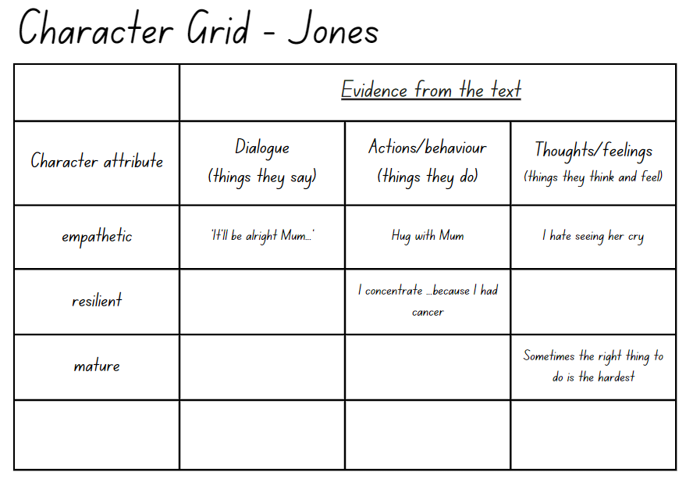

Resource 2 – character grid
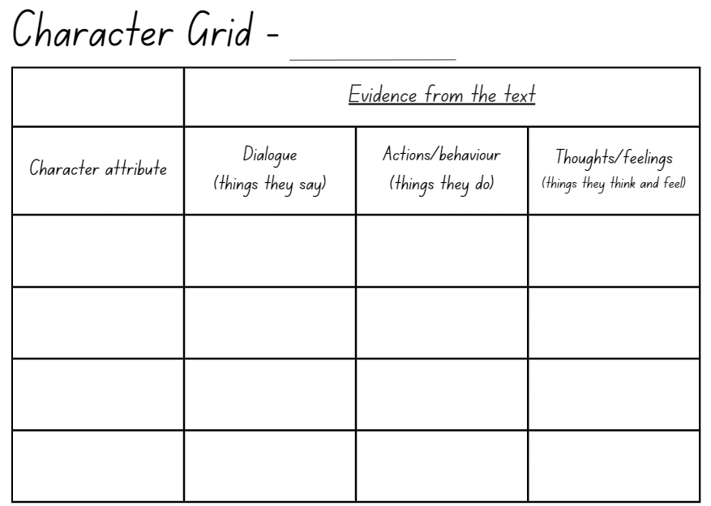

Resource 3 – script
Lexi (knitting on the couch): Good morning, brother August.
(August stretches and groans on the floor)
Lexi: How was footy? Apart from Archer’s magic mark and goal of the season? Which I’ve heard about at least eight times already.
August: The same.
Lexi: By the same, you mean misery and torture?
(August nods and Lexi glares at him)
Lexi: When are you going to tell Dad you loathe football?
August: After this season.
Lexi: You said that last season.
August: I know, but I mean it this time.
Lexi: Ok, it’s your life, Bud. But if it were me, I wouldn’t want to waste a second more of it chasing an oddly shaped ball around a muddy field with Dad yelling at me to lift my game.
August: Is it hard to learn knitting?
Lexi: Not really. Want me to teach you?
August: Where’s Dad?
Lexi: Conked out snoring in the study.
August: Okay, sure.
(August sits beside Lexi on the couch and she begins showing him how to knit)
Lexi (smiling): You’re good at this.
(Dad enters the room, without Lexi or August noticing)
Dad: Knitting, August?
August (dropping the needles): I was bored.
Dad: If you’re so bored, you can come to the park with me and Archer and do kicking drills. You’re still crossing your feet and lifting your head too early.
(Lexi nudges August)
Dad: Get your boots on. We can get in a good hour before dinner. Unless you want to stay here with your sister and her knitting?
(Dad exits the room)
Lexi (whispering): Say something.
August: I can’t.
Lexi: You can, Gus.
August (getting off the couch): I’m a wuss.

Resource 4 – archetypes in August & Jones
Character | Archetype represented | Evidence from the text | Other examples of this archetype

Resource 5 – character analysis exemplar
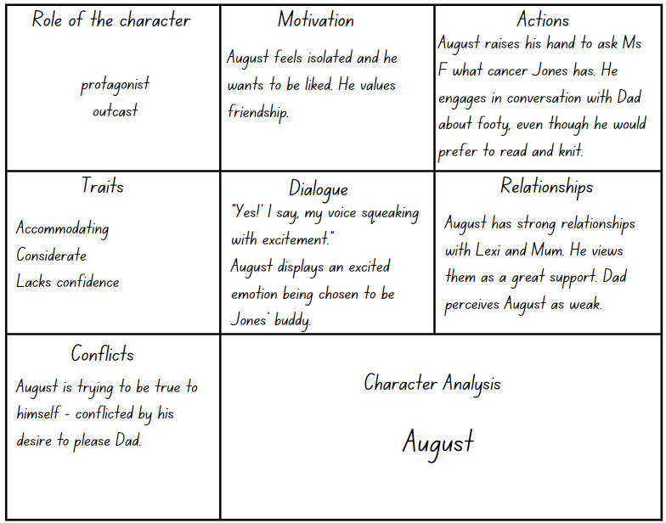

Resource 6 – character analysis
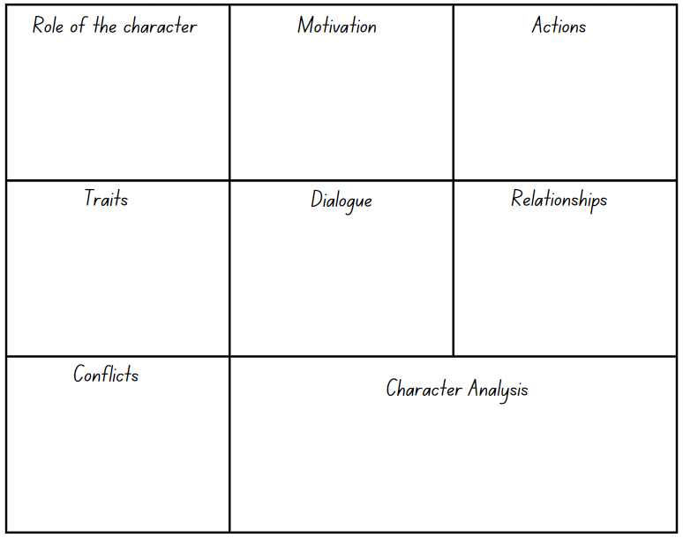

Resource 7 – characterisation through plot development (August)
Plot development: Jones’ first day at school
Character: August
Evidence from the text:
Sequence of events | Character attributes | Dialogue (what they say) | Thoughts, feelings and/or actions
The class crowds around Jones | Lacks confidence | “I guess Jones doesn’t need me to be her buddy anymore” (p 61) | August is pushed out of the way and then begins to walk away.
Jones plays on the climbing frame | Plays it safe | “I don’t like heights...How can she be so fearless?” (p 62) | August stands beneath Jones with his arms out, ready to catch her, ‘just in case’.
Jones’ prosthetic eye comes out | Mature
August and Jones chat while they eat lunch |  | “The scientific name for tomato is Solanum lycopersicum, meaning wolf peach.” (p 65) | August usually wouldn’t share facts at school for fear of being called a nerd.
Jones invites August for a play date | Overjoyed | “I haven’t been invited on a play date in a long time” (p 70)
August attends footy training

Resource 8 – characterisation through plot development (Jones)
Plot development: play date at Jones’ house
Character: Jones
Evidence from the text:
Sequence of events | Character attributes | Dialogue (what they say) | Thoughts, feelings and/or actions
Jones reflects on her first 2 weeks at her new school | Optimistic | “Ms F is my favourite teacher ever and I love playing on the climbing frame.” (p 71). | Whilst her new school is different from Cotton Public School, Jones believes that it’s just as good.
August arrives at Jones’ apartment | Excited
Jones notices the table set for afternoon tea |  | “I feel sad for her. Mum needs to make friends in the city too.” (p 74).
August asks to see Jones’ prosthetic eye collection | Cautious |  | Jones wonders if she can trust August.
Jones reveals her box of treasures, including her prosthetic eye collection | Vulnerable
Jones tries to knit
At bedtime, Jones chats with her dad | Adventurous | “Knitting isn’t my thing. I’m an adrenaline junkie.” (p 80)

Resource 9 – postcard exemplar
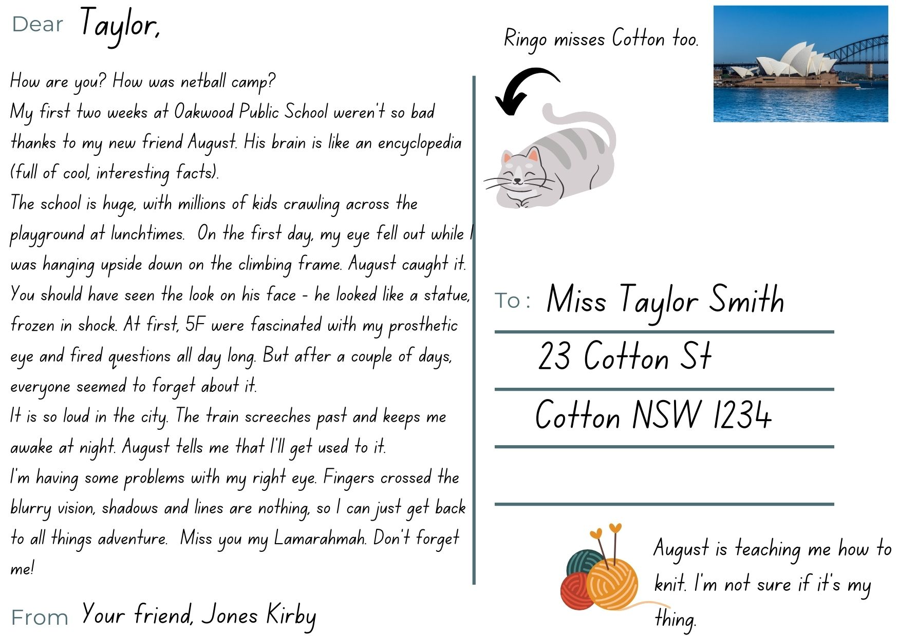

Resource 10 – research scaffold
The extraordinary person I am researching is:_____________________
Time and place of birth: | Quote they live by:
Personal attributes | Physical attributes and disability
What motivates them? | What makes them extraordinary?

Resource 11 – exemplar letter
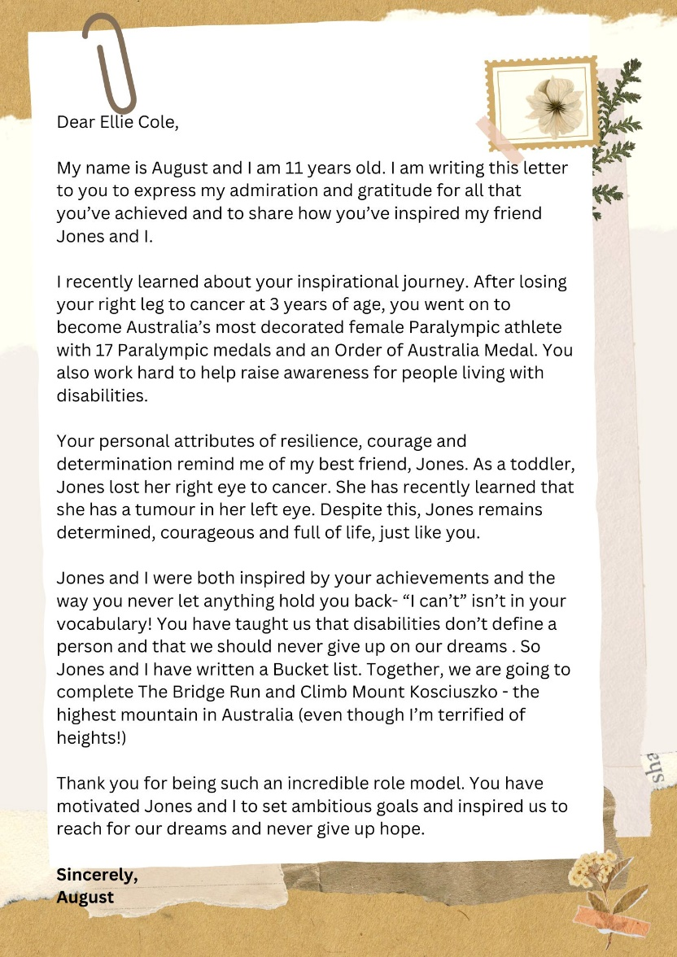

Resource 12 – planning scaffold
Dear__________________________________
Paragraph 1 – explain the purpose of the letter
Paragraph 2 – outline the chosen person’s achievements
Paragraph 3 – describe their personal attributes and how they remind you of Jones’
Paragraph 4 – explain why they inspire you and Jones. Include a quote they live by (optional)
Paragraph 5 – conclusion

References
This resource contains NSW Curriculum and syllabus content. The NSW Curriculum is developed by the NSW Education Standards Authority. This content is prepared by NESA for and on behalf of the Crown in right of the State of New South Wales. The material is protected by Crown copyright.
Please refer to the NESA Copyright Disclaimer for more information. https://educationstandards.nsw.edu.au/wps/portal/nesa/mini-footer/copyright
NESA holds the only official and up-to-date versions of the NSW Curriculum and syllabus documents. Please visit the NSW Education Standards Authority (NESA) website https://educationstandards.nsw.edu.au/ and the NSW Curriculum website https://curriculum.nsw.edu.au.
English K–10 Syllabus © NSW Education Standards Authority (NESA) for and on behalf of the Crown in right of the State of New South Wales, 2022.
National Literacy Learning Progression © Australian Curriculum, Assessment and Reporting Authority (ACARA) 2010 to present, unless otherwise indicated. This material was downloaded from the Australian Curriculum website (National Literacy Learning Progression) (accessed 11 September 2023) and was not modified.
Cancer Institute NSW (2022) About cancer, Cancer Institute website, accessed 18 December 2023.
Harry P (2022) August & Jones, Lothian Children’s Books, Melbourne.
McDonald L (2023) A New Literature Companion for Teachers, 3rd edn, PETAA, Australia.
NESA (NSW Education Standards Authority) (2024) ‘Glossary’, Resources, NESA website, accessed 8 September 2023.
NSW Government (2023) English A-Z Department of Education (website), accessed 18 December 2023.
Pip Harry Author and Editor (2022) Introducing August & Jones, Pip Harry Author and Editor website, accessed 18 December 2023.
Stoodt-Hill BD and Amspaugh-Corson L (2009) Children’s Literature: Discovery for a Lifetime, 4th edition, Pearson.
© State of New South Wales (Department of Education), 2024
The copyright material published in this resource is subject to the Copyright Act 1968 (Cth) and is owned by the NSW Department of Education or, where indicated, by a party other than the NSW Department of Education (third-party material).
Copyright material available in this resource and owned by the NSW Department of Education is licensed under a Creative Commons Attribution 4.0 International (CC BY 4.0) license.
This license allows you to share and adapt the material for any purpose, even commercially.
Attribution should be given to © State of New South Wales (Department of Education), 2024.
Material in this resource not available under a Creative Commons license:
- the NSW Department of Education logo, other logos and trademark-protected material
- material owned by a third party that has been reproduced with permission. You will need to obtain permission from the third party to reuse its material.
Links to third-party material and websites
Please note that the provided (reading/viewing material/list/links/texts) are a suggestion only and implies no endorsement, by the New South Wales Department of Education, of any author, publisher, or book title. School principals and teachers are best placed to assess the suitability of resources that would complement the curriculum and reflect the needs and interests of their students.
If you use the links provided in this document to access a third-party's website, you acknowledge that the terms of use, including licence terms set out on the third-party's website apply to the use which may be made of the materials on that third-party website or where permitted by the Copyright Act 1968 (Cth). The department accepts no responsibility for content on third-party websites.

