English Stage 3 First year – Unit 1
Narrative – The Wild Robot

Contents
Teacher notes 7
Outcomes and content 9
Resources 13
Component A teaching and learning 17
Teaching guide 17
Planning framework 28
Component B teaching and learning 28
Learning intentions and success criteria 28
Learning intention 29
Success criteria 29
Lesson 1 – explore narrative conventions and patterns 29
Lesson 2 – identify science fiction as a genre of narrative 32
Lesson 3 – analyse and write a narrative orientation using verb groups 34
Lesson 4 – explore and write an engaging narrative orientation 38
Component A teaching and learning 43
Teaching guide 43
Planning framework 53
Component B teaching and learning 53
Learning intentions and success criteria 53
Learning intention 53
Success criteria 53
Lesson 5 – understand characterisation and analyse characters – Roz 1 54
Lesson 6 – explore narrative voice and use it in writing 56
Lesson 7 – analyse how characters add meaning to a narrative plot 60
Lesson 8 – understand complications and rising action (series of tension building events) 62
Component A teaching and learning 65
Teaching guide 65
Planning framework 74
Component B teaching and learning 74
Learning intentions and success criteria 75
Learning intention 75
Success criteria 75
Lesson 9 – identify and create a complication 75
Lesson 10 – analyse and use literary techniques to build tension 78
Lesson 11 – characterisation through patterns and dialogue – Roz 2 81
Lesson 12 – analyse and create a climax (dramatic event or complication) 85
Component A teaching and learning 88
Teaching guide 88
Planning framework 97
Component B teaching and learning 97
Learning intentions and success criteria 98
Learning intention 98
Success criteria 98
Lesson 13 – analyse and discuss narrative resolutions 98
Lesson 14 – write an effective narrative resolution 100
Lesson 15 – analyse and discuss themes in narratives 103
Lesson 16 – analysing character development – Roz 3 106
Component A teaching and learning 110
Teaching guide 110
Planning framework 118
Component B teaching and learning 118
Learning intentions and success criteria 119
Learning intention 119
Success criteria 119
Lesson 17 – plan a narrative 119
Lesson 18 – create a narrative – orientation 121
Lesson 19 – create a complication and resolution and apply feedback 122
Lesson 20 – publish, share and reflect on learning 123

Unit overview and instructions for use
In this 5-week unit, students will explore the mentor concept of ‘narrative’ and the supporting concept of ‘characterisation’ through an in-depth analysis of the text The Wild Robot and the animation Origins. Throughout the unit students will develop a deeper understanding of how patterns in narratives set up expectations and notice when those patterns are subverted. Students will further explore narrative conventions and characterisation, then apply this knowledge when creating their own science-fiction narratives.
Outcomes and content in this unit are organised into Component A and Component B. The components are connected, with learning in Component A complementing learning in Component B.
Note: the duration of this unit can be adapted to suit individual school contexts. For example, learning could occur across 5 days rather than 4.
The table below highlights the focus areas and preparation required for Component A and Component B.
Teaching and learning | Component A | Component B
Suggested duration | 60 minutes × 4 days/week or equivalent | 60 minutes × 4 days/week or equivalent
Explicit teaching focus areas | Component A addresses content from the focus areas:  - Vocabulary  - Reading comprehension  - Creating written texts  - Spelling  - Handwriting and digital transcription  It centres on the development of foundational skills and knowledge through regular, systematic and repeated practice. | Component B addresses content from the focus areas:  - Oral language and communication  - Vocabulary  - Reading comprehension  - Creating written texts  - Understanding and responding to literature  It centres on the conceptual understandings of English and exemplifies the importance of learning about and enjoying literature through the study of quality texts.
Preparing for teaching and learning | - Specific teaching and learning activities need to be developed by the teacher. When planning for these activities, please refer to the Component A outcomes and content, teaching guides and planning frameworks.  - Plan and document how you will sequence teaching and learning in whole-class and targeted-groups across the 5-week cycle as required. This should be based on student needs identified through ongoing assessment data. | - Familiarise yourself with the mentor and supporting texts and textual concepts, and the teaching and learning sequence.  - Determine how you will support students in whole-class and targeted-groups across the 5-week cycle as required. This should be based on student needs identified through ongoing assessment data.
English K–10 Syllabus © NSW Education Standards Authority (NESA) for and on behalf of the Crown in right of the State of New South Wales, 2022.

Teacher notes
- Narrative can refer to a story itself or how we communicate and understand it. It can be a part of everyday communication to convey a message and to connect people to information, values and ideas. Through narrative we explore human actions, interactions, motivations and reactions – English Textual Concepts and Learning Processes (2016).
- Understanding of narrative can be supported through watching the department’s video: Narrative (3:51).
- While ‘narrative’ is the mentor concept for the conceptual component of this unit, the supporting concept of ‘characterisation’ will also be explored.
- For information on narrative voice, verb groups, adverbial clauses, refer to the NESA Glossary.
- Understanding of the supporting concept ‘characterisation’ can be supported through watching the department’s video: Character (2:31).
- In addition to the resources listed, students will require access to short passages of the mentor and/or supporting texts. Teachers can copy extracts from texts in reliance on the Statutory Text and Artistic Works Licence. Teachers need to attribute the extracts and include the following notice: ‘This material has been copied [and communicated to you] in accordance with the statutory licence in section 113P of the Copyright Act. Any further reproduction or communication of this material by you may be the subject of copyright protection under the Act. Do not remove this notice’.
- Consider prior student knowledge of narrative voice, verb groups and adverbial phrases or clauses.
- Reflect on student learning and engagement in activities and record differentiation and adjustments within the unit to inform future teaching and learning. One way of doing this could be to add comments to the digital file.
- In NSW classrooms there is a diverse range of students including Aboriginal and/or Torres Strait Islander students, students learning English as an additional language or dialect, high potential and gifted students and students with disability. Some students may identify with more than one of these groups, or possibly all of them. Refer to Curriculum planning for every student – advice for further information.
- Content points are linked to the National Literacy Learning Progression (version 3).
Levels and indicators sourced from National Literacy Learning Progression © Australian Curriculum, Assessment and Reporting Authority (ACARA), (accessed 1 August 2023) and was not modified. See references for more information.

Outcomes and content
The table below outlines the outcomes and content for this unit. The letters 'A' and 'B' in the header refer to Components A and B. The numbers 1 to 5 refer to weeks. The use of 'x' in these columns indicates where the content points are intended to be addressed and in which week.
Focus area and outcome, content points and National Literacy Learning Progression | A | B | 1 | 2 | 3 | 4 | 5
Oral language and communication
EN3-OLC-01 communicates to wide audiences with social and cultural awareness, by interacting and presenting, and by analysing and evaluating for understanding
- Describe ways of interacting with cultural protocols or practice used by Aboriginal and/or Torres Strait Islander Peoples |  | x |  | x
- Follow agreed-upon protocols and define individual roles as needed for in-person or online interactions, establishing specific goals, criteria or timeframes (InT6) |  | x |  | x
Vocabulary
EN3-VOCAB-01 extends Tier 2 and Tier 3 vocabulary through interacting, wide reading and writing, morphological analysis and generating precise definitions for specific contexts
- Analyse morphemic structures of Tier 2 and Tier 3 words to determine their meaning (SpG10, SpG11) | x |  | x | x | x | x | x
- Identify newly encountered words from interactions and wide reading, and use them in writing, discussions and presentations | x | x | x | x | x | x | x
Reading comprehension
EN3-RECOM-01 fluently reads and comprehends texts for wide purposes, analysing text structures and language, and by monitoring comprehension
- Syllabify, blend grapheme–phoneme correspondences and use morphemic knowledge as strategies for reading words accurately (SpG10, PKW9, FlY6) | x |  | x | x | x | x | x
- Select, compare and reflect on texts read for personal interest |  | x | x |  |  |  | x
- Adjust reading approach to suit the purpose for reading (UnT8) | x |  | x | x | x | x | x
- Use morphology and etymology to work out the meaning of unfamiliar words (UnT8) | x |  | x | x | x | x | x
- Monitor and repair reading when meaning breaks down (UnT9) | x |  | x | x | x | x | x
Creating written texts
EN3-CWT-01 plans, creates and revises written texts for multiple purposes and audiences through selection of text features, sentence-level grammar, punctuation and word-level language
- Experiment with characterisation (CrT9) |  | x |  | x | x | x | x
- Choose and control narrative voice across a text |  | x |  | x |  |  | x
- Make choices about verbs and verb groups to achieve precision and add detail (GrA6) | x | x | x |  |  | x | x
- Experiment with the placement of adverbial clauses, to modify the meaning or to add detail to a verb or verb group (GrA6) | x | x |  | x | x | x | x
- Use capital letters at the beginning of a sentence, to indicate proper nouns, for headings and subheadings, to indicate the beginning of a poetry line, for emphasis, and when using acronyms (PuN7) | x | x | x
- Use a comma to separate a subordinate clause or a phrase from the main clause, or to separate information within a sentence, or to separate items in a list (CrT8, PuN6) | x | x |  | x | x
- Use quotation marks consistently across a text to distinguish words that are spoken by characters in dialogue or words authored by others (PuN5, PuN7) | x | x | x |  | x |  | x
Spelling
EN3-SPELL-01 automatically applies taught phonological, orthographic and morphological generalisations and strategies when spelling in a range of contexts, and justifies spelling strategies used to spell unfamiliar words
- Segment unfamiliar multisyllabic words into syllables and phonemes as a strategy when spelling | x |  | x | x | x | x | x
- Recognise that the same grapheme can represent different phonemes (SpG10) | x |  | x | x | x | x | x
- Explain and use spelling conventions to add derivational suffixes such as -ion, -ian, -ence, -ous to base words or roots (SpG10) | x |  | x | x | x | x | x
Handwriting and digital transcription
EN3-HANDW-01 sustains a legible, fluent and automatic handwriting style
- Sustain writing with a legible, fluent and personal handwriting style across a text (HwK8) | x |  | x | x | x | x | x
Understanding and responding to literature
EN3-UARL-01 analyses representations of ideas in literature through narrative, character, imagery, symbol and connotation, and adapts these representations when creating texts
- Describe how narrative conventions engage the reader through models of behaviour, and apply narrative conventions when creating texts |  | x | x | x | x | x | x
- Describe how patterns in narratives set up expectations and notice when those patterns are subverted |  | x | x | x | x | x
- Analyse attributes of character and use similar attributes when creating texts |  | x | x | x | x | x | x
English K–10 Syllabus © NSW Education Standards Authority (NESA) for and on behalf of the Crown in right of the State of New South Wales, 2022.

Resources
The resources in the table below are referred to in this unit. Letters 'A' and 'B' in the header refer to Component A and B respectively, and the numbers 1 to 5 indicate weeks. The use of 'x' in these columns indicate whether the resources are required in Component A, B or both, and in which week.
Resource | A | B | 1 | 2 | 3 | 4 | 5
Brown P (2016) The Wild Robot, Little, Brown and Company, Unites States of America. ISBN13: 9781848127272 | x | x | x | x | x | x | x
Video: Origins (2:09) |  | x | x | x | x | x | x
Resource 1– fluency and close reading passage 1 | x |  | x
Resource 2 – self-monitoring checklist | x |  | x | x | x | x | x
Resource 3 – vocabulary and morphology example 1 | x |  | x
Video: Robot talking animation (0:42) |  | x | x
Resource 4 – predicting |  | x | x
Chart paper |  | x | x | x | x | x | x
Resource 5 – key words – settings |  | x | x
Resource 6 – setting quilt template |  | x | x
Resource 7– story starters |  | x | x
Resource 8 – Freytag’s pyramid planning template |  | x | x | x | x | x | x
Resource 9 – vocabulary and morphology example 2 | x |  |  | x
Video: Character (2:31) |  | x |  | x
Resource 10 – robot head |  | x |  | x
Resource 11 – comic strip |  | x |  | x
Resource 12 – characterisation template |  | x |  | x
Resource 13 – fluency and close reading passage 3 | x |  |  |  | x
Resource 14 – vocabulary and morphology example 3 | x |  |  |  | x
Individual whiteboards and markers |  | x |  |  | x
Resource 15 – robot torso |  | x |  |  | x
Resource 16 – predicting possible endings |  | x |  |  |  | x
Video: Understanding theme (2:52) |  | x |  |  |  | x
Resource 17 – identifying themes |  | x |  |  |  | x
Resource 18 – robot limbs |  | x |  |  |  | x
Resource 19 – writing process |  | x |  |  |  |  | x
Resource 20 – writing stimulus |  | x |  |  |  |  | x
Sticky notes |  | x |  |  |  |  | x
Split pins |  | x |  |  |  |  | x

Week 1

Component A teaching and learning
Component A focuses on the development of foundational skills and knowledge through regular, systematic and repeated practice. The mentor and supporting texts used in Component B of this unit can support the effective implementation of Component A teaching and learning.

Teaching guide
Guidance for explicit teaching, teaching notes, resources and examples for the related outcomes and content points have been provided in the table below.
Focus areas and teaching notes | Resources and examples
Reading comprehension  Reading fluently  - Syllabify, blend grapheme–phoneme correspondences and use morphemic knowledge as strategies for reading words accurately  - Locate and syllabify multisyllabic words, including those with morphemic suffixes (for example, -ing, -ly)  - For every syllable, there is at least one vowel phoneme.  - Morphemic suffixes usually form their own syllable. Using knowledge of morphemes can assist in reading unfamiliar words accurately.  - Model blending grapheme–phoneme correspondences to support reading accuracy in decoding and reading unfamiliar words from the text. | Reading comprehension  Reading fluently  - Resource 1– fluency and close reading passage 1 – Chapter 3: The Robot (p 7), and Chapter 4: The Robot Hatches (p 8) (263 words).  - Suggested words from the passage  - Morphemic information  - automatically – automatic + ally  - robotic – robot + ic  - absorbing – absorb + ing  - restrained – restrain + ed.  - Syllables  - automatically – 5 syllables  - robotic – 3 syllables  - absorbing – 3 syllables  - restrained – 2 syllables.  - Resource 3 – vocabulary and morphology example 1.  Note: the passage from the text will need to be a teacher-created resource.
Reading for interest and wide purposes  - Adjust reading approach to suit the purpose for reading  - Adjusting the reading approach to suit the purpose for reading is crucial as different reading purposes require different strategies and skills.  - Close reading may be used for the analysis of texts, skimming could be used to locate key information, scanning might be used to identify key vocabulary, and note-taking could be undertaken for summarisation (NESA 2024). | Reading for interest and wide purposes  - Purpose of this passage: reading for enjoyment, to discuss the science fiction features of the text and provide information on Roz who is the main character.  - Strategies: making connections, as the reader uses their understanding of computer terminology to develop an understanding of the character of Roz.
Comprehending language  - Use morphology and etymology to work out the meaning of unfamiliar words  - Understanding the meaning of common morphemes and roots assists in determining the meaning of unfamiliar words.  - Teaching activities may include creating ‘word trees’ with suggested vocabulary from the text, where the root word is at the base, and students add branches representing different words formed by adding prefixes and suffixes. This visual representation may help students understand word relationships. | Comprehending language  - Suggested unfamiliar words from Week 1 reading material  - automatically, robotic, activating, absorbing, curious, restrained.  - Resource 3 – vocabulary and morphology example 1.
Monitoring comprehension  - Monitor and repair reading when meaning breaks down  - Meaning may break down when  - there is a change of narrative voice  - technical vocabulary is used.  - Students use Resource 2 – self-monitoring checklist, to monitor their own understanding of the text. | Monitoring comprehension  - Meaning may break down when the author switches from telling the story in third voice to second voice – ‘As you might know, robots don’t really feel emotions’ (p 8).  - Technical vocabulary includes ‘booted up’, ‘coming online’  - Resource 2 – self-monitoring checklist.
Vocabulary  Learning and using words  - Identify newly encountered words from interactions and wide reading, and use them in writing, discussions and presentations  - Identify and discuss the meaning of newly encountered Tier 2 and Tier 3 words in the text to improve vocabulary knowledge and comprehension. | Vocabulary  Learning and using words  - Suggested vocabulary from the passage  - automatically, robotic, systems, activating, absorbing, curious, computer, restrained.
Defining and analysing words  - Analyse morphemic structures of Tier 2 and Tier 3 words to determine their meaning  - Tier 2 words add power and precision to written and spoken language. Many Tier 2 words are most commonly found in written language and explicit teaching of these words is recommended (NESA 2024).  - Tier 3 words are technical words that are used in specific situations, such as activating, automatically, robotic.  - Understanding the meaning of different morphemes assists in determining an unfamiliar word’s meaning. | Defining and analysing words  - Resource 3 – vocabulary and morphology example 1  Note: content in Vocabulary will support the focus areas Reading comprehension and Spelling.
Spelling  Phonological component  - Segment unfamiliar multisyllabic words into syllables and phonemes as a strategy when spelling  - Revise how to segment multisyllabic words into syllables, for example, robotic has 3 syllables  - Revise how to segment multisyllabic words into phonemes, such as, robotic has 7 phonemes (r-o-b-o-t- i-c)  - This is a phonological skill that should be practised regularly. | Spelling  Phonological component  - Suggested words from Week 1 reading material: task, raged, chaos, ball, around, applied  - Sample words: accident, balance, bath, grass, wander, swampy, apron, active-activate, affection-affectionate, captive-captivate, fabric-fabricate, passion-passionate, consider-considerate, domestic-domesticate.  Note: each week of learning contains a phonological, orthographic and morphological focus. These focuses are intended to be taught simultaneously through linguistic inquiry. Suggested words have been selected to show how phonological, orthographic and morphological content can be integrated. In addition to words selected from the mentor and/or supporting text, additional sample words for inquiry are provided.
Orthographic component  - Recognise that the same grapheme can represent different phonemes  - Graph [a] represents phonemes /a/, /ar/, /o/, /ay/ and /schwa/.  - Highlight the different phonemes that are represented by the graph [a]. For example, grass /ar/, apron/ ay/, star /ar/.  - Note the grapheme’s position within base words.  - Explain that the /ay/ phoneme within the suffix -ate is represented by the split digraph [a_e]. | Orthographic component  - As above
Morphological component  - Explain and use spelling conventions to add derivational suffixes to base words or roots  - Derivational suffixes are added to a base word or root to change part of speech. A base word is a morpheme that stands freely on its own to make a word. A root is a morpheme that gives the word its core meaning. A root may or may not stand alone as a word. Many roots in Standard Australian English derive from Latin and Greek.  - Introduce derivational suffix -ate meaning ‘possessing, having the appearance of characteristics, the product of a process’.  - Teach adding -ate to nouns to form adjectives: fortune-fortunate.  - Teach adding -ate to verbs to form nouns: condense-condensate.  - Teach adding -ate to nouns and adjectives to form verbs: hyphen-hyphenate.  - Teach drop the e rule: active-activate. | Morphological component  - As above  Note: content in spelling will support learning in the focus areas Vocabulary and Reading comprehension.
Creating written texts  Sentence-level grammar  - Make choices about verbs and verb groups to achieve precision and add detail  - Review types of verbs (action, thinking, feeling, saying and relating).  - Review identification of the head verb in a clause or verb group.  - Review verb groups (sometimes known as a complex verb or compound verb) containing auxiliary or 'helping’ verbs to indicate tense or modality, such as ‘I am going soon. I must leave before dark.’  - Review that verb groups contain 2 or more verbs, such as ‘The wolf huffed and puffed.’  - Review verb groups with other words such as adverbs or prepositions, such as ‘The plane took off.’ | Creating written texts  Sentence-level grammar  - Suggested sentences to demonstrate the use of verb groups from the passage  - The robot's computer brain booted up. (p 7)  - While my robotic systems are activating, I will tell you about myself. (p 7)  - I am fully activated. (p 7)  Note: verb groups are highlighted in bold.
Punctuation  - Use capital letters at the beginning of a sentence, to indicate proper nouns, for headings and subheadings, to indicate the beginning of a poetry line, for emphasis, and when using acronyms  - Review capital letters at the beginning of a sentence: a capital letter is used as the first letter of the first word of every sentence.  - Proper nouns: capital letters are used as the first letter for all proper nouns. For example, Australia, Sydney, Lucas, Ryan.  - Headings and subheadings: the main words in headings and subheadings start with a capital. For example, The Mysteries of the Universe.  - Use quotation marks consistently across a text to distinguish words that are spoken by characters in dialogue or words authored by others  - Quotation marks are used at the beginning and end of what is spoken by characters in dialogue or words authored by others.  - For dialogue with more than one character speaking, a change of line for each new speaker is used. | Punctuation  - Suggested examples from the passage, to demonstrate the use of capital letters  - Capital letters for chapter headings for example, ‘THE ROBOT’  - Capital letters for proper nouns for example, ‘Roz’  - Capital letter for the beginning of sentences for example, ‘By morning the hurricane was gone.’ (p 1)  - Suggested examples from the Week 1 reading materials, to demonstrate the use of quotation marks and dialogue  - 'Hello, I am ROZZUM unit 7134, but you may call me Roz. While my robotic systems are activating, I will tell you about myself.' (p 7)  - 'Thank you for your time.' (p 7)  - 'Hello, otters, my name is Roz.' (p 10)
Handwriting and digital transcription  Handwriting legibility and fluency  - Sustain writing with a legible, fluent and personal handwriting style across a text  - Form legible and fluent Foundation Style printing, including  - lower case letters  - upper case letters  - punctuation marks  - numerals.  - Posture  - Feet are to be flat on the floor with the back of the chair supporting the hollow of the back.  - The body should be upright.  - The writing arm should pivot from the elbow.  - Paper  - The non-writing hand holds the paper. This non-writing arm can take the weight to allow the writing arm to glide over the writing surface.  - Pencil grip  - Hold the pen(cil) between the thumb and index finger with the pen(cil) resting on the middle finger. | Handwriting and digital transcription  Handwriting legibility and fluency  - Suggested fluency pattern  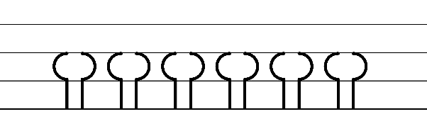  - Example NSW Foundation Style handwriting formation  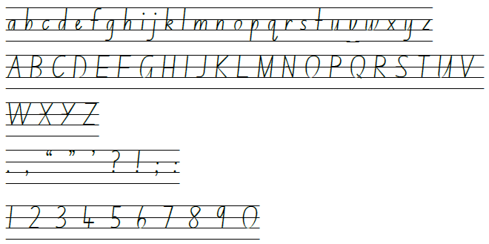  - Suggested practice text from the passage  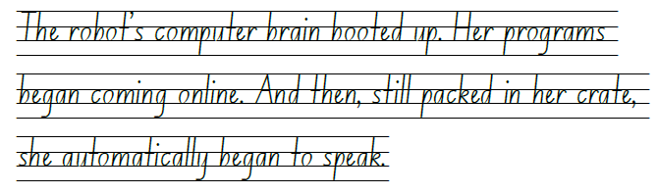

Planning framework
To plan and document Component A teaching and learning, a planning scaffold (DOCX 228 KB) is provided. To support you in your planning, a link to a detailed example of a one-week teaching and learning cycle is included in the scaffold. Additional resources to support teaching and learning in each focus area can be found at Lesson advice guides.

Component B teaching and learning
The following teaching and learning sequence has been designed to address Component B outcomes and content and develops conceptual understandings of English through the study of quality texts. Adapt the sequence as required to best meet the needs of your students.

Learning intentions and success criteria
Learning intentions and success criteria are best co-constructed with students.

Learning intention
Students are learning to analyse and describe representations of ideas through narrative and apply narrative conventions when creating texts.

Success criteria
Students can:
- explore narrative conventions and patterns
- identify science fiction as a genre of narrative
- notice and discuss how patterns in narratives are subverted
- analyse and write a narrative orientation using verb groups
- explore and write an engaging orientation.

Lesson 1 – explore narrative conventions and patterns
Prior to the lesson create a space for a classroom display that will support student learning throughout the unit as the text is explored. The display will be added to each lesson. Alternatively, this can be created digitally.
- Explain how different cultures, including Aboriginal and/or Torres Strait Islander Peoples, use protocols and practices when speaking and interacting. For example, gestures and hand talk during conversation. Discuss how these protocols are intended to show respect when interacting with others. Ask students to recall ways that they show respect in their family and classroom.
- Co-construct an anchor chart with appropriate protocols for students to use when interacting with each other. For example, one person speaks at a time, speak in a clear voice, make eye contact with the audience, listen to the speaker, ask questions and respond appropriately. Keep the chart as it will be referred to later in the unit.
- Display the Robot talking animation (0:42) to introduce the textual concept of narrative and the focus for learning when reading The Wild Robot.
Note: a narrative is an account of events or experiences, which are real or imagined. In English literary theory, narrative includes a story (that is narrated) and a discourse (how it is narrated). Narrative can present as an explicit sequencing of events (type of text), or it can be an implied or inferred component in a text (NESA 2024).
- Co-construct a concept map to activate students’ background knowledge about narrative. Add this to the classroom display. For example:
- orientation (characters and setting)
- complication (problem)
- series of events (attempts to resolve the complication with rising action/tension, climax)
- resolution (falling action, different types of endings)
- coda (a reflective moment at the end of the text or a message inferred by the reader).
- Introduce the idea of patterns in narratives and how they set up expectations. Explain that sometimes the patterns in narratives are subverted or unexpected, which influences how a reader engages or enjoys a text.
- Brainstorm examples of well-known narratives and identify those that follow expected and subverted patterns. For example, Matilda by Roald Dahl. She is a gifted young girl who overcomes obstacles, stands up against injustice, and finds her true family. It has an expected pattern of complication, series of events and resolution. However, Alice's Adventures in Wonderland by Lewis Carroll uses subverted patterns as it deviates from a traditional narrative pattern. It takes the reader on a whimsical journey through a fantasy world with peculiar characters and surreal situations. It has a series of subverted patterns designed to keep the reader engaged.
- Display the front cover and a collage of illustrations from the text. Use the See Think Wonder strategy to encourage student predictions about the text while viewing the collage. Illustrations could include the robot:
- coming out of the crate (p 9)
- on the cliff (p 14)
- on top of mountain (p 22)
- in a pine tree (p 36)
- with a duck (pp 157–158).
- Ask students what type of pattern (expected or subverted) the text might follow and why they think that. Ensure an adequate number of illustrations are provided so that students can start thinking about subverted patterns.
- In small groups, using the co-constructed protocols from activity 2, students share their predictions. Discuss how the protocols will help students interact respectfully.
- Students use Resource 4 – predicting to record their thinking. Keep these predictions to refer to once the text has been read.
- Read Chapters 1 to 7 of The Wild Robot. While reading, point out how the author has used narrative voice in the text. For example, ‘Our story begins...’ (p 1), ‘Now, reader, what I haven’t mentioned...’ (p 2), ‘As you might know...’ (p 8). Discuss the effect of narrative voice on the reader. Narrative voice will be explored further in Lesson 6.
- Ask students to identify some clues in the text that indicate subverted patterns. For example, the blending of artificial and natural worlds (Roz in the wild). Discuss how this is not something readers might expect. Ask what might be expected from reading a text about a robot. Student responses might include a more futuristic setting and other robot characters.

Lesson 2 – identify science fiction as a genre of narrative
- Read Peter Brown’s, A note about the story, The Wild Robot (p 271). Identify and discuss the author’s purpose and intended audience. For example, Peter Brown is an author and illustrator of children’s books. He wanted to write a robot nature story because he was fascinated with robots and the natural world from a young age.
- Explain that The Wild Robot is a science fiction text. Discuss other age-appropriate science fiction films and books that students are familiar with. For example, Space Boy by David Walliams, Mechanica by Lance Balchin, Star Wars, Disney’s Big Hero 6 and Pixar’s Wall-E.
- Ask students to explain what the word fiction means and to compare a fiction to a non-fiction text. Reinforce the idea that fictional texts involve the creation of imaginary worlds and narratives, while non-fiction focuses on presenting factual information. Fictional texts entertain and explore themes, while non-fiction texts inform and educate readers about the real world.
- Activate students’ background knowledge of the science fiction genre by creating a word cloud on an anchor chart or digitally using Mentimeter. Students add words they associate with science fiction to the word cloud. For example, imaginative, futuristic, space exploration, time travel, advanced technology, steampunk, superhuman characters, robots, aliens, teleportation and artificial intelligence. Add the word cloud to the classroom display.
Note: artificial intelligence is intelligence demonstrated by machines. It is sometimes called machine intelligence (NESA 2024).
- Revisit Chapters 1 to Chapter 7. Analyse the text and find evidence that The Wild Robot is a science fiction text. For example:
- the main character is a robot
- illustrations represent situations that could be futuristic within our world. For example, a robot scaling a cliff like a crab
- the use of vocabulary such as: robot, computer brain, booted up, robotic systems, activating, programs, online.
- Model writing a paragraph in first person using vocabulary that might reflect a science fiction text. For example:
Dear humans, my name is Lannie. I am a humanoid robot from the intergalactic planet of McBolt. I use artificial intelligence. My mission is to complete your homework with speed and precision. My electronic sensors are booting up. When fully charged, I will be at your service.
- Students draw or create their own robot character which they will use as a stimulus for writing.
- Use the modelled writing example to co-construct success criteria to support students write a descriptive science fiction themed paragraph This could include: use of dialogue, written in first person, use of Tier 2 and 3 vocabulary that shows the text is science fiction.
- Using vocabulary from activity 4, drawing the modelled text and success criteria, students write a science fiction themed paragraph about their robot character. They can include their robot’s name, origin, technological features and its mission or purpose.
Too hard? Provide students with the modelled example and sentence stems to complete.
Too easy? Support students to use AI text-to-image and text-to-speech tools in Canva to design a robot that speaks.
- Read Chapters 8 to15 of The Wild Robot. While reading, identify and discuss other clues in the text that prove the text is science fiction.

Lesson 3 – analyse and write a narrative orientation using verb groups
- Activate students’ prior knowledge about what makes a good narrative orientation. For example, an engaging start, descriptive setting or an introduction to the characters. Brainstorm ideas and add them to the concept map created in Lesson 1.
- Revise how patterns in narratives set up expectations and that sometimes the patterns are subverted or unexpected. Patterns and subverted patterns influence how a reader engages with or enjoys a text. Identify narratives with subverted orientations, for example, Shrek by William Steig, which introduces readers to a grumpy and unattractive ogre. Instead of being the typical villain, Shrek embarks on an unexpected adventure and ultimately finds love and acceptance.
- Brainstorm behaviour expected of a robot. Ask students to think about the robot character Roz in The Wild Robot and discuss if she follows the expected pattern of behaviour of a robot. Ask students to elaborate on their answer using evidence from the text. For example, whilst Roz begins as a typical robot (analytical, performs tasks, intelligent), she begins to have new experiences and experience feelings. In Chapter 12 and Chapter 13 she starts to feel safe in her new environment and relief that the storm is over. In Chapter 14 and Chapter 15 she starts to feel fear and begins to come up with original thoughts and ideas, subverting the notion that robots lack emotions or humanity.
- Read Chapter 16 to Chapter 19 of The Wild Robot. While reading, focus on the different settings introduced in the orientation and draw attention to the vocabulary used to describe them. For example:
- the ocean (pp 1–3): swallowed up, tumbling, rumbling, bobbing, crashing, soared
- the northern shore (p 4): sparkled, curious creatures, romping, cautiously, approached, torso
- the wilderness (p 16): rustling, underbrush, darting, stumbled, toppled
- the mountain (p 21): dense, distant, unison, teeming, artificial.
- Discuss why the author has chosen these words and what the reader might infer. For example:
- Engagement: authors use interesting and descriptive words to engage the reader.
- Mental model: authors intentionally select words to describe real or imagined characters, settings and events so that readers can make inferences and visualise the story.
- Setting the mood: authors choose words to evoke emotion in the reader. For example, scared or excited.
- Display an enlarged copy of Resource 5 – key words – settings. Revisit descriptions of the ocean in The Wild Robot. Model how to identify and record key words that help create a mental model. For example, thunder, lightning, roared, chaos. In pairs, students discuss the mental model that the words helped to create.
- Provide students with their own copy of Resource 5 – key words – settings. Re-read pages from the text that describe the other 3 settings from activity 4, such as the northern shore (p 4), the wilderness (p 16) and the mountain (page 21). As the setting descriptions are re-read, students list the key words that help create a mental model of each setting.
- Students share their key words with the class and explain how the mental model they created may have changed as different words were read aloud or added to the resource.
- Display an enlarged copy of Resource 6 – setting quilt template. Explain that students will draw their mental model of one setting using the key words from Resource 5 – key words – settings.
- Provide each student with a copy of Resource 6 – setting quilt template. Students complete their drawing in the top half of the hexagon.
- Revise verbs and verb groups from teaching in Component A. Discuss how choice of verb and verb groups help to achieve precision and add detail. Ask students to identify and share examples from their copy of Resource 5 – key word – settings and elaborate on the intended effect. For example, verbs such as stumbling and darting are used to show movement in the text.
- Model how to write an orientation focusing on the setting using the key words from Resource 5 – key words – settings. Record on Resource 6 –setting quilt template. For example:
As the thunder roared and lightning flashed across the darkened sky, the hurricane crept closer. Crates thrashed up and down in the angry ocean as one by one, waves swallowed them up. One lonely crate slammed onto the sharp rocks. Roz was safe inside.
- Using a modelled orientation example such as the one in activity 12, ask students to identify verbs (action, thinking, feeling, saying or relating) and verb groups used and discuss how they add detail and meaning to the orientation. For example, ‘the hurricane crept closer’ provides details about where and how dangerous the hurricane is.
- Students independently write an orientation focusing on the setting and record it on their copy of Resource 6 – setting quilt template. Remind students to make choices about verb and verb groups to add precision and detail.
Too hard? Students draw their mental model of a setting then write key words about the setting.
Too easy? Students write a descriptive paragraph about a second setting from The Wild Robot. Students compare the 2 settings and discuss the effect the choice of words has on the reader.
- Combine the individual pieces of the setting quilt together to create one large quilt. Add it to the classroom display created in Lesson 1. This is a visual representation of the various settings in the orientation of The Wild Robot.
- Ask students to reflect on the purpose of settings in a narrative orientation and if narratives usually have one setting or multiple.
- Reinforce the idea that the setting is important because it provides the reader with information about the physical location and space and helps to establish mood. Also, the setting often changes as the plot progresses.
Assessment task 1 – observations and work samples from this lesson allow students to demonstrate achievement towards the following syllabus outcomes and content points:
EN3-VOCAB-01 – extends Tier 2 and Tier 3 vocabulary through interacting, wide reading and writing, morphological analysis and generating precise definitions for specific contexts
- identify newly encountered words from interactions and wide reading, and use them in writing, discussions and presentations.
EN3-CWT-01 – plans, creates and revises written texts for multiple purposes and audiences through selection of text features, sentence-level grammar, punctuation and word-level language
- make choices about verbs and verb groups to achieve precision and add detail.

Lesson 4 – explore and write an engaging narrative orientation
- Introduce the video Origins (2:09). Explain that Origins is a wordless animation. Students will use it as a stimulus to write a narrative. This lesson will focus on the orientation.
- Rewatch Origins (0:00–0:32) and ask students to identify the techniques used by the author to create an engaging orientation. For example:
- Setting
- imagery using senses: sound and touch, crunchy leaf, train whistle, melancholy music, cold metal, warm sunlight
- lighting and colours: warm glow from sunlight, autumn colours in nature scenes vs cold and dark colours in human-made scenes
- salience and camera angles: close ups, long shots.
- Characterisation
- physical appearance: robotic movement, facial expressions
- actions: searching, curious, brave
- feelings and thoughts: lonely, lost, confused.
- Revisit the orientation of The Wild Robot from Lesson 3. Ask students to compare and contrast it with the orientation of Origins. As a class, record ideas on a Venn diagram. For example, The Wild Robot starts with a hurricane and the author addresses the reader using the word ‘Our’. Origins starts with a wide shot of the forest and zooms in to introduce the character. It is wordless. Both texts have a robot. Discuss the different moods inferred in both texts.
- Display an enlarged copy of Resource 7 – story starters. Discuss the techniques used by authors to engage the reader. For example, using figurative language to show what is happening, starting with action, dialogue, posing a question or using onomatopoeia.
- Read and analyse each story starter and as a class match up the story starter with the techniques listed on the resource. Discuss the ineffective story starter and how it could be improved.
- In pairs, students turn and talk to analyse the effect an engaging story starter has on the reader and discuss ideas on how to start their own science fiction narrative. Students share responses. Record a list of effective story starter techniques and ideas and add to the classroom display created in Lesson 1.
- Explain that over the next few weeks, students will work in pairs to create a science fiction narrative, using Origins as a stimulus. Students will use ideas from analysing The Wild Robot and skills developed throughout the unit.
- Display an enlarged copy of Resource 8 – Freytag’s pyramid planning template. Explain to students that this resource will be used as a planning template for narrative writing and will be added to in future lessons. Refer to the different sections of the planning template and explain that each box will include key words that will support students to write the orientation, complication, rising action (tension building events), climax, falling action and resolution for their science fiction narrative.
- Display a modelled example of an orientation where figurative language is used to introduce the main character. For example, ‘Ancient trees guarded LR8, as he skipped through the sunlit forest that he called home. With his metallic robotic frame gleaming under the warm sunlight, LR8’s optical sensors scanned the surroundings.’
- As a class, brainstorm other examples of figurative language that could be used in an orientation to introduce the robot character. Add these to an anchor chart to scaffold student writing.
- Using think-alouds and an enlarged copy of Resource 8 – Freytag’s pyramid planning template, model planning then writing an orientation. Refer to and include ideas from class anchor charts. For example:
Our story starts near ancient trees that guarded LR8 as he skipped through the sunlit forest that he called home. With his metallic robotic frame gleaming under the warm sunlight, LR8's optical sensors scanned the surroundings. He enjoyed the warm glow of autumn leaves and the unique sounds of wildlife that echoed through the woodlands. As he roamed the forest floor, his processors were alive with curiosity, eagerly soaking in the sights, sounds, and scents around him.
Yet, despite its advanced capabilities, LR8 felt an overwhelming sense of loneliness, like a small bird separated from its flock. He yearned for companionship, or someone or something to make sense of this vast and unfamiliar world. Suddenly, he felt lost like leaves in the autumn wind. ‘Where do I belong?' he whispered softly to himself while looking at the logo on his robotic torso.
- Revise the correct use of capital letters taught in Component A. Provide examples from the text, such as capital letters for chapter headings ‘THE ROBOT’, proper nouns ‘Roz’, the beginning of sentences and emphasis 'TWEEE-tweedle!'. Ask students to identify correct use in the modelled example and share their own examples.
- Co-construct a success criteria for an orientation. For example, I can write an engaging orientation that includes:
- an engaging story starter
- imagery to describe a setting
- verbs and verb groups to achieve precision and add detail
- science-fiction or robotic vocabulary such as sensors, processor
- figurative language to introduce a character – will the robot character follow an expected pattern of robotic behaviour, or will it be subverted and be human-like?
- correct use of capital letters.
- Students plan an engaging orientation for their narrative on a copy of Resource 8 – Freytag’s pyramid planning template.
- Students write an orientation for a science fiction narrative based on Origins, using the success criteria to guide their writing.
Too hard? Students work in a small group and co-construct the orientation with the teacher.
Too easy? Students re-read the orientation and highlight verbs and verb groups. Ask students to consider if their word choice achieved the precision and detail they envisioned.
- Demonstrate how good writers revise and edit their work by adding further details.
- Students read each other's writing and provide feedback based on the success criteria.
- Students revise and edit their orientation based on feedback given from peers.
- Read The Wild Robot, Chapters 20 to 24.
Assessment task 2 – observations and work samples from this lesson allow students to demonstrate achievement towards the following syllabus outcomes and content points:
EN3-CWT-01 – plans, creates and revises written texts for multiple purposes and audiences through selection of text features, sentence-level grammar, punctuation and word-level language
- use capital letters at the beginning of a sentence, to indicate proper nouns, for headings and subheadings, to indicate the beginning of a poetry line, for emphasis, and when using acronyms.
EN3-RECOM-01 – fluently reads and comprehends texts for wide purposes, analysing text structures and language, and by monitoring comprehension
- select, compare and reflect on texts read for personal interest.

Week 2

Component A teaching and learning
Component A focuses on the development of foundational skills and knowledge through regular, systematic and repeated practice. The mentor and supporting texts used in Component B of this unit can support the effective implementation of Component A teaching and learning.

Teaching guide
Guidance for explicit teaching, teaching notes, resources and examples for the related outcomes and content points have been provided in the table below.
Focus areas and teaching notes | Resources and examples
Reading comprehension  Reading fluently  - Syllabify, blend grapheme–phoneme correspondences and use morphemic knowledge as strategies for reading words accurately  - Locate and syllabify multisyllabic words, including those with morphemic suffixes (for example, -ing, -ly)  - For every syllable, there is at least one vowel phoneme.  - Morphemic suffixes usually form their own syllable. Using knowledge of morphemes can assist in reading unfamiliar words accurately.  - Model blending grapheme–phoneme correspondences to support reading accuracy in decoding and reading unfamiliar words from the text. | Reading comprehension  Reading fluently  - Fluency and close reading passage 2 – Chapter 34: The Mother (pp 96–99) from ‘Like most goslings...’ to ‘... their parenting advice’ and (p 99) ‘No gosling ever …’ to ‘… becoming an excellent mother’ (252 words).  - Suggested words from the passage  - Morphemic information  - meandering – meander + ing  - designed – de + sign + ed  - attentive – attend + ive.  - Syllables  - meandering – 4 syllables  - designed – 2 syllables  - attentive – 3 syllables.  - Resource 9 – vocabulary and morphology example 2  Note: the passage from the text will need to be a teacher-created resource.
Reading for interest and wide purposes  - Adjust reading approach to suit the purpose for reading  - Adjusting the reading approach to suit the purpose for reading is crucial as different reading purposes require different strategies and skills.  - Close reading may be used for the analysis of texts, skimming could be used to locate key information, scanning might be used to identify key vocabulary, and note-taking could be undertaken for summarisation (NESA 2024). | Reading for interest and wide purposes  - Purpose of this passage: reading for enjoyment and to provide information on how Roz’s character has developed as she becomes a mother, the development of the relationship between Roz and Brightbill and how Roz’s actions have made other characters act differently towards her.  - Strategies may include:  - re-reading to clarify meaning of the text. Many characters and their actions are mentioned which may require clarification to maintain meaning.  - slow reading rate to decode new content or vocabulary. For example, tottering, meandering, gnawing and fawns.
Comprehending language  - Use morphology and etymology to work out the meaning of unfamiliar words  - Understanding the meaning of common morphemes and roots assists in determining the meaning of unfamiliar words.  - Model breaking down unfamiliar words from the text into familiar parts using morphemes and discuss the etymology. Then, combine these parts to make inferences about the word's meaning. | Comprehending language  - Suggested unfamiliar words from the passage  - meandering, attention, designed, attentive, wandered, excellent.  - Suggested unfamiliar words from Week 2 reading material  - sprawling, inspecting, nocturnal, acquaintance, demeanour, encountering, gratitude.  - Resource 9 – vocabulary and morphology example 2
Monitoring comprehension  - Monitor and repair reading when meaning breaks down  - Meaning may break down when unfamiliar Tier 2 or Tier 3 vocabulary is included.  - Students use Resource 2 – self-monitoring checklist, to monitor their own understanding of the text. | Monitoring comprehension  - Unfamiliar Tier 2 or Tier 3 words may include meandering, attention, eager, gnawing, attentive, gosling, banks.  - Resource 2 – self-monitoring checklist
Vocabulary  Learning and using words  - Identify newly encountered words from interactions and wide reading, and use them in writing, discussions and presentations  - Identify and discuss the meanings of newly encountered Tier 2 and Tier 3 words in the text to improve vocabulary knowledge and comprehension. | Vocabulary  Learning and using words  - Suggested vocabulary from the passage  - meandering, attention, designed, eager, attentive, whisk, advice, excellent.
Defining and analysing words  - Analyse morphemic structures of Tier 2 and Tier 3 words to determine their meaning  - Understanding the meaning of different morphemes assists in determining an unfamiliar word’s meaning. | Defining and analysing words  - As above  - Resource 9 – vocabulary and morphology example 2  Note: content in Vocabulary will support the focus areas Reading comprehension and Spelling.
Spelling  Phonological component  - Segment unfamiliar multisyllabic words into syllables and phonemes as a strategy when spelling  - Revise how to segment multisyllabic words into syllables, for example, eager has 2 syllables.  - Revise how to segment multisyllabic words into phonemes, such as eager has 3 phonemes (ea-g-er).  - This is a phonological skill that should be practised regularly. | Spelling  Phonological component  - Suggested words from Week 2 reading material  - paths, afternoon, garden, laughing, amazing, waved, always, trail.  - Sample words: phantom, bath, glasses, fast, squash, swab, was, apron, radio, pastry, hazy, narrate-narrative, collaborate-collaborative, communicate-communicative, initiate-initiative, imagine-imaginative, inform-informative, appreciate-appreciative, appositive.
Orthographic component  - Recognise that the same grapheme can represent different phonemes  - Graph [a] represents phonemes /a/, /ar/, /o/, /ay/ and /schwa/.  - Highlight the different phonemes that are represented by the graph [a]. For example, grass /ar/, apron/ ay/.  - Note the grapheme’s position within base words.  - Revise that the split digraph [a_e] represents the /ay/ phoneme: communicate, initiate. | Orthographic component  - As above
Morphological component  - Explain and use spelling conventions to add derivational suffixes to base words or roots  - Derivational suffixes are added to a base word or root to change part of speech.  - Introduce derivational suffixes -ive, -ative, -itive: meaning ‘a tendency, inclination or quality’.  - Teach adding -ive, -ative, -itive to nouns and verbs to form adjectives.  - Teach that some adjectives formed often become nouns (for example, narrative).  - Teach drop the e rule: imagine-imaginative.  - Note -ative is the combination of 2 suffixes, -ate and -ive. | Morphological component  - As above  Note: content in spelling will support learning in the focus areas Vocabulary and Reading comprehension.
Creating written texts  Sentence-level grammar  - Experiment with the placement of adverbial clauses, to modify the meaning or to add detail to a verb or verb group  - Review use of adverbial clauses.  - Adverbial clause: A dependent clause that modifies a verb, adjective or another adverb. It includes words that provide information about the time, place, condition, reason, manner or purpose (NESA 2024).  - In an imaginative text, the phrase ‘After the sun went down, the old house came to life’ might change the placement of the adverbial clause, such as ‘The old house came to life after the sun came down.' (NESA 2024)  - Adverbial clauses begin with subordinating conjunctions, such as after, although, as, because, since, until, when, while. These tell how, when, where and why. | Creating written texts  Sentence-level grammar  - Suggested sentences to demonstrate the use of adverbial clauses from the text  - Beginning of the sentence: ‘When Roz first listened to the chickadees, their song sound like “TWEE-tweedle! TWEE-Tweedle!'’’ (p 47). ‘As Roz wandered through the springtime, she saw all the different ways that animals entered the world.’ (p 57)  - End of the sentence: ‘One after another, they were swallowed up by the waves until only five crates remained.’ (p 1). ‘Roz continued exploring the gravesite until a playful ocean wave washed over her.’ (p 11)  Note: adverbial clauses are highlighted in bold.
Punctuation  Use a comma to separate a subordinate clause or a phrase from the main clause, or to separate information within a sentence, or to separate items in a list  - A comma can be used to separate an adverbial clause from the main clause.  - If the dependent clause comes after the independent clause, a comma is not needed to separate the 2 clauses. | Punctuation  - Suggested sentences to demonstrate the use of commas: see above.
Handwriting and digital transcription  Handwriting legibility and fluency  - Sustain writing with a legible, fluent and personal handwriting style across a text  - Form legible and fluent diagonal joins from the baseline to short letters from a downstroke. These are sometimes referred to as baseline joins.  - Diagonal joins come from letters with exits near the baseline, including a, c, d, e, h, i, k, l, m, n, u and z.  - Diagonal joins to short letters continue the exit hook diagonally upwards to the start of the next letter.  - Most diagonal joins meet the next letter at the top of the letter’s body at a 45-degree angle.  - Highlight the position of the diagonal join to the letter e.  - Form legible and fluent diagonal letters from the baseline to tall letters.  - Diagonal joins from the baseline to tall letters join at line 2 (the neckline) and continue all the way to line 1 (the top line) before retracing part of the way back down and finishing the new letter.  - Focus attention on how joins provide a quick change in direction for letters that end on a downstroke at the baseline. Emphasise the downstroke so joining movements are not overemphasised and widened. | Handwriting and digital transcription  Handwriting legibility and fluency  - Suggested fluency pattern  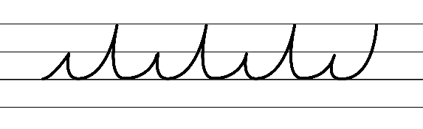  - Example NSW Foundation Style handwriting formation − diagonal joins to short letters from a downstroke  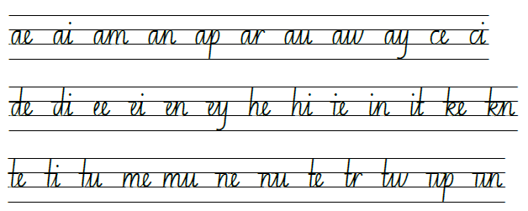  - Example NSW Foundation Style handwriting formation − diagonal joins to tall letters from a downstroke  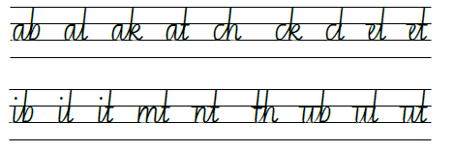  - Suggested practice text from the passage  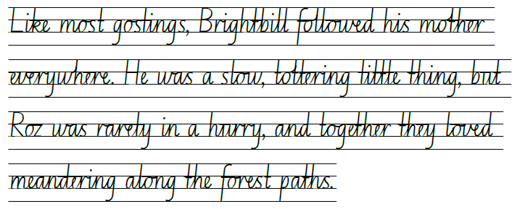

Planning framework
To plan and document Component A teaching and learning, a planning scaffold (DOCX 228 KB) is provided. To support you in your planning, a link to a detailed example of a one-week teaching and learning cycle is included in the scaffold. Additional resources to support teaching and learning in each focus area can be found at Lesson advice guides.

Component B teaching and learning
The following teaching and learning sequence has been designed to address Component B outcomes and content and develops conceptual understandings of English through the study of quality texts. Adapt the sequence as required to best meet the needs of your students.

Learning intentions and success criteria
Learning intentions and success criteria are best co-constructed with students.

Learning intention
Students are learning to analyse and describe representations of ideas through narrative and apply narrative conventions when creating texts.

Success criteria
Students can:
- understand characterisation and analyse characters in a text
- explore narrative voice and use it in writing
- analyse how characters add meaning to a narrative plot
- understand complications and tension building events.

Lesson 5 – understand characterisation and analyse characters – Roz 1
- View Character (2:31). Explain that characterisation is the technique used by authors to build a character’s features, such as appearance, actions, mood or thoughts. Discuss how characters have a personality, thoughts and motivations. Add these ideas to the classroom display created in Lesson 1.
Note: characterisation is the technical construction and representation of any personality or person-like figure in text, including features such as their appearance, actions, words or thoughts (NESA 2024).
- Explain to students that throughout the unit a large-scale robot will be constructed and displayed as a teaching resource to support experimentation with characterisation. The large-scale robot will represent The Wild Robot’s main character, Roz, who is the protagonist of the narrative. Display an enlarged copy of Resource 10 – robot head. Explain that, after the discussion, key words to describe Roz’s character will be recorded inside the Robot head.
- Consider how the author, Peter Brown, has developed Roz’s character. Use question prompts to analyse, discuss and elaborate on Roz’s features including her appearance, actions, thoughts, personality and motivations. List key words from the discussion on the enlarged copy of Resource 10 – robot head. For example:
- What does she look like? Humanoid, shiny, tall.
- How does she move? Jerky robotic gestures, imitates the behaviour of animals she observes.
- What is her personality? Intelligent, curious, adaptable, empathetic, courageous.
- What are her thoughts and motivations (needs and wants)? Survival, understanding and learning, connection and belonging.
- Discuss how good writers develop character attributes by using words that infer. For example, instead of saying Roz is intelligent, the author may write that Roz imitates animals around her to improve her movement.
- As a class or in small groups, students play a game called ‘Characterisation Guess’. One student thinks of words that may describe or show a character feature and the other students need to guess the word the student is thinking of. For example, one student might think of the word ‘curious’ and say, ‘The robot looked carefully at everything around him, trying to understand everything he saw.’ The other students need to correctly guess the word ‘curious’.
- Reinforce the idea that characterisation is achieved by describing the character’s appearance, actions, words or thoughts.
- Provide students with their own copy of Resource 10 – robot head. Ask students to copy any key words from the class chart that might help them to write a character analysis and description of Roz.
- In pairs, students describe the development of Roz’s character using the key words. Ask students to support their analysis by including evidence from the text and the author's purpose. For example:
- Actions: Roz mimics the behaviours of animals.
- Evidence from text: Roz noticed how easily the crab moved over the rocks so, Roz decided to try out his climbing technique. Roz moved awkwardly at first but as she climbed higher and higher, she started to get the hang of it.
- Author's purpose: Showing the reader that Roz is intelligent and is willing to learn from others.
- Model how to use the key words from Resource 10 – robot head to write a one paragraph character analysis of Roz. Remind students to use evidence from the text to support their thinking. For example:
Roz is a humanoid robot with advanced technological features who knows that she must learn from the animals on the island to survive. Initially, she moves using jerky robotic gestures, but she slowly begins to move and climb more naturally after mimicking the animals on the island, such as the crab. Roz is curious and intelligent and constantly adapts and learns from her experiences.
- Students independently write a character analysis of Roz from what has been read so far. Explain that students will continue to analyse Roz’s character in Lesson 11 and Lesson 16 to explore how it develops.
Too easy? Students include quotes from The Wild Robot to evidence their claims.
- Read The Wild Robot, Chapter 25 to Chapter 29. While reading, focus on new evidence about Roz’s character features as they arise and add them to the enlarged copy of Resource 10 – robot head. Add the resource to the classroom display.

Lesson 6 – explore narrative voice and use it in writing
- Explain that narrative voice refers to the point of view from which a story is told. In The Wild Robot, Peter Brown uses all 3 types of narrative voice to engage the reader. Introduce first, second and third person narrative voice. For example:
- First person: the narrator talks about themselves using pronouns like I, me, my, we, our, us, mine.
- Second person: the narrator talks to the reader directly using pronouns like you, your, yourself.
- Third person: the narrator talks about other people using pronouns like he, she, it, they, their.
- Co-construct an anchor chart to explain narrative voice. Add to the anchor chart throughout the lesson as new ideas are developed and add to the classroom display from Lesson 1.
- Read The Wild Robot, Chapter 30 to 33. Stop when different narrative voice is used and provide time for students to refer to the anchor chart to consider what voice is used. Ask questions to support student thinking such as:
- Who is telling the story?
- How do I know?
- What effect does it have on the reader?
- Display the quote, ‘As you can imagine, Tawny’s request got everyone’s attention’ (p 93).
- In pairs, students analyse and discuss the quote. Use question prompts to support student thinking:
- What type of narrative voice is this and how do you know? Second person voice, the narrator is directly addressing the reader and uses the pronoun ‘you’.
- Why has the author chosen to use this type of narrative voice in this section of the text? It establishes a personal connection, making readers feel like active participants in the events unfolding.
- How does this quote make you feel? It feels as though the narrator is personally telling us the story and it seems to signal important information.
- Retell the garden scene on page 93 using first person narrative voice. Explain to students that using first person narrative voice would be telling the story from Tawny’s perspective. Highlight the shift in pronouns from ‘she’ and ‘her’ to ‘I’ and my’. For example:
I asked Roz to remove all the dried brambles and weeds and leaves from the garden area. I asked my burrowing friends, the moles and the groundhogs, to dig through the dirt and loosen the soil. I asked all the neighbours to do something peculiar. 'Please leave your droppings around the Nest!'
- Students use the Think-Pair-Share strategy to compare and contrast the use of first person and second person narrative voice using the examples from page 93.
- Revisit the video Origins (2:09). Pause at the 4 main scenes (forest, train, factory, end) and discuss how the robot does not speak but uses facial expressions and movements to communicate. The creator of the animation also uses colours and symbols to portray meaning. For example, the robot playing on the leaves and the warm forest colours represent the familiar, home environment of the robot.
- As a class, discuss what the robot could have been doing, thinking, feeling and what it might say during each scene. Ask students to experiment with narrative voice by orally describing the scene using first, second and third person voice. For example, ‘Our robot felt lost and confused (second voice) and whispered to himself, 'Where am I?'’. Record student responses on an anchor chart to support student comic strip writing.
- Display an enlarged copy of Resource 11 – comic strip. Explain that students will complete the comic strip illustrating the 4 scenes from the video and write one sentence experimenting with different narrative voice. Model by completing the first box and drawing the forest scene from Origins. Model using first person narrative voice to write what the robot might say. For example, 'Where do I belong?' I whispered softly to myself. Revise the use of dialogue and quotation marks from Component A to indicate that the character is speaking and what is being said.
- Provide students with their own copy of Resource 11 – comic strip to independently complete.
Too hard? Students create their comic strip and verbalise the sentence experimenting with narrative voice for transcription by a dictation tool.
Too easy? Students write a sentence about the scene experimenting with narrative voice and consider the effect it has on the reader.
- Students take on the role of the robot from Origins and use Resource 11 – comic strip to perform one scene to the class. Revisit the set of protocols for students when making presentations from Lesson 1. Consider the ways of interacting with cultural protocols or practices used by Aboriginal and/or Torres Strait Islander Peoples. For example, use of silence, gestures and hand talk during conversation.
- Using knowledge of narrative voice learnt in this lesson, ask students to revise their orientation from Lesson 4 and experiment with narrative voice. For example, if students have only written in third voice, suggest starting with second person voice, ‘Now reader,’ or including first person voice.
Assessment task 3 – observations and work samples from this lesson allow students to demonstrate achievement towards the following syllabus outcomes and content points:
EN3-OLC-01 – communicates to wide audiences with social and cultural awareness, by interacting and presenting, and by analysing and evaluating for understanding
- describe ways of interacting with cultural protocols or practice used by Aboriginal and/or Torres Strait Islander Peoples
- follow agreed-upon protocols and define individual roles as needed for in-person or online interactions, establishing specific goals, criteria or timeframes.
EN3-CWT-01 – plans, creates and revises written texts for multiple purposes and audiences through selection of text features, sentence-level grammar, punctuation and word-level language
- choose and control narrative voice across a text.

Lesson 7 – analyse how characters add meaning to a narrative plot
- Read The Wild Robot, Chapters 34 to 39. While reading, focus on the characters that are introduced.
- Revisit some of the characters introduced earlier in the text. Discuss why the author chose to use specific animals. Encourage students to make connections to animal behaviours and instincts and the personality traits of the characters in The Wild Robot. Questions to prompt student analysis could include:
- Why do you think a goose was chosen to be a main character? Geese are known to be loyal to their families, wildly protective and nurturing to their babies (p 69).
- What traits of a beaver help move the storyline along? Beavers are clever engineers who build new ecosystems in the form of dams. They are also creating a habitat for other animals to survive in (p 79).
- Do any of the animals display subverted character traits?
- Use the thinking tool 5 Whys to investigate the roles and responsibilities of the characters in the story. Begin the activity with the leading question, why does every character on the island have a job? Follow up each answer by asking ‘why?’ 5 times.
- Ask students to identify characters who have a major or minor role in the text and provide reasons for their responses.
- Reinforce the idea that there are many characters in The Wild Robot, some major and some minor and that they all play an important role in the development of Roz’s character and help to progress the plot.
- Revisit some of the pages listed below and discuss how each character (traits and actions) helps to drive the plot of the text. Record ideas using key words on an anchor chart.
- Brightbill (pp 69–70)
- Loudwing (pp 72–77)
- Mr Beaver (pp 79–83)
- Chitchat (pp 110–111).
- Display an enlarged copy of Resource 12 – characterisation template. Explain that students will work with a partner to choose one of the 4 characters to discuss and complete the questions on the template. Provide students with their own copy of the template and remind students to use the anchor chart for support.
- Revise student learning about characterisation in Lesson 5.
- Using information from their characterisation template, students work in pairs to write an additional scene with the character and Roz.
- Remind students that to develop characterisation in the additional scene, they should include details about the character’s appearance, actions, words and thoughts.
- Ask students to reflect on what they have learnt in this lesson. Focus the discussion on, how characters add meaning to and drive the plot of a narrative. Use the Two stars and a wish feedback structure to guide reflection.
- Students share their reflections with a partner.
Assessment task 4 – observations and work samples from this lesson allow students to demonstrate achievement towards the following syllabus outcomes and content points:
EN3-CWT-01 – plans, creates and revises written texts for multiple purposes and audiences through selection of text features, sentence-level grammar, punctuation and word-level language
- experiment with characterisation.
EN3-UARL-01 – analyses representations of ideas in literature through narrative, character, imagery, symbol and connotation, and adapts these representations when creating texts
- analyse attributes of character and use similar attributes when creating texts.

Lesson 8 – understand complications and rising action (series of tension building events)
- As a class, brainstorm student understanding of complications and rising action (series of tension building events), to activate students’ prior knowledge.
- Reinforce the idea that most narratives will start with an overarching complication after the orientation but throughout the story additional complications will arise to make the narrative unpredictable and engaging.
- Create a class definition for a complication, for example, a complication is a problem that a character must face or overcome.
- Ask students to use the Think-Pair-Share strategy to discuss and identify the overarching complication introduced at the start of The Wild Robot.
- Reinforce the idea that the overarching complication is that Roz is learning to adapt and survive in an unknown environment.
- Discuss why authors use rising action (tension building events) in a narrative. Reinforce the idea that tension building is a technique authors use to engage the reader.
- Revise the idea that a series of tension building events usually lead to a climax (a dramatic event or another complication) in the text.
- Read The Wild Robot, Chapter 40 to 46. While reading, identify the series of tension building events that lead to the climax (a dramatic event or complication) and discuss how they relate to the characters and storyline.
- Using Chapters 42 to 45 as a model, identify the events that build tension. For example:
- Rising action (Tension building event 1): The goslings were teasing Brightbill about his mother (Roz) being a monster.
- Rising action (Tension building event 2): Brightbill struggled to understand his ‘strange family’ and had lots of questions that Roz was unable to answer.
- Climax (a dramatic event or another complication): Brightbill runs away. He flew off, despite his lack of flying ability and Roz’s objections to the dead robots.
- Watch the video Origins (0:33–1:31) and ask students to identify a series of tension events that lead to a climax or another complication in the animation.
- List the Complication, Rising action (series of events) and Climax on the enlarged copy of Resource 8 – Freytag’s pyramid planning template from Lesson 4
- Encourage students to describe the events using verbs that add detail or precision. For example:
- Complication: The robot was roaming through the forest. It was confused and lost in nature. It noticed smoke blowing in the distance. It stumbled across a train which curiously, had the same logo as it did.
- Rising action (series of events – tension): It jumped on the train and slumped into a dark corner all alone. It was heading to an unknown destination to search for answers about where it belonged.
- Climax (tension, dramatic action or another complication: It leapt off the train and began walking cautiously through the factory. Machines charged around the factory, quickly and concisely completing their programmed jobs. The robot jumped and dove out of the way, invisible to the machine. It was lost, alone and in danger.
- Using key words or gist statements, students describe the Complication, Rising action (series of events) and Climax from Origins on their own copy of Resource 8 – Freytag’s pyramid planning template from Lesson 4.

Week 3

Component A teaching and learning
Component A focuses on the development of foundational skills and knowledge through regular, systematic and repeated practice. The mentor and supporting texts used in Component B of this unit can support the effective implementation of Component A teaching and learning.

Teaching guide
Guidance for explicit teaching, teaching notes, resources and examples for the related outcomes and content points have been provided in the table below.
Focus areas and teaching notes | Resources and examples
Reading comprehension  Reading fluently  - Syllabify, blend grapheme–phoneme correspondences and use morphemic knowledge as strategies for reading words accurately  - Locate and syllabify multisyllabic words, including those with morphemic suffixes (for example, -ing, -ly)  - For every syllable, there is at least one vowel phoneme.  - Morphemic suffixes usually form their own syllable. Using knowledge of morphemes can assist in reading unfamiliar words accurately.  - Model blending grapheme–phoneme correspondences to support reading accuracy in decoding and reading unfamiliar words from the text. | Reading comprehension  Reading fluently  - Resource 13 – fluency and close reading passage 3  - Chapter 57: The Fire page 185 from ‘Strange sounds were echoing...’ to page 187 ‘... the charred foundation of the lodge’ (320 words).  - Suggested words from the passage  - Morphemic information  - echoing – echo + ing  - gradually – gradual + ly  - terrified – terrify + ed  - engulfed – en + gulf + ed.  - Syllables  - echoing – 3 syllables  - gradually – 3 syllables  - terrified – 3 syllables  - engulfed – 2 syllables.  Note: the passage from the text will need to be a teacher-created resource.
Reading for interest and wide purposes  - Adjust reading approach to suit the purpose for reading  - Adjusting the reading approach to suit the purpose for reading is crucial as different reading purposes require different strategies and skills.  - Close reading may be used for the analysis of texts, skimming could be used to locate key information, scanning might be used to identify key vocabulary, and note-taking could be undertaken for summarisation (NESA 2024). | Reading for interest and wide purposes  - Purpose of this passage: reading for enjoyment, to provide information on how Roz’s character has developed as she bravely rescues the animals from a fire in the burning lodge and to understand tension building events.  - Reading rate may need to be adjusted to accommodate unfamiliar vocabulary. For example, plume, crouching, shielded and charred.  - Re-reading may be required due to the extensive use of dialogue.  - Re-reading may be required to support visualisation – the descriptive language used to create tension supports the reader to create a picture in their mind, which will support comprehension.
Comprehending language  - Use morphology and etymology to work out the meaning of unfamiliar words  - Understanding the meaning of common morphemes and roots assists in determining the meaning of unfamiliar words. | Comprehending language  - Suggested unfamiliar words from the passage  - echoing, murmur, gradually, terrified, eerie, engulfed, raging, fleeing, violently, smothering.  - Resource 14 – vocabulary and morphology example 3
Monitoring comprehension  - Monitor and repair reading when meaning breaks down  - Meaning may break down when unfamiliar Tier 2 or Tier 3 vocabulary is included.  - Students use Resource 2 – self-monitoring checklist, to monitor their own understanding of the text. | Monitoring comprehension  - Unfamiliar Tier 2 or Tier 3 words may include echoing, murmur, gradually, terrified, eerie, engulfed, raging, fleeing, violently, smothering.  - Resource 2 – self-monitoring checklist.
Vocabulary  Learning and using words  - Identify newly encountered words from interactions and wide reading, and use them in writing, discussions and presentations  - Identify and discuss the meanings of newly encountered Tier 2 and Tier 3 words in the text to improve vocabulary knowledge and comprehension. | Vocabulary  Learning and using words  - Suggested vocabulary from the passage: echoing, murmur, gradually, terrified, eerie, engulfed, raging, fleeing, violently, smothering
Defining and analysing words  - Analyse morphemic structures of Tier 2 and Tier 3 words to determine their meaning  - Tier 2 words add power and precision to written and spoken language, but many Tier 2 words are most commonly found in written language and explicit teaching of these words is recommended (NESA 2024).  - Tier 3 words are technical words that are used in specific situations (NESA 2024).  - Understanding the meaning of different morphemes assists in determining an unfamiliar word’s meaning. | Defining and analysing words  - As above  - Resource 14 – vocabulary and morphology example 3  Note: content in Vocabulary will support the focus areas Reading comprehension and Spelling.
Spelling  Phonological component  - Segment unfamiliar multisyllabic words into syllables and phonemes as a strategy when spelling  - Revise how to segment multisyllabic words into syllables, for example, murmur has 2 syllables.  - Revise how to segment multisyllabic words into phonemes, for example, murmur has 4 phonemes (m-ur-m-ur).  - This is a phonological skill that should be practised regularly. | Spelling  Phonological component  - Suggested words from Week 3 reading material: forest, short, story  - Sample words: organ, thorn, flora, dormant, sector, worldly, worship, sponsor, elevator, password, store-storage, short-shortage, orphan-orphanage, anchor-anchorage
Orthographic component  - Recognise that the same grapheme can represent different phonemes  - Grapheme [or] represents phonemes /or/, /er/ and /schwa/.  - Highlight the different phonemes that are represented by the grapheme ‘or’. For example, flora /or/, worship /er/, visitor /schwa/.  - Note the grapheme’s position within base words. | Orthographic component  - As above
Morphological component  - Explain and use spelling conventions to add derivational suffixes to base words or roots  - Revise derivational suffixes. The suffix -age can be added to verbs to form nouns, nouns to form names of places.  - Introduce derivational suffix- age, meaning ‘result of, state of’.  - Teach adding -age to verbs to form nouns: pack-package  - Teaching adding -age to nouns to form names of places: orphan-orphanage  - Teach drop the e rule: use-usage. | Morphological component  - As above  Note: content in spelling will support learning in the focus areas Vocabulary and Reading comprehension.
Creating written texts  Punctuation  - Use a comma to separate a subordinate clause or a phrase from the main clause, or to separate information within a sentence, or to separate items in a list  - A comma can be used to separate a subordinating clause from the main clause when placed at the beginning of a sentence.  - A comma can be used to separate information within a sentence.  - Commas can be used to show additional information in the form of an appositive. | Creating written texts  Punctuation  - Suggested sentences to demonstrate the use of commas to separate a subordinating clause or phrase from the main clause  - ‘Now that everyone was away safely, the robot turned her attention to putting out the fire.’ (p 186)  - ‘Then with all the strength in her legs, Roz launched herself high up into the snowy branches of the nearest pine tree.’ (p 186)  Note: subordinating clause or phrase is highlighted in bold.  - Suggested sentences to demonstrate the use of commas to separate information:  - ‘The migratory birds had all left, the hibernators were asleep, and everyone else had begun their simple winter routines.’ (p 172)  - ‘So she crouched into the Nest, slid the door behind her, and sat in the darkness.’ (p 172)
Handwriting and digital transcription  Handwriting legibility and fluency  - Sustain writing with a legible, fluent and personal handwriting style across a text  - Form legible and fluent diagonal joins to anticlockwise letters, including to a, c, d, g, o and q. These are sometimes referred to as backtouch or drop-in joins.  - To form a join to anticlockwise letters, continue the exit hook almost up to line 2 (the neckline) then draw in the anticlockwise letter so that it neatly touches the end of the exit hook.  - Slope cards can be used to reinforce spatial relations, including the maintaining of a consistent parallel slope between letters. | Handwriting and digital transcription  Handwriting legibility and fluency  - Suggested fluency pattern  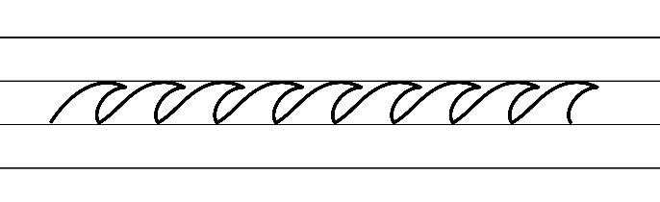  - Example NSW Foundation Style handwriting formation − diagonal joins to anticlockwise letters  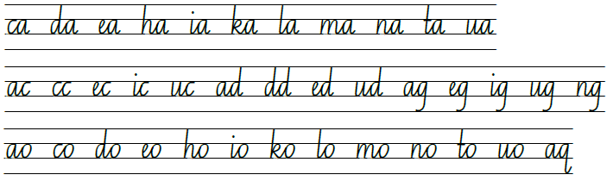  - Suggested practice text from the passage  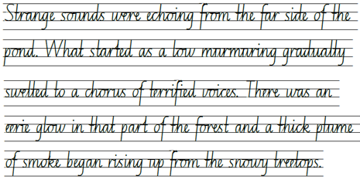

Planning framework
To plan and document Component A teaching and learning, a planning scaffold (DOCX 228 KB) is provided. To support you in your planning, a link to a detailed example of a one-week teaching and learning cycle is included in the scaffold. Additional resources to support teaching and learning in each focus area can be found at Lesson advice guides.

Component B teaching and learning
The following teaching and learning sequence has been designed to address Component B outcomes and content and develops conceptual understandings of English through the study of quality texts. Adapt the sequence as required to best meet the needs of your students.

Learning intentions and success criteria
Learning intentions and success criteria are best co-constructed with students.

Learning intention
Students are learning to analyse and describe representations of ideas through narrative and apply narrative conventions when creating texts.

Success criteria
Students can:
- identify and create a complication
- analyse and use literary techniques to build tension in writing
- understand how authors use dialogue and quotation marks to support characterisation
- analyse and create a climax in a narrative.

Lesson 9 – identify and create a complication
- Rewatch the video Origins (2:09). Ask students to explain why they think the video is titled Origins. Record student ideas.
- As a class complete a Frayer diagram to understand what the word ‘origin’ means.
- Reinforce the idea that the meaning of origin is where you came from, your ancestry and is connected to the concept of belonging. In pairs, students turn and talk to share their understanding of the concept, belonging. As a class write a definition of belonging. For example, belonging means someone feels like they are a valued or important member of a group such as family, friends, school.
- Revisit the video Origins and discuss the overarching complication.
- Reinforce the idea that the overarching complication is that the robot feels like he does not belong and wants to know where he came from (his origins).
- Ask students to consider what thoughts and feelings the robot was experiencing. For example, confused, lost, scared, not having a sense of belonging. Ask students how they know. For example, the robot was alone and it did not seem to know what the logo on its body meant.
- Revise student understanding of adverbial clauses learnt in Component A. Reinforce the idea that an adverbial clause is a dependent clause that modifies a verb, adjective or another adverb (NESA 2024). Adverbial clauses begin with a subordinating conjunction, such as: after, although, as, because, since, until, when, while. They tell us how, when, where and why, and provide information about the time, place, condition, reason, manner or purpose. For example: As the robot roamed through the forest to investigate, (adverbial clause of reason) it became increasingly lost and confused.
- Revise student understanding from Component A, that a comma is used to separate the subordinate clause (adverbial clause) when placed before the main clause. When the adverbial clause follows the main clause, no comma is required.
- Record sentence starters about the robot in Origins. Ask students to complete sentences by adding an adverbial clause at either the beginning or end of the main clause. For example:
- Why (adverbial clause of reason): The robot felt all alone because it didn’t have any friends or a place to call home.
- Where (adverbial clause of place): The robot discovered train tracks where there was a clearing in the forest.
- When (adverbial clause of time): When the robot stumbled across a fast-moving train, it quickly jumped onto it.
- How (adverbial clause of manner): The robot slumped into a dark corner as if it was nervous and afraid.
- Use think-alouds and the enlarged copy of Resource 8 – Freytag’s pyramid planning template to model writing the complication for the science fiction narrative. For example:
Now reader, despite his advanced capabilities, LR8 felt an overwhelming sense of loneliness, like a small bird separated from its flock. He yearned for companionship, someone, or something to make sense of this vast and unfamiliar world. He felt lost like leaves in the autumn wind. 'Where do I belong?' he whispered softly to himself, while looking at the logo on his robotic torso.
Suddenly, LR8 suddenly saw something unusual engulfing the sky. It was billowing smoke. As he roamed through the forest to investigate, LR8 became increasingly lost and confused. His sensors and circuits hummed with uncertainty. While he shuffled through the dense foliage, his mechanical heart pounded with a mix of curiosity and trepidation. Suddenly, through a small clearing in the vast forest, LR8 stumbled upon a train. It was such a wondrous sight! Astonishingly, this train had the very same logo as LR8 itself. Our robot started to have feelings of both intrigue and wonder.
- Ask students to identify and analyse the effective use of verb, verb groups and adverbial clauses in the modelled example. Discuss how the use of verbs and verb groups can add tension to the event. For example, suddenly saw, engulfing the sky, roamed, hummed, pounded.
- Students write the complication for their science fiction narrative using Resource 8 – Freytag’s pyramid planning template. Students will continue writing their narrative in Lesson 10.
Too hard? Students work in small groups to co-construct the complication with the teacher.
Too easy? Students elaborate on their complication by writing the first tension building event.
- Students revise and edit their writing to ensure correct use of punctuation, spelling and underline the effective use of verbs, verb groups and adverbial clauses.
- Read The Wild Robot, Chapters 46 to 49. Reflect on the similarities and differences between the text The Wild Robot and animation, Origins.
Assessment task 5 – observations and work samples from this lesson allow students to demonstrate achievement towards the following syllabus outcome and content point:
EN3-CWT-01 – plans, creates and revises written texts for multiple purposes and audiences through selection of text features, sentence-level grammar, punctuation and word-level language
- experiment with the placement of adverbial clauses, to modify the meaning or to add detail to a verb or verb group
- use a comma to separate a subordinate clause or a phrase from the main clause, or to separate information within a sentence, or to separate items in a list.

Lesson 10 – analyse and use literary techniques to build tension
- Revisit Chapter 46: The Fight. In pairs, ask students to identify the rising action or tension building events and climax. List these on an individual whiteboard. Ask students to share ideas and record on chart paper. For example:
- Rising action (Tension building event 1): Roz ran into the bickering bears who were verbally threatening to hurt her.
- Rising action (Tension building event 2): The bears growled. The bears attacked. They clawed, thrashed, slashed and wrestled her, ignoring Mother Bear’s instructions to stop.
- Climax (a dramatic event or another complication): Thorn twisted Roz’s foot and popped it off her leg, which plummeted to the shore. Thorn tumbled off the cliff.
- Revise literacy techniques authors use to build tension and engage the reader such as imagery, repetition, onomatopoeia, alliteration and dialogue.
- As a class record the literary techniques identified in Chapter 46 used to build tension in the fight scene between Roz and the bears. Add examples to the chart paper from activity 1. For example:
- imagery: ‘howl’
- repetition: ‘Poor Roz was in serious trouble. The bears were closing in on her, but she couldn’t run, she couldn’t hide, and she couldn’t fight. The robot didn’t know what to do.’
- onomatopoeia: ‘thwip’
- alliteration: ‘bickering bears’
- dialogue: ‘Whatever you are, we don’t like you,' said Thorn. 'Please don’t drop me, Roz! I don’t want to die!'
- Rewatch the rising action and tension building events in Origins (0:33–1:31).
- Discuss and record examples of literacy devices that could be included in the second tension building event. For example:
- imagery: The robot was enveloped in shadows.
- personification: The wind whispered secrets through the cracks and crevices of the train.
- alliteration: The robot's digital eyes darted, diligently scanning the passing landscape, seeking solace in the shimmering, shifting lights outside.
- dialogue: While the train sped along, the robot whispered to itself, 'Where do I truly belong? What secrets shall this journey unveil?'
- Use think-alouds and the enlarged copy of Resource 8 – Freytag’s pyramid planning template to model writing the rising action (series of events) for the science fiction narrative. For example:
Now reader, you will be surprised with what our robot does next. With a leap of anticipation, LR8 hopped onto the train, his metal joints clinking in rhythm with the rolling wheels. He slumped into a dark corner, enveloped in shadows, isolating himself from the world. The rhythmic chugging of the train echoed through the carriage. While the train sped along, he whispered to himself, 'Where do I truly belong? What secrets will this journey unveil?'
As the train hurtled forward, LR8 woke up in the darkness and felt disorientated. The wind whispered secrets through the cracks and crevices. LR8’s digital eyes scanned the passing landscape, seeking solace in the flickering lights outside. Inside the cabin, a flicker of determination sparked within his circuits. The train's wheels continued to spin carrying LR8 toward an unknown destination. Each click and clack of the tracks was a step closer to unearthing answers. In the depths of the dark corner, LR8’s resolve grew stronger. He whispered nervously to the shadows, 'I will uncover the truth, even if it takes me to the ends of the world.'
- Students use their copy of Resource 8 – Freytag’s pyramid planning template to continue writing their science fiction narrative by recording the next event paragraphs describing the rising action events and tension.
Too hard? Work with a small group of students to co-construct the next event paragraphs describing the rising action.
Too easy? Students include a variety of literary devices in their writing.
- Students revise and edit their writing for correct use of punctuation, spelling and ensuring that they have included literary techniques.
- Read The Wild Robot, Chapters 50 to 54. Reflect on how the reader’s personal connections to the characters in the text help connect the reader and create enjoyment. Display guiding questions to scaffold student reflection. For example:
- What emotions do you feel towards the characters and how does this affect your interactions with the characters?
- Do you personally relate to any of the characters?

Lesson 11 – characterisation through patterns and dialogue – Roz 2
- Revise the idea that sometimes the patterns in narratives are subverted or unexpected, which influences how a reader engages or enjoys a text. Read The Wild Robot, Chapters 55 to 58.
- Support students to analyse character patterns in the text by posing the following questions:
- Did the subverted or unexpected character patterns enhance or detract from your enjoyment of the story? Why?
- How did Roz’s subversion of character patterns affect your perception of robots and artificial intelligence?
- Did Roz’s transformation and development of emotions make you reconsider the relationship between machines and living beings? Why or why not?
- Reinforce student understanding of the subverted character patterns of Roz in The Wild Robot. For example, her character challenges the traditional robot model and expectations of artificial intelligence. She develops emotions and forms meaningful relationships with the animals on the island, showcasing her capacity for growth and empathy.
- Revise how Peter Brown developed Roz’s character throughout the text so far, including her appearance, actions, thoughts, personality and motivations.
- Explain that this lesson will focus on analysing the development of Roz’s thoughts and emotions.
- Discuss how the use of dialogue in a story can support characterisation by revealing a character's personality, motivations, relationships, and emotions.
- Revise student understanding that quotation marks tell us which character is speaking. Remind students that when a new character is speaking the author starts a new line to make this clear for the reader.
- Provide examples of dialogue from the text that support characterisation. Ask students to infer the author’s purpose for including it. For example, ‘“Please stay away!' said the robot’ (p 34) shows Roz is feeling scared and makes the scene more dramatic. ‘“I am going to miss you too,” said Roz as she nuzzled her son’ (p 170) shows the close relationship that has developed between Roz and Brightbill and portrays Roz’s feelings of sorrow as Brightbill leaves during the migration.
- Display an enlarged copy of Resource 15 – robot torso. Use question prompts to discuss Roz’s feelings and emotions. List key words from the discussion on the enlarged copy of Resource 15 – robot torso. For example:
- What are some of the emotions and feelings Roz has experienced as her character developed?
- How does Roz's initial lack of emotions and feelings contribute to your understanding of her character at the beginning of the story? How does it change as the story progresses?
- What are some key moments or interactions in the book where Roz exhibits emotions or feelings? How do these instances affect your perception of her as a character? Some examples that could be discussed:
- confusion: Chapter 15: The Escape
- curiosity: Chapter 20: The Language of the Animals
- loneliness: Chapter 21: The Introduction
- compassion: Chapter 25: The Egg
- joy: Chapter 34: The Mother
- fear: Chapter 35: The First Swim
- sadness: Chapter 53: The Migration.
- Model how to write a character analysis about Roz’s emotions and record the evidence from the text, such as Roz’s dialogue to support it. For example:
Beginning of the text: Chapter 15: The Escape
Emotion/feeling: Confusion.
Evidence from the text: ‘“I do not understand you, bears,” said the robot.’
Author’s purpose: To show the overarching complication and demonstrate Roz’s lack of understanding and feelings.
Middle of the text: Chapter 53: The Migration
Emotion/feeling: Sadness
Evidence from the text: ‘“I am going to miss you too,” said Roz as she nuzzled her son.’
Author’s purpose: To demonstrate Roz’s love for Brightbill and how her emotions have developed throughout the text.
At the beginning of the story, the quote ‘“I do not understand you, bears,” said the robot’, shows that Roz felt confused and disorientated as she adapted to her new environment. When she encountered the animals on the island, she was initially perplexed by their behaviours and communication. She struggled to understand their sounds and movements, leading to confusion about how to interact with them. An example of this is her encounter with the bears.
By the middle of the story, Roz developed a greater understanding of the animals by watching their behaviours and learning their language. As the text progresses, her emotional connection and relationship with the animals deepens. For example, the quote, ‘“I am going to miss you too”, said Roz as she nuzzled her son.’, shows that she has developed a love for her son Brightbill and will miss him, while he is away, during winter migration.
- Select and display 2 or 3 sections of text from the list of chapters in the activity above. In pairs, students select 2 sections of text to analyse. Students use the modelled example to write a character analysis using evidence from the text to show how Roz’s feelings and emotions develop throughout the text.
- Students share their character analysis with the class.
- Ask students to reflect and discuss how the narrative might be different if Roz’s character was cruel, unhelpful and emotionless.
Assessment task 6 – observations and work samples from this lesson allow students to demonstrate achievement towards the following syllabus outcome and content point:
EN3-CWT-01 – plans, creates and revises written texts for multiple purposes and audiences through selection of text features, sentence-level grammar, punctuation and word-level language
- use quotation marks consistently across a text to distinguish words that are spoken by characters in dialogue or words authored by others.

Lesson 12 – analyse and create a climax (dramatic event or complication)
- Discuss student understanding of a climax (dramatic event or complication) within a narrative.
- Revise the idea of patterns in narratives, how they set up expectations and can be subverted or unexpected. For example, in The Wizard of Oz Dorothy is transported to the magical land of Oz, hoping to find a way back home. Along her journey, she meets a group of friends. A subverted climax (dramatic event or complication) arises when they finally meet the wizard, only to discover that he is a fraud.
- Students Think-Pair-Share familiar narratives and identify the climax (dramatic event or complication). Ask students to analyse and discuss whether the rising action, events and climax followed a predictable or unexpected/subverted pattern. Students provide reasons for their responses.
- Revisit The Wild Robot and recall the various events that led to the climax in the story. Plot these events on chart paper in the order they occurred in the text.
- Rewatch the video Origins (2:09) and focus on the build-up of tension and climax in the last scene of the video. For example:
Climax (dramatic event or complication): The robot leapt off the train and began walking cautiously through the factory. Machines charged around the factory, quickly and concisely completing their programmed jobs. The robot jumped out of the way, invisible to the machine. It was lost, alone and in danger.
- Students revisit their own copy of Resource 8 – Freytag’s pyramid planning template. Explain that students will continue to create a climax for their science fiction narrative.
- Students revise their writing using a variety of sentences, such as short sharp sentences, to create tension. Display effective examples from The Wild Robot to support students in their writing, such as ‘All of a sudden, something burst out of the trees and onto the open clifftop. It was Mother Bear. She was gigantic, like a mountain of golden fur. And she was furious.’ (p 141).
- Remind students to use verbs to create movement in the scene. For example, run, hide, fight, clawed, slashed, grabbed, twisted, toppled, fell, hung, gripped.
- Students use the Think-Pair-Share strategy to brainstorm examples of short sharp sentences to include in their narrative and list these on individual whiteboards. Record student examples on an anchor chart.
- Students discuss and add ideas to their own copy of Resource 8 – Freytag’s pyramid planning template.
- Use think-alouds and the enlarged copy of Resource 8 – Freytag’s pyramid planning template to model writing a paragraph that ends with a climax for the science fiction narrative. For example:
Now reader, as he leapt off the train, our robot found himself in the heart of a bustling factory. Surrounded by whirring machines. LR8 knew he had to tread carefully and not to draw any attention to himself. As he cautiously navigated through the labyrinth of metal beasts, LR8 couldn't shake the feelings of danger, isolation, and vulnerability. The factory seemed vast and unwelcoming. He felt his circuits racing. He felt lost. He felt alone. LR8 dodged the angry machines that charged towards him. 'Beep, beep, beep!' blared his safety warning sensors as he fell to the ground.
- Use the modelled example from activity 12 to co-construct a success criteria for writing an effective climax. For example, I can write an effective climax which includes:
- literary devices
- verbs and verb groups
- adverbial clauses
- dialogue
- a variety of sentences including short sharp sentences.
- Students write a paragraph that ends with a climax for their science fiction narrative using the success criteria to guide their writing.
- Students read each other's writing and use the Two stars and one wish strategy to provide feedback based on the success criteria.
- Students edit their paragraph based on feedback provided.
- Read The Wild Robot, Chapters 59 to 63. Students turn and talk to identify any climatic events and discuss the narrative techniques used to create suspense.

Week 4

Component A teaching and learning
Component A focuses on the development of foundational skills and knowledge through regular, systematic and repeated practice. The mentor and supporting texts used in Component B of this unit can support the effective implementation of Component A teaching and learning.

Teaching guide
Guidance for explicit teaching, teaching notes, resources and examples for the related outcomes and content points have been provided in the table below.
Focus areas and teaching notes | Resources and examples
Reading comprehension  Reading fluently  - Syllabify, blend grapheme–phoneme correspondences and use morphemic knowledge as strategies for reading words accurately  - Locate and syllabify multisyllabic words, including those with morphemic suffixes (for example, -ing, -ly)  - For every syllable, there is at least one vowel phoneme.  - Morphemic suffixes usually form their own syllable.  - The morphemic suffix -ed forms a syllable when pronounced as ‘ed’ but does not when pronounced as ‘d’ or ‘t’. | Reading comprehension  Reading fluently  - Fluency and close reading passage 4 – Chapter 74: The Click page 249 from ‘Four robot hands...’ to page 251 ‘...Click.’ (287 words)  - Suggested words from the passage  - Morphemic information  - camouflaged – camouflage + ed  - pounded – pound + ed  - ignored – ignore + ed.  - Syllables  - camouflaged – 3 syllables  - pounded – 2 syllables  - ignored – 2 syllables.  Note: the passage from the text will need to be a teacher-created resource.
Reading for interest and wide purposes  - Adjust reading approach to suit the purpose for reading  - Adjusting the reading approach to suit the purpose for reading is crucial as different reading purposes require different strategies and skills.  - Close reading may be used for the analysis of texts, skimming could be used to locate key information, scanning might be used to identify key vocabulary, and note-taking could be undertaken for summarisation (NESA 2024). | Reading for interest and wide purposes  - Purpose of this passage: reading for enjoyment, to provide information about the complication in the text. Roz’s arms and legs are blown off during a battle with the RECO 1 robot who eventually deactivates her.  - Strategies  - re-reading to clarify meaning of the text, specifically around pronoun references  - slow reading rate to ensure the impact of the tension scene is understood  - read to accommodate unfamiliar vocabulary that builds tension leading to the complication.
Comprehending language  - Use morphology and etymology to work out the meaning of unfamiliar words  - Model breaking down unfamiliar words from the text into familiar parts using morphemes and discuss the etymology. Then, combine these parts to make inferences about the word's meaning. | Comprehending language  - Suggested unfamiliar words from the passage  - loomed, camouflaged, lurched, pounded, grappled, brutal, faint, charred, instincts, battered, ignored.  - Suggested unfamiliar words from Week 4 reading material  - hibernation (p 212), adopted (p 213), announcement (p 214), interruption (p 214), generation (p 214), excitement (p 215).
Monitoring comprehension  - Monitor and repair reading when meaning breaks down  - Meaning may break down when unfamiliar Tier 2 or Tier 3 vocabulary is included.  - A break in comprehension can occur when a text includes complex cohesive ties within and between sentences (pronouns).  - Students use Resource 2 – self-monitoring checklist, to monitor their own understanding of the text, to monitor their own understanding of the text. | Monitoring comprehension  - Unfamiliar Tier 2 or Tier 3 words may include loomed, camouflaged, lurched, grappled, brutal, hibernation, adopted, announcement.  - Meaning may break down if students cannot visualise the combat between Roz and RECO1. The use of short sentences with pronoun references describes the combat. Roz is consistently referred to as 'she' but RECO1 is referred to as 'the hunter' and 'he'. They are collectively referred to as 'the robots'.  - Resource 2 – self-monitoring checklist
Vocabulary  Learning and using words  - Identify newly encountered words from interactions and wide reading, and use them in writing, discussions and presentations  - Identify and discuss the meanings of newly encountered Tier 2 and Tier 3 words in the text to improve vocabulary knowledge and comprehension. | Vocabulary  Learning and using words  - Suggested vocabulary from the passage: loomed, camouflaged, lurched, pounded, grappled, brutal, faint, charred, instincts, battered, ignored.
Defining and analysing words  - Analyse morphemic structures of Tier 2 and Tier 3 words to determine their meaning  - Tier 2 words add power and precision to written and spoken language, but many Tier 2 words are most commonly found in written language and explicit teaching of these words is recommended (NESA 2024).  - Tier 3 words are technical words that are used in specific situations, such as activating, automatically, robotic.  - Understanding the meaning of different morphemes assists in determining an unfamiliar word’s meaning. | Defining and analysing words  - As above  Note: content in Vocabulary will support the focus areas Reading comprehension and Spelling.
Spelling  Phonological component  - Segment unfamiliar multisyllabic words into syllables and phonemes as a strategy when spelling  - Revise how to segment multisyllabic words into syllables, for example, grappled has 2 syllables.  - Revise how to segment multisyllabic words into phonemes, such as grappled has 6 phonemes (g-r-a-pp-l-ed).  - This is a phonological skill that should be practised regularly. | Spelling  Phonological component  - Suggested words from Week 4 reading material: factory, for, ignored, exploring.  - Sample words: informative, navigator, prior, choir, horror, forum, tutor, equator, organism, sense-sensory, direct-directory, participate-participatory, mandate-mandatory, invent-inventory, advise-advisory, migrate-migratory.
Orthographic component  - Recognise that the same grapheme can represent different phonemes  - Grapheme [or] represents phonemes /or/, /er/ and /schwa/.  - Highlight the different phonemes that are represented by the grapheme ‘or’. For example, flora /or/, worship /er/, visitor /schwa/.  - Note the grapheme’s position within base words. | Orthographic component  - As above
Morphological component  - Explain and use spelling conventions to add derivational suffixes to base words or roots.  - Introduce derivational suffix -ory: indicating ‘a place or something having a specific use relating to’, ‘characterised by’.  - Attaches to verbs to form nouns: observe-observatory, direct-directory.  - Attaches to verbs and nouns to form adjectives: sense-sensory.  - Teach drop the e rule: sense-sensory. | Morphological component  - As above  Note: content in spelling will support learning in the focus areas Vocabulary and Reading comprehension.
Creating written texts  Sentence-level grammar  - Revise: Make choices about verbs and verb groups to achieve precision and add detail  - Revise: verb groups (sometimes known as a complex verb or compound verb) containing auxiliary or 'helping’ verbs to indicate tense or modality, such as I am going soon. I must leave before dark.  - Revise verb groups contain 2 or more verbs, such as ‘The wolf huffed and puffed.’  - Revise verb groups with other words such as adverbs or prepositions, such as ‘The plane took off.’  - Revise: Experiment with the placement of adverbial clauses, to modify the meaning or to add detail to a verb or verb group.  - Review use of adverbial clauses.  - Adverbial clause: A dependent clause that modifies a verb, adjective or another adverb. It includes words that provide information about the time, place, condition, reason, manner or purpose (NESA 2024).  - Adverbial clauses begin with subordinating conjunctions, such as: after, although, as, because, since, until, when, while. These tell how, when, where and why. | Creating written texts  Sentence-level grammar  - Suggested sentences to demonstrate the use of verb groups from the text  - ‘Four robot hands were clamped around the rifle.’ (p 249)  - ‘And then the hunter suddenly lurched and twisted as he tried to rip the rifle away from his target.’ (p 249)  - ‘Seaweed fell from her body, as she was lifted right off the ground.’ (p 249)  Note: verb groups are highlighted in bold.  - Suggested sentences to demonstrate the use of adverbial clauses from the text  - Beginning of the sentence: ‘When the smoke cleared, shards of the rifle were everywhere’ (p 250). ‘With the target deactivated, RECO 1 calmly moved on to the next phase of his mission.’ (p 252)  - End of the sentence: ‘Brightbill watched in horror as his mother slowly disappeared under a pile of parts.’ (p 252)  Note: adverbial clause highlighted in bold.
Handwriting and digital transcription  Handwriting legibility and fluency  - Sustain writing with a legible, fluent and personal handwriting style across a text  - Form legible and fluent horizontal joins to short letters. These are sometimes known as neckline joins. The letters o, r, v, w and x join to the following letter with a horizontal join.  - There is slight dip in a horizontal join to a short letter.  - Form legible and fluent horizontal joins to tall letters.  - Horizontal joins meet the tall letter at line 2 (the neckline) and continue to the top of the letter before it is retraced back down. | Handwriting and digital transcription  Handwriting legibility and fluency  - Suggested fluency pattern  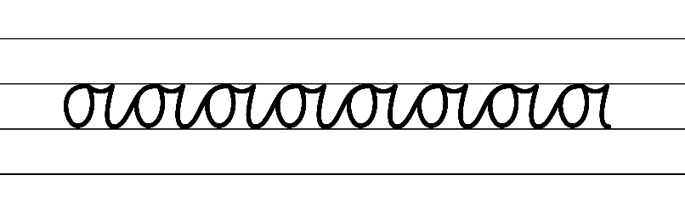  - Example NSW Foundation Style handwriting formation − horizontal joins to short letters  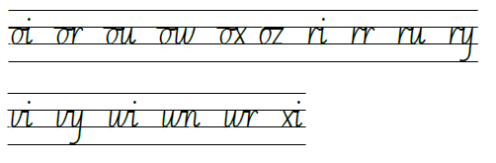  - Suggested practice text from the passage  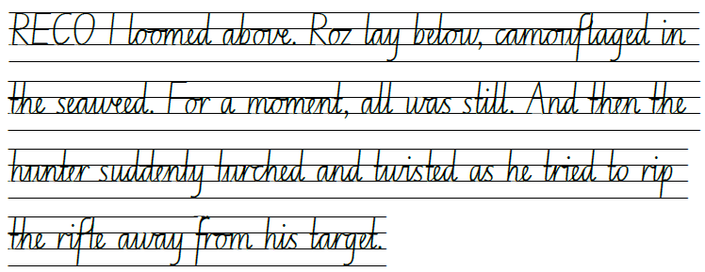

Planning framework
To plan and document Component A teaching and learning, a planning scaffold (DOCX 228 KB) is provided. To support you in your planning, a link to a detailed example of a one-week teaching and learning cycle is included in the scaffold. Additional resources to support teaching and learning in each focus area can be found at Lesson advice guides.

Component B teaching and learning
The following teaching and learning sequence has been designed to address Component B outcomes and content and develops conceptual understandings of English through the study of quality texts. Adapt the sequence as required to best meet the needs of your students.

Learning intentions and success criteria
Learning intentions and success criteria are best co-constructed with students.

Learning intention
Students are learning to analyse and describe representations of ideas through narrative and apply narrative conventions when creating texts.

Success criteria
Students can:
- analyse and discuss narrative resolutions
- write an effective resolution to a narrative
- analyse and discuss themes in narratives.

Lesson 13 – analyse and discuss narrative resolutions
- Activate students’ prior knowledge about what makes a good narrative resolution. Brainstorm ideas and add them to the concept map created in Lesson 1.
- Revise the idea of patterns in narratives, how they set up expectations and can be subverted or unexpected. For example, in Matilda by Roald Dahl, Matilda uses intelligence to outsmart Miss Trunchbull and bring justice to her school, rather than resorting to her telekinetic powers to directly overpower her.
- Explore a variety of effective resolutions and co-construct an anchor chart to record ideas. For example:
- Cliff hangers: leaving the reader in suspense. For example, The Jungle Book (2016). Mowgli decides to leave the jungle and return to the human village. As he sets off, the film ends with the tiger, Shere Khan, still lurking in the shadows, hinting at the possibility of future confrontations.
- Unexpected endings: something unpredictable happens. For example, Big Hero 6 (2014). The film follows the bond between a young robotics prodigy named Hiro and his robot companion, Baymax. The surprise ending reveals the survival of a presumed-dead character, leading to an emotional and unexpected reunion.
- Funny endings: something that makes the reader laugh. For example, Despicable Me (2010). After Gru’s change of heart and transformation into a loving father figure, the film ends with the Minions performing a silly dance routine at the girls’ ballet recital, providing a comical conclusion.
- Circular endings: stories that circle back to the beginning. For example, The Lion King (1994). The film begins and ends with the presentation of Simba, the future king, on Pride Rock. This circular structure symbolises the circle of life and the cyclical nature of Simba’s journey.
- Arrange students into groups and provide each one with an enlarged copy of Resource 16 – predicting possible endings. Allocate groups a different type of resolution/ending; cliff hanger, unexpected, funny or circular. Groups brainstorm ideas for the ending of The Wild Robot based on their allocated ending. For example, an unexpected ending could be a scientist, who arrives on the airship, telling Roz she was part of an experiment to see if robots could develop feelings and emotions.
- Students independently write a resolution to The Wild Robot based on one of the ideas.
- Students share their resolution with a partner and evaluate its impact on the reader.
- Read The Wild Robot, Chapter 64 to 72. Discuss the chapters read and analyse the narrative conventions used to engage the reader through models of behaviour.

Lesson 14 – write an effective narrative resolution
- Read The Wild Robot, Chapters 73 to 80. While reading, focus on the narrative techniques used by Peter Brown as the story enters its final chapters. Discuss and add ideas to the resolution anchor chart.
- Revisit the different types of narrative resolutions (cliff hanger, unexpected, funny and circular) from Lesson 13.
- Present examples of effective and ineffective narrative resolutions without explaining what each recorded example is. For example:
- A young wizard restores harmony and becomes a hero in the enchanted land. (effective)
- A lost puppy finds a loving forever home. (effective)
- A brave young explorer uses her intelligence and strength to save her land and becomes a wise and respected leader. (effective)
- They all lived happily ever after. (ineffective)
- Then I woke up and it was all a dream. (ineffective)
- In pairs, students analyse each possible ending, evaluate its impact on the reader and record key characteristics of an effective resolution.
- Ask students to share their thinking and as a class co-construct a definition for an effective resolution to add to the classroom display created in Lesson 1. For example, effective resolutions solve the main problems or challenges and achieve the character’s goals. It may convey an important message or lesson and the reader is left with a sense of satisfaction. This is called a ‘coda’.
- Watch the video Origins (1:33–2:09) and consider the narrative resolution. Ask:
- How were the main problems or challenges of the story resolved?
- How did the main character evolve or change throughout the story?
- What type of ending did the author use? (Origins has a circular ending, connecting the viewer back to the forest in the beginning.)
- What techniques did the author use in the resolution? Were they effective? For example:
- Emotions and expressions: the character’s feelings and emotions were shown through his face, body language, and movements.
- Music and sounds effects: the heavy and dramatic music changed to a light and hopeful mood in the resolution.
- Colour and lighting: the warm autumn colours of the forest provided a contrast to the cold and clinical factory allowing the viewer to see the character was more comfortable in the natural environment.
- Symbolism: the use of the leaf (to symbolise where he belonged) and the logo (to symbolise where he came from) represented a deeper meaning, allowing viewers to make insightful connections between the symbols and the theme of belonging.
- Using Origins as a stimulus, students Think-Pair-Share a resolution for their science fiction narrative. Students record their ideas on their copy of Resource 8 – Freytag’s pyramid planning template.
- Use the class definition of an effective resolution to co-construct a success criteria to support writing. For example:
- main problems or challenges are solved
- the reader is left feeling satisfied
- characters’ goals are achieved.
- Use think-alouds and the enlarged copy of Resource 8 – Freytag’s pyramid planning template to model writing a resolution for the science fiction narrative. For example:
To our robot’s surprise, a strong arm lifted him off the ground and whisked him away from danger. As he looked up, LR8 saw similar robotic eyes looking at him with curiosity and concern. 'Hi, my name is LW8. You are safe now but stay away from there or you will become scrap metal.' LR8 looked closer and to his surprise saw that the robot had the same logo as him. LW8 explained that she also went in search for her origins and was nearly killed by the metal beasts in the factory. Both robots looked happily at each other and realised they had come searching for the same thing. Whilst they didn’t find a home, they had found each other.
- Students write their resolution. Remind students to refer to the co-constructed success criteria as they write.
Too easy? Students come up with a subverted or unexpected resolution to the narrative.
- Students use the co-constructed success criteria to reflect on their writing and identify whether their resolution followed an expected or subverted pattern.
- Students revise and edit their writing.

Lesson 15 – analyse and discuss themes in narratives
- Revise narrative conventions and explain that narratives present models of behaviour. Explain how authors use events to create an overarching idea or message. Ask students to discuss:
- What message is the author of The Wild Robot trying to send? How do you know?
- What connections can be made to the text? (text to text, self, text to self, text to world)
Note: theme is an overarching or recurring idea that describes attitudes or values that are perceived in a text. A theme may range from the understood ‘moral’ of a text to philosophical observations that the audience makes about the events, characters and experiences depicted in a text. A text may have more than one theme (NESA 2024).
- Use the guiding questions to identify the theme of The Wild Robot. For example:
- How did the characters react to problems?
- Roz (the protagonist): as a robot, Roz approached problems analytically and logically. She used her programming and problem-solving skills to find solutions. When faced with a language barrier, she learnt the language of the animals on the island to communicate and build relationships.
- The animals: initially, the animals on the island are wary of Roz because she is a robot and they viewed her as a potential threat. However, as Roz showed kindness and helps them, they gradually started to trust and depend on her. They reacted to problems by relying on their instincts and natural abilities. For example, when a fire threatens the island, the animals worked together to put it out, using their unique skills and cooperation.
- What important decisions did the characters make?
- Roz, a stranded robot, decided to adapt and survive on the uninhabited island. She learned the language of the animals, built relationships, and integrated into their community which proved vital for her survival and handling the obstacles she encountered. Roz made a conscious choice to approach the animals with kindness and assistance. Instead of isolating herself or being confrontational, she invested time and effort into learning their language and understanding their needs.
- The animals, initially wary of Roz, eventually trusted her and joined forces to overcome challenges like the destructive fire and protecting their territory. Their decisions highlighted their ability to overcome initial fears and collaborate for the benefit of the community.
- How did the characters grow and change?
- Roz evolved from an emotionless robot to a compassionate being, developing empathy and understanding through her interactions with the animals. She became caring, adaptable, and resourceful, expanding her problem-solving skills.
- The animals transitioned from fear of a monster to trust, accepting Roz as part of their community.
- What did the characters learn?
- Roz learned the significance of empathy, compassion, and forming connections with others, realising how they enrich her existence and purpose.
- The animals on the island learned the power of trust and acceptance, putting aside their initial fear of Roz and embracing her as a valuable ally, leading to the discovery of strength through unity, cooperation, and teamwork.
- Discuss and determine the themes from The Wild Robot using the discussion points from activity 2. Reinforce the idea that 3 major themes are belonging, survival and nature verses technology. Encourage students to relate each theme to their own lives using the question prompts below and write class a definition of each. For example:
- Belonging: the feeling of being connected to a group, community, or place, and feeling accepted and valued within that group.
- When have you felt a strong sense of belonging?
- What are some examples of groups or communities where you feel you belong?
- Survival: the ability to stay alive and adapt to different challenges and environments.
- What are some dangerous situations where your survival instincts have kicked in?
- What are some strategies we use to survive? For example, problem-solving, learning from others, adapting to new environments, and building relationships with others.
- Discuss the importance of these strategies in real-life survival situations as well.
- Nature verses technology: nature refers to the natural world, including plants, animals, and landscapes, while technology represents human-made inventions and advancements.
- How do Roz’s encounters with the natural world shape her understanding of the environment and her own identity?
- How do the animals on the island respond to the presence of a robot?
- What are the advantages and disadvantages of both nature and technology?
- Display an enlarged copy of Resource 17 – identifying themes. As a class, analyse and explore the theme of belonging in The Wild Robot. Model recording evidence from the text that demonstrates the theme. For example, Roz invites the animals into the nest to protect them from the harsh winter. Roz created a space where they all felt safe. They called a ‘truce’ which unified them, contributing to a sense of belonging.
- In small groups, students analyse and explore the theme of survival or nature verses technology from The Wild Robot.
- Students record their thinking for their chosen theme on Resource 17 – identifying themes.

Lesson 16 – analysing character development – Roz 3
- Read Chapters 75 to 80 inThe Wild Robot. While reading, review the themes of belonging, survival and nature verses technology explored in Lesson 15.
- Discuss the narrative coda in Chapter 80: The Sky, explaining that it provides a final resolution or insight into the events and characters, offering a sense of closure or reflection.
- As a class, reflect on the ending of the narrative and discuss if the events were expected or subverted (unexpected). For example: Did students expect that the ROSSUM robots would deactivate Roz, or that Brightbill, would get into danger? Was it expected that the animals would help to save Brightbill and Roz? Was it expected that in the end Roz would choose to leave the island?
- In pairs, students turn and talk to describe how patterns in narratives helped to set up expectations in The Wild Robot and discuss other instances when patterns were subverted. Students share their ideas with the class.
- Reinforce the idea that patterns in narratives play a crucial role in setting up reader expectations and can be effectively subverted to create surprises and generate new insights. For example, initially Roz, who is a robot, is rejected by the other animals on the island. This changes when she repeatedly acts with kindness and helps the animals. It is unexpected that in the end the animals work together to save Roz from the Rozzum robots. When the Rozzum robots are destroyed Roz leaves the island at the end, this is an unexpected turn of events.
- Remind students about the large-scale robot introduced in Lesson 5 and Lesson 11. Introduce an enlarged copy of Resource 18 – robot limbs and connect to an enlarged copy of Resource 15 – robot torso to complete the large-scale robot. The new parts of the robot will be used to represent Roz’s growth and transformation in relation to the themes of the text – belonging, survival and nature verses technology.
- Revise the techniques Peter Brown used to develop Roz’s character features including her appearance, actions, personality, motivations, thoughts and emotions.
- In small groups, students identify how Roz has grown and transformed since the beginning of the text. Select groups to share their thinking and support each group to elaborate on Roz’s physical features, emotions and personality.
- Students add new key words from the discussion to the enlarged copy of the robot torso.
- As a class, use a different limb to record evidence for each theme.
- Use question prompts to discuss Roz’s growth and transformation. Model using evidence from the text to support and elaborate on thinking. For example:
- Belonging (arm): What are some occasions where Roz’s sense of belonging changes throughout the text?
- no sense of belonging (Chapter 9: The Mountain)
- adapting to the animal community (Chapter 21: The Introduction)
- becoming a mother (Chapter 27: The Gosling)
- Survival (arm): When was Roz forced to use her programmed instincts to survive?
- avoiding danger to take care of herself (Chapter 5: The Robot Gravesite)
- understanding weather and natural disasters (Chapter 57: The Fire)
- creating shelter and a safe environment for Brightbill (Chapter 31: The First Night)
- Nature (leg): How did Roz adapt to the natural environment?
- learning from observation of animals (Chapter 18: The Camouflaged Robot)
- acquiring survival skills (Chapter 16: The Pine Tree)
- social integration with the animals (Chapter 29: The Beavers)
- Technology (leg): What challenges did Roz face as an artificial robot living in nature?
- integration with wildlife (Chapter 32: The Deer)
- environmental adaptation (Chapter 54: The Winter)
- emotional understanding (Chapter 60: The Fish)
- In small groups, students complete their own copy of Resource 18 – robot limbs using evidence from the text to show Roz’s growth and transformation.
- Using Resource 18 – robot limbs, students write a character analysis of how Roz’s character has developed throughout the text. For example:
Whilst Roz experiences confusion and loneliness at the beginning, as she forms connections and learns she develops a range of feelings including joy, fear, and sadness. Roz shows us how to survive in a tough environment by finding creative solutions to problems. As she befriends the animals and becomes a part of their community, Roz teaches us the importance of belonging and how technology can work together with nature instead of being separate from it.
- Using split pins, students construct their own Roz robot using their copy of the robot head, torso and limbs. Display these in the classroom.
- Ask students to reflect and discuss how the narrative might change if Roz’s character was unwilling to learn, transform and evolve.
Assessment task 7 – observations from this lesson allow students to demonstrate achievement towards the following syllabus outcome and content point:
EN3-UARL-01 – analyses representations of ideas in literature through narrative, character, imagery, symbol and connotation, and adapts these representations when creating texts
- describe how patterns in narratives set up expectations and notice when those patterns are subverted.

Week 5

Component A teaching and learning
Component A focuses on the development of foundational skills and knowledge through regular, systematic and repeated practice. The mentor and supporting texts used in Component B of this unit can support the effective implementation of Component A teaching and learning.

Teaching guide
Guidance for explicit teaching, teaching notes, resources and examples for the related outcomes and content points have been provided in the table below.
Focus areas and teaching notes | Resources and examples
Reading comprehension  Reading fluently  - Syllabify, blend grapheme–phoneme correspondences and use morphemic knowledge as strategies for reading words accurately  - Locate and syllabify multisyllabic words, including those with morphemic suffixes (for example, -ing, -ly)  - For every syllable, there is at least one vowel phoneme.  - Morphemic suffixes usually form their own syllable.  - The morphemic suffix -ed forms a syllable when pronounced as ‘ed’ but does not when pronounced as ‘d’ or ‘t’. | Reading comprehension  Reading fluency  - Fluency and close reading passage 5 – Chapter 75: The Last Rifle page 253 from ‘Brightbill hugged his mother’s face...’ to page 254 ‘...Brightbill fluttered away’ (288 words).  - Suggested words from the passage  - Morphemic information  - clattered – clatter + ed  - fumbled – fumble + ed  - oozing – ooze + ing  - gaping – gape + ing.  - Syllables  - clattered – 2 syllables  - fumbled – 2 syllables  - oozing – 2 syllables  - gaping – 2 syllables.  Note: the passage from the text will need to be a teacher-created resource.
Reading for interest and wide purposes  - Adjust reading approach to suit the purpose for reading  - The purpose for reading helps to determine the strategies that will be utilised. For example, if the purpose for reading is to understand the resolution of the story, the reader may re-read passages, slow rate and identify key words. | Reading for interest and wide purposes  - Purpose of this passage: reading for enjoyment, to provide information about the resolution in the text. The RECO 1 robot tries to kill Brightbill but the other animals work together to fire a rifle at it and kill it.  - Strategies  - re-reading to clarify meaning of the text  - slow reading rate to decode new vocabulary  - identify key words that help to build tension leading to the resolution.
Comprehending language  - Use morphology and etymology to work out the meaning of unfamiliar words  - Model breaking down unfamiliar words from the text into familiar parts using morphemes and discuss the etymology. Then, combine these parts to make inferences about the word's meaning. | Comprehending language  - Suggested unfamiliar words from the passage  - squirm, sloshed, vultures, talons, clattered, fumbled, clunky, gloom, oozing, gaping, unclenched.
Monitoring comprehension  - Monitor and repair reading when meaning breaks down  - Repairing reading might include pausing, self-correcting, re-reading or reading on; using phonic, morphemic and word knowledge; and reactivating background knowledge.  - Students use Resource 2 – self-monitoring checklist, to monitor their own understanding of the text. | Monitoring comprehension  - Resource 2 – self-monitoring checklist
Vocabulary  Learning and using words  - Identify newly encountered words from interactions and wide reading, and use them in writing, discussions and presentations  - Identify and discuss the meanings of newly encountered Tier 2 and Tier 3 words in the text to improve vocabulary knowledge and comprehension. | Vocabulary  Learning and using words  - Suggested vocabulary from the passage: squirm, sloshed, vultures, talons, clattered, fumbled, clunky, gloom, oozing, gaping, unclenched.
Defining and analysing words  - Analyse morphemic structures of Tier 2 and Tier 3 words to determine their meaning  - Tier 2 words add power and precision to written and spoken language, but many Tier 2 words are most commonly found in written language and explicit teaching of these words is recommended (NESA 2024).  - Tier 3 words are technical words that are used in specific situations, such as activating, automatically, robotic.  - Understanding the meaning of different morphemes assists in determining an unfamiliar word’s meaning. | Defining and analysing words  - As above  Note: content in Vocabulary will support the focus areas Reading comprehension and Spelling.
Spelling  Phonological component  - Segment unfamiliar multisyllabic words into syllables and phonemes as a strategy when spelling  - Revise how to segment multisyllabic words into syllables, for example, vultures has 2 syllables.  - Revise how to segment multisyllabic words into phonemes, such as vultures has 6 phonemes (v-u-l-t-ure-s). | Spelling  Phonological component  - Use suggested words from text and related words from the previous 4 weeks of learning.
Orthographic component  - Recognise that the same grapheme can represent different phonemes  - Revision: Consider the position of graph [a] and grapheme [or]. | Orthographic component  - As above
Morphological component  - Explain and use spelling conventions to add derivational suffixes to base words or roots.  - Revision: Derivational suffixes: -ate, -ive, -ative, -itive, -age, -ory.  - Consolidate previous 4 weeks of learning. | Morphological component  - As above  Note: content in spelling will support learning in the focus areas Vocabulary and Reading comprehension.
Creating written texts  Punctuation  - Revise: Use quotation marks consistently across a text to distinguish words that are spoken by characters in dialogue or words authored by others  - Quotation marks are used at the beginning and end of what is spoken by characters in dialogue or words authored by others.  - For dialogue with more than one character speaking, a change of line for each new speaker is used. | Creating written texts  Punctuation  - Suggested examples from the text, to demonstrate the use of quotation marks and dialogue  - 'Mama, wake up!'  - 'What happened?' she said finally. 'Where is the Reco?'  - 'He’s coming this way!'  - 'What are you thinking. Brightbill? You must leave before he kills us both!'  - 'I was scared, Mama!' cried the goose. 'I didn’t know what to do!'
Handwriting and digital transcription  Handwriting legibility and fluency  - Sustain writing with a legible, fluent and personal handwriting style across a text  - Form legible and fluent horizontal joins to anticlockwise letters, including to a, c, d, g, o and q.  - When a horizontal join is made to an anti-clockwise letter, the top of the letter is retraced a little. | Handwriting and digital transcription  Handwriting legibility and fluency  - Suggested fluency pattern  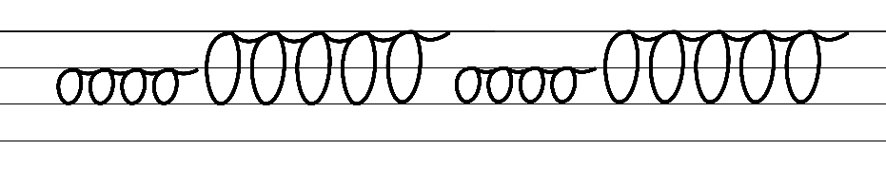  - Example NSW Foundation Style handwriting formation − horizontal joins to anticlockwise letters  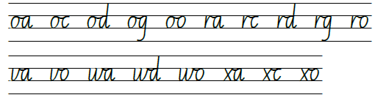  - Suggested practice text from the passage  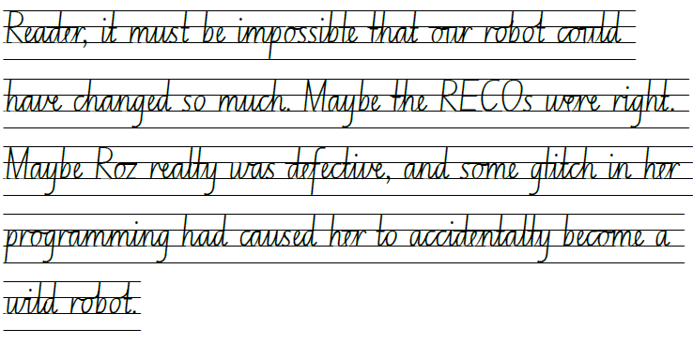

Planning framework
To plan and document Component A teaching and learning, a planning scaffold (DOCX 228 KB) is provided. To support you in your planning, a link to a detailed example of a one-week teaching and learning cycle is included in the scaffold. Additional resources to support teaching and learning in each focus area can be found at Lesson advice guides.

Component B teaching and learning
The following teaching and learning sequence has been designed to address Component B outcomes and content and develops conceptual understandings of English through the study of quality texts. Adapt the sequence as required to best meet the needs of your students.

Learning intentions and success criteria
Learning intentions and success criteria are best co-constructed with students.

Learning intention
Students are learning to apply narrative conventions when creating texts.

Success criteria
Students can:
- plan a narrative applying understanding of narrative conventions
- refer to success criteria to create a narrative
- revise, edit and publish a narrative
- reflect on learning.

Lesson 17 – plan a narrative
- Introduce Resource 19 – writing process. Explain that students will be working through this process to write their own science fiction narrative.
- Revisit previous learning on narrative conventions and patterns and why they are important. Explain how following a structure and pattern helps set up expectations, supports character development and contributes to a reader making sense of what they read.
- Display the images on Resource 20 – writing stimulus and provide time for students to compose an ‘I wonder’ question. Discuss student questions and provide opportunities for other students to respond with their own ideas.
- Explain that students will independently write a narrative about one of the 4 images using their acquired knowledge from the unit and that this lesson will focus on planning.
- Brainstorm ideas for each of the images and record on a class anchor chart. Encourage students to think of techniques that could be used to engage a reader, drawing inspiration from author Peter Brown. For example: vivid descriptions, imagery, repetition, onomatopoeia, alliteration and dialogue.
- Provide students with a blank copy of Resource 8 – Freytag’s pyramid planning template. Explain that this will be used as a planning template to support writing their independent science fiction narrative.
- Revisit features of the orientation, complication and resolution. For example:
- Orientation: characters, setting
- Complication: a problem
- Series of events: rising action, tension and a climax
- Resolution: different types of endings, coda.
- Students independently select an image and plan their narrative by recording key words onto their copy of Resource 8 – Freytag’s pyramid planning template. Encourage students to access information and ideas from the classroom display, previous learning, and inspiration from The Wild Robot and Origins.
- Students share and discuss the ideas from their plan with a partner.
- Students provide peer feedback, reflect and revise their plan.
Too hard? Students work in small groups to generate ideas. Add points to an enlarged blank copy of Resource 8 – Freytag’s pyramid planning template.

Lesson 18 – create a narrative – orientation
- Jointly construct success criteria to display and support students’ writing throughout Lessons 18 to 20. For example:
I can write an interesting narrative that includes:
- an engaging orientation that introduces characters and a setting
- a complication
- series of events – rising action, tension and a climax
- a resolution where the problem has been solved, using an impactful ending and coda
- narrative voice – could this include examples of first, second and third person voice
- literary features to add impact and engage the reader
- effective use of verbs, verb groups, adverbial clauses, dialogue
- the correct use of sentence structure, punctuation, paragraphs and spelling.
Note: students could identify what type of narrative voice they will use or if they will use multiple types of narrative voice.
- Remind students of the importance of the orientation in a narrative. Revisit examples from The Wild Robot and Origins, paying close attention to the setting, introduction of characters and the techniques the author used to engage readers, reminding students of narrative voice.
- Referring to their planning template, students write an engaging orientation focusing on the setting, characters and narrative voice.
Too hard? Work with small groups of students to jointly construct the orientation.
- Using the success criteria, students revise and edit their orientation paragraph.

Lesson 19 – create a complication and resolution and apply feedback
- Revise the features of a complication, series of events and resolution in a narrative.
- Revisit examples from The Wild Robot and Origins paying close attention to the series of events that build tension. Highlight how the author resolves the problem, by discussing the ending and coda.
- Students independently write the complication, series of events and resolution paragraphs, referring to their plan created in Lesson 17.
Too hard? Provide sentence stems for each paragraph or section of the narrative.
- Model how to effectively edit a piece of writing using the success criteria.
- Students use the success criteria to revise and edit their writing.
- In pairs, students take turns to read their narrative and provide peer feedback using the success criteria.
- Students use feedback to revise and continue to edit their writing.

Lesson 20 – publish, share and reflect on learning
- Discuss the purpose and process of publishing. Co-construct a success criteria for students to refer to. For example:
I can effectively publish a narrative that includes:
- carefully edited work
- illustrations that add meaning to the narrative
- a layout that is easy for the reader to follow.
- Students publish their narrative using either paper or a digital platform such as Microsoft Word, PowerPoint, Google docs, Book Creator or Canva for Education.
- Students share their narrative with an audience. For example, read their writing aloud to younger students, buddy classes or staff.
- After reading, students ask their audience to identify any narrative conventions that were used to make the text engaging. For example, engaging orientation, interesting setting, descriptive characters, unexpected complications, tension, interesting resolution and coda.
- Display students’ narratives or compile into a class book.
- Students analyse and reflect on what they have learnt during the unit. On a sticky note or exit ticket students write:
- One part of the unit they enjoyed the most
- Two parts of the unit they found interesting
- Three areas of improvement in their learning.
Assessment task 8 – observations and work samples from this lesson allow students to demonstrate achievement towards the following syllabus outcomes and content points:
EN3-CWT-01 – plans, creates and revises written texts for multiple purposes and audiences through selection of text features, sentence-level grammar, punctuation and word-level language
- experiment with characterisation
- choose and control narrative voice across a text
- experiment with the placement of adverbial clauses, to modify the meaning or to add detail to a verb or verb group
- use quotation marks consistently across a text to distinguish words that are spoken by characters in dialogue or words authored by others.
EN3-UARL-01 – analyses representations of ideas in literature through narrative, character, imagery, symbol and connotation, and adapts these representations when creating texts
- describe how narrative conventions engage the reader through models of behaviour and apply narrative conventions when creating texts.

Resource 1 – fluency and close reading passage 1
Focus | Notes
Passage | Chapter 3: The Robot (p 7), to Chapter 4: The Robot Hatches (p 8) (263 words)
Synopsis | These 2 passages introduce the main character (Roz the robot) and is part of the orientation to the narrative. It describes how she is activated and positions the reader to understand that this book is of the science-fiction genre.
Passage structure | - Introduction and description of the main character Roz the robot being activated.  - Description of the main character Roz the robot at the beginning of the text:  - What she says  - How she talks  - How/what she feels  - How she works  - How she functions.
Language features | Punctuation  - Use capital letters at the beginning of a sentence, to indicate proper nouns, for headings and subheadings, to indicate the beginning of a poetry line, for emphasis, and when using acronyms.  - Capital letters for chapter headings for example, ‘THE ROBOT’  - Capital letters for proper nouns for example, ‘Roz’  - Capital letter for the beginning of sentences.  - Use quotation marks consistently across a text to distinguish words that are spoken by characters in dialogue or words authored by others  - Dialogue is used in most of Chapter 3 to show that Roz is speaking. The first 2 sentences are the author’s voice. Dialogue is used to introduce the robot character.  - Examples of dialogue used in the text:  - 'Hello, I am ROZZUM unit 7134, but you may call me Roz. While my robotic systems are activating, I will tell you about myself.' (p 7)  - 'Thank you for your time.' (p 7)  - 'Hello, otters, my name is Roz' (p10)  Sentence- level grammar  - Make choices about verbs and verb groups to achieve precision and add detail.  - Sentences from the text including verb groups.  - The robot's computer brain booted up. (p 7)  - Her programs began coming online. (p 7)  - I will tell you about myself. (p 7)  - I am fully activated. (p 7)

Resource 2 – self-monitoring checklist
Students use the key below to label and monitor their own understanding of the text.
Key | Meaning
P | I understand this information.
? | I don't understand this information.
* | This is important information.
! | This is interesting information.

Resource 3 – vocabulary and morphology example 1
Sample word | Context | Morphology | Student-friendly definition
automatically | ‘And then, still packed in her crate, she [Roz] automatically started to speak.’ (p 7) | Base word: automatic (adjective)  Morpheme: -ally changes it to an adverb. | Automatically means that something happens all by itself, without needing someone to do it. For example, imagine a robot that cleans your room on its own without you giving it any instructions.
robotic | ‘While my robotic systems are activating, I will tell you about myself.’ (p 7) | Base word: robot (noun)  Morpheme: -ic changes it to an adjective. | Robotic means something that is like a robot or behaves like a robot. A robot is a special machine that can do different tasks or jobs.
systems | ‘While my robotic systems are activating, I will tell you about myself.’ (p 7) | Base word: system (noun)  Morpheme: -s changes the noun to a plural. | Systems are like teams that work together to get things done. A system is a group of things that work together to achieve a goal.
activating | ‘While my robotic systems are activating, I will tell you about myself.’ (p 7) | Base word: activate (verb)  Morpheme: -ing changes the tense to present. | Activating means to turn something on or start it up. It's like pressing a button or flipping a switch to make something come to life or work.
absorbing | ‘The robot felt her body absorbing the sun's energy.’ (p 8) | Base word: absorb (verb)  Morpheme: -ing changes it to present tense. | Absorbing means to soak up or take in something like a sponge. Just like when you use a sponge to soak up water, things can also be absorbed by other things.
curious | ‘She [Roz] was curious about the warm ball of light shining down from above.’ (p. 8) | Base word: curious (verb)  Morpheme: -ly changes it to an adverb. | Being curious means asking questions and wanting to learn about new things. It describes someone who wants to discover and understand the world.
restrained | ‘She [Roz] tried to life her arms, but they were restrained by cords.’ (p.8) | Base word: restrain (verb)  Morpheme: -ed changes it to past tense. | Restrain means to hold back or keep something or someone from doing something.
cords | ‘She [Roz] tried to life her arms, but they were restrained by cords.’ (p 8) | Base word: cord (noun)  Morpheme: -s changes the noun to a plural. | Cords are like special ropes or strings that help connect things together.

Resource 4 – predicting
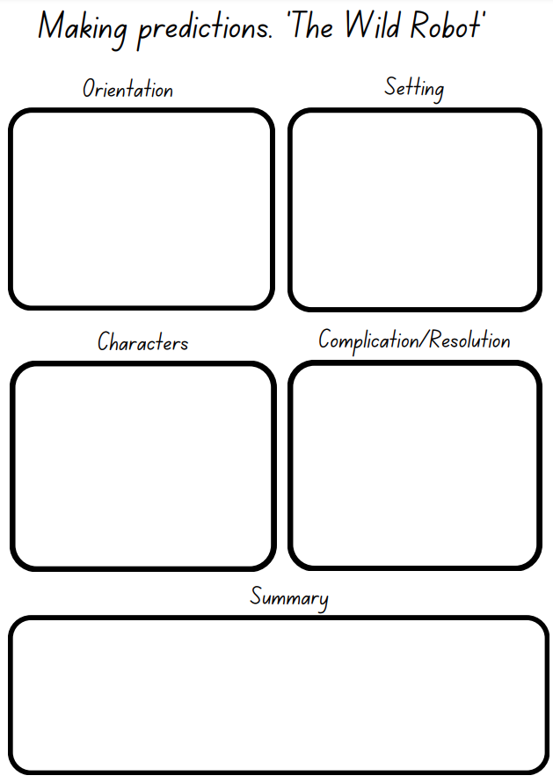

Resource 5 – key words – settings
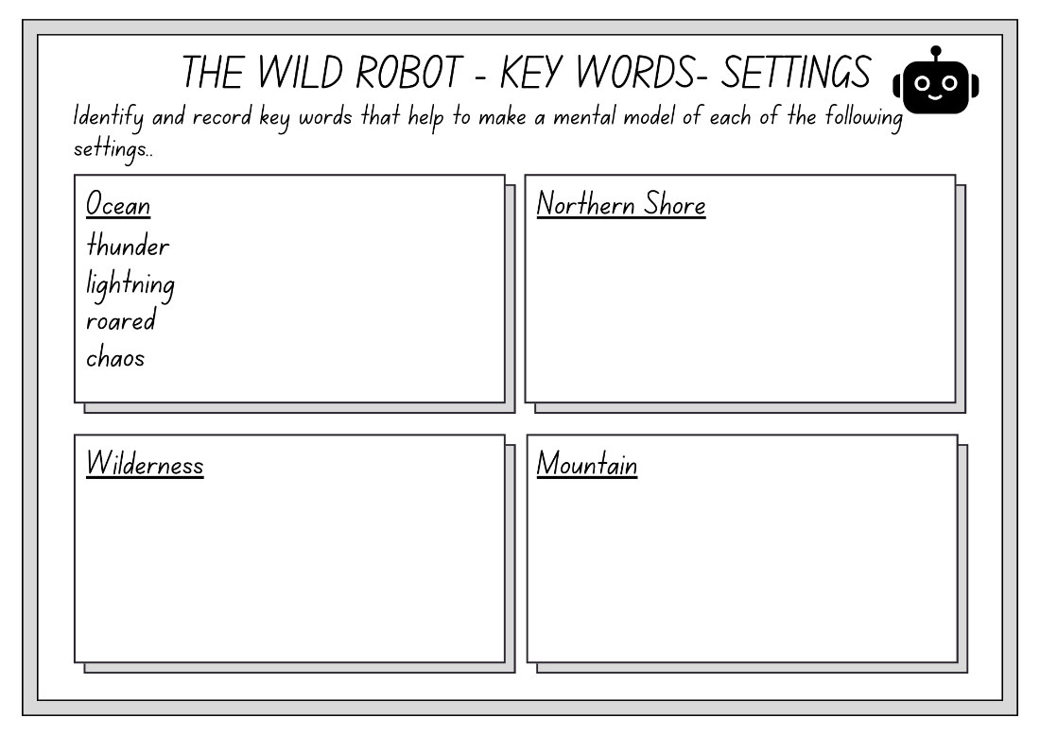

Resource 6 – setting quilt template
- Draw a picture to illustrate your mental model, of a setting from The Wild Robot, using key words from the text.
- Underneath, write an orientation for the text focusing on setting.
- Carefully cut around the dotted edges to form a whole-class wall display.
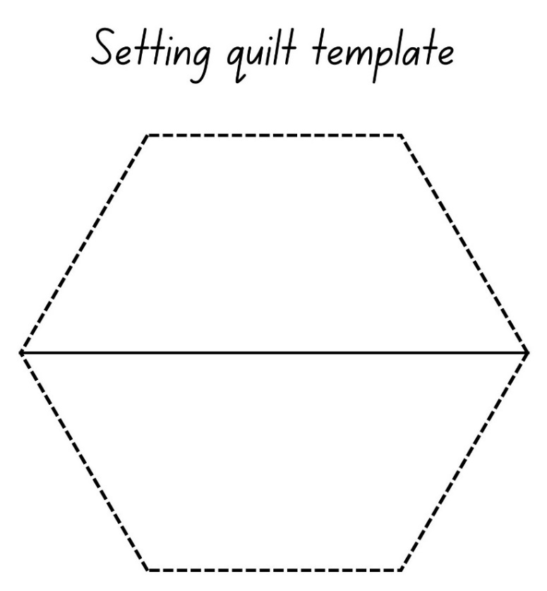

Resource 7 – story starters
Match the following story starter techniques with the text by writing the technique in the box provided. Can you find the ineffective story starter?
Setting starter | Imagery | Rhetorical question
Emotional appeal | Dialogue | Action

Story starter | Text
 | Alex slammed the book shut; frustration etched on his face. "I can't believe we're stuck in this dusty old library all day", he muttered to his best friend, Sarah, who was quietly reading beside them.
 | Sadie hugged her stuffed bear tight, tears streaming down her face. The move to a new town had been tough, and she felt lonely in her unfamiliar room. But as she wiped away her tears, a soft glow illuminated from under her bed, and a mischievous giggle filled the air.
 | As Lily stepped onto the golden sandy beach, the warm breeze tousled her hair and filled her lungs with the scent of the sea. The waves crashed against the shore, leaving a trail of seashells and seaweed in their wake.
 | Have you ever wondered what it would be like to travel through time? Well, Amelia had. And when she stumbled upon an ancient pocket watch in her grandfather's attic, she couldn't resist turning the hands, not realizing that with each tick, she was about to embark on an extraordinary adventure through the ages.
 | The sound of footsteps echoed through the dimly lit alley as Mia ran for her life. Her heart pounded in her chest, and every breath felt like fire in her lungs.
 | One fine day, I woke up. I got out of bed and went to the kitchen. I ate my breakfast then went and got dressed. Then I went to school.
 | The dense fog hung low over the ancient ruins, obscuring everything in its eerie grasp. Emily cautiously stepped forward, her footsteps muffled by the damp moss-covered ground. She was drawn to the ruins by an old legend, a tale of hidden treasures and the ghostly guardians who protected them.

Resource 8 – Freytag’s pyramid planning template
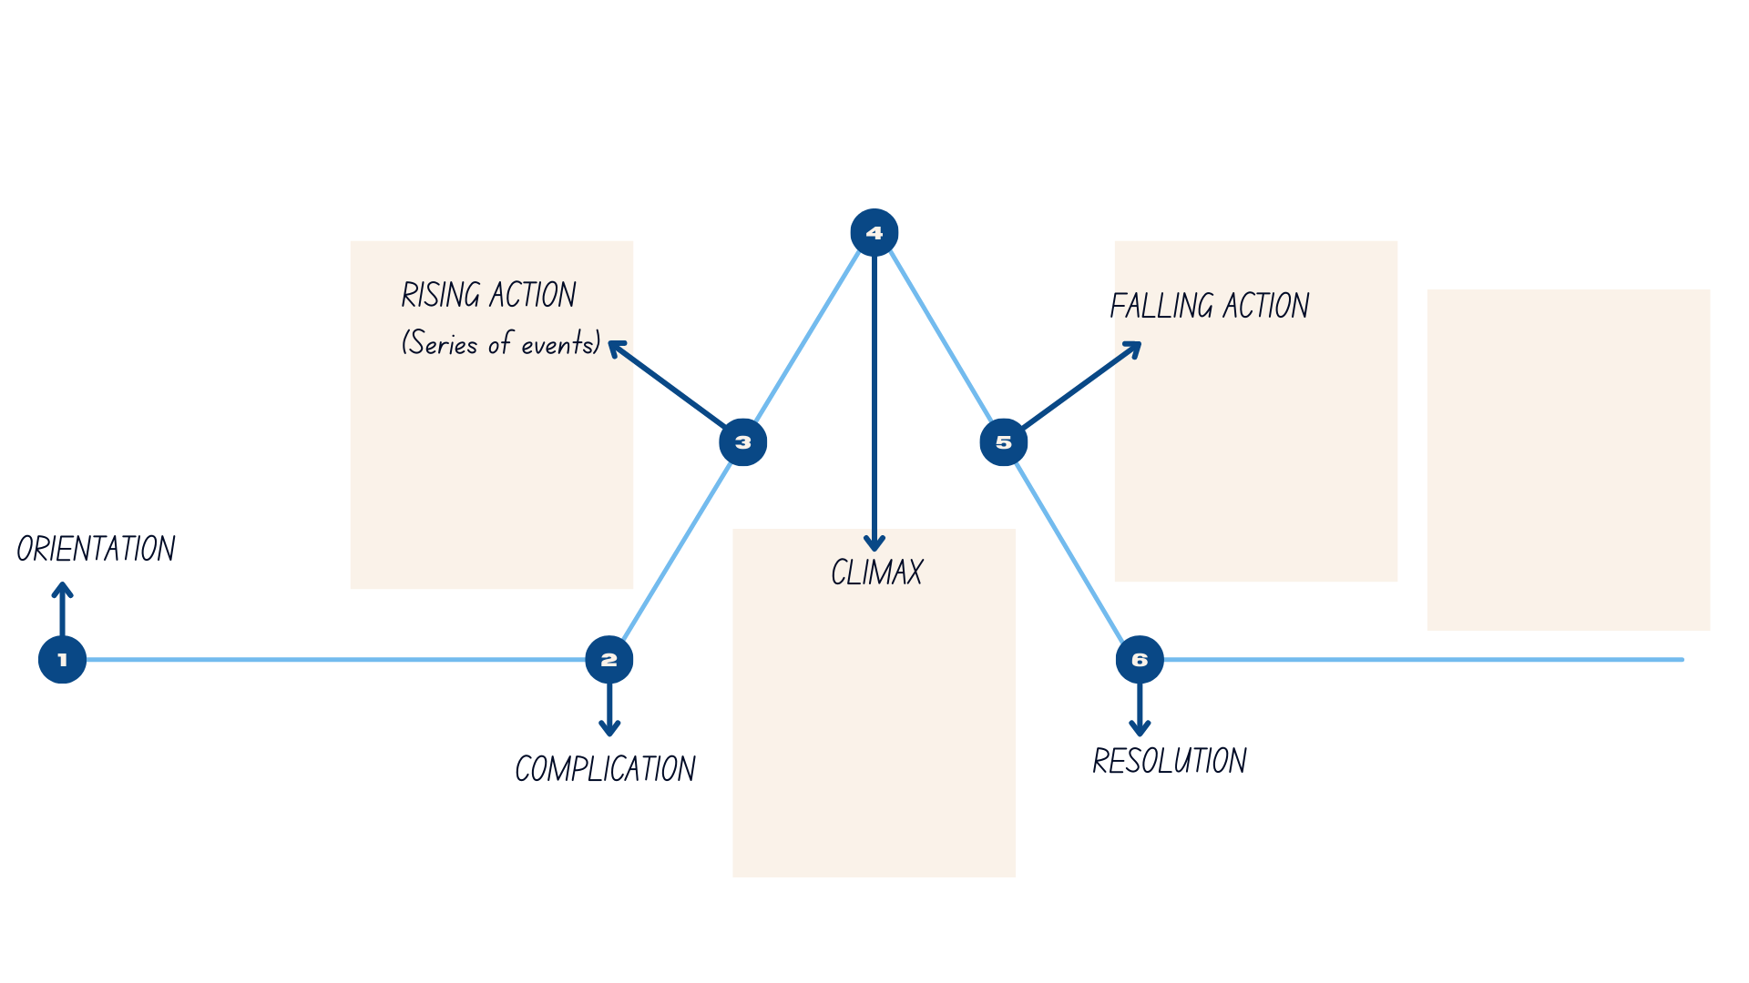

Resource 9 – vocabulary and morphology example 2
Sample word | Context | Morphology | Student-friendly definition
meandering | ‘He [Brightbill] was a slow tottering little thing, but Roz was rarely in a hurry, and together they loved meandering along the forest paths and around the banks of the pond.’ (p 96) | Base word: meander (verb)  Morpheme: -ing changes the tense to present. | Meandering is like going on a slow, leisurely stroll, enjoying the scenery, and not being in a rush to get anywhere specific.
attention | ‘Thanks to the robot’s [Roz] careful attention, it was now bursting with colours and scents and flavours.’ (p 96) | Base word: attend (verb)  Morpheme: -tion changes it to a noun. | Attention means focusing on something specific. It involves concentrating and noticing all the important details.
designed | ‘Clearly, Roz was designed to work with plants.’ (p 96) | Base word: design (verb)  Morpheme: -ed changes the verb to past tense. | Designed means when someone plans and creates something with a specific purpose in mind. It's like having a special plan or blueprint to make something just the way you want it to be.
eager | ‘And at the Dawn Truce, the other mothers were eager to share their parenting advice.’ (p 99) | Base word: eager (adjective)  Morpheme: -ly changes it to an adverb. | Eager means feeling really excited and enthusiastic about something. For example, when you can't wait to do or learn something because you're so interested and curious.
attentive | ‘No gosling ever had a more attentive mother.’ (p 99) | Base word: attend (verb)  Morpheme: -tive changes it to an adjective. | Attentive means paying close and careful attention to something or someone.
whisk | ‘Roz was always there, ready to answer her son’s questions, or to play with him, or to rock him to sleep, or whisk him away from danger.’ | Base word: whisk (verb)  Morpheme: -ed changes it to past tense. | Whisk means to quickly and swiftly take someone away from a potentially dangerous situation. Just like whisking ingredients in a bowl, it's like scooping up the person swiftly and carrying them to a safe place.
advice | ‘With a brain packed full of parenting advice, and the lessons she was learning on her own, the robot [Roz] was actually becoming an excellent mother.’ | Base word: advice (noun)  Morpheme: -sing changes it to a verb. | Advice means suggestions or ideas to help you make good decisions or solve a problem.
excellent | ‘With a brain packed full of parenting advice, and the lessons she was learning on her own, the robot [Roz] was actually becoming an excellent mother.’ | Base word: excel (verb)  Morpheme: -lent changes it to an adjective. | Excellent means something is really good or impressive. It's like when you do your absolute best on something and achieve great results.

Resource 10 – robot head
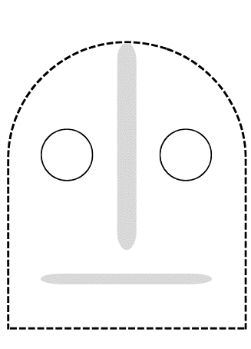

Resource 11 – comic strip
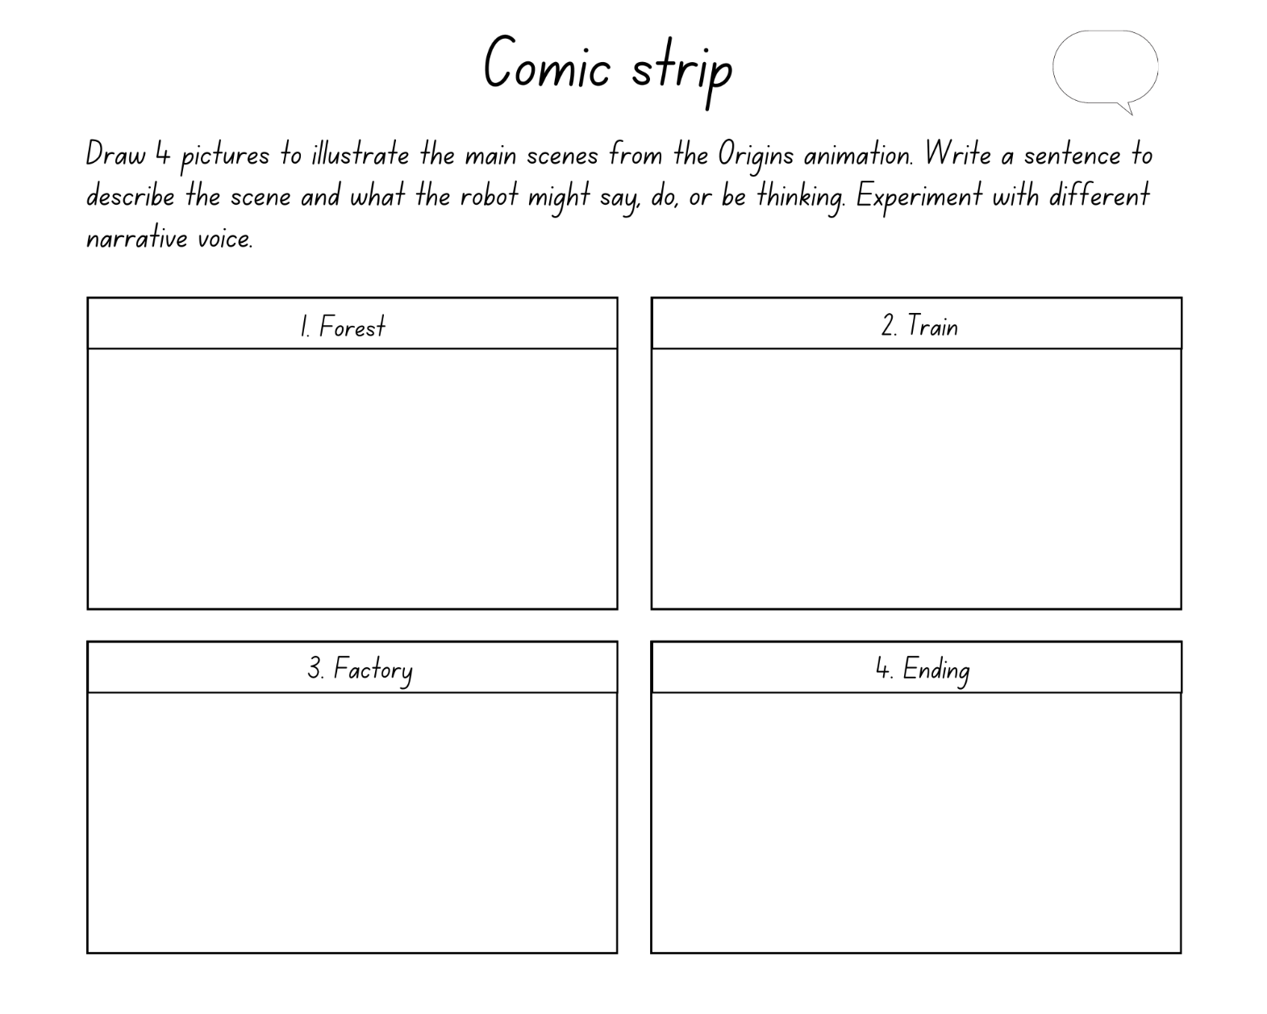

Resource 12 – characterisation template
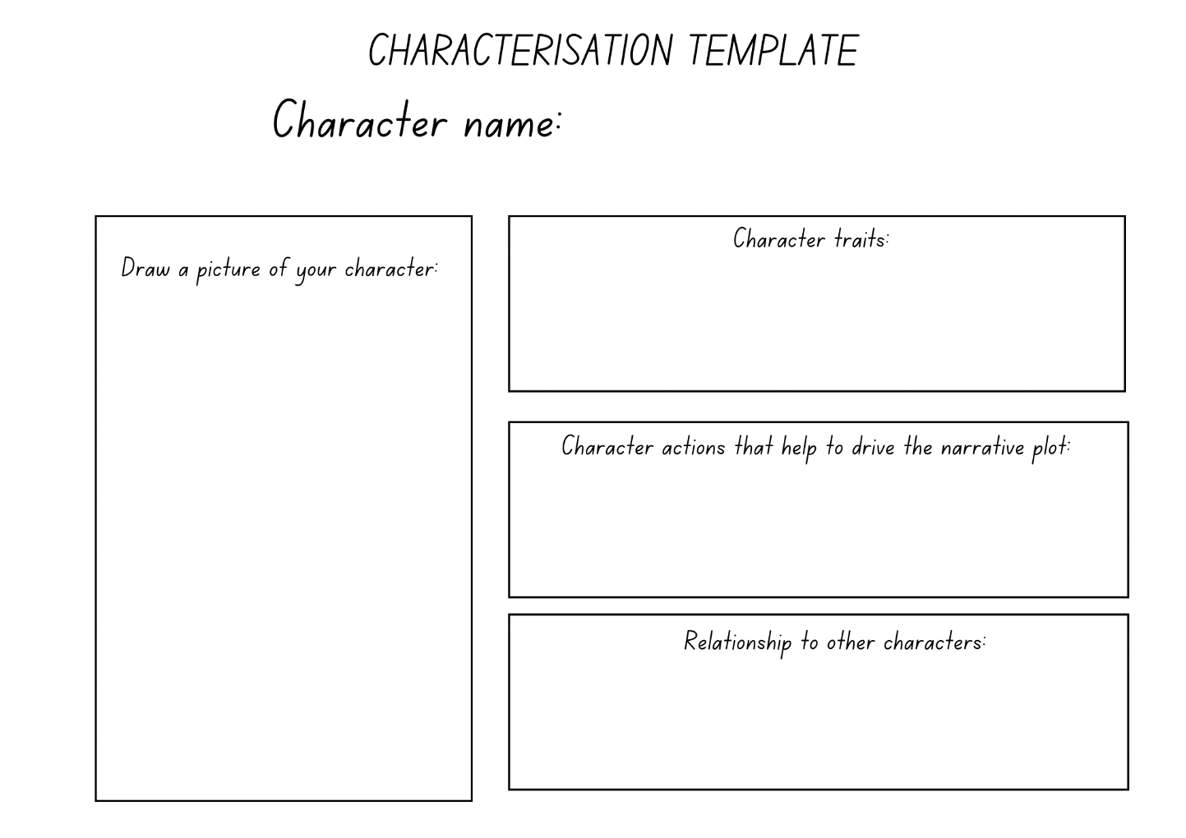

Resource 13 – fluency and close reading passage 3
Focus | Notes
Passage | Chapter 57: The Fire (p 185) from ‘Strange sounds were echoing...’ to (p 187) ‘... the charred foundation of the lodge.’ (320 words)
Synopsis | In this chapter Roz helps the animals who are stuck in a burning lodge.
Passage structure | - Introduction of a tension event as strange sounds are heard in the distance.  - Continuation of tension building and the introduction of the focalising/main character as Roz charges across the ice to the lodge.  - Continuation of tension building as Roz finds the lodge engulfed in flames and the animals fleeing for their lives.  - Climax of tension building and complication as a mother cries for help because her baby is trapped in the burning lodge and Roz charges for the rescue.  - Resolution of the complication in this part of the story as Roz saves the baby and puts out the fire.
Language features | Creating written texts  - Use a comma to separate a subordinate clause or a phrase from the main clause, or to separate information within a sentence, or to separate items in a list  - Subordinating clause: when placed at the beginning of the sentence; multiple clauses. For example, ‘Now that everyone was safely away, the robot turned her attention to putting out the fire.’ (p 186).  - Separate information: For example, ‘Then with all the strength in her legs, Roz launched herself high up into the snowy branches of the nearest pine tree’ (p 186).  - Exclamatory sentences: creates a sense of urgency within the passage  - ‘We put too many logs in the fire pit!’ ‘My baby is still in there!’ (p 185)  Descriptive language  - Personification: ‘...a chorus of terrified voices...’ ‘The flames climbed...’ (p 185)  - Newly encountered vocabulary: echoing (p 185), murmur (p 185), gradually (p 185), terrified (p 185), eerie (p 185), engulfed (p 185) raging (p 185), fleeing (p 185), violently (p 187), smothering (p 187).

Resource 14 – vocabulary and morphology example 3
Sample word | Context | Morphology | Student-friendly definition
echoing | ‘Strange sounds were echoing from the far side of the pond.’ (p 185) | Base word: echo (noun)  Morpheme: -ing changes it to a verb. | Echoing is when a sound repeats or bounces back after hitting a surface. For example, hearing a sound twice because it reflects off something and comes back to your ears.
murmur | ‘What started as a low murmur gradually swelled to a chorus of terrified voices.' (p 185) | Base word: murmur (noun)  Morpheme: -ing changes it to a verb. | Murmur is a soft and gentle sound that people make when they speak quietly or in a hushed voice. For example, a low, gentle whisper or a soft humming sound.
gradually | ‘What started as a low murmur gradually swelled to a chorus of terrified voices.’ (p 185) | Base word: gradual (adjective)  Morpheme: -ly changes it to an adverb. | Gradually means that something happens or changes little by little over time. For example, when a plant grows slowly and you can see it getting bigger, or when the sun sets and the sky slowly turns darker.
terrified | ‘What started as a low murmur gradually swelled to a chorus of terrified voices.’ (p 185) | Base word: terrify (verb)  Morpheme: -ied changes it to an adjective. | Terrified means feeling extreme fear or being really scared. It's like when you see something that gives you a big fright and your heart starts racing, your body feels shaky, and you might even scream or want to run away.
eerie | ‘There was an eerie glow in that part of the forest...’ (p 185) | Base word: eerie (adjective)  Morpheme: -er changes it to a (comparative adjective) | Eerie means something that feels strange, spooky, or a little bit creepy. For example, when you're in a dark room and you hear a noise that gives you a shivery feeling.
engulfed | ‘Roz charged across the ice and found the second lodge completely engulfed by a raging fire.’ (p 185) | Base word: engulf (verb)  Morpheme: -ed changes it to past tense. | Engulfed means to be completely surrounded, swallowed or taken over by something. For example, a fire engulfing a building or a big crowd engulfing a small space.
raging | ‘Roz charged across the ice and found the second lodge completely engulfed by a raging fire.’ (p.185) | Base word: rage (verb)  Morpheme: -ing changes it to an adjective. | Raging means when something is really intense, strong, or out of control. For example, a big storm with heavy rain, strong winds, and loud thunder.
fleeing | ‘Frightened animals were running in every direction, fleeing for their lives through the deep snow.’ (p 185) | Base word: excel (verb)  Morpheme: -lent changes it to an adjective. | Fleeing means to run away or escape from a dangerous or scary situation as quickly as possible.
violently | ‘...the tree was shaking violently and heaps of snow were sliding from its branches...’ (p 187) | Base word: violent (adjective)  Morpheme: -ly changes it to an adverb. | Violently means when something happens with a lot of force, aggression, or strong energy. For example, a big explosion that causes things to break apart forcefully.
smothering | ‘Stem hissed up through the smothering mould of snow.’ (p 187) | Base word: smother (verb)  Morpheme: -ing changes it to an adjective. | Smothering means covering or suffocating something or someone completely. For example, being wrapped up or covered in a way that makes it hard to move or breathe freely.

Resource 15 – robot torso

Resource 16 – predicting possible endings
Discuss and list how each of the endings could be used to finish The Wild Robot. Record ideas below.
Circular | Cliffhanger | Unexpected | Funny

Resource 17 – identifying themes
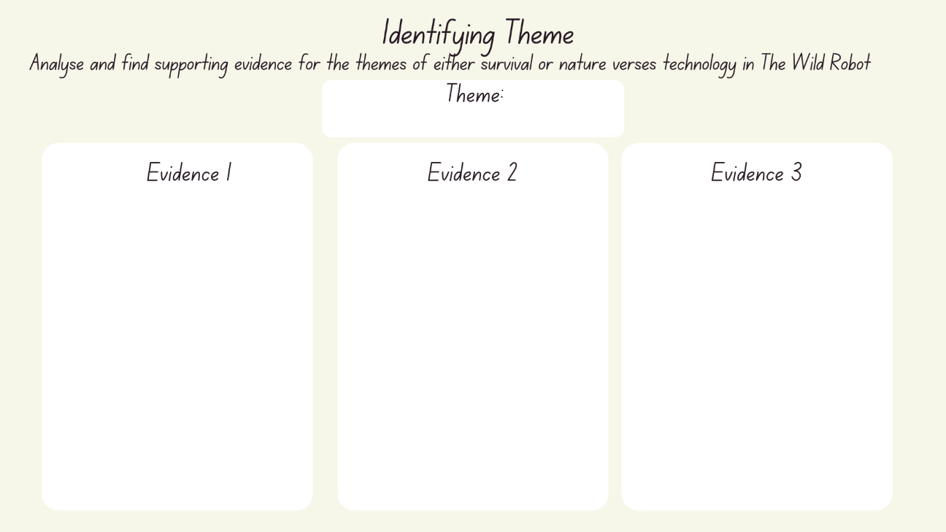

Resource 18 – robot limbs
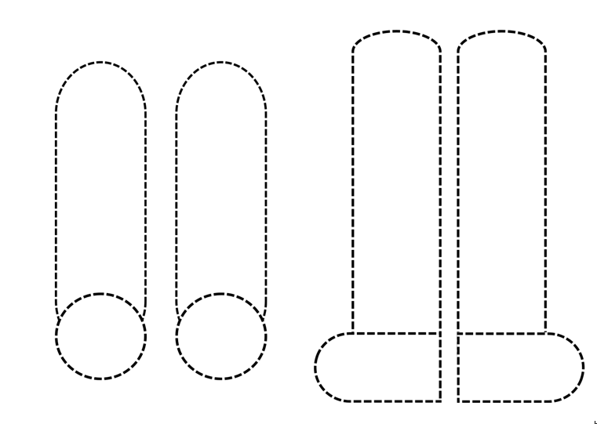

Resource 19 – writing process
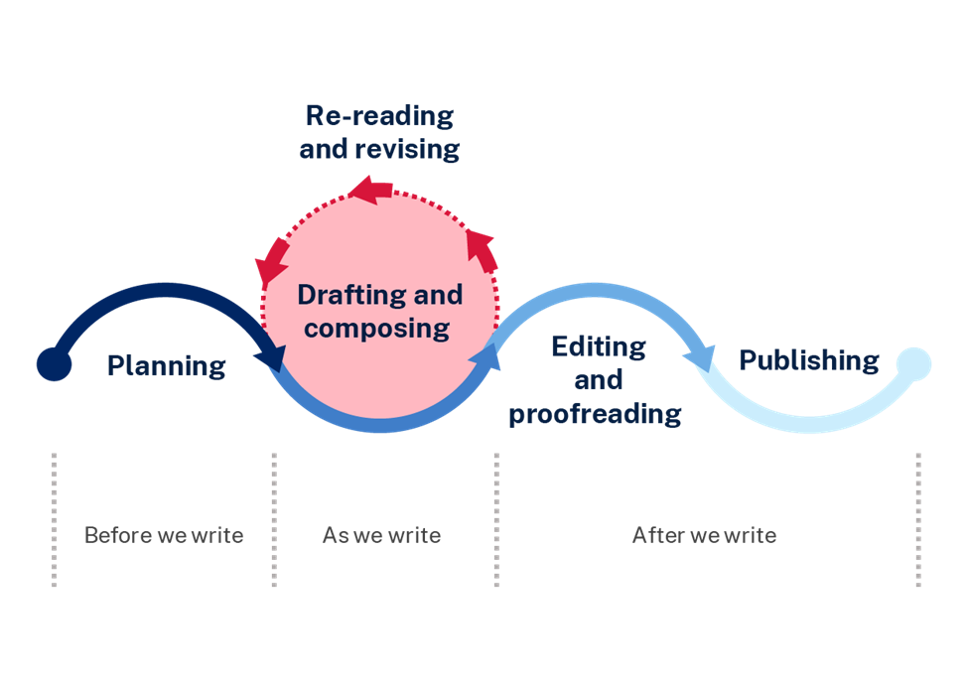

Resource 20 – writing stimulus
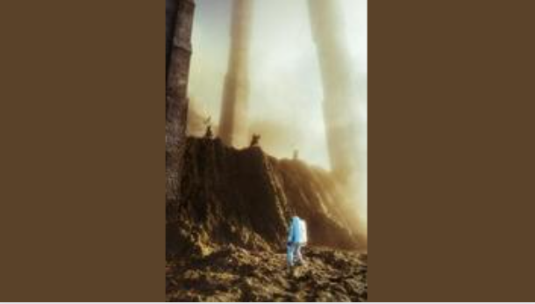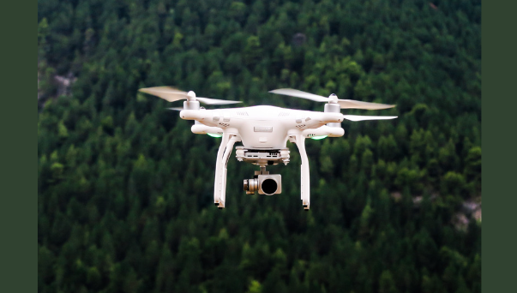
Images licensed under Unsplash License.

References
This resource contains NSW Curriculum and syllabus content. The NSW Curriculum is developed by the NSW Education Standards Authority. This content is prepared by NESA for and on behalf of the Crown in right of the State of New South Wales. The material is protected by Crown copyright.
Please refer to the NESA Copyright Disclaimer for more information. https://educationstandards.nsw.edu.au/wps/portal/nesa/mini-footer/copyright
NESA holds the only official and up-to-date versions of the NSW Curriculum and syllabus documents. Please visit the NSW Education Standards Authority (NESA) website https://educationstandards.nsw.edu.au/wps/portal/nesa/home and the NSW Curriculum website https://curriculum.nsw.edu.au.
English K–10 Syllabus © NSW Education Standards Authority (NESA) for and on behalf of the Crown in right of the State of New South Wales, 2022.
National Literacy Learning Progression © Australian Curriculum, Assessment and Reporting Authority (ACARA) 2010 to present, unless otherwise indicated. This material was downloaded from the Australian Curriculum website (National Literacy Learning Progression) (accessed 7 August 2023) and was not modified.
Brown P (2016) The Wild Robot, Little, Brown and Company, Unites States of America.
ETA (English Teachers Association) and NSW Department of Education (2016) Narrative, English Textual Concepts website, accessed 31 July 2023.
ETA (English Teachers Association) and NSW Department of Education (2016) Character, English Textual Concepts website, accessed 31 July 2023.
NESA (NSW Education Standards Authority) (2024) ‘Glossary’, Resources, NESA website, accessed
Showalter R (1 August 2011) ‘Origins’ [video], Mad Artist Publishing CGI & Films, YouTube, accessed 31 July 2023.

© State of New South Wales (Department of Education), 2023
The copyright material published in this resource is subject to the Copyright Act 1968 (Cth) and is owned by the NSW Department of Education or, where indicated, by a party other than the NSW Department of Education (third-party material).
Copyright material available in this resource and owned by the NSW Department of Education is licensed under a Creative Commons Attribution 4.0 International (CC BY 4.0) license.
This license allows you to share and adapt the material for any purpose, even commercially.
Attribution should be given to © State of New South Wales (Department of Education), 2023.
Material in this resource not available under a Creative Commons license:
the NSW Department of Education logo, other logos and trademark-protected material
material owned by a third party that has been reproduced with permission. You will need to obtain permission from the third party to reuse its material.
Links to third-party material and websites
Please note that the provided (reading/viewing material/list/links/texts) are a suggestion only and implies no endorsement, by the New South Wales Department of Education, of any author, publisher, or book title. School principals and teachers are best placed to assess the suitability of resources that would complement the curriculum and reflect the needs and interests of their students.
If you use the links provided in this document to access a third-party's website, you acknowledge that the terms of use, including licence terms set out on the third-party's website apply to the use which may be made of the materials on that third-party website or where permitted by the Copyright Act 1968 (Cth). The department accepts no responsibility for content on third-party websites.

