English Stage 2 Second year – Unit 14
Perspective and context – The Little Refugee

Contents
Unit overview and instructions for use 5
Teacher notes 7
Outcomes and content 10
Resources 19
Week 1 21
Component A teaching and learning 21
Planning framework 21
Component B teaching and learning 21
Learning intentions and success criteria 21
Lesson 1 – building context and knowledge 22
Lesson 2 – exploring author’s perspective 24
Lesson 3 – identifying theme 27
Lesson 4 – exploring personal context 29
Week 2 33
Component A teaching and learning 33
Planning framework 33
Component B teaching and learning 33
Learning intentions and success criteria 33
Lesson 5 – exploring salience to understand perspective 34
Lesson 6 – understanding context through dialogue 37
Lesson 7 – recognising context through declarative sentences 42
Lesson 8 – exploring perspective through exclamatory sentences 45
Week 3 49
Component A teaching and learning 49
Planning framework 49
Component B teaching and learning 49
Learning intentions and success criteria 49
Lesson 9 – adverbial phrases or clauses to add meaning 50
Lesson 10 – planning a multimodal historical account 55
Lesson 11 – drafting a multimodal historical account 57
Lesson 12 – presenting a multimodal historical account 60
Week 4 63
Component A teaching and learning 63
Planning framework 63
Component B teaching and learning 63
Learning intentions and success criteria 63
Lesson 13 – multimodal features of texts 64
Lesson 14 – using literal and implied meaning to build understanding and context 67
Lesson 15 – identifying theme within a text 72
Lesson 16 – free verse poetry planning 74
Week 5 77
Component A teaching and learning 77
Planning framework 77
Component B teaching and learning 77
Learning intentions and success criteria 77
Lesson 17 – free verse poetry draft 78
Lesson 18 – feedback 81
Lesson 19 – oral presentation 84
Lesson 20 – reflection 86
Resource 1 – KWL template 88
Resource 2 – theme detective jigsaw 89
Resource 3 – theme detective jigsaw (teacher resource) 90
Resource 4 – pivotal moment 91
Resource 5 – articles table (teacher resource) 92
Resource 6 – vocabulary table 93
Resource 7 – free verse planning 94
Resource 8 – unit reflection 95
References 96

Unit overview and instructions for use
In this 5-week unit, students will explore the mentor concept of ‘perspective and context’ as well as the supporting concept of ‘theme’ through analysis of the texts, The Little Refugee and We Are Australians. Students develop an understanding of how authors use perspective and context to make connections with the themes. Students create multimodal historical accounts and free verse poetry, drawing upon their personal, social and cultural contexts to explore their own identity.
Outcomes and content in this unit are organised into Component A and Component B. The components are connected, with learning in Component A complementing learning in Component B.
Note: the duration of this unit can be adapted to suit individual school contexts. For example, learning could occur across 5 days rather than 4.
The table below highlights the focus areas and preparation required for Component A and Component B.
Teaching and learning | Component A | Component B
Suggested duration | 60 minutes × 4 days/week or equivalent | 60 minutes × 4 days/week or equivalent
Explicit teaching focus areas | Component A addresses content from the focus areas:  - Vocabulary  - Reading fluency  - Reading comprehension  - Creating written texts  - Spelling  - Handwriting and digital transcription  It centres on the development of foundational skills and knowledge through regular, systematic and repeated practice. | Component B addresses content from the focus areas:  - Oral language and communication  - Vocabulary  - Reading comprehension  - Creating written texts  - Understanding and responding to literature  It centres on the conceptual understandings of English and exemplifies the importance of learning about and enjoying literature through the study of quality texts.
Preparing for teaching and learning | - Specific teaching and learning activities need to be developed by the teacher. When planning for these activities, please refer to the Component A outcomes and content, teaching guides and planning frameworks.  - Plan and document how you will sequence teaching and learning in whole-class and targeted-groups across the 5-week cycle as required. This should be based on student needs identified through ongoing assessment data. | - Familiarise yourself with the mentor and supporting texts and textual concepts, and the teaching and learning sequence.  - Determine how you will support students in whole-class and targeted-groups across the 5-week cycle as required. This should be based on student needs identified through ongoing assessment data.
English K–10 Syllabus © NSW Education Standards Authority (NESA) for and on behalf of the Crown in right of the State of New South Wales, 2022.

Teacher notes
- The Little Refugee, written by Anh Do and Suzanne Do, tells of his experiences coming to Australia. It was inspired by his true story The Happiest Refugee. Teachers need to answer questions about the Vietnam War that may arise from the text with age-appropriate responses.
- The text The Little Refugee is a story about a Vietnamese family who feel unsafe in their own county due to their allegiances during the Vietnam War. The story tells of the family’s difficult journey by boat before being rescued and establishing their life in Australia. Please consider the students in your school and class and determine the suitability of this text for your school context.
- The content in this unit requires sensitivity awareness, particularly regarding refugees and multiculturalism. The Multicultural unit provide professional learning and resources for teachers when supporting refugee students.
- The supporting text, We Are Australians, encourages readers to look further into the topics of citizenship and the role of Australia’s First Nations people.
- Aboriginal and/or Torres Strait Islander people should be aware that this resource may contain images, voices or names of deceased persons in photographs, film, audio recordings or printed material. Please ensure classrooms are culturally safe for the delivery of this unit.
At the NSW Department of Education, we recognise the traditional custodians of the lands and waterways where we work and live. We celebrate Aboriginal and Torres Strait Islander peoples’ unique cultural and spiritual relationship to Country and acknowledge the significance of their cultures in Australia. We pay respect to Ancestors and Elders past, present and future.
The department recognises that by acknowledging our past, we are laying the groundwork for a future that embraces all Australians; a future based on mutual respect and shared responsibility.
- To find out and develop more knowledge about cultural principles and protocols, definitions and terminology related to Aboriginal education, schools can contact their Local/Regional Aboriginal Education Consultative Group (AECG), Aboriginal education officers/advisers within education sectors, local Aboriginal Land Councils and/or Aboriginal language centres. Further support can be found using the Diversity of learners resources, and the Australian Government’s Style Manual. Visit the NSW Education Standards Authority (NESA) website to download the Aboriginal and Torres Strait Islander principles and protocols [PDF 66.8 KB]. The Narragunnawali online platform may support the implementation of reconciliation initiatives.
- Additional advice can be found at NESA Teaching advice (additional): Working with Aboriginal and Torres Strait Islander content, resources on the NESA website.
- In NSW classrooms there is a diverse range of students including Aboriginal and/or Torres Strait Islander students, students learning English as an additional language or dialect, high potential and gifted students and students with disability. Some students may identify with more than one of these groups, or possibly all of them. Refer to Curriculum planning for every student – advice for further information.
- Perspective is a lens through which the author perceives the world and creates a text, or the lens through which the reader or viewer perceives the world and understands a text. Readers may also temporarily adopt the perspectives of others as a way of understanding texts (NESA 2024).
- Context is the range of personal, situational, social, historical and cultural circumstances that shape how texts and their representations are conceived, constructed, understood and interpreted (NESA 2024).
- Understanding of perspective and context can be supported by watching the department’s videos: Understanding perspective (3:37) and Understanding context (5:24).
- While ‘perspective and context’ is the mentor textual concept and ‘theme’ is the supporting concept, ‘imagery, symbol and connotation’ elements are also explored. Additional textual concepts may be included based on individual school context and student needs. Understanding ‘theme’ and ‘imagery, symbol and connotation’ can be supported by watching the department’s videos: Understanding theme (2:52) and Understanding connotation, imagery and symbol (6:06).
- For information on adjectival phrases and adverbial phrases refer to the NESA Glossary.
- In addition to the resources listed, students will require access to short passages of the mentor and/or supporting texts. Teachers can copy extracts from texts in reliance on the Statutory Text and Artistic Works Licence. Teachers need to attribute the extracts and include the following notice: ‘This material has been copied [and communicated to you] in accordance with the statutory licence in section 113P of the Copyright Act. Any further reproduction or communication of this material by you may be the subject of copyright protection under the Act. Do not remove this notice’.
- This unit could enhance student learning towards the achievement of human society and its environment and creative arts outcomes.
- Reflect on student learning and engagement in activities and record differentiation and adjustments within the unit to inform future teaching and learning. One way of doing this could be to add comments to the digital file.
- Content points are linked to the National Literacy Learning Progression (version 3).
Levels and indicators sourced from National Literacy Learning Progression © Australian Curriculum, Assessment and Reporting Authority (ACARA), (accessed 11 April 2024) and was not modified. See references for more information.

Outcomes and content
The table below outlines the outcomes and content for this unit. The letters ‘A’ and ‘B’ in the header refer to Components A and B. The numbers 1 to 5 refer to weeks. The use of ‘x’ in these columns indicates where the content points are intended to be addressed and in which week.
Focus area and outcome, content points and National Literacy Learning Progression | A | B | 1 | 2 | 3 | 4 | 5
Oral language and communication
EN2-OLC-01 communicates with familiar audiences for social and learning purposes, by interacting, understanding and presenting
- Identify contexts in which social conventions can vary and influence interactions (InT4, InT5) |  | x | x | x | x |  | x
- Demonstrate appropriate language use when interacting in different social and learning contexts (InT4, InT5) |  | x | x | x | x | x | x
- Listen actively to identify spoken information, acknowledging the value of others’ contributions (LiS6) |  | x | x | x | x |  | x
- Plan and deliver spoken presentations using language and structure to suit purpose and audience (SpK5) |  | x |  |  | x |  | x
- Adjust volume, pace and intonation to enhance meaning when presenting and reciting (SpK5) |  | x |  |  | x |  | x
- Select and use prepositional, adverbial and adjectival phrases to extend communication and to suit the intended purpose of a planned and delivered spoken presentation (GrA4, SpK4) |  | x |  | x | x | x | x
- Reflect on and monitor own presentations according to given criteria |  | x |  |  | x |  | x
Vocabulary
EN2-VOCAB-01 builds knowledge and use of Tier 1, Tier 2 and Tier 3 vocabulary through interacting, wide reading and writing, and by defining and analysing words
- Identify and explain the difference between synonyms and antonyms (SpK6) | x | x | x | x | x
- Recognise that words and phrases can have literal or implied meanings according to context (UnT7) | x | x |  |  | x | x
Reading fluency
EN2-REFLU-01 sustains independent reading with accuracy, automaticity, rate and prosody suited to purpose, audience and meaning
- Explain how prosodic reading involves emphasis, expression, intonation and pausing | x |  |  |  |  | x | x
- Apply appropriate tone to represent characters’ emotions when reading text with dialogue (FlY5) | x |  | x | x |  | x
- Reflect on how adjusting reading rate and prosody supports comprehension and can engage an audience | x |  | x | x | x | x | x
Reading comprehension
EN2-RECOM-01 reads and comprehends texts for wide purposes using knowledge of text structures and language, and by monitoring comprehension
- Build topic knowledge, including key vocabulary, and activate background knowledge prior to and during reading (UnT7) | x | x | x | x |  | x
- Identify similarities and compare differences within and between texts by making text-to-self, text-to-text and text-to-world connections | x | x | x | x |  | x
- Describe how multimodal features enhance meaning and contribute to salience in texts (UnT7) |  | x |  | x | x | x | x
- Understand that dialogue is a common feature of imaginative texts, signalled by quotation marks or speech bubbles to indicate interactions between characters | x | x |  | x | x
- Understand that literal information can be sourced directly from a text and that inferences can be made by using multiple sources of information | x | x | x |  |  | x
- Identify word patterns, including repetition, that create cohesion or effect | x | x | x | x |  | x | x
- Reflect on reading experiences and identify texts of personal significance and pleasure | x |  |  | x | x | x
- Reflect on own understanding of texts and monitor own goals for reading | x |  | x |  |  |  | x
Creating written texts
EN2-CWT-02 plans, creates and revises written texts for informative purposes, using text features, sentence-level grammar, punctuation and word-level language for a target audience
- Create imaginative texts to engage an audience, using first person or third person narrative voice (CrT8) | x | x | x | x | x | x | x
- Experiment with using and punctuating dialogue in texts (PuN5) | x | x |  | x | x
- Experiment with different poetic forms using stanzas |  | x |  |  |  | x | x
- Experiment with poetry to include innovative use of punctuation to suit purpose and for effect | x | x |  |  |  | x | x
- Create written texts that describe experiences and observations to connect with and inform an audience (CrT8) |  | x |  | x | x
- Create written factual and historical accounts that include an introduction with the who, what, when, where and why of an experience or event, a description of a series of events and a conclusion (CrT8) |  | x |  | x | x
- Use definite articles for particular things and indefinite articles for general things for cohesion | x | x |  | x | x | x | x
- Select and use multimodal features to add meaning |  | x |  | x | x | x | x
- Use adverbial phrases or clauses to add information to the verb or verb group of the main or other clauses, to provide reasons for or circumstances (GrA4) | x | x |  | x | x | x | x
- Use declarative sentences to provide facts or state a viewpoint | x | x |  | x | x
- Use exclamatory sentences to emphasise a point or express a strong emotion | x | x | x | x | x
- Use apostrophes for contractions, and to show singular and plural possession (PuN4, PuN5, SpG9) | x | x | x | x | x
- Use personal pronouns to suit purpose and to connect personally with the audience | x | x | x | x | x | x | x
- Use synonyms to replace words to avoid repetition and engage the reader (CrT7) | x | x | x | x | x
- Proofread, revise and edit written texts to refine language, correct spelling and ensure cohesion and engagement for the reader |  | x |  | x | x |  | x
Spelling
EN2-SPELL-01 selects, applies and describes appropriate phonological, orthographic and morphological generalisations and strategies when spelling in a range of contexts
- Explain how to segment multisyllabic words into syllables and phonemes, and apply this knowledge when spelling | x |  | x |  |  |  | x
- Identify differences in vowel phonemes (short, long, diphthong and schwa vowels) (SpG9) | x |  | x | x | x | x | x
- Apply knowledge of taught vowel graphemes when spelling (SpG9) | x |  | x | x | x | x | x
- Proofread, identify and correct misspellings when creating written texts | x |  |  | x |  |  | x
- Use spelling reference tools where required and recognise that spellcheck accuracy may depend on understanding the word | x |  |  |  | x |  | x
- Identify derivational suffixes such as -able, -ness, -ian and -ment, explaining when and how to treat base words when they are affixed, and apply this knowledge when spelling (SpG9) | x |  |  | x | x |  | x
- Correctly spell taught homophones when creating written texts (SpG9) | x |  | x |  |  | x | x
Handwriting and digital transcription
EN2-HANDW-01 forms legible joined letters to develop handwriting fluency
EN2-HANDW-02 uses digital technologies to create texts
- Understand that legible handwriting is consistent in size and spacing and can support learning (HwK6) | x |  | x | x |  |  | x
- Sustain the NSW Foundation Style cursive to facilitate fluency and legibility across a text (HwK6) | x |  |  |  | x |  | x
- Monitor goals that build on typing accuracy and rate | x |  |  |  |  |  | x
- Use word-processing program functions or augmentative and alternative communication (AAC) to draft and revise texts | x |  |  | x |  | x | x
- Select and insert visual, print and audio elements into texts | x |  |  |  | x | x | x
Understanding and responding to literature
EN2-UARL-01 identifies and describes how ideas are represented in literature and strategically uses similar representations when creating texts
- Describe how words, sounds, images, logos and colour contribute to meaning in literature |  | x | x | x | x | x | x
- Recognise how Aboriginal and Torres Strait Islander authors use imagery and symbols in texts |  | x |  |  |  | x
- Identify themes in literature, recognising that there may be multiple themes within and between texts |  | x | x |  |  | x
- Understand that literature is created by drawing upon personal, social and cultural contexts and perspectives (UnT8) |  | x | x | x | x | x | x
- Identify and describe ways in which perspective is represented in literature (UnT7) |  | x | x | x | x | x
- Identify and discuss the purpose of a text, and its intended audience, mode and medium (UnT7) |  | x | x | x |  | x | x
- Understand how context informs the setting within a text, and experiment with setting for different contexts when creating texts (UnT7, CrT8) |  | x | x | x | x
- Describe how Aboriginal and/or Torres Strait Islander authors use language to build cultural understanding and context (UnT7) |  | x |  |  |  | x
English K–10 Syllabus © NSW Education Standards Authority (NESA) for and on behalf of the Crown in right of the State of New South Wales, 2022.

Resources
The resources in the table below are referred to in this unit. Letters ‘A’ and ‘B’ in the header refer to Component A and B respectively, and the numbers 1 to 5 indicate weeks. The use of ‘x’ in these columns indicates whether the resources are required in Component A, B or both, and in which week.
Resource | A | B | 1 | 2 | 3 | 4 | 5
Do A and Do S (2011) The Little Refugee, Allen & Unwin Children’s, Australia. ISBN13: 9781742378329 | x | x | x | x | x | x | x
Smith D and Godwin N (2022) We Are Australians, Simon & Schuster, Australia. ISBN13: 9781742036328 | x | x |  |  |  | x | x
Resource 1 – KWL template (enlarged teacher copy and individual student copies) |  | x | x
Sticky notes |  | x | x |  |  |  | x
Resource 2 – theme detective jigsaw (one enlarged piece for each group) |  | x | x
Resource 3 – theme detective jigsaw (teacher resource) |  | x | x
Individual whiteboards and markers |  | x | x | x |  |  | x
Resource 4 – pivotal moment (5 enlarged teacher copies and 5 individual copies for students) |  | x |  | x | x
Resource 5 – articles table (teacher resource) |  | x |  |  | x
Resource 6 – vocabulary table |  | x |  |  |  | x
Resource 7 – free verse planning (enlarged teacher copy and individual student copies) |  | x |  |  |  | x | x
Resource 8 – unit reflection (enlarged teacher copy and individual student copies) |  | x |  |  |  |  | x
Video: Anh Do honoured by major literary prize (7:18) |  | x | x
Webpage: Portrait of activist Jack Charles wins Archibald People’s Choice award |  | x |  |  |  | x
Webpage: AIATSIS Map of Indigenous Australia |  | x |  |  |  | x
Webpage: Jandamarra Cadd: The Spaces Between |  | x |  |  |  | x

Week 1

Component A teaching and learning
Component A focuses on the development of foundational skills and knowledge through regular, systematic and repeated practice. The mentor and supporting texts used in Component B of this unit will support the effective implementation of Component A teaching and learning.

Planning framework
To plan and document Component A teaching and learning, a planning scaffold (DOCX 228 KB) is provided. To support you in your planning, a link to a detailed example of a one-week teaching and learning cycle is included in the scaffold. Additional resources to support teaching and learning in each focus area can be found at Lesson advice guides.

Component B teaching and learning
The following teaching and learning sequence has been designed to address Component B outcomes and content and develops conceptual understandings of English through the study of quality texts. Adapt the sequence as required to best meet the needs of your students.

Learning intentions and success criteria
Learning intentions and success criteria are best co-constructed with students.

Learning intention
Students are learning to deepen their understanding of an author’s perspective and context and identify the themes within the text.

Success criteria
Students can:
- explore the author’s context to activate their own background knowledge
- understand the author’s perspective
- identify themes within a text
- identify, explain and use synonyms and antonyms to develop an understanding of text setting
- explore the contexts of characters to develop a deeper understanding of the text.

Lesson 1 – building context and knowledge
- Display a collection of children’s texts by Anh Do. For example, WeirDo, Hot Dog, Wolf Girl. Provide time for students to look at the cover, read the blurb and flick through the text. Ask:
- If you have read any of these texts before, what stood out for you?
- What similarities can you identify?
- Acknowledge that all texts were written by Anh Do. Record what students ‘know’ about Anh Do, on an enlarged copy of Resource 1 – KWL template. For example, author, artist, comedian, painter.
Note: additional information will be added to this resource throughout the lesson.
- Introduce The Little Refugee by Anh Do. Read and discuss the front and back covers and students predict what the text may be about.
- Explain that the book is based on Anh Do’s life and that he was a refugee. As a class, use a Frayer diagram to define the word ‘refugee’.
Refugees are people who have fled their homelands due to persecution, threat or danger in their country of origin, usually as a result of civil unrest or war (Department of Education 2024).
- Define context and explain that each person’s context is unique. For example, holidays celebrated throughout the year are different for each cultural context, how many people that live in a house can determine a personal context, where people are located determines their situational context. Ask students to provide additional examples for cultural, personal and situational context.
- Explain that background knowledge is important in understanding a person’s context. Sometimes information may not be provided which means that readers need to join separate pieces of information together. Explore Anh Do’s country of origin, Vietnam and its locality in relation to Australia on a map, for example, Google Maps.
- Watch Anh Do honoured by major literary prize (7:18) from (0:18–5:52).
Note: ensure the video is cued to start at 0:18 to skip ads and introduction.
- Brainstorm what students learned about Anh Do’s context.
Optional: re-watch Anh Do honoured by major literary prize (7:18) from (0:18–5:52). While watching, students take notes about Anh Do using a note taking strategy to support background knowledge.
- Remind students that context is important to understand and interpret the text. Discuss and provide examples of Anh Do’s context. Add new knowledge of what students know about Anh Do to the enlarged copy of Resource 1 – KWL template. For example, a refugee, from Vietnam, family members fought in the Vietnam War, fled after the Vietnam War ended.
- In pairs, students use Resource 1 – KWL template to share what they know, wonder and learned about Anh Do.

Lesson 2 – exploring author’s perspective
- Review enlarged copy of Resource 1 – KWL template from Lesson 1. Ask if students have any new wonderings or have discovered new information about Anh Do. Add to the resource.
- Remind students to draw on learning from Component A to revise first-person narrative voice. Explain that The Little Refugee is written using first-person narrative voice.
- Read the first 3 pages of the text. Ask:
- What do we know about first person narrative voice? For example, a story told from the point of view of one character.
- How can we tell The Little Refugee is written in first person narrative voice? For example, the use of personal pronouns I, my, we, me.
- Explain that The Little Refugee is written from Anh Do’s perspective. Watch Understanding perspective (3:37).
- Explore that each person’s values, beliefs and personal experiences form their perspective. The author’s perspective shapes how the reader is meant to understand the text. Create a class definition of perspective in texts. For example, a lens that shapes the way we create and understand texts.
- Read The Little Refugee, to the end of the page with the 3 sewing machines. Optional: distribute some eyeglasses or make some for students to wear, to help them adopt the perspective of the author.
- Ask:
- What do you think Anh Do’s values and beliefs are? For example, family and happiness.
- How do Anh Do’s childhood experiences help a reader understand his perspective? For example, to see how things were through his lens.
- How has his social and cultural context influenced him? For example, he is a refugee who fled war-torn Vietnam.
- How did his situational context change throughout the text? For example, the settings changed from Vietnam to the boat and then to Australia.
- Discuss why it is important to identify the author’s perspective when reading a text. For example, it helps readers understand what the text is about and influences how they may connect and respond to it.
- Display the page of Anh Do’s childhood house in Vietnam. Draw attention to the language used to engage the reader. Explain that skilled readers analyse a text to understand an author’s perspective.
- Model writing questions to help a reader understand an author’s perspective. Keep the questions on display. Record answers on sticky notes to place on the page of Anh Do’s childhood house in Vietnam. For example:
- What is the author’s intended purpose for writing? For example, to show the reader his perspective of his childhood in Vietnam.
- What mode and medium has been used? For example, mode (printed words and images), medium (published text).
- What opinions and attitudes does he have about the subject? For example, opinion: although his house was small, it was full of love and happiness.
- What is his purpose for expressing this opinion and attitude? For example, to demonstrate to the reader that despite the hard times, he still made the best of every situation, showing appreciation for what he had.
- Using the question prompts from activity 9, students work in small groups to explore Anh Do’s perspective from allocated pages in the text. Students record ideas on sticky notes and place on the allocated page. Remind students to use appropriate language when interacting with their peers and that active listening should be used. Pages could include:
- the motorbike full of people
- the children playing with the chicks
- the mother and her 2 children on the boat
- the people looking at the empty pots after the storm
- the people standing up ready to fight the pirates
- the 4 children walking to school.
- Explain that the context (time, place and culture) in which Anh Do grew up shaped his story, perspective and writing of The Little Refugee.
- Model writing sentences about Anh Do’s childhood, culture and perspective. Refer to Resource 1 – KWL template from Lesson 1. For example:
Anh Do grew up in Vietnam during a time of war. His family were very poor and shared a tiny house with fourteen people. I think it would have been very noisy and busy living with that many people. I believe he was happy because he was with his family. Anh Do’s perspective of the world is that challenges can be overcome with family by your side. He understands the importance of being happy and grateful for what he has in his life.
- Students write what they have learned about Anh Do’s childhood, culture and perspective using Resource 1 – KWL template.
Too hard? Students draw what they know about Anh Do’s childhood and culture, then add key words or sentences.
Too easy? Students include examples of Anh Do’s context and provide examples of how it informs the lens of the reader.
- Students complete a gallery walk of the KWL charts and identify additional information discovered about Anh Do.

Lesson 3 – identifying theme
- Revisit the first 3 pages of The Little Refugee read in Lesson 2. Read the remainder of the text. While reading, use ‘I wonder’ statements to highlight the recurring theme of hope demonstrated by Anh Do’s mother. For example, I wonder what she was thinking when she was hugging the boys on the boat.
- Watch the Understanding theme video (2:52). As a class, define theme and record on an anchor chart.
- Explain that, like a detective, theme can be identified by finding and examining clues from the text. Revisit the page with Anh Do and his mother under the bed. Using the think aloud strategy, model identifying the power of hope as a central message or theme. Display an enlarged copy of Resource 2 – theme detective jigsaw. Refer to Resource 3 – theme detective jigsaw (teacher resource). Discuss:
- the key moments in the text. Did the characters exhibit hope?
- the illustrations in the book. How do the illustrations contribute meaning and convey the emotions of the characters and the power of hope?
- the lessons that can be learned from Anh Do’s story about the importance of hope and resilience in our own lives.
- As a class, identify the central messages or themes in The Little Refugee. Record identified themes on the anchor chart from activity 2. For example, hope, conflict, displacement, belonging, family, multiculturalism. Ask:
- What is the central message or theme in the text?
- Why do you think that?
- How does information from the text support your thinking?
- Divide the class into ‘theme’ groups. Allocate each group a theme to explore, from activity 4, and complete one piece of the enlarged Resource 2 – theme detective jigsaw using evidence from the text.
- As a class, each group presents their puzzle piece. Students put the puzzle back together.
- Students write key information and draw images on individual copies of Resource 2 – theme detective jigsaw, referring to the enlarged class jigsaw.
Too hard? Students write one word and draw images to complete Resource 2 – theme detective jigsaw.
Too easy? Students make text-to-text and text-to-world connections with the themes in The Little Refugee.
- Discuss why the author includes the key themes in the text. For example, he wants to show the importance of the themes to convey the perspective and context of his life. This helps the reader develop an understanding and create an emotional response to the text. Students share their understanding of the text and some of the emotions they have felt.

Lesson 4 – exploring personal context
- Display the page in The Little Refugee of the house in Vietnam. Discuss the language used and how it shapes the way the reader responds to events in the text. Draw attention to the words used for effect. For example, ‘... were very poor ...’, ‘... in a tiny three-room house.’ Refer to other language used. For example:
- on the page with the picture of the shed in the backyard: ‘... sobbing quietly to herself ...’
- on the page starting with ‘A pirate grabbed hold ...’: ‘... dangled the baby ...’.
- Ask students guiding questions to check for understanding. For example:
- How does the author’s use of this vocabulary shape the way a reader responds to the text? For example, words like sobbing adds emotional depth.
- What impact does the word choice have on the reader? For example, using the word ‘dangled’ creates tension and worry.
- What emotions do you feel when you hear this language? For example, feeling scared, worried or empathetic.
- Do you think all readers will experience the same emotions? Why or why not?
- Revise synonyms and antonyms and record class definitions as taught in Component A. Explain that authors use synonyms and antonyms to avoid repetition and engage the reader. Note that authors can use repetition to create effect.
- Read the text to the page ending with ‘… crammed on board’. Revisit the words ‘squashed’, ‘crowded’ and ‘crammed’. Ask:
- What do these words have in common? For example, they all mean the same thing.
- What are some synonyms for these words? For example, packed, jammed, bursting.
- What are some antonyms for these words? For example, spacious, empty, abandoned.
- Why does the author include the words ‘squashed’, ‘crowded’ and ‘crammed’ when they have similar meanings? For example, it draws upon personal context demonstrating the author’s perspective of the event.
- Model constructing 2 Word clines to deepen vocabulary knowledge of synonyms and antonyms. Discuss which synonym has the most significant impact on the reader and place this word last, on the first word cline. Continue placing words on the word cline from most impactful to least impactful. For example, bursting, crammed, squashed, jammed, crowded, packed. Discuss which antonym has the most significant impact for the reader. Place this as the last word on the second word cline. Order all the words in the appropriate place based on impact. For example, spacious, empty, abandoned.
- Display the sentence ‘Even though we were poor and the house was crowded, I was happy because there were always lots of people to play with me.’ from The Little Refugee. Ask:
- What synonyms/antonyms could be used to replace the word ‘crowded’?
- Why do you think the author chose to use the word ‘crowded’?
- Why was it important for Anh Do to tell the reader how many people were in the house?
- What does this vocabulary tell you about Anh Do’s context?
- Using the sentence from activity 6, choose a different word to replace with synonyms and antonyms. For example, ‘Even though we were rich and the house was spacious ...’. Students record responses on individual whiteboards. Repeat as required. Ask students how replacing words changes the understanding of context for the reader.
- Locate and record vocabulary in the text that could be changed using synonyms and antonyms, to engage the reader.
- In pairs, students select 2 words from activity 9 and create 2 word clines to show impact.
- Individually, ask students to select a word from their word cline and write an alternate sentence, using different synonyms and/or antonyms.
Too hard? Students co-construct sentences using words from the word cline.
Too easy? Students use multiple synonyms and antonyms to create complex sentences.
- Revise that social conventions are like unspoken rules or expectations for how people should behave in different contexts. For example, when participating in a class discussion it is expected students raise their hand to speak.
- In pairs, students discuss how using a variety of synonyms and antonyms informed their understanding of Anh Do’s personal context.
- As a class, ask students to identify evidence from the text illustrating how specific language use, such as antonyms and synonyms, informs understanding of the setting.
- Allocate pairs of students keywords from the lesson. For example, synonym, antonym, perspective, context. Ask each pair to define, explain and provide examples of their keywords.
- Revise the textual concept of perspective and context. Students turn and talk to reflect on their understanding of the textual concept by identifying 3 things they have learned, 2 questions they have and a reason why it is important to learn about perspective and context.

Week 2

Component A teaching and learning
Component A focuses on the development of foundational skills and knowledge through regular, systematic and repeated practice. The mentor and supporting texts used in Component B of this unit will support the effective implementation of Component A teaching and learning.

Planning framework
To plan and document Component A teaching and learning, a planning scaffold (DOCX 228 KB) is provided. To support you in your planning, a link to a detailed example of a one-week teaching and learning cycle is included in the scaffold. Additional resources to support teaching and learning in each focus area can be found at Lesson advice guides.

Component B teaching and learning
The following teaching and learning sequence has been designed to address Component B outcomes and content and develops conceptual understandings of English through the study of quality texts. Adapt the sequence as required to best meet the needs of your students.

Learning intentions and success criteria
Learning intentions and success criteria are best co-constructed with students.

Learning intention
Students are learning to explore perspective and context through language features in literature.

Success criteria
Students can:
- describe how multimodal features enhance meaning and contribute to salience
- select and use adjectival phrases or clauses to add meaning
- experiment with using and punctuating dialogue
- use apostrophes for contractions and to show possession
- use declarative sentences to understand context
- explore perspective and emotion through exclamatory sentences.

Lesson 5 – exploring salience to understand perspective
- Revise that salience is a strategy used by authors and illustrators to highlight, or draw attention to, what is important in a multimodal text.
- Ask students to close their eyes. Select a page with an illustration of a pivotal moment from The Little Refugee. For example, the pirate, the new boy with a banana or dad clapping. Explain that when they open their eyes, the first thing students are drawn to on the page is the salience. Ask students to open their eyes.
- Discuss the salience on the page from activity 2. Ask:
- What salient feature draws your attention?
- What word, image or colour did you first notice?
- Why do you think the illustrator included this salience and how did it contribute to meaning within the text?
- Revise that salience is always planned and intentional and is usually created through contrast, colours, lines and scale. Display the front cover of The Little Refugee and model the think aloud strategy to describe the salience. For example, my eyes are drawn to the little boy’s big smile. I can see that the cartoon-style image, colours, scale of the figure, the sepia tones and sketch lines in the background draws attention to the boy.
- Display various illustrations of other pivotal moments in the text. Discuss the salience on each page. Ask:
- How has the illustrator created salience? For example, colours, lines and scale used in the illustrations.
- What visual elements or techniques have been used? For example, contrast, colour, framing, layout.
- How does the salience of images impact the reader? For example, draws attention to significant parts of the page.
- Discuss and model drawing a picture of something that brings personal joy. For example, I enjoy playing basketball so I will draw a basketball hoop and a large ball. Ensure that there is salience in the drawing.
- Model writing a short description to explain the drawing, the salience and why the viewers’ attention should be drawn to that point. For example:
I have drawn a basketball and a hoop. The ball is much larger and is the salient feature because I scored the winning shot in my grand final. I want to emphasise the ball because it represents my first ever grand final win.
Note: this will form part of a class display to scaffold the writing task for Lesson 10 to Lesson 12.
- Students draw a picture of something that gives them joy. For example, sport, books, food, friends, special people or places. Remind students to include salience.
- Have students write a description explaining their drawing, what their salient feature is and why they want the viewers’ attention to be drawn to that point.
- Define adjectival phrases and discuss how they can be used to extend communication to suit the intended purpose or a planned and delivered spoken presentation.
Adjectival phrase: a group of words (usually beginning with a preposition) that gives more information about a noun (NESA 2024).
- Revisit the modelled drawing and description from activity 6 and 7. Highlight the nouns in the description.
- Model adding an adjectival phrase to improve the description of the salient feature in the drawing. For example:
- original sentence: I have drawn a basketball and a hoop.
- sentence with adjectival phrase: I have drawn a basketball with a bubbly surface and a hoop.
- Students revisit their drawing and description then highlight the nouns in their sentences.
- Students turn and talk to brainstorm adjectival phrases that could be included in their sentences before editing their description to include adjectival phrases to extend communication.
Too easy? Students expand their descriptions to add more detail by including a variety of synonyms and antonyms.
- In small groups, students present their drawing and short description. Students provide peer feedback on the effect of adjectival phrases for the intended purpose.
- Provide students with a list of prepositions. For example: in, on, up, down. Students use each of the prepositions to add detail about their given object. For example:
- The basketball, in my sports bag, is my most prized possession.
- The basketball, with its rough surface, provides hours of fun.
- In pairs, students take turns to orally create adjectival phrases.

Lesson 6 – understanding context through dialogue
- Read the page with a picture of Anh Do’s mum hugging the 2 boys on the boat, in The Little Refugee.
- Revise the definition of dialogue as taught in Component A. Explain that dialogue is a common feature of narrative texts. It shows the interactions between characters and the purpose of a text by conveying themes and continuing the plot. Dialogue helps to identify underlying messages, conflicts or viewpoints, providing insight into the text’s themes. This develops a deeper understanding of the context.
Dialogue: a conversation between 2 or more people; the conversation between characters in a text; an exchange of ideas or opinions on a particular issue; or a literary work in the form of a conversation (NESA 2024).
- Re-read the page leaving out the dialogue from Anh Do’s mum, stopping at the word ‘tight’. Ask:
- What is the difference between the scene read with dialogue and the scene read without dialogue?
- Why is the dialogue from Anh Do’s mum important?
- From the image on the page, would readers know what Anh Do’s mum was thinking if the dialogue was not there? How might the situational context of the setting inform thinking?
- How do these interactions differ to other settings and contexts within the text?
- Draw attention to the minimal dialogue used in the text. Ask:
- Why is there limited dialogue? For example, the dialogue is used to highlight pivotal moments for the characters and their personality.
- Why is this effective? For example, the reader emotionally connects with the story and characters, to gain a deeper understanding of the sequence of events.
- Revise and record what students know about punctuating dialogue. Include:
- quotation marks placed around spoken words
- a capital letter at the start of what is spoken and for proper nouns
- punctuation before closing the quotation mark (full stop, comma, exclamation mark, question mark)
- start a new line when there is a new speaker.
- Revise apostrophes from Component A learning. Display the page with the picture of Anh being announced as class captain. Draw attention to the words ‘year’s’ and ‘couldn’t’. Examine how the apostrophe has been used in 2 different ways; in a contraction and to show possession. Explain that using contractions during dialogue is informal, mirrors real life speech and maintains a smooth flow. Using an apostrophe of possession enables the writer to show who owns something.
- Display the page with Anh’s parents standing and applauding, focusing on their facial expressions. Discuss how this image contributes to the meaning of the text. Imagine and discuss what the characters are thinking or saying to one another. For example, Dad could be saying, “I’m so proud of Anh.” Mum could respond by saying, “Yes! Me too!”
- Display the unpunctuated sentences: Im so proud of Anh beamed Dad. yes me too smiled mum. Model correctly punctuating the sentence for dialogue and apostrophes. For example:
“I’m so proud of Anh,” beamed Dad.
“Yes! Me too!” smiled Mum.
- Revisit the apostrophe of contraction from activity 8.
- Identify examples of words that include apostrophes for contraction or possession from the text. For example: didn’t, don’t, couldn’t, I’ll, I’m, people’s, baby’s, mother’s. Discuss the different use of apostrophes in the identified words. Co-construct an unpunctuated sentence that includes a word with an apostrophe. Students record and punctuate the sentence, using individual whiteboards.
- Explain that students will analyse the pivotal moments in Anh Do’s life from the text. Students will then select one pivotal moment from their own life to create a multimodal historical presentation from their perspective in Week 3. Clarify that pivotal moments are life-changing events such as going to school, having siblings, moving, getting married.
- Brainstorm 4 pivotal moments from the text. For example:
- growing up in Vietnam during the war
- escaping on the boat
- arriving in Australia
- learning English and thriving at school.
- Revise salience from Lesson 5. Model illustrating the first pivotal moment on an enlarged copy of Resource 4 – pivotal moment to highlight the salience of that pivotal moment. For example, using sepia tones to draw a tiny 3-bedroom house to reflect the warm and safe feeling of being with the family.
- Provide each student with a copy of Resource 4 – pivotal moment. Students illustrate the first pivotal moment from activity 12 to reveal the salience of that pivotal moment.
- Review punctuating dialogue. Model writing the first pivotal moment on an enlarged copy of Resource 4 – pivotal moment using dialogue and apostrophes for contractions and to show possession. For example:
Orientation: There were fourteen people living in my small home. I loved my life. My Mum’s family made life fun because they were always around to play with me. I didn’t mind sharing such a small space.
Series of events: One day I asked mum if I could go and play.
Mum said, “Yes, but be careful Anh! Don’t rip your clothes.”
I nodded and said, “No worries, Mum!” As I ran to the door.
“Don’t forget your shoes,” Mum cried after me.
We played outside for ages. Enjoying each other’s company. It was so nice to not have to worry about anything.
Conclusion: That night Dad sat us down and told us he had bought a boat. He said we would soon leave Vietnam with some of our family, neighbours and friends because of the war. He wanted a better life for his children.
- In pairs, students discuss and plan what dialogue could be used to help readers understand the situational context.
- Students write the first pivotal moment on Resource 4 – pivotal moment using dialogue and apostrophes for contractions and to show possession.
Too hard? Students innovate from the teacher model to create their first pivotal moment.
Note: students will complete the other pivotal moments in Lesson 7, Lesson 8 and Lesson 9.
- Review the teacher model and add relevant synonyms and antonyms. For example:
- ‘I nodded and said,’ – change ‘said’ to the synonym ‘replied’ to remove the repeated word.
- ‘There were fourteen people living in my small home’ – change ‘small’ to synonym ‘tiny’ as it was not a ‘big’ house.
- Discuss why ‘small’ was changed to tiny, using a synonym rather than an antonym. For example, using an antonym would completely change the meaning of the sentence.
- Students review their writing and add relevant synonyms and antonyms.
- In small groups, students explain their first pivotal moment. Each student reads their first pivotal moment. Students discuss the use of dialogue and the different synonyms and antonyms added to their writing.
Assessment task 1 – observations and work samples from this lesson allows students to demonstrate achievement towards the following syllabus outcome and content point:
EN2-VOCAB-01 – builds knowledge and use of Tier 1, Tier 2 and Tier 3 vocabulary through interacting, wide reading and writing, and by defining and analysing words
- identify and explain the difference between synonyms and antonyms.

Lesson 7 – recognising context through declarative sentences
- In pairs, students turn and talk to provide one fact about their personal and cultural context. For example, ‘I have 2 brothers’. ‘My great grandmother was born is Malaysia’. Ask students to discuss why learning about personal context is important. For example, value of understanding each other’s backgrounds, developing empathy and creating connections.
- Revise declarative sentences, as taught in Component A.
Declarative sentences: a statement presented as a complete sentence to provide fact, evidence or detail. For example: Drinking water is important for your health (NESA 2024).
- Revisit learning about context from Lesson 1. Consider Anh Do’s context and explain that he uses declarative sentences in The Little Refugee to inform the reader about his cultural context. Identify declarative sentences from the text and record on an anchor chart. For example: ‘I was born in a faraway country called Vietnam.’
- Explain that personal pronouns are used to suit the text’s purpose and connect personally with the audience as taught in Component A.
- Analyse the sentence, ‘I was born in a faraway country called Vietnam.’ to identify the factual part of the sentence and the personal pronoun used. Ask:
- What personal pronoun is used in this sentence?
- What other personal pronouns are used in the text. For example, ‘my’.
- Why does the author use personal pronouns in declarative sentences? For example, to provide factual personal details.
- Review and discuss the enlarged teacher copy of Resource 4 – pivotal moment from Lesson 6. Revisit the second pivotal moment. For example, escaping on a boat.
- Model illustrating the second pivotal moment to reveal the salience of that moment, on an additional enlarged copy of Resource 4 – pivotal moment. For example, a greyscale fishing boat.
- Model writing the second pivotal moment on an enlarged copy of Resource 4 – pivotal moment using declarative sentences and personal pronouns. For example:
Orientation: Under the cover of darkness, we left our home. We boarded the old wooden fishing boat that stank of fish. Forty people, including our family, friends and neighbours were on board to escape Vietnam. We all took only what we could carry.
Series of events: We were on the old fishing boat for 5 days. Our family had a scarce food supply, and I was always hungry. The water from the storm had ruined our food and water supply. Pirates boarded our boat. They took everything and I was scared. Luckily, one of them threw us a water bottle. It saved our lives.
Conclusion: On our fifth day at sea, we saw another boat. At first, we were worried that we would encounter more pirates, but to our relief, it was a German cargo ship. We were rescued and finally taken to safety.
- Students illustrate the second pivotal moment on an additional copy of Resource 4 – pivotal moment. Students write the second pivotal moment on Resource 4 – pivotal moment using declarative sentences and personal pronouns.
Too hard? In small groups, co-construct declarative sentences for the second pivotal moment.
- Revise that social conventions are like unspoken rules or expectations for how people should behave in different contexts. Explain that when participating in small group discussions it is expected that everyone listens actively to identify spoken information. Revise and share ideas of how the contribution of others can be acknowledged. For example, nonverbal cues such as smiling and nodding. Ask students to share examples of appropriate language to use when interacting with others. For example, words to express politeness and phrases to use to clarify comments such as “Could you please explain that some more?”.
- Display and pose the question, ‘Why do you think it is important for the text to have pivotal moments that change everything for the characters?’ Explain that students will participate in a Snowball activity to analyse the question. Once a consensus is made, record the collective response under the question and discuss how students can apply this to their writing.
- Begin to co-construct a success criteria to create a multimodal historical presentation. For example, create a text with:
- multimodal features, such as diagrams and images
- dialogue
- apostrophes to show possession and contractions
- synonyms and antonyms to avoid repetition
- personal pronouns
- declarative sentences.

Lesson 8 – exploring perspective through exclamatory sentences
- Provide a scenario, such as students have been given a gift. In pairs, students respond with their immediate reaction. For example, Wow! Thanks so much. Explain that this response was from their perspective, as it was the lens in which they viewed the scenario. Repeat using additional scenarios and discuss student reactions.
- Revisit perspective from Lesson 2, referring to how the author’s perspective creates the lens through which the reader or viewer perceives the world and understands a text (NESA 2024). Consider the perspective of Anh Do and his brother by looking at the Sydney Harbour Bridge illustration in The Little Refugee. Ask:
- What might Anh Do be thinking?
- What might Anh Do’s brother Khoa, be thinking?
- Why do you think they might be thinking differently?
- Do you think the author intended for readers to see the text in this way? Why or why not?
- Re-read and display the double page of the image of the Sydney Harbour Bridge. Ask students what they notice.
- Revise exclamatory sentences as taught in Component A.
Exclamatory sentence: a statement expressing a strong emotion, formed as a complete sentence, and often ending with an exclamation mark (NESA 2024).
- Identity and record the exclamatory sentences. For example:
- “What a great country!”
- “What a pretty little daughter you have!”
- He was wearing a girl’s dress!
- Review and discuss the enlarged teacher copies of Resource 4 – pivotal moment from Lesson 6 and Lesson 7. Revisit the third pivotal moment. For example, arriving in Australia.
- Model illustrating the third pivotal moment on an additional copy of Resource 4 – pivotal moment to reveal the salience of that pivotal moment. For example, using pastel colours to draw the harbour with the Sydney Harbour Bridge.
- Model writing the third pivotal moment on an enlarged copy of Resource 4 – pivotal moment using exclamatory sentences with personal pronouns. For example:
Orientation: I had never been so glad to see land. “What a great country!” my parents exclaimed. The people in Australia were so kind to us. They gave us bags of clothes. Mum was too polite to say anything when they gave her little girls’ clothes for Khoa.
Series of events: Soon we found a house to live in and Khoa and I started going to school. “Everything is so different!” I declared. I couldn’t speak English very well and my lunch was different from the other students and when some students laughed at me, it hurt! Mum and Dad started a sewing business so they could make money and buy the things we needed for school. When the 3 brand new sewing machines were stolen, Mum cried. She was so sad!
Conclusion: Even though we faced another hardship, Mum reflected, “We are so lucky to be alive and living in such a wonderful country!" She was right! So many people were much worse off than us. My Mum is so positive and full of hope!
- Students illustrate the third pivotal moment on an additional copy of Resource 4 – pivotal moment. Students write the third pivotal moment on Resource 4 – pivotal moment using exclamatory sentences with personal pronouns.
Too hard? In small groups, co-construct exclamatory sentences for the second pivotal moment.
Too easy? Students include dialogue in the third pivotal moment.
- Revise that social conventions are like unspoken rules or expectations for how people should behave in different contexts. Explain that when participating in peer discussions it is expected students listen actively and use appropriate language to interact with others.
- Students refer to the scenario in activity 1. In pairs, students take turns to say exclamatory sentences to indicate their reaction to the gift while their partner identifies the emotion being expressed. For example, “Wow! I love the handball you gave me!” proclaimed Anh.
- Add exclamatory sentences to the co-constructed success criteria from Lesson 7. For example:
- create a text with multimodal features, such as diagrams and images
- dialogue
- apostrophes to show possession and contractions
- synonyms and antonyms to avoid repetition
- personal pronouns
- declarative sentences
- exclamatory sentences.

Week 3

Component A teaching and learning
Component A focuses on the development of foundational skills and knowledge through regular, systematic and repeated practice. The mentor and supporting texts used in Component B of this unit will support the effective implementation of Component A teaching and learning.

Planning framework
To plan and document Component A teaching and learning, a planning scaffold (DOCX 228 KB) is provided. To support you in your planning, a link to a detailed example of a one-week teaching and learning cycle is included in the scaffold. Additional resources to support teaching and learning in each focus area can be found at Lesson advice guides.

Component B teaching and learning
The following teaching and learning sequence has been designed to address Component B outcomes and content and develops conceptual understandings of English through the study of quality texts. Adapt the sequence as required to best meet the needs of your students.

Learning intentions and success criteria
Learning intentions and success criteria are best co-constructed with students.

Learning intention
Students are learning to create multimodal texts to reveal the perspective and context of the author.

Success criteria
Students can:
- identify and use articles to create cohesion when writing
- use adverbial phrases or clauses to provide additional information about context
- plan an historical account using success criteria
- draft and edit an historical account using success criteria
- illustrate, present and reflect on a multimodal historical account using success criteria.

Lesson 9 – adverbial phrases or clauses to add meaning
- Students identify a personal, social or cultural context they have recently experienced. Describe to a peer without naming the context. The partner guesses the context from the description. For example, making a new friend.
- Revise articles to introduce the noun in the sentence, as taught in Component A.

An article describes a noun and is a special kind of adjective. There are 3 articles: ‘the’, ‘a’ and ‘an’.
Definite articles: ‘the’ is a definite article. It is called definite because it refers to a particular thing or things. This article has only one form and is used in front of both singular and plural nouns. For example, The boys were swimming in the river. [Definite articles referring to a particular thing: ‘the boys’ and ’the river’].
Indefinite articles: ‘a’ and ‘an’ are indefinite articles. They are used to refer to general things for cohesion.
- Explain that articles provide cohesion and help the reader to understand the text by identifying clear transition between nouns. This helps to identify the purpose of the text. Provide examples of sentences that include articles from the text. Students identify the article and state what it is referring to. For example, a pirate indicates one pirate, an afternoon identifies one time of day, the child tells the reader about who the author is referring to. Repeat activity as needed referring to Resource 5 – articles table (teacher resource).
- Display 3 sentences from The Little Refugee that include articles. For example:
- “A pirate grabbed hold of a baby!”
- “We must save the child!”
- But I begged Mum and Dad to take an afternoon off work...
- Review Component A content of adverbial phrases and clauses.

Adverbial phrase: a group of words that provides information about where, when, with what, how far, how long, with whom, about what, as what. For example, She swept the floor with an old broom (NESA 2024). Adverbial phrases do the work of adverbs. Like adverbs, they add meaning to, or modify, the action of verbs, adjectives and other adverbs. Some adverbial phrases are also prepositional phrases. They begin with a preposition, followed by a noun group.
Adverbial clause: a dependent clause that modifies a verb, adjective or another adverb. It includes words that provide information about the time, place, condition, reason, manner or purpose (NESA 2024). Adverbial clauses are in complex sentences. Adverbial clauses that modify verbs provide additional information about the action in the main clause. They typically answer questions related to how, when, where, why or to what extent the action occurred. Subordinating conjunctions link details and circumstances relating to manner and reason. For example, They swim where the water is clear.
- Locate examples of adverbial phrases in The Little Refugee. Determine what type of information they provide and identify how they add context to the text. For example:
- ‘The next day was our fifth day at sea.’ For example, this helps the reader to understand ‘where’ they are. (phrase)
- The next morning, we awoke to the sound of my uncle shouting, “A boat! I can see a boat!” For example, this helps the reader to understand ‘when’ it happened. (phrase)
- Locate examples of adverbial clauses in The Little Refugee. Remind students that they contain a subordinating conjunction. Determine what type of information they provide and identify how they add context to the text. For example:
- ‘As I walked towards the principal to shake hands, I heard a big whoop from the audience.’ For example, it provides the context of ‘when’ Anh Doh heard his parent cheering. (clause)
- ‘My parents never came to school functions because they were always working.’ This provides an example of ‘why’ Anh’s parents didn’t attend school functions. (clause)
- Clarify student understanding of how adverbial phrases or clauses help readers understand context by asking guiding questions. For example:
- Why does the author use adverbial phrases or clauses?
- How do they help the reader?
- How does Anh Doh use adverbial phrases or clauses to help readers understand context?
- Review and discuss the enlarged teacher copies of Resource 4 – pivotal moment from Lesson 6, Lesson 7 and Lesson 8. Revisit the fourth pivotal moment. For example, learning English and thriving at school.
- Model illustrating the fourth pivotal moment on an additional copy of Resource 4 – pivotal moment to reveal the salience of that pivotal moment. For example, using pastel colours to draw Anh Do laying on the floor completing his homework.
- Model writing the fourth pivotal moment on an enlarged copy of Resource 4 – pivotal moment using articles and adverbial phrases or clauses. For example:
Orientation: I knew I had to try hard at school and learn English quicky, as it would make Mum and Dad happy. It was really challenging but I worked hard at school and did all my homework, and slowly mastered a new language.
Series of events: Making friends slowly but steadily has helped me adjust to the new school environment. At the beginning of Year 3, I met a boy named Angus. I started to play handball with him, and soon other boys asked to join in. We ended up having an amazing handball competition. I started to do better at school. I even asked my parents to come to the end of the year prize-giving assembly. I really hoped I would get an award. When I didn’t, I was disappointed, but then the Principal announced me as the class captain for Year 5. I was so excited.
Conclusion: I am feeling proud after an amazing achievement at school and I had made Mum and Dad happy. I could feel how excited they were for me. Mum and Dad were right! They told me that I needed to believe everything would turn out okay in the end and it did!
- Students illustrate the fourth pivotal moment on an additional copy of Resource 4 – pivotal moment. Students write the fourth pivotal moment on Resource 4 – pivotal moment using articles and adverbial phrases or clauses.
Too hard? In small groups, co-construct exclamatory sentences for the second pivotal moment.
Too easy? Students include dialogue in the third pivotal moment.
- Add articles and adverbial phrases or clauses to the co-constructed success criteria. For example:
- create a text with multimodal features, such as diagrams and images
- dialogue
- apostrophes to show possession and contractions
- synonyms and antonyms to avoid repetition
- personal pronouns
- declarative sentences
- exclamatory sentences
- articles
- adverbial phrases or clauses.
- Explain that students will review the 4 pivotal moments on their 4 completed Resource 4 – pivotal moment for the inclusion of the co-constructed success criteria from activity 13. Clarify that not all of the success criteria needed to be included in every pivotal moment.
- Students review and proofread the 4 pivotal moments on their 4 completed Resource 4 – pivotal moment. Students edit using the co-constructed success criteria.

Lesson 10 – planning a multimodal historical account
- In pairs, one student says a noun relating to Anh Do. The other student decides which article could be included. For example, boy – the, English lesson – an, family – a.
- Students expand on the article and noun by saying a prepositional phrase. For example, ‘The boy named Anh is in Australia.’
- Reintroduce that students will select one pivotal moment from their own life to create a multimodal historical presentation from their perspective, similar to the analysis of the 4 pivotal moments in Anh Do’s life from the text. Explain that students will discuss, plan, draft, edit and present their task. Remind students that pivotal moments are life-changing events that they have experienced.
- In small groups, students brainstorm and record pivotal moments that they have experienced in their life. For example, going to school, a new sibling, moving house.
- Record ideas as each group shares their brainstormed pivotal moments. Filter, select and record relevant pivotal moments for students to write about.
- Flick through the text and revisit the salience and colours used in the illustrations. Discuss how the images contribute to the meaning in the text.
- Select a recorded pivotal moment from the brainstorm and model sketching the moment, such as starting at a new school, through the perspective of the author, using an enlarged Resource 4 – pivotal moment. Use think-alouds to explain how the illustration contributes to the meaning of the pivotal moment. Explain that students will have the opportunity to add detail to their sketch in Lesson 12.
- Students select a pivotal moment that they have experienced and sketch the moment, using Resource 4 – pivotal moment.
- Explain that students will expand on their sketch and plan a multimodal historical presentation about their pivotal moment. Reinforce that it needs to include an orientation, series of events and conclusion.
- Model planning the multimodal historical presentation about a teacher starting a new school through their perspective using dot points on Resource 4 – pivotal moment.
Orientation: who – teacher; where – school, classroom; when – new school year; what – arrive at school, meet the staff, set up the classroom; why – new school.
Series of events: morning assembly, meeting and teaching students, playground duty.
Conclusion: marking, staff meeting.
- Students plan their multimodal historical presentation about their pivotal moment from their perspective using dot points on Resource 4 – pivotal moment.
- In pairs, students discuss their plans by actively listening, asking questions to clarify information and providing relevant feedback for improvement.

Lesson 11 – drafting a multimodal historical account
- Display the names of Anh’s immediate family members around the classroom. For example, Anh, Khoa, Mum, Dad. Provide students with pivotal moments from the text. Students point to the character that was most affected by this pivotal moment. For example:
- fighting in the war: Dad
- the sewing machines were stolen: Mum
- starting a new school: Anh.
- Re-read The Little Refugee. Use the text to identify examples of the success criteria updated in Lesson 9. For example:
- create a text with multimodal features
- dialogue
- use apostrophes to show possession and contractions
- synonyms and antonyms to avoid repetition
- personal pronouns
- declarative sentences
- exclamatory sentences
- articles
- adverbial phrases or clauses.
- Revisit the teacher modelled Resource 4 – pivotal moment plan from Lesson 10. Model drafting a historical account about the pivotal moment of a teacher starting a new school through their perspective. Refer to the success criteria and remind students to include an orientation (who, what, when, where and why), series of events and conclusion. For example:
Orientation: It was the beginning of 2022. I had moved to a new town to start at my new school. The Principal greeted me in the staffroom and introduced me to my colleagues. They were all very nice. She showed me to my new classroom after she took me on a tour of the school. Wow! I was amazed! With posters, books and desks arranged just right, the room soon felt like a welcoming space for learning.
Series of events: The day kicked off with a lively morning assembly, where all the students and teachers gathered in the school hall. I stood proudly with my class and felt a sense of belonging among my new colleagues and students. After the assembly, it was time for me to meet my new students. I welcomed each one with a warm smile, eager to get to know them and help them succeed. With enthusiasm, I began teaching my first lesson, making sure I created a fun and engaging environment for learning. During recess, I completed my first playground duty by watching over the children as they played and interacted.
“How are you?” I asked some of the boys playing near me.
“Fine thanks, what’s your name?” They questioned as they stood there smiling.
“I’m Miss Lee!” I smiled back at them.
They ran off laughing.
Conclusion: At the end of the school day, I gathered the students, assigned homework and bid them farewell. I sat down to have a rest. It was then time for me to tackle the marking, carefully assessing my students’ work to help them improve. Later, I attended a staff meeting, where I couldn’t wait to share my ideas with the other teachers. I felt an amazing sense of gratitude for the supportive community I had found at my new school.
- Students revisit their Resource 4 – pivotal moment plan from Lesson 10. Draft a historical account about their pivotal moment from their perspective referring to the success criteria.
Too hard? Students refer to the teacher modelled plan and innovate and expand on ideas.
Too easy? Students expand ideas to include propositional and adjectival phrases.
- Revise classroom norms for active listening and acknowledging the value of others’ contributions.
- Model editing the teacher draft historical account using the success criteria.
- Students proofread and edit their draft historical accounts using the success criteria.
- In pairs, students edit their partner’s draft historical accounts using the success criteria.
- Optional: complete peer feedback using Pre-flight checklist.
- Students apply peer feedback to their draft historical account.
- Students complete a self-reflection to indicate their progress, using thumbs up, thumbs middle, thumbs down. For example, thumbs up – I am ready to present, thumbs to the middle – I need more time, thumbs down – I need teacher help.

Lesson 12 – presenting a multimodal historical account
- Display and discuss the pages with the boat in the storm and Mum hugging the 2 boys in The Little Refugee. Ask students to identify how the illustrations have been drawn differently. For example:
- colour – the black, white and grey of the boat; the warmer sepia tones of Mum and the boys
- lines – short, repeated horizontal lines of the boat; smooth, fluid, continuous lines of Mum and the boys
- shape – indistinct faces on the boat; distinct, expressive faces of Mum and the boys.
- Ask students why the illustrator might have made the 2 images different. For example, they depict Anh Do’s emotional responses to the event. The crammed boat in the storm was chaotic and traumatic; Mum hugging the 2 boys was warm and safe.
- Display and discuss the double page with Anh Do completing his homework on the floor. Ask:
- How could you describe this illustration? For example, smooth, continuous, fluid lines, cartoon-like, many colours.
- Why do you think the illustrations have changed throughout the story? For example, to show the transition between Vietnam and Australia; the black/white/sepia illustrations are before the family arrived in Australia; the cartoon-like colourful illustrations are after the family arrived in Australia.
- Provide opportunity for students to add to their sketches from Resource 4 – pivotal moment. Students consider the salience, colour and how they contribute to meaning and publish their illustrations.
- Explain that students will present their selected pivotal moment in small groups.
- Co-construct success criteria for presenting. For example:
- adjust volume, pace and intonation to enhance meaning
- use prepositional, adverbial and adjectival phrases to extend communication and suit the intended purpose
- listen actively to identify spoken information
- use appropriate language to interact with others.
- In small groups, students take turns presenting their multimodal historical account of their pivotal moment.
- Students reflect on their presented multimodal historical account by considering the success criteria for presenting.
Assessment task 2 – collecting work samples from this lesson allows students to demonstrate achievement towards the following syllabus outcomes and content points:
EN2-RECOM-01 – reads and comprehends texts for wide purposes using knowledge of text structures and language, and by monitoring comprehension
- understand that dialogue is a common feature of imaginative texts, signalled by quotation marks or speech bubbles to indicate interactions between characters.
EN2-CWT-02 – plans, creates and revises written texts for informative purposes, using text features, sentence-level grammar, punctuation and word-level language for a target audience
- experiment with using and punctuating dialogue in texts
- create written texts that describe experiences and observations to connect with and inform an audience
- create written factual and historical accounts that include an introduction with the who, what, when, where and why of an experience or event, a description of a series of events and a conclusion
- use definite articles for particular things and indefinite articles for general things for cohesion
- use adverbial phrases or clauses to add information to the verb or verb group of the main or other clauses, to provide reasons for or circumstances
- use declarative sentences to provide facts or state a viewpoint
- use exclamatory sentences to emphasise a point or express a strong emotion
- use apostrophes for contractions, and to show singular and plural possession
- use synonyms to replace words to avoid repetition and engage the reader.
EN2-UARL-01 – identifies and describes how ideas are represented in literature and strategically uses similar representations when creating texts
- understand how context informs the setting within a text, and experiment with setting for different contexts when creating texts.

Week 4

Component A teaching and learning
Component A focuses on the development of foundational skills and knowledge through regular, systematic and repeated practice. The mentor and supporting texts used in Component B of this unit will support the effective implementation of Component A teaching and learning.

Planning framework
To plan and document Component A teaching and learning, a planning scaffold (DOCX 228 KB) is provided. To support you in your planning, a link to a detailed example of a one-week teaching and learning cycle is included in the scaffold. Additional resources to support teaching and learning in each focus area can be found at Lesson advice guides.

Component B teaching and learning
The following teaching and learning sequence has been designed to address Component B outcomes and content and develops conceptual understandings of English through the study of quality texts. Adapt the sequence as required to best meet the needs of your students.

Learning intentions and success criteria
Learning intentions and success criteria are best co-constructed with students.

Learning intention
Students are learning to identify and create texts that have a theme and context and include literal and implied meaning.

Success criteria
Students can:
- describe how multimodal features enhance meaning
- recognise that words can have literal and implied meanings to build cultural understanding
- identify themes within a text
- plan for free verse poetry writing.

Lesson 13 – multimodal features of texts
- Ask if students know that Anh Do is a famous artist. Share Anh Do’s Archibald Prize winning portrait of Indigenous actor, Jack Charles in 2017, referring to Portrait of activist Jack Charles wins Archibald People’s Choice award.
- Explain to students that Jack Charles, often referred to as Uncle Jack, was an actor, author, musician, potter, Aboriginal Elder and an advocate for the rights of First Nations communities. Explain what it means to be an Elder. This is why he is called Uncle Jack. An Elder is someone who is seen as a holder of knowledge and/or wisdom. Elders are highly respected in the Aboriginal and/or Torres Strait Islander community. Uncle Jack Charles is a Bunurong and Wiradjuri man, and a member of the Stolen Generation. In 2022, he was awarded the NAIDOC Male Elder of the Year. His portrait, by Anh Do, is exhibited at the Art Gallery of NSW.
Optional: locate Uncle Jack’s communities on the AIATSIS Map of Indigenous Australia.
- Display the work titled ‘Uncle Jack’ from Jandamarra Cadd: The Spaces Between. Explain that another portrait of Uncle Jack Charles is on display in the Tandanya National Aboriginal Cultural Institute in Adelaide. The artist is Jandamarra Cadd, a Yorta Yorta and Dja Dja Warung descendent. Painting has been a way of life that has enabled him to express his creativity and storytelling. This portrait is also used in the book, We Are Australians by Duncan Smith and Nicole Godwin.
Optional: locate communities on the AIATSIS Map of Indigenous Australia.
- Display page 20 of We Are Australians. Explain that the images are photographs of Jandamarra Cadd’s Aboriginal artworks. Jandamarra combines traditional Aboriginal art techniques with his own unique, contemporary style.
- Note: an explanation of some of the Aboriginal art techniques may be required to distinguish the difference between these and the artists unique style and techniques.
- Display the front cover to explore the features of the artwork and make comparisons with Uncle Jack’s portrait. For example, Uncle Jack’s portrait uses dot art and neutral tones. The front cover uses contemporary features of art and vibrant colours.
- Explain that texts use multimodal features to communicate and enhance meaning for the reader or viewer.
Multimodal text: a text that combines 2 or more expressive modes to communicate (NESA 2024).
- Display pages 2 to 23 of the text and use the think aloud strategy to discuss the multimodal features used. For example, I can see different coloured text (pp 2–3), the picture is coloured on a black background (p 5), salient feature (p 6), text size (p 8), alignment of text (p 13). Ask students what mode and medium the author has used. For example, mode (printed words and images), medium (published text).
- Display pages 10 to 11. Discuss and record the multimodal features and how they enhance meaning, using Layered Inference. Ask:
- What information can we gather? For example, the child is the learner, and the adult is the knowledge holder. The child has respect for the adult.
- What draws your attention? Why? For example, points of salience – the adult’s hands, alignment of text, size of words: larger words stand out – culture, knowledge, songlines, shared, dance, story, celebration, dark background.
- What information can we infer?
- What do I wonder? For example, is he being painted for a ceremony?
- Display a different double page from We Are Australians. In small groups, students discuss and record how the multimodal features enhance meaning, using the questions from activity 8.
- Students write a summary of the multimodal features used and how these enhanced the meaning of the artwork.
Too hard? Students write a description of their picture and discuss the colours and patterns they used.
- Optional: students create a portrait of a face, using the multimodal features discussed.
- Students reflect on the lesson using the rose, bud, thorn exit ticket.
Assessment task 3 – observations and work samples from this lesson allow students to demonstrate achievement towards the following syllabus outcomes and content points:
EN-RECOM-01 – reads and comprehends texts for wide purposes using knowledge of text structures and language, and by monitoring comprehension
- describe how multimodal features enhance meaning and contribute to salience in texts.
EN2-UARL-01 – identifies and describes how ideas are represented in literature and strategically uses similar representations when creating texts
- describe how words, sounds, images, logos and colour contribute to meaning in literature.

Lesson 14 – using literal and implied meaning to build understanding and context
- Read We Are Australians (pp 2–23). Explain that this text is a form of free verse poetry written using arranged lines, known as stanzas. The text has also been written in first person narrative voice by 2 authors. Ask: What is the purpose of this text and who is the intended audience? For example, to entertain and provide a direct message for the reader.
- Discuss the use of us/we as the first-person pronouns compared to the I/me pronouns in The Little Refugee. Draw attention to the correct noun-pronoun referencing used in the repetitive use of ‘we’ and ‘us’ to refer to the citizens. Explain that this creates text cohesion.
- Introduce the authors of the text.
Duncan Smith is a Wiradjuri man, who spent his childhood learning his culture and painting with his Elders and members of his family. Elders in Duncan’s community took him hunting and gathering and taught him cultural dances.
Nicole Godwin is a multi-award-winning author who writes about environmental issues, animal rights and social justice issues through captivating picture books. Her books engage readers and help to create a generation of thoughtful, committed and compassionate individuals (Royal Historical Society of Victoria, 2018).
- Discuss that having 2 authors, Duncan Smith, a First Nations man and Nicole Godwin a non-Indigenous woman, brings different perspectives and contexts into We Are Australians. Ask: What language did the authors use to build an understanding of culture and context? For example:
- we have responsibilities (p 7)
- cared for Country (p 8)
- song lines (p 10)
- listen to Country (p 21).
Aboriginal songlines: texts that describes landscapes and directions of the tracks forged in lands, waters and skies by Creator Spirits during the Dreaming (NESA 2024).
- Discuss and define specific vocabulary from the text. For example:
- citizens (p 4)
- responsibilities (p 5)
- generations (p 14)
- acknowledge (p 14)
- ancestors (p18).
- Explain that words can have literal and implied meaning as learned in Component A. Explain that Aboriginal and/or Torres Strait Islander authors use language to build cultural understanding and context. Implied meaning in We Are Australians can be shown through the imagery and symbols used.
- Display Resource 6 – vocabulary table. Discuss and compare the vocabulary between The Little Refugee and We Are Australians. Explain that the literal meaning can be sourced directly from a text and inferences can be made by using multiple sources of information. Model comparing literal and implied meaning of the word ‘country’ from both texts, in the first row of Resource 6 – vocabulary table. For example:
- literal meaning: The Little Refugee – geographical area that has or used to have its own government
- literal meaning: We Are Australians – a place where Aboriginal Peoples stay connected and happy
- implied meaning: The Little Refugee – the countries of Vietnam and Australia
- implied meaning: We Are Australians – share Aboriginal Peoples stories and learnings from Country with each other.

Note: Country is used to describe a specific area of a nation or clan including physical, linguistic and spiritual features. Aboriginal communities’ cultural associations with their Country may include or relate to languages, cultural practices, knowledge, songs, stories, art, paths, landforms, flora, fauna and minerals. These cultural associations may include custodial relationships with particular landscapes such as land, sea, sky, rivers as well as the intangible places associated with the Dreaming(s) (NESA, 2024).
‘Country’ is capitalised when talking about Aboriginal and/or Torres Strait Islander cultures as it is a pronoun. Relationships to Country are complex and interrelated. The term ‘Country’ is often used by Aboriginal and Torres Strait Islander people to describe family origins and associations with particular parts of Australia (The Australian Indigenous HealthInfoNet Guidelines for Aboriginal and Torres Strait Islander Terminology).
- List other vocabulary from both texts to add to Resource 6 – vocabulary table. For example, stand, family.
- Model selecting a word from the vocabulary table, to write new sentences with literal and implied meanings. For example:
- literal: Australia is the beautiful country that we live in, and Canberra is the capital city
- implied: First Nations people live and care for Country.
- Students add relevant literal and implied meanings for the word ‘stand’, from both texts to Resource 6 – vocabulary table. For example:
- literal meaning: The Little Refugee – stand on your feet
- literal meaning: We Are Australians – stand together
- implied meaning: We Are Australians – a community united.
Too hard? Students use a dictionary to locate and define the literal meaning of words.
- Students select words from Resource 6 – vocabulary table, to write new sentences with literal and implied meanings.
Too hard? Co-construct sentences to focus on literal meanings.
- Students reflect on their learning by making a list of other words they know that have literal and implied meanings. For example, key, light, dream.
Assessment task 4 – observations and work samples from this lesson allow students to demonstrate achievement towards the following syllabus outcomes and content points:
EN2-VOCAB-01 – builds knowledge and use of Tier 1, Tier 2 and Tier 3 vocabulary through interacting, wide reading and writing, and by defining and analysing words
- recognise that words and phrases can have literal or implied meanings according to context.
EN2-RECOM-01 – reads and comprehends texts for wide purposes using knowledge of text structures and language, and by monitoring comprehension
- understand that literal information can be sourced directly from a text and that inferences can be made by using multiple sources of information
- identify and describe ways in which perspective is represented in literature.

Lesson 15 – identifying theme within a text
- Re-read We Are Australians (pp 2–23), adjusting volume, pace and intonation. Discuss how the text was read to enhance the meaning of the free verse poem.
- Discuss punctuation and repetitive word use and the effect that it has throughout the poem. For example, no punctuation (p 3), use of commas and full stops, ‘We are ...’ (pp 2–3), ‘We have ...’ (pp 4–7), ‘To ...’ (p 14 and p 21).
- Identify the use of imagery and symbol used in the text and why the author has used these techniques to make connections to culture, family, belonging or sense of being. For example, ‘Stamp our feet, wake up the ancestors.’ (p 18) – connections to culture and family.
- Revisit the class definition of theme recorded on the anchor chart in Lesson 3. Ask students to identify the central messages or themes in the text. For example, citizenship, Country, responsibilities, belonging, rights. Record the themes of the text on an anchor chart.
- Ask:
- Why do you think these are the main messages or themes of the text?
- What information did you use to inform your opinion?
- What language did the authors’ use to build an understanding of theme?
- Revisit the themes identified in The Little Refugee from Lesson 3.
- Compare and contrast the themes in both texts by asking:
- How are the themes similar?
- How are they different?
- Re-read We Are Australians pages 13 to 23. Focusing on context and the cultural background from which the book has been written, ask:
- What are our responsibilities as Australians? For example, to know, connect, and acknowledge our history; care for each other and the land.
- What is the purpose of this message? For example, to persuade and inform readers to stand together and care for our land.
- Model using a Frayer diagram to record key words related to the theme of ‘responsibilities’.
- In small groups, students select a theme from the brainstorm in activity 3 and create a Frayer diagram using key words.
- Model identifying and recording evidence of the theme ‘responsibilities’ using Resource 3 – theme detective jigsaw (teacher resource). Refer to the teacher modelled ‘hope’ jigsaw from Lesson 3. Explain that the jigsaw describes how the author uses language to build cultural understanding and context.
- In small groups, allocate a theme from We Are Australians. Using Resource 3 – theme detective jigsaw (teacher resource) students identify and record evidence from the text to support their understanding of theme. Once completed, students are reassigned into expert groups so that one person from each group joins with other experts from different themes. Theme experts share their findings with their new groups.
- Model writing about the theme of ‘responsibility’. Incorporate personal emotions, feelings, thoughts or stories.
- Students select and write about one of the themes incorporating personal emotions, feelings, thoughts or stories.
Too hard? Students write or illustrate what they know about the selected theme.
- In small groups, students identify their theme and share one piece of information from their writing.
Assessment task 5 – observations and work samples from this lesson allow students to demonstrate achievement towards the following syllabus outcomes and content points:
EN2-RECOM-01 – reads and comprehends texts for wide purposes using knowledge of text structures and language, and by monitoring comprehension
- build topic knowledge, including key vocabulary, and activate background knowledge prior to and during reading
- identify similarities and compare differences within and between texts by making text-to-self, text-to-text and text-to-world connections
- identify word patterns, including repetition, that create cohesion or effect.
EN2-UARL-01 – identifies and describes how ideas are represented in literature and strategically uses similar representations when creating texts
- recognise how Aboriginal and Torres Strait Islander authors use imagery and symbols in texts
- describe how Aboriginal and/or Torres Strait Islander authors use language to build cultural understanding and context
- identify themes in literature, recognising that there may be multiple themes within and between texts.

Lesson 16 – free verse poetry planning
- Review themes from We Are Australians, using the anchor chart created in Lesson 15.
- Display the completed Frayer diagram on the theme of ‘responsibilities’, from Lesson 15. Discuss related keywords.
- Read pages 2 and 3 from We Are Australians. Revise the punctuation used for effect and introduce the free verse poetry task. Students use the prompts on page 3 of We Are Australians to answer the question, ‘What does it mean to be a part of my ...?’ For example, what does it mean to be a part of my family?
- Explain that students will use their chosen theme from Lesson 15 to write a free verse poem. Read a section of free verse poetry from We Are Australians. For example, pages 22 to 23.
- Explain that free verse poetry does not use traditional rhythm or rhyme. It often sounds like natural speech. It is popular with modern poets as there are no restrictions on expressing thoughts and emotions. Remind students that free verse poetry does not follow strict punctuation conventions and may include larger words, words in colour, beginning sentences with ‘And’, words anywhere on the page, writing incomplete sentences and the creative use of punctuation for effect. Free verse poetry may include stanzas, which are a series of lines arranged together.
- Read We Are Australians (pp 2–23), focusing on volume, pace and intonation. As the text is read, co-construct success criteria for writing a free verse poem. For example:
- multimodal features, such as diagrams and images
- a theme and first-person narrative voice
- stanzas
- pronouns
- prepositional and/or adverbial and/or adjectival phrases
- innovative and effective punctuation.
- Display an enlarged Resource 7 – free verse planning, co-construct planning using the theme of ‘responsibilities’. For example, My responsibilities of being a member of a family.
- What is your theme: responsibility.
- Key words relevant to theme: job, work, proud.
- What group are you writing about? Provide information: my wider family including my parents, siblings, aunts and uncles and grandparents. We all have responsibilities to keep our family unit united.
- What is the context: extended family living under the one roof.
- Students complete individual copies of Resource 7 – free verse planning.
Too hard? Students complete the first and third section of the resource.

Week 5

Component A teaching and learning
Component A focuses on the development of foundational skills and knowledge through regular, systematic and repeated practice. The mentor and supporting texts used in Component B of this unit will support the effective implementation of Component A teaching and learning.

Planning framework
To plan and document Component A teaching and learning, a planning scaffold (DOCX 228 KB) is provided. To support you in your planning, a link to a detailed example of a one-week teaching and learning cycle is included in the scaffold. Additional resources to support teaching and learning in each focus area can be found at Lesson advice guides.

Component B teaching and learning
The following teaching and learning sequence has been designed to address Component B outcomes and content and develops conceptual understandings of English through the study of quality texts. Adapt the sequence as required to best meet the needs of your students.

Learning intentions and success criteria
Learning intentions and success criteria are best co-constructed with students.

Learning intention
Students are learning to identify, describe and use ideas represented in literature to create a free verse poem for a presentation.

Success criteria
Students can:
- draft and provide feedback on free verse poetry writing
- understand the purpose and audience for a text
- edit and publish free verse poetry writing
- listen actively and value others’ feedback or contributions
- plan and deliver spoken presentations to suit purpose and audience
- reflect on the textual concepts of theme, perspective and context and imagery, symbol and connotation.

Lesson 17 – free verse poetry draft
- Ask and discuss what it means to be part of my community, church, team or school.
- Revise the success criteria from Lesson 16. Re-read We Are Australians (pp 2–23), while addressing examples of each success criteria. For example:
- multimodal features: different styled images, larger words, coloured words, patterns and backgrounds
- a theme and first-person narrative voice
- stanzas: pages 13, 14 and 17
- pronouns: we, they, us, our
- prepositional (‘... on our skin.’ p 19) and/or adverbial ‘(... to make Australia their home.’ p 13) and/or adjectival phrases (‘... those yet to come.’ p 17)
- innovative and effective punctuation: on pages 2 to 4 punctuation has been used sparingly and a new line has been taken for emphasis.
- Display and revisit completed co-constructed Resource 7 – free verse planning from Lesson 16. For example:
- What is your theme: responsibility.
- Key words relevant to theme: jobs, family, proud.
- What group are you writing about? Provide information: my wider family including my parents, siblings, aunts and uncles and grandparents. We all have responsibilities to keep our family unit united.
- What is the context: extended family living under the one roof.
- In small groups, students share their completed Resource 7 – free verse planning from Lesson 16. Peers provide feedback of ideas that could be included in their free verse poem.
- Model writing a free verse poem about responsibilities using the completed co-constructed Resource 7 – free verse planning. For example:
My extended family under one roof
But we fit together like a puzzle and all play our part to get the job done.
If everyone does a little bit, then together we achieve a lot.
The laughter outweighs everything. How lucky I am to be surrounded with ...
such rich knowledge ...
and ...
everlasting love.
I will work hard every day to show my people that they mean the world to me.
A proud family unit built on ...
RESPONSIBILITY!
- Model identifying one success criteria in the poem. Write the identified success criteria and the example from the poem, on a sticky note. For example, pronouns – ‘I’. Place the sticky note next to the poem.
- Assign pairs of students one of the success criteria. In pairs, students analyse the poem and write an example of the identified success criteria on a sticky note. Place the sticky notes next to the modelled poem.
- Students draft their free verse poem, referring to Resource 7 – free verse planning.
Too hard? Students draw an illustration and write words and phrases associated with their theme and context.
- Students share their poems with a partner, providing feedback on 2 to 3 success criteria and examples of how to enhance the poem. Students apply peer feedback to their poem.
- Students complete a self-reflection using thumbs up, thumbs middle, thumbs down, to indicate where they are up to. For example, thumbs up – I am ready to publish, thumbs to the middle – I need more time, thumbs down – I need teacher help.

Lesson 18 – feedback
- Display and read the question, ‘What does it mean to be a citizen of Australia?’ on the back cover of We Are Australians. Ask students to consider the question and stand up if they can provide an answer. Share and discuss responses.
Optional: re-read We Are Australians. Display and discuss the timeline events for the following years: 1949, 1973, 2001, 2021 (pp 24–25).
- Explain that poetry has a purpose and an audience. Display the modelled free verse poem from Lesson 17. Ask:
- What is the purpose of writing this free verse poem? For example, to show the reader the author’s family responsibilities
- Who is the audience? For example, people who enjoy poetry or want to learn more about responsibility
- What does the author want the audience to know? For example, that they are a proud, responsible family member.
- In pairs, read their draft poems and analyse them using the questions from activity 2.
- Students apply feedback from Lesson 17 to edit their draft poems and consider the mode and medium to publish.
- Revise classroom norms of interacting with peers and listening behaviours, for students to demonstrate while observing their peers' presentations. Consider how these interactions may differ to small group interactions.
- Revisit the success criteria for presenting from Lesson 12. For example:
- adjust volume, pace and intonation to enhance meaning
- use prepositional, adverbial and adjectival phrases to extend communication and suit the intended purpose
- listen actively to identify spoken information
- use appropriate language to interact with others.
- In small groups, students practise presenting their free verse poems while considering the success criteria for presenting.
- After each person has presented, students provide feedback using the ‘+1 Routine’ , by recording a list of key success criteria that they noticed in their peers practise presentation. Students may refer to the co-constructed success criteria.
- Students reflect on their free verse poem and apply feedback to their presentations.
Optional: students create an artwork based on their free verse poetry, focussing on how images, logos and colour contribute to the meaning of their free verse poem. Make links with the images in We Are Australians.
Assessment task 6 – observations and work samples from this lesson allow students to demonstrate achievement towards the following syllabus outcomes and content points:
EN2-OLC-01 – communicates with familiar audiences for social and learning purposes, by interacting, understanding and presenting
- listen actively to identify spoken information, acknowledging the value of others’ contributions.
EN2-CWT-02 – plans, creates and revises written texts for informative purposes, using text features, sentence-level grammar, punctuation and word-level language for a target audience
- create imaginative texts to engage an audience, using first person or third person narrative voice
- experiment with different poetic forms using stanzas
- experiment with poetry to include innovative use of punctuation to suit purpose and for effect
- select and use multimodal features to add meaning
- proofread, revise and edit written texts to refine language, correct spelling and ensure cohesion and engagement for the reader.
EN2-UARL-01 – identifies and describes how ideas are represented in literature and strategically uses similar representations when creating texts
- identify and discuss the purpose of a text, and its intended audience, mode and medium.

Lesson 19 – oral presentation
- Revise classroom norms of interacting and listening behaviours that students should demonstrate while observing their peers’ presentations.
- Revise the success criteria for presenting from Lesson 12. For example:
- adjust volume, pace and intonation to enhance meaning
- use prepositional, adverbial and adjectival phrases to extend communication and suit the intended purpose
- listen actively to identify spoken information
- use appropriate language to interact with others.
- Display Guided feedback chat and modelled poem from Lesson 17. Model selecting a focus for the type of feedback received and complete the first column of the Guided feedback chat.
- In pairs, using a guided feedback chat, students choose and record a focus area to complete the first column, then swap with their partner.
- Students present their chosen task while their peer provides the focused feedback that was asked for and completes the second column of the Guided feedback chat.
Note: Lesson 20 has time allocated to continue with presentations.
Optional: record all presentations.
- Model completing the third reflection column on the displayed guided feedback chat.
- Students complete the third reflection column on their guided feedback chat.
- Students complete a quick write about something they learned while listening to the presentations.
Assessment task 7 – observations and work samples from this lesson allow students to demonstrate achievement towards the following syllabus outcomes and content points:
EN2-OLC-01 – communicates with familiar audiences for social and learning purposes, by interacting, understanding and presenting
- identify contexts in which social conventions can vary and influence interactions
- demonstrate appropriate language use when interacting in different social and learning contexts
- plan and deliver spoken presentations using language and structure to suit purpose and audience
- adjust volume, pace and intonation to enhance meaning when presenting and reciting
- select and use prepositional, adverbial and adjectival phrases to extend communication and to suit the intended purpose of a planned and delivered spoken presentation.
EN2-CWT-01 – plans, creates and revises written texts for imaginative purposes, using text features, sentence-level grammar, punctuation and word-level language for a target audience
- use personal pronouns to suit purpose and to connect personally with the audience.

Lesson 20 – reflection
- Complete student presentations, and guided feedback chat from Lesson 19 if required. Revise classroom norms of interacting and listening behaviours that students should demonstrate while observing peer presentations and the success criteria for presenting from Lesson 12.
- Students complete the top 2 hexagons of Resource 8 – unit reflection. Remind students to consider their personal learning related to The Little Refugee and We Are Australians and reflect on the value of peer feedback.
- Students engage in a personal reflection about learning by completing the questions in the rectangles on Resource 8 – unit reflection.
Too hard? Students orally complete their personal reflection.
- Students may choose to share their reflections with the class.
Assessment task 8 – observations and work samples from this lesson allow students to demonstrate achievement towards the following syllabus outcomes and content points:
EN2-OLC-01 – communicates with familiar audiences for social and learning purposes, by interacting, understanding and presenting
- reflect on and monitor own presentations according to given criteria.
EN2-CWT-01 – plans, creates and revises written texts for imaginative purposes, using text features, sentence-level grammar, punctuation and word-level language for a target audience
- use definite articles for particular things and indefinite articles for general things for cohesion.
EN2-UARL-01 – identifies and describes how ideas are represented in literature and strategically uses similar representations when creating texts
- understand that literature is created by drawing upon personal, social and cultural contexts and perspectives.

Resource 1 – KWL template
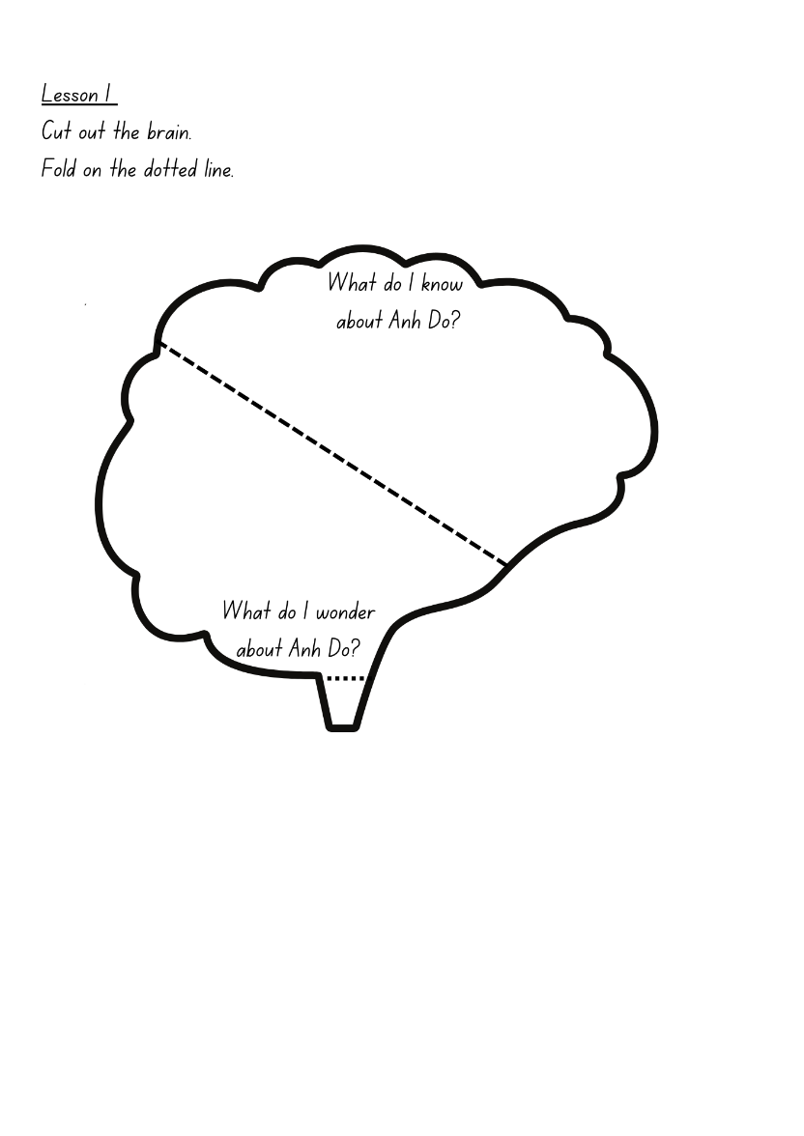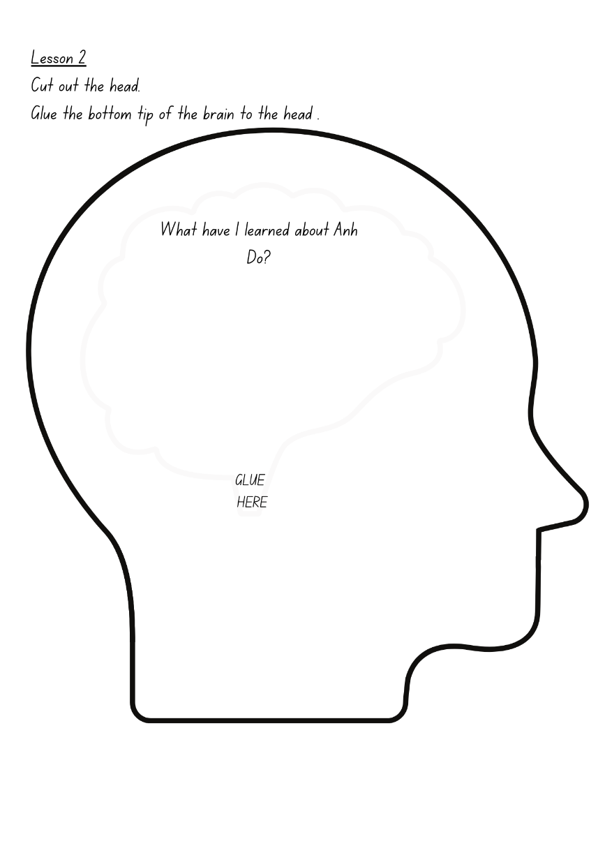

Resource 2 – theme detective jigsaw
Teacher instructions: enlarge to A3 (or larger). Cut into individual jigsaw pieces. Give one piece to each home group to complete for their allocated theme. Students record their theme, evidence from the text to support their thinking, and any personal connections and/or learnings from the text. Once completed, put the pieces of the jigsaw back together to show a complete picture of the themes in the text.
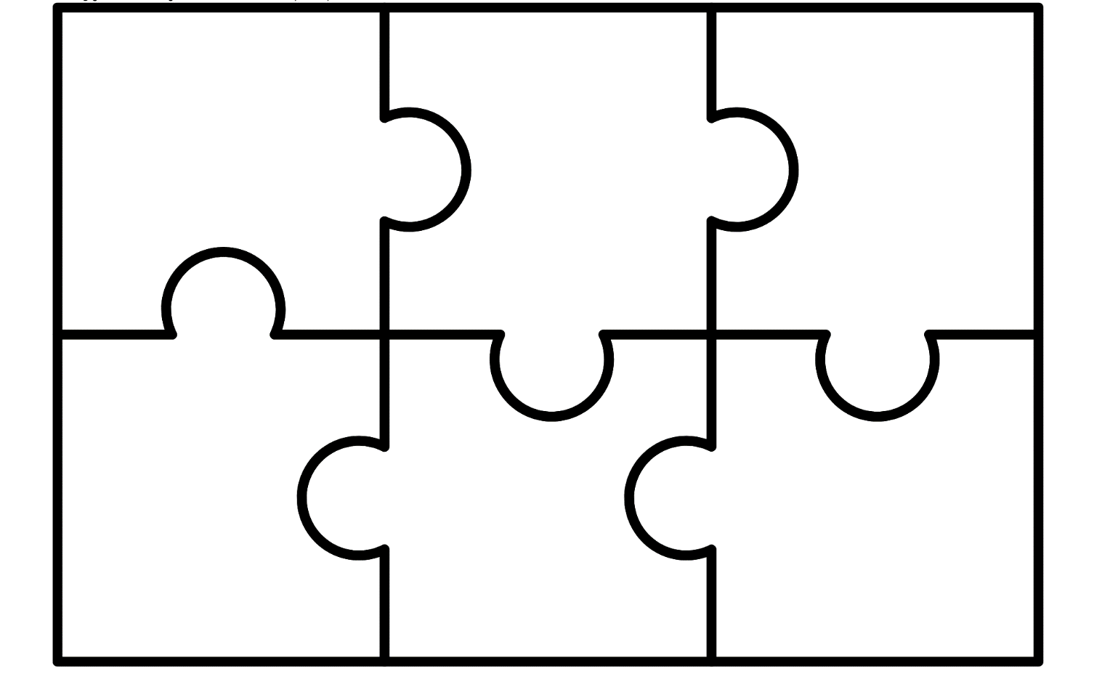

Resource 3 – theme detective jigsaw (teacher resource)
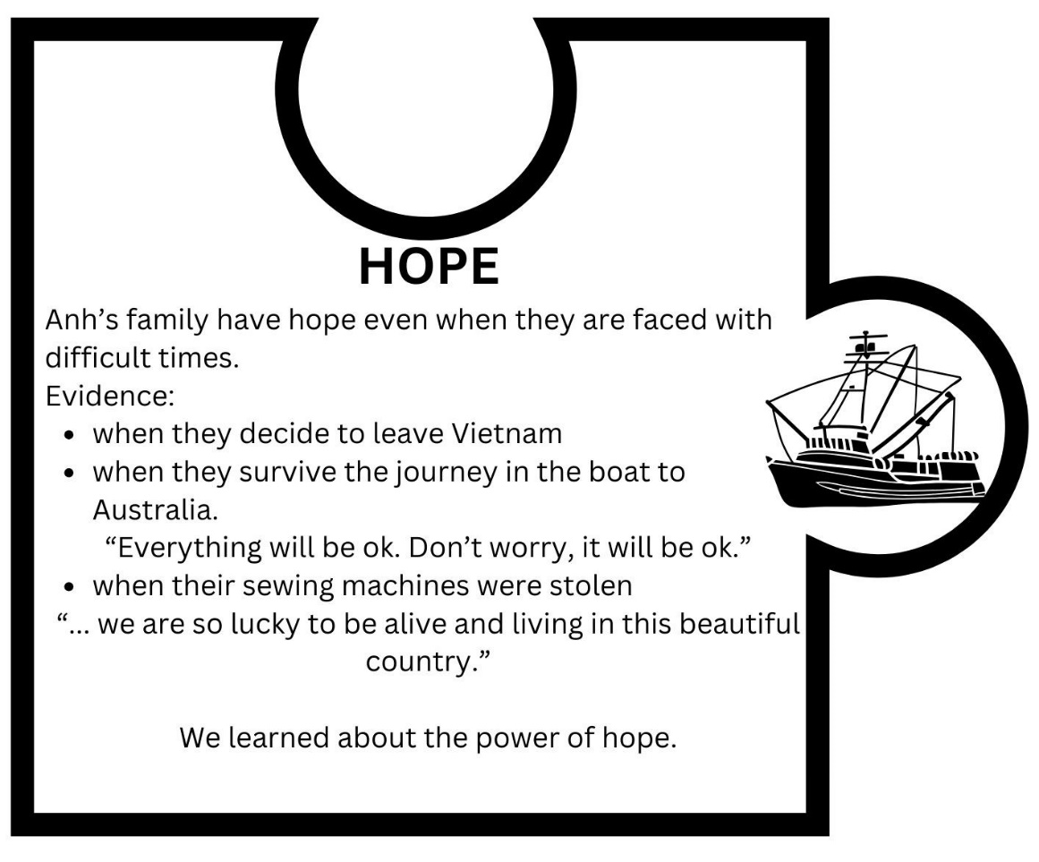

Resource 4 – pivotal moment
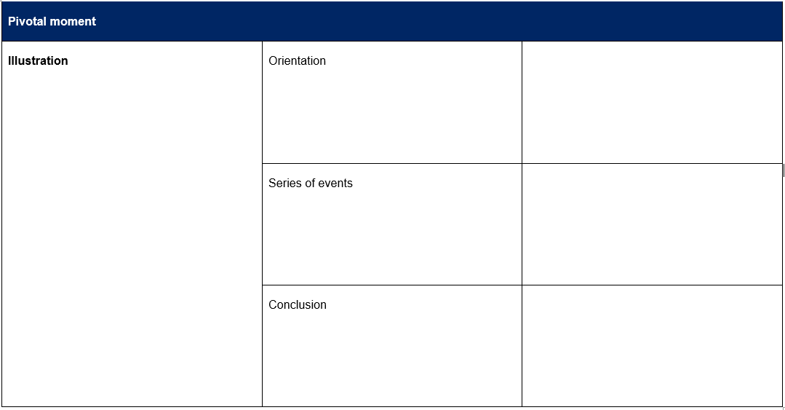

Resource 5 – articles table (teacher resource)
a | an | the
a war  a boat  a pirate  a new kid | an angry storm  an afternoon  an old lady  an old wooden fishing boat | the war  the storm  the sun  the school principal

Resource 6 – vocabulary table
Word | Literal meaning/definition | Implied meaning – The Little Refugee | Implied meaning – We Are Australians

Resource 7 – free verse planning
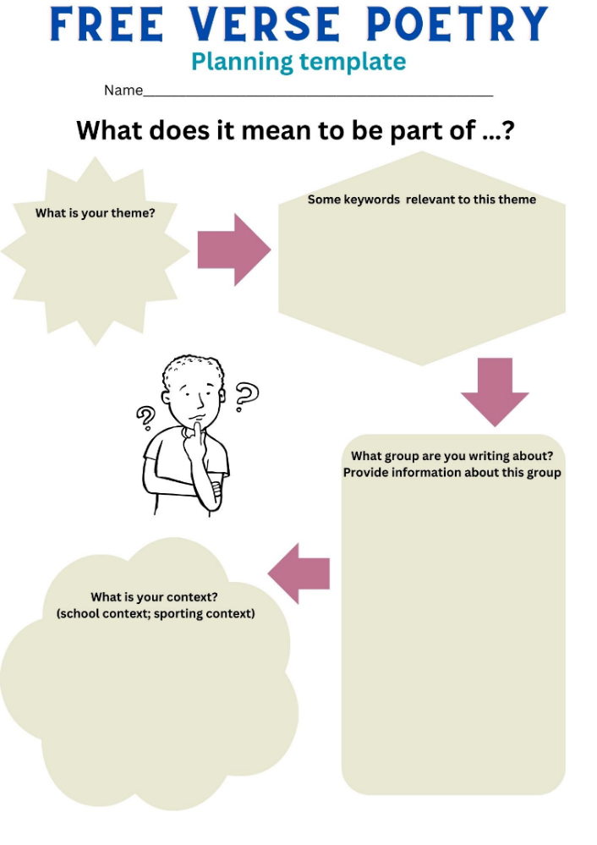

Resource 8 – unit reflection
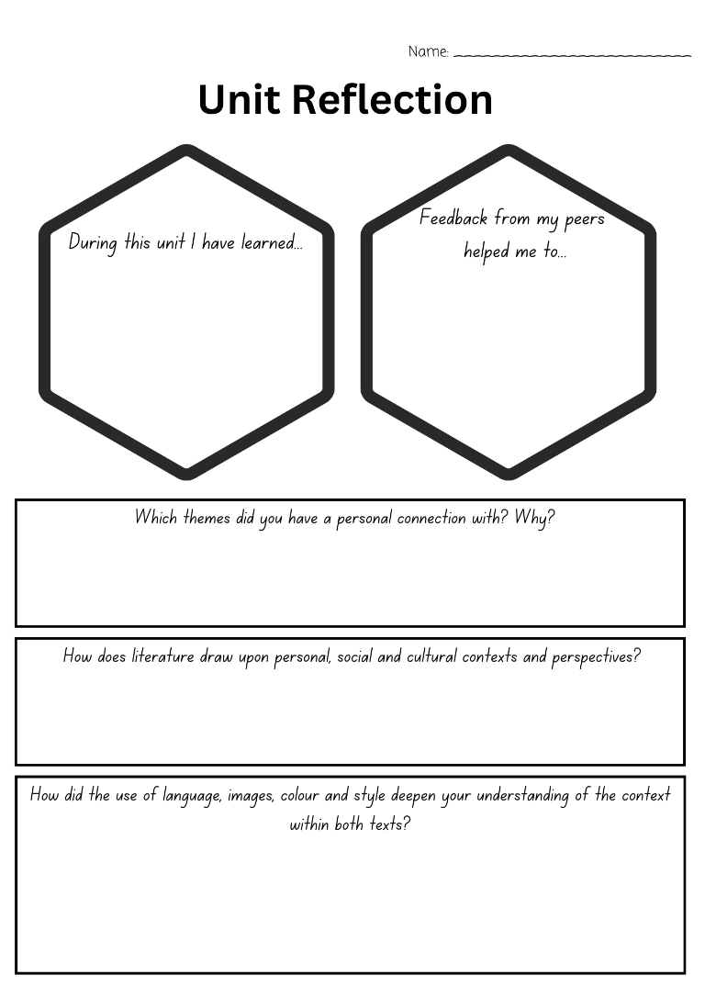

References
This resource contains NSW Curriculum and syllabus content. The NSW Curriculum is developed by the NSW Education Standards Authority. This content is prepared by NESA for and on behalf of the Crown in right of the State of New South Wales. The material is protected by Crown copyright.
Please refer to the NESA Copyright Disclaimer for more information https://educationstandards.nsw.edu.au/wps/portal/nesa/mini-footer/copyright.
NESA holds the only official and up-to-date versions of the NSW Curriculum and syllabus documents. Please visit the NSW Education Standards Authority (NESA) website https://educationstandards.nsw.edu.au/ and the NSW Curriculum website https://curriculum.nsw.edu.au.
English K–10 Syllabus © NSW Education Standards Authority (NESA) for and on behalf of the Crown in right of the State of New South Wales, 2022.
National Literacy Learning Progression © Australian Curriculum, Assessment and Reporting Authority (ACARA) 2010 to present, unless otherwise indicated. This material was downloaded from the Australian Curriculum website (National Literacy Learning Progression) (accessed 11 April 2024) and was not modified.
ABC News (Australia) (27 July 2011) ‘Anh Do honoured by major literary prize’ [video], ABC News (Australia), YouTube, accessed 30 August 2023.
ARTS hub (2017) Jandamarra Cadd: The Spaces Between, ARTS hub website, accessed 30 August 2023.
Australian Indigenous HealthInfoNet (2022) The Australian Indigenous HealthInfoNet Guidelines for Aboriginal and Torres Strait Islander Terminology, Australian Indigenous HealthInfoNet website, accessed 24 August 2024.
Do A and Do S (2011) The Little Refugee, Allen & Unwin Children’s, Australia.
Japingka Aboriginal Art (n.d.) Australian Aboriginal Dot Painting, Japingka Aboriginal Art website, accessed 31 August 2023.
Kraner-Tucci R(2022) Remembering the community spirit of the late Uncle Jack Charles, PRObono Australia website, accessed 30 August 2023.
Narragunnawali (n.d.) ‘Narragunnawali: Reconciliation in Education’ [video], Narragunnawali website, accessed 23 February 2024.
New South Wales Government (Department of Education) (2024) Supporting refugee students, Department of Education website, accessed 11 April 2024.
NESA (NSW Education Standards Authority) (2023) ‘Glossary’, Resources, NESA website, accessed 11 April 2024.
NITV News (2017) Portrait of activist Jack Charles wins Archibald People’s Choice award, NITV News, SBS website, accessed 30 August 2023.
President and Fellows of Harvard College and Harvard Graduate School of Education (2020) ‘+1 Routine...’, Thinking Routine Toolbox, Project Zero website, accessed 20 March 2024.
Royal Historical Society of Victoria (2018) We Are Australians By Duncan Smith and Nicole Godwin Illustrated by Jandamarra Cadd, Royal Historical Society of Victoria website, accessed 30 August 2023.
Smith D and Godwin N (2022) We Are Australians, Simon & Schuster, Australia.
The Australian Institute of Aboriginal and Torres Strait Islander Studies (AITSIS) (n.d.) Map of Indigenous Australia, AIATSIS website, accessed 30 August 2023.

© State of New South Wales (Department of Education), 2024
The copyright material published in this resource is subject to the Copyright Act 1968 (Cth) and is owned by the NSW Department of Education or, where indicated, by a party other than the NSW Department of Education (third-party material).
Copyright material available in this resource and owned by the NSW Department of Education is licensed under a Creative Commons Attribution 4.0 International (CC BY 4.0) license.
This license allows you to share and adapt the material for any purpose, even commercially.
Attribution should be given to © State of New South Wales (Department of Education), 2024.
Material in this resource not available under a Creative Commons license:
- the NSW Department of Education logo, other logos and trademark-protected material
- material owned by a third party that has been reproduced with permission. You will need to obtain permission from the third party to reuse its material.
Links to third-party material and websites
Please note that the provided (reading/viewing material/list/links/texts) are a suggestion only and implies no endorsement, by the New South Wales Department of Education, of any author, publisher, or book title. School principals and teachers are best placed to assess the suitability of resources that would complement the curriculum and reflect the needs and interests of their students.
If you use the links provided in this document to access a third-party's website, you acknowledge that the terms of use, including licence terms set out on the third-party's website apply to the use which may be made of the materials on that third-party website or where permitted by the Copyright Act 1968 (Cth). The department accepts no responsibility for content on third-party websites.

