English Stage 2 Second year – Unit 13
Characterisation – The Callers
Contents
Unit overview and instructions for use 6
Teacher notes 9
Outcomes and content 11
Resources 19
Week 1 22
Component A teaching and learning 22
Planning framework 22
Component B teaching and learning 22
Learning intentions and success criteria 22
Learning intention 23
Success criteria 23
Lesson 1 – textual orientation and characterisation 24
Lesson 2 – exploring character actions and decisions 27
Lesson 3 – creating imagery through symbol and personification 30
Lesson 4 – character inferences 32
Week 2 37
Component A teaching and learning 37
Planning framework 37
Component B teaching and learning 37
Learning intentions and success criteria 37
Learning intention 38
Success criteria 38
Lesson 5 – exploring character thoughts and emotions 38
Lesson 6 – connectives that support cohesion 43
Lesson 7 – imagery using descriptive and figurative language 45
Lesson 8 – exploring character decisions 48
Week 3 52
Component A teaching and learning 52
Planning framework 52
Component B teaching and learning 52
Learning intentions and success criteria 52
Learning intention 53
Success criteria 53
Lesson 9 – relationships between characters 53
Lesson 10 – exploring wordplay and summarisation 58
Lesson 11 – exploring symbolism 61
Lesson 12 – verbs that control meaning and editing 65
Week 4 67
Component A teaching and learning 67
Planning framework 67
Component B teaching and learning 67
Learning intentions and success criteria 67
Learning intention 68
Success criteria 68
Lesson 13 – exploring characterisation through interrogative sentences 68
Lesson 14 – comparing characters 72
Lesson 15 – exploring character actions using a variety of sentence types 74
Lesson 16 – character development 76
Week 5 79
Component A teaching and learning 79
Planning framework 79
Component B teaching and learning 79
Learning intentions and success criteria 79
Learning intention 80
Success criteria 80
Lesson 17 – exploring mental models and summarisation 80
Lesson 18 – creating a character 84
Lesson 19 – writing an interview script for a character 87
Lesson 20 – presenting and reflecting 88
Resource 1 – images 90
Resource 2 – prediction table 92
Resource 3 – character profile 93
Resource 4 – decision exemplar 94
Resource 5 – decision template 95
Resource 6 – character timeline 96
Resource 7 – diary entry planner 97
Resource 8 – character relationships 98
Resource 9 – puns 99
Resource 10 – chapter summary 100
Resource 11 – 5 senses template 101
Resource 12 – editing checklist teacher resource 102
Resource 13 – missing person poster 103
Resource 14 – character comparison table 104
Resource 15 – story map 105
References 106

Unit overview and instructions for use
In this 5-week unit, students will be learning about the textual concept of ‘characterisation’ and the supporting concept of ‘imagery, symbol and connotation’. Though a close study of the text The Callers by Kiah Thomas, students will learn about characterisation as the qualities attributed to imagined characters, including their personality and emotional attributes. Students will examine excerpts from the text that explore the author’s purpose in the development of characters and the various aspects of characterisation, such as appearance, actions, words and thoughts. Students will create written texts for imaginative purposes and enhance their understanding of the textual concepts. They will apply their understanding of characterisation to develop and present their own character in the final part of the unit.
Outcomes and content in this unit are organised into Component A and Component B. The components are connected, with learning in Component A complementing learning in Component B.
Note: the duration of this unit can be adapted to suit individual school contexts. For example, learning could occur across 5 days rather than 4.
The table below highlights the focus areas and preparation required for Component A and Component B.
Teaching and learning | Component A | Component B
Suggested duration | 60 minutes × 4 days/week or equivalent | 60 minutes × 4 days/week or equivalent
Explicit teaching focus areas | Component A addresses content from the focus areas:  - Vocabulary  - Reading fluency  - Reading comprehension  - Creating written texts  - Spelling  - Handwriting and digital transcription  It centres on the development of foundational skills and knowledge through regular, systematic and repeated practice. | Component B addresses content from the focus areas:  - Oral language and communication  - Vocabulary  - Reading comprehension  - Creating written texts  - Understanding and responding to literature  It centres on the conceptual understandings of English and exemplifies the importance of learning about and enjoying literature through the study of quality texts.
Preparing for teaching and learning | - Specific teaching and learning activities need to be developed by the teacher. When planning for these activities, please refer to the Component A outcomes and content, teaching guides and planning frameworks.  - Plan and document how you will sequence teaching and learning in whole-class and targeted-groups across the 5-week cycle as required. This should be based on student needs identified through ongoing assessment data. | - Familiarise yourself with the mentor and supporting texts and textual concepts, and the teaching and learning sequence.  - Determine how you will support students in whole-class and targeted-groups across the 5-week cycle as required. This should be based on student needs identified through ongoing assessment data.
English K–10 Syllabus © NSW Education Standards Authority (NESA) for and on behalf of the Crown in right of the State of New South Wales, 2022.

Teacher notes
- Characterisation is the mentor concept of this unit, explored using the text The Callers by Kiah Thomas. Characterisation is the technical construction and representation of any personality or person-like figure in text, including features such as their appearance, actions, words or thoughts (NESA 2024).
- Understanding characterisation can be supported through watching the department’s video: Character (2:31).
- While ‘characterisation’ is the mentor concept for the conceptual component of this unit, the supporting concept of ‘imagery, symbol and connotation’ is also be explored. Additional textual concepts may be included based on individual school context and student needs.
- For information on figurative language and temporal, causal and conditional conjunctions refer to the NESA Glossary.
- Throughout this unit students will be required to complete quick writes. Further information on Quick writes can be found on the Digital Learning Selector.
- In addition to the resources listed, students will require access to short passages of the mentor and/or supporting texts. Teachers can copy extracts from texts in reliance on the Statutory Text and Artistic Works Licence. Teachers need to attribute the extracts and include the following notice: ‘This material has been copied [and communicated to you] in accordance with the statutory licence in section 113P of the Copyright Act. Any further reproduction or communication of this material by you may be the subject of copyright protection under the Act. Do not remove this notice’.
- This unit could enhance student learning towards the achievement of creative arts outcomes.
- Reflect on student learning and engagement in activities and record differentiation and adjustments within the unit to inform future teaching and learning. One way of doing this could be to add comments to the digital file.
- In NSW classrooms there is a diverse range of students including Aboriginal and/or Torres Strait Islander students, students learning English as an additional language or dialect, high potential and gifted students and students with disability. Some students may identify with more than one of these groups, or possibly all of them. Refer to Curriculum planning for every student – advice for further information.
- Content points are linked to the National Literacy Learning Progression (version 3).
Levels and indicators sourced from National Literacy Learning Progression © Australian Curriculum, Assessment and Reporting Authority (ACARA), (accessed 31 August 2023) and was not modified. See references for more information.

Outcomes and content
The table below outlines the outcomes and content for this unit. The letters 'A' and 'B' in the header refer to Components A and B. The numbers 1 to 5 refer to weeks. The use of 'x' in these columns indicates where the content points are intended to be addressed and in which week.
Focus area and outcome, content points and National Literacy Learning Progression | A | B | 1 | 2 | 3 | 4 | 5
Oral language and communication
EN2-OLC-01 communicates with familiar audiences for social and learning purposes, by interacting, understanding and presenting
- Pose and respond to open-ended questions about literature that contribute to own or others’ enjoyment (InT5) |  | x | x | x | x | x | x
- Pose and respond to specific questions to clarify or follow up on information (InT5) |  | x | x | x | x | x | x
- Identify connective vocabulary that supports cohesion and understanding in a spoken text (LiS5) |  | x |  | x |  |  | x
- Understand that rhetorical questions can be used for intentional effect |  | x |  | x |  | x
- Use temporal connectives to sequence planned information in a presentation (SpK4, UnT7, GrA4) |  | x |  | x |  |  | x
Vocabulary
EN2-VOCAB-01 builds knowledge and use of Tier 1, Tier 2 and Tier 3 vocabulary through interacting, wide reading and writing, and by defining and analysing words
- Build personal Tier 1, Tier 2 and Tier 3 vocabulary through social and learning interactions, reading and writing (SpK5) |  | x | x | x | x | x
- Recognise that words and phrases can have literal or implied meanings according to context (UnT7) | x | x | x | x | x | x | x
- Understand and use wordplay including puns and spoonerisms (CrT7) | x | x |  | x | x
Reading fluency
EN2-REFLU-01 sustains independent reading with accuracy, automaticity, rate and prosody suited to purpose, audience and meaning
- Explain how effortless and accurate word reading, at a pace appropriate for text and purpose, can support reading fluency and comprehension | x |  | x |  | x
- Syllabify, blend grapheme–phoneme correspondences and use morphemic knowledge as strategies for reading words accurately (PKW8) | x |  | x |  | x |  | x
- Maintain stamina when reading extended texts | x |  |  | x |  | x | x
- Reflect on stamina for reading sustained texts | x |  |  | x |  | x | x
Reading comprehension
EN2-RECOM-01 reads and comprehends texts for wide purposes using knowledge of text structures and language, and by monitoring comprehension
- Identify different purposes and strategies for reading (FlY5) | x |  |  |  | x |  | x
- Use morphemic knowledge to read and understand the meaning of words (UnT7) | x |  | x |  |  |  | x
- Use key words from a text to visualise events, characters and settings when making inferences and confirming predictions | x | x | x | x | x | x | x
- Identify the adverbs, nouns and verbs that influence own emotional response to characters | x | x |  | x |  | x | x
- Identify different types of verbs that control meaning | x | x |  |  | x | x | x
- Identify different types of connectives used by the author that support inference | x | x |  | x |  | x | x
- Understand past, present and future tense and their impact on text meaning (GrA4) | x | x | x | x |  | x | x
- Identify how their background knowledge is used to actively build and adjust a mental model prior to and during reading (UnT6) | x | x | x | x | x | x | x
- Use information from paragraphs or chapters to group related ideas and support summarisation of the whole text (UnT6) |  | x |  |  | x |  | x
- Reflect on reading experiences and identify texts of personal significance and pleasure | x |  | x | x |  | x | x
- Reflect on own understanding of texts and monitor own goals for reading | x |  | x |  |  |  | x
Creating written texts
EN2-CWT-01 plans, creates and revises written texts for imaginative purposes, using text features, sentence-level grammar, punctuation and word-level language for a target audience
- Create imaginative texts to engage an audience, using first person or third person narrative voice (CrT8) |  | x | x |  |  |  | x
- Sequence ideas and actions into paragraphs aligned to the stages of the text, to provide elaborated details about settings, character motives and actions (CrT8) |  | x | x | x |  |  | x
- Maintain appropriate, consistent past, present or future tense across a text (CrT8, GrA4) | x | x | x | x |  | x | x
- Use temporal, conditional and causal conjunctions within sentences, and as connectives to link ideas across sentences for cohesion (CrT8) | x | x |  | x |  | x | x
- Maintain correct subject–verb agreement throughout a text (GrA5) | x | x |  | x | x
- Use language to create imagery or humour, including idioms, puns, simile and personification (CrT8) | x | x | x | x | x |  | x
- Use coordinating conjunctions in compound sentences to compare and contrast, or for addition (GrA4) |  | x |  | x |  | x
- Use subordinating conjunctions in complex sentences to signal sequence, reason or cause and effect (GrA6) |  | x |  | x |  | x
- Select and use precise saying, thinking, acting, and relating verbs and verb groups to align with text purposes (GrA5, CrT8) | x | x |  |  | x | x | x
- Use imperative sentences to advise, provide instructions, express a request or a command | x | x |  |  | x | x
- Use exclamatory sentences to emphasise a point or express a strong emotion | x | x |  |  | x | x
- Use interrogative sentences to ask a direct question, or for rhetorical effect to engage the reader with a viewpoint | x | x |  |  | x | x | x
- Use simple, compound and complex sentences of varying lengths for variation and readability (CrT7, GrA5) | x | x |  | x | x | x
- Use personal pronouns to suit purpose and to connect personally with the audience | x | x | x | x | x
- Use adjectives to develop descriptive features (CrT8) |  | x |  |  | x | x | x
- Create texts by drawing on personal and others’ experiences, and texts read, viewed and listened to for inspiration and ideas |  | x | x | x | x | x | x
- Reflect on and monitor texts according to given criteria, and respond to feedback from others |  | x |  | x | x | x | x
- Proofread, revise and edit written texts to refine language, correct spelling and ensure cohesion and engagement for the reader |  | x |  | x | x | x | x
Spelling
EN2-SPELL-01 selects, applies and describes appropriate phonological, orthographic and morphological generalisations and strategies when spelling in a range of contexts
- Explain how to segment multisyllabic words into syllables and phonemes, and apply this knowledge when spelling | x |  | x | x | x | x | x
- Understand that some graphemes are dependent on their position in a word in English and apply this knowledge when spelling | x |  | x | x | x | x | x
- Understand that graphemes can be explained by their etymology (SpG9) | x |  | x | x | x | x | x
- Use spelling reference tools where required and recognise that spellcheck accuracy may depend on understanding the word | x |  |  |  | x
- Identify prefixes that require no change to the base word or root when they are affixed, and apply this knowledge when spelling (SpG9) | x |  | x | x | x | x | x
Handwriting and digital transcription
EN2-HANDW-01 forms legible joined letters to develop handwriting fluency
EN2-HANDW-02 uses digital technologies to create texts
- Sustain the NSW Foundation Style cursive to facilitate fluency and legibility across a text (HwK7) | x |  | x | x | x |  | x
- Monitor goals that build on typing accuracy and rate | x |  |  | x
- Use word-processing program functions or augmentative and alternative communication (AAC) to draft and revise texts | x |  |  |  | x | x | x
Understanding and responding to literature
EN2-UARL-01 identifies and describes how ideas are represented in literature and strategically uses similar representations when creating texts
- Understand that characterisation refers to the qualities attributed to real and imagined characters, including their personality and emotional attributes |  | x | x | x | x | x | x
- Identify how authors use dialogue to convey what characters say and think, and experiment with dialogue when creating texts |  | x |  |  | x |  | x
- Describe how a character drives the plot in a narrative |  | x | x | x | x | x | x
- Describe how characters invite emotional engagement with literature |  | x | x | x | x | x | x
- Recognise imagery and symbols in literature (UnT7) |  | x | x | x | x |  | x
English K–10 Syllabus © NSW Education Standards Authority (NESA) for and on behalf of the Crown in right of the State of New South Wales, 2022.

Resources
The resources in the table below are referred to in this unit. Letters 'A' and 'B' in the header refer to Component A and B respectively, and the numbers 1 to 5 indicate weeks. The use of 'x' in these columns indicates whether the resources are required in Component A, B or both, and in which week.
Resource | A | B | 1 | 2 | 3 | 4 | 5
Thomas K (2022) The Callers, HarperCollins Publishers, Australia. ISBN13: 9781460762141 | x | x | x | x | x | x | x
Resource 1 – images (enlarged copy) |  | x | x
Optional: feely boxes × 2 |  | x | x
Resource 2 – prediction table (enlarged copy, individual student copies) |  | x | x | x |  |  | x
Resource 3 – character profile (4 enlarged copies, individual student copies) |  | x | x | x | x | x | x
Resource 4 – decision exemplar (enlarged copy, individual student copies) |  | x | x
Resource 5 – decision template (enlarged copy, individual student copies) |  | x | x
Resource 6 – character timeline (enlarged copy) |  | x | x | x | x | x
Sentence strips for each student |  | x | x
Resource 7 – diary entry planner (enlarged copy, individual student copies) |  | x |  | x
Individual whiteboards and markers |  | x |  | x
Container |  | x |  |  | x
Resource 8 – character relationships (enlarged copy, individual student copies) |  | x |  |  | x
Resource 9 – puns (enlarged copy) |  | x |  |  | x
Resource 10 – chapter summary (enlarged copy, individual student copies) |  | x |  |  | x
Resource 11 – 5 senses template (enlarged copy, individual student copies) |  | x |  |  | x
Resource 12 – editing checklist teacher resource (enlarged copy) |  | x |  |  | x
Resource 13 – missing person poster (enlarged copy, individual student copies) |  | x |  |  |  | x
Resource 14 – character comparison table (enlarged copy, individual student copies) |  | x |  |  |  | x
Resource 15 – story map (enlarged copy, individual student copies) |  | x |  |  |  |  | x
Website: Ten Terrifying Questions with Kiah Thomas |  |  |  |  |  | x | x

Week 1

Component A teaching and learning
Component A focuses on the development of foundational skills and knowledge through regular, systematic and repeated practice. The mentor and supporting texts used in Component B of this unit will support the effective implementation of Component A teaching and learning.

Planning framework
To plan and document Component A teaching and learning, a planning scaffold (DOCX 228 KB) is provided. To support you in your planning, a link to a detailed example of a one-week teaching and learning cycle is included in the scaffold. Additional resources to support teaching and learning in each focus area can be found at Lesson advice guides.

Component B teaching and learning
The following teaching and learning sequence has been designed to address Component B outcomes and content and develops conceptual understandings of English through the study of quality texts. Adapt the sequence as required to best meet the needs of your students.

Learning intentions and success criteria
Learning intentions and success criteria are best co-constructed with students.

Learning intention
Students are learning how language is used in a text to develop a deeper knowledge of characterisation.

Success criteria
Students can:
- use background knowledge to make connections and predictions about characters
- explore the decisions and actions of characters
- explore the use of imagery to create a mental model
- use personal pronouns to connect with the audience
- make inferences about characters through the language used by the author.

Lesson 1 – textual orientation and characterisation
Note: prior to the lesson, print, cut out and display enlarged copies of Resource 1 – images around the classroom.
- Students explore Resource 1 – images displayed in the classroom. Explain that these images have a connection to the text that will be read.
Optional: create 2 feely boxes. Students take turns feeling the items, while not looking at them. Students use ‘I see...’, ‘I think...’, ‘I wonder...’ statements to record predictions about the items and their possible connection to the text. Provide a variety of different resources. For example:
- Box 1: natural objects such as leaves and vines
- Box 2: cool, hard objects such as rocks, metal and household items.
- Read the prologue on the first page of The Callers by Kiah Thomas. Display the front cover, concealing the image of the boy. Explore possible connections between the front cover and the displayed images from Resource 1 – images (and the feely boxes if used). Students make predictions about the text. Ask:
- What connections do you see?
- What do you think this text is about?
- Why do you think the colour green is so dominant?
- Read the paragraph on the back cover of the book beginning with ‘Now Quin must team up ...’. In pairs, students turn and talk to discuss how their predictions may have changed.
- Explore characterisation. Explain that a character is given an identity with a personality, wants, emotions and feelings. Characters are important because they drive the action and plot of a narrative. They must want or need to do something and set about trying to achieve or obtain a goal.
Characterisation: the technical construction and representation of any personality or person-like figure in text, including features such as their appearance, actions, words or thoughts (NESA 2024).
- Display the front of the text and reveal the image of the boy. Explain that it is important for a reader to emotionally connect with characters in a text so that they become more engaged. Emotional connections also support readers to follow the characters' experiences and feel a sense of shared joy, sadness, or excitement. Ask:
- Who could the boy on the front cover be?
- What emotions can we identify in his facial expression?
- What is he is holding? How do you think it is important to his character?
- Revise and discuss predictions in activity 2 and 3. Display an enlarged copy of Resource 2 – prediction table. Model making predictions using think-alouds and key words from the prologue to visualise events, characters and settings. Complete the Lesson 1 section of Resource 2 – prediction table.
- Students independently complete the Lesson 1 section on Resource 2 – prediction table.
Note: the prediction table will be revisited in Lesson 7 and Lesson 17.
- Read Chapter 1, drawing attention to the Tier 2 vocabulary used. Ask:
- What do we learn about Quin’s relationship with Davinia and Adriana?
- How does Quin feel towards Adriana? How do you know?
- What is a Caller? How does Quin feel about the Calling process?
- What are the Spurges? Where are they located?
- Where do you think Quin and his family are going the next morning?
- Revise Tier 2 vocabulary from the Chapter 1 reading. Discuss the importance of how vocabulary is used in the text to engage the reader. Revise Tier 2 vocabulary. Record Tier 2 vocabulary used in Chapter 1 on a word wall. For example, snorted (p 8), thudded (p 9), twist (p 10), unofficially (p 11), instinctive (p 12), scolded (p13), terrifyingly (p 14), constructed (p 15), trickled (p 16), assistance (p 17).
Note: the word wall will be developed throughout the unit.
- Display Resource 3 – character profile. In groups, allocate students one of the following sections for Adriana, Quin and Davinia: ‘Appearance’, ‘Personality’ and ‘Relationships’. Students brainstorm and record their ideas for each character in the relevant section, on 3 separate enlarged copies of Resource 3 – character profile. Share Quin’s character profile.
Note: these character profiles will be developed and referred to throughout the unit.
- Students write a short text to describe Quin's personality and relationships, referring to the character profile. Encourage students to refer to the Tier 2 word wall. For example:
Quin: Quin prefers to keep to himself and does not enjoy the unwanted attention he gets from his family. He senses that his mother and sister are critical of him because he has not been able to Call anything yet. Quin gets a terrifyingly anxious feeling when he thinks about the test. He knows his best friend Cassius has been making excellent progress with his Calling.
Too hard? Provide students with sentence stems.
- As a class, students share one fact from their short text to provide examples of Quin's personality and relationships.

Lesson 2 – exploring character actions and decisions
- Read Chapter 2 of The Callers. Ask:
- How does Quin feel about his dreams? How do you know?
- Why is Adriana reliant on Quin’s assistance? What does this reveal about her relationship with Quin? For example, she needs him more than he needs her.
- Why does Milo’s mum lie to Adriana? What might she be worried about?
- Why do you think Cecelia says that ‘Calling is a crime’ (p 23)?
- How does Quin feel about going to the Spurges and visiting Milo? What in the text tells you this?
- Re-read page 27 from ‘“Hello,” said Adriana…’ to the end of the chapter. Discuss how Quin might feel in this situation using evidence from the text to support thinking. For example, his stomach rolled as he was worried about his mum’s reaction.
- Ask students if they have ever been in a situation where they have had to make a difficult decision. Explain that their attributes, such as what they think and feel, will impact the decisions they make as well as the outcome and consequences of those decisions. Explain that this is known as a moral dilemma.
- Present a moral dilemma to students encouraging them to focus on how they would feel being torn between making 2 decisions. For example, ‘You find $20 on the pavement at school. What do you do?’.
- View and discuss the responses on Resource 4 – decision exemplar. Students complete quick writes based on what they would do if they found $20 on the pavement at school.
- Re-read page 27 to the end of the chapter. Discuss Quin’s moral dilemma. Ask:
- Why is this a moral dilemma for Quin?
- What choices does Quin have?
- What are the consequences of these choices for Quin and Milo?
- Students consider Quin’s moral dilemma and individually complete Resource 5 – decision template.
- In small groups, students use the agreement and disagreement pages in Peer discussion and conferencing to discuss their responses to the moral dilemma.
- Explain that this text is written in third-person narrative voice. This is a way of telling a story when the narrator is not one of the characters in the text. Third-person narrative voice uses pronouns such as he, she, it, or they, to talk about the characters. Explain that a personal pronoun is a word used in place of a noun and to suit purpose, as taught in Component A. For example, him, he, his (p 18), they, her (p 19).
- Discuss the impact of using third-person narrative voice. For example, engages the reader as they can connect with different characters and provides multiple angles within the text.
- Model writing statements about what Milo is feeling and thinking during the moral dilemma, using third-person narrative voice and appropriate personal pronouns. For example:
When Milo saw Quin, his belly felt like a thousand butterflies exploding. He was thinking deeply about why Quin was at his house. Was Quin going to give him away. Milo could barely breath and his legs were shaking. Were they thinking of taking him to Orbis?
- Students write statements about what Quin is feeling and thinking, using third person narrative voice and appropriate personal pronouns. Refer to completed Resource 4 – decision exemplar.
- Explain that students will be creating a timeline to identify the significant events in the text that contribute to Quin’s character development. Display an enlarged copy of Resource 6 – character timeline. As a class, begin adding Quin’s character developments to the timeline.
Note: this character timeline will be added to throughout the unit, as Quin’s character changes and emerges. Keep displayed.

Lesson 3 – creating imagery through symbol and personification
- Revise mental models from learning in Component A. Explain that students will create a mental model drawing on their background knowledge, while reading The Callers.
Mental model: a mental representation of the information in a real or an imaginary world. A student develops a mental model as the text progresses. It may include information derived from inferences and from background knowledge as well as from what is explicitly stated in the text itself (NESA 2024).
- Ask students to reflect on their favourite place, for example, a park or their bedroom. Ask them to create an image of that place drawing on their background knowledge. Explain that what they see in their mind is their initial mental model. Explore that each time they visit that place their mental model will change as their knowledge grows. Discuss that mental models will adjust and develop as the text is read.
- Read the passage in italics at the start of Chapter 3. While reading, ask students to close their eyes and create their initial mental model.
- In pairs, students take turns telling their partner what they imagined, while the other uses Sketches and squiggles to draw the visualisation.
- Discuss the use of colour in Quin’s dream and the symbolism that it represents. Explain that this is important to the character’s development through the text. Ask:
- What colour is referred to in Quin’s dream?
- What does the colour green symbolise? For example, nature, health, luck, life, plants, regrowth, freshness, relaxation.
- What can we infer about Quin’s character from this passage? For example, he might have a connection to nature.
- Is there a connection between the front cover and the passage?
- Ask students to recall their understanding of imagery and the use of figurative language, as taught in Component A. Re-read the second sentence in Chapter 3 starting at ‘A breeze curled...’ and identify what form of figurative language is used. For example, personification. Discuss how this helps to develop the reader's mental model as it attributes human characteristics to an object in the text, that appeals to the senses of the reader.
- Ask and record what words the author uses in the passage to help create a mental model. For example, curled, danced, stretched, pulsing, tingling. Explain that these words provide objects with human characteristics.
- The author refers to the colour green in this passage. Model writing sentences that include personification and the colour green, using responses from activity 6 and 7. For example:
- The green leaves stretched their way along the tree trunk.
- The long, green grass danced in the breeze.
- Ask students what the word blue could symbolise, and brainstorm words associated with this colour. For example, sad, feeling blue, waves, sky, rain.
- Students write sentences on sentence strips that include personification using the colour blue, referring to the recorded words from activity 6 and 9. For example:
- The blue waves danced on the shore.
- The blue sky stretched endlessly above us.
Too hard? Provide students with a list of associated words for a colour and sentence starters.
- Students locate peers who have written sentences using the same brainstormed word from activity 9. For example, waves. Students share and combine their sentences to write a description. For example:
The waves gracefully dance across the ocean. They move up and down, waving hello to the shore, making a soothing sound as they reach the land, like a gentle whisper. It might even seem like they're talking to you if you listen closely.

Lesson 4 – character inferences
- Read Chapter 3 of The Callers. Ask:
- Why do you think Quin writes a list of the things he knows about Calling?
- Why does Adriana think people will not withhold information from her?
- Why is Quin impressed that Milo’s mum stands up to Adriana?
- Explain how authors purposely give characters certain traits to develop their personality and the plot of the text. Jointly construct the ‘Morals and Motive’ section of Resource 3 – character profile for Adriana, Quin and Davinia, from Lesson 1.
- Ask students to recall their understanding of adverbs, nouns and verbs that influence emotional responses to characters, as taught in Component A.
- Display pages 33 to 37 of the text. Discuss and identify the actions and emotions that Quin experiences in the lead up to his test. Identify verbs, nouns and adverbs and discuss the author’s intended connection to the reader. For example:
- ‘They took a Council vehicle (noun) to chambers.’ (p 33). For example, the author names the type of vehicle to add impact and highlight the status of Quin's mother.
- ‘…stumbling (verb) slightly (adverb)...’ (p 34). For example, the use of the verb and the adverb show that Quin is nervous.
- ‘…ignore (verb) the rising worry...’ (p 35). For example, the author uses ignore to create a sense of empathy within readers. Readers may connect to Quin as they may have had to ignore a worry and face a challenge.
- ‘...relieved that it wasn’t shaking noticeably (adverb)...’ (p 35). For example, the deliberate choice of the adverb adds impact and highlights the specific detail of Quin's relief.
- Revisit Tier 2 vocabulary from Lesson 1 and draw attention to the verbs and adverbs used in activity 4. Discuss how these words add power to the text and are considered Tier 2 vocabulary. Add additional Tier 2 vocabulary to the word wall.
- Revise that when making inferences, readers form conclusions about characters based on evidence from the text and their own thinking.
- Display the following excerpts from the text and ask what can be inferred about Adriana’s personality. For example:
- ‘sat in the front, her back straight, eyes fixed forward.’ (p 33). For example, this shows that Adriana is formal and not relaxed.
- ‘Adriana Octavius was never one to make a subtle appearance.’ (p 34), ‘...the whole room turned to look at them.’ (p 35). For example, a presence that demands attention.
- ‘The man’s face paled.’ (p 36). For example, the word paled shows that the man does not realise who he is speaking to until he looks up and feels intimidated by Adriana’s presence.
- ‘...eyes flicking nervously to Adriana...’ (p 36). For example, the verb and adverb show that the man is nervous and does not know what Adriana might do next.
- “Of course I know, Marcellus...” (p 36). For example, this demonstrates Adriana asserting her authority over Marcellus.
- Display a 2-column chart with the headings ‘text and ‘inference’. Model using parts of the text from activity 7 to make inferences about Adriana. For example:
- Text: ‘The man’s face paled.’ (p 36)
- Inference: implies that he found Adriana intimidating.
- Ask students to fold a piece of paper in half to create a 2-column chart with the headings ‘text and ‘inference’. Explain that sections of text will be used to make inferences for Quin. Display the following excerpts from the text and ask what can be inferred about Quin’s personality:
- ‘A thread of guilt ran through him...’ (p 33). For example, Quin feels guilty for telling a lie to his mum about Zaccheus (Milo).
- ‘Thank you for your help...’ (p 36). For example, Quin is kind and appreciates the people around him.
- ‘Quin’s palms felt damp.’ (p 37). For example, Quin is sweating as he feels nervous.
- Students independently record inferences on their 2-column chart.
- Revise the structure of a paragraph. For example:
- topic sentence
- first point
- second point
- third point
- concluding statement.
- Co-construct a paragraph plan exploring inferences about Adriana, using the 2-column chart from activity 8. For example:
- Topic sentence: Adriana is the Chief Councillor
- First point: she intimidated people
- Second point: she was strict
- Third point: she presented as cold and hard
- Concluding statement: people knew when Adriana was present.
- Model writing a paragraph using the inferences about Adriana, using personal pronouns and referring to the Tier 2 word wall and paragraph plan. For example:
Adriana is the Chief Councillor. She intimidated people with her strong and determined personality. Adriana was strict and made sure rules were followed, which sometimes made people feel a little nervous around her. With her serious attitude, she presented as cold and hard. Whenever Adriana was around, everyone knew because her presence left a lasting impression.
- Students independently plan a paragraph, exploring inferences about Quin, using the 2-column chart from activity 9. For example:
- Topic sentence: Quin was different to his family
- First point: he felt guilty for telling his Mum a lie
- Second point: he was kind and appreciated other people
- Third point: he felt nervous to let his family down
- Concluding statement: Quin knew he did not fit into his family.
- Students write a paragraph using the inferences about Quin, using personal pronouns and referring to the word wall and paragraph plan.
Too hard? Students write their topic sentence and first argument point.
Too easy? Students include personification in their paragraph.
- As a class complete the ‘thoughts and feelings’ section of Resource 3 – character profile for Adriana, Quin and Davinia, from Lesson 1.

Week 2

Component A teaching and learning
Component A focuses on the development of foundational skills and knowledge through regular, systematic and repeated practice. The mentor and supporting texts used in Component B of this unit can support the effective implementation of Component A teaching and learning.

Planning framework
To plan and document Component A teaching and learning, a planning scaffold (DOCX 228 KB) is provided. To support you in your planning, a link to a detailed example of a one-week teaching and learning cycle is included in the scaffold. Additional resources to support teaching and learning in each focus area can be found at Lesson advice guides.

Component B teaching and learning
The following teaching and learning sequence has been designed to address Component B outcomes and content and develops conceptual understandings of English through the study of quality texts. Adapt the sequence as required to best meet the needs of your students.

Learning intentions and success criteria
Learning intentions and success criteria are best co-constructed with students.

Learning intention
Students are learning about characterisation and imagery to construct cohesive writing.

Success criteria
Students can:
- write a diary entry to show a character's thoughts and emotional attributes
- maintain correct tense, subject-verb agreement and use pronouns in writing
- identify and use connectives to support cohesion in writing
- use imagery including figurative and descriptive language in writing
- write a paragraph using simple, compound and complex sentences.

Lesson 5 – exploring character thoughts and emotions
- Display and discuss Resource 3 – character profile for Adriana, Quin and Davinia. Record any additional information and complete the ‘actions’ section.
- Read Chapters 4 to 5 of The Callers, stopping at ‘And maybe it was time to face that.’ (p 52) Ask:
- Why do you think becoming a Caller is so important to Cassius?
- What do you think would have happened if Adriana and Davinia’s plan had not worked?
- How do you think Davinia felt covering the lie for Quin and Calling the items in his test?
- Why do you think Quin is not able to Call?
- Re-read the text in italics on pages 45, 46, 50 and 51. Ask why the author might use italics for this part of the text. Explain that the italics provide insight into Quin’s innermost thoughts and emotions and allow for a deeper understanding of his character. For example, ‘Say nothing’ (p 46), 'False Caller. Dutiful son. Sucker’ (p 51).
- Refer to the enlarged displayed Resource 6 – character timeline from Lesson 2. Discuss and record additional significant events to the timeline. For example:
- not being able to Call
- his family’s cover up at the testing
- coming to the realisation that he is not a Caller
- being officially recognised and accepted as a Caller.
- Display Resource 7 – diary entry planner. Explain that students will complete a diary entry from Quin’s point of view using the information in Resource 7 – diary entry planner. Read the modelled examples on Resource 7 – diary entry planner and co-construct the next row, using the example below.
- Word/phrase: ‘...opened the door...’ (p 47)
- When does it happen: after the testing
- How does it happen: numbly
- Associated words to describe how Quin is feeling: grateful, avoid public embarrassment.
- Provide students with an individual copy of Resource 7 – diary entry planner. Students complete the remaining 3 boxes, using words and phrases in the text stopping at ‘And maybe it was time to face that.’ (p 52)
Note: this resource will be revisited in Lesson 15.
- Revise past, present and future tense from Component A. Explain that past tense identifies events that have already occurred. It helps readers understand that the event is being retold. Present tense shows events in the present moment within the text. Future tense shows what is going to happen. Ask students what impact tense has on the meaning of the text. For example, writers use tense to convey the timing and sequence of events and build the reader’s understanding of the text.
Tense: the form of the verb that indicates when something is happening in relation to the speaker’s time: past, present or future (NESA 2024).
- Explain that diary entries consist of a person retelling an event that has happened to them. Introduce the structure of a diary entry. For example:
- the date or time
- written in first person and include personal pronouns. For example, ‘I’, ‘me’, ‘my’
- maintain the use of past tense (verbs)
- tell events in order, usually written in paragraphs
- describe events from the writer’s point of view
- describe the places where things happened
- include personal feelings and thoughts.
- Model writing a diary entry using the modelled Resource 7 – diary entry planner. For example:
December 12, 2026
Hi Diary,
Yesterday was really tough! When I arrived at the testing, I discovered that Cassius had flourished. I felt doubt, worry and was extremely nervous. I knew I couldn't Call and I was scared. Mum and Davinia were there with me during the test.
The testers asked me to Call a banana. I knew nothing would happen! My palms felt sweaty. I had a hot forehead and was even more nervous. They were going to find out I couldn’t Call.
But here is the thing, when I said banana, mum coughed, and a banana appeared. It was very strange at first until I realised that Davinia was sneakily doing the calling and mum covered it up with a cough. They had it all planned out!
I am worried about what will happen in the future when I can't rely on my sister. I feel like I'm not being honest about my Calling abilities. It's a bit scary and I felt this as I opened the door for Mum and Davinia as we left. To be honest, I was a tiny bit grateful that I wouldn’t have to face the public embarrassment of everyone discovering that I could not Call.
I'm not excited about what comes next.
Sadly yours, Quin.
- Students draft their diary entry for Quin, using their copy of Resource 7 – diary entry planner.
Too hard? Provide students with sentence stems and a list of past tense verbs.
Too easy? Students include figurative language. For example, personification.
- Revisit previous learning on subject-verb agreement from Component A. Explain that good writers maintain correct subject-verb agreement as well as correct tense, to support readers’ understanding. Display the sentence ‘He was going …' (p 50). Identify and discuss the subject–verb agreement in this sentence. For example, the subject is ‘he’ and the verb is ‘was’. Repeat with different examples as needed.
- Students edit their diary entries. Considering the following questions:
- Have I used personal pronouns?
- Does my writing maintain correct subject-verb agreement and correct tense?
- What text could be italicised to show Quin’s inner thoughts and emotions?
- In pairs, students swap their diary entries to provide feedback and make additional suggestions on the considerations in activity 12.

Lesson 6 – connectives that support cohesion
- Read pages 52 to 53 of The Callers from ‘He rubbed his fingers along the mark on his palm...’. Students complete quick writes to record their predictions in response to the question: What might happen now that everything has gone black? In pairs, students discuss their predictions.
- Read Chapters 6 and 7 of the text. Record additional details and draw a picture of each character on the enlarged copies of Resource 3 – character profile. Update the Tier 2 vocabulary on the word wall as required.
- Ask students to recall what they know about connectives. Define, brainstorm and record examples of connectives. For example, and, but, so, first, next, for, furthermore, rather, yet, although, then.
Connective: words which link paragraphs and sentences in logical relationships of time, cause and effect, comparison or addition. Connectives relate ideas to one another and help to show the logic of the information. Connectives are important resources for creating cohesion in texts (NESA 2024).
- Revise the use of temporal, conditional and causal conjunctions within sentences, as taught in Component A. Explain that these conjunctions are types of connectives that link ideas across sentences. Record additional examples on the brainstorm from activity 3 and display for the remainder of the unit. For example:
- Temporal: indicates when something is happening (NESA 2024). For example, first, next, finally, before, after, then.
- Conditional: describes the condition that needs to be met for something to happen (NESA 2024). For example, however, although, unless, if, in addition.
- Causal: explaining how something works or why something happens (NESA 2024). For example, as a result, because, due to, so.
- Display the following sentences from the text, identify the type of conjunction and discuss how it supports cohesion throughout the text:
- ‘... yell questions until he felt …' (p 56) – temporal: supports sequence and organisation
- ‘...even though the situation...’ (p 56) – conditional: supports understanding
- '...rushed through him, so...’ (p 56) – causal: supports cause and effect
- '...swung over, then ...' (p 57) – temporal: supports sequence and organisation.
- In pairs, students share a different sentence about Quin, using connectives from activity 3 and 4. For example, Quin is in Evantra, however he feels guilty and wants to go back to Elipsom. Their partner identifies the connective they have used.
- Review the use of temporal connectives to indicate when something is happening. Explain that students will brainstorm questions to ask Allie while she is in the Hot seat. Each question will be based on something that is happening in the text. Allie will answer these questions, using temporal connectives. For example:
- What happens before Quin arrives in the cavern? For example, Quin is at home when he feels a strange sensation, then he arrives at the cavern.
- What would have happened if you and Quin were caught? Firstly, if we were caught the Callers would have stunned us with a lumina ballista. Then we would have been punished.
- In small groups, students take turns being Allie. Students who are listening record the connective heard in each answer on individual whiteboards. For example, firstly.
- Students use the recorded connective to write an alternate answer to the question. For example, Firstly, the Callers would have taken us to the fields and then they would have made us work all night.
- As a class, co-construct the ‘Appearance’, ‘Personality’, ‘Relationships’, ‘Thoughts and feelings’, ‘Morals and motives’ and ‘Actions’ sections for Allie, on the enlarged copy of Resource 3 – character profile.
- Explain that students will draw a picture of Allie using the information on the enlarged copy of Allie’s Resource 3 – character profile.
- Students draw their picture of Allie.
- Discuss the attributes most important to Allie’s character. Select 3–5 attributes and model writing them in sentences that include personification, personal pronouns, connectives and correct subject–verb agreement. For example, Allie’s heart throbbed with life, when she started running to escape to safety.
- Students consider Allie’s most important attributes and write them in sentences around their drawing. Encourage the use of personification, personal pronouns, connectives and correct subject–verb agreement.
Too hard? Students label their drawing with Allie’s attributes.
Too easy? Students write their response as a paragraph maintaining correct tense.
- Display student drawings around Allie’s Resource 3 – character profile. Students select their favourite attribute to share.

Lesson 7 – imagery using descriptive and figurative language
- Revisit the enlarged teacher modelled Resource 2 – prediction table from Lesson 1. Explain that a reader’s mental model will shift as more of the text is read. Model using think-alouds to reflect on the previous prediction and record a new prediction drawing from evidence in the text to support thinking. Explain that students will consider if their prediction has changed.
- Students re-read their prediction from Lesson 1 on Resource 2 – prediction table then turn and talk with a partner to discuss how their mental model has shifted.
- Students record a reflection based on their previous prediction and record a new prediction for Chapters 8 to 22 by completing the Lesson 7 section of the resource.
- Read Chapters 8 and 9 of The Callers. Ask:
- What can we infer about Quin’s feelings? For example, ‘...a strange feeling creeping into the pit of Quin’s stomach’ (p 80)
- When Quin finds out the truth about Calling, what thoughts and feelings might he be experiencing? For example, disbelief, anger, shock, confusion.
- Explore that rhetorical questions can be used for intentional effect. Explain that students will analyse a passage of the text to identify rhetorical questions and discuss the author’s intention for their inclusion.
- Display ‘Had something bitten him?’ (p 99) Explain that this is a rhetorical question. In pairs, students discuss possible reasons for inclusion of this rhetorical questions and the effect it creates for the reader. For example, it identifies to the reader that Quin is connected to the Vine and leaves the reader intrigued for what may come next.
- Discuss how the author uses imagery to convey differences between Elipsom and Evantra. For example:
- Elipsom: ‘...perfectly spaced trees...’ (p 33)
- Evantra: ‘...rows and rows of fruit and vegetables...’ (p 95)
- Explain that students will compare the 2 continents using a 2-column table with the headings Elipsom and Evantra. Students draw what they visualise and record descriptive language in each column, as the teacher reads the following passages:
- Elipsom: ‘...manicured streets...’ (p 19), ‘...perfectly spaced trees...’ (p 33), the paragraph of: ‘The building loomed...’ (p 34), ‘after centuries of mining...’ (p 83)
- Evantra: ‘A fertile land... (p 84), ‘...surveillance towers...’, the paragraph beginning: ‘Morning light filtered...’, ‘...a great tower rose...’ (p 95), ‘...rows and rows of fruit and vegetables...’ (p 95)
Too hard? Students draw and label images to compare Elipsom and Evantra.
- In small groups, students share their comparisons from their 2-column table and record any additional information.
- As a class, compare and analyse the differences between the 2 continents and how this might impact Quin and Allie.
- Revise figurative language including similes and personification from Component A.
Simile: a figure of speech that compares the similar qualities of 2 different things. The comparison usually includes like, as or as if (NESA 2024).
Personification: attributing human characteristics to abstractions such as love, things or animals (NESA 2024).
- Model writing a descriptive paragraph for one of the continents, using descriptive and figurative language with a focus on similes, personification and personal pronouns. For example:
As I strolled down the manicured streets of Elipsom, it felt as if the road itself was reaching out to greet me. The perfectly-spaced trees lining the sidewalks stood tall and proud, their branches swaying gently in the breeze like a synchronised dance, casting shadows that played tag with the sunlight. It was as if they were the guardians of the town, whispering secrets of the past to anyone who cared to listen. As I continued my journey, I couldn't help but stop and stand in silence when I reached the imposing building that loomed over me. After centuries of mining, the town told a tale of hard work and determination.
- Students write a descriptive paragraph for each of the continents, using descriptive and figurative language with a focus on similes, personification and personal pronouns. Referring to their completed comparison 2-column table.
Too hard? Students write a paragraph about one continent.
Too easy? Students incorporate other figurative language techniques, such as metaphors.
- In small groups, students read their paragraphs. Students provide feedback using Guided feedback chat.
- Students edit their work to apply feedback.

Lesson 8 – exploring character decisions
- Read Chapter 10 of The Callers. Ask:
- How do you think Quin feels when he goes through the tunnel and sees the glow of the Vine?
- Why is the Vine turning black?
- How might Quin feel knowing he is Vine-touched?
- What do you think happens to all the people from Evantra who are Vine-touched?
- Why do you think the Vine is always pulsing?
- Explain and discuss how the author uses nouns, verbs and adverbs to show how the character acts, thinks, feels and communicates and to help the reader create an emotional response to the character. For example:
- In the chapter, Quin is feeling uncertain, frustrated and angry.
- Uncertainty is demonstrated through the intentional choice of words and phrases, such as: …staring at her in disbelief., …trying to keep his voice level, …felt like the ground was shifting, …turning everything he knew on its head.
- Quin’s feelings of frustration and anger are revealed through the words and phrases: The burning in his stomach rose, snapped, shouted, stealing, yelling, choked… was going to explode.
- Ask students if they can relate to any of Quin’s emotions. Discuss how this association helps the reader connect on a deeper level with the character. In small groups, students share how they emotionally connect with Quin. Students justify the reasoning for their statements.
- Read Chapter 11 of the text. Ask:
- Who are Management and what do they do?
- How does Quin feel when the Evantrans get ‘stunned’ if they don’t comply or look like they are causing trouble?
- Do you think it is fair that Management controls the food the Evantrans receive? Why?
- How has Allie been able to keep her Calling abilities to herself?
- Why do you think Allie has not used her Calling abilities to help the community?
- Discuss the feelings Quin is experiencing and why he is feeling torn. For example, remaining in Evantra feels right. He is Vine-touched and significant to the community. Life on Elipsom is very different. He does not feel like he belongs as he is not a caller. He is an insignificant member of his family and community and feels almost invisible.
- Divide students into 2 groups and explain that students will be participating in Conscience alley to argue reasons ‘for’ and ‘against’ Quin staying on Evantra.
- In small groups, each student creates 3 arguments to share with the team. Each group selects the top 3 ideas.
- Students participate in Conscience alley.
Note: record questions posed during the activity and responses given, to support students’ quick writes in the next activity.
- Revise simple, compound and complex sentences as taught in Component A. Explain that authors use a variety of sentences to make a text engaging for the reader. Identify examples of each sentence by re-reading the first paragraph on page 117.
- Display the first sentence on page 117. Explain that it is a complex sentence as it has a dependent and independent clause with the subordinating conjunction ‘until’. In the complex sentence the dependent clause is an adverbial clause as it provides additional information about Quin holding his breath.
- Display the second sentence on page 117. Explain that it is a compound sentence as it has 2 independent clauses with the coordinating conjunction ‘and’.
- Students write a paragraph in response to the question ‘Should Quin remain in Evantra or return home to Elipsom?’, referring to the Conscience alley activity and recorded questions and responses. Remind students to consider Quin’s character and his personality and emotional attributes. Students should include simple, compound and complex sentences.
Too hard? Students use recorded responses in activity 8, as sentence starters.
Too easy? Students write a paragraph incorporating figurative language.

Week 3

Component A teaching and learning
Component A focuses on the development of foundational skills and knowledge through regular, systematic and repeated practice. The mentor and supporting texts used in Component B of this unit can support the effective implementation of Component A teaching and learning.

Planning framework
To plan and document Component A teaching and learning, a planning scaffold (DOCX 228 KB) is provided. To support you in your planning, a link to a detailed example of a one-week teaching and learning cycle is included in the scaffold. Additional resources to support teaching and learning in each focus area can be found at Lesson advice guides.

Component B teaching and learning
The following teaching and learning sequence has been designed to address Component B outcomes and content and develops conceptual understandings of English through the study of quality texts. Adapt the sequence as required to best meet the needs of your students.

Learning intentions and success criteria
Learning intentions and success criteria are best co-constructed with students.

Learning intention
Students explore how authors use a range of techniques and language features to develop characters within the text.

Success criteria
Students can:
- understand the relationships between characters that invite emotional engagement
- identify and use different forms of wordplay
- use information from chapters to group related ideas and support summarisation
- recognise how language is used to create imagery and symbolism
- recognise and use verbs that control meaning
- proofread, revise and edit writing.

Lesson 9 – relationships between characters
- Refer to the displayed enlarged Resource 6 – character timeline. Discuss and add significant events from the text to the timeline. For example:
- Quin feels a connection to Evantra.
- He is Vine-touched.
- Discuss the characters in the text. Ask:
- What new characters have we met?
- What has changed for the main characters?
- Which minor characters are beginning to play a more significant role?
- Read Chapter 12 of The Callers. While reading, discuss and add Tier 2 vocabulary to the word wall. Ask:
- Why do you think Allie takes Quin to the fields when she calls in sick?
- Do you think Allie does the right thing when breaking into Management to get the medical supplies? Is taking the gardening equipment the right thing to do? What does this tell us about Allie’s character?
- How does Demetrius describe Allie? (p 127) Why do you think he gets emotional when he is talking about her?
- Why might Allie have kept the Garden a secret from Quin? What could she have been worried about Quin doing to that space?
- Revisit exclamatory sentences from Component A. Explain that exclamatory sentences are a statement expressing a strong emotion, formed as a complete sentence, and often ending with an exclamation mark (NESA 2024).
- Revisit Chapter 12. Identify exclamatory sentences and discuss whether they are used to express a point or a strong emotion. For example:
- ‘We can swap tips!’ (p126) – emphasis.
- ‘I heard the new crop of maengoberries is flourishing!’ (p 128) – emphasis.
- ‘Allie!’ (p131) – emphasis.
- ‘No fair!’ (p131) – emotion.
- Discuss how Quin plays a central role in the text development, as he is connected to each character in the story. This allows the reader to explore the development of the character and the relationships between the characters which invites emotional engagement from the reader. Ask:
- How do character relationships provide a better understanding of each character?
- How do these relationships help the reader understand Quin’s character?
- What emotions are displayed by each character? Use an exclamatory sentence to show the emotion.
- How do the relationships and emotions change throughout the story? Why do they change?
- Explain that students will be describing the emotions and relationships between Quin and the other characters in the text. Place character names into a container. For example, Allie, Davinia, Milo, Demitrius, Maya, Louis and Adriana.
Note: names can be written multiple times to ensure there is at least one name for each pair to select.
- Display the following questions:
- What is this character's relationship to Quin?
- What key moments have they shared in the text?
- What emotions have they experienced?
- Why is their relationship with Quin important for their characters development?
- Display Resource 8 – character relationships. Discuss and model answering the relationship questions about Quin and Adriana, in the first character section of Resource 8 – character relationships. Students add information to individual copies of Resource 8 – character relationships. For example:
Quin is Adriana’s son. She uses Quin to get what she wants. She is on Council and therefore has lots of secrets. Adriana hides the fact that Quin cannot Call.
- In pairs, students select one name out of the container and answer the displayed questions. Students record their responses in the second character section of Resource 8 – character relationships. Repeat for a second character.
- As a class, explore and reflect on the different relationships Quin has with other characters throughout the text, referring to completed Resource 8 – character relationships.
- Revisit the relationship between Quin and Adriana on Resource 8 – character relationships and identify the importance of this relationship. Co-construct a paragraph describing this relationship, using Resource 8 – character relationships and evidence from the text. Include a variety of sentences, connectives, personal pronouns and maintain subject-verb agreement. For example:
Quin is Adriana’s son and their relationship is founded on what Adriana needs from Quin. She is ashamed that he cannot Call and is happy to keep that secret due to her position of power on the Council. Quin does not feel connected to his Mum but cannot work out why he feels this way.
- Students write a paragraph describing the relationship between Quin and each of the other characters, referring to Resource 8 – character relationships. Remind students to include a variety of sentences, connectives, personal pronouns and maintain subject-verb agreement.
Too hard? Students select one character to complete.
Too easy? Students use personification to describe the relationships between characters.
- In small groups, students share their responses and record any additional information.
- Display and complete the ‘role in the text’ section of all Resource 3 – character profiles.
Assessment task 1 – observations and work samples from this lesson allow students to demonstrate achievement towards the following syllabus outcome and content points:
EN2-CWT-01 – plans, creates and revises written texts for imaginative purposes, using text features, sentence-level grammar, punctuation and word-level language for a target audience
- maintain correct subject–verb agreement throughout a text
- use personal pronouns to suit purpose and to connect personally with the audience.

Lesson 10 – exploring wordplay and summarisation
- Recall the key events of the text, referring to Resource 6 – character timeline.
- Explain that authors create words or use phrases as a form of wordplay, to create engagement for the reader. Phrases that include wordplay can have literal and implied meanings, according to context.
- Display and read the passage describing the words ‘maengoberries’ (pp 130–131), ‘brocini’ (p 132) and ‘bowlates’ (p 134). Students draw a picture of what they think the item looks like and write a description that suggests the implied meaning.
- Students share their drawings and implied meanings. Discuss what links they made with the words to create their drawings. For example, bowl + plate = bowlate.
- Explain that these words have been combined to make nonsense words. This is a form of wordplay that the author has used to engage the reader.
- Draw attention to the use of idioms in the text as another form of wordplay. Display idioms from the text and ask students what figurative language technique is used and what the phrase implies. For example:
- '...Spurges was already on a knife’s edge...’ (p 27). For example, is an idiomatic expression or metaphor to show that the relationship was finely balanced and any small shift could have significant consequences.
- ‘You will be the death of us all, Allie my girl...’ (p 126) For example, an idiom that is used to emphasise Allie’s carefree, confident and daring character traits that often leads to frustration, exasperation or concerns about her actions or behaviour.
Idiom: a commonly used phrase or expression, usually figurative or non-literal, that has an understood meaning specific to a language or dialect. For example, over the moon, half asleep, pull your socks up (NESA 2024).
- Read the following sentence: ‘The internet keeps cutting out and it is driving me up the wall!’. Students Think–Pair–Share to discuss what this phrase implies about how the person is feeling. For example, this phrase implies that the person is annoyed and frustrated in this situation.
- Share the riddle ‘How do you throw a space party? You planet.’ Explain that this riddle is an example of a pun.
Pun: a figure of speech where there is a play on words, usually created through the use of a homonym or homophone. Puns rely on more than one meaning of a word to emphasise the point (NESA 2024).
Optional: source examples of puns for students to gain a deeper understanding of the concept. Ask students if they are familiar with any other examples.
- Explain that puns can be created by using words that have multiple meanings. Model the following example of a pun and discuss that it has multiple meanings: The dog was barking up the wrong tree. The multiple meanings could include: bark – the sound produced by a dog or the outer covering or layer of a tree. The metaphorical meaning infers that someone is making a mistake or chasing a goal in an incorrect or ineffective way.
- Display Resource 9 – puns. In pairs, students create and record one rule for Calling using one the images. For example:
- donut/do not Call constructed materials
- bee/be responsible with what you Call
- peas/please Call only what you need
- staying grounded will keep everyone safe
- lettuce/let us try our best
- if you are corn-fused/confused just ask for help.
Optional: provide each student with a copy of the images. Students cut the pictures out and create posters of the rules for Calling.
- Explain that summarisation helps the reader understand the most important points and is a shortened version of the original text, Summarisation contains the main ideas and most important details.
Summarise: express, concisely, the relevant details (NESA 2024).
- Read the beginning of Chapter 13 of The Callers to ‘...pattern of the weave.’ on page 155. Model the first main idea on an enlarged copy of Resource 10 – chapter summary. Students copy the idea onto individual copies of Resource 10 – chapter summary.
- Continue reading ‘Quin leaned forward...’ on page 135 to ‘...and Maya groaned’ on page 136. Co-construct the next main idea on the enlarged copy of the chapter summary. Students copy onto their individual copy of their chapter summary.
- Explain that the next section of text will be read, and students will independently write the third main idea on their individual copies of the chapter summary. Read from ‘There was an easy silence...’ on page 136 to ‘...stood around the plants’ on page 141.
- Continue reading to the end of the chapter. While reading, students record the last main point on their chapter summary.
- Model writing a summary statement using wordplay and a variety of sentence types on the enlarged copy of Resource 10 – chapter summary.
- Students write their summary statement using wordplay and a variety of sentence types on their copy of Resource 10 – chapter summary.
Assessment task 2 – observations and work samples from this lesson allow students to demonstrate achievement towards the following syllabus outcome and content points:
EN2-VOCAB-01 – builds knowledge and use of Tier 1, Tier 2 and Tier 3 vocabulary through interacting, wide reading and writing, and by defining and analysing words
- recognise that words and phrases can have literal or implied meanings according to context
- understand and use wordplay including puns and spoonerisms.

Lesson 11 – exploring symbolism
- Read Chapter 14 of The Callers. Pause after reading page 146, ask the following questions:
- When do you alter the pace of your reading? How does this help to understand the action and visualise what is happening? For example, the multiple use of commas to pause and allow time to visualise.
- Why does reading pace slow down when coming to an unknown word? For example, changing pace when reading can help to understand the text and process what is happening. It is important when reading a section of the text that is highly descriptive, to visualise and create a clear picture.
- When could the pace be increased? For example, during an action or tension scene.
- Explain that dialogue is used to convey what characters are thinking and saying. Discuss why authors use dialogue in a text Ask:
- What is the purpose of dialogue within a text. For example, to convey what the characters are saying and thinking.
- How does the author use dialogue in this text? For example, to provide the reader with information about the characters and show the developing relationship between characters.
- Continue reading until the end of Chapter 15. Ask:
- Why do you think the author uses a capital letter when referring to the Vine and Calling?
- What does the capitalisation of ‘the Vine’ reveal about its significance in the text?
- What does Quin wonder about his mother? Why?
- What happens to Quin at the end of Chapter 15? Students share predictions in response to ‘... everything went black’ (p 155).
- What impact does the dialogue have on this chapter?
- Building on Lesson 3 and focusing on Quin’s dreaming experiences, explain how readers now know that Quin’s dreams are a premonition of the vines and garden in Evantra. Display the quote ‘Quin felt a strange sense of déjà vu.' (p 107). Ask students what this tells us about Quin’s character. For example, he is intuitive and perceptive; he has strong instincts that guide his experiences and decisions throughout the text.
- Students share interpretations of what the Vine symbolises. For example, Quin’s connection to Evantra, life, regrowth, regeneration, health, prosperity, renewal, nature. Record student ideas.
- Students complete quick writes, responding to the questions: What does the Vine symbolise? What is Quin’s connection to the Vine?
- Revise that adjectives describe, identify or quantify a noun or a pronoun (NESA 2024). Re-read page 146, drawing attention to how the author crafts a clear description of the Vine using adjectives and creates imagery using rich, explicit language. For example, ‘...streaks of black...’ (p 146).
- Brainstorm and record adjectives, verbs and figurative language to describe the Vine from Quin’s point of view, using the 5 senses.
- Students complete Resource 11 – 5 senses template to describe the Vine from Quin’s point of view, referring to the brainstorm in activity 8.
- Re-read pages 107 to 108, while students record additional information about the vine on Resource 11 – 5 senses template.
- Model writing a passage describing the vine from Quin’s point of view using one of the senses and a variety of simple, compound and complex sentences. Refer to a student sample of Resource 11 – 5 senses template, for writing. For example:
Feel: The glowing trunk had ripples of patterns running through it and it felt like grains of sand. If you rubbed the black streaks on the trunk, it felt as smooth as a marble. The offshoots of green were spiky.
- Students write a passage describing the vine referring to all the senses, using a variety of simple, compound and complex sentences. Refer to their completed Resource 11 – 5 senses template.
Note: this passage will be used in Lesson 12.
Too hard? Students write one sentence for each sense. For example, I can see...
Too easy? Students add complexity by incorporating a variety of figurative language techniques.
- Revise imperative sentences, as taught in Component A.
Imperative sentence: a complete sentence conveying a direct command, request, invitation, warning or instruction, typically directed to an implied person (NESA 2024).
- Identify imperative sentences in the text. For example, ‘...try picturing it.’ (p 150), ‘...we should stop for the day...’ (p 154).
- Instruct students to write imperative sentences to provide instructions to a partner to draw a vine. For example, draw the layers of patterns in the sea of green that is the vine, add the streaks of black stretching throughout the vine. In pairs, students sit back-to-back to engage in a barrier activity. One student reads their imperative sentences while the partner draws the details of the vine provided in the instructions.
Assessment task 3 – observations and work samples from this lesson allow students to demonstrate achievement towards the following syllabus outcome and content point:
EN2-UARL-01 – identifies and describes how ideas are represented in literature and strategically uses similar representations when creating texts
  - recognise imagery and symbols in literature.

Lesson 12 – verbs that control meaning and editing
- Revise different types of verbs that control meaning from Component A. Remind students that the type of verb used influences or shapes the meaning of the sentence. Types of verbs include:
- relating verbs such as have, has, is, become, appear and remain, can help to define or describe.
- sensing verbs such as feel, taste, observe, understand, imagine and believe, can help to depict thoughts and feelings.
- action verbs such as scuttle, exert, bound, grind, prance and devour, represent physical happenings.
- saying verbs, such as whisper, growl, whimper, shout and explain, express responses to events (NESA 2024).
- Provide pairs of students with pages 146 to 147, students identify and discuss the different types of verbs that control meaning. For example:
- relating verbs: had, was
- sensing verbs: overthink, guide, imagined, overwhelmed
- action verbs: stepped, reached, rested, lit
- saying verbs: asked, said.
- As a class, share responses and record on an anchor chart with the headings relating verbs, sensing verbs, action verbs and saying verbs. Students brainstorm additional verbs for inclusion on the anchor chart. Display the anchor chart.
- In pairs, students take turns writing sentences using verbs from the anchor chart. The partner identifies the type of verb and discusses the reason for its inclusion.
- Revisit the teacher-modelled senses passage from Lesson 11. Model identifying the verbs that control meaning and discuss their purpose for inclusion. Add additional verbs as needed.
- Students identify the verbs that control meaning and discuss their purpose for inclusion in their senses passage from Lesson 11. Add additional verbs as needed.
- Co-construct an editing checklist. For example, Resource 12 – editing checklist teacher resource.
- Model editing the teacher modelled senses passage from Lesson 11, using the co-constructed editing checklist.
- In pairs, students edit their descriptive piece of writing about the Vine from Lesson 11, using the editing checklist.
Optional: students publish passages.
- Read Chapters 16 and 17 of The Callers. Ask:
- Why do you think Adriana calls Quin back?
- When Quin tells his mother he is sorry to have worried her (p 159), why do you think ‘the words tasted like dust in his mouth’?
- What might Cassius be thinking and feeling when Quin is letting him know about where he has been and what he has seen?
- Why do you think Cassius hesitated when Quin is telling him about items being stolen during Calling? (p 163)
- How has the relationship between Davinia and Quin changed?

Week 4

Component A teaching and learning
Component A focuses on the development of foundational skills and knowledge through regular, systematic and repeated practice. The mentor and supporting texts used in Component B of this unit can support the effective implementation of Component A teaching and learning.

Planning framework
To plan and document Component A teaching and learning, a planning scaffold (DOCX 228 KB) is provided. To support you in your planning, a link to a detailed example of a one-week teaching and learning cycle is included in the scaffold. Additional resources to support teaching and learning in each focus area can be found at Lesson advice guides.

Component B teaching and learning
The following teaching and learning sequence has been designed to address Component B outcomes and content and develops conceptual understandings of English through the study of quality texts. Adapt the sequence as required to best meet the needs of your students.

Learning intentions and success criteria
Learning intentions and success criteria are best co-constructed with students.

Learning intention
Students are learning to compare and analyse characters within a text.

Success criteria
Students can:
- use interrogative sentences to develop a deeper understanding of characterisation
- compare characters and their values and morals
- understand how characters develop throughout a text
- use a variety of sentence types in writing
- adjust their mental model and write about the main character.

Lesson 13 – exploring characterisation through interrogative sentences
- Recap and discuss the main ideas of the text. For example, the introduced characters and settings, why these characters and settings are important and what connections they have, as well as the main events that have occurred.
- Read pages 170 to 176 of The Callers. Ask:
- How does Quin know Evantra was not a dream?
- Why was Quin worried about Allie when Adriana gave him maengoberries to try?
- Revise that rhetorical questions can be used for intentional effect from Lesson 7. Explain that students will analyse a passage of the text to identify rhetorical questions and discuss the author’s intention for their inclusion.
- Provide pairs of students with a text excerpt starting from ‘Quin forced his gaze to his sister...’ to ‘...so stupid?!’ (p 173). Students identify the rhetorical questions. For example, ‘Was she ok?’, ‘Had they captured her?’ ‘How could he have been so stupid?!’
- In pairs, students discuss possible reasons for inclusion of rhetorical questions and the effect they create for the reader. For example, it identifies to the reader that Adriana knows about Allie. These questions show that Quin is worried about her safety. The effect created is empathy for the characters as Quin shares his inner thoughts. Students share their responses with the class.
- Discuss how the people of Evantra will be feeling and thinking now that Allie has vanished from Evantra and has been called to Chambers by Adriana. Explore the Tier 2 vocabulary used and add to the wall display. For example, panicked, distressed, worried.
- Discuss what is known about Allie and why she is important to the Evantrans, referring to her character profile. For example, people in Evantra depend on her because she endeavours to protect them. Discuss and record words that students could use to describe Allie’s character attributes in a word bank. For example, petite, messy brown hair, brave, fearless, independent.
- Display and explore each section on an enlarged copy of Resource 13 – missing person poster. Explain that effective missing persons posters contain adjectives to provide clear and precise descriptions.
- Students create a missing person poster for Allie from the viewpoint of the Evantrans, such as her father and Demetrius, using Resource 13 – missing person poster. Students incorporate adjectives and refer to the word bank in activity 5.
- Revise that interrogative sentences ask a direct or indirect question (NESA 2024). Explain that when writing a script for an interview, it is like holding a conversation, where questions are asked to engage the audience. These are interrogative sentences to ask a direct question. It is important to consider what is known about the person and use this information to develop the relevant questions. Questions that can be answered with ‘yes’ or ‘no’ should be avoided to make it as interesting as possible for the audience.
- Brainstorm and record ‘question’ starters. For example, who, why, how, does.
- Display and read Ten Terrifying Questions with Kiah Thomas. Explain that this is an example of an interview. Read through the script, carefully analysing the way the questions (interrogative sentences) are worded in an open-ended manner with details and specifics provided in Kiah Thomas’ responses. Ask and record: What additional question starters could be recorded on the list from activity 9?
- Explain that students will be conducting an interview asking the people of Evantra about Allie and her whereabouts. This process will involve writing a script with interrogative sentences that ask a direct question with possible responses. Co-construct and record questions to ask the people of Evantra, for example:
- What is your name? (Maya)
- What was your connection with Allie? (She is a friend of my grandfather Demetrius.)
- Why do you think Allie disappeared? (The Callers found out she was not ill when she called in sick for work so they took her away for questioning.)
- Where did you last see her? (In the fields.)
- Do you think she will come back? (Yes I do.)
- Do you think it has something to do with a person named Quin? (I am not sure, but it is strange that they have both disappeared.)
- In pairs, students create an interview script with questions and responses of the people of Evantra.
Too hard? Students use co-constructed questions from activity 12.
Too easy? Encourage students to incorporate Tier 2 vocabulary and use higher-order questions that require careful consideration of character motives and relationships.
Optional: students present their script and missing person poster.
- Read Chapter 18 of The Callers. Ask:
- How would you describe Quin’s relationship with Milo? Why has the author included Milo’s character?
- Why does the author choose to include the Calling Principles in the text? What do they represent? For example, deception and injustice. Why does Quin feel angry when reading them?
- What does the wearing of the robes reveal about how Quin is feeling at this stage of the text?
Assessment task 4 – observations and work samples from this lesson allow students to demonstrate achievement towards the following syllabus outcome and content point:
EN2-OLC-01 – communicates with familiar audiences for social and learning purposes, by interacting, understanding and presenting
  - pose and respond to specific questions to clarify or follow up on information
- understand that rhetorical questions can be used for intentional effect.

Lesson 14 – comparing characters
- Read Chapter 19 of The Callers.
- Create a 2-column chart with the headings Allie and Adriana. Ask the following questions and record information about each character in the relevant column:
- What is Allie’s role in her community in Evantra? What are her intentions?
- What is Adriana’s role in her community in Elipsom? What are her intentions?
- How do other people view and perceive Allie?
- How do other people view and perceive Adriana?
- Why do you think the author chooses to create 2 characters with vastly different values and qualities and presents them as the matriarchs of their respective societies? For example, the comparison between these 2 characters adds impact to the storyline and acts as a vehicle to explore the textual themes of sustainability and systemic injustice, encouraging the reader to question what is right and what is wrong and what it means to be a leader.
- Revisit excerpts from the text about the characters of Allie and Adriana and record additional information on the 2-column chart. While reading, focus on the way adverbs and different types of verbs influence the emotional response to the characters. For example:
- Allie – pages 58 to 59, page 136. For example, fierce, determined, ‘heart’ of Evantra, respected by the people, a leader, deeply affected
- Adriana – page 28, pages 186 to 188. For example, rules through fear and control, intimidating, assertive and demanding, regally inclining.
- Display and explain Resource 14 – character comparison table. Co-construct the first response for both characters, referring to the 2-column chart and Resource 3 – character profile from Lesson 1 and Lesson 6.
- In small groups, students complete Resource 14 – character comparison table to compare the 2 characters. Share responses as a class.
- Brainstorm and record connectives. Model orally comparing the 2 characters using connectives, referring to Resource 14 – character comparison table. For example, Allie is well-respected, however Adriana is feared.
- In pairs, students orally compare the 2 characters using connectives, referring to the completed Resource 14 – character comparison table. Students identify the connectives used in each other’s sentences.
- Students write a short text to compare Adriana and Allie, focusing on their values, intentions and morals. Students use connectives and Tier 2 vocabulary. Referring to the ideas generated in activity 7 and Resource 14 – character comparison table.
Too hard? Provide students with sentence stems, which include connectives.
Too easy? Encourage students to use more complex connectives, such as alternatively and comparatively.
- Revise proofreading and editing, from Lesson 12. Students proofread their writing.
Assessment task 5 – observations and work samples from this lesson allow students to demonstrate achievement towards the following syllabus outcome and content point:
EN2-VOCAB-01 – builds knowledge and use of Tier 1, Tier 2 and Tier 3 vocabulary through interacting, wide reading and writing, and by defining and analysing words
- build personal Tier 1, Tier 2 and Tier 3 vocabulary through social and learning interactions, reading and writing.

Lesson 15 – exploring character actions using a variety of sentence types
- Read Chapter 20 of The Callers. Ask:
- How has the relationship between Quin and Davinia changed? What evidence from the text supports your answer?
- Why does Davinia decide to betray her mother and help Quin?
- How do Davinia’s actions help Quin?
- How have your opinions of Davinia changed throughout the text? Why?
- Explore how the author has used the relationships between characters to create emotional engagement and create connections for the reader. For example, Davinia is depicted as caring when she betrays her mother to protect Quin, this shows their relationship development. Davinia’s caring nature for Quin evokes a positive emotional response from the reader.
- Revisit imperative, exclamatory and interrogative sentences. Identify and discuss examples from the text. For example:
- ‘Nothing comes from nothing!’ (p 195) – exclamatory
- ‘You have to listen to me...’ (p 198) – imperative
- ‘Have you seen Allie?’ (p 198) – interrogative
- ‘How is that possible?’ (p 200) – interrogative.
- Discuss Davinia’s motivations and actions throughout the text. Model locating evidence from the text to justify responses. Refer to Resource 3 – character profile of Davinia.
- In pairs, students record Davinia’s actions and motivations at the beginning, middle and end of the text, locating evidence from the text to justify responses. Students should reflect on Davinia’s feelings, thoughts, actions, motivations and how they change over the course of the text.
- Revisit the diary entries from Quin’s point of view in Lesson 5. Remind students of the writing style and vocabulary that is used. Students write a diary entry from Davinia’s viewpoint, using their notes on Davinia’s actions and motivations from activity 5. Encourage students to consider how they will emotionally engage the reader in their diary entry and use imperative, exclamatory and interrogative sentences.
Too hard? Students write a statement for each sense (I saw..., I heard..., I felt...) from Davinia’s viewpoint. For example, I heard they were keeping Allie in the western corridor.
Too easy? Students reflect on the turning point for Davinia, when and why she decided to betray her mother and help Quin.
- As a class, reflect on student diary entries and how a reader is emotionally engaged. Record additional information about Davina on the class character profile from Lesson 1.
Assessment task 6 – observations and work samples from this lesson allow students to demonstrate achievement towards the following syllabus outcome and content points:
EN2-CWT-01 – plans, creates and revises written texts for imaginative purposes, using text features, sentence-level grammar, punctuation and word-level language for a target audience
  - use imperative sentences to advise, provide instructions, express a request or a command
  - use exclamatory sentences to emphasise a point or express a strong emotion.

Lesson 16 – character development
- Read Chapter 21 of The Callers. Ask:
- How do you think Quin feels when he sees Allie again? What in the text tells you this?
- Quin wishes he could show Allie the ‘good parts’ (p 207) of Elipsom before they try to make their way back to Evantra. What could the ‘good parts’ be?
- Why do you think Quin’s vision blurs when Dawn touches his hand (p 211)?
- Explain that when new information is introduced, mental models are adjusted. This means some of text may need to be re-read for understanding and to make meaning by drawing on background knowledge. Discuss students’ mental model of Quin, while adding to Resource 6 – character timeline from Lesson 2. Ask:
- What character traits do you associate with Quin? Have they changed? Why?
- How has your mental model of Quin changed?
- Display a 3-column table labelled ‘before’, ‘pivotal moment’ and ‘after’. Discuss how a pivotal moment for a character drives the plot in a narrative. For example, a pivotal moment is a significant event or decision that impacts the character and the plot.
- Brainstorm pivotal moments that impact Quin’s character or the plot of the narrative. Record in the second column of the table, labelled ‘pivotal moment’. For example, Quin realises that Adriana had organised Davinia to Call in his test, when everything goes black, and he awakes in a dimly lit cavern.
- Select one pivotal event from activity 4. Brainstorm words and phrases to describe Quin before the pivotal moment occurs. Record in the first column of the 3-column table, labelled ‘before’.
- Brainstorm words and phrases to describe Quin after the pivotal moment occurs. Record in the last column of the table, labelled ‘after’.
- Students independently complete a 3-column table, focusing on how Quin’s character changes and develops due to pivotal moments.
- Remind students that the words an author uses can influence a reader's emotional response to the characters. Brainstorm adverbs, nouns and different types of verbs from chapter 21, that have been intentionally used by the author to provide the reader with an emotional response. For example, ‘her eyes filling with tears.’ (p 206) ‘He wished he could show her the good parts, too.’ (p 207).
- Model writing a passage that explains how Quin’s character changes over time, referring to a completed student sample 3-column table. Incorporate adverbs, nouns and verbs to evoke emotion and a range of simple, compound and complex sentences for variation. For example:
Quin always felt like he didn’t quite belong, like he wasn’t part of the family. He couldn’t understand why he could not Call but everyone else in the family could. Quin started to understand that a whole other part of him existed as Allie Called him to Evantra. Quin learned many things about himself, although he still felt guilty for not going back to Elipsom.
- Students write a passage that explains how Quin’s character changes over time, selecting a different pivotal moment, referring to their completed 3-column table. Students incorporate adverbs, nouns and verbs to evoke emotion and a range of simple, compound and complex sentences for variation.
Too hard? Students draw and label images to show how Quin’s character changes over time. Write about each label using a variety of simple and compound sentences.
Too easy? Students select another character and explore their development throughout the text. For example, Cassius, Allie, Adriana.
- Update the class character profile wall display from Lesson 1.
Assessment task 7 – observations and work samples from this lesson allow students to demonstrate achievement towards the following syllabus outcomes and content points:
EN2-RECOM-01 – reads and comprehends texts for wide purposes using knowledge of text structures and language, and by monitoring comprehension
  - identify the adverbs, nouns and verbs that influence own emotional response to characters.
EN2-CWT-01 – plans, creates and revises written texts for imaginative purposes, using text features, sentence-level grammar, punctuation and word-level language for a target audience
  - use coordinating conjunctions in compound sentences to compare and contrast, or for addition
  - use subordinating conjunctions in complex sentences to signal sequence, reason or cause and effect
  - use simple, compound and complex sentences of varying lengths for variation and readability.

Week 5

Component A teaching and learning
Component A focuses on the development of foundational skills and knowledge through regular, systematic and repeated practice. The mentor and supporting texts used in Component B of this unit can support the effective implementation of Component A teaching and learning.

Planning framework
To plan and document Component A teaching and learning, a planning scaffold (DOCX 228 KB) is provided. To support you in your planning, a link to a detailed example of a one-week teaching and learning cycle is included in the scaffold. Additional resources to support teaching and learning in each focus area can be found at Lesson advice guides.

Component B teaching and learning
The following teaching and learning sequence has been designed to address Component B outcomes and content and develops conceptual understandings of English through the study of quality texts. Adapt the sequence as required to best meet the needs of your students.

Learning intentions and success criteria
Learning intentions and success criteria are best co-constructed with students.

Learning intention
Students are learning to create a character that invites emotional engagement and drives the plot of a narrative.

Success criteria
Students can:
- explore the main idea and summarise a text
- create a character that invites emotional engagement and drives the plot
- experiment with dialogue in writing to convey what characters say and think
- write interview questions and include responses that demonstrate an understanding of characterisation
- deliver a presentation that demonstrates the character qualities, personality and emotional attributes.

Lesson 17 – exploring mental models and summarisation
- Recap and discuss the main ideas of the text. For example, the introduced characters and settings, why these characters and settings are important and what connections they have, as well as the main events that have occurred.
- Students Think–Pair–Share the following question: What has recently happened to the characters of Quin, Allie, Davinia and Adriana?
- Read Chapter 22 of The Callers. Ask:
- Why is Adriana trying so hard to stop Quin from leaving Elipsom? What is she afraid of? Who does she feel threatened by?
- How do Quin’s feelings of loyalty towards Adriana change over the course of the story? Why do they change?
- What causes Quin’s character to change and develop throughout the text?
- What message is the author trying to convey to the readers in this story? How does Quin’s character serve to convey this message?
- Explain that texts are created for different purposes. Ask students to share what these different purposes are. For example, to entertain, to inform, to persuade. Discuss the purpose of the text and ask students to justify their ideas with reasons. For example, the purpose of The Callers is to entertain because the author engages the reader through storytelling and interesting characters and settings.
- Students reflect on how their mental model changes throughout the text then complete the final section of Resource 2 – prediction table from Lesson 1 and Lesson 7. Students share their reflections.
- Reflect on the messages the author wants to convey to the reader. Display one of the following prompts for students to consider. For example:
- the moral(s) in the story is/are...
- we all have choices and are accountable for our actions...
- family first and foremost...
- it is easier to stay than it is to leave...
- ‘nothing comes from nothing’ (p 194).
- Students write a response to one of the prompts from activity 6, adding evidence from the text.
- Display Resource 15 – story map. Explain that students will use the story map to group ideas to write a summary of the text.
- Revisit the finalised character timeline developed throughout the unit. Draw attention to the key characters and settings. Record the key characters and settings in the corresponding box on the story map.
- Identify and discuss the key events of the text. Model using think-alouds to complete the event box of the story map, using key words and phrases to record ideas.
- Jointly construct the next box of the story map, using key words and phrases to record ideas.
- Students complete Resource 15 – story map using dot points to record ideas, referring to the modelled example as needed.
- Explain that students will write a sequenced summary of the text in paragraphs, using their story map. Revise the structure of a paragraph from Lesson 4 and connectives from Lesson 6.
- Model writing a summary of the first event, using the completed story map. Draw attention to the use of key words and connectives. Refer to the displayed connectives from Lesson 6.
- Students write a summary of the text, referring to the completed Resource 15 – story map. Students write one paragraph for each stage of the story map. Encourage students to use a variety of sentences, key words and connectives.
Too hard? Provide students with sentence starters for each stage of the story map to write a summary.
Too easy? Students annotate their summary for: key words, the main idea, connectives and past tense verbs.
- Allow time for students to proofread and edit their work.
- In pairs, students read their summaries, focusing on the use of temporal connectives to indicate when events happened. Students compare their responses and alter or add details where necessary.
Assessment task 8 – observations and work samples from this lesson allow students to demonstrate achievement towards the following syllabus outcomes and content points:
EN2-OLC-01 – communicates with familiar audiences for social and learning purposes, by interacting, understanding and presenting
- pose and respond to open-ended questions about literature that contribute to own or others’ enjoyment
- identify connective vocabulary that supports cohesion and understanding in a spoken text
- use temporal connectives to sequence planned information in a presentation.
EN2-RECOM-01 – reads and comprehends texts for wide purposes using knowledge of text structures and language, and by monitoring comprehension
- use key words from a text to visualise events, characters and settings when making inferences and confirming predictions
- identify different types of connectives used by the author that support inference
- understand past, present and future tense and their impact on text meaning
- identify how their background knowledge is used to actively build and adjust a mental model prior to and during reading
- use information from paragraphs or chapters to group related ideas and support summarisation of the whole text.
EN2-CWT-01 – plans, creates and revises written texts for imaginative purposes, using text features, sentence-level grammar, punctuation and word-level language for a target audience
- sequence ideas and actions into paragraphs aligned to the stages of the text, to provide elaborated details about settings, character motives and actions
- maintain appropriate, consistent past, present or future tense across a text
- use temporal, conditional and causal conjunctions within sentences, and as connectives to link ideas across sentences for cohesion.

Lesson 18 – creating a character
- Explain that students will create a new character for The Callers Book 2. The new character could be a friend or family member of an existing character or a villain. Encourage students to think about the new character’s role within The Callers Book 2. Consider how the character might drive the plot and create emotional engagement for the reader. For example, a character from Evantra (a friend or villain) that is introduced as soon as Quin and Allie return, has another secret to share with Quin.
- Students Think–Pair–Share ideas for a character and discuss what the character’s role might be in The Callers Book 2.
- Model brainstorming and recording adjectives, different types of verbs and imagery to describe a new character’s attributes and actions.
- Model developing the character, using Resource 3 – character profile. Consider how the character might drive the plot and create emotional engagement for the reader of The Callers Book 2.
- Students select their character and brainstorm and record adjectives, different types of verbs and imagery that could describe the character’s attributes and actions.
- Students develop their character, using Resource 3 – character profile. Consider how the character might drive the plot and create emotional engagement for the reader of The Callers Book 2.
- Students create an annotated illustration of their character, labelling the physical features.
- Explain that students will write a paragraph about their character, for the first chapter of The Callers Book 2. Remind students that The Callers is written using third person narrative and that they will write in the same style.
- Revisit how dialogue can convey what a character is saying, thinking and feeling. The dialogue provides the reader with greater insight into motivations and relationships. Explain that students will be experimenting with dialogue to show the character’s emotions, connections with others and development.
- Co-construct a success criteria for writing. For example:
- use language to create imagery or humour, including idioms, puns, simile and personification
- experiment with dialogue
- select and use precise saying, thinking, acting, and relating verbs and verb groups to control meaning
- use adjectives to develop descriptive features.
- Model writing a paragraph about the teacher’s character, for the first chapter of The Callers Book 2, referring to the teacher annotated illustration and Resource 3 – character profile.
- Students write a paragraph about their character, for the first chapter of The Callers Book 2, referring to their annotated illustration and Resource 3 – character profile.
Too hard? Provide students with a word bank to support writing.
Too easy? Students incorporate information about their character’s role in The Callers Book 2, their relationships and perceptions of other characters and their hidden intentions.
Assessment task 9 – observations and work samples from this lesson allow students to demonstrate achievement towards the following syllabus outcomes and content points:
EN2-RECOM-01 – reads and comprehends texts for wide purposes using knowledge of text structures and language, and by monitoring comprehension
  - identify different types of verbs that control meaning.
EN2-CWT-01 – plans, creates and revises written texts for imaginative purposes, using text features, sentence-level grammar, punctuation and word-level language for a target audience
  - create imaginative texts to engage an audience, using first person or third person narrative voice
  - use language to create imagery or humour, including idioms, puns, simile and personification
  - select and use precise saying, thinking, acting, and relating verbs and verb groups to align with text purposes
  - use adjectives to develop descriptive features
  - create texts by drawing on personal and others’ experiences, and texts read, viewed and listened to for inspiration and ideas.
EN2-UARL-01 – identifies and describes how ideas are represented in literature and strategically uses similar representations when creating texts
  - understand that characterisation refers to the qualities attributed to real and imagined characters, including their personality and emotional attributes
  - identify how authors use dialogue to convey what characters say and think, and experiment with dialogue when creating texts.
  - describe how a character drives the plot in a narrative
  - describe how characters invite emotional engagement with literature.

Lesson 19 – writing an interview script for a character
- Explain that students will be writing a script for an interview, with the character they created in Lesson 18.
- Revise how to write a script for an interview from Lesson 13, referring to the Ten Terrifying Questions with Kiah Thomas. Remind students that their questions should focus on aspects of characterisation. For example, motives, actions, thoughts, feelings, words, personality, values, relationships and perceptions of other characters, their role in the text, strengths and flaws.
- Revise interrogative sentences from Lesson 13. Encourage students to use a variety of questioning techniques in their script.
- Model constructing questions for the interview, using think-alouds to demonstrate purposeful use of direct questioning. Construct responses to the interview questions regarding aspects of characterisation to provide detail and engage the listener. For example:
- How would you describe your relationship with Quin? (Quin is my friend, and he is someone I admire. His strength and determination makes me want to be more like him which is why we get along so well.)
- What are your thoughts on Calling? (Calling needs to be used in balance. I do not like the way our resources have been depleted.)
- Students write a script for an interview with their character created in Lesson 18, referring to the modelled questions and answers from activity 4.
Too hard? Students use teacher modelled questions to begin the task.
Too easy? Students use higher-order thinking questions. For example, Compare and contrast yourself with Quin.
Assessment task 10 – observations and work samples from this lesson allow students to demonstrate achievement towards the following syllabus outcome and content point:
EN2-CWT-01 – plans, creates and revises written texts for imaginative purposes, using text features, sentence-level grammar, punctuation and word-level language for a target audience
- use interrogative sentences to ask a direct question, or for rhetorical effect to engage the reader with a viewpoint.

Lesson 20 – presenting and reflecting
- Students proofread and edit their interview script from Lesson 19.
- In pairs, students use the TAG feedback strategy to edit each other’s completed interview scripts, referring to the editing checklist developed in Lesson 12. Students apply peer feedback to their interview scripts.
Too hard? Provide students with a modified editing checklist, focusing on less complex editing.
- In groups, students present their completed Resource 3 – character profile and annotated illustrations, describing their character’s traits and role in the story. Students perform their scripts in an interview style session, where one person reads the questions, and the presenter answers the questions pretending to be the created character, by reading the script.
Optional: students record their interview and create a multimodal text using the ‘Educational Video software templates’ in Canva.
- Students consider 3 things they learned about the textual concepts of characterisation, imagery and symbol, 2 reasons why it is important to learn about these things and 1 question they might still have, using the 3-2-1 strategy.
Assessment task 11 – observations and work samples from this lesson allow students to demonstrate achievement towards the following syllabus outcome and content points:
EN2-CWT-01 – plans, creates and revises written texts for imaginative purposes, using text features, sentence-level grammar, punctuation and word-level language for a target audience
- reflect on and monitor texts according to given criteria, and respond to feedback from others
- proofread, revise and edit written texts to refine language, correct spelling and ensure cohesion and engagement for the reader.

Resource 1 – images

Resource 2 – prediction table
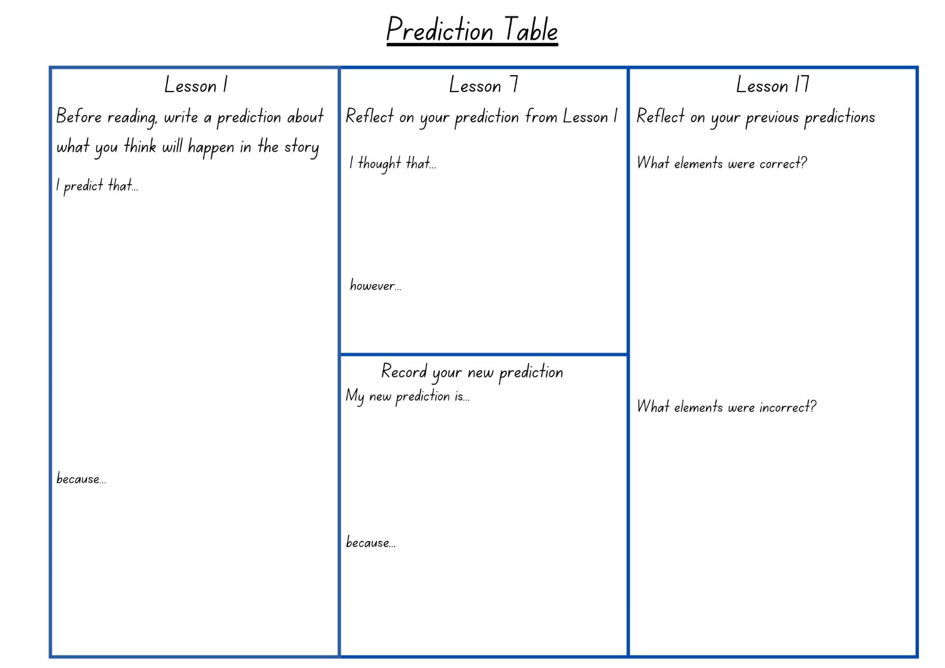

Resource 3 – character profile
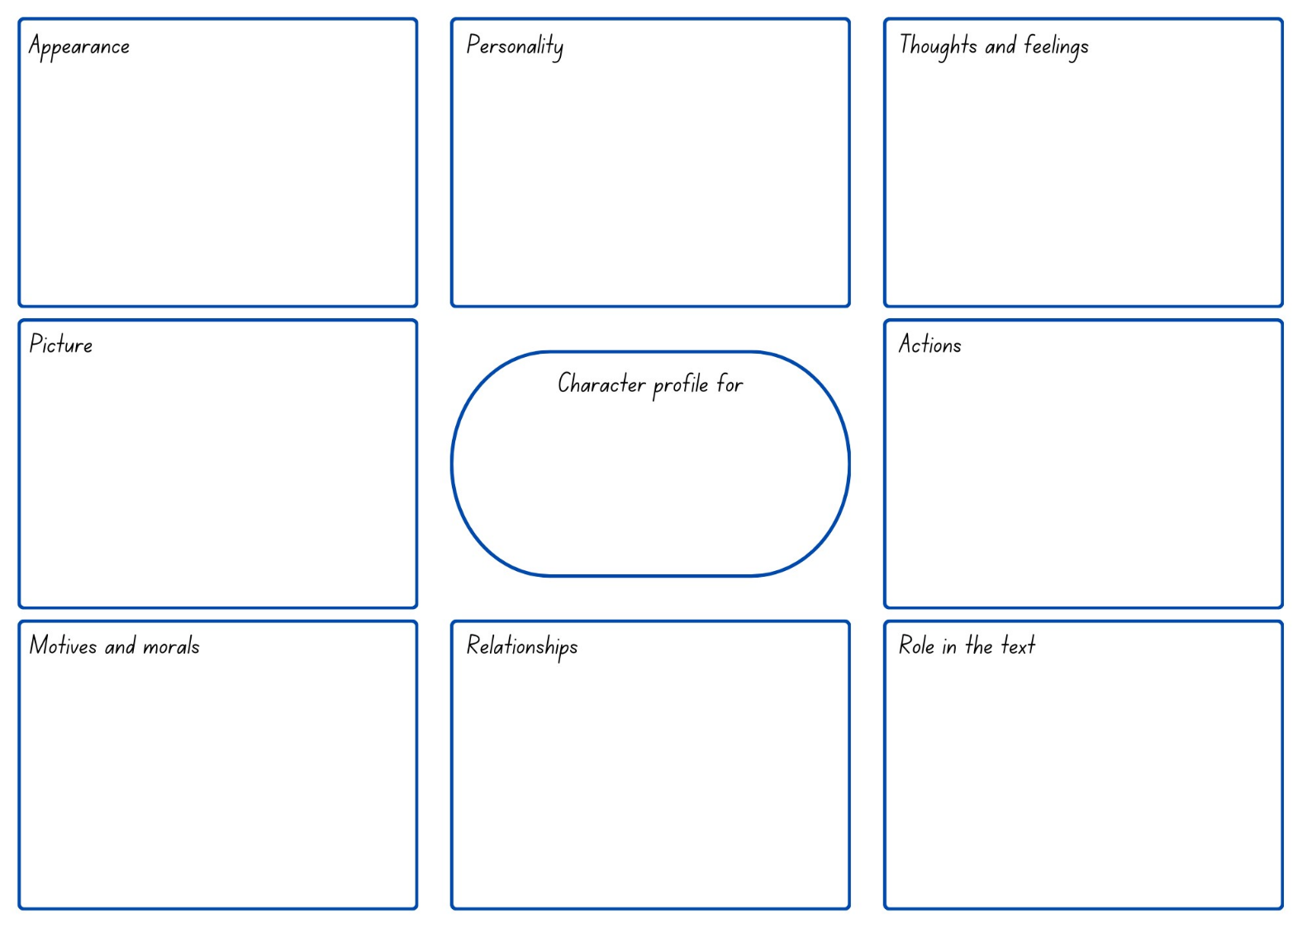

Resource 4 – decision exemplar
Dilemma  What is the problem? | The money does not belong to me, it belongs to someone else.
Choices  What options are there?  How might the character respond/act? | I could choose to keep the money and use it for something at the canteen or the shops after school.  I could take the money to the school office, where they can try to return it to the person who lost it
Outcome  What is the final decision?  How does the character feel about this decision? | I made the decision to return the money to the office so it could be given back to its owner.  I'm happy with my choice because the person who lost it might really need the money.
Consequences  What happened to the character from this decision? (positive/negative) | The money is returned to its rightful owner. If I had kept it, it would have been like stealing. Even though I might not have been caught, I would have felt guilty about keeping it.
Lessons learned  What does the character take away from this choice? | I've learned the importance of doing the right thing, and it brings a sense of happiness. If I were in a similar situation, I would hope for someone to return my money as well.

Resource 5 – decision template
Dilemma
What is the problem?
Choices
What options are there?
How might the character respond/act?
Outcome
What is the final decision?
How does the character feel about this decision?
Consequences
What happened to the character from this decision? (positive/negative)
Lessons learned
What does the character take away from this choice?

Resource 6 – character timeline
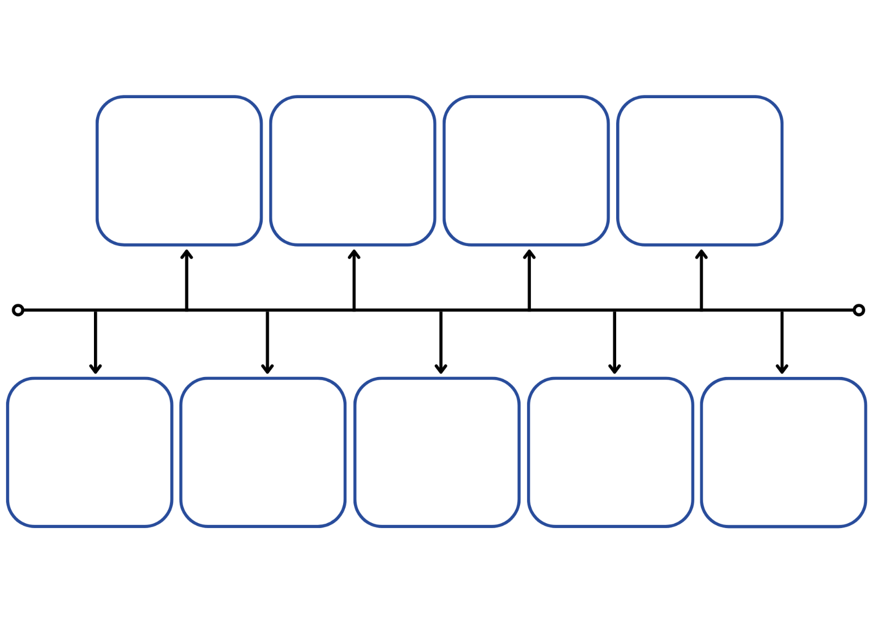

Resource 7 – diary entry planner
Word/phrase | When does it happen? | How does it happen? | Associated words to describe how Quin is feeling
‘...Cassius’s had flourished...’ (p 39) | before the test | in passing | doubt, worry, nervous
‘“Banana,” he croaked,...’ (p 42) | at the start of the test | speaking nervously | nervous, hot forehead, sticky palms
‘This time, when his mother coughed...’ (p 45) | during the test | loudly | embarrassed, insides churned, chest aching, head thumping, disappointed

Resource 8 – character relationships
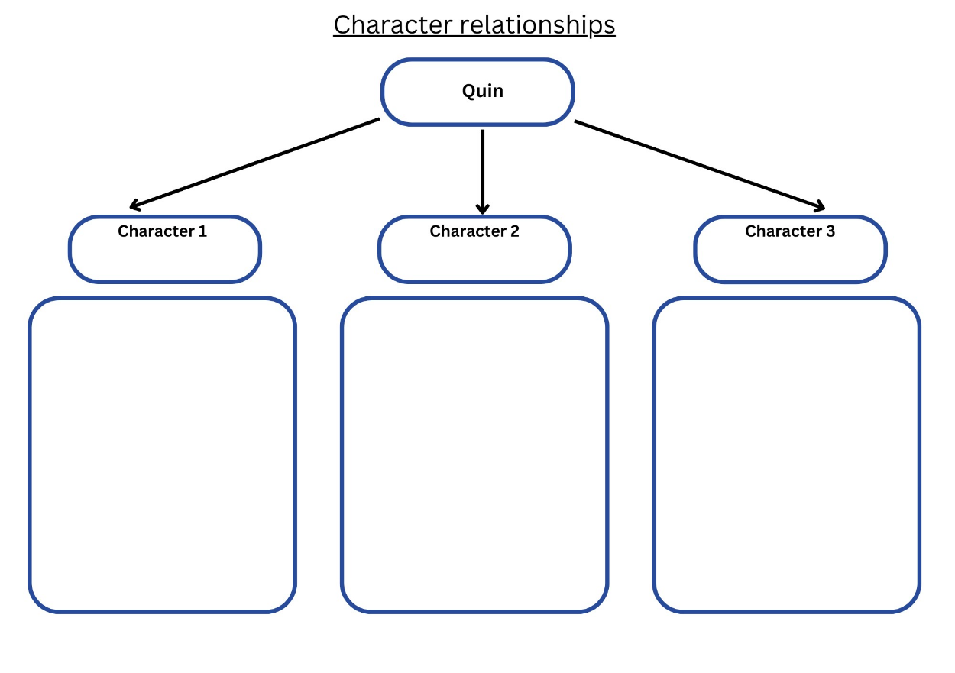

Resource 9 – puns

Resource 10 – chapter summary
Chapter summary
Identify 3 or 4 important main ideas from the text:
1.
2.
3.
4.
Write a summary statement (2–4 sentences)

Resource 11 – 5 senses template
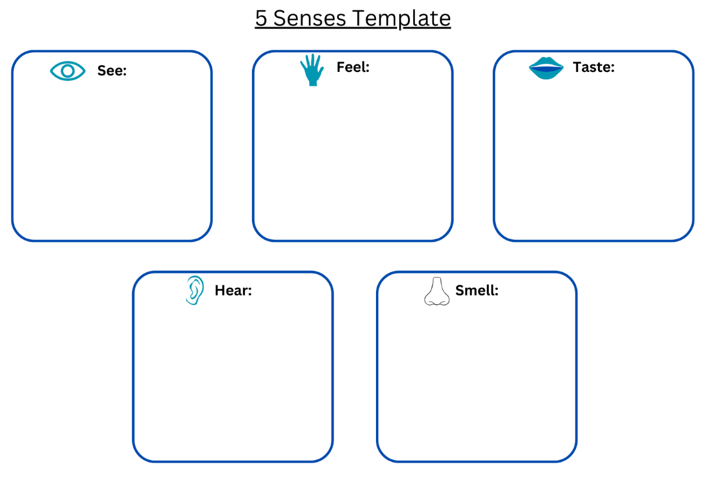

Resource 12 – editing checklist teacher resource
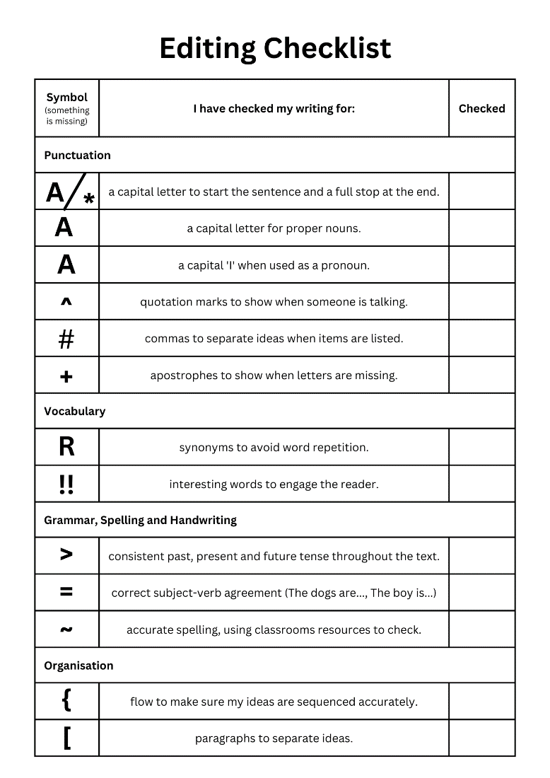

Resource 13 – missing person poster
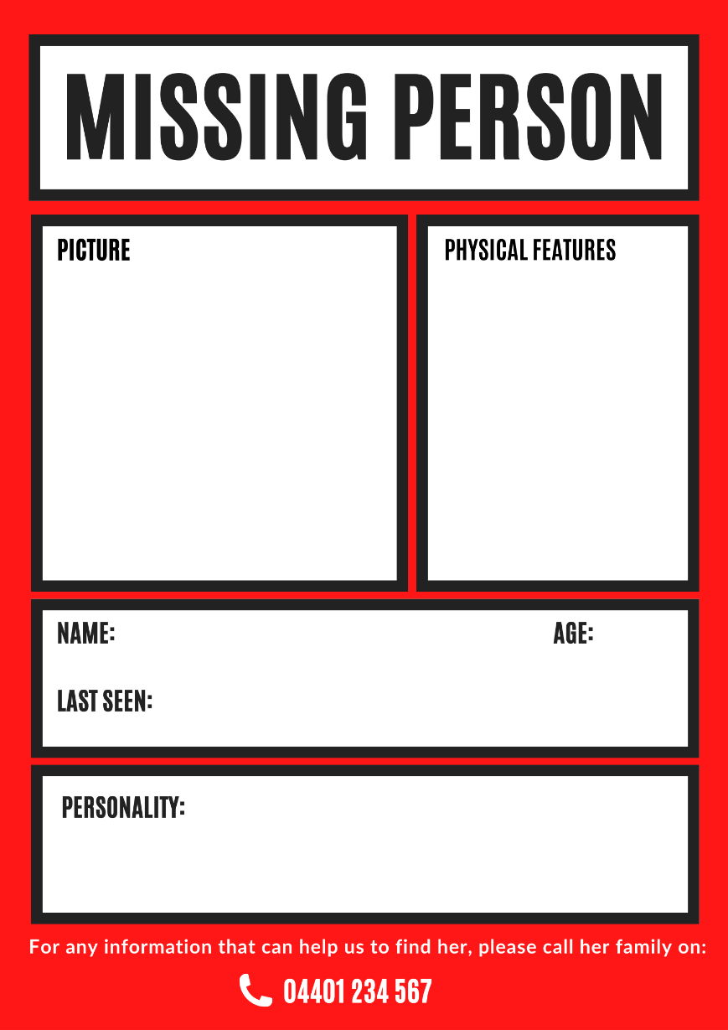

Resource 14 – character comparison table
Questions | Allie | Adriana
What is the character's problem?
What is the character's goal? What do they want to achieve?
What does the character do to try and solve their problem or attain their goal?
How do other characters perceive this character?
How did the author convey this character?
What is this character's role in the story?
Describe the relationship between the 2 characters:

Resource 15 – story map
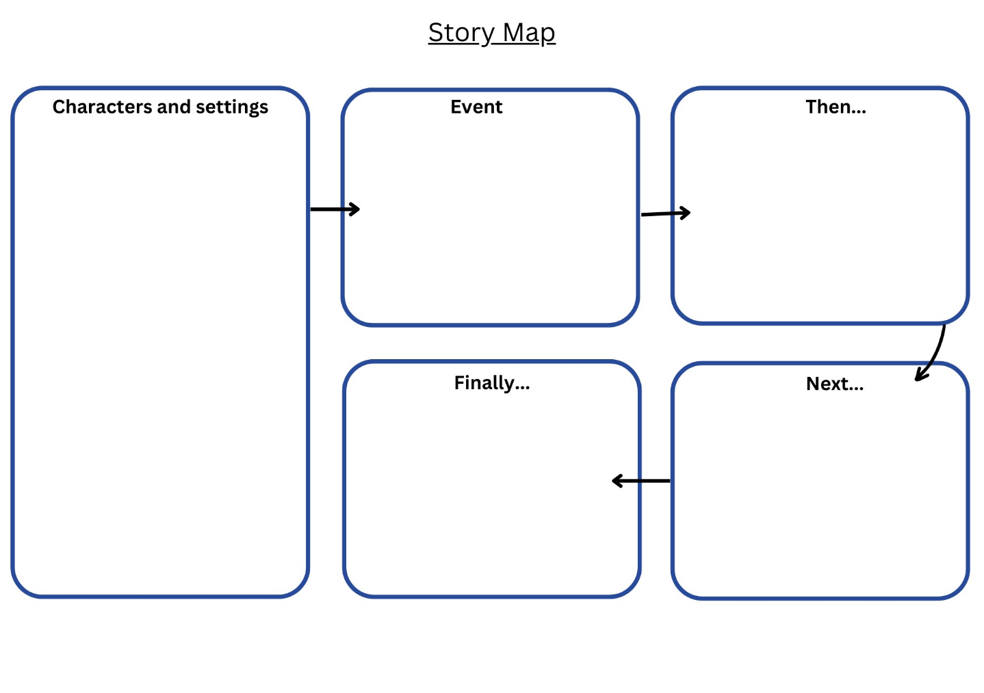

References
This resource contains NSW Curriculum and syllabus content. The NSW Curriculum is developed by the NSW Education Standards Authority. This content is prepared by NESA for and on behalf of the Crown in right of the State of New South Wales. The material is protected by Crown copyright.
Please refer to the NESA Copyright Disclaimer for more information. https://educationstandards.nsw.edu.au/wps/portal/nesa/mini-footer/copyright
NESA holds the only official and up-to-date versions of the NSW Curriculum and syllabus documents. Please visit the NSW Education Standards Authority (NESA) website https://educationstandards.nsw.edu.au/wps/portal/nesa/home and the NSW Curriculum website https://curriculum.nsw.edu.au.
English K–10 Syllabus © NSW Education Standards Authority (NESA) for and on behalf of the Crown in right of the State of New South Wales, 2022.
National Literacy Learning Progression © Australian Curriculum, Assessment and Reporting Authority (ACARA) 2010 to present, unless otherwise indicated. This material was downloaded from the Australian Curriculum website (National Literacy Learning Progression) (accessed 31 August 2023) and was not modified.
Booktopia (3 June 2022) ‘Ten Terrifying Questions with Kiah Thomas’, Booktopia, accessed 9 August 2023
NESA (NSW Education Standards Authority) (2024) ‘Glossary’, Resources, NESA website, accessed 31 August 2023
Thomas K (2022) The Callers, HarperCollins Publishers, Australia.

© State of New South Wales (Department of Education), 2024
The copyright material published in this resource is subject to the Copyright Act 1968 (Cth) and is owned by the NSW Department of Education or, where indicated, by a party other than the NSW Department of Education (third-party material).
Copyright material available in this resource and owned by the NSW Department of Education is licensed under a Creative Commons Attribution 4.0 International (CC BY 4.0) license.
This license allows you to share and adapt the material for any purpose, even commercially.
Attribution should be given to © State of New South Wales (Department of Education), 2024.
Material in this resource not available under a Creative Commons license:
- the NSW Department of Education logo, other logos and trademark-protected material
- material owned by a third party that has been reproduced with permission. You will need to obtain permission from the third party to reuse its material.
Links to third-party material and websites
Please note that the provided (reading/viewing material/list/links/texts) are a suggestion only and implies no endorsement, by the New South Wales Department of Education, of any author, publisher, or book title. School principals and teachers are best placed to assess the suitability of resources that would complement the curriculum and reflect the needs and interests of their students.
If you use the links provided in this document to access a third-party's website, you acknowledge that the terms of use, including licence terms set out on the third-party's website apply to the use which may be made of the materials on that third-party website or where permitted by the Copyright Act 1968 (Cth). The department accepts no responsibility for content on third-party websites.

