English Stage 2 Second year – Unit 9
Narrative – The Thing about Oliver
Contents
Unit overview and instructions for use 6
Teacher notes 8
Outcomes and content 10
Resources 16
Week 1 18
Component A teaching and learning 18
Teaching guide 18
Planning framework 29
Component B teaching and learning 29
Learning intentions and success criteria 29
Learning intention 30
Success criteria 30
Lesson 1 – exploring orientation features and patterns 30
Lesson 2 – analysing personal qualities of characters 33
Lesson 3 – orientation from a different point of view 36
Lesson 4 – using vocabulary to create an image 38
Week 2 42
Component A teaching and learning 42
Teaching guide 42
Planning framework 54
Component B teaching and learning 54
Learning intentions and success criteria 54
Learning intention 54
Success criteria 54
Lesson 5 – characterisation, plot building and dialogue 55
Lesson 6 – building tension to engage the reader 59
Lesson 7 – exploring the relationship between tension and a complication 60
Lesson 8 – identifying events that build tension in a text 62
Week 3 65
Component A teaching and learning 65
Teaching guide 65
Planning framework 75
Component B teaching and learning 75
Learning intentions and success criteria 75
Learning intention 75
Success criteria 75
Lesson 9 – building tension within a series of events 76
Lesson 10 – exploring the complication in a narrative 78
Lesson 11 – identifying point of view during a complication 79
Lesson 12 – understanding and identifying the resolution in a text 80
Week 4 82
Component A teaching and learning 82
Teaching guide 82
Planning framework 91
Component B teaching and learning 92
Learning intentions and success criteria 92
Learning intention 92
Success criteria 92
Lesson 13 – purpose of a narrative coda and character development 93
Lesson 14 – narrative conventions and imagery 95
Lesson 15 – revising sentence types and grammatical features 97
Lesson 16 – planning a narrative 99
Week 5 102
Component A teaching and learning 102
Teaching guide 102
Planning framework 113
Component B teaching and learning 113
Learning intentions and success criteria 113
Learning intention 113
Success criteria 113
Lesson 17 – planning a narrative (continued) 114
Lesson 18 – drafting a narrative 115
Lesson 19 – drafting a narrative (continued) 116
Lesson 20 – editing and publishing a narrative 117
Resource 1 – Tell Me 119
Resource 2 – Tell Me exemplar 120
Resource 3 – character chart 121
Resource 4 – fluency and close reading passage analysis 122
Resource 5 – tension volcano 125
Resource 6 – series of events exemplar 126
Resource 7 – complication exemplar 127
Resource 8 – fluency and close reading passage analysis 128
Resource 9 – writing process 131
Resource 10 – planning template 132
References 134

Unit overview and instructions for use
In this 5-week unit, students will explore the mentor concept of ‘narrative’ and the supporting concept of ‘characterisation’ through a deep analysis of the text The Thing About Oliver. Throughout the unit students will develop a deeper understanding of narrative conventions and explore the interplay of plot, character and setting, then apply this knowledge when creating their own texts.
Outcomes and content in this unit are organised into Component A and Component B. The components are connected, with learning in Component A complementing learning in Component B.
Note: the duration of this unit can be adapted to suit individual school contexts. For example, learning could occur across 5 days rather than 4.
The table below highlights the focus areas and preparation required for Component A and Component B.
Teaching and learning | Component A | Component B
Suggested duration | 60 minutes × 4 days/week or equivalent | 60 minutes × 4 days/week or equivalent
Explicit teaching focus areas | Component A addresses content from the focus areas:  - Vocabulary  - Reading fluency  - Reading comprehension  - Creating written texts  - Spelling  - Handwriting and digital transcription  It centres on the development of foundational skills and knowledge through regular, systematic and repeated practice. | Component B addresses content from the focus areas:  - Oral language and communication  - Vocabulary  - Reading comprehension  - Creating written texts  - Understanding and responding to literature  It centres on the conceptual understandings of English and exemplifies the importance of learning about and enjoying literature through the study of quality texts.
Preparing for teaching and learning | - Specific teaching and learning activities need to be developed by the teacher. When planning for these activities, please refer to the Component A outcomes and content, teaching guides and planning frameworks.  - Plan and document how you will sequence teaching and learning in whole-class and targeted-groups across the 5-week cycle as required. This should be based on student needs identified through ongoing assessment data. | - Familiarise yourself with the mentor and supporting texts and textual concepts, and the teaching and learning sequence.  - Determine how you will support students in whole-class and targeted-groups across the 5-week cycle as required. This should be based on student needs identified through ongoing assessment data.
English K–10 Syllabus © NSW Education Standards Authority (NESA) for and on behalf of the Crown in right of the State of New South Wales, 2022.

Teacher notes
- Narrative is an account of events or experiences, which are real or imagined. In English literary theory, narrative includes a story (that is narrated) and a discourse (how it is narrated). Narrative can present as an explicit sequencing of events (type of text), or it can be an implied or inferred component in a text (NESA 2024).
- Understanding of narrative can be supported through watching the department’s video: Narrative (3:51).
- While ‘narrative’ is the mentor concept for the conceptual component of this unit, the supporting concept of ‘characterisation’ can also be explored. Additional textual concepts may be included based on individual school context and student needs.
- Oliver, the main character in the text, has autism. For information, definitions, and terminology related to autism, refer to the Inclusive Practice Hub. Consider student and class context when discussing autism.
- In this unit, students will write a narrative from Oliver’s point of view. This will be modelled in sections and will be referred to in several lessons. This model should be created on large paper or in Microsoft Word for easy reference and editing.
- For information on gist statements, figurative language, point of view, Tier 2 and Tier 3 words, conventions, and temporal, conditional and causal connectives refer to the NESA Glossary.
- In addition to the resources listed, students will require access to short passages of the mentor and/or supporting texts. Teachers can copy extracts from texts in reliance on the Statutory Text and Artistic Works Licence. Teachers need to attribute the extracts and include the following notice: ‘This material has been copied [and communicated to you] in accordance with the statutory licence in section 113P of the Copyright Act. Any further reproduction or communication of this material by you may be the subject of copyright protection under the Act. Do not remove this notice’.
- Consider prior student knowledge about tiered language, simple, compound and complex sentences, and commas.
- Reflect on student learning and engagement in activities and record differentiation and adjustments within the unit to inform future teaching and learning. One way of doing this could be to add comments to the digital file.
- In NSW classrooms there is a diverse range of students including Aboriginal and/or Torres Strait Islander students, students learning English as an additional language or dialect, high potential and gifted students and students with disability. Some students may identify with more than one of these groups, or possibly all of them. Refer to Curriculum planning for every student – advice for further information.
- Content points are linked to the National Literacy Learning Progression (version 3).
Levels and indicators sourced from National Literacy Learning Progression © Australian Curriculum, Assessment and Reporting Authority (ACARA), (accessed 11 September 2023) and was not modified. See references for more information.

Outcomes and content
The table below outlines the outcomes and content for this unit. The letters 'A' and 'B' in the header refer to Components A and B. The numbers 1 to 5 refer to weeks. The use of 'x' in these columns indicates where the content points are intended to be addressed and in which week.
Focus area and outcome, content points and National Literacy Learning Progression | A | B | 1 | 2 | 3 | 4 | 5
Oral language and communication
EN2-OLC-01 communicates with familiar audiences for social and learning purposes, by interacting, understanding and presenting
- Identify contexts in which social conventions can vary and influence interactions (InT4, InT5) |  | x | x
- Demonstrate appropriate language use when interacting in different social and learning contexts (InT4, InT5) |  | x | x | x | x
- Pose and respond to specific questions to clarify or follow up on information (LiS6) |  | x | x | x | x | x | x
Vocabulary
EN2-VOCAB-01 builds knowledge and use of Tier 1, Tier 2 and Tier 3 vocabulary through interacting, wide reading and writing, and by defining and analysing words
- Build personal Tier 1, Tier 2 and Tier 3 vocabulary through social and learning interactions, reading and writing (SpK5) | x | x | x | x | x | x | x
- Identify and explain the difference between synonyms and antonyms (SpK6) | x | x | x
Reading fluency
EN2-REFLU-01 sustains independent reading with accuracy, automaticity, rate and prosody suited to purpose, audience and meaning
- Syllabify, blend grapheme–phoneme correspondences and use morphemic knowledge as strategies for reading words accurately (PKW8) | x |  | x | x | x | x | x
- Explain how prosodic reading involves emphasis, expression, intonation and pausing | x |  | x | x | x | x | x
- Reflect on stamina for reading sustained texts | x |  |  | x |  |  | x
Reading comprehension
EN2-RECOM-01 reads and comprehends texts for wide purposes using knowledge of text structures and language, and by monitoring comprehension
- Identify different purposes and strategies for reading (FIY5) | x |  | x | x
- Understand that dialogue is a common feature of imaginative texts, signalled by quotation marks or speech bubbles to indicate interactions between characters | x | x |  | x |  | x | x
- Understand that literal information can be sourced directly from a text and that inferences can be made by using multiple sources of information | x | x | x | x | x | x
- Use morphemic knowledge to read and understand the meaning of words | x |  | x | x | x | x | x
- Clarify and link the meanings of key words across a text to support global inferencing | x | x |  | x | x |  | x
- Make gist statements and record them to monitor understanding (UnT6) | x | x | x | x
Creating written texts
EN2-CWT-01 plans, creates and revises written texts for imaginative purposes, using text features, sentence-level grammar, punctuation and word-level language for a target audience
- Use an orientation, complication, resolution structure to create narratives centred on time, place and characters (CrT8) |  | x | x | x | x | x | x
- Sequence ideas and actions into paragraphs aligned to the stages of the text, to provide elaborated details about settings, character motives and actions (CrT8) |  | x | x | x |  | x | x
- Experiment with using and punctuating dialogue in texts (PuN5) | x | x |  | x |  | x | x
- Use temporal, conditional and causal conjunctions within sentences, and as connectives to link ideas across sentences for cohesion (CrT8) | x | x |  |  | x | x | x
- Use language to create imagery or humour, including idioms, puns, simile and personification (CrT8) | x | x |  |  |  | x | x
- Use simple, compound and complex sentences of varying lengths for variation and readability (CrT7, GrA5) | x | x | x | x | x | x | x
Use commas between words in a list or to separate adjectives when more than one is used |  | x | x | x
- Use a comma to separate a dependent clause before a main clause (PuN6) |  | x |  |  |  | x | x
Spelling
EN2-SPELL-01 selects, applies and describes appropriate phonological, orthographic and morphological generalisations and strategies when spelling in a range of contexts
- Explain how to segment multisyllabic words into syllables and phonemes, and apply this knowledge when spelling (SpG7) | x |  | x | x | x | x | x
- Identify differences in vowel phonemes (short, long, diphthong and schwa vowels) (SpG9) | x |  | x | x | x | x | x
- Understand that some graphemes are dependent on their position in a word in English and apply this knowledge when spelling | x |  | x | x | x | x | x
- Apply knowledge of taught vowel graphemes when spelling (SpG9) | x |  | x | x | x | x | x
- Identify prefixes that require no change to the base word or root when they are affixed, and apply this knowledge when spelling (SpG9) | x |  | x | x | x | x | x
Handwriting and digital transcription
EN2-HANDW-01 forms legible joined letters to develop handwriting fluency
EN2-HANDW-02 uses digital technologies to create texts
- Join letters when writing familiar words (HwK6) | x |  | x | x | x | x | x
- Apply appropriate pressure when joining letters | x |  | x | x | x | x | x
- Use knowledge of the keyboard layout and functions to type texts (HwK7) | x |  |  |  |  | x | x
Understanding and responding to literature
EN2-UARL-01 identifies and describes how ideas are represented in literature and strategically uses similar representations when creating texts
- Describe the interplay of plot, character and setting in different types of narratives |  | x | x | x | x | x | x
- Describe how narratives set up expectations using familiar, real and imagined characters, situations and phrases |  | x | x | x | x | x
- Describe how narrative conventions engage the reader |  | x | x | x | x | x | x
- Describe connections between own or shared experiences and those depicted in narratives |  | x | x | x |  | x
- Experiment with narrative structures and narrative conventions encountered in literature when creating texts |  | x | x | x | x | x | x
- Identify how authors use dialogue to convey what characters say and think, and experiment with dialogue when creating texts |  | x |  | x | x |  | x
- Describe how a character drives the plot in a narrative |  | x | x | x | x |  | x
English K–10 Syllabus © NSW Education Standards Authority (NESA) for and on behalf of the Crown in right of the State of New South Wales, 2022.

Resources
The resources in the table below are referred to in this unit. Letters 'A' and 'B' in the header refer to Component A and B respectively, and the numbers 1 to 5 indicate weeks. The use of 'x' in these columns indicate whether the resources are required in Component A, B or both, and in which week.
Resource | A | B | 1 | 2 | 3 | 4 | 5
Kelly D (2019) The Thing About Oliver, Wombat Books, Queensland. ISBN13: 9781925563818 | x | x | x | x | x | x
Website: Penguin Books – Deborah Kelly |  |  | x
Resource 1 – Tell Me (enlarged copy) |  | x | x
Resource 2 – Tell Me exemplar |  | x | x
A4 paper |  | x | x
Individual whiteboards |  | x | x
Resource 3 – character chart (4 enlarged copies) |  | x | x
Resource 4 – fluency and close reading passage analysis | x |  |  | x
Balloon |  | x |  | x
Resource 5 – tension volcano (enlarged copy and individual copies for each student) |  | x |  | x | x
Resource 6 – series of events exemplar |  | x |  |  | x
Resource 7 – complication exemplar |  | x |  |  | x
Resource 8 – fluency and close reading passage analysis | x |  |  |  |  | x
Resource 9 – writing process |  | x |  |  |  | x | x
Resource 10 – planning template (enlarged copy and individual copies for each student) |  | x |  |  |  | x | x

Week 1

Component A teaching and learning
Component A focuses on the development of foundational skills and knowledge through regular, systematic and repeated practice. The mentor and supporting texts used in Component B of this unit can support the effective implementation of Component A teaching and learning.

Teaching guide
Guidance for explicit teaching, teaching notes, resources and examples for the related outcomes and content points have been provided in the table below.
Focus areas and teaching notes | Resources and examples
Reading fluency  Reading automaticity and rate  - Syllabify, blend grapheme–phoneme correspondences and use morphemic knowledge as strategies for reading words accurately  - Model how to blend grapheme–phoneme correspondences accurately while maintaining fluency and understanding.  - Locate and syllabify multisyllabic words, including those with morphemic suffixes.  - For every syllable, there is at least one vowel phoneme.  - Morphemic suffixes usually form their own syllable. | Reading fluency  Reading automaticity and rate  - Fluency and close reading passage – Chapter 1 (p 4) from ‘I’ve filled almost half of the pages with interesting facts already...’ to ‘...it’s called symbiosis’ (184 words).  Note: the passage from the text will need to be a teacher-created resource.  - Suggested words from the passage:  - Morphemic information  - poisonous – poison + ous  - stinging – sting + ing  - actually – actual + ly  - agreement – agree + ment.  - Syllables  - poisonous – 3 syllables  - stinging – 2 syllables  - actually – 3 syllables  - agreement – 3 syllables.
Prosody  - Explain how prosodic reading involves emphasis, expression, intonation and pausing.  - Emphasis is when the reader gives extra importance or focus to specific words or parts of a sentence. It helps to convey the meaning or feeling behind the text. | Prosody  - Suggested sentences to illustrate the use of emphasis from the passage.  - ‘I’ve filled almost half of the pages with interesting facts already. Did you know that sea cucumbers breathe in and out of their bottoms?’  - ‘Most people have never even heard of the mantis shrimp...’  - They never sting the clownfish, though.’
Reading comprehension  Reading for interest and wide purposes  - Identify different purposes and strategies for reading  - Purposes might include reading for enjoyment, to gather information, to understand the author’s perspective and to find information to support an opinion.  - The purpose for reading helps to determine the strategies that will be utilised. For example, if the purpose for reading is to find specific information, the strategy of scanning may be used. | Reading comprehension  Reading for interest and wide purposes  - Purpose of this passage: reading for enjoyment and to provide information on Tilly and her passion for marine creatures.  - Strategies may include making connections and inferring. The passage provides information about Tilly's passion for marine creatures and infers that she uses this passion to distract herself when her brother is having a meltdown.
Comprehending text structures and features  - Understand that literal information can be sourced directly from a text and that inferences can be made by using multiple sources of information  - Sources used to infer meaning may include background or prior knowledge, key words and visuals. | Comprehending text structures and features  - Student prior knowledge or background knowledge of marine life and sea creatures would assist understanding.  - Understanding of key words within the passage. For example:  - mantis shrimp, aquarium, clown fish, anemone, tentacles, symbiosis.
Comprehending language  - Use morphemic knowledge to read and understand the meaning of words  - To work out the meaning of portable (capable of being carried), students use knowledge of the morphemes, port (carry) and able (capable of). | Comprehending language  - Prefixes include:  - de- meaning ‘opposite’  - anti- meaning ‘against’.  - Examples from the text:  - transform (p 4) trans- meaning ‘change’  - unlock (p 6) un- meaning ‘not’  - intersection (p 30) inter- meaning ‘among’ or ‘between’.
Monitoring comprehension  - Make gist statements and record them to monitor understanding  - Gist statements are succinct notes that summarise what has been read. They may be recorded in print or digitally. | Monitoring comprehension  - Example using information from the text:  - Mum is feeling anxious, distracted and upset as Oliver is consuming a lot of her time.
Vocabulary  Learning and using words  - Build personal Tier 1, Tier 2 and Tier 3 vocabulary through social and learning interactions, reading and writing  - Tier 1 words are basic-level, everyday words. For example, dog, baby, happy, pretty, was, come, said (NESA 2024).  - Tier 2 words add power and precision to written and spoken language, but many Tier 2 words are most commonly found in written language. For example, contradict, precede, stale, awful, snuggle (NESA 2024).  - Tier 3 words are words that are used rarely (low frequency) and only in highly specific situations. For example, decibel, cataclysm, atom (NESA 2024).  - Identify and explain the difference between synonyms and antonyms  - A synonym is a word or phrase that has the same or a similar meaning to another word or phrase. For example, sick and ill (NESA 2024).  - An antonym is a word or phrase that has the opposite meaning of another word or phrase (NESA 2024). | Vocabulary  Learning and using words  - Suggested vocabulary from the passage  - mantis, shrimp, aquarium, clown fish, anemone, tentacles, symbiosis.  - Suggested vocabulary from the Week 1 reading material  - neon tetra (p 2), marine scientist (p 3), therapist (p 10), fragment (p 11), cetaceans (p 21), porpoises (p 21).  - Suggested synonyms from the Week 1 reading material  - interesting facts/information, transform/change, drawing /illustrations, greenish blue/aqua, fine/supersharp.
Spelling  Phonological component  - Explain how to segment multisyllabic words into syllables and phonemes, and apply this knowledge when spelling  - Explain how to segment multisyllabic words into syllables, such as tentacle has 3 syllables.  - Explain how to segment multisyllabic words into phonemes, such as tentacle has 7 phonemes (t-e-n-t-a-c-le).  - Identify differences in vowel phonemes (short, long, diphthong and schwa vowels)  - A common grapheme that represents the short vowel phoneme is /o/ as in cot [o, a, au].  - A common grapheme that represents a long vowel phoneme /ow/ as in own [oa, ow, o_e, o, oe]. | Spelling  Note: each week of learning contains a phonological, orthographic and morphological focus. These focuses are intended to be taught simultaneously through linguistic inquiry. Suggested words have been selected to show how phonological, orthographic and morphological content can be integrated. In addition to words selected from the mentor and/or supporting text, additional sample words for inquiry are provided.  Phonological component  - Suggested words from the Week 1 reading material: bottoms, box, strong, Oliver, neon, lock, orange, clothes, impossible.  - Sample words fog, logic, common, problem, wander, watch, swamp, swan, squash, quality, quantity, cauliflower, sausage, antivenom, antifog, antihero, antitoxic, defrost, decode, decompose, deconstruct.
Orthographic component  - Understand that some graphemes are dependent on their position in a word in English and apply this knowledge when spelling  - The grapheme [o] is used in the middle and beginning of base words.  - The [a] is used in the middle of base words, often after the graphemes [w] and [qu].  - The graphemes [au] are used in the middle of base words.  - Apply knowledge of taught vowel graphemes when spelling  - Single-letter graphemes ‘o’ and ‘a’ are used to represent the short vowel phoneme /o/. This phoneme can also be represented using the vowel digraph ‘au’.  - The vowel digraphs ‘oa’, ‘ow’ and ‘oe’ represent the long vowel phoneme /ow/. This phoneme can also be represented using the split digraph [o_e] and the grapheme [o]. | Orthographic component  - As above
Morphological component  - Identify prefixes that require no change to the base word or root when they are affixed, and apply this knowledge when spelling  - A prefix is a bound morpheme that attaches to the beginning of a base word or root that changes or modifies the meaning of words.  - Revise previously introduced prefixes.  - Introduce prefixes: de- meaning ‘opposite’ and anti- meaning ‘against’.  - Teach that no change is required when affixing this prefix to the base word. | Morphological component  - As above
Creating written texts  Sentence-level grammar  - Use simple, compound and complex sentences of varying lengths for variation and readability  - A sentence may express a statement, exclamation, command or question.  - A sentence begins with a capital letter and ends with a full stop, exclamation mark or question mark.  - Simple sentence features  - a complete message that contains a subject and predicate, forming a single independent clause.  - Compound sentence features  - a sentence comprising 2 or more independent clauses joined by a coordinating conjunction.  - Complex sentence features  - formed by adding one or more dependent (subordinate) clauses to a main (independent) clause using subordinating conjunctions and/or relative pronouns. | Creating written texts  Sentence-level grammar  - Examples from the fluency passage  - Simple: I have been drawing pictures. (p 4)  - Note: this has been innovated from the fluency passage.  - Compound: ‘Most people have never even heard of the mantis shrimp, but it can throw a punch strong enough to break the glass in an aquarium!’ (p 4)  - Example from the text  - Complex: ‘When I do spot a small group of cattle standing in the shade of a shed, they look just as bony as Oliver.’ (p 24)
Handwriting and digital transcription  Handwriting legibility and fluency  - Join letters when writing familiar words  - Form legible and fluent Foundation Style printing, including  - lower case letters  - upper case letters  - punctuation marks  - numerals.  - Posture  - Feet are to be flat on the floor with the back of the chair supporting the hollow of the back.  - The body should be upright.  - The writing arm should pivot from the elbow.  - Paper  - The non-writing hand holds the paper. This non-writing arm can take the weight to allow the writing arm to glide over the writing surface.  - Apply appropriate pressure when joining letters  - Pencil grip  - Hold the pen(cil) between the thumb and index finger with the pen(cil) resting on the middle finger.  - Holding the pen(cil) with too much pressure can cause fatigue and reduce fluency.  - Increasing the width of the pen(cil) shaft, including with a pencil grip if needed, can reduce pencil grip pressure. | Handwriting and digital transcription  Handwriting legibility and fluency  - Suggested fluency pattern  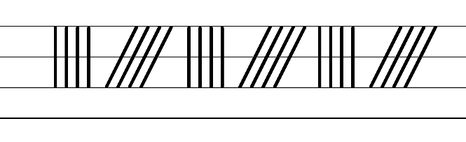  - Example NSW Foundation Style handwriting formation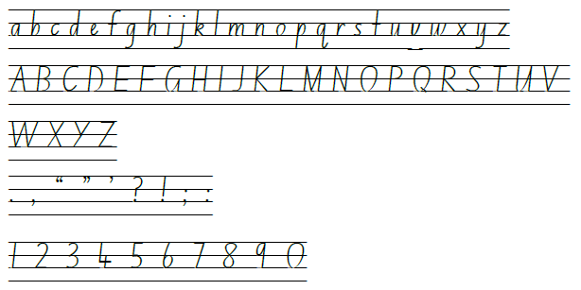  - Suggested practice text from the passage  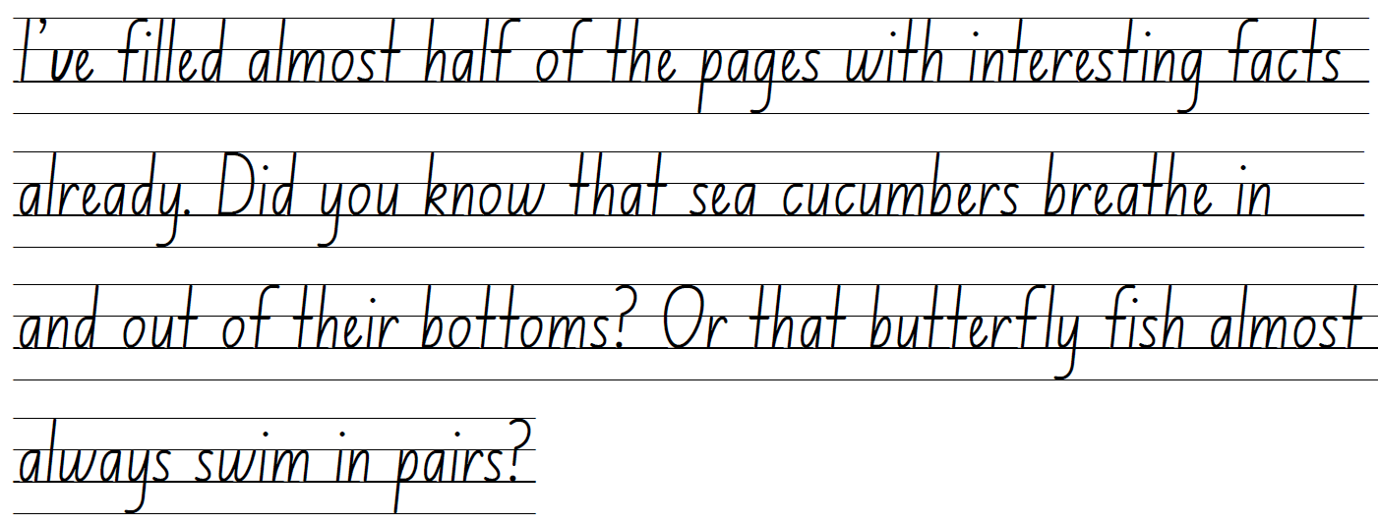

Planning framework
To plan and document Component A teaching and learning, a planning scaffold (DOCX 228 KB) is provided. To support you in your planning, a link to a detailed example of a one-week teaching and learning cycle is included in the scaffold. Additional resources to support teaching and learning in each focus area can be found at Lesson advice guides.

Component B teaching and learning
The following teaching and learning sequence has been designed to address Component B outcomes and content and develops conceptual understandings of English through the study of quality texts. Adapt the sequence as required to best meet the needs of your students.

Learning intentions and success criteria
Learning intentions and success criteria are best co-constructed with students.

Learning intention
Students are learning to identify patterns and features in an orientation and understand how characterisation adds meaning to the text.

Success criteria
Students can:
- identify patterns, features and expectations of a narrative
- understand how characterisation can add meaning to a text
- use commas to separate adjectives when describing characters
- write an orientation from another character's point of view or shared experience
- understand how vocabulary is used to engage the reader.

Lesson 1 – exploring orientation features and patterns
- Open the website Penguin Books – Deborah Kelly and view the image of the author. Read the short biography and ask students to consider the key information learned to predict what types of narratives the author may write.
- Display the front cover of The Thing About Oliver. Make connections between the front cover and what students know about Deborah Kelly. For example, she studied Marine Biology and there is coral and clown fish on the cover.
- Students Think-Pair-Share what type of text they think it might be, what it might be about and reasons why they think this. Encourage students to make connections to the biography about Deborah Kelly.
- Activate prior knowledge by discussing what students already know about narrative. Discussion prompts may include:
- What do you know about narrative?
- Why do authors write narratives?
- What are the features of narrative?
- What are some patterns authors use? For example, orientation, series of events.
- Ask students to reflect on why patterns in narratives can support the reader. For example, patterns in the orientation such as the introduction of the characters and setting, can engage a reader. Authors use patterns so that a text is easier to follow as it is cohesive. Explain that patterns help readers make predictions and build a connection with characters.
- Create a narrative timeline to visually display narrative structures and conventions. Add ‘orientation’ to the start of the timeline.
Note: the narrative timeline will be referenced and added to throughout the unit and can be in digital form or displayed in the classroom.
- Read The Thing About Oliver, Chapters 1 to 3. While reading these chapters, encourage students to consider the characters and setting information that the author has presented in the orientation. Ask students why this information is important to include in an orientation.
- Display an enlarged copy of Resource 1 – Tell Me with discussion stems to further analyse the features of the orientation. List student ideas in the relevant columns about what they notice in the orientation. Refer to Resource 2 – Tell Me exemplar to guide student answers. Discuss that each thought and point noted on the resource is valuable as it is a response to the text.
Note: for further information on Tell Me, refer to McDonald L (2023) A New Literature Companion for Teachers as cited in Chambers A (1994).
- Use the points listed on the resource to highlight commonalities and discus how some students have similar thoughts, puzzles and connections. Draw out the responses to the final section of the resource to focus on patterns, reminding students that an orientation introduces characters and setting.
- Explore and discuss how narratives set up expectations by using familiar and imagined characters and situations. Explain that the introduction of characters and situations enables the reader to make connections between their own and shared experiences. For example, the characters are presented as a family of mum and 2 children which many readers can relate to and connect with. The orientation sets up the expectations that the narrative will be about these characters and the situations they will face.
- Model writing a paragraph about the key features and events from the orientation in The Thing About Oliver, using the information from the class Tell me resource. Use think-alouds to model and explore how ideas are sequenced within the paragraph.
- Students independently write a paragraph about the orientation from Chapters 1 to 3, using ideas from the resource.
Too hard? Students writes simple and compound sentences to summarise the orientation.
- Invite students to share their writing with the class. Select one or 2 student examples to add to the narrative timeline under the ‘orientation’ heading.
- Ask students to share one thing they are curious about. Students may be curious about a character or what events in the text will help shape the narrative.

Lesson 2 – analysing personal qualities of characters
- Revise the concept of ‘narrative’. Refer to the narrative timeline from Lesson 1 to review Chapters 1, 2 and 3. Pose the following questions to allow students to analyse the information from the first 3 chapters:
- Why is the text titled The Thing About Oliver?
- Who is telling the story? Discuss that the story is told using from Tilly’s point of view – first voice.
- Who is the protagonist/main character of the story and how do we know?
- Discuss appropriate language use when interacting in different social and learning contexts.
- Discuss student understanding about autism to build background knowledge, according to context. Refer to Other considerations for autism to support student understanding of how language and interaction styles sometimes need to be adapted or changed so that others can understand what is being communicated.
- Elaborate on the appropriate use of language when having conversations about people with autism.
- Remind students that an orientation to a narrative usually introduces the main characters.
- Re-read Chapter 2 from page 8 to 12. Explain that the purpose for reading is to better understand characterisation. While reading, students record key words used to describe Mum and Tilly on individual whiteboards. Keep this for activities 6 and 9.
- Display 2 enlarged copies of Resource 3 – character chart. Brainstorm adjectives that could be used to describe the personal qualities of a character (personal qualities: think, feel, actions, appearance). For example, Mum – busy, anxious, distracted, upset. Tilly – upset, mature, responsible, considerate, accommodating.
- Model completing an enlarged character chart about Mum, using student examples from their individual whiteboard and ideas from activity 5.
- Explain that gist statements are succinct information that has been read, heard or viewed. Gist statements can be in the form of dot points or short sentences.
- Model writing gist statements about Mum using information from the modelled character chart. For example, Mum is feeling anxious, distracted and upset as Oliver is consuming a lot of her time. Explain that a comma is used to separate the adjectives in the statement to make the meaning clearer.
- As a class, complete the second character chart about Tilly using student examples from their individual whiteboard.
- Co-construct a gist statement about Tilly, using commas to separate adjectives. Refer to the character chart.
- Students independently record gist statements about Tilly. Encourage use of commas to separate adjectives.
Too hard? Students work in pairs to record gist statements about Tilly.
- Students share gist statements with a small group, then with the class. Explain how students should adjust their speech, including tone and language choices, to effectively communicate and adapt to various social contexts.
- Discuss how students changed their volume, tone, vocabulary and body language when communicating ideas with certain groups or people within the school context. For example, changing speaking skills to suit a particular audience, including talking to peers or the whole class. Consider other settings or audiences that speaking skills may need to be changed. For example, talking with the principal, a parent, or at assembly.
- Explore how Mum and Tilly change the way they speak to each other and to Oliver.
- Ask students to explain why understanding a character is important. For example:
- How or why do you think Tilly’s thoughts and feelings will be an important part of the narrative?
- How might the narrative be different if Tilly had different qualities?
- Add the completed character charts and one or two student gist statements to the narrative timeline under the ‘orientation’ heading.
Assessment task 1 – observations and work samples from this lesson allow students to demonstrate achievement towards the following syllabus outcomes and content points:
EN2-OLC-01 – communicates with familiar audiences for social and learning purposes, by interacting, understanding and presenting
- identify contexts in which social conventions can vary and influence interactions
- demonstrate appropriate language use when interacting in different social and learning contexts.
EN2-RECOM-01 reads and comprehends texts for wide purposes using knowledge of text structures and language, and by monitoring comprehension
- identify different purposes and strategies for reading.

Lesson 3 – orientation from a different point of view
- Play a game of ‘Guess the character’. Select various sentences or phrases from Chapters 1, 2 or 3 that the author has included to describe or provide information about Tilly, Mum and Oliver. For example:
- ‘I feel a pang of jealousy’ (p 6) and ‘I settle for vegemite instead’ (p 15) describes Tilly’s character.
- ‘she rocks him back and forth’ (p 6) and ‘Her face is pale’ (p 6) describes Mum’s character.
- ‘good at smashing things’ (p 2) or ‘piercing shrieks’ (p 2) describes Oliver’s character.
- After reading each one, allow students time to guess which character is being described by making inferences.
- In pairs, students analyse and discuss the purpose and importance of familiar and imagined characters and how they set up expectations in a narrative. Ask students to share their responses with the class and elaborate on their thinking by providing examples. For example, readers form a connection to characters using their own or shared experiences and those depicted in narratives. Characters also move the story along (drive the plot).
- Revise Chapters 1, 2 and 3 and ask students to focus on Oliver’s character.
- As a class complete Resource 3 – character chart about Oliver using student ideas. Add the character chart about Oliver to the narrative timeline under the ‘orientation’ heading.
- Revise the features of an orientation. For example, the orientation introduces the central characters and gives the reader a sense of what the story is about, the setting and the mood of the story.
- Explain that students will write the orientation from Oliver’s point of view. Explore and discuss other narratives that students have read where there has been an adapted version from a different character’s point of view. For example, The Three Little Pigs compared to The Real Story of the Three Little Pigs.
- Display the questions below. In small groups students are allocated a question to analyse and describe the interplay of plot, character and setting from Tilly and Oliver’s point of view during Chapters 1 to 3.
- How does the character’s personality or traits influence their role in the plot?
- How does the setting impact the character's actions or decisions throughout the story?
- How does the character’s relationship with other characters shape their role in the story?
- How does the character’s interactions with the setting affect their emotions or attitudes?
- Select a group member to share their thinking with the class.
- Re-read Chapter 1. As a class, list key ideas from the orientation within the areas of, setting, characters and mood. List these on A4 paper and add it to the narrative timeline under the ‘orientation’ heading.
- Using Oliver’s reaction to sensory input, as described by his mother and sister, write the orientation from his point of view. Co-construct the first 2 sentences with the students. Encourage use of commas to separate adjectives to add detail. For example:
It is so early, and these pyjamas are too scratchy, uncomfortable, and annoying. I never understand why Mum gives these to me, she knows I hate them! I kick the wall really hard and start banging my head too. Maybe Mum will notice this time and change my pyjamas.
- Students continue to write the orientation from Oliver’s point of view. Encourage use of commas to separate adjectives.
Too hard? Provide students with sentence stems to add to the orientation.
Too easy? Students add more detail about what Oliver might be thinking and feeling as well as thoughts about Mum and Tilly.
- Ask students to imagine how they would feel if they could not express their feelings or needs through spoken words. Brainstorm a list of adjectives that could be used to describe different emotions. For example, frustrated, annoyed, overwhelmed. Provide time for students to reflect on their writing and decide if any adjectives could be added to their writing. For example, I am feeling overwhelmed.

Lesson 4 – using vocabulary to create an image
- Using the Think-Pair-Share strategy, students discuss and record what they know about narrative complications to activate prior knowledge. Students respond to peers’ ideas by asking follow-up questions to clarify meaning or to seek further information. Add a ‘complication’ heading to the narrative timeline.
- Read Chapters 4 to 5. During reading, students list key information about the events that lead to a complication in this section of the book.
- Use student responses to co-construct a chart listing key information about the complication. Add the complication chart to the narrative timeline.
- Discuss any new information from the chapters relating to Mum, Tilly and Oliver. Add these to the enlarged character charts from Lesson 2 and Lesson 3.
- Select a word that that the author has used to describe how Oliver expresses his emotions. For example, ‘shriek’ (p 24). Discuss how authors intentionally select words to describe how the characters are feeling, thinking or behaving which helps create a mental image for readers.
- Complete a Frayer diagram for the selected word from activity 5. Revise synonyms and antonyms from Component A. Write synonyms and antonyms for the selected word. Re-read the sentence containing the chosen word and swap with a synonym or antonym. Ask students to explain the impact a different word has on the metal image they create and the meaning of the sentence.
- Students complete a Frayer diagram for another word. For example, ‘frantically’ (p 25). Write synonyms and antonyms for the selected word.
- Ask students to explain how Tilly is feeling about moving to Townsville using examples of vocabulary from the text to support their thinking. Discuss how authors use vocabulary, such as metaphors, to help describe what characters are feeling in an interesting way and to engage the reader. For example, ‘My wave of hope has been dragged out to sea’ (p 29), ‘Anger boils up inside me instead’ (p 29). Ask students what this reveals about Tilly’s character.
- Discuss how Oliver might be feeling about the move. Students turn and talk to decide on some adjectives that could be used to express how Oliver is feeling. List some of the words on the board. As the words are listed, categorise the words into Tier 1 and Tier 2 words. For example, Tier 1 – sad, upset, hurt, worried; Tier 2 – anxious, miserable, tearful, confused.
- Revise the use of simple, compound and complex sentences from Component A. Model writing the first sentence about how Oliver might feel about the move using Tier 1 words. For example:
I am upset. I am shaking all over, because I cannot understand why Mum would make us move so far away.
- Draw attention to the correct placement of the comma. Co-construct different sentences using Tier 2 words. Remind students of the impact word choice can have on a reader. For example:
I feel anxious about moving to a new location, as I am unsure of what to expect and how things will change. Even though Mum tries, she doesn’t understand how confused I am feeling.
- Students write a paragraph about how Oliver might react to the move using simple, compound and complex sentences.
Too hard? Students write using simple and compound sentences.

Assessment task 2 – observations and work samples from this lesson allow students to demonstrate achievement towards the following syllabus outcomes and content points:
EN2-OLC-01 – communicates with familiar audiences for social and learning purposes, by interacting, understanding and presenting
- pose and respond to specific questions to clarify or follow up on information.
EN2-VOCAB-01 – builds knowledge and use of Tier 1, Tier 2 and Tier 3 vocabulary through interacting, wide reading and writing, and by defining and analysing words
- identify and explain the difference between synonyms and antonyms
- build personal Tier 1, Tier 2 and Tier 3 vocabulary through social and learning interactions, reading and writing.

Week 2

Component A teaching and learning
Component A focuses on the development of foundational skills and knowledge through regular, systematic and repeated practice. The mentor and supporting texts used in Component B of this unit can support the effective implementation of Component A teaching and learning.

Teaching guide
Guidance for explicit teaching, teaching notes, resources and examples for the related outcomes and content points have been provided in the table below.
Focus areas and teaching notes | Resources and examples
Reading fluency  Reading automaticity and rate  - Syllabify, blend grapheme–phoneme correspondences and use morphemic knowledge as strategies for reading words accurately  - Model how to use blend grapheme–phoneme correspondences accurately while maintaining fluency and understanding.  - Locate and syllabify multisyllabic words, including those with morphemic suffixes.  - For every syllable, there is at least one vowel phoneme.  - Morphemic suffixes usually form their own syllable. | Reading fluency  Reading automaticity and rate  - Resource 4 – fluency and close reading passage analysis – Chapter 8 (p 49) from ‘I stretch out my legs...’ to ‘...before school starts’ (206 words).  Note: the passage from the text will need to be a teacher-created resource.  - Suggested words from the passage  - Morphemic information  - fishing – fish + ing  - smaller – small + er  - definitely – definite + ly.  - Syllables  - fishing – 2 syllables  - smaller – 2 syllables  - definitely – 4 syllables.
Prosody  - Explain how prosodic reading involves emphasis, expression, intonation and pausing  - Expression is when the reader reads aloud with feeling and puts emotion into the words on the page, so that the listener can understand the authors intent. | Prosody  - Suggested sentences to illustrate the use of expression from the passage  - I stretch out my legs and wiggle my toes. ‘Can you show us the beach?’  Aunt Janine smiles. ‘Of course!’  - ‘The river is just down this way.’ Aunt Janine points.
Monitoring and reading fluency  - Reflect on stamina for reading sustained texts  - Increasing reading for longer periods of time  - Pacing: Adjusting reading speed of a text can improve stamina and comprehension. | Monitoring and reading fluency  - Teaching reading fluency through accuracy, automaticity and prosodic reading should occur in an integrated and synchronous manner. In support of this, teachers should implement a reading program that includes:  - modelled reading  - assisted and repeated oral readings  - opportunities for students to regularly practise their reading  - assessing and monitoring reading fluency  - student goal setting with reflection.
Reading comprehension  Reading for interest and wide purposes  - Identify different purposes and strategies for reading  - Purposes might include reading for enjoyment, to gather information, to understand the author’s point of view and to find information to support an opinion.  - The purpose for reading helps to determine the strategies that will be utilised. For example, if the purpose for reading is to find specific information, the strategy of scanning may be used. | Reading comprehension  Reading for interest and wide purposes  - Purpose: reading for enjoyment and to provide information on marine creatures.  - Strategies may include re-reading to clarify meaning of the text, particularly dialogue, and slowing the reading rate to decode new content or vocabulary.
Comprehending text structures and features  - Understand that dialogue is a common feature of imaginative texts, signalled by quotation marks or speech bubbles to indicate interactions between characters  - Consider student knowledge and application of quotation marks and speech bubbles.  - When reading dialogue in an imaginative text, the reader needs to understand who is talking. | Comprehending text structures and features  Example from the fluency passage: ‘"Are there any crocodiles in that river?" I ask warily’. Aunt Janine nods. "We do encounter freshies from time to time."
Comprehending language  - Use morphemic knowledge to read and understand the meaning of words  - To work out the meaning of portable (capable of being carried), students use knowledge of the morphemes, port (carry) and able (capable of).  - Clarify and link the meanings of key words across a text to support global inferencing  - Global inferencing requires the reader to comprehend implied information from across relatively larger sections of text and is supported by the reader’s depth of vocabulary and background knowledge (NESA 2024). | Comprehending language  - Prefixes include  - de- meaning ‘opposite’  - anti- meaning ‘against’.  - Examples from the text  - almost (p 37) al- meaning ‘towards’  - uncomfortable (p83), untwist (p 89) un- meaning ‘not’  - independent (p 84) in- meaning ‘in’, ‘on’ or ‘not  - Examples from the text: Tilly is upset and/or disappointed because: she cannot have swimming lessons, mum comes home with a new haircut, mum forgets to buy the lock for her room and the local swimming pool is closed for repairs. By connecting the events readers can infer that Tilly is becoming increasingly frustrated and angry.
Monitoring comprehension  - Make gist statements and record them to monitor understanding  - Gist statements are succinct notes that summarise what has been read. They may be recorded in print or digitally. | Monitoring comprehension  - Example using information from the text  - Tilly is upset again because she cannot have swimming lessons as the local swimming pool is closed for repairs.
Vocabulary  Learning and using words  - Build personal Tier 1, Tier 2 and Tier 3 vocabulary through social and learning interactions, reading and writing  - Identify and discuss Tier 1, Tier 2 and Tier 3 words in the text to improve vocabulary knowledge and comprehension. | Vocabulary  Learning and using words  - Suggested words from the passage  - Tier 2: absolutely, murky, swollen  - Tier 3: Hibiscus, freshwater, saltwater.  - Suggested words from the Week 2 reading material: billboard (p 39), Jacaranda (p 41), Queenslanders (p 41), resume (p 50), Nudibranchs (p 57), exasperation (p 61), cicadas (p 67), psychologist (p 72).
Spelling  Phonological component  - Explain how to segment multisyllabic words into syllables and phonemes, and apply this knowledge when spelling  - Explain how to segment multisyllabic words into syllables. For example, absolutely has 4 syllables.  - Explain how to segment multisyllabic words into phonemes. For example, absolutely has 9 phonemes  (a-b-s-o-l-u-te-l-y).  - Identify differences in vowel phonemes (short, long, diphthong and schwa vowels)  - Identify the short vowel phoneme /o/ as in cot [o, a, au].  - Identify the long vowel phoneme /ow/ as in own [oa, ow, o_e, o, oe] | Spelling  Phonological component  - Suggested words from the Week 2 reading material: officer (p 44), conditioning (p 46), crocodiles (p 49), mozzies (p 53), occupational (p 72), curiosity (p 74), wardrobe (p 39), notice (p 43), marshmallows (p 45), tiptoes (p 45), homemade (p 46), window (p 77).  - Sample words: October, commandeer, volunteer, borrow, meadow, wash, salt, want, vault, fault, declutter, deactivate, devalue, anticlimax, antiracism, antiseptic, antiviolence.
Orthographic component  - Understand that some graphemes are dependent on their position in a word in English and apply this knowledge when spelling  - The grapheme [o] is used in the middle and beginning of base words.  - The [a] is used in the middle of base words, often after the graphemes [w] and [qu].  - The graphemes [au] is used in the middle of base words.  - Apply knowledge of taught vowel graphemes when spelling  - Single-letter graphemes ‘o’ and ‘a’ are used to represent the short vowel phoneme /o/. This phoneme can also be represented using the vowel digraph ‘au’.  - The vowel digraphs ‘oa’, ‘ow’ and ‘oe’ represent the long vowel phoneme /ow/. This phoneme can also be represented using the split digraph [o_e] and the grapheme [o]. | Orthographic component  - As above
Morphological component  - Identify prefixes that require no change to the base word or root when they are affixed, and apply this knowledge when spelling  - Revise prefixes: de-, anti-  - The prefix de- means ‘opposite’  - The prefix anti- means ‘against’  - Teach that no change is required when affixing these prefixes to the base word. | Morphological component  - As above
Creating written texts  Sentence-level grammar  - Use simple, compound and complex sentences of varying lengths for variation and readability  - Review  - A sentence may express a statement, exclamation, command or question.  - Sentences begin with a capital letter and ends with a full stop, exclamation mark or question mark.  - Review simple, compound and complex sentence features. | Creating written texts  Sentence-level grammar  - Examples from the fluency passage  - Simple: 'Aunt Janine nods.’  - Compound: ‘Lots of people go fishing there but at the moment the river is swollen from all the rain.’  - Complex: ‘Maybe I'll go swimming there too, once I learn how.’
Imaginative purposes  - Experiment with using and punctuating dialogue in texts  - When each new character speaks, a new line is used.  - Dialogue can be used at the beginning of a sentence. The direct speech is at the beginning of the sentence. The punctuation that is part of the direct speech is placed within the inverted commas. The text explains who has just spoken. For example, ‘“Do you want to go to the park?” asked Annabelle.’  - Dialogue can be used at the end of a sentence. The text explains who is about to speak. A comma is placed before the direct speech. The direct speech is at the end of the sentence and includes the punctuation that is part of the sentence within the inverted commas. For example, ‘Annabelle asked, “Do you want to go to the park?”’ | Imaginative purposes  - Examples from the fluency passage of dialogue  - “Can you show us the beach?”  - ‘“The river is just down this way,” Aunt Janine points.’  - ‘“Are there any crocodiles in that river?” I ask warily.’
Handwriting and digital transcription  Handwriting legibility and fluency  - Join letters when writing familiar words  - Form cursive letters and words with diagonal joins from the baseline to short letters. These are sometimes referred to as baseline joins.  - Diagonal joins come from letters with exits near the baseline, including a, c, d, e, h, i, k, l, m, n, t, u and z.  - Diagonal joins to short letters continue the exit hook diagonally upwards to the start of the next letter.  - Most diagonal joins meet the next letter at the top of the letter’s body at a 45-degree angle.  - Highlight the position of the diagonal join to the letter e. This join is positioned between Line 2 and the baseline.  - The cross bar on the letter t is added last. It is positioned on Line 2.  - Apply appropriate pressure when joining letters.  - Revise pen(cil) grip pressure. Students monitor if they have a comfortable grip that allows the hands and fingers to move freely and easily when writing. | Handwriting and digital transcription  Handwriting legibility and fluency  - Suggested fluency pattern  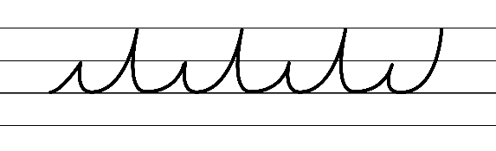  - Example NSW Cursive Style handwriting formation  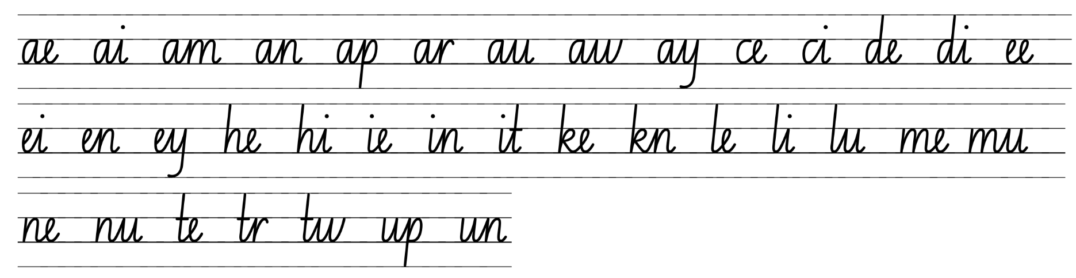  - Familiar words in NSW Cursive Style handwriting formation  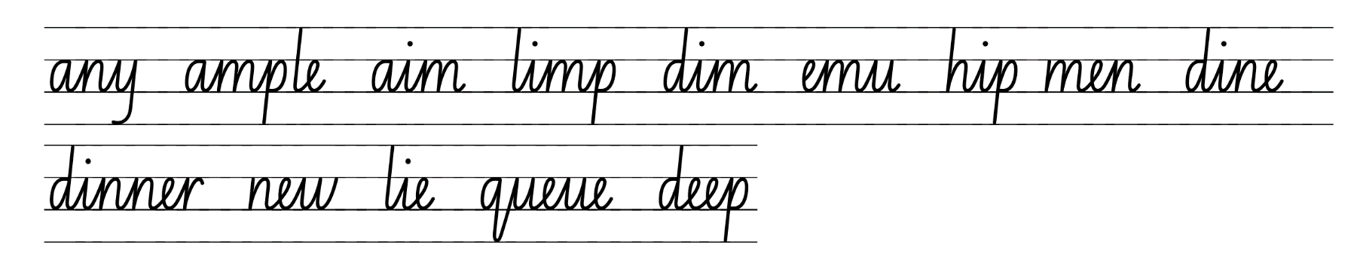  - Suggested practice text from the passage  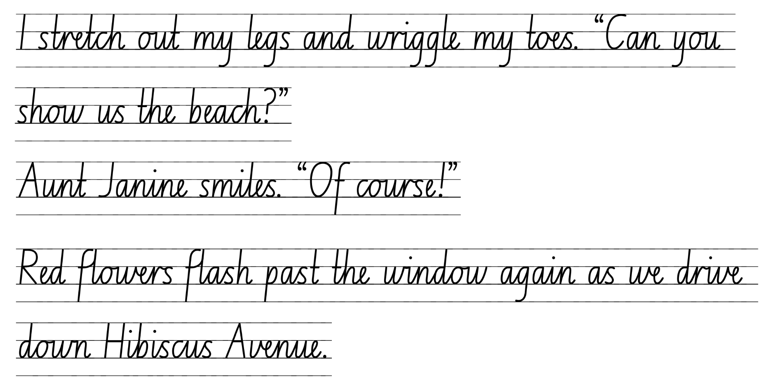  Note: ensure that students are fluent in NSW Foundation and Pre-cursive Style before beginning NSW Foundation Cursive Style.

Planning framework
To plan and document Component A teaching and learning, a planning scaffold (DOCX 228 KB) is provided. To support you in your planning, a link to a detailed example of a one-week teaching and learning cycle is included in the scaffold. Additional resources to support teaching and learning in each focus area can be found at Lesson advice guides.

Component B teaching and learning
The following teaching and learning sequence has been designed to address Component B outcomes and content and develops conceptual understandings of English through the study of quality texts. Adapt the sequence as required to best meet the needs of your students.

Learning intentions and success criteria
Learning intentions and success criteria are best co-constructed with students.

Learning intention
Students are learning to identify and build tension in a series of events within a narrative.

Success criteria
Students can:
- understand a character's point of view to create dialogue
- use declarative and exclamatory sentences to provide detail and add tension
- identify and build tension when writing
- predict a complication following tension building events
- identify and sequence tension building events from the text.

Lesson 5 – characterisation, plot building and dialogue
- Revisit the narrative timeline and recall the orientation and the first complication that occurred in the text.
- Read The Thing About Oliver, Chapters 6 to 8, pausing at the end of each chapter to discuss student wonderings and the key ideas.
- Explain that, as the text progresses, the audience is given more information about the characters and may form additional connections. Ask students what additional information the reader has learned about Oliver and how this information has set up expectations about him.
- Review the character chart about Oliver from Lesson 3. Students write sentences or dot points summarising any new information presented about Oliver’s character. Provide time for students to share their thoughts and add new or interesting information.
- Discuss the text progression and ask questions to support student understanding of why Aunt Janine has been introduced as a new character. For example:
- Why do you think the author introduced Aunt Janine?
- Do you think Aunt Janine’s relationship with Tilly/Oliver/Mum will be an important part of the narrative? Why?
- Do you think Aunt Janine will create a new complication in the story? What do you think that could be?
- Co-construct a character chart about Aunt Janine using Resource 3 – character chart. Add the completed Aunt Janine character chart to the narrative timeline.
- As a class, discuss which heading the ‘moving house’ event sits under, on the narrative timeline. Co-construct a summary of this event to be added under the ‘complication’ heading on the timeline.
- Write the word ‘plot’ on the board, or create an anchor chart, and ask students to share their understanding of this word. Explain that the plot in a narrative is more than the sequence of events. Plots can have more than one complication and the conflict characters face are an important part of a developing plot. For example, character conflict could be an internal conflict, or conflict with another character. Explain that understanding a plot can help readers identify different components of a narrative. Revisit the word ‘plot’ and ask students to recall their understanding. As students recall their learning, record key words.
- In small groups, students identify evidence that shows how Oliver is driving the plot in the text. For example, his behaviour impacts the events that occur, the family’s tour around the town is cut short because ‘he loses it’ due to mosquitoes. Ask students to share and explain why they chose the evidence.
- Ask students to consider why dialogue between characters is an important part of a developing plot. Explain that the dialogue between characters is important as the tension can be built, character’s thoughts and feelings can be clarified, information about a setting can be communicated and dialogue can help drive the plot.
- Revise the use of dialogue in texts from Component A. Record an example of dialogue that includes declarative and exclamatory sentences. For example, ‘”Nobody swims here in summer,” Aunt Janine tells me, slapping at her leg. “It’s stinger season!”’’ (p 52). Draw attention to the use of punctuation.
- Revise declarative and exclamatory sentences. For example:
Declarative: a statement presented as a complete sentence to provide fact, evidence or detail (NESA 2024).
Exclamatory: a statement expressing a strong emotion, formed as a complete sentence, and often ending with an exclamation mark (NESA 2024).
- Analyse how the sentences are used to provide detail and create tension. For example:
- “Nobody swims here in summer,”– a declarative sentence as it provides information
- “It’s stinger season!” – an exclamatory sentence as it expresses strong emotion and ends with an exclamation mark.
- Using Chapters 7 to 8, model drawing a series of events from Aunt Janine’s point of view. Discuss what dialogue could be used between the characters and what her thoughts could be.
- Use the drawing to model writing the series of events from Aunt Janine’s point of view. Include the use of dialogue, declarative and exclamatory sentences. Refer to the co-constructed character chart about Aunt Janine from activity 5 to support ideas. For example:
It’s another gorgeous day in paradise and I can’t wait to see Dana and the kids later today. I hope they remember what I look like; it’s been so long. A car rolls into the driveway, and I hear doors open and close along with mixed muffled conversations. They’re here! I have one last check in the mirror before I head down the stairs.
I open the door and there they all are. Dana looks beautiful, and Tilly looks all grown up. And Oliver, well, he’s squirming – and I think he’s covered in vomit! I walk straight over to Dana and hug her tightly. I breathe in and can smell her cherry blossom shampoo. It’s just like I remember.
Once we are inside the house, Oliver starts running wild, touching everything he passes. I’m worried he will break something. Ding-dong! Ding-dong! I think I’ll go insane if he keeps pushing that button. I look over at Tilly as she watches everything Oliver does. She seems so mature for her age, and I can see she cares about Oliver a lot. Poor Dana looks exhausted. I wonder how much sleep she gets a night. It doesn’t look like much.
“Let’s go for a drive around town,” I say.
“Oh, that would be lovely,” Dana replies as she looks across at Tilly with an encouraging smile.
The car is stiflingly hot when we get in. I hope the kids will be ok with the windows down. “The ocean breeze should cool the car down quickly,” I say. “So breathe in that fresh Queensland air.”
Tilly asks to see the beach and then the river. As we drive, she asks about a hundred different questions. This girl loves the water and to swim which is perfect for living up here. I can’t wait to have a swimming buddy!
Just as we turn the corner into our street, Oliver starts screaming. I’ve never heard a noise like this before. He starts thrashing about the car with his arms and legs kicking out in every direction.
“Oh my gosh, the mozzies!” I say as I realise some must have flown through the window. I turn around and see Oliver’s face scrunched and in pain.
“I’m sorry Oliver. Quick. Roll up the windows. We’re nearly home.”
- Identify examples of dialogue and declarative and exclamatory sentences from the teacher modelled example.
- In pairs, students turn and talk to discuss what Oliver could be thinking and feeling.
- Students independently write an event from Chapters 7 to 8 from Oliver’s point of view, using dialogue and declarative and exclamatory sentences. Encourage students to consider what sorts of things he might be thinking and trying to communicate.
Too hard? Provide students with prompts or sentence stems to generate ideas what Oliver might be thinking.

Lesson 6 – building tension to engage the reader
- To help students understand how to build tension, state a series of frustrating events that might have occurred before school that morning. For example, I spilled my coffee, I left my lunch at home, my son couldn’t find his shoe. After each event is shared, blow into a balloon until it is a large size.
- Ask students what tension means and what might follow a series of tension building events (complication). Using the balloon demonstrate that tension can be released slowly to alleviate an explosion or if more tension is added the balloon will pop.
- Model planning and recording dot points about frustrating events that lead to tension building. For example, I run late for work, I spill my lunch on my shirt, my students do not stop talking.
- Students plan dot points about things that frustrate them and builds tension.
- Model writing a paragraph. Use the frustrating events from activity 4 to show how the tension was building throughout the terrible morning. For example:
I tossed and turned all night, I hardly slept, I am exhausted today. I was running late, and my car refused to start. I couldn’t believe my bad luck. I was worried I would be late for work, so I had to call a taxi which cost me far too much money. The traffic was horrendous, there was a car accident, and would you believe, a monkey escaped from the zoo causing traffic chaos. When I finally got to school, I realised I left my lunch at home. I wonder what will happen next in my day.
- Students refer to the dot points listed in activity 5 to write a paragraph about a frustrating morning to build tension in their writing.
Too hard? In pairs, students use their dot points to jointly construct sentences about a frustrating morning to build tension.
- Explain that authors build tension through events that will eventually lead to a dramatic event. Discuss why authors build tension in a narrative. For example, it makes the story more interested and engages the reader.
- Read The Thing About Oliver, Chapters 9 to 11. During reading, students write keywords or ideas that represent tension building within the text. For example, Tilly is disappointed because her mum sleeps with Oliver; she wants to have swimming lessons; Tilly is like glass – transparent and nobody sees or listens to her; she is asked to take Oliver out the front to play.
- Explain that interesting narratives build tension to keep the reader engaged. Ask:
- How is Tilly feeling? How do you know?
- Why is she hiding on the front veranda?
- Read ‘Sometimes I wish Oliver and I could trade places’ (p 55). What does Tilly mean by this?
- Read ‘My jaw clenches, I knew she was going to say that’ (p 61). What is happening here?
- Read ‘Maybe I really am made out of glass’ (p 62). What does this mean? Why is Tilly feeling like glass?

Lesson 7 – exploring the relationship between tension and a complication
- Ask students to recall their understanding of why authors build tension within a narrative. Discuss the impact it has on a reader.
- Revise gist statements as introduced in Component A. Explain that students will record gist statements about the tension building and plot in Chapters 12 to 14.
- Read The Thing About Oliver, Chapters 12 to 14. While reading, students identify and record the events that build tension.
- In small groups, students analyse events. For example, Tilly is upset again because she cannot have swimming lessons, Tilly is annoyed because her mum comes home with a new haircut, Mum forgets to buy the lock for Tilly’s room, the local swimming pool is closed for repairs.
- Explain that a complication is a problem or challenge that a character in the text needs to solve or overcome. A complication is part of the structure of a narrative that is intertwined with tension building to enhance reader engagement. Discuss why authors do not solve the complication or problem faced by characters the first time it is encountered.
- Applying their knowledge of events that have added tension to the plot, students discuss any patterns they have noticed and how these might lead to a larger complication.
- Inform students that global inferencing requires the reader to comprehend implied information from across the text as taught in Component A. In pairs, students infer and predict what could happen next, using global inferencing from events that have occurred in the text.
Note: global inferencing requires the reader to comprehend implied information from across relatively larger sections of text and is supported by the reader’s depth of vocabulary and background knowledge (NESA 2024).
- Students independently record what their predicted complication might be in response to the question ‘What happens next?’ For example, Aunt Janine cannot take the pressure anymore and sends the family away; Tilly runs away and learns how to swim; Mum wins the lottery, but Oliver eats the paper ticket.
- In pairs, students share their predicted complications and select one to write.
- Add some of the tension building events and predicted complications to the narrative timeline.
Assessment task 3 – observations from this lesson allow students to demonstrate achievement towards the following syllabus outcome and content points:
EN2-RECOM-01 – reads and comprehends texts for wide purposes using knowledge of text structures and language, and by monitoring comprehension
- understand that literal information can be sourced directly from a text and that inferences can be made by using multiple sources of information
- clarify and link the meanings of key words across a text to support global inferencing
- make gist statements and record them to monitor understanding.

Lesson 8 – identifying events that build tension in a text
- Revise what tension means and the identified tension building events from Lesson 7.
- Read The Thing About Oliver, Chapters 15 to 16. As the text is read, ask students to identify and record the tension building events that led to the dramatic ending in Chapter 16.
- Introduce Resource 5 – tension volcano. Explain that students will write tension building events in the boxes provided, slowly moving their way up to the peak of the volcano where the eruption, or complication, occurs.
- Discuss and analyse the tension building events students identified from activity 2.
- Model writing tension building events on an enlarged copy of Resource 5 – tension volcano, leaving the complication box empty.
Note: the tension building events may be drawn from Chapters 12 to 16.
- In pairs, students plot a series of tension building events into the boxes from the chapters read in this lesson, using their own copy of Resource 5 – tension volcano. This will be used in Lesson 9.
- As a class, add some of the identified tension building events to the narrative timeline. Make connections to the characters that these events directly impact and how it has developed their character. Discuss if the character development is positive or negative and why.
- Explicitly teach how to use tension building events to draw out important moments, as displayed in the mentor text. For example, the author provides detailed descriptions about many events using character action and dialogue.
- Use the completed enlarged copy of Resource 5 – tension volcano to model planning a sequence of ideas and write an event from Mum’s point of view. See Resource 6 – series of events exemplar for support. Students write a tension event that occurred in Chapters 12 to 16 from Oliver’s point of view. Students modify the dialogue, setting or actions of a character to increase or decrease tension. Encourage students to include commas to separate adjectives. Encourage students to use include declarative and exclamatory sentences within dialogue.
Too hard? Students work in pairs to write a tension event from Chapters 12 to 16.
Assessment task 4 – observations and work samples from this lesson allow students to demonstrate achievement towards the following syllabus outcomes and content points:
EN2-CWT-01 – plans, creates and revises written texts for imaginative purposes, using text features, sentence-level grammar, punctuation and word-level language for a target audience
- use declarative sentences to provide facts or state a viewpoint
- use exclamatory sentences to emphasise a point or express a strong emotion
- use commas between words in a list or to separate adjectives when more than one is used.
EN2-UARL-01 – identifies and describes how ideas are represented in literature and strategically uses similar representations when creating texts
- identify how authors use dialogue to convey what characters say and think, and experiment with dialogue when creating texts.

Week 3

Component A teaching and learning
Component A focuses on the development of foundational skills and knowledge through regular, systematic and repeated practice. The mentor and supporting texts used in Component B of this unit can support the effective implementation of Component A teaching and learning.

Teaching guide
Guidance for explicit teaching, teaching notes, resources and examples for the related outcomes and content points have been provided in the table below.
Focus areas and teaching notes | Resources and examples
Reading fluency  Reading automaticity and rate  - Syllabify, blend grapheme–phoneme correspondences and use morphemic knowledge as strategies for reading words accurately  - Model how to use blend grapheme–phoneme correspondences accurately while maintaining fluency and understanding.  - Locate and syllabify multisyllabic words, including those with morphemic suffixes.  - For every syllable, there is at least one vowel phoneme.  - Morphemic suffixes usually form their own syllable. | Reading fluency  Reading automaticity and rate  - Fluency and close reading passage – Chapter 17 (p 94) from ‘I wonder what it would have been like to have a brother...’ to ‘...I bet they all do now’ (192 words).  Note: the passage from the text will need to be a teacher-created resource.  - Suggested words from the passage  - Morphemic information  - goggles – goggle + s  - stitches – stitch+ es  - knowing – know + ing.  - Syllables  - goggles – 2 syllables  - stitches – 2 syllables  - knowing – 2 syllables.
Prosody  - Explain how prosodic reading involves emphasis, expression, intonation and pausing  - Intonation is the pattern or melody of pitch changes in connected speech, especially the pitch pattern of a sentence (NESA 2024). The rising and falling of pitch can:  - indicate a question is being asked  - highlight important information  - signal intention  - convey attitude or emotion.  - Explain that falling intonation ends with a lower pitch.  - Explain that rising intonation ends with a higher pitch. | Prosody  - Suggested sentences to illustrate the use of intonation from the passage  - ‘I wonder what it would have been like to have a brother I could play imaginary games with.’ (falling intonation)  - ‘Well, he would have before.’ (rising intonation)
Reading comprehension  Comprehending text structures and features  - Understand that literal information can be sourced directly from a text and that inferences can be made by using multiple sources of information  - Sources used to infer meaning may include background or prior knowledge, key words and visuals. | Reading comprehension  Comprehending text structures and features  - Student prior knowledge and ability to make connections with emotions, would assist understanding in this passage.  - Understanding of key words and phrases to describe Tilly’s feelings, within the passage. For example  - ‘I wonder what it would have been like...’  - ‘I feel heavy with shame’  - ‘I don’t know if he’ll ever go near me again’  - ‘I wouldn’t blame Aunt Janine’.
Comprehending language  - Use morphemic knowledge to read and understand the meaning of words  - To work out the meaning of portable (capable of being carried), students use knowledge of the morphemes, port (carry) and able (capable of).  - Clarify and link the meanings of key words across a text to support global inferencing  - Global inferencing requires the reader to comprehend implied information from across relatively larger sections of text and is supported by the reader’s depth of vocabulary and background knowledge (NESA 2024).  - To infer that a narrative setting is the beach, key words or phrases across a text may include sand, waves and made sandcastles. To infer why the characters left the beach, key words or phrases may include the wind picked up, they quickly gathered their clothes and went home (NESA 2024). | Comprehending language  - Prefixes include  - under- meaning ‘under’ or ‘too little’  - sub- meaning ‘under’.  - Examples from the text  - understand (p 84) under- meaning ‘under’ or ‘too little’  - mistakes (p 102) mis- meaning ‘incorrect’  - disappears (p 106) dis- meaning ‘not’ or ‘reverse’.  - Examples from the passage  To infer that Tilly is upset with her actions, keywords or phrases from the text may include ‘feel heavy with shame’, ‘feel bad’, ‘I didn't mean what I said’, ‘blame’.
Vocabulary  Learning and using words  - Build personal Tier 1, Tier 2 and Tier 3 vocabulary through social and learning interactions, reading and writing  - Identify and discuss Tier 1, Tier 2 and Tier 3 words in the text to improve vocabulary knowledge and comprehension. | Vocabulary  Learning and using words  - Suggested words from the passage  - Tier 2: imaginary, scrambled, hospital  - Tier 3: stitches.  - Suggested vocabulary from Week 3 reading material include: rubberneckers (p 100), Senior Constable (p 101), Senior Sargeant (p 103), impaired (p 105), scuba diving (p 108).
Spelling  Phonological component  - Explain how to segment multisyllabic words into syllables and phonemes, and apply this knowledge when spelling  - Explain how to segment multisyllabic words into syllables. For example, tentacle has 3 syllables.  - Explain how to segment multisyllabic words into phonemes. For example, tentacle has 7 phonemes (t-e-n-t-a-c-le).  - Identify differences in vowel phonemes (short, long, diphthong and schwa vowels)  - Identify short vowel phoneme /u/ as in up [u, o, ou, oo].  - Revise identifying differences in vowel phonemes (short, long, diphthong and schwa vowels). For example, the first and second syllable in the word umbrella has a short vowel and the third syllable is schwa. | Spelling  Phonological component  - Suggested words from Week 3 reading material include: wonder (p 93), brother (p 94), suddenly (p 97), nothing (p 103), interrupts (p 104), understands (p 120).  - Sample words: under, scrunch, umbrella, cover, Monday, discover, comfortable, company, rough, tough, blood, flood, submarine, subzero, subtitle, subheading, substandard, subtropical, undercover, undercurrent, underarm, underage, undersupply, underwear, underripe.
Orthographic component  - Understand that some graphemes are dependent on their position in a word in English and apply this knowledge when spelling  - The vowel graphemes [u, o, ou, oo] are often used in the middle of base words.  - Apply knowledge of taught vowel graphemes when spelling  - Single-letter graphemes ‘u’ and ‘o’ are used to represent the short vowel phoneme /u/ as in up. This phoneme can also be represented using the vowel digraphs ‘ou’ and ‘oo’. | Orthographic component  - As above
Morphological component  - Identify prefixes that require no change to the base word or root when they are affixed, and apply this knowledge when spelling  - Identify prefix: sub- under  - Introduce prefixes: under- meaning ‘under’ or ‘too little’ sub- meaning 'under’.  - Teach that no change is required when affixing this prefix to the base word. | Morphological component  - As above
Creating written texts  Sentence-level grammar  - Use simple, compound and complex sentences of varying lengths for variation and readability  - Revise that a sentence may express a statement, exclamation, command or question.  - Revise that a sentence begins with a capital letter and ends with a full stop, exclamation mark or question mark.  - Revise features of simple, compound and complex sentence. | Creating written texts  Sentence-level grammar  - Examples from the fluency passage  - Simple: I wonder if her face needs stitches.  - Compound: I wonder what it would have been like to have a brother I could play imaginary games with, but I guess I'll never know.  - Complex: I wouldn't blame Aunt Janine if she did want us to leave.
Text features for multiple purposes  - Use temporal, conditional and causal conjunctions within sentences, and as connectives to link ideas across sentences for cohesion  - Introduce the use of conjunctions to establish a relationship between sentences.  - Temporal conjunctions indicate time relationships (sequence - ‘when’): first, next, finally [after, before, when, while, since, until, as, meanwhile, during, whenever]  - Conditional conjunctions express conditions or possibilities: however, although, unless, if  - Causal conjunctions show cause-and-effect relationships: as a result, because, due to, so. | Text features for multiple purposes  - Examples from the fluency passage  - ‘When I think about how he scrambled out of my way in terror, I feel heavy with shame.’ (temporal)  - ‘If Oliver were here, he would want me to push him on the swing.’ (conditional)  - Examples from the Week 3 reading material  - ‘I turn around and watch the helicopter as it hovers near the river.’(temporal)  - ‘Oliver ruined something I loved, so I shouted at him and then ran away’(causal)
Handwriting and digital transcription  Handwriting legibility and fluency  - Join letters when writing familiar words  - Form cursive letters and words with diagonal joins from the baseline to tall letters. These are sometimes referred to as baseline joins.  - Diagonal joins from the baseline to tall letters join at line 2 (the neckline) and continue all the way to line 1 (the top line) before retracing part of the way back down and finishing the new letter.  - Apply appropriate pressure when joining letters.  - Compare pen(cil) grip pressure when writing with different pencils, pens, and fine liners. Students monitor if it feels easier to write with some implements more than others and if their hand becomes sore or tired. | Handwriting and digital transcription  Handwriting legibility and fluency  - Suggested fluency pattern  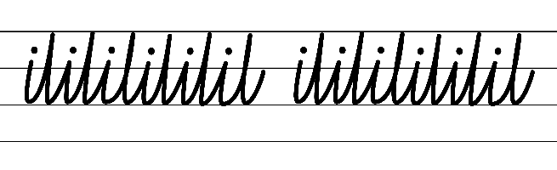  - Example NSW Cursive Style handwriting formation  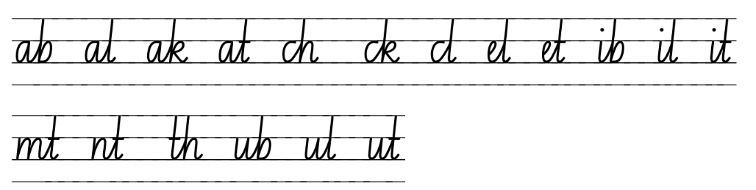  - Familiar words in NSW Cursive Style handwriting formation  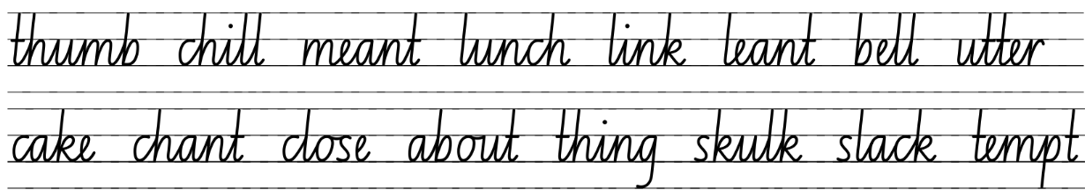  - Suggested practice text from the passage  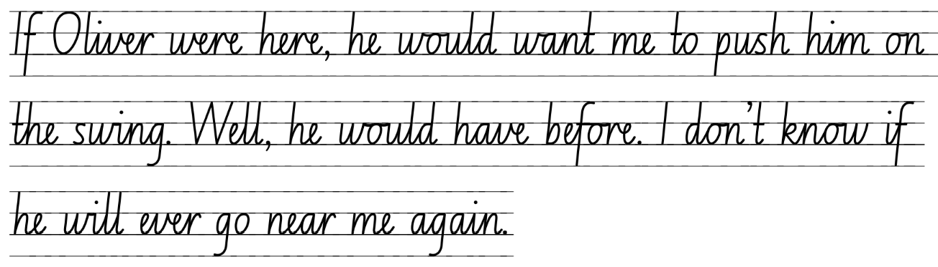

Planning framework
To plan and document Component A teaching and learning, a planning scaffold (DOCX 228 KB) is provided. To support you in your planning, a link to a detailed example of a one-week teaching and learning cycle is included in the scaffold. Additional resources to support teaching and learning in each focus area can be found at Lesson advice guides.

Component B teaching and learning
The following teaching and learning sequence has been designed to address Component B outcomes and content and develops conceptual understandings of English through the study of quality texts. Adapt the sequence as required to best meet the needs of your students.

Learning intentions and success criteria
Learning intentions and success criteria are best co-constructed with students.

Learning intention
Students are learning to understand the development of characters and the purpose of a complication and resolution in a narrative.

Success criteria
Students can:
- write a variety of sentences using appropriate conjunctions
- build tension within a series of events
- identify and understand the purpose of a complication
- write a complication based on another character’s point of view
- understand the development of a character to write a resolution.

Lesson 9 – building tension within a series of events
- Revise the key events that occurred in The Thing About Oliver, Chapters 12 to 16.
- Revise teaching in Component A about simple, compound and complex sentences.
- Display examples of simple, compound and complex sentences from the text. For example:
- Simple: I wonder if her face needs stitches.
- Compound: I wonder what it would have been like to have a brother I could play imaginary games with, but I guess I'll never know.
- Complex: I wouldn't blame Aunt Janine if she did want us to leave.
- Explain that a compound sentence contains 2 independent clauses which are of equal importance. In a complex sentence there is a main clause, and a dependent clause that provides additional information or circumstances around the main clause. Compound and complex sentences include a conjunction. Analyse and identify the conjunctions used.
- Discuss the differences between the types of conjunctions. Explain that ‘but’ is an example of a coordinating conjunction that is used in a compound sentence. It links 2 independent clauses. ‘If’ is an example of a subordinating conjunction that is used in a complex sentence. It links a dependent clause to an independent clause.
- Brainstorm and record coordinating and subordinating conjunctions.
- Display the beginning of sentence. For example, ‘I try to soothe him by singing and putting on his favourite music,’. Model finishing the sentence using a coordinating or subordinating conjunction. For example:
- ‘I try to soothe him by singing and putting on his favourite music, but Oliver is throwing things around the house. (compound sentence)
- ‘I try to soothe him by singing and putting on his favourite music before we go to bed. (complex sentence)
- In pairs, students write a compound and complex sentence with different conjunctions, using the sentence beginning from activity 7.
- In pairs, students revise their completed copy of Resource 5 – tension volcano and select another event to write, from Oliver’s point of view. Encourage students to use simple, compound and complex sentences with a variety of conjunctions.
- Students turn and talk to discuss what Oliver might be thinking, feeling and doing during these tension building moments. Remind students to share ideas on how the tension can be drawn out, so that a reader is engaged and that tension events are not instantly resolved.
- Students write the event, including tension building moments from Oliver's point of view, to add to their narrative.
Too hard? Students work in pairs or small groups to rewrite the sequence of events from Oliver’s point of view.

Lesson 10 – exploring the complication in a narrative
- Revise the meaning of tension within a narrative and explain that these events build up to a complication. Students turn and talk to define what ‘complication’ means. Create a class definition, for example, a complication is a big event that a character must face or overcome to learn something about themselves or others.
- Explain that a complication is an important part of a narrative structure and is the direct result of tension building events.
- Review the complication predictions students made in Lesson 7. Discuss if these were accurate and if the expectations of the narrative occurred.
- Revise and list the main events that occurred within Chapters 12 to 16. Explain that a major complication is about to occur and ask students to infer what it could be using links from across the text. For example, when Tilly ran out of the house (p 91) it may mean that she gets lost and cannot find her way home.
- Read The Thing About Oliver, Chapters 17 to 18.
- At the end of Chapter 18, ask students to use background knowledge to infer what ‘uniformed arms’ (p 100) means and who this person might be. For example, emergency service people such as paramedics, police officers, fire brigade wear uniforms. Discuss what might have happened at the house for this person to be there.
- Read Chapter 19 and identify and discuss the major complication that has occurred.
- Revisit the completed copy of Resource 5 – tension volcano from Lesson 8. Students write the complication in the box atop the volcano.
- Students write a series of questions they could ask Mum about the events in Chapter 19. For example, students could ask: what she felt when she noticed Oliver was missing, what was she thinking, what did she think Oliver might do or where he might go?
- In small groups, students participate in a hot seat activity, imagining they are Mum. One student at a time is asked 2 to 3 questions written by their peers. Students swap until each group member has had a turn at answering questions.
- Share and record group questions and responses on a chart. This chart will be used in Lesson 11.
- Add the major complication and key details to the narrative timeline under the ‘complication’ heading.

Lesson 11 – identifying point of view during a complication
- Revise the key events that took place in Chapters 17 to 19.
- Using the chart of questions and responses from hot seat activity in Lesson 10. Model writing the complication from Mum’s point of view. See Resource 7 – complication exemplar for support. Analyse how the use of dialogue conveys what Mum is saying and thinking. Ask students to consider Tilly’s point of view during these events. Discuss what the major complication is, how Tilly might be feeling, what she is thinking and what actions she takes to try and resolve the situation.
- Read Chapters 20 to 21.
- As a class, generate and record ideas from Oliver's point of view during the complication. Explain that the events are occurring simultaneously to Tilly’s, beginning from when Oliver ran out of the house. Students consider where Oliver went and why, what events unfolded and how he was feeling.
- Revisit the modelled writing from activity 1 and draw on learning from Component A to highlight varying sentence types and different types of conjunctions within and across sentences to support cohesion. Explain that students will write the complication from Oliver’s point of view using learning from Component A.
- Students write the complication from Oliver’s point of view. Remind students that Oliver is non-verbal. Any dialogue used would be internal dialogue.
Too hard? Students work in groups to generate ideas. In pairs or small groups students write the complication from Oliver’s point of view.
- As a class, add some of the ideas generated about Oliver’s experiences throughout the complication to the narrative timeline under the relevant headings.

Lesson 12 – understanding and identifying the resolution in a text
- Reflect upon the events within Chapters 20 to 21, allow students to predict and infer what might happen next in the story.
- Read Chapter 22.
- In small groups, allocate students character from the chapter, for example, Tilly, Mum, Oliver, Aunt Janine, police officer, garbage truck driver, a neighbour. Students brainstorm how their character is feeling as the events unfold in Chapter 22. Ask students to consider what their character might be thinking or what they might say.
- Allow each group to share their ideas with the class. Add relevant ideas to the narrative timeline to develop students’ understanding of characterisation.
- Explain what a resolution is, making connections to the structure of a narrative. For example, the solution or ending to a narrative following a series of events and major complication. Ask students to identify the resolution in The Thing About Oliver.
- Students use the information from Chapter 22, to write the resolution from Oliver's point of view.
Too hard? Students work in groups to generate ideas.
- Add the resolution and any important character developments to the narrative timeline under the ‘resolution’ heading.

Week 4

Component A teaching and learning
Component A focuses on the development of foundational skills and knowledge through regular, systematic and repeated practice. The mentor and supporting texts used in Component B of this unit can support the effective implementation of Component A teaching and learning.

Teaching guide
Guidance for explicit teaching, teaching notes, resources and examples for the related outcomes and content points have been provided in the table below.
Focus areas and teaching notes | Resources and examples
Reading fluency  Reading automaticity and rate  - Syllabify, blend grapheme–phoneme correspondences and use morphemic knowledge as strategies for reading words accurately  - Model how to use blend grapheme–phoneme correspondences accurately while maintaining fluency and understanding.  - Locate and syllabify multisyllabic words, including those with morphemic suffixes.  - For every syllable, there is at least one vowel phoneme.  - Morphemic suffixes usually form their own syllable.  - The morphemic suffix -ed forms a syllable when pronounced as ‘ed’ but does not when pronounced as ‘d’ or ‘t’. | Reading fluency  Reading automaticity and rate  - Resource 8 – fluency and close reading passage analysis – Chapter 23 (pp 122–123) from ‘As I head for the...’ to ‘...wearing his swimmers.’ (237 words).  Note: The passage from the text will need to be a teacher-created resource.  - Suggested words from the passage  - Morphemic information  - renovations – renovate + ion + s  - suddenly – sudden + ly  - surrounded – surround + ed.  - Syllables  - renovations – 4 syllables  - suddenly – 3 syllables  - surrounded – 3 syllables.
Prosody  - Explain how prosodic reading involves emphasis, expression, intonation and pausing  - A pause is a short stop or break when reading.  - Pausing allows readers to show punctuation and key ideas during reading and adds drama to reading. | Prosody  - Suggested sentences to illustrate the use of pausing from the passage  - ‘I’ve wanted to learn to swim for so long, but now that the big day is here, I’m more nervous than a cloud of plankton.’  - ‘What if I can't do it? What if the teacher tries her best, but I'm just no good at swimming?’
Reading comprehension  Comprehending text structures and features  - Understand that literal information can be sourced directly from a text and that inferences can be made by using multiple sources of information  - Sources used to infer meaning may include background or prior knowledge, key words and visuals. | Reading comprehension  Comprehending text structures and features  - Students can make real life connections to individual situations where they may have been unsure, using prior or background knowledge.  - Understanding of key words and phrases to infer Tilly’s feelings of anxiousness and uncertainty within the passage include  - a hundred pairs of butterfly fish start swimming around in my stomach  - I am going to eject my stomach out of my mouth like a starfish.
Comprehending language  - Use morphemic knowledge to read and understand the meaning of words  - To work out the meaning of portable (capable of being carried), students use knowledge of the morphemes, port (carry) and able (capable of). | Comprehending language  - Prefixes include  - under- meaning ‘under’ or ‘too little’  - sub- meaning ‘under’  - Examples from the text  - exhausted (p 120), excited (p 121) ex- meaning  - impressed (p 124) im- meaning ‘in’, ‘onto’ or ‘toward’  - underneath (p 121) under- meaning ‘under’ or ‘too little’.
Vocabulary  Learning and using words  - Build personal Tier 1, Tier 2 and Tier 3 vocabulary through social and learning interactions, reading and writing  - Identify and discuss Tier 1, Tier 2 and Tier 3 words in the text to improve vocabulary knowledge and comprehension. | Vocabulary  Learning and using words  - Suggested words from the passage  - Tier 2: renovations, nervous, surrounded  - Tier 3: plankton, Spanish dancer.  - Suggested vocabulary from Week 4 reading material: kiosk (p 121), stimulate (p 122), plankton (p 123), kickboard (p 125), waterproof (p 126), Pterois Volitans (p 129), beatboxing (p 130).
Spelling  Phonological component  - Explain how to segment multisyllabic words into syllables and phonemes, and apply this knowledge when spelling  - Explain how to segment multisyllabic words into syllables. For example, tentacle has 3 syllables.  - Explain how to segment multisyllabic words into phonemes. For example, tentacle has 7 phonemes (t-e-n-t-a-c-le).  - Identify differences in vowel phonemes (short, long, diphthong and schwa vowels)  - Short vowel phoneme /u/ as in up [u, o, ou, oo]  - Revise identifying differences in vowel phonemes (short, long, diphthong and schwa vowels). For example, the first and second syllable in the word umbrella has a short vowel and the third syllable is schwa. | Spelling  Phonological component  - Suggested words from Week 4 reading material: slung (p 121), instructor (p 122), frustrate (p 126), sunscreen (p 131), frangipani (p 132), underneath (p 121).  - Sample words: pumpkin, thunder, abundant, wonder, love, customer, cousin, country, undercooked, underestimate, underground, underwear, underwater, undertow, submarine, submerge, subscribe.
Orthographic component  - Understand that some graphemes are dependent on their position in a word in English and apply this knowledge when spelling  - The vowel graphemes [u, o, ou, oo] are often used in the middle of base words.  - Apply knowledge of taught vowel graphemes when spelling  - Single-letter graphemes ‘u’ and ‘o’ are used to represent the short vowel phoneme /u/ as in up. This phoneme can also be represented using the vowel digraphs ‘ou’ and ‘oo’. | Orthographic component  - As above
Morphological component  - Identify prefixes that require no change to the base word or root when they are affixed, and apply this knowledge when spelling  - Identify the prefix: ‘sub-’ and ‘under-’.  - Revise prefixes: under- meaning ‘under’ or ‘too little’ sub- meaning 'under’.  - Teach that no change is required when affixing these prefixes to the base word. | Morphological component  - As above
Creating written texts  Sentence- level grammar  - Use simple, compound and complex sentences of varying lengths for variation and readability  - Revise that a sentence may express a statement, exclamation, command or question.  - Revise that a sentence begins with a capital letter and ends with a full stop, exclamation mark or question mark.  - Revise features of simple, compound and complex sentence. | Creating written texts  Sentence- level grammar  - Examples from the fluency passage  - Simple: ‘What if I can’t do it?’  - Compound: ‘What if the teacher tries her best but I'm just no good at swimming?’  - Complex: ‘Of all the amazing reef creatures I might never get to see in real life, unless I learn to swim.’
Text features for multiple purposes  - Use temporal, conditional and causal conjunctions within sentences, and as connectives to link ideas across sentences for cohesion  - Introduce use of conjunctions to establish relationship between sentences.  - Temporal conjunctions indicate time relationships (sequence - ‘when’): first, next, finally [after, before, when, while, since, until, as, meanwhile, during, whenever].  - Conditional conjunctions express conditions or possibilities, however, although, unless, if.  - Causal conjunctions show cause-and-effect relationships as a result, because, due to, so.  - Use language to create imagery or humour, including idioms, puns, simile and personification  - Use of figurative language to represent objects, characters, actions or ideas in such a way that they appeal to the senses of the reader or viewer. | Text features for multiple purposes  - Suggested examples of conjunctions from the passage  - temporal conjunctions – When I come back out, Oliver is wearing his swimmers. (p 123)  - causal conjunctions – 'As I head for the change rooms, a hundred pairs of butterfly fish start swimming around in my stomach.’ (p 122)  - Using ideas from the text  - conditional conjunctions – Although I have wanted to learn to swim for so long, I am more nervous than a cloud of plankton surrounded by whales.  - Suggested examples of figurative language from the passage  - simile – ‘I am going to eject my stomach out of my mouth like a starfish.’  - metaphor/hyperbole– ‘As I head for the change rooms, a hundred pairs of butterfly fish start swimming around in my stomach.’
Handwriting and digital transcription  Handwriting legibility and fluency  - Join letters when writing familiar words  - Form letters and words with diagonal joins to anticlockwise letters, including a, c and d. These are sometimes referred to as back touch or drop-in joins.  - To form a join to an anticlockwise letter, the exit hook is extended high towards the top of the next letter near line 2. The pen(cil) is lifted and the letter is ‘dropped’ into place and touches the exit on the way down.  - Apply appropriate pressure when joining letters.  - Revise content from previous weeks  Software functionalities and typing  - Use knowledge of the keyboard layout and functions to type texts  - Revise the position of a device.  - Use knowledge of keyboard functions, such as:  - space bar to put a space between words  - backspace to delete text  - enter to start a new line  - shift and caps lock to type capital letters. | Handwriting and digital transcription  Handwriting legibility and fluency  - Suggested fluency pattern  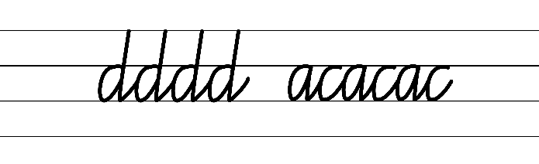  - Example NSW Cursive Style handwriting formation  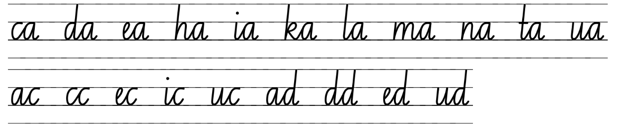  - Familiar words in NSW Cursive Style handwriting formation  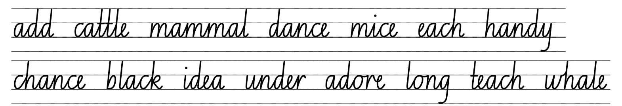  - Suggested practice text from the passage  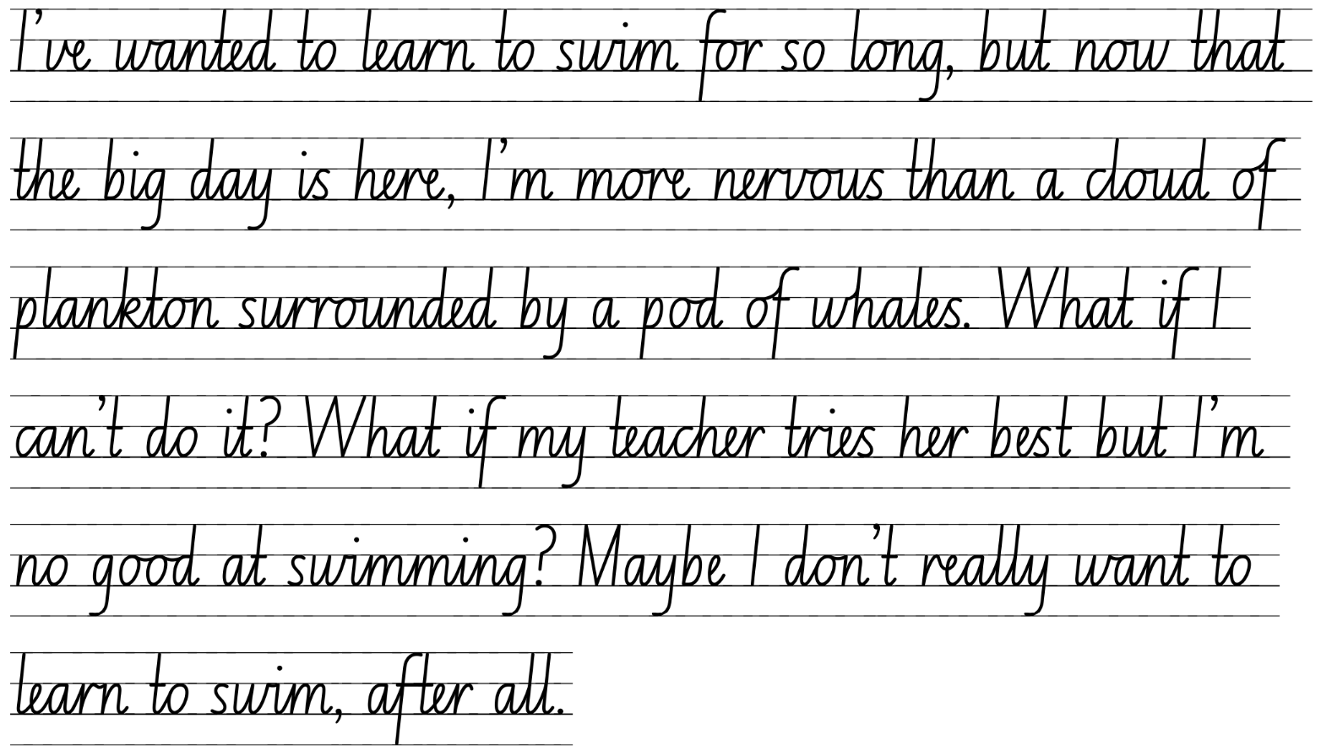

Planning framework
To plan and document Component A teaching and learning, a planning scaffold (DOCX 228 KB) is provided. To support you in your planning, a link to a detailed example of a one-week teaching and learning cycle is included in the scaffold. Additional resources to support teaching and learning in each focus area can be found at Lesson advice guides.

Component B teaching and learning
The following teaching and learning sequence has been designed to address Component B outcomes and content and develops conceptual understandings of English through the study of quality texts. Adapt the sequence as required to best meet the needs of your students.

Learning intentions and success criteria
Learning intentions and success criteria are best co-constructed with students.

Learning intention
Students are learning to use a range of narrative conventions and features to enhance planning and writing.

Success criteria
Students can:
- identify the coda and character development
- understand the purpose of narrative conventions
- describe connections between own or shared experiences and those in the text
- use figurative language to create imagery in writing
- use a variety of sentence types to enhance writing
- plan a narrative orientation, referring to the success criteria.

Lesson 13 – purpose of a narrative coda and character development
- Read the first page of Chapter 23, stopping at ‘She looks up and gives us a wave.’ Explain that a reasonable amount of time has passed between the end of Chapter 22 and the beginning of Chapter 23. Ask:
- How does the audience know that time has passed? For example, Tilly and Oliver are going to swimming lessons.
- What might have happened during this time? For example, Tilly and Oliver have settled into their new life.
- Why do you think the author did this?
- Read Chapters 23 to 24.
- Refer to the characterisation charts on the narrative timeline. Discuss how the characters have changed and grown from the beginning of the story to the end and what evidence supports this from the text. Consider how the characters have transformed and how they are feeling now. For example, Mum has a new job and seems happy; Oliver is eating more, is enjoying different music and is attempting to talk; Tilly has a bike and rides to the pool with her new friend Eve.
- Explain that Chapters 23 to 24 reveal the overall resolution to the text and that it is called the ‘coda’. A coda conveys how characters have changed and reveals the moral or message of the story.
- In small groups, students record responses to the following questions:
- How are Tilly and Oliver different in the coda compared to the beginning of the story? For example, Oliver is eating more, is enjoying different music and is attempting to talk; Tilly has a bike and rides to the pool with her new friend Eve.
- What is the overall message the author created? For example, to never give up or be afraid of change, to put family first.
- Allow each group to share their responses with the class.
- Jointly construct a coda from Mum’s point of view.
- In pairs, students plan and share ideas for a coda for Oliver. When students have planned the coda, provide questions to support reflecting on and refining planning. For example:
- Does the coda ‘tie up loose ends’ and provide a clear resolution to the main conflicts within the narrative?
- Is the coda written and obvious or will the reader need to infer?
- Is there a satisfying answer to questions for readers?
- Will the readers be able to identify the message?
- Provide time for students to revisit and refine their plan for the coda.
- Students write a coda from Oliver’s point of view.
Too hard? Students work in pairs to write the coda from Oliver’s point of view.
Too easy? Students write the coda from Oliver’s point view, 5 years after the events of the story conclude.
- Add student codas and any important character developments to the narrative timeline under the ‘coda’ heading.

Lesson 14 – narrative conventions and imagery
- Revise that narratives are written to entertain and engage an audience using a variety of conventions. The author supports readers to make connections (self-text-world) by using familiar characters and situations to set up expectations. For example, the familiar character of siblings. Provide time for students to describe any connections they have made between the text and their own experiences. Be mindful that some students may share differing levels of knowledge about autism. Refer to the Teaching notes to access the Inclusive Practices Hub for further support.
- As a class, brainstorm different narrative conventions that the author has included to make The Thing About Oliver entertaining and discuss why these conventions are important. Record student responses on a chart. For example, details about plot, point of view (written in first person), setting, characters, theme, conflict, actions using adjectives, figurative language, varied sentence structure, dialogue, relatable for a younger audience.
- Provide small groups of students with one part of the teacher modelled writing from previous lessons to analyse and identify the narrative conventions used. Students share their ideas with another group.
- Students re-read their writing from Weeks 2 and 3 to identify and describe the narrative conventions used. Encourage students to consider if the conventions they used would help engage a reader.
- Explain that narratives are organised into paragraphs to reflect the sequence of events, ideas and actions of the characters. Show an example from the teacher modelled writing and how it reflects this organisation. For example, the orientation and an event have been written in separate paragraphs and there is a connection between them.
- Students revise their work to make sure they have written paragraphs aligned to the stages of a narrative.
- Ask the students to reflect on how their language choices could be more interesting to engage the reader. Allow for responses.
- Explain that authors use figurative language, such as similes, metaphors and onomatopoeia to create imagery for the audience. Revise the meaning of each, for example:
- Simile: using ‘like’ or ‘as’ to compare similar qualities.
- Metaphor: implies one thing is something else.
- Onomatopoeia: a word that is indicative of the sound that it describes.
- Identify figurative language used in The Thing About Oliver and what each line means. For example:
- Simile: ‘like trying to get a onesie on an octopus’ (p 6); ‘just like a flamenco dancer, swishing her skirt in time with the music’ (p 58).
- Metaphor: ‘A ball of anger rises in my throat’ (p 7); ‘The wave of hope comes smashing down’ (p 28).
- Onomatopoeia and repetition: ‘Thump! Thump! Thump!’ (Oliver kicking the wall) (p 3); ‘Clunk, clunk, clunk’ (garbage truck noise) (p 14).
- Revisit the teacher modelled writing and co-construct examples of figurative language that could be added to the writing. Re-read each section with the added content and ask students to explain which they think is better and why. Support students to consider how the use of figurative language can have an emotional response on the reader.
- Students re-read and revise their writing from Oliver’s point of view and add figurative language to create imagery.
Too hard? Co-construct examples of figurative language that could be included.
Assessment task 5 –observations and work samples from this lesson allow students to demonstrate achievement towards the following syllabus outcome and content point:
EN2-UARL-01 – identifies and describes how ideas are represented in literature and strategically uses similar representations when creating texts
- describe how narratives set up expectations using familiar, real and imagined characters, situations and phrases
- describe how narrative conventions engage the reader
- describe connections between own or shared experiences and those depicted in narratives.

Lesson 15 – revising sentence types and grammatical features
- Display the teacher modelled writing from previous lessons and ask students to identify the different sentence types that have been used. Discuss how using different sentence types makes writing more engaging for the reader.
- Revise teaching in Component A about simple, compound and complex sentences.
- Use a simple sentence from the text to model creating compound and complex sentences. For example:
- Simple: ‘Mum carries Oliver back to bed.’ (p 8)
- Compound: Oliver buries his face in Mum’s chest, and she carries him back to bed.
- Complex: Before making herself a cup of tea, Mum carries Oliver back to bed.
- Explain how a comma is used to separate a dependent clause when it is positioned before the main clause.
- Highlight the impact of each sentence choice. For example, repeatedly using a simple sentence may emphasise an idea or help create tension. A complex sentence might be used to convey greater detail and create a vivid picture in the reader’s mind.
- In pairs, students read their writing from Oliver’s point of view and identify at least one example of a simple, compound and complex sentence. Students could use colour coding. Encourage students to carefully consider why each sentence type is used and if it has a desired impact.
- Independently, students revise and edit their writing to include additional examples of compound and complex sentences.
- Revise the use of conditional and causal conjunctions within compound and complex sentences as taught in Component A. As a class, identify examples from The Thing About Oliver. For example:
- conditional conjunctions: as long as, unless, if, otherwise, although, however. ‘If he hears the rubbish truck going up and down our street, he might come out from wherever he is hiding.’ (p 112).
- causal conjunctions: as, now that, since, because, so, due to ‘I didn't like the lettering, so I covered it up with stickers I had of fish and turtles.’ (p 4).
- In pairs, students read their writing from Oliver's point of view and identify examples of conditional and casual conjunctions.
- Independently, students edit their writing to include additional examples of temporal, conditional and casual conjunctions.
Optional: students publish their writing from Oliver’s point of view.

Lesson 16 – planning a narrative
- Explain that students will be using The Thing About Oliver and their knowledge of narrative structure to create their own text.
- Students will write a narrative in first voice, as though they are the protagonist. Their text will also include several additional characters.
- Revisit previous learning about the plot of a narrative from Lesson 5, remind students that the plot is the main storyline that keeps readers engaged. Ask students to briefly retell the plot of The Thing about Oliver or ask questions to consolidate understanding. For example:
- What was the main challenge or obstacle that the characters face throughout the narrative?
- How did the tension events impact the narrative?
- What is the climax of the narrative, and how did it impact the characters?
- Explore a plot for all students to write a narrative about. For example, the protagonist's sibling, friend, or relative is going through a change that is getting harder to manage and keep a secret.
- Brainstorm and list ideas for possible changes the sibling, friend or relative might be experiencing. For example, growing taller each day, shrinking each day, turns invisible when emotional, moving to a new city/school, pursuing a dream, experiencing a cultural challenge when living in a new country, a change in family dynamics. Note: the changes may be realistic or imaginative.
- Co-construct writing criteria for the structure of the narrative text. For example:
- Orientation: introduction to characters setting, plot, and potential problem
- Events and tension building: in sequence with tension building throughout
- Complication: a big problem that can be resolved
- Resolution: resolve the problem, but not too quickly
- Coda: events that occur after the resolution to show what the characters have learned.
- Co-construct success criteria for students’ writing. For example:
- sequence the stages of the narrative into detailed paragraphs
- write simple, compound and complex sentences to engage a reader
- use speech marks to indicate dialogue between characters
- create imagery by using figurative language such as similes, metaphors, and onomatopoeia
- use temporal, conditional and causal conjunctions to link ideas
- use a comma to separate a dependent clause in a complex sentence
- publish writing using a keyboard.
- Introduce Resource 9 – writing process and explain that students will be working through this process to write their narrative and will be starting with the drafting phase.
- Display an enlarged blank copy of Resource 10 – planning template. As a class, complete the orientation section of the planning template using a selected idea from activity 4.
- Students use their own copy of Resource 10 – planning template, to complete the plan for their orientation.
Too hard? Students work in small groups to generate ideas. Add points to the planning template.

Week 5

Component A teaching and learning
Component A focuses on the development of foundational skills and knowledge through regular, systematic and repeated practice. The mentor and supporting texts used in Component B of this unit can support the effective implementation of Component A teaching and learning.

Teaching guide
Guidance for explicit teaching, teaching notes, resources and examples for the related outcomes and content points have been provided in the table below.
Focus areas and teaching notes | Resources and examples
Reading fluency  Reading automaticity and rate  - Syllabify, blend grapheme–phoneme correspondences and use morphemic knowledge as strategies for reading words accurately  - Model how to use blend grapheme–phoneme correspondences accurately while maintaining fluency and understanding.  - Locate and syllabify multisyllabic words, including those with morphemic suffixes.  - For every syllable, there is at least one vowel phoneme.  - Morphemic suffixes usually form their own syllable.  - The morphemic suffix -ed forms a syllable when pronounced as ‘ed’ but does not when pronounced as ‘d’ or ‘t’. | Reading fluency  Reading automaticity and rate  - Fluency passage 5 – Chapter 24 (p 131) from ‘Aunt Janine gives me a wink...’ to page 132, ‘...have a good swim’ (169 words).  Note: the passage from the text will need to be a teacher-created resource.  - Suggested words from the passage  - Morphemic information  - mashed – mash + ed  - lately – late + ly  - properly – proper + ly  - tucking – tuck + ing.  - Syllables  - mashed – 1 syllable  - lately – 2 syllables  - properly – 2 syllables  - tucking – 2 syllables.
Prosody  - Explain how prosodic reading involves emphasis, expression, intonation and pausing  - Emphasis is when the reader gives extra importance or focus to specific words or parts of a sentence. It helps to convey the meaning or feeling behind the text.  - Expression is when the reader reads aloud with feeling and puts emotion into the words on the page, so that the listener can understand the authors intent.  - Intonation is the pattern or melody of pitch changes in connected speech, especially the pitch pattern of a sentence  - falling intonation ends with a lower pitch  - rising intonation ends with a higher pitch.  - Pausing allows readers to show punctuation and key ideas during reading and adds drama to reading. | Prosody  - Suggested sentences to illustrate the use of emphasis, expression, intonation and pausing from the passage  - ‘I can’t believe it: first mango and now toast. What’s next-Vegemite?!’  - ‘I never thought I’d ever see our little monkey eat anything but yoghurt and mashed bananas, but that’s the thing about Oliver lately: he is full of surprises.’
Monitoring and reading fluency  - Reflect on stamina for reading sustained texts  - Increasing reading for longer periods of time  - Pacing: adjusting reading speed of a text can improve stamina and comprehension. | Monitoring and reading fluency  - Students use strategies to reflect on sustained reading. For example: modelled reading, opportunities to practise regularly, goal setting with reflection.
Reading comprehension  Comprehending text structures and features  - Understand that dialogue is a common feature of imaginative texts, signalled by quotation marks or speech bubbles to indicate interactions between characters  - Consider student knowledge and understanding and application of quotation marks and speech bubbles.  - Note that during dialogue in an imaginative text, the reader needs to understand who is talking. | Reading comprehension  Comprehending text structures and features  - Suggested sentences to illustrate the use of dialogue from the passage  - “Make sure you ride on the footpath.” Mum follows me to the door. “And watch out for driveways.”  - “Okay!” I jog down the front steps.’
Comprehending language  - Use morphemic knowledge to read and understand the meaning of words  - To work out the meaning of portable (capable of being carried), students use knowledge of the morphemes, port (carry) and able (capable of).  - Clarify and link the meanings of key words across a text to support global inferencing  - Global inferencing requires the reader to comprehend implied information from across relatively larger sections of text and is supported by the reader’s depth of vocabulary and background knowledge (NESA 2024). | Comprehending language  - Prefixes include  - de- meaning ‘opposite’  - anti- meaning ‘against’.  - under- meaning ‘under’ or ‘too little’  - sub- meaning ‘under’.  - Examples from the text  - underpants (p 22) under- meaning ‘under’ or ‘too little’  - underneath (p 59) under- meaning ‘under’ or ‘too little’  - antiseptic (p 78) anti- meaning ‘against’  - reassuringly (p 106) re- meaning ‘again’.  Examples from the passage  - To infer that Tilly is leaving the home without another family member, keywords or phrases may include “I’ll be sure to wear it properly!”, blows me a kiss, “Have a good swim!”
Vocabulary  Learning and using words  - Build personal Tier 1, Tier 2 and Tier 3 vocabulary through social and learning interactions, reading and writing  - Identify and discuss Tier 1, Tier 2 and Tier 3 words in the text to improve vocabulary knowledge and comprehension. | Vocabulary  Learning and using words  - Suggested words from the passage  - Tier 2: yoghurt, surprises, shoulder  - Tier 3: frangipani.  - Suggested vocabulary from Week 5 reading material includes: sling (p 131), frangipani (p 132), mock (p 132).
Spelling  Phonological component  - Explain how to segment multisyllabic words into syllables and phonemes, and apply this knowledge when spelling  - Explain how to segment multisyllabic words into syllables. For example, tentacle has 3 syllables.  - Explain how to segment multisyllabic words into phonemes. For example, tentacle has 7 phonemes (t-e-n-t-a-c-le).  - Identify differences in vowel phonemes (short, long, diphthong and schwa vowels)  - Identify short vowel phonemes /o/ and /u/ within multisyllabic words. | Spelling  Phonological component  - Use suggested words from text and sample words from the previous 4 weeks of learning.
Orthographic component  - Understand that some graphemes are dependent on their position in a word in English and apply this knowledge when spelling  - The grapheme [o] is used in the middle and beginning of base words.  - The grapheme [a] is used in the middle of base words, often after the graphemes [w] and [qu].  - The grapheme [au] is used in the middle of base words.  - The vowel graphemes [u, o, ou, oo] are often used in the middle of base words.  - Apply knowledge of taught vowel graphemes when spelling  - Single-letter graphemes ‘o’ and ‘a’ are used to represent the short vowel phoneme /o/. This phoneme can also be represented using the vowel digraph ‘au’.  - The vowel digraphs ‘oa’, ‘ow’ and ‘oe’ represent the long vowel phoneme /ow/. This phoneme can also be represented using the split digraph [o_e] and the grapheme [o].  - Single-letter graphemes ‘u’ and ‘o’ are used to represent the short vowel phoneme /u/ as in up. This phoneme can also be represented using the vowel digraphs ‘ou’ and ‘oo’. | Orthographic component  - As above
Morphological component  - Identify prefixes that require no change to the base word or root when they are affixed, and apply this knowledge when spelling  - Identify and apply the prefixes de-, anti-, sub-, under-. | Morphological component  - As above
Creating written texts  Sentence-level grammar  - Use simple, compound and complex sentences of varying lengths for variation and readability  - Review  - a sentence may express a statement, exclamation, command or question  - begins with a capital letter and ends with a full stop, exclamation mark or question mark  - simple, compound and complex sentence features. | Creating written texts  Sentence-level grammar  - Examples from fluency passage  - Simple sentence: ‘Aunt Janine gives me a wink.’  - Compound sentence: ‘I never thought I'd ever see our little monkey eat anything but yoghurt and mashed bananas, but that’s the thing about Oliver lately: he is full of surprises.’  - Complex sentence: ‘I hold it to my nose and inhale deeply, before tucking it behind my ear.’ (‘it’ refers to the frangipani flower in the previous sentence)
Imaginative purposes  - Experiment with using and punctuating dialogue in texts  - When each new character speaks, a new line is used.  - Dialogue can be used at the beginning of a sentence. The direct speech is at the beginning of the sentence. The punctuation that is part of the direct speech is placed within the inverted commas. The text explains who has just spoken. For example, “Do you want to go to the park?” asked Annabelle.  - Dialogue can be used at the end of a sentence. The text explains who is about to speak. A comma is placed before the direct speech. The direct speech is at the end of the sentence and includes the punctuation that is part of the sentence within the inverted commas. For example, Annabelle asked, “Do you want to go to the park?” | Imaginative purposes  - Examples from the fluency passage of dialogue  - “Where’s your helmet, Tilly?” Mum asks suddenly.  - “In the shed! And before you ask, I'll be sure to wear it properly.”
Handwriting and digital transcription  Handwriting legibility and fluency  - Join letters when writing familiar words  - Revise forming letters and words with diagonal joins to anticlockwise letters, including g, o and q.  - Apply appropriate pressure when joining letters  - Continue to revise content previous weeks.  Software functionalities and typing  - Use knowledge of the keyboard layout and functions to type texts  - Revise the position of a device.  - Use knowledge of keyboard functions, such as:  - space bar to put a space between words  - backspace to delete text  - enter to start a new line  - shift and caps lock to type capital letters. | Handwriting and digital transcription  Handwriting legibility and fluency  - Suggested fluency pattern  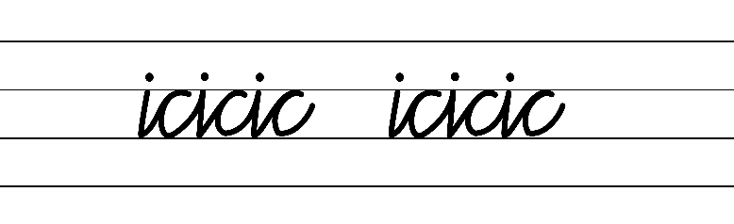  - Example NSW Cursive Style handwriting formation  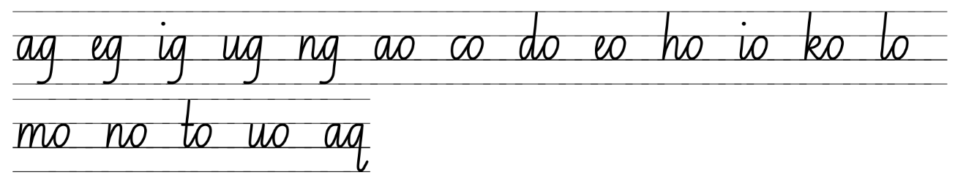  - Familiar words in NSW Cursive Style handwriting formation  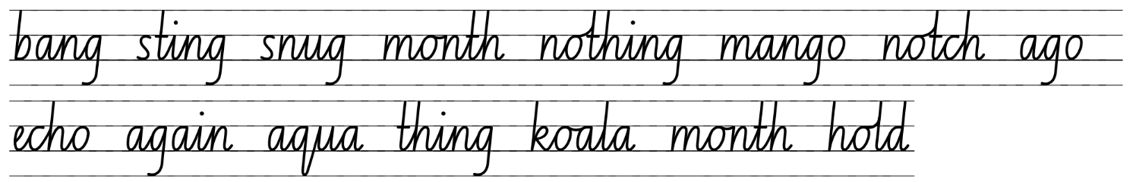  - Suggested practice text from the passage  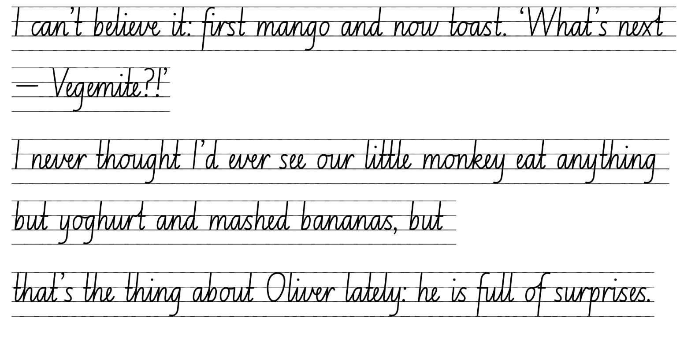

Planning framework
To plan and document Component A teaching and learning, a planning scaffold (DOCX 228 KB) is provided. To support you in your planning, a link to a detailed example of a one-week teaching and learning cycle is included in the scaffold. Additional resources to support teaching and learning in each focus area can be found at Lesson advice guides.

Component B teaching and learning
The following teaching and learning sequence has been designed to address Component B outcomes and content and develops conceptual understandings of English through the study of quality texts. Adapt the sequence as required to best meet the needs of your students.

Learning intentions and success criteria
Learning intentions and success criteria are best co-constructed with students.

Learning intention
Students are learning to engage in the writing process to produce quality and purposeful narratives.

Success criteria
Students can:
- plan a narrative whilst referring to a writing and success criteria
- draft a narrative whilst referring to a writing and success criteria
- draft and revise their narrative whilst referring to a writing and success criteria
- edit and publish their narrative.

Lesson 17 – planning a narrative (continued)
- Revise both the co-constructed writing and success criteria created in Lesson 16. Ensure that each point is read carefully and understood by the students. The success criteria could be used to set individual goals.
- Remind students that they will be using The Thing About Oliver and their knowledge of narrative structure to create their own text. Discuss the purpose or plot of their narrative and the importance of developing engaging characters. For example, the protagonist's sibling, friend, or relative is going through a change that is becoming harder to manage.
- Display the enlarged copy of Resource 10 – planning template and review the ideas generated in the orientation. Refer to the co-constructed writing criteria from Lesson 16 to revisit the structure of a narrative. As a class, complete the series of events, complication and resolution sections of the planning template.
- Students use their own copy of Resource 10 – planning template, to complete the plan for the series of events, complication and resolution for their narrative. Encourage students to consider the personal qualities of their chosen characters and how these may develop throughout different stages of the text.
Too hard? Students work in small groups to generate ideas. Add points to an enlarged planning template.
- In pairs, students share their plan and provide peer feedback, using the co-constructed writing criteria as a guide.
- Refer to Resource 9 – writing process and explain the next phase will be the drafting and composing phases. Explain that good writers move between the phases as they plan, edit and write. Discuss the cyclical process of planning, drafting and composing and the importance of re-reading and revising during this phase.

Lesson 18 – drafting a narrative
- Model how to use both the co-constructed writing and success criteria created in Lesson 16 to self-assess writing. As each point is read, use think-alouds to ask questions to monitor progress. For example:
- Did I include a compound sentence?
- Does the sentence work well there?
- Could I change it to use a complex sentence so that I can vary my sentence use?
- Do my characters drive the plot?
- Are my characters developing and changing as the story progresses?
- Model drafting the orientation of the narrative, referring to the completed copy of Resource 10 – planning template and the co-constructed writing and success criteria from Lesson 16.
- Using the modelled orientation, explore how each paragraph sequences ideas and actions that align to the stages of the text. Ask student to identify where to details about settings, character motives and actions are evident.
- Using their plan, students begin to draft their narrative.
Too hard? Provide sentence stems for each paragraph/section of the narrative.

Lesson 19 – drafting a narrative (continued)
- Remind students of the co-constructed writing and success criteria created in Lesson 16 and how to use it to self-assess.
- Students finalise their draft narrative ensuring their characters have been developed effectively and appropriate narrative conventions have been used.
- Refer to Resource 9 – writing process and explain that students will engage in the editing and proofreading phase.
- In pairs, students read their completed draft and describe how they have used the characters, setting and plot to create a cohesive narrative. Students talk about how their main character (either protagonist or the sibling, friend, relative) drives the plot.
- Students re-read and revise their writing.
Assessment task 6 –observations from this lesson allow students to demonstrate achievement towards the following syllabus outcome and content points:
EN2-UARL-01 – identifies and describes how ideas are represented in literature and strategically uses similar representations when creating texts
- describe the interplay of plot, character and setting in different types of narratives
- describe how a character drives the plot in a narrative.

Lesson 20 – editing and publishing a narrative
- In pairs, students provide peer feedback referring to the co-constructed writing and success criteria.
- Students apply the feedback to edit their writing.
- Refer to Resource 9 – writing process and explain the publishing phase.
- Students publish their narrative using a technology.
- Allow opportunity for students to share their narratives.
- Students complete an exit slip using Traffic light reflection, to self-assess their final text based on the narrative conventions and character development presented in The Thing About Oliver.
Assessment task 7 –observations and work samples from this lesson allow students to demonstrate achievement towards the following syllabus outcomes and content points:
EN2-CWT-01 – plans, creates and revises written texts for imaginative purposes, using text features, sentence-level grammar, punctuation and word-level language for a target audience
- use an orientation, complication, resolution structure to create narratives centred on time, place and characters
- sequence ideas and actions into paragraphs aligned to the stages of the text, to provide elaborated details about settings, character motives and actions
- experiment with using and punctuating dialogue in texts
- use temporal, conditional and causal conjunctions within sentences, and as connectives to link ideas across sentences for cohesion
- use coordinating conjunctions in compound sentences to compare and contrast, or for addition
- use subordinating conjunctions in complex sentences to signal sequence, reason or cause and effect
- use language to create imagery or humour, including idioms, puns, simile and personification
- use simple, compound and complex sentences of varying lengths for variation and readability
- use a comma to separate a dependent clause before a main clause.
EN2-UARL-01 – identifies and describes how ideas are represented in literature and strategically uses similar representations when creating texts
- experiment with narrative structures and narrative conventions encountered in literature when creating texts.

Resource 1 – Tell Me
Tell me, what did you like or dislike about the orientation? | Tell me, what features of the orientation did you notice? | Tell me, was there anything that puzzled you? | Tell me, were there any patterns or connections that you noticed?

Resource 2 – Tell Me exemplar
Tell me, what did you like or dislike about the orientation? | Tell me, what features of an orientation did you notice? | Tell me, was there anything that puzzled you? | Tell me, were there any patterns or connections that you noticed?
I like that Tilly has a hobby of studying marine creatures.  I like that Tilly cares so much about her brother.  I didn’t like that Tilly had to wash Oliver’s sheets. | Characters: 3 were introduced: Tilly, Oliver and Mum.  Setting: at Tilly’s house which is in drought-stricken Australia.  Plot: Tilly and Mum work very hard to manage Oliver and his needs. | I was puzzled why Oliver had to wear a helmet in the house.  I was puzzled why Oliver was naked a lot.  I was puzzled why Mum hasn’t taken Tilly to swimming lessons. | The book follows the pattern that an orientation sets up the main ideas for the story.  Oliver seems to get angry and loud very often because Tilly spoke about the neighbours always complaining.  Tilly is always helping Mum with Oliver.

Resource 3 – character chart
Character name: __________________________
Appearance | Actions
Feelings | Thoughts

Resource 4 – fluency and close reading passage analysis
Focus | Notes
Passage | Chapter 8 (p 49) from ‘I stretch out my legs...’ to ‘...before school starts.’ (206 words)
Synopsis | This passage is dialogue between the family as they are driving in the car. It includes many simple, compound and complex sentence examples.
Passage structure | The text is structured as a narrative using dialogue:  Description  - includes simple, compound and complex sentences  - includes punctuated dialogue  - understand that dialogue is a common feature of imaginative texts.
Language features | Language  - technical language is used to create precise definitions and explanations of topic-specific information. For example: freshwater crocodiles, saltwater crocodiles, Hibiscus  Temporal, conditional and causal conjunctions  - expose students to temporal, causal and conditional conjunctions  - teach temporal conjunctions  - Examples from the passage  - temporal conjunctions: once, as, but.  Simple, compound and complex sentences  - simple sentences:  - Aunt Janine nods.  - She must mean freshwater crocodiles.  - compound sentences:  - I stretch out my legs and wriggle my toes.  - We crane our necks, and I catch a glimpse of murky brown water.  - complex sentences  - Maybe I'll go swimming there too, once I learn how.  - Even so, when I do learn to swim, I definitely won’t be practising in the river.  Capital letters  - indicate the beginning of a sentence and proper nouns.

Resource 5 – tension volcano
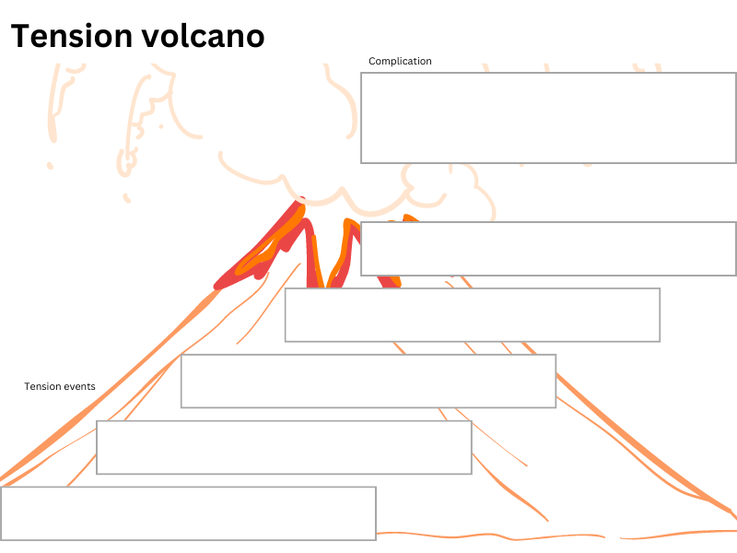

Resource 6 – series of events exemplar
I roll over to see the sun has risen. How long did I sleep for? Ugh, only 2 hours. Oliver was hard work last night; I didn’t think he would take this long to settle. I walk into the living room and see that Janine has already cleaned up the destruction caused by Oliver. I feel so bad about him destroying her pots. She and Tilly are outside sitting on the front step. Quietly, I turn the lock, ease the door open, and step outside. The fresh air hits my face and helps me to clear my mind. “What a night!” I turn and carefully lock the door even though I know Oliver is still asleep.
As I sit down on the top step next to Janine and Tilly, I rub the side of my head. I wish I could erase both my dull headache and the memories of last night’s events. I apologise immediately to Janine. She has been so good to us.
Thoughts from last night’s events sit heavily in my mind, so I try to explain my plans for the day. If I tell Janine about my resume and job-hunting plans, she might let us stay. I don’t know what we would do, or where we would go if Janine gave up on us. I look across at Tilly for reassurance. Before I can see her face, she stands up and walks to the door.
I wish she could see that I am trying.

Resource 7 – complication exemplar
“Did you look behind their shed?” I asked with my voice breaking. We have searched everywhere for Oliver… our yard, the neighbour’s yard, across the street. I can’t believe he is gone. He must have followed Tilly when she left. I look across and see Oliver’s clothes strewn across the front lawn. Please no. Let him be safe. Please let Oliver be safe.
Janine looks at me and nods silently, indicating that it is time. I clumsily grab for my phone which is in my short’s pocket. My heart is pounding. My mind is racing, and my fears for Oliver are overtaking my breathing. I try to call the number, but my fingers clumsily miss. Without realising, I let out an anguished scream. I try again. The operator answers and calmly asks for my emergency. I frantically try and explain. Oliver... Gone... Autistic... Door was unlocked. Please find him. You have to find Oliver. Janine reaches across and gently takes the phone from my hand. I hear her say words but cannot make out what they are. Oliver is gone. Oliver is gone.
“They are sending a squad now,” Janine says as she reaches out and tries to comfort me. “They will be here soon. The police will…”
I can’t hear anything else she says. My fears overtake my body. I crumble onto the ground in shock.

Resource 8 – fluency and close reading passage analysis
Focus | Notes
Passage | Chapter 23 (pp 122–123) from ‘As I head for the …' to ‘... wearing his swimmers.’ (237 words).
Synopsis | This passage is described from Tilly’s perspective and initial her thoughts on swimming lessons. It includes many examples of figurative language and simple, compound and complex sentence examples.
Passage structure | The text is structured as a narrative using imagery to create a picture for the reader.  Description  - Includes simple, compound and complex sentences.  - Includes imagery such as metaphors, similes.
Language features | Language  - Technical language is used to create precise definitions and explanations of topic-specific information. For example: starfish, plankton, Spanish dancer.  - Figurative language: use language to create imagery  - use of figurative language to represent objects, characters, actions or ideas in such a way that they appeal to the senses of the reader or viewer  - simile – ‘...I am going to eject my stomach out of my mouth like a starfish.’ (p 123)  - metaphor/hyperbole – ‘As I head for the change rooms, a hundred pairs of butterfly fish start swimming around in my stomach.’ (p 122)  Temporal, conditional and causal conjunctions  - Expose students to temporal, causal and conditional conjunctions.  - Teach temporal conjunctions.  Examples from the passage:  - temporal conjunctions – When I come back out, Oliver is wearing his swimmers. (p 123)  - causal conjunctions – 'As I head for the change rooms, a hundred pairs of butterfly fish start swimming around in my stomach.’ (p 122)  Simple, compound and complex sentences  - Simple sentence  - What if I can’t do it?  - Compound sentence  - What if the teacher tries her best, but I'm just no good at swimming?  - Complex sentence  - Of all the amazing reef creatures I might never get to see in real life, unless I learn to swim.  Capital letters  - Indicate the beginning of a sentence and proper nouns.

Resource 9 – writing process
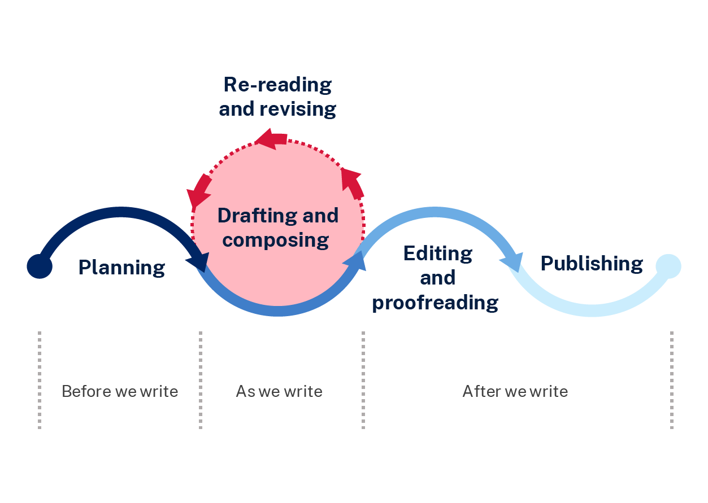

Resource 10 – planning template
Section of narrative | Ideas for planning
Orientation
Setting (time and place)
Characters
Series of events
Tension building
Complication
Minor complication
Major complication
Resolution
How is the problem resolved?
Is the ending subverted?
Coda
Events that follow the resolution
What have the characters learned?

References
This resource contains NSW Curriculum and syllabus content. The NSW Curriculum is developed by the NSW Education Standards Authority. This content is prepared by NESA for and on behalf of the Crown in right of the State of New South Wales. The material is protected by Crown copyright.
Please refer to the NESA Copyright Disclaimer for more information. https://educationstandards.nsw.edu.au/wps/portal/nesa/mini-footer/copyright
NESA holds the only official and up-to-date versions of the NSW Curriculum and syllabus documents. Please visit the NSW Education Standards Authority (NESA) website https://educationstandards.nsw.edu.au/wps/portal/nesa/home and the NSW Curriculum website https://curriculum.nsw.edu.au.
English K–10 Syllabus © NSW Education Standards Authority (NESA) for and on behalf of the Crown in right of the State of New South Wales, 2022.
National Literacy Learning Progression © Australian Curriculum, Assessment and Reporting Authority (ACARA) 2010 to present, unless otherwise indicated. This material was downloaded from the Australian Curriculum website (National Literacy Learning Progression) (accessed 11 September 2023) and was not modified.
Chambers A (1994/2011) Tell me: Children: Reading and Talk, Primary English Teaching Association in association with the Thimble Press, Newtown.
Kelly D (2019) The Thing About Oliver, Wombat Books, Queensland.
McDonald L (2023) A New Literature Companion for Teachers, Primary English Reaching Association, Australia.
NESA (NSW Education Standards Authority) (2024) ‘Glossary’, Resources, NESA website, accessed 12 March 2024.

© State of New South Wales (Department of Education), 2023
The copyright material published in this resource is subject to the Copyright Act 1968 (Cth) and is owned by the NSW Department of Education or, where indicated, by a party other than the NSW Department of Education (third-party material).
Copyright material available in this resource and owned by the NSW Department of Education is licensed under a Creative Commons Attribution 4.0 International (CC BY 4.0) license.
This license allows you to share and adapt the material for any purpose, even commercially.
Attribution should be given to © State of New South Wales (Department of Education), 2023.
Material in this resource not available under a Creative Commons license:
- the NSW Department of Education logo, other logos and trademark-protected material
- material owned by a third party that has been reproduced with permission. You will need to obtain permission from the third party to reuse its material.
Links to third-party material and websites
Please note that the provided (reading/viewing material/list/links/texts) are a suggestion only and implies no endorsement, by the New South Wales Department of Education, of any author, publisher, or book title. School principals and teachers are best placed to assess the suitability of resources that would complement the curriculum and reflect the needs and interests of their students.
If you use the links provided in this document to access a third-party's website, you acknowledge that the terms of use, including licence terms set out on the third-party's website apply to the use which may be made of the materials on that third-party website or where permitted by the Copyright Act 1968 (Cth). The department accepts no responsibility for content on third-party websites.

