English Stage 2 First year – Unit 6
Perspective and context – Sadako and the Thousand Paper Cranes

Contents
Unit overview and instructions for use 6
Teacher notes 8
Outcomes and content 10
Resources 18
Week 1 22
Component A teaching and learning 22
Planning framework 22
Component B teaching and learning 22
Learning intentions and success criteria 22
Learning intention 23
Success criteria 23
Lesson 1 – building topic knowledge prior to reading 23
Lesson 2 – exploring Sadako’s context 25
Lesson 3 – exploring perspective through questioning 29
Lesson 4 – using text evidence to identify perspective 32
Week 2 36
Component A teaching and learning 36
Planning framework 36
Component B teaching and learning 36
Learning intentions and success criteria 36
Learning intention 37
Success criteria 37
Lesson 5 – exploring similarities and differences in informative texts 37
Lesson 6 – reflecting on Sadako and following instructions 41
Lesson 7 – using experiences to create an informative text that instructs 43
Lesson 8 – providing feedback and publishing an informative text 44
Week 3 47
Component A teaching and learning 47
Planning framework 47
Component B teaching and learning 47
Learning intentions and success criteria 47
Learning intention 48
Success criteria 48
Lesson 9 – exploring topics and themes in a text 48
Lesson 10 – identifying and using cause-and-effect statements 51
Lesson 11 – composing a factual and historical introduction 53
Lesson 12 – exploring Malala’s Magic Pencil 55
Week 4 59
Component A teaching and learning 59
Planning framework 59
Component B teaching and learning 59
Learning intentions and success criteria 59
Learning intention 60
Success criteria 60
Lesson 13 – exploring themes in Malala’s Magic Pencil 60
Lesson 14 – making inferences about a text 64
Lesson 15 – researching Malala Yousafzai 67
Lesson 16 – planning and composing a factual and historical account 70
Week 5 73
Component A teaching and learning 73
Planning framework 73
Component B teaching and learning 73
Learning intentions and success criteria 73
Learning intention 74
Success criteria 74
Lesson 17 – composing a description of a series of events 74
Lesson 18 – composing a conclusion and peer feedback 76
Lesson 19 – publishing a historical account 78
Lesson 20 – reflecting on Sadako and Malala 79
Resource 1 – image cards 82
Resource 2 – vocabulary cards 83
Resource 3 – author’s inspiration 84
Resource 4 – question matrix 85
Resource 5 – author’s perspective analysis 86
Resource 6 – paper crane instructions 88
Resource 7 – drawing cards 89
Resource 8 – writing process 90
Resource 9 – Sadako theme quotes 91
Resource 10 – cause-and-effect statements 92
Resource 11 – cloze passage 93
Resource 12 – timeline cards 94
References 95

Unit overview and instructions for use
In this 5-week unit, students will explore the textual concepts of ‘perspective and context’ and ‘theme’ through an analysis of the texts Sadako and the Thousand Paper Cranes and Malala’s Magic Pencil. Students will identify ways in which perspective is represented in texts and how it informs the setting. Students will use their understanding of perspective and context to create a factual and historical account. Students will also describe the difference between themes and topics and use symbols to represent themes in texts.
Outcomes and content in this unit are organised into Component A and Component B. The components are connected, with learning in Component A complementing learning in Component B.
Note: the duration of this unit can be adapted to suit individual school contexts. For example, learning could occur across 5 days rather than 4.
The table below highlights the focus areas and preparation required for Component A and Component B.
Teaching and learning | Component A | Component B
Suggested duration | 60 minutes × 4 days/week or equivalent | 60 minutes × 4 days/week or equivalent
Explicit teaching focus areas | Component A addresses content from the focus areas:  - Vocabulary  - Reading fluency  - Reading comprehension  - Creating written texts  - Spelling  - Handwriting and digital transcription  It centres on the development of foundational skills and knowledge through regular, systematic and repeated practice. | Component B addresses content from the focus areas:  - Oral language and communication  - Vocabulary  - Reading comprehension  - Creating written texts  - Understanding and responding to literature  It centres on the conceptual understandings of English and exemplifies the importance of learning about and enjoying literature through the study of quality texts.
Preparing for teaching and learning | - Specific teaching and learning activities need to be developed by the teacher. When planning for these activities, please refer to the Component A outcomes and content, teaching guides and planning frameworks.  - Plan and document how you will sequence teaching and learning in whole-class and targeted-groups across the 5-week cycle as required. This should be based on student needs identified through ongoing assessment data. | - Familiarise yourself with the mentor and supporting texts and textual concepts, and the teaching and learning sequence.  - Determine how you will support students in whole-class and targeted-groups across the 5-week cycle as required. This should be based on student needs identified through ongoing assessment data.
English K–10 Syllabus © NSW Education Standards Authority (NESA) for and on behalf of the Crown in right of the State of New South Wales, 2022.

Teacher notes
- The content in this unit requires sensitivity and awareness, particularly about the effects of war in Sadako and the Thousand Paper Cranes and life in Taliban-ruled Afghanistan in Malala’s Magic Pencil. The potential of the imagery of war and death could be triggering for some students. Advice about cultural inclusion and supporting students from refugee backgrounds is available on the Multicultural Education website. Although the texts include uplifting events that reflect positive messaging, such as resilience and perseverance, some events in the text may be triggering for some students. Please consider the students in your school and class and determine the suitability of these texts for your school context.
- ‘Perspective and context’ is the mentor concept of this unit, explored using the texts Sadako and the Thousand Paper Cranes by Eleanor Coerr and Malala’s Magic Pencil by Malala Yousafzai, illustrated by Kerascoët.
- Perspective is a lens through which the author perceives the world and creates a text, or the lens through which the reader or viewer perceives the world and understands a text. Readers may also temporarily adopt the perspectives of others as a way of understanding texts (NESA 2024).
- Understanding perspective can be supported through watching the department’s video: Understanding perspective (3:37).
- Understanding context can be supported through watching the department’s video: Understanding context (5:24).
- While ‘perspective and context’ is the mentor concept for the conceptual component of this unit, the supporting concept of ‘theme’ is explored within relevant sections of the mentor and/or supporting texts.
- For information on adverbial phrases or clauses, subordinating conjunctions or declarative and imperative sentences refer to the NESA Glossary and English – Stage 2 Instructional sequence – Grammar and punctuation.
- In addition to the resources listed, students will require access to short passages of the mentor and/or supporting texts. Teachers can copy extracts from texts in reliance on the Statutory Text and Artistic Works Licence. Teachers need to attribute the extracts and include the following notice: ‘This material has been copied [and communicated to you] in accordance with the statutory licence in section 113P of the Copyright Act. Any further reproduction or communication of this material by you may be the subject of copyright protection under the Act. Do not remove this notice’.
- This unit could enhance student learning towards the achievement of human society and its environment outcomes.
- Reflect on student learning and engagement in activities and record differentiation and adjustments within the unit to inform future teaching and learning. One way of doing this could be to add comments to the digital file.
- In NSW classrooms there is a diverse range of students including Aboriginal and/or Torres Strait Islander students, students learning English as an additional language or dialect, high potential and gifted students and students with disability. Some students may identify with more than one of these groups, or possibly all of them. Refer to Curriculum planning for every student – advice for further information.
- Content points are linked to the National Literacy Learning Progression (version 3).
Levels and indicators sourced from National Literacy Learning Progression © Australian Curriculum, Assessment and Reporting Authority (ACARA), (accessed 26 September 2023) and was not modified. See references for more information.

Outcomes and content
The table below outlines the outcomes and content for this unit. The letters 'A' and 'B' in the header refer to Components A and B. The numbers 1 to 5 refer to weeks. The use of 'x' in these columns indicates where the content points are intended to be addressed and in which week.
Focus area and outcome, content points and National Literacy Learning Progression | A | B | 1 | 2 | 3 | 4 | 5
Oral language and communication
EN2-OLC-01 communicates with familiar audiences for social and learning purposes, by interacting, understanding and presenting
- Pose and respond to open-ended questions about literature that contribute to own or others’ enjoyment (InT5) |  | x | x |  | x | x | x
- Pose and respond to specific questions to clarify or follow up on information (LiS6) |  | x | x | x | x | x | x
- Adjust volume, pace and intonation to enhance meaning when presenting and reciting (SpK5) |  | x |  |  |  | x | x
- Use temporal connectives to sequence planned information in a presentation |  | x |  | x |  | x
Vocabulary
EN2-VOCAB-01 builds knowledge and use of Tier 1, Tier 2 and Tier 3 vocabulary through interacting, wide reading and writing, and by defining and analysing words
- Build personal Tier 1, Tier 2 and Tier 3 vocabulary through social and learning interactions, reading and writing (SpK5) | x | x | x | x | x | x | x
- Understand and use language associated with digital texts | x |  |  | x | x | x | x
- Define meanings for homonyms according to context | x | x | x | x | x | x
Reading fluency
EN2-REFLU-01 sustains independent reading with accuracy, automaticity, rate and prosody suited to purpose, audience and meaning
- Explain how effortless and accurate word reading, at a pace appropriate for text and purpose, can support reading fluency and comprehension | x |  |  |  | x | x | x
- Maintain stamina when reading extended texts | x |  | x | x | x | x | x
- Explain how prosodic reading involves emphasis, expression, intonation and pausing | x |  | x | x | x
- Apply appropriate tone to represent characters' emotions when reading text with dialogue (FlY5) | x |  | x | x | x | x | x
- Recognise that there are different purposes and audiences for reading and adjust reading rate to suit a text’s purpose (FlY5) | x |  | x |  | x |  | x
- Reflect on and compare differences between own oral reading fluency and silent reading fluency | x |  |  | x | x | x
- Monitor and adjust own goals for improving reading fluency | x |  |  | x | x | x | x
Reading comprehension
EN2-RECOM-01 reads and comprehends texts for wide purposes using knowledge of text structures and language, and by monitoring comprehension
- Select and read texts of personal interest and to gather information for learning (UnT7) | x |  |  |  | x | x | x
- Build topic knowledge, including key vocabulary, and activate background knowledge prior to and during reading (UnT7) | x | x | x | x |  | x | x
- Understand that literal information can be sourced directly from a text and that inferences can be made by using multiple sources of information | x | x | x | x | x | x
- Adjust own mental model as reading presents new words and understanding | x | x | x | x | x | x
- Identify different types of connectives used by the author that support inference | x |  | x | x |  | x | x
- Link the meanings of words and phrases across consecutive sentences to support local inferencing | x |  | x | x | x |  | x
- Identify and use strategies to repair reading when meaning breaks down (UnT6) | x |  | x | x | x | x | x
- Ask questions to clarify meaning and promote deeper understanding of a text (LiS6, UnT6) | x | x |  | x | x | x | x
Creating written texts
EN2-CWT-02 plans, creates and revises written texts for informative purposes, using text features, sentence-level grammar, punctuation and word-level language for a target audience
- Create written texts that describe experiences and observations to connect with and inform an audience (CrT8) |  | x |  | x
- Create written texts that instruct, that may include a statement of purpose or goal, a list of resources and a series of steps (CrT8) |  | x |  | x
- Create written factual and historical accounts that include an introduction with the who, what, when, where and why of an experience or event, a description of a series of events and a conclusion (CrT8) |  | x |  |  | x | x | x
- Maintain noun–pronoun referencing across a text for cohesion (CrT7) | x | x |  |  | x | x | x
- Select and use multimodal features to add meaning |  | x |  | x | x
- Use adverbial phrases or clauses to add information to the verb or verb group of the main or other clauses, to provide reasons for or circumstances (GrA5) | x | x | x | x | x | x | x
- Use subordinating conjunctions in complex sentences to signal sequence, reason or cause and effect (GrA6) | x | x | x |  | x | x | x
- Use verb sentence openers to indicate action processes | x | x |  | x |  |  | x
- Create cause-and-effect statements (CrT7) | x | x |  |  | x | x | x
- Use declarative sentences to provide facts or state a viewpoint | x | x | x | x | x | x | x
- Use imperative sentences to advise, provide instructions, express a request or a command | x | x |  | x |  |  | x
- Use capital letters to indicate the beginning of a sentence, proper nouns, headings and subheadings, to indicate the beginning of a poetry line, for emphasis, and when using acronyms (PuN5) | x | x | x | x | x | x
- Use a comma to separate a dependent clause before a main clause (PuN6) | x | x |  |  | x | x | x
- Use bullet points or numbering to list items or a sequence of steps | x | x |  | x | x
- Plan structures and language to suit the purpose of a text (CrT7) |  | x |  | x |  | x | x
- Create texts using digital technologies (HwK7) |  | x |  | x |  | x | x
Spelling
EN2-SPELL-01 selects, applies and describes appropriate phonological, orthographic and morphological generalisations and strategies when spelling in a range of contexts
- Explain how to segment multisyllabic words into syllables and phonemes, and apply this knowledge when spelling | x |  | x | x | x | x | x
- Recognise stressed and unstressed syllables in multisyllabic words and apply this knowledge when spelling | x |  | x | x |  |  | x
- Understand that the schwa occurs in an unstressed syllable and apply this knowledge when spelling | x |  | x | x |  |  | x
- Apply knowledge of taught vowel graphemes when spelling (SpG9) | x |  | x | x | x | x | x
- Proofread, identify and correct misspellings when creating written texts (SpG9) | x |  |  | x | x |  | x
- Use spelling reference tools where required and recognise that spellcheck accuracy may depend on understanding the word (SpG9) | x |  |  |  | x |  | x
- Identify derivational suffixes such as -able, -ness, -ian and -ment, explaining when and how to treat base words when they are affixed, and apply this knowledge when spelling (SpG9) | x |  | x | x | x | x | x
Handwriting and digital transcription
EN2-HANDW-01 forms legible joined letters to develop handwriting fluency
EN2-HANDW-02 uses digital technologies to create texts
- Apply appropriate pressure when joining letters | x |  | x | x |  | x | x
- Join letters using consistent size and spacing to develop fluency (HwK6) | x |  | x | x |  | x | x
- Use knowledge of the keyboard layout and functions to type texts (HwK7) | x |  |  | x |  | x
- Select and insert visual, print and audio elements into texts | x |  |  |  | x |  | x
Understanding and responding to literature
EN2-UARL-01 identifies and describes how ideas are represented in literature and strategically uses similar representations when creating texts
- Describe the difference between themes and topics in literature |  | x |  |  | x | x | x
- Identify and describe ways in which perspective is represented in literature (UnT7) |  | x | x |  | x | x | x
- Identify and discuss the purpose of a text, and its intended audience, mode and medium (UnT7) |  | x | x | x |  | x | x
- Understand how context informs the setting within a text, and experiment with setting for different contexts when creating texts (UnT7, CrT8) |  | x | x |  | x | x | x
English K–10 Syllabus © NSW Education Standards Authority (NESA) for and on behalf of the Crown in right of the State of New South Wales, 2022.

Resources
The resources in the table below are referred to in this unit. Letters 'A' and 'B' in the header refer to Component A and B respectively, and the numbers 1 to 5 indicate weeks. The use of 'x' in these columns indicates whether the resources are required in Component A, B or both, and in which week.
Resource | A | B | 1 | 2 | 3 | 4 | 5
Coerr E (1977) Sadako and the Thousand Paper Cranes, Hachette Children’s Books, Australia. ISBN13: 9780733617324 | x | x | x | x | x |  | x
Yousafzai M (2019) Malala’s Magic Pencil (Kerascoët, illus), Penguin Books, United Kingdom. ISBN13: 9780241322574 | x | x |  |  | x | x | x
Resource 1 – image cards |  | x | x
Resource 2 – vocabulary cards |  | x | x
Resource 3 – author's inspiration |  | x | x |  | x | x
Resource 4 – question matrix |  | x | x
Resource 5 – author’s perspective analysis |  | x | x
Resource 6 – paper crane instructions |  | x |  | x
Resource 7 – drawing cards |  | x |  | x | x
Resource 8 – writing process |  | x |  | x |  | x | x
Resource 9 – Sadako theme quotes |  | x |  |  | x
Resource 10 – cause-and-effect statements |  | x |  |  | x
Resource 11 – cloze passage |  | x |  |  |  | x
Resource 12 – timeline cards |  | x |  |  |  |  | x
Video: Understanding perspective video (3:37) |  | x | x
Video: Hiroshima (4:05) |  | x | x |  | x
Video: Origami peace crane instructions (6:15) |  | x |  | x
Video: How to make an origami lantern (4:20) |  | x |  | x
Video: Malala’s Fight for Education (5:32) |  | x |  |  |  | x
Website: Kids Peace Station Hiroshima |  | x | x
Website: History Makers: Malala Yousafzai |  | x |  |  |  | x | x
Website: Digital timeline |  | x |  |  |  | x
A range of familiar picture books, for example: Iceberg by Claire Saxby, Piano Fingers by Caroline Magerl, Sonam and the Silence by Eddie Ayres |  | x |  | x
Venn diagram |  | x | x |  |  |  | x
Individual whiteboards |  | x |  | x
KWLH chart |  | x |  |  |  | x
Concept map |  | x |  |  |  | x
Informative writing scaffold |  | x |  |  |  | x
PMI chart |  | x |  |  |  |  | x

Week 1

Component A teaching and learning
Component A focuses on the development of foundational skills and knowledge through regular, systematic and repeated practice. The mentor and supporting texts used in Component B of this unit will support the effective implementation of Component A teaching and learning.

Planning framework
To plan and document Component A teaching and learning, a planning scaffold (DOCX 228 KB) is provided. To support you in your planning, a link to a detailed example of a one-week teaching and learning cycle is included in the scaffold. Additional resources to support teaching and learning in each focus area can be found at Lesson advice guides.

Component B teaching and learning
The following teaching and learning sequence has been designed to address Component B outcomes and content and develops conceptual understandings of English through the study of quality texts. Adapt the sequence as required to best meet the needs of your students.

Learning intentions and success criteria
Learning intentions and success criteria are best co-constructed with students.

Learning intention
Students are learning to identify and describe how perspective and context are represented in literature.

Success criteria
Students can:
- use topic knowledge to make connections to a text
- understand how context informs the setting of a text
- pose and respond to open-ended questions to explore perspective in a text
- use key information and language features in a text to understand the author’s perspective.

Lesson 1 – building topic knowledge prior to reading
- Display Resource 1 – image cards. Students observe and interpret the images using the See, Think, Wonder routine. Ask:
- What do you see?
- What do you think about that?
- What does it make you wonder?
- Share responses and encourage students to make connections (text-to-text, text-to-self, text-to-world) to activate their prior knowledge.
- Introduce key vocabulary from Sadako and the Thousand Paper Cranes by matching Resource 1 – image cards to Resource 2 – vocabulary cards.
Too easy? Students create their own definitions for each image.
- Watch Hiroshima (4:05). Continue to build students’ topic knowledge and vocabulary about the context and setting of the text. Ask students to listen for key vocabulary while they watch the text, making connections to vocabulary in activity 3. Explore the purpose, intended audience, mode and medium of the video.
Note: mode is the semiotic (meaning-making) resource or process of communication. For example, sounds, music, printed or spoken words, images and gestures. Medium is the means of communication, such as publishing, broadcasting, or the internet (NESA 2024).
- Display the front and back cover of Sadako and the Thousand Paper Cranes by Eleanor Coerr. In pairs, students turn and talk to discuss what they notice. Encourage students to make connections to the images and vocabulary explored in activity 3. Ask guiding questions about the text, for example:
- Who do you think is on the front cover?
- What do you think she is holding? Why do you think it is important? What do you think it symbolises?
- Where might this story be set? How do you know?
- What do you think may have happened?
- What connections can you make between the book and the video?
- What do you think the purpose of the text is? What makes you say that?
- Read the prologue on page 7. In pairs, students make connections between the information in the prologue, their responses from activity 1 (See, Think, Wonder), key vocabulary from activity 3 and the video from activity 4.
- Students write a reflection summarising information from the video and the prologue. Students include information about what stood out the most and what they expect to happen in the first 2 chapters of the book.
Too hard? Students orally share the main ideas from the video and prologue. Jointly construct a summary.
- In pairs, students share their reflections and identify key vocabulary or phrases from the lesson and provide their own definition. Students explain the significance to Sadako’s story. Encourage students to consider what questions they still have and the aspects of Sadako’s story they are curious about.
- Students record their thinking about the lesson using the statement; ‘I used to think...now I think...’.

Lesson 2 – exploring Sadako’s context
- Using the Kids Peace Station Hiroshima website, briefly display the black and white photograph of Sadako from 1955 titled: The candle of Sadako’s life is blown out. After viewing, students record 10 words describing what they notice about the photograph. Share student responses. Revisit vocabulary from Lesson 1. Display the photograph a second time, encouraging students to look more deeply and beyond the obvious features. Students add Tier 2 and 3 vocabulary to add further detail about the photograph. For example, Hiroshima, atomic bomb, kimono.
- Introduce or revise the textual concept of context. Explore the factors that contribute to context, including the where, when, who, how, what or why of the text. Optional: view and display Textual concepts context poster.
Note: context is the range of personal, situational, social, historical and cultural circumstances that shape how texts and their representations are conceived, constructed, understood and interpreted (NESA 2024).
- In pairs, students examine their own context. Ask guiding questions such as:
- Who do you live and spend time with? For example, family, friends, community groups.
- What period are you living in? For example, year, month, season.
- Where do you live and learn? For example, school, town, country.
- What is your background? For example, traditions, culture, religion, school.
- What is important to you? For example, animals, hobbies, values.
- Read Chapters 1 and 2 of Sadako and the Thousand Paper Cranes. While reading, encourage students to consider the context of the text. Ask:
- When and where is the story set? How do you know?
- What does the opening paragraph (Chapter 1) reveal about Sadako's personality and interests?
- What special day was Sadako looking forward to, and why was it significant to her family?
- What do you learn about Sadako's family's morning routine and their religious practices in the orientation of the text?
- What memories and impressions did Sadako have about the atom bomb, even though she was very young at the time?
- What was the emotional atmosphere during the evening's festivities, particularly when the lanterns are launched?
- Display an enlarged Venn diagram with the headings ‘Sadako’s context’ and ‘My context’. As a class, discuss and record ideas to describe Sadako’s context. Encourage students to consider Sadako’s background, family, setting, period and culture. Discuss and record ideas to describe the students’ own contexts. Encourage students to make text-to-self and text-to-world connections.
Too easy? Students independently complete a Venn diagram to compare and contrast Sadako’s context to their own.
- Review types of adverbial phrases and clauses from Component A and the use of commas to separate a dependent and main (independent) clause.
Note: when an adverbial phrase appears at the beginning of a sentence, a comma is often used to separate it from the main clause. This adverbial phrase can take various forms, including prepositional phrases, or single adverbs. The purpose of the comma is to indicate a slight pause and help clarify the structure of the sentence. Some complex sentences use a comma to separate a dependent clause from a main (independent) clause. If the dependent clause comes after the independent clause, a comma is not needed to separate the 2 clauses. If the dependent clause comes before the independent clause, a comma is used to separate the dependent clause from the main (independent) clause.
- Explore how the author uses adverbial phrases and clauses to provide reasons and circumstances about the text's context and setting. For example:
- Adverbial phrase of time (when): ‘One morning in August 1964, Sadako ran outside into the street...’ (p 9)
- Adverbial phrase of place (where): ‘At the entrance to the Peace Park, people filed through the memorial building in silence.’ (p 17)
- Adverbial phrase of how or manner: ‘There were stalls selling everything from bean cakes to chirping crickets.’ (p 18)
- Adverbial clause of time (when): ‘When the candles were burning brightly, the lanterns were launched on the Ohta River.’ (p 19)
- Using ideas from activity 5, model writing a paragraph describing Sadako’s context and comparing it to their own. For example:
Sadako is a primary school-aged girl who lived in Japan and had a group of close friends. I am also a primary school student. When I am at school, I love to play soccer with my friends. Sadako was close to her family and had 2 brothers and a sister. I have an older sister, younger brother and a little dog called Pepper. Sadako participated in a yearly ceremony to remember the people who lost their lives during and after the bombing. At school, we hold a service on ANZAC Day to remember the soldiers who fought for our country.
- Deconstruct the modelled paragraph and explore how adverbial phrases and clauses are used to provide reasons for or circumstances. For example:
- Adverbial phrase of place (where): ‘At school...’
- Adverbial clause of time (when): ‘When I am at school (dependent), I love to play soccer with my friends (independent)’.
- Students write a paragraph using adverbial phrases and clauses to compare Sadako’s context to their own.
Too hard? Students draw Sadako’s context and their own. Students write descriptive sentences about each context and orally explain the similarities and differences.
- Share students’ writing and as a class, co-construct a class definition of context. Display the definition in the classroom to refer to throughout the unit.

Lesson 3 – exploring perspective through questioning
- Revisit and display an enlarged copy of Resource 1 – image cards. Invite students to share their personal opinions about the context and subject matter within the images. For example:
- I think the significance of origami paper cranes is important in Japanese cultural heritage. They symbolise peace, hope and resilience.
- I know origami paper cranes are an intricate art form and need a lot of skill to create them. They need precise paper folding and creativity.
- Using responses from activity 1, discuss how students' perspectives may be influenced by their personal experiences or cultural background. Explain that people see or perceive images differently because of their personal experiences and beliefs.
- Revise the textual concept of perspective and watch Understanding perspective (3:37). Encourage discussion around students’ understanding of perspective.
Note: perspective is a lens through which the author perceives the world and creates a text, or the lens through which the reader or viewer perceives the world and understands a text. Readers may also temporarily adopt the perspectives of others as a way of understanding texts (NESA 2024).
- Explain that authors have their own perspectives, beliefs, values and attitudes. The perspective of an author influences the structure, purpose, and language features of the texts they write. Ask:
- Why is it important for a reader to be able to identify the perspective of an author?
- What clues might the author use to show their perspective?
- Display and read Resource 3 – author’s inspiration. While reading, pause to clarify information and vocabulary using students’ background knowledge. Explore Eleanor Coerr’s perspective and why she wrote Sadako and the Thousand Paper Cranes. Ask guiding questions, for example:
- What did we learn about the author's background?
- What might the author’s opinion and/or attitude about war, illness and bravery be?
- What might the author’s purpose for expressing this opinion or attitude be?
Too easy? In pairs, students read the information and record their responses to the questions.
- Review how literal information can be sourced from a text and inferences can be made using multiple sources (background or prior knowledge, key words, visuals) from Component A.
- Read Chapters 3 and 4 of Sadako and the Thousand Paper Cranes. Encourage students to make inferences using key vocabulary and background knowledge. Ask guiding questions, for example:
- What motivated Sadako during the relay race, and what happened after the race was over?
- How did Sadako deal with her secret, and why did she keep it to herself?
- What special wish did Sadako make on New Year's Eve, and what was the significance of this moment?
- How do you think Sadako’s family felt when they found out she was sick? How can you tell?
- What emotions or feelings does the author convey as Sadako’s journey unfolds? What might the author want the audience to feel?
- Explain that open-ended questions are used to help draw out opinions and thoughts from individuals and groups. They usually start with words such as: ‘why,’ ‘how,’ and ‘what if’. Open-ended questions usually encourage a detailed answer, rather than a simple ‘yes’ or ‘no’ response.
- Display Resource 4 – question matrix. Model posing open-ended, higher-order questions about Sadako using the prompts in the table. For example, ‘Why was Sadako sick?’ or ‘How might Sadako feel about giving up on her dreams?’.
Note: the question matrix is a grid that builds layers of complexity in questions as students move from crafting simple to higher order questions.
- Explain that students will write questions to build a deeper understanding of Eleanor Coerr’s perspective. In pairs, students pose and record open-ended questions about the information presented in Resource 3 – author’s inspiration. For example:
- Why did Eleanor Coerr decide to dive into the story of Sadako and write a book about her?
- How did witnessing the destruction caused by the war in Japan impact Eleanor Coerr?
- How did Eleanor Coerr’s experiences as a newspaper reporter inform her storytelling, particularly presenting historical events in an engaging way?
Too hard? Provide students with question starters.
- In small groups, students Hot seat to explore Eleanor Coerr’s perspective. Students take turns adopting the role of Eleanor Coerr and respond to questions from activity 10.
- As a class, reflect on the textual concept of perspective. Ask guiding questions, for example:
- How might your background and personal experiences influence your perspective when viewing images?
- Why is it important for a reader to understand the perspective of an author when reading a text?
- How can an author's background and experiences be reflected in the structure, purpose, and language features of their texts? Can you provide examples from Sadako and the Thousand Paper Cranes by Eleanor Coerr?

Lesson 4 – using text evidence to identify perspective
- Revise homonyms from learning in Component A. Display homonyms from Sadako and the Thousand Paper Cranes. For example, ‘crane’, ‘well’, ‘safe’, ‘letters’, ‘spell’, ‘lap’, ‘shed’. In small groups, students play charades using the homonyms from the text.
- Ask students to share their understanding of a mental model. Encourage students to use their understanding from Component A and previous learning.
Note: a mental model is a mental representation of the information in a real or an imaginary world. A student develops a mental model as the text progresses. It may include information derived from inferences and from background knowledge as well as from what is explicitly stated in the text itself (NESA 2024).
- Read Chapters 5 and 6 of Sadako and the Thousand Paper Cranes. While reading, pause and ask questions that support students to build and adjust their mental model of the text. For example:
- How does Sadako's attitude toward the paper cranes change after she receives the golden crane from Chizuko? (Chapter 5)
- Why does Sadako feel safe and lucky with the golden crane nearby? (Chapter 5)
- How does Kenji's attitude and outlook on life differ from Sadako's, and what impact does it have on Sadako? (Chapter 6)
- How do Sadako’s actions and emotions throughout Chapters 5 and 6 help you adjust your mental model?
- Provide students with sentences from Chapters 5 and 6 to explore the use of homonyms in context. For example:
- ‘With the golden crane nearby she felt safe and lucky’ (p 34)
- ‘And more dizzy spells sent Sadako into deep blackness’ (p 38)
- ‘She did her homework, wrote letters to friends and pen pals, and amused her visitors with games, riddles and songs’ (p 38)
- ‘She would stay there for hours, holding the golden crane in her lap’ (p 39).
- In pairs, students use context clues to define the meaning of each homonym. For example, ‘safe’ refers to Sadako feeling secure or protected.
Too easy? Students record a definition for both meanings of the word. For example, ‘safe’ can also be a homonym for a container used to keep valuable items secure.
- Revise the textual concept of perspective from Lesson 3. Explain that vocabulary choices, text structure and images in a text can help the reader identify the author’s perspective.
- As a class, explore how vocabulary choices, text structure and images in Chapters 5 and 6 help the reader to understand Eleanor Coerr’s perspective.
Note: use Resource 5 – author’s perspective analysis to guide responses.
- In small groups, students discuss the author’s perspective using evidence from Chapters 5 and 6. Ask the following guiding questions:
- What words does the author use, and how do they make you feel?
- What do you notice about how the text is structured?
- What images are used, and how do they make you feel?
- How does understanding the history of Hiroshima change or influence your understanding of the characters and events in the story?
- Students write a paragraph exploring the author's perspective, using evidence from the text to support thinking. For example:
Eleanor Coerr uses vocabulary choices, text structure, and images to show her perspective. She carefully chooses words and phrases to reveal her deep respect for Japanese cultural traditions. By describing the paper crane as a ‘golden crane’ and a ‘good luck charm’, she highlights their cultural significance and celebrates Japanese beliefs. Eleanor Coerr narrates the story in a way that helps readers to learn about the historical context and events that occurred in Hiroshima during and after World War 2. Telling the story through Sadako’s eyes highlights her interactions with her family and friends, revealing Eleanor Coerr’s perspective on the significance of friendship, compassion, and support.
Too hard? Students record ideas answering the guiding questions from activity 8.
Too easy? Students use evidence from Chapters 1 to 6 to support their thinking.
- In pairs, students share their writing and explain how understanding the author’s perspective enhances their comprehension of the text.
Assessment task 1 – observations from this lesson allows students to demonstrate achievement towards the following syllabus outcome and content point:
EN2-VOCAB-01 – builds knowledge and use of Tier 1, Tier 2 and Tier 3 vocabulary through interacting, wide reading and writing, and by defining and analysing words
- define meanings for homonyms according to context.

Week 2

Component A teaching and learning
Component A focuses on the development of foundational skills and knowledge through regular, systematic and repeated practice. The mentor and supporting texts used in Component B of this unit can support the effective implementation of Component A teaching and learning.

Planning framework
To plan and document Component A teaching and learning, a planning scaffold (DOCX 228 KB) is provided. To support you in your planning, a link to a detailed example of a one-week teaching and learning cycle is included in the scaffold. Additional resources to support teaching and learning in each focus area can be found at Lesson advice guides.

Component B teaching and learning
The following teaching and learning sequence has been designed to address Component B outcomes and content and develops conceptual understandings of English through the study of quality texts. Adapt the sequence as required to best meet the needs of your students.

Learning intentions and success criteria
Learning intentions and success criteria are best co-constructed with students.

Learning intention
Students are learning to apply their understanding of a text’s purpose to draft and compose an informative text.

Success criteria
Students can:
- identify similarities and differences between informative texts
- identify language choices authors use to support a text’s purpose
- use structure and language choices that support written texts to instruct
- use multimodal features to publish a text using digital technologies.

Lesson 5 – exploring similarities and differences in informative texts
- Read Chapters 7 and 8 of Sadako and the Thousand Paper Cranes. While reading these sensitive chapters, the teacher should ask questions and clarify information to support students understanding and emotions. Ask guiding questions to support students' comprehension. For example:
- Why did Sadako say ‘I’m such a turtle!’ (p 46)? How did her mother react to her comment? (Chapter 7)
- How did Sadako's reaction to the chocolate-scented paper crane (p 47) differ from her earlier mood? Why was it considered a good sign? (Chapter 7)
- What is the significance of O Bon, and how did the Sasaki family prepare for this holiday? (Chapter 8)
- How did the golden crane help Sadako during her treatment? (Chapter 8)
- What was the significance of Sadako folding her last paper crane, and how do you think Sadako was feeling? (Chapter 8)
- How has your initial mental model of the text and plot changed since reading the early chapters in the book?
- Reflect on the significance of the paper crane throughout the text. Watch Origami Peace Crane Instructions (6:15). Ask:
- What is the purpose of the text? How do you know?
- Who is the intended audience? What makes you say that?
- How is the text communicated (mode)? For example, sounds, music, spoken or written language, images.
- How is the text conveyed (medium)? For example, email, video, radio, newspaper.
- Display and read Resource 6 – paper crane instructions. Analyse the printed instructions by asking the same guiding questions from activity 2.
- Revise the purpose of imperative sentences and verb sentence openers from previous learning and Component A. Deconstruct the text’s structure and language features and explore how they support its purpose. For example, the instructions include:
- a statement of purpose, list of resources and a series of steps
- bullet points to list items and numbering for a series of steps
- capital letters to indicate the beginning of a sentence, headings and subheadings
- verb sentence openers to indicate an action
- imperative sentences to provide instructions
- adverbial phrases to tell how, when, where or why an action takes place.
Too easy? Students independently deconstruct the text to identify the structure and language features.
- As a class, explore how the written text and video from activity 2 are similar. For example, both share the same purpose (to inform and instruct) and include imperative sentences and adverbial phrases or clauses. Explore the differences between the texts. For example, one is a spoken text and the other is written. Explore how the written text uses numbers to sequence a series of steps. Optional: students make a paper crane.
- Introduce the term ‘temporal connective’.
Note: temporal connectives are words that indicates when something is happening. For example, first, next, finally, before, after, then (NESA 2024).
- Rewatch the Origami Peace Crane Instructions (6:15). While listening, students record the temporal connectives used on individual whiteboards. For example, now, then, before. Read aloud a set of instructions on how to draw the Japanese flag, emphasising the use of temporal connectives. For example:
- First, draw a 10 cm straight line across the bottom of the page.
- Then, draw two 5 cm vertical lines at each end of the first line.
- Next, connect the lines across the top of the page to form a large rectangle.
- Finally, draw a circle in the middle of the rectangle and colour it red.
- Pause at each step and provide time for students to follow each instruction.
- In pairs, students share their drawings and explain what words or phrases helped them follow each instruction and why. For example:
- temporal connectives sequenced information (first, then, next, finally)
- imperative sentences provided instructions
- verbs to indicate action processes
- adverbial phrases and/or clauses provided details about how, where, when and why.
- Explain that students will take turns giving oral instructions to a partner to draw a symbol related to Sadako and the Thousand Paper Cranes. Without revealing the image, provide each pair with a different image from Resource 7 – drawing cards. Students take turns giving instructions, while the other draws the image. Encourage students to use temporal connectives, imperative sentences, verbs and adverbial phrases and/or clauses. Students can then compare their completed drawings with the card before swapping roles with their partner.
Too hard? Display a list of temporal connectives for students use.
Too easy? Students draw their own symbol related to the text and then give instructions to a partner.
- In pairs, students analyse the symbols they drew. For example:
- peace: peace symbol, olive branch
- hope and resilience: rising sun, rainbow
- remembrance: Japanese floating lantern
- strength: maple tree.
- Students write a paragraph about the significance of their symbol to the text.
- Provide students with the opportunity to self-assess their interaction skills during this lesson. Students record one success they had listening to and following instructions and one challenge they faced.

Lesson 6 – reflecting on Sadako and following instructions
- Read Chapter 9 and the epilogue at the end of Sadako and the Thousand Paper Cranes. While reading this sensitive chapter, the teacher should ask questions and clarify information to support students understanding and emotions. Ask guiding questions to support students' comprehension. For example:
- What was Sadako's emotional response when she sees her mother crying? Why did she feel this way? (Chapter 9)
- What role did the golden crane and the paper cranes play in Sadako's final moments? (Chapter 9)
- How did Sadako's classmates fulfill her wish after her death? (Epilogue)
- What special event occurred at Sadako's statue on August 6? What were their significance? (Epilogue)
- Students write a reflection to explore their thoughts and feelings about the text. Ask guiding questions, such as:
- How did Sadako's story impact you?
- What did you learn from her experiences?
Too hard? Students draw images to represent their thoughts and feelings about the text.
Too easy? Students analyse the main message and what they learnt from the text. Students reflect on how they can apply their learnings to their own life and the impact the text can have on future generations.
- Students share responses.
Note: students will examine the themes and topics explored in the text in Lesson 9.
- Review the significance of the origami paper crane in the text and its connection to Japanese culture. Watch How to make an origami lantern step by step (4:20). Ask:
- What is the purpose of the text? How do you know? (Encourage students to use their understanding of imperative sentences and verb sentence openers from Component A to support their thinking.)
- Who is the intended audience? What makes you say that?
- How is the text communicated (mode)? For example, sounds, music, spoken or written language, images.
- How is the text conveyed (medium)? For example, video, podcast, social media post, newspaper.
- Rewatch the video on origami lanterns. While watching, students follow the instructions to make an origami lantern.
- As a class, reflect on students' experiences. Ask:
- Were you successful in making an origami lantern? Why or why not?
- What features of the video helped you? Why?
- Were there any challenges you faced during the experience? Why?
- What multimodal features could be added to the video to help the audience follow the instructions? (spoken or written text).

Lesson 7 – using experiences to create an informative text that instructs
- Rewatch How to make an origami lantern step by step (4:20) and review students’ reflections about the successes and challenges of following the instructions from Lesson 6.
- Explain that students will create the written instructions to accompany the video. Explore the purpose (to inform) and intended audience. Students could select different audiences for their text. For example, the school community or buddy class.
- Using Resource 6 – paper crane instructions as an exemplar, co-construct success criteria for writing. For example:
- include a purpose or goal, list of resources and a series of steps
- use verb sentence openers to indicate an action
- use imperative sentences to provide instructions
- use adverbial phrases or clauses to tell how, when, where or why an action takes place
- use bullet points to list and numbering for a series of steps
- use capital letters to indicate the beginning of a sentence, heading or subheading
- select and use multimodal elements (such as drawings) to add meaning.
- Review Resource 8 – writing process and explain that students will begin planning their text.
- In pairs, students review the steps to make an origami lantern and record key words or phrases to plan their ideas. Share student ideas.
- Students begin drafting and composing an informative text with instructions on how to make an origami lantern.
Too hard? Provide students with images to sequence in order. Students write simple imperative sentences with verb sentence openers.
- In pairs, students share their writing. Explain that students will continue drafting and composing their text in Lesson 8, if needed.

Lesson 8 – providing feedback and publishing an informative text
- Review the purpose for writing from Lesson 7, to create the written instructions to accompany the video, How to make an origami lantern step by step (4:20). Students continue drafting and composing their informative text to instruct someone to make an origami lantern from Lesson 7.
- Select a peer feedback protocol for students to use. In pairs, students share their informative text and provide peer feedback, using the success criteria as a guide. Encourage students to listen actively and ask clarifying questions if necessary.
- Provide time for students to apply feedback and to edit their text.
- As a class, explore ways to enhance student writing that supports the texts’ purpose. Explain that students will publish their text and include multimodal features to add meaning.
- Students select a digital tool to publish their text. For example, Microsoft Word Online, Google Docs or Canva for Education.
- Provide an opportunity for students to share their writing with their intended audience. For example, share with the school community via the newsletter.
Assessment task 2 – collecting work samples from this lesson allows students to demonstrate achievement towards the following syllabus outcome and content points:
EN2-CWT-02 – plans, creates and revises written texts for informative purposes, using text features, sentence-level grammar, punctuation and word-level language for a target audience
- create written texts that describe experiences and observations to connect with and inform an audience
- create written texts that instruct, that may include a statement of purpose or goal, a list of resources and a series of steps
- select and use multimodal features to add meaning
- use adverbial phrases or clauses to add information to the verb or verb group of the main or other clauses, to provide reasons for or circumstances
- use verb sentence openers to indicate action processes
- use imperative sentences to advise, provide instructions, express a request or a command
- use capital letters to indicate the beginning of a sentence, proper nouns, headings and subheadings, to indicate the beginning of a poetry line, for emphasis, and when using acronyms
- use bullet points or numbering to list items or a sequence of steps.

Week 3

Component A teaching and learning
Component A focuses on the development of foundational skills and knowledge through regular, systematic and repeated practice. The mentor and supporting texts used in Component B of this unit can support the effective implementation of Component A teaching and learning.

Planning framework
To plan and document Component A teaching and learning, a planning scaffold (DOCX 228 KB) is provided. To support you in your planning, a link to a detailed example of a one-week teaching and learning cycle is included in the scaffold. Additional resources to support teaching and learning in each focus area can be found at Lesson advice guides.

Component B teaching and learning
The following teaching and learning sequence has been designed to address Component B outcomes and content and develops conceptual understandings of English through the study of quality texts. Adapt the sequence as required to best meet the needs of your students.

Learning intentions and success criteria
Learning intentions and success criteria are best co-constructed with students.

Learning intention
Students are learning to describe themes in texts and apply their understanding of perspective and context to create texts for informative purposes.

Success criteria
Students can:
- describe the differences between topics and themes in a text
- identify and use cause-and-effect statements
- compose a factual and historical introduction that includes the who, what, when, where and why of an experience and/or event
- make connections to a text using their background knowledge.

Lesson 9 – exploring topics and themes in a text
- Display a range of familiar picture books around the classroom. For example, Iceberg by Claire Saxby, Piano Fingers by Caroline Magerl, Sonam and the Silence by Eddie Ayres. In small groups, students use one of the pictures books to explore the theme and topic of their text. Ask the following guiding questions:
- What is the story about?
- What is the topic of the story?
- What is the main idea or message conveyed by the author?
- How do the characters in the story change or grow over time?
- How do the images contribute to the main idea? What do they reveal about the story’s deeper meaning?
- How does the story end? Does the resolution offer insight into a moral or lesson?
- Introduce the textual concept of theme.
Note: a ‘theme’ is an overarching or recurring idea that describes attitudes or values that are perceived in a text. A theme may range from the understood ‘moral’ of a text to philosophical observations that the audience makes about the events, characters and experiences depicted in a text. A text may have more than one theme (NESA 2024).
- Using one of the picture books explored in activity 1, discuss the difference between the topic and the theme(s). Explain that the topic is the content, or what the text is about. For example, in the text Iceberg, the topic is the life cycle of an iceberg. Explain that the theme is the message of the text that makes the reader think about their values and beliefs. For example, the theme is climate change and global warming.
- In pairs, students review the characters, setting, plot and language features in Sadako and the Thousand Paper Cranes. As a class, identify the topics explored in Sadako and the Thousand Paper Cranes. For example, war, illness, Japanese culture. Share and record student responses.
- Display Resource 9 – Sadako theme quotes around the classroom. In small groups, students move around the classroom and discuss the possible theme explored in each quote. Encourage students to pose and respond to questions to clarify information.
Note: the themes of ‘hope for the future’, ‘peace for the world’ and ‘courage when facing challenges’ have been selected. If desired, other themes and excerpts from the text may be chosen to illustrate alternative themes.
- As a class, share student ideas and discuss the themes. Generate and record a shared understanding of the key themes in Sadako and the Thousand Paper Cranes.
- Review Resource 7 – drawing cards and how images can represent ideas from a text. Explore how the images represent the different themes from Sadako and the Thousand Paper Cranes. For example, people holding hands or a dove flying over the globe can represent ‘peace for the world’.
- Using students’ ideas, model drawing an image to represent one of the themes explored in the text. For example, people holding hands. Using this image, model writing a paragraph that explains how the image represents a theme from Sadako and the Thousand Paper Cranes. For example:
This image of people holding hands represents the theme of ‘peace in the world’. This is a theme of Sadako and the Thousand Paper Cranes because Sadako and her family faced challenges in the aftermath of the war. They did not want others to feel the same pain and suffering they did. After Sadako dies, her friends and family spread the message of peace in the world so this will never happen again. I have chosen to represent peace by drawing Sadako and her friends holding hands.
- Students create an image to represent one of the themes from the text. Students write a paragraph that explains how their image represents a theme from Sadako and the Thousand Paper Cranes.
Too hard? Students create an image to represent one of the themes and orally explain their thinking.
Too easy? Students create a visual collage using digital technologies to represent multiple themes from the text. Students write a paragraph explaining how multiple themes are connected in the text.
- Re-read the epilogue of Sadako and the Thousand Paper Cranes and explore how it relates to the themes from the text. Ask the following guiding questions:
- How does the epilogue reinforce the themes explored throughout the text?
- How does the epilogue show the impact of Sadako's story on her friends and people in Japan? How did they honour her memory and her wish for peace?
- The wish engraved on the base of the statue, ‘This is our cry, this is our prayer; peace in the world’, is a powerful message. How does the quote reflect the book's theme of hope for a better and more peaceful future?
- In pairs, students describe the difference between theme and topic and record their ideas on an exit ticket.

Lesson 10 – identifying and using cause-and-effect statements
- Rewatch Hiroshima (4:05) and revise learning about cause-and-effect statements from Component A. Display the questions from the video, ‘What led up to this terrible event?’ and ‘What has the world learnt from it?’. Jointly construct cause-and-effect statements to answer each question. For example:
- ‘What led up to this terrible event?’. Cause: the American bomber plane Enola Gay dropped an atomic bomb on Hiroshima on August 6, 1945, during World War II. Effect: the explosion obliterated 90 percent of Hiroshima and caused the immediate death of around 70,000 people. Japan surrendered, marking the end of World War II.
- ‘What has the world learnt from it?’. Cause: the radiation killed people long after the war had concluded. Effect: most countries have promised not to develop atomic bombs. The aim is to protect people from the most destructive weapon ever created.
- Explore how Eleanor Coerr uses cause-and-effect statements in Sadako and the Thousand Paper Cranes to inform an audience. Use think-alouds to highlight the cause and effect statements. For example:
- Ten years later she died (effect) as a result of radiation from the bomb (cause) (p 7).
- The lanterns carried names of relatives who had died (effect) because of the Thunderbolt (cause) (p 18).
- Her classmates folded three hundred and fifty-six cranes (cause) so that one thousand were buried with Sadako (effect) (p 61).
- Revise subordinating conjunctions from Component A. Explain that in complex sentences, subordinating conjunctions can be used to show cause and effect (causal). For example, because, since, as, consequently, so that, therefore, due to.
- Explain that subordinating conjunctions can be used in the middle or at the start of a sentence. Model using subordinating conjunctions to create cause-and-effect statements with the subordinating conjunction in different positions. For example:
- Since Sadako couldn’t go to school anymore (cause), her friends visited her regularly in the hospital (effect).
- The streets were crowded with people (effect) due to the Peace Day ceremony (cause).
Note: some complex sentences use a comma to separate a dependent clause from a main (independent) clause. If the dependent clause comes after the independent clause, a comma is not needed to separate the 2 clauses. If the dependent clause comes before the independent clause, a comma is used to separate the dependent clause from the main (independent) clause.
- In pairs, students the match the cards on Resource 10 – cause-and-effect statements. Students identify the cause and effect and explore the placement of the subordinating conjunction within the sentence.
- Students write cause-and-effect statements about Sadako and Thousand Paper Cranes.
Too hard? Provide students with sentence stems. For example, ‘Sadako folds over one thousand paper cranes because...’, ‘The children send paper cranes to Sadako so that...’, ‘The legacy of Sadako's bravery lives on as...’.
- In pairs, students swap their writing and to identify the cause and effect in each statement and to circle the subordinating conjunction.

Lesson 11 – composing a factual and historical introduction
- Display context-specific Tier 2 and Tier 3 words from Sadako and the Thousand Paper Cranes. For example, paper crane, Hiroshima, atomic bomb, Peace Day, Kokeshi. To develop students’ understanding of words, play What’s the question?. Students pose questions based on the Tier 2 and Tier 3 words. For example, the answer is paper crane, the question is, ‘What good luck charm did Chizuko give Sadako?’
- Explore the similarities between the biographical recount in Resource 3 – author’s inspiration and Sadako and the Thousand Paper Cranes. For example, both texts recount past experiences to inform the audience, and they are both factual, historical accounts.
- Re-read the introduction in Resource 3 – author’s inspiration. Explore the structure of the paragraph. For example, the who, what, when, where and why of an experience.
- Explain that students will write a factual and historical introduction about Sadako Sasaki. As a class, use factual information from the text to plan ideas by recording who, what, where, when and why on an anchor chart.
- Outline that for information to be easy to read, texts need to be cohesive. Revise noun–pronoun referencing from Component A. Model writing a factual and historical introduction about Sadako Sasaki using the information from the anchor chart in activity 4. Highlight the use of cohesive ties through noun–pronoun references. For example:
Sadako Sasaki is the main character in the text, Sadako and the Thousand Paper Cranes. Many years ago, she lived in a Japanese city called Hiroshima. When Sadako was two years old, an atom bomb was dropped on her city. This bomb killed many people immediately. It also killed many others because of its radiation. Sadako was one of these people. Ten years after the bomb was dropped, she became very ill. Sadly, Sadako died. As a result of her story, she is known around the world as a symbol for peace and hope.
- Deconstruct the modelled paragraph and co-construct a success criteria. For example:
- include information about the who, what, where, when and why
- use declarative sentences to provide facts
- use cause-and-effect statements with a subordinating conjunction
- include adverbial phrases and/or clauses to provide reasons for or circumstances
- maintain noun–pronoun referencing across a text for cohesion
- use appropriate punctuation including capital letters for proper nouns and commas to separate clauses in a complex sentence.
- Students write a factual and historical introduction about Sadako Sasaki. Encourage students to use cause-and-effect statements.
Too hard? Students record ideas on a concept map with the headings ‘who’, ‘what’, ‘where’, ‘when’, ‘why’.
- In pairs, students reflect on their writing using the success criteria by asking a range of guiding questions. For example:
- Does my introduction include information about the who, what, where, when and why?
- Does my writing include cause-and-effect statements with subordinating conjunctions? Provide an example.
- Does my writing include adverbial phrases and/or clauses to provide reasons for and/or circumstances? Provide an example of how they have been used.
- Does my text maintain noun–pronoun referencing for cohesion?

Lesson 12 – exploring Malala’s Magic Pencil
- Display Malala’s Magic Pencil by Malala Yousafzai. View the title and the front and back cover of the book. Ask:
- What do you notice? (images, colours, setting)
- What are the images of? (peace, dove, microphone, pencil, book, glasses, mehndi designs, clothing)
- Why do you think the illustrator used these images?
- What does the title, Malala’s Magic Pencil make you think about?
- How can a pencil be ‘magic’?
- Without reading, guide students through a picture walk of the text. Encourage students to consider the purpose of the text and encourage connections with their background knowledge. Ask guiding questions, such as:
- What do you notice first? How does the author draw your attention to different parts of the image?
- What do the images remind you of?
- What do you think the purpose of the text is and who is the intended audience?
- What do you think the text is about? Why do you think that?
- Read Malala’s Magic Pencil. While reading, pause and ask questions to clarify information that supports students to build a mental model of the text. For example:
- How did Malala try to help the world?
- How is Malala’s experience of school different from yours?
- How does the cultural context shape Malala's perspective on education?
- How does Malala’s perspective of the world evolve throughout the narrative?
- How would you describe Malala’s actions? Provide examples from the text to support your thinking.
- How does the historical and cultural context of the text influence your understanding of the characters and events?
- Provide time for students to pose their own questions about the text.
- Read ‘Dear friend’ at the back of the book. In pairs, students discuss why they think Malala includes this letter in the text. Share responses.
- Explore how the letter provides information about Malala’s context, revealing the impact that Sanju and his magic pencil had on her life. Direct students' attention to the pages in the text where Malala uses her magic pencil. Ask:
- What did Malala use her magic pencil for when she was younger? Why?
- How did the things Malala wished for change as she grew older?
- What came out of Malala’s pencil? What might these images symbolise?
- Students make comparisons between Malala’s context and their own.
- Students turn and talk to explain what they would draw if they had a magic pencil. Encourage students to consider topics that would help make the world a better place. For example, eliminating bullying, equal opportunities, sustainability. Ask guiding questions, for example:
- What have you chosen to change? What is your perspective on the topic?
- Why have you chosen this topic?
- How could it help to make the world a better place?
- Using student ideas, model writing a paragraph about what the magic pencil could do to make the world a better place. Re-read the paragraph and ask students to consider what images could be included to enhance meaning. Model innovating on the front cover of Malala’s Magic Pencil and adding images around the paragraph.
- Students write a paragraph about what they would do with their magic pencil to make the world a better place. Students include multimodal features, such as images and symbols to add meaning.
Too hard? Provide students with the sentence starter ‘If I had a magic pencil, then I would make the world a better place by drawing...’.
Too easy? Students include potential challenges that may be faced and how they would overcome them.
- Students share their writing and describe how their perspective is represented in their text.
- Re-read the passage from the ‘Dear Friend’ letter from ‘Once, I wished for Sanju’s magic pencil’ to ‘...every pencil can be magic.’ Explore how this passage represents Malala's perspective. For example, this highlights her perspective that small actions and individual voices can make a difference.

Week 4

Component A teaching and learning
Component A focuses on the development of foundational skills and knowledge through regular, systematic and repeated practice. The mentor and supporting texts used in Component B of this unit can support the effective implementation of Component A teaching and learning.

Planning framework
To plan and document Component A teaching and learning, a planning scaffold (DOCX 228 KB) is provided. To support you in your planning, a link to a detailed example of a one-week teaching and learning cycle is included in the scaffold. Additional resources to support teaching and learning in each focus area can be found at Lesson advice guides.

Component B teaching and learning
The following teaching and learning sequence has been designed to address Component B outcomes and content and develops conceptual understandings of English through the study of quality texts. Adapt the sequence as required to best meet the needs of your students.

Learning intentions and success criteria
Learning intentions and success criteria are best co-constructed with students.

Learning intention
Students are learning to describe themes in texts and apply their understanding of perspective and context to create texts for informative purposes.

Success criteria
Students can:
- identify and describe topics and themes in a text
- make inferences about a text
- use temporal connectives to sequence information in an oral recount
- research information to plan for writing
- compose a factual and historical introduction that includes the who, what, when, where and why of an experience and/or event.

Lesson 13 – exploring themes in Malala’s Magic Pencil
- Students sit in a circle and view pages 1 and 2 of Malala’s Magic Pencil. Read aloud the opening sentence from each page. Using the illustrations as a guide, the first student in the circle continues retelling the story, adding one or 2 sentences. Continue viewing the images from the text to support students to orally retell the story. Continue around the circle until the story concludes. Students explain factors that add to their understanding of the story. For example, prior and background knowledge, vocabulary and additional information. Explain how all these factors contribute to building a mental model and deepen a reader’s comprehension of the text.
- Display an enlarged KWLH chart. In pairs, students discuss what they know about Malala and any questions they still have. On sticky notes, students record declarative sentences about what they have learnt from the text and place them in the ‘What I know’ column. Students record questions they still have and place them in the ‘What I want to know’ column. The chart will be referred to again in Lesson 15.
- Read ‘About Malala Yousafzai’ from the back of the book. Ask:
- What new information did you find out about Malala? Were any of your questions answered?
- Do you have any new questions after reading this part of the book?
- Provide time for students to record ideas and place them on the KWLH chart.
- Revise the textual concept of theme from Lesson 9. In small groups, students use a brainstorming template to record the possible themes (equality, courage, culture) or topics (education, war, the Taliban) explored in the text. Encourage students to use key vocabulary and images to support their thinking.
- Students share their ideas and describe the differences between themes and topics. As a class, generate a shared understanding of the key themes in Malala’s Magic Pencil.
- In pairs, students reflect on the themes explored in Malala’s Magic Pencil. Encourage students to consider how their perspective and context may influence the themes they connect with. Ask guiding questions, for example:
- What theme do you relate with the most?
- Why is the theme important to you and the people around you (family, friends, country)?
- Draw students' attention to the page in Malala’s Magic Pencil where the crowd are holding posters supporting Malala. Examine the illustrations and explore the messages on the posters in the crowd. Ask:
- What do you notice about the words or phrases on the posters?
- How are they connected to the topics and themes explored in activity 5? Why do you think that?
- How do you think the people in the crowd are feeling? What makes you say that?
- Ask students to imagine they are standing in the crowd, holding a sign or poster. Pose questions, such as:
- What words or phrases would be written on your poster?
- Why are those words or phrases important?
- How does it support Malala and her message?
- What images or colours would be included on your poster? Why?
- Explain that students will create a digital poster to support Malala by highlighting one of the themes from the text.
- Revise declarative and imperative sentences from Component A. Model creating a poster using digital tools, such as Canva for Education, Microsoft PowerPoint Online or Google Slides. For example, ‘All children deserve equal access to quality education, regardless of their background, gender, culture or location. We must act now!’
- Students create a digital poster using words or phrases and images to support Malala and the themes in the text.
- In small groups, students present and explain their posters using guiding questions. For example:
- Who was the intended audience of your poster?
- What theme did you choose? Did your personal experiences influence your choice?
- How did you structure your poster to make it easy for your audience to understand?
- Do you believe you achieved the purpose of your text? Why or why not?
Assessment task 3 – observations and work samples from this lesson allow students to demonstrate achievement towards the following syllabus outcomes and content points:
EN2-OLC-01 – communicates with familiar audiences for social and learning purposes, by interacting, understanding and presenting
- pose and respond to open-ended questions about literature that contribute to own or others’ enjoyment.
EN2-RECOM-01 – reads and comprehends texts for wide purposes using knowledge of text structures and language, and by monitoring comprehension
- adjust own mental model as reading presents new words and understanding.
EN2-CWT-02 – plans, creates and revises written texts for informative purposes, using text features, sentence-level grammar, punctuation and word-level language for a target audience
- create texts using digital technologies.
EN2-UARL-01 – identifies and describes how ideas are represented in literature and strategically uses similar representations when creating texts
- describe the difference between themes and topics in literature.

Lesson 14 – making inferences about a text
- As a class, review the themes and topics explored in Malala’s Magic Pencil from Lesson 13.
- Revise inferencing from Component A. Explore that sometimes answers and information are hidden in texts and inferences need to be made to understand what is happening. Ask students to consider what information may be hidden, and require inferencing, when reading Malala’s Magic Pencil.
Note: inference is a conclusion reached on the basis of evidence and reasoning (NESA 2024).
- Re-read Malala’s Magic Pencil. Pause to ask students inferential questions that relate to the text, for example, ‘Why does the little boy in the TV show choose to draw a police officer?’ Encourage students to use their understanding of context to make inferences. For example, many children in Pakistan have experienced danger from the war, and police officers help them feel safe.
- Review temporal connectives from Lesson 5. Examine how they are used to sequence information in a text by providing information about what has happened.
- Explore how the author uses temporal connectives in Malala’s Magic Pencil to provide information about what has happened, supporting inferential comprehension. For example, ‘First, I would erase war, poverty and hunger. Then I would draw girls and boys together as equals.’ Ask:
- What is not observable or is hidden? For example, why Malala wants to erase war, poverty and hunger.
- What can be inferred from these 2 sentences? For example, inequality exists in the world.
- In pairs, students use temporal connectives to orally recount the sequence of events in Malala’s Magic Pencil. For example:
Initially, Malala wished she had a magic pencil to stop time and lock her brother out of her room. Then, she realised that she wanted to make other people happy. She worked hard at school and became top in her class. Next, Malala wanted to spread the message of equality for girls in her country. She wrote speeches and talked to reporters from newspapers. Meanwhile, dangerous men tried to silence her, but they failed. Eventually, Malala’s message was spread around the world, and she continues to wish for a peaceful world.
Too hard? Provide a list of temporal connectives for students and/or visuals of the main events of the text to sequence.
- Review cause-and-effect statements from Lesson 10 and how they indicate why or how something happens. Examine how the author creates cause-and effect statements to provide information about why, supporting inferential comprehension. For example:
- ‘In recognition of her courage and advocacy (cause), Malala was honoured with the National Youth Peace Prize in Pakistan...’ (effect) (from About Malala Yousafzai at the back of the book).
- ‘...I would be expected to cook and clean for my brothers (effect), because where I came from (cause) many girls weren’t allowed to become what they dreamed of’ (effect).
- Ask guiding questions to examine how the 2 examples from the text provide information about why or how something happened, supporting inferential comprehension. For example:
- What is not observable or is hidden?
- What can be inferred from these 2 sentences?
- Jointly construct cause-and-effect statements about Malala's experiences. Experiment with the placement of the cause and the effect within the sentence. For example:
- Malala promoted peace through education (cause) consequently earning her the Nobel Peace Prize (effect).
- Malala was targeted by the Taliban (effect) because she spoke out about girls’ education (cause).
- Students compose cause-and-effect statements about Malala's experiences.
Too hard? Provide students with cause statements about Malala. Students independently write the effect statement.
- Students ‘walk and talk’ to share their responses. Students walk around the classroom and when they hear the word ‘talk’, they stop next to the nearest person and share their writing.
- Students complete Resource 11 – cloze passage. In pairs, students share their completed passages with a partner.
- Students reflect on their learning. Ask guiding questions, for example:
- What clues from the text helped you make inferences to fill in the blanks?
- Can you explain the process you used to determine the missing words based on the context?
- Were there any words or phrases that were particularly challenging to infer? Why?
Assessment task 4 – observations and work samples from this lesson allow students to demonstrate achievement towards the following syllabus outcomes and content points:
EN2-OLC-01 – communicates with familiar audiences for social and learning purposes, by interacting, understanding and presenting
- use temporal connectives to sequence planned information in a presentation.
EN2-RECOM-01 – reads and comprehends texts for wide purposes using knowledge of text structures and language, and by monitoring comprehension
- understand that literal information can be sourced directly from a text and that inferences can be made by using multiple sources of information.

Lesson 15 – researching Malala Yousafzai
- View the History Makers: Malala Yousafzai website and watch Malala’s Fight for Education (5:32). Explore the purpose of the text, author’s perspective and context. Ask:
- What is the purpose of the text and who is the intended audience?
- How is the text communicated (mode) and conveyed (medium)?
- What is the author’s opinion or attitude towards Malala’s story? What is the purpose of them expressing their opinion?
- How does the author’s perspective in the video compare to Malala's perspective in Malala’s Magic Pencil?
- How does the context inform the text’s setting?
- Display and read the History Makers: Malala Yousafzai article. Review homonyms from Component A and Lesson 4. Discuss new vocabulary from the article and meanings of homonyms in context. For example, ‘spot’ referring to a destination, ‘globe’ referring to the world. Provide time for students to ask questions to clarify meaning and promote a deeper understanding of the text.
- Explain that students will complete a cooperative learning strategy called ‘jigsaw’. Provide small groups of students with a section from the article. Students read the information and write the main ideas presented.
Too hard? Select one section of the article to read and identify the main idea in a teacher guided group.
- Students share their information in jigsaw groups. Encourage students to pose and respond to specific questions to clarify or follow up on information.
Note: jigsaw is a cooperative learning strategy where students are assigned one aspect of a topic. They then meet with members from other groups who are assigned the same aspect. After mastering the material, students return to their initial group and teach the material to their group members.
- As a class, review the KWLH chart from Lesson 13 and record information in the ‘What I learned’ and ‘How I learn more’ column using key vocabulary.
- Using information from the KWLH chart, jointly construct a digital timeline of the significant events in Malala’s life. Optional: create a timeline on a whiteboard or poster paper.
- Students create a digital timeline by selecting significant events in Malala’s life.
Note: students’ timelines will be used in Lesson 17.
Too hard? Students sequence Resource 12 – timeline cards. Students then orally recount Malala’s experiences.
- Review Resource 3 – author’s inspiration and why Eleanor Coerr decided to write a factual and historical account about Sadako Sasaki. For example, she was inspired by Sadako’s story and wanted to share it with a wider audience. Review how Eleanor Coerr’s experiences as a newspaper reporter informed her writing and helped her present historical events in an engaging way.
- Explain that, just like Eleanor Coerr, students will use information about Malala to plan, draft and compose a factual and historical account over the next few lessons.
Assessment task 5 – observations from this lesson allows students to demonstrate achievement towards the following syllabus outcomes and content points:
EN2-OLC-01 – communicates with familiar audiences for social and learning purposes, by interacting, understanding and presenting
- pose and respond to specific questions to clarify or follow up on information.
EN2-RECOM-01 – reads and comprehends texts for wide purposes using knowledge of text structures and language, and by monitoring comprehension
- build topic knowledge, including key vocabulary, and activate background knowledge prior to and during reading
- ask questions to clarify meaning and promote deeper understanding of a text.
EN2-VOCAB-01 – builds knowledge and use of Tier 1, Tier 2 and Tier 3 vocabulary through interacting, wide reading and writing, and by defining and analysing words
- build personal Tier 1, Tier 2 and Tier 3 vocabulary through social and learning interactions, reading and writing.
EN2-UARL-01 – identifies and describes how ideas are represented in literature and strategically uses similar representations when creating texts
- identify and describe ways in which perspective is represented in literature
- identify and discuss the purpose of a text, and its intended audience, mode and medium.

Lesson 16 – planning and composing a factual and historical account
- Review Malala’s Magic Pencil and explore how context informs the setting within a text. Ask guiding questions, for example:
- How does Malala's family background, especially her father's activism, influence her views on education?
- How does the historical context of the Taliban rule impact Malala's community and her personal journey?
- How does the attention from the media impact Malala's story, both positively and potentially negatively?
- What significant contributions has Malala made to the global conversation on girls' education?
- Why is Malala known around the world? What is the significance of her story?
- Display the double-page spread of the cameraman filming Malala. Explain that students will use their information about Malala to write a factual and historical account, from the perspective of a news reporter. Students will present their text as a video or audio recording.
- Review the purpose of a factual and historical account from Lesson 11 (to inform an audience by providing an accurate and detailed record of past events).
- Review the structure and language features of a factual and historical account and co-construct success criteria for writing. For example:
- include an introduction, a description of a series of events and a conclusion
- include subject-specific Tier 2 and 3 vocabulary
- maintain noun–pronoun referencing across a text
- use adverbial phrases and clauses to provide reasons for or circumstances
- use subordinating conjunctions to create cause-and-effect statements
- use declarative sentences to provide facts
- use correct punctuation including capital letters, full stops and commas to separate clauses.
- Review Resource 8 – writing process and the different phases of writing and explain that students will begin planning their factual and historical account.
- Display a concept map with the headings ‘who’, ‘what’, ‘when’, ‘where’ and ‘why’. As a class, use the information about Malala’s experiences from Lesson 15 to record words or phrases under each heading.
Too easy? Students independently complete the concept map.
- Model writing an introductory paragraph using an informative writing scaffold. Include who, what, when, where and why from activity 6.
Malala Yousafzai grew up in Swat Valley, Pakistan. She is very special because she showed everyone how important it is for all children to go to school. Malala was born on July 12, 1997. Her story teaches us about the importance of education. When Malala was a young girl, the Taliban didn’t want girls to go to school. This filled her heart with sadness. But instead of staying quiet, she spoke up for all the girls who wanted to learn. Her bravery inspired many people all over the world.
- Students use the planned ideas from activity 6 to draft and compose their introduction using an informative writing scaffold.
Too hard? Provide students with sentence stems to support their writing. For example, ‘Malala is...’, ‘Malala lived...’, ‘Malala is special because...’.
- Explain that students will continue drafting and composing their text in Lesson 17.

Week 5

Component A teaching and learning
Component A focuses on the development of foundational skills and knowledge through regular, systematic and repeated practice. The mentor and supporting texts used in Component B of this unit can support the effective implementation of Component A teaching and learning.

Planning framework
To plan and document Component A teaching and learning, a planning scaffold (DOCX 228 KB) is provided. To support you in your planning, a link to a detailed example of a one-week teaching and learning cycle is included in the scaffold. Additional resources to support teaching and learning in each focus area can be found at Lesson advice guides.

Component B teaching and learning
The following teaching and learning sequence has been designed to address Component B outcomes and content and develops conceptual understandings of English through the study of quality texts. Adapt the sequence as required to best meet the needs of your students.

Learning intentions and success criteria
Learning intentions and success criteria are best co-constructed with students.

Learning intention
Students are learning to apply their understanding of perspective and context to create a factual and historical account.

Success criteria
Students can:
- flexibly use the writing process to draft, compose, edit and revise a factual and historical account
- apply feedback to improve writing
- publish informative texts, considering language, structure and purpose
- reflect on the textual concepts of perspective, context and theme.

Lesson 17 – composing a description of a series of events
- Review students’ timelines about Malala’s life from Lesson 15. Students orally recount the events using temporal connectives. Share responses.
- Revise the purpose for writing from Lesson 16 and explain that students will compose a series of events for their factual and historical account about Malala.
- In pairs, students orally plan ideas for the series of events using information about Malala’s life from Malala’s Magic Pencil, the History Makers: Malala Yousafzai website and the timeline cards.
- Display the modelled introduction and success criteria from Lesson 16.
- Model writing a series of events about Malala’s life. For example:
The Taliban banned girls from attending school in Pakistan, but Malala continued to attend. In 2009, Malala started writing about her experiences in a blog called Diary of a Pakistani schoolgirl. She described the dangers faced by girls wanting to attend school. Her blog became very popular. After Malala spoke publicly about girls’ education, she was interviewed by newspaper and TV reporters. As a result, more and more people around the world started listening to her and supporting her cause.
In 2012, the Taliban hurt Malala because she was outspoken about her views on education. Malala didn’t give up. She became even stronger, and she kept working to fight for quality education for all girls. In 2013, Malala and her father started the ‘Malala Fund’ to help girls around the world go to school regardless of their income level, cultural background or gender.
Because of her hard work, Malala received the Nobel Peace Prize in 2014. She showed everyone that it is important for all girls to have a chance to learn and choose their own future.
- As a class, deconstruct the text against the success criteria.
- Students begin drafting and composing paragraphs for the series of events.
Too hard? Students draw Malala’s experiences and write sequenced sentences.
- Explain that students will continue drafting and composing their text in Lesson 18.

Lesson 18 – composing a conclusion and peer feedback
- Revise the purpose of a conclusion in a factual and historical account. For example, to provide a summary and reflection of the key events.
- Using the modelled introduction from Lesson 16 and the series of events from Lesson 17, model writing a conclusion. For example:
Malala Yousafzai’s life story is about being brave and fighting for equality. Even when something scary happened to her, she did not give up. Instead, she kept working hard to ensure all girls have the right to education. Malala’s story teaches us that we can be brave too, and we should always keep trying to make the world a better place for everyone.
- Deconstruct the paragraph against the success criteria from Lesson 16 and highlight the language choices that support the text’s purpose. Reinforce how the historical and cultural context informs the setting of the text.
- Students use their own introduction from Lesson 16 and the series of events from Lesson 17 to write their conclusion.
Too hard? Provide students with sentence stems to support their writing.
- Discuss the difference between revising and editing. For example, editing involves making changes to spelling and punctuation while revising involves looking over the writing as a whole and reworking the organisation and details. Grammatical features, text structure and language choices are also considered during the revising stage.
- Use the think aloud strategy when modelling how to make revisions and edits to the example text.
- Students re-read and revise their work.
- Select a peer feedback protocol for students to use. In pairs, students provide feedback about their writing, using the co-constructed success criteria from Lesson 16. Provide time for students to apply feedback and edit their work.
Assessment task 6 – collecting work samples from this lesson allows students to demonstrate achievement towards the following syllabus outcomes and content points:
EN2-CWT-02 – plans, creates and revises written texts for informative purposes, using text features, sentence-level grammar, punctuation and word-level language for a target audience
- create written factual and historical accounts that include an introduction with the who, what, when, where and why of an experience or event, a description of a series of events and a conclusion
- maintain noun–pronoun referencing across a text for cohesion
- use adverbial phrases or clauses to add information to the verb or verb group of the main or other clauses, to provide reasons for or circumstances
- use subordinating conjunctions in complex sentences to signal sequence, reason or cause and effect
- create cause-and-effect statements
- use declarative sentences to provide facts or state a viewpoint
- use a comma to separate a dependent clause before a main clause
- plan structures and language to suit the purpose of a text.
EN2-UARL-01 – identifies and describes how ideas are represented in literature and strategically uses similar representations when creating texts
- understand how context informs the setting within a text, and experiment with setting for different contexts when creating texts.

Lesson 19 – publishing a historical account
- Review Resource 8 – writing process and explain that students will publish their text as a video or audio recording. Co-construct success criteria for presenting information orally to an audience. For example:
- speak clearly using appropriate volume, pace and intonation
- maintain eye contact to engage the audience
- use appropriate facial expressions, gestures and body language.
- Provide time for students to practise presenting their text.
- Using a recording device, students record their historical account.
- As a class, reflect on the process of publishing texts as a video or audio recording. Ask:
- How does the audio format enhance the presentation of information? For example, the use of sounds and spoken language to convey information.
- How does the audio format limit the ability to express some details about the event? For example, the use of visuals such as maps.
- What other ways could the information be communicated (mode)? For example, printed or spoken words, images, sounds
- What other ways could the information be conveyed (medium)? For example, newspaper article, article on a website.
- How does the structure and language choice suit the purpose of the text?
- Provide time for students to listen to the video or audio recordings. Optional: students present their recordings using QRCode Monkey, Microsoft Teams or Google Classroom.
Assessment task 7 – observations and work samples from this lesson allows students to demonstrate achievement towards the following syllabus outcome and content point:
EN2-OLC-01 – communicates with familiar audiences for social and learning purposes, by interacting, understanding and presenting
- adjust volume, pace and intonation to enhance meaning when presenting and reciting.

Lesson 20 – reflecting on Sadako and Malala
- Review the texts, Sadako and the Thousand Paper Cranes by Eleanor Coerr and Malala’s Magic Pencil by Malala Yousafzai. Ask:
- What challenges did Sadako and Malala face?
- How did Sadako and Malala demonstrate courage and resilience?
- What impact did their actions have on their communities and the world?
- How did Sadako and Malala’s context influence their actions?
- Encourage students to consider how Sadako and Malala’s personal, cultural and historical contexts shaped their stories. In pairs or small groups, students compare and contrast Malala and Sadako’s experiences, actions and impacts on a Venn diagram. Students discuss similarities and differences between the themes, topics, perspectives and contexts of the 2 texts.
- Students write a personal reflection about how Sadako and Malala impacted their life. Ask guiding questions, for example:
- What lessons did you learn from Malala and Sadako about facing challenges and standing up for what is right?
- How do their stories inspire you personally?
- In what ways can you contribute to promoting education and peace in your own community?
- How might your own context shape your perspective on challenges and opportunities for positive change?
- Students publish their reflections using a medium of their choice. For example, drawing, writing, poetry. Provide time for students to share their reflections with a partner or small group.
- Use exit tickets to reflect on the textual concepts of ‘perspective and context’ and ‘theme’. For example:
- How does an author represent their perspective in a text?
- Why is it important to understand an author's perspective?
- How does context inform the setting in a text?
- What are the factors that contribute to context?
- What is the difference between the theme and topic of a text?
- What is similar and different about the theme, topic and context of a text?
- Ask students to analyse their learning throughout the unit using a PMI chart. Students record their positive learning experiences, things that challenged their thinking and the concepts that they found interesting.

Resource 1 – image cards
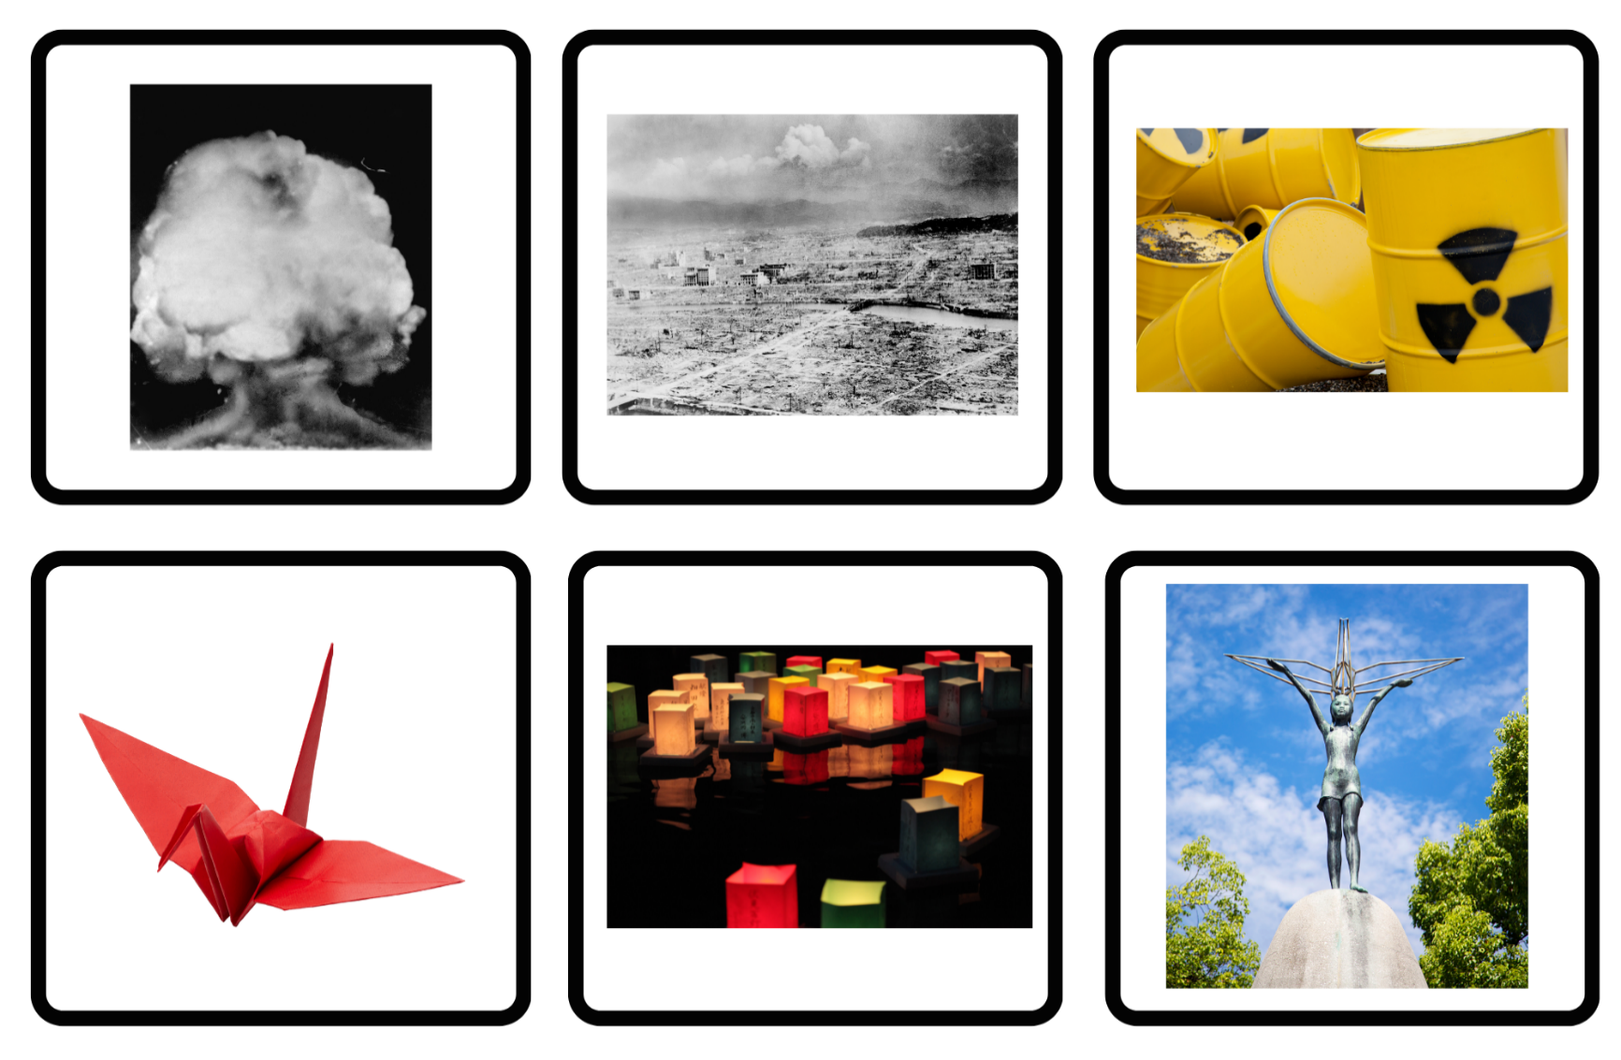

Resource 2 – vocabulary cards
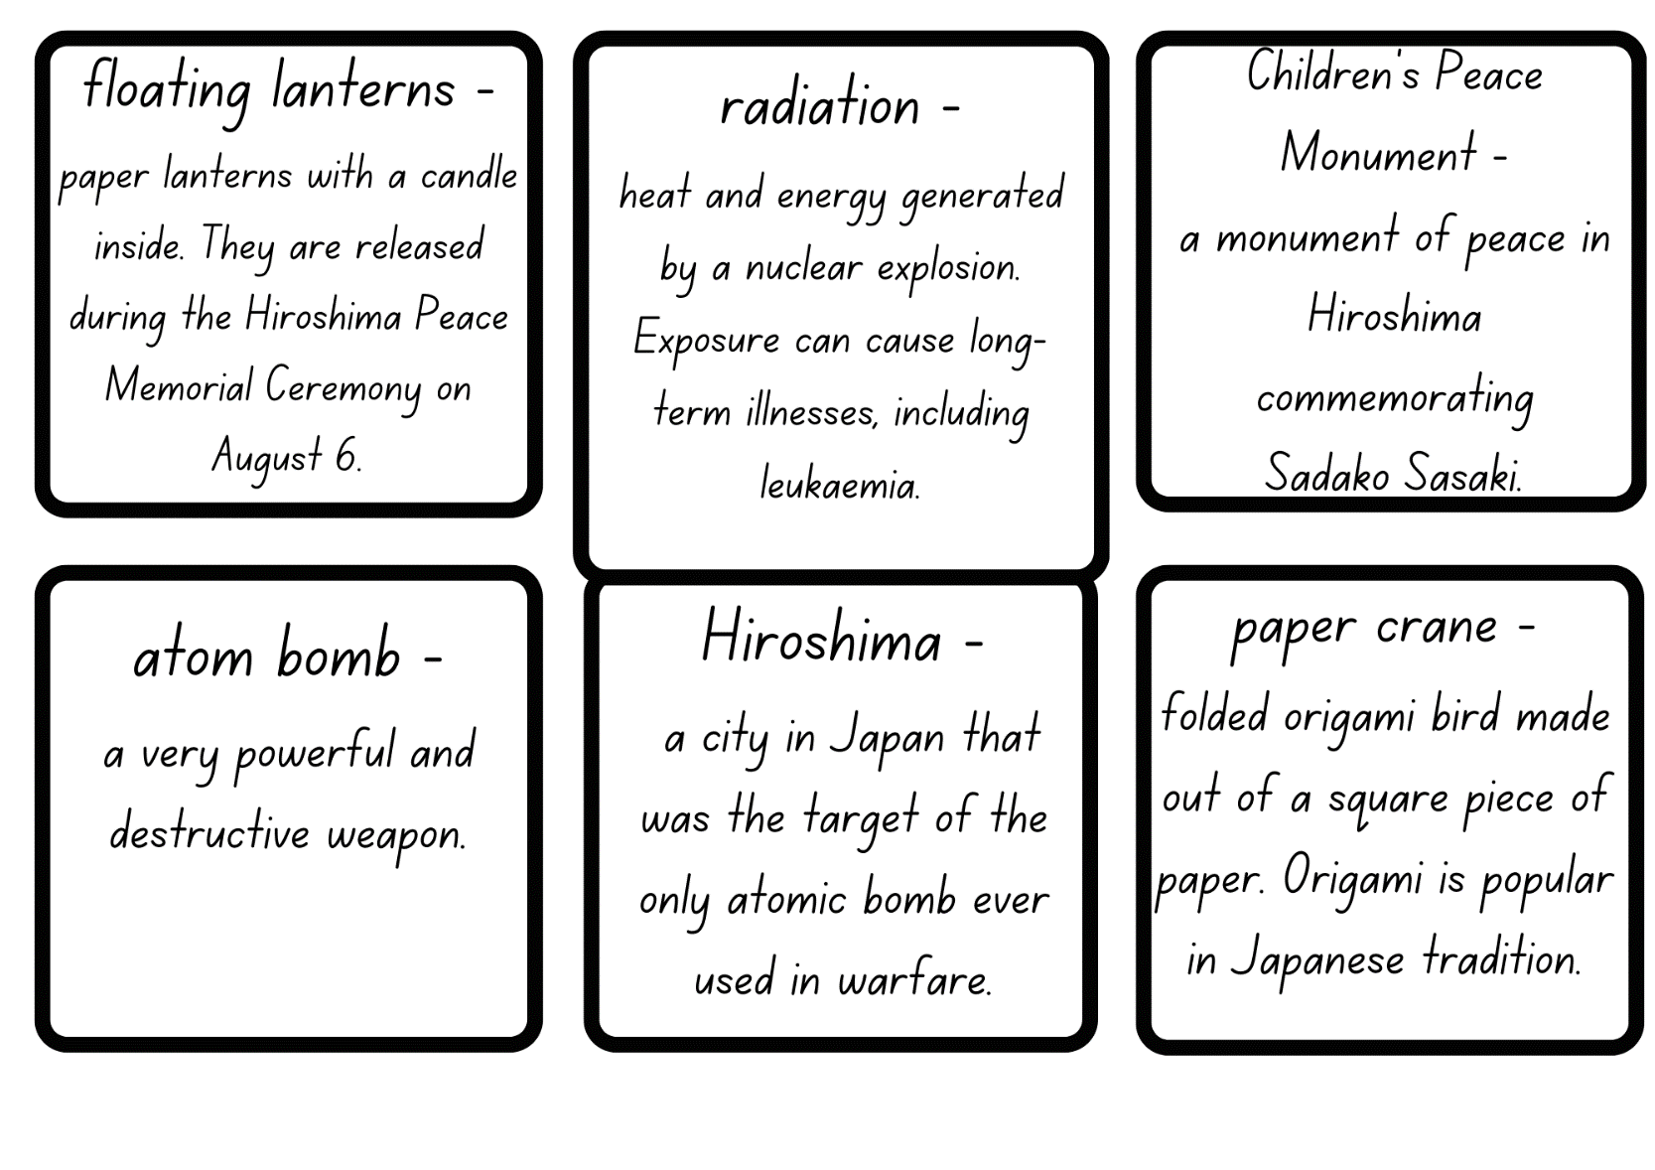

Resource 3 – author’s inspiration
Author’s inspiration for Sadako and the Thousand Paper Cranes
Eleanor Coerr was born in 1922 and was raised in Canada. She worked as a journalist and children’s author, but she is best known for writing Sadako and the Thousand Paper Cranes. When living in Japan as a newspaper reporter in 1949, Eleanor Coerr saw the destruction caused by the war. She later heard the story of Sadako Sasaki and decided to write a book about this brave Japanese girl. The book is about Sadako’s courage and why it is important to strive for hope and peace.
Sadako had a sickness called leukaemia which was caused by radiation from the atomic bomb that was dropped on the city of Hiroshima where she lived. Even though she was very sick, Sadako had a big dream. She had heard about a Japanese legend that said, if a sick person folds one thousand paper cranes, the gods will grant them a wish and make them healthy again. So, Sadako started folding lots and lots of colourful paper cranes.
Inspired by Sadako’s story, Eleanor visited Hiroshima and saw the devastation the bomb had caused. She also met people and heard stories about children like Sadako who were hurt by the bomb but stayed strong.
After searching for many years, Eleanor found a copy of an autobiography and letters written by Sadako that told of her life before and after she became ill. Eleanor read Sadako's letters and autobiography to learn more about her life and illness. Finally, in 1977, Eleanor had enough information to write the true-life story of Sadako, called Sadako and the Thousand Paper Cranes. Because of Eleanor Coerr, the amazing story of Sadako and its message of peace, hope and bravery has been shared with children all around the world for over forty-five years.

Resource 4 – question matrix
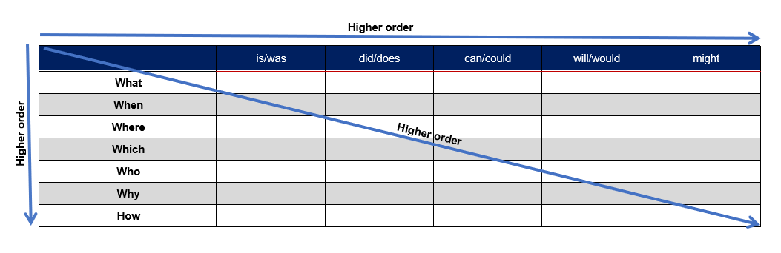

Resource 5 – author’s perspective analysis
Elements | Use the guiding questions to analyse the author’s perspective
Vocabulary  What words are used and how do they make you feel? | The terms ‘golden crane’ (p 31) and ‘good luck charm’ (p 33) have cultural significance and reveal the author’s respect and celebration of Japanese cultural traditions.  The repetition of the phrase ‘I wish I’d get better’ (p 36) reveals the author’s perspective of hope, resilience and the importance of positive thinking to overcome challenges.  The terms ‘promise’ (p 34), ‘old friends’ (p 40) and ‘comfort him’ (p 41) highlight the author’s perspective on the importance of relationships and the role they play in providing strength and comfort during difficult times.
Text structure  What do you notice about how the text is structured? | The chapter title, ‘The Golden Crane’ (p 31) supports the author’s perspective of hope, resilience and cultural significance.  The linear narrative structure highlights the author’s commitment to representing true events.  The chronological structure allows the author to provide details about the historical context of the bombing of Hiroshima.  Portraying character relationships (Sadako’s interactions with her family and friends) reveals the author’s perspective about the importance of friendship, compassion and support.
Images  What images are used and how do they make you feel? | Sadako sitting in a wheelchair, holding a paper crane, evokes a powerful emotional impact on the reader, highlighting Sadako's vulnerability, sense of longing, and hope. The image also incorporates symbolism and cultural elements, aligning with the author’s perspective on the importance of cultural traditions.

Resource 6 – paper crane instructions
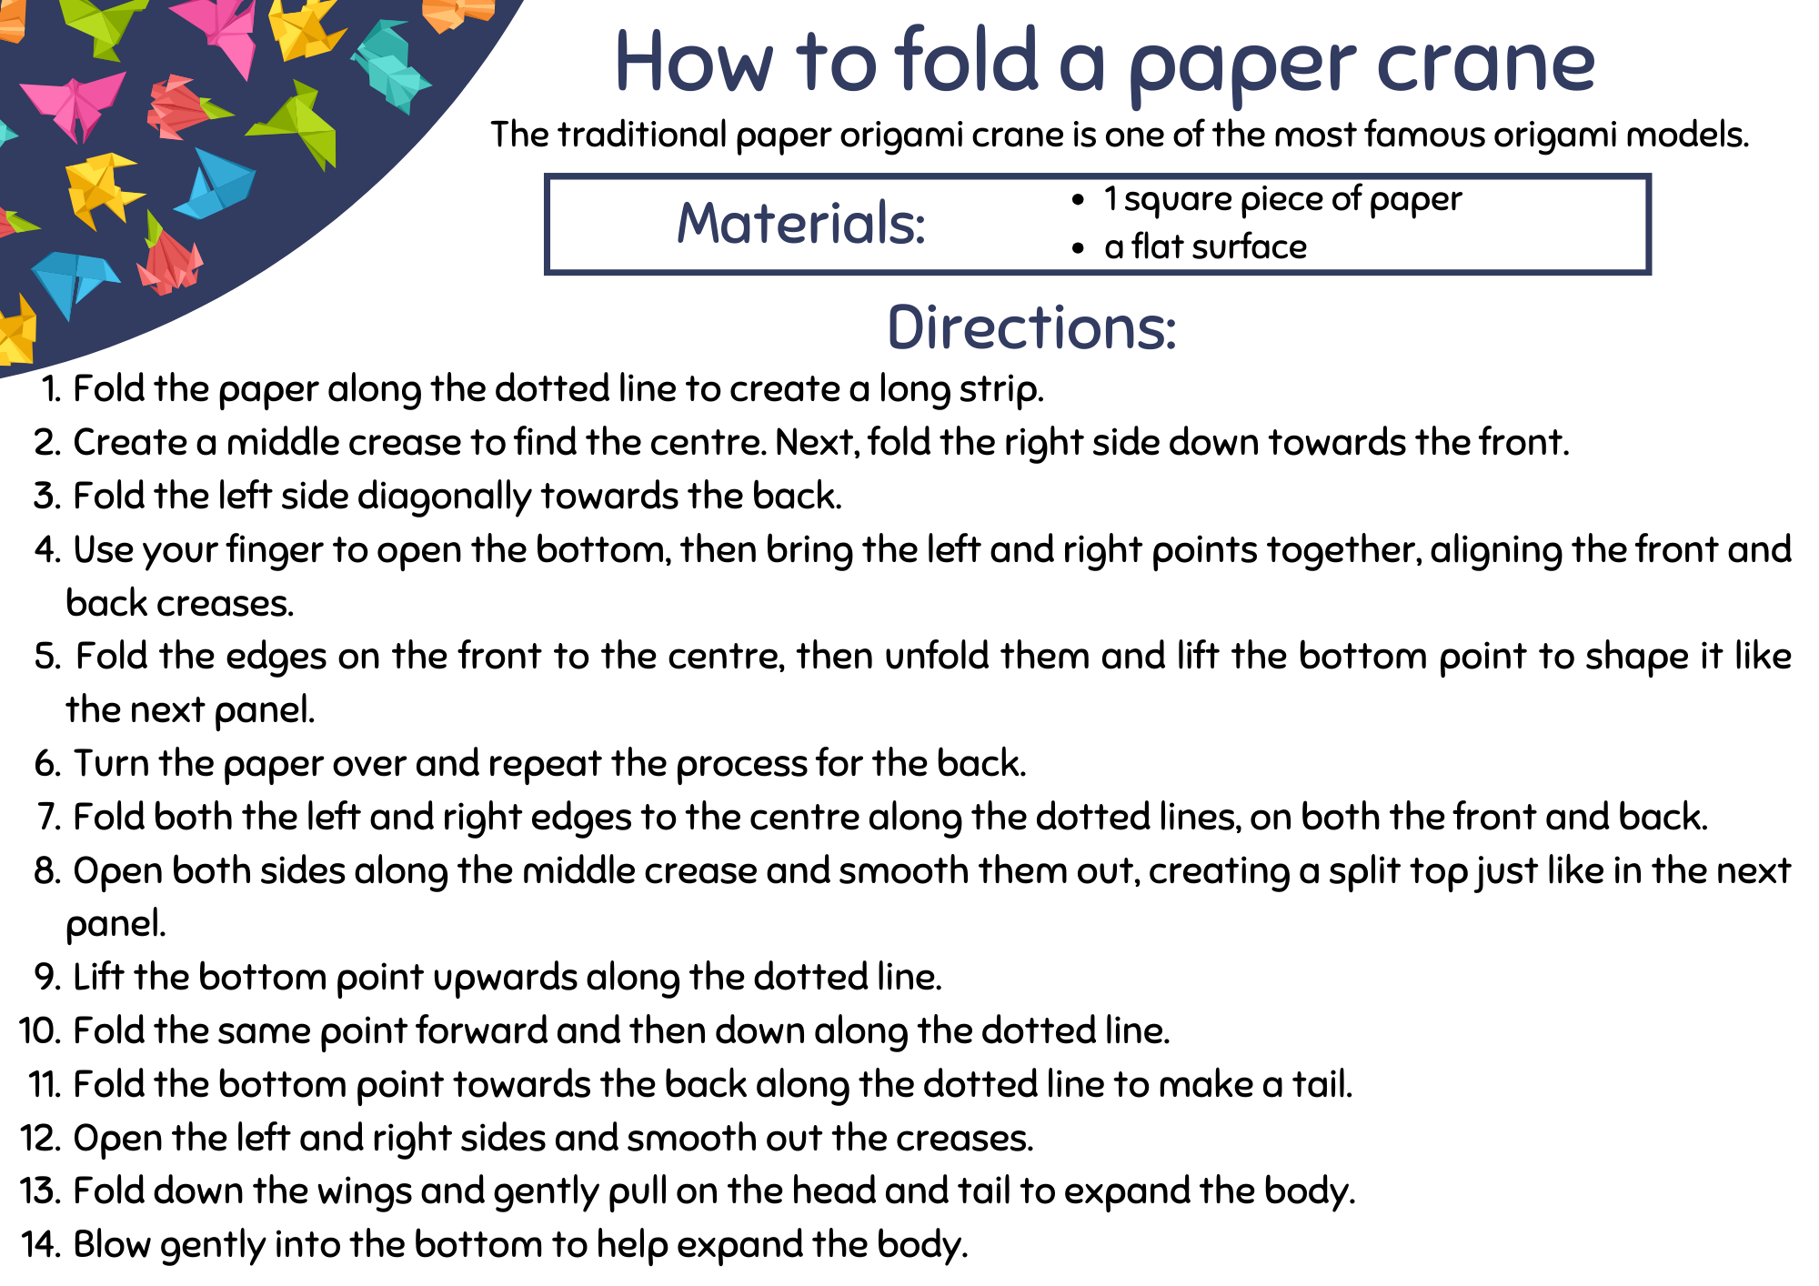

Resource 7 – drawing cards
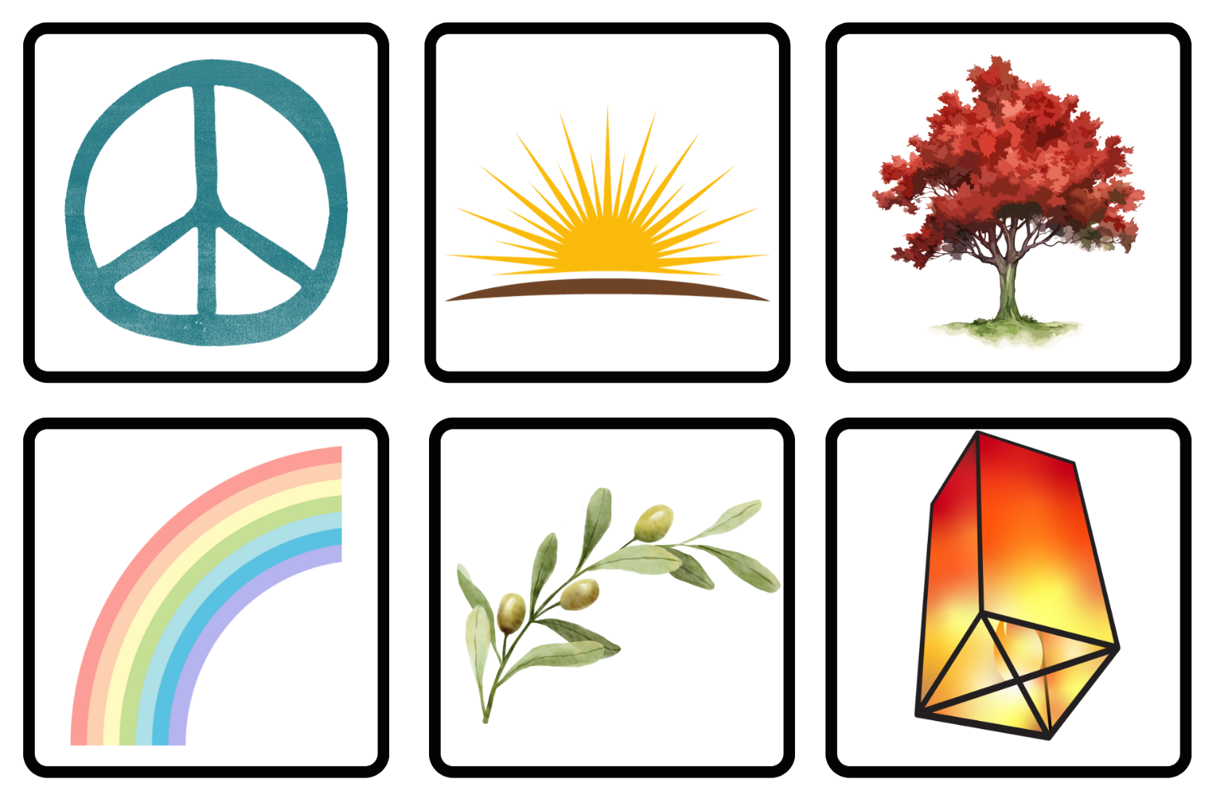

Resource 8 – writing process
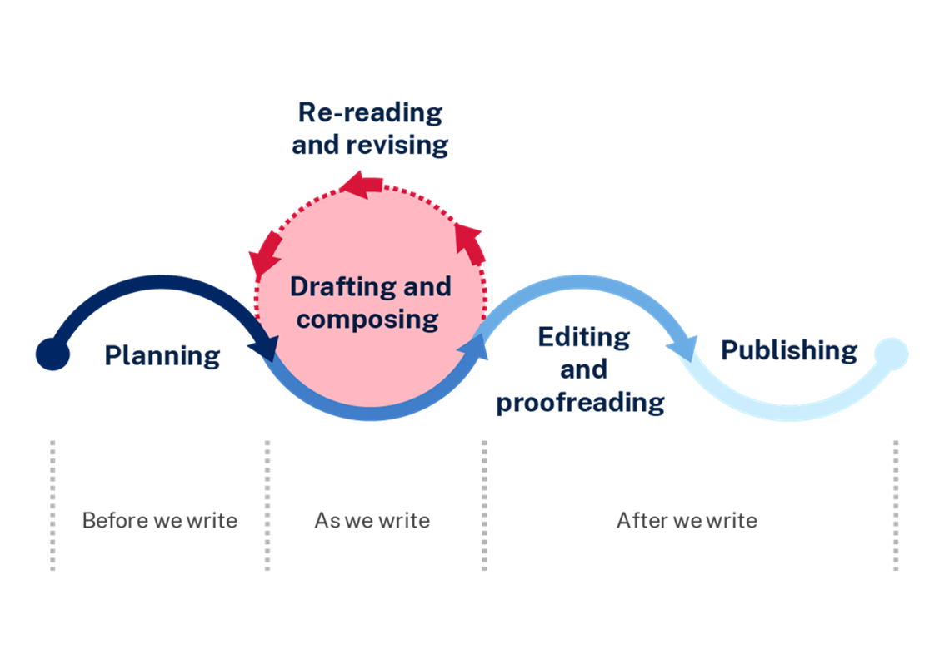

Resource 9 – Sadako theme quotes
Quotes from Sadako
‘Her courage made Sadako a heroine to children in Japan.’ (p 7)
‘Sadako was always on the lookout for good luck signs.’ (p 10)
The engraving on the base of Sadako’s statue; ‘This is our cry, this is our prayer; peace in the world.’ (p 62)
‘Life was slipping away from her, but the crane made Sadako feel stronger inside.’ (p 59)
‘“I am over halfway to 1000 cranes”, she told Masahiro. “So, something good is going to happen.”’ (p 48)
‘After speeches by Buddhist priests and the mayor, hundreds of white doves were freed from their cages. They circled the twisted, scarred Atomic Dome. Sadako thought the doves looked like spirits of the dead flying into the freedom of the sky.’ (p 17 $–$18)

Resource 10 – cause-and-effect statements
Match the cause-and-effect statements.
Many people died from the disease | she embarked on a journey of folding one thousand paper cranes.
Because Sadako developed leukaemia, | The Children’s Peace Monument was erected in her honour.
Due to Sadako’s courage, | due to the radiation from the atomic bomb explosion.
Sadako died before being able to fold one thousand cranes, | so that she could make a wish for peace.
Sadako folded paper cranes | as a result her classmates folded the remaining three hundred and fifty-six cranes.

Resource 11 – cloze passage
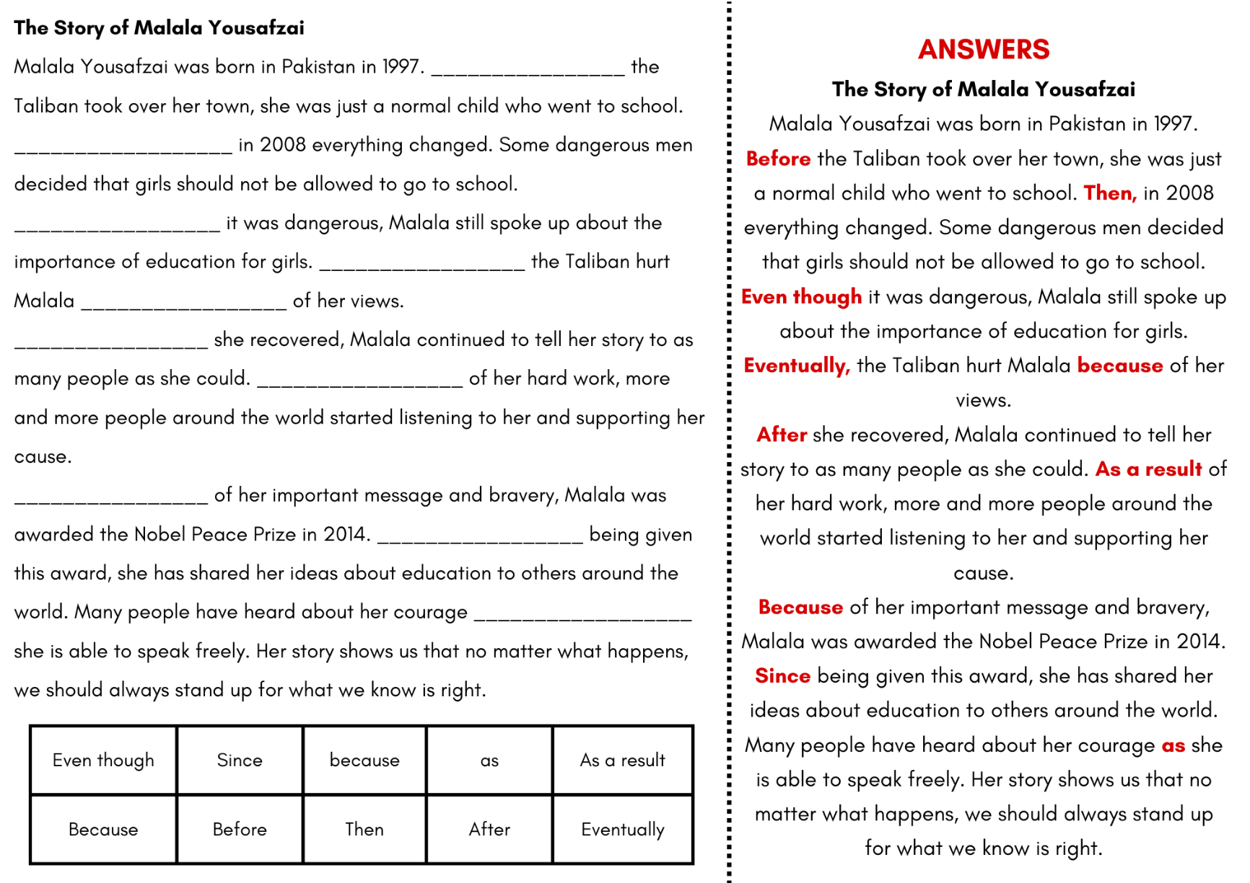

Resource 12 – timeline cards
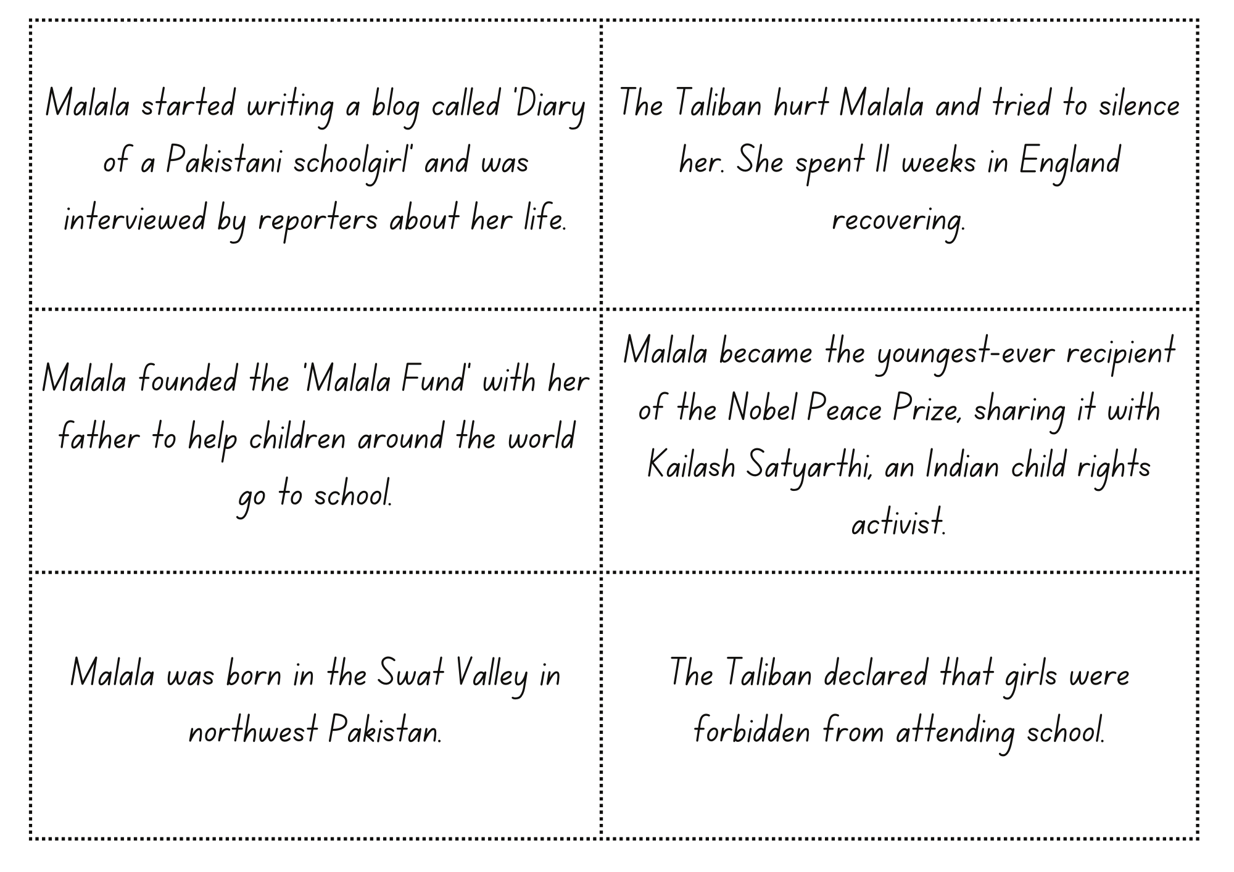

References
This resource contains NSW Curriculum and syllabus content. The NSW Curriculum is developed by the NSW Education Standards Authority. This content is prepared by NESA for and on behalf of the Crown in right of the State of New South Wales. The material is protected by Crown copyright.
Please refer to the NESA Copyright Disclaimer for more information. https://educationstandards.nsw.edu.au/wps/portal/nesa/mini-footer/copyright
NESA holds the only official and up-to-date versions of the NSW Curriculum and syllabus documents. Please visit the NSW Education Standards Authority (NESA) website https://educationstandards.nsw.edu.au/wps/portal/nesa/home and the NSW Curriculum website https://curriculum.nsw.edu.au.
English K–10 Syllabus © NSW Education Standards Authority (NESA) for and on behalf of the Crown in right of the State of New South Wales, 2022.
National Literacy Learning Progression © Australian Curriculum, Assessment and Reporting Authority (ACARA) 2010 to present, unless otherwise indicated. This material was downloaded from the Australian Curriculum website (National Literacy Learning Progression) (accessed 26 September 2023) and was not modified.
Coerr E (1977) Sadako and the Thousand Paper Cranes, Hachette Children’s Books, Australia.
ETA (English Teachers Association) and NSW Department of Education (2016) Context, English Textual Concepts website, accessed 8 November 2023.
ETA (English Teachers Association) and NSW Department of Education (2016) Perspective, English Textual Concepts website, accessed 8 November 2023.
ETA (English Teachers Association) and NSW Department of Education (2016) Theme, English Textual Concepts website, accessed 8 November 2023.
Harvard Graduate School of Education (2015) ‘See, Think, Wonder’, Core Thinking Routines, Project Zero website, accessed 11 October 2023.
Hiroshima Peace Memorial Museum (n.d.) ‘Sadako and the Atomic Bombing’, Kids Peace Station, Hiroshima Peace Memorial Museum website, accessed 8 November 2023.
NESA (NSW Education Standards Authority) (2024) ‘Glossary’, Resources, NESA website, accessed 11 October 2023.
Yousafzai M (2019) Malala’s Magic Pencil (Kerascoët, illus), Penguin Books, United Kingdom.
National Council of Teachers of English (NCTE) (n.d.) What Is A Timeline?, National Council of Teachers of English, accessed 8 November 2023.
Being A Kid Again (2 October 2014) ‘How to make an origami lantern step by step’ [video], Being A Kid Again, YouTube, accessed 8 November 2023.
CND Peace Education (12 November 2014) ‘Origami Peace Crane Instructions’ [video], CND Peace Education, YouTube, accessed 8 November 2023.
Australian Broadcasting Corporation (ABC) (4 August 2015) ‘Hiroshima’ [video], Behind the News (BTN), ABC, accessed 8 November 2023.
Scholastic News (3 October 2022) ‘History Makers: Malala Yousafzai’, Rebecca Zissou, Scholastic News website, accessed 8 November 2023.

© State of New South Wales (Department of Education), 2024
The copyright material published in this resource is subject to the Copyright Act 1968 (Cth) and is owned by the NSW Department of Education or, where indicated, by a party other than the NSW Department of Education (third-party material).
Copyright material available in this resource and owned by the NSW Department of Education is licensed under a Creative Commons Attribution 4.0 International (CC BY 4.0) license.
This license allows you to share and adapt the material for any purpose, even commercially.
Attribution should be given to © State of New South Wales (Department of Education), 2024.
Material in this resource not available under a Creative Commons license:
- the NSW Department of Education logo, other logos and trademark-protected material
- material owned by a third party that has been reproduced with permission. You will need to obtain permission from the third party to reuse its material.
Links to third-party material and websites
Please note that the provided (reading/viewing material/list/links/texts) are a suggestion only and implies no endorsement, by the New South Wales Department of Education, of any author, publisher, or book title. School principals and teachers are best placed to assess the suitability of resources that would complement the curriculum and reflect the needs and interests of their students.
If you use the links provided in this document to access a third-party's website, you acknowledge that the terms of use, including licence terms set out on the third-party's website apply to the use which may be made of the materials on that third-party website or where permitted by the Copyright Act 1968 (Cth). The department accepts no responsibility for content on third-party websites.

