English 3–6 Multi-age – Year A Unit 5
Characterisation – Deltora Quest: The Forests of Silence
Contents
Unit overview and instructions for use 8
Teacher notes 10
Outcomes and content 12
Resources 26
Week 1 29
Component A teaching and learning 29
Planning framework 29
Component B teaching and learning 29
Learning intentions and success criteria 29
Lesson 1 – introducing characterisation 30
Whole 31
Part 32
Whole 33
Lesson 2 – exploring word associations and inferencing 34
Whole 35
Part 36
Part 38
Whole 39
Lesson 3 – exploring the wordless text, Quest 39
Whole 40
Lesson 4 – using key words to visualise a villainous character 42
Whole 42
Part 43
Whole 45
Week 2 48
Component A teaching and learning 48
Planning framework 48
Component B teaching and learning 48
Learning intentions and success criteria 48
Lesson 5 – exploring characterisation 50
Whole 50
Part 51
Part 53
Whole 54
Lesson 6 – understanding characterisation through dialogue 57
Whole 57
Lesson 7 – exploring narrative voice 60
Whole 60
Part 62
Whole 63
Lesson 8 – creating a backstory to a narrative 65
Whole 65
Part 66
Whole 67
Week 3 72
Component A teaching and learning 72
Planning framework 72
Component B teaching and learning 72
Learning intentions and success criteria 72
Lesson 9 – exploring sentence types 74
Whole 74
Part 75
Part 76
Whole 78
Lesson 10 – experimenting with dialogue 79
Whole 79
Lesson 11 – building character descriptions 83
Whole 83
Part 84
Part 86
Whole 87
Lesson 12 – reflecting on reading to connect with characters 88
Whole 88
Part 90
Part 92
Whole 93
Week 4 95
Component A teaching and learning 95
Planning framework 95
Component B teaching and learning 95
Learning intentions and success criteria 95
Lesson 13 – creating descriptions of settings 96
Whole 97
Part 98
Whole 99
Lesson 14 – drawing on texts read to create characters 104
Whole 104
Lesson 15 – exploring character growth through inferencing 108
Whole 108
Part 110
Part 112
Whole 114
Lesson 16 – planning for writing 116
Whole 116
Week 5 120
Component A teaching and learning 120
Planning framework 120
Component B teaching and learning 120
Learning intentions and success criteria 120
Lesson 17 – drafting, composing and revising – part 1 121
Whole 122
Lesson 18 – drafting, composing and revising – part 2 126
Whole 126
Lesson 19 – editing, proofreading and publishing 128
Whole 128
Lesson 20 – presenting and reflecting 131
Whole 131
Resource 1 – vocabulary cards 136
Resource 2 – ask away 137
Resource 3 – character web example 138
Resource 4 – Jarred & Endon inferring character traits 139
Resource 5 – creating characters 140
Resource 6 – saying verbs 141
Resource 7 – dialogue checklist 142
Resource 8 – connectives 143
Resource 9 – homonym charades 144
Resource 10 – multiple meaning words 145
Resource 11 – conversation model 146
Resource 12 – character guessing 147
Resource 13 – villainous character profile 148
Resource 14 – writing process 149
Resource 15 – Quest narrative planning template 150
Resource 16 – Quest narrative planning template example 152
References 154

Unit overview and instructions for use
In this five-week unit, students will gain a deeper understanding of the textual concepts of ‘characterisation’ and ‘narrative’ through the texts Deltora Quest: The Forests of Silence and Quest. Throughout the unit, students will investigate ways in which characters are represented in literature and experiment with dialogue and characterisation. Students will draw on shared experiences of texts read and viewed to plan, draft, revise and present an imaginative text.
Outcomes and content in this unit are organised into Component A and Component B. The components are connected, with learning in Component A complementing learning in Component B.
Note: the duration of this unit can be adapted to suit individual school contexts. For example, learning could occur across 5 days rather than 4.
The table below highlights the focus areas and preparation required for Component A and Component B.
Teaching and learning | Component A | Component B
Suggested duration | 60 minutes × 4 days/week or equivalent | 60 minutes × 4 days/week or equivalent
Explicit teaching focus areas | Component A addresses content from the focus areas:  - Vocabulary  - Reading fluency (Stage 2)  - Reading comprehension  - Creating written texts  - Spelling  - Handwriting and digital transcription  It centres on the development of foundational skills and knowledge through regular, systematic and repeated practice. | Component B addresses content from the focus areas:  - Oral language and communication  - Vocabulary  - Reading comprehension  - Creating written texts  - Understanding and responding to literature  It centres on the conceptual understandings of English and exemplifies the importance of learning about and enjoying literature through the study of quality texts.
Preparing for teaching and learning | - Specific teaching and learning activities need to be developed by the teacher. When planning for these activities, please refer to the Component A outcomes and content, teaching guides and planning frameworks.  - Plan and document how you will sequence teaching and learning in whole-class and targeted-groups across the 5-week cycle as required. This should be based on student needs identified through ongoing assessment data. | - Familiarise yourself with the mentor and supporting texts and textual concepts, and the teaching and learning sequence.  - Determine how you will support students in whole-class and targeted-groups across the 5-week cycle as required. This should be based on student needs identified through ongoing assessment data.
English K–10 Syllabus © NSW Education Standards Authority (NESA) for and on behalf of the Crown in right of the State of New South Wales, 2022.

Teacher notes
- Characterisation is the mentor concept of this unit, explored using the texts Deltora Quest: The Forests of Silence by Emily Rodda and Quest by Aaron Becker. Characterisation is the technical construction and representation of any personality or person-like figure in text, including features such as their appearance, actions, words or thoughts. (NESA 2024).
- Understanding of characterisation can be supported through watching the department’s video: Understanding character (2:31).
- While ‘characterisation’ is the mentor concept for the conceptual component of this unit, the supporting concept of ‘narrative’ is explored. Additional textual concepts may be included based on individual school context and student needs.
- For information on adjectival clauses, interrogative sentences and word associations refer to the NESA Glossary.
- In addition to the resources listed, students will require access to short passages of the mentor and/or supporting texts. Teachers can copy extracts from texts in reliance on the Statutory Text and Artistic Works Licence. Teachers need to attribute the extracts and include the following notice: ‘This material has been copied [and communicated to you] in accordance with the statutory licence in section 113P of the Copyright Act. Any further reproduction or communication of this material by you may be the subject of copyright protection under the Act. Do not remove this notice’.
- This unit could enhance student learning towards the achievement of history and geography outcomes.
- Lesson 12 requires students to create a word cloud which can be accessed via the Digital Learning Selector’s Mentimeter. All staff can create a free account. To access a word cloud, select Mentimeter Overview then Features.
- Reflect on student learning and engagement in activities and record differentiation and adjustments within the unit to inform future teaching and learning. One way of doing this could be to add comments to the digital file.
- In NSW classrooms there is a diverse range of students including Aboriginal and/or Torres Strait Islander students learning English as an additional language or dialect, high potential and gifted students and students with disability. Some students may identify with more than one of these groups, or possibly all of them. Refer to Curriculum planning for every student – advice for further information.
- Content points are linked to the National Literacy Learning Progression (version 3).
Levels and indicators sourced from National Literacy Learning Progression © Australian Curriculum, Assessment and Reporting Authority (ACARA), (accessed 28 February 2024) and was not modified. See references for more information.

Outcomes and content
The tables below outline the outcomes and content for this unit. The letters ‘A’ and ‘B’ in the header refer to Components A and B. The numbers 1 to 5 refer to weeks. The use of ‘x’ in these columns indicates where the content points are intended to be addressed and in which week.
Stage 2 focus area and outcome, content points and National Literacy Learning Progression | A | B | 1 | 2 | 3 | 4 | 5
Oral language and communication
EN2-OLC-01 communicates with familiar audiences for social and learning purposes, by interacting, understanding and presenting
- Contribute to discussions with peers and stay on topic, build on others' ideas and express own ideas (InT4) |  | x | x | x | x | x | x
- Follow agreed-upon protocols and assigned roles for classroom interactions in person and through the use of technology (InT5) |  | x | x | x | x | x | x
- Pose and respond to specific questions to clarify or follow up on information (InT5) |  | x | x | x | x | x | x
- Listen actively to identify spoken information, acknowledging the value of others’ contributions (LiS6) |  | x | x | x | x | x | x
- Plan and deliver spoken presentations using language and structure to suit purpose and audience (SpK5) |  | x | x | x |  |  | x
- Reflect on and monitor own presentations according to given criteria |  | x | x |  |  |  | x
Vocabulary
EN2-VOCAB-01 builds knowledge and use of Tier 1, Tier 2 and Tier 3 vocabulary through interacting, wide reading and writing, and by defining and analysing words
- Build personal Tier 1, Tier 2 and Tier 3 vocabulary through social and learning interactions, reading and writing (SpK5) | x | x | x | x | x | x | x
- Define meanings for homonyms according to context | x | x |  | x | x | x
- Use word associations to build word knowledge | x | x | x |  | x | x | x
Reading fluency
EN2-REFLU-01 sustains independent reading with accuracy, automaticity, rate and prosody suited to purpose, audience and meaning
- Maintain stamina when reading extended texts | x |  | x | x | x | x | x
- Apply appropriate tone to represent characters' emotions when reading text with dialogue (FlY5) | x |  | x | x | x | x | x
- Reflect on how adjusting reading rate and prosody supports comprehension and can engage an audience | x |  | x | x | x | x | x
Reading comprehension
EN2-RECOM-01 reads and comprehends texts for wide purposes using knowledge of text structures and language, and by monitoring comprehension
- Use key words from a text to visualise events, characters and settings when making inferences and confirming predictions | x | x | x | x | x | x | x
- Link the meanings of words and phrases across consecutive sentences to support local inferencing | x | x | x | x | x | x
- Reflect on reading experiences and identify texts of personal significance and pleasure | x | x | x | x | x | x | x
- Reflect on own understanding of texts and monitor own goals for reading | x |  | x | x | x | x | x
Creating written texts
EN2-CWT-01 plans, creates and revises written texts for imaginative purposes, using text features, sentence-level grammar, punctuation and word-level language for a target audience
- Create imaginative texts to engage an audience, using first person or third person narrative voice (CrT8) | x | x |  | x |  | x | x
- Sequence ideas and actions into paragraphs aligned to the stages of the text, to provide elaborated details about settings, character motives and actions (CrT8) |  | x |  | x |  |  | x
- Experiment with using and punctuating dialogue in texts (PuN5) | x | x |  | x | x |  | x
- Maintain noun–pronoun referencing across a text for cohesion (CrT7) | x | x | x | x | x | x | x
- Use adjectival clauses with noun groups to add information to subjects and objects | x | x | x | x | x | x | x
- Select and use precise saying, thinking, acting, and relating verbs and verb groups to align with text purposes (GrA5) (CrT8) | x | x | x | x | x | x | x
- Use exclamatory sentences to emphasise a point or express a strong emotion | x | x |  | x | x | x | x
- Use interrogative sentences to ask a direct question, or for rhetorical effect to engage the reader with a viewpoint | x | x |  | x | x | x | x
- Use capital letters to indicate the beginning of a sentence, proper nouns, headings and subheadings, to indicate the beginning of a poetry line, for emphasis, and when using acronyms (PuN5) | x | x | x | x | x | x | x
- Use commas between words in a list or to separate adjectives when more than one is used (PuN4) (PuN6) | x | x | x |  | x | x | x
- Understand and use quoted and reported text or speech in own writing | x | x | x | x | x |  | x
- Use personal pronouns to suit purpose and to connect personally with the audience | x | x | x | x | x |  | x
- Use adjectives to develop descriptive features (CrT8) | x | x | x | x | x | x | x
- Create texts by drawing on personal and others’ experiences, and texts read, viewed and listened to for inspiration and ideas |  | x | x | x | x | x | x
Spelling
EN2-SPELL-01 selects, applies and describes appropriate phonological, orthographic and morphological generalisations and strategies when spelling in a range of contexts
- Explain how to segment multisyllabic words into syllables and phonemes, and apply this knowledge when spelling | x |  | x | x | x | x | x
- Identify differences in vowel phonemes (short, long, diphthong and schwa vowels) (SpG9) | x |  |  | x |  |  | x
- Understand that some graphemes are dependent on their position in a word in English and apply this knowledge when spelling | x |  | x | x | x | x | x
- Use spelling reference tools where required and recognise that spellcheck accuracy may depend on understanding the word (SpG9) | x |  |  |  |  | x | x
- Identify prefixes that require no change to the base word or root when they are affixed, and apply this knowledge when spelling (SpG9) | x |  | x | x |  |  | x
- Correctly spell taught homophones when creating written texts (SpG9) | x |  |  |  | x | x | x
Handwriting and digital transcription
EN2-HANDW-01 forms legible joined letters to develop handwriting fluency
EN2-HANDW-02 uses digital technologies to create texts
- Apply appropriate pressure when joining letters (Year 3) | x |  | x |  | x | x | x
- Join letters using consistent size and spacing to develop fluency (HwK6) (Year 3) | x |  | x |  | x | x | x
- Sustain the NSW Foundation Style cursive to facilitate fluency and legibility across a text (HwK6) (Year 4) | x |  | x |  | x | x | x
- Use knowledge of the keyboard layout and functions to type texts (HwK7) (Year 3) | x |  |  | x | x | x | x
- Monitor goals that build on typing accuracy and rate (Year 4) | x |  |  | x | x | x
- Use word-processing program functions or augmentative and alternative communication (AAC) to draft and revise texts (Year 4) | x |  |  | x |  |  | x
Understanding and responding to literature
EN2-UARL-01 identifies and describes how ideas are represented in literature and strategically uses similar representations when creating texts
- Describe how narratives set up expectations using familiar, real and imagined characters, situations and phrases |  | x | x | x | x | x | x
- Describe connections between own or shared experiences and those depicted in narratives |  | x |  |  | x | x | x
- Recognise that characters may be identified through familiar, individual or group characteristics |  | x | x | x | x | x | x
- Identify how authors use dialogue to convey what characters say and think, and experiment with dialogue when creating texts |  | x | x |  | x | x | x
- Describe ways in which characters are represented in literature and experiment with characterisation when creating texts |  | x | x | x | x | x | x
English K–10 Syllabus © NSW Education Standards Authority (NESA) for and on behalf of the Crown in right of the State of New South Wales, 2022.

Stage 3 focus area and outcome, content points and National Literacy Learning Progression | A | B | 1 | 2 | 3 | 4 | 5
Oral language and communication
EN3-OLC-01 communicates to wide audiences with social and cultural awareness, by interacting and presenting, and by analysing and evaluating for understanding
- Follow agreed-upon protocols and define individual roles as needed for in-person or online interactions, establishing specific goals, criteria or timeframes (InT6) |  | x | x | x |  | x
- Ask and respond to analytical and evaluative questions about literature that contribute to own or others’ enjoyment and understanding (SpK5, UnT7) |  | x | x | x | x | x | x
- Apply interactive listening strategies by responding to and providing feedback to the speaker (InT5) |  | x | x | x | x | x | x
- Apply active listening strategies by retelling or repeating what another person has expressed and by building on what has been said (InT5, InT6) |  | x | x | x | x | x | x
- Deliver presentations suited to purpose and audience (SpK6) |  | x | x | x |  |  | x
- Reflect on and monitor own and peer presentations according to given criteria |  | x | x | x |  |  | x
Vocabulary
EN3-VOCAB-01 extends Tier 2 and Tier 3 vocabulary through interacting, wide reading and writing, morphological analysis and generating precise definitions for specific contexts
- Apply knowledge of taught Tier 3 subject-specific morphemes and their meanings (UnT9, CrT8) | x |  | x |  | x | x | x
- Describe multiple meanings of words, including their metaphorical uses (UnT8) | x | x | x | x |  | x
Reading comprehension
EN3-RECOM-01 fluently reads and comprehends texts for wide purposes, analysing text structures and language, and by monitoring comprehension
- Adjust reading rate to suit the purpose for reading and the complexity of the text (FlY6) | x |  | x | x | x | x | x
- Select, compare and reflect on texts read for personal interest | x |  | x | x | x | x | x
- Explain how language evokes responses when reading (UnT9) | x | x |  |  | x | x
- Analyse how the meanings of key words and phrases in sentences and across a text support local and global inferencing when reading (UnT8) | x | x | x |  | x | x
- Generate, monitor and adjust own goals for improving oral reading fluency and silent reading fluency | x |  | x | x | x | x | x
Creating written texts
EN3-CWT-01 plans, creates and revises written texts for multiple purposes and audiences through selection of text features, sentence-level grammar, punctuation and word-level language
- Choose literary forms with appropriate text structures, features and language to engage target audiences (CrT9) |  | x |  | x |  | x | x
- Make creative choices about temporal and spatial settings, character profiles and motives to enhance reader engagement (CrT9) |  | x | x | x | x | x | x
- Choose and control narrative voice across a text | x | x |  | x |  | x | x
- Maintain correct noun–pronoun referencing, subject–verb agreement and use temporal, conditional and causal connectives to build cohesive links across a text (GrA5, CrT9, GrA6) | x | x | x | x | x | x | x
- Use word repetition and word associations as cohesive devices across texts | x | x | x |  | x | x | x
- Create written texts that include multiple paragraphs with clear, coherent transition of ideas |  | x |  | x | x |  | x
- Make choices about verbs and verb groups to achieve precision and add detail (GrA6) | x | x |  | x | x | x | x
- Experiment with embedding adjectival clauses with the subject and/or object of other clauses, to modify the meaning or to add detail to a noun or noun group (GrA6) | x | x | x | x | x | x | x
- Make choices about the use of declarative, exclamatory, interrogative and imperative sentences to suit text purpose, and for meaning and effect (CrT8) | x | x | x | x | x | x | x
- Use capital letters at the beginning of a sentence, to indicate proper nouns, for headings and subheadings, to indicate the beginning of a poetry line, for emphasis, and when using acronyms (PuN7) | x | x | x | x |  | x | x
- Use quotation marks consistently across a text to distinguish words that are spoken by characters in dialogue or words authored by others (PuN5, PuN7) | x | x | x | x | x | x | x
- Use print or digital tools to plan, sequence, create, revise, edit and publish texts |  | x |  | x | x | x | x
Spelling
EN3-SPELL-01 automatically applies taught phonological, orthographic and morphological generalisations and strategies when spelling in a range of contexts, and justifies spelling strategies used to spell unfamiliar words
- Segment unfamiliar multisyllabic words into syllables and phonemes as a strategy when spelling | x |  | x | x | x | x | x
- Apply and explain graphemes identified by their etymology (SpG11) | x |  |  |  | x | x | x
- Recognise that the same grapheme can represent different phonemes (SpG10) | x |  | x | x | x | x | x
- Explain the etymology of taught roots and apply this knowledge when creating written texts (SpG10) | x |  |  |  | x | x | x
- Correctly spell taught homophones when creating written texts across a range of writing topics and learning areas (SpG10) | x |  | x | x |  |  | x
Handwriting and digital transcription
EN3-HANDW-01 sustains a legible, fluent and automatic handwriting style
EN3-HANDW-02 selects digital technologies to suit audience and purpose to create texts
- Sustain writing with a legible, fluent and personal handwriting style across a text (HwK8) (Year 5) | x |  | x |  | x | x | x
- Use handwriting efficiently in formal and informal situations (HwK8) | x |  | x |  | x | x | x
- Adjust handwriting style to suit writing purpose (HwK8) (Year 6) | x |  | x |  | x | x | x
- Navigate the keyboard with efficiency and accuracy when typing words, numerals, punctuation and other symbols (HwK8) (Year 5) | x |  |  | x | x | x | x
- Reflect on and monitor typing accuracy and rate according to goals and given criteria | x |  |  | x | x | x
- Use taught shortcut functions on digital tools to facilitate text creation (HwK8) (Year 6) | x |  |  | x | x |  | x
Understanding and responding to literature
EN3-UARL-01 analyses representations of ideas in literature through narrative, character, imagery, symbol and connotation, and adapts these representations when creating texts
- Recognise that narratives reflect both personal and common lived experiences and offer models of behaviour, which may be rejected or accepted |  | x | x | x | x | x | x
- Analyse how engagement with characters within and between texts invites enjoyment of literature |  | x | x | x | x | x | x
English K–10 Syllabus © NSW Education Standards Authority (NESA) for and on behalf of the Crown in right of the State of New South Wales, 2022.

Resources
The resources in the table below are referred to in this unit. Letters ‘A’ and ‘B’ in the header refer to Component A and B respectively, and the numbers 1 to 5 indicate weeks. The use of ‘x’ in these columns indicates whether the resources are required in Component A, B or both, and in which week.
Resource | A | B | 1 | 2 | 3 | 4 | 5
Rodda E (2005) Deltora Quest: The Forests of Silence, Scholastic Australia Pty Ltd, Australia. ISBN13: 9781741697520 | x | x | x | x | x | x | x
Becker A (2015) Quest, Walker Books, Australia. ISBN13: 9781406360813 |  | x | x | x | x | x | x
Resource 1 – vocabulary cards |  | x | x
Resource 2 – ask away |  | x | x
Resource 3 – character web example |  | x | x | x | x | x
Resource 4 – Jarrod & Endon inferring character traits |  | x | x
Venn diagram from Digital Learning Selector |  | x | x |  | x
Resource 5 – creating characters |  | x | x
Resource 6 – saying verbs |  | x |  | x |  |  | x
Resource 7 – dialogue checklist |  | x |  | x | x |  | x
Storyboard from Digital Learning Selector |  | x |  | x |  | x
Resource 8 – connectives |  | x |  | x |  |  | x
Resource 9 – homonym charades |  | x |  | x
Resource 10 – multiple meaning words |  | x |  | x
Resource 11 – conversation model |  | x |  |  | x
Concept map from Digital Learning Selector |  | x |  |  | x
Resource 12 – character guessing |  | x |  |  |  | x
Resource 13 – villainous character profile |  | x |  |  |  | x
Video: Quest Book Trailer (0:56) |  | x |  |  |  | x | x
Resource 14 – writing process |  | x |  |  |  | x | x
Resource 15 – Quest narrative planning template |  | x |  |  |  | x | x
Resource 16 – Quest narrative writing template example |  | x |  |  |  | x | x
Webpage: About Emily Rodda |  | x |  |  |  |  | x

Week 1

Component A teaching and learning
Component A focuses on the development of foundational skills and knowledge through regular, systematic and repeated practice. The mentor and supporting texts used in Component B of this unit can support the effective implementation of Component A teaching and learning.

Planning framework
To plan and document Component A teaching and learning, a planning scaffold (DOCX 228 KB) is provided. To support you in your planning, a link to a detailed example of a one-week teaching and learning cycle is included in the scaffold. Additional resources to support teaching and learning in each focus area can be found at Lesson advice guides.

Component B teaching and learning
The following teaching and learning sequence has been designed to address Component B outcomes and content and develops conceptual understandings of English through the study of quality texts. Adapt the sequence as required to best meet the needs of your students.

Learning intentions and success criteria
Learning intentions and success criteria are best co-constructed with students. The table below contains a suggested learning intention and success criteria.
Element | Stage 2 | Stage 3
Learning intention | Students are learning to describe ways in which authors represent characters in literature to experiment with characterisation. | Students are learning to analyse how authors represent characters for enjoyment within and between texts to experiment with characterisation.
Success criteria | Students can:  - pose and respond to questions to explore the concept of characterisation  - build word knowledge using word associations to support inferencing  - experiment with characterisation strategies to describe a character’s physical appearance, thoughts, actions and speech  - use key words from a text to visualise and describe characters. | Students can:  - ask and respond to analytical and evaluative questions to explore the textual concept of characterisation  - analyse the cohesive devices of word repetition and word associations across a text to support inferencing  - experiment with characterisation strategies to create engaging characters  - explore multiple meanings of words to visualise and describe characters.

Lesson 1 – introducing characterisation
The following teaching and learning activities support multi-age settings.

Whole
- Review the importance of meaningful conversations in the classroom to create positive learning environments. Explain that interactions play an important role in learning by promoting clarification, active engagement, collaboration, reflection, consolidation of knowledge and understanding. Explain that through active listening, students can understand different perspectives and learn new ideas.
- Develop a shared criteria for classroom interaction with a whole-class, small group and partner context or review the criteria from previous units. For example, listen actively, acknowledge the value of others’ contributions, build on from what has been said and offer constructive and supportive feedback. Explain that these criteria will be referred to throughout the unit as guidelines for positive communication.
- Display and read Tier 2 vocabulary on Resource 1 – vocabulary cards (words selected from the blurb of Deltora Quest: The Forests of Silence by Emily Rodda). Ask students what type of words are used (adjectives) and discuss the meaning of new or unknown words. Explain that Tier 2 adjectives are an essential part of character descriptions as they help bring characters to life. They provide descriptive features, qualities and characteristics that shape the character's appearance, personality, actions, words or thoughts.
- In pairs, students associate a familiar character with one or more of the words from Resource 1 – vocabulary cards. For example, Scar from The Lion King or Voldemort from the Harry Potter series can be described as evil. Students share responses.
- Introduce or revise the textual concept of characterisation as the technical construction and representation of any personality or person-like figure in a text, including features such as their appearance, actions, words or thoughts (NESA 2024). Discuss how authors often use familiar and relatable characters to engage the audience.
- Highlight the common strategies for constructing characterisation and record on an anchor chart. For example:
- describing the character’s physical appearance
- involving the characters in particular events and describing their behaviour and emotions
- developing characters through dialogue in verbal or thought form.
- Display the front cover of Deltora Quest: The Forests of Silence by Emily Rodda. Explain that Emily Rodda is an Australian author who is well-known for her books that take young readers to magical lands, where heroes solve puzzles and mysteries to save the day. Ask students to share any other books they have read by Emily Rodda. For example, the Rowan of Rin or Fairy Realm series.
- Remind students of the shared criteria for partner interactions from activity 2. Students turn and talk to discuss the title and the illustrations on the front cover. Ask:
- What is the definition of a quest?
- Who do you think the character on the front cover is? Why?
- What do you predict about the setting, characters and events from the front cover of the book?

Part
The table below details the differentiated teaching and learning activities for each stage.
Stage 2 (pairs/independent) | Stage 3 (teacher guided)
- On individual whiteboards, students discuss and record questions they are wondering about the text. Encourage students to use the front cover to support their thinking. For example:  - I wonder who the main character is and what their quest in the Forests of Silence entails?  - I wonder what creatures the characters will encounter in the forest?  - Students share their questions with their peers. | - Display an enlarged copy of Resource 2 – ask away. Explore the characteristics of analytical and evaluative questions that can be asked or responded to about literature.  - Model examples of analytical and evaluative questions. For example:  - What elements or symbols on the cover do you think might be important to the story? Why?  - On a scale of 1 to 10, how much does the cover make you want to read the book? What aspects of the cover influence your rating?  - Students use Resource 2 – ask away to record analytical and evaluative questions they could pose about the book.

Whole
- Display and read the blurb on the back cover of the text. Make connections to the vocabulary used in activity 3. Ask students to consider how the use of descriptive Tier 2 vocabulary used in the blurb impacts the reader and what it may suggest about the characters in the book. Students share their wonderings or questions about the book with the class.
- Discuss the importance of posing and responding to questions to enhance critical thinking, communication and comprehension. Model question sentence starters to support students when posing questions to clarify or follow up on information. For example, ‘Can you explain…?’ or ‘What do you mean by…?’. Display in the classroom to support students to ask questions throughout the unit.
- Read Chapter 1 of Deltora Quest: The Forests of Silence. Pause to discuss key Tier 2 vocabulary, characters and storyline. Encourage students to pose questions to clarify understanding using the sentence starters from activity 15. Ask questions to monitor students’ understanding of the narrative. For example:
- Why was Jarred woken from his sleep?
- What was the relationship between Jarred and Endon?
- What was the Rule? How does the Rule impact the lives of Jarred and Endon?
- Were any of your wonderings or questions answered as we read Chapter 1?
- Ask students to identify the characters introduced in Chapter 1. For example, King Alton, Jarred, Endon and Prandine.
- Explain that as Deltora Quest: The Forests of Silence is read, a class character web will be created to help track and understand the characters' relationships, traits and roles in the narrative (see Resource 3 – character web example). As a class, begin creating a character web.
- Optional: use coloured paper or string to show the connections between characters. For example, Endon and Jarred could be connected with yellow to symbolise their friendship. Endon could be connected to King Alton with purple to symbolise that they are part of the royal family.
Note: the character web will be added to and used throughout the unit.

Lesson 2 – exploring word associations and inferencing
The following teaching and learning activities support multi-age settings.

Whole
- Review word associations from Component A as the relationship between a word and other words that are semantically related in a text (NESA 2024). Explain that authors use word associations to enhance the richness and effectiveness of their writing and to create cohesion.
- Students form a circle. Select a word associated with Deltora Quest: The Forests of Silence. For example, prince. Students take turns saying a word related to the previous word. For example, prince, palace, gold, crown, royal, princess. Ensure the difficulty and complexity of the word associations vary to keep the game engaging and challenging.
- Read Chapter 2 of Deltora Quest: The Forests of Silence. Pause to discuss key Tier 2 vocabulary, characters and storyline. Encourage students to pose questions including analytical and evaluative questions to clarify understanding. Ask:
- Why did Jarred want to protect Endon?
- When was the Belt of Deltora meant to be worn?
- What would Endon learn if he went outside the palace gates and spoke to his people?
- Revise the textual concept of narrative. Explore how narratives are an account of events or experiences, which can be real or imagined involving characters, settings and situations.
- Identify the characters that have been introduced so far (King Alton, Jarred, Endon, Prandine). Add characters to the class character web from Lesson 1 and record their roles in the kingdom. Use the character web as a visual tool to help students understand the relationships between characters as the story is read throughout the unit (see Resource 3 – character web example).
- Explain that the use of words and phrases from the text can support readers to make inferences about characters, events and settings. Review inferencing from Component A as the process of drawing conclusions using evidence from the text. Explore how key words from the text and background knowledge can be used to make inferences about the setting. Ask:
- How could you describe the setting of Deltora Quest: The Forests of Silence? What does it look like?
- Which specific words and language choices has Emily Rodda used to convey the setting’s time and place?
- Considering the narrative’s medieval setting, what kinds of characters would you anticipate encountering within this world? What makes you say that?
- Revise from Component A that local inferencing requires the reader to comprehend implied information from within relatively small sections of text, such as 2 adjacent sentences (NESA 2024).
- Read the excerpt on page 14 from ‘You must see...’ to ‘It is beautiful’. Model the importance of comprehending the implied meaning when reading. For example, the ‘view of the city’ is not an accurate representation, and the reader can infer that Endon is naïve for thinking the kingdom is ‘beautiful’.
- Re-read the phrase ‘“You should not be here, Jarred,” he whispered. “It is against the Rule.”’ (p 13). Ask students to draw on their comprehension skills to make inferences about Endon’s character. For example, Endon is obedient as he follows the Rule.

Part
The table below details the differentiated teaching and learning activities for each stage.
Stage 2 (pairs) | Stage 3 (teacher guided)
- Provide students with a copy of Resource 4 – Jarred & Endon inferring character traits. Students use evidence from Chapter 2 to make inferences about Endon and Jarred’s character traits. For example:  - evidence from the text: ‘Now, for the first time...’ to ‘... outside high walls’ (p 8)  - Jarred’s character traits: conscious and aware.  Too hard? Students draw and label Jarred and Endon using key words to describe their character traits. | - Display the excerpt from Chapter 1, page 8 of the text ‘Now, for the first time ...’ to ‘...outside high walls’. Discuss and identify how Emily Rodda has used word repetition and word associations to infer what Jarred is thinking. For example:  - Word repetition (‘for the first time’): the repetition of the phrase highlights the idea that this is a pivotal moment in Jarred’s life. It signifies a change from his previous beliefs about the Belt.  - Word associations (wondered, doubt, wisdom, power for good, protect): these words and phrases are associated with Jarred’s internal reflection and his evolving thoughts.  - Reinforce that by repeating the introductory phrase and using related words, the passage conveys a sense of progression in Jarred’s thought process. This cohesion helps readers follow the sequence of ideas in the text. It also highlights the significance of this moment in Jarred’s character development.

Part
The table below details the differentiated teaching and learning activities for each stage.
Stage 2 (teacher guided/independent) | Stage 3 (pairs)
- Reinforce that word associations build word knowledge to support comprehension including the use of word repetition and synonyms.  - Students use one of the characters and their identified character traits from Resource 4 – Jarred & Endon inferring character traits to create a word association map for Jarred or Endon. | - Students draw on their comprehension skills to make inferences about Endon and Jarred’s character traits using the evidence from Chapters 1 and 2 of the text. Students use Resource 4 – Jarred & Endon inferring character traits to record their answers.  - Students determine word associations that reflect Jarred and Endon’s relationship using page 2. For example, companions, brothers, together, played, royal.  - Students engage in a quick write to describe the characters of Jarred and Endon drawing on their knowledge of word associations and inferencing.  Too easy? Using information gathered from Resource 4 – Jarred & Endon inferring character traits, students write a paragraph to compare the characters of Jarred and Endon. For example, Jarred is tempted to break the rules while Endon is quiet and obedient. Jarred and Endon live in the palace and both learned archery.

Whole
- Reflect how Emily Rodda depicts Jarred and Endon in Chapters 1 and 2 and the importance of making inferences using evidence from the text. Discuss how the author has developed character relationships and interactions that contribute to characterisation and their models of behaviour (their actions, reactions and choices).
- Discuss how the author has depicted Jarred and Endon in the narrative. Explain that although Jarred and Endon have many things in common, they are also very different characters. Students turn and talk to discuss the similarities and differences between the 2 characters using Resource 4 – Jarred & Endon inferring character traits.
- Students use their understanding of Jarred and Endon’s characters in Chapters 1 and 2 to predict how their characters will grow and change throughout the text.

Lesson 3 – exploring the wordless text, Quest
The following teaching and learning activities support multi-age settings.

Whole
- Introduce the text Quest by Aaron Becker. As a class, record word associations related to the word ‘quest’. For example, adventure, journey, mission, search, exploration, discovery, expedition.
- Display the front cover of Quest. Ask students what they think the narrative might be about. Revise how narratives set up expectations using characters, settings and situations. Discuss how narratives reflect personal and common experiences and offer models of behaviour reflected by the characters within a text.
- Review the textual concepts of characterisation and narrative. Flick through the text Quest and ask students what they notice. For example, it is a wordless picture book/narrative.
- Discuss how the characterisation strategies may differ from Deltora Quest: the Forests of Silence. For example, Emily Rodda relies on written language, dialogue and author’s narration to convey character traits, thoughts and emotions, while Aaron Becker relies on visual cues and reader interpretation. Details such as facial expressions, body language, clothing and actions are important to convey emotions, personalities and relationships between characters.
- Explain that students will work with a partner to retell one double-page spread from the text. Display the first double-page spread where the children are standing next to the door. Use think-alouds to describe what is happening in the picture, referring to features of an orientation (characters, setting, time).
- Allocate pairs of students one double-page spread from the text. Students write a description of what is happening in the picture.
- Students share their description to retell the story (ensure students retell their descriptions in sequential order). As a class, explore how the story follows a narrative structure (orientation, complication, series of events, resolution).
- In pairs, students select 2 characters. Students observe and interpret the visual images to make inferences about each character. For example, physical appearance, actions (behaviours and emotions) and dialogue (verbal or thought form). Students record their ideas on Resource 5 – creating characters. Remind students to use bullet points, key words and phrases to describe the character’s qualities including names, clothing, abilities, actions, traits, thoughts and speech.
Too hard? Students draw and label the characters.
Too easy? Students use the information from Resource 5 – creating characters to write a paragraph about each character.
- In small groups, students share their ideas about the characters.
- Explain that students will dramatise one scene from the text using the character qualities they have created.
- Discuss protocols, roles and expectations for presenting. For example, when presenters are speaking the audience members are actively listening, making eye contact and thinking about feedback that they could provide. Co-construct success criteria for presenting. For example:
- use an expressive voice
- maintain eye contact
- use gestures appropriately
- use volume, tone and intonation effectively to engage the audience.
- Provide time for students to prepare and rehearse their drama scene.
- In pairs, students present their scene. After each presentation, students offer feedback using the co-constructed success criteria.
- Reflect on student performances. Ask guiding questions, for example:
- What emotions are the characters experiencing in this scene? How did you convey this to the audience?
- What type of interactions did the characters have? How did you convey their relationship to the audience?
- Did you find any personal connections to the characters or emotions in this scene? How did that make you feel?
- How did your own experiences or feelings influence your interpretation of the characters qualities?
- How does your understanding of characters in this scene contribute to the overall narrative in Quest?

Lesson 4 – using key words to visualise a villainous character
The following teaching and learning activities support multi-age settings.

Whole
- Read the last sentence from Chapter 2 of Deltora Quest: The Forests of Silence ‘“And is that not enough?”’ to ‘...like sharp steel’ (p 14). Ask students to make predictions about the identity of the speaker. Encourage students to explain their thinking.
- Read Chapter 3 of the text up until page 17 that reads ‘...Prandine was evil’. Pause to discuss key Tier 2 vocabulary, characters and storyline. Encourage students to pose questions (Stage 2) including evaluative and analytical questions (Stage 3) to clarify understanding. Ask questions to support students’ comprehension, for example:
- Who was Prandine and what was his relationship to Endon and Jarred?
- Did Prandine behave the way you expected? What makes you say that?
- What did Prandine’s dialogue reveal about his character? How do you know?
- Why do you think Emily Rodda created Prandine’s character?
- Confirm student’s predictions about the identity of the speaker (Prandine) from activity 1.
- Explain that Emily Rodda uses key words and phrases within dialogue to develop characterisation. Discuss Prandine’s character features (appearance, actions, words and thoughts) and how these contribute to character development. For example:
- The phrase ‘cold voice’, (p 14) suggests that Prandine is devoid of warmth or empathy.
- The rhetorical question ‘And is that not enough?’ (p 14) is used by Prandine to challenge Jarred’s words about the Belt of Deltora.
- The use of the simile ‘...like sharp steel’ (p 14) creates a vivid image in the reader’s mind. It likens Prandine’s voice to a cutting and deadly weapon, suggesting that the words have the power to harm.
- Review the character web from Lesson 1 and explore what students know about Prandine. For example, he was the chief advisor under King Alton, having held the position since Prince Endon and Jarred were young boys.
- Refer to the excerpt in Chapter 3, ‘He was sure now that Prandine was evil’ (p 17). Explain that Emily Rodda uses character’s thoughts and speech as a form of foreshadowing and hinting at future conflicts or challenges in the story.

Part
The table below details the differentiated teaching and learning activities for each stage.
Stage 2 (pairs/small groups) | Stage 3 (teacher guided/pairs)
- In pairs, students record key words and phrases in Chapter 3 that state and infer that Prandine is an evil, villainous character. For example:  - ‘His eyes...glittered with hatred.’ (p 15)  - ‘...Prandine’s mocking, triumphant smile.’ (p 16)  - In small groups, students discuss the character of Prandine by listening actively and building on others’ ideas.  - After discussions, students record any new information about Prandine. | - Revise that words and phrases can have multiple meanings including metaphorical meanings to enhance the enjoyment of literature.  - Display the excerpt on page 2 from ‘There they hid...’ to ‘...Prandine, the King’s chief advisor, a tall, thin, sour man.’  - Discuss the multiple meaning of the term ‘sour’. For example, having an acid taste like lemon or vinegar and feeling or expressing resentment, disappointment or anger.  - Explain that Emily Rodda uses descriptive language to convey a clear image of Prandine. The adjectives ‘tall’, ‘thin’ and ‘sour’ provide physical and emotional descriptions that help readers visualise and form an impression of the character.  - Display the excerpt from ‘...the enemy is clever...’ to ‘...the blink of an eye’ (p 20). Explore the metaphorical expression comparing time to ‘the blink of an eye’. For example, the metaphor is used to convey that, from the perspective of the enemy’s anger and envy, a thousand years pass very quickly much like how a blink of an eye is brief.  - In pairs, students use Chapters 1 to 3 of the text to find further descriptions that build Prandine’s evil, villainous character. Prompt students to identify how words with multiple meanings have been used. Students record their ideas.  Too hard? Students create a list of descriptive words about Prandine.  Too easy? Students locate other forms of figurative language that describe the character of Prandine.

Whole
- As a class, revise the use of adjectives to develop descriptive features of characters. Model the process of using adjectives and key words to visualise the character of Prandine. Model drawing and labelling an illustration of Prandine using commas to separate adjectives when more than one is used. As a class, add additional features and labels to the illustration that are consistent with identifying the villainous character.
- Students draw and label an illustration of Prandine. In pairs, students share their illustrations and describe the character of Prandine. Provide time for students to add additional features and labels to their illustration. Encourage students to draw on Tier 2 vocabulary including adjectives introduced in Component A.
- Conduct a gallery walk of student work, drawing attention to the different representations created for the character of Prandine. Ask students to explain how key words and phrases used in the text informed their representation of the character.
- Continue reading Chapters 3 and 4. Pause to discuss key Tier 2 vocabulary, characters and storyline. Encourage students to pose questions to clarify understanding. For example:
- How did Crian help Jarred?
- How did Crian feel about the King and Queen? What makes you say that?
- Should Jarred have told Crian and Anna what he knew about the Belt of Deltora? Why or why not?
- As a class, identify the characters that have been introduced so far (King Alton, Jarred, Endon, Min, Prandine, Crian). Add characters to the class character web from Lesson 1, recording their role in the kingdom (see Resource 3 – character web example).
- In small groups, students reflect on the characterisation of Prandine. Ask guiding questions, for example:
- Do you personally connect with the character Prandine? Why or why not? (Stage 2)
- How does the author use familiar and group characteristics to identify Prandine as a villain? (Stage 2)
- What models of behaviour does Prandine portray in the narrative? (Stage 3)
- How does the engagement with Prandine contribute to reader enjoyment? (Stage 3)
Stage 2 Assessment task 1 – observations and work samples from this lesson allow students to demonstrate achievement towards the following syllabus outcome and content point:
EN2-RECOM-01 – reads and comprehends texts for wide purposes using knowledge of text structures and language, and by monitoring comprehension
- use key words from a text to visualise events, characters and settings when making inferences and confirming predictions.

Week 2

Component A teaching and learning
Component A focuses on the development of foundational skills and knowledge through regular, systematic and repeated practice. The mentor and supporting texts used in Component B of this unit can support the effective implementation of Component A teaching and learning.

Planning framework
To plan and document Component A teaching and learning, a planning scaffold (DOCX 228 KB) is provided. To support you in your planning, a link to a detailed example of a one-week teaching and learning cycle is included in the scaffold. Additional resources to support teaching and learning in each focus area can be found at Lesson advice guides.

Component B teaching and learning
The following teaching and learning sequence has been designed to address Component B outcomes and content and develops conceptual understandings of English through the study of quality texts. Adapt the sequence as required to best meet the needs of your students.

Learning intentions and success criteria
Learning intentions and success criteria are best co-constructed with students. The table below contains a suggested learning intention and success criteria.
Element | Stage 2 | Stage 3
Learning intention | Students are learning to describe how narratives set up expectations using narrative devices. | Students recognise that narratives reflect experiences and models of behaviour in characters.
Success criteria | Students can:  - explore the use of personal pronouns, noun–pronoun referencing and adjectival clauses when building characterisation  - experiment with punctuating dialogue and use saying verbs to show characterisation  - create imaginative texts to engage an audience using first and third person narrative voice  - use descriptive language to develop a character’s backstory. | Students can:  - explore the use of noun–pronoun referencing, subject–verb agreement and adjectival clauses when creating texts  - use saying verbs and quoted speech to effectively portray characters’ actions and emotions through dialogue, to achieve precision and add detail  - create imaginative texts to engage an audience by using connectives and controlling narrative voice.  - develop a character’s backstory that reflects personal and/or common lived experiences and models of behaviour.

Lesson 5 – exploring characterisation
The following teaching and learning activities support multi-age settings.

Whole
- Display a character trait from the text, Deltora Quest: The Forests of Silence. Students identify the character or characters who demonstrate that trait. For example, Endon is naïve. Encourage students to use evidence from the text to explain their thinking. Repeat with other character traits.
- Read Chapters 5 and 6 of Deltora Quest: The Forests of Silence. Pause to discuss key Tier 2 vocabulary, characters and storyline. Encourage students to pose questions (Stage 2) including analytical and evaluative questions (Stage 3) to clarify understanding. While reading, ask questions to monitor comprehension. For example:
- What happened to Jarred in the years that had passed?
- What impact does the presence of the Ak-Baba have on the kingdom?
- How do you think Jarred and Endon feel when entering the tower room?
- Identify the characters that have been introduced so far (King Alton, Jarred, Endon, Min, Prandine, Crian, Anna, Ak-Baba, Sharn). Add characters to the class character web from Lesson 1, recording their roles in the kingdom (see Resource 3 – character web example).
- Re-read the excerpt on page 39 from ‘“Sharn!” exclaimed Endon’ to ‘... as if she had kept watch all night’. Ask students to identify who is telling the story (the narrator). Explain that every piece of writing is written from a point of view. Explore how the text uses third person narrative voice to describe the characters and their actions using characters names and personal pronouns (he, she, it, they).
- Revise noun–pronoun referencing from Component A and how authors use it to maintain clarity and cohesion within a text. Model locating noun–pronoun references using personal pronouns within the excerpt from activity 4. For example, he (Endon), she, her (Sharn).

Part
The table below details the differentiated teaching and learning activities for each stage.
Stage 2 (pairs/independent) | Stage 3 (teacher guided/independent)
- In pairs, students read pages 40 to 41 and highlight the pronouns used for cohesion. Students identify which characters (subject) are being referenced. For example, ‘She gasped...’ (p 40) is referring to Sharn.  - Students select a character from the character web and write what they know about him or her so far. Encourage students to maintain noun–pronoun referencing.  - In pairs, students share their writing and highlight the pronouns used for cohesion. | - Explain that authors build engagement with characters by making creative choices, such as carefully selecting words, crafting settings and developing characters through their actions, thoughts and words.  - Review subject–verb agreement and discuss the importance of maintaining correct subject–verb agreement to build cohesion and context. For example, ‘Jarred realised...’ (p 36), ‘Endon stared...’ (p 40).  - Review adjectival clauses as a type of dependent clause that operates as an adjective to give more information to a noun or pronoun in a sentence (NESA 2024). Note: an adjectival clause begins with a relative pronoun (who, whom, which, that) (Winch 2022).  - Display the sentence in Chapter 6 from ‘He ran to meet...’ to ‘...slipping into the chapel’ (p 39). Explain that the adjectival clause provides more detail about Queen Sharn indicating her action and location. For example:  - noun: the pretty young woman  - adjectival clause: who was slipping into the chapel.  - Review embedding adjectival clauses from Component A. By embedding adjectival clauses within other clauses, writers can create more complex and sophisticated sentence structures, and provide a richer and more detailed description of the sentence subject.  - Model embedding adjectival clauses within the subject and/or object of other clauses, to modify the meaning or to add detail to a noun or noun group based on Queen Sharn. For example:  - Queen Sharn, who was wearing a dress of fine cloth, slipped into the dark room.  - Queen Sharn had glossy hair which was always twisted high on her head.

Part
The table below details the differentiated teaching and learning activities for each stage.
Stage 2 (teacher guided) | Stage 3 (pairs/independent)
- Explain that physical description is another typical strategy that authors use to build characterisation.  - Revise learning of adjectival clauses with noun groups to add information to subjects and objects from Component A.  - Display the sentence ‘His stiff robes and high collar were encrusted with tiny gems that glittered in the light’ (p 36). Explain that the adjectival clause provides more detail about Queen Sharn (subject) indicating her action and location. For example:  - noun group: tiny gems  - adjectival clause modifying the noun: that glittered in the light.  - Using Chapter 6 of the text, students locate other examples of adjectival clauses with noun groups to add information to subjects and objects. For example:  - subject/noun group: the old nurse  - adjectival clause: who had cared for him through his childhood (p 37). | - In pairs, students analyse pages 40 to 41 and highlight the noun–pronoun refencing and the subject–verb agreement used in the text for cohesion. Students identify which characters (subject) are being referenced. For example, ‘She gasped...’ (p 40) is referring to Sharn.  - Students write about Queen Sharn using adjectival clauses, noun–pronoun refencing and subject–verb agreement.  - In pairs, students share their writing.

Whole
- Explain that students will use the text Quest to describe and add detail to the character of the king, using adjectival clauses to provide more information about the noun or noun group. Display the page showing the scene where a king emerges from a hidden door in a city park, startling 2 children sheltering from the rain.
- As a class, examine the king as a supporting character. Brainstorm and record student ideas using the following prompts:
- The king’s clothing and attire: note the style, colours and symbolic elements in his clothing, such as a crown.
- Facial features: note the eyes, nose, mouth and any distinctive characteristics including facial expressions such as a stern gaze or a kind smile.
- Hair and beard: note the length, colour and style. Is his hair neatly groomed, or does he have flowing locks?
- Age and demeanour: is he a young or an elderly monarch with a lifetime of experience etched into his face? Describe how his age influences his appearance.
- Posture and stature: does he stand tall and regal, or does he have a commanding presence as he emerges?
- Symbolism and significance: reflect on the symbolism of the king’s appearance and how it may align with the story. Does he embody qualities like strength and wisdom through his appearance?
- Model writing a paragraph describing the king from Quest using third person narrative voice, noun–pronoun referencing, adjectival clauses and subject–verb agreement (Stage 3). For example:
King Eldric suddenly emerged from a mysterious hidden door in a city park startling Josh and Ava who were sheltering from the rain. His tall, figure commanded attention as he stood there shivering with fear. His age was etched in the lines on his noble face and his hair boasted streaks of silver that flowed down to his shoulders. The king’s long, tangled beard framed his strong jawline and his deep-set, perceptive eyes, the colour of stormy seas, held a stern gaze. With a subtle gesture, he signalled for silence. Swiftly, he pressed a map into their hands...
- Display in the classroom to use in Lesson 16.
- Explain that students will experiment with characterisation to write a description of the king. As a class, deconstruct the modelled writing and co-construct success criteria for writing. The table below outlines suggested success criteria for Stage 2 and 3.
Stage 2 success criteria | Stage 3 success criteria
- sequence ideas into paragraph(s) to provide elaborated detail about a character  - experiment with characterisation to describe physical appearance  - maintain noun–pronoun referencing for cohesion  - use adjectival clauses with noun groups  - use personal pronouns to suit purpose  - use capital letters at the beginning of a sentence and to indicate proper nouns. | - create an imaginative text using third person narrative voice  - maintain noun–pronoun referencing and subject–verb agreement  - sequence ideas into paragraph(s) to provide clear and coherent ideas  - experiment with embedding adjectival clauses with the subject and/or object of other clauses, to modify the meaning or to add detail to a noun or noun group  - use capital letters at the beginning of a sentence and to indicate proper nouns.
- Students write a description of the king. Students re-read and revise their writing to ensure the co-constructed success criteria has been met.
Too hard? Students draw the king and write simple and compound sentences to describe him.
Too easy? Students use figurative language to enrich their character description.
- Students read their work to a partner and justify how they have met the success criteria.
Note: students will use their description of the king in Lesson 16 and Lesson 17.

Lesson 6 – understanding characterisation through dialogue
The following teaching and learning activities support multi-age settings.

Whole
- In pairs, students craft 2 statements about a character from Deltora Quest: The Forests of Silence. One statement must be true (fact), while the other should be false (fib). Students present their statements to the class to guess the fact or the fib.
- Revise how Emily Rodda uses key words and phrases within dialogue to develop characterisation. Discuss features of characters including their appearance, actions, words and thoughts and how these contribute to character development.
- Revise verbs and verb groups from Component A. Discuss that authors use saying verbs within dialogue to explain how something is spoken. Use Resource 6 – saying verbs to explore examples of saying verbs.
- Read the excerpt from Chapter 7 in Deltora Quest: The Forests of Silence from ‘With a cry...’ (p 42) to ‘“What is it?” snarled Prandine, suddenly alert’ (p 44). Students explore the saying verbs used before or after dialogue to build an understanding of Prandine’s character. For example, ‘he snarled’ (p 42), ‘he spat’ (p 43), ‘he hissed’ (p 44). Reinforce how authors use a variety of saying verbs in dialogue to develop characterisation and to make dialogue more interesting.
- Discuss why the scene has significance in building Prandine’s character through dialogue. Ask guiding questions, for example:
- What is happening at the beginning of Chapter 7?
- How has dialogue created tension within the scene?
- What does the dialogue convey about the characters of Sharn, Jarred and Prandine?
- How was Prandine’s evil nature portrayed through dialogue?
- Analyse the excerpt from activity 4 to examine how dialogue is improved by gestures, actions and descriptions in the narration. Record examples of the narration that build the reader’s understanding of Prandine. For example:
- ‘The grave, serious expression had gone. Now, greed and triumph lit his eyes and cruelty twisted his thin mouth’ (p 42)
- ‘But Prandine was laughing again, kicking the door shut behind him’ (p 43)
- ‘He looked at Endon with contempt’ (p 44).
- Reflect on the use of dialogue. Ask:
- What does this dialogue show the reader about the relationships between characters?
- How do these interactions help shape the reader’s mental model of the characters?
- How does the dialogue add precision and detail to support character models of behaviour?
- Revisit the excerpt from Chapter 7 from ‘With a cry...’ (p 42) to ‘“What is it?” snarled Prandine, suddenly alert’ (p 44) to examine and brainstorm the key features of quoted speech in dialogue including text layout and punctuation. For example: dialogue at the beginning of a sentence, changing lines for each new speaker, use of quotation marks.
- Co-construct a dialogue checklist. Include key features of how dialogue is created for the purpose of conveying what characters say and think. Note: refer to Resource 7 – dialogue checklist.
- Revisit the excerpt from Chapter 7, ‘Cowering against the wall...’ to ‘“What is it?” snarled Prandine, suddenly alert’ (p 44). Students Think-Pair-Share to discuss how Sharn and Prandine are feeling at the end of this scene and to predict what Sharn has witnessed. Students share their ideas.
- Model writing a conversation between Sharn and Prandine using the dialogue checklist from activity 9. Use think-alouds to highlight punctuation including the use of quotation marks, changing lines for each new speaker and how saying verbs refer to a spoken action to explain how a character has spoken. For example:
“What is it?” snarled Prandine, suddenly alert.
“I-I saw something, Prandine. It was a figure, lurking in the shadows down there,” Sharn breathed heavily.
“A figure? Are you sure? What did it look like?” Prandine barked glancing out the window.
Sharn shook her head and stammered, “It was dark, cloaked in shadows. I couldn’t see its face, but it moved with an eerie grace.”
Prandine looked awfully cautious and shouted, “There is no one there you fool!” He knew Sharn was lying as he yelled, “You will never escape!”
- In pairs, students write a conversation between Sharn and Prandine using the dialogue checklist.
Too hard? Students use speech bubbles to record the dialogue using simple punctuation.
- In pairs, students peer-assess each other’s work.
- Review protocols, roles and expectations for presenting. Students prepare, practise and present their conversation as a role-play to the class with one student as Sharn and the other as Prandine. Students reflect on and monitor their own presentations using the following criteria:
- use an expressive voice
- maintain eye contact
- use gestures appropriately
- use volume, tone and intonation effectively to engage the audience.
- Re-read the remainder of Chapter 7 to confirm students’ predictions about the narrative events that follow.

Lesson 7 – exploring narrative voice
The following teaching and learning activities support multi-age settings.

Whole
- Choose 3 to 4 students and write the name of a character from Deltora Quest: The Forests of Silence above each student’s head. Students pose yes or no questions referring to the text to guess the identity of their character.
- Read Chapter 8 of Deltora Quest: The Forests of Silence and pause to discuss key Tier 2 vocabulary, characters and storyline. Encourage students to pose questions (Stage 2) including evaluative and analytical questions (Stage 3) to clarify understanding. While reading, ask questions to support students’ comprehension. For example:
- Why is this section of the text labelled ‘Part II: Under the shadow’?
- What was the significance of Lief’s birthday present?
- Why was Lief in danger?
- How did Lief get away from the Grey Guards?
- Using the information presented from Chapter 8 of the text, brainstorm what the reader learns about Lief’s character on an anchor chart. For example:
- Lief celebrated his 16th birthday with a free afternoon (p 51)
- Lief and his friends picked apples and ate them in secret as they were stolen from the hated Shadow Lord (p 53)
- He prided himself on his many lucky escapes in the past (p 54)
- He expressed anger for the people of the city who felt like they had to creep around like a criminal in fear of branding, imprisonment or death (p 57)
- He loved his parents Jarred and Anna very much (p 58).
- Explain that a narrative’s series of events is instrumental in shaping and developing its characters. The challenges, decisions and interactions the characters experience contribute to their depth, complexity and development as the story unfolds.
- Review third person narrative voice from Component A. Explain that in third person narrative, the narrator is an outside observer telling the story about characters using ‘he’, ‘she’ or ‘they’ personal pronouns.

Part
The table below details the differentiated teaching and learning activities for each stage.
Stage 2 (small groups/independent) | Stage 3 (teacher guided/pairs)
- In small groups, students re-read Chapter 8 of the text. Students discuss the events of Lief’s journey home that reveal his character traits through third person narrative voice.  - Students create a storyboard of Lief’s journey home. Students write and draw the characteristics and emotions depicted by Lief as he travels home. Encourage students to identify familiar characteristics and make connections between own or shared experiences.  - Students share their storyboard.  - In pairs, students reflect on their storyboard by revising their writing to check for consistency when using third person narrative voice. | - Revise the use of temporal, conditional and causal connectives from Component A and how they are used to build cohesion and support reader engagement. Display Resource 8 – connectives and discuss the purpose and effect of each connective.  - Read and display the excerpt in Chapter 8, ‘Lief had prowled...’ to ‘...Who had thrown it?’ (pp 53–54). Discuss the purpose and effect of the different connectives used by Emily Rodda. For example:  - temporal connective: ‘then’ (p 54)  - causal connective: ‘so’ (p 54).  - Model applying a conditional connective using Resource 8 – connectives to one of the sentences from the excerpt. For example, ‘In seconds, he was climbing for his life even though his heart was pounding with fear’.  - In pairs, students apply a conditional connective using Resource 8 – connectives to one of the sentences from the excerpt. Students turn and talk to discuss the purpose and effect of temporal, conditional and causal connectives.  - In pairs, students re-read Chapter 8 recording the connectives used to create cohesion and discuss why the author has chosen to use a particular connective.

Whole
- Discuss the events and emotions Lief felt on his journey home using evidence from Chapter 8. For example, he felt overjoyed when he was granted leave (p 51), or he felt anger when he felt like he had to creep around his own city like a criminal (p 57).
- Explain that authors use inner monologue to provide insight into a character’s inner world, allowing readers to understand their motivations, conflicts and emotions. This technique helps create depth and complexity in fictional characters. Explore how Emily Rodda uses inner monologue to express a character’s thoughts and emotions. For example, ‘If only they would turn around! He thought feverishly. If only something would distract them! Then I would have a chance’ (p 54).
- Revise first person narrative voice from Component A. Model writing a journal entry from Lief to reflect on the events from Chapter 8. Use first person narrative voice to highlight Lief’s inner thoughts and feelings on his journey home. Use think-alouds to emphasise the use of adjectives for description, paragraphs with clear ideas and first-person personal pronouns to express the character’s point of view. For example:
Dear diary,
Today was a day like no other. Father granted me the rare gift of freedom on my sixteenth birthday, a gesture that filled my heart with joy. We finished our midday meal, and he spoke those words that released me from my usual duties. I raced towards the city chaos. Soon, I found my friends and we happily roamed our favourite haunts together. We stumbled upon a twisted, ancient tree laden with small, round, crimson apples. We plucked as many as we could carry. Urged by a sense of secrecy, we descended into the drain-tunnels beneath the city to indulge in the sweet, forbidden fruit.
When I resurfaced, night had fallen casting shadows of danger upon my path. Two Grey Guards turned a corner, and I sought escape in the city’s maze. Then, suddenly a rope appeared from above and I was climbing for my life. With all my strength, I climbed up, feeling scared. I saw the forge gates ahead and I felt so relieved. Coming back home, I carried the memories of this amazing day and lots of different feelings that will stay with me forever.
- Students write a journal entry using first person narrative voice to describe Lief’s words, thoughts, actions and emotions. Prompt Stage 3 students to use temporal, causal and conditional connectives to build cohesive links across their text.
Too hard? Work with students to brainstorm ideas and co-construct a plan for writing.
Too easy? Students include dialogue and adjectival clauses to add precision and detail to their writing.
- Refer to the shared criteria for classroom interactions when working in a small group. For example, listen actively, acknowledge the value of others’ contributions, build on from what has been said and offer constructive and supportive feedback.
- In small groups, students read their diary entry and listen actively to provide feedback to the speaker.
- Students use exit tickets to reflect on their learning. Ask:
- How do character actions and interactions contribute to character development?
- How does narrative voice impact storytelling?
- What impact does using first person narrative voice have on engaging an audience?
- How do the use of temporal, conditional and causal connectives contribute to the coherence of a first-person imaginative text? (Stage 3)

Lesson 8 – creating a backstory to a narrative
The following teaching and learning activities support multi-age settings.

Whole
- Review homonyms explored in Component A as a word having the same sound and the same spelling as another, but a different meaning (NESA 2024).
- Divide the class into 2 teams. Using Resource 9 – homonym charades, each team takes turns selecting a card, with a student acting out the word’s multiple meanings. For example, if a student selects the word ‘rose’, they act the word out in 2 different ways. First, a flower, and then the act of getting up. The other team must guess the homonym within a time limit. Award points for correct guesses. Discuss the multiple meanings of the homonyms after each round to reinforce learning.
- Read Chapter 9 of Deltora Quest: The Forests of Silence. Pause to discuss key Tier 2 vocabulary, characters and storyline. Encourage students to pose questions (Stage 2) including evaluative and analytical questions (Stage 3) to clarify understanding. While reading, ask questions to support students’ comprehension. For example:
- Why did Jarred’s parents keep the secret from him?
- What was the importance of the quest?
- Why has the author taken so long to reveal the complication of the story?
- Who is Barda? Why was Lief surprised to hear that his companion on the quest would be Barda?
- Illustrate that Emily Rodda relies on the context within the narrative to guide readers in understanding the intended meaning of homonyms. Locate examples of homonyms in the text and discuss their multiple meanings. Ask students to define the multiple meanings of the words in the context of the story. For example, drawing (p 60), fine (p 64), hard (p 67), light (p 67).

Part
The table below details the differentiated teaching and learning activities for each stage.
Stage 2 (pairs/independent) | Stage 3 (teacher guided)
- Provide students with the following homonyms: drawing (p 60), left (p 61), land (p 61), fine (p 62), hard (p 67), light (p 67), well (p 67).  - In pairs, students locate the words in the text and discuss the meaning of the word in context.  - Students select a homonym from the text to show the meaning of the word. Students record their thinking on Resource 10 – multiple meaning words.  - In pairs, students turn and talk to share their reasoning by listening actively and building on the ideas of their partner. | - As introduced in Component A, explain that many words and phrases have multiple meanings, and some can be used metaphorically in addition to their literal definitions.  - Review the definition of a metaphor as a figure of speech used for effect that implies one thing by referring to another (NESA 2024).  - Display the phrases, ‘His stomach turned over’ and ‘Lief’s jaw dropped’ (p 68). Discuss how the phrases have been used metaphorically. For example:  - ‘His stomach turned over’ describes a strong reaction to something, indicating a feeling of nausea or shock. It is not meant to be taken literally but conveys the idea of a sudden and unpleasant physical sensation.  - ‘Lief’s jaw dropped’ indicates extreme surprise or astonishment. While the jaw does not literally drop, the image is used to convey the idea of someone being so shocked that their mouth opens wide.

Whole
- Explain that Chapter 9 uses the narrative device, backstory, to provide context, depth and richness to the characters, plot and world of the story. For example:
- Character development: backstories help readers or viewers understand the experiences, motivations and history of the characters.
- Motivations: knowing a character’s backstory can shed light on their current motivations. It helps answer the question of ‘why’ a character is acting a certain way.
- Conflict and tension: backstories can introduce elements of conflict or tension from a character’s past that continue to affect them in the present. This can create layers of complexity and depth in the narrative.
- Foreshadowing: backstories can contain elements that foreshadow future events or plot twists. This can create a sense of anticipation and intrigue for the audience.
- Emotional engagement: learning about a character’s past, especially if it involves struggles, triumphs or significant life events, can evoke empathy and an emotional connection from the audience.
- Understanding relationships, behaviours and choices: understanding the backstories of multiple characters can clarify their relationships with one another and provide explanations for a character’s behaviour, beliefs and decision-making processes.
- Explain why Emily Rodda has chosen to include a backstory at this point of Chapter 9 of Deltora Quest: The Forests of Silence. For example:
- to let the reader know what has happened in the sixteen-year gap between Part I and Part II
- to place the reader and the central character, Lief, in a common place as neither knows what has happened
- to set up the premise for the remainder of the narrative.
- Explain that students will create a backstory for the characters in the text, Quest. Encourage students to be creative with their ideas as their backstory does not necessarily have to relate solely on the illustrations in Quest. Ask guiding questions to support students’ planning. For example:
- How and where did the characters meet?
- What is the relationship between the 2 characters? For example, cousins, siblings, friends.
- How have the characters personalities connected? For example, one could be more adventurous, one could be a leader and one a follower.
- How did the characters get to the park?
- What were they planning to do before they met the king?
- In pairs, students orally plan what type of backstory could be developed for the characters in Quest.
- Model composing a backstory for the 2 characters in Quest. For example:
Josh and Ava’s friendship blossomed at the local after school program, a place where they found a mutual zest for adventure. Living just around the corner from one another, they quickly became an inseparable duo. They enjoyed exploring each corner of their neighbourhood on their trusty bicycles. For Josh, the streets and alleys held a lifetime of memories. Ava, on the other hand, had just moved into the neighbourhood.
One morning, a plan hatched between the two friends. Their destination was the sun-dappled city park which was a sanctuary of grassy fields and towering trees. They were ready for a soccer match with the rest of their crew when nature had other plans. The sky gave way to a sudden cascade of rain. Determined to salvage their day, Josh and Ava sought refuge under a sheltering bridge until...
- Display in the classroom to use in Lesson 16.
- As a class, deconstruct the modelled text and build on the co-constructed success criteria from Lesson 5. The table below contains example success criteria for Stage 2 and 3.
Stage 2 success criteria | Stage 3 success criteria
- create an imaginative text using third person narrative voice  - sequence ideas into paragraph(s) to provide elaborated detail  - maintain noun–pronoun referencing for cohesion  - use adjectival clauses with noun groups  - use personal pronouns to suit purpose  - use capital letters at the beginning of a sentence and to indicate proper nouns  - use adjectives for description. | - create an imaginative text using third person narrative voice  - maintain noun–pronoun referencing and subject–verb agreement  - use temporal, conditional and causal connectives  - sequence ideas into paragraph(s) to provide clear and coherent ideas  - experiment with embedding adjectival clauses with the subject and/or object of other clauses, to modify the meaning or to add detail to a noun or noun group  - use capital letters at the beginning of a sentence and to indicate proper nouns.
- Students create a backstory for the characters in Quest.
Too hard? Students work in a teacher-guided group to jointly construct a backstory.
- Students re-read and revise their writing according to the co-constructed success criteria.
- Students share their writing with the class.
Note: students will use their backstory as a narrative introduction in Lesson 16 and Lesson 17.

Week 3

Component A teaching and learning
Component A focuses on the development of foundational skills and knowledge through regular, systematic and repeated practice. The mentor and supporting texts used in Component B of this unit can support the effective implementation of Component A teaching and learning.

Planning framework
To plan and document Component A teaching and learning, a planning scaffold (DOCX 228 KB) is provided. To support you in your planning, a link to a detailed example of a one-week teaching and learning cycle is included in the scaffold. Additional resources to support teaching and learning in each focus area can be found at Lesson advice guides.

Component B teaching and learning
The following teaching and learning sequence has been designed to address Component B outcomes and content and develops conceptual understandings of English through the study of quality texts. Adapt the sequence as required to best meet the needs of your students.

Learning intentions and success criteria
Learning intentions and success criteria are best co-constructed with students. The table below contains a suggested learning intention and success criteria.
Element | Stage 2 | Stage 3
Learning intention | Students are learning to understand how authors use characterisation strategies to convey character’s words, thoughts, actions and emotions. | Students are learning to distinguish how authors use characterisation strategies to create engagement with characters within and between texts.
Success criteria | Students can:  - use interrogative sentences in dialogue to develop characterisation  - apply their understanding of dialogue, punctuation and verbs to create and present a conversation between characters  - use Tier 2 vocabulary and adjectival clauses to build character descriptions  - reflect on text conventions and describe connections to characters. | Students can:  - use declarative, exclamatory, interrogative and imperative sentences in dialogue to develop characterisation  - use a variety of sentence types, verbs and punctuation in dialogue to highlight relationships between characters  - use Tier 2 vocabulary and adjectival clauses with noun groups to build character descriptions  - explain how language evokes responses when reading.

Lesson 9 – exploring sentence types
The following teaching and learning activities support multi-age settings.

Whole
- Read several dialogue excerpts from Deltora Quest: The Forests of Silence in the form of interrogative sentences or questions. Students decide which character said each piece using their knowledge of the characters so far. For example:
- “And is that not enough?” (Prandine, p 14)
- “You could stay here boy. But you would have to work hard to earn your keep. Could you do it?” (Crian, p 23)
- “Oh Jarred, what are they?” (Anna, p 29)
- “What-what did you see from the window?” (Jarred, p 45)
- “You say we must run, that we must hide, but where can we go?” (Endon, p 48).
- Explore how Emily Rodda uses interrogative sentences to ask direct questions in dialogue in Chapter 9. Explain that by asking direct questions, characters demonstrate their curiosity, confusion and desire for a better understanding of a particular situation. For example, when Lief learns about his father’s past, he seeks answers by asking questions to understand why his parents kept this information from him for so long. For example:
- “You once lived in the palace? You were the king’s friend?” (p 60)
- “But why did the shadow Lord not find them?” (p 61)
- “But – how do you know that the child was born safely and is still alive, Father?” (p 62)
- “Where is the heir?” (p 66).
- Students turn and talk to explain what is revealed about Lief’s character during Chapter 9. For example, Lief’s inquisitive nature and his need for clarity in this moment of significant revelation. Encourage Stage 3 students to consider how Lief’s character responds to the situation (models of behaviour). For example, resilient, decisive.

Part
The table below details the differentiated teaching and learning activities for each stage.
Stage 2 (teacher guided/pairs) | Stage 3 (pairs/small groups)
- Revise how interrogative sentences can be used for rhetorical effect to engage the reader and exclamatory sentences can express a strong emotion from Component A.  - Model writing Lief’s reaction to learning the truth about his parents using interrogative and exclamatory sentences. For example, “What do you mean Barda is a good friend? I cannot believe you have lied all this time!”.  - Discuss the emotions revealed for the character Lief and how these sentences engage the reader.  - In pairs, students write an interrogative sentence followed by an exclamatory sentence to highlight Lief’s reaction. Remind students to use capital letters for the beginning of a sentence, proper nouns or for emphasis.  Too hard? Provide students with question and sentence stems to scaffold their writing.  Too easy? Students choose a different event from the text. Students write the inner monologue expressing the character’s thoughts and emotions.  - Students share their sentences identifying the interrogative and exclamatory sentences used by their partner. | - In pairs, students use the Question Formulation Technique (QFT) to record interrogative sentences that Lief could ask his parents and Barda the beggar, to seek clarification about the unexpected events in Chapter 9. For example:  - Why did you agree to be my companion on this quest?  - How did you manage to keep your true identity hidden for so long?  - Why did you decide it was best to keep this a secret from me until now?  - In small groups, students reflect on their questions to create a list of their top 5 questions.

Part
The table below details the differentiated teaching and learning activities for each stage.
Stage 2 (pairs) | Stage 3 (teacher guided/independent/pairs)
- Students imagine being the character of Lief. In pairs, students create interrogative questions Lief could ask Barda the beggar and his parents (Jarred and Anna) to seek clarification about the unexpected events that have just been presented.  - In pairs, students record questions that Lief could ask his parents and Barda the beggar to find out more information. For example:  - Why did you agree to be my companion on this quest?  - How did you manage to keep your true identity hidden for so long?  - Why did you decide it was best to keep this a secret from me until now?  - In pairs, students read their questions and reflect on what they noticed about the way the sentences sounded when read aloud. | - Referring to Component A, revise the 4 types of sentences (declarative, exclamatory, imperative and interrogative). Explain that authors make intentional choices about the sentences used to suit a specific purpose and to create a desired effect.  - Model writing exclamatory, declarative and imperative sentences that depict Lief’s reaction when realising the truth about Barda. For example:  - exclamatory sentence: I cannot believe you are a person from my parents’ past!  - declarative sentence: It's hard to believe what I am hearing.  - imperative sentence: Tell me more about the past and how you know my parents.  - Students write a paragraph using the 4 types of sentences within dialogue to describe Lief’s reaction to his parents’ news.  Too hard? Provide students with sentence stems to scaffold their understanding of sentence types.  - In pairs, students share their paragraphs identifying the 4 types of sentences used by their partner.

Whole
- In small groups, students take on the roles of Lief, his parents and Barda to role-play an interview or scene using the interrogative sentences or questions created. Reflect on how the use of interrogative sentences allows characters to demonstrate their curiosity, confusion and desire for a better understanding of a particular situation.
- Read Chapter 10 of Deltora Quest: the Forests of Silence. Ask students if any of their questions were answered throughout the chapter.
- Explore how Emily Rodda sets up character expectations of Barda as a beggar until Chapter 10 when his identity is revealed and how this creates a sense of anticipation and intrigue in the narrative.
- In small groups, students answer guiding questions to monitor comprehension from Chapter 10. Encourage students to build on others’ ideas and express their own ideas using information from the text. For example:
- What information did Barda tell Lief about his own past?
- Why did Barda leave the palace?
- What training did Barda want Lief to have as he grew up? Why?
- Lief fears going to the Forests of Silence. Have you ever had to do something challenging that you were reluctant or fearful to tackle?
- Do you know of any other stories where someone has had to do something they were really scared to do?

Lesson 10 – experimenting with dialogue
The following teaching and learning activities support multi-age settings.

Whole
- Display a passage of text from Deltora Quest: The Forests of Silence with the punctuation omitted. Model reading the passage. Students take turns suggesting punctuation to be included in the passage to create emphasis. Reflect on the reading experience to discuss the effect punctuation has on meaning and engagement.
- Read Chapter 11 of Deltora Quest: The Forests of Silence. Pause to discuss key vocabulary, characters and storyline. Encourage students to pose questions to clarify understanding. While reading, ask guiding questions to monitor students’ comprehension. For example:
- Why was Lief so scared of the Forests of Silence?
- Why was Lief determined not to be the one to call for a rest?
- Lief becomes angry with himself and Barda. What do these emotions tell us about Lief?
- As a class, identify the characters that have been introduced so far (King Alton, Jarred, Endon, Min, Prandine, Crian, Anna, Ak-Baba, Sharn, Lief, Barda). Add characters to the class character web from Lesson 1, recording their roles in the kingdom. Use the character web to support students’ understanding of the relationships between the characters as they continue to read the text (see Resource 3 – character web example).
- Explore how Leif and Barda’s relationship develops throughout the chapter. Re-read the passage ‘A terrible dream...’ (p 80) to ‘I think – I think we are in the Forests of Silence’ p (81). Draw students’ attention to the use of dialogue spoken by Lief and Barda to create suspense in the narrative. Highlight the characters’ emotions as they embark on their quest through the Forests of Silence.
- Review punctuating dialogue from Component A. Explore the language techniques and punctuation Emily Rodda uses to create suspense and highlight the emotions of the characters. For example:
- interrogative sentences using a question mark for rhetorical effect: ‘Had it all been real?’ (p 80)
- exclamatory sentences using an exclamation mark to show emotion: “Lief – I have led you to your death!” (p 81)
- ellipses to indicate that something has been left out, or suspense: ‘But... had it been a dream?’ (p 80)
- dashes: “I think – I think we are in the Forests of Silence.” (p 81)
- quoted speech using quotation marks: “The creatures have paralysed us so that we still live, but cannot move,” Barda’s voice went on. (p 81).
- Review and display the dialogue checklist from Lesson 6.
- Display pages 81 to 82 of Chapter 11 and identify examples that reflect each of the criteria from the checklist.
- Explore the different ways dialogue is structured within sentences and identify the purpose and/or effect. For example, a sentence can begin or end with dialogue where characters often speak more than one sentence at a time. Therefore, the written text is interrupted with a saying verb, such as, ‘“They carried us a long way,” Barda said weakly. “I think – I think we are in the Forests of Silence.”’ (p 81).
- Revise types of precise verbs from Component A (saying, thinking, acting and relating verbs). As a class, analyse the types of saying verbs Emily Rodda uses to develop the characterisation of Lief. For example, called (p 76), hissed (p 78), cried (p 81), asked (p 82). Use think-alouds to highlight how the saying verbs from the text provide more information about his character.
- In pairs, students use the excerpt beginning from ‘A terrible dream...’ (p 80) to the end of Chapter 11 to highlight the saying verbs that develop description and add detail. On individual whiteboards, students record the saying verbs used to reveal more about Lief and Barda. Students analyse how the saying verbs in Chapter 11 develop characterisation and add detail to reveal more about the character of Barda’s personality, emotions or intentions. As a class, share ideas.
- Re-read the excerpt in Chapter 11 beginning from ‘There was a rustle from the tree...’ to ‘...right beside Lief’s head’ (p 82). In pairs, students discuss who the ‘wild-haired girl’ may be and predict what could happen next. Record student ideas on an anchor chart.
- Explain that students will write a conversation between Lief, Barda and the ‘wild-haired girl’. Students will use quoted speech to reflect the emotions and questions the characters may have during this scene.
- Display Resource 11 – conversation model and identify how the conversation has met the criteria from the dialogue checklist.
- In small groups, students write a conversation between Lief, Barda and the ‘wild-haired girl’. Encourage students to experiment using exclamation marks, question marks, ellipses, quotation marks, commas and capital letters. Remind students to use a variety of saying verbs to reveal character traits including thoughts, actions, words and emotions.
Too hard? Students use speech bubbles to record dialogue between characters.
Too easy? Students use a variety of declarative, interrogative, imperative and exclamatory sentences in their dialogue and include gestures, actions and descriptions in the narration.
- In small groups, students assess their writing using the dialogue checklist and provide peer feedback.
- Explain that students will role-play their conversation between Leif, Barda and the ‘wild-haired girl’.
- Discuss how punctuation, word choice and dialogue influence the way a text is read. Explain that using volume, pace and intonation when presenting or reciting a text enhances meaning. Model reading the conversation on Resource 11 – conversation model in a monotone voice. Re-read the conversation using intonation, varying volume and pace and using punctuation marks to enhance meaning when reading aloud.
- Discuss protocols, roles and expectations for presenting. Review and add to the co-constructed success criteria for presenting from Lesson 3. For example:
- use an expressive voice
- maintain eye contact
- use gestures appropriately
- use volume, tone and intonation effectively to engage the audience
- pause at commas, ellipses and dashes
- use expression when there is an exclamation mark or question mark
- place emphasis on the word with dashes, for example, ‘lo–o–o–ong’
- place emphasis or use intonation for particular words to create effect
- use a character voice for quotation marks.
- In groups of 3, students read the dialogue aloud. Encourage students to take on the role of a character and apply appropriate tone to represent the character’s emotions.
- In small groups, students reflect on the co-constructed success criteria for presenting and self-assess their role-play experience.

Lesson 11 – building character descriptions
The following teaching and learning activities support multi-age settings.

Whole
- Read Chapter 12 of Deltora Quest: The Forests of Silence. Pause to discuss key vocabulary, characters and storyline. Encourage students to pose questions to clarify understanding. While reading, ask guiding questions to monitor students’ comprehension. For example:
- Who were Filli and Kree? Why were these creatures Jasmine’s family?
- Why do you think Jasmine acted so suspiciously towards Lief and Barda?
- How do you believe the impending arrival of the Wennbar influences the characters’ actions and emotions?
- Revise the textual concept of characterisation from Lesson 1. Review how Emily Rodda uses physical description of characters, a typical author strategy, to build characterisation and allow readers to visualise characters.
- Explore how Emily Rodda uses imagined characters, such as Kree, Filli and the Wennbar that exist only within the world of the narrative. Explain that these imagined characters possess qualities or characteristics that are distinct from what is typically encountered in reality or in other stories.
- Review Tier 2 vocabulary from Component A. Discuss that Tier 2 vocabulary plays an important role in building the description of a character’s appearance, personality, actions and behaviour. Explain that Tier 2 adjectives build characterisation through noun groups by providing additional information about the noun they modify. Adjectives add details, qualities and characteristics to nouns, which helps create more specific character descriptions.
- Display the excerpt in Chapter 12 from ‘Lief raised his eyes...’ to ‘...one sharp, yellow eye’ (p 84). Explore how Emily Rodda uses descriptive language, such as noun groups, to portray Kree, Jasmine’s raven companion. For example, ‘a black bird’ and ‘one sharp yellow eye’.
- Revise learning of adjectival clauses with noun groups to add information to subjects and objects from Component A and Lesson 5.
- Display the excerpt from ‘With shock...’ to ‘...creature that was clinging to her shoulder’ (p 83). Explain that Emily Rodda uses adjectival clauses with a noun group to describe Filli, another of Jasmine’s animal companions. For example:
- subject/noun group: a small, furry wide-eyed creature
- adjectival clause: that was clinging to her shoulder.
- Review the use of commas between words to separate adjectives when more than one is used from Component A (Stage 2). Discuss how Emily Rodda uses commas in her descriptions of Filli to separate adjectives. For example, ‘small, furry, wide-eyed creature’ (p 83).

Part
The table below details the differentiated teaching and learning activities for each stage.
Stage 2 (pairs/independent) | Stage 3 (teacher guided/pairs)
- Provide students with a copy of the excerpt in Chapter 12 from ‘Then a huge...’ to ‘... foul air with every breath’ (pp 89–90).  - In pairs, students use the excerpt to locate and record noun groups to describe the Wennbar. For example, a huge hideous creature, four stubby legs, a swollen body, vast flat feet, wrinkled green-grey flesh, two tiny eyes, long wicked jaws, dripping black teeth.  - Using the noun groups identified, students visualise the Wennbar. Students then draw and label a picture of the Wennbar.  - In pairs, students share their illustrations of the Wennbar and compare the different representations created.  Note: student illustrations of the Wennbar may be added to the character web. | - Display the sentence in Chapter 12 from ‘Then a huge...’ to ‘...crawled into view’ (p 89). Revise modifying the meaning or adding detail to noun and noun groups by embedding adjectival clauses.  - In pairs, students locate noun groups from Chapter 12. Share responses and record on an anchor chart.  - Display one of the noun groups from activity 14. Model embedding an adjectival clause with the subject and/or object of other clauses, to modify the meaning or to add detail to the noun or noun group. For example, ‘Then a huge, hideous creature, like nothing he had ever seen, crawled into view’ (p 89) could include an embedded clause such as, ‘Then a huge, hideous creature which was like nothing he had ever seen, crawled into view’.  - In pairs, students select noun groups from activity 14 and experiment with embedding adjectival clauses with the subject and/or object of other clauses, to modify the meaning or to add detail to a noun or noun group. Encourage students to begin their adjectival clause with a relative pronoun (who, whom, which, that).

Part
The table below details the differentiated teaching and learning activities for each stage.
Stage 2 (teacher guided/independent) | Stage 3 (small groups)
- Students share the noun groups located to describe the Wennbar. Record on an anchor chart.  - Reinforce that an adjectival clause is a type of dependent clause that operates as an adjective to give more information to a noun or pronoun in a sentence (NESA 2024).  - Using the noun groups recorded in activity 17, model writing an adjectival clause with a noun group about the Wennbar. Highlight using a capital letter for the beginning of a sentence and for proper nouns (Wennbar) and commas to separate adjectives. For example, The Wennbar’s long, wicked jaws that gaped open, released a gust of foul air with every breath.  - Students write about the Wennbar using adjectival clauses with noun groups, capital letters for proper nouns and commas to separate adjectives. Prompt students to begin their adjectival clause with a relative pronoun (who, whom, which, that).  Too hard? Provide students with a sentence using adjectival clauses that have words missing (cloze passage). Students select Tier 2 vocabulary (from a word bank) to complete the sentence. | - In small groups, students re-read the excerpt in Chapter 12 from ‘Then a huge...’ to ‘...foul air with every breath’ (pp 89–90).  - Students use the excerpt to draw and label a picture of the Wennbar using the noun groups identified.  - Students write a paragraph about the Wennbar and experiment with embedding adjectival clauses with the subject and/or object of other clauses, to modify the meaning or to add detail to a noun or noun group. For example:  Legends say that the Wennbar, a huge hideous creature, which is said to dwell deep within the heart of the forest, guards ancient treasures and secrets hidden away from prying eyes. With its green-grey flesh, wicked jaws, black teeth and grotesque features, the Wennbar strikes fear into the hearts of even the bravest adventurers that dare to enter its territory.  Too hard? Provide students with a sentence using adjectival clauses that have words missing (cloze passage). Students select Tier 2 vocabulary (from a word bank) to complete the sentence.  Too easy? Students write about a different character from the text.

Whole
- Display the image of the purple bird on the front cover of Quest. Walk students through the illustrations to explore how the purple bird appears to be an animal companion for the characters in Quest. Students turn and talk to discuss and record noun groups that could be used to describe the purple bird. Encourage students to use Tier 2 adjectives to build specific descriptions within their noun groups. For example, ‘a purple-plumed bird’ or ‘the mystical, lavender-winged creature’. Record noun groups on an anchor chart.
- Using noun groups from the anchor chart, model writing a paragraph describing the purple bird using adjectival clauses with noun groups. Emphasise the use of relative pronouns to begin an adjectival clause. Use think-alouds to build vivid descriptions using Tier 2 adjectives. For example:
The purple-plumed bird with its long, elegant tail looked like a bright jewel against the backdrop of the forest canopy. It looked around with clever, shiny eyes which protected the wilderness. Sometimes, it sang a sweet song that sounded like it had secrets about exciting adventures. Its presence was a symbol of both beauty and mystery, awaiting the arrival of those brave enough to embark on their quest.
- Students write a description of the purple bird. Encourage Stage 3 students to include multiple paragraphs with clear transition of ideas. For example, describing its physical appearance, actions and qualities.
Too hard? Students independently write a description of the purple bird.
- In pairs, students reflect on how the language choices used build characterisation. Ask guiding questions, for example:
- How did the use of adjectival clauses enhance details in the description?
- Provide examples of how Tier 2 adjectives add precision and enhance imagery.
- Does the description successfully convey personality traits for the bird? Explain your thinking.

Lesson 12 – reflecting on reading to connect with characters
The following teaching and learning activities support multi-age settings.

Whole
- Students work in small groups to test their language comprehension skills related to Deltora Quest: The Forests of Silence. In each round, provide each group with a word related to Deltora Quest, such as a character name, place or object. The group then collaboratively converses and shares 3 words associated with the chosen vocabulary within a 30-second time limit. Award points based on the relevance, creativity and originality of the associations. Encourage discussions after each round to explain word associations. For example, if the word is ‘Lief’, students may respond with ‘brave’, ‘quest’, ‘belt’.
- As a class, identify the characters that have been introduced so far. Display and add characters to the class character web from Lesson 1, recording their role in the kingdom (see Resource 3 – character web example).
- Read Chapter 13 and pause to discuss key Tier 2 vocabulary, characters and storyline. Encourage students to pose questions to clarify understanding. While reading, ask questions to monitor comprehension. For example:
- How was Lief able to climb to the higher branches of the tree?
- How did the Wennbar communicate with the Wenn?
- Do you think Barda was right in not telling Jasmine what they were searching for? Why or why not?
- How did Lief and Barda travel to Jasmine’s nest?
- Revise the importance of identifying key words that assist the reader to visualise events, characters and settings and how this contributes to enjoyment and engagement when reading.
- Explain that students will create a word association concept map to indicate a character’s traits such as thoughts, words and actions.
- Organise students into 3 groups, assigning each group the character of Lief, Barda or Jasmine. Students collaboratively create a word association concept map for their assigned character. Students brainstorm words that immediately come to mind when they think of that character. For example, Jasmine could be described as ‘brave, wild-haired’ (p 82), ‘elfin faced with black hair, slating black brows, and green eyes’ (p 83), ‘ragged grey clothes’ (p 83), ‘tangled mass of hair’ (p 84), ‘tattered grey clothes’ (p 95).
- Students share their concept map with the class. Encourage students to contribute to the class discussion by building on and responding to others’ ideas.

Part
The table below details the differentiated teaching and learning activities for each stage.
Stage 2 (small groups) | Stage 3 (teacher guided/small groups)
- In small groups, students reflect on their reading of Chapter 13 to construct a word cloud using Mentimeter. Students brainstorm words they associate with the chapter to add to their word cloud. For example, adventure, gems, Lief, Barda, Jasmine, danger, quest.  Too easy? Students construct a Mentimeter or a word cloud using words they associate for the whole text. For example, adventure, danger, fantasy, magic, mystery. | - Re-read the passage in Chapter 13 from ‘How long have you lived...’ to ‘...lived ever since’ (pp 96–97).  - Analyse the text and record how Emily Rodda uses accepted models of behaviour to describe why Jasmine lives alone. For example, ‘...she did not cry...’ (p 96) infers that Jasmine is strong and resilient.  - Remind students that language used by the author evokes a response when reading. Discuss the language Emily Rodda uses to describe why Jasmine lives alone and the impact on the reader.  - Explain that students will use the Claim, Support Question routine to describe the models of behaviour for the character Jasmine. Display the claim ‘Jasmine has learnt to live alone’.  - In small groups, students use the Claim, Support Question routine to identify examples from Chapter 13 that support their claim and the factors that question this claim. Students record their answers using language from the text. Encourage students to contribute to discussions by listening attentively, building on the ideas of others and providing feedback to their peers.  - Ask students the following guiding questions to prompt their thinking:  - How does the author use language to convey Jasmine’s emotions, especially when recounting the fate of her parents? For example, the language conveys a deep sense of loss and sorrow. The mention of Jasmine’s hope that her parents would return, followed by the realisation that they never did, brings a sense of sadness. The description of Jasmine’s mouth tightening and turning down at the corners, though she does not cry, also implies a subdued sorrow, and engages the reader on an emotional level.  - How does the dialogue between Barda, Lief and Jasmine contribute to the emotional tone of the passage? For example, the dialogue serves to bring out the details of Jasmine’s backstory. It also creates a sense of empathy and understanding between the characters.  - Share student responses.

Part
The table below details the differentiated teaching and learning activities for each stage.
Stage 2 (teacher guided/small groups) | Stage 3 (pairs)
- Re-read the passage in Chapter 13 from ‘How long have you lived...’ to ‘...lived ever since’ (pp 96–97).  - Remind students that language used by the author supports readers to make a connection with the characters and events in a text. Discuss how language is used to describe Jasmine living alone and the impact on the reader. For example, ‘...she did not cry...’ (p 96) infers that she is quite strong and resilient.  - Explain that students will make connections to Jasmine including actions, thoughts, words and emotions. Students record similarities and differences between themselves and Jasmine on a Venn diagram.  - In pairs, students share their ideas and compare information gained about Jasmine. | - In pairs, students reflect on Chapter 13 to brainstorm the character traits of Jasmine.  - Students refer to their Claim, Support Question in activity 13 to draw and write a character profile for Jasmine, including her thoughts, actions, words and appearance.  - In pairs, students share their character profiles and compare information gained about Jasmine.

Whole
- Students reflect on their reading experience of Deltora Quest: The Forests of Silence so far. Prompt students to think about the 3 characters from the story, Lief, Barda and Jasmine. Pose the following question and provide thinking time:
- How did your engagement with a specific character in Deltora Quest: The Forests of Silence contribute to your enjoyment of the story?
- Students use the following sentence stems to turn and talk and record their ideas:
- The character I admire the most is…
- Adjectives to describe my character are...
- The qualities that I admire the most are…
Too easy? Students provide details and elaborate on their ideas using examples from the text.
Too hard? Students select 2 to 3 sentence stems to record their ideas.
- Students share their ideas with the class.
Stage 2 Assessment task 2 – observations from this lesson allow students to demonstrate achievement towards the following syllabus outcome and content points:
EN2-OLC-01 – communicates with familiar audiences for social and learning purposes, by interacting, understanding and presenting
- contribute to discussions with peers and stay on topic, build on others’ ideas and express own ideas
- pose and respond to specific questions to clarify or follow up on information
- listen actively to identify spoken information, acknowledging the value of others’ contribution.
Stage 3 Assessment task 1 – observations from this lesson allow students to demonstrate achievement towards the following syllabus outcome and content points:
EN3-OLC-01 – communicates to wide audiences with social and cultural awareness, by interacting and presenting, and by analysing and evaluating for understanding
- ask and respond to analytical and evaluative questions about literature that contribute to own or others’ enjoyment and understanding
- apply active listening strategies by retelling or repeating what another person has expressed and by building on what has been said.

Week 4

Component A teaching and learning
Component A focuses on the development of foundational skills and knowledge through regular, systematic and repeated practice. The mentor and supporting texts used in Component B of this unit can support the effective implementation of Component A teaching and learning.

Planning framework
To plan and document Component A teaching and learning, a planning scaffold (DOCX 228 KB) is provided. To support you in your planning, a link to a detailed example of a one-week teaching and learning cycle is included in the scaffold. Additional resources to support teaching and learning in each focus area can be found at Lesson advice guides.

Component B teaching and learning
The following teaching and learning sequence has been designed to address Component B outcomes and content and develops conceptual understandings of English through the study of quality texts. Adapt the sequence as required to best meet the needs of your students.

Learning intentions and success criteria
Learning intentions and success criteria are best co-constructed with students. The table below contains a suggested learning intention and success criteria.
Element | Stage 2 | Stage 3
Learning intention | Students are learning to understand how authors build characterisation in texts and experiment with characterisation through a range of language devices. | Students are learning to reflect on how authors build characterisation through narratives and select a range of language devices to show characterisation.
Success criteria | Students can:  - use Tier 2 words to build descriptions using third person narrative voice  - reflect on known character traits to develop a villainous character  - apply local inferencing to reflect on how an author has shown character development throughout a text  - plan a narrative and use dialogue to build characterisation. | Students can:  - use word repetition and word associations as cohesive devices to write descriptions  - reflect on models of behaviour and make creative choices to create a villainous character profile  - apply global inferencing to analyse how an author has shown character development throughout a text  - plan a narrative to experiment with characterisation and dialogue.

Lesson 13 – creating descriptions of settings
The following teaching and learning activities support multi-age settings.

Whole
- In small groups, students explore a double-page spread from Quest. After students have observed the illustrations for 20 seconds, remove the double-page spread. Students take turns asking questions about the illustrations to recall details. For example, what is the setting depicted on this page? Limit the questions to 5 per round, switching roles after each round. Continue playing until all students have tested their observational skills.
- Read Chapter 14 of Deltora Quest: The Forests of Silence. Pause to discuss key Tier 2 vocabulary, characters and storyline. Encourage students to pose questions to clarify understanding. Ask students questions to monitor comprehension, for example:
- How was Jasmine able to lead Lief and Barda safely through the trees at night?
- Why would ‘The Dark’ be a good place to hide a gem?
- What power did the ‘Lilies of Life’ have? What can we learn about Gorl from the explanation of the Lilies?
- Explore how Emily Rodda creates an imaginary world in The Forests of Silence where the events or setting of the narrative are fictional. Explain that authors often include familiar characters or experiences to enhance the reader’s emotional engagement with the text.
- Explore how Emily Rodda depicts real-world experiences such as themes of bravery including embracing courage in a time of adversity and conflict.
- Highlight how authors use descriptions to support readers to visualise characters, settings and events. For example:
- Characters: ‘Barda’s lips tighten’ (p 102) suggests that Barda is feeling nervous or anxious about his surroundings. This shows or infers the character’s personality and emotions.
- Setting: the Forests of Silence is a crucial location in the story. By spending time on its description, Emily Rodda sets a specific mood and atmosphere that is essential for the reader to feel the tension, eeriness and mystery of the place.
- Events: draws the reader’s attention to significant objects and events, such as ‘The belt grew warmer around Lief’s waist’ (p 102).
- Review Tier 2 vocabulary and adjectives from Component A, exploring how Emily Rodda applies language and word choice to create descriptions. Display the excerpt from Chapter 14 ‘They reached the floor...’ (p 102) to ‘...smell of damp and decay’ (p 102). In pairs, students identify Tier 2 vocabulary including adjectives from the passage that describe the setting of ‘The Dark’. For example, still, silence, fungus, lumps, spider webs, damp, twisted.
- Students turn and talk to describe what type of atmosphere is created through the choice of vocabulary. For example, the choice of vocabulary creates suspenseful anticipation, with an underlying sense of danger and uncertainty. Encourage students to listen actively and build on from what their partner has said.

Part
The table below details the differentiated teaching and learning activities for each stage.
Stage 2 (pairs/independent/small groups) | Stage 3 (teacher guided)
- Provide students with the excerpt in Chapter 14 from ‘The wall of twisted stems...’ to ‘...show dimly what lay inside the circle’ (p 104). In pairs, students read the description of ‘The Dark’ and highlight key Tier 2 and/or Tier 3 vocabulary.  - Using key vocabulary, students visualise, draw and label an illustration of ‘The Dark’.  - In small groups, students share their illustrations. Encourage students to build personal Tier 1, Tier 2 and Tier 3 vocabulary through their discussions. | - Display and read the description in Chapter 14 from ‘The wall of twisted stems...’ to ‘...more and more trees were taken’ (p 104).  - Students locate word repetition that Emily Rodda uses. For example, ‘Many, many great trees’ and ‘more and more vines grew, and more and more trees grew’. Explain that overall, the repetition of ‘more and more’ and ‘many, many’ creates cohesion by consistently emphasising the idea of increasing quantity and growth, which is central to the description of the thickening wall of twisted stems and vines.  - Discuss the key words Emily Rodda has used in the description. For example, stems, vines, trees. Ask students how word associations create cohesion. For example, word associations create cohesion by establishing connections between words and concepts, guiding the reader’s understanding and maintaining a logical flow of ideas within the text to create a cohesive description.

Whole
- Review how Aaron Becker’s characters opened the door into a medieval world in Quest. Explain that students will write a narrative about characters that open a door to a different world or setting.
- Brainstorm possible settings the characters could explore on a quest into a different world. Students share their responses and record ideas on an anchor chart. For example:
- mysterious caves: dark and treacherous underground passages
- a volcanic island: a dangerous island dominated by an active volcano
- an underwater kingdom: an aquatic realm beneath the ocean’s surface
- a deserted castle: a once-majestic castle now in ruins, with secrets hidden within
- an enchanted snow forest: a frigid, icy landscape with extreme cold and hidden dangers
- a celestial realm: a fantastical world among the stars or clouds, potentially with celestial beings
- a haunted swamp: eerie, fog-covered wetlands with mysterious creatures.
- Review protocols, roles and expectations for working in small groups. Divide the class into groups of 3 to 4 students and allocate each group a setting from activity 2. In small groups, students create a concept map of Tier 2 and 3 words, including adjectives associated with their setting. Encourage students to draw on their 5 senses to consider what their characters might see, hear and smell. Optional: allow time for students to research settings online or use dictionaries and thesauruses to promote vocabulary development and support ideas.
- Students share their word association concept map with the class. Display in the classroom.
- Explain that students will write a paragraph describing their setting using third person narrative voice. Encourage students to use their word association concept map to support their ideas. Explain that students will draw on inspiration from both Deltora Quest: The Forests of Silence and Quest to write about their new setting.
- Model writing a descriptive paragraph on a chosen setting. For example:
Finally, an enchanted forest was revealed. Everything was covered in glistening, white snow, sparkling in the moonlight. Tall, tall, ancient trees with icy branches stood like silent guardians. The crisp winter air which seemed to freeze even the slightest breath was painfully cold. If anyone were courageous enough to go exploring, magic would be in the air, showing the forest’s secrets and asking only the bravest to come in.
- As a class, deconstruct the modelled text and review the co-constructed success criteria from Lesson 5 and Lesson 8. Where needed, revise and adapt the success criteria for writing. The table below outlines suggested success criteria for Stage 2 and 3.
Stage 2 success criteria | Stage 3 success criteria
- create an imaginative text using third person narrative voice  - write a paragraph to provide elaborated detail  - use Tier 2 vocabulary to enhance description  - select and use precise verbs  - maintain noun–pronoun referencing for cohesion  - use adjectival clauses with noun groups  - use adjectives for description and use commas to separate adjectives when more than one is used  - use correct punctuation, including capital letters at the beginning of a sentence and for proper nouns  - use commas between words to separate adjectives when more than one is used. | - create an imaginative text using third person narrative voice  - provide clear and coherent ideas into a paragraph  - use Tier 2 and/or 3 vocabulary to enhance description  - select verbs and verb groups for precision and detail  - use word repetition and word associations as cohesive devices  - maintain correct noun–pronoun referencing, subject–verb agreement, and use temporal, conditional and causal connectives to build cohesive links  - experiment with embedding adjectival clauses to modify the meaning or to add detail to a noun or noun group  - use a variety of sentence types (declarative, exclamatory, interrogative and imperative).
- Students write a description of their setting. Encourage students to refer to concept maps to incorporate Tier 2 vocabulary, adjectival clauses and adjectives to enhance writing. Remind students to revise and edit their writing.
Too hard? Provide students with sentence stems drawing on their senses. For example, I see..., I feel..., I hear...
Too easy? Students use words and phrases with multiple meanings (including metaphorical uses) to enhance description.
- In small groups, students read their descriptions aloud and provide peer feedback using the co-constructed success criteria.
Note: students will use their description of a setting in Lesson 17.
Stage 2 Assessment task 3 – observations and work samples from this lesson allow students to demonstrate achievement towards the following syllabus outcomes and content points:
EN2-VOCAB-01 – builds knowledge and use of Tier 1, Tier 2 and Tier 3 vocabulary through interacting, wide reading and writing, and by defining and analysing words
- build personal Tier 1, Tier 2 and Tier 3 vocabulary through social and learning interactions, reading and writing
- use word associations to build word knowledge.
EN2-CWT-01 – plans, creates and revises written texts for imaginative purposes, using text features, sentence-level grammar, punctuation and word-level language for a target audience
- use adjectives to develop descriptive features
- use adjectival clauses with noun groups to add information to subjects and objects
- use capital letters to indicate the beginning of a sentence, proper nouns, headings and subheadings, to indicate the beginning of a poetry line, for emphasis, and when using acronyms
- use commas between words in a list or to separate adjectives when more than one is used.
Stage 3 Assessment task 2 – collecting work samples from this lesson allows students to demonstrate achievement towards the following syllabus outcome and content points:
EN3-CWT-01 – plans, creates and revises written texts for multiple purposes and audiences through selection of text features, sentence-level grammar, punctuation and word-level language
- make creative choices about temporal and spatial settings, character profiles and motives to enhance reader engagement
- use word repetition and word associations as cohesive devices across texts
- experiment with embedding adjectival clauses with the subject and/or object of other clauses, to modify the meaning or to add detail to a noun or noun group
- use capital letters at the beginning of a sentence, to indicate proper nouns, for headings and subheadings, to indicate the beginning of a poetry line, for emphasis, and when using acronyms.

Lesson 14 – drawing on texts read to create characters
The following teaching and learning activities support multi-age settings.

Whole
- Divide the class into teams and prepare cards from Resource 12 – character guessing for each team. The clue-giver from each team picks up a card and tries to get their teammates to guess the word at the top of the card without using any of the words listed beneath the main word. They can provide verbal clues and hints. The clue-giver has a limited time (usually one minute) to get their teammates to guess as many words as possible.
- Explore what students know about the character of Gorl. For example, he was the guardian of the topaz who was a knight in golden battle armour. He wore a helmet crowned with golden horns and had a great sword in his hand.
- Analyse how Emily Rodda develops Gorl as a villainous character using excerpts in Chapter 14 of Deltora Quest: The Forests of Silence. For example:
- ‘He stood, motionless, on guard, a great sword in his hand’ (p103) suggests Gorl’s imposing and intimidating physical presence and the weapon he holds creates an aura of danger.
- ‘Stay and you will die’ (p103) suggests that he is willing to kill intruders without hesitation, portraying his ruthless nature.
- ‘He towered above them. “Thieves! Fools!” he growled’ (p104). The use of the word ‘growled’ to describe Gorl’s speech adds an animalistic quality to his character.
- Add Gorl to the class character web from Lesson 1, recording his role in the kingdom (see Resource 3 – character web example).
- Read Chapter 15 of Deltora Quest: The Forests of Silence and pause to discuss key Tier 2 vocabulary, characters and storyline. Encourage students to pose questions to clarify understanding. While reading, ask students questions to monitor comprehension. For example:
- What did Barda mean when he told Gorl he was not a true knight? What makes you say that?
- Why did Gorl kill his companions?
- How did Gorl take care of the vines?
- Display the excerpt from Chapter 15, ‘Then he heard Barda...’ (p 106) to '...vines have grown so strong without my care’ (p 108). Analyse how the choice of verbs within dialogues describes Gorl and contributes to the reader’s visualisation of his character. For example, ‘Gorl’s voice rose to a loud, high, whine’ (p107), ‘“I had to do it!” he wailed’ (p 107). Explain that Emily Rodda deliberately undermines Gorl’s previous image as a strong, fearless knight by employing words like ‘whine’ and ‘wail’. This prompts the reader to associate Gorl with weak, childlike behaviour.
- Discuss how Emily Rodda meticulously selects her words to describe the models of behaviour for the character Gorl including his actions, thoughts and words. For example, when Gorl attempts to justify the murder of his brothers, he places the blame on them, exposing his true selfish nature, stating ‘I could not share with them! I needed a whole cup of nectar for myself’ (p 107).
- View the text, Quest. In small groups, students identify who the villainous character may be. Use the following guiding questions as prompts:
- Who is the villain and how do you know? For example, he is dressed in dark colours except for his golden armour.
- How do we know he is an authority figure? For example, he is often shown leading the other knights.
- What can we infer about his villainous character? What are some of his character traits? How do you know? For example, he is determined because he continues to follow the children throughout their quest. He is greedy because he has taken over the kingdom and tries to steal the bird.
- Students share their reasons on who they believe is the villainous character in the text Quest. Discuss the similarities and differences of the character Gorl and the villainous character in the text Quest. Record student thinking using a Venn diagram.
- Explain that students will create a character profile of a villainous character for their own narrative about a quest. Discuss that a good villain in any narrative can wreak havoc on other characters and generates conflict. Emphasise that before a villain can be put into action, students should consider the characters they have already created in Lesson 3 the backstory created in Lesson 8 and their setting description in Lesson 13.
- Using Resource 13 – villainous character profile, model planning a villainous character. Highlight the use of key words including adjectives for description. Draw on familiar characteristics from other texts, including Deltora Quest: The Forests of Silence for inspiration and ideas.
- Students create a character profile using Resource 13 – villainous character profile. Encourage Stage 3 students to make creative choices about their villainous character profile to captivate the reader and make the character more memorable and engaging.
Too hard? Work with students to brainstorm ideas and co-construct a plan for writing.
Too easy? Students craft descriptive detail to their character profile that provides the background information, motivations, appearance, flaws and unique quirks of their villain.
- In pairs, students share their villainous character. Encourage students to listen actively to their partner to identify similarities and differences. Encourage students to ask reflective questions, such as:
- Does your villain have any character traits that readers might recognise or find familiar?
- Did you base your villain’s actions on things that happen in real life, or did you make up their behaviour? How did this shape your character?
- What special or imaginative ideas did you add to your villain to make them interesting and unique?
Note: students may use their copy of Resource 13 – villainous character profile in Lesson 16.
Stage 2 Assessment task 4 – observations from this lesson allow students to demonstrate achievement towards the following syllabus outcome and content point:
EN2-OLC-01 – communicates with familiar audiences for social and learning purposes, by interacting, understanding and presenting
- follow agreed-upon protocols and assigned roles for classroom interactions in person and through the use of technology.
Stage 3 Assessment task 2 – observations from this lesson allow students to demonstrate achievement towards the following syllabus outcome and content point:
EN3-OLC-01 – communicates to wide audiences with social and cultural awareness, by interacting and presenting, and by analysing and evaluating for understanding
- follow agreed-upon protocols and define individual roles as needed for in-person or online interactions, establishing specific goals, criteria or timeframes.

Lesson 15 – exploring character growth through inferencing
The following teaching and learning activities support multi-age settings.

Whole
- Refer to the class character web from Lesson 1 and discuss the characters from Deltora Quest: The Forests of Silence. For example, King Alton, Jarred, Endon, Min, Prandine, Crian, Anna, Ak-Baba, Sharn, Lief, Barda, Jasmine, Kree, Filli, the Wennbar and Gorl.
- Read Chapter 16 of Deltora Quest: The Forests of Silence and pause to discuss key vocabulary, characters and storyline. Encourage students to pose questions to clarify understanding. Ask students guiding questions to support student comprehension, for example:
- How did the ‘Lilies of Life’ help Barda?
- Do you think including Jasmine in the quest was a good idea? Why or why not?
- How did finding the first gem change Lief’s opinion of himself?
- How did the relationship between Lief, Barda and Jasmine evolve throughout the narrative? How did their teamwork strengthen as they faced challenges?
- Explain that the use of words and phrases from the text can support readers to make inferences about characters, events and settings. Review inferencing from Component A as the process of drawing conclusions using evidence from the text. Explore how key words and background knowledge are used to make inferences about Lief’s character development through ‘Part II: Under the shadow’.
- Revise that local inferencing requires the reader to comprehend implied information from within relatively small sections of text, such as 2 adjacent sentences. Review how global inferencing requires the reader to comprehend implied information from across sections of text and is supported by a reader’s depth of vocabulary and background knowledge (NESA 2024).
- Model using think-alouds to support student understanding of the process of making inferences to recognise and understand character development. Read aloud the excerpt in Chapter 16 from ‘Suddenly his mind...’ to ‘...calling his name’ (p 111). Explain that this text infers that Lief has a compassionate nature as he was concerned for Barda’s well-being when he finds him injured.
- Explore Lief’s journey through ‘Part II’ of Deltora Quest: The Forests of Silence. In small groups, students make inferences using evidence from the text to identify Leif’s character traits. Students share their ideas and contribute to a class brainstorm. For example:
- ‘But his parents had insisted that the lesson go on, and, grumbling, Lief had obeyed’ (p 51). Students could infer that Lief is obedient and respectful ultimately obeying his parents’ insistence on continuing his lessons.
- ‘He prided himself on his many lucky escapes in the past. He was fast, agile and daring’ (p 54). Students could infer that Lief is confident and daring, taking pride in his agility, speed and impulsive nature.
- ‘But Barda’s eyes were upon him, and he would rather have died than show his fear’ (p 73). Students could infer that Lief showed pride and determination to face challenges head-on and prove himself.
- Reflect on key moments that highlight Lief’s personality and character traits, focusing on how Lief developed throughout the text. For example, Leif’s portrayal at the beginning of ‘Part II’ depicts him as a brave but impulsive young man from Deltora, determined to find the first gem to complete the ‘Belt of Deltora’. As the narrative progresses, Lief faces challenges and dangers within the ‘Forests of Silence’. These experiences force him to become more resourceful, strategic and compassionate.
- In small groups, students create a visual representation of the changes in Lief’s character throughout the text. Each student strikes a pose portraying Lief at a different stage to show the development of his character. For example, one student could be standing tall with arms flexed to represent Lief’s bravery, while another student could be standing tall with a smile to represent his excitement at the end of the story. Each group presents their portrayal to the class, explaining why they represent Lief in each of their chosen poses.
- Explain that students will create a storyboard to depict Lief’s character development throughout ‘Part II: Under the shadow’ of Deltora Quest: The Forests of Silence (pp 50–120) using ideas from activity 8.
- Model creating the beginning of a storyboard by drawing and writing key information about Lief that portrays his character. For example, for box 1: ‘Lief is a 16-year-old boy who is brave but somewhat impulsive’.

Part
The table below details the differentiated teaching and learning activities for each stage.
Stage 2 (small groups) | Stage 3 (teacher guided)
- Students create a storyboard to illustrate Lief’s character development. Students record how Lief’s character has grown and changed throughout the text.  Too hard? Provide sentence stem prompts for students to scaffold their discussion of ideas. For example, ‘The key moments in Leif’s character development are...’, ‘I chose these key moments because...’, ‘These moments tell us...’.  - Students work with another group to share and discuss their storyboards. | - As introduced in Component A, revisit and explain that many words and phrases have multiple meanings, and some can be used metaphorically in addition to their literal definitions.  - Display the sentence ‘No longer bound...’ to ‘...towards the sky’ (p 119). Ask students to describe the implied meaning and metaphorical meaning of the phrase ‘...stretching gladly towards the sky’ (p 119). For example:  - literal meaning: this phrase is describing a physical change in the condition of the trees.  - metaphorical meaning: the removal of the binding elements allows the trees to thrive which can be a metaphor for overcoming obstacles and embracing positive change.  - Explain that words and phrases with multiple meanings, including metaphorical uses, can be used to describe Lief, to provide a comprehensive portrayal of his character.  - Co-construct descriptions of Lief with multiple meanings, including metaphorical uses that provide an understanding of Lief’s character, his strengths and the transformative journey he undertakes. For example:  - Lief’s courage is armour  - literal meaning: Lief displays bravery in the face of danger.  - metaphorical meaning: his courage served as a protective armour that shielded him and his companions from the threats they encountered.  - Lief’s cleverness is a key  - literal meaning: Lief is clever and resourceful, adept at solving problems.  - metaphorical meaning: his cleverness acted as a key, unlocking solutions that allowed him to navigate the complexities of his quest.  - Using the examples from activity 17, explore how language, including words with metaphorical meanings evoke responses in the reader. For example, ‘Lief’s courage is armour’ uses descriptive language that paints a vivid picture in the reader’s mind. The word ‘courage’ conveys positive connotations, and the use of metaphor prompts the reader to consider that courage can be a protective quality.  - Students experiment writing words and phrases that have multiple meanings about Lief.

Part
The table below details the differentiated teaching and learning activities for each stage.
Stage 2 (teacher guided) | Stage 3 (small groups/independent)
- Review homonyms explored in Component A and Lesson 8.  - Revise that Emily Rodda uses the context within the narrative to guide readers in understanding the intended meaning of the homonym.  - Ask students to locate examples of homonyms in Chapter 16 and discuss their multiple meanings. Students define the multiple meanings of the words in the context of the story and record their thinking. For example:  - ‘The three companions froze’ (p 116) refers to becoming motionless due to fear, rather than storing something at a low temperature.  - ‘In a day or two the trees will be free’ (p 119) refers to being released, rather than not costing money.  - Students review their storyboard and experiment using homonyms in context. | - In small groups, students create a storyboard to illustrate Lief’s character development.  - Students work with another group to share and discuss their storyboards.  - Students write a descriptive paragraph about Lief that includes words and/or phrases with multiple meanings, including metaphorical uses.  Too hard? Students use the list of co-constructed descriptions of Lief with multiple meanings, including metaphorical uses in their sentence.  - Students share their description with the group and explore how language evokes a response in the reader.

Whole
- As a class, explore the importance of reflecting on reading experiences and the significance and enjoyment derived from reading. Ask students to reflect on Deltora Quest: The Forests of Silence and to acknowledge its impact on their reading journey.
- In pairs, students respond to and discuss reflective questions about the book. Encourage Stage 3 students to build on the ideas of others. For example:
- Were the events and outcomes of the story in Deltora Quest: The Forests of Silence what you anticipated, or were there surprises along the way?
- Think about what aspects of the text stood out to you. Did you find certain characters, events or themes particularly meaningful or relatable? For example, Lief and Barda’s determination to find the gems.
- Consider whether you genuinely enjoyed reading Deltora Quest: The Forests of Silence. Did the story captivate you? Did you look forward to picking up the book and continuing the adventure? Did you find the world of Deltora intriguing and engaging?
- Reflect on how reading this text contributed to your overall reading experience. Did it introduce you to a new genre or style of storytelling? Did it evoke emotions or thoughts during particular chapters of the text? If so, provide examples.
- Think about how your experience with Deltora Quest: The Forests of Silence might influence your future reading choices. Would you explore other works in the fantasy genre or continue with the rest of the Deltora Quest series? Why or why not?
- Are there any other personal experiences or emotions that you can connect with elements of the story? For example, you might empathise with the characters’ struggles or feel inspired by their bravery.
Stage 2 Assessment task 5 – observations from this lesson allow students to demonstrate achievement towards the following syllabus outcomes and content points:
EN2-VOCAB-01 – builds knowledge and use of Tier 1, Tier 2 and Tier 3 vocabulary through interacting, wide reading and writing, and by defining and analysing words
- define meanings for homonyms according to context.
EN2-RECOM-01 – reads and comprehends texts for wide purposes using knowledge of text structures and language, and by monitoring comprehension
- reflect on reading experiences and identify texts of personal significance and pleasure
- link the meanings of words and phrases across consecutive sentences to support local inferencing.
Stage 3 Assessment task 3 – observations and work samples from this lesson allow students to demonstrate achievement towards the following syllabus outcomes and content points:
EN3-VOCAB-01 – extends Tier 2 and Tier 3 vocabulary through interacting, wide reading and writing, morphological analysis and generating precise definitions for specific contexts
- describe multiple meanings of words, including their metaphorical uses.
EN3-RECOM-01 – fluently reads and comprehends texts for wide purposes, analysing text structures and language, and by monitoring comprehension
- explain how language evokes responses when reading
- analyse how the meanings of key words and phrases in sentences and across a text support local and global inferencing when reading.

Lesson 16 – planning for writing
The following teaching and learning activities support multi-age settings.

Whole
- Review word associations related to the word ‘quest’ from Lesson 3. For example, adventure, journey, mission, search, exploration. Ask students to form a circle. Explain that students will narrate the story of Quest in third person narrative voice. Flick through the illustrations and allow each student to contribute a sentence or 2 describing the story. Encourage students to experiment with characterisation, considering the characters' appearance, emotions, and actions and incorporating dialogue.
- View Quest by Aaron Becker Book Trailer (0:56) stopping at 0:27 ‘A journey continues...’ and explain that students will create their own narrative titled ‘Quest’ by drawing on Emily Rodda’s Deltora Quest: The Forests of Silence and Aaron Becker’s Quest.
- Explain that students will plan a narrative that explores a problem occurring after the characters enter the wooden doors in Quest. Review that students have created a king description in Lesson 5, a backstory in Lesson 8, a villain description in Lesson 14 and a setting description in Lesson 13. Remind students that their ideas can be changed or adapted as they develop their narrative.
- Display Resource 14 – writing process and revise the different phases of writing.
- As a class, brainstorm quest objectives and a possible challenge that could be tailored to specific settings from Lesson 13. Explore how their ‘Quest’ narratives should set up expectations for unique challenges and opportunities to explore characterisation. For example:
- Mysterious caves
- Quest objective: find a rare gem rumoured to grant unimaginable powers.
- Challenge: navigate through pitch-black tunnels, avoiding deadly creatures and unstable terrain.
- A volcanic island
- Quest objective: uncover the source of the island’s volcanic activity, which holds a powerful secret.
- Challenge: withstand intense heat, evade lava flows and outsmart fire-resistant creatures.
- An underwater kingdom
- Quest objective: retrieve a lost artefact that can control the creatures of the deep.
- Challenge: overcome pressure changes, escape dangerous sea creatures and decipher underwater puzzles.
- A deserted castle
- Quest objective: discover the truth behind a curse that befell the castle and its inhabitants.
- Challenge: navigate through crumbling halls, avoid spectral apparitions and find hidden chambers.
- An enchanted snow forest
- Quest objective: locate a mystical crystal that can harness the power of ice.
- Challenge: endure freezing temperatures, fend off ice monsters and survive blizzards.
- A celestial realm
- Quest objective: seek the guidance of celestial beings to prevent an impending cosmic disaster.
- Challenge: navigate through shifting star constellations and interact with celestial guardians.
- A haunted swamp
- Quest objective: release trapped spirits from a curse that binds them to the swamp.
- Challenge: navigate through murky waters, avoid malevolent swamp creatures and confront vengeful spirits.
- Revise the narrative structure (orientation, complication, series of events and resolution).
- As a class, re-read the king’s description from Lesson 5 and the modelled backstory from Lesson 8.
- Using the backstory and the King’s description as an orientation to the narrative, model completing Resource 15 – Quest narrative planning template to plan a complication (quest objective), a series of events (challenges) and a resolution. Display the plan in the classroom to use in Lesson 17.
Note: refer to Resource 16 – Quest narrative planning template example for ideas.
- Students plan their ideas using Resource 15 – Quest narrative planning template.
Too hard? Students work in a small group with the teacher completing one section at a time.
Too easy? Students experiment using a non-conventional narrative structure. For example, nonlinear narrative, parallel storylines.

Week 5

Component A teaching and learning
Component A focuses on the development of foundational skills and knowledge through regular, systematic and repeated practice. The mentor and supporting texts used in Component B of this unit can support the effective implementation of Component A teaching and learning.

Planning framework
To plan and document Component A teaching and learning, a planning scaffold (DOCX 228 KB) is provided. To support you in your planning, a link to a detailed example of a one-week teaching and learning cycle is included in the scaffold. Additional resources to support teaching and learning in each focus area can be found at Lesson advice guides.

Component B teaching and learning
The following teaching and learning sequence has been designed to address Component B outcomes and content and develops conceptual understandings of English through the study of quality texts. Adapt the sequence as required to best meet the needs of your students.

Learning intentions and success criteria
Learning intentions and success criteria are best co-constructed with students. The table below contains a suggested learning intention and success criteria.
Element | Stage 2 | Stage 3
Learning intention | Students are learning to use their understanding of characterisation and narrative to draft, compose, edit and publish an imaginative text. | Students are learning to use their understanding of characterisation and narrative to draft, compose, edit and publish an imaginative text.
Success criteria | Students can:  - draft, compose and edit a narrative experimenting with dialogue and characterisation  - use the co-constructed success criteria to edit own writing and provide feedback on others’ writing  - present their narrative to an audience and reflect on and monitor their presentation using given criteria  - reflect on the textual concepts of characterisation and narrative in texts. | Students can:  - draft, compose and edit a narrative experimenting with dialogue and characterisation  - apply the co-constructed success criteria to edit own writing and provide feedback on others’ writing  - present their narrative suited to purpose and audience and reflect on and monitor their own and peer presentations according to given criteria  - reflect on the textual concepts of characterisation and narrative in texts.

Lesson 17 – drafting, composing and revising – part 1
The following teaching and learning activities support multi-age settings.

Whole
- Display and read About Emily Rodda. Highlight the excerpt ‘...children need a good supply of fast-moving, entertaining stories that will grip their attention and make them want to read on’. Ask students how they can incorporate this idea in their own writing. Discuss strategies that make engaging narratives. For example, an attention-grabbing opening, descriptive language that allows readers to visualise characters and setting, dynamic characters with clear character traits, use of dialogue for engagement and conflict or tension to build suspense.
- Rewatch Quest by Aaron Becker Book Trailer (0:56) stopping at 0:27 ‘A journey continues...’ and review that students will create their own narrative titled ‘Quest’ by drawing on Emily Rodda’s Deltora Quest: The Forests of Silence and Aaron Becker’s Quest. Students will experiment with characterisation and dialogue to create a narrative for imaginative purposes.
- Provide students with their narrative planning template from Lesson 16 and revisit Resource 14 – writing process.
- Co-construct success criteria for writing a narrative. Refer to the success criteria from Lesson 5, Lesson 8, and Lesson 13 and adapt where needed. The table below outlines suggested success criteria for Stage 2 and 3.
Stage 2 success criteria | Stage 3 success criteria
- sequence ideas and actions into paragraphs  - use third person narrative voice  - experiment with using and punctuating dialogue  - maintain noun–pronoun referencing  - use adjectival clauses with noun groups  - use adjectives to develop descriptive features  - select and use precise saying, thinking, acting and relating verbs and verb groups  - use a variety of sentence types, such as exclamatory and interrogative sentences  - use correct punctuation, including commas to separate adjectives, when more than one is used, capital letters at the beginning of a sentence and to indicate proper nouns  - use quoted speech  - draw on personal and others’ experiences, and texts read, for inspiration and ideas. | - make creative choices about temporal and spatial settings, character profiles and motives  - choose literary forms with appropriate text structures, features and language  - choose and control narrative voice across the text  - maintain correct noun–pronoun referencing, subject–verb agreement and temporal, conditional and causal connectives  - use word repetition and word associations as cohesive devices  - experiment with embedding adjectival clauses to modify the meaning or to add detail to a noun or noun group  - use a variety of sentence types (declarative, exclamatory, interrogative and imperative sentences)  - use verbs and verb groups to achieve precision and add detail  - use correct punctuation, including capital letters at the beginning of a sentence and to indicate proper nouns  - incorporate dialogue using quotation marks.
Note: adapt and modify the success criteria to suit the class context.
- Re-read the orientation including the modelled backstory from Lesson 8 and the king’s description from Lesson 5. Explain that these have been used as the orientation to the modelled story. For example:
Lesson 8 – backstory
Josh and Ava’s friendship blossomed at the local after school program, a place where they found a mutual zest for adventure. Living just around the corner from one another, they quickly became an inseparable duo. They enjoyed exploring each corner of their neighbourhood on their trusty bicycles. For Josh, the streets and alleys held a lifetime of memories. Ava, on the other hand, had just moved into the neighbourhood.
One morning, a plan hatched between the two friends. Their destination was the sun-dappled city park which was a sanctuary of grassy fields and towering trees. They were ready for a soccer match with the rest of their crew when nature had other plans. The sky gave way to a sudden cascade of rain. Determined to salvage their day, Josh and Ava sought refuge under a sheltering bridge until...
Lesson 5 – King’s description
King Eldric suddenly emerged from a mysterious hidden door in a city park startling Josh and Ava who were sheltering from the rain. His tall, figure commanded attention as he stood there shivering with fear. His age was etched in the lines on his noble face and his hair boasted streaks of silver that flowed down to his shoulders. The king’s long, tangled beard framed his strong jawline and his deep-set, perceptive eyes, the colour of stormy seas, held a stern gaze. With a subtle gesture, he signalled for silence. Swiftly, he pressed a map into their hands...
- Use the completed Quest planning template from Lesson 16 to model writing the complication including the series of events (the first 2 challenges) in the narrative. Refer to the success criteria throughout the modelled writing. Note: students may wish to include their setting description from Lesson 13 into their narrative text. For example:
“Listen closely,” King Eldric’s voice rumbled, his words carrying the weight of authority. “This map leads to a place few have ever ventured, a realm of enchantment and danger. You two are our last hope.”
Ava exchanged a glance with Josh and her eyes were wide with curiosity. “But why us?” she stammered, her voice barely above a whisper.
“Destiny has chosen you,” the king replied. “Only the brave can undertake this quest. You must rescue a kidnapped rabbit family to restore balance to our realm.”
As King Eldric’s words hung in the air, Josh and Ava felt a surge of determination. They nodded in unison, ready to embark on the adventure of a lifetime. They walked through the large, wooden doors and finally, an enchanted forest was revealed. Everything was covered in glistening, white snow, sparkling in the moonlight. Tall, tall, ancient trees with icy branches stood like silent guardians. The crisp winter air which seemed to freeze even the slightest breath was painfully cold. If anyone were brave enough to go exploring, magic would be in the air, showing the forest’s secrets and asking only the bravest to come in.
As they trudged through the thick snow, Josh and Ava could feel the weight of their adventure bearing down on them. Suddenly, they heard a soft voice coming from a nearby bush. “Hello? Can you help us?” It was a rabbit and its fur was glistening with frost. “My family’s been kidnapped by wicked creatures. Please, you have to help us!”
Ava knelt down and gently said, “Don’t worry, little one. We’ll do everything we can to rescue them. Can you show us where they’ve taken them?” The rabbit nodded, leading them deeper into the snowy woods. However, their progress was slow. The snow was deep and made walking difficult. “We need something to help us move through this snow,” Ava said, looking around. Then her eyes fell on a sturdy tree branch. With swift determination, she began crafting makeshift snowshoes. “These should do the trick,” she declared, strapping them to her feet. Josh followed suit, and soon they were able to move more freely.
But just as they were making progress, the sun dipped below the horizon, casting the forest into darkness. Ava, Josh and the rabbit found refuge in a small, weathered shed that was dark and eerie. Breathing heavily, Josh fumbled through the darkness to find a bright torch. “We’re going to need this tonight,” Josh said, his tone grave.
- Students use their plan to draft and compose the complication and series of events that include the first 2 challenges. Remind students to incorporate their setting description from Lesson 13. Encourage students to use the success criteria to re-read and revise during the composing phase.
Too hard? Students work in a teacher-guided group to plan and write their orientation and events.
- Explain that students will continue to compose their narrative text in Lesson 18.
Note: the modelled text will be used in Lesson 18, Lesson 19 and Lesson 20.

Lesson 18 – drafting, composing and revising – part 2
The following teaching and learning activities support multi-age settings.

Whole
- Provide students with their narrative planning template from Lesson 16 and writing from Lesson 17. In pairs, students review their ideas and share their writing. Explain that students will compose the final challenge in their series of events and a resolution to their ‘Quest’ narrative.
- Revisit Resource 14 – writing process and read the modelled example from Lesson 17.
- Revise the co-constructed success criteria and model constructing the final challenge in the series of events and the resolution to the narrative. For example:
The next day, they followed the rabbit’s lead and eventually arrived at a rocky cave nestled in the side of a hill. The entrance was partially concealed by hanging vines and snow-covered boulders. “This must be it!” Ava expressed, her breath misting in the chilly air. They cautiously stepped inside, their eyes adjusting to the dim light. Then, in the heart of the cave they discovered a group of frightened bunnies that were huddled together to keep warm.
“It’s alright, little ones,” Josh murmured, extending a gentle hand. “We’re here to help you.” Ava joined in, her touch reassuring. With delicate care, they worked to free the scared bunnies who were locked in a makeshift prison. As the last one scampered free, a low growl rumbled through the cave. Startled, a massive form appeared in the cave entrance. They slowly turned to see a White Beast. Its eyes held a mixture of surprise and wariness.
“We mean you no harm,” Ava said, her voice steady. “We only wanted to help these bunnies.” The White Beast eyed them sceptically, its stance tense. When Josh shone his torch, it brightly lit the cave casting shadows on the walls. The Beast shrank back, fear gleaming in its eyes. With newfound courage, Ava and Josh moved closer. The bunnies, sensing an opportunity, darted past the Beast and out into the snowy night.
As they watched the bunnies disappear into the forest, Ava turned to the White Beast, a sudden realisation dawning in her eyes. “You’re lonely, aren’t you?” she whispered softly. “That’s why you took the bunnies. You wanted someone to be with.” The White Beast’s gaze softened and it nodded with a hint of sadness in its eyes. Ava exchanged a glance with Josh, and they knew what they had to do.
“We can keep you company,” Josh offered, his voice kind. “We’ll live together, and you won’t be lonely anymore.” The White Beast’s eyes sparkled with gratitude and a newfound warmth. It stepped aside, allowing them to leave the cave together. Hand in hand, Josh, Ava and the White Beast ventured out into the enchanted forest. The balance in the realm was restored and together, Josh, Ava and the White Beast happily embarked on a new chapter of their lives.
- Students use their plan to write the final challenge and the resolution to their narrative. Encourage students to use the success criteria to re-read and revise their writing during the composing phase.
Too hard? Jointly construct the resolution.
Too easy? Students read and provide feedback to a partner based on the co-constructed success criteria for writing.
Note: the modelled text will be used in Lesson 19 and Lesson 20.

Lesson 19 – editing, proofreading and publishing
The following teaching and learning activities support multi-age settings.

Whole
- Display Resource 14 – writing process and explain that students will edit and proofread their writing. Encourage students to focus on text structure, sentence structure and word choice, to ensure their writing suits the intended purpose and audience.
- Revise the co-constructed success criteria and read the modelled narrative from Lesson 17 and Lesson 18.
- Model making changes to the first draft using the co-constructed success criteria as a checklist.
- Provide time for students to edit and proofread their writing independently. Encourage students to proofread multiple times to revise for meaning and structure. For example, attend to clarity of meaning, grammar, punctuation, spelling. Remind students to refer to the success criteria as a checklist and provide dictionaries to support spelling.
- In pairs, students provide peer feedback using the co-constructed success criteria. Encourage students to reflect on how they highlighted characterisation in their writing.
- Work with small groups to provide feedback to each student. Reflect on students’ progress and achievement using the success criteria.
- Students publish their narrative using print or digital tools, applying their revisions. Students may format their published text in landscape, with the A4 page divided into 2 columns to create a double page spread of a chapter book. Optional: students can draw inspiration from Deltora Quest: The Forests of Silence to structure their text into chapters and assign a title to each chapter.
Stage 2 Assessment task 6 – collecting work samples from this lesson allows students to demonstrate achievement towards the following syllabus outcome and content points:
EN2-CWT-01 – plans, creates and revises written texts for imaginative purposes, using text features, sentence-level grammar, punctuation and word-level language for a target audience
- create imaginative texts to engage an audience, using first person or third person narrative voice
- sequence ideas and actions into paragraphs aligned to the stages of the text, to provide elaborated details about settings, character motives and actions
- experiment with using and punctuating dialogue in texts
- maintain noun–pronoun referencing across a text for cohesion
- select and use precise saying, thinking, acting, and relating verbs and verb groups to align with text purposes
- use exclamatory sentences to emphasise a point or express a strong emotion
- use interrogative sentences to ask a direct question, or for rhetorical effect to engage the reader with a viewpoint
- understand and use quoted and reported text or speech in own writing
- use personal pronouns to suit purpose and to connect personally with the audience
- create texts by drawing on personal and others’ experiences, and texts read, viewed and listened to for inspiration and ideas.
Stage 3 Assessment task 4 – collecting work samples from this lesson allows students to demonstrate achievement towards the following syllabus outcome and content points:
EN3-CWT-01 – plans, creates and revises written texts for multiple purposes and audiences through selection of text features, sentence-level grammar, punctuation and word-level language
- choose literary forms with appropriate text structures, features and language to engage target audiences
- choose and control narrative voice across a text
- maintain correct noun–pronoun referencing, subject–verb agreement and use temporal, conditional and causal connectives to build cohesive links across a text
- create written texts that include multiple paragraphs with clear, coherent transition of ideas
- make choices about verbs and verb groups to achieve precision and add detail
- make choices about the use of declarative, exclamatory, interrogative and imperative sentences to suit text purpose, and for meaning and effect
- use quotation marks consistently across a text to distinguish words that are spoken by characters in dialogue or words authored by others
- use print or digital tools to plan, sequence, create, revise, edit and publish texts.

Lesson 20 – presenting and reflecting
The following teaching and learning activities support multi-age settings.

Whole
- Explain that students will present their narratives to the class. Explore that reading a narrative aloud can captivate the audience’s attention and draw them into the story. Explain that when presenting a narrative, the presenter should add their own interpretation, emotions and voice inflections to bring the characters, dialogue and events to life. Highlight that when presenting a narrative, language and expression is modelled through observing punctuation to convey and enhance meaning.
- Revise protocols, roles and expectations for presenting. Adapt the co-constructed success criteria for presenting from Lesson 3 to include criteria regarding delivery and engagement with the audience. For example:
- apply appropriate tone to represent characters’ emotions when reading text with dialogue
- adjust reading rate and prosody to engage the audience
- maintain posture and eye contact
- use gestures appropriately
- use appropriate volume and intonation to engage the audience.
- Read the modelled narrative from Lesson 17 and Lesson 18. Model the process of self-reflection to ensure the co-constructed success criteria for presenting has been met.
- Provide time for students to prepare, practise and present their narratives to the class. Optional: provide opportunities for students to record their own presentations to support self-reflection.
- After students present their narrative to the class, facilitate peer feedback sessions where students can discuss what they observed and offer constructive feedback.
- Explain the importance of self-reflection to improve presentation skills. Explain that by reflecting on and monitoring own presentations, students can identify areas for improvement and become more effective communicators.
- Allow students time to reflect on and monitor own presentations according to the co-constructed success criteria. Ask guiding questions, such as:
- How did the maintenance of eye contact with the audience contribute to the effectiveness of my presentation?
- In what ways did the clarity and appropriateness of my voice tone enhance the delivery of the narrative’s content?
- How did the variation in my voice tone and pace contribute to conveying the mood and emotions of the narrative?
- In what manner did the effective projection of my voice ensure that all audience members could hear me clearly during the presentation?
- How did the use of appropriate gestures and body language enhance the overall quality of my presentation without becoming distracting?
- What impact did my level of confidence (or any signs of nervousness or uncertainty) have on the audience’s perception of my presentation?
- Students use exit tickets to demonstrate their knowledge of the textual concepts of characterisation and narrative. The table below outlines sample reflective questions for Stage 2 and 3.
Stage 2 reflective questions | Stage 3 reflective questions
- Why is it important for readers to recognise and identify with characters in a story?  - How do narratives use characters to create expectations for the audience?  - In what ways can you relate your own experiences to those depicted in Deltora Quest: The Forests of Silence and Quest? Can you think of a specific instance where a character’s experience resonated with your own?  - How does dialogue contribute to conveying what characters say and think in a narrative? Can you think of an example where dialogue has revealed important information about a character? | - What strategies do authors use to bring characters to life?  - How do narratives present models of behaviour for the readers? Can you identify examples of characters in Deltora Quest: The Forests of Silence that are portrayed positively and negatively?  - Reflect on a character in Deltora Quest: The Forests of Silence or Quest whose behaviour you accepted. What qualities made that character’s behaviour admirable to you?  - How does engagement with characters enhance the enjoyment of literature for you? Can you recall a specific character who made a lasting impact on your reading experience?
Stage 2 Assessment task 7 – observations and work samples from this lesson allow students to demonstrate achievement towards the following syllabus outcomes and content points:
EN2-OLC-01 – communicates with familiar audiences for social and learning purposes, by interacting, understanding and presenting
- plan and deliver spoken presentations using language and structure to suit purpose and audience
- reflect on and monitor own presentations according to given criteria.
EN2-UARL-01 – identifies and describes how ideas are represented in literature and strategically uses similar representations when creating texts
- describe how narratives set up expectations using familiar, real and imagined characters, situations and phrases
- describe connections between own or shared experiences and those depicted in narratives
- recognise that characters may be identified through familiar, individual or group characteristics
- identify how authors use dialogue to convey what characters say and think, and experiment with dialogue when creating texts
- describe ways in which characters are represented in literature and experiment with characterisation when creating texts.
Stage 3 Assessment task 5 – observations from this lesson allow students to demonstrate achievement towards the following syllabus outcomes and content points:
EN3-OLC-01 – communicates to wide audiences with social and cultural awareness, by interacting and presenting, and by analysing and evaluating for understanding
- apply interactive listening strategies by responding to and providing feedback to the speaker
- deliver presentations suited to purpose and audience
- reflect on and monitor own and peer presentations according to given criteria.
EN3-UARL-01 – analyses representations of ideas in literature through narrative, character, imagery, symbol and connotation, and adapts these representations when creating texts
- recognise that narratives reflect both personal and common lived experiences and offer models of behaviour, which may be rejected or accepted
- analyse how engagement with characters within and between texts invites enjoyment of literature.

Resource 1 – vocabulary cards
evil | terrible
magic | sinister
mysterious | great
dark | perilous

Resource 2 – ask away
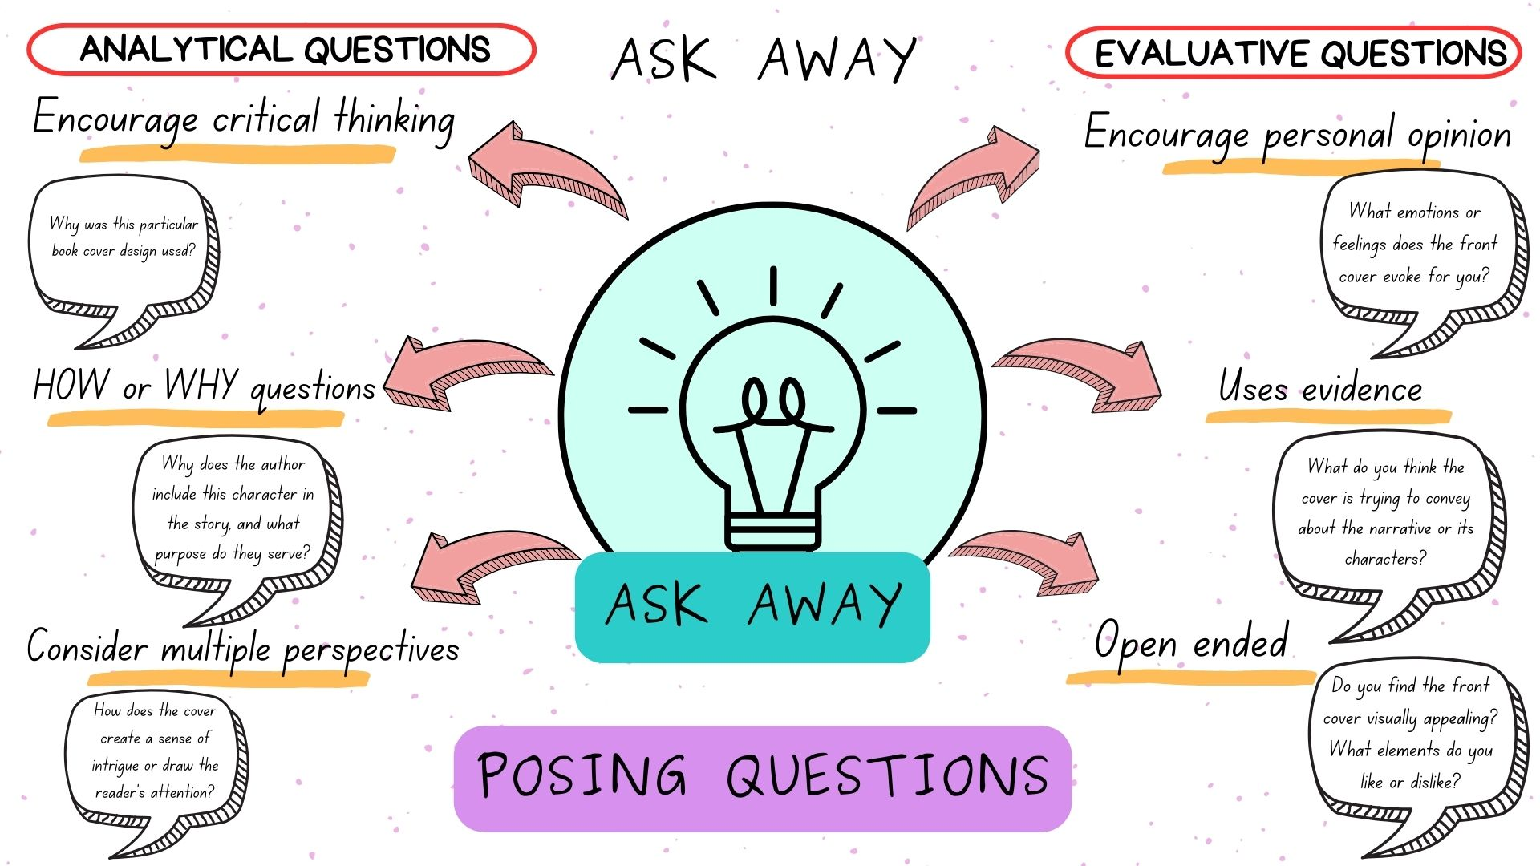

Resource 3 – character web example
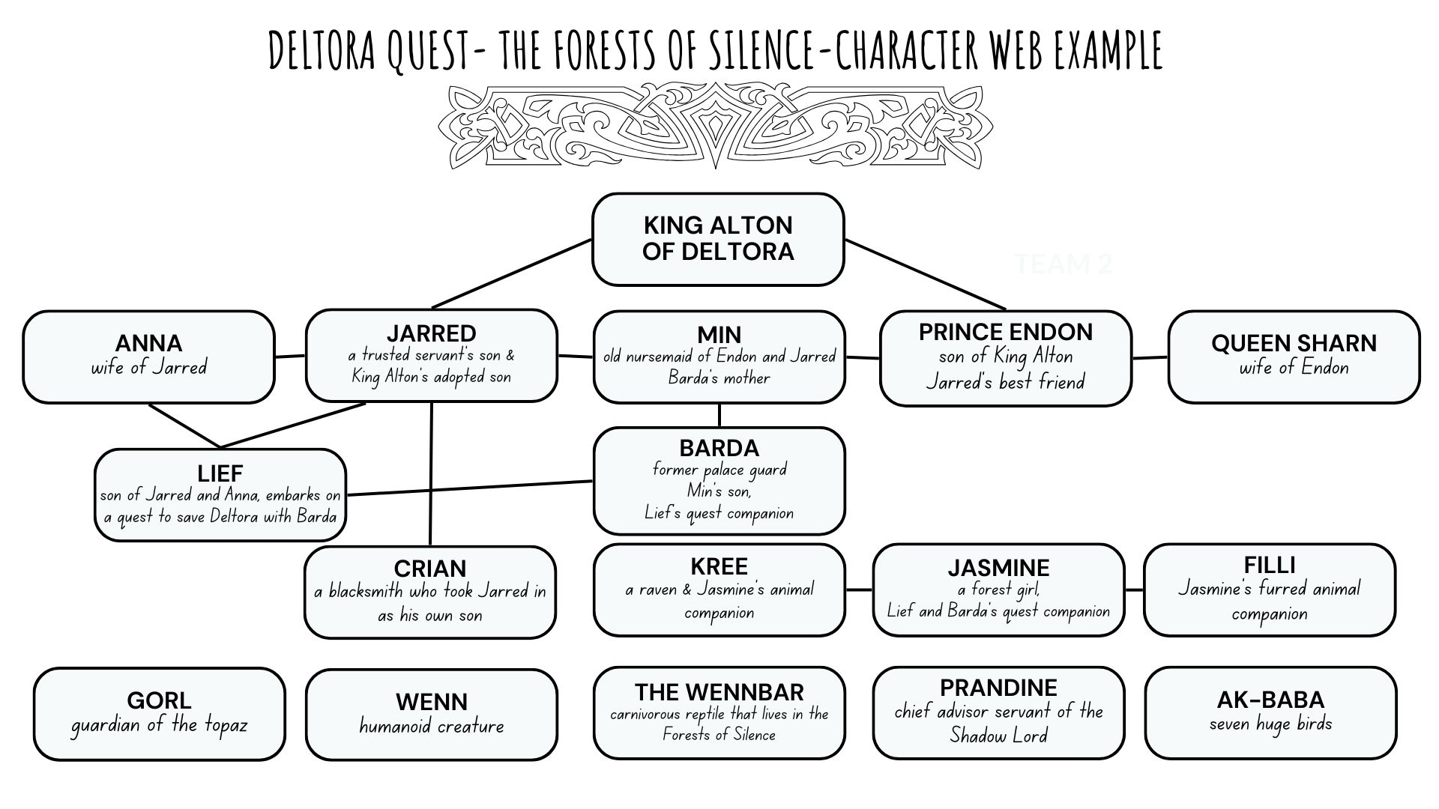

Resource 4 – Jarred & Endon inferring character traits
Evidence from the text | Inferred character trait

Resource 5 – creating characters
Character 1 | Character 2
Physical appearance | Physical appearance
Actions (behaviour and emotions) | Actions (behaviour and emotions)
What does the character say and think? | What does the character say and think?

Resource 6 – saying verbs
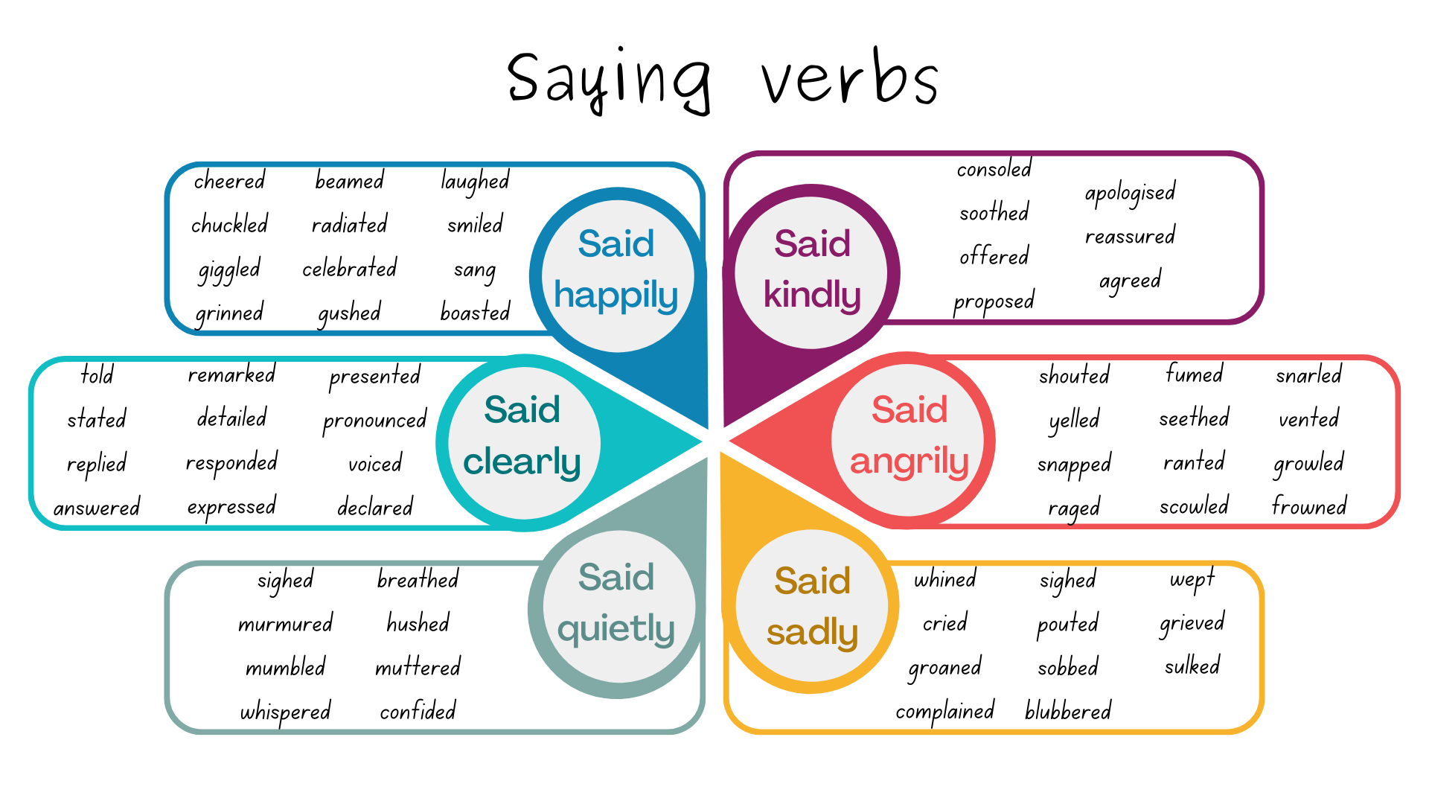

Resource 7 – dialogue checklist
Dialogue Checklist | Dialogue Checklist
- A sentence can begin with dialogue or end with dialogue.  - Saying verbs are used as dialogue tags to describe how speech is spoken.  - Dialogue is often improved by using gestures, actions and descriptions in the narration.  - Quotation marks go around exactly what is spoken.  - A capital letter is used at the start of what is spoken and for proper nouns.  - There is punctuation before the close of quotation marks (full stops, commas, exclamation marks, question marks).  - A new line is used when a new speaker speaks.  - Dialogue uses declarative, interrogative, imperative and exclamatory sentences. | - A sentence can begin with dialogue or end with dialogue.  - Saying verbs are used as dialogue tags to describe how speech is spoken.  - Dialogue is often improved by using gestures, actions and descriptions in the narration.  - Quotation marks go around exactly what is spoken.  - A capital letter is used at the start of what is spoken and for proper nouns.  - There is punctuation before the close of quotation marks (full stops, commas, exclamation marks, question marks).  - A new line is used when a new speaker speaks.  - Dialogue uses declarative, interrogative, imperative and exclamatory sentences.

Resource 8 – connectives
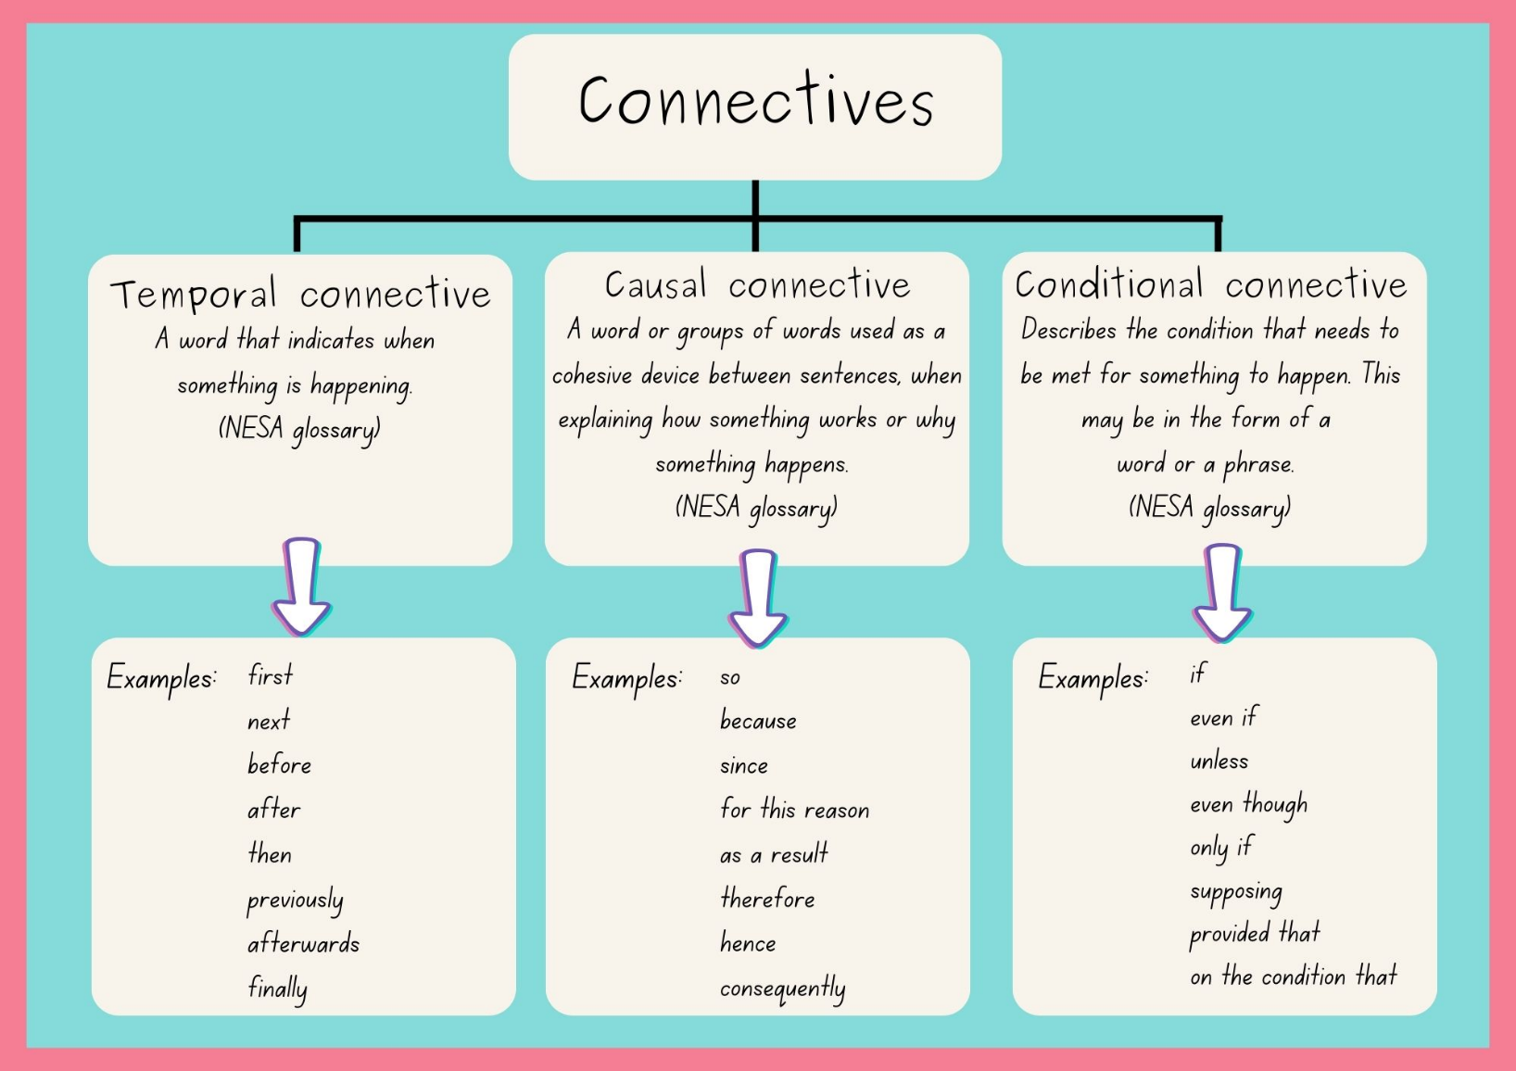

Resource 9 – homonym charades
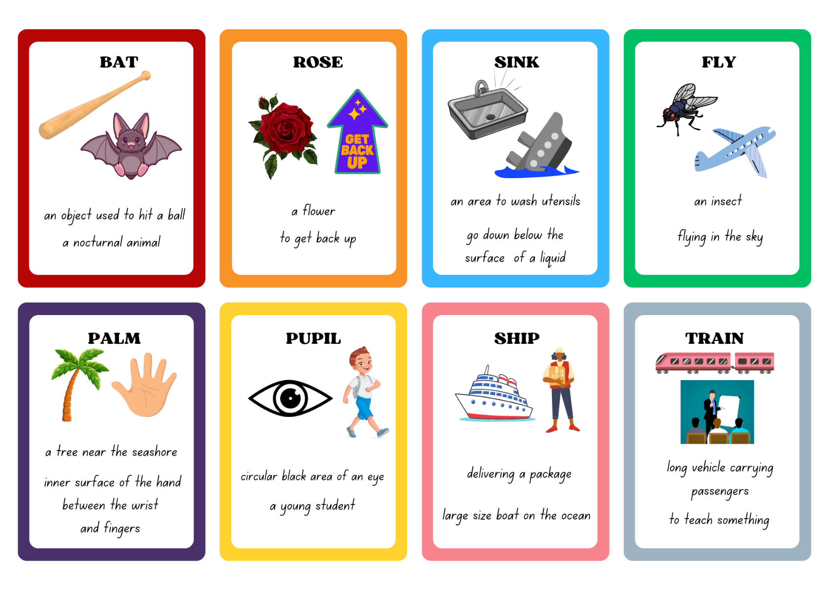

Resource 10 – multiple meaning words
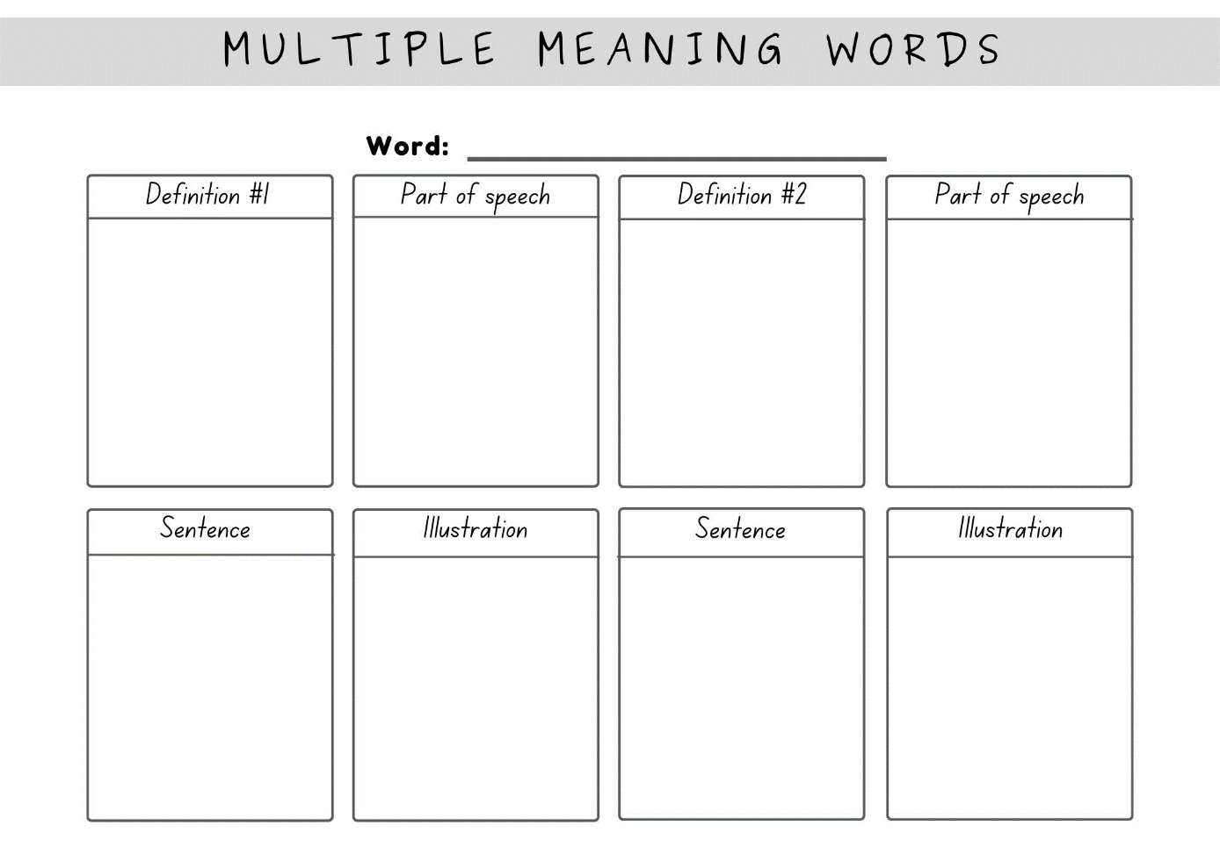

Resource 11 – conversation model
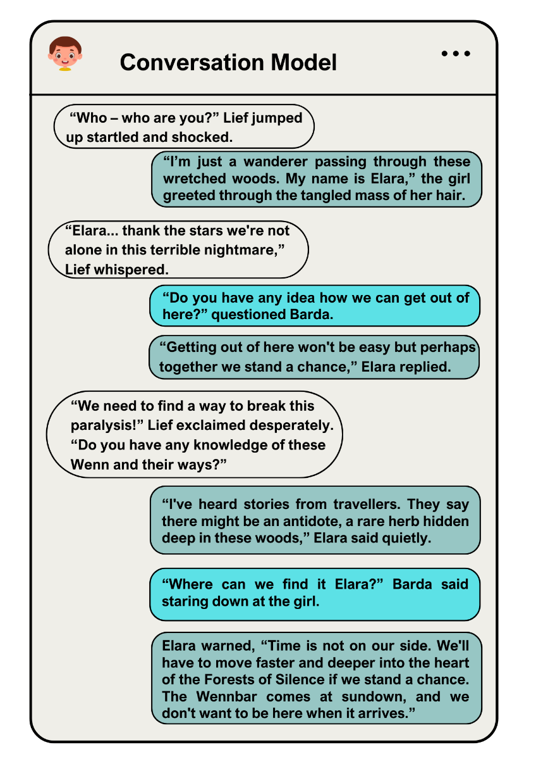

Resource 12 – character guessing
Barda  You cannot say:  - protector  - palace guard  - beggar | Prandine  You cannot say:  - advisor  - evil  - thin | Jasmine  You cannot say:  - forest girl  - Filli and Kree  - orphan | Gorl  You cannot say:  - guardian  - armour  - sword
Filli and Kree  You cannot say:  - birds  - companions  - wings | Lief  You cannot say:  - quest  - belt  - gem | The Wennbar  You cannot say:  - creature  - aggressive  - hideous

Resource 13 – villainous character profile
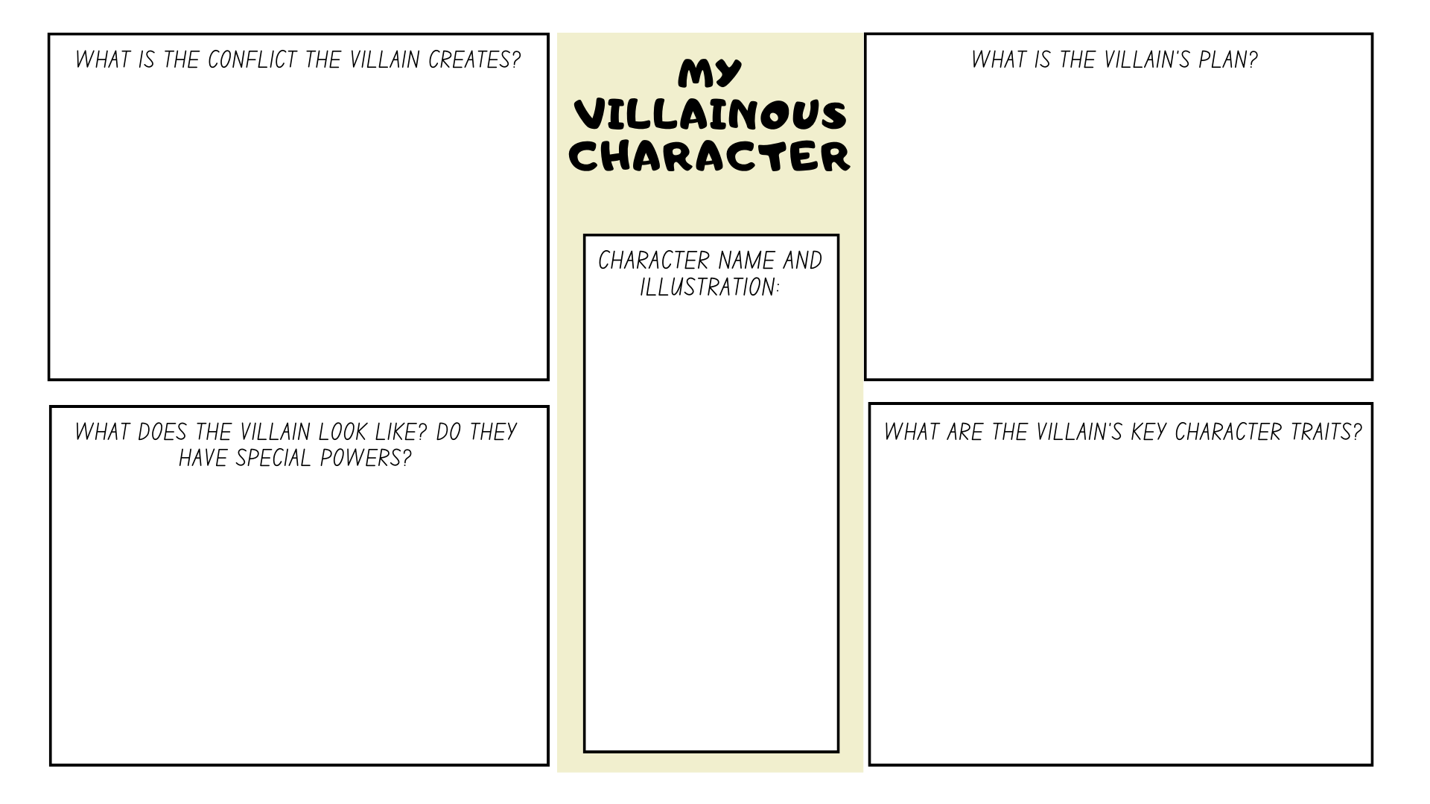

Resource 14 – writing process
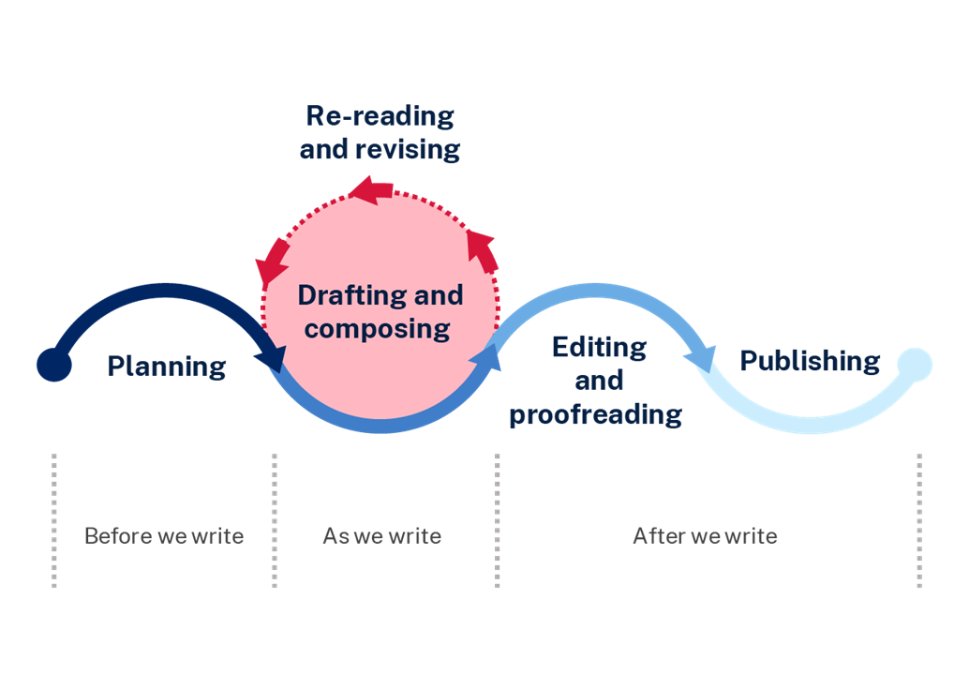

Resource 15 – Quest narrative planning template
Orientation:
What is the backstory?
Where does the quest begin?
Who are the main characters?
Complication:
What is the problem within the story?
What is ‘the quest’ objective?
Series of events: What challenges do the characters face? What is the plan to solve the problem?
Challenge 1
Challenge 2
Challenge 3
Resolution:
How is the problem solved?
How do the characters feel?

Resource 16 – Quest narrative planning template example
Orientation:  What is the backstory?  Where does the quest begin?  Who are the main characters? | - Josh and Ava planned for a soccer match at the city park  - started to rain so Josh and Ava seek refuge under a bridge  - King Eldric emerged from a mysterious hidden door  - enchanted forest covered in snow  - Ava, Josh, a rabbit & the White Beast
Complication: What is the problem within the story?  What is ‘the quest’ objective? | - King Eldric hands Josh and Ava a map to embark on an adventure  - Josh and Ava must save a kidnapped rabbit family to restore balance to the world
Series of events: What challenges do the characters face? What is the plan to solve the problem?  Challenge 1  Challenge 2  Challenge 3 | Challenge 1:  - Trudge through thick snow  - A rabbit asks for help to save his family kidnapped from wicked creatures  - Josh and Ava make snowshoes from a tree branch to help walk through the snow  Challenge 2:  - day turns to night  - Josh and Ava find refuge in a small weathered shed  - find a torch  Challenge 3:  - Josh and Ava follow rabbit to a cave  - They find rabbit’s family and try to set them free  - The White Beast becomes aware of intruders  - Josh and Ava scare the White Beast with fire and the bunnies escape
Resolution: How is the problem solved?  How do the characters feel? | - Ava realises the White Beast has been lonely  - they venture happily into the forest together as friends  - balance in the realm is restored

References
This resource contains NSW Curriculum and syllabus content. The NSW Curriculum is developed by the NSW Education Standards Authority. This content is prepared by NESA for and on behalf of the Crown in right of the State of New South Wales. The material is protected by Crown copyright.
Please refer to the NESA Copyright Disclaimer for more information https://educationstandards.nsw.edu.au/wps/portal/nesa/mini-footer/copyright.
NESA holds the only official and up-to-date versions of the NSW Curriculum and syllabus documents. Please visit the NSW Education Standards Authority (NESA) website https://educationstandards.nsw.edu.au/wps/portal/nesa/home and the NSW Curriculum website https://curriculum.nsw.edu.au.
English K–10 Syllabus © NSW Education Standards Authority (NESA) for and on behalf of the Crown in right of the State of New South Wales, 2022.
National Literacy Learning Progression © Australian Curriculum, Assessment and Reporting Authority (ACARA) 2010 to present, unless otherwise indicated. This material was downloaded from the Australian Curriculum website (National Literacy Learning Progression) (accessed 21 September 2023) and was not modified.
Becker A (2015) Quest, Walker Books, Australia.
Becker A (n.d.) Quest Book Trailer, Storybreathing website, accessed 21 September 2023.
McDonald L (2023) A New Literature Companion for Teachers, 3rd edn, PETAA, Australia.
NESA (NSW Education Standards Authority) (2024) Glossary, NESA website, accessed 21 September 2023.
NSW Department of Education (2023a) Stage 2 reading - Exploring characters, NSW Department of Education website, accessed 18 August 2023.
NSW Department of Education (2023b) Stage 3 reading - Understanding character, NSW Department of Education website, accessed 18 August 2023.
Rodda E (2005) Deltora Quest: The Forests of Silence, Scholastic Australia PTY LTD, Australia.
Rodda E (2024) About Emily Rodda, Emily Rodda website, accessed 21 September 2023.
Winch G (2022) Primary Grammar Book, Oxford University Press, Australia and New Zealand.

© State of New South Wales (Department of Education), 2024
The copyright material published in this resource is subject to the Copyright Act 1968 (Cth) and is owned by the NSW Department of Education or, where indicated, by a party other than the NSW Department of Education (third-party material).
Copyright material available in this resource and owned by the NSW Department of Education is licensed under a Creative Commons Attribution 4.0 International (CC BY 4.0) license.
This license allows you to share and adapt the material for any purpose, even commercially.
Attribution should be given to © State of New South Wales (Department of Education), 2024.
Material in this resource not available under a Creative Commons license:
- the NSW Department of Education logo, other logos and trademark-protected material
- material owned by a third party that has been reproduced with permission. You will need to obtain permission from the third party to reuse its material.
Links to third-party material and websites
Please note that the provided (reading/viewing material/list/links/texts) are a suggestion only and implies no endorsement, by the New South Wales Department of Education, of any author, publisher, or book title. School principals and teachers are best placed to assess the suitability of resources that would complement the curriculum and reflect the needs and interests of their students.
If you use the links provided in this document to access a third-party's website, you acknowledge that the terms of use, including licence terms set out on the third-party's website apply to the use which may be made of the materials on that third-party website or where permitted by the Copyright Act 1968 (Cth). The department accepts no responsibility for content on third-party websites.

