iSTEM Stage 5 – sample assessment task
Agriculture Technology (AgriTech) – design task
Resource code – AGT AST

Contents
Advice to teachers 2
Task 2
Scheduling 2
Assessment task 3
Task description 3
Task 4
Steps to success 4
1. Define the problem 4
2. Identify the constraints 4
3. Brainstorm solutions 4
4. Design 5
What is the teacher looking for? 5
Student support material 6
Marking rubric 9
Support and alignment 11
Evidence base 12

Advice to teachers
Note: the examples in this package are provided so that schools and teachers may choose relevant information and adjust for their contexts and their school-based practices. Relevant information should be transferred into the school’s assessment task template.

Task
Students will design a response to the design brief ‘Create a small desktop smart greenhouse that can help manage temperature and other growth conditions.’ Students will work in groups for the task, however, teachers can change the task to an individual workflow and submission if that is preferred.
This task has been constructed to capture student progress in brainstorming and sketching design ideas. The focus of the task is to capture the iterative nature of design and students should be encouraged to share all ideas and sketches, even those that may have been altered or discarded during brainstorming and design phases.
In Week 4 of the iSTEM AgriTech learning sequence, students design and document their smart greenhouses. Brainstorming and capturing ideas in different sketch formats should be modelled in lessons. Support videos that model brainstorming and sketching a design solution are available on the Engineering design process – Smart greenhouse webpage. Decide when to show these videos to your students based on student levels of proficiency and progress with the design brief. See AGT PPT1 and AGT PPT2 for additional support in delivering this assessment task and the iSTEM AgriTech program of learning.
The ‘Assessment task’ section contains student facing information. Change the assessment task advice if your design brief or your scope for the assessment task is different.

Scheduling
This task is designed for Week 4 of the iSTEM AgriTech learning sequence. At this point in the learning sequence, students are designing a smart greenhouse.
Consider this assessment when creating your iSTEM scope and sequence. School reporting timelines may dictate when this learning sequence and assessment task is used.

Assessment task

Task description
Type of task: design folio
Format: design task
Weighting: (school-based decision)
Submission: students work collaboratively to complete and submit a design folio, including images or scans of sketch examples.
Outcomes being assessed:
- ST5-2 demonstrates critical thinking, creativity, problem-solving, entrepreneurship and engineering design skills and decision-making techniques in a range of STEM contexts
- ST5-3 applies engineering design processes to address real-world STEM-based problems
- ST5-6 selects and safely uses a range of technologies in the development, evaluation, and presentation of solutions to STEM-based problems
- ST5-7 selects and applies project management strategies when developing and evaluating STEM-based design solutions
- ST5-8 uses a range of techniques and technologies to communicate design solutions and technical information for a range of audiences.
Outcomes referred to in this document are from the iSTEM course document © State of New South Wales (Department of Education), 2021..

Task
Work in groups to brainstorm and sketch a solution to the design brief ‘Create a small desktop smart greenhouse that can help manage temperature and other growth conditions.’
Create a design folio, with defined sections and accompanying images, to capture and communicate design ideas.

Steps to success
Use a design folio to document and communicate the engineering design process. The following steps must be included in your folio.

Define the problem
Define the challenge. For example:
- write the design brief in your own words
- define the design criteria based on the task instructions.

Identify the constraints
Outline specific boundaries that confine the challenge. For example:
- consider various materials, tools and equipment
- document constraints specified by the teacher
- identify constraints of the size of the smart greenhouse.

Brainstorm solutions
Use divergent thinking to produce as many creative ideas as possible, for example you could:
- produce thumbnail sketches and annotations of initial ideas
- draw a spider diagram (Figure 1) to organise your ideas by features, elements or users
- consider potential technologies and techniques that could be used.

Design
Design, refine and sketch your greenhouse solution.
- Create and capture at least 3 concept sketches of your design ideas (see Figure 2).
- Create and capture an orthographic drawing of your design. Capture the front, top and side views of your possible design (see Figure 3 and Figure 4 for example ideas).

What is the teacher looking for?
In this task, the teacher will be evaluating the design folio based on the presence of the following components:
- a clear design brief
- 3 design constraints are identified
- at least 10 brainstorm ideas, notes or thumbnail sketches are relevant to the design brief
- at least 3 concept sketches detailing an element of the design
- one orthographic drawing showing the front, top and side of a smart greenhouse design idea.

Student support material
The following figures are examples of what your brainstorm ideas, thumbnail sketches, concept sketches and orthographic drawings could look like.
Figure 1 – example spider diagram of brainstorm ideas and thumbnail sketches
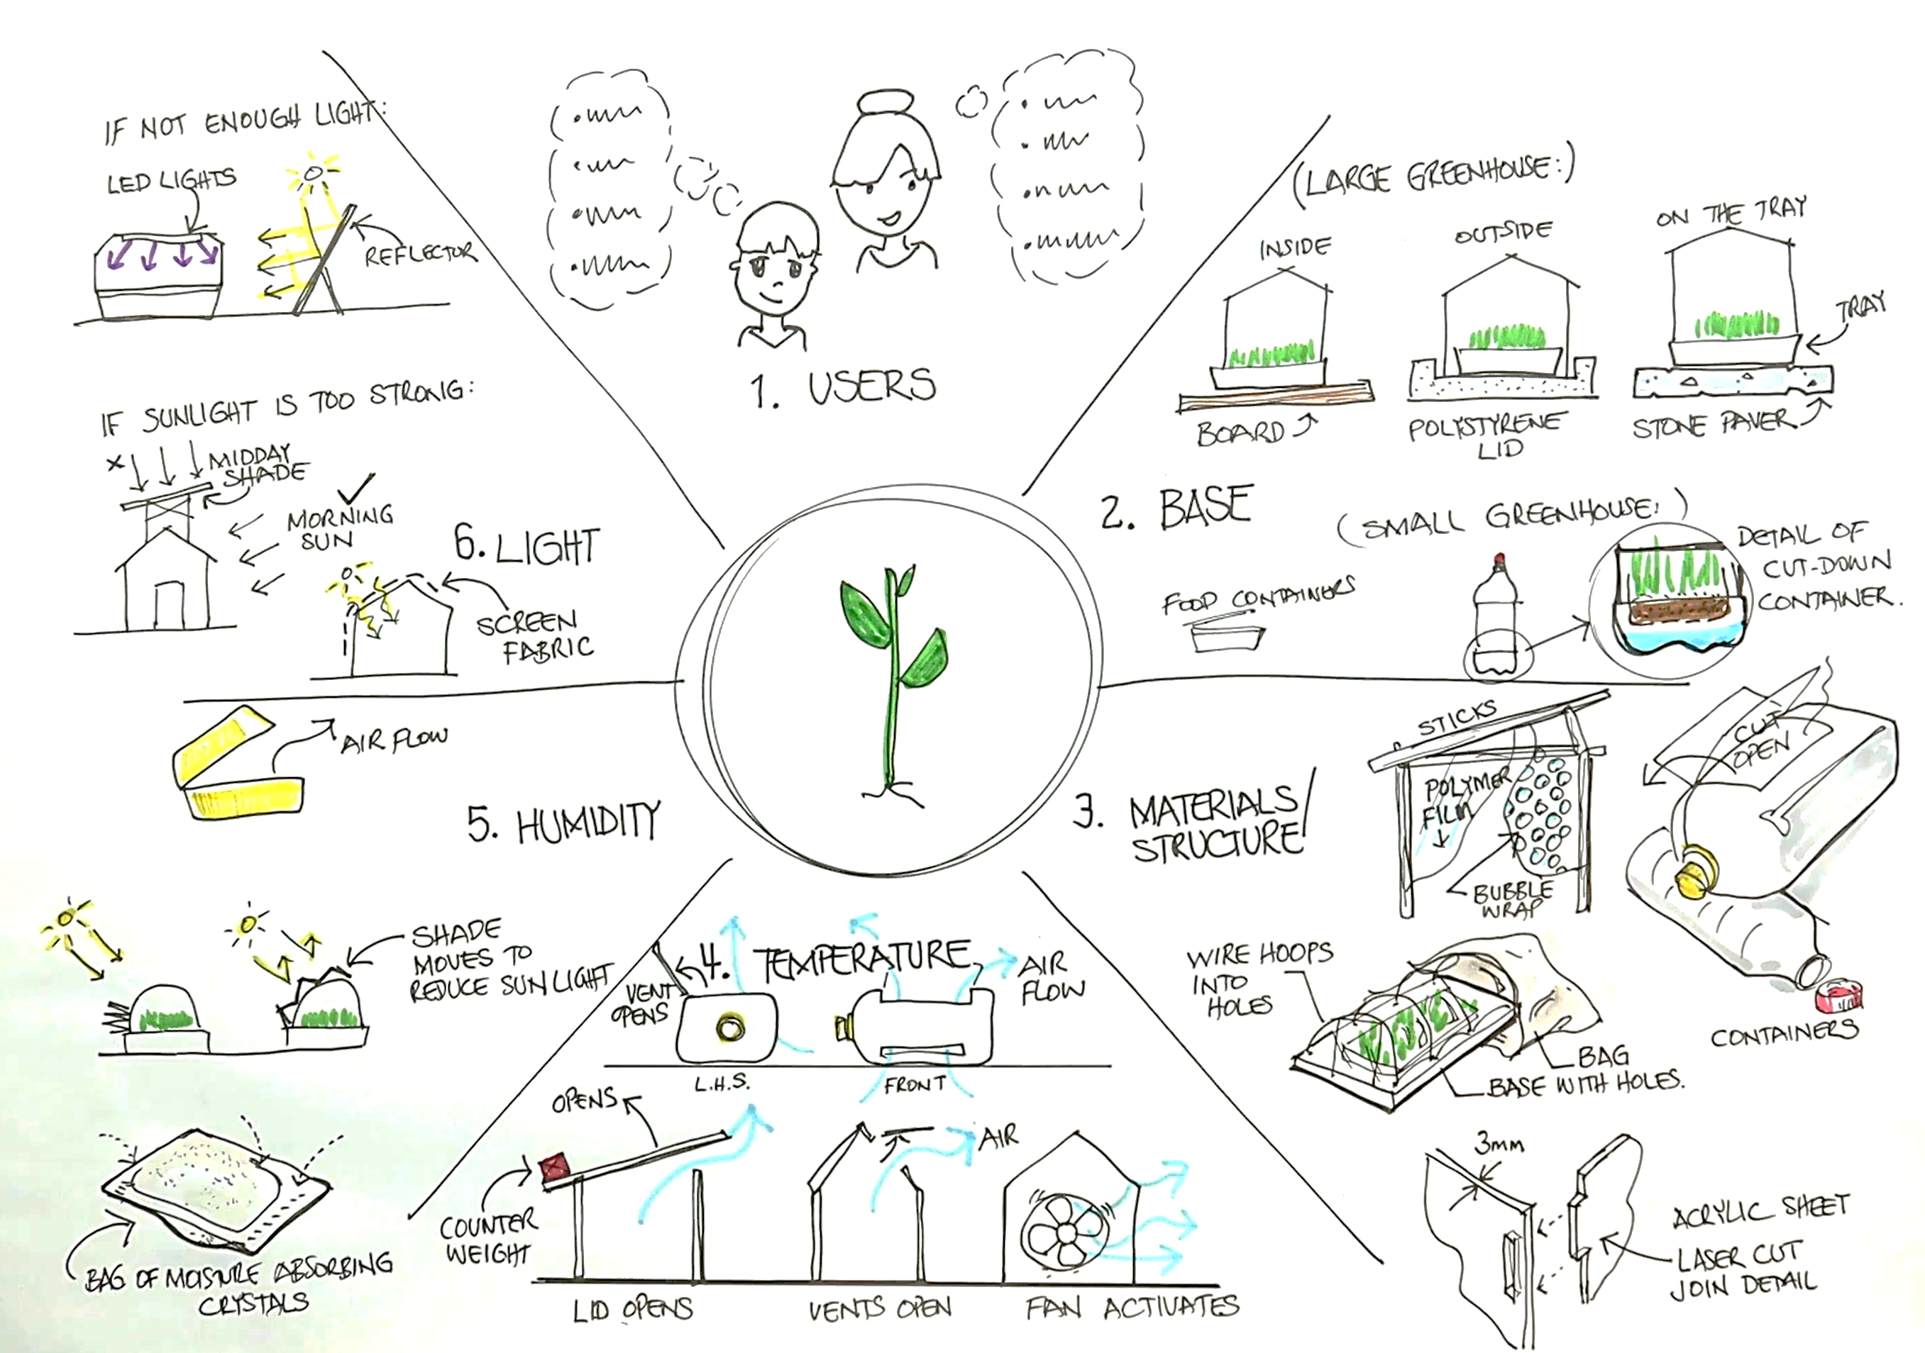
Figure 2 – concept sketch example
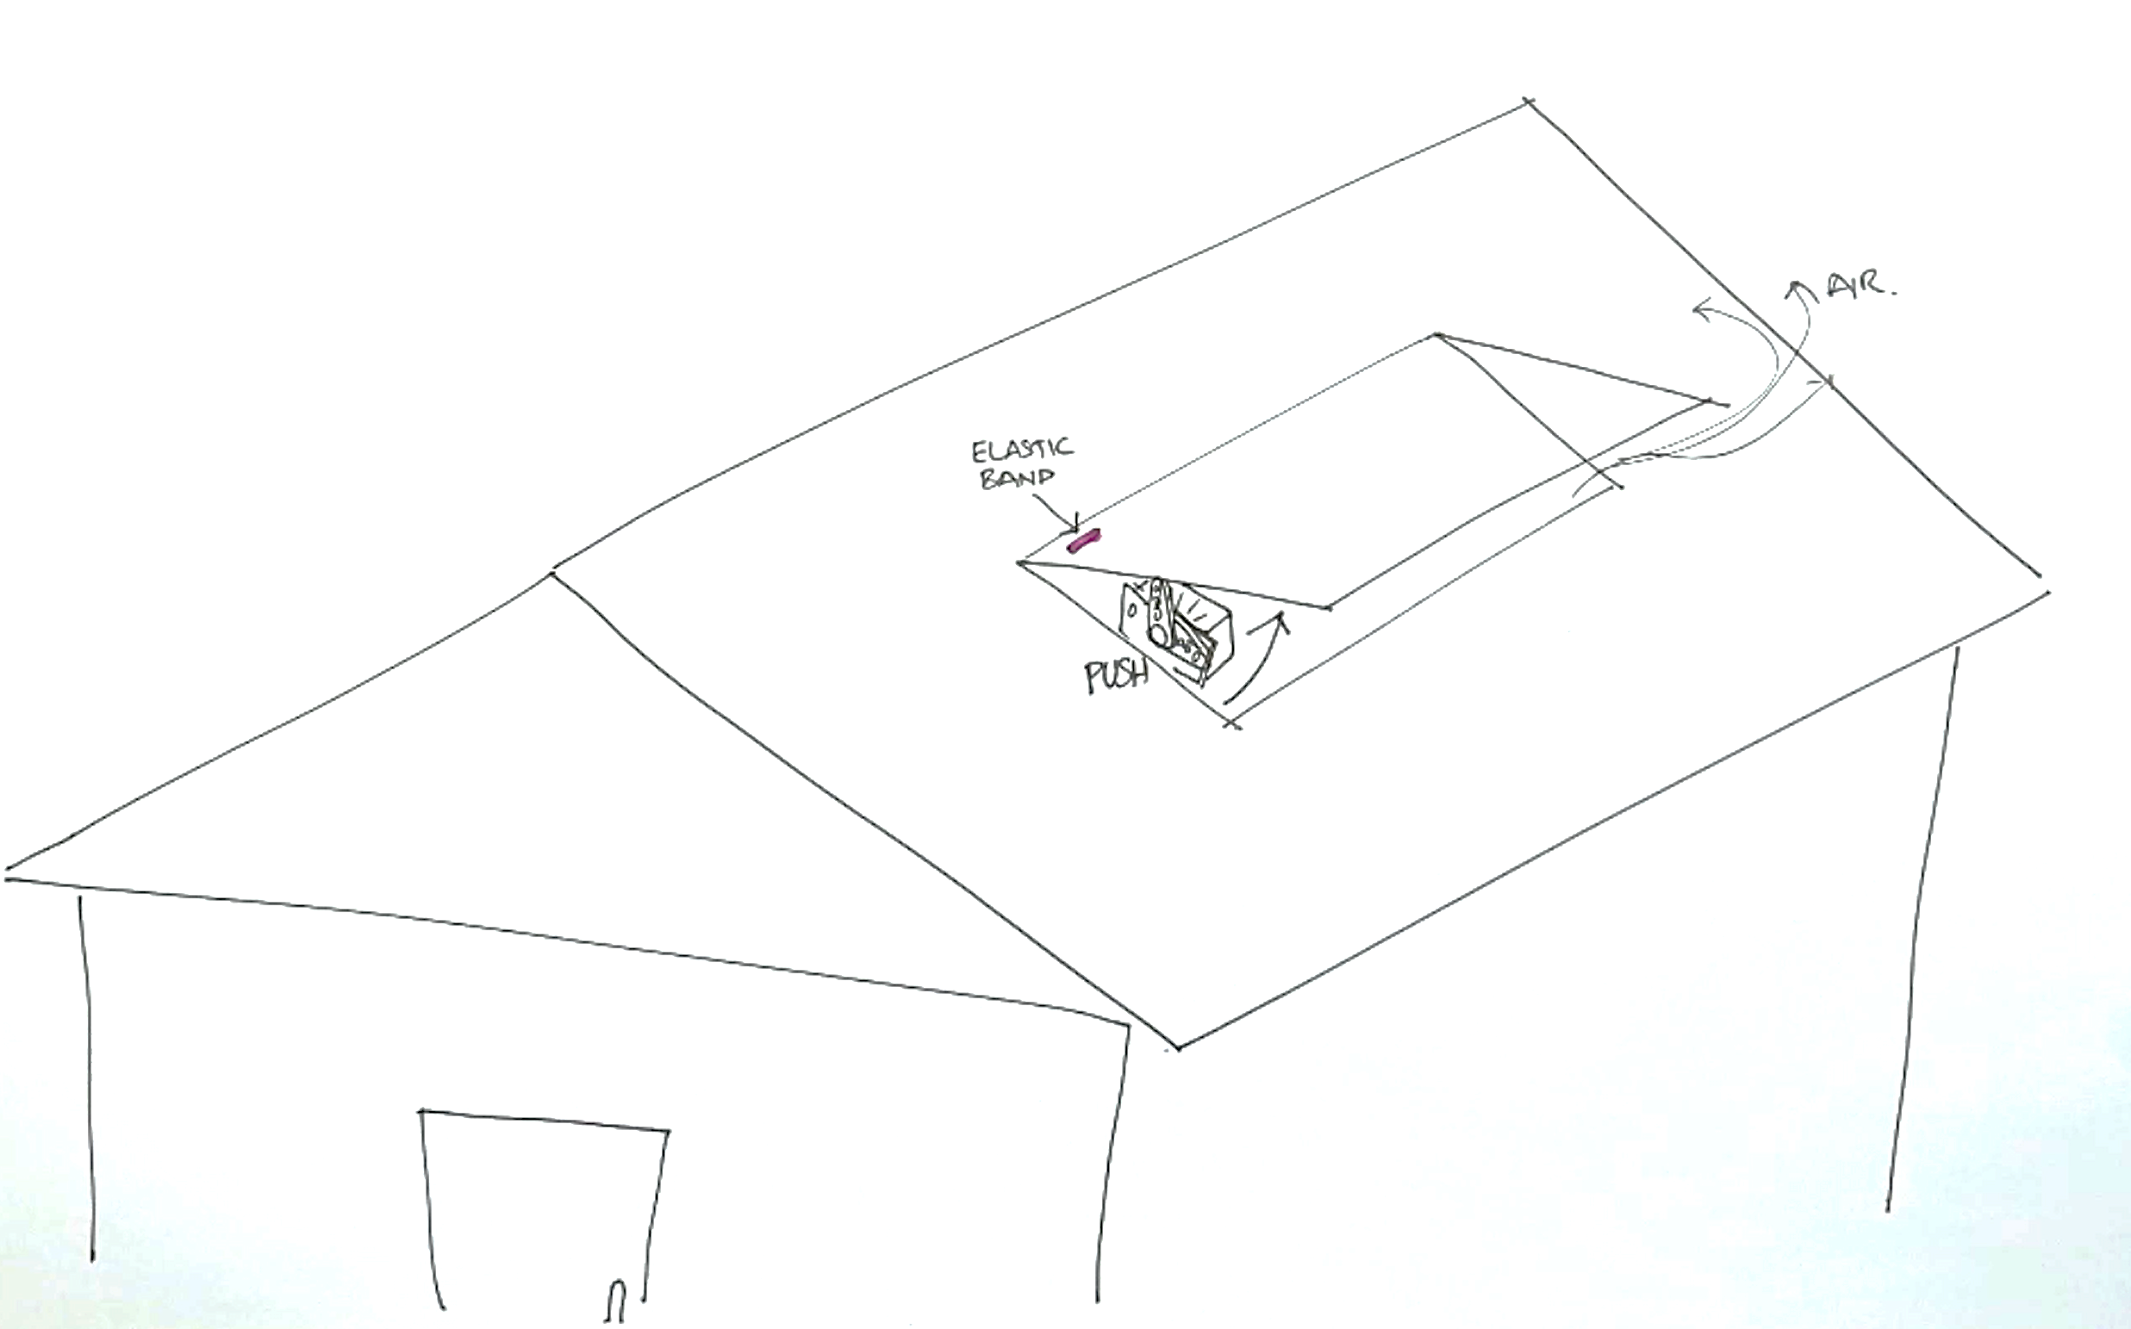
Figure 3 – orthographic and isometric drawing sample sketches
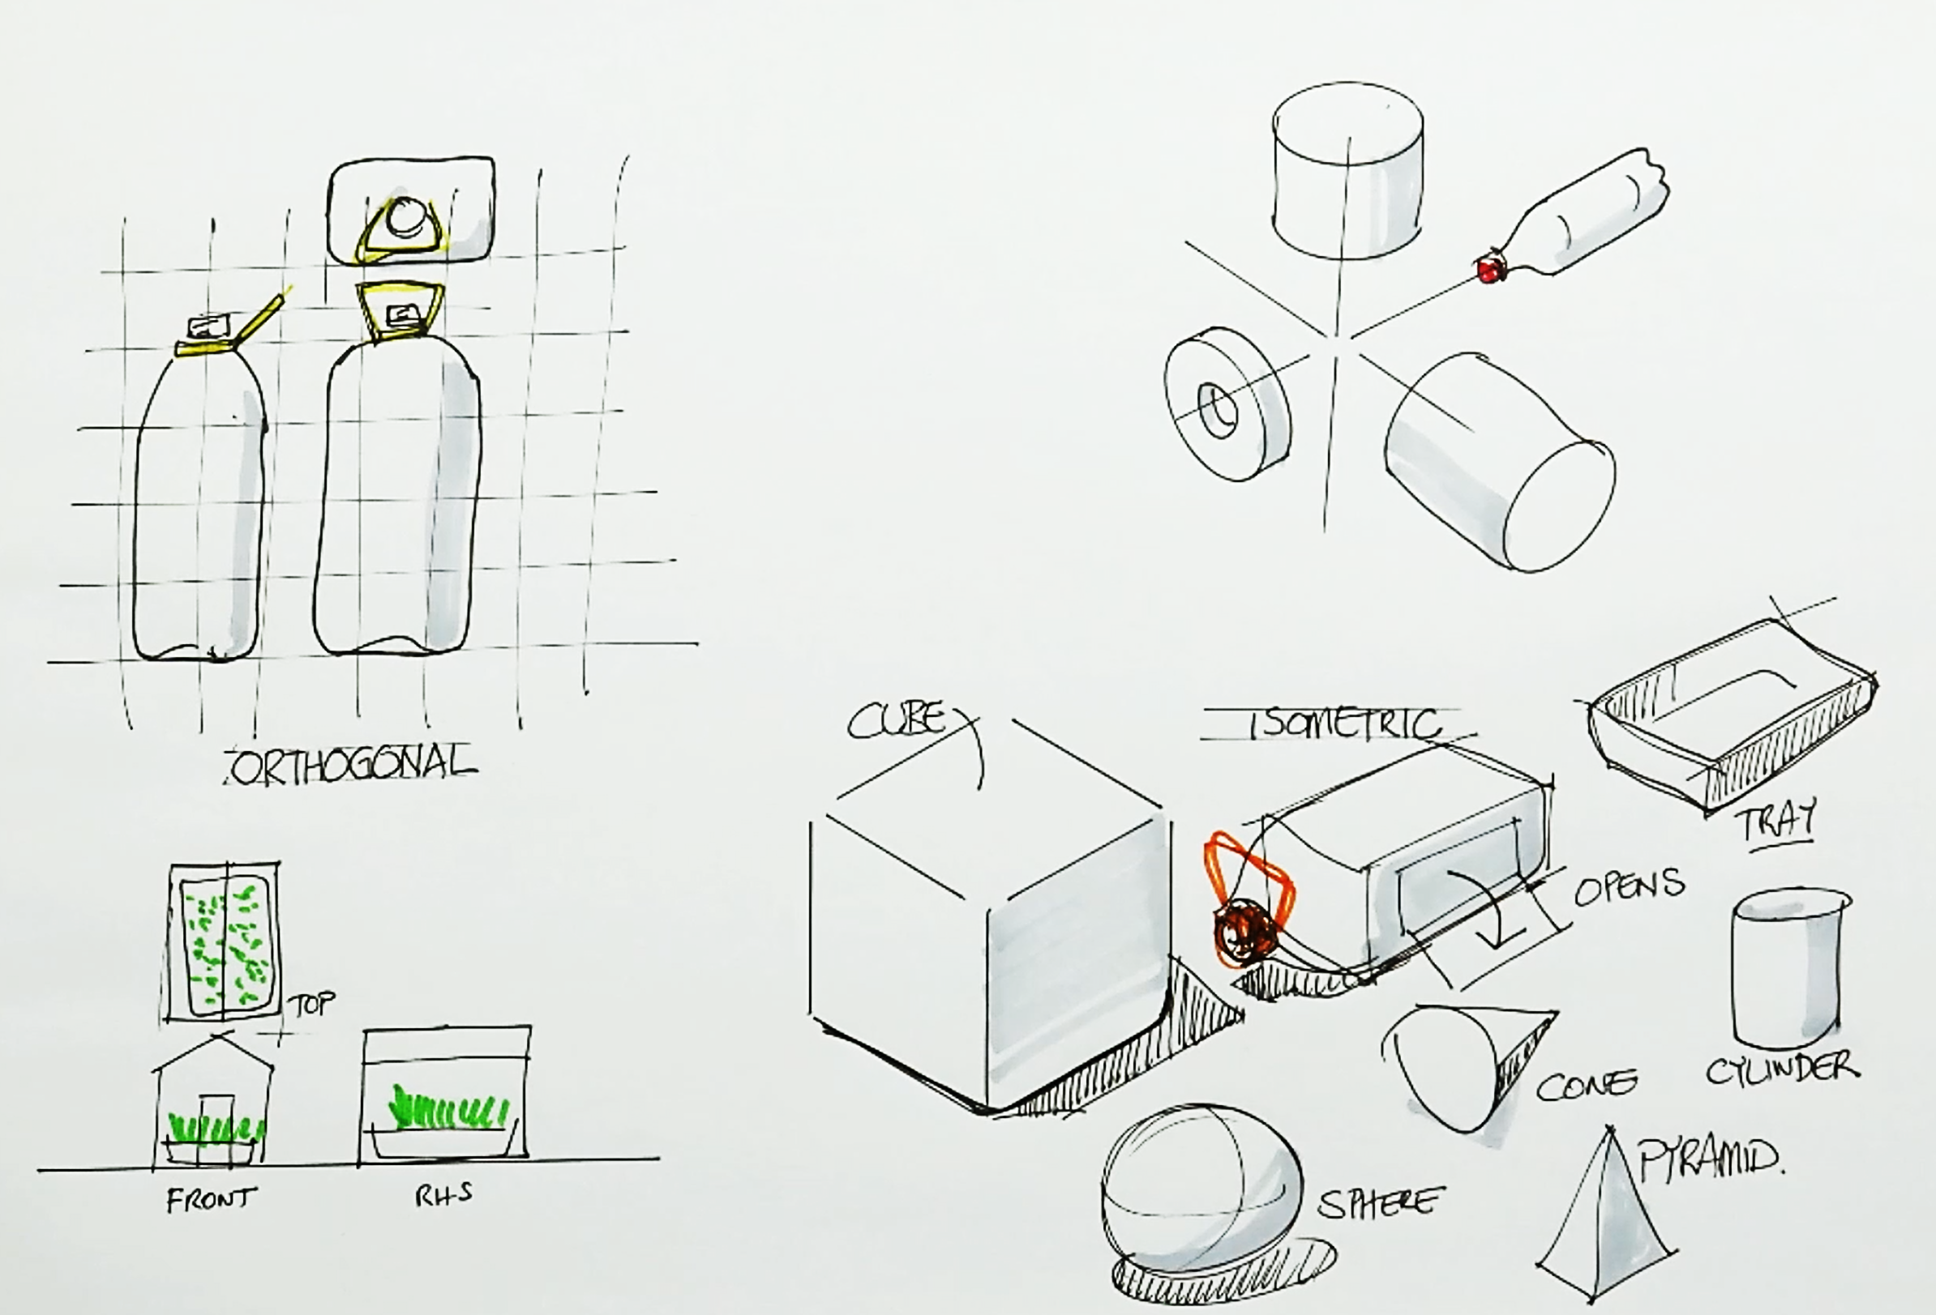
Figure 4 – example orthographic drawing of a smart greenhouse using a recycled 4 L bottle.
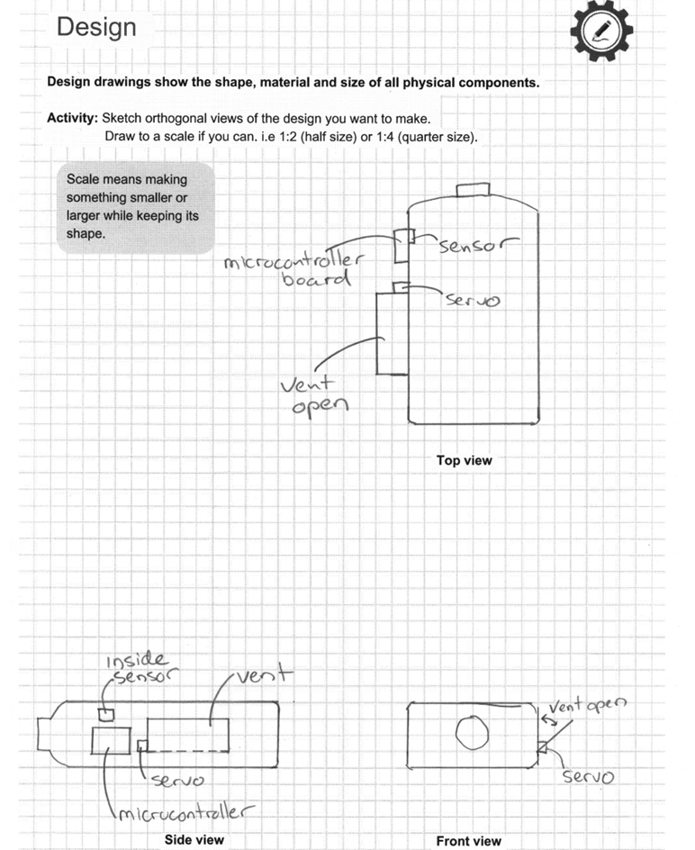

Marking rubric
Note: the criteria and outcomes presented in this table are not mandatory for assessing the task. Teachers are encouraged to select and/or adjust criteria based on their students’ needs and the assessment and reporting requirements of their school.
Table 1 – marking rubric
Criteria | Outstanding | High | Sound | Basic | Limited
Define the brief and identify constraints  ST5-3 | Communicates clear and accurate design brief, constraints, success criteria and ideas about the challenge. | Communicates clear and accurate brief.  Communicates relevant constraints, success criteria and ideas about the challenge. | Communicates constraints, success criteria and ideas about the challenge. | Defines part of the brief, identifies one constraint, records ideas for one part of the challenge. | Identifies a part of the brief.
Brainstorm solutions  ST5-2 | Documents 10 or more ideas as short notes or small sketches (thumbnails).  Demonstrates creativity, innovation or multiple ideas. | Documents at least 6 ideas as notes or small sketches.  Demonstrates creativity, innovation or multiple ideas. | Documents 4 diverse ideas as notes or small sketches. | Documents 4 ideas as notes or small sketches. | Documents some ideas as notes or small sketches.
Design  ST5-6, ST5-7, ST5-8 | Creates and documents 3 or more concept sketches, with annotations.  Creates and documents an orthographic drawing of a proposed design solution. | Creates and documents 2 concept sketches and an orthographic drawing of a proposed design solution. | Creates and documents a concept sketch and an orthographic drawing of a proposed design solution. | Creates and documents a concept sketch or an orthographic drawing of a proposed design solution. | Attempts a sketch of a solution or part of a design solution.
Note: a ‘STEM skills’ student self-evaluation rubric can be found in the Assessment task – critical problem solving document found under the ‘Elective topics’ section of the iSTEM webpage.

Support and alignment
Resource evaluation and support: all curriculum resources are prepared through a rigorous process. Resources are periodically reviewed as part of our ongoing evaluation plan to ensure currency, relevance and effectiveness. For additional support or advice, or to provide feedback, contact the Teaching and Learning Curriculum team by emailing secondaryteachingandlearning@det.nsw.edu.au.
Differentiation: further advice to support Aboriginal and/or Torres Strait Islander students, students learning English as an additional language or dialect (EAL/D), students with a disability and/or additional needs and high potential and gifted students can be found on the Planning programming and assessing 7–12 webpage. This includes the Inclusion and differentiation advice 7–10 webpage.
Assessment: further advice to support formative assessment is available on the Planning programming and assessing 7–12 webpage. This includes the Classroom assessment advice 7–10. For summative assessment tasks, the Assessment task advice 7–10 webpage is available.
Alignment to system priorities and/or needs: School Excellence Policy, Our Plan for NSW Public Education.
Alignment to the School Excellence Framework: this resource supports the School Excellence Framework elements of curriculum (curriculum provision) and effective classroom practice (lesson planning, explicit teaching).
Alignment to Australian Professional Standards for Teachers: this resource supports teachers to address Proficient Teacher Standard Descriptors 3.2.2, 3.3.2.
Creation date: 19 March 2026.

Evidence base
iSTEM course document © NSW Department of Education for and on behalf of the Crown in the State of New South Wales, 2021.
Brookhart SM (2018) ‘Appropriate Criteria: Key to Effective Rubrics’, Frontiers in Education, volume 3(22):1–12, doi:10.3389/feduc.2018.00022, accessed 5 March 2025.
CESE (Centre for Education Statistics and Evaluation) (2021) Growth goal setting – what works best in practice, NSW Department of Education website, accessed 5 March 2025.
——(n.d.) What Works Best 2025, NSW Department of Education website, accessed 23 June 2026.
——(2025) What Works Best 2025 – practice guides, NSW Department of Education website, accessed 23 June 2026.
Cowie B and Bell B (2010) ‘A Model of Formative Assessment in Science Education’, Assessment in Education: Principles, Policy and Practice, 6(1):101–116, doi.org/10.1080/09695949993026.
Fisher D and Frey N (1 November 2009) ‘Feed Up, Back, Forward’, ASCD (Association for Supervision and Curriculum Development): Educational Leadership magazine, 67(3), accessed 5 March 2025.
Griffin P (2017) Assessment for Teaching, 2nd edn, Cambridge University Press, Port Melbourne, Victoria.
Hattie J and Timperley H (2007) ‘The Power of Feedback’, Review of Educational Research, 77(1): 81–112, doi:10.3102/003465430298487.
Panadero E and Jonsson A (2013) ‘The use of scoring rubrics for formative assessment purposes revisited: A review’, Educational Research Review, 9:129–144, doi:10.1016/j.edurev.2013.01.002, accessed 5 March 2025.
Sherrington T (2019) Rosenshine’s Principles in Action, John Catt Educational Limited, Melton, Woodbridge.
Wiliam D (2013) ‘Assessment: The Bridge between Teaching and Learning’, Voices from the Middle, 21(2):15–20, doi:10.58680/vm201324461.
© State of New South Wales (Department of Education), 2026
The copyright material published in this resource is subject to the Copyright Act 1968 (Cth) and is owned by the NSW Department of Education or, where indicated, by a party other than the NSW Department of Education (third-party material).
Copyright material available in this resource and owned by the NSW Department of Education is licensed under a Creative Commons Attribution 4.0 International (CC BY 4.0) license.

This license allows you to share and adapt the material for any purpose, even commercially.
Attribution should be given to © State of New South Wales (Department of Education), 2026
Material in this resource not available under a Creative Commons license:
- the NSW Department of Education logo, other logos and trademark-protected material
- material owned by a third party that has been reproduced with permission. You will need to obtain permission from the third party to reuse its material.
Links to third-party material and websites
Please note that the provided (reading/viewing material/list/links/texts) are a suggestion only and implies no endorsement, by the New South Wales Department of Education, of any author, publisher, or book title. School principals and teachers are best placed to assess the suitability of resources that would complement the curriculum and reflect the needs and interests of their students.
If you use the links provided in this document to access a third-party's website, you acknowledge that the terms of use, including licence terms set out on the third-party's website apply to the use which may be made of the materials on that third-party website or where permitted by the Copyright Act 1968 (Cth). The department accepts no responsibility for content on third-party websites.

