# Design and media studies – student workbook

## Option 5– Film and video production 1: Development and pre-production

This student workbook is related to the Option 5 – Film and video production 1: Development and pre-production learning sequence produced by Newtown Performing Arts High School as an illustration of practice for the department approved elective Design and Media Studies.

## Camera shot, angle and movement revision table

|  |  |  |
| --- | --- | --- |
| **Camera Work** | **Example (image or video)** | **Purpose/effect** |
| Extreme Close-Up that pulls out to a reverse dolly shot |  |  |
| Crane shot |  |  |
| Whip Pan |  |  |
| Low Angle |  |  |
| Dutch Angle |  |  |
| Worms Eye View |  |  |
| Extreme slow motion of action shot |  |  |
| Extreme slow motion of a reaction shot |  |  |
| Time Lapse |  |  |
| Match Cut |  |  |
| Combine a zoom with a dolly |  |  |
| 360 degrees shot |  |  |

## Designing to a provocation task sheet

A CREATIVE PROVOCATION

Some projects we make in film will respond to a ‘provocation’ – a stimulus used to initiate creative activity in which you will apply your understanding of practice in one or more design and media forms to create a resolved product that satisfies the conditions of the provocation.

The provocation offers you an opportunity to explore your film making practice, then produce resolved design and media works.

Provocations could include:

* a creative brief
* a theme or concept brainstorm
* a medium
* guidelines for an event
* a literary source
* an evaluation of previous projects with the intention to revise, extend, rework or refine the design and media works
* combination of the above.

For this exercise you need to present a 45 sec task to show your ability to respond to a creative brief.

Below is your task. This will take 2 lessons.

**PROVOCATION:**

You are to plan, film and edit a 45 sec (strict MAX time limit) short film about being ACTIVE.

Try to have a narrative feel to it rather than an info-mercial feel.

You MUST address one of the 2 topic area below:

1. Top tips for being physically active OR
2. How being physically active is fun

Use the following link to help direct ideas:

<https://www.health.gov.au/topics/physical-activity-and-exercise/physical-activity-and-exercise-guidelines-for-all-australians>

**CRITERIA:**

TARGET AUDIENCE - High School Age

TARGET publication - You Tube Channel and Websites

RATING - G

MUSIC - Royalty Free

Permission must be granted by all people in the film.

No extreme sports or revealing activewear please

File size no greater than 1GB

.MP4 or .mov format

**CLIENT NOTES**

*The client would like you to think in the following terms:*

CARE

COURAGE

CRITICAL THINKING

CONCEPT and

CREATIVITY

Film will be evaluated on the following criteria:

1. Ability to ENGAGE a target audience of young people
2. The impact of the message - that the message is an important one
3. Your creativity in your presentation style

**Your task:**

1. Write up the idea - in a sentence - what elements are you going for from the Guidelines
2. Write up the idea - in a paragraph
3. What Genre is the film set
4. What cinematic techniques will you use to get this genre across
5. What information/narrative/entertainment techniques will you use to get your message/information across?
6. Who do you need to film it
7. What location will you need to film it
8. When will you film it?
9. What costumes and props will you need?
10. What music / sound design / sound editing will you include?

**DELIVERY:**

FILMS ARE DUE, uploaded to GOOGLE CLASSROOM for viewing in class.

Date:

(Footage to be shot outside of class time, you will have one full lesson to work on the editing)

## Sample student answer sheet

**Your task:**

**1. Write up the idea - in a sentence - what elements are you going for from the Guidelines**

*Western inspired volleyball*

1. **Write up the idea - in a paragraph**

*Very action packed as if we are going into war with very western inspired shots of the extreme close up of the eyes, the weapon and hands, and use of slow motion when throwing and hitting the ball.*

1. **What Genre is the film set**

*Action, western and inspirational*

1. **What cinematic techniques will you use to get this genre across**

*Close ups, extreme close ups, vertigo shots, tilts and dutch angles*

1. **What information/narrative/entertainment techniques will you use to get your message/information across?**

*Western duel*

1. **Who do you need to film it**

*A friend*

1. **What location will you need to film it**

*School gym*

1. **When will you film it?**

*Lunch time*

1. **What costumes and props will you need?**

*Either a PDHPE teacher or a friend doing it*

1. **What music / sound design / sound editing will you include?**

*Western inspired music (whistling)*

## Pitch document template

**DESIGN & MEDIA**

**FILM PRODUCTION UNIT: Pre-Production**

**Pitch Document**

Remember to keep your pitch clear, concise, and visually appealing. Tailor it to your specific project and the preferences of the individuals or entities you're pitching to.

Additionally, practice delivering your pitch confidently and be prepared to answer questions or provide additional information.

**Title :** Clearly state the title of your screenplay or short film.

|  |
| --- |
|  |

**Tagline:** Craft a concise and engaging tag line that hooks your audience in and leaves them wanting more.

|  |
| --- |
|  |

**Logline:** Craft a concise and engaging logline that summarizes the essence of your story in a sentence or two.

|  |
| --- |
|  |

**Genre:** Specify the genre of your screenplay or short film. Genres help set expectations and attract the right audience.

|  |
| --- |
|  |

**Synopsis:** Offer a more detailed overview of the story without giving away all the plot details. Highlight the main characters, central conflict, and the journey they undertake.

|  |
| --- |
| Story: Most importantly - how is this story different to all the others we have seen  eg: it’s a family story passed down, it’s an event that once happened that is a fav to tell your friends  Main Characters:  Central Conflict:  Journey they undertake: (is there a twist?)  Resolution:  How will you be incorporating the word “spark” into the piece: |

Now let's go deeper:

1. **Main Characters:**

Introduce the main characters, providing a brief description of their personalities, motivations, and arcs. Focus on what makes them compelling and unique.

|  |
| --- |
|  |

1. **Themes:**

Discuss the underlying themes or messages explored in your screenplay or short film. This helps convey the depth and substance of your story.

|  |
| --- |
|  |

1. **Visual Style**

Describe the visual style of your project. Include information about the tone, atmosphere, and any unique visual elements that set your screenplay or short film apart.

|  |
| --- |
|  |

1. **Target Audience:**

Identify the target audience for your project. Knowing your audience helps potential investors or producers gauge the marketability of your screenplay.

|  |
| --- |
|  |

1. **Comparison to Existing Works:**

Draw comparisons to existing successful films or TV shows that share similarities with your project. This helps contextualize your work and gives a sense of its market potential.

|  |
| --- |
|  |

1. **Unique Selling Points (USPs):**

Highlight the unique aspects of your screenplay or short film that make it stand out. This could include original concepts, fresh perspectives, or innovative storytelling techniques.

|  |
| --- |
|  |

1. **Budget and Scope:**

Provide an estimate of the budget range and discuss the overall scope of your project. This information helps potential investors understand the financial considerations.

|  |
| --- |
|  |

1. **Timeline: complete this as a table**

Outline a tentative timeline for the development and production of your screenplay or short film. This gives a sense of the project's feasibility and your commitment to its execution.

|  |  |  |  |  |
| --- | --- | --- | --- | --- |
| **Date to begin** | **Time estimate** | **Action** | **People** | **Notes** |
| Eg: Early March | 1 week | Complete the screenplay and have it signed off by all group members | Me  John  Jenny  Joey | There is a shared document here (link). All to contribute to the script. Uploaded to Google classroom by 07 March. |
|  |  |  |  |  |
|  |  |  |  |  |
|  |  |  |  |  |
|  |  |  |  |  |
|  |  |  |  |  |

1. **Closing Statement: when you present your pitch to the class - how will you sum it up.**

Summarise your pitch with a compelling closing statement. Emphasise why your screenplay or short film is worth investing time and resources in.

|  |
| --- |
|  |

## Sample student pitch document

**DESIGN & MEDIA**

**FILM PRODUCTION UNIT: Pre-Production**

**Pitch Document**

Remember to keep your pitch clear, concise, and visually appealing. Tailor it to your specific project and the preferences of the individuals or entities you're pitching to.

Additionally, practice delivering your pitch confidently and be prepared to answer questions or provide additional information.

**Title :** Clearly state the title of your screenplay or short film.

|  |
| --- |
| Rekindled |

**Tagline:** Craft a concise and engaging tag line that hooks your audience in and leaves them wanting more.

|  |
| --- |
| Instead of trying to control your flame, let it roam free |

**Logline:** Craft a concise and engaging logline that summarizes the essence of your story in a sentence or two.

|  |
| --- |
| When you feel a flame and a connection, don’t try and hide or push that away, accept it and welcome it. |

**Genre:** Specify the genre of your screenplay or short film. Genres help set expectations and attract the right audience.

|  |
| --- |
| Wholesome |

**Synopsis:** Offer a more detailed overview of the story without giving away all the plot details. Highlight the main characters, central conflict, and the journey they undertake.

|  |
| --- |
| **Main Characters:** Sylvie and Taylan  **Central Conflict:** Taylan keeps lighting on fire every time he sees Sylvie and he doesn’t know why or how to stop it.  **Journey they undertake:** Taylan will stray from his schedule and try to avoid Sylvie but he ends up giving up and just lets the flame happen. Sylvie then walks over to Taylan and it turns out she also keeps lighting on fire**.**  **Resolution:** Sylvie reveals that she also sparks/lights on fire when she sees Taylan and they start talking.  **How will you be incorporating the word “spark” into the piece:** Whenever Taylan sees Sylvie his hands will light on fire or SPARK. |

Now let's go deeper:

1. **Main Characters:**

Introduce the main characters, providing a brief description of their personalities, motivations, and arcs. Focus on what makes them compelling and unique.

|  |
| --- |
| **Taylan:** He is very quiet, keeps to himself and has a very tight and repeated schedule. He is having some issues with his parents at home so he likes to stay out of the house as long as possible.  **Sylvie:** Very much the opposite of Taylan as she is very social and really just goes with the flow every day unlike Taylan**.** |

1. **Themes:**

Discuss the underlying themes or messages explored in your screenplay or short film. This helps convey the depth and substance of your story.

|  |
| --- |
| The main messages and theme is to never hide your flame/passion and to open up yourself to others. |

1. **Visual Style**

Describe the visual style of your project. Include information about the tone, atmosphere, and any unique visual elements that set your screenplay or short film apart.

|  |
| --- |
| Very moody and dark. This way the flame will stand out against the moodiness of the film. The flame will really stand out as a visual element in this film**.** |

1. **Target Audience:**

Identify the target audience for your project. Knowing your audience helps potential investors or producers gauge the marketability of your screenplay.

|  |
| --- |
| 10+. It might be a little complicated but it is aimed at teenagers adults or anyone who is passionate about anything. |

1. **Comparison to Existing Works:**

Draw comparisons to existing successful films or TV shows that share similarities with your project. This helps contextualize your work and gives a sense of its market potential.

|  |
| --- |
| This short animation called Extinguished was my inspiration for this film. |

1. **Unique Selling Points (USPs):**

Highlight the unique aspects of your screenplay or short film that make it stand out. This could include original concepts, fresh perspectives, or innovative storytelling techniques.

|  |
| --- |
| The whole contrast between the main characters and then the flames and the tone of the film are going to play a big part in the way I am going to capture the audience's attention. |

1. **Budget and Scope:**

Provide an estimate of the budget range and discuss the overall scope of your project. This information helps potential investors understand the financial considerations.

|  |
| --- |
| The budget is around $20 as I need to buy the fire/sparklers and we need to pay the train ride to get to town hall and film on the train. |

1. **Timeline: complete this as a table**

Outline a tentative timeline for the development and production of your screenplay or short film. This gives a sense of the project's feasibility and your commitment to its execution.

|  |  |  |  |  |
| --- | --- | --- | --- | --- |
| **Date to begin** | **Time estimate** | **Action** | **People** | **Notes** |
| 29 Feb | 1 afternoon | Test to see how close to my hand fire can get | Me  Nika | Use tape and just test it in a safe environment |
| The 5th of march | One day | Start to film | Me  Nika  Taylan  Sylvie | Film as much of the train as possible |
| The 11th of March | One day | Finish filming | Me  Nika  Taylan | This is only a precaution if we don't finish filming on the first day |

1. **Closing Statement: when you present your pitch to the class - how will you sum it up.**

Summarise your pitch with a compelling closing statement. Emphasize why your screenplay or short film is worth investing time and resources in.

|  |
| --- |
| My short film is worth investing time watching as it does not take up a majority of your time to watch and it really showcases the important message of not ignoring your passion and future. It is something I am really passionate about and I really want the message to get out there that you need to go through and do something with your passion whether it's a hobby or a person. |

***TEACHER FEEDBACK WHILST PRODUCTION MEETING BETWEEN STUDENT AND TEACHER OCCURS:***

Teenage recluse character who doesn't have a lot of interaction with world as he does everything early in morn - almost nocturnal. Doesn't like staying in the house, examples throughout of yelling, then silent treatment, then absence....we see a journey of the parents through this. The spark of the parents has been lost and picked up by our boy. Comes across someone at early hours of morning - his hand lights on fire - he is shocked at this, confused - tries to it out when he does get it out, she is gone. Happens again on the train - sees her again and hand sparks. Keeps seeing her everywhere, turns a little unnatural that she is everywhere. He grabs the wedding photo the next morning to have on him and goes searching for the girl - he nearly gives up - thinking it’s her on the swing etc (false hope) - gets on train and she gets on at a stop and comes sits next him. They notice each other’s spark; the photo comes out and he motions for her to have a look - they hold it together - and the spark goes out - can we have the moment of "transfers" to the parents. He continues home on train and walks in on parents, deep in conversation, goes into time passing montage with gentle affection, he inconspicuously puts picture back, mum and dad get home and they have been "changed" - they go to each other to talk and talk long into the night. The spark has been re-ignited. Titling could play with the "i" in "Rekindled" - blown out at the opening and reversed (flame brought back to life)..... Talen and Sylvie and Mum and Dad (fingers crossed they agree!)

## Ways to think about the word Spark

Some ways to think about the word ‘Spark’

* A particle
* A catalyst
* A form of energy / life force (think both vitality in life and bringing back to life Personality trait (sparky person)

Some ideas that have come up in Google, Chat and your Jam Boards from last time we looked at this

* The spark of creativity - where a creative idea has changed people’s ideas/thoughts/actions
* A spark of connection - love/relationship story
* The spark of innovation (scientific discovery)
* A small spark of understanding, between people, that changes the course of an event
* A spark of physical change - a supernatural change in someone
* A spark of rebellion - where a person, group of people rebel against something and start a "thing"
* A spark of recollection unveils hidden truths and changes a characters perception of the past (can be around a person or an event) - maybe use of flashbacks, non-linear narrative etc
* A spark of hope....maybe where there has been none A sudden brilliant idea

Left of centre: (think of some more like this)

* A parks name where they action is set eg: Sydney Park and in one text we see the words "Meet you at S Park in 10 mins"
* Someone comes up with something and a line of dialogue like "that's a spark of genius kid!" is spoken....could even be a look that is given
* Someone could mis-hear someone saying something about bark, park, dark etc and it is misunderstood to spark and the whole meaning of the action is changed or vice versa.
* It could be the name of a business, last name of a protagonist eg: "Spick & Sparks Cleaning Service" - a business card of the couple that were cleaning the protagonists house in the moments before the very important object when missing....causing a while lot of issues
* It could be inconspicuously found in the scene eg: a really dirty car has the following written into the dirt on the back window.....(maybe it's washed off to a point that all we see left is the beginning letters...)
* **S**oot

**P**ee

**A**nd

**R**oad

**K**ill.....

the more creative the idea the more your film idea will "pop".

## Sample student synopsis

**Synopsis:**

This man lives a very boring life. Repeating the same timetable every day, trying to escape the fighting that happens between his parents. The spark is lost between his parents, so he has decided that he has no hope. One day he sees this girl and his hand sparks on fire. This keeps happening everywhere and he keeps seeing this girl and sparking. He decides that we will try and pursue this after some time of thinking, but he cannot find her. He is on the train when she approaches him, showing him that she is also sparking. He brings out a wedding photo of his parents and when they both touch it their sparks go away. Back at his home though the spark has returned back into his parents as they make up.

**How I will incorporate spark:**

I will incorporate spark into this film physically and internally as I used an actual spark to represent the spark between two people.

## Peer feedback questions

* Does the idea show creative thinking and an original idea?
* Is the storyline clear and coherent/cohesive?
* Are the characters well developed? Have motives? Have conflicts? Resolutions?
* Is the short film thought provoking? How?
* Does the pitch give us a feeling the film has strong visual elements within?
* Does the group have innovative ideas for their cinematography?
* Is the idea a practical idea for the logistics needed to make it, including timeframe and budget
* Is the film idea culturally respectful?

## Sample student screenplay

Imbalance by K.C. Newtown Performing Arts High School

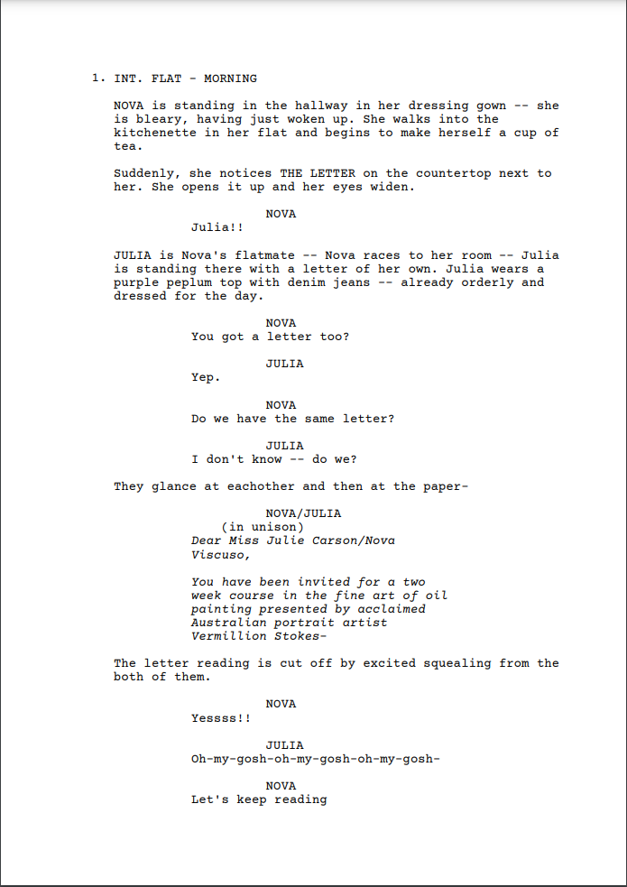

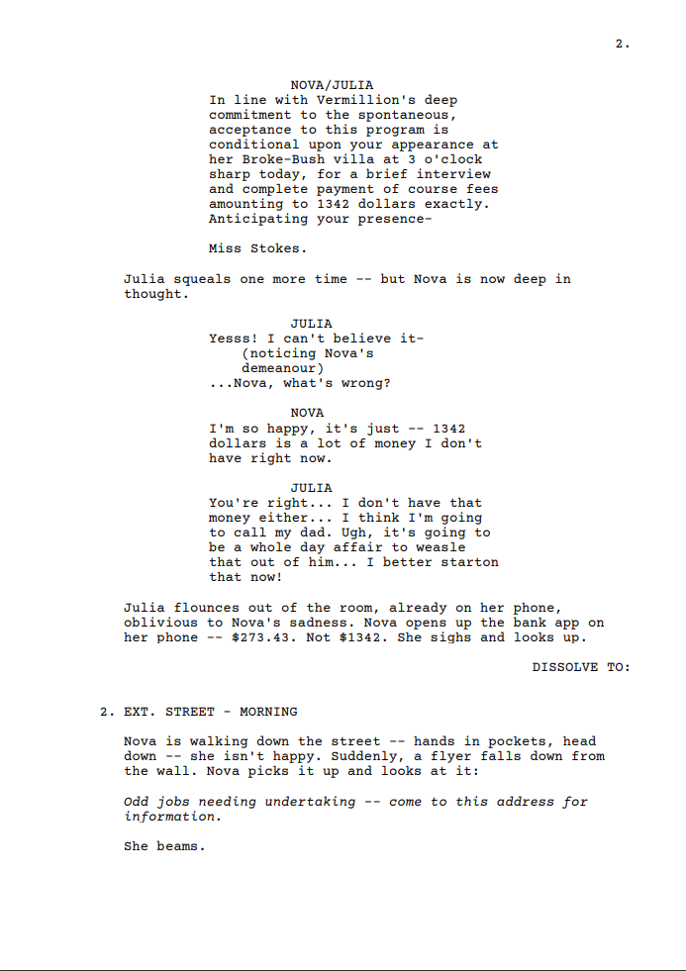

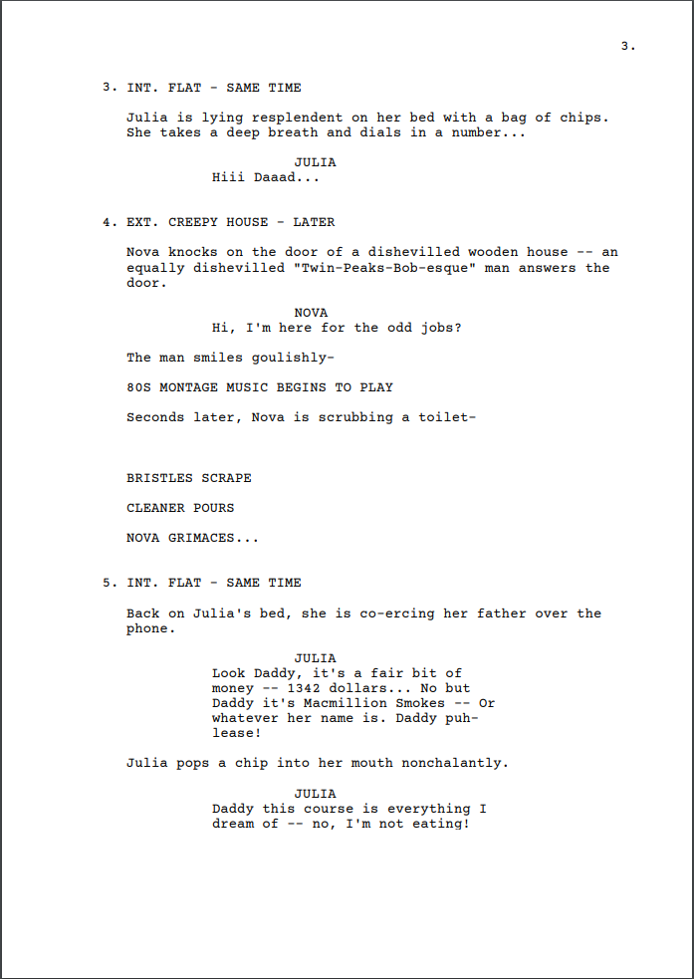

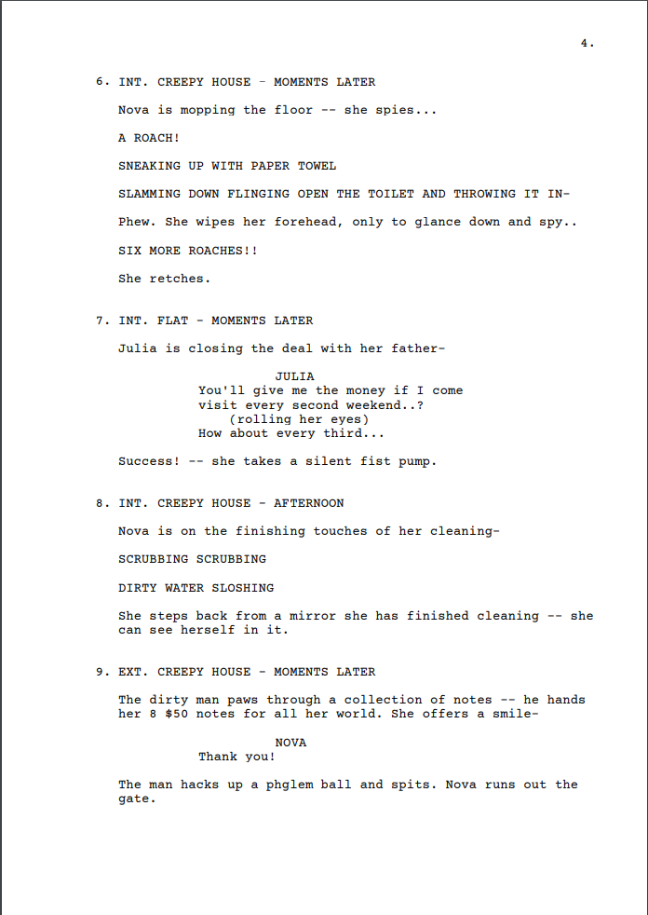

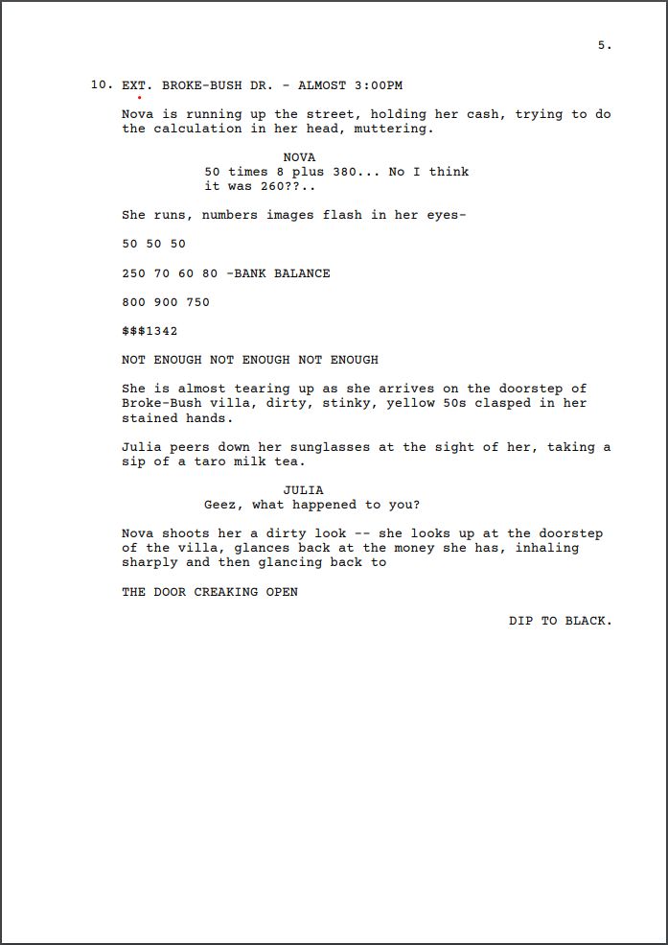

## Edwards Scissorhands Character in landscape analysis grid

**The study of Sign, Symbols, Semiotics: Meaning**

|  |  |  |
| --- | --- | --- |
| **ITEM** | **DESCRIPTION (what you see/hear) EXAMPLES from EDWARD’s WORLD** | **ANALYSIS (MEANING for AUDIENCE)** |
| **LIGHTING** |  |  |
| **COLOUR** | • | • |
| **CAMERA MOVEMENT** |  |  |
| **SHOT COMPOSITION /FRAMING** |  |  |
| **SOUND**  (Diagetic and Non Diagetic) |  |  |
| **EDITING** |  |  |
| **SEMIOTICS**  (symbols and signs) |  |  |
| **COSTUME** |  |  |
| **LANDSCAPE** |  |  |
| **DRAMATIC ACTION** |  |  |

## Shotlist template

Film title:

Student names:

| **Shot number** | **Interior (I)**  **Exterior (E)** | **Shot type** | **Camera angle** | **Camera movement** | **Audio** | **Description** |
| --- | --- | --- | --- | --- | --- | --- |
|  |  |  |  |  |  |  |
|  |  |  |  |  |  |  |
|  |  |  |  |  |  |  |
|  |  |  |  |  |  |  |
|  |  |  |  |  |  |  |
|  |  |  |  |  |  |  |
|  |  |  |  |  |  |  |
|  |  |  |  |  |  |  |
|  |  |  |  |  |  |  |
|  |  |  |  |  |  |  |
|  |  |  |  |  |  |  |
|  |  |  |  |  |  |  |

## Sample student shotlist excerpt

| **Shot number** | **Interior (I)**  **Exterior (E)** | **Shot type** | **Camera angle** | **Camera movement** | **Audio** | **Description** |
| --- | --- | --- | --- | --- | --- | --- |
| **1** | EXT | Wide | Up | none | yes | Opening Shot: Wide shot of Sydney Park jogging amidst the greenery. Multiple unique shots of Finn running from different angles. |
| **2** | EXT | close up | down | up | yes | Close-up of character squinting as the sun glares in his eyes, indicating the heat. |
| **3** | EXT | close up | down | Up | Yes | Close-up of the character's disappointed expression as he realizes his water bottle is empty. |
| **4** | EXT | medium shot | Up | With character | Yes | Medium shot of character spotting a water fountain and running towards it. |
| **5** | EXT | close up | Down | Down | Yes | Close-up of the character reaching the water fountain, only to be interrupted by another boy. |

## Reflection questions template

**UNIT: Yr 10 Design & Media: FILM STUDIES Production Design Reflection**

**Who was in your group?**

|  |
| --- |
|  |

**How did your group come up with your idea?**

Discuss how your group controlled a space for use as a set or location in a film or video production by designing, selecting and/or arranging props and other visual elements.

**Give specific scenes. What was your desired effect?**

|  |
| --- |
|  |

**Discuss how your group used SPARK in your piece - how did you have to style, were there any considerations about how this “spark” was achieved?**

|  |
| --- |
|  |

**Discuss how your group set the visual mood for a film or video production by controlling natural and artificial lighting. Give specific scenes. What was your desired effect?**

|  |
| --- |
|  |

**What elements worked well in your pre-production phase? Who in your group crafted the screenplay?**

|  |
| --- |
|  |

**What worked really well in your production / filming process?**

|  |
| --- |
|  |

**What worked really well in your final edit? Who in the group did the final cut?**

|  |
| --- |
|  |

**What was a challenge in your process?**

|  |
| --- |
|  |

**How did your group manage this challenge?**

|  |
| --- |
|  |

**What were the edits / feedback you got from the teacher or peers in the class? How did you go about using this feedback to enhance your piece? Give details.**

|  |
| --- |
|  |

**What could be improved in your final piece if you had more time or could re-shoot any aspect of it?**

|  |
| --- |
|  |

**What is one important lesson you have taken away from this particular film task - please add one technical/cinematic element and one collaborative element.**

|  |
| --- |
|  |

*Well done and thanks for your film!*

## Sample student reflection

**UNIT: Yr 10 Design & Media: FILM STUDIES Production Design Reflection**

**How did your group come up with your idea?**

A few months ago, I watched a short film called Extinguished and I thought it was incredible. It was about this guy who liked a girl and when he felt this feeling a fire set off in his chest. The idea of a physical thing showing one's feelings is so cool to me, so when I heard we had to use spark in our piece I got excited and immediately decided I wanted to take inspiration from that short film. Instead of having a fire go off in someone's chest I wanted an actual physical spark to represent the sparking feelings between two people.

**Give specific scenes. What was your desired effect?**

Because we were using sparks/fire, we had to go through many safety precautions. I did this before production by scraping some of the flammable stuff off of the sparkler so that when it was on the actor's hand it would not burn down all the way and burn him. This controlled the production of the film as we could make sure that our actors were safe whilst we created a cool effect. In the scene where you see Taylan’s hand spark on fire, I did not want to use digital effects whilst editing as I thought it would not be realistic enough so by using an actual sparkler I could create a much more realistic spark and then add onto this and enhance it later on in editing using digital effects and sound.

**Discuss how your group used SPARK in your piece - how did you have to style, were there any considerations about how this “spark” was achieved?**

I used spark in my film both physically and internally as the physical spark represented the feelings of a character and the spark between relationships. By using digital effects and real time sparkler props, I achieved this to enhance the emotion of the film. I liked the idea of having a physical spark represent the internal spark.

**Discuss how your group set the visual mood for a film or video production by controlling natural and artificial lighting. Give specific scenes. What was your desired effect?**

The mood of this film is very down and inspirational. I achieved this by specifically choosing locations that could enhance this mood. Filming on the train is such a good setting for these kinds of films as there are many ways you can shoot specific angles and place the actors. I tried to make sure that every scene on the train was interesting in some way. I would have the actor be in a moody position looking out the window at the landscape, or I would shoot the shot using natural frames. I would do this by positioning the camera and shifting its focus to create interesting ways of viewing the scene.

**What elements worked well in your pre-production phase? Who in your group crafted the Screenplay?**

I crafted the screenplay along with all the other pre-production documents. This works very well for me as I like to have everything planned out and drawn up way before I actually film, maybe even a few months before. This way I can think about all the outcomes and challenges that I might have to face throughout the process. The most useful document that helped me during the filming was the screenplay as I could refer to my shot types whilst filming on the day.

**What worked really well in your production / filming process?**

Something that I really did not expect to find worked well was having someone to help me with props and behind the scenes stuff. Just having someone there to help light the sparkler saved so much time as well as holding the actor’s stuff whilst filming. This worked incredibly well as they suggested ways to make the filming process easier and less stressful for me. For example, Nika would light the sparkler so that I would not have to and I could be ready in position to film. It worked really well to have another pair of eyes on the situation and help out in case of an issue.

**What worked really well in your final edit? Who in the group did the final cut?**

I relied quite a bit on sound in my film so editing was a very crucial stage. I was a little worried it would be a bit confusing but it turned out that the sound really worked with what I had filmed. I edited the entire film structure first including effects and then I added the film in last. The difference that sound made to my film was incredible as it really pulled the film together and added such a large emotional aspect to it.

**What was a challenge in your process?**

A challenge that appeared when I was editing and reviewing the footage was that the sparkler was not as bright as when I tested it at home. Because we were outside at 6:30am it got quite bright outside so when looking at the footage, the sparkler did not appear to be as bright as I wanted. Along with this, I wanted to have scenes on the trains where there was a spark but we could not light a sparkler on the train as it could be a danger to the public and we would've gotten kicked off.

**How did your group manage this challenge?**

This is where sound became my hero. By using the sound of electrical sizzling and fire crackling, I could overcome this challenge and show that a character is sparking with reaction shots and distinctive sounds. By layering the sounds and then visual effects, I overcame this challenge and did end up achieving what I was going for.

**What were the edits / feedback you got from the teacher or peers in the class? How did you go about using this feedback to enhance your piece? Give details.**

When I showed the actors the edit of the film where there was no sound yet, they said it was a bit confusing and suggested that I cut some of the shots down so they look different when the days are being repeated. I did this and moved the frame around so that it would look like a different shot each time. When I showed the actors the finished film, they agreed that it was much better this way and that the sound also helped the film come together and make much more sense than before.

**What could be improved in your final piece if you had more time or could re-shoot any aspect of it?**

I would re-shoot the scenes on the train. I would move the camera closer to the sparkler so that it is more obvious and brighter. I could have manipulated the light so that it was brighter as well.

**What is one important lesson you have taken away from this particular film task - please add one technical/cinematic element and one collaborative element.**

I have learned how important sound is in a production as well as visual effects. I think from now on I will challenge myself to add even more visual effects into my film. I will also continue to have someone on set with me to help out almost like an assistant director of sorts to look at things from a different perspective and help out with props.

*Well done and thanks for your film!*