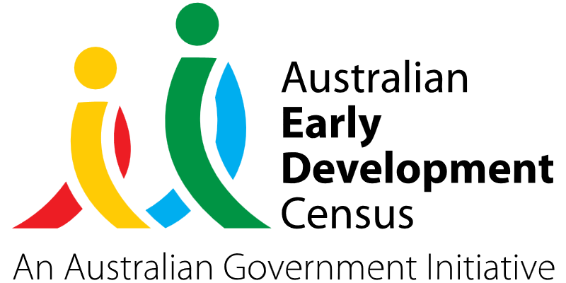
Ready, Set, Go! Program

Rockdale Public School

About the community
Rockdale is a suburb in southern Sydney NSW. It is located 13 kilometres south of the Sydney central business district and is part of the St George area.
Rockdale Public School is part of a vibrant multicultural community within the Bayside area. The school is culturally diverse, with a population of 369 students, 95% of whom have a language background other than English. The school represents 28 different cultures in the surrounding community and is part of the Rockdale Children and Families Hub, along with multiple health agencies and early childhood settings to support families with transitioning their children into school successfully.

What did the data show?
The Australian Early Development Census (AEDC) is a national measure of early childhood development that is collected at the time children commence their first year of full-time schooling. The AEDC collects data relating to 5 key areas of early childhood development, referred to as ‘domains’. The domains are physical health and wellbeing, social competence, emotional maturity, language and cognitive skills (school-based), and communication skills and general knowledge.
The 2021 AEDC outcomes for Rockdale Public School showed a significant increase in the percentage of children vulnerable on the physical health and wellbeing domain, from 12.5% in 2018 to 21.4% in 2021. In addition, 26.2% of children were vulnerable in one or more domains and 7.1% were vulnerable in 2 or more domains.

Bringing about change
The Ready, Set, Go! Program involved facilitating a playgroup with a play-based educational focus on the Rockdale Public School site. The playgroup was available to children aged 4 to 5 who are to be enrolled in the school, as well as children in the local community with additional needs that would benefit from being part of an in-school playgroup. Sessions were also open to parents and younger siblings.
Allied health professionals attended the playgroup to assist with the early identification of developmental needs and to connect parents and children to services for further support. They were also able to run parent information sessions to provide information about health and wellbeing services in the local area, as well as to provide support and guidance on all aspects of child development.
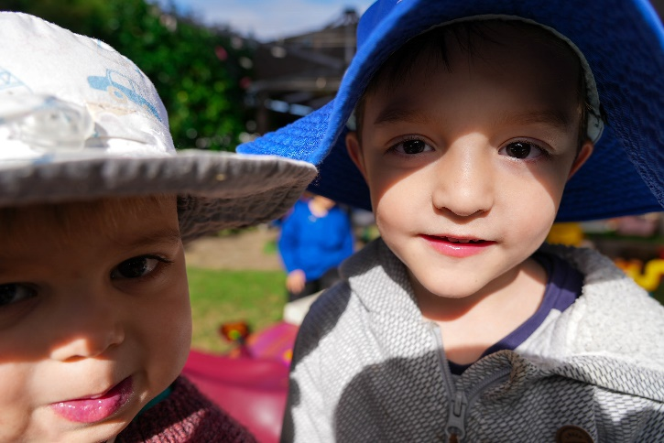
The Ready, Set, Go! Program was intended to provide support across all AEDC domains but with a stronger focus on the physical health and wellbeing, social competence and emotional maturity domains. The playgroup supported children’s physical health and wellbeing through gross motor games and activities, enabled children to participate in age-appropriate mindfulness practice and resilience activities to encourage emotional maturity, and provided opportunities to meet new friends and gain a social understanding of working in groups and with other children to promote social competence.
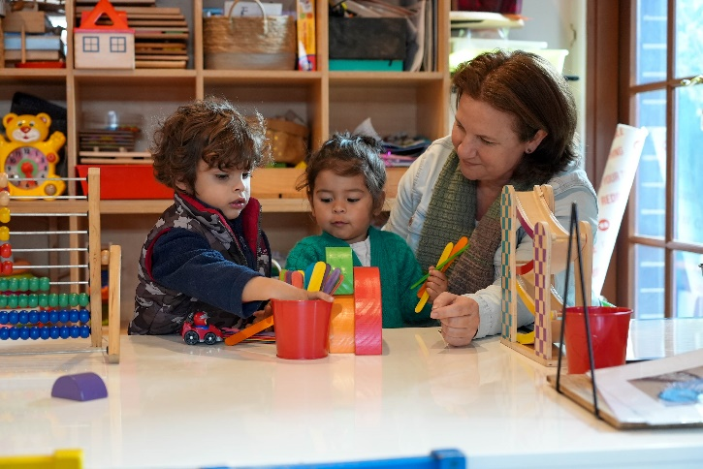

Partnerships
The Ready, Set, Go! Program was delivered alongside the following key partners:
- Project Leader – Kerry Barris
- Rockdale Public School Principal – Amy Ha
- Teacher – Jennifer Power
- Lead of Rockdale Children and Families Hub
- South Eastern Sydney Local Health District
- United Fredrick Street Preschool
- Integricare Rockdale and Integricare Rockdale Plaza.

Achievements
The playgroup run by Rockdale Public School provided a safe place for children to play and learn and encouraged children to make new friends to assist with a successful transition to school. It also provided a network system for parents and families to share experiences and support one another.
The satisfaction and impact of the Ready, Set, Go! Program on the target group of Kindergarten students in 2024 and parents was overwhelmingly positive, as evidenced by the increased uptake of future students attending the playgroup, positive parent feedback and engagement in transition programs.

Looking ahead
To enhance AEDC outcomes for children in the community, Rockdale Public School has recognised the importance of a multifaceted approach centred on better transition through parent engagement. Fostering the active involvement of parents is key due to the crucial role that parents play in their child's early development. Establishing regular communication channels, workshops, and information sessions that include insights into developmental milestones, effective learning strategies and ways to create an enriching home environment will empower parents with the knowledge and skills required to support their child’s educational journey. By strengthening the partnership between educators and parents, Rockdale Public School aims to create a seamless transition for children entering formal schooling, ultimately positively impacting their social and academic outcomes.
Going forward, Rockdale Public School would like to implement orientation programs, mentorship initiatives and community-building activities to foster a sense of belonging for students. The school would also like to provide resources and workshops focused on managing school-related anxiety for both parents and students to contribute to a more confident and prepared entry into the academic environment. By prioritising the emotional wellbeing of students and parents, Rockdale Public School hopes to create an environment where children feel secure, connected, and ready to achieve their social and academic milestones in 2024 and beyond.
For more information, contact the AEDC NSW Project Team:
Phone: 1300 083 698
Email: aedc@det.nsw.edu.au

