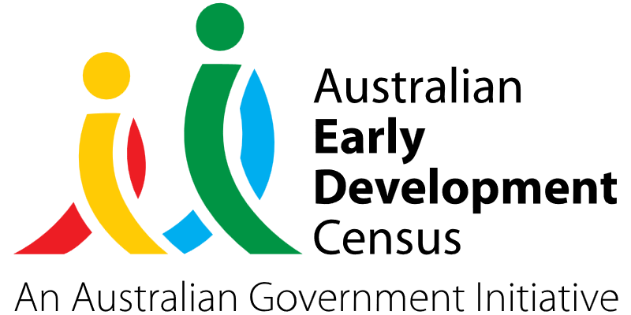
Strong Start to School Program

Kings Langley Public School

About the community
Kings Langley is located 28.3 kilometres north-west of the Sydney central business district, in the local government area of Blacktown City Council.
Kings Langley Public School is a K–6 school with a student population of 660 students. Approximately 26% of students come from a language background other than English, and this percentage has been increasing steadily in recent years.
The school established a Community Hub onsite in 2021 to connect families with school staff, community members and services. There is also a playgroup running at the school that is open to the wider community and has been supported by a trained primary teacher supplied by Kings Langley Public School.

What did the data show?
The Australian Early Development Census (AEDC) is a national measure of early childhood development that is collected at the time children commence their first year of full-time schooling. The AEDC collects data relating to 5 key areas of early childhood development referred to as ‘domains’. The domains are physical health and wellbeing, social competence, emotional maturity, language and cognitive skills (school-based), communication skills and general knowledge.
The 2021 AEDC outcomes for Kings Langley Public School showed significant improvements in all 5 AEDC domains between 2018 and 2021, as summarised in the table below.

Domain | Developmentally on track (2018) | Developmentally on track (2021)
Physical health and wellbeing | 60.9% | 83.1%
Social competence | 59.8% | 76.6%
Emotional maturity | 66.3% | 84.4%
Language and cognitive skills (school-based) | 68.5% | 90.9%
Communication skills and general knowledge | 72.8% | 87.0%

Bringing about change
The Strong Start to School Program aims to work with families and the local community to ensure all students have an equitable and strong start to school. The program targets the identified AEDC priority areas of social competence, emotional maturity, and physical health and wellbeing. It was created in response to observations by school staff that many children were starting school with deficits in social skills and interacting with peers, due to not attending early childhood education and care services during Covid lockdowns.
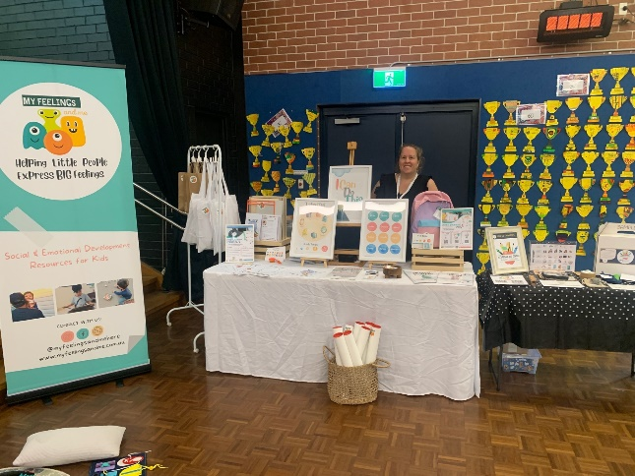
An early childhood expo was held by the school to provide an opportunity for families to connect with community agencies and health organisations, so they could better understand the supports available to provide the best start for children going into school.
An occupational therapist (OT) and speech therapist were engaged as part of the transition to school program to assist with early identification of developmental needs and to support children to build independence. They were present at transition visits, parent events and the early childhood expo to build understanding of age-appropriate skills, provide expertise in supporting students and provide guidance to families in seeking support.
Engagement in small-group programs with a social worker supported students at playgroup to develop age-appropriate social skills, communication skills, and self-help skills. This ensured that students started school with a higher level of social competence and emotional maturity, equipped to successfully navigate the school context. It also enabled school staff to identify students and families requiring support prior to starting school and to offer early intervention services where needed.
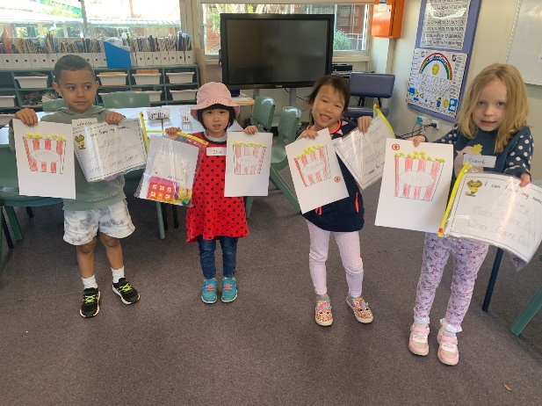
The Ten Busy Fingers Program was also run by the school to help children develop their fine motor skills in the year before school. The program encourages scissor work, pencil holding, colouring, and left to right tracking to help children build up the strength in their hands so they are ready to read and write when they start school.

Partnerships
Kings Langley Public School worked in conjunction with their onsite Community Hub, allied health professionals (including occupational therapists, speech therapists and a social worker), local early childhood services and teachers at the school to deliver the Strong Start to School Program.

Achievements
The early childhood expo held by Kings Langley Public School had 15 agencies and over 50 families visit, connecting children aged 0 to 8 years old with support from NDIS, speech therapists, occupational therapists, Scouts, social workers, Wesley Mission, the local council, day care services, playgroup and the school. Twelve families joined the Ten Busy Fingers Program which also enabled educators to identify students requiring additional support and refer families to the right connections within the community. The school’s playgroup focusing on positive play, physical activity and social skills has grown significantly. Initially there were only 2 families at initiation, but now 15 families each Thursday and 12 families each Tuesday are supported by the program.
The social worker visits to playgroup enabled families to see activities designed to support social and emotional skills development in action. By providing families access to speech and occupational therapists, this gave families the opportunity to get initial feedback and referrals for their children should further assistance be required. Early childhood health checks were also set up at the school through NSW Health which established the school as a central hub for families from birth through to 8 years old to identify and meet the needs of children in their early years.
Educators have seen many children grow in confidence and skills, ready to enter school in 2024, whether that be at Kings Langley Public School or other schools in the community. The school has been able to successfully identify students with additional needs, offer pathways to early intervention, and build strong connections with families and networks with agencies throughout the local community.
One of our Kindergarten teachers was given time off class to visit 3 of the main feeder preschools. She ran 4 school readiness sessions at each preschool.
At the first orientation visit (6 months prior to starting school) we gave each student a fine motor pack that our OT and teachers put together. These packs included modelling clay, a threading activity, a spinning top, a laminated name card for students to trace, and a list of suggested activities to build fine motor strength.

Looking ahead
Kings Langley Public School plans to continue their current programs and hold another early childhood expo next year. The school will also continue focusing on creating and strengthening interagency relationships to ensure the needs of all families are met.
For more information, contact the AEDC NSW Project Team:
Phone: 1300 083 698
Email: aedc@det.nsw.edu.au

