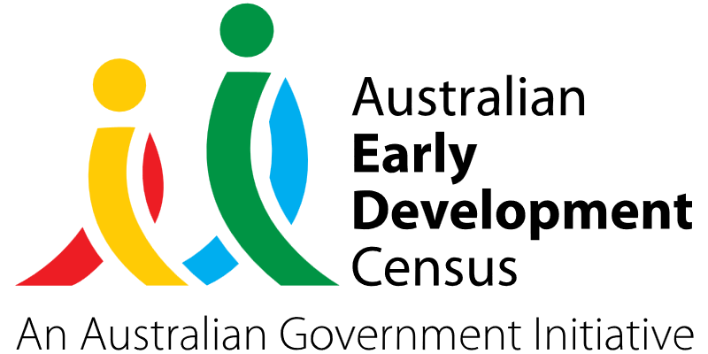
Self-Publishing for children – children as author, illustrator, subject

Garfield Street Children’s Centre

About the community
Five Dock is a suburb in the inner-west of Sydney, located 10 kilometres west of the Sydney central business district. It is in the local government area of the City of Canada Bay.
Garfield Street Children’s Centre operates a 60-place Long Day Care centre in Five Dock, catering for children aged 0 to 5 years.

What did the data show?
The Australian Early Development Census (AEDC) is a national measure of early childhood development that is collected at the time children commence their first year of full-time schooling. The AEDC collects data relating to 5 key areas of early childhood development referred to as ‘domains’. The domains are physical health and wellbeing, social competence, emotional maturity, language and cognitive skills (school-based), communication skills and general knowledge.
The 2021 AEDC outcomes for the Five Dock local community showed a significant decline in the percentage of children on track in the social competence domain (from 90.7% in 2018 to 79.4% in 2021), emotional maturity domain (from 89.9% in 2018 to 81.4% in 2021) and the communication skills and general knowledge domain (from 86.8% in 2018 to 77.3% in 2021).

Bringing about change
The ‘Self-Publishing for children’ project was created to empower children to express their ideas using information and communication technology, as well as different art processes. It promotes children to be active agents in the processes of reflection, planning and communication and helps them develop capabilities in both working cooperatively with others and independently.
Resident artists, authors and photographers were invited to Garfield Street Children’s Centre to share their skills and experiences with children and provide mentoring and guidance. As part of the project, children were supported to create books that were printed and shared with their families and the broader community through street libraries, local council libraries and other services.
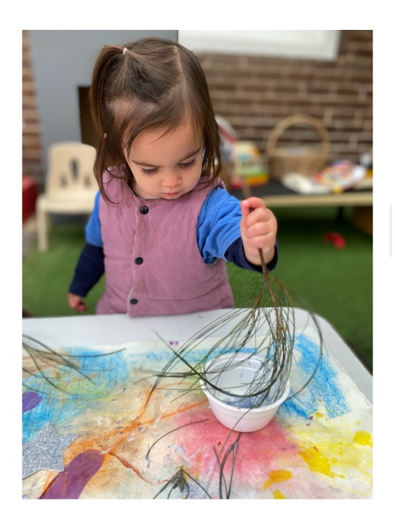
This provided the opportunity for children to read material published by other children and enabled the completed publications to benefit others. The series of self-published books covered different genres such as fiction, non-fiction, rhyme and social learning stories. They reflected children's interests, goals, experiences and community connections.
The books built on children's current capabilities through engaging with familiar technologies such as smart phones and tablets as well as drawing, painting, collage, and nature play.
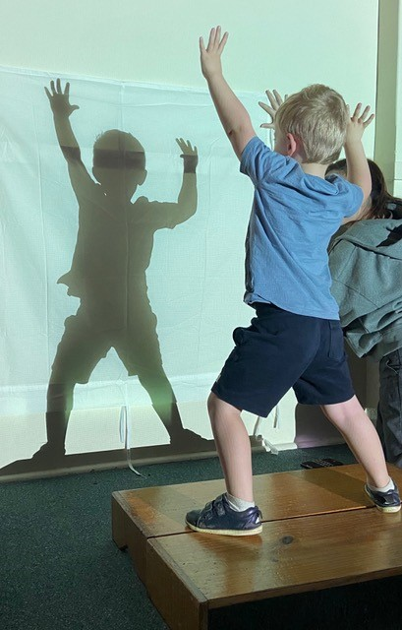

Partnerships
The ‘Self-Publishing for children’ project involved collaborative partnerships with local artists, including Aboriginal and Torres Strait Islander artists from the community. Partnerships were also developed with local businesses and professional services such as local printers and libraries, allied health professionals and organisations. Project partners included:
- Rose Colbeck – local artist
- Eleanor Clapham – local musician
- Gleebooks
- Ronojoy Ghosh – local artist
- Lutfi Hady – local photographer
- Georgia Freebody – local artist, therapist, facilitator
- Uncle Jimmy Smith – local Elder
- Boori Monty Pryor – author, performer
- Jasmine Seymour – author, illustrator, Darug Custodian
- Staff from The University of Sydney
- Five Dock Library
- The Familyworks Pty Ltd management
- Garfield Street Children's Centre Parent Committee

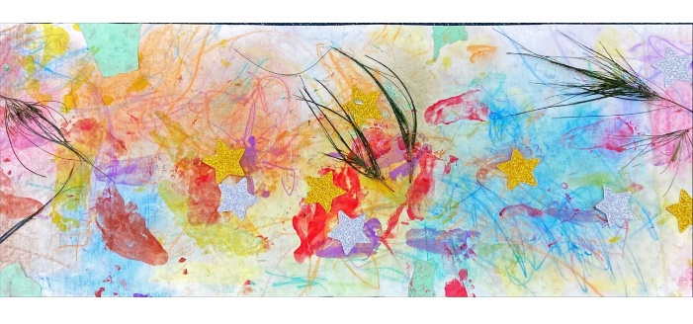

Achievements
The ‘Self-Publishing for children’ project has increased the ability of children to self-reflect and express their feelings, ideas and needs in positive ways. It supported children to learn new skills, broaden their knowledge and connect with others through the sharing of experiences.
All children were able to participate and contribute due to the multimodal nature of the project. Beyond creating, they also learned to reflect and critique their own work and the work of others. Children were supported to use the language of the relevant media mode such as art, movement, photography, mapping or music.
The project had positive impacts on emotional and mental wellbeing, giving children a sense of empowerment, recognition, belonging and identity. Children were noticeably more relaxed as they immersed themselves in exploring a range of materials and processes in a safe and supportive yet stimulating learning environment. Social skills improved as children shared spaces, resources and ideas with each other and collaborated to create stories and art together. Children's literacy development (language and cognitive skills) was also developed by engaging with media to express meaning, convey messages and exchange ideas.
Educators reported feeling inspired to see the greater potential of multimodal meaning-making for children’s learning and communication and began reflecting on their own teaching practices to support this. They also recognised their own positions as co-learners and participants in the learning experiences led by the arts and community partners involved in the project, including Elders, artists and performers.

Looking ahead
Going forward, Garfield Street Children’s Centre would like to continue what the service has learned from the ‘Self-Publishing for children’ project by engaging the children with digital technologies such as animation and augmented reality to support continued storytelling.
For more information, contact the AEDC NSW Project Team:
Phone: 1300 083 698
Email: aedc@det.nsw.edu.au

