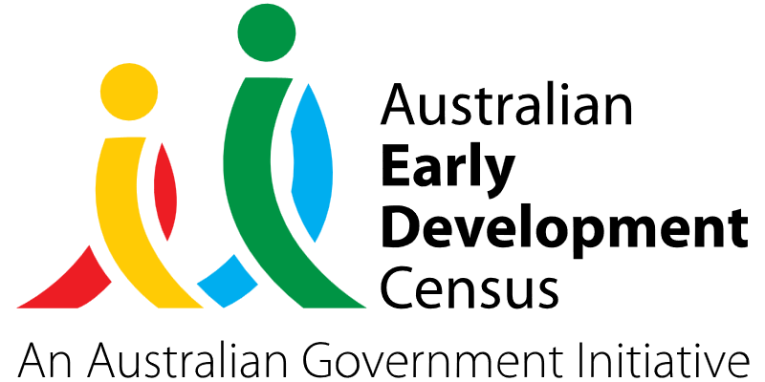
Allied health support playgroup

Chester Hill Neighbourhood Centre

About the community
Chester Hill, a suburb of the City of Canterbury-Bankstown local government area, is located 25 kilometres west of the Sydney central business district in NSW.
Chester Hill Neighbourhood Centre is a community centre providing a wide range of services to children, youth, families and older people living in Bankstown and surrounding suburbs such as Chester Hill, Villawood, Sefton, Yagoona and Bass Hill. These services include parenting programs, early intervention, youth and family services, emergency relief, Out of School Hours (OOSH) childcare, vacation care and respite care, aged care and volunteer programs, Chester Hill Community Garden and garage sales.
Chester Hill Neighbourhood Centre currently runs one supported playgroup aimed at children aged 0 to 5 years every Monday and Thursday to support children’s development to enable their effective transition to school.

What did the data show?
The Australian Early Development Census (AEDC) is a national measure of early childhood development that is collected at the time children commence their first year of full-time schooling. The AEDC collects data relating to 5 key areas of early childhood development referred to as ‘domains’. The domains are physical health and wellbeing, social competence, emotional maturity, language and cognitive skills (school-based), communication skills and general knowledge.
The 2021 AEDC data outcomes for the Bankstown community showed significant increases in the percentage of children vulnerable in one or more domains (from 23.5% in 2018 to 26.5% in 2021) and the percentage of children vulnerable in 2 or more domains (from 11.1% in 2018 to 13.6% in 2021).
The Bankstown community also had higher rates of developmental vulnerability across all domains compared to NSW averages, as summarised in the table below.
Developmentally vulnerable in 2021 | Bankstown | NSW
Physical | 12.3% | 9.4%
Social | 11.4% | 9.4%
Emotional | 7.7% | 7.3%
Language | 9.1% | 6.2%
Communication | 12.4% | 8.4%

Bringing about change
Educators at Chester Hill Neighbourhood Centre recognised that many families were not aware of services such as speech therapy, occupational therapy, nutritionist support and family intervention services. There were also extensive wait periods for community health services in the local area and financial barriers which prevented many families from accessing these services privately.
Chester Hill Neighbourhood Centre developed the ‘Allied health support at playgroup’ project to help families access allied health support earlier in a familiar and non-clinical environment through their already established supported playgroups.
Under the project, a speech therapist and an occupational therapist attended both playgroups (0 to 3 years and 3 to 5 years) on a fortnightly basis to discuss early intervention and developmental milestones with parents, as well as provide strategies on encouraging early speech and enhancing motor skills. During the sessions, therapists also had an opportunity to focus on individual children and discuss any areas of concern with parents or carers.
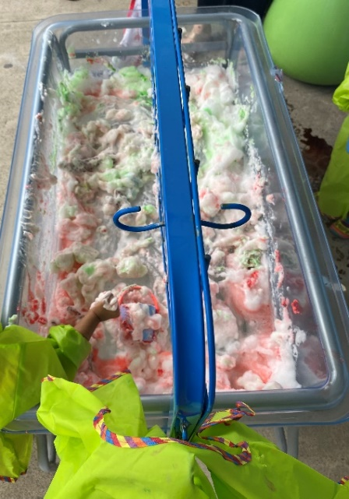
A nutritionist attended monthly playgroup sessions to focus on topics such as having meal preferences, healthy lunch boxes, snacks and family healthy meal planning. The project also utilised the support of a family worker to focus on specific areas of child and family wellbeing, positive behaviour strategies, accessing community support and emotional development.
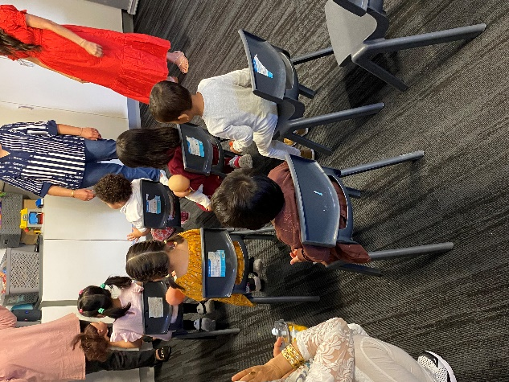

Partnerships
The ‘Allied health support at playgroup’ speech therapy, occupational therapy and nutritionist sessions were planned based on discussions with a program coordinator, parents and carers, and other local service providers. Referrals were sought from local schools, childcare operators and other playgroup providers, and any disadvantaged families identified or referred were prioritised for available support services.

Achievements
Since the ‘Allied health support at playgroup’ project commenced, Chester Hill Neighbourhood Centre has experienced an increase of approximately 5 to 7 children regularly attending the playgroup sessions. These new children joining the playgroup mostly came from word of mouth, as well as referrals from other services and community hubs in the local area.
Positive feedback was received from parents, who reported receiving helpful advice from the therapists and observing significant improvements in their child’s speech and physical development. Parents appreciated the regular interactions with allied health professionals and felt that the information and individual support offered by speech therapists, occupational therapists and nutritionists at the playgroup sessions provided valuable insights to follow up further therapy or undertake tasks at home with their child.
As a result of staff working closely with therapists during the playgroup sessions, they became more confident in identifying the initial needs of children. Staff increased their awareness of services families could access in the community and developed a better understanding of how to plan activities that encourage communication and fine motor development in children. Educators also gained valuable experience in managing conversations with parents about their child’s development and nutritional needs and worked closely with therapists on activities such as identifying nutritional snacks, having meal preferences, developing games to encourage communication and tips on self-regulation for children that will be incorporated into playgroup planning for the years ahead.

Looking ahead
Chester Hill Neighbourhood Centre would like to run an ‘It Takes Two to Talk’ program by The Hanen Centre in the future, which is a program promoting communication development in preschool children with language delays.
Based on modelling and seeking opportunities for communication between caregivers and children, Chester Hill Neighbourhood Centre would like to tailor the program for their culturally and linguistically diverse community and utilise speech therapy students to have a more hands on approach to the program.
In response to interest from other school-based playgroups to access similar sessions from allied health professionals, Chester Hill Neighbourhood Centre would also like to create an outreach model that would assist other families in the Bankstown area.
For more information, contact the AEDC NSW Project Team:
Phone: 1300 083 698
Email: aedc@det.nsw.edu.au

