HSC Music 2 Stage 6 – music of the last 25 years (Australian focus)
‘[A]part 1’ by Ellen Kirkwood
Contents
Rationale 3
‘[A]part 1 by Ellen Kirkwood 4
Who is Ellen Kirkwood? 6
Activities 7
Musicology 7
Aural and musicology 7
Activity 1 – first observations 7
Activity 2 – melodic dictation 8
Activity 3 – score reading 9
Performance and composition 12
Activity 1 12
Activity 2 12
Aural and musicology 13
Listening guide 13
Musical features 23
Activity 1 – a condensed analysis 23
Activity 2 – music for social commentary 24
Composition – methods of composing 25
Additional resources 26
Answers 27
Musicology 27
Aural and musicology 28
Activity 1 – first observations 28
Activity 2 – melodic dictation 28
Activity 3 – score reading 29
Additional information 35
Differentiation advice 35
Support and alignment 36
Evidence base 38
References 39

Rationale
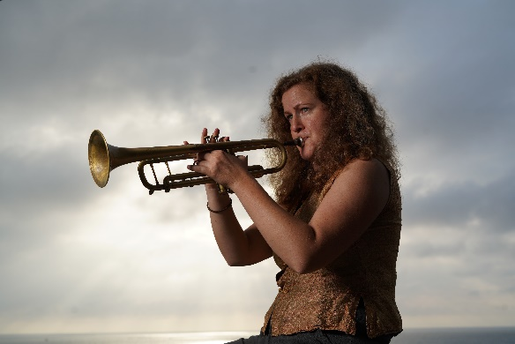
Image by Andy Baker © Andy Baker (2024) and reproduced with permission.
This educational resource has been prepared for students studying the NSW Higher School Certificate Music 2 course as part of the mandatory topic ‘Australian Music of the Last 25 Years’. It is comprised of a 56-minute suite for Sirens Big Band titled ‘[A]part’ (2017) written by Australian composer Ellen Kirkwood. This work was funded by Australia Council and performed by Sirens Big Band who are passionate about increasing gender diversity in jazz through their predominantly female and trans line-up. Ellen Kirkwood, a member since Sirens’ formation in early 2010, has been an important contributor to the group’s unique repertoire.
This resource focuses on part 1 of the work which is titled ‘[A]part 1 – The Internet: wonder and malignance’. It contains a variety of aural, musicology, performance, and composition activities suitable for study. Scores, worksheets, and answers for the teacher are also included. The activities contained in the resource provide students with opportunities to explore the musical concepts and compositional techniques that Kirkwood has utilised to represent the context of the work. Class performance activities are integrated to develop performance and score reading skills, and to further explore the compositional devices used in the work. A listening guide is included for score study, in addition to guided aural and musicology activities. Teachers should adapt these learning resources for their own teaching and learning context.
If you would like to provide feedback on this resource, please email CreativeArts7-12@det.nsw.edu.au.

‘[A]part 1 by Ellen Kirkwood
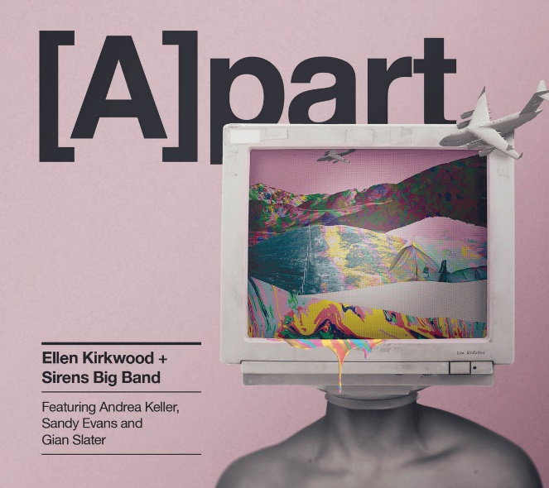
‘[A]part album cover’ image by Monica Higgins © Green Peas for Breakfast (2024) and reproduced with permission.
[A]part is a 56-minute, 4-movement suite written for the 13-piece Sirens Big Band and featured soloists Andrea Keller (piano), Sandy Evans (saxophones) and Gian Slater (vocals). This piece is Kirkwood’s response to growing issues in a rapidly changing world such as the wonder and malignance of the internet, the refugee crisis, greed and climate change:
There’s a lot of different ways music and the arts in general can engage with issues and hopefully help people to reflect upon them or at least think about them a little bit differently. (Kirkwood, 2017)
Although the instrumentation and overall aesthetic is within the realm of contemporary jazz, [A]part reflects a diverse array of styles and influences including neo-classicism, chorale, Afro-Cuban, electronic and metal. Kirkwood’s imaginative and daring composition style draws listeners in with her narrative-style writing, full of character, feeling and unexpected twists. Listeners can expect a journey through music that evokes rage, bewilderment, calm, determination, and everything in between.
[A]part was penned in 2016 to 2017 during Kirkwood’s Australia Council funded composition mentorship with composer/pianist Barney McAll. [A]part was a 2018 finalist in the APRA Art Music Awards for Jazz Work of the Year, and Kirkwood was a finalist in the 2017 Freedman Jazz Fellowships largely due to this work. Kirkwood was the winner of the 2019 NSW APRA Art Music Award for Jazz Excellence, on the strength of [A]part and other activities in 2018. The studio-recorded album of [A]part was released in October 2018 on Earshift Music and launched with performances at the Wangaratta Festival of Jazz and Blues and the Sydney International Women’s Jazz Festival.
[A]part consists of 4 movements:
- [A]part 1 – The internet: wonder and malignance (11:44)
- [A]part 2 – On the refugee crisis (14:40)
- [A]part 3 – Greed and climate change (13:24)
- [A]part 4 – The present: reflections and reactions (16:31)
This resource will focus on Part 1 of the [A]part suite titled ‘[A]part 1 – The internet: wonder and malignance.’
Adapted from ‘Ellen Kirkwood projects’ by Ellen Kirkwood, accessed 20 January 2024.
Score distribution permissions for Curriculum Secondary Learners, Curriculum and Reform Directorate of the NSW Department of Education have been granted by @ Ellen Kirkwood (2023).

Who is Ellen Kirkwood?
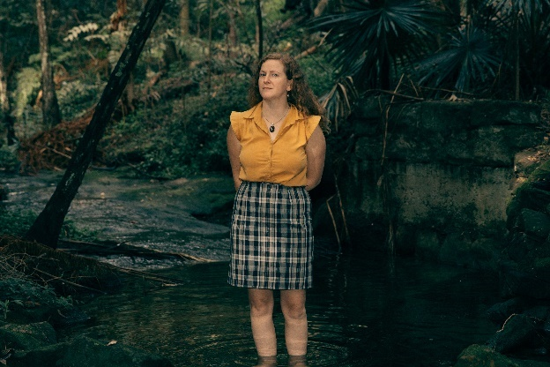
’29 Underwards’ image by Noni Carroll © Noni Carroll (2024) and reproduced with permission.
Ellen Kirkwood is an award-winning composer, trumpeter, band leader and educator. She was born on Biripi Country on the mid-north coast of NSW and is of British and Irish heritage.
She completed a Bachelor of Music, majoring in Jazz Performance, at Sydney Conservatorium in 2008, and completed an Honours in composition at UNSW in 2020, receiving the grade of 1st Class. Kirkwood was the 2019 winner of the NSW APRA Art Music Award for Jazz Excellence, and the 2012 Jann Rutherford Memorial Award for young women in Jazz. She was a finalist in the 2017 Freedman Jazz Fellowships and her one-hour suite for Sirens Big Band and guests, entitled [A]part, was a finalist for Jazz Work of the Year in the 2018 APRA Art Music Awards. She was one of 10 recipients of the 2021 APRA Art Music Fund commission, leading to the creation and recording of 5 works for her group Underwards in 2022. As of January 2024, she has released 4 albums of her original works; ‘Theseus and the Minotaur’ by Captain Kirkwood, ‘I Don’t Care’ by Fat Yahoozah, ‘[A]part’ by Ellen Kirkwood + Sirens Big Band and ‘Delve’ by Underwards. Her works and trumpet performances also feature on many other Australian releases.
Ellen Kirkwood is passionate about promoting gender diversity in the world of jazz. 2016 saw the formation of the Young Women’s Jazz Orchestra (later renamed Spectra Jazz Orchestra); a large ensemble for young women and gender diverse musicians, which she directs. She has also tutored and carried out workshops at various programs around Australia aimed at helping young women and gender diverse people build jazz skills. Another key driver behind Kirkwood’s musical activities is environmental activism. Her interest in the importance of positive relationships between humans and the natural world, and how music can be a way of expressing and strengthening these relationships, led her to begin a PhD in 2023.

Activities
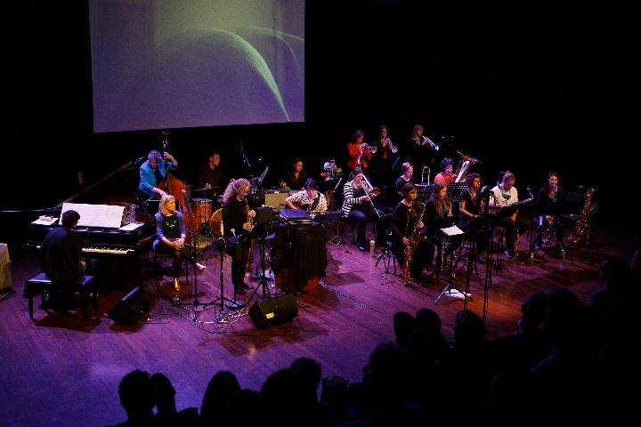
‘Premiere performance of [A]part August 5 2017’ image by Catherine McElhone © Catherine McElhone (2024) and reproduced with permission.

Musicology
- Access Mini Documentary - [A]part by Ellen Kirkwood + Sirens Big Band (9:05) and write down 5 musically-significant points about the work and/or composer Ellen Kirkwood.
- Share and discuss your observations with the class. This can be done in discussion or via a shared digital platform such as Google Jamboard, Padlet or Canva for Education.

Aural and musicology

Activity 1 – first observations
Access the Sirens Big Band (2021) [A]part 1- (11:44) [audio] recording and complete the following activities..
- Listen to ‘[A]part 1 – The internet: wonder and malignance’ and brainstorm any interesting musical observations or first impressions you have of the work using a concept map, Consider aspects of the concepts of music in your observations.
- Kirkwood integrated new music technology into ‘[A]part’ by scoring for AirSticks. The AirSticks are an electronic instrument that allows you to turn your movements and gestures into sounds. The AirSticks are featured throughout ‘[A]part 1’ and can be distinctively heard in the introduction.
Access AirSticks – music, tech and innovation with Alon Ilssar (2:44) and answer the following questions:
- What do the AirSticks allow the performer to do?
- How is sound created by the AirSticks?
- What opportunities do you think the AirSticks provide for performers and composers to create music?

Activity 2 – melodic dictation
Notate the pitch of the vocal melody as heard in ‘[A]part 1’ by Ellen Kirkwood (0:44 – 2:01) [audio]. The melody consists of 4 phrases and has a G tonal centre. This dictation may need to be completed based on intervals rather than tonality. The rhythm and some pitches have been given to assist you.
Phrase 1
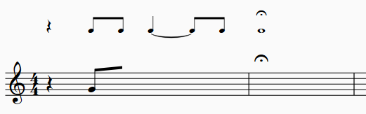
Phrase 2
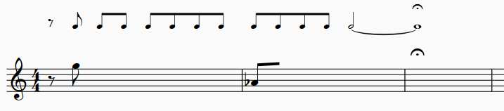

Phrase 3
Phrase 4 (extension)
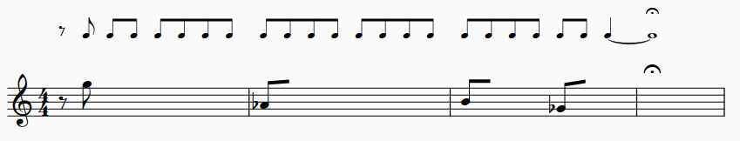

Activity 3 – score reading
- Access the '[A]part 1' by Ellen Kirkwood score booklet (PDF 581 KB). This movement contains 2 sections to be marked on the score:
- Section 1 – ‘Wonder’ (bars 1 to 186)
This section is about how wondrous and promising the internet is. The composer’s own experience of the internet in the 1990s informed the music.
- Section 2 – ‘Malignance’ (bars 187 to 274)
This section is about the sinister or negative content found on the internet including misinformation, fake news, conspiracy theories, cyberbullying and viruses.
- Listen to ‘[A]part 1’ again whilst following the score provided and identify any sections or themes you can hear.

Themes
This piece contains 4 different themes: themes A, B, C and D. The ‘Wonder’ section contains theme A and theme B. The ‘Malignance’ section contains theme C and D. Mark these themes on your score.
Theme A – human chorale
The ‘human chorale' appears several times throughout the entire suite and is a unifying feature of the work. It is found in its original form in ‘[A]part 2’. A score of the original ‘human chorale’ theme is found in the score resource provided and is heard at 11:45 in ‘[A]part 2’. It is considered by Kirkwood to be ‘introspective’ in its meaning, a moment of reflection.
In ‘[A]part 1’, the human chorale is referenced through multiple developments of the original ‘human chorale’ theme stated in ‘[A]part 2’. It is characterised by rich, unexpected harmonies, long, sustained chordal clusters and warm brass timbres which can be identified each time the theme appears. It is often accompanied by a polyrhythmic quaver countermelody, played by the saxophones.
Theme B – canon theme
The first time the canon theme appears is in bar 34 in the piano part. It is then imitated by other instruments such as the guitar, soprano saxophone and trumpet using canon, with the theme shared amongst individual layers. It is played legato and features an ascending, then descending contour. For example:
Piano (bar 34–35)
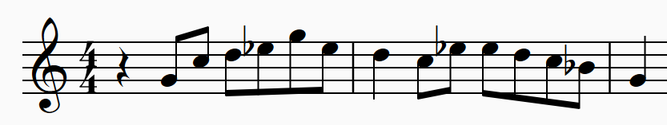
Theme C – staccato theme
The staccato theme first appears at bar 187 and consists of multiple staccato phrases which are imitated and played in pairs using call and response.
Theme D – bass theme
The bass theme is first heard halfway through bar 214 but is made more obvious at bar 226. It is played by the rhythm section and bass instruments such as baritone saxophone and tuba and is characterised by heavy, distorted bass timbres and angular, disjunct melodic lines. Most importantly, it is accompanied by what Kirkwood describes as ‘dancing demons’ horn lines. For example:
Bass (bar 214–219)
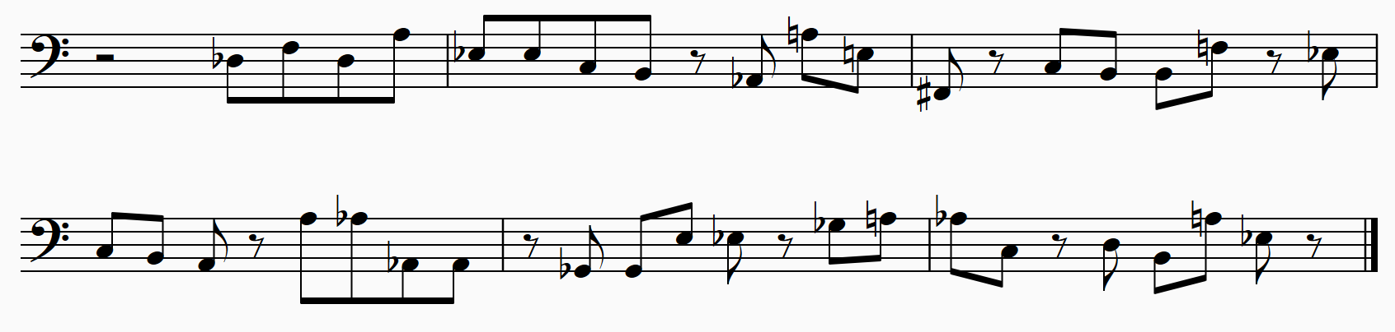
- Answer the following questions:
- With reference to the score and audio, describe the use of duration in bars 1–16.
- Discuss the musical relationships between the instruments in bars 32–51. Refer to the concepts of music in your response.
- How have the concepts of music been used in the improvised piano solo to create unity and contrast?
- Define the following performance directions provided on the score:
Table 1 – performance directions
Bar | Direction | Definition
34 | Pno beat 2
51 | Ad lib cymbals – quaver groupings 3 over 4
112 | Glitchy
122 | Comp under solo, line optional
122 | Groove ad lib
122 | (build thru solo)
138 | 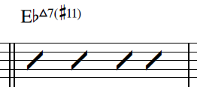
196 | Dirty
- How have the 2 contrasting themes of ‘wonder’ and ‘malignance’ been explored in each section through the musical material? Consider the concepts of music and document your musical observations (including bar numbers) in the table below:
Table 2 – wonder and malignance characteristics
Wonder | Malignance

Performance and composition

Activity 1
Play through each of the 4 themes: A, B, C and D to familiarise yourself with each theme. This can be done individually, in small groups or as a class.
Choose one section of the work to rehearse and perform either individually or as a class. You may like to play along with the recording. Transposition may be required.
Reflection questions:
- How did the duration elements affect your performance as an ensemble?
- Were the harmonies easy to listen to? Is the dissonance effective? Why or why not?
- What did you find challenging about performing this work and why?

Activity 2
Play through the canon theme in unison as a class. Experiment with the arrangement of the layering of parts to create a new canon arrangement. You may also like to add your own accompaniment. Perform to the class.
Reflection questions:
- What was successful and not so successful about your arrangement? Why?
- How did the layering of parts affect your arrangement decisions? Consider the concepts of music in your discussion.

Aural and musicology

Listening guide
Use this listening guide to analyse the musical material and label important features on the score.
The macro structure of ‘[A]part 1’ contains 2 parts:
- ‘Wonder’ – bars 1 to 186 (contains themes A and B)
- ‘Malignance’ – bars 187 to 274 (contains themes C and D)
Table 3 – structure of [A]part 1
Section | Bars | Description
Intro | Bars 1–16 | Free time AirSticks improvisation followed by a chorale like section
A | Bars 17–31 | The ‘human chorale’ (Theme A) is introduced
B | Bars 32–50 | Canon theme (Theme B)
A | Bars 51–66 | Theme A
B | Bars 67–78 | Theme B
A | Bars 79–93 | Theme A
B | Bars 94–121 | Theme B
Solo | Bars 122–145 | Piano improvisation
Bridge | Bars 146–186 | This transition section is based on Theme A and B combined
C | Bars 187–225 | Staccato theme (Theme C)
D | Bars 215–247 | Bass theme with trill accompaniment (Theme D)
Coda | Bars 248–274 | Theme A and Theme C combined
Table 4 – aural and musicology analysis for [A]part 1
Section | Musical material
Intro  Bars 1–16  0:00–2:22 | - This is the beginning of the ‘wonder’ section which concludes at rehearsal marking N.  - The opening electronic sounds are played by AirSticks. This is a reference to the technology theme of the work using ‘digital’ type sounds. Free time and indefinite pitch are evident.  - A G tonal centre is evident however, the tonality is ambiguous.  - At bar 2, a moderate tempo is established, and the melody is stated by the voice, clarinet, tenor saxophone and trumpet using short phrases of 2 or 4 bars. Call and response with the AirSticks are interspersed with both long and regular fermatas to allow for improvisation.  - The section contains dissonant harmonies and is a harmonisation of the melody at letter G. The vocals have the main melodic line, whilst the other instruments provide harmony.  - Unexpected chord progressions and pitch combinations using extended chords are featured in bars 2–16. For example, Bbdim (add2) in bar 3 and 10, Eb (maj7b5) in bar 7, and Bb (maj7b5) in bar 15.  - Mezzo piano dynamic and moderately thin, homophonic texture with the vocals providing the main melodic line.  - The AirSticks employ a range of electronic techniques such as filtering and volume fading of droning tones and noise. This creates changing timbres ranging from airy, whooshing, percussive and dry through sweeping gestures.
Section A  Bars 17–31  2:22–2:49 | - A definite beat and fast tempo of Allegro is established however, the beat appears ambiguous. This is due to the cross rhythm created by the syncopated quaver saxophone line played in groupings of 3 (suggesting 12/8) against the chord tones played by the brass on the beat in 4/4.  - The saxophones play in rhythmic unison using parallel motion and dissonant harmony. They provide a compound feel over the 4/4 time signature. These rhythmic patterns and overlapping of textures represent mindboggling racing tides of information found on the internet.  - The pitches in all parts are adapted from the ‘human chorale’. The musical material consists of 3 bar phrases which contain the following chord progression: Bsus2(b6)/G in bars 17–19, and C7sus2/E in bars 20–22. This chord progression is then repeated before ending on a Cm/Eb into EbM7 in bars 29–30.  - The piano and guitar provide harmonic support playing chord tones in octaves. The absence of drums and bass adds to the rhythmic ambiguity.  - The brass chords in bars 29–30 use a ‘chorale like’ sound and bright timbre. This cadence-like gesture ending on EbM7 chord serves as a segue into section B and defines the Eb major tonality of the next section.
Section B  Bars 32–50  2:49–3:22 | - Eb major tonality (but avoids the 4th). A moderately fast groove is established by the bass and drums with the bass outlining I – V. Kirkwood describes this energetic and repetitive pattern as having a ‘feel good’ mood and represents ‘information torrents.’  - Canonic treatment of the musical material is seen as the new theme is shared amongst parts creating a polyphonic texture. The 2-bar quaver motif is first heard in the piano part and then echoed canonically on guitar, trumpet 2 and soprano saxophone. The entry of the motif occurs on different beats each time it is repeated. The overlapping of textures continues to reference the technological theme with ‘ripples and tides of information’.  - Smooth, legato articulation is used in all parts.  - At bar 43, Kirkwood states that the music ‘glitches’ with fragmentation of 1 beat of the canon motif repeated 4 times. This represents the technological character of the work and suggests the fallibility of technology. The music builds using a crescendo to mezzo forte with accents on the beat.  - At bar 44–46, polyrhythms are reinforced by the lower brass playing a syncopated inner voicing whilst the main theme continues.
Section A  Bars 51–66  3:23–3:52 | - This section is built on the human chorale. The saxophones continue the polyrhythmic quaver lines over the chord tones in the brass.  - Unpredictable, dissonant extended chords and slash chords continue, with A6add9 in bars 51-53 and A7b9/E in bars 54–56. These same chords appear again from bars 57–63.  - Additional bass layers are now added such as the baritone saxophone, tuba, piano left hand and bass playing the bass line seen in section B, but in paired, call and response.  - The drums now play ad lib cymbals using quaver groupings of 3 over 4 which further adds to the rhythmic ambiguity and cross rhythmic effect.  - The overlapping textures and rhythmic patterns create a thicker texture, and the section concludes with the brass section playing sustained semibreves at mezzo piano using highly dissonant tone clusters.
Section B  Bars 67–78  3:53 – 4:14 | - The B section material returns and is developed using a B major tonality with a B mixolydian b6 scale.  - The 2-bar quaver motif is again shared between instruments in canon.  - A new backing figure is added at bar 71 in the alto saxophone, baritone saxophone, trumpet 1 and trombone 1 part to create interest and build energy. This is played in unison and moves in minor and major 2nds, ending in a descending pattern. This contrasts with the main motif which ascends and descends in small leaps of mainly 3rds.
Section A  Bars 79–93  4:15–4:42 | - The A material returns with further development through additional layers.  - The bass line played by the baritone saxophone, tuba, left hand piano and bass is now more prominent as it is now played in unison. The rhythm has been developed further through augmentation and syncopation. For example, bar 82–83 and 86–87.  - A ‘glitch’ moment is seen at bars 83 and 84 when the crotchet rhythm in the saxophone part disrupts the repeated syncopated motif.  - This section also ends with a thinner texture due to the omission of the rhythm section and saxophones. The brass play sustained chords at a mezzo piano dynamic which includes Ebsus4 to EbM7 in bars 91–93.
Section B  Bars 94–104  4:43–5:00 | - The B theme returns very briefly with an Eb tonality before an unexpected change to Gb major in bar 100. This Gb tonic is clearly established by the lower instruments using heavy articulation and a booming timbre.  - Multimetre is featured throughout this section with 6/4, 3/4 and 2/4 evident.  - Tension is created through the use of multimetre, gradual crescendo dynamic, the unexpected modulation to Gb major, and the polyrhythms generated by the layering of parts.
Bars 105–121  5:01–5:30 | - A release of tension is apparent as the piece modulates back to Eb major at bar 105 and the 4/4 time signature is once again established. Kirkwood describes this section as ‘a climactic moment of peak happiness’.  - The B theme continues; however, a new countermelody is introduced in the alto saxophone 2, tenor, trumpet 1, horn and trombone parts. The countermelody consists of 4 phrases which are spaced apart by bars of rest.  - A ‘glitch’ moment reappears at bar 111 to 115 where fragments of the B theme are repeated and accented.  - The multiple layers are woven together to create a highly polyphonic texture with long continuous phrases. Phrases are shaped with crescendos and decrescendos.
Piano solo  Bars 122–145  5:31–6:57 | - Improvised piano solo – dizzying, naïve, full of wonder.  - The chord progression is based on only 2 chords including EbM7(#11) and B7(b13).  - Thin, homophonic texture with the piano providing the melody and the rhythm section providing the harmonic and rhythmic accompaniment.  - The piano solo is highly syncopated and rhythmically complex, demonstrating expressive gestures using accents, crushed notes and flourishing, fast, scalic passages. Repeated patterns and sequences are also evident in the improvisation. A wide range of notes that explore almost the whole upper range of the piano are used in the right-hand melody, whilst the left-hand supports with chordal material.  - The electric guitar deviates from the score, and instead improvises sustained chordal tones using a warm, bright timbre as a light accompaniment.  - The bass and drums continue to provide a steady groove.  - The backing figures at bar 130 played by the saxophones imitate the brass rhythms heard at bar 44.  - As the piano solo progresses, tension is created through a crescendo dynamic and highly dissonant notes choices played by the piano with short note values. The solo concludes with a diminuendo.
Bridge  Bars 146–154  6:58–7:14 | - An Eb major tonality is established as the B melody continues; however, tension is evident through the A in the bass which contributes to the dark timbre and implies an A Locrian scale.  - The Am7b5 chord used in this section (which comes from the Locrian scale) has a dark sound quality as it contains the A diminished triad.  - The dotted crotchet rhythm also adds to the tension and uncertainty.  - Despite momentary returns to the Eb tonality, the A in the bass and the dotted rhythms keep returning until they dominate at bar 155 creating a dark mood. Kirkwood describes it as ‘a bit like a virus spreading’.
Bars 155–166  7:15–7:40 | - A tonal centre and 6/4 time signature.  - Tension is further developed through the cross rhythms created by all instruments. This consists of the dotted crotchet figures in the lower horns, bass and left-hand piano which are layered over the B theme riff continued in the guitar and right-hand piano part; and the sustained chords played by the saxophones and trumpets that are described by Kirkwood as ‘a cry in distress’.  - This section continues to build with the crescendo dynamic and thickening of texture due to the layering of parts and drums implementing ‘smashy’ cymbals to support the dotted crotchet rhythms.  - In bar 160, the A tonal centre in the bass fades away and the ‘human chorale’ returns in 4/4 time. The dynamics get softer, and the texture becomes thinner with the omission of the drums and bass.
Bars 167–186  7:41–8:18 | - This section returns to the 1 bar ‘glitchy’ version of the motif which uses only a fragment of the original melodic material which is then repeated. Kirkwood describes this section as ‘wistful and sad’.  - Unified, rhythmic backing figures performed by the alto saxophone, trumpet, horn and trombone play syncopated crotchets and quaver rests across the beat, which imitates the dotted crotchet rhythms heard previously. This continues to create rhythmic ambiguity through cross rhythm.  - The ‘bridge’ passage at bar 175 consists of the ‘human chorale’ in 5-part orchestration. This serves as a transition into ‘N’ which is the ‘malignance section’. The syncopated rhythms, motifs and glitches are gone resulting in a reflective moment.
Section C  Bars 187–195  8:19–8:35 | - Malignance – this section is representative of viruses, fake news, cyberbullying, conspiracy theories, misinformation and the negative content that has emerged from the internet.  - New musical material (Theme C) is introduced consisting mainly of quavers and semiquavers played on the beat using staccato. The contour of the pitch material is angular and disjunct.  - The tonal centre is ambiguous, and the pitch material is based on the chromatic scale. The tempo is slightly slower than the previous section at moderately fast.  - Some of the instruments work in pairs using call and response. For example, in bars 188–192, the 2 alto saxophones repeat the same 2 bar phrase one after the other. The horn and trombone are also paired and repeat a phrase using call and response. The response layer for each of these phrases is placed on a different beat of the bar.  - The tenor saxophone, and trumpet parts have independent lines to the paired instrument groups. The rhythm section is omitted.  - The layering of parts combined with the short articulations creates a busy rhythmic tapestry.  - At bar 191 the AirSticks return (although the score has them enter at bar 187) playing glitchy high pitched short electronic sounds.
Bars 196–214  8:36–9:13 | - Short, heavy, grunge-like figures are introduced by the baritone saxophone, tuba and rhythm section from bars 196 to 211. These are played in unison and use a range of note values including crotchet triplets and dotted rhythms. The articulation is marked as ‘heaps tenuto’ and ‘dirty’. Kirkwood describes these figures as ‘punchy, angry and badass.’  - The horns continue the 2 bar phrases using overlapping textures and short, light articulation. Kirkwood describes this section as ‘demented and mischievous.’  - The texture is busy and dense due to the multiple independent layers. The bass line is played forte, making it the most prominent musical feature of this section.  - ‘Glitch’ occurs again at bars 209–210 with repeated quavers in most parts using tenutos and accents. The pitch material here is very dissonant with Eb, D, C played in all parts.  - The AirSticks continue to improvise using digital sounds and futuristic space like sound effects.
Section D  Bars 215–225  9:14–9:34 | - A new bass theme is introduced in this section which starts halfway through bar 214. This has similar features to the previous bass figures but is now presented as a longer, continuous phrase.  - The AirSticks continue to improvise using electronic sounds which build in intensity.  - ‘Glitch’ occurs again at bar 220–224 with repeated, angular, disjunct motifs using large leaps of 6ths and 7ths.
Bars 226–247  9:35–10:02 | - The new theme is then repeated in the tuba, guitar and rhythm section parts whilst the drums play a heavy almost metal like drumbeat. The guitar uses some distortion which contributes to the harsh timbre of this section.  - The horns introduce what Kirkwood describes as ‘dancing demons’ horn lines. These figures use crotchets with trills with alternating staccato, tenuto articulation for each note. Jarring intervals including the b2, #4 and minor 3rds contribute to the ‘evil’ mood.  - The horns use a more restricted set of notes with an Ab tonal centre in a scale that Kirkwood created: Ab, A, B, C, D, Eb, F#, G.  - The dynamics are mezzo forte to fortissimo and the texture is thick to emphasise the climactic moment of these section.  - Multimetre including a 2/4 bar is interspersed at the end of each horn phrase with a reduction in texture and drum fill to create interest at bar 225, 231 and 237. An unexpected 3/4 bar is used at bar 247 in the same manner to intentionally create tension.  - A ‘glitch’ moment in 2/4 at bar 238 reflects a ‘villain’ moment. The tritone interval is used in the alto saxophone and horn, whilst the bass parts descend using a semitone followed by a minor 3rd, further enhancing the evil mood.
Coda  Bars 248–274  10:13 to end | - This section sees a dramatic thinning of texture with just the upper saxophones playing mezzo piano ‘demented staccato quavers.’  - From bar 253 the human chorale reappears but is played with rubato (conducted). The chords are voiced closely using low register trumpets and middle register horn, trombone and tuba. Crescendos and decrescendos shape the phrases which each end with a fermata.  - At bar 260 the AirSticks are added playing atmospheric digital sounds that undulate and phase in and out.  - At bar 264 the saxophones return with the staccato phrases heard previously at mezzo piano.  - As the chorale continues, the pitches augment and the dissonant unexpected harmonies persist. The piece ends with a brass decrescendo and the AirSticks use a fade out.

Musical features
‘[A]part 1’ contains multiple musical features. These include:
- tonal ambiguity including unexpected pitch combinations and harmonies that move to unusual destinations
- improvisation
- extended chords and use of modal pitch material
- rhythmic ambiguity derived from cross rhythms, polyrhythms and multimetre
- use of AirSticks to reflect the technology theme of the work
- use of the ‘human chorale’ as a unifying musical feature of the entire suite
- the choice of performing media was determined by the specific ensemble and soloists
- the intent or purpose of the work is a comment and reflection on world issues and is clearly represented through the musical material
- musical choices and decisions designed to reflect the information and technology theme of the work. For example, the overlapping textures and rhythms which are representative of ‘mindboggling tides of information’ and ‘glitching’.

Activity 1 – a condensed analysis
Using the information in the listening guide above and your own analysis, create a condensed analysis of the main musical features of the work and examples using the table below.
Table 5 – condensed musical analysis
Concept | Musical features and examples
Structure
Duration
Pitch
Texture
Tone colour
Dynamics and expressive techniques

Activity 2 – music for social commentary
Music can be a powerful tool for social commentary. From protest songs during the civil rights movement to modern-day anthems addressing social and political issues, artists have used their music to express their thoughts, provoke discussions, and inspire change. Kirkwood’s piece ‘[A]part’ is an example of music written for social commentary.
Choose a work that is an example of music for social commentary and answer the following question in an extended response:
With reference to the concepts of music, how do composers and artists musically communicate their ideas on social issues?
In your answer, make specific reference to ‘[A]part 1’ by Ellen Kirkwood and one other work of your choice.

Composition – methods of composing
Kirkwood used the following methods of composing to compose ‘[A]part 1’. Experiment with how one or more of these techniques may assist you in the development of your own composition. Choose at least one of these methods and apply it to a section or fragment of your core composition that requires further development.
- Building harmonies – Kirkwood wrote a melody first, and then added one layer of pitch underneath it, and continued to add layers one by one until a 4-part harmony was created. She was not concerned with traditional chordal functions or typical chord progressions, but instead, built her own chords based on what she liked the sound of and how each chord moved from one to the next.
Choose a melody or motif from your own piece and apply the same ‘building harmony’ technique to develop or reharmonise your idea.
- Chordal voicing – Kirkwood developed the human chorale material in multiple ways such as voicing the chords differently. She experimented with shifting the registers of individual lines, explored different timbres, and moved the order of notes around within the harmony to achieve contrast.
If you have used chordal material in your core composition, experiment with reordering your notes in each chord to achieve different sounds and colours.
- Canon – Kirkwood used this technique exclusively for Theme B throughout the work.
Choose a melodic idea within your own piece and experiment with canon to develop your theme.
- Tapping into emotions – Kirkwood often creates new ideas by connecting with her own emotions. Kirkwood says ‘much of the music in ‘[A]part’ came from little ‘seeds’ of musical ideas that popped into my head when I was experiencing heightened emotions.’
Create a new musical idea or motif that reflects a particular feeling you have experienced recently.
- Adding layers – One way to create variety and build interest and energy is to add more layers to repeated sections. Kirkwood does this repetitively through ‘[A]part 1’.
Experiment with adding another layer to a repeated section in your piece. How does it change the mood or direction of the piece?
- Melodies with meaning – Kirkwood wrote with a clear purpose in what she wanted to communicate for each section of her work through the themes of ‘wonder’ and ‘malignance’. She found parallels with the expression used to create her thematic material and the intent of each section.
Does your piece communicate meaning or have a theme? How have you expressed this?

Additional resources
Alon Ilsar (2024) AirSticks, Alon Ilsar website, accessed 10 February 2024.
Ford A (20 October 2018) ‘Ellen Kirkwood’s magnum opus’ [podcast], The Music Show, ABC Radio National, accessed 8 February 2024.
Fotakis N (31 October 2018) ‘Ellen Kirkwood: I enjoy writing music that has a story to it’, Australian Jazz, accessed 8 February 2024.
Ilsar A (9 December 2022) 'Airsticks 2.0: instrument providing new possibilities to create music | Alon Ilsar | TEDxSydneySalon' [video], TEDx Talks, YouTube, accessed 10 February 2024.
Kirkwood E (18 October 2018) ‘Insight: The Making of [A]part’, Resonate magazine, accessed 8 February 2024.
Shand J (31 July 2017) ‘Ellen Kirkwood takes on the big issues’, The Sydney Morning Herald, accessed 8 February 2024.

Answers

Musicology
- Access Mini Documentary - [A]part by Ellen Kirkwood + Sirens Big Band (9:05) and write down 5 musically-significant points about the work and/or composer Ellen Kirkwood.
- Share and discuss your observations with the class. This can be done in discussion or via a shared digital platform such as Google Jamboard or Miro.
Answers may include:
- Kirkwood is a composer and trumpeter and wrote a one-hour suite for big band called [A]part.
- The repertoire consists of a colourful blend of traditional jazz as well as other different types of music from around the world.
- Kirkwood learnt from her mentor Barney McAll about where ideas come from, how to develop them and how to experiment with them to develop the work as a whole.
- The work is split into 4 parts and is a comment on the various connections and disconnections that people around the world have with issues such as climate change, the refugee crisis, and the nature of the internet and how it connects and divides us in different ways.
- The first part is about the internet and is split into 2 sections: ‘wonder’ and ‘malignance’. This section is about how promising and wondrous the internet is but also how there is a lot of dodginess and sinister content such as viruses and misinformation.
- The second part is about the refugee crisis. The first section is a reflection as to what it might be like to be a refugee. The second section is an expression of Kirkwood’s rage at the way many refugees have been treated around the world.
- The third part is about greed and climate change. The music comments on the absurd greed of those that deny climate change versus the actual reality of climate change and the huge force and danger of it.
- The fourth part reflects on how we can act upon these world issues.
- Three significant female musicians Sandy Evans (saxophones), Andrea Keller (piano) and Gian Slater (vocals) lifted the piece to a new level with beauty, power and energy through their musical contributions.
- Kirkwood believes that music and the arts can engage with world issues and hopefully help people reflect upon them. She believes we must have hope to mend these issues.

Aural and musicology

Activity 1 – first observations
- Kirkwood integrated new music technology into [A]part by scoring for AirSticks. The AirSticks are an electronic instrument that allows you to turn your movements and gestures into sounds. The AirSticks are featured throughout [A]part 1 and can be distinctively heard in the introduction.
Access AirSticks – music, tech and innovation with Alon Ilssar (2:44) and answer the following questions:
Answers may include:
- What do the AirSticks allow the performer to do?
AirSticks allow the performer to play the drums in space without hitting anything and allows the performer to morph sounds and move them around the room and filter them. It has all the possibilities of a laptop with the physicality of a drumkit.
- How is sound created by the AirSticks?
Game controllers have been repurposed to create sound through moving and gesturing in certain ways.
- What opportunities and challenges do you think the AirSticks provide for performers and composers to create music?
Student’s own response.

Activity 2 – melodic dictation
Please refer to the first page of the score for the melodic dictation answers.

Activity 3 – score reading
- Answer the following questions:
With reference to the score and audio, describe the duration in bars 1–16.
Answers may include:
- The intro performed by the AirSticks is played using free time to allow for the improvised musical material. The rhythmic material here is layered with both long and short note values using rhythmic gestures and free rhythm. There are synth pad sounds which are layered with faster repeated ‘clicking’ sounds which increase and decrease in speed.
- The tempo is marked at a crotchet at 80 which is a moderate speed, and the time signature is in 4/4.
- At bar 2, the vocals, clarinet, tenor saxophone and trumpet enter with the melodic and harmonic material playing in rhythmic unison. Call and response is seen between the AirSticks and the ensemble.
- Fermatas and long fermatas are used at the end of each phrase to allow for the AirSticks to continue with their musical material.
- The beat is difficult to ascertain from bar 2 onwards due to the lack of a strong beat and the use of fermatas.
- Quavers, crotchets and semibreves which include tied notes are used by the melodic and harmonic material. The phrase length duration is from 2–4 bars.
- Rhythmic extension is seen in bars 14–15 as an extension of the rhythm seen in bars 5–6.

Discuss the musical relationships between the instruments in bars 32–51. Refer to the concepts of music in your response.
Answers may include:
- This section is characterised by 3 musical ideas played by groups of different performing media. The canon theme material layered polyphonically, the rhythm section of drums and bass providing the rhythmic and harmonic accompaniment and the brass playing a contrasting theme as harmonic accompaniment.
- Canonic treatment of the musical material is seen as the new theme is shared amongst parts creating a polyphonic texture. The 2-bar quaver motif is first heard in the piano part and then echoed canonically on guitar, trumpet 2 and soprano saxophone. The entry of the motif occurs on different beats each time it is repeated. The overlapping of textures continues to reference the technological theme.
- Smooth, legato articulation is used in all parts which is a unifying feature of this section and is observed by all instruments.
- The bass and drums work closely together to provide the groove with an energetic repeated pattern using light cymbals in the drum kit part and a 1-bar bass ostinato.
- At bars 44–46, polyrhythms are reinforced by the lower brass playing a syncopated inner voicing whilst the main theme continues. This contrasts with the canon theme provided by the soprano saxophone, trumpet, guitar and piano.

How have the concepts of music been used in the improvised piano solo to create unity and contrast?
Answers may include:
Contrast
- The piano solo is highly syncopated and rhythmically complex, demonstrating expressive gestures using accents, crushed notes and flourishing, fast, scalic passages which creates contrast in the rhythmic material.
- A wide range of notes are used in the right-hand melody which explores almost the whole upper range of the piano, whilst the left hand supports with chordal material. This creates contrast as the melodic material ascends and descends rapidly across registers which generates interest and momentum.
- As the piano solo progresses, increased tension is created through a crescendo dynamic and highly-dissonant note choices played by the piano with short note values. This creates contrast through pitch, dynamics and duration as the solo increases in intensity.
Unity
- The light and mellow timbre of the opening of the solo is consistent and unified across all performing media which is highlighted by the soft dynamic and sparse texture.
- Repeated patterns and sequences are evident in the piano improvisation which creates unity.
- The chord progression is based on only 2 chords including EbM7(#11) and B7(b13). This creates pitch stability and unifies the chord progression of the improvised solo.
- The texture throughout this section remains thin and homophonic with the piano providing the melody and the rhythm section providing the harmonic and rhythmic accompaniment.
- The backing figures at 130 played by the saxophones imitate the brass rhythms heard at bar 44. This is a unifying feature of this section with reference to previously heard material.

Define the following performance directions provided on the score.
Answers may include:
Table 1 – performance directions
Bar | Direction | Definition
34 | Pno beat 2 | This is a cue to assist with counting and entries and indicates that the piano enters on beat 2.
51 | Ad lib cymbals – quaver groupings 3 over 4 | Ab libitum; meaning ‘at one’s liberty.’ This drummer is encouraged to improvise the cymbal part as appropriate. The quaver groupings of 3 over 4 provide the cross rhythm with which the improvised drum feel should stem from.
112 | Glitchy | This is a term Kirkwood has used to describe when the music ‘glitches.’ It almost sounds like the audio is stuck on repeat. A fragment (1 beat) of the material is repeated multiple times in succession. The term ‘glitch’ is a reference to a genre of electronic music from the 1990s.
122 | Comp under solo, line optional | Comping – when the rhythm of the harmony (chords) is improvised and provides harmonic accompaniment. The ‘under solo’ refers to playing dynamically under (softer than) the piano solo. The written countermelody is optional.
122 | Groove ad lib | Groove is the rhythmic feel of the piece. It is the way the individual parts (most notably the rhythm section) rhythmically interact and interlock with one another to create a unified rhythmic effect called ‘the groove’.
122 | (build thru solo) | This refers to the bass and drums who are accompanying the piano solo, to build in musical intensity as the solo progresses. This may include an increase in dynamics, tension, or rhythmic complexity.
138 |  | Slash notation indicates the accompanying performer to improvise or comp the rhythm of the chord indicated above the staff.
196 | Dirty | This term refers to the players to use a ‘dirty’ timbre when performing the material.
How have the 2 contrasting themes of ‘wonder’ and ‘malignance’ been explored in each section through the musical material? Consider the concepts of music and document your musical observations (including bar numbers) in the table below.
Answers may include:
Table 2 – wonder and malignance characteristics
Wonder | Malignance
- The electronic, free-time intro sounds futuristic and enhances the theme of technology with digital sounds and timbres.  - The chorale like sections contain long, sustained semibreves using rich harmony and mid-high registers in the brass which contributes to the warm timbre and sense of wonderment.  - The overlapping textures, harmony and rhythmic patterns from bar 17 in the saxophones build tension through close harmonies contributing to the futuristic mood.  - The energetic and repetitive groove in combination with the canon theme from bar 32 utilises a brighter tonality and creates an uplifting feel of hope and wonder.  - The piano solo at bar 122 is presented with a light texture, with light accompaniment on the cymbals and bright sounding waves of sustained notes from the guitar. The piano uses its upper register which is sparkling and silvery. These timbre choices contribute to the ethereal mood of this section. | - The overall tonality from bar 187 is more ambiguous. Chromaticism is heavily featured which creates tension.  - Expressive directions such as ‘videogame/evil/glitchy’ at bar 187 contribute to the evil theme.  - The heavy bass line labelled ‘dirty’ and ‘heaps tenuto’ at bar 196 is almost grunge-like and heavy in its execution. This contributes to the dark mood.  - The electronic sounds interjected by the AirSticks from bar 191 onwards are unpredictable in rhythm and timbre. This creates tension when layered with the other parts.  - At bar 226, heavy-metal like musical characteristics are used with heavy drums, distorted guitar, and a strong, unified bass line which uses jarring intervals.  - The trills played by the saxophones and brass in succession at bar 226 contribute to the sense of unease and trepidation.  - The use of fortissimo at bar 226 and throughout this section heightens the tension.  - Unexpected moments of release through sudden rests such as at bar 224, 225 and 237 create uncertainty and rhythmic anticipation.

Additional information
This resource has been developed to assist teachers in NSW Department of Education schools to create learning that is contextualised to their classroom. It can be used as a basis for the teacher’s own program, assessment, or scope and sequence, or be used as an example of how the curriculum could be implemented. The resource should be used with timeframes that are created by the teacher to meet the overall schedules of assessment.
For additional support or advice, contact the Creative arts curriculum team by emailing creativearts7-12@det.nsw.edu.au.

Differentiation advice
Differentiated learning can be enabled by differentiating the assessment approach to content, process, and product. Reasonable adjustments of assessment for students with disability is a legal requirement under the Disability Standards for Education 2005 (Cth). For students with a disability, adjustment in assessment tasks should be made through the Collaborative curriculum planning process. For more information on differentiation, go to Differentiating learning and Differentiation. When using this resource, teachers can use a range of adjustments to ensure a personalised approach to student learning.
- Some common adjustments are available through the Inclusive Practice hub assessment and reporting site.
- The Universal Design for Learning planning tool can be used to support the diverse learning needs of students using inclusive teaching and learning strategies.
- The HPGE Differentiation Adjustment tool and Differentiation package can assist teachers to decide how to provide extension and additional challenge for High Potential and Gifted (HPG) students.
The steps below may be useful to consider when creating access opportunities for all students:
- Remove unnecessary words or images.
- Simplify any tricky words or make a glossary of subject-specific words.
- Reduce the lexical density of the steps and use student-friendly language.
- Chunk large passages of reading or offer alternate ways of representing the information, such as a visual.
- Make the task description a checklist with numbered steps.
- Limit options and/or reduce the number of choices students need to make independently.

Support and alignment
Resource evaluation and support: all curriculum resources are prepared through a rigorous process. Resources are periodically reviewed. For additional support or advice contact the Creative arts curriculum team by emailing CreativeArts7-12@det.nsw.edu.au.
Alignment to system priorities and/or needs: School Excellence Policy
Alignment to the School Excellence Framework: this resource supports the School Excellence Framework element of assessment (student engagement).
Alignment to Australian Professional Teaching Standards: this resource supports teachers to address Australian Professional Teaching Standards 3.2.2, 3.2.2.
Consulted with: the composer and subject matter experts
NSW Syllabus: Stage 6 Music 2
Syllabus outcomes: H1, H2, H3, H4, H5, H6, H7, H8, H9, H10, H11, H12
Author: Creative arts Curriculum Team
Publisher: State of NSW, Department of Education
Resource: Learning sequence
Related resources: further resources to support Stage 6 Music 2 can be found on the HSC hub and the Creative arts K–12 curriculum page.
Professional learning: relevant professional learning is available through MyPL and HSC Professional Learning or via the Creative arts statewide staffroom.
Universal Design for Learning: Universal Design for Learning planning tool. Support the diverse learning needs of students using inclusive teaching and learning strategies.
Creation date: 25/2/2024
Rights: © State of New South Wales, Department of Education.

Evidence base
Music 2 Stage 6 Syllabus © 2009 NSW Education Standards Authority (NESA) for and on behalf of the Crown in right of the State of New South Wales.
I

References
This resource contains NSW Curriculum and syllabus content. The NSW Curriculum is developed by the NSW Education Standards Authority. This content is prepared by NESA for and on behalf of the Crown in right of the State of New South Wales. The material is protected by Crown copyright.
Please refer to the NESA Copyright Disclaimer for more information https://educationstandards.nsw.edu.au/wps/portal/nesa/mini-footer/copyright.
NESA holds the only official and up-to-date versions of the NSW Curriculum and syllabus documents. Please visit the NSW Education Standards Authority (NESA) website https://educationstandards.nsw.edu.au/ and the NSW Curriculum website https://curriculum.nsw.edu.au.
Kirkwood E (2024) Ellen Kirkwood – Musician [website], accessed 17 March 2024.
Kirkwood E (2023) Projects, Ellen Kirkwood – Musician, accessed 20 January 2024.

Questacon (17 January 2019) 'AirSticks - Music, Tech & Innovation with Alon Ilsar | Enterprising Australians' [video], Questacon, YouTube, accessed 10 February 2024.
Kirkwood E (21 December 2020) 'Mini Documentary - [A]part by Ellen Kirkwood + Sirens Big Band' [video], Ellen Kirkwood, YouTube, accessed 20 January 2024.
Sirens Big Band (2020) Sirens Big Band [website], accessed 17 March 2024.

© State of New South Wales (Department of Education), 2024
The copyright material published in this resource is subject to the Copyright Act 1968 (Cth) and is owned by the NSW Department of Education or, where indicated, by a party other than the NSW Department of Education (third-party material).
Copyright material available in this resource and owned by the NSW Department of Education is licensed under a Creative Commons Attribution 4.0 International (CC BY 4.0) license.
This license allows you to share and adapt the material for any purpose, even commercially.
Attribution should be given to © State of New South Wales (Department of Education), 2024.
Material in this resource not available under a Creative Commons license:
- the NSW Department of Education logo, other logos and trademark-protected material
- material owned by a third party that has been reproduced with permission. You will need to obtain permission from the third party to reuse its material.
Links to third-party material and websites
Please note that the provided (reading/viewing material/list/links/texts) are a suggestion only and implies no endorsement, by the New South Wales Department of Education, of any author, publisher, or book title. School principals and teachers are best placed to assess the suitability of resources that would complement the curriculum and reflect the needs and interests of their students.
If you use the links provided in this document to access a third-party's website, you acknowledge that the terms of use, including licence terms set out on the third-party's website apply to the use which may be made of the materials on that third-party website or where permitted by the Copyright Act 1968 (Cth). The department accepts no responsibility for content on third-party websites.

