Music Stage 5 – teacher resource booklet
Australian perspectives
Contents
Learning sequence 1 – Missy Higgins – ‘Scar’ 4
Activity 1.1 – ‘Scar’ – Missy Higgins – listening and performing 4
Discussion points and answers for ‘Scar’ – Missy Higgins 4
Performing activities 5
Activity 1.2 – ‘Scar’ – Missy Higgins – listening and performing continued 6
Performing activity support 6
Learning sequence 2 – ‘Where?’ from The Rabbits – Kate Miller-Heidke 7
Activity 2.1 – ‘Where?’ – Kate Miller-Heidke – listening and performing 7
Performing activities 7
Think-Pair-Share suggested answers 7
Student worksheet 8
Answer sheet 9
‘Where?’ – Kate Miller-Heidke cloze passage 9
Activity 2.2 – ‘Where?’ – Kate Miller-Heidke – listening and performing 10
Answers – chorus 2 score reading questions 10
Circle of fifths worksheet 11
Answers – circle of fifths 12
Transposition tools 12
Learning sequence 3 – ‘Bedouin Song’– Lior 14
Activity 3.1 – ‘Bedouin Song’ – Lior – listening 14
Suggested answers – Lior discusses his childhood 14
Suggested answers – ‘Bedouin Song’ – listening and score reading 15
Vocal exercises 16
Activity 3.2 – ‘Bedouin Song’ – Lior – listening and score reading 17
Answers – ‘Bedouin Song’ – listening and score reading 17
Answers – Lior and Joseph Tawadros – ‘Bedouin Song’ 19
Activity 3.3 – assessment task – more steps to success 20
Performance assessment introduction 20
Activity 3.4 – ‘Bedouin Song’ – Lior – composing and performing 20
Useful tools for composing 21
Learning sequence 5 – depth study – getting started 23
Activity 5.1 – depth study – an introduction 23
Examples of products 24
Activity 5.2 – depth study – project proposal and planner 25
Why a project proposal? 25
Depth study proposal examples 25
Working in groups 29
Project management tools 29
Group norms contract 29
Learning sequence 6 – further exploration of Australian music 31
Activity 6.1 – ‘Wish You Well’ – Bernard Fanning and Baker Boy – listening, composing and performing 31
Comparison – ‘Wish You Well’ suggestions 31
Unity and contrast – ‘Wish You Well’ suggestions 33
Activity 6.2 – Baker Boy– identity through composing and performing 37
Supporting resource 37
Baker Boy – Language and Culture suggested responses 37
Suggested differentiation – rap lyric suggestions 37
Rap verse rhythmic ostinato examples: 38
Activity 6.3 – ‘Murrgumurrgu’ in context – James Henry 40
Student worksheet – ‘Murrgumurrgu’ sharing and protocols – James Henry 40
Answer sheet – ‘Murrgumurrgu’ sharing and protocols – James Henry 43
Additive rhythms 44
Activity 6.4 – ‘Murrgumurrgu’ in practice – James Henry 45
Suggested answers – expression articulations and dynamics 45
Activity 6.5 – ‘First Nation’ – Midnight Oil – listening 46
‘First Nation’ – Midnight Oil – suggested answers 46
Learning sequence 7 – depth study 50
Activity 7.2 to 7.5 – depth study – independent lessons and facilitator meetings 50
Facilitator meeting monitoring sheet 50
Peer feedback 50
Activity 7.8 – presentation or submission of depth study product 52
Sample facilitator feedback sheet 52
Appendix 54
Activity – Bluey – listening, performing and score reading 54
Score reading questions – answers 54
Class arrangement 55
References 57

Learning sequence 1 – Missy Higgins – ‘Scar’

Activity 1.1 – ‘Scar’ – Missy Higgins – listening and performing
Discussion points and answers for ‘Scar’ – Missy Higgins
This piece explores identity and authenticity. The image of a ‘triangle trying to squeeze through a circle’ vividly captures the frustration of trying to fit into a mould that doesn't align with one's true self. In the context of ‘Scar’, Missy Higgins uses this metaphor to highlight the pressures of the music industry, which often attempts to shape artists into marketable products rather than allowing them to express their individuality.
- What is the time signature of this piece? ${4 \atop 4}$
- What is the tempo of this piece? Moderato – at a moderate speed
- Define anacrusis and identify one lyric that is on the anacrusis. Anacrusis – an upbeat that occurs before the first beat of the bar
- Define syncopation. Syncopation – on the off beat
- Define ostinato. Ostinato – repeated pattern
- What effect does the bass ostinato have on:
- the beat – gives a strong sense of the pulse as well as establishing the tempo
- the harmony – gives a strong sense of the harmonic rhythm, as it is the bass note of the chords used in the song (C, G, A and F)
- List the performing media in this piece. Performing media – vocals (lead and backing vocals), piano, drumkit, bass guitar, acoustic guitar, electric guitar, keyboard, tambourine, congas, trumpet/flugel horn
- Use the following chart to outline the structure of this piece.
Table 1 – question 8 answers
Structure | Total bars
Intro | 4 bars
Verse 1 | 8 bars
Pre-chorus | 4 bars
Chorus | 8 bars
Instrumental break | 4 bars
Verse 2 | 8 bars
Pre-chorus | 4 bars
Chorus | 8 bars
Bridge | 14 bars
Outro (extended chorus) | 16 bars

Performing activities
- PowerPoint slides: Activity 1.1 – ‘Scar’ – Missy Higgins – performing (2), (3) and (4) include backing tracks to support teaching the content. Note – there is a starting note given in the first bar if students are singing the syncopated lyrics, and an 8-beat count in is provided. It is recommended that the teacher models each rhythm to start with and asks students to join in. Start with the beat and gradually add the layers of melodic lyrics and drumbeat.
- PowerPoint slides: Activity 1.1 – ‘Scar’ – Missy Higgins – performing (5) and (6) can be used to teach the bass line and can support the ensemble activity. The bass line can be performed on bass guitar, tuned percussion, lower strings of acoustic guitar or keyboard. When placing the straight drum rhythm, syncopated lyrics, syncopated drum pattern and bass line together as a class ensemble, students can be grouped based on their ability at the discretion of the teacher.

Activity 1.2 – ‘Scar’ – Missy Higgins – listening and performing continued
The teacher is to explicitly teach students about protocols and ethics when purchasing and performing music. This hits the content point: ‘Apply protocols related to information, identity and intellectual property when composing, commenting on or sharing compositions or related material on public or private forums’.
Points of discussion could include:
- where to source sheet music – the ethical and legal way to source sheet music/scores is to purchase it from authorised sources such as publishers or retailers – when purchasing, always read the copyright guidelines (for example, this copy is only authorised for [name of purchaser], no additional copies are to be made)
- the use of AI – after listening to the ABC interview with Missy Higgins, discuss the questions: Have copyright laws been followed? Has the artist been compensated fairly? An unethical use of AI is when the original artist is not acknowledged and/or has not given permission for their music to be used, and monetary or social gain is made from an artist without their permission
- understand copyright and licensing – resources to support understanding: Licensing for schools, Guide to music copyright for instrumental teachers, A Survival Guide for Musicians in the Age of AI I Harvey Mason jr. | TED (12:54).

Performing activity support
All sound files on the PowerPoint slides for the performing activity include an 8-beat count in. Most slides provide 2 different tempo backing tracks, slow for learning and at tempo once confident.
In group performing activities, students may be grouped based on their ability at the teacher’s discretion. Note – there is an 8-beat count in and the track includes a 4-bar introduction and 8-bar verse.

Learning sequence 2 – ‘Where?’ from The Rabbits – Kate Miller-Heidke

Activity 2.1 – ‘Where?’ – Kate Miller-Heidke – listening and performing

Performing activities
The ‘Where’ backing track mp3 (0:13) can be used for both the vocal warm-ups and to learn the lyrics and pitch of the opening pre-chorus phrase. Note – the backing track has a piano accompaniment. The piano accompaniment has a 4-bar introduction and in the final 2 bars of this introduction, there is a 6-beat count in.

Think-Pair-Share suggested answers
Whose perspective is the song written from? Marsupials
Who needs saving? The First Nations people and the Australian land
Who are the mothers and the fathers? The Elders of the First Nations people – making a connection to the importance of Elders in Aboriginal culture
Who are the rabbits? European settlers
Why do you think the songwriter chose rabbits as a symbol? Rabbits were an introduced species to Australia in 1859 with the European settlers which reinforces the infestation imagery that colonisation created

Student worksheet

‘Where?’ – Kate Miller-Heidke cloze passage
The piece ‘Where?’ was written from the perspective of the ____________________. The lyrics indicate these perspectives by referring to the ____________ and the changes that have occurred since the arrival of the _____________________. The lyrics indicating this are as follows ‘I have walked these ____________ for the whole mem’ry of my ____________.
The song indicates that the ___________ needs ____________, and this is done through the ____________ lyrics. These include references to where is the rich, dark ____________’, ‘____ of the ____________’, ‘the ____________, the long-legged ____________?’ The ____________ people also need saving and this is shown in the lyrics ‘____________ of these plains’.
The _________ and the fathers in this song are the symbolic ____________ of the ___________________, as the song talks about the soul of these people and their ____________ to the land. The _________ represent the ________________________ as they invade the land. Rabbits were an introduced ____________ to ____________ in _________, and these ________ are used in this song to create an ____________ that relates to ____________ and the devastation this brought to the land. At the end of the song, Kate Miller-Heidke ____________ ‘from the rabbits’ in a ____________ manner to make the ____________ think about the effects of ____________.
Table 2 – word bank – activity 2.1
Word bank
rain | chorus | ghosts | soul | birds
land | ancestors | Australia | rabbits | European settlers
saving | marsupials | connection | imagery | land
colonising | plains | haunting | colonisation | smell
billabongs | species | marsupials | earth | rabbits
indigenous | 1859 | whispers | listener | mothers
animals

Answer sheet

‘Where?’ – Kate Miller-Heidke cloze passage
The piece ‘Where?’ was written from the perspective of the marsupials. The lyrics indicate these perspectives by referring to the land and the changes that have occurred since the arrival of the rabbits. The lyrics indicating this are as follows ‘I have walked these plains for the whole mem’ry of my soul’.
The song indicates that the land needs saving, and this is done through the chorus lyrics. These include references to where is the rich, dark earth’, ‘smell of the rain’, ‘the billabongs, the long-legged birds?’ The indigenous people also need saving and this is shown in the lyrics ‘ghosts of these plains’.
The mothers and the fathers in this song are the symbolic ancestors of the marsupials, as the song talks about the soul of these people and their connection to the land. The rabbits represent the European settlers as they invade the land. Rabbits were an introduced species to Australia in 1859, and these animals are used in this song to create an imagery that relates to colonising and the devastation this brought to the land. At the end of the song, Kate Miller-Heidke whispers ‘from the rabbits’ in a haunting manner to make the listener think about the effects of colonisation.

Activity 2.2 – ‘Where?’ – Kate Miller-Heidke – listening and performing

Answers – chorus 2 score reading questions
- List the chords used in chorus 2 – Eb min, Eb min, Db/F (Db chord with an F as the bass note), Gb, Absus4 (Ab, Db and Eb), Ab
- What is the effect of the very low left hand piano octave notes? – the low notes extend the range of the piano, whilst adding to the mood of the piece. These notes support the harmonic line of the piece (harmonic rhythm), creates a sense of openness and stillness in the bass line to support the lyrics.
- In bars 112, 117 and 123, the piano right hand uses dotted crotchets. What does this do to the rhythmic pulse of the piece? – the change to dotted crotchets gives a feel of 2 in a bar to represent a ${6 \atop 8}$ feel. This contrasts with the other bars of the third verse, where the ${3 \atop 4}$ time signature is supported by quaver ostinato in the piano’s right hand. This rhythmic shift implies a hemiola (3 beats per bar is shifted to a feeling of 2 beats per bar).
- What does this symbol mean in bar 108: Db/F – the chord for this bar is Db major (Db, F, A) with a F in the bass clef (left hand of the piano).
- Look at the first 3 phrases of the melody line for chorus 2. Outline one observation about this melody– the first 2 bars of the melodic line for the 3 phrases start with exactly the same melodic material. The last 2 bars of each phrase varies the melodic material to create interest. The beginning 3 bars have a descending feel, with the notes moving by step, with 2 large leaps at the end.
- How many notes higher than the beginning of chorus 2 is the melody of this final phrase? – one note (one tone – Db to Eb)
- What effect does this modulation add to the piece? – a sense of uncertainty and suspense as to what is going to happen in the piece and storyline.

Circle of fifths worksheet
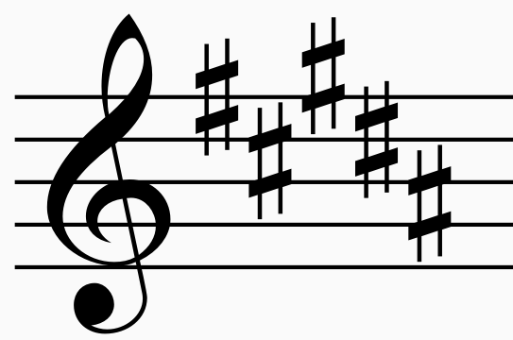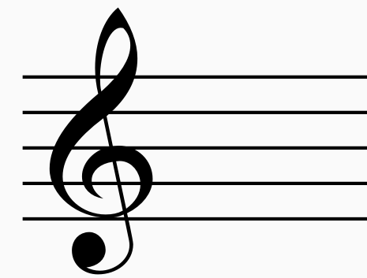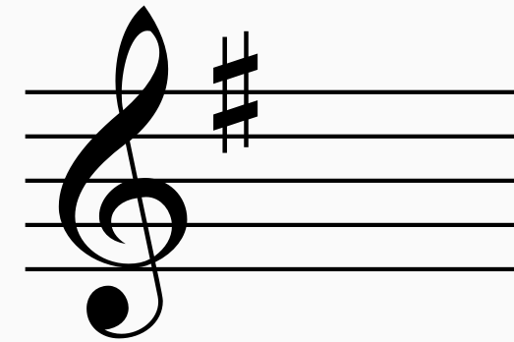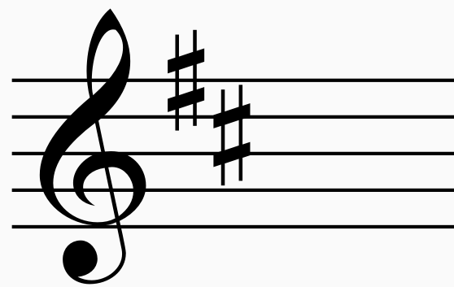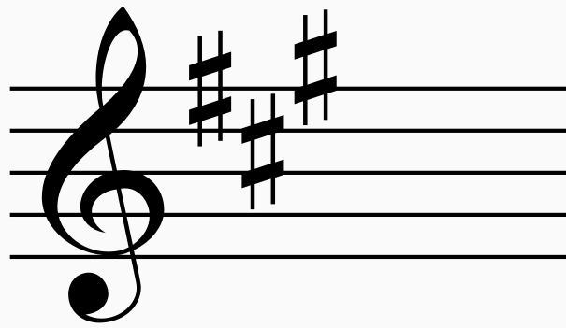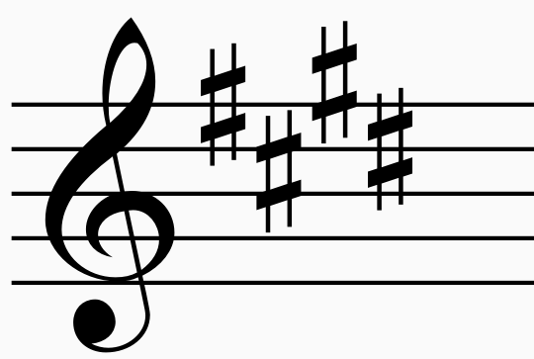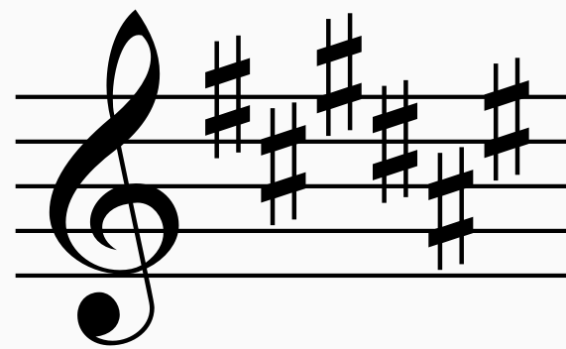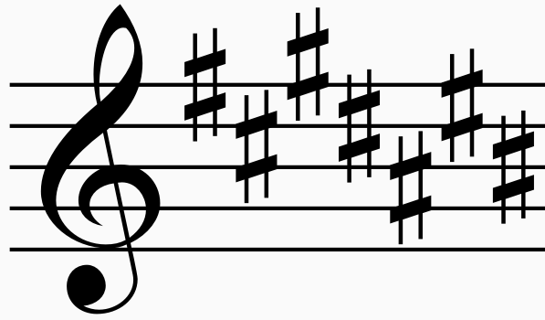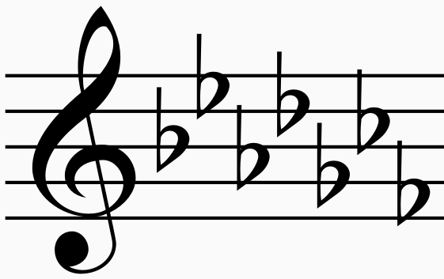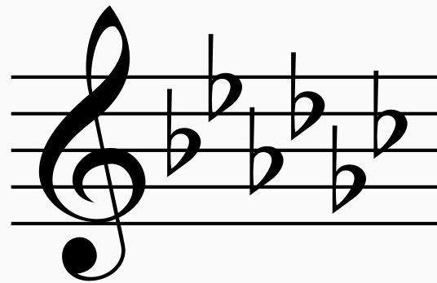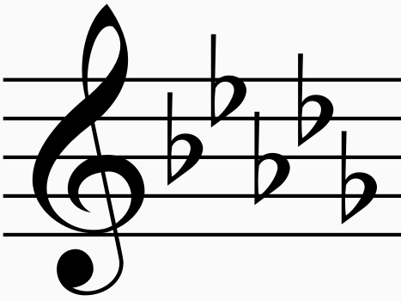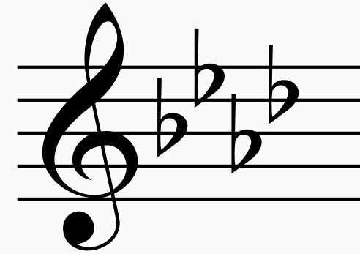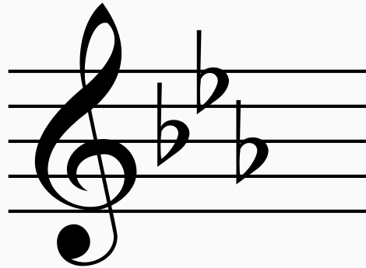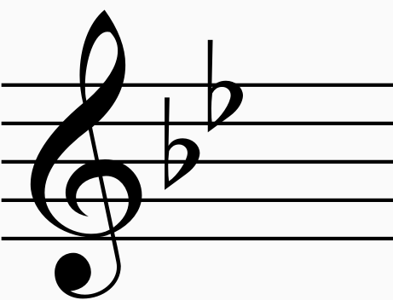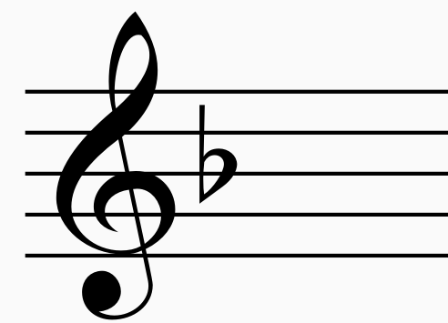

Answers – circle of fifths
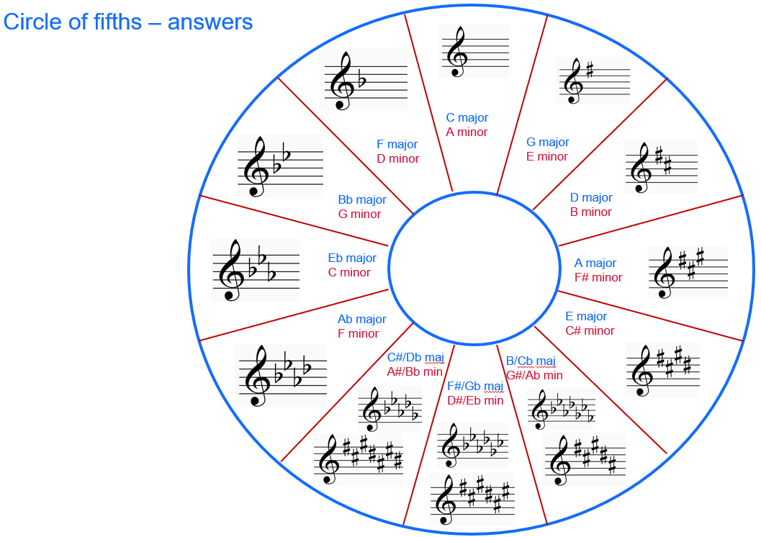
Key signatures used in ‘Where?’ – Db major (bar 1) and C minor (bar 124)

Transposition tools

Keyboard diagram
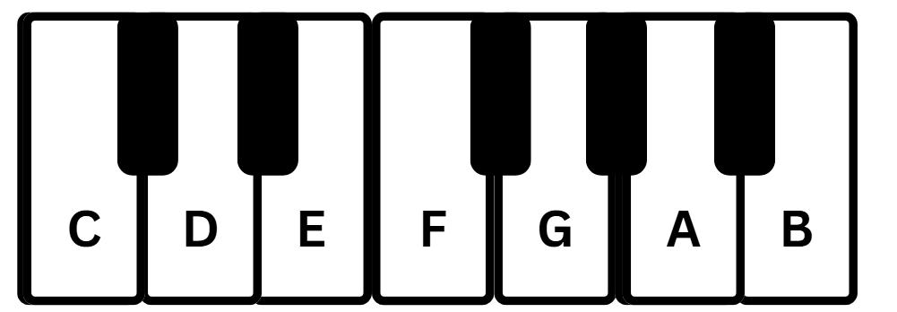

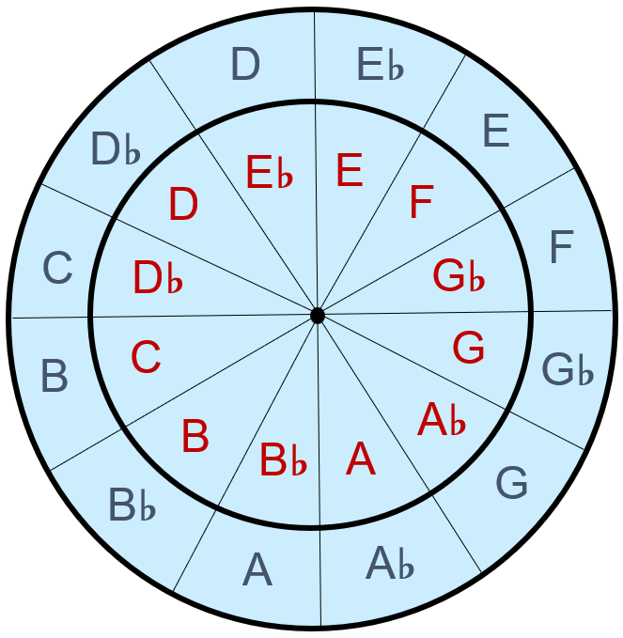
Transposition wheel

Blue – original key
Red – transposed key
Note – this can be made into an interactive tool by layering the 2 circles and using a split pin in the centre.

Learning sequence 3 – ‘Bedouin Song’– Lior

Activity 3.1 – ‘Bedouin Song’ – Lior – listening

Suggested answers – Lior discusses his childhood
- List one point that Lior remembers about his life in Israel (0:48–1:02) – Mediterranean upbringing, sunshine, happiness, community, playing football
- What is Lior’s view of Australia? (1:44–2:04) – laid back, multicultural, welcoming (doesn’t feel foreign), Australia is a new country
- Why did his parents decide to move to Australia? (2:04–2:34) – Lior’s parents were worried and disillusioned with where Israel was heading.
- Outline Lior’s first musical experiences (4:41–5:03) – Lior had one guitar lesson before moving to Australia. When he was 11, he started playing guitar and progressed to also singing a few years later.
- Why did Lior want to be good at music? (5:03–5:32) – Lior was not from a musical family but felt touched by music. Singing gave him a feeling of being able to escape, so he worked hard at his musical progression.

Suggested answers – ‘Bedouin Song’ – listening and score reading
- Make a chart to demonstrate the structure of ‘Bedouin Song’ – an example could be: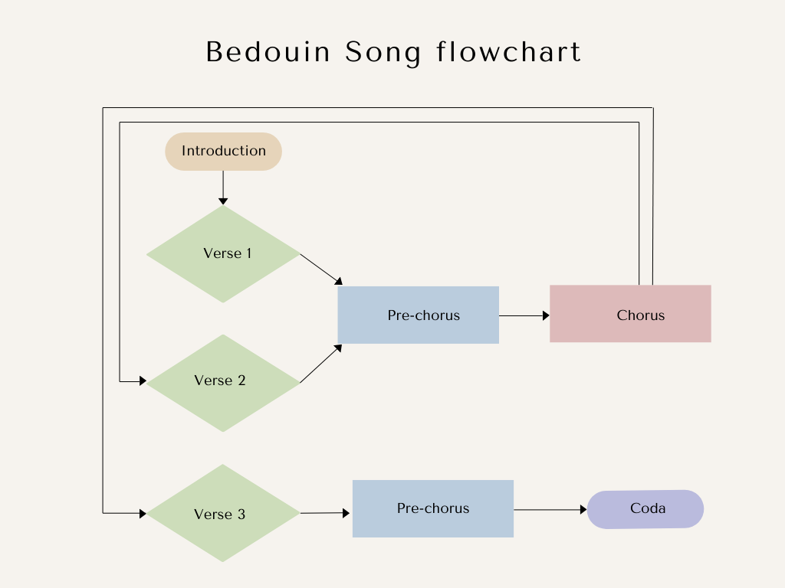
- List the performing media of this song – male vocals and acoustic guitar
- Using one word, identify the timbre of the introduction of this piece (guitar 0:00–0:08) – warm, clear, mellow
- Lior sings in falsetto at the beginning of this piece.
- What is falsetto? – a method of voice production used to sing notes higher than the singer’s normal range
- Write one word to identify the timbre of Lior’s voice – falsetto – breathy, tenor range – warm
- Use one word to identify the pitch movement of the accompaniment in the introduction – ascending
- Draw a graphic representation of the pitch movement in bars 1 and 2

- Identify the highest and lowest melodic note in the melody in the verse (range) – D below the stave to A second space on the stave
- Is the melodic range of this verse wide or narrow – narrow
- Describe a change in the pre-chorus in:
- harmony – the chordal changes are a lot more frequent and use a greater variety of chords including both major and minor chords
- melody – the register of the voice in the pre-chorus is lower and centres around the B below middle C
- Find 3 melismas in ‘Bedouin Song’ (identify the bar number or the syllable Lior is singing) Verse 1 – ‘west’ (bar 5), ‘ern’ (bar 6), ‘dows’ (bar 7), ‘the’ (bar 9), ‘row’ (bar 10 and 11), ‘ooh’ (bar 11 and 12), Pre-chorus – ‘mad’ (bar 13), ‘rain’ (bar 14), ‘flou’ (bar 15), ‘once’ (bar 15 and 16), ‘gain’ (16, 17 and 18), Verse 2 – ‘east’ (bar 5, 6, 7 and 8), ‘leased’ (bar 11 and 12), Chorus – ‘in’ (bar 21), ‘real’ (bar 23), ‘ooh’ (bar 25), ‘how’ (bar 25), ‘ta’ (bar 27), ‘fall’ (bar 28, 29 and 30), Pre-chorus – ‘flow’ (bar 13), ‘way’ (bar 16, 17 and 18), Verse 3 – ‘rain’ (bar 5 and 6), ‘veins’ (bar 7 and 8), ‘O’ (bar 9 and 10), ‘shame’ (bar 11 and 12), Coda – ‘find’ (bar 4 of coda), ‘a’ (bar 4 of coda), ‘way’ (bar 5, 6 and 7 of coda)
- The final chord in this piece is arpeggiated. By looking at the score, define arpeggiated – a chord where the individual notes are played quickly in sequence following the direction of the arrow (lowest to highest)

Vocal exercises
Teacher models each of the following vocal warmups to start with and then asks students to join in.
- Vocal warmup no 1 (0:56) – falsetto
- Vocal warmup no 2 (2:28) – melisma

Activity 3.2 – ‘Bedouin Song’ – Lior – listening and score reading

Answers – ‘Bedouin Song’ – listening and score reading
- Identify an Italian tempo term for this piece: crotchet = c. 47 (freely) – c. – circa (around), crotchet = 47 – Largo, freely – performer has the freedom to modify the tempo and rhythm at their discretion.
- What difference do you notice between the note values of the guitar and melody in the pre-chorus? List one observation and the bar number it occurs – in bars 13, 14, 15 and 16 the guitar line is predominantly quaver based to emphasise the ${6 \atop 8}$ time signature and provide a steady pulse throughout the pre-chorus, whilst the melodic line uses note values that contrast to fit with the syllables and melismas – semiquavers, dotted quavers and crotchets.
- What do these rhythmic differences in the guitar and vocal part add to the pre-chorus – a sense of movement, contrast and rhythmic interest.
- Outline the values of the notes in the chart.
Table 3 – note value chart answers – Activity 3.2
Note | Value – in quaver beats
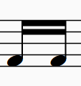 | one quaver beat
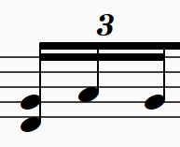 | one quaver beat
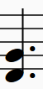 | 3 quaver beats
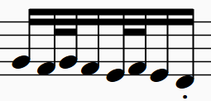 | 3 quaver beats
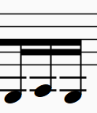 | one quaver beat
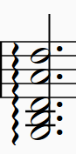 | 6 quaver beats
- Identify the term that describes the texture of this piece – homophonic (chordal accompaniment and melody)
- Write one sentence to describe the texture – the texture is constantly homophonic in this piece. There are no changes in the texture and this helps to highlight the melodic material, vocal timbre and musical message of the piece.
- Identify one place where Lior speeds up the tempo in this piece (accelerando) – start of the pre-chorus (bar 13)
- Identify one place where Lior slows the tempo down of this piece (ritardando) – at the end of phrases
- Identify 3 examples of ornamentation and discuss the effect these ornaments have on the piece –
Table 4 – ornamentation suggested answers – Activity 3.2
Ornamentation | Symbol | Effect
Vibrato | n/a | Adds warmth to the singer’s timbre
Melisma | n/a | Adds a sense of expression and complexity
Arpeggiated chord |  | Adds emotional depth and movement
Appoggiatura | 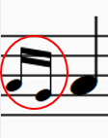 | Adds expression, musical interest and tension
Acciaccatura | 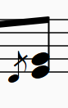 | Adds expression, musical interest and tension

Answers – Lior and Joseph Tawadros – ‘Bedouin Song’
- What does the performing media of the orchestra accompaniment add to the piece – the orchestral accompaniment adds harmonic support as well as creating a warm timbre to the piece. The string section uses the technique called tremolo (rapid movement of the bow) and the lower brass sustain pedal notes to emphasise the tonal centre. The woodwind mainly add a harmonic role. The dynamics of the accompaniment is piano (soft) to not overshadow Lior. The chorus is slightly louder with a mezzo piano (moderately soft) dynamic. The note values in the orchestra are long and sustained.
- How is the oud played and what does the inclusion of this instrument add to the piece – the oud is a plucked string instrument that obtains resonance from the body of the instrument. The strings of the oud are plucked with a plectrum called a risha. Sometimes the oud is doubling the melodic line and in other places it provides short melodic countermelodies in an improvised style.

Activity 3.3 – assessment task – more steps to success

Performance assessment introduction
Other teaching tools include:
- use sentence starters or fill-in-the-blank outlines for beginners
- encourage rehearsal of the spoken introduction – it is part of the performance
- make it interactive – students present to each other and give feedback.

Activity 3.4 – ‘Bedouin Song’ – Lior – composing and performing
This is a small group compositional activity.
Teacher-led instructions:
- the word cloud is to be used as a stimulus and/or as lyrics for both sections
- students are encouraged to play their instruments as they compose, ensuring they are writing appropriately for the instrument and player ability
- this task may be completed using written notation.
Lead a discussion on Lior’s melodic line:
- both phrases end on a longer note value – phrase 1 has a slightly larger range of notes than phrase 2.
- both phrases have a similar shape and start the same (D, G, A, B). Lior uses notes of the G major chord (highlighted red on the PowerPoint) as the basis of his melody with passing notes. Discuss that it is good practice to use mostly notes from the chord with some passing notes for writing a successful melody.
The teacher may like to distribute or display the ‘Useful tools for composing’ sheet below.

Useful tools for composing

Chords – keyboard diagrams
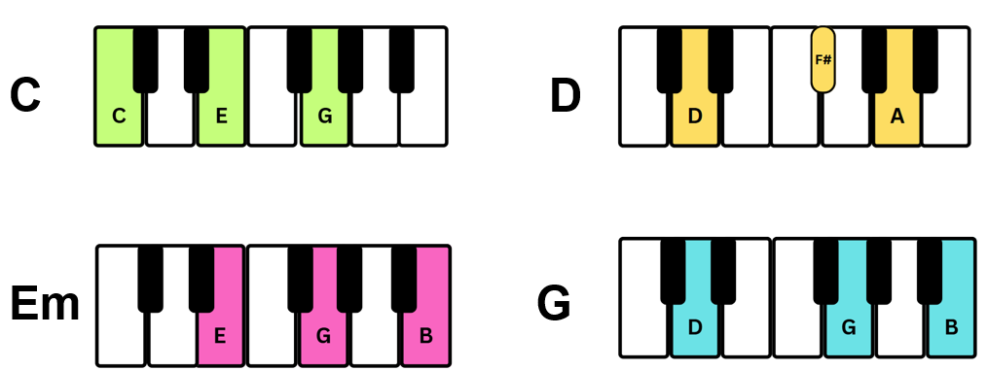

Guitar chord charts
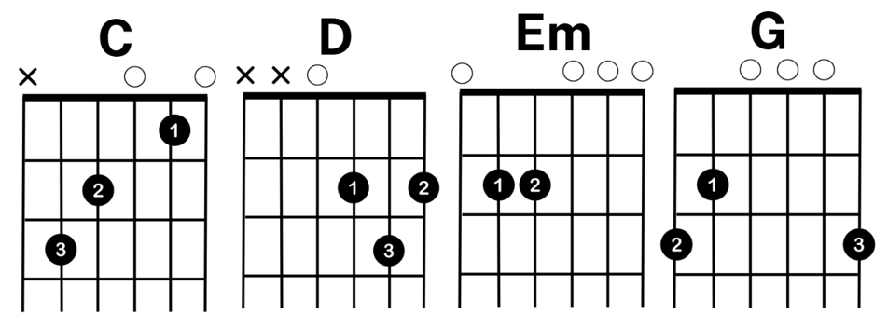

Ukulele chord charts
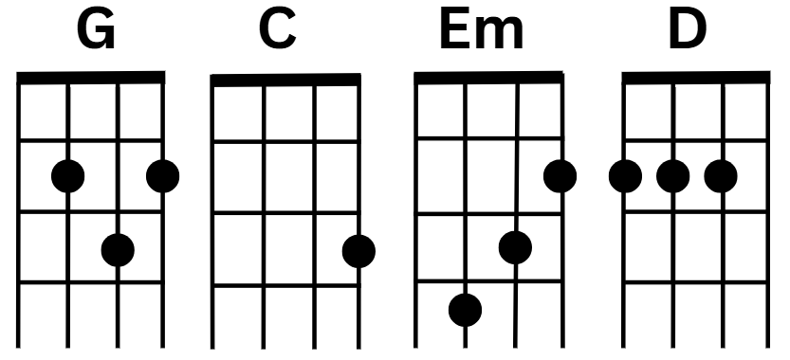

Section 1 scaffold
Table 5 – composition scaffold bars 1–9 – Activity 3.4
Bar 1 | Bar 2 | Bar 3 | Bar 4
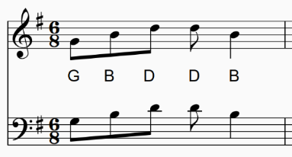
Bar 5 | Bar 6 | Bar 7 | Bar 8

Section 2 scaffold
Table 6 – composition scaffold bars 9–16 – Activity 3.4
Bar 9 | Bar 10 | Bar 11 | Bar 12
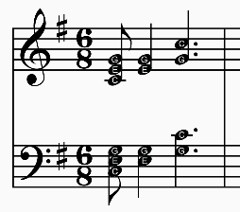
Bar 13 | Bar 14 | Bar 15 | Bar 16

Learning sequence 5 – depth study – getting started

Activity 5.1 – depth study – an introduction
Both the department and NESA have provided support materials for implementing the depth study in the classroom.
The department has provided support materials through a microlearning Music 7–10 module in MyPL and on the Music 7–10 (2024) webpage of Planning, programming and assessing creative arts 7–10 for ‘Australian perspectives’ and ‘Backstage pass’.
NESA’s advice on the depth study is available on their website Music 7–10 Music Syllabus (2024) and can be found on the overview page and in the teaching and learning tab.
What is the teacher’s role in the depth study? After delivering some explicit teaching lessons to set students up with the skills they require to complete the depth study, the teacher will become the facilitator and will conduct check-in discussions with individual students or collaborative student groups. A check-in monitoring sheet is beneficial in keeping track of students’ progress and documenting support that some students may require.
The student booklet can be distributed as a hardcopy or an e-copy.
What is a driving question? A driving question should evoke curiosity and cannot be answered with a yes or no response. The driving question for this unit is ‘How does my perspective of Australia shape my music?’ and should allow students to call on prior knowledge from lesson content taught in this unit and give students the opportunity to explore their perspective on Australian music through one or more of the focus areas.
The driving question for this depth study is to be answered by creating a product. The product that students create must be achievable in 7 independent lessons. The product needs to call on skills and knowledge that have been obtained in the course throughout the year. The sky is the limit for creative ways to answer the driving question.
Some students may find it difficult to be creative in thinking of a product. The PowerPoint and the table below provide some examples of possible products as inspiration.

Examples of products
Table 7 – depth study product examples
Performing | Composing | Listening
Take a well-known Australian song (for example, ‘Waltzing Matilda’, ‘I Am Australian’) and re-arrange it in a modern or culturally influenced style (for example, hip-hop, jazz, K-pop), expressing how your personal identity intersects with traditional Australian narratives. | Write a composition that captures the sound and atmosphere of a specific Australian environment (for example, desert, beach, suburb, rainforest) to express how your connection to place influences your musical ideas. | Explore 2 artists with different perspectives (for example, Kev Carmody and Sia) and present how their perspectives influence their understanding of Australian music and shape your own preferences or creative voice.
Solo or ensemble performance centred on Australian themes (for example, drought, migration, urban life), using instrumentation or staging to emphasise your shared view of Australian life. | Compose background music for a scene (real or fictional) that takes place in Australia—like a beach, a protest, a rural town—demonstrating how you musically interpret Australian stories. | Interview a local musician, family member, or Elder about their musical experiences in Australia. Then reflect (written, audio, or visual) on how that person’s story reshapes or reinforces your own perspective of Australian music and identity.
Select and perform short excerpts from several Australian songs that, when combined, tell a story about your life in Australia. Use transitions, expression, or narration to guide the audience through your personal journey or viewpoint. | Write music responding to an event that shaped Australia or you personally (for example, bushfires, reconciliation movements, sporting victories), showing emotional or political engagement. | Curate a chronological playlist of Australian songs that reflect key moments in your personal life (for example, childhood, cultural discovery, moving towns). For each song, write or present a short reflection explaining how it connects to your evolving perspective of Australia and how music has helped shape that view.

Activity 5.2 – depth study – project proposal and planner

Why a project proposal?
The project proposal in the Stage 5 student booklet – depth study is designed to assist students in focusing their thoughts and giving commitment to their product development.

Depth study proposal examples
Table 8 – depth study proposal example 1
Name:
Outline the proposed product (what are you going to create?)
An original song that blends elements of contemporary pop with traditional Chinese instruments and/or scales to express my personal identity with Chinese Australians. The lyrics will reflect the theme of mixing traditional with contemporary cultural expectations.
I will submit this song as a recording and with an annotated lyric sheet showing musical decisions.
What is the focus area of my product? (circle one or more)

Combination of 2–3 focus areas: 1. 2. 3.
What skills/knowledge will I need?
1. An understanding of contemporary pop music:
- Structure – intro, verse, chorus, bridge and so on
- Chords and harmony – common pop chord progressions like I IV vi IV
- Melody – writing catchy, singable lines
- Duration – understand typical pop beats and patterns
2. Traditional Chinese musical elements:
- Instruments – know how the sound is made and what timbre they produce
- Scales and modes – pentatonic scale, heptatonic modes
- Texture and ornamentation typical to Chinese music
3. Lyric writing and cultural expression:
- Express personal identity and hybrid culture. For example, balancing family traditions with modern Australian life
- Skills in writing reflective, emotive, or narrative lyrics
- Awareness of tone and language choice to respectfully represent my cultural background
4. Recording techniques:
- Layering vocals or instruments using MIDI or loops
- DAW (Digital Audio Workstation)
- Recording live sound using software on computer or phone

What research will I need to complete?
I will need to research contemporary music structures and Chinese scales and modes. I will ask my parents and grandparents about cultural traditions that are important to them so I can reflect that in the lyrics. I will need to research how I am going to record, especially knowing that I only have 6 lessons to get it written and recorded.
Will I be collaborating with others (list names) or working solo?
I will be working solo.

Table 9 – depth study proposal example 2
Name:
Outline the proposed product (what are you going to create?)
A written critique that explores how Australian identity and our personal perspectives influence music. Our critique will analyse 2 or 3 pieces of music that reflect different aspects of Australian culture – such as music of Aboriginal and Torres Strait Islander Peoples, migrant influences and/or contemporary Australian artists. We will examine how these works express ideas that connect with our views of what it means to be Australian, and how that shapes our musical preferences.
What is the focus area of my product? (circle one or more)

Combination of 2–3 focus areas: 1. 2. 3.
What skills/knowledge will I need?
- Knowledge of the Elements of music
- Skills in musical analysis and critical writing
- An understanding of how cultural identity can be expressed through music
- The ability to connect my personal experiences and views with broader musical and cultural ideas
What research will I need to complete?
- Background information on the pieces/artists I am critiquing (for example, context, style, influence)
- How different aspects of Australian culture are reflected in music (for example, lyrics, sound, instrumentation)
- Examples of how music has been used to explore identity, belonging or national themes in Australia
Will I be collaborating with others (list names) or working solo?
[collaborator’s name]

Working in groups

Project management tools
Support students in selecting a cloud-based management tool. Ask the group to add the teacher to this management tool, so you can also monitor and use for the facilitator meetings.

Group norms contract
Table 10 – group norms contract example
Agreement
- Our group will use [name of cloud-based tool] to assist with management of our project work
- Respect – listen actively when other group members are speaking
- Stay on task – focus on our group’s goals and timeline and avoid distractions
- Share responsibility – divide tasks fairly and meet deadlines
- Feedback – be open to suggestions and be willing to adjust my work
If someone on our team goes away from one or more of our norms, the team may have a meeting and ask the person to follow our agreement. If the person still acts outside of the norms, we will ask our teacher to help ﬁnd a solution.
Name | Signature | Date
Note – students will submit their depth study proposal, planner and group norms documentation at the end of this lesson. There are 6 lessons in between this submission lesson and when students begin independently working on their product. This is to allow the teacher to review documentation and have meaningful conversations with students that may not show an understanding of the task to assist them prior to the independent working lessons.

Learning sequence 6 – further exploration of Australian music

Activity 6.1 – ‘Wish You Well’ – Bernard Fanning and Baker Boy – listening, composing and performing
32

Comparison – ‘Wish You Well’ suggestions

Bernard Fanning – ‘Wish You Well’
Pitch – the riff played by the electric acoustic guitar is played through strumming block chords to give strong sense of the primary chords (I, IV, V), this is doubled by the electric guitar as well. The bass guitar plays the root note of the chord to support the guitars and keyboard. The male vocals are in a mid to high range and use a small range of notes that are extended as he sings towards the chorus. The melodic and harmonic lines are simple and repetitive. There is a guitar solo towards the end utilising a mid-register and some slides. Drums and claps are unpitched. The piece is in D major.
Duration – this piece is in ${4 \atop 4}$ time signature with a strong pulse and this is evident from the drumbeat. The tempo is steady and maintained throughout the piece – allegro (crotchet = 124). The acoustic electric guitar, keyboard and electric guitar play in rhythmic unison to add to the excitement of the main riff of the piece. The rhythmic riff (played on electric acoustic guitar, bass guitar, keyboard and electric guitar utilises some syncopation, however there is a strong first beat. The rhythms of the melody are simple and repetitive with some dotted note values to give a sense of rhythmic movement.
Texture – the texture of this piece starts thin and gradually builds (heading to the chorus). Like most pop songs, it is homophonic. The acoustic electric guitar, keyboard and electric guitar play in rhythmic unison to add to the textural layers of this song.
Structure – this piece uses a typical pop style structure – introduction, verse, chorus, bridge.
Dynamics and expression – the introduction of this piece is moderately soft (mp) and the verse is moderately loud (mf). There are strong accents in the drums on the second and fourth beat. Bernard Fanning uses melismas at the end of some phrases. The chorus is louder in dynamics to bring out the main message of the song. There is a crescendo into the chorus to add excitement. The electric guitar solo uses glissandos.
Performing media and timbre – electric acoustic guitar (clear), electric guitar (clear and strong), male vocals – sung (mellow), backup vocals (resonant), drums (strong), bass guitar (muffled and deep), keyboard (electronic), hand claps (resonant).

Baker Boy ft. Bernard Fanning – ‘Wish You Well’
Pitch – Harmony: the electric guitar is providing the harmonic basis along with the bass guitar. The electric guitar chords are played in a block style in a mid-register. The bass guitar plays the root note of the chord with some passing notes to add interest. The melodic line is held by the male vocals and is sometimes in a spoken style. When sung, the register is in the middle and there is a small range of notes used. The register is extended in the section where ‘I know it’ is sung. There is a register rise in the melodic line leading into the chorus. The backup vocals are in unison with the male vocals. The bass guitar is low, exploring a large range of notes. The synthesiser plays in a mid to high range. Drums and claps are unpitched. The piece is in D major. There is a slight vocal echo in the verse that repeats the same melodic material as what is sung before the echo.
Duration – this piece is in ${4 \atop 4}$ time signature with a strong pulse and this is evident from the drumbeat. The accompanying instruments (bass guitar, electric guitar, claps) use ostinato patterns throughout the piece. The rhythmic patterns of the rap are fast and complex, with a strong emphasis of the pulse. Bernard Fanning’s vocal rhythmic patterns are simple and mainly on the beat (with some syncopation). The claps are in rhythmic unison with the hi-hat in some places (emphasising the 2 and 4 beats). The tempo is steady and maintained throughout the piece – allegro (crotchet = 122).
Texture – the texture of this piece starts thin and gradually builds (heading to the chorus). Like most pop songs, it is homophonic. There is a small polyphonic section towards the end of the piece (when the synthesizer keyboard adds a small countermelody).
Structure – this piece uses a typical pop style structure – introduction, verse, chorus, bridge.
Dynamics and expression – the introduction of this piece is moderately soft (mp) and the verse is moderately loud (mf). There are strong accents in the drums on the 2nd and 4th beat. Baker Boy also places accents on some words in the rap section of the song. The chorus is louder in dynamics to bring out the main message of the song. There is a crescendo into the chorus to add excitement. The synthesizer keyboard uses a lot of glissandos in a legato style.
Performing media and timbre – male – vocals are sung (clear) and rapped (harsh and clear), piano (clear, bright), electric guitar (rich and clear), drums (strong and clear), backup vocals (resonant), bass guitar (booming and strong), synthesizer keyboard (nasal, electric and resonant), hand claps (clear).

Unity and contrast – ‘Wish You Well’ suggestions
Unity
Pitch – both pieces are in D major. The male vocals in both pieces are in a middle to high range and use a small range of notes. There is a register rise in the melodic line leading into the chorus in both songs. Drums and claps are unpitched in both songs. The guitars in both pieces play block chords in a strumming pattern.
Duration – both pieces are in ${4 \atop 4}$ time signature with a strong pulse and this is evident from the drumbeat. The tempo of both pieces is allegro (although Bernard Fanning’s version has a slightly faster crotchet bpm). There are ostinato patterns in both songs (especially in the drumkit). Both songs use a lot of rhythmic repetition and a mixture of simple rhythms with some syncopation.
Texture – the texture of both pieces starts thin and gradually builds (heading to the chorus). Both are homophonic.
Structure – both use a typical pop style structure – introduction, verse, chorus, bridge.
Dynamics and expression – both pieces have an introduction that is moderately soft (mp) and the verse is moderately loud (mf). There are strong accents in the drums on the 2nd and 4th beat. The chorus of both songs is louder in dynamics to bring out the main message of the song. There is a crescendo into the chorus to add excitement in both songs.
Performing media and timbre – both use male vocals, backup vocals, drums, bass guitar and hand claps. They both have keyboards and electric guitars; however, their timbral sounds are very different.

Contrast
Pitch – the bass guitar in Bernard Fanning’s (BF) version uses the root note only whereas Baker Boy’s (BB) version utilises many passing notes. BB utilises rapping in his version and that is in a spoken style. BF has a guitar solo towards the end, whereas BB has a keyboard countermelody. BF uses melismas in his melody.
Duration – there is a lot of rhythmic unison in the BF version. The rhythmic patterns of BB’s rap are fast and complex. There is a lot more rhythmic complexity in the BB version.
Texture – BB’s version is texturally busy compared to the BF version.
Structure – there is no contrast in structure.
Dynamics and expression – BB places accents on some words in the rap section of the song. Glissandos are employed in both pieces but in BB it is the keyboard and in BF it is the electric guitar.
Performing media and timbre – the accompanying instruments are different in both versions of the song. The electronic manipulation of the instruments is also different in the 2 pieces, with a greater exploration of timbral qualities in the BB version. The timbre of each instrument is very different in both versions.
To support the composing and performing element of this activity, the following graphics could be placed around the room or printed and given to students.

Guitar chord chart
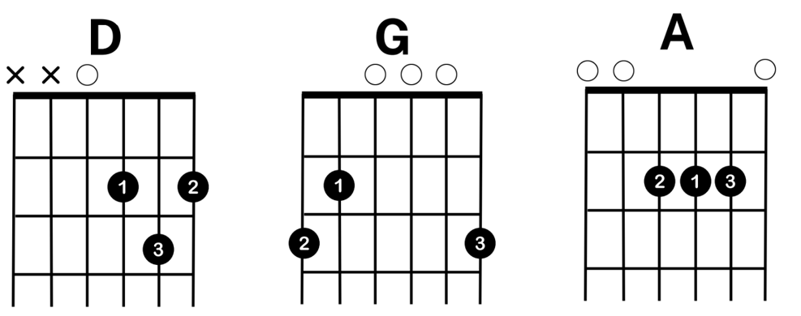

Ukulele chart
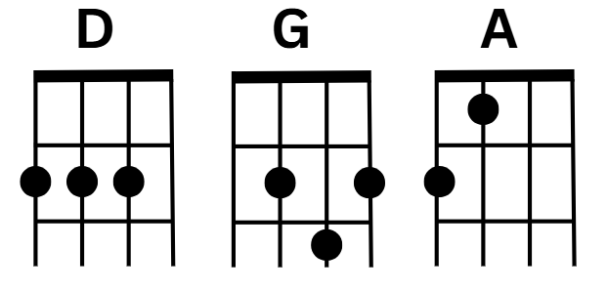

Keyboard chord chart
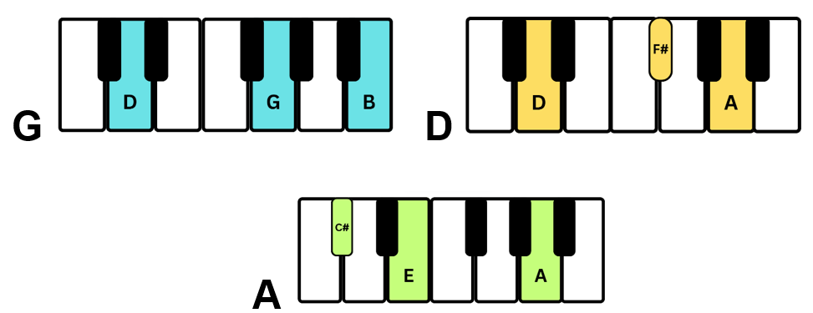

Bass guitar chart
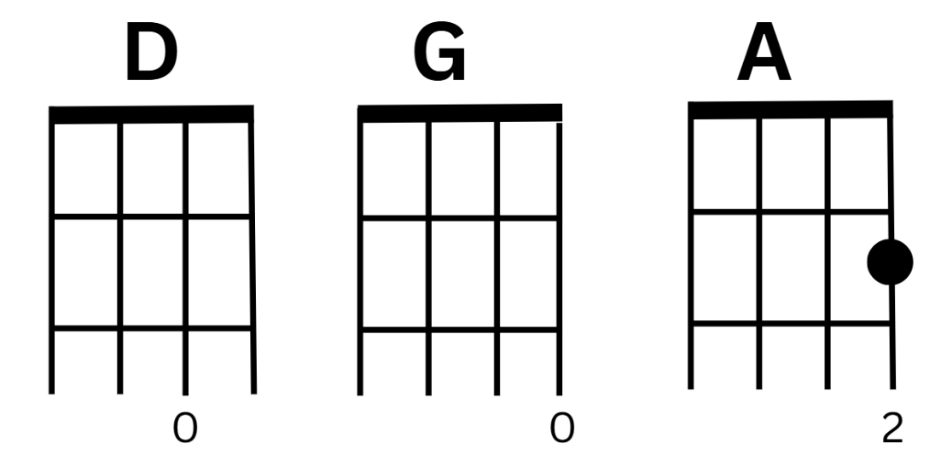

Tuned percussion chart
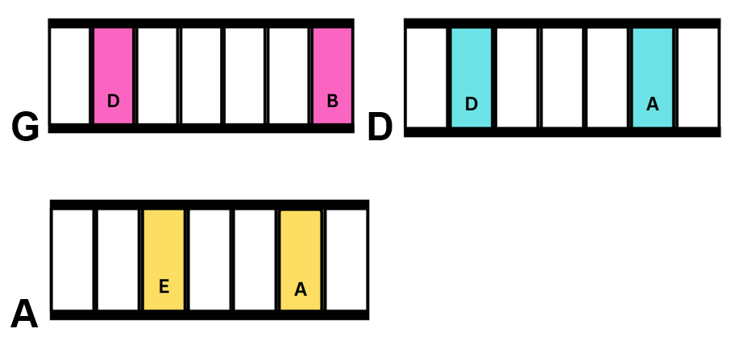

Activity 6.2 – Baker Boy– identity through composing and performing
32

Supporting resource
Additional background information for Baker Boy.

Baker Boy – Language and Culture suggested responses
Who is Baker Boy? – Baker Boy is an Yolŋu rapper, dancer and artist. His father and his father’s brothers and sisters used to be called Baker Boys and this name was passed down to him.
Where is he from? – Baker Boy is from the Yolŋu communities of Milingimbi and Maningrida in north-east Arnhem Land, Northern Territory.
What influenced Baker Boy – his Yolŋu Language and Culture, his upbringing, cultural and musical influences.
How does Baker Boy include Culture in his music – Baker Boy blends Yolŋu Matha and English lyrics, and uses traditional instruments like the yidaki. Baker Boy celebrates Aboriginal identity, pride and heritage in his music.
What is the effect of Baker Boy’s music on the listener – Baker Boy’s music inspires pride, promotes cultural awareness, and empowers listeners by celebrating identity, language, and community through his energetic and uplifting storytelling.

Suggested differentiation – rap lyric suggestions
The lyrics below are suggested material for the verse for those students that find writing the lyrics for the short rap in their own voice a challenge.
- I’m a reflection of the struggle and the fight,
A mix of history, vision, and light.
Got my roots in the past, but my dreams in the sky,
I’m a journey, a story, watch me rise, watch me fly.
- I’m the whispers of my ancestors, the voices in my mind,
Every step I take, I’m leaving traces behind.
A canvas full of memories, yet fun in my sight,
I’m rewriting the story, defining my light.
- I’m made of all the pieces they said wouldn’t fit,
Every scar, every story, every ounce of grit.
I’m the heartbeat of a dream that never fades,
A mix of the past and the moves I’ve made.
- I’m the sum of every choice I ever made,
The quiet and the loud, the night and the day.
I’m the lessons, the growth, the battles I fight,
A vision unfolding, I’m owning my light.

Rap verse rhythmic ostinato examples:
The following ostinato patterns are suggestions for the verse and can be taught aurally or using notation. Everyday school items and/or percussion instruments and/or sampled sounds could be used to play these ostinato patterns.
Table 11 – suggested one-bar rhythmic ostinatos
One-bar rhythmic ostinato patterns
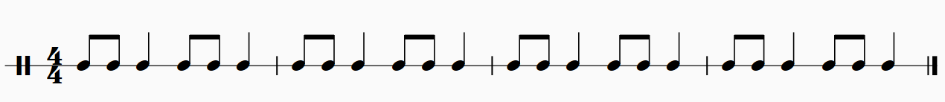
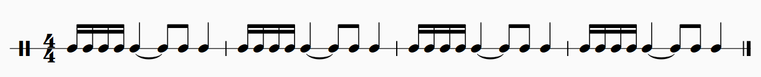
Table 12 – suggested 2-bar rhythmic ostinatos
2-bar rhythmic ostinato patterns

Activity 6.3 – ‘Murrgumurrgu’ in context – James Henry
Although James has given permission for his song to be taught in classrooms across the state, teachers must also seek permission and advice from the local Aboriginal Community for singing this song on the Country that you are on. If permission is not granted you can sing an open vowel or find a song that reflects the local Aboriginal Community.

Student worksheet – ‘Murrgumurrgu’ sharing and protocols – James Henry
Read the following, written by the composer.
I grew up knowing bits and pieces of it through my Great-Grandmother, Grandmother, Aunties, and Uncles. Many words and aspects of Yuwaalaraay are similar to Gamilaraay. Yuwaalaraay Country stretches south to Walgett and includes towns to the north such as Goodooga, Lightning Ridge, and Angledool. It also encompasses Dharriwaa (Narran Lakes), the setting of the Murrgumurrgu song. Yuwaalaraay is my maternal lineage, and I give permission for all people to sing this song in the Yuwaalaraay language. The original translation of the song into Yuwaalaraay was done by John Giacon, an Italian Australian who has worked extensively with both the Gamilaraay and Yuwaalaraay languages. I then had it clarified and revised by Brendan ‘Odee’ Welsh, who is Gamilaraay/Yuwaalaraay and teaches the language in various settings. His input ensured that pronunciation was accurate, and that the song aligned with the most up-to-date understanding of the language, based on early documentation and archives. This song was created by me. While it draws from traditional Aboriginal influences in terms of melody and structure, it is more Pan-Aboriginal in style rather than being specific to the Yuwaalaraay region, which has its own unique musical nuances that aren’t reflected in this piece. Originally, I wrote the song to be free of cultural restrictions yet still carry a sense of traditional authenticity. I didn’t expect it to be performed widely beyond myself, but I’ve since noticed genuine interest from a broad audience. Because of that, I see value in sharing it more widely including with non-Aboriginal people. As much as possible, people should aim to follow the pronunciation guidelines and perform the song as it is presented. Sing in your own voice—don’t try to “sound Aboriginal”—but do your best to pronounce the words correctly. Ultimately, this is a contemporary piece of music. I feel that placing too many restrictions on it might stifle its potential to be shared and to let the song’s meaning reach people’s hearts and minds. This is a great opportunity for both non-Aboriginal and non-Yuwaalaraay Aboriginal people to speak an Aboriginal language, connect with culture, and hopefully be inspired to learn more. For those interested in doing something different with this piece beyond what is written, it would be good for them to contact me just as you might with any songwriter, but also to ensure any unforeseen complications are avoided. For those interested in exploring further, Brendan ‘Odee’ Welsh offers Gamilaraay language lessons online, which also support learning of Yuwaalaraay.
James Henry Litte
jameshenrycomposer@gmail.com

Questions
- Who did James Henry learn parts of the Yawaalaraay Language from growing up and how does this connect to his identity?
- What is the geographical area covered by Yawaalaraay Country and what significance does Dharriwaa (Narren Lakes) hold in the song?
- What is the relationship between Yawaalaraay and Gamilaraay Languages according to the composer?
- Why did James Henry involve both John Giacon and Brendan ‘Odee’ Welsh in the translation and revision of the song’s lyrics?
- How does James describe the style and intention behind the song’s creation?
- What does the composer say about non-Aboriginal and non-Yuwaalaraay people singing the song?
- What guidelines does the composer give for performing the song respectfully?
- What should someone do if they want to change or adapt the song in any way?
- Why is it important to approach songs in Aboriginal Languages, like James Henry’s Yuwaalaraay composition, with cultural understanding and care – even when permission to sing them is granted?
- Why is it important to connect with your own local Aboriginal community and seek their guidance before singing ‘Murrgumurrgu’, even if the artist has given general permission to use it.
Suggested differentiation – to support students in responding to question 9, the following prompts or sentence starters may assist.
- What does the composer say about the song’s connection to Culture and Language?
- How does singing in another language affect how we understand and respect that culture?
- What might happen if people perform the song without care or understanding?
- How is this song different from traditional Aboriginal songs?
- Why might James Henry have included guidelines even though he gave permission?
- It is important to approach songs in Aboriginal Languages with care because…
- Even though permission is given, performers still have a responsibility to…
- Singing in Yuwaalaraay allows people to connect with…
- If people perform the song without understanding the Culture, it could lead to…
- This song reflects both traditional influences and contemporary intentions, which means…

Answer sheet – ‘Murrgumurrgu’ sharing and protocols – James Henry
- Who did James Henry learn parts of the Yawaalaraay Language from growing up and how does this connect to his identity? He learned bits and pieces of the language from his great-grandmother, grandmother, Aunties and Uncles. This connects to his identity because Yawaalaraay is his maternal lineage.
- What is the geographical area covered by Yawaalaraay Country and what significance does Dharriwaa (Narren Lakes) hold in the song? Yawaalaraay Country stretches south to Walgett, and includes Goodooga, Lightning Ridge and Angledool to the north. Dharriwaa (Narren Lakes) is significant as it is the setting of the ‘Murrgumurrgu’ song.
- What is the relationship between Yawaalaraay and Gamilaraay Languages according to the composer? The composer says that many words and aspects of Yawaalaraay are similar to Gamilaraay, suggesting a close linguistic relationship between the 2.
- Why did James Henry involve both John Giacon and Brendan ‘Odee’ Welsh in the translation and revision of the song’s lyrics? John Giacon, who has worked extensively with both languages, did the original translation into Yuwaalaraay. Brendan ‘Odee’ Welsh, a Gamilaraay/Yuwaalaraay language teacher, clarified and revised it to ensure pronunciation was accurate and aligned with the most up-to-date understanding of the language.
- How does James describe the style and intention behind the song’s creation? He describes it as a contemporary piece that draws on traditional Aboriginal influences but is Pan-Aboriginal in style rather than specific to the Yuwaalaraay region. He intended it to be free of cultural restrictions while still carrying a sense of traditional authenticity.
- What does the composer say about non-Aboriginal and non-Yuwaalaraay people singing the song? He welcomes non-Aboriginal and non-Yuwaalaraay Aboriginal people to sing the song in Yuwaalaraay Language. He sees it as an opportunity for people to connect with culture and be inspired to learn more about Aboriginal Languages.
- What guidelines does the composer give for performing the song respectfully? Performers should:
- follow pronunciation guidelines as accurately as possible
- sing in their own voice (not try to ‘sound Aboriginal’)
- perform the song as it is presented, without altering it unless you seek permission.
- What should someone do if they want to change or adapt the song in any way? They should contact James Henry just as they would with any songwriter to ask permission and avoid unforeseen complications.
- Why is it important to approach songs in Aboriginal Languages, like James Henry’s Yuwaalaraay composition, with cultural understanding and care – even when permission to sing them is granted? This question should prompt students to consider themes like cultural respect, language revitalisation, shared ownership, and the responsibilities of performing music from cultures other than their own.
- Why is it important to connect with your own local Aboriginal community and seek their guidance before singing ‘Murrgumurrgu’, even if the artist has given general permission to use it? Every Aboriginal Community has its own unique protocols, histories and connections to land. They may have specific views about how Aboriginal Languages and music should be shared or performed in their area.
By seeking local guidance, performers demonstrate cultural humility and help build relationships based on trust and respect. It also helps avoid unintentionally causing offence or overlooking important local cultural knowledge. While James Henry has welcomed broader use of the song, including by non-Aboriginal people, it’s still essential to recognise the importance of place-based protocols and involve the people whose land you are on when performing Aboriginal-Language music.

Additive rhythms

Further support
Additive Rhythms in Lead Guitar for Better Phrasing (5:21)
Note – there is a 5-beat count in for the body percussion activity recordings in Activity 6.3 – performing (1) of the PowerPoint.

Activity 6.4 – ‘Murrgumurrgu’ in practice – James Henry

Suggested answers – expression articulations and dynamics
Table 13 – suggested answers - expression articulations and dynamics – ‘Murrgumurrgu’
Bar number | Name | Symbol | Definition
anacrusis | octave clef | 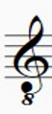 | When the 8 is at the bottom of the clef, it means to play or sing an octave (8 notes) lower than notated
2 (many examples) | staccato |  | To play the note short and detached
15 | accent |  | An emphasis on a note
23 | slur | 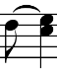 | Notes are to be played smooth and connected
60 | accented staccato |  | A short and emphasised note
85 | tenuto |  | To be emphasised and played for the full duration of the note
45 | piano | 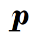 | Soft
79 | forte |  | Loud
91 | decrescendo |  | Gradually getting softer
45 | crescendo | 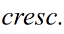 | Gradually getting louder
22 | mezzo piano | 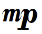 | Moderately soft

Activity 6.5 – ‘First Nation’ – Midnight Oil – listening

‘First Nation’ – Midnight Oil – suggested answers

Song meaning
- List the artists that sing this song – Peter Garrett (main vocals), Jessica Mauboy (back-up vocals), Tasman Keith (rap)
- What is the song about? – this song is about Aboriginal and Torres Strait Islander Peoples (First Nation) and their rights.
- How does this song make you feel? – Happy/sad/angry/hopeful – answers may vary from excited, hope, frustration.
- What words or lines stood out to you in this song? Why are these words important? – answers may vary. Focus may be on the lyrics of the title of the song ‘First Nation’.
- Why is the song called ‘First Nation’ – it is discussing Aboriginal and Torres Strait Islander Peoples and their heritage and connection to Country.

Verse 1 and 2 (0:00–1:19)
- Is the pulse of this song strong or weak? How do you know if the pulse is strong or weak – strong (from the drumbeat)
- What is the tempo of this piece – moderately fast (crotchet = 108)
- The time signature of this piece is ${6 \atop 4}$. Write out the first bar of the drum pattern.
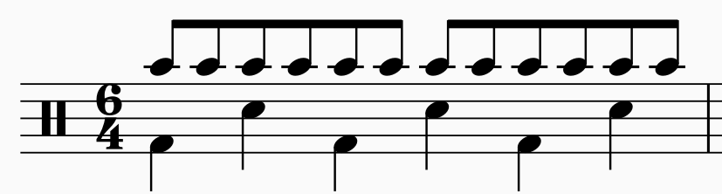
- Name the instrument (performing media) that is playing with the drumkit at the beginning of the piece in the introduction – electric guitar
Identify:
- how it is being played – plucked with a guitar pick
- a word to describe the timbre of this instrument – electric, amplified, clear, clean
- the note values this instrument is playing – semiquavers
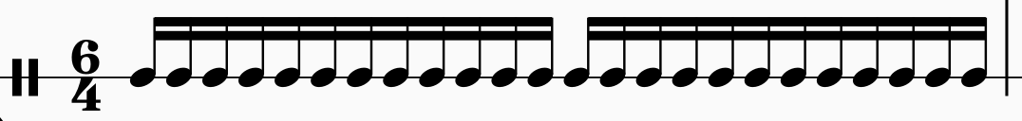
- Draw a graphic score of the pitch pattern of the backing vocals (‘do, do, do, do, do, do, do’).

- Compare the main vocals with the backing vocals for the following:
- timbre – male vocals: rough and harsh, backing vocals: sweet and smooth
- register – male vocals: in the middle register (spoken style), backing vocals: in the middle register (small range of notes)
- rhythmic note values (word bank – ostinato, syncopation, long/short, repetition) – male vocals: syncopated, repetitive, simple, a mixture of long and short notes. Back-up vocals: ostinato pattern, on the beat, quaver based, simple
- Use the rhythm below to notate the pitch of the bass line ostinato in this piece.
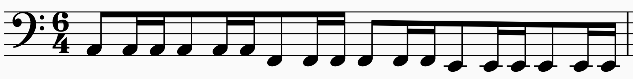

Pre-chorus (1:19–1:31)
- What happens to the time signature in the bridge before the chorus (‘out loud’)? – moves to ${4 \atop 4}$. This is evident through the change in accents on the drumkit and the tambourine.
- Write one sentence to describe the melodic line in the bridge – 3 phrases. The first 2 phrases are the same and the 3rd phrase is sung higher. The voices are in unison one octave apart. These melodic phrases are very simple.
- Both the main vocals and backing vocals sing this bridge. What is different about their pitch? – unison one octave apart.
- What happens to the texture of the song in the bridge? – the texture becomes thinner, because the performing media is less, but this builds as the bridge progresses (into the chorus).
- Identify one element of music and write one sentence referring to how the drums use this element to add excitement in the bridge. – Duration: the bass drum is on every beat and there is a fill into the chorus. The drum uses rhythmic diminution into the chorus (gradually shortening the notes values). Performing media and timbre: the tom tom drums and bass drum are used to give a booming timbre. Expression and dynamics: the drums use accents and build in dynamics as the bridge progresses.
- Name the dynamic and expression marking that gradually occurs throughout the bridge – crescendo (gradually getting louder) or poco a poco crescendo (little by little getting louder).

Chorus (1:31–1:47)
- What dynamic marking is the chorus of this song – forte (loud) or fortissimo (very loud).
- Identify 3 instruments (performing media) in the chorus and use a word to describe their timbre – tambourine: clean and clear, electric guitar: distorted, male and female vocals: resonant and harsh, bass guitar: booming, drums: clear and strong, electronic keyboard: amplified and resonant.
- What effect does the vocal ‘growl’ at the end of the chorus create? – adds excitement, more drama to the protest song, emphasises the rough timbre a voice can produce (the change in timbre creates variety).

Rap section – (1:47–2:14)
- Use one word to describe the timbre of the rap – clear/spoken, harsh
- There is a slight echo (call and response) at the end of each rap phrase. Write 2 points about this echo (‘response’) – the echo adds musical drama and emphasises the points of the rap lyric. It also changes the timbre as it is heavily electronically manipulated.
- Does the performing role of the drums and bass riff change (variety) or stay the same (unity) in this section? – stay the same (unity)
- There is a high-pitched electronic keyboard in this section. What effect does this high–pitched electronic keyboard create? – creates a sense of uneasiness and the timbre is rich, electronic and clear, yet scratchy.

Learning sequence 7 – depth study

Activity 7.2 to 7.5 – depth study – independent lessons and facilitator meetings

Facilitator meeting monitoring sheet
Table 14 – facilitator meeting monitoring sheet
Student name(s) | Discussion | Support required | Date

Peer feedback
Teacher should organise a round robin or roster for students to present their product for feedback to at least one peer. Give each student 5 minutes to present their product and collect feedback from their peer. It is recommended that a timer be put on the board to assist with time management during feedback sessions.
Step students through the safety protocols for providing feedback – be considerate, be specific, be helpful.
Assist students in developing skills to ask clarifying questions of their peers using warm and cool feedback starters.

Activity 7.8 – presentation or submission of depth study product
Decide how the products are to be submitted and communicate that to the students at the beginning of Lesson 7.1. This could be through live presentation, electronic submission or physical submission on the due date. It is recommended that the depth study proposal is included with product submission.

Sample facilitator feedback sheet
Table 15 – sample facilitator feedback sheet
Student/group name(s)
How well does the product meet the goal proposed in the ‘depth study proposal’?
Where: 1 = attempted to address the goal outlined and 5 = outstanding delivery of the goal outlined
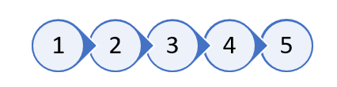
Does the product clearly use the focus area(s) identified in the proposal?

Is there evidence in the final product that the outlined skills, knowledge and research in the proposal, have been used and completed?
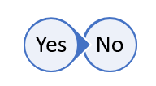
Does the product answer the driving question – ‘How does my perspective of Australia shape my music?’
Comments on how effective the product is in answering the driving question.

How consistent was the approach to creating the product during class time?
Where: 1 = found it difficult to self-manage time and work and 5 = made excellent use of class time


Appendix

Activity – Bluey – listening, performing and score reading
Season 1 BBQ (7:00)
The following backing tracks can be used to learn the ‘Bluey theme song’ rhythm section, rhythm section and bass line, class arrangement. Note – there is an 8-beat count in.
- Bluey rhythm section backing track mp3 (slower tempo)
- Bluey rhythm section and bass line mp3 (slower tempo)
- Bluey class arrangement without melody mp3 (correct tempo)
- Bluey class arrangement with melody mp3 (correct tempo)

Score reading questions – answers
- List 3 ways the composer creates a happy mood in this piece – happiness and excitement is achieved through – the tenor saxophone riff uses staccatos, the added rests create a sense of excitement and anticipation of what is to come, the nasal timbral qualities of the children’s voices, the major guitar strummed chords, the repetition of the riff, clapping on the 2 and 4, the many different percussive layers used.
- Identify bars and instrument(s) where you see the following:
- syncopation – in the first, second and third bars in the keyboard, bass guitar and bass parts. In the first and third bars in the drum part. In the first and third bars of the melody.
- rhythmic unison – in the first and third bars in the clap and tambourine parts. Bars 1 in the bass guitar, guitar and keyboard (note – the bass part also has rhythmic unison in bar 1; however, it is not tied into the second bar). In the fifth bar in the bass part, shaker and bass guitar. In the first and third bars on the first and second beat of the melody part and shaker part. In the second bar on the second and third beat in the melody, keyboard, guitar, bass part and bass guitar. In the second bar on the third and fourth beat in the melody and drum set part.
- an expression marking (include the Italian term in your answer) – the excerpt is marked presto (performed at a quick tempo). Staccato (short and detached) markings – in bar 1 on the first beat of the keyboard, guitar and bass part. In the second bar on the second and third beats in the keyboard, guitar, bass part and bass guitar. In the third bar on the first and fourth beat in the keyboard, guitar and bass part. In the fourth bar on the second beat in the melody, bass part and bass guitar. Accent (emphasise or stress a note) markings are in the tambourine part for the whole arrangement.
- What is effect of the ${5 \atop 4}$time signature change in the last bar? – to create rhythmic contrast as well as a sense of surprise, which fits with the happy mood of the piece.
- Define the ${5 \atop 4}$ time signature of the final bar – five crotchet beats per bar.

Class arrangement

Bass guitar TAB
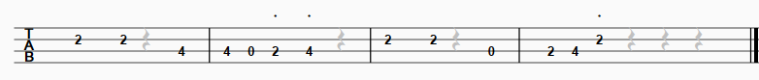

Easy guitar option TAB
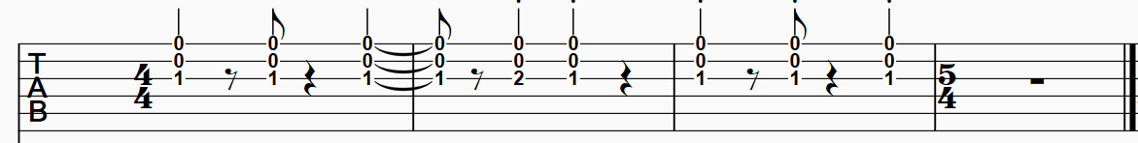

Guitar TAB
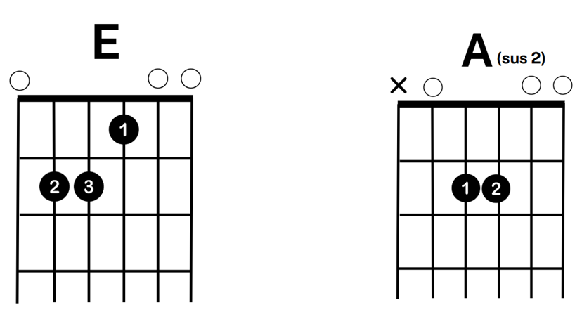

Keyboard chords
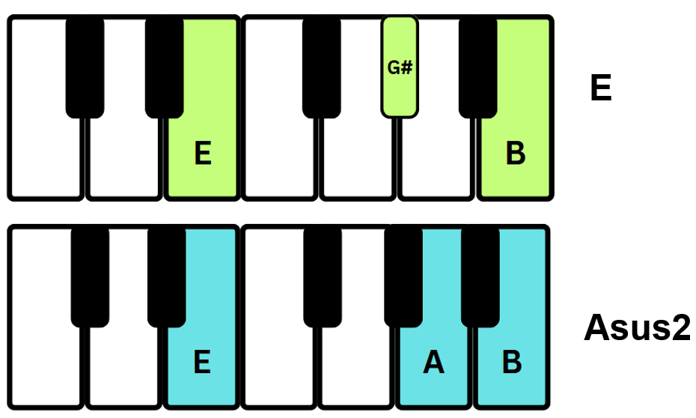

References
This resource contains NSW Curriculum and syllabus content. The NSW Curriculum is developed by the NSW Education Standards Authority. This content is prepared by NESA for and on behalf of the Crown in right of the State of New South Wales. The material is protected by Crown copyright.
Please refer to the NESA Copyright Disclaimer for more information https://educationstandards.nsw.edu.au/wps/portal/nesa/mini-footer/copyright.
NESA holds the only official and up-to-date versions of the NSW Curriculum and syllabus documents. Please visit the NSW Education Standards Authority (NESA) website https://educationstandards.nsw.edu.au and the NSW Curriculum website https://curriculum.nsw.edu.au.
Music 7–10 Syllabus © NSW Education Standards Authority (NESA) for and on behalf of the Crown in right of the State of New South Wales, 2024.
@thisisshari (4 April 2023) 'How To Develop and Strengthen Your Falsetto Singing Voice’ [video], @thisisshari, YouTube, accessed 24 March 2025.
APRA AMCOS (2025) ‘Licensing for schools’, Music Licences, APRA AMCOS website, accessed 20 May 2025.
APRA AMCOS (2025) ‘Guide to music copyright for instrumental teachers’, Music Licences: Education licences, APRA AMCOS website, accessed 20 May 2025.
Baker Boy (2025) Baker Boy Official [website], accessed 1 July 2025.
Brumm J (Series Director) (2018) ‘BBQ’ [television program], Bluey, (season 1, episode 7), ABC, Brisbane.
Cheryl Porter Vocal Coach (23 October 2023) ‘VOCAL AGILITY Exercise DUET w/Vocal Coach Cheryl Porter’ [video], Cheryl Porter Vocal Coach, YouTube, accessed 20 May 2025.
Tagliarino B (26 December 2021) ‘Additive Rhythms in Lead Guitar for Better Phrasing’ [video], Barret Tagliarino, YouTube, accessed 16 June 2025.
TED (4 April 2025) A Survival Guide for Musicians in the Age of AI I Harvey Mason jr. I TED [video], TED, YouTube, accessed 20 May 2025.

© State of New South Wales (Department of Education), 2025
The copyright material published in this resource is subject to the Copyright Act 1968 (Cth) and is owned by the NSW Department of Education or, where indicated, by a party other than the NSW Department of Education (third-party material).
Copyright material available in this resource and owned by the NSW Department of Education is licensed under a Creative Commons Attribution 4.0 International (CC BY 4.0) license.

This license allows you to share and adapt the material for any purpose, even commercially.
Attribution should be given to © State of New South Wales (Department of Education), 2025.
Material in this resource not available under a Creative Commons license:
- the NSW Department of Education logo, other logos and trademark-protected material
- material owned by a third party that has been reproduced with permission. You will need to obtain permission from the third party to reuse its material.
Links to third-party material and websites
Please note that the provided (reading/viewing material/list/links/texts) are a suggestion only and implies no endorsement, by the New South Wales Department of Education, of any author, publisher, or book title. School principals and teachers are best placed to assess the suitability of resources that would complement the curriculum and reflect the needs and interests of their students.
If you use the links provided in this document to access a third-party's website, you acknowledge that the terms of use, including licence terms set out on the third-party's website apply to the use which may be made of the materials on that third-party website or where permitted by the Copyright Act 1968 (Cth). The department accepts no responsibility for content on third-party websites.

