School Check-in using the Service NSW app

Visitor scenario 1
School Check-in via the Service NSW app for visitors who already have a MyService NSW account.
Checking into a school using School Check-in
Step 1: Open the Service NSW app on phone | 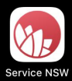
Step 2 (optional): Log in  If the visitor is not already logged into the Service NSW app, they can log in using their MyServiceNSW account details.  Tap the Settings cog on the Homepage to see the Login button. | 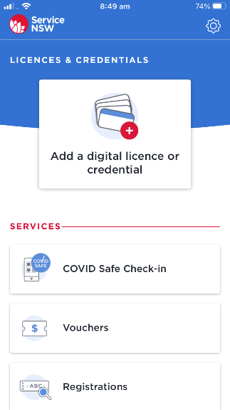  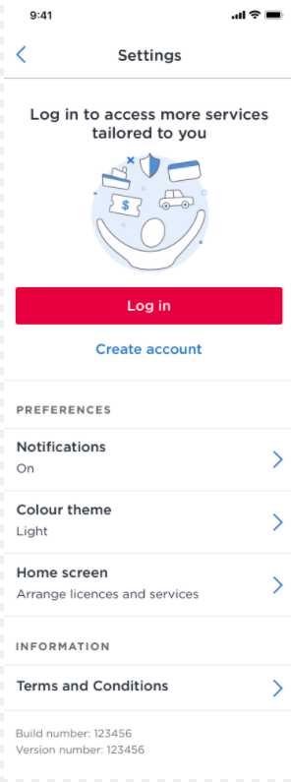
Step 3: Select School Check-in  Tap the School Check-in tile to get started. | 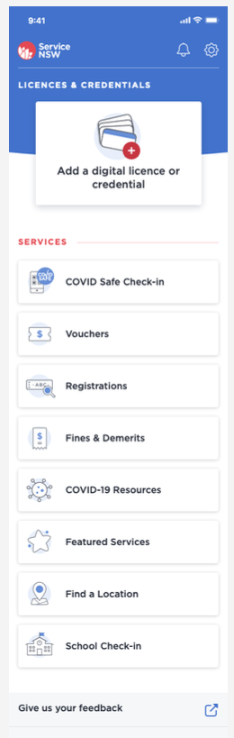
Step 4: Scan school QR code  Visitor to use camera phone to scan the QR code. Position the QR code in the square on the screen. | 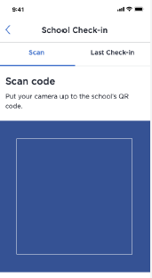
Step 5: Update or confirm contact details  Visitor shown contact details as per their MyServiceNSW account.  If name needs updating, tap Edit, enter correct name details and Save.  If mobile number needs updating, tap Edit, enter new mobile number and tap Send code.  Review privacy information.  If contact details correct, tap the red Next button. | 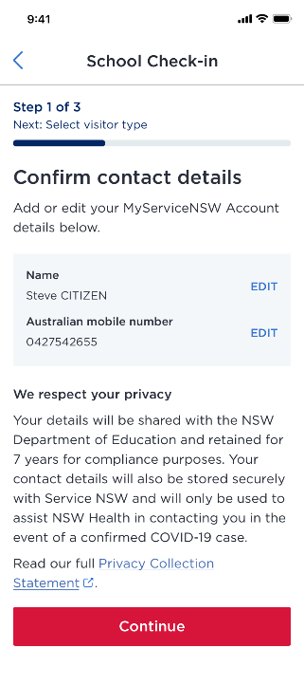
Step 6: Select visitor type  Select Visitor type (parent/carer or contractor/other).  Tap the red Continue button. | 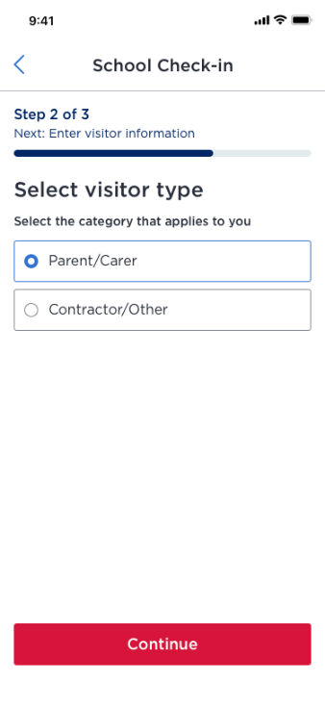
Step 6a: Enter Parent/carer visitor type information  If Parent/carer visitor type selected, the parent/carer will then have to enter Reason for visit and School contact.  Select ‘Check in’ to submit details. | 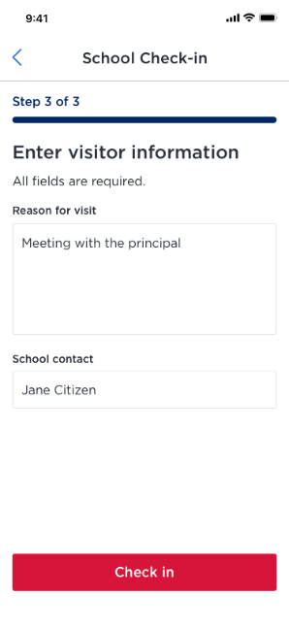
Step 6b: Enter Contractor/other visitor type information  If Contractor/other visitor type selected, the contractor will then have to enter Organisation name, Reason for visit and School contact.  Answer yes or no as to whether they will be working in child-related work.  Select ‘Check in’ to submit details. | 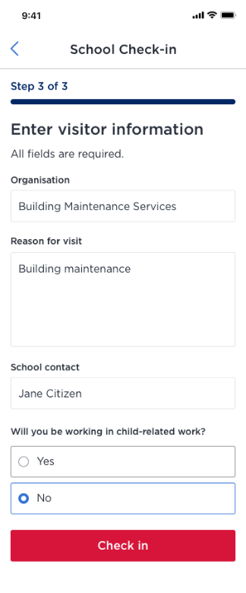
Step 7: Confirmation screen  After selecting the ‘Check in’ button, the form will display a successful submission screen with the sign-in details.  Note: If the visitor answered ‘Yes’ in response to the question asking if they would be working in child-related work, they will be asked to provide their Working with Children Check (see screenshot, far right). | 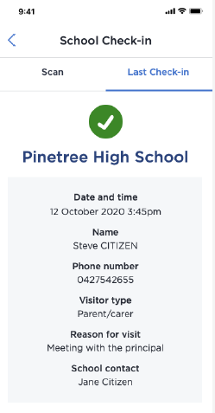  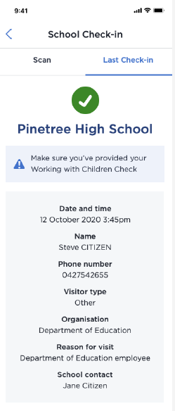

Visitor scenario 2
Webform check-in for visitors who have a smartphone, but do not have the Service NSW app.
Checking into a school using School Check-in

Step 1: Scan school’s QR code

Scan the QR code with a smartphone or QR code reader. Position the QR code so that yellow brackets form at the corners.

They will be directed to a Service NSW webpage.
Step 2: Choose ‘Webform’ option  On the webpage a choice is given to use the app or continue to the webform.  Click on Webform button. | 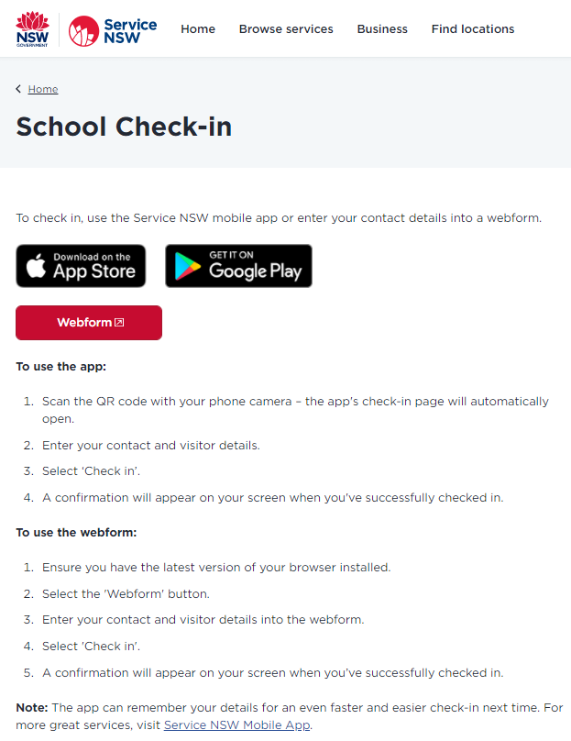
Step 3: Enter contact details and select visitor type  Enter contact details (first name, last name, Australian phone number).  Note: ‘International phone number’ can be selected if required and then the international phone number should be entered.  Select Visitor type (parent/carer, contractor, or other). | 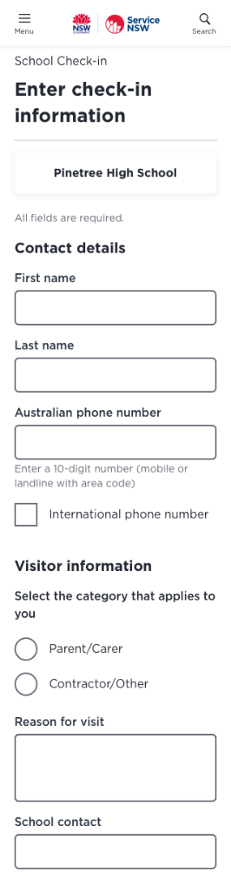
Step 3a: Enter Parent/carer information  Select ‘Parent/carer’ visitor type.  Enter Reason for visit and School contact. | 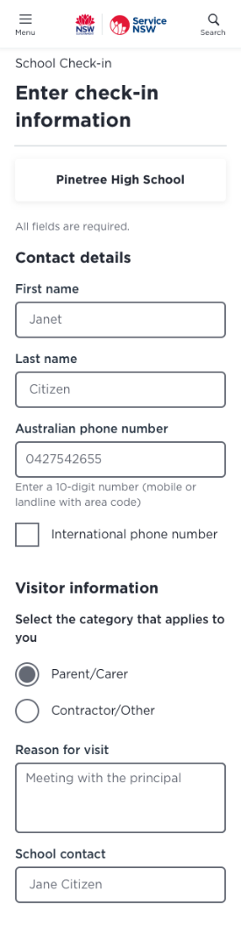
Step 3b: Enter Contractor/Other information  Select ‘Contractor/Other’ visitor type.  Enter Organisation name.  Answer Yes or No as to whether you will be working in child-related work.  Enter Reason for visit and School contact. | 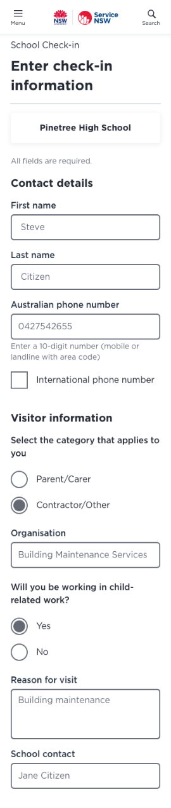
Step 4: Acknowledgement

Review privacy information.

Select ‘Check in’ to submit details.

Step 5: Confirmation screen  After selecting the ‘Check in’ button, the form will display a successful submission screen with the sign-in details.  Note: If the visitor answered ‘Yes’ in response to the question asking if they would be working in child-related work, they will be asked to provide their Working with Children Check (see screenshot, far right). | 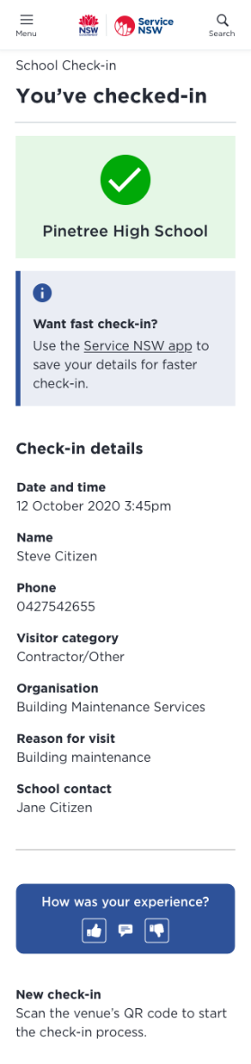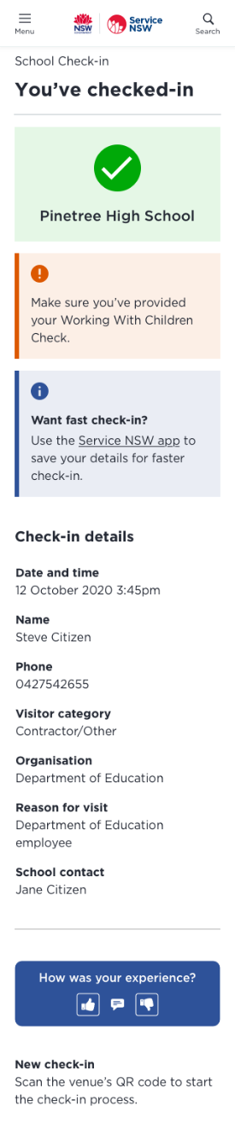

Visitor scenario 3
Webform check-in for visitors who do not have a smartphone or internet connection.
Checking into a school using School Check-in

Step 1: Set up Concierge webform

Schools enter Concierge webform URL link into web browser address bar.

Tip: You can add the URL link as a ‘favourite’ so you can find it quickly when needed.

A Service NSW webform will appear on the page.
Step 3: Enter contact details and select visitor type

Enter contact details (first name, last name, Australian phone number).

Note: ‘International phone number’ can be selected if required and then the international phone number should be entered.

Select Visitor type (parent/carer, contractor, or other).

Step 3a: Enter Parent/carer information

Select ‘Parent/carer’ visitor type.

Enter Reason for visit and School contact.
Step 3b: Enter Contractor/Other information

Select ‘Contractor/Other’ visitor type.

Enter Organisation name.

Answer Yes or No as to whether you will be working in child-related work.

Enter Reason for visit and School contact.
Step 4: Acknowledgement

Review privacy information.

Select ‘Check in’ to submit details.

Step 5: Confirmation screen  After selecting the ‘Check in’ button, the form will display a successful submission screen with the sign-in details.  Note: If the visitor answered ‘Yes’ in response to the question asking if they would be working in child-related work, they will be asked to provide their Working with Children Check (see screenshot, far right). | 