Providing school staff with access to the logbook

Principals and SAMs can grant access
Principals and SAMs can use this to give access to any school staff member.
Principals and SAMs should only give access to the logbook to staff that will use the system on a regular basis (e.g teachers would not ordinarily get access to the logbook).
- Visit https://msa.education.nsw.gov.au/
- Choose the staff member to whom you wish to give access
- Select "Check-in Logbook "
- Tick the box to finalise. The selected staff member will receive a confirmation email.

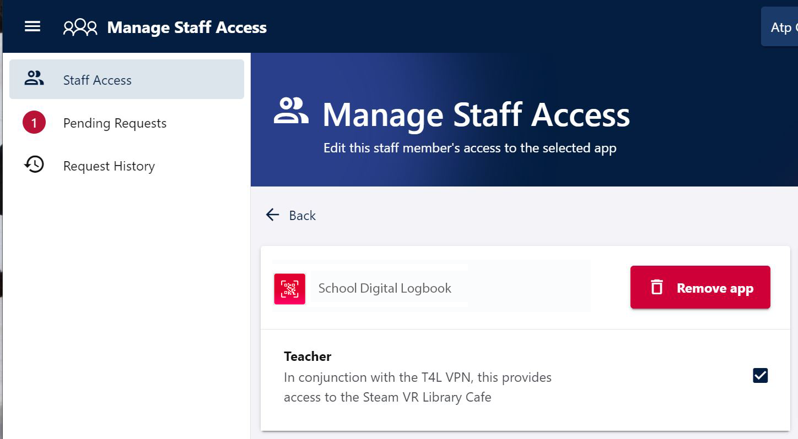
Check-in Logbook

School support staff can request access
School staff that require access to the School Check-in Logbook can initiate an access request through MMA (Manage My Access).
- Visit https://mma.education.nsw.gov.au/.
- Scroll to the bottom and click on "Check-in Logbook".
- Click 'None', indicating you don't currently have access.
- Click 'submit' to send the request to your principal or delegate to approve.
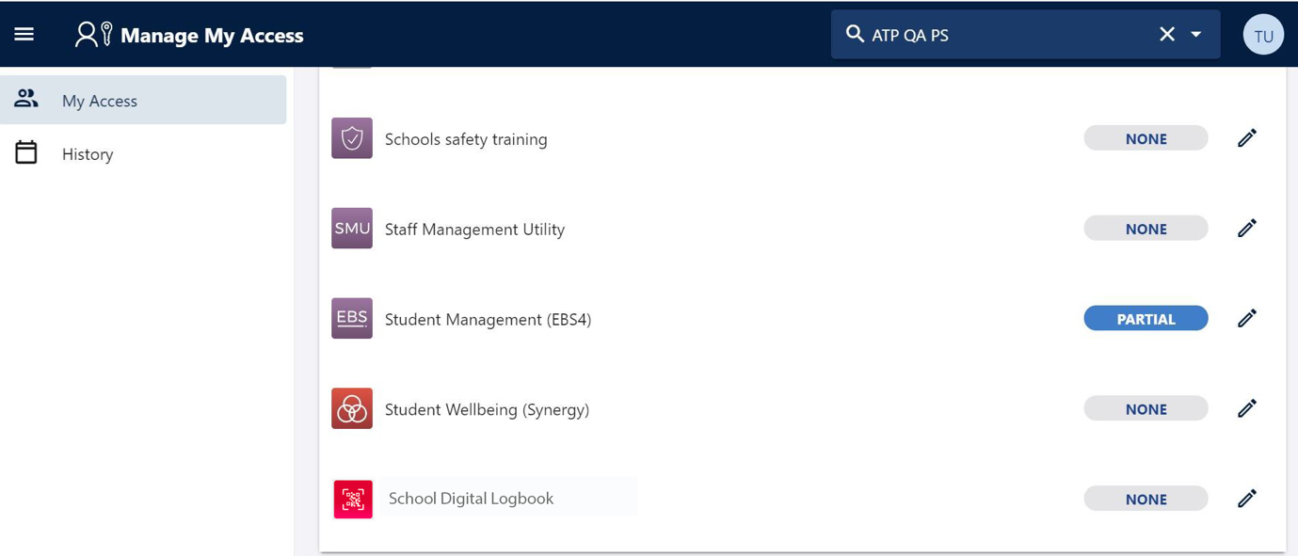
Check-in Logbook

Using the School Check-in Logbook on a Mobile device

The logbook is best accessed through the Staff Portal App.
The app is designed to deliver a smoother mobile experience when using the staff portal and fast authentication to My Essentials
To access the logbook through the app, download the Staff App from the Apple Store or Google Play store, by searching for “DoE Staff App”.

