User guide menu

- Add MSA to My Essentials | - Remove application and role access
- View and grant staff access | - Configure email notification settings
- Manage delegates | - Review last 30 days of requests
- Approve or deny a request

Add MSA to My essentials

- Log into DoE staff portal.  For principals,  Manage Staff Access is available in My Essentials by default.  It also appears in Essentials in the Staff Portal app. |  | 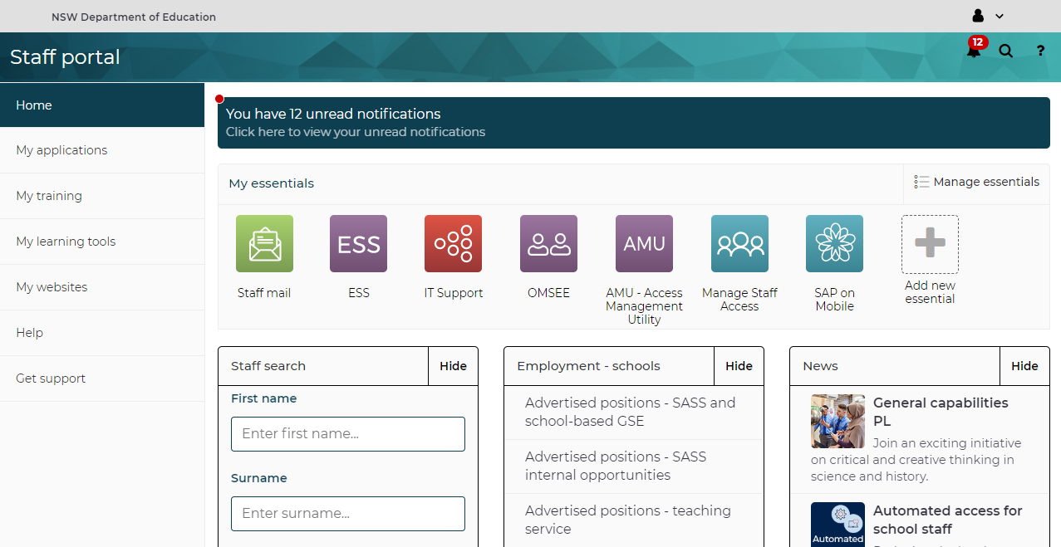
- For delegates, you need to add Manage Staff Access to My Essentials.  Select My Applications on the left hand menu.  Type MSA in the search field and select Show details. |  | 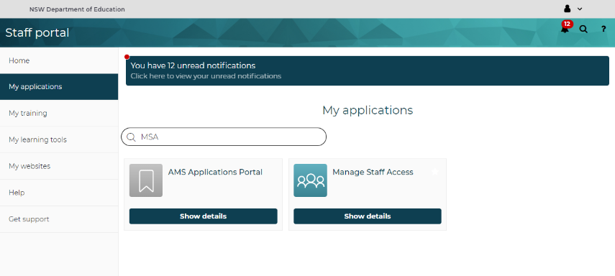
- Select + Add to my essentials list. |  | 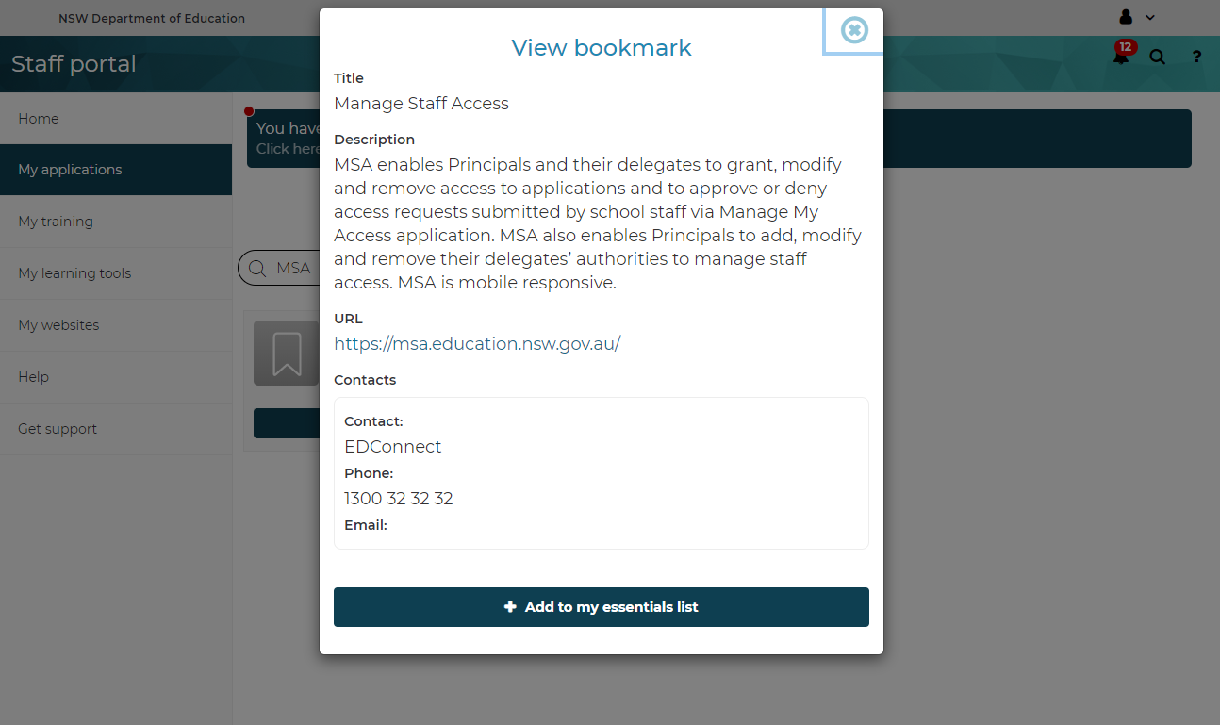
- When you select Home from the left hand menu, you will see Manage Staff Access in My essentials.

View and grant staff access

- From the MSA homepage ensure your current school is displayed on the top right.  The Staff Access page shows all the staff for this school.  You can scroll down to the bottom to see any external users that were added by you to the school as well. | 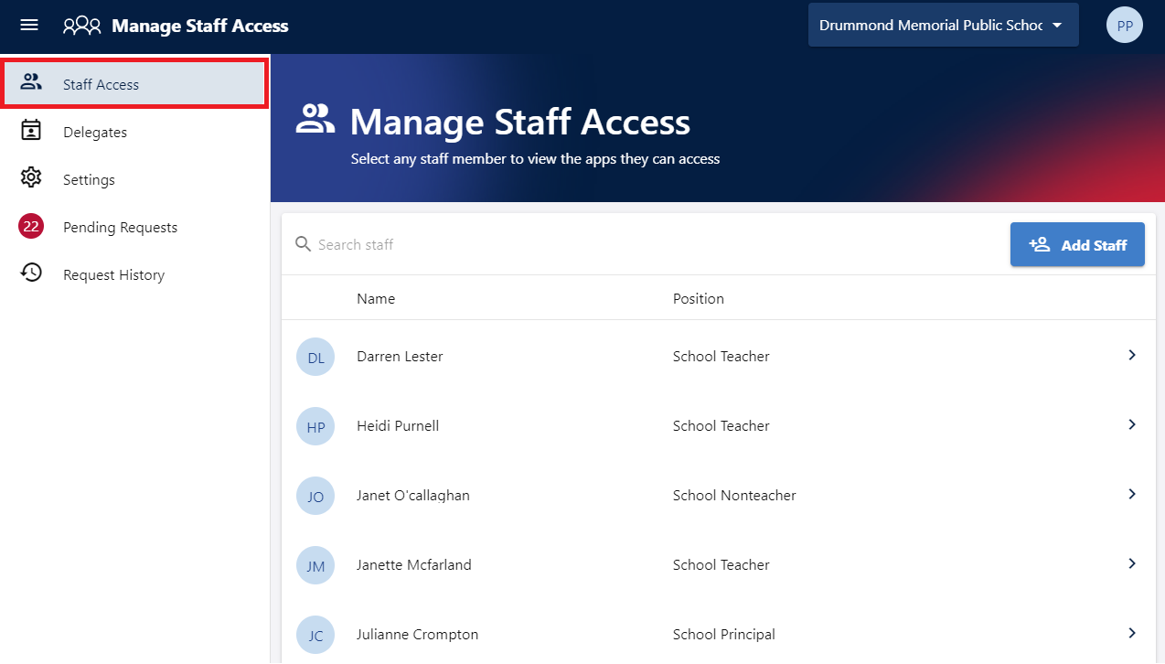
- Click on a user, to view their current access details.  You will see their role and individual application access. | 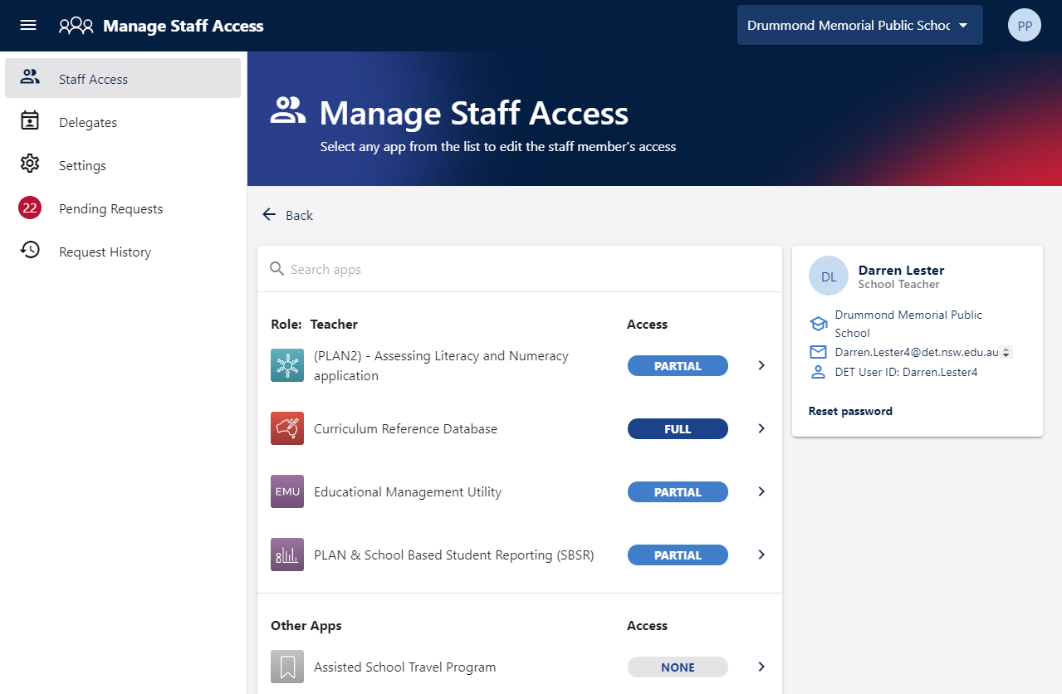
- Click on an application in the list to view the user’s current access levels.  You can check or uncheck the access levels to grant or remove access.  The change is saved immediately.  The access levels associated with a role are greyed out and cannot be modified. | 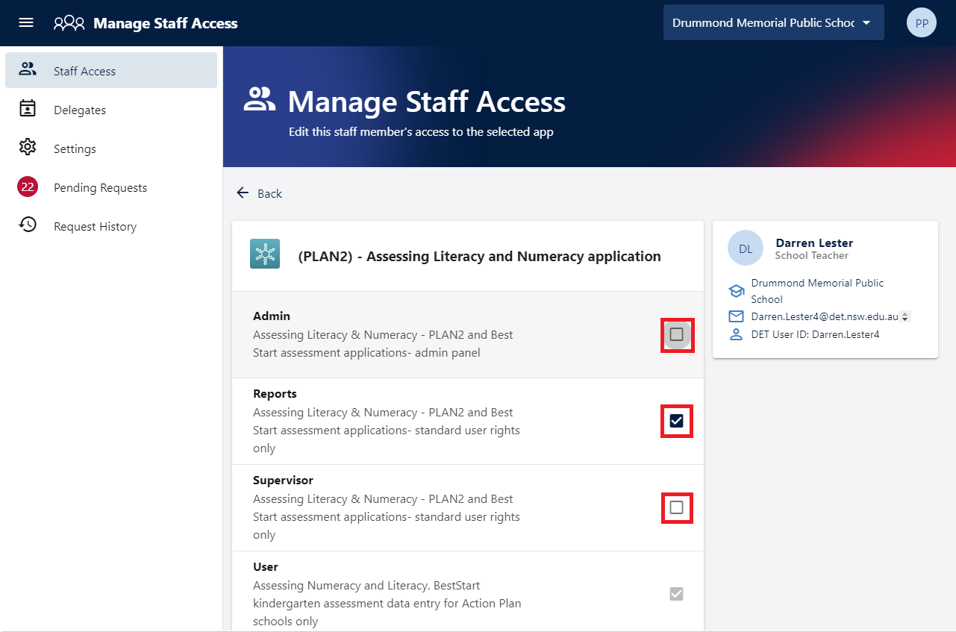

Manage delegates

- From the MSA homepage ensure your current school is displayed on the top right.  Select Delegates on the left-hand menu.  You will see all the delegates for this school. | 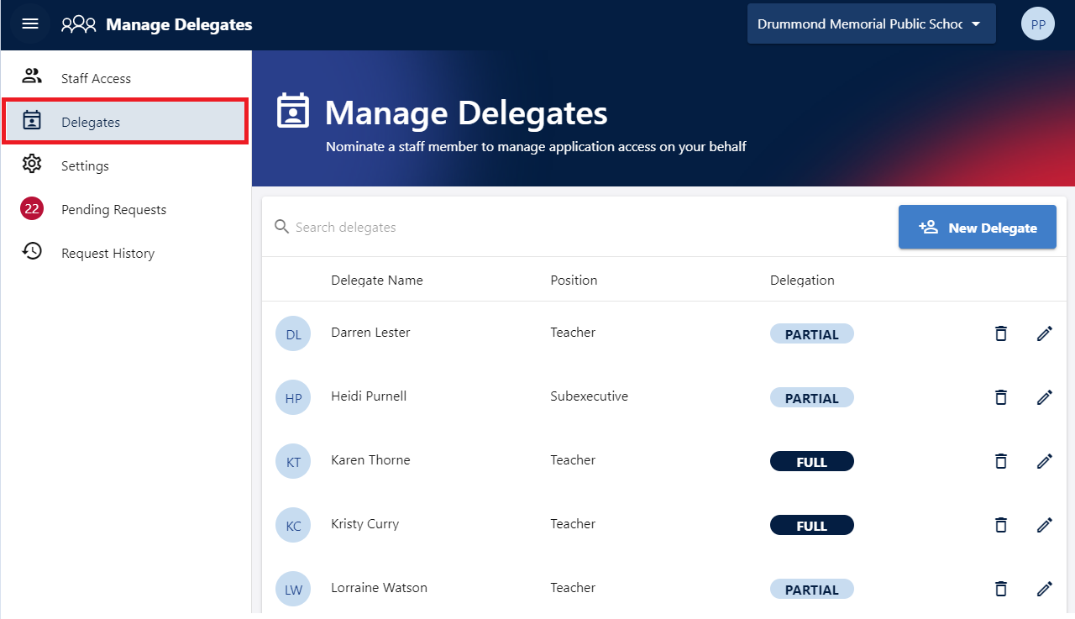
- To remove a delegate, click on the bin icon next to the user and select Remove Delegations.  This will remove the staff member from the delegates list and revoke all delegation privileges for them. | 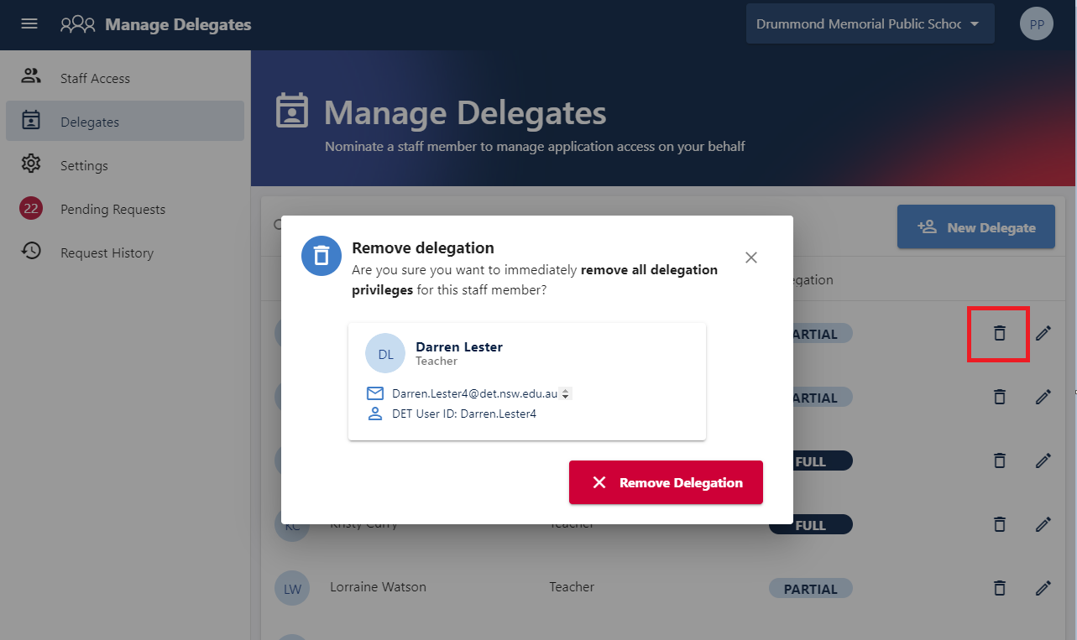
- To edit delegate privileges, click the pen icon next to the user.  In the Apps to delegate list, check or uncheck each application to grant or remove the delegated privileges.  The change will be saved immediately. | 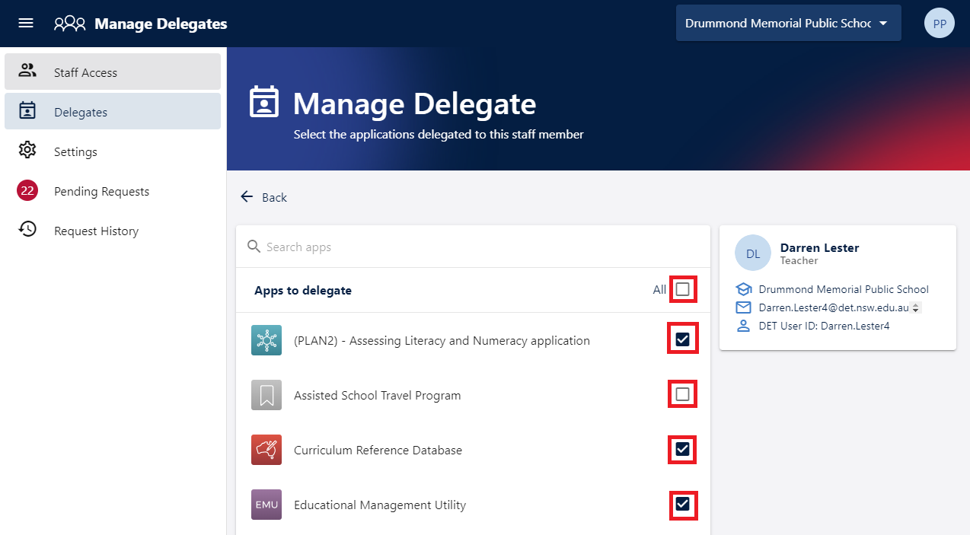

Approve or deny a request

- From the MSA homepage ensure your current school is displayed on the top right.  Select Pending Requests from the left hand menu.  Any pending requests will be shown in red. | 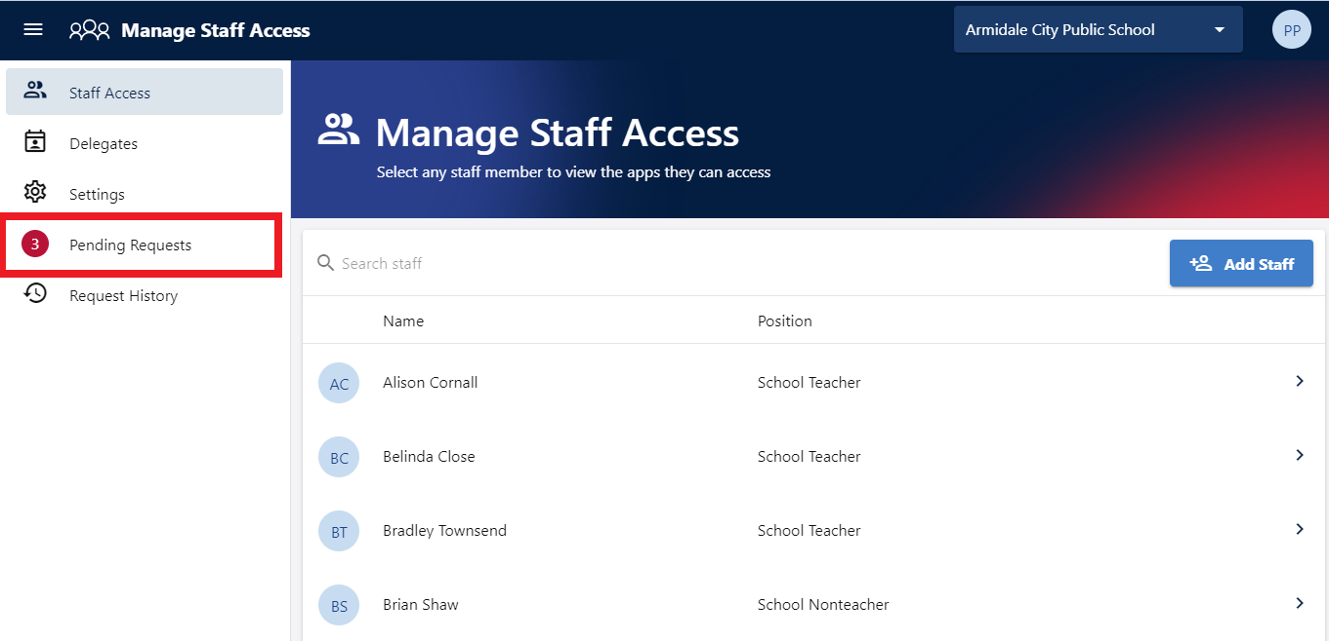
- Pending requests are only visible to the principal and the delegates who have authority to approve those requests.  Select the tick or cross icon next to a request to approve or deny it. | 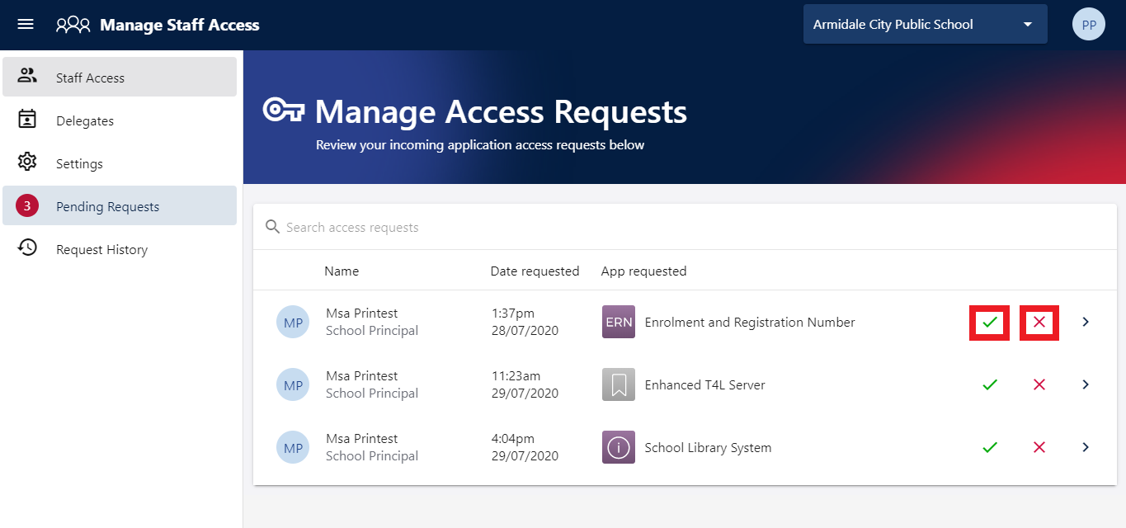
- To see detailed information about the request, click on the arrow icon next to the request.  Click Approve or Deny to approve or deny the request. | 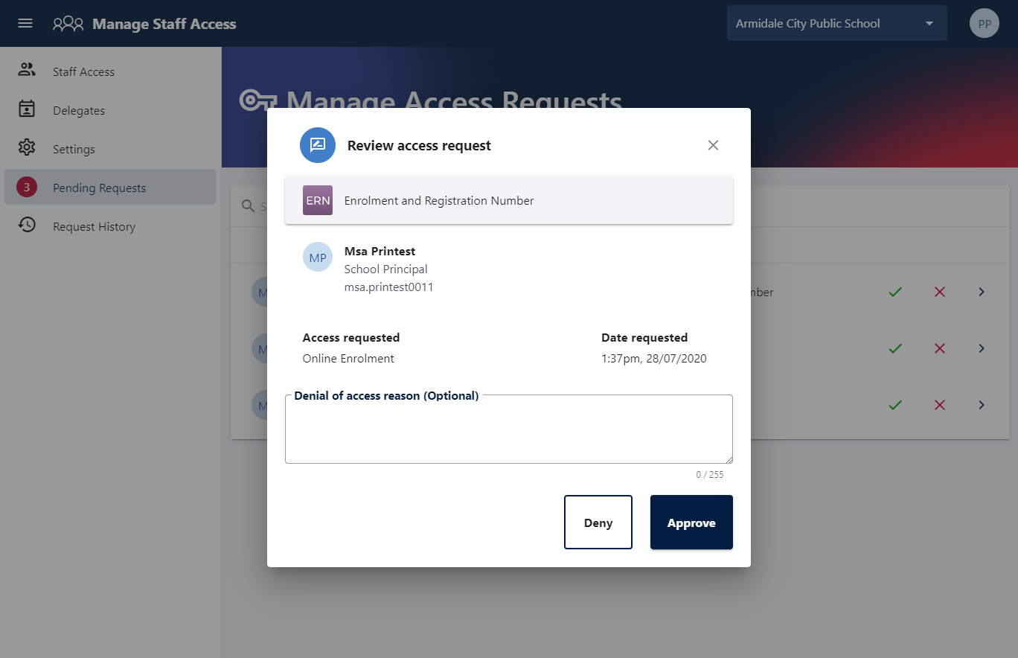

Remove application and role access

- From the Staff Access page, click on the staff member, and then on the application.  Uncheck the access levels to remove access.  The change is saved immediately.  Note that access levels associated with a role are greyed out and cannot be removed. | 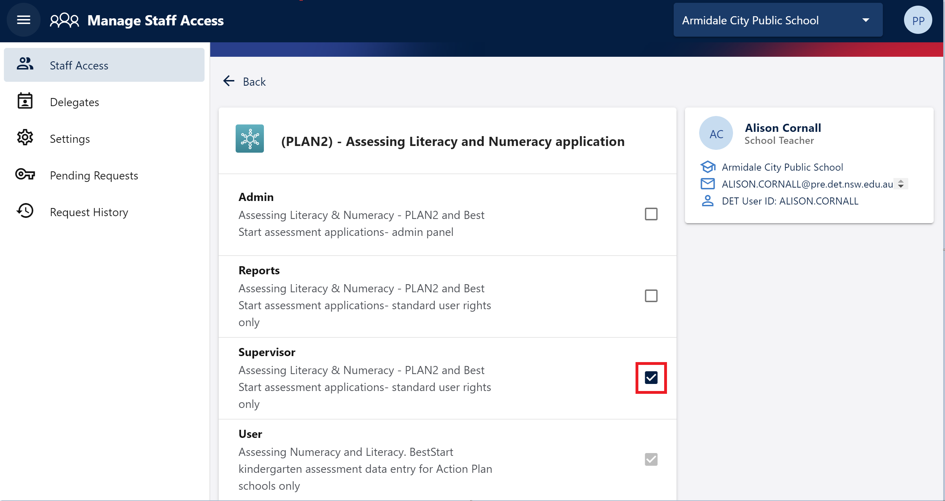
- Roles assigned by the system to permanent staff cannot be removed or modified as this is automated by IT systems.  You also cannot remove a role that you have manually assigned to a casual or temporary user through MSA.  To do this, you have to log an incident in Remedy. In the incident, specify the user and the role that you want to remove. | 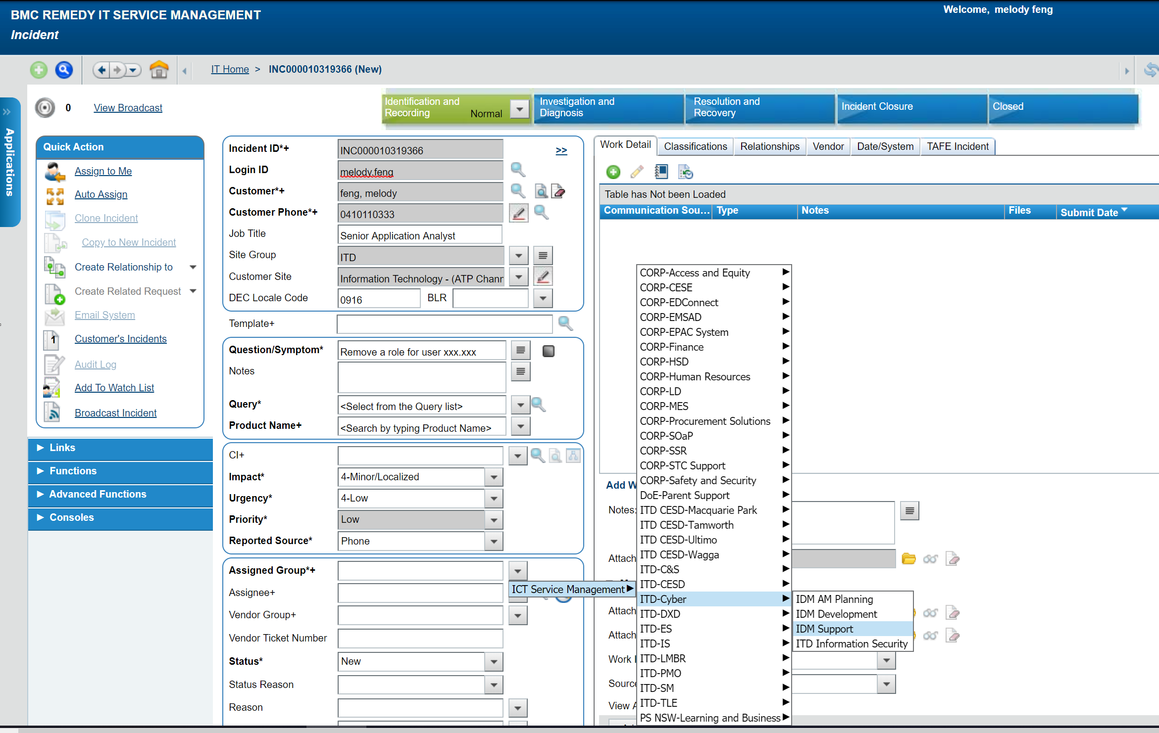

Configure email notification settings

- From the MSA homepage select Settings page from the left hand menu.  This page is only available to school principals and is a global setting, applying to all principals at the school (if there are more than one). | 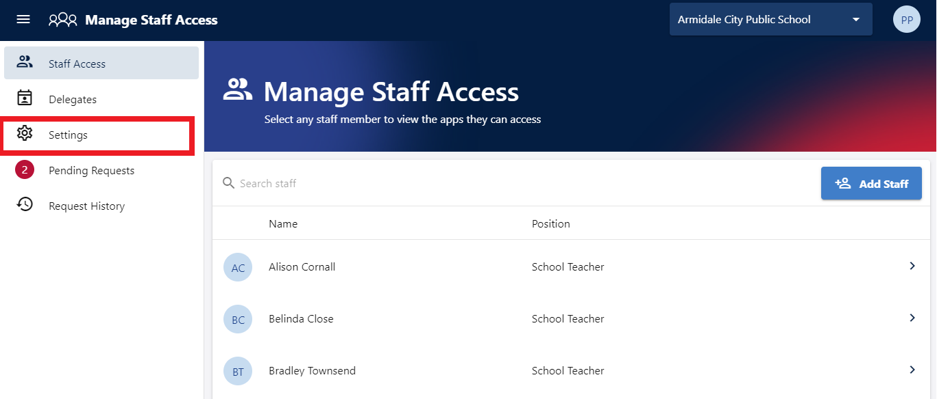
- Turn on Access request notifications to receive an email every time an access request is logged. This is disabled by default.  Access request escalations determines the number of days before a un-actioned request is escalated to the principal (can be 3 or 7 days). | 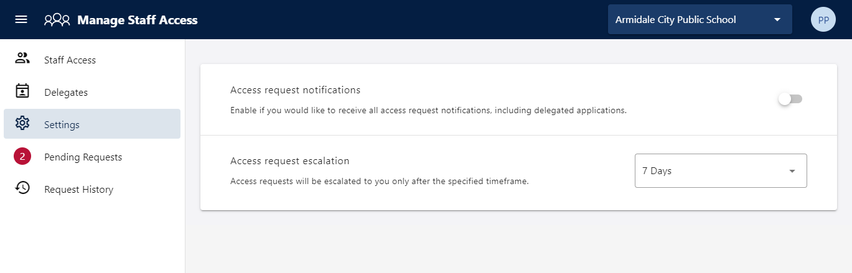
- Depending on the settings, school principals will receive email notifications either every time a request is logged, or after a request remains un-actioned by delegates for 3 or 7 days. | 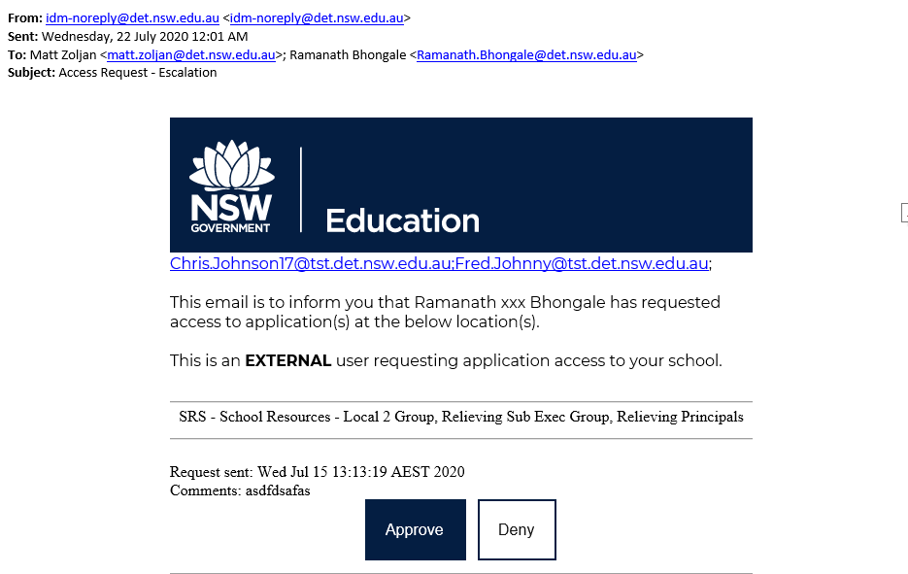

Review last 30 days of requests

- Select Request History from the left hand menu to view all requests raised for your school in the last 30 days. | 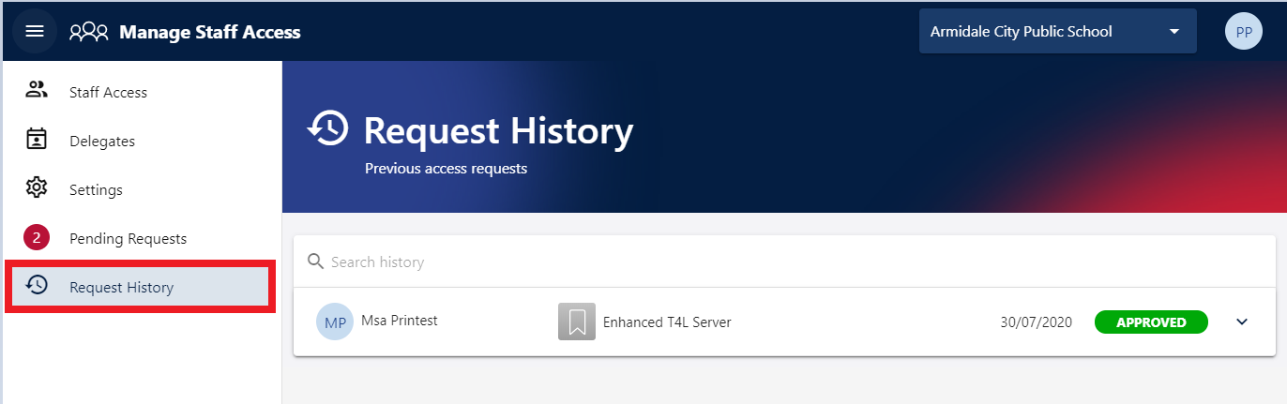
- To view detailed information for a request click on the arrow button next to it | 