How to access the School Check-in Logbook

Login to your Staff Portal.
Within you’re My Essentials, you should see the Check-in Logbook icon.
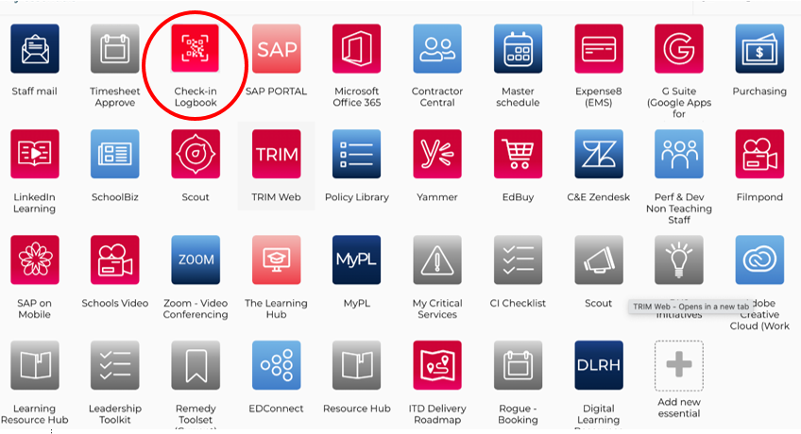
Figure 1: The School Check-in Logbook can be accessed via the Staff Portal.

School Check-in Logbook - Functionality
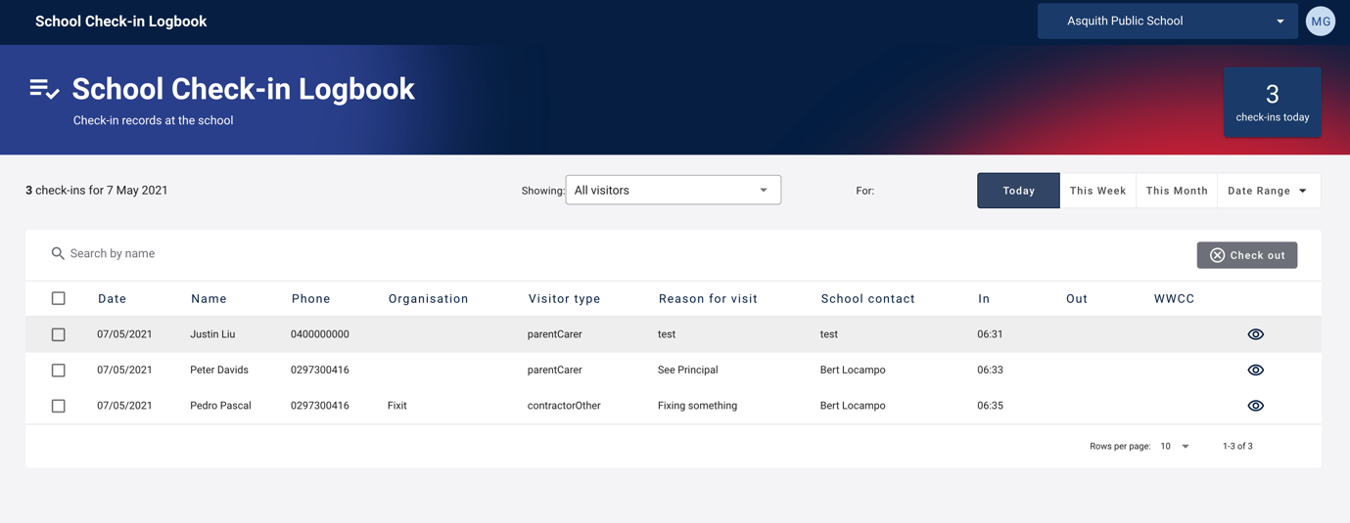
Figure 2: The main log-book interface provides a list of visitors that have checked into your school via the Service NSW App.

Figure 3: By default, only the school principal and the School’s SAM will have access to the Digital Logbook. When you login to the Logbook via the Portal, you will see the name of the school and your profile in the top right corner of the application.

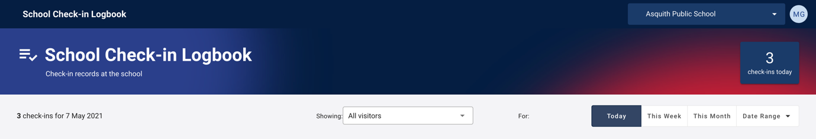
Figure 4: the main screen will show total number of check-ins for that day.
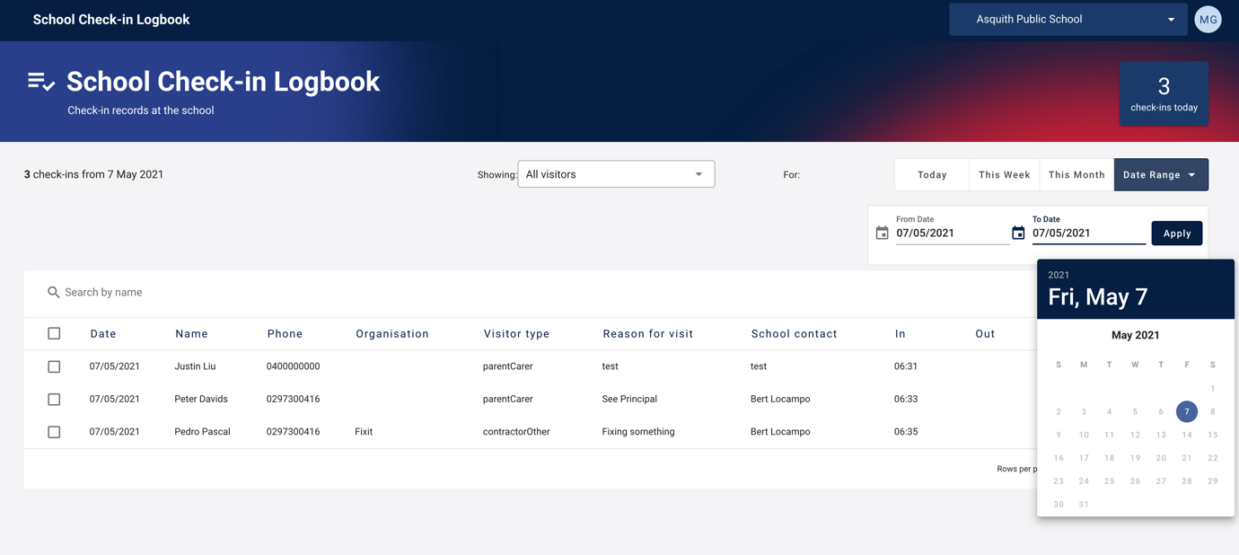
Figure 5: School staff can also select check-ins for the current week and current month. They can also specify the date range via the date selector.

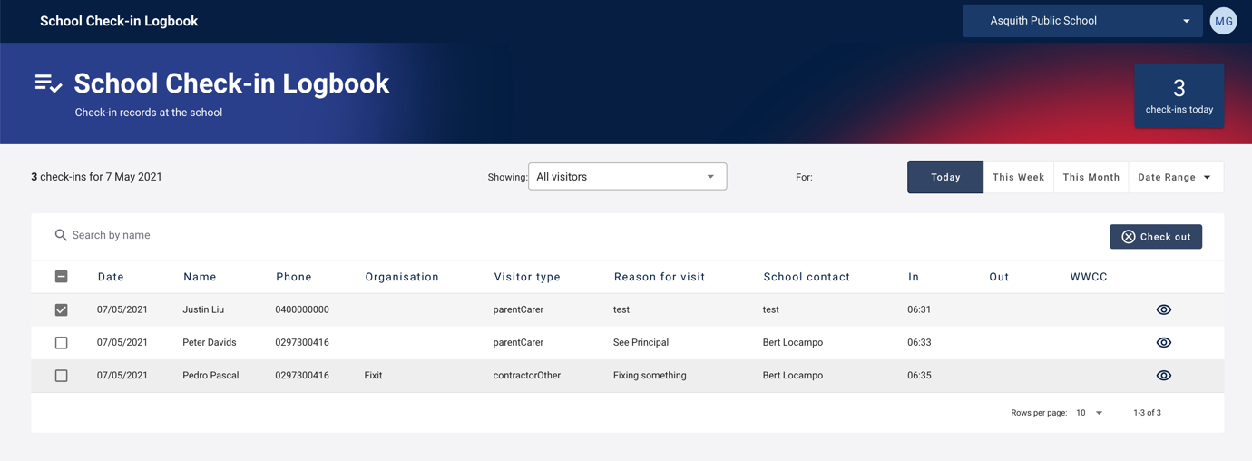
Figure 6: School Staff can select a user to check out on their behalf. Use the check box to select the user, and Select Check Out.

Mobile view
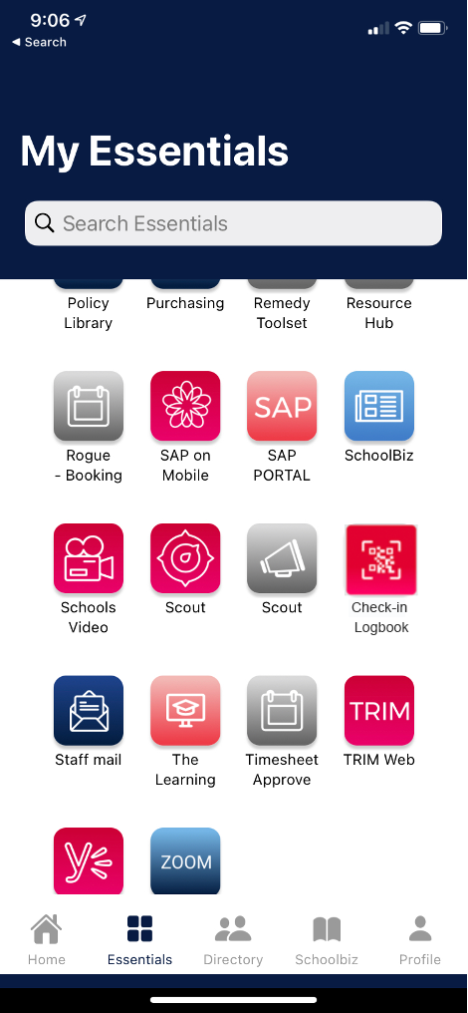
Figure 7 Once downloaded, find the Schools Check-in Logbook by accessing the My Essentials tab on the Staff App and searching for Check-in Logbook.
Staff can also access the Check-in Logbook directly within their mobile web browser by going to visitor.education.nsw.gov.au and signing in with their DoE login.

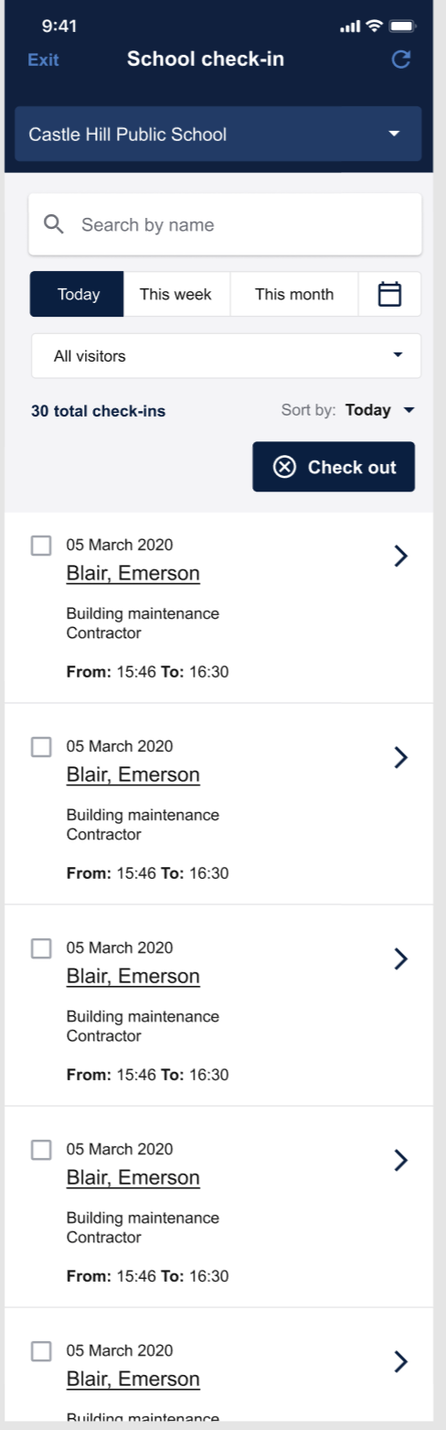
Figure 8 The School Check-in Logbook can be viewed easily on a mobile device.

