Project Overview

In response to feedback from parents, students, staff and the community, the NSW Government has announced upgrades for all four schools in Murwillumbah.

These upgrades have been funded as part of the 2023-24 NSW Budget, and will enable a return to two high school sites in Murwillumbah for the start of the 2025 school year.

The upgrades, which will take place across all four schools, will include

- Air conditioning to all learning spaces and libraries;
- Lighting upgrades;
- Renovated bathrooms;
- New furniture and equipment; and
- Painting and new floor coverings.

The flood levee at Murwillumbah East Public School, and the full restoration of Murwillumbah High School, will progress first. Works at all schools will be prioritised.

Next Steps

The community will be kept informed of key milestones along the way through project updates issued by School Infrastructure NSW.

The task of appointing contractors to progress the work is now underway.

A full copy of the consultation report is available online at https://education.nsw.gov.au/content/dam/main-education/about-us/strategies-and-reports/media/documents/Murwillumbah_Schools_Full_Consultation_Report_2023.pdf.

Foreword

From NSW Department of Education Secretary Murat Dizdar

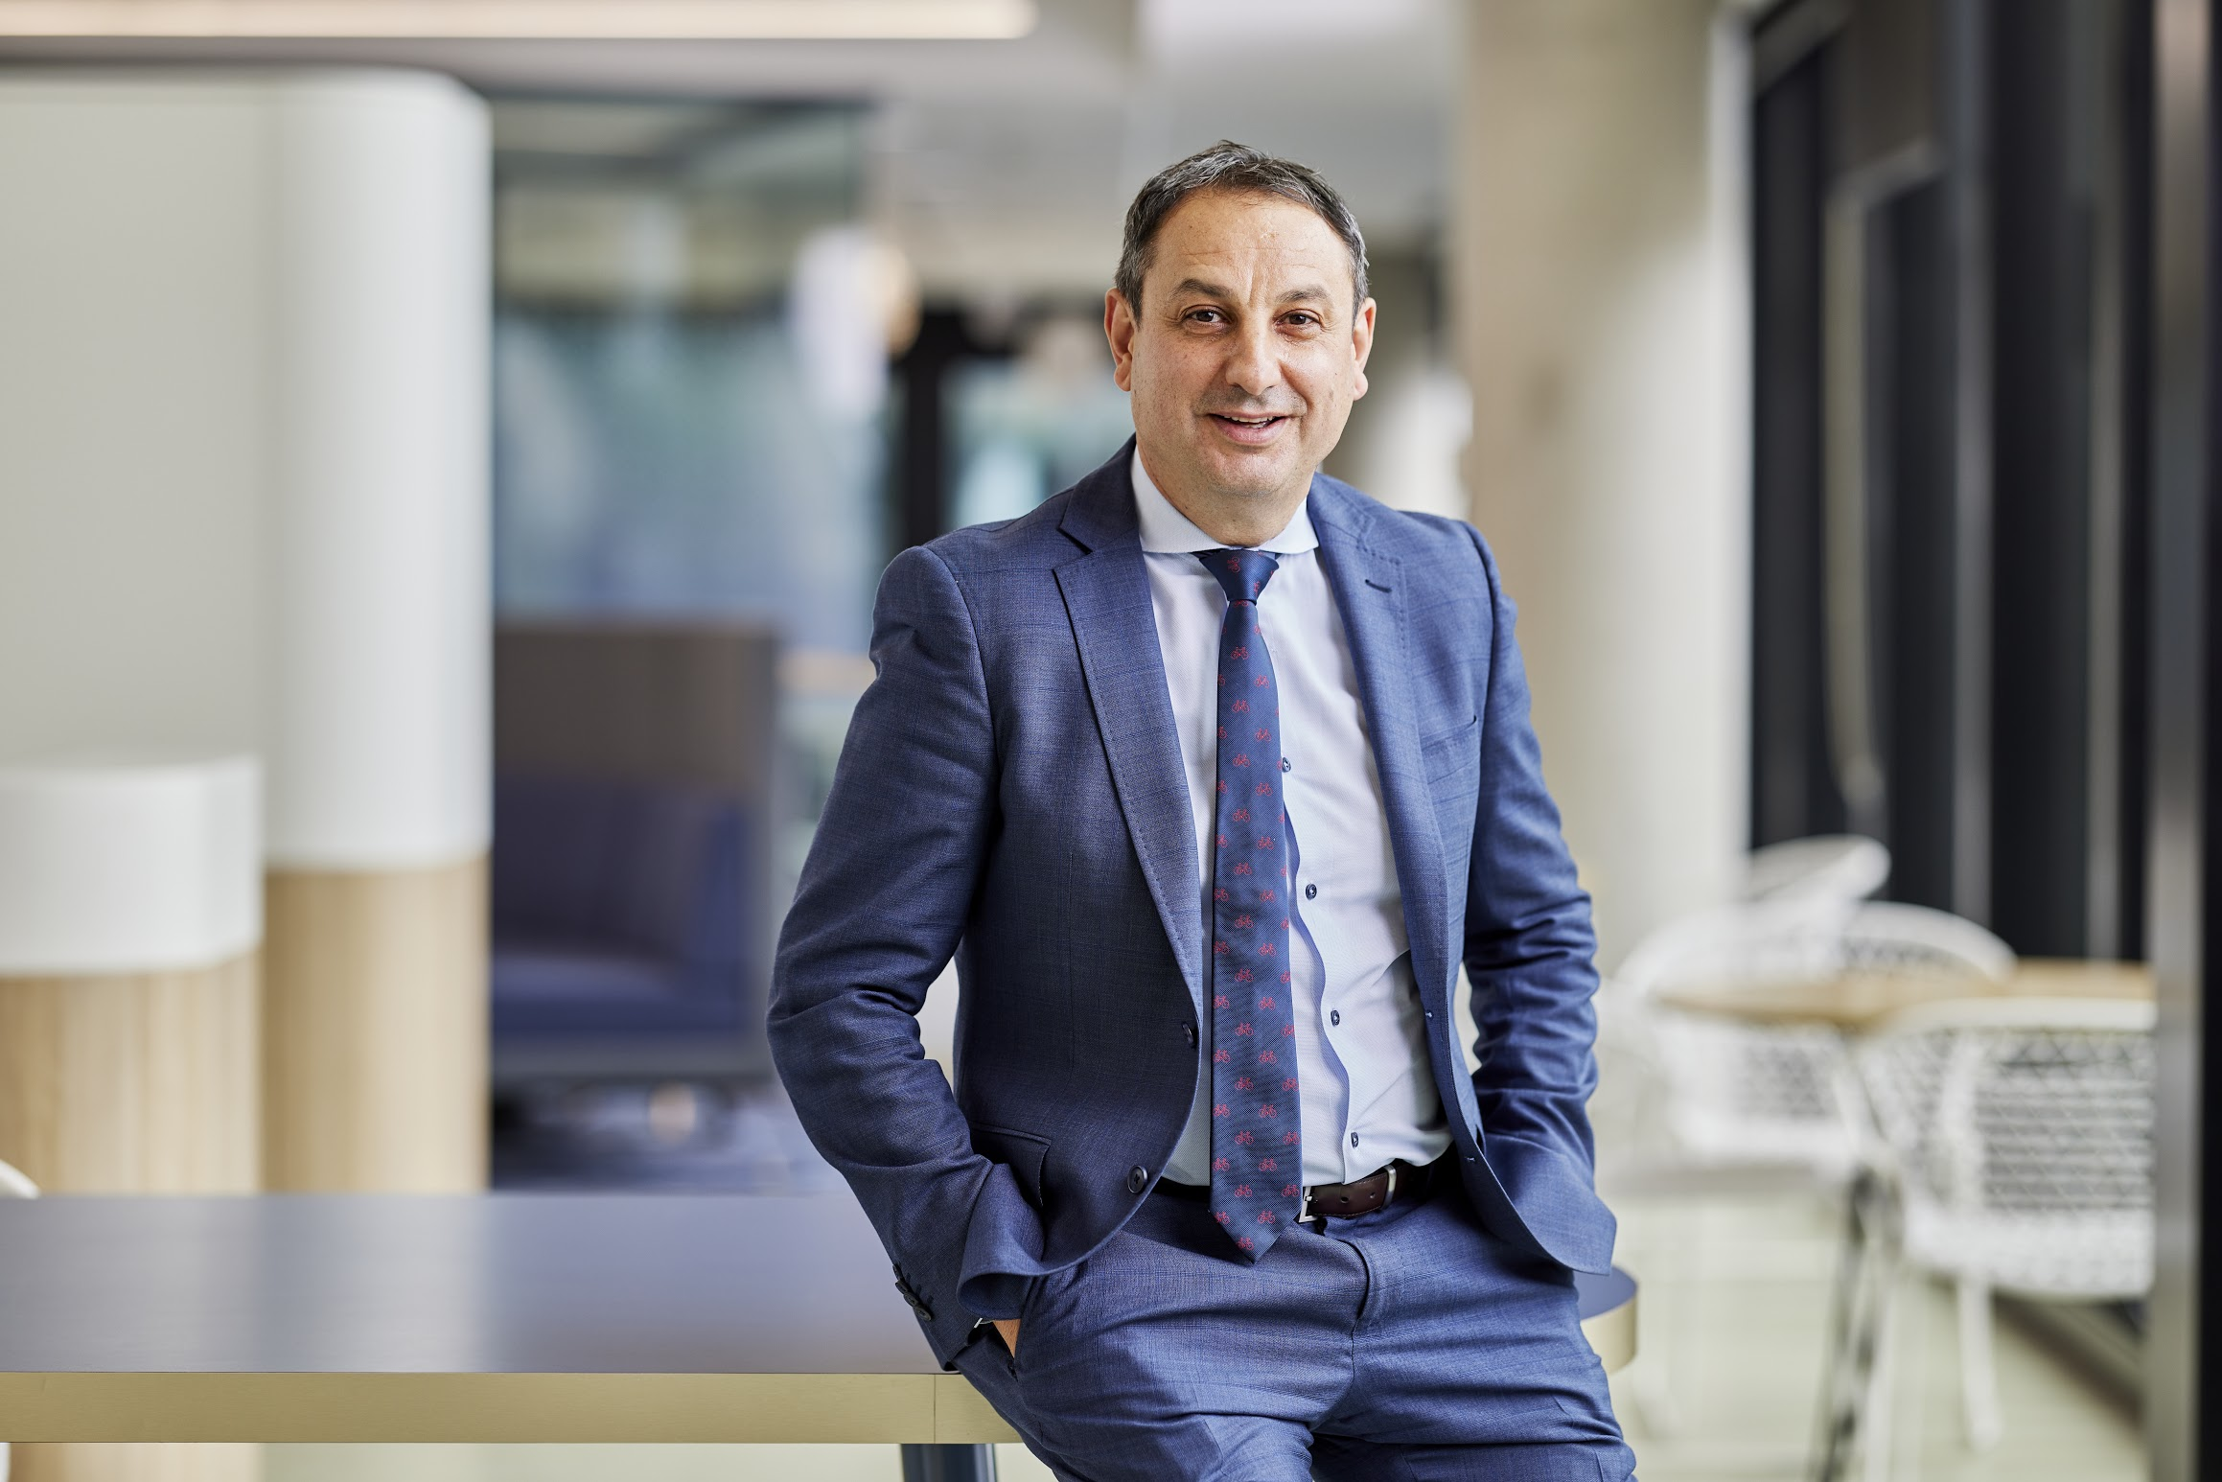
I would like to thank the students, teachers, parents, and stakeholder groups, across all four public schools in Murwillumbah who provided frank and honest feedback during the consultation process.
As part of the consultation 265 students, parents and staff gave up their valuable time to contribute their perspectives in face-to-face meetings. We also received 482 responses via the online feedback forms as well as 14 written submissions.
This wealth of feedback demonstrates how much the people of Murwillumbah care about their public schools and want to see their students succeed.
The past few years have been particularly challenging for the Murwillumbah school communities, with bushfires, floods and the pandemic all adding to the challenges faced by students and staff as they negotiated the mergers.
As we move through the process of returning to four public schools in Murwillumbah, the department’s priority will be supporting our staff and students.
While this report highlights the many and varied views across the communities, one thing is crystal clear: staff, students and families all want frequent, transparent, clear and detailed communication about the transition process.
We will be working hard to ensure the school communities, particularly those connected to the high schools, are kept informed along the way.
I want the community to know that we will be working closely with you at every step in this process. Your input matters and will shape the return to four public schools in Murwillumbah.
As a parent whose children attend public schools, I know how important our schools are to our communities. I want your local public schools to be your first choice. With the return to four public schools, we will continue to ensure ongoing, excellent public education provision.

Overview

The NSW Department of Education conducted a consultation process in relation to implementing the NSW Government commitment to return to four public schools in Murwillumbah. The consultation, from July 2023 to August 2023, included the following:

- In person engagement with approximately 265 students, staff, parents and carers, and community members across 9 separate face-to-face consultation sessions held at Murwillumbah Learning Community (MLC) High School, Murwillumbah East Public School (MEPS) and Murwillumbah Public School (MPS).
- Provision of 6 online feedback forms tailored to each stakeholder group, generating 482 responses from students, staff, parents and carers, and community members.
- Direct engagement via phone and email with key stakeholders including the NSW Teachers’ Federation, P&C Associations, school principals, Tweed/Wollumbin Aboriginal Education Consultative Group, Mayor of Tweed Shire Council, and principals of partner primary schools in the Murwillumbah school network.
- Review of 14 written submissions provided at consultation sessions and 26 emails received at the murwillumbahschools@det.nsw.edu.au email address.
- Deputy Premier and Minister for Education and Early Learning meeting with key stakeholders, including the Member for Lismore, staff and P&C Associations.

The open nature of the consultation generated a large volume of predominantly qualitative data reflecting a diverse range of views. Feedback received has been analysed to extract findings in relation to the key stimulus questions posed during consultation.

Consultation feedback and department outcomes

Our students and staff will return to two high school sites in Murwillumbah for the start of the 2025 school year, fulfilling a key election promise made by the NSW Government to restore all four public schools in Murwillumbah.

The consultation did not demonstrate a clear majority consensus among MLC High School staff and parents regarding the preferred timing for the return to the Murwillumbah High School (MHS) site:
- HS parents: 44% in favour of returning sooner with basic refurbishment; 51% in favour of returning later with new and improved facilities.
- HS staff: 58% in favour of returning sooner with basic refurbishment; 33% in favour of returning later to new and improved facilities.

Our students will be provided with a safe, stable, and effective learning environment at MLC High School now and through the transition back to two separate schools.

Knowing a return to two separate sites isn’t possible immediately due to the condition of the Murwillumbah High School site, consultation participants identified the need for additional focus on supporting our students and staff through the transition period.

School Leadership
We have established the timeframe for a 2025 return to two separate high schools and will commence recruitment processes for permanent principals for both schools.
There is currently an experienced, relieving Principal leading MLC High School with a focus on current teaching and learning, student support and improved student attendance.
Strong transition planning is also a focus.

The department has allocated a Director, School Operational Readiness, to assist with the transition.

Student Enrolments
During the end of 2023 and in 2024, students will continue to be enrolled in the current high school as Murwillumbah Learning Community High School students. In 2024, clear, timely enrolment advice will be provided for Year 7 students and new students for 2025.

2024 Curriculum
The current high school curriculum structure will be maintained for 2024, with the school operating on a single timetable. Student subject choices will inform the 2024 timetable. The delivery of chosen subjects for our Year 12 students, 2025 will be assured.

Student Wellbeing
We recognise that our students have formed strong relationships in the MLC environment. Planning for the return to two secondary schools, will consider feedback provided through consultation and incorporate student voice in decision making.
The wellbeing of our students is of paramount importance. Wellbeing supports are available for students across all Murwillumbah schools, including:
- School counselling service
- Kin groups
- Student Support Officers (SSO)
- Access to Wellbeing and Health In-reach Nurse
- Beyond Broncos program
- Wellbeing hub
- Dedicated wellbeing and inclusion staff
- Other school specific programs

The school will support 2023 Year 12 students if they wish to make individual misadventure applications to the NSW Educational Standards Authority and Universities Admissions Centre.

High School Uniform
Uniforms will not change for 2024. In line with the Department’s school uniform policy, school principals will work with school communities to make future uniform decisions. We also understand the significant cost of living pressures currently facing parents. Department of Education schools offer school uniform assistance when families require support.

Our primary schools will continue to provide excellent learning environments for our students with strong school leadership and upgraded facilities, as they return to having their own unique identity.

Following the consultation, the department appointed a permanent Principal to lead Murwillumbah East Public School.

Murwillumbah East Public School (MEPS) feedback
The MEPS community identified a range of success factors for the future of the school including,
- confirming school leadership,
- maintaining staffing levels,
- attracting enrolments,
- upgrading the school to provide new facilities,
- a focus on student wellbeing.

Murwillumbah Public School (MPS) feedback
The MPS community identified a range of success factors for the future of the school including:
- maintaining staffing levels,
- unity within school teams,
- commitment to quality teaching and learning,
- focus on staff and student wellbeing,
- promotion of the school to encourage enrolments.

The department recognises the impact of the events of recent years and will ensure that this is considered throughout the transition and return to four schools in Murwillumbah.

Across all stakeholder groups, respondents indicated they have been impacted over the previous 5 years with floods, COVID, the proposed school mergers, the move to one high school campus at the start of this year and the more recent change in the future for the schools. This has affected school community harmony, resilience, morale and energy levels.

Staff across all schools reported that additional workload was involved with preparing for the proposed mergers, including high school staff who talked about the work involved with the relocation of Murwillumbah HS to Wollumbin HS at the beginning of the 2023 school year.

Wellbeing of staff
The department values our staff, their wellbeing and their working conditions.

No permanent staff member will lose employment with the department due to the return to four schools. A package of support has been developed for teachers at Murwillumbah schools, including:

- extension and enhancement of the Murwillumbah permanent staffing entitlement, with special provisions in place to ensure maintaining the 2020 staffing entitlement as a minimum. The provision was originally in place until the end of 2025 and will now be extended until at least the end of 2027. This will ensure permanent staff positions are protected, even if enrolment numbers fluctuate.
- special consideration for those who wish to move to other school settings. Staff will be supported if they wish to apply for priority transfers.
- provision of additional resources to support planning for the return to two separate high schools. The department is working with its Health and Safety and Staff Wellbeing Directorate to continue to provide support and ongoing, confidential assistance for all staff.

All four schools will have new painting, new floor coverings, air conditioning to learning spaces and library, renovated bathrooms, new lighting, and new furniture and equipment. We will undertake flood mitigation works at Murwillumbah East Public School.

For safety and operational reasons, the Murwillumbah High School refurbishment will be completed first. However, works at all schools will be prioritised.

School infrastructure and facilities was a commonly raised topic across the various consultation forums.

Consultation participants expressed a priority for funding and clarity around the infrastructure scope of works for the schools.

Feedback received indicated that:
- School communities believe MHS requires investment to ensure it is fit for purpose.
- Infrastructure is a key priority for the MEPS community, with staff and parents believing the school should receive new permanent facilities and flood proofing, in keeping with historical proposals.
- Staff at MPS believe investment in improving facilities at the school would have a positive impact on attracting new families and enrolments and ensure the school was not disadvantaged.
- While it was understood that WHS is in better condition than MHS, school communities felt investment in infrastructure and facilities was warranted at the school to ensure equity across the two high schools.

We will work hard to rebuild community confidence in our public schools through clear, timely, communication of our timelines and planning decisions, as we progress the return to four public schools in Murwillumbah.

Across all consultation forums, school communities expressed a desire for more frequent, transparent, clear and detailed communication with staff, students and families about both the transition back to separate schools and the day-to-day operations of schools, to help alleviate uncertainty and anxiety and rebuild trust.

School communities also indicated they would like to see ongoing engagement with staff, students and families so they have a voice as plans for the return to four separate schools in Murwillumbah are developed and implemented.
The key priority for all school communities was a confirmed and clearly communicated date, timeline and milestones for the students’ return to two high schools and communication to attract enrolments.

Strategies for success identified by school communities included having a long-term vision for the high schools and public education in Murwillumbah more broadly, sufficient time and money allocated to each school, and investigation of alternative ways the two high schools could work together to provide a full curriculum and equal opportunities to all students.

The consultation report can be found online here: https://education.nsw.gov.au/content/dam/main-education/about-us/strategies-and-reports/media/documents/Murwillumbah_Schools_Full_Consultation_Report_2023.pdf.

Send any questions or requests for further information to Murwillumbah Schools (murwillumbahschools@det.nsw.edu.au).

