Staff Consultation – Facilitator’s Notes
Before you commence – resources and information are required to complete the activities. Details are included in these notes. Please review the facilitator notes to ensure local information is added to the slides and activities are prepared.
Slide 1 – Title page
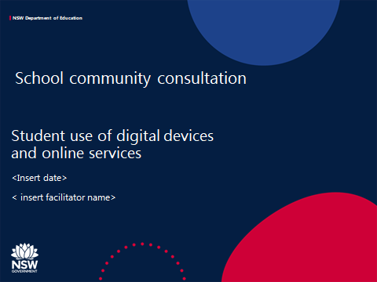
Introduction
This package will support schools to engage with staff to:
- Introduce the Student Use of Digital Devices and Online Services policy
- Identify the current use of digital technology in the school
- Gather feedback from staff to inform the school’s digital direction aligned with the school plan
- Gather feedback from staff to develop the school’s Student Use of Digital Devices and Online Services Procedure and support students to use digital technology safely, responsibly and respectfully

The script for the facilitator’s use is also included in the slide notes
The facilitator may wish to modify the script to their school’s context
Some slides are specifically for primary school (slide 17) or high schools (slides 15 and 16). Schools with K-12 enrolments may need to combine some slides.
Schools may choose to use some or all of this content.

Script
The use of digital technology has increased as an important tool for teaching, learning and leading in our school. We also know our students use technology frequently in their everyday lives.

This meeting is the start of a conversation about how digital technology is used in our school.

Slide 2 – Purpose
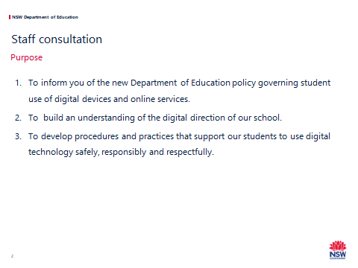

Script:
At the start of 2020, the Student Use of Digital Devices and Online Services policy was released for implementation in NSW Public Schools.
This workshop will provide us with an opportunity to:
1. Understand the key requirements of the policy.
2. Gather feedback to inform our school’s digital direction aligned with our school plan.
3. Gather feedback to develop the school’s Student Use of Digital Devices and Online Services Procedure and support students to use digital technology safely, responsibly and respectfully.

Slide 3 – The Policy - Background
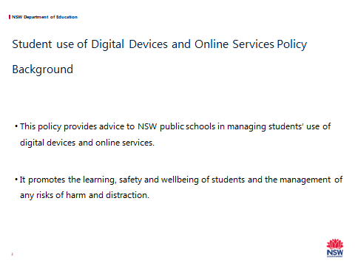
Script
This policy provides advice to NSW public schools in managing students’ use of digital devices and online services.
It promotes the learning, safety and wellbeing of students and management of any risk of harm and distraction.
Our students have grown up with digital technology and it is woven into their lives. Now, more than ever, it is vital we support students in how to best use technology effectively and safely.
Using digital technology can provide opportunities for deep, meaningful and authentic learning as well as increased student engagement and participation.
It also supports access to a broader range of content and learning resources that can supplement students’ learning experiences.

Slide 4 – Online services
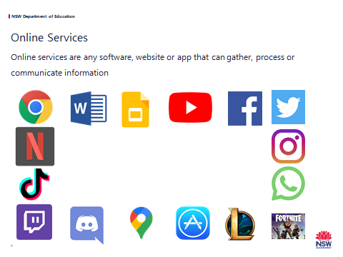
Script
An online service is any technical means to gather, process or communicate information, e.g. websites, apps, social media, and other means for communicating and sharing.
Discussion
Here are some apps that are commonly used.
Can anyone identify these apps?
Clockwise top left- hand corner:
- Google Chrome – cross-platform web browser
- Microsoft word – word processor
- Google slides – presentation program
- YouTube – online video-sharing platform
- Facebook – social media and social networking platform
- Twitter – microblogging and social networking service
- Instagram – photo and video-sharing social networking service
- WhatsApp – cross-platform messaging and voice service
- Fortnite – online video platform (shooter-survival game)
- League of Legends – a multiplayer online battle arena video game
- App store – a digital distribution platform for computer software applications (apps)
- Google maps – a web mapping service
- Discord – an unmoderated group voice chat service for people to talk and collaborate, often used to talk to other people while playing games online
- Twitch – a live video-streaming service, popular for watching people play games
- TikTok – social media app where people can share short videos
- Netflix – video-streaming platform.

Discussion questions
Which online services are appropriate for learning at school?
Why?
How can you tell?
What are some of the risks for students when using online services?
Many of these apps have 13+ restrictions.

Slide 5- Digital Devices
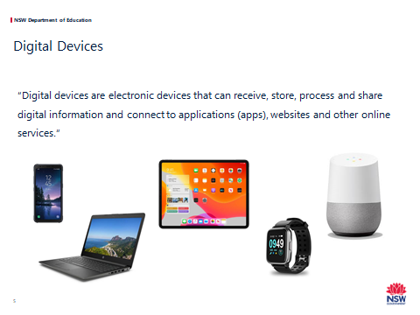
Script
- Digital devices are the tools we use to connect to the internet or communicate with other people.
- As more devices become internet-capable, it’s an impossible task to try and define every possible piece of hardware that can connect to the internet or to another device. Some cars and fridges connect to the internet.
- The same thing is true with all the new websites, apps, games, social media, and other online services that are appearing and disappearing every day.
- For this reason, the policy gives us broad definitions that are flexible enough to include all current and future technologies.
- At the end of the day, it doesn’t matter what bit of hardware our students are holding or touching, and it doesn’t matter what actual bit of software they are using to communicate.
- Instead, the test is simply whether they are using digital devices or online services at school for educational purposes and in ways that are safe, responsible, respectful and teacher-approved.

Slide 6 – Key ideas

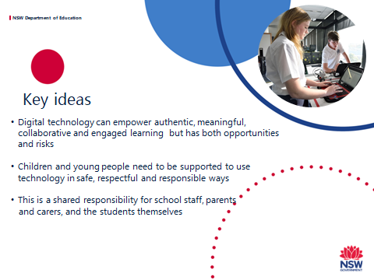
Script
The key ideas of the policy are:
- Digital technology has become an important part of our day-to-day lives. Mobile phones, for example, are everywhere, including in our schools.
- The new policy provides a road map to maximise the potential of digital technology, minimise the risks of harm, and equip our students with the skills to safely learn at and beyond school.
- The policy promotes shared responsibility and highlights the importance of our school community engaging in the future direction for digital technology and also in the development of the school’s procedure and practices.

Slide 7 - For primary schools

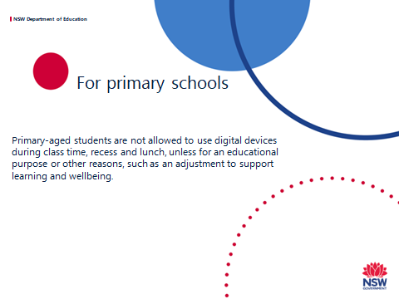
Script
- Under the new policy, primary-aged students are not allowed to use digital devices during class time, recess and lunch, unless for an educational purpose or other reasons, such as an adjustment to support learning and wellbeing.
- For many schools, this reflects current practice and will not be a major change.

Slide 8 - For secondary schools

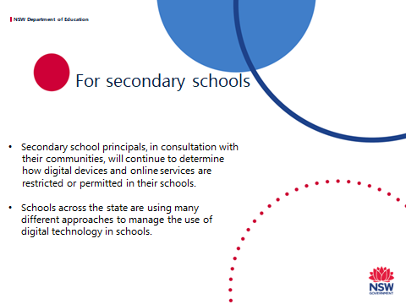

Script
- The policy acknowledges that technology plays an important and increasing role as students’ progress through their education and gives secondary schools the flexibility to find a balance between the benefits and risks that best supports their school community.
- Schools across the state are using many different approaches to manage the use of digital technology in schools.
- In our school the current approach is <add your school’s approach here>.

Additional information about different ways that schools manage devices can be found at https://www.digitalcitizenship.nsw.edu.au/articles/student-use-of-digital-devices-and-online-services

Slide 9 - Digital technology at our school

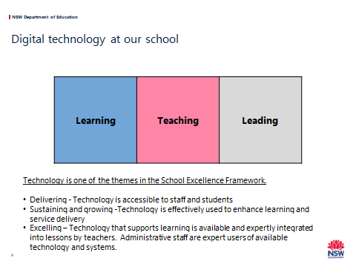
Script
Before we develop our school procedure, it is important that we understand how students, teachers and school leaders use digital technology now and how we want technology used in the future.
Technology is one of the themes in the School Excellence Framework.
The School Excellence Framework provides a road map for school improvement from Delivering to Excelling.
- Delivering schools demonstrate – Technology is accessible to staff and students.
- Sustaining and growing schools demonstrate – Technology is effectively used to enhance learning and service delivery.
- Excelling schools demonstrate – Technology that supports learning is available and expertly integrated into lessons by teachers. Administrative staff are expert users of available technology and systems.

Slide 10 - Digital technology use at our school

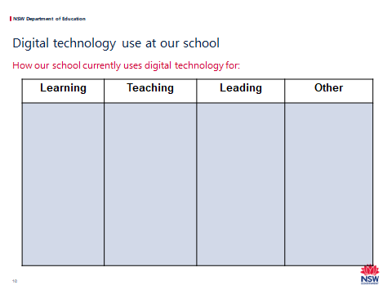
It is recommended that workshop participants are divided into small groups.
Each group will need:
- An A3 copy of Handout A – Digital technology use at our school
- Post-it notes to list responses
- 2 different coloured highlighters
- A copy of the Handout B – Digital Development Statements (3 pages).
Four pages of butcher’s paper should be displayed in the room:
- One titled - Learning
- One titled - Teaching
- One titled - Leading
- One titled - Other
Script
- In small groups, we are going to examine how digital technology is used in our school.
- The information we collect in these activities will help us understand how the school is developing digitally and support our school planning.
- It will also assist in the development of the school procedures we need to support our students.
- In your groups, write down on post-it notes some different ways our school uses digital technology for learning, teaching and leading. You can also list other ways it is used.
When you have finished stick them on the relevant column of your group's A3 sheet – Teaching, Learning, Leading or Other.
Some prompts are below:
- Students use devices to present their work.
- Students collaborate remotely using Google classroom to complete a group assignment.
- Students engage online with an expert in the field they are studying.
- Teachers prepare school reports using school software.
- Teachers use ZOOM to complete professional learning with colleagues from a rural/metropolitan area.
- Teachers provide recorded feedback on a student’s dance performance video.
- The school librarian manages a repository of digital resources for teachers.
- The school executive uses school databases to monitor student-s’ learning and wellbeing.
- The principal uses the school Facebook page to communicate with the school community.
- Parents communicate with teachers using email.
When completed the group provides feedback to the room and then moves the post-it notes to the appropriate butcher's paper.
Hand out to each group a copy of: Handout B – Digital Development Statements (3 pages)
Script
- Consider what we have identified about how our school currently uses digital technology for learning, teaching and leading.
- Then read the Digital Development Statements for Learning, Teaching and Leading.
- As a group, from what you know, highlight in one colour where you think our school is currently on the continuum of:
  - Foundation
  - Delivering
  - Sustaining and Growing
  - Excelling.
When you are done, put that sheet aside for now.

Slide 11 - Digital technology at our school
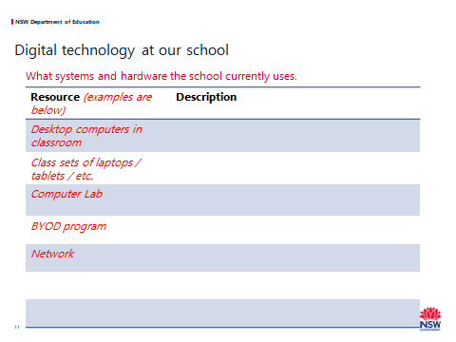

Please complete this slide before the presentation based on your school's resources.
Some examples are included in the table – they may not be relevant for your school.
Schools can access data from school records, your school assets register or through ICT+ on the staff portal.
Script
It is also helpful to understand the systems and hardware we currently have in place.
Explain the resources currently available.

Slide 12 – Our digital direction

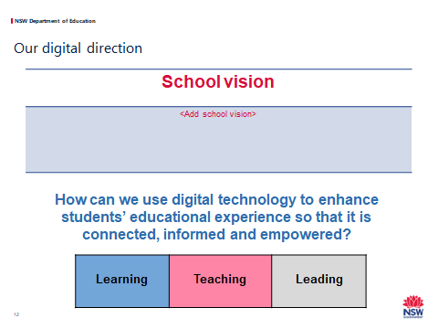

Add your school vision to this slide.
Script
Our digital direction should be aligned with our school vision and school planning.
The question we are asking is:
How can we want to use digital technology to enhance our students’ educational experience so that it is connected, informed and empowered?
As our school planning cycle is over 4 years, we should think about this question 4 years into the future.
For example, if a student is in Year 7/Year 2 – how would you hope they are using digital technology in Year 11/Year 6.
In your group review the Digital Development Statements for Learning, Teaching and Leading you completed before.
As a group – considering what is realistic in terms of resources, time and the professional learning needs of staff – discuss and highlight in the other colour where you think our school should be aiming on the continuum in 4 years’ time.
Now we have thought about where we are heading, we can now look at shaping our schools procedure that can enable us to get there.

Slide 13 – Developing our school procedure
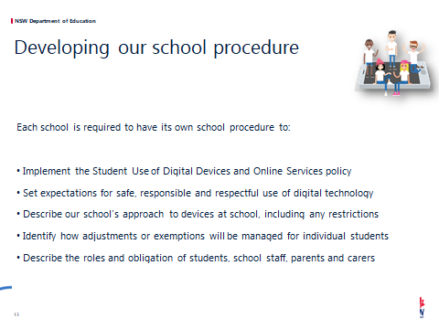

Please Note: a sample school procedure and an online form to generate the school procedure can be found at https://www.digitalcitizenship.nsw.edu.au/articles/student-use-of-digital-devices-and-online-services. The school may wish to use the Sample school procedure to guide content development.
Script
- Each school is required to have a Student Use of Digital Devices and Online Services procedure.
- This procedure can support the school to achieve our digital direction.
Our school procedure will:
- Set expectations for safe, responsible and respectful use of digital technology
- Describe our school’s approach to devices at school, including any restrictions
- Identify how adjustments or exemptions will be managed for individual students
- Describe the roles and obligation of students, school staff, parents and carers.

Slide 14 – Process

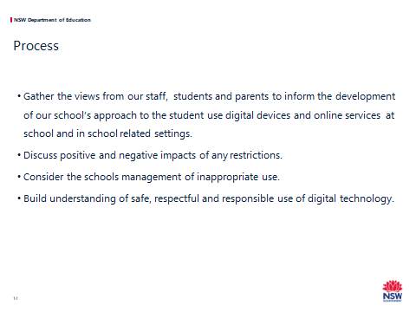

Script:
- To develop our school procedure we are gathering the views from our staff, students and parents to inform what will be included.
- The school executive will make the final decision after listening to the voices of our community.
- Today we will discuss:
  - Positive and negative impacts of any restrictions.
  - How we will manage inappropriate use of devices.
- We will also share with you the description of safe, respectful and responsible use of digital technology and the rights and obligations of stakeholders as described in the policy - school staff, parents and students.

Slide 15 – What will this mean for our school?
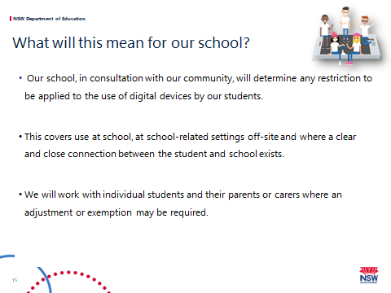
This is a secondary school slide.
Script
Our school, in consultation with our community, will determine any restriction to be applied to the use of digital devices by our students.
This includes school, personal and BYOD (if relevant) devices.
The procedure will cover use at school and at school-related settings off-site.
School-related settings include excursions, camps, sport, work experience, and other teaching venues.
It also includes other places and activities where there is a clear and close connection between the student and the school.
The school will work with individual students and their parents or carers where an adjustment or exemption may be required for a student’s learning and/or wellbeing needs.
Exemptions
Provision for exemptions must be included in the school procedure and can be requested from the principal by parents, carers, school counsellors and other student support staff, and, if required, students themselves. This may cover times when or places where use would otherwise be restricted.
Additional information if required:
A clear and close connection can include issues that occur outside of school but are then reported to a school staff member or have an impact in the school.
This connection may exist in situations where, for example:
- Online contact has flow-on consequences at school
- Students are online in digital classrooms
- There is harassment or vilification of another student or staff member
- There is inappropriate discussion about school matters taking place publically and online.
Exemptions
- Provision for exemptions must be included in the school procedure and can be requested from the principal by parents, carers, school counsellors and other student support staff, and, if required, students themselves. This may cover times when or places where use would otherwise be restricted.
- Except where required by law, the school principal has discretion to consider and approve exemptions and to choose which parts of the school procedure the exemptions applies.
- The exemption may be ongoing or for a certain time period.
- Examples of exemptions include:
  - A student has wellbeing needs and may need to privately contact a support service or their parents or carers. Examples of support services may include Headspace, FACS, juvenile justice caseworkers and religious leaders.
  - A student is a young carer.
  - Family circumstances may require an exemption for compassionate reasons. This may include circumstances such as a family member having a new baby, undergoing an operation or facing terminal illness.
  - It may also include restrictions on times such as contacting a family member living overseas or due to parental incarceration.
  - A student has a compelling, short term reason such as hearing back from an employment interview.
Adjustments
Some students require reasonable adjustments to their learning and support needs for reason of a disability.
- A disability includes a medical condition impacting a student.
- Reasonable adjustments include access to digital technologies to participate in their education on the same basis as a student without a disability.
- The school must consult the student, and their parents or carers as appropriate, in determining the adjustments for the student.
Providing reasonable adjustments to students with disability is an obligation under the Disability Standards and does not require students or parents or carers to seek an exemption under the policy.

Slide 16 - Digital technology – Possible approaches in secondary schools
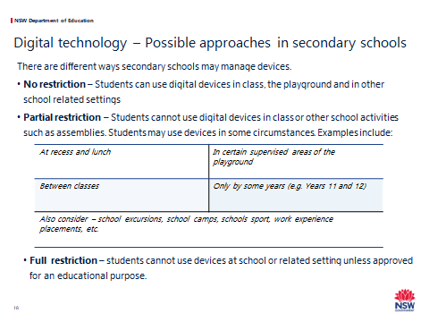
This is a secondary school slide.
Facilitators might like to do this activity as small groups, a whole group or as post-it notes on larger sheets.
Facilitators will need multiple copies of the Handout C – Reporting Sheet – different approaches – PMO or large sheets headed Plus Minus Other and post-it notes.
Script
We need to consider a way to manage devices that best suits our school community. There are different ways schools may manage devices at schools.
First click:
No restriction – Students can use digital devices in class, the playground and in school related settings.
Second click:
Partial restriction – Students cannot use digital devices in class or other school activities such as assemblies. Students may use devices in some circumstances.
Third Click:
Examples include:
- At recess and lunch
- In certain supervised areas of the playground
- Between classes
- Only by some years (e.g. Years 11 and 12)
- Also consider – school excursions, school camps, schools sport, work-experience placements, etc.
Fourth Click:
Full restriction – students cannot use devices at school or related settings unless approved for an educational purpose.

In small groups, discuss these option and others you may think of. When discussing partial restrictions –consider when and where devices could be used.

On the handouts list each approach you are considering and the positive, negative and other consequences of each approach.

Slide 17 - What will this mean for our school?

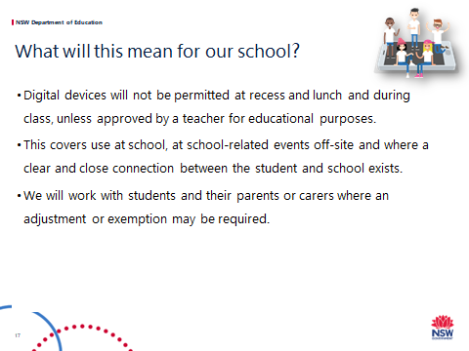

This is a primary school slide.
Script
Our school will develop and implement a new procedure on the use of digital technology.
This includes school, personal and BYOD (if relevant) devices.
This new school procedure sets school-wide expectations for staff, students, parents and carers.
- For primary school students, digital devices will not be permitted at recess and lunch and during class, unless approved by a teacher for educational purposes – this is mandatory and will be included in our procedure.
- It covers use at school, at school-related events off-site and where a clear and close connection between the student and schools exists. The school procedure applies for all students while they are at school.
- The procedure also applies to school-related settings including excursions, camps, other teaching venues, and other places and times where there is a clear and close connection between the student and the school.
A clear and close connection can include issues that occur outside of school but are then reported to a school staff member or have an impact in the school.
- This connection may exist in situations where:
  - Online contact has flow on consequences at school
  - Students are online in digital classrooms there is harassment or vilification of another student or staff member
  - There is inappropriate discussion about school matters taking place publically and online.
The school will work with students and their parents or carers where an adjustment or exemption may be required for student learning and/or wellbeing needs.
Exemptions
Provision for exemptions must be included in the school procedure and can be requested from the principal by parents, carers, school counsellors and other student support staff, and, if required, students themselves. This may cover times when or places where use would otherwise be restricted.
Except where required by law, the school principal has discretion to consider and approve exemptions and to choose which parts of the school procedure the exemptions apply.
The exemption may be ongoing or for a certain time period.
Examples of exemptions include:
- A student has wellbeing needs and may need to privately contact a support service or their parents or carers. Examples of support services may Headspace, FACS, juvenile justice case workers and religious leaders.
- A student is a young carer.
- Family circumstances may require an exemption for compassionate reasons. This may include circumstances such as a family member having a new baby, undergoing an operation or facing terminal illness. It may also include restrictions on times when a student can contact a family member living overseas or due to parental incarceration.
- A student has a compelling, short term reason such as hearing back from an employment interview.
Adjustments
Some students require reasonable adjustments to their learning and support needs for reason of a disability.
- A disability includes a medical condition impacting a student.
- Reasonable adjustments include access to digital technologies to participate in the education on the same basis as a student without a disability.
- The school must consult the student, and their parents or carers as appropriate, in determining the adjustments for the student.
Providing reasonable adjustments to students with disability is an obligation under the Disability Standards and does not require students or parents or carers to seek an exemption under the policy.

Slide 18 – Our school’s approach.
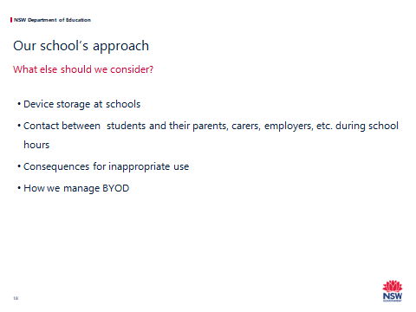

Script
Schools should make themselves familiar with:
- Legal Bulletin 8 Claims for loss of or damage to personal property
- Legal Bulletin 56 Confiscation of student property
- Legal Bulletin 35 Misuse of technology in schools.
Activity - Whole group discussion on the following points. A staff member should take notes of the content of the discussion.
Script
First click
- We are now going to discuss other elements of the school procedure.
- We need to consider the way forward and try to predict any unintended consequences.
Second Click
Device storage at school
If our school has restrictions on the use of devices, particularly mobile phones, we need to consider the school protocol for storage of devices when not in use. Ideas include:
- Off and away in bags
- Phones in lockers (when available)
- Off and left at the school office
- Hand in your phone at the start of class (in a box)
- Phones are class but can only be used for learning activities
- Locked phone pouch.

For further information see “Different ways to manage devices” in the workshop resources.
Third Click
Contact between students and their parents, carers, employers, etc. during school hours
We need to consider our school’s approach to parent, carer and student communication during the school day.
It is recommended that if a student should need to make a call during the school day, they approach the administration office and ask for permission to use the school’s phone.
During school hours, parents and carers are expected to only contact their children via the school office.
Fourth Click
Consequences for inappropriate use
Do we have specific consequences about digital devices or follow our school wellbeing and discipline procedures?
Fifth click (or delete in not applicable)
Bring your own device
The procedure also governs students participating in our school’s BYOD program.
Devices used in our school’s BYOD program are to be considered just like any other digital device at school, and the restriction on the use of these devices applies here just as it does with school-owned digital devices.
Teachers will continue to incorporate digital devices into their classroom practice, and will decide when and how they are best used in their classrooms.
In summary:
- There is no change to the types of devices allowed, or their specifications. BYO devices can still be brought to school.
- Students are expected to use all digital devices in safe, responsible and respectful ways.
- The school procedure on digital devices and online services applies whether the student is using a device they own or one the school has provided.
- Just like other devices, use of BYO devices is not permitted during class, at recess and at lunch unless approved by a teacher.
- Classroom teachers decide when and how students can use digital devices for BYOD/educational purposes.

Slide 19
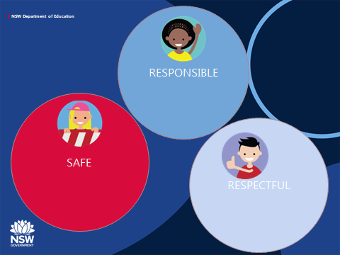
Butcher’s paper should be displayed in the room titled safe, responsible and respectful.
Pens and post-it notes should also be available.
Script
- Students’ safe, responsible and respectful use of digital devices and online services is a key message of this policy.
- This is the greatest protective factor when students use technology.
- We want students to have enough information to be clear about what this looks like when they are using digital technology.
- Write on some post-it notes your thoughts on how our students can be safe, respectful and responsible when using digital devices and online services.

- You can post these on the sheet hanging on the walls.

Slide 20

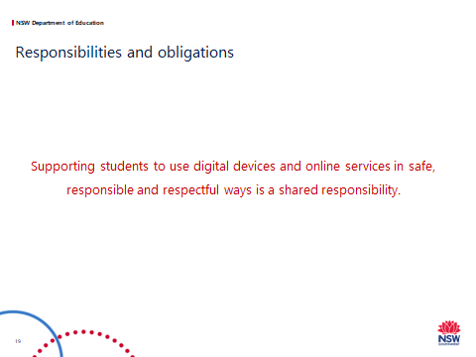
Handout D: Responsibilities and Obligations.
Copies for each attendee – preferably A3
Script
- It is a shared responsibility by students, school staff, parents and the broader community to support our children and young people to navigate the modern world safely.
- This is of great importance when children and young people are using digital technology.
- The Student use of Digital Devices and Online Services policy includes details of these responsibilities and obligations. We need to consider these when we develop our school procedure.
- This handout outlines these responsibilities and obligations.
- Take your time to read the handout and write any comments on the sheet.

Slide 21
Script
Thank you for the important information you have shared with us to support the development of our school procedure.
Provide advice about the schools next steps in developing the schools digital direction and school procedure.
Take questions.

