Student Consultation – Facilitator’s Notes
Before you commence – resources and information are required to complete the activities. Details are included in these notes. Please review the facilitator notes to ensure local information is added to the slides and activities are prepared.
Slide 1 – Title page
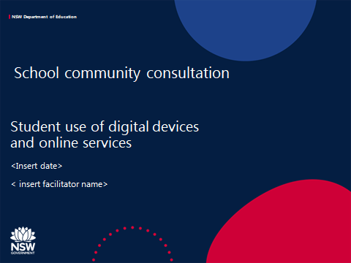
Introduction
This package will support schools to engage with students to:
- Introduce the Student Use of Digital Devices and Online Services policy
- Identify the current use of digital technology in the school
- Gather student feedback to inform the school’s digital direction aligned with the school plan
- Gather student feedback to develop the school’s Student Use of Digital Devices and Online Services Procedure and support students to use digital technology safely, responsibly and respectfully

The script for the facilitator’s use is also included in the slide notes
The facilitator may wish to modify the script to their school’s context
Some slides are specifically for primary schools (slide 13) or high schools (slides 8, 11 and 12). Schools with K-12 enrolments may need to combine some slides.
Schools may choose to use some or all of this content.

Script
Icebreaker questions:
- Raise your hand if you can tell me when you first started using digital technology?
- Can anyone tell me about a recent time when they didn’t have access to the internet for more than a day?
The use of digital technology is an important element in all our lives.
School is also an important part of our lives and digital technology is an valuable tool for teaching, learning and leading at our school.
This meeting is the start of very important conversations with you, your teachers and parents/carers about how digital technology, digital devices and online services, are used in our school.

Slide 2 – Purpose
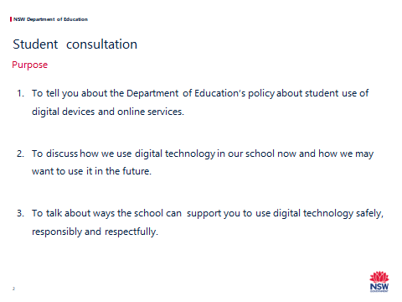

Script
At the start of 2020, the Department of Education released a new policy about using digital technology in schools.
In this workshop we are going to talk about:
- What is in the policy.
2. How we use digital technology in our school now and how we may want to use it in the future.
3. How the school can support you to use digital technology safely, responsibly and respectfully.
This will help us to develop our school’s Student Use of Digital Devices and Online Services Procedure.

Slide 3 – Online services
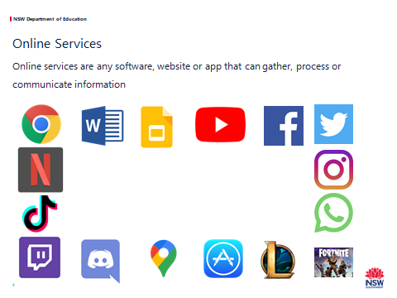
Script:
Discuss with your neighbour how you would describe an online service?
Give students the opportunity to share their ideas.
First click
An online service is any technical means to gather, process or communicate information, for example, websites, apps, social media, and other means for communicating and sharing.
Second click
Discussion
Here are some frequently used apps.
Can anyone identify these apps?
Clockwise from top left-hand corner
- Google Chrome – cross-platform web browser
- Microsoft Word – word processor
- Google Slides – presentation program
- YouTube – online video sharing platform
- Facebook – social media and social networking platform
- Twitter – microblogging and social networking service
- Instagram – photo and video-sharing social networking service
- WhatsApp – cross-platform messaging and voice service
- Fortnite – online video platform (shooter-survival game)
- League of Legends – a multiplayer online battle arena video game
- App store – a digital distribution platform for computer software applications (apps)
- Google maps – a web mapping service
- Discord – an unmoderated group voice chat service for people to talk and collaborate, often used to talk to other people while playing games online
- Twitch – a live video-streaming service, popular for watching people play games
- TikTok – social media app where people can share short videos
- Netflix – video-streaming platform
Discussion
- Which online services are appropriate for learning at school?
- Why?
- How can you tell?
- What are some of the risks for students when using online services?
Note: Many of these apps have 13+ restrictions.

Slide 4- Digital Devices
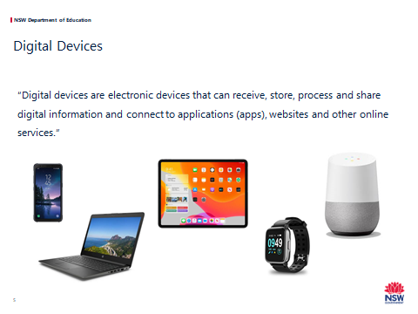
Script
- Digital devices are the tools we use to connect to the internet or communicate with other people.
- Here are some common devices.
- Can you think of some other devices?
- As more devices become internet-capable (e.g. fridges and cars), it’s an impossible task to try and define every possible piece of hardware that can connect to the internet or to another device.
- The same thing is true with all the new websites, apps, games, social media, and other online services that are appearing and disappearing every day.
- For this reason, we use these broad definitions that are flexible enough to include all current and future technologies.
- At the end of the day, it doesn’t matter which piece of hardware you are holding or touching, and it doesn’t matter what software you are using to communicate.
- Our focus is that when you are using digital devices or online services at school you use them in ways that are safe, responsible, respectful and approved.

Slide 5 - For primary schools

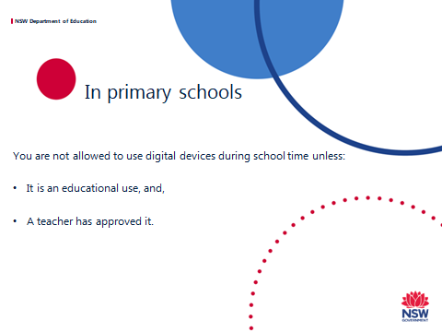
This is a primary school slide
Script
- Under the new policy, primary-aged students are not allowed to use digital devices during class time, recess and lunch, unless for an educational purpose or other reasons, such as an adjustment to support learning and wellbeing.
- What do you think are the good things and bad things about this?

Slide 6 - For secondary schools

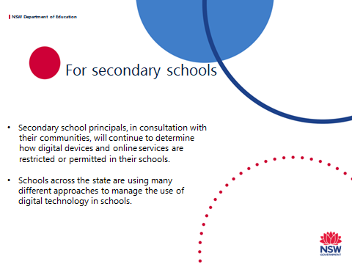
This is a secondary school slide
Script
- The new policy acknowledges that technology plays an important and increasing role as students’ progress through their education.
- It gives us the flexibility to find a balance between the benefits and risks that best supports our school community.
- Schools across the state are using many different approaches to manage their use of digital technology, including mobile devices.
- In our school the current approach is <include school approach>.

Additional information about different ways that school manage devices can be found at https://www.digitalcitizenship.nsw.edu.au/articles/student-use-of-digital-devices-and-online-services

Slide 7 - Digital technology use at our school
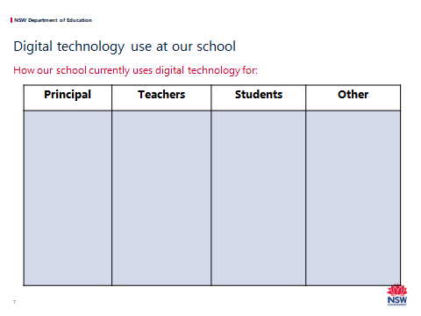
It is recommended that workshop participants are divided into small groups.
Each group will need:
- Post-it notes to list responses
Four pages of butcher’s paper should be displayed in the room
- One titled - Principal
- One titled - Teachers
- One titled - Students
- One titled - Other
Another page titled “The Future” should be prepared for later.
Script
- In small groups, we are going to look at how different people in our schools use digital technology now and how we might want to use it in the future.
- In your groups, write down on post-it notes some different ways digital devices and online services are used in our school now.
- Think about ways different people in our school use technology – the principal, teachers, students and any other uses.
When students finish – each group can present their ideas to the group and stick the post-it notes on the butcher’s paper sheets for Principal, Teachers, Students or Other.
- Now I want you to think into the future and write down how you think you might like to use technology at school in the future – about 4 years on.
When students finish – each group can present their ideas to the group and stick the post-it notes on the butcher’s paper sheet for “The Future”.

Some prompts are below:
- Students using devices to present their work
- Students collaborate remotely using Google classroom to complete a group assignment
- Students engage online with an expert in the field they are studying
- Teachers prepare school reports using school software
- Teachers use ZOOM to complete professional learning with colleagues from a rural/metropolitan area
- Teachers provide recorded feedback on a student’s dance performance video
- The school librarian manages a repository of digital resources for teachers
- The school executive uses school databases to monitor student’s learning and wellbeing
- The principal uses the school Facebook page to communicate with the school community
- Parents communicate with teachers using email.

Slide 8 – Our digital direction
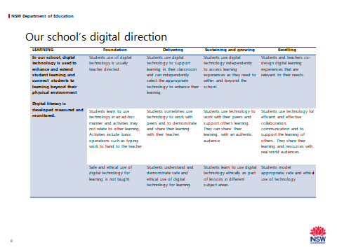

Optional slide for secondary school
Each group will need:
A copy of the Handout A – Digital Direction – Learning Framework and two different coloured highlighters
Script
Think about the ideas you had about how we are using digital technology for learning now and into the future.
Read the statements on the Digital Direction – Learning Framework handout.
In one colour, highlight which statement in each row describes how students use digital technology for learning now.
In the other colour, highlight which statement in each row describes how you would like to see students use digital technology for learning 4 years into the future.

Slide 9 – Developing our school procedure

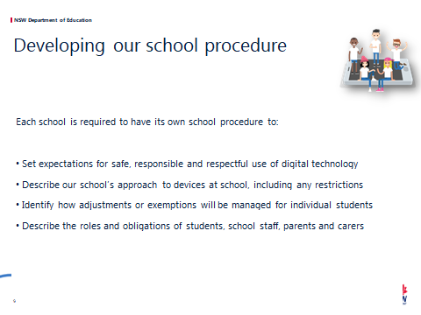
Please Note: a sample school procedure and an online form to generate the school procedure can be found at https://www.digitalcitizenship.nsw.edu.au/articles/student-use-of-digital-devices-and-online-services. The school may wish to use the Sample school procedure to guide content development.
Script
- Each school is required to have a Student Use of Digital Devices and Online Services procedure.
Our school procedure will:
- Set expectations for safe, responsible and respectful use of digital technology
- Describe our school’s approach to devices at school, including any restrictions
- Identify how adjustments or exemptions will be managed for individual students
- Describe the roles and obligations of students, school staff, parents and carers

Slide 10 – Process

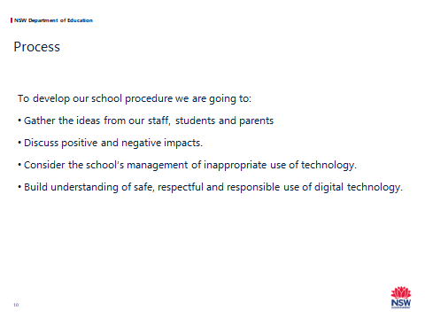

Script:
Script:
- To develop our school procedure we are gathering the views from our staff, students and parents.
- The school executive will write our procedure after listening to the voices of our school community.
- Today we will discuss:
  - Positive and negative impacts of any restrictions
  - How we will manage appropriate use of devices
- We will also gather your thoughts on safe, respectful and responsible use of digital technology.

Slide 11 – What will this mean for our school?
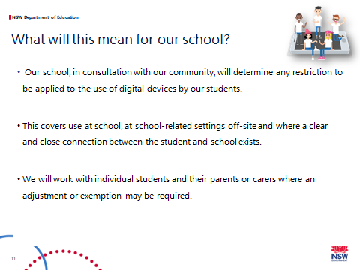
This is a secondary school slide
Script
Our school, in consultation with our community, will determine any restrictions to be applied to the use of digital devices by our students.
This includes school, personal and BYOD (if relevant) devices.
The procedure will cover use at school, at school-related settings off-site.
School-related settings include excursions, camps, sport, work experience, and other teaching venues.
It also includes other places and activities where there is a clear and close connection between the student and the school.
The school will work with individual students and their parents or carers where an adjustment or exemption may be required for a student’s learning and/or wellbeing needs.

Additional information if required:
A clear and close connection can include issues that occur outside of school but are then reported to a school staff member or have an impact in the school.
This connection may exist in situations where, for example:
- Online contact has flow on consequences at school
- Students are online in digital classrooms
- There is harassment or vilification of another student or staff member
- There is inappropriate discussion about school matters taking place publically and online

Exemptions
- Provision for exemptions must be included in the school procedure and can be requested from the principal by parents, carers, school counsellors and other student support staff, and, if required, students themselves. This may cover times when or places where use would otherwise be restricted.
- Except where required by law, the school principal has discretion to consider and approve exemptions and to choose which parts of the school procedure the exemptions applies.
- The exemption may be ongoing or for a certain time period.
- Examples of exemptions include:
  - A student has wellbeing needs and may need to privately contact a support service or their parents or carers. Examples of support services may include Headspace, FACS, juvenile justice case workers and religious leaders.
  - A student is a young carer.
  - Family circumstances may require an exemption for compassionate reasons. This may include circumstances such as a family member having a new baby, undergoing an operation or facing terminal illness.
  - It may also include restrictions on times such as contacting a family member living overseas or due to parental incarceration.
  - A student has a compelling, short term reason such as hearing back from an employment interview.
Adjustments
Some students require reasonable adjustments to their learning and support needs for reason of a disability.
- A disability includes a medical condition impacting a student.
- Reasonable adjustments include access to digital technologies to participate in the education on the same basis as a student without a disability.
- The school must consult the student, and their parents or carers as appropriate, in determining the adjustments for the student.
Providing reasonable adjustments to students with disability is an obligation under the Disability Standards and does not require students or parents or carers to seek an exemption under the policy.

Slide 12 - Digital technology – Possible approaches in secondary schools
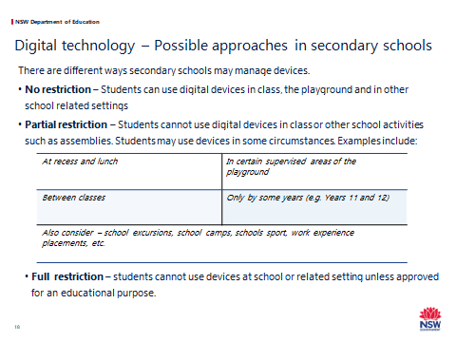
This is a secondary school slide.
Facilitators should do this activity in small groups.
Facilitators will need multiple copies of the Handout B – Reporting Sheet – different approaches – PMO. Each group may want up to 8 sheets.
Script
We need to consider a way to manage devices that best suits our school. There are different ways schools may manage devices at schools.
First click:
No restriction – Students can use digital devices in class, the playground and in the school related settings.
Second click:
Partial restriction – Students cannot use digital devices in class or other schools activities such as assemblies. Students may use devices in some circumstances.
Third Click:
Examples include:
- At recess and lunch
- In certain supervised areas of the playground
- Between classes
- Only by some years (e.g. Years 11 and 12)
- Also consider – school excursions, school camps, schools sport, work
experience placements, etc.
Fourth Click:
Full restriction – students cannot use devices at school or related settings unless approved for an educational purpose.

In small groups, discuss these option and others you may think of. When discussing partial restrictions –consider when and where devices could be used.

On the handouts list each approach you are considering and the positive, negative and other consequences of each approach.

The facilitator should collect responses.
Slide 13

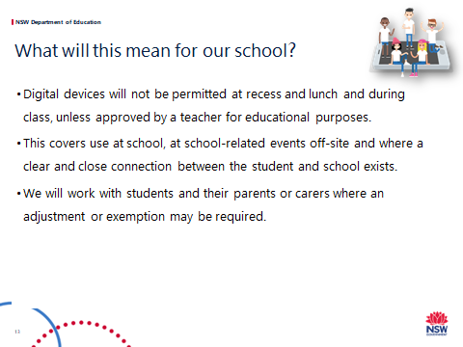

This is a primary school slide.
Script
Our primary schools will develop and implement a new procedure on the use of digital technology.
This includes school, personal and BYOD (if relevant) devices.
- For primary school students, digital devices will not be permitted at recess, lunchtime and during class, unless approved by a teacher for educational purposes – this is mandatory and will be included our procedure.
- The school procedure applies for all students while they are at school. The procedure also applies to school-related settings such as excursions, camps, other teaching venues, and places and times where there is a clear and close connection between the student and the school.
A clear and close connection can include issues that occur outside of school but are then reported to a teacher or principal or have an impact in the school.
This connection may exist in situations where:
  - Online contact has flow on consequences at school
  - Students are online in digital classrooms
  - There is harassment or vilification of another student or staff member
  - There is inappropriate discussion about school matters taking place publically or online
The school will work with students and their parents or carers where an adjustment or exemption may be required for a student learning and/or wellbeing need.

Slide 14

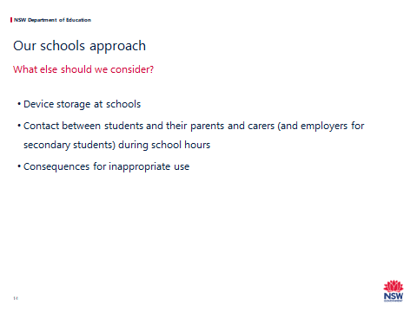
Script
Schools should make themselves familiar with:
- Legal Bulletin 8 Claims for loss of or damage to personal property
- Legal Bulletin 56 Confiscation of student property
- Legal Bulletin 35 Misuse of technology in schools
Activity - Whole group discussion on the following points. A staff member should take notes of the content of the discussion.
Script
First click
- We are now going to discuss other elements of the school procedure.
- We need to consider the way forward and try to predict any unintended consequences.
Second Click
If our school has restrictions on the use of devices, particularly mobile phones, we need to consider the school protocol for storage of devices when not in use.
Ideas include:
- Phones are class but can only be used for learning activities
- Off and away in bags
- Hand in your phone at the start of class (in a box)
- Phones in lockers (when available)
- Off and left at the school office
- Locked phone pouch
For further information see “Different ways to manage devices” in the workshop resources.
Third Click
If you need to contact your parents (or if you are in high school, your employer) – or they need to contact you – how should this happen?
Fourth Click
Do we have specific consequences about digital devices or follow our school wellbeing and discipline procedures?

Slide 15
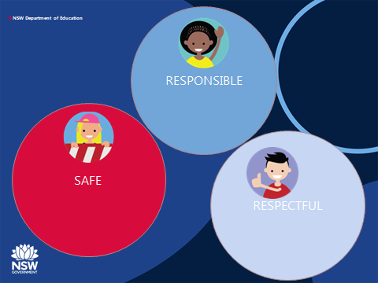
Butcher’s paper should be displayed in the room title safe, responsible and respectful.
Pens and post-it notes should also be available.
Script
- Students’ safe, responsible and respectful use of digital devices and online services is a key message.
- We want you to have enough information to be clear about what this looks like when you are using digital technology.
- Write on some post-it notes your thoughts on how you can be safe, respectful and responsible when using digital devices and online services.

- You can post these on the sheet hanging on the walls.

Slide 16
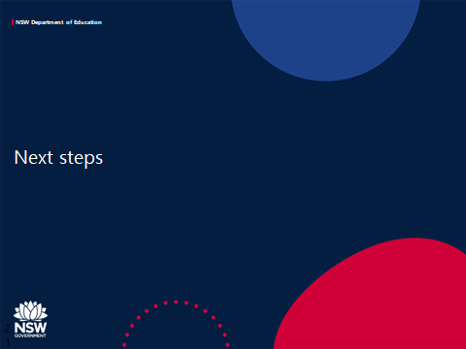
Script
Thank you for the important information you have shared with us today and we look forward to sharing our schools procedure with your soon.
Take questions.

