Scholarship Name (e.g. 2024 Premier’s NESA Quality Teaching Scholarship)

Your Title here
  - Your subtitle here
Author Name
School or institution
Sponsored by
When inserting your logo image, please use ‘Format Picture’ settings to include alt text for screen readers.

Introduction
Use this section to introduce your report. This section should be 200 – 300 words.

Focus of Study
What were you looking for?
Refer to the Significant Learning section below for formatting details.

Significant Learning
What did your find during your study tour?
Remember that you are writing a report, not an essay or a narrative. Your report should be a short, concise document and relatively formal in tone, not the informal language of a narrative.
Use concise, active and engaging language. Drawing comparisons with the current NSW education setting is critical to engaging your audience with the findings of your report.
When reporting on numerous site visits, organise your findings into common themes, rather than listing many events without drawing any conclusions.
See below for further formatting details on how to include photos (maximum of five), headings, number lists and bullet lists
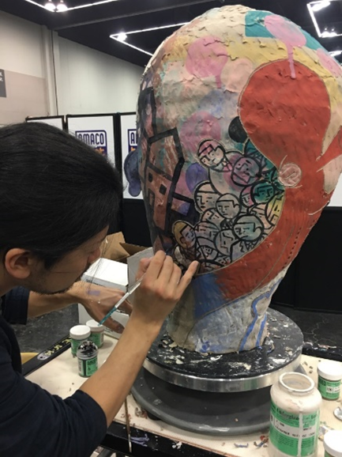
Figure 1: Live demonstration by En Iwamura at NCECA 2017 (Photo by Melissa Grahovac)
A maximum of five photos may be included in the report. As these photos will be published on a public web page there must be approval from all subjects in the photos for this use. An email agreement is the miniumum requirement. Photos should:
- Be 100KB in size
- Include alt (alternate) text for screen readers
- Include a caption
- Be placed on a separate line to the text as shown above
- Acknowledge the photopgrapher

Heading 2
Text following headings
“I hate quotations. Tell me what you know.” – Ralph Waldo Emerson (Quote style)
Never use italics to emphasise! Use Strong text style instead.

Heading 3

Age of Students Taught (60 responses)
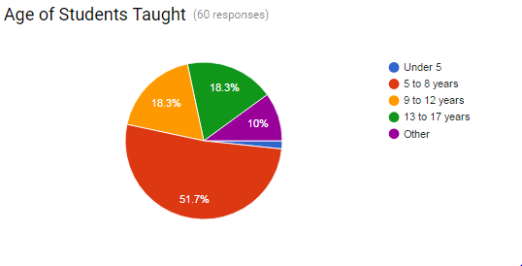
Under 5 | 1.7%
5 to 8 years | 51.7%
9 to 12 years | 18.3%
13 to 17 years | 18.3%
Other | 10%

If you need to use figures and graphs, they must be captioned to provide information in an alternate non-visual format. For example, if you use a graph then also, and underneath, use a table with the same information.

Unordered Lists
- Unordered List item 1
- Unordered List item 2
  - Unordered List item 2a
  - Unordered List item 2b
    - Unordered List item 2b(i)
    - Unordered List item 2b(ii)
- Unordered List item 3

Ordered List
- Ordered List item 1
- Ordered List item 2
  - Ordered List item 2a
  - Ordered List item 2b
    - Ordered List item 2b(i)
    - Ordered List item 2b(ii)
- Ordered List item 3

Conclusion
Use this section to conclude your report. It should provide your thought-provoking insights gained as a result of your study. This section may include your plans for dissemination of the your learning. This section should be at least 300 words.

Acknowledgments
Please keep acknowledgments to a minimum.

References
Include where cited references are linked to the body of your report. While you may have read extensively on your subject, a reading list is different from a reference list and is not required. The Harvard AGPS is recommended.

