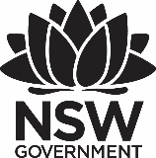

2024 Premier’s Teachers Mutual Bank Aboriginal Education Scholarship

Winhangarra

‘Hear, Think, Listen’ – Wiradjuri Language

Sally McGrath

Berkeley Vale Public School

Sponsored by Teachers Mutual Bank

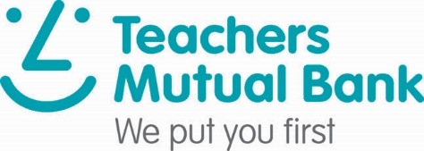

# Introduction

This report compares two language programs; Te Reo Mäori in Aotearoa (New Zealand), and Wiradjuri language in Central West New South Wales in Australia. The report attempts to outline the focus of the study and the main significant findings regarding the integration of languages in both settings including historical underpinnings and sustaining language approaches into the future.

# Focus of Study

The study tour aimed to ascertain how the revised Aboriginal Languages Curriculum is established and taught in New South Wales Public Schools.

Observing the integration of Te Reo Mäori in English medium schools in Aotearoa (New Zealand) helped to understand best practices in language programs. It also highlights the commitment, resources and educational support required to establish and maintain language programs that uphold the vision of Tau Mai Te Reo (Mäori language strategy) - ‘Kia tau te reo’, a state in which the language thrives and cloaks the land and people (Ministry of Education, 2013).

I observed the Wiradjuri language lessons taught in Public Schools in NSW’s Central West to draw parallels between the Mäori language curriculum and our Australian context. The demographic was comparable, and the language programs have remarkable longevity; having been taught for 20 years.

As a Wiradjuri woman, learning and observing the Wiradjuri language on Country was also culturally appropriate and is important when seeking permission to learn and teach language off Country when returning to the NSW Central Coast (Darkinjung Country) where I live and teach.

# Significant Learning

### Acknowledging our shared histories

The history of colonisation in Australia is remarkably similar to that of Aotearoa. By the time the first Europeans arrived, the Aboriginal and Mäori people had long settled the lands of their country. Wars and policies would see both cultures significantly impacted to the point where Pakeha or ‘white people’ dominated politically, socially and economically. Of particular interest to this report, is the impact of British colonisation on Moari and Aboriginal languages.

Although many early settlers spoke Te Reo to communicate trade with the Mäori people, over time the language declined. The colonists didn’t believe or understand the sacredness or purpose of Te Reo which resulted in its ban in many schools and communities. The early 1900s saw a shift in the education sector that severely affected the health of the Mäori language. Children who were fluent in Mäori language were being forced to leave their language at the school gate. Accounts of children being punished for speaking the Mäori language in and out of the classroom can be found through Aotearoa historical literature (Ministry of Education, 2013). In 1987, the Mäori Language Act declared Mäori language as an official language of Aotearoa. Te Taura Whiri i te Reo Mäori (the Mäori Language Commission) has since primarily focused on the support and development of the Mäori language. The Government's Mäori language strategy (2003), Te Rautaki Reo Mäori, charged the Ministry of Education with the implementation and planning of Mäori language in education. Mäori language is acknowledged as an official language and is included in The Aotearoa Curriculum within the ‘learning languages’ area, and is taught as a second language in English medium schools. It is acknowledged that as learners learn Mäori language, they also deepen their knowledge and understanding of Mäori culture. Mäori language is taught in English medium education settings to a diverse group of students, in many different contexts, and by education professionals with a wide range of language and teaching backgrounds. In 2007, curriculum guidelines were produced to support the teaching and learning of Mäori language in schools. Under the Education Act 5, all schools must provide Mäori language programmes to learners if requested by parents, and state how this will be provided within their school charter.

The history of colonisation and policies impacting language is very similar in Australia, with the Aborigines Protection Act, Assimilation Policy and White Australia Policy just a few among the many that would see the attempt to eradicate our peoples and therefore our languages. Unlike Aotearoa, Australia has yet to legislate language rights and as such broad-based, robust frameworks and policies do not support a shared strategy towards language revival in Australia. One productive area of policy and planning by the Australian government for Indigenous languages has been the development of syllabuses and curricula for language education in schools. This began in 2006 and has been revised for implementation in 2024. It is important to note that resources and frameworks to support Aboriginal languages is particularly difficult given the diversity of our languages. Whilst the Mäori language varies in sociolect and dialect, it is a mostly common language. It is estimated Aboriginal people spoke over 250 languages, and their knowledge, stories and songs all vary from Country to Country. The most difficult barrier to overcome in Australia is, therefore, the loss of language. It is estimated that only 20 languages of over 250 remain and thrive. As such, the difficulty is not only in reawakening the language but in finding it too.

### Two Countries, two languages

Aotearoa’s commitment to language is clear: every sign and every place name is written in two languages – Mäori first, and then English. The classrooms are drenched with language – Timetables, colours, numbers, emotions, shapes, nouns, verbs. Teachers code switch: “Put up your ringa ringa (hand). Let’s get our kai (food) and wai (water) and we will read a pukka pukka (book)”. Cultural narratives drive intentional leadership and all reaffirm that it is important that you see and feel the culture as you walk through the school. While not all staff know and understand their obligation to the Treaty, it feels as though most do. It wasn’t always this way but Aotearoa is truly an example of best practice when it comes to embedding language in English medium schools.

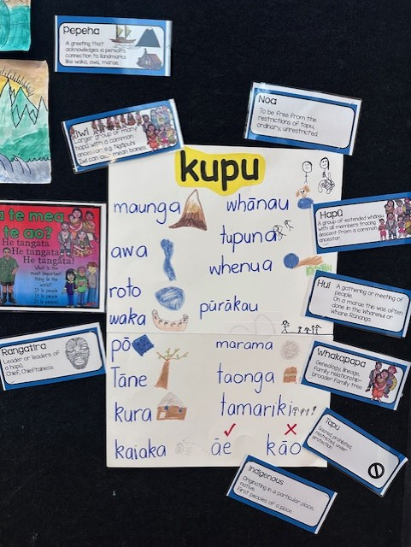

Figure 1: Maori language-rich environment

For the past 20 years, the Wiradjuri language group has worked hand in hand with schools to deliver Wiradjuri lessons. Today, four of the six local schools continue to deliver. Perhaps the biggest barrier is access to language speakers. Esther Job is a language teacher at Parkes High School and is the only non-Aboriginal person with the right to teach the Wiradjuri language. Students at Parkes High School receive 20 hours of Aboriginal languages a year in Year 7 (1 lesson per fortnight) to supplement their language curriculum. Esther approaches language in a very similar way to Aotearoa however, expresses concern that there isn’t enough known Wirajduri language to teach 120 hours as per the syllabus. The majority of the language group teachers were taught by Uncle Stan Grant Snr himself, and while Uncle Geoff Anderson continues to work hard on language revitalisation he himself was a late language learner. In Primary settings, students get 30 minutes of Wiradjuri per week. The tutors teach a collaboratively developed and community-determined scope and sequence. Teachers and tutors found that the curriculum expectations and community language capacity did not align and therefore developed their own scope and sequence to support need and available resources.

In both settings, it is clear that language can not be taught without culture, and culture can not be taught without language. Both settings also share teacher confidence as a big concern when delivering languages. In Aotearoa, much of the language is taught around the major times of celebration. Throughout May, June and July, schools were teaching and learning through Matariki; the Mäori new year. Art, writing, reading, science, and history were all taught through Matariki and all students demonstrated a deep knowledge and understanding of the celebration. In our languages, our words seldom have a single meaning, they are metaphors and we teach and learn through our ways of knowing and being which is why this is a successful approach.

In Wiradjuri country, students are excited about Wiradjuri lessons. For 30 minutes each week, they get to learn about the culture of the Country on which they live and learn. Students excitedly exclaimed: “Yes it’s Wiradjuri day today,” when they saw their Wiradjuri teacher. Schools also display beautiful signage in language and artworks telling stories of the past.

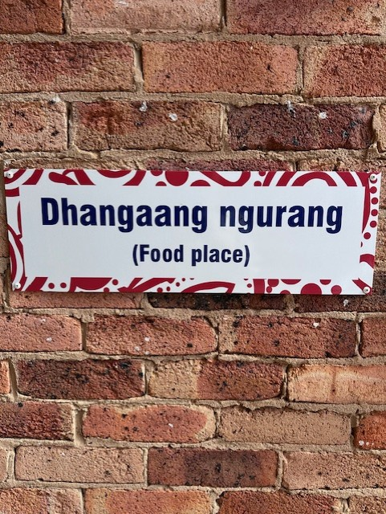

Figure 2: Wiradjuri signage Middleton

The Principal of Parkes East Public School believes that part of the success of the language program in the Central West is that the majority of students are Wiradjuri, learning Wiradjuri on Wiradjuri Country, whereas in places like the Central Coast, students come from all different Countries.

Across both settings, teachers are committed language learners. In Wiradjuri Country, the language group meets every week to share and support one another in language. In Aotearoa, teachers and principals attend Kapahaka lessons to build their knowledge and confidence when delivering culture and language. Of notable concern was the commitment to ensuring the programs and language within schools was sustained.

### Sustaining Language

In Aotearoa, the position of Mäori tutor is a REAP (Rural Education Activities Program) funded position for a period of three years. This is a full-time, identified position, based within schools with the goal to build teacher knowledge and capacity to teach Mäori and Te Reo language. The goal of this position was always to build capacity within staff (especially Pakeha) so that they could maintain and sustain their role within schools, every day, in every classroom. Teachers found this to be the most valuable resource in building their confidence and ensuring cultural sensitivity. Following on from the work of the Mäori tutor, teachers can apply to be the cultural leader of the school. They are paid a higher duties allowance and are open to teaching staff who are competent in supporting their team to continue to deliver authentic cultural education. This looks different in all schools. In some, it involves co-teaching and delivering Mäori lessons. In others, it is providing teachers with resources and encouraging integration in everyday practice through modelling exemplary practice.

In Wiradjuri Country, there is no specific funding for Wiradjuri tutors. it is up to the Principal and community to use school funds to fund the positions yearly and it is on a temporary basis. Access to resources is limited and are usually created by the language group or the teachers themselves. So much of our knowledge and culture has been lost. We cling tightly to our knowledge and our knowledge is sacred. As such, who shares knowledge is just as important, if not more than the knowledge that is shared. In Wiradjuri Country, it is important that only Wiradjuri people teach Wiradjuri language, with the exception of Esther.

When speaking with Karaitiana Tamatea the Associate Dean of Mäori Education at the University of Waikaito, he highlighted the importance of working with the Pakeha. He said: “We are only 15% of the population. If we want real change, we need to work with the Pakeha because they are the majority and will ensure it happens in our schools.” In Aotearoa, pre-service teachers must study core papers on Te Reo Mäori and the Treaty of Waitangi. Te Reo starts with the basics and upon completion, teachers must be able to complete a checklist enabling them to use Te Reo Mäori regularly in the classroom. This is to be observed during their teaching supervision during placement, or submitting a recording of their lesson embedding Te Reo Mäori.

# Conclusion

Whilst our histories between Australia and Aoterora are not too dissimilar, when we look at other postcolonial English-speaking societies, the absence of Australian legislation guaranteeing Indigenous language rights is starkly obvious. An obvious conclusion that was drawn whilst on the study tour was the history of the treaty in Aoterora and of course, the lack of treaty history in Australia. Aotearoa boasts broadly based planning and coordination for language revitalisation. Whilst the existence of robust policy frameworks would be of great value language revitalisation may need to be achieved without an official policy, and the Aboriginal Languages Curriculum is one of the many vehicles required to do this. The Wiradjuri language program in Central West of New South Wales has taken 20 years to establish and faces significant barriers to being sustained. Efforts to include language and culture in schools feel disconnected while we continue to learn and grow. In Aoterora, the support of the Government and Ngai Tangi (Elders) and the cooperation of the Pakeha demonstrate the importance of collaboration and cooperation in maintaining and sustaining language programs.

# Acknowledgments

I would like to thank and acknowledge Teacher’s Mutual Bank for giving me this incredible opportunity. I would also like to thank the following people and places:

* Lisa Ritherdon, Berkeley Vale Public School
* Staff and students - Te Kura o Take Karara
* Staff and students - Wanaka Primary School
* Staff and students - Alexandra Primary School
* Staff and students - University of Waikaito
* Mary-Anne Tamati
* Uncle Geoff Anderson
* Aunty Bronwyn Chambers
* The Wollotuka Institue / University of Newcastle
* Wiradjuri Language Group
* Staff and students - Parkes East Public School
* Condobolin Wiradjuri Cultural Centre
* Staff and students - Middleton Public School
* Staff and students - Parkes High School.

# References

Te Pa Tu, *History of New Zealand’s Native Language (N.D)* <https://te-pa-tu.com/our-stories/the-fascinating-history-of-new-zealands-native-language/#:~:text=Many%20early%20English%20settlers%20spoke,in%20many%20schools%20and%20communities>.

Ministry of Education, *Tau Mai Te Reo* *Language Strategy,* <https://www.education.govt.nz/assets/Documents/Ministry/Strategies-and-policies/Ka-Hikitia/TauMaiTeReoFullStrategyEnglish.pdf>